Polarization-dependent phase transition temperature in plasmonic thin films

Wakana Kubo1, 2*, Yosuke Ogata2, 3, James Frame4, Takuo Tanaka2, 3, 5, 6, and Xu Fang4

1 Department of Electrical and Electronic Engineering, Tokyo University of Agriculture and Technology, Koganei, Tokyo 184-8588, Japan

2 Metamaterials Laboratory, RIKEN, 2-1 Hirosawa, Wako, Saitama 351-0198, Japan

3Department of Physics, Faculty of Science, Gakushuin University, 1-5-1 Mejiro, Toshima-ku, Tokyo 171-8588, Japan

4School of Electronics and Computer Science, University of Southampton, Southampton SO17 1BJ, UK

5Innovative Photon Manipulation Research Team, RIKEN Center for Advanced Photonics, 2-1 Hirosawa, Wako, Saitama 351-0198, Japan

6Institute of Post-LED Photonics, Tokushima University, 2-1 Mishima, Minami-Jyosanjima, Tokushima 770-8560, Japan

*E-mail: w-kubo@cc.tuat.ac.jp

Nano-engineering the effective, macroscopic properties of composite materials is becoming increasingly important in material sciences and device development. Here, we report on using embedded plasmonic nanorods to modify the effective, as opposed to the intrinsic, phase transition temperature of vanadium oxide, a phase change material vital for infrared imaging and thermochromics. The nanorods function as controllable, nano-sized thermal sources through the excitation and dissipation of surface plasmons. The polarization dependence in the excitation efficiency modifies the effective phase transition temperature by up to 4.2 °C under broadband illumination of 5.0 W. This work constitutes a proof-of-principle demonstration of tunable and reversible plasmonic modulation of the phase transition temperature in a phase change material. It also represents a new strategy of thermo-plasmonic engineering at the nanoscale.

1. Introduction

The effective, macroscopic properties of many materials are often underpinned by their micro- and nano-structures. By actively exploiting this relation, numerous functional materials and novel devices have been developed where the functionalities originate from rational design of the micro- and nanostructures. For example, the effective refractive index of both photonic crystal slabs and fibers, a parameter crucial for confining and guiding light, can be adjusted by using micrometer-spaced air holes.1) Fine-tuning these microstructures further optimizes the dispersion and the size of optical modes, increasing the nonlinear refractive index by orders of magnitude relative to the constituent materials.2) Meanwhile, metallic micro- and nano-structures can create negative magnetic permeability and negative refractive index, the discovery of which has led to the development of invisibility cloak and superlens.3) More recent development in metamaterial research includes the hyperbolic metamaterials.4) Their effective electric permittivity or effective magnetic permeability is highly anisotropic, a property that could be very useful for high-resolution imaging and lithography. In areas beyond electromagnetism, a broad range of material properties inconceivable in natural materials have been also reported, which include negative values of thermal conductivity, elastic constants and mass density.5-7)

This work shows that the effective, macroscopic phase transition temperature of plasmonic vanadium oxide (VOx) thin films depends on the polarization of incident light. It constitutes a proof-of-principle demonstration of tunable and reversible thermo-plasmonic engineering of the phase transition temperature in a phase change material. VOx is chosen as the example phase change material for several reasons. (1) The optical properties of VOx can change drastically across the metal-insulator phase transition, making the optical detection and analysis of the transition relatively easy.8,9) (2) As the phase transition is volatile and the critical temperature is close to room temperature (68 °C for VO2 and lower for other stoichiometry),10) the transition is thus easily initiated, maintained and influenced using relatively little power. (3) VOx is the key material in infrared focal-plane arrays that currently dominate the market of uncooled infrared sensors, where the phase transition temperature is a crucial parameter.11) As this work shows a method to influence the phase transition temperature without altering the material composition, it may lead to significant improvement in sensor performance.

**2. Experimental methods**

This work explores the electromagnetic and thermal interactions between VOx thin films and embedded plasmonic nanorods. The interplay between surface plasmons and a variety of phase change materials including vanadium dioxide (VO2)12-21) and chalcogenides22,23) has been intensively studied. Indeed, it is widely viewed as a promising approach to constructing reconfigurable metamaterials and meta-devices.24,25) However, most of these previous reports only explored the plasmonic wavelengths, where the behaviors of the plasmons and the phase change materials are highly intertwined. By comparison, this work adopts a very different approach. It explores wavelengths far away from the plasmonic resonances, providing the opportunity to highlight changes in material properties (here the effective phase transition temperature) that plasmons induce. It is worth highlighting that, this work does not aim to modify any intrinsic material property of the VOx films. Instead, it demonstrates that the phase transition temperature, a key parameter for all phase change materials, can appear at a different value under the influence of surface plasmons.

Figure 1 illustrates key fabrication steps and typical sample morphology. A resist layer was spin coated on the surface of a silicon wafer (Fig. 1a) and subsequently patterned by electron beam lithography (Fig. 1b). A chromium buffer layer and a gold thin film, with respective thicknesses of 5 nm and 40 nm, were deposited on the sample by electron beam evaporation (Fig. 1c). Nanorods were obtained after the lift-off process (Figs. 1d and 1g). After the lift-off, the sample was subsequently covered with a vanadium layer of 70 nm in thickness by reactive sputtering (Fig. 1e). The sputtering power was 40 W, the pressure was 0.6 Pa, and the gas flow rates of argon and oxygen were 15 sccm and 0.3 sccm, respectively. Finally, the film was annealed in air to oxidize the vanadium (Fig. 1f). The oxidization temperature was 440 °C and the temperature increase rate was 1.9 °C/min.

We found that small variations in fabrication conditions often resulted in noticeable changes in the properties of VOx films. To allow for unambiguous comparison between samples, four nanorod arrays were fabricated on the same silicon substrate, and vanadium sputtering and oxidation were then conducted on the whole substrate. The nanorods had designed planar dimensions of 485 nm × 75 nm and each array covered an area of 1 mm × 1 mm. The nanorod periodicity depended on the sample, viz. 1 µm × 300 nm (Sample A), 750 nm × 300 nm (B), 1 µm × 200 nm (C) and 750 nm × 200 nm (D). The stoichiometry of the VOx films obtained through X-ray diffraction analysis was x≈2.2.

**3. Results and Discussion**

**3.1 Transmission spectrum measurements**

Infrared transmission spectra of the samples were measured by using a microscopic Fourier-transform infrared spectrometer (FTIR-6300 and IRT-3000, JASCO) (see Fig. S1 in the Supporting Information (SI)). A high-intensity ceramic light source generated an infrared spectrum that covered the broad range from 2 µm to 16 µm. The incident light was linearly polarized and its intensity was 5.0 W at the sample surface. Tuning the relative orientation between light polarization and anisotropic nanostructures is a well-established method to modulate plasmonic resonances. In this report, the light polarization was parallel to either the long axis (i.e. long-axis illumination) or the short axis (i.e. short-axis illumination) of the nanorods, which was achieved by rotating the sample. The incident light was loosely focused down to a diameter of 600 µm, smaller than the size of each nanorod array. Transmission spectra were recorded by using an HgCdTe photodetector with a clean silicon wafer as reference. Accurate temperature control and measurement, which were crucial in this experiment, were achieved by using a Peltier module and a temperature sensor attached to the bottom and topside of the sample, respectively. At each temperature, the spectrum was recorded after the temperature sensor had stabilized for a few minutes to allow the sample to reach thermal steady state. In the whole experimental range, the sample temperature was controlled with an accuracy of ± 0.1 °C.

Figure 2a shows the transmission spectra of Sample A measured at each temperature interval between 25 °C to 75 °C. The incident light is polarized along the long axis of the nanorods. A profound spectral feature at ~3.8 µm is observed in all the spectra. As will be discussed in theoretical analysis following Fig. 3, it corresponds to localized surface plasmon resonance oscillating along the longitudinal axis of the nanorods. Figure 2a shows a slight shift of ~140 nm in resonance wavelength with temperature, congruent with a change in VOx permittivity. For wavelengths away from the resonance, transmission clearly decreases with increasing temperature within the studied temperature range. This is due to the transition of the film from insulating to more reflective metallic phase. The spectral features at ~12 µm are attributed to intrinsic material loss in the VOx,26) and the intensity drop at ~16 µm originates from the limited spectral range of the light source and the spectrometer. Figure 2b shows spectra measured in a cooling process, where the differences with Fig. 2a are easily noticeable. Figure 2c shows the temperature-dependent transmission at 10 µm, an example wavelength far away from the plasmonic resonance. The transmission over the complete heating and cooling process traces a hysteresis loop. It is worth noting that the intersection at 60 °C in Fig. 2c, a feature that has rarely been reported in VOx studies before, is reproduced in numerical simulation (Fig. S2 in the SI) by using the modified Maxwell Garnet effective medium model.27)

The effective phase transition temperature *Teff* can be extracted from the hysteresis loop in Fig. 2c. It is defined as the center of the loop (the black triangle in Fig. 2c), and its value is determined following these three steps. (1) Transmission at 25 °C and 75 °C determines the center of the loop in the y axis. (2) The two temperatures that produce this transmission are located on the hysteresis loop. (3) The average of these two temperatures determines the center of the loop in the *x* axis and consequently *Teff*.

Similar measurements and analysis were conducted for the orthogonal polarization, i.e. along the short axis of the nanorods. Figures 2d, 2e and 2f show the heating spectra, the cooling spectra and the hysteresis loop, respectively. Different from the long-axis spectra, no plasmonic spectral feature is discernible, an observation that is supported by the numerical simulation in Fig. 3. Figure 2f shows a hysteresis loop similar to that in Fig. 2c, and the loop center is also highlighted.

A key difference between Figs. 2c and 2f, which is also the main discovery of this work, is that *Teff* depends on polarization. To determine the magnitude of this difference to high accuracy, hysteresis is analyzed at wavelengths from 8 µm to 15 µm at an interval of 1 µm (see Table S1 in the SI). *Teff* under the long-axis illumination is always lower than that under the short-axis illumination; the average and standard deviation of the difference are ∆ *Teff* = 3.37±0.11 °C. It is worth emphasizing that such polarization dependence is not an experimental artefact because it is not observed in the control sample, which is a plain, nanorod-free VOx film (Fig. S3 in the SI).

**3.2 Numerical simulation and theoretical analysis**

In order to identify the origin of ∆*Teff*, numerical simulation was conducted using COMSOL Multiphysics finite-element solver. Experimentally identifying the temperature-dependent permittivity of the VOx thin film in the wavelength range of interest was beyond our capability. As a numerical approximation for elucidating underlying mechanisms, the VOx layer was modelled as a 70-nm thick stoichiometric VO2 layer, which relatively reliable material properties can be found in the literature.28,29) Rod dimensions and periodicity took experimental values. The corners of the nanorod had an in-plane radius of 25 nm. The permittivity of silicon was 11.7. The wavelength-dependent permittivity of the two pure phases of VO2 was taken from References 28 and 29. The wavelength-dependent permittivity of gold and chromium was taken from References 30 and 31, respectively. The transmission spectra (Figs. 3a and 3f) included all diffraction orders in the forward direction, while the absorption cross section (Fig. 4b) was derived from dissipation inside the nanorods.

Figure 3a shows the simulated transmission of sample under long-axis illumination with the VO2 in the pure insulator phase. The resonance wavelength (~ 3.8 μm) and the overall shape of the experimental spectra are reproduced in the simulation. The near-field enhancement of the electric field in Figs. 3b-3e clearly shows that the resonance resembles an electric dipole. In contrast, the short-axis spectrum in Fig. 3f lacks any pronounced plasmonic resonance feature. This observation is consistent with the near-field plots where no field enhancement is visible (Figs. 3g-3j). The sharp contrast between the two polarizations in Fig. 3 suggests that the finite value of ∆*Teff* can be attributed to plasmonic resonance. Plasmonic resonance allows for highly controlled light absorption, which has been explored for a variety of applications such as optical data processing32) and novel spectroscopy.33) Light absorption generates heat with a spatial dependence derived from the heat-generation rate of $ω∙Im[ε]\frac{E^{2}}{2}$, where *ω* is the angular frequency, Im[*ε*] is the imaginary part of the permittivity *ε*, and *E* is the electric field. As plasmons are often associated with highly localized electric field enhancement (e.g. in Figs. 3b-3e), plasmonic nanoparticles function like heaters at the nanoscale. This property has proved to be crucial for heat assisted magnetic recording,34) photothermal cancer therapy35) and triggering chemical reactions at the nanoscale.36,37)

Polarization dependence as demonstrated in this work, achieved through the adoption of elongated nanorods, enables an extra degree of control over plasmons as compared to many previous works on thermo-plasmonics. Under long-axis illumination, the presence of plasmonic resonance (Figs. 3b-3e) implies that a noticeable temperature distribution exists in the film, which persists even in the thermal steady state. As compared to the sample surface where the thermal sensor is located, the nanorods and the VOx (VO2 in simulation) in their vicinity are expected to be at a slightly higher temperature. The whole VOx film consequently has an effective temperature higher than its surface temperature, and its phase transition appears to occur at a lower measured temperature. Meanwhile, under short-axis illumination, no plasmonic resonance exists in the spectral range (Figs. 3g-3j). This contrast suggests that temperature of the VOx film depends on the light polarization, which directly leads to the finite value of ∆*Teff*.

**3.3 Influence of nanorod density on effective phase transition temperature**

To further support our interpretation of the phenomenon, the same measurement and analysis were conducted for the other three samples (Samples B, C and D). The nanorods have the same dimensions in all the four samples. The samples only differ in nanorod periodicity, but none of the periodicity is small enough to introduce dimer resonance in the measured wavelength range. Consequently, similar phenomenon is expected to appear in all these samples based on the analysis above. Indeed, a finite value of ∆*Teff* is detected in each sample, which is 4.03±0.07 °C for Sample B, 3.34±0.25 °C for Sample C, and 4.23±0.37 °C for Sample D (see SI for details).

Figure 4 shows a quantitative estimation of ∆*Teff* by combining experimental measurement, computational modelling and analytical calculation. Based on the effective medium principle, a continuous VOx layer and its embedded gold nanorods are approximated as a homogenous film without any internal heat source. The nano-heaters are instead approximated as a thin sheet of heat source *q* at the interface between silicon and this hypothetical film. In the steady state, the temperature field *T* obeys the heat equations of $-k∇^{2}T=q$ at the silicon-film interface and $-k∇^{2}T=0$ inside the film, where *k* is the thermal conductivity. It is obvious that the temperature decreases linearly moving from the heat source to the air interface. The temperature at the center of the film is thus above that at the air interface, and the difference is considered to be the theoretical value of ∆*Teff*.

Reference 38 established an analytical model for calculating the temperature rise of a metal nanoparticle array under light illumination. We extend its analysis on the collective temperature rise, which only accommodated single-wavelength illumination, to address our experiment, which uses a broad band light source. We arrive at

$∆T_{eff}=\frac{1}{\left(κ_{f}+κ_{s}\right) π D A} \left(1-2\frac{\sqrt{A}}{\sqrt{π} D}\right)\int{P(λ) σ_{abs}(λ) dλ}$ (1)

where *λ* is the wavelength, and *P*(*λ*) and *σabs*(*λ*) are the wavelength-dependent spectral flux and absorption cross section, respectively. *kf* and *ks* are the thermal conductivity of the film (taken as 6 W/mK, the value of VO2)39) and the silicon substrate (149 W/mK), respectively. *D* is the diameter of the focal spot (600 µm) and *A* is the size of the unit cell (1 mm × 1 mm). The integral range of *λ* is 2 µm - 16 µm, the main radiation range of the light source.

The radiation intensity *P*(*λ*) measured at the light source is shown in Fig. 4a. It is approximated by blackbody radiation at 590 K. The theoretical values, after normalization against the total incident power at $\int{P\left(λ\right) dλ=5 W}$, are used for the following calculation. The absorption cross section *σabs*(*λ*) of a single nanorod in Samples A, B, C and D is shown in Fig. 4b. A strong peak is observed in each spectrum and it corresponds to the plasmonic resonance. The decrease in peak intensity from Samples A to D is mainly due to the decrease in the size of the unit cell (from 1 µm × 300 nm in Sample A to 750 nm × 200 nm in Sample D), while the change in the peak shape may originate from factors such as finite crosstalk between the nanoantennas. Figure 4c shows the measured ∆*Teff* against the nanorod density. It also shows analytical values of ∆*Teff* computed based on Eq. (1), the *P*(*λ*) in Fig. 4a and the *σabs*(*λ*) in Fig. 4b. The analytical results roughly follow the trend of the experiment, providing strong support to our interpretation of the physical origin of ∆*Teff*. The analysis nevertheless underestimates ∆*Teff* by a few times, and this discrepancy probably has its main source in the assumptions made in theoretical analysis. Firstly, the analysis is based on stoichiometric VO2 whereas our samples are of mixed composition; the permittivity and thermal conductivity are therefore likely to differ. Additionally, the assumption of Au/VO2 as a homogenous medium heated from one side may be too simple; the plasmonic hot spots are likely to play a more complicated role in the phase transition than discussed above.

Equation (1) indicates that further decrease in *Teff* (i.e. an increase in ∆*Teff*) can be obtained by shaping the spectral of the incident light (i.e. modifying $P\left(λ\right)$, as $P\left(λ\right)$ that matches *σabs*(*λ*) can convert incident light power into heat effectively), increasing the incident light power $\int{P\left(λ\right) dλ}$ and increasing the absorption cross section *σabs*(*λ*). Interestingly, both Eq. (1) and Fig. 4c also indicate that solely increasing the nanorod density is instead not an optimal solution. ∆*Teff* shows monotonic increase with the nanorod density in neither the experiment nor the analysis. Equation (1) provides useful insight into this behavior. As the unit cell size A is normally much smaller than the beam diameter *D*, $1-2\sqrt{A}/(\sqrt{π} D)≈1$. For a given material system under given illumination conditions (i.e. *kf*, *ks*, *D* and *P*(*λ*) are fixed), $∆T_{eff}∝ \left(1/A\right)\int{P(λ) σ_{abs}(λ) dλ}$. Increasing the nanorod density increases 1/*A* but decreases *σabs*(*λ*), and the resulted change in ∆*Teff* will depend on the competition of these two factors. A linear increase in ∆*Teff* with the nanorod density can be expected only at low densities, the regime where the density has little influence on *σabs*(*λ*).

**4 Conclusion**

To conclude, we have demonstrated altering the effective phase transition temperature of vanadium oxide thin films by embedding gold nanorods. The temperature depends on both the polarization of the illumination light and the nanorod density. In experiment, the temperature difference between two orthogonal polarizations reaches up to 4.2 °C in one sample. Theoretical analysis based on numerical simulation and effective medium approximation attributes this phenomenon to inhomogeneous, plasmon-induced heat generation. The localized heating facilitates an effective phase transition temperature of the composite material that is tunable, without changing the intrinsic properties of the constituent materials. This report also shows a new approach of using effective medium analysis to interpret thermo-plasmonic phenomena in phase change materials.

The plasmon-induced temperature modulation is both tunable and reversible. These unique properties may prove ideal for many applications, as existing methods of temperature modulation (e.g. changing stoichiometry and tungsten doping40)) are mostly irreversible. This work shows a new strategy of modulating macroscopic material properties through thermo-plasmonic engineering at the nanoscale. Besides plasmonic phase transitions, the analysis reported here may also provide valuable insights to research on other plasmon-dielectric systems, e.g. plasmonic solar cells41) and plasmon-enhanced water splitting,42,43) where thermal management at the nanoscale under broadband illumination is critical to device performance.

**Acknowledgments**

The authors are grateful to Nicolas Green for fruitful discussions.

**References**

1. I. Liberal and N. Engheta, Nat. Photon. **11**, 149 (2017).
2. J. M. Dudley and J. R. Taylor, Nat Photon. **3**, 85 (2009).
3. Y. Liu and X. Zhang, Chem. Soc. Rev. **40**, 2494 (2011).
4. A. Poddubny, I. Iorsh, P. Belov, and Y. Kivshar, Nat Photon. **7**, 948 (2013).
5. C. Z. Fan, Y. Gao, and J. P. Huang, Appl. Phys. Lett. **92**, 251907 (2008).
6. X. N. Liu, G. K. Hu, G. L. Huang, and C. T. Sun, Appl. Phys. Lett. **98**, 251907 (2011).
7. R. Zhu, X. N. Liu, G. K. Hu, C. T. Sun, and G. L. Huang, Nat. Commun. **5**, 5510 (2014).
8. J. B. Kana, J. M. Ndjaka, G. Vignaud, A. Gibaud, and M. Maaza, Opt. Commun. **284**, 807 (2011).
9. M. Currie, M. A. Mastro, and V. D. Wheeler, Opt. Mater. Express **7**, 1697 (2017).
10. M. E. A. Warwick and R. Binions, J. Mater. Chem. A **2**, 3275 (2014).
11. A. Rogalski, Infrared Phys. Technol. **54**, 136 (2011).
12. T. Driscoll, H.-T. Kim, B.-G. Chae, B.-J. Kim, Y.-W. Lee, N. M. Jokerst, S. Palit, D. R. Smith, M. Di Ventra, and D. N. Basov, Science **325**, 1518 (2009).
13. M. J. Dicken, K. Aydin, I. M. Pryce, L. A. Sweatlock, E. M. Boyd, S. Walavalkar, J. Ma, and H. A. Atwater, Opt. Express **17**, 18330 (2009).
14. M. Liu, H. Y. Hwang, H. Tao, A. C. Strikwerda, K. Fan, G. R. Keiser, A. J. Sternbach, K. G. West, S. Kittiwatanakul, J. Lu, S. A. Wolf, F. G. Omenetto, X. Zhang, K. A. Nelson, and R. D. Averitt, Nature **487**, 345 (2012).
15. M. A. Kats, R. Blanchard, P. Genevet, Z. Yang, M. M. Qazilbash, D. N. Basov, S. Ramanathan, and F. Capasso, Opt. Lett. **38**, 368 (2013).
16. K. Appavoo, B. Wang, N. F. Brady, M. Seo, J. Nag, R. P. Prasankumar, D. J. Hilton, S. T. Pantelides, and R. F. Haglund, Nano Lett. **14**, 1127 (2014).
17. D. Y. Lei, K. Appavoo, F. Ligmajer, Y. Sonnefraud, R. F. Haglund, and S. A. Maier, ACS Photonics **2**, 1306 (2015).
18. Y. Urade, Y. Nakata, K. Okimura, T. Nakanishi, F. Miyamaru, M. W. Takeda, and M. Kitano, Opt. Express **24**, 4405 (2016).
19. K. Sun, C. A. Riedel, A. Urbani, M. Simeoni, S. Mengali, M. Zalkovskij, B. Bilenberg, C. H. de Groot, and O. L. Muskens, ACS Photonics **5**, 2280 (2018).
20. S. Song, X. Ma, M. Pu, X. Li, Z. Zhang, P. Gao, and X. Luo, Appl. Phys. Express **11**, 042004 (2018).
21. H. Takeya, J. Frame, T. Tanaka, Y. Urade, X. Fang, and W. Kubo, Sci. Rep. **8**, 12764 (2018).
22. Y. G. Chen, T. S. Kao, B. Ng, X. Li, X. G. Luo, B. Luk'yanchuk, S. A. Maier, and M. H. Hong, Opt. Express. **21**, 13691 (2013).
23. A. Tittl, A.-K. Michel, M. Schäferling, X. Yin, B. Gholipour, L. Cui, M. Wuttig, T. Taubner, F. Neubrech, and H. Giessen, Adv. Mater. **27**, 4597 (2015).
24. G. Oliveri, D. H. Werner, and A. Massa, Proc. IEEE **103**, 1034 (2015).
25. M. Wuttig, H. Bhaskaran, and T. Taubner, Nat Photon. **11**, 465 (2017).
26. A. Šurca, B. Orel, G. Drazic, and B. Pihlar, J. Electrochem. Soc. **146**, 232 (1999).
27. J. D. Frame, N. G. Green, and X. Fang, Opt. Mater. Express **8**, 1988 (2018).
28. H. W. Verleur, A. S. Barker, and C. N. Berglund, Phys. Rev. **172**, 788 (1968).
29. I. Pirozhenko and A. Lambrecht, Phys. Rev. A **77**, 013811 (2008).
30. R. L. Olmon, B. Slovick, T. W. Johnson, D. Shelton, S.-H. Oh, G. D. Boreman, and M. B. Raschke, Phys. Rev. B **86**, 235147 (2012).
31. A. D. Rakić, A. B. Djurišić, J. M. Elazar, and M. L. Majewski, Appl. Opt. **37**, 5271 (1998).
32. X. Fang, K. F. MacDonald, and N. I. Zheludev, Light Sci. Appl. **4**, e292 (2015).
33. F. He, K. F. MacDonald, and X. Fang, Opt. Express **26**, 12415 (2018).
34. W. A. Challener, C. Peng, A. V. Itagi, D. Karns, W. Peng, Y. Peng, X. Yang, X. Zhu, N. J. Gokemeijer, Y. T. Hsia, G. Ju, R. E. Rottmayer, M. A. Seigler, and E. C. Gage, Nat. Photon. **3**, 220 (2009).
35. E. C. Dreaden, A. M. Alkilany, X. Huang, C. J. Murphy, and M. A. El-Sayed, Chem. Soc. Rev. **41**, 2740 (2012).
36. G. Baffou and R. Quidant, Chem. Soc. Rev. **43**, 3898 (2014).
37. L. Zhou, D. F. Swearer, C. Zhang, H. Robatjazi, H. Zhao, L. Henderson, L. Dong, P. Christopher, E. A. Carter, P. Nordlander, and N. J. Halas, Science **362**, 69 (2018).
38. G. Baffou, P. Berto, E. B. Urena, R. Quidant, S. Monneret, J. Polleux, and H. Rigneault, ACS Nano **7**, 6478 (2013).
39. G. V. Samsonov, The Oxide Handbook (Springer US, 2013).
40. X. Tan, T. Yao, R. Long, Z. Sun, Y. Feng, H. Cheng, X. Yuan, W. Zhang, Q. Liu, C. Wu, Y. Xie, and S. Wei, Sci. Rep. **2**, 466 (2012).
41. Y. H. Jang, Y. J. Jang, S. Kim, L. N. Quan, K. Chung, and D. H. Kim, Chem. Rev. **116**, 14982 (2016).
42. P. Zhang, T. Wang, and J. Gong, Adv. Mater. **27**, 5328 (2015).
43. J. C. Ndukaife, V. M. Shalaev, and A. Boltasseva, Science **351**, 334 (2016).

**Figure Captions**

**Fig. 1.** (Color online) Key steps of sample fabrication and the morphology of a nanorod array. (a) Spin coating of electron beam resist on a silicon wafer. (b) Nanorod pattern formation through electron beam lithography. (c) Deposition of a chromium buffer layer and a gold thin film. (d) Formation of gold nanorods after lift-off. (e) Reactive sputtering of a vanadium thin film. (f) Formation of vanadium oxide (VOx) after annealing. (g) Scanning electron microscope images taken after the lift-off step. The scale bar represents 1 µm and 300 nm in the low and high magnification images, respectively.

**Fig. 2.** (Color online) Experimental transmission of Sample A. (a) Transmission spectra measured at different temperatures in a heating process. Incident light was polarized along the long axis of the nanorods. Spectra at eight different temperatures were measured: 25 °C, 35 °C, 45 °C, 50 °C, 55 °C, 60 °C, 70 °C and 75 °C. (b) Corresponding spectra in a cooling process. (c) Transmission hysteresis loop at 10 µm, an example wavelength far away from the plasmonic resonance, obtained in a complete heating (solid line) and cooling (dashed line) cycle. The effective phase transition temperature *Teff* (black triangle) is at the center of the loop. (d-f) Corresponding (d) heating spectra, (e) cooling spectra and (f) hysteresis loop for the orthogonal polarization, i.e. along the short axis of the nanorods.

**Fig. 3.** (Color online) Numerically simulated optical properties of Sample A. The VOx film is approximated with stoichiometric VO2 in the room-temperature insulator phase. (a) Transmission spectrum of the sample under long-axis illumination. (b-e) Electric field distribution of a 2D plane located 10 nm above the nanorod top surface within the VO2 layer. The field strength is normalized against the value at the same location inside a plain VO2 film. The whole wavelength range of interest is sampled at (b) 4 μm, (b) 8 μm, (c) 12 μm and (d) 16 μm. (e-j) Corresponding transmission spectrum and field distribution under short-axis illumination. All the field maps follow the same color scale.

**Fig. 4.** (Color online) Plasmon-induced change in phase transition. (a) Experimental (black dots) and theoretical (red line) spectral flux of the light source. The theoretical spectrum corresponds to blackbody radiation at 590 K. (b) Theoretical values of the absorption cross section of a nanorod in each sample of A, B, C and D. (c) The average (dots) and standard deviation (error bars) of the measured ∆*Teff* overlaid with the theoretical values. The *x* axis is the planar nanorod density.



Fig. 1 (Color online)

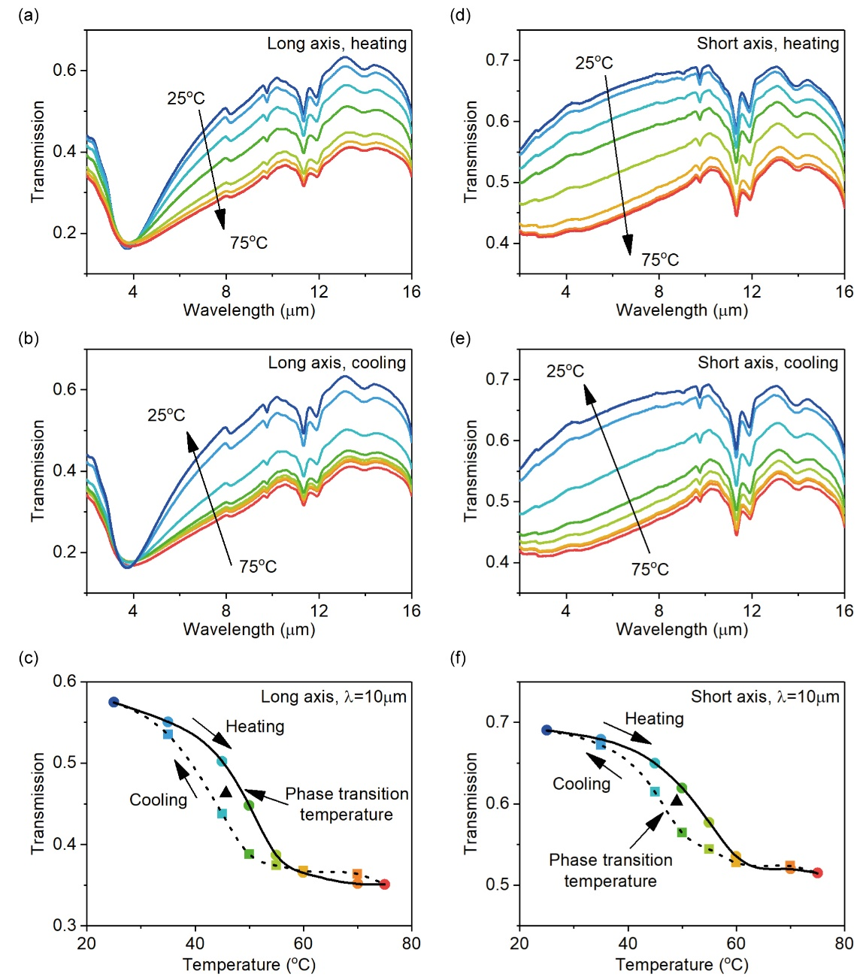

Fig. 2 (Color online)

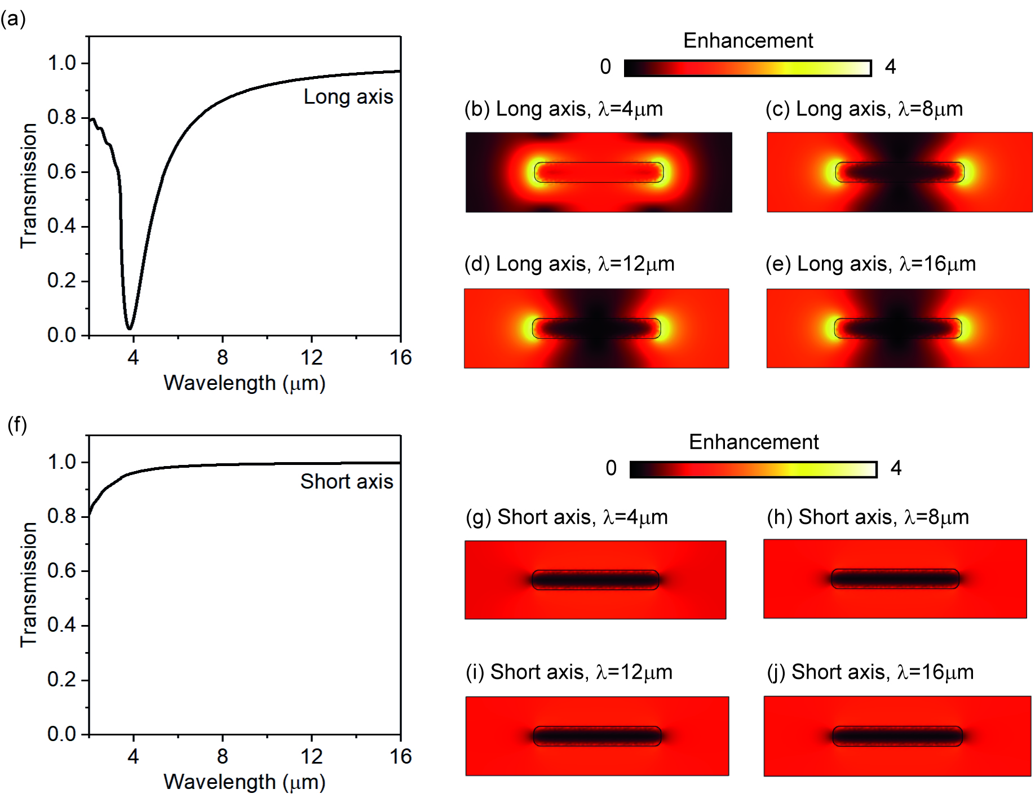

Fig. 3 (Color online)

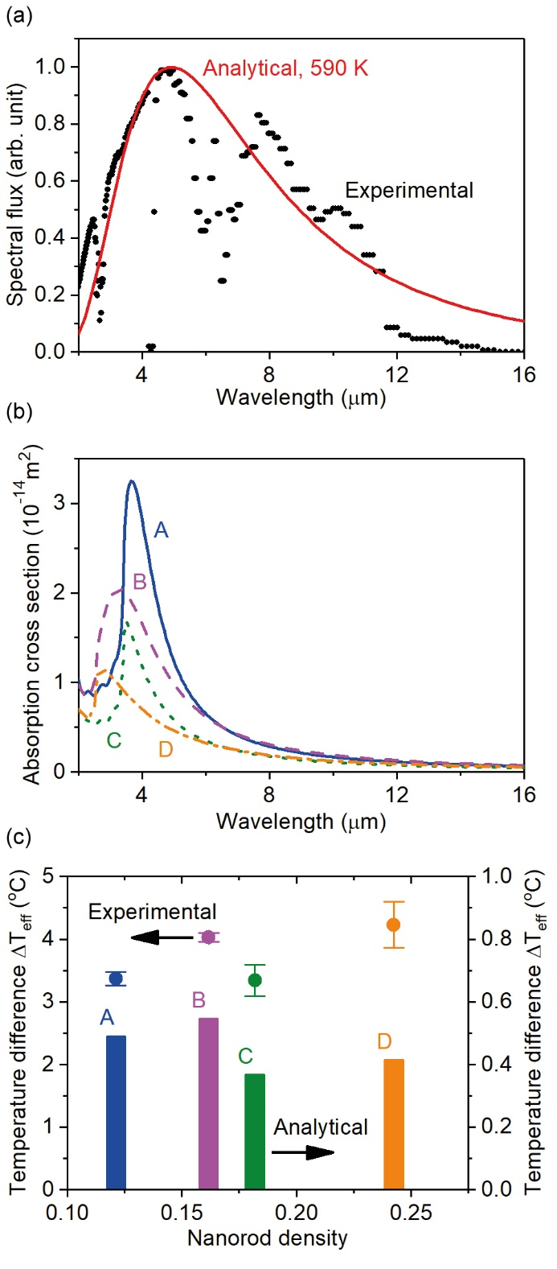

Fig. 4 (Color online)