# On the acoustics of the *Teatro 1763* in Bologna

# Lamberto Tronchin1, Francesca Merli1 and Massimiliano Manfren2

1Department of Architecture, University of Bologna, Via dell’Università 50, 47521 Cesena, Italy

2Faculty of Engineering and Physical Sciences, University of Southampton, Highfield, Southampton SO17 1BJ, U.K.

Emails: M.Manfren@soton.ac.uk (Massimiliano Manfren), francesca.merli8@unibo.it (Francesca Merli)

**Corresponding author:**

Lamberto Tronchin, Department of Architecture, University of Bologna, Via dell’Università 50, 47521 Cesena, Italy

Email: [lamberto.tronchin@unibo.it](mailto:lamberto.tronchin@unibo.it)

**Abstract**

The need for capturing the acoustic properties and spatial information of significant ancient theatres became very important in the last years. Particularly, the knowledge of sound propagation became very important during the design or refurbishment of historic theatres and opera houses. Theatre 1763 in Villa Aldrovandi Mazzacorati, in Bologna (Italy), is chosen as a remarkable example. This is a small private theatre built by the Aldrovandi family during the 18th Century inside the historic Villa Aldrovandi Mazzacorati. The theatre maintains its original shape, indoor materials and furnishings as chairs. For this reason and its peculiarities, the theatre was deeply investigated by several architects, but no acoustic measurements were extensively conducted within the hall. This article reports the results of two measurement campaigns which were conducted in different periods and with different methodologies, to evaluate the variability of the acoustic parameters and determine intrinsic characteristics of this unique small theatre.

**1. Introduction**

The acoustics must be considered a cultural heritage and an important feature of several ancient buildings. For theatres, in particular, this idea that the acoustic property is by itself a “cultural heritage” became important after the destruction by fire of two important opera houses in Italy at the end of the last century [1, 2]. Since this idea obtained considerable attention and importance with a number of researchers concentrating upon this topic leading to the definition of guidelines to correctly measure the acoustical properties of theatre and sacred spaces [3, 4] by taking into account sound source positions, receiver positions and room conditions. Nevertheless, the introduction of modern theatrical devices and uncontrolled restorations are often causing significant damage from an acoustic point of view [5, 6]. While safety and performance requirements change over time, concerning the acoustic quality, the original working condition should be maintained as much as possible [7]. However, the analysis of the acoustic properties of opera houses and theatres often represents an issue due to their architectural features (geometry and materials).

This paper focuses on a small theatre, known as “*Teatro 1763* in Villa Aldrovandi Mazzacorati”, in Bologna (Italy), and presents acoustic parameters extracted from the Impulse Responses (IRs), which have been measured during two acoustic measurements.

2. The *Teatro 1763*

The *Teatro 1763* in Bologna was opened on 24th September 1763, a few months later Municipal Theatre’s inauguration, with a performance of the Voltaire tragedy *Alzira* by Vincenzo Fontanelli in Italian translation, who was an exponent of the Estensi Court of Modena and father-in-law of the landlord, Count Gian Francesco Aldrovandi.

It is a small theatre inside historic Villa Aldrovandi Mazzacorati and is located in the left-wing of the building. The exterior of villa was designed by Francesco and Petronio Tadolini, while the theatre was built as a private theatre of Aldrovandi family. The interior decoration of the theatre was entirely organized by Count Gian Francesco Aldrovandi, who took care of every detail. Paintings were commissioned to Filippo Balugani and backdrop on stage was assigned to Antonio Basoli in 1810. The audience area has a rectangular shape and is characterized by the presence of twenty-four plaster telamones and caryatids, which support two continuous “U”-shaped balconies. The Theatre 1763 has a backstage, raised stage, tooling room, foyer and double access from outside and an exit that connects it with internal halls. It could host 80 persons, but originally stalls and balconies could accommodate until 200 persons. Currently, it is not possible to access the first and the second order for safety reasons and due to structural problems. During the refurbishment occurred after the second world war, the access door to the second-order was closed due to structural restoration and actually, the first order is used only for maintenance work and the audience can only access to the stalls. With the extinction of Aldrovandi branch, the Villa was sold to Giuseppe Mazzacorati in 1828, and after that Sarti family was the last owner, which in 1928 ceded it to fascist soldiers which made it a holiday camp for children.

Today, the Villa is used by Regional Health Care as a health centre and the owner is Regione Emilia-Romagna.

Thus the Arcadian theatre is the last "private" suburban theatre in Bologna, known in the world for its “perfect acoustic” properties, which seems due to the application of ancient theories, an excellent relationship between depth and width of the main hall and the use of local construction materials. In the theatre, the microphones are not necessary and there is no echo effect; voice actors on stage can be well heard from stalls and balconies. Therefore, since twenty-five years, baroque concerts (soloists, small ensembles and chamber music) and prose shows have been taking place without any amplification, with extremely high intelligibility and acoustic quality. This acoustic quality also depends on the shoe-box shape and small volume of the theatre.

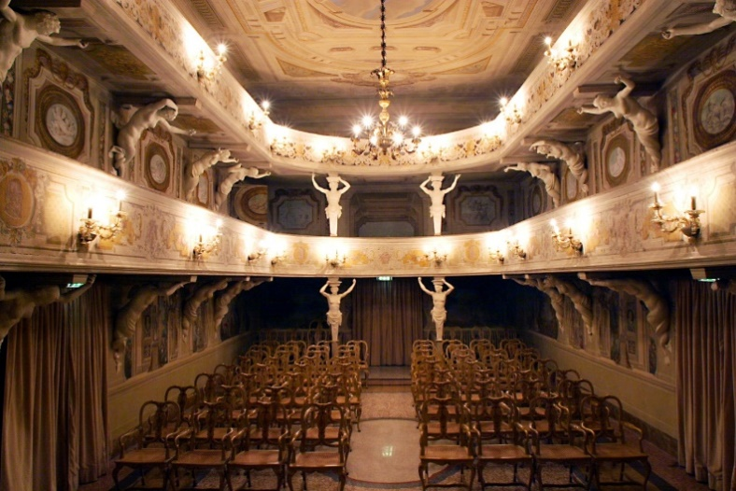 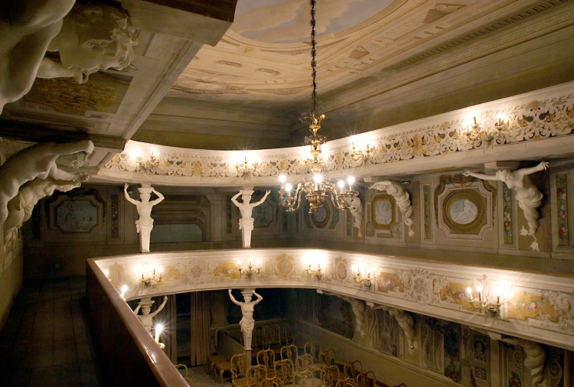

Figure 1: Views on the main hall of Theatre 1763. In the stalls, the original chairs (still used during performances) are represented.

Although the theatre fell into disuse for many years, even though the villa was damaged during the Second World War, the theatre itself wasn’t damaged during the war and maintained its original shape, including most of the original chairs. Moreover, it still retains some original elements including canvas backdrop and ten sceneries on stage. No heating (or conditioning) system has been provided for the theatre. Today it opens for guided tours and performances thanks to a city association [8-10].

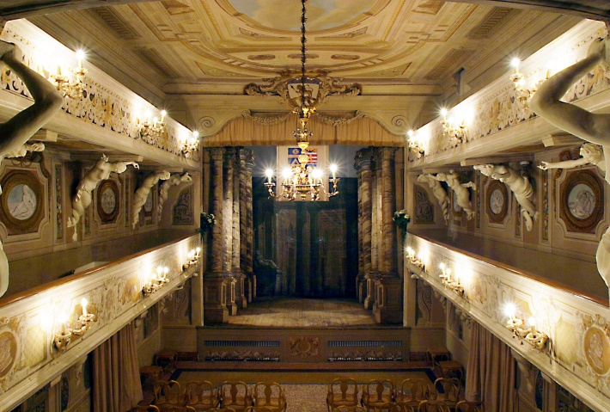 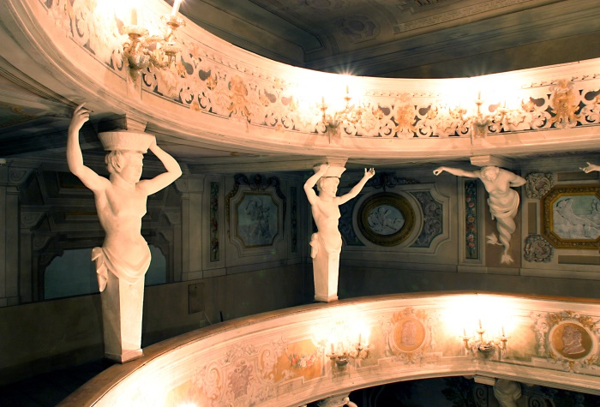

Figure 2: Views of the theatre from the first gallery.

3 Acoustic Measurements

Two acoustic surveys were carried out under unoccupied conditions in different periods.

3.1 The first survey

The workflow of the first measurements campaign followed also the ISO 3382-1 [11] recommendations. The sound source located in two positions on the stage and microphones used for recording the impulse responses in eleven different receivers in the stalls and the first gallery (Figure 3). Exponential Sine Sweep (ESS) was used as an excitation signal and the impulse responses (IRs) were measured for each sound source in each position of stalls and gallery.

Mono-aural, binaural and B-Format measurements were conducted using the following instrumentations:

* digitally equalized dodecahedron as the sound source to generate Exponential Sine Sweep signal (ESS) [12];
* B-Format microphone (Soundfield MK-V), which allowed the measurements of B-Format IRs;
* dummy head (Sennheiser), which allowed the measurements of binaural impulse responses;

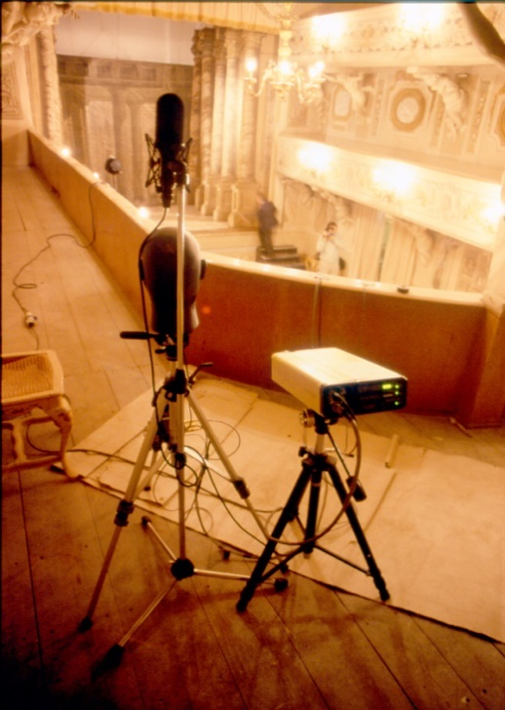

Figure 3: Instrumentation in the first gallery during the first acoustic campaign.

3.2 The second survey

The second campaign was aimed at deepening the study of the acoustics of this theatre, to obtain a complete description of spatial sound propagation and to evaluate the local variation of acoustic field inside the hall.

Mono-aural, binaural and beamforming measurements were performed employing the following instrumentations:

* digitally equalized dodecahedron as a sound source;
* B-Format microphone (Soundfield MK-V);
* dummy head (Neumann KU-100);
* omnidirectional microphone (Bruel & Kjaer 4189).

During this acoustic survey, measurements were conducted only in the stalls at different lateral positions and different heights of microphones. In the first configuration, omnidirectional microphones and dummy head were fixed in the middle of the room, to be used as reference measurements, while Soundfield microphone was moved from left to right side of the theatre in 10 different positions along the second row, as shown in Figure 4a. Figure 4b presents instrumentations in the second configuration: the Soundfied was lifted for 15 different heights from 1.10 m to 1.40 m, while Neumann and BK microphones were fixed in the second row. The dodecahedron was used as the sound source and was placed on the stage.

a) b)

teatro1 teatro2

Figure 4a – 4b: Plans of Theatre 1763, with positions of microphones for the two types of measurement configurations.

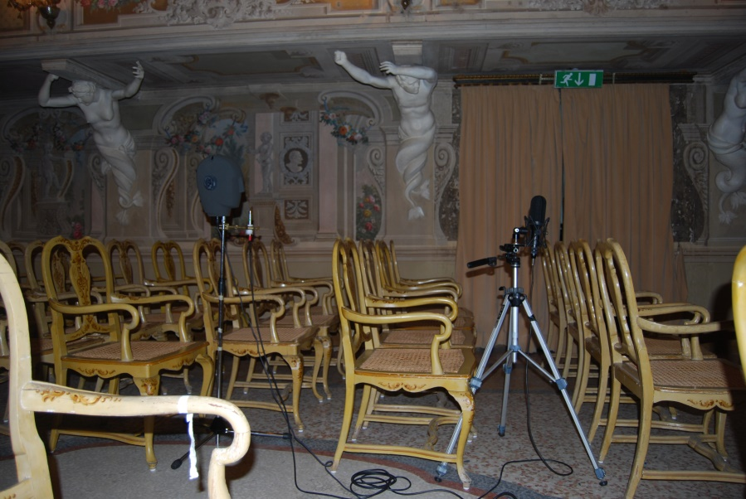

Figure 5: View of instrumentations during measurements.

The first measurement session allowed to properly analyse the acoustic parameters in all the seating area of the theatre (stalls and balcony) and measuring sound diffuseness, which represents an important aspect of music perception.The second campaign was aimed to understand the variation of the acoustic parameters analysing real positions occupied by the listeners in the stalls and for different spectator heights. Therefore receivers were distributed only in the stalls area with different heights to represent the usual positions of the audience during the performances, including the variation due to the different height of the listeners. The results obtained from the second session will give a precise description of the acoustics limited to the real position occupied by the spectators during the performance.

Moreover, during the second measurement session photos were taken to map the different reflections coming from the walls and ceiling of the theatre. The two measurement campaigns will provide also key performance data for future monitoring and controlling.

4. Analysis of the results

The recorded impulse responses (IRs) were elaborated with the software Aurora and several acoustic parameters defined in the ISO 3382-1 [11], such as the reverberation time (T20, T30), the clarity (C50, C80), the definition (D50), Ts, EDT, and spatial parameters (LF and IACC) were analyzed. These parameters were computed for each octave-band frequency, from 125 Hz to 8 kHz, and they were compared with Just Noticeable Difference (JND) [13] to analyze the variability.

4.1 Results of the first survey

The acoustic parameters have been calculated from the omnidirectional output of Soundfield microphone (W channel), while IACC is calculated by dummy head (Sennheiser) output.

The overall acoustic parameters obtained from the first measurement campaign are reported in Table 1 and Figure 6, and the average was conducted among all the receivers.

Table 1: Value of acoustic parameters obtained from the first measurement campaign.

|  |  |  |  |  |  |  |
| --- | --- | --- | --- | --- | --- | --- |
| **Freq. (Hz)** | **125** | **250** | **500** | **1000** | **2000** | **4000** |
| EDT (s) | 1.22 | 1.31 | 1.37 | 1.19 | 1.11 | 0.88 |
| T20 (s) | 1.31 | 1.29 | 1.25 | 1.15 | 1.08 | 0.89 |
| T30 (s) | 1.36 | 1.30 | 1.25 | 1.15 | 1.07 | 0.89 |
| C50 (dB) | -1.93 | -2.05 | -1.25 | -0.74 | 0.10 | 1.71 |
| C80 (dB) | 1.17 | 1.06 | 1.05 | 1.98 | 2.86 | 4.60 |
| D50 (%) | 39.54 | 38.93 | 43.21 | 45.81 | 50.47 | 59.46 |
| Ts (ms) | 105.28 | 105.22 | 97.22 | 84.68 | 74.58 | 58.42 |
| LF | 0.21 | 0.24 | 0.25 | 0.32 | 0.45 | 0.69 |
| IACC | 0.69 | 0.20 | 0.15 | 0.12 | 0.12 | 0.11 |

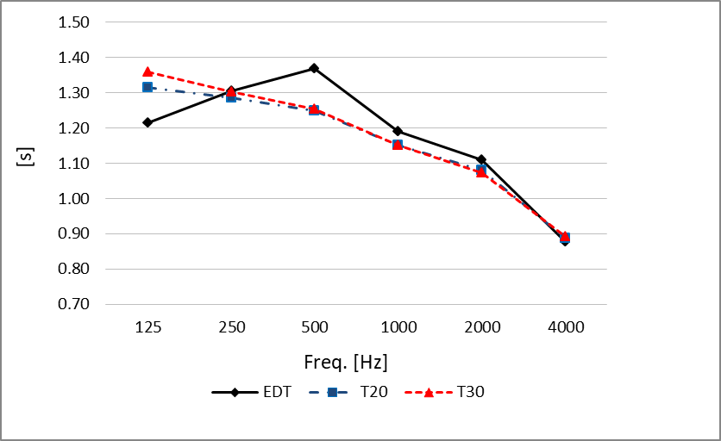 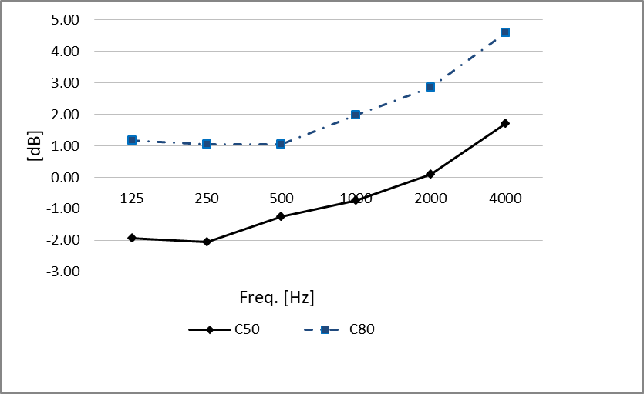

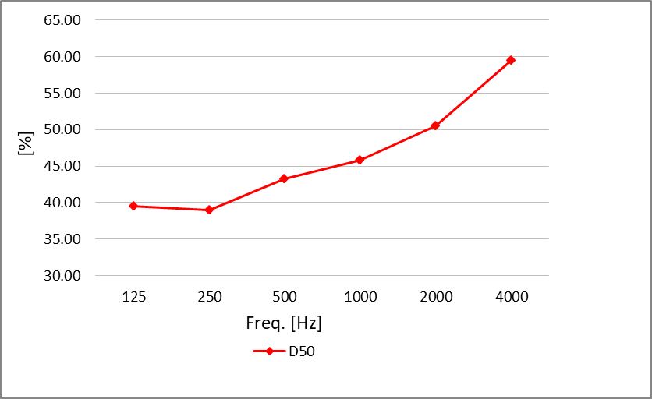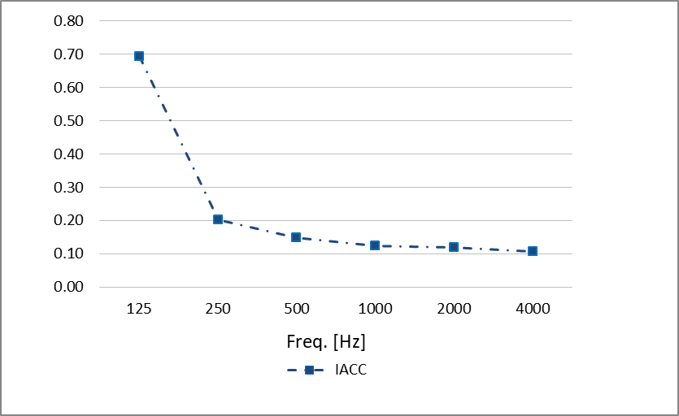

Figure 6: Average values of the measured acoustic parameters (EDT, T20, T30, C50, C80, D50 and IACC) obtained from the first measurement campaign.

The analysis of reverberation time (T30 and T20) measurements showed an average value at medium frequencies (500 Hz and 1 kHz) of 1.20 s. This value is above the reverberation time of Italian opera houses (Figure 7). Therefore, the theatre is more "resonant", but at the same time, good intelligibility could be achieved without any electro-acoustic support. In fact, the small volume of the theatre and the low background noise (the Villa is located on the hills and far from the road) make speech listening very clear and sound "brilliant". Furthermore, the balcony fronts of both levels, the ceiling as well as the walls of the stage are made of wood, so these elements vibrate during performances and make the sound brilliant.

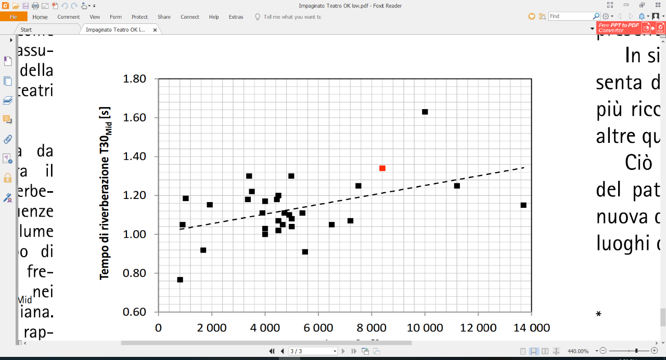

Reverberation Time T30Mid [s]

Figure 7: Relation between Volume (mc) and T30 (s). Black square: T30 of Italian opera houses, Red square: T30 of the *Teatro 1763*.

Moreover, the chairs in the stalls are original and aren’t upholstered, but only made of thin wood elements and straw (Figures 1 and especially Figure 5). This is one of the reasons for the specific acoustic behavior of this theatre.

The overall values (31.5-16k Hz) of the parameters C50 and C80 are 1.2 dB and 3.9 dB respectively, so corresponding to good condition for musical performance. Moreover, the parameter D50 assumes an average value of 56%, which corresponds to optimal for speech listening, but less desirable conditions for musical performances. To investigate further the acoustic characteristics of the theatre, spatial parameters (LF and IACC) were analysed. The IACC presents low values and this assures good sound diffusion and provides an immersive listening experience to people. Moreover, the first reflections that come to the listener from the lateral directions are one of the main causes that give the impression of spatiality and this is proved by the results of LF, around 0.38. In this first campaign of measurements, the LF at high frequencies presents high and anomalous values differently from the subsequent measurement campaigns, perhaps due to some reflecting material locate laterally in some positions.

4.2 Results of the second survey

4.2.1 Acoustic parameters from lateral movements

Figure 8 shows the position of the sound source on the stage and ten Soundfield microphone positions in the stalls disposed along the second sitting row. Table 2 reports the results of acoustic parameters at 1 kHz obtained from measured impulse responses, whereas Figure 9 displays the results as a function of the distance from the sound source to receivers. As can be seen from the graphs the reverberation times (T20 and T30) are quite similar, and for EDT the differences are slightly greater.

These measured values for the reverberation time are slightly longer than those obtained during the first acoustic campaign, however small difference resulted in the sound perception along the seating row and as a function of sound source distance. Moreover, the parameters C50 at 1 kHz assumes values lower than 0 dB and C80 result greater than 0 dB, and therefore the theatre has a less desirable condition for speech listening.

To evaluate the perception of spatialization from analyzed listener positions, Lateral Fraction (LF) and Interaural Cross-Correlation Coefficient (IACC) were calculated.

The LF results are constant at mid frequencies 1 kHz and its variation is linear and within the range of 0.05 indicated by the JND, as well as IACC parameter presents values with an average difference about 0.01; though these values result greater than IACC obtained during the first campaign. However, these measured values prove good spatial impression along the second sitting row in the stalls. Centre time values (Ts) are within the range of the JND (10 ms) almost in every measurement point. Only one position (n.2) shows a value greater of 10 ms. However, if compared with the absolute value of Ts, we could see that the variation of Ts in that position is about 11%, e.g. almost within the uncertainty due to this acoustic parameter. This might suggest considering for JND the relative valued rather than the absolute values. Overall, the comparison between the results shows that the position of the receiver had low influence.

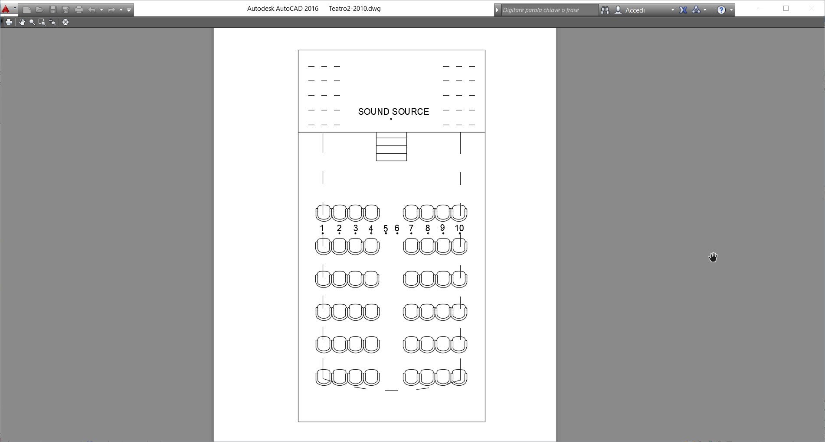

Figure 8: Plan of Theatre 1763 with the indication of Soundfield microphone positions during lateral moving.

Table 2: Results of measurements for lateral moving at 1 kHz.

|  |  |  |  |  |  |  |  |  |  |  |
| --- | --- | --- | --- | --- | --- | --- | --- | --- | --- | --- |
| **Position** | **Distance S-R (m)** | **C50** | **C80** | **D50** | **Ts** | **EDT** | **T20** | **T30** | **LF** | **IACC** |
| Position 1 | 6.41 | -1.48 | 0.87 | 41.59 | 127.8 | 1.32 | 1.21 | 1.22 | 0.201 | 0.388 |
| Position 2 | 6.04 | -2.56 | 0.67 | 35.71 | 139.1 | 1.27 | 1.15 | 1.17 | 0.212 | 0.377 |
| Position 3 | 5.76 | -1.48 | 1.29 | 41.57 | 120.7 | 1.24 | 1.23 | 1.21 | 0.251 | 0.379 |
| Position 4 | 5.58 | -1.34 | 1.10 | 42.41 | 120.2 | 1.32 | 1.18 | 1.18 | 0.246 | 0.382 |
| Position 5 | 5.48 | -1.57 | 0.61 | 41.16 | 123.7 | 1.34 | 1.24 | 1.26 | 0.213 | 0.366 |
| Position 6 | 5.51 | -1.68 | 0.52 | 40.53 | 120.1 | 1.30 | 1.23 | 1.23 | 0.227 | 0.38 |
| Position 7 | 5.59 | -1.02 | 0.86 | 44.43 | 119.7 | 1.34 | 1.21 | 1.19 | 0.156 | 0.374 |
| Position 8 | 5.78 | -1.15 | 1.28 | 43.50 | 130.0 | 1.37 | 1.19 | 1.21 | 0.216 | 0.37 |
| Position 9 | 6.05 | -2.09 | 0.33 | 38.26 | 131.5 | 1.30 | 1.24 | 1.24 | 0.191 | 0.375 |
| Position 10 | 6.45 | -1.15 | 1.14 | 43.55 | 116.3 | 1.29 | 1.24 | 1.20 | 0.207 | 0.413 |
| Average | - | -1.53 | 0.88 | 41.27 | 124.9 | 1.31 | 1.21 | 1.21 | 0.21 | 0.38 |
| Standard Dev. | - | 0.47 | 0.33 | 2.63 | 7.02 | 0.04 | 0.03 | 0.03 | 0.03 | 0.01 |



 

Figure 9: Measured values of EDT, T20, T30, TS, C50,C80, LF and IACC at 1 kHz as a function of the distance from the sound source to the SoundField microphone for lateral moving.

4.2.2 Acoustic parameters from vertical movements

Room acoustic parameters at 1 kHz derived from IR recording for vertical movements are reported in Table 3, and Figure 10 shows the results as a function of the SoundField microphone height. The values of reverberation times T30 and T20 in the vertical plane are practically stable, and values are always within the JND range. Small difference results for EDT values, all included around 1.22 s - 1.38 s and within the threshold values of the JND. For vertical moving of microphone, clarity variation was linear and calculated values remained within the range of JND (1 dB). Finally, the values of spatial parameters remain stable for all height. These results show that the intrinsic characteristics of theatre are respected in every position and confirms that the quality of the sound field is constant in almost all analysed positions. Similar to lateral moving, parameter Ts presents values slightly unstable.

Table 3: Results of measurements for vertical moving at 1kHz.

|  |  |  |  |  |  |  |  |  |  |
| --- | --- | --- | --- | --- | --- | --- | --- | --- | --- |
| **Height (cm)** | **C50** | **C80** | **D50** | **Ts** | **EDT** | **T20** | **T30** | **LF** | **IACC** |
| 140.8 | -1.14 | 1.37 | 43.48 | 119.1 | 1.22 | 1.20 | 1.21 | 0.2 | 0.401 |
| 138.6 | -1.18 | 1.51 | 43.26 | 114.4 | 1.24 | 1.20 | 1.20 | 0.211 | 0.391 |
| 136.4 | -1.17 | 1.55 | 43.35 | 112.3 | 1.28 | 1.23 | 1.21 | 0.22 | 0.397 |
| 134.2 | -1.25 | 1.58 | 42.87 | 110.5 | 1.31 | 1.24 | 1.21 | 0.224 | 0.39 |
| 132 | -1.25 | 1.51 | 42.89 | 112.0 | 1.30 | 1.25 | 1.21 | 0.225 | 0.391 |
| 129.8 | -1.25 | 1.41 | 42.86 | 111.3 | 1.28 | 1.24 | 1.21 | 0.233 | 0.401 |
| 127.6 | -1.29 | 1.25 | 42.68 | 117.4 | 1.31 | 1.21 | 1.20 | 0.219 | 0.389 |
| 125.4 | -1.42 | 1.20 | 41.96 | 121.3 | 1.33 | 1.19 | 1.20 | 0.2 | 0.387 |
| 123.2 | -1.44 | 1.19 | 41.78 | 128.8 | 1.34 | 1.19 | 1.19 | 0.203 | 0.38 |
| 121 | -1.53 | 1.07 | 41.32 | 132.3 | 1.36 | 1.18 | 1.19 | 0.185 | 0.391 |
| 118.8 | -1.28 | 1.29 | 42.70 | 128.0 | 1.38 | 1.19 | 1.19 | 0.198 | 0.393 |
| 116.6 | -1.32 | 1.07 | 42.48 | 125.6 | 1.34 | 1.18 | 1.19 | 0.191 | 0.387 |
| 114.4 | -0.96 | 1.16 | 44.48 | 120.3 | 1.33 | 1.19 | 1.19 | 0.21 | 0.381 |
| 112.2 | -0.90 | 1.05 | 44.84 | 118.3 | 1.32 | 1.19 | 1.19 | 0.216 | 0.385 |
| 110 | -0.80 | 1.03 | 45.41 | 115.9 | 1.31 | 1.19 | 1.19 | 0.227 | 0.397 |
| Average | -1.21 | 1.29 | 43.09 | 119.2 | 1.31 | 1.20 | 1.20 | 0.21 | 0.39 |
| Standard Dev. | 0.20 | 0.19 | 1.12 | 6.88 | 0.04 | 0.02 | 0.01 | 0.01 | 0.01 |

 

 

Figure 10: Measured values of EDT, T20, T30, TS, C50,C80, LF and IACC at 1 kHz as a function of the SoundField microphone height.

From the comparison between the first and the second campaign, there is an evident difference in reverberation time and lateral fraction. In particular, in the first measurement, the reverberation time was shorter and lateral fraction bigger, and this may be due to the different arrangement of furnishings (e.g. chairs) and the presence of a piano in the stalls during the second campaign. However, the acoustic parameters were slightly affected by the different arrangement of furnishings. Another difference is in IACC values probably due to the use of two different dummy heads during the two campaigns.

4.2.3 Spatial Analysis of sound energy

Mono-aural microphones cannot provide complete information about spatial sound distribution in the theatre. For this reason, a multi-microphone system is necessary to capture the complete spatial information [14]. The spatial visualization of sound energy was developed to reconstruct the three-dimensional sound distribution in the theatre. B-Format Impulse responses measured through B- format Microphone (e.g. Soundfield microphone) was used to detect the direction-of-arrival of every reflection calculating the sound intensity [15].

By taking advantage of the microphone potential, three-dimensional sound maps were obtained for source-receiver combinations. Such maps are useful to show the direction of arrival of sound reflections and their relative intensity, contributing to understanding the specific role of architectural elements interacting with sound.

Post-processing tool shows the “moving circle”, located at position (*a,e*) and with diameter proportional to the sound intensity modulus and opacity proportional to rE (energy ratio) [15].

During the second acoustic survey, 3D Impulse Responses were recorded using the SoundField microphone located in the centre of the hall and oriented towards the stage (Figure 11) to perform “spatial” measurements. From the microphone position, a series of 360-degree photographs was taken to obtain a panoramic image of the theatre. Measurement was done using digitally equalized dodecahedron as the sound source to generate Exponential Sine Sweep signal (ESS).

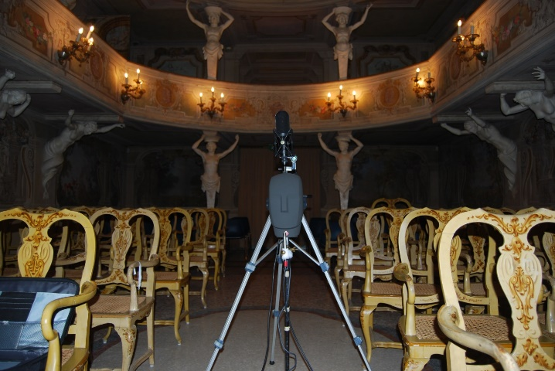 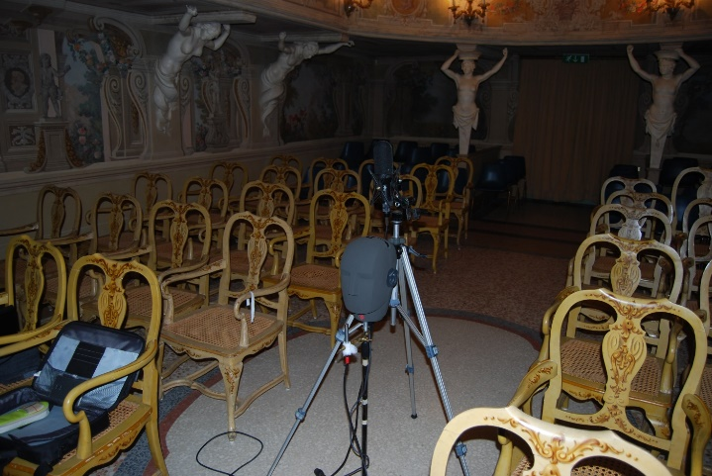

Figure 11: View of the microphone during measurement of the 3D impulse response.

Thanks to the use of a specially developed script [15, 16], B-Format signals were plotted over the panoramic image to show energy and direction of early reflections inside the theatre. The software allows displaying the instantaneous direction of the total energy flow thanks to a sphere that moves virtually following the movements of the sound signal inside the theatre.

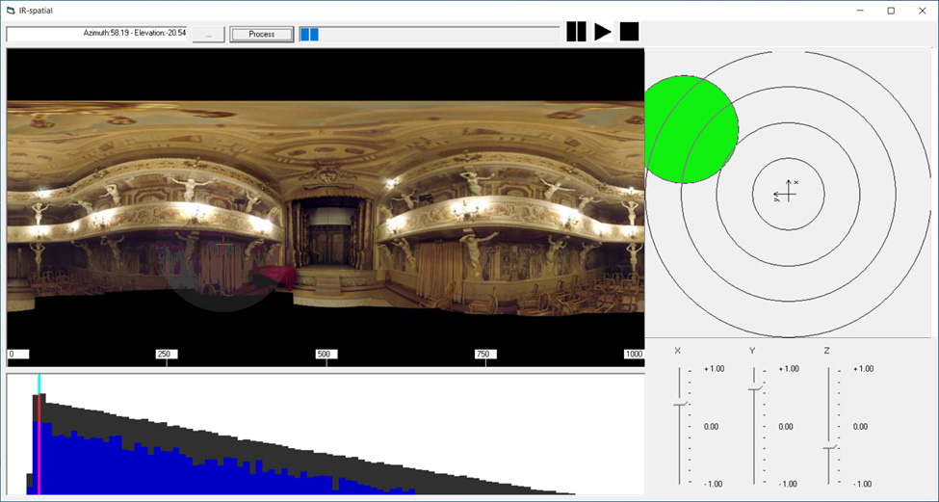

Figure 12: Directional reflection map for the receiver in the centre of the hall and sound source on the stage (the x-axis is oriented towards the stage).

An example of the usefulness of such image is given in Figure 12 which shows an early reflection arriving at receiver in the hall when the sound source was on the stage. The sound came mostly from the vertical plane and a fairly strong reflection was caused by the lateral wall on the left side.

5. Conclusion

This paper has described the acoustic behaviour of the *Teatro 1763*, a private little theatre inside historic Villa Aldrovandi Mazzacorati on the hills of Bologna (Italy).

Two measurement campaigns were carried out in different periods to obtain a complete characterisation of the theatre, studying the acoustics and sound diffusion. The first measurement session allowed to analyse the acoustic parameters in the stalls and balcony, whereas the second campaign was aimed at understanding the variation of the acoustic parameters analysing the real positions occupied by the listeners in the stalls and for different spectator heights.

The results obtained from the elaboration of IRs recorded during measurements show that the theatre is more "resonant" and brilliant when compared with other similar theatres, but at the same time, good intelligibility could be achieved without any electro-acoustic support. The reverberation time is on average greater than for other small opera houses, and intelligibility very high. Moreover, small differences resulted in the sound perception along the second seating row and as a function of sound source distance and the receiver height. Furthermore, the use of the acoustic map showed that in this case, the sound gets to the audience thanks to the lateral wall on the left side (providing an early reflection).

Finally, further acoustic investigations will be undertaken within SIPARIO project employing a new spherical microphone array to understand the precise direction of arrival of sound reflections and their relative intensity, and to understand the specific role of architectural elements that interacting with sound.

SIPARIO is a project recently funded by the Italian region Emilia Romagna with the goal of virtually reconstructing both 3D audio and 360° video of real performances by making recordings and undertaking acoustic measurements inside historical theatres and concert halls.

Acknowledgements:

The Authors wish to thank Angelo Farina for his work during the developing of the numerical code. Moreover, the Authors wish to thank Marilena Frati for her useful information about the history of the theatre. This work was partially funded by the research project n.201594LT3F which is funded by PRIN (Programmi di Ricerca Scientifica di Rilevante Interesse Nazionale) of the Italian Ministry of Education, University and Research, and the and the project “SIPARIO - Il Suono: arte Intangibile delle Performing Arts – Ricerca su teatri italiani per l’Opera POR-FESR 2014-20” n. PG/2018/632038, funded by the Regione Emilia Romagna under EU Commission.

References

1. P. Fausti, R. Pompoli, N. Prodi, Acoustics of opera houses: a cultural heritage, J.Acoust. Soc. Am. 105 (1999) 929.
2. L. Tronchin, A. Farina, The acoustics of the former teatro "La Fenice", Venice. JAES 45 (1997) 1051–1062.
3. N. Prodi, R. Pompoli, Guidelines for acoustical measurements inside historical opera houses: procedures and validation, J. Sound Vib. 232 (2000) 281–301.
4. F. Martellotta, E. Cirillo, A. Carbonari, P. Ricciardi, Guidelines for acoustical measurements in churches, Appl. Acoust. 70 (2009) 378–388.
5. L. Mazzarella, M. Cairoli, Petrarca Theatre: A case study to identify the acoustic parameters trends and their sensitivity in a horseshoe shape opera house, Appl. Acoust. 136 (2018) 61–75.
6. J.Y. Jeon, J.H. Kim, J.K. Ryu, The effects of stage absorption on reverberation times in opera house seating areas. J. Acoust. Soc. Am. 137 (3) (2015) 1099-1107.
7. N. Prodi, From Tangible to Intangible Heritage inside Italian Historical Opera Houses, Heritage. 2,(2019)826–835.
8. Architettura, Scenografia e pittura di paesaggio, catalogo critico a cura di Anna Maria Matteucci, Deanna Lenzi, Wanda Bergamini, Gian Carlo Cavalli, Renzo Grandi, Anna Ottani Cavina, Eugenio Riccomini, (Architecture, scenography and landscape painting, critical catalog edited by Anna Maria Matteucci, Deanna Lenzi, Wanda Bergamini, Gian Carlo Cavalli, Renzo Grandi, Anna Ottani Cavina, Eugenio Riccomini), Bologna, Alfa, 1980.
9. M. Forsyth, Edifici per la musica. L’architetto, il musicista, il pubblico dal Seicento a oggi, (Buildings for music. The architect, the musician, the public from the seventeenth century to the present), Bologna, Zanichelli, 1987.
10. A. Frabetti, D. Lenzi, Villa Aldrovandi Mazzacorati, Bologna, Grafis, 1987.
11. ISO 3382-1 – “Acoustics — Measurement of room acoustic parameters — Part 1: Performance spaces”, 2009.
12. A. Farina, Simultaneous measurement of impulse response and distortion with a swept-sine technique, 110th AES Convention, Paris, 18-22 February 2000.
13. I. Witew, G. Behler, M. Vorländer, About just noticeable differences for aspects of spatial impressions in concert halls, Acoustical Science and Technology. 26 (2005) 185-192.
14. A. Farina, L. Tronchin, Measurement and reproduction of spatial sound characteristics of auditoria, Acoustical Science and Technology. 26(2) (2005) 193-199.
15. A. Farina, L. Tronchin, 3D sound characterisation in theatres employing microphone arrays, Acta Acustica United with Acustica. 99(1) (2013) 118-125.
16. S. Tervo, J. Pätynen, A. Kuusinen, T. Lokki, Spatial decomposition method for room impulse responses, AES: Journal of the Audio Engineering Society, 61 (1-2), (2013) pp. 17-28.