The impact of corrosion-stress interactions on the topological features and ultimate strength of large-scale steel structures

Eko C. Ilman^{a,b,} Yikun Wangª, Julian A. Wharton^{c}, Adam J. Sobey^{a,d},
ª Maritime Engineering Group, University of Southampton, Boldrewood Innovation Campus, Highfield, Southampton SO16 7QF, UK.
^{b} Ocean Engineering Program, Institut Teknologi Bandung, Bandung 40132, Indonesia.
^{c} National Centre of Advanced Tribology at Southampton (nCATS), University of Southampton, Highfield, Southampton SO17 1BJ, UK.
^{d} Marine and Maritime Group, Data-centric Engineering Programme, The Alan Turing Institute, The British Library, London, NW1 2DB, UK.

Abstract

Aged marine structural analysis often relies on simplified corrosion modelling. Empirical or statistical methods are used to predict a uniform thickness reduction over time. Although convenient, this approach cannot incorporate the corrosion evolution or the rough surfaces in the damaged area. This is fundamentally due to the lack of representation of the underlying corrosion mechanisms in service environments. To better understand how structural response changes based on corrosion under service loads, this paper presents a series of finite element analyses which consider the coupling relationship between the surface mechanical stresses and the resulting change of corrosion rate. The coupling provide complex corrosion-stress interaction depending on the experimental datasets. The quantification of this interaction is based on in situ experimental measurements of corrosion kinetics at different stress levels. The simulations show the stress effect results in the generation of more realistic corrosion patterns on the structural surface, based on a two-bay/two-span large-scale panel model subject to uniaxial compression. In addition, the incorporation of corrosion experiments allows the modelling of corrosion evolution based on physical observations instead of empirical assumptions. The irregular surface damage leads to a change in structural buckling mode, and up to 8% reduction in ultimate strength compared to models without considering the stress effect.

Keywords: Steel, Finite element method, Grillage, Marine corrosion, Ships and offshore structures, Mechano-electrochemistry
- Requirement for mechano-electrochemical assessment
In ship structural design, corrosion is frequently simplified to make analysis easier. A uniform thickness reduction is often considered where measurements from ships are used to approximate a standard rate of reduction over time. This differs from actual corrosion damage which typically exhibits an irregular corrosion depth [1], as illustrated in Fig. 1, where a carbon steel surface typically shows the development of shallow broad pits with bench-like features, when immersed in seawater [2]. The predicted thickness reduction in the literature is mostly derived from statistical datasets collected from ship surveys or field experiments [3, 4] leading to empirical formulations [1, 5-8]. These formulae do not explicitly reflect the effects from operating conditions such as the service load or the environment. The effectiveness of this simplified approach is largely dependent on the similarity between the service conditions encountered by the structure being examined and the original dataset. To simulate more realistic corrosion, damage features are included in finite element models as a rough surface instead of a uniform thickness reduction [9-11]. However, these approaches are based on statistical/empirical assumptions and the progression of the corrosion is manually updated.

One of the key factors influencing marine corrosion is the mechanical stress experienced on the structural surface. Often termed mechano-electrochemistry, this effect was first recognised in the 1950s [12]. It describes the corrosion mechanisms, where the spatial/temporal structural loading can affect the corrosion rate and vice versa [12-15]. It is generally agreed that stress and strain will increase the surface free energy and hence the corrosion behaviour; this is regardless whether it is a compressive or tensile stress [16, 17]. However, the actual kinetics are highly sensitive to the surface filming condition, which will be affected by the stress level and direction [18]. Despite its prevalence in the corrosion literature, there are limited investigations into the interaction between mechanical stress and corrosion on a structural component, among which the main focus is on simple geometries such as flat plates [13, 19, 20]. However, previous structural analysis shows a clear indication of the importance of studying corrosion on more complex stiffened structures [21]. An initial assessment by the authors into the effect of mechanical loading on corrosion in a stiffened plate was performed under a compressive load which was equivalent to 85% of the yield strength of the material [14, 22]. The results show that the effect of mechanical stress may trigger localised buckling and a change in the failure mode [22]. This is consistent with experimental results showing that different irregular corrosion distributions provide different failure modes [23]. In addition, it was also observed that the incorporation of mechanical stimuli initiated irregular broad-shaped pits, which are similar to those seen in reality [14, 22]. However, the location of corrosion within a structure has a significant effect on its strength capacity [14]. Modelling a single stiffened plate may give pessimistic predictions of ultimate strength and post collapse behaviour when localised damage or corrosion occurs in a specific part of the structure and the stress pattern is dominated by the boundary equations, potentially giving unrealistic thickness reductions and patterns. Therefore, a large scale stiffened panel model is required to better understand the corrosion evolution and the effect on the structural responses [24].

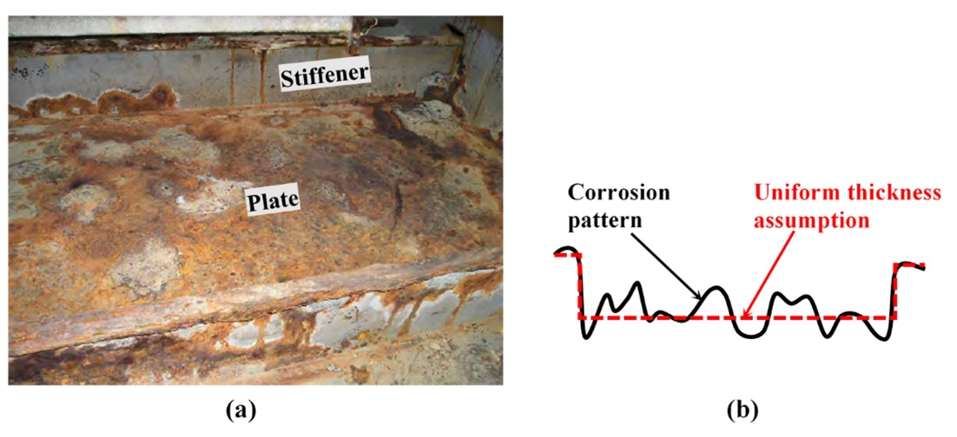
Fig. 1. Corrosion in a stiffened structure: (a) from an aged ship ballast tank [25]; (b) idealisation of the corrosion surface profile on a plate surface, typically in centimetres breadth and millimetres depth.

This paper therefore incorporates in situ mechanical-corrosion measurements into a large-scale structural panel subjected to realistic loading conditions to investigate the impact of the mechano-electrochemically induced corrosion on the structural responses. The coupling relationship between the mechanical stresses and thickness reduction due to corrosion is investigated for different initial plate thicknesses, initial imperfections and corrosion locations. This coupling is considered by using the two experimental datasets [13, 14] which provide kinetic information for stress states, but the mechanical response is modified by the thickness diminution from the FEA model. This allows the modelling of corrosion evolution based on physical corrosion measurements and enhances understanding of its effects on the ultimate strength reduction and failure mode changes.
- Modelling of stiffened panels
  - Intact stiffened panel model definition
To ensure that the boundary conditions in the area of interest are realistic, a two-bay/two-span stiffened panel model was developed, as shown in Fig. 2, with an overall plate size of 9.5 m × 17.1 m [26-28]. The dimensions were taken from a typical size a Very Large Crude Carrier (VLCC) ballast tank [29], representing the bottom panel geometry with angle bar stiffeners, with a height (h_{w}) of 300 mm, breadth (b_{f}) of 90 mm, web thickness (t_{w}) of 13 mm and flange thickness (t_{f}) of 17 mm. Two plate thickness values (t_{p}) were compared, 10 mm and 20 mm. The analysis was performed using Abaqus 2018, considering nonlinearities induced by both large deformations and material plasticity. The model was built using four-node quadrilateral shell elements with reduced integration, S4R. Eleven points of integration were used in the through-thickness direction to better capture the stress distribution through the thickness, especially when the model behaves nonlinearly. Periodic boundary conditions were used for the panel, assuming that it forms part of a continuous structure. A full description of these boundary conditions is given in Table 1, which were adapted from [28] and [30], where U is the translation and R is the rotational constraint. A quasi-static uniaxial compression was applied to the model in the longitudinal direction.

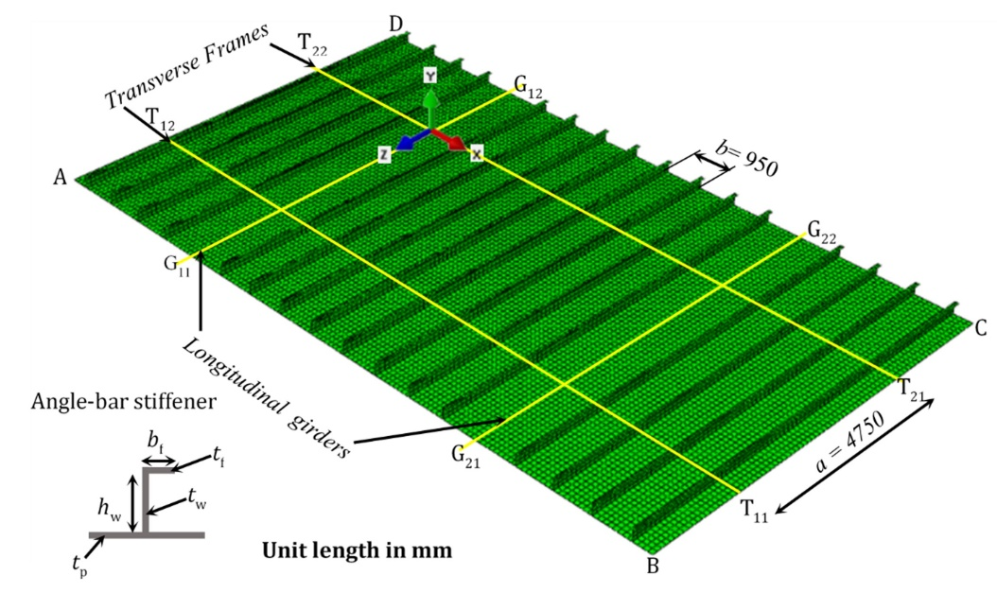
Fig. 2. The two-bay/two-span stiffened panels geometry [26-28].

A mesh convergence study was performed before considering the corrosion damage. The model’s ultimate strength became asymptotic with 19,200 elements and a corresponding mesh size of 118.75 mm in the plate, ensuring that there were three elements through the height of the stiffener web and two elements across the width of the flange; this is in line with the minimum requirements specified by Lloyd Register’s Guidance [31]. An explicit dynamic solver was used to enhance convergence [29]. The kinetic energy of the system was evaluated to ensure that the time step and loading rate were sufficiently small to give a quasi-static response. A total loading time of 10 s and loading rate of 2 mm s^{–1} were utilised, ensuring that the kinetic energy was always less than 5% of the internal energy and this setting was implemented in all case studies. The material properties were taken from Refs. [26, 28] with a yield stress, σ_{y}, of 313.6 MPa; a Young’s modulus, E, of 205.8 GPa; a Poisson’s ratio, ν, of 0.3 and zero tangent modulus. The material model used in this study is a bi-linear elastic-perfectly plastic model which is commonly used in ultimate strength assessments.

Table 1. Description of the periodic boundary conditions
Boundary (Refer to Fig. 2) | Description
AB and CD | Periodic condition with U_{x,AB} = U_{x,CD}, U_{y,AB} = U_{y,CD}, R_{x,AB} = R_{x,CD}, R_{y,AB} = R_{y,CD} = 0, R_{z,AB}=R_{z,CD} and w uniform along AB and CD, coupled with the longitudinal stiffener.
AD and BC | Periodic condition with U_{y,AD} = U_{y,BC}, U_{z,AD} = U_{z,BC}, R_{x,AD} = R_{x,BC}, R_{y,AD} = R_{y,BC}, R_{z,AD} = R_{z,BC} and U_{x} uniform along AD and BC, coupled with the plate.
G₁₁G₁₂ and G₂₁G₂₂ | U_{y} = 0, R_{x} = 0
T₁₁T₁₂ and T₂₁T₂₂ | U_{y} = 0, R_{z} = 0
Stiffener web intersection with transverse frames | U_{x} uniform with an intersection point on the plate, R_{z} = 0

Geometrical imperfections are known to have significant effects on the ultimate strength of a modelled structure and its failure mode, and are considered using the method suggested by ISSC 2012 [26] and Tanaka et al. [28]. In this study the initial imperfections were adapted from Tanaka et al. [28] which were originally based on measurements performed on a range of ships. Table 2 lists equations used to describe the imperfection shapes, where a and b are the length and width of the local plate respectively; B is the length between girders and A_{Vertical}, A_{Stiffener} and A_{Plate} are the maximum amplitudes of the initial imperfections. Specifically, A_{Vertical} = A_{Stiffener} = 0.001a, and A_{Plate} = min[0.1β² t_{p}, 6 mm] [28], where the plate slenderness ratio is $β=b/t_{p}\sqrt{σ_{y}/E}$. These amplitudes were used with the coefficient A_{i} from Tanaka et al. [28] for a plate aspect ratio of five to generate the so-called hungry-horse mode initial imperfection, in the positive y-direction in the model. The stiffener web height h_{s} = t_{p}/2 + h_{w} was measured from the mid-thickness plane of the plate. In addition, two global initial imperfections (M1 and M2, as shown in Table 2 and Fig. 3) which are symmetric about XY were assessed, which resulted in the top surface of the panel centre being in compression for M1 and tension for M2. This is to investigate the effect of different loading scenarios on the thickness reduction. By locating the corrosion area in the centre, M1 will result in a globally compressed corrosion area whereas M2 will lead to a globally tensile corrosion area.

Table 2. Initial imperfections adapted from Tanaka et al. [28]
Initial imperfection | Expression
Global initial imperfection / mm  - Type M1  - Type M2  Stiffener sideways initial / mm  Plate initial imperfection / mm | $$y={-A}_{Vertical}sin⁡(πz/a)sin⁡(πx/B)$$  $$y=A_{Vertical}sin⁡(πz/a)sin⁡(πx/B)$$  $$x={-A}_{Stiffener}(y/h_{s})sin⁡(πz/a)$$  $$y=\left|A_{Plate}∑_{i=1}^{11}A_{i}sin⁡(iπz/a)sin⁡(πx/b)\right|$$

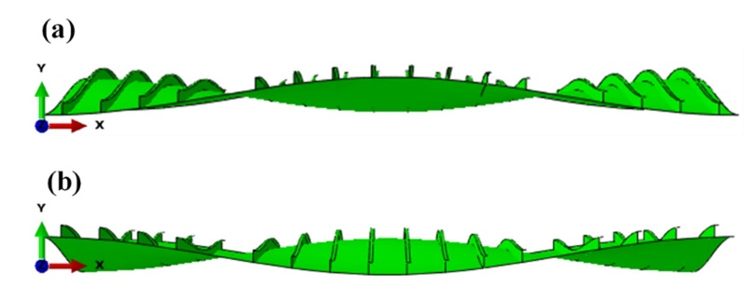
Fig. 3. Global initial imperfections applied to the stiffened panels (9.5 m × 11.7 m): (a) M1; (b) M2. (Deformation × 50)
  - Structural model verification
The structural model was verified against the ISSC 2012 benchmark study [26] and Tanaka’s model [28]. Comparison of the ultimate strength was made for the slenderness ratio, β, ranging between 1.0 and 3.5 in increments of 0.5, as shown in Fig. 4. Across the six slenderness ratios, the differences in ultimate compressive strength ranges are between 1.2% and 7.4% when compared to the ISSC benchmark results [26]. The difference is between 0.6% and 5.5% when compared to the Tanaka model [28]. The differences between the model and those of the ISSC and Tanaka’s analysis are therefore small and considered to be primarily associated with different finite element packages, solvers, number of integration points through-thickness and the mesh size.
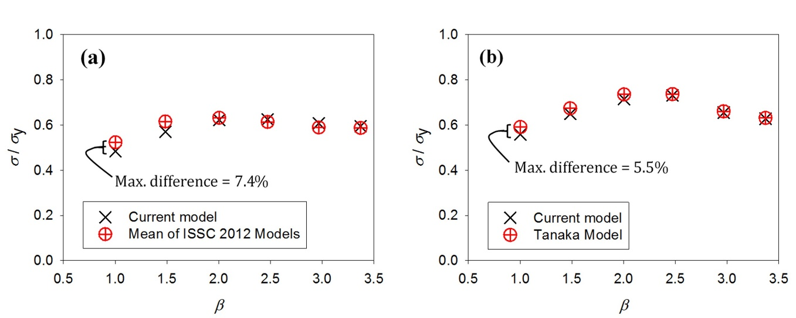
Fig. 4. Verification of the intact stiffened panel model, comparing ultimate strength values (σ/σ_{y}) for various plate slenderness ratios (β) with an angle bar stiffener (h_{w} = 235 mm, b_{f} = 90 mm, t_{w} = 10 mm, and t_{f} = 15 mm): (a) mean value of ISSC 2012 benchmark models [26]; and (b) Tanaka model [28].
  - Load definition
The typical service load condition of a VLCC was considered to realistically assess the stress influence on corrosion. For these double-hull tankers the main loads in the bottom stiffened panels are from still water bending moments and wave-induced bending moments. This study considers the hogging condition, where the bottom panel is subjected to compressive load. Hogging condition is well-known become a concern when performing strength assessment of ship bottom panels as this condition produce compressive loads. The still-water bending moment is defined in Teixeira et al. [32] with a partial safety factor of 0.9 [33] for a VLCC, while the wave-induced bending moment is calculated for a ballast case according to IACS Common Structural Rules (CSR) [3]. Prediction of the combined vertical bending stress with a probability level 1 was carried out as a representation of the average service load during operational conditions. This value was estimated by linear interpolation from a calculated load probability between 10^{–2} and 10^{–8} [3] for long-term prediction [34]. This resulted in a compressive service load of 58 MPa. The load was then applied statically on the stiffened panels, from which the von Mises stresses were extracted from the structural surface for corrosion analysis.
  - Corroded stiffened panels
A corrosion area was defined assuming coating breakdown and loss within this region. A finer mesh of 30 mm (length of an element) was used for this area, with an example shown in Fig. 5. A mesh convergence study was performed considering the change in both the surface von Mises stress and corrosion evolution. A 30 mm mesh size was then selected based on this convergence study, while also considering that the corrosion features observed in reality are in the order of tens of centimetres and that this mesh size was small enough to capture these features. The finer mesh size in the corroded area was created by introducing a mesh transition until the mesh size was a quarter of the coarse mesh in the intact area. This provided a smooth transition as advised in the CSR [3].

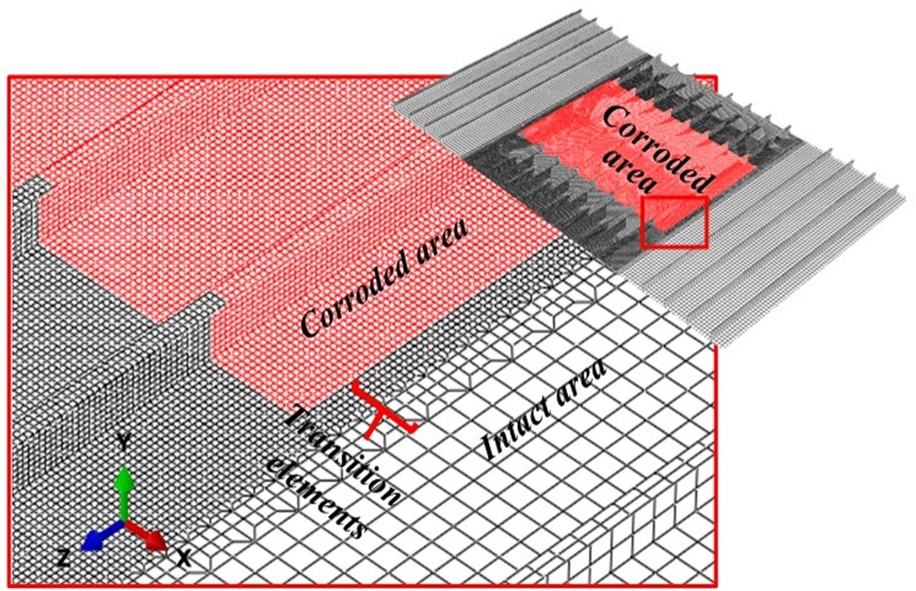
Fig. 5. Mesh refinement for the corroded area, representing corrosion covering the entire middle section of the stiffened panels.

The stress-free corrosion rate was predicted using a nonlinear time-dependent model via a Weibull function [13],

$f\left(T\right)=d_{∞}(/{η)}({T/η)}^{\left(-1\right)}exp⁡[-\left({T/η)}^{}\right],$ (1)

where $f\left(T\right)$is the corrosion rate in mm y^{–1}, $d_{∞}$ is the long-term corrosion wastage, 2.6 mm, = 1.075 and $η$ = 12 [13]. The time-dependent corrosion rate model was derived from a long term electrochemical measurement of a Q235B steel coupon immersed in aerated simulated seawater, 3.5% sodium chloride [13]. This is based on the assumption that the alloying/grade has little effect on the corrosion behaviour of carbon steels in seawater. Carbon steels of different grades have corrosion rates in the same order of magnitude and the corrosion rate will be primarily dependent on the environmental conditions, such as the dissolved oxygen, the ambient temperature and the immersion time [35]. The effect of mechanical stress was represented as a correction factor of the time-dependent model [36]. This stress-influenced corrosion was determined based on corrosion data of the same steel under elastic tensile stress in the same electrolyte [13]. The corrosion rate was normalised by dividing it by the corrosion rate taken from the stress-free condition [22]. This results in the dimensionless function,

$g\left(σ\right)= p σ +1$, (2)

where $g\left(σ\right)$ is the dimensionless stress factor, $p$ is a coefficient in MPa^{–1} and σ is the von Mises stress from the element surface, in MPa. Within the model the equivalent stress concept is used as a scalar to represent a uniaxial stress state by determining a constant, the unit distortion strain energy. This approach is commonly used when assessing the mechano-electrochemical effect in FE applications [19, 37, 38]. Eqn. 2 implies that higher stresses will increase the stress factor and hence the corrosion rate. However, for different corrosion conditions, for example in an electrolyte with a lower pH and a higher concentration of sodium chloride, the corrosion rate is shown to have a nonlinear relationship with the stress level [18].

To assess how the location of corrosion affects the structural capacity, two corrosion simulations were considered, one with the corrosion at the centre of the panel (P1) and one with corrosion located in two-patches of the same size (P2), as shown in Fig. 6. In addition, corrosion was assumed to occur only on one side of each panel, including the plate, stiffener web and flange, which are shown as the red region in Fig. 5. This was achieved by offsetting the bottom surface of each shell element as a reference surface to keep the bottom surface flat when the shell thickness changed. This method has been validated against full-field experiments performed by the authors [37, 39].

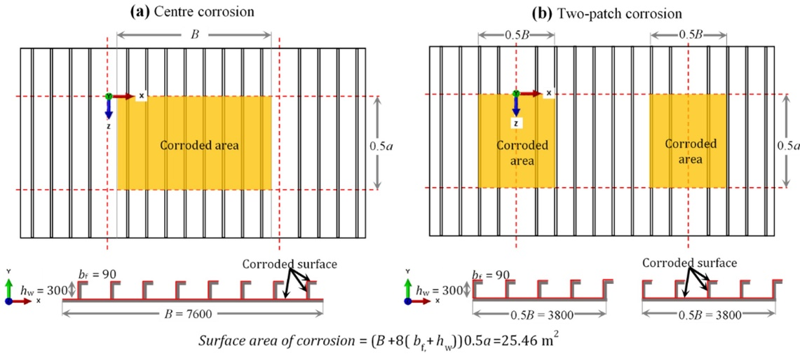
Fig. 6. Schematic of the corrosion location on the studied stiffened panel: (a) corrosion in the centre (P1); (b) two locations of corrosion (P2). Both scenarios have an identical corroded surface area (unit length in mm).

The corrosion model was applied with and without the stress factor $g\left(σ\right)$ for each element in the corroded area, the resulting 12 case study matrix is defined in Table 3. Initially, the structure was assumed to be intact and a compressive service load of 58 MPa was applied, from which the surface von Mises stresses were extracted and used to update the stress factor and the corrosion rate. The individual element thicknesses were adjusted for each year, followed by updating the stress field under the service load. This process was performed in one-year increments for a total of 20 years. An ultimate strength analysis was performed at the end of each year to determine the performance of the panel.

Table 3. Stiffened panel model test matrix (12 case studies)
Case | Plate thickness, t_{p} / mm | Resulting surface load from initial imperfection | Corrosion location | Stress factor | ID | Failure mode (see note)
 |  |  |  |  |  | Intact | Corroded
1 | 20 | Compression (M1) | Centre (P1) | Yes (S) | T20M1P1S | A | B
2 |  |  |  | No (N) | T20M1P1N | A | B
3 | 10 | Compression (M1) | Centre (P1) | Yes (S) | T10M1P1S | C | C
4 |  |  |  | No (N) | T10M1P1N | C | C
5 | 20 | Tension  (M2) | Centre (P1) | Yes (S) | T20M2P1S | A | B
6 |  |  |  | No (N) | T20M2P1N | A | B
7 | 10 | Tension  (M2) | Centre (P1) | Yes (S) | T10M2P1S | C | C
8 |  |  |  | No (N) | T10M2P1N | C | C
9 | 20 | Compression (M1) | Two-patch (P2) | Yes (S) | T20M1P2S | A | B
10 |  |  |  | No (N) | T20M1P2N | A | B
11 | 10 | Compression (M1) | Two-patch (P2) | Yes (S) | T10M1P2S | C | C
12 |  |  |  | No (N) | T10M1P2N | C | C
Note: A: Overall panel failure mode; B: Overall panel failure mode with stiffener tripping; C: Local plate failure between stiffener.

- Effect of the stress on the thickness reduction and ultimate strength
  - Determination of thickness reduction in the corroded areas
Fig. 7 shows the corrosion thickness reduction scenario for the central location (P1), with M1 initial imperfection resulting in compression loading, and for two plate thicknesses, t_{p}, of 10 mm and 20 mm. The whisker lines above and below the box plot are the 10th and 90th percentiles and the scatter plot beyond the whiskers are the extreme value outliers which represent significant localised thickness reductions. Assuming no repair takes place during the service life, the worst-case scenario, the stress-free corrosion model leads to a thickness reduction of just under 2 mm at Year 20, as seen in Fig. 7(a). However, when the stress effect is considered, the thickness reduction is greater with higher variation from 1 mm in Year 5 to 2.4 mm in Year 20. Fig. 7(b) shows the difference in thickness reduction between the cases with and without the stress factor, which varies nonlinearly with time and reaches a maximum of 0.3 mm after 20 years. When reducing the initial plate thickness to 10 mm (Fig. 7(c-d)) and considering the influences of stress on corrosion, the average thickness reduction is similar to the 20 mm plate. However, the difference in the range of thickness reductions is doubled, from 0.1 mm to 0.2 mm, from the model with 10 mm thick plate to the 20 mm one(Fig. 7(d)). The results indicate that the surface topography is relatively flat during the first five years; however, a more significant degradation appears with the development of irregular surface, as might be expected for actual corrosion degradation.

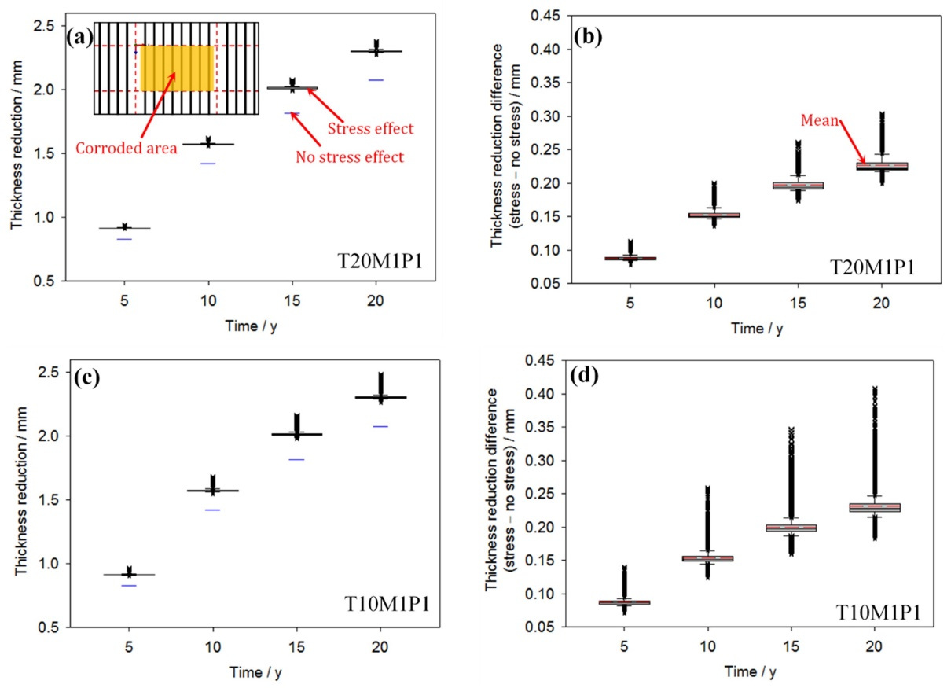
Fig. 7. Thickness reduction for the central corrosion location with and without the stress factor: (a) thickness reduction, t_{p} = 20 mm; (b) thickness reduction difference, t_{p} = 20 mm; (c) thickness reduction, t_{p} = 10 mm; (d) thickness reduction difference, t_{p} = 10 mm.

Fig. 8 provides representative data (t_{p} = 20 mm, Year 15) to better understand the effect of the two corrosion locations (P1 and P2) and global imperfections (M1 and M2) on the thickness reduction. For the three cases, T20M1P1S, T20M1P2S and T20M2P1S, the mean thickness reduction is approximately 2 mm at Year 15. This is a similar annual thickness reduction to Fig. 7, showing that the initial imperfection M2 resulted in a minimal difference in thickness reduction. In addition, the corrosion location (P1 or P2) has a negligible effect on the thickness reduction when considering the stress effect.

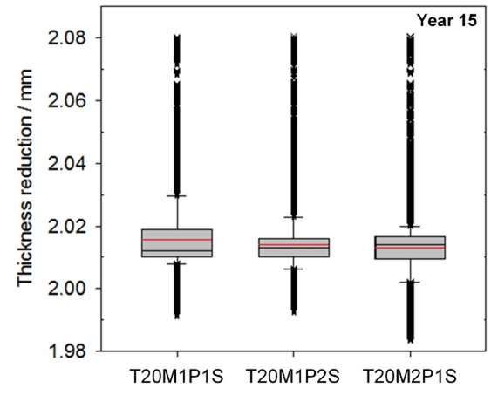
Fig. 8. Thickness reduction distribution of stiffened panels for t_{p} = 20 mm at Year 15.

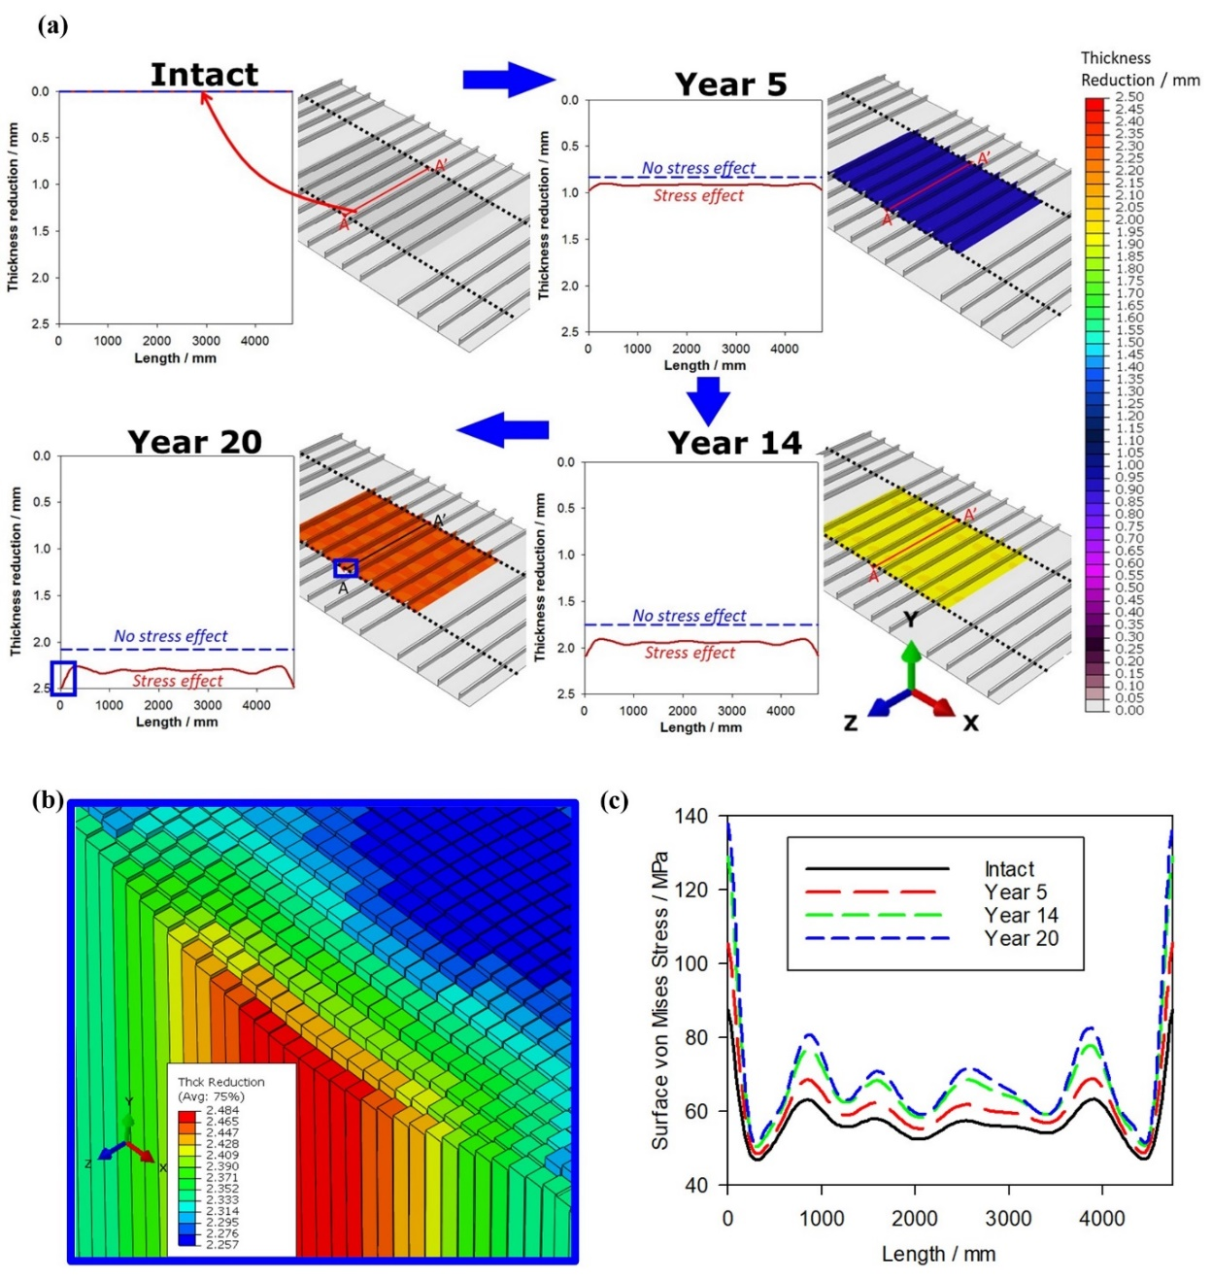
Fig. 9. Evolution of the corrosion and the corresponding surface von Mises stresses at path A-A’ for panel with corrosion located at the centre, the M1 imperfection and t_{p} = 10 mm (T10M1P1N and T10M1P1S): (a) a comparison of the evolution of the thickness reduction for the panel with and without stress effect, where the dotted black lines show panels boundaries with transverse frames; (b) the shell-elements (with rendering thickness) at the top surface of the plate with stress included at the location indicated by the small blue box for Year 20 in Fig. 9(a), (shell thickness × 500); (c) the corresponding evolution of the surface von Mises stresses.

  - Corrosion evolution with time
Fig. 9(a) presents the corrosion evolution over 20 years for the central corrosion scenario and a 10 mm initial plate thickness (T10M1P1N and T10M1P1S). It is evident that an irregular surface is obtained on the panels when the influence of stress is considered for the corrosion process. The irregularity increases with increasing time from Year 5 to Year 20, with the remaining thickness ranging from 7.52 mm to 7.75 mm after 20 years in service. Fig. 9(b) shows a rendered shell element at the top surface of the plate with corrosion affected by the stress for the location indicated using a blue box at Year 20 in Fig. 9(a). The surface von Mises stress distribution in the longitudinal direction along path A-A’ is shown in Fig. 9(c) with stress ranging between 45 to 140 MPa. Stresses increase with time and have a consistent interaction with the thickness reduction in Fig. 9(a). This study considers the stress concentration affected by the inhomogeneity of the corrosion surface due to the stress-corrosion coupling. Fig. 9(c), at path A-A’, shows that the stress concentration peaks significantly increase through the simulation as a result of the undulated corrosion surface evolution shown in Fig. 9(a) and Fig. 9(b).

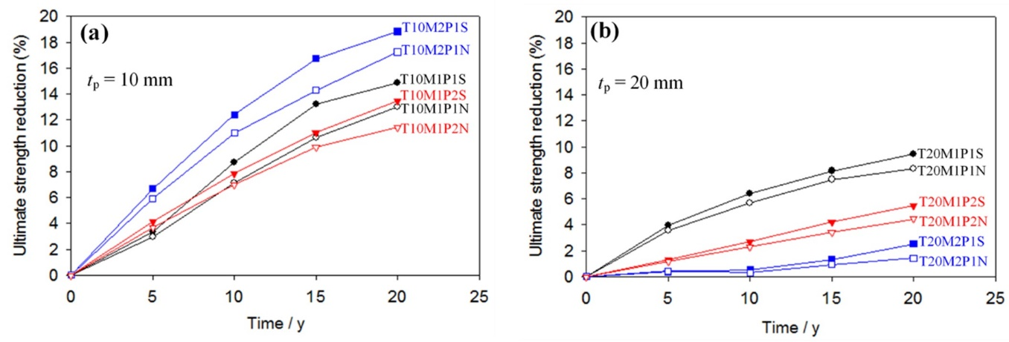
Fig. 10. Ultimate strength reduction of stiffened panels for the 12 case studies at year 5, 10, 15 and 20 with and without stress-influenced corrosion: (a) 10 mm initial plate thickness; (b) 20 mm initial plate thickness. The intact plate condition is at 0 years.

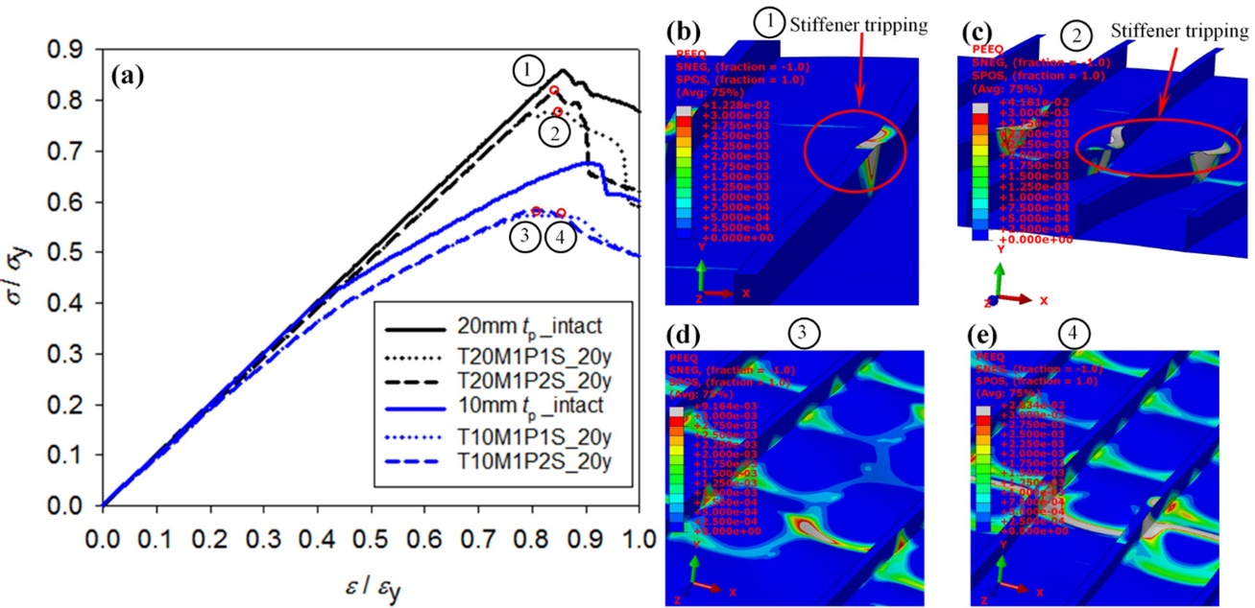
Fig. 11. Load-shortening curves and associated surface equivalent plastic strain at ultimate strength stage with deformation plots, for the intact condition and with corrosion at Year 20 and M1 global imperfection (Deformation × 5) : (a) load shortening curves; (b) surface equivalent plastic strain and stiffener tripping deformation for two-patch corrosion (P2) and t_{p} = 20 mm (T20M1P2S); (c) surface equivalent plastic strain and stiffener tripping deformation for central corrosion (P1) and t_{p} = 20 mm (T20M1P1S); (d) surface equivalent plastic strain and plate failure for two-patch corrosion (P2) and t_{p} = 10 mm (T10M1P2S), (e) surface equivalent plastic strain and plate failure for central corrosion (P1) and t_{p} = 10 mm (T10M1P1S).

  - Ultimate strength reduction
The ultimate strength reduction is compared with the intact condition at five-year intervals, as seen in Fig. 10. The effect of stress-induced corrosion influences the ultimate strength, especially for the panel with the thinner plate, t_{p} = 10 mm (Fig. 10(a)). Corrosion without the stress effect produces a lower ultimate strength reduction, between 1% and 3%, compared to the corrosion model with the stress effect. The maximum strength reduction of 19% is achieved at Year 20 for the M2 imperfection and the central corrosion case (T10M2P1S). For the two-patch corroded area (P2) the reduction in the ultimate strength is generally smaller than the P1 condition, assuming other parameters are the same. This effect is more prominent for the panel thickness of 20 mm and is demonstrated through a change in load-shortening curves and the failure modes at Year 20, shown in Fig. 11. The failure modes for all studied cases are summarised in Table 3. For thicker plate, t_{p} = 20 mm, the failure mode for the intact condition is an overall stiffened panel failure mode which is caused by the high stress concentrations on the stiffeners, represented with the letter A in Table 3. When corrosion occurs stiffener tripping is then induced, represented with the letter B in Table 3. For the stress affected corrosion, both corrosion locations P1 and P2 experience stiffener tripping, as indicated at Points 1 and 2 in Fig. 11. However, the tripping deformation is more extensive for the central corrosion case (P1), and hence a lower ultimate strength is obtained. However, the panels with a uniform thickness reduction exhibited less significant stiffener tripping, in particular at Year 15 for corrosion location P1 and at Year 20 for corrosion location P2 as indicated in Fig. 10(a). In comparison, for the thinner plate, t_{p} = 10 mm, the failure mode is local plate failure between the stiffeners for both the intact and the corroded condition, represented with the letter C in Table 3. The initial yielding starts from plates below the longitudinal stiffener. When the corrosion is affected by the stress, the corrosion location, P1 and P2, has little effect on the ultimate strength reduction, shown by the similar locations of points 3 and 4 in Fig. 11, where both conditions result in plate buckling centered in corrosion locations as the primary failure mode. The plates with a uniform reduction exhibited less localised failure at the corrosion locations compared to the cases where stress affected the corrosion, as indicated in Fig. 10(b).
- The importance of representative corrosion data
The results above are based on corrosion data reported by Yang et al. [13] for a Q235B steel immersed in an oxygen saturated 3.5% sodium chloride test solution and a tensile stress up to 160 MPa, with the yield strength documented as 336 MPa. Electrochemical measurements were conducted after a 12 h immersion. Fig. 12 compares this dataset to an alternative study that used a high strength carbon steel, UNS G10210, and a naturally aerated 3.5% sodium chloride solution and a tensile stress up to yield point, with a yield strength documented as 340 MPa [14]. Both test conditions have used a simplified test solution to simulate the seawater ballast tank environment. The main differences between the two studies are dissolved oxygen levels, steel strength and the initial immersion time where the corrosion potential was recorded. The study by Wang et al. [14] initiated tests after a much shorter immersion of 30 mins. A clear difference in the calculated stress factor can be observed based on the two datasets, with higher corrosion rates obtained for shorter immersion times (red-dashed line in Fig. 12). Yang et al.’s stress factor increases linearly with applied stress up to a maximum of 160 MPa, while Wang et al.’s stress factor initially increases up to 130 MPa and then linearly decreases as the applied stress level is further increased. The decrease in the stress factor is due to a decrease in corrosion current density, most likely affected by the combined interaction of the activated metal surface and film formation which limits the anodic dissolution. This interaction leads to a more complex behaviour at higher stress levels. This indicates that the stress effect is sensitive to the test conditions even if the type of steel and electrolyte are nominally similar.

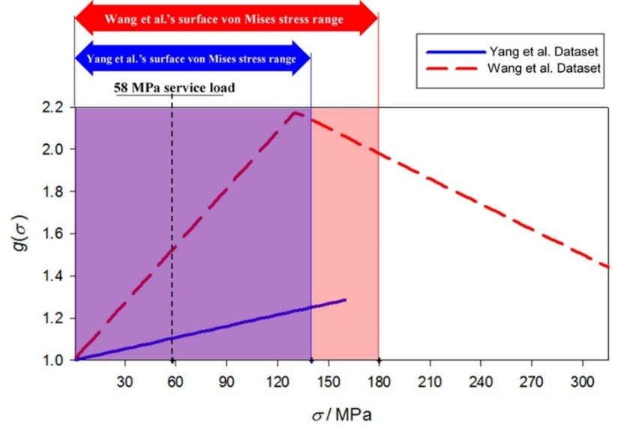
Fig. 12. Comparison of the calculated stress factor g(σ) obtained from Yang et al. [13] and Wang et al. [14] datasets.

To investigate the stress factor effect on the corrosion and structural behaviour, the T10M2P1S panel is selected since it demonstrates the most significant reduction in ultimate strength for the studies discussed in Section 3. Under the 58 MPa service load, a greater variation in the surface von Mises stress is obtained using Wang et al.’s corrosion data [14] , 12 MPa to 180 MPa, compared to Yang et al.’s corrosion condition, 40 MPa to 140 MPa, shown in the box plots in Fig. 13(a). In addition, the maximum stress concentration is more severe when using the corrosion data from Wang et al. [14], with a value of 180 MPa, which is 30% higher than for the stress factor based on Yang et al.’s measurements [13]; this is despite the mean stress values remaining similar in both cases. The higher maximum stresses are primarily attributed to a larger difference in remaining thickness distributions in corrosion location using Wang et al.’s corrosion dataset, the dashed line in Fig. 12. This difference in stress factors results in a bigger difference in thickness reductions, as shown in Fig 13(b), where the higher stress factor increases the mean and the maximum values of the thickness reduction. Using Wang et al.’s corrosion dataset results in a marked decrease in the panel ultimate strength which is 11% at Year 5 and increases to 23% at Year 20, or approximately 8% compared to the stress-free corrosion case at Year 20 (Fig. 14). In comparison, corrosion modelled using Yang et al.’s dataset [13] leads to an 18% decrease after 20 years in service, which is similar to the models without stress-influenced corrosion (Fig. 14).

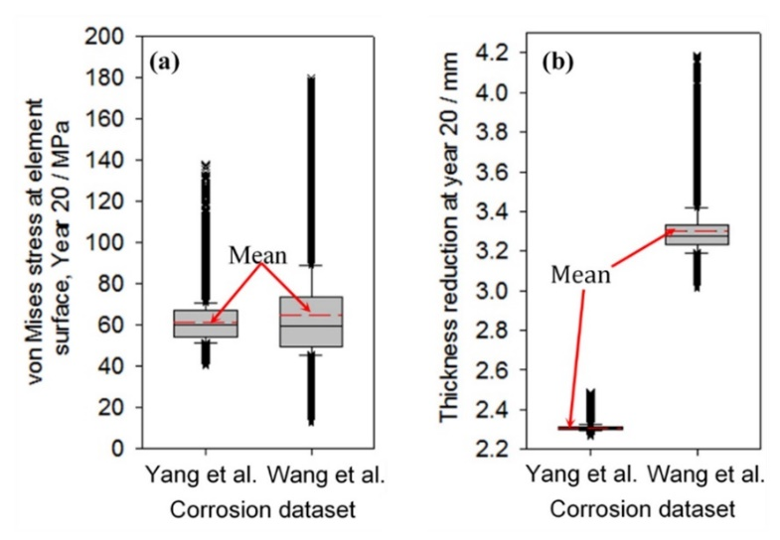
Fig. 13. Comparison of stress and thickness reduction for stress factors based on Yang et al. [13] and Wang et al. [14], M2 imperfection and t_{p} = 10 mm, at Year 20; (a) surface von Mises stresses at a 58 MPa service load and (b) thickness reductions.
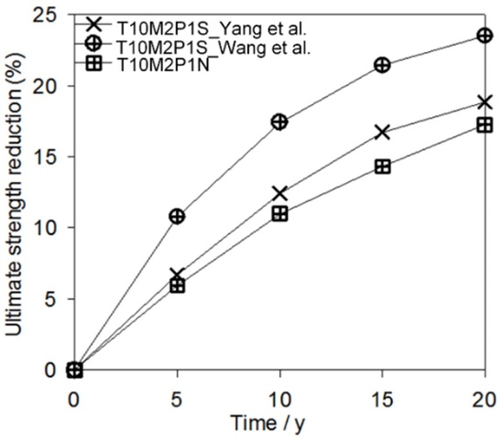
Fig. 14. Ultimate strength reduction for Yang et al. [13] and Wang et al. [14] with stress-influenced corrosion and without stress-influenced corrosion.

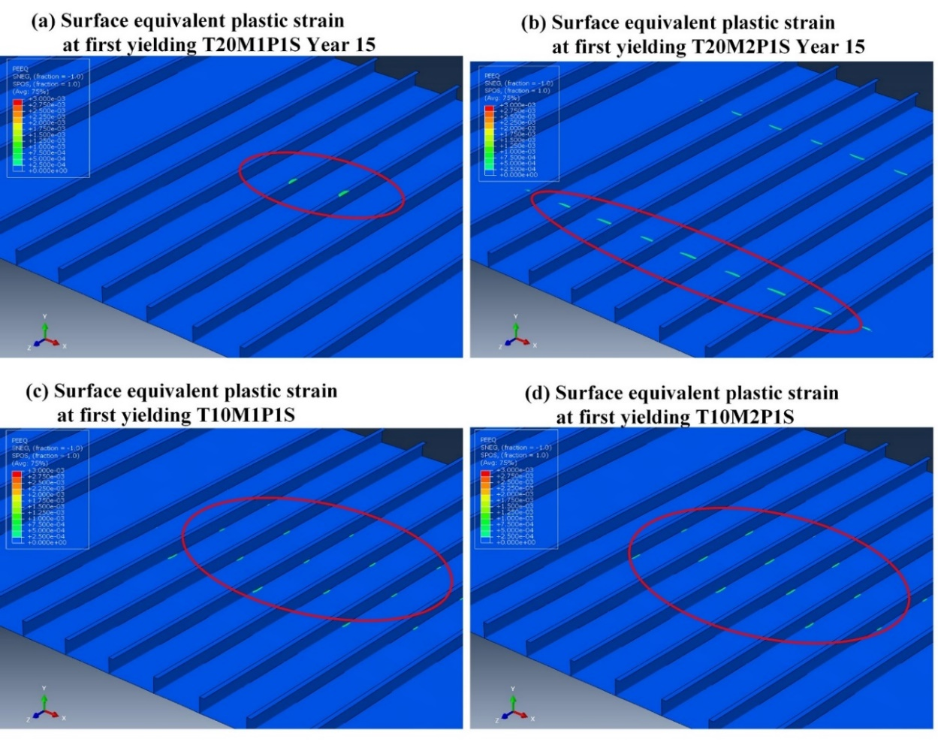
Fig. 15. Comparison in the equivalent plastic strain at first yielding of central corrosion (P1), t_{p} = 10 mm and 20 mm, M1 and M2 initial imperfection; (Deformation × 10).
- Discussion
This study demonstrates that the introduction of a stress factor to the corrosion model creates a non-uniform thickness reduction at the structural surface. With increasing time, the thickness variation in the corrosion zone increases, due to the interaction between the irregular surface and changes in the stress field subject to the service load. This highlights the importance of using corrosion evolution modelling based on the fundamental corrosion process. The irregular corrosion surface features have a detrimental effect on the ultimate strength for panels with the thinner plate thickness, t_{p} = 10 mm. This behaviour is due to the higher thickness variation obtained in the corroded area, which consequently induces higher stress concentrations. A previous comparison to experiments shows that shell models can predict stress concentrations with a reasonable level of accuracy [20]. Instead of using a solid model, which would be computationally expensive at this scale of structure, several measures have been considered, including: using appropriate boundary conditions by modelling the corroded area far from the boundary, using S4R shell elements which have hourglass control, assigning 11 integration points through the thickness and using finer meshes at the corrosion location.

The stress-induced corrosion effect is different for the two global imperfections, M1 or M2, which result in compressive loads or tension loads in the surface of the corroded area. When the central corrosion area of the panel is in compression, M1, the thickness reduction is primarily located on the stiffener flanges in the compression zone, whereas for the M2 global imperfection, the thickness reduction occurs mainly on the plating between the stiffeners. As shown in Fig. 15(a) and (b), for the 20 mm panels, the M1 imperfection led to stiffener-induced failure and lower ultimate strength. In comparison, the M2 imperfection resulted in a plate-induced failure mode and a lower ultimate strength reduction. For 10 mm panels, the failure mode for both M1 and M2 is plate-induced failure, shown in Fig. 15(c) and (d). Greater ultimate strength loss is related to the case where the thickness reduction is concentrated on the plating (M2).

The corrosion location, P1 or P2, has a greater effect on the ultimate strength of the 20 mm panel compared to the 10 mm panel, as shown in Fig. 10. For thicker panels, t_{p} = 20 mm, the ultimate strength reduction for the central corrosion (P1) almost doubled in comparison to the case with two-patches of corrosion (P2). This behaviour is affected by stiffener tripping behaviour, as illustrated in Fig. 11, where the number of the deformed stiffeners is directly related to the ultimate strength level of the panel. For thinner panels, t_{p} = 10 mm, the effect of corrosion location, P1 or P2, is less significant. This behaviour is caused by earlier plate failure with a yield area that spreads across the plate and stiffeners until the ultimate strength is reached.

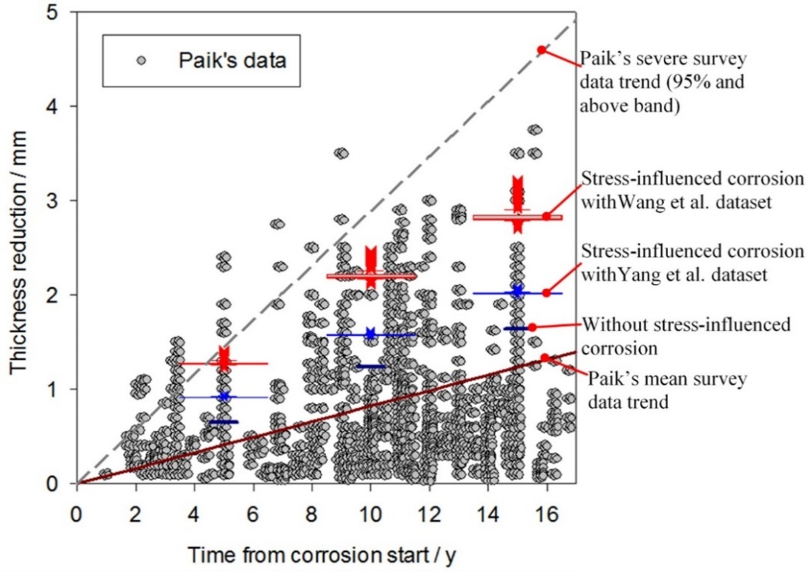
Fig. 16. Comparison of the calculated thickness reductions and seawater ballast tanks survey data of various oil tankers and bulk carriers with different conditions taken with image digitising from Paik et al. [1]; with the stress-influenced corrosion in red and without stress-influenced corrosion in blue; time zero is the time when the corrosion starts.

Comparisons of thickness reduction can also be made with ship inspection data from Paik et al. [1], as shown in Fig. 16. This confirms that the results lie in a reasonable range and give potentially realistic thickness reduction predictions under these conditions. The inspection dataset consists of 1937 measurements from bottom and side plates within oil tanker and bulk carrier seawater ballast tanks, which would have been exposed to a broad range of temperature, pollutant and coating conditions from more than a hundred ships [1, 40]. The data from repaired structural members were not included in this dataset [1]. The corrosion rate used in the current study lies above the mean values of the inspection dataset. However, the results are within the 95% confidence level and follow the same trend as time increases. This indicates that the severe corrosion damage from the inspection data could be due to stress raisers or concentrations. Nonetheless, this needs to be confirmed by accurate information of the stress distribution, temperature profile and coating conditions, which are rarely available in large quantities in the public literature. In addition, it demonstrates the requirement for further experiments and modelling in this area to ensure that the link between the mechanical stresses and thickness reduction is accurate.
- Conclusions
Currently, corrosion modelling is often simplified in structural analysis to allow for rapid design. However, this necessitates that these models do not incorporate a true mechano-electrochemical response, where the stress in the structural component affects the corrosion rate and vice versa. The corrosion-stress coupling provide complex interaction for both mechanical response and thickness reduction depending on the experimental datasets [13, 14]. This investigation provides a range of case studies using a more realistic representation of the corrosion development over time, to determine the effect of corrosion-stress interactions on the strength capacity of marine structures. A typical size two-bay/two-span stiffened panels (9.5 m × 11.7 m) of a ship ballast tank bottom panel is selected and modelled incorporating the interaction between mechanical stresses and the thickness reduction, which is compared to a traditional uniform thickness reduction. This results in the following findings:

- when the stress-effect is included there is a distinct change in the corrosion pattern, which has a more realistic form seen in service;
- appropriate incorporation of the electrochemical data enables the modelling of corrosion evolution within the structural analysis based on real physical observations;
- variation in stress concentrations leads to an irregular corroded surface that alters the structural failure mode;
- up to 23% loss in ultimate strength, or 8% compared to the assumption of a uniform thickness reduction, is obtained at the end of service life, representing the worst-case scenario. This value is highly dependent on the corrosion data used in the model and requires further investigation.

There are areas of improvement including the incorporation of a more accurate corrosion model through calibration either with intensive small scale stress-corrosion lab test or costly large scale stress-corrosion experiments, using solid element in structural FEA models, and direct comparisons with field observations. These will be explored in the authors’ future work.

Acknowledgements
The authors gratefully acknowledge the Indonesia Endowment Fund for Education (LPDP) and the Lloyd’s Register Foundation for the sponsorship of this research.
References
[1] J.K. Paik, A.K. Thayamballi, Y.I. Park, J.S. Hwang, A time-dependent corrosion wastage model for seawater ballast tank structures of ships, Corros. Sci. 46(2) (2004) 471-486.
[2] R. Jeffrey, R.E. Melchers, The changing topography of corroding mild steel surfaces in seawater, Corros. Sci. 49(5) (2007) 2270-2288.
[3] IACS, Common structural rules for bulk carriers and oil tankers, International Association of Classification Societies, 2019.
[4] IACS, Technical background on corrosion addition, International Association of Classification Societies, 2004.
[5] J.K. Paik, D.K. Kim, Advanced method for the development of an empirical model to predict time-dependent corrosion wastage, Corros. Sci. 63 (2012) 51-58.
[6] C. Guedes Soares, Y. Garbatov, Reliability of maintained ship hulls subjected to corrosion and fatigue under combined loading, J. Constr. Steel Res. 52(1) (1999) 93-115.
[7] N. Yamamoto, K. Ikegami, A study on the degradation of coating and corrosion of ship's hull based on the probabilistic approach, J. Offshore Mech. Arct. Eng. 120(3) (1998) 121-128.
[8] R.E. Melchers, Corrosion uncertainty modelling for steel structures, J. Constr. Steel Res. 52(1) (1999) 3-19.
[9] M. Reza Khedmati, Z.H.M.E. Nouri, Analytical simulation of nonlinear elastic–plastic average stress–average strain relationships for un-corroded/both-sides randomly corroded steel plates under uniaxial compression, Thin-Walled Struct 86 (2015) 132-141.
[10] J.E. Silva, Y. Garbatov, C. Guedes Soares, Ultimate strength assessment of rectangular steel plates subjected to a random localised corrosion degradation, Eng. Struct. 52 (2013) 295-305.
[11] M.R. Manco, M.A. Vaz, J.C.R. Cyrino, N.M. Ramos, D.A. Liang, Experimental and numerical study of uniaxially compressed stiffened plates with different plating thickness, Thin-Walled Struct 145 (2019) 106422.
[12] J.J. Harwood, The influence of stress on corrosion (part 1 of two parts), Corrosion 6(8) (1950) 249-259.
[13] H.-Q. Yang, Q. Zhang, S.-S. Tu, Y. Wang, Y.-M. Li, Y. Huang, A study on time-variant corrosion model for immersed steel plate elements considering the effect of mechanical stress, Ocean Eng. 125 (2016) 134-146.
[14] Y. Wang, E.C. Ilman, N. Sohan Roy, A.J. Sobey, J.A. Wharton, R.A. Shenoi, Implementation of in situ corrosion measurements in structural analysis, 7th Int. Conf. on Mar. Struct., Dubrovnik, Croatia, 2019.
[15] J. Sun, Y.F. Cheng, Modelling of mechano-electrochemical interaction of multiple longitudinally aligned corrosion defects on oil/gas pipelines, Eng. Struct. 190 (2019) 9-19.
[16] E.M. Gutman, Mechanochemistry of solid surfaces, World Scientific, 1994.
[17] S. Zhang, X. Pang, Y. Wang, K. Gao, Corrosion behavior of steel with different microstructures under various elastic loading conditions, Corros. Sci. 75 (2013) 293-299.
[18] Y. Wang, J. Downes, J.A. Wharton, R.A. Shenoi, Marine structural integrity subject to mechano-electrochemical induced corrosion, NACE International, 2017.
[19] L. Xu, Y. Cheng, Development of a finite element model for simulation and prediction of mechanoelectrochemical effect of pipeline corrosion, Corros. Sci. 73 (2013) 150-160.
[20] Y. Wang, J. Downes, J.A. Wharton, R.A. Shenoi, Assessing the performances of elastic-plastic buckling and shell-solid combination in finite element analysis on plated structures with and without idealised corrosion defects, Thin-Walled Struct 127 (2018) 17-30.
[21] S. Sultana, Y. Wang, A.J. Sobey, J.A. Wharton, R.A. Shenoi, Influence of corrosion on the ultimate compressive strength of steel plates and stiffened panels, Thin-Walled Struct 96 (2015) 95-104.
[22] E.C. Ilman, J.A. Wharton, Y. Wang, A.J. Sobey, Non-uniform corrosion prediction of stiffened plates due to interactions with mechanical stress, 1st Int. Conf. on Structural Integrity for Offshore Energy Industry, ASRANet Ltd, Aberdeen, 2018.
[23] S. Saad-Eldeen, Y. Garbatov, C.G. Soares, Experimental assessment of the ultimate strength of a box girder subjected to severe corrosion, Mar. Struct. 24(4) (2011) 338-357.
[24] M. Witkowska, C. Guedes Soares, Ultimate strength of locally damaged panels, Thin-Walled Struct 97 (2015) 225-240.
[25] IACS, 87-Guidelines for coating maintenance and repairs for ballast tanks and combined cargo/ ballast tanks on oil tankers, Ballast Tanks on Oil Tankers, revision, International Association of Classification Societies, 2015.
[26] ISSC, Report of specialist committee III. 1 ultimate strength, Proceedings of the 18th International Ship and Offshore Structures Congress, Rostock, Germany 2012, pp. 285–363.
[27] J.K. Paik, S.J. Kim, D.H. Kim, D.C. Kim, P.A. Frieze, M. Abbattista, M. Vallascas, O.F. Hughes, Benchmark study on use of ALPS/ULSAP method to determine plate and stiffened panel ultimate strength, Chapter 19 (2011) 169-186.
[28] S. Tanaka, D. Yanagihara, A. Yasuoka, M. Harada, S. Okazawa, M. Fujikubo, T. Yao, Evaluation of ultimate strength of stiffened panels under longitudinal thrust, Mar. Struct. 36(Supplement C) (2014) 21-50.
[29] ISSC, Report of specialist committee III. 1 ultimate strength, Proceedings of the 19th International Ship and Offshore Structures Congress, Cascais, Portugal 2015, pp. 280-394.
[30] M.C. Xu, D. Yanagihara, M. Fujikubo, C. Guedes Soares, Influence of boundary conditions on the collapse behaviour of stiffened panels under combined loads, Mar. Struct. 34 (2013) 205-225.
[31] LR, Nonlinear structural collapse analysis for plates and stiffened panels, ShipRight Design and Construction, Lloyd's Register, 2016.
[32] A.P. Teixeira, C. Guedes Soares, N.-Z. Chen, G. Wang, Uncertainty analysis of load combination factors for global longitudinal bending moments of double-hull tankers, J Ship Res 57(1) (2013) 42-58.
[33] T. Horte, G. Wang, N. White, Calibration of the hull girder ultimate capacity criterion for double hull tankers, 10th International Symposium on Practical Design of Ships and Other Floating Structures, ABS, Houston, USA, pp. 1-5.
[34] O.F. Hughes, J.K. Paik, Ship structural analysis and design, SNAME, 2010.
[35] I. Matsushima, Carbon steel-corrosion by seawater, Uhlig's Corrosion Handbook, Third Edition (2011) 601-607.
[36] C.G. Soares, Y. Garbatov, A. Zayed, G. Wang, Non-linear corrosion model for immersed steel plates accounting for environmental factors, 2005 SNAME Maritime Technology Conference and Expo and Ship Production Symposium, Houston, TX, 2006.
[37] Y. Wang, J.A. Wharton, R.A. Shenoi, Mechano-electrochemical modelling of corroded steel structures, Eng. Struct. 128 (2016) 1-14.
[38] J. Sun, Y.F. Cheng, Investigation by numerical modeling of the mechano-electrochemical interaction of circumferentially aligned corrosion defects on pipelines, Thin-Walled Struct 144 (2019) 106314.
[39] Y. Wang, J.A. Wharton, R.A. Shenoi, Influence of Localized Pit Distribution and Bench-Shaped Pits on the Ultimate Compressive Strength of Steel Plating for Shipping, Corrosion 70(9) (2014) 915-927.
[40] J.K. Paik, A.K. Thayamballi, Ultimate limit state design of steel-plated structures, John Wiley & Sons, 2003.

Corresponding author at: Maritime Engineering Group, University of Southampton, Boldrewood Innovation Campus, Southampton SO16 7QF, UK. E-mail address: eci1m15@soton.ac.uk (Eko C. Ilman).
A video demonstrating this corrosion evolution is available at: https://youtu.be/wiF3PccO3TI.

