Analysis of Thermo-Mechanical Stress in Three Core Submarine Power Cables
M. A. Hamdan, J. A. Pilgrim and P. L. Lewin
The Tony Davies High Voltage Laboratory
School of Electronics and Computer Science
University of Southampton
Southampton, SO17 1BJ, UK

ABSTRACT
Power delivery from offshore wind farms is dependent on the performance of the export cables. However, the variable and uncontrollable nature of wind resources mean the loading on these circuits is more dynamic. Three-core (3C) cables are tested to assure that they will operate as expected throughout their entire lifetime. However, according to CIGRE TB 490 recommendations, electrical testing of only one core of the whole cable is permitted. Before layup, these cores are highly concentric, but after the installation of the cable, the cores may lose their circular shape. Due to the deformation arising from thermomechanical forces, the lead sheath could deform plastically, increasing the chances of forming gaps at the interface between the sheath and the inner core layers. In this paper, a 2D thermal –mechanical coupled model is established using finite element modelling. Through simulation, the advantage of testing the whole cable is highlighted. It is found that the risk of creating a gap between dielectric and sheath is higher during cooling than heating especially when the sheath is plastically deformed. The deformed cable model is then studied through an electrical model. It is concluded based on the simulation results that the potential differences in the gaps created are found to be insufficient to trigger any degradation process.

Index Terms — plastic deformation, thermo-mechanical stress, three core

INTRODUCTION
TRANSMISSION of green energy, power trading, supplying marine platforms and connection of islands are all applications where submarine power cables are utilized [1]. The increased number of these applications has stimulated intense research on improving submarine power cable reliability. The design of submarine cable links is complex. The main cable components are conductor, insulation, metal sheath, armour and outer protection [2]. Possible internal threats are insulation degradation and thermal fatigue of lead (Pb) sheath which could cause cracks and loss of water tightness [3]. The intermittent nature of wind creates a significant number of load current cycles during service. Cables connected to wind could stay unloaded for a while and then be rapidly loaded to the maximum rated load in a short time. The variation of the output power from high power production to low or no power production means that cables will heat and expand then cool and contract, more frequently. If the cables are severely load cycled this will increase the internal thermo-mechanical stresses. Cables are subjected to type tests to demonstrate that the specific cable design is sufficient to meet the desired application [2].
Manuscript received on xx Month 20yy, in final form xx Month 20yy, accepted xx Month 20yy. Corresponding author: M. Name.

In the electrical test, the cable is exposed to 20 thermal cycles of 24 hours duration. The cycle consists of an eight-hour period of full load current followed by 16-hours period of natural cooling [3]. However, only one cable core from a three-core cable or a single-core cable without armour may be exposed to the electrical test according to CIGRE TB 490. It should be noted that this is allowed, if the thermal distribution for a single core without an armour or a cable core from a three core does not significantly differ from the thermal distribution in a cable with armour [2]. This does not represent accurately what happens during operational conditions since the tested core is highly concentric whereas cores in laid up cables may be more eccentric. Furthermore, the temperature distribution in a three core is different from that in a single core.
Temperature distribution in a single core is radial and uniformly distributed as shown in Figure 1. This results in a uniform distribution of temperature along the sheath circumference. However, the temperature distribution inside a 3C cable is not uniform. This can be observed even more clearly in Figure 2, where the temperature distribution in the sheath is illustrated. The part of the sheath facing the cores is at substantially higher temperature (82℃) than the part facing the armour, which is at 74℃. This observation could be very important when dealing with thermo-mechanical stresses as it may cause a non-uniform distribution of mechanical stress.
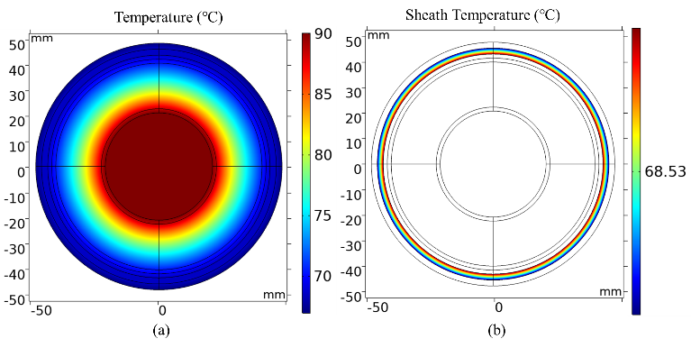
Figure 1. (a) Temperature distribution of a single core cable at 90℃ (b) Sheath Temperature Distribution.

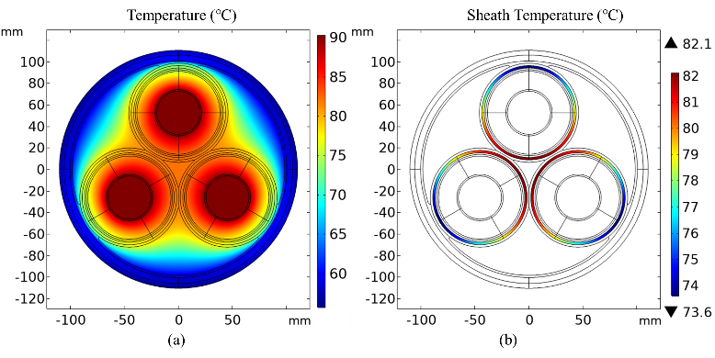
Figure 2. (a) Temperature distribution of a three-core cable at 90℃ (b) Sheath Temperature Distribution.

Moreover, the effect of cable insulation on sheath mechanical stresses cannot be neglected. Figure 3 shows how the elastic modulus and thermal expansion change with temperature [4, 5]. At high temperature, the elastic modulus of XLPE decreases while the thermal expansion increases. XLPE has a high thermal expansion. As its temperature increases from 25 ℃ to 105 ℃, XLPE expands by 15% while copper expands by less than 3% in the same temperature range [6]. Moreover, XLPE’s thermal expansion is higher than lead thermal expansion (28.9×10⁻⁶ ℃⁻¹) by a tenfold difference. This indicates that XPLE might generate a high pressure on the inner wall of the cable sheath.
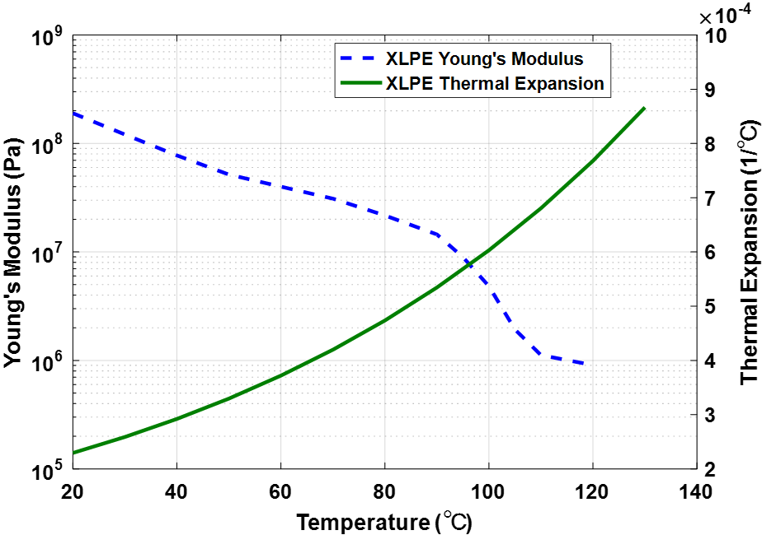
Figure 3. Elastic modulus and thermal expansion of XLPE [4, 5].
Lead and lead alloys are ductile materials and must be protected against mechanical stresses during manufacturing, cable transport, installation, operation and maintenance. Lead is a common metal used for metallic sheaths due to its corrosion resistance and ease of manufacturing. Alloy elements such as tin, calcium and tellurium are used with lead to improve long-term stability, creep and extrusion properties of lead sheaths.
Pure lead has yield stress of 5.5 MPa and lead alloy can have a yield stress of maximum of 66 MPa [7]. If the sheath used has a low yield stress, there is a possibility that the thermal stresses exceed the yield stress of the sheath. Then, the sheath will start to deform in the plastic region (irreversible deformation) increasing the chances of forming gaps at the interface between the sheath and bulk insulation. The size of possible gaps will highly depend on the quality of the materials used.

In this paper, thermo-mechanical stresses in a three core cable is investigated. The non-uniform distribution of temperature, the effect of temperature on XLPE’s properties and sheath plastic deformation are taken into account. Finite element method is used to model thermomechanical stresses inside AC three core submarine cables. The main factors that influence sheath plastic deformation are investigated. An electrical model in the frequency domain is then developed to take into account the capacitive and resistive effects. The electric field distribution inside the deformed geometry is explored. In section two, a description of the model and boundary conditions is provided. Section three presents a comparison of thermomechanical stresses in a one core and a three core. Section four an analysis of the main parameters that affect sheath plastic strain. Section five shows the deformed mesh after heating and cooling. In addition, it focuses on the electrical simulations of the deformed geometry.

Three core submarine power cable model
In this part, a description of the model physics, governing equations, material properties and boundary conditions is presented.

Sheath Plastic Deformation Model
Materials undergo temporary (elastic) deformation when subjected to a stress level below their yield stress (elastic limit). In the elastic region, the material can fully recover its original shape upon unloading. The stress strain relation will be linear and governed by Hooke’s law as long as the stress does not exceed the elastic limit. If the stress is further increased beyond the elastic limit, the amount of deformation increases but this extra amount is permanent (not recoverable upon unloading). After passing the yield stress, the material will deform in the plastic region. The total strain can be considered as the sum of the elastic and plastic strain. Usually the elastic component is neglected since there could be a large amount of plastic strain is larger than the elastic strain. It is worth noting that when the applied stress goes back to zero only the plastic strain is permanent.
For ductile materials, there are different ways to describe the increase in stress needed to continue plastic deformation known as strain hardening. If no strain hardening is included, the material is said to be perfectly plastic. In this case, the plastic curve is horizontal and stress in the plastic region does not depend on plastic strain. The introduction of strain hardening can be through linear or power law relations.
The Ludwik equation is used [8, 9],
$$\begin{aligned}σ=\left\{\begin{aligned}Eϵ_{el}, &σ≤σ_{Y} \\ σ_{Y}+k{ϵ_{p}}^{n}, &σ>σ_{Y}\end{aligned}\right.,\#\left(1\right)\end{aligned}$$
where E is the elastic modulus N.$m^{-2}$, $σ_{Y}$ is the yield stress N.$m^{-2}$, $ϵ_{el}$ and $ϵ_{p}$ are the elastic and plastic strain respectively. The constants k and n depend on the nature of the material, temperature and strain. Usually n is between 0.2 and 0.5, whereas the values of k varies between G/100 and G/1000, G being the shear modulus [8, 9]. If the stress is in the elastic region namely ($ϵ_{p}$=0,$σ≤σ_{Y}$) then it has a linear relation with the strain. On the other hand, when the strain develops after exceeding the elastic limit it is prescribed by nonlinear relationship as in equation 1.

multiphysics approach
A 132 kV three phase XLPE insulated SL-type (each phase in separate lead sheath) submarine cable with 1000 mm² conductors is modelled (1150 A). The three cores are protected and covered together using layers of polyethylene and single steel armour wires. The cable dimensions and thermal material properties are presented in [10]. To model thermal stresses inside a power cable, heat sources must be identified and calculated. There are four main heat sources within a power cable: conductor, sheath, armour and dielectric losses. The losses are calculated based on IEC 60287 standard. Once the heat sources have been set with the appropriate boundary conditions, the heat transfer equation of thermal conduction is solved for the temperature distribution. The heat transfer equation is given in equation 2, where ρ is the mass density (kg.$m^{-3}$), $C_{p}$ the specific heat capacity (J.${kg}^{-1}{.K}^{-1}$), T the absolute temperature (K), k the thermal conductivity (W.$m^{-1}{.K}^{-1}$) and Q is the heat source (W.$m^{-3}$).
$$\begin{aligned}ρC_{p}\frac{∂T}{∂t}=∇.\left(k∇T\right)+Q\#\left(2\right)\end{aligned}$$
$$\begin{aligned}∇∙σ+F_{v}=ρ\frac{∂^{2}u}{∂t^{2}}\#\left(3\right)\end{aligned}$$
For the structural analysis, the thermal strain and stress are found by applying the equilibrium equation 3, where u and σ are the displacement and the stress (N.$m^{-2}$) respectively, $F_{v}$ is the body force per unit volume (N.m⁻³).

MODEL parameters and boundary conditions
An important part of the model is setting the boundary conditions. In the heat transfer module, the contact interface is modelled as a thin layer with a low thermal resistance using thermal contact boundary condition. In addition, the thermal environment was represented by an environment having an external heat transfer coefficient 5.6 (W.m².K⁻¹) [11]. It is worth noting that changing this value will not change the temperature difference within each layer, which governs the main behaviour of interest here. It will only shift the temperature profile.

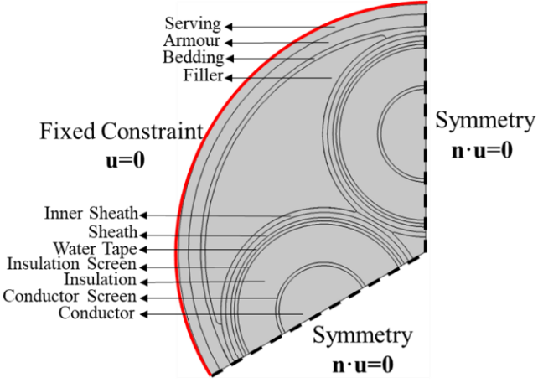
Figure 4. Simpliﬁed cross section of the three-phase export cable

Table 1. Materials Mechanical Properties
Geometry | Material | Thermal  Expansion (K⁻¹) | Young’s  Modulus (Pa) | Poisson’s ratio
Conductor | Copper | 19×10⁻⁶ | 110×10⁹ | 0.35
Conductor screen | Semicon XLPE | 20×10⁻⁵ | 160×10⁶ | 0.46
Insulation | XLPE | 25×10⁻⁵ | 120×10⁶ | 0.46
Insulation screen | Semicon XLPE | 20×10⁻⁵ | 160×10⁶ | 0.46
Water blocking tape | Polymer | 10×10⁻⁵ | 100×10⁶ | 0.46
Sheath | Lead | 28.9×10⁻⁶ | 16×10⁹ | 0.44
Inner sheath | PE | 15×10⁻⁵ | 1×10⁹ | 0.45
Bedding & Filler | Polypropylene | 10×10⁻⁵ | 85×10⁶ | 0.42
Armour | Steel | 12.3×10⁻⁶ | 200×10⁹ | 0.30
Serving | PE | 15×10⁻⁵ | 1×10⁹ | 0.45

Under the mechanical physics, the circumference of the cable should be defined as fixed constraint (e.g. u=0) to fulfil the requirement for a constrained cable (e.g. buried in the soil). In addition, only one third of the cable is simulated and symmetry is assumed as seen in Figure 4. Under the mechanical physics, contact pairs are defined and adhesion with no separation is assumed for the contacts inside each core except for the sheath-water blocking tape interface, which has a static friction only [12]. Moreover, cable cores are assumed to be in contact (but separable with no adhesion) to avoid any mesh deformations in the narrow area between the cores. Materials mechanical properties are listed in Table 1. Modelling of submarine power cables is not an easy task because of their complex structure. There are set of assumptions considered in this model and they are presented in the following points. In addition, three sensitivity analyses are conducted to investigate some of the effects these assumptions have on sheath plastic strain.

- The cores are assumed perfectly identical to improve computational efficiency, and so symmetry can be assumed.
- The conductor and the insulation screens are bonded with the insulation: this assumption can be justified since the three layers (conductor screen, insulation and insulation screen) are manufactured simultaneously in a triple extrusion system. In this simulation, the outer and inner semi-con are bounded with the insulation since the interest here is in the bulk deformation.
- The bedding is attached to the filler: the bedding is attached with the filler, to avoid mesh deformation for the bedding layer due to its small thickness and low mechanical strength.
- Armour is represented by a tube rather than of wires: considering the armour as a tube could be an over estimation in the axial direction. However, the motivation here is to consider the worst case in terms of radial stresses. Moreover, since the external cover of the cable is considered as fixed constraint, the armour effect on sheath deformation is minimal.
- Residual stresses within cable cores are not included: It was found by [13] that residual stresses would have decreased after a week to about 20% of their initial value. Residual stresses will decay with time because of stress relaxation which will reduce their effect by the time the cable is installed. Moreover, the measured residual stresses in the tested cables (400 and 132 kV) in [13] were low to have an effect on the breakdown strength of the insulation.
- The pressure and expansion of gases which are generated from by-products of crosslinking reaction is not included: The generation of gases is considered to have minimal since it depends on the degassing process. Moreover, in the case presented the sheath thickness is sufficiently thick so the pressure developed from the gases if any is expected to have low impact on the sheath (i.e. less than 0.5 MPa) [14].

Three Core Versus One Core
The non-uniform thermal distribution in a 3C will cause a non-uniform distribution of mechanical stresses. To illusrate the difference between a 3C and a single core, the stress and strain distribution for both cases are presented. Figures 6a and 6b show the von Mises stress and plastic strain distribution for the sheath in a single core at conductor temperature of 90 ℃. For ductile materials, von Mises stress is adopted as one of the failure criteria. The stress represented is the von Mises stress, which is defined as the maximum equivalent stress produced by the combination of tensile, compression, bending and shear loading. It is clear that the stress and strain are uniformly distributed in the radial direction. Figure 7a illustrates the stress distribution for the sheath inside a 3C cable.
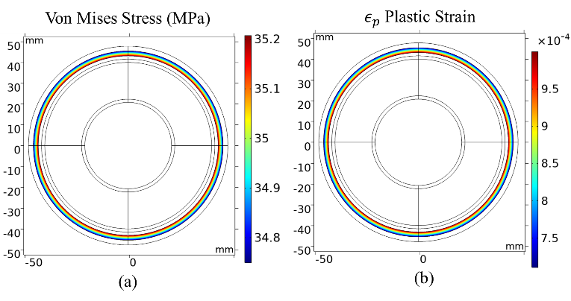
Figure 6. (a) Von Mises Stress Distribution in the sheath at Conductor Temperature of 90 ℃. (b)Sheath Plastic Strain at Conductor Temperature of 90 ℃.
As seen from Figure 7a, the highest stresses are located at the parts of the sheath facing the other cores and the armour. Figure 7b shows sheath plastic strain inside three-core cable at 90℃. The highest plastic strain is where the thermal stresses are the highest. This shows the difference between a complete three-core and single core configuration. If only one core is tested, the expected thermal stresses from other cores and armour will not affect the sheath deformation.
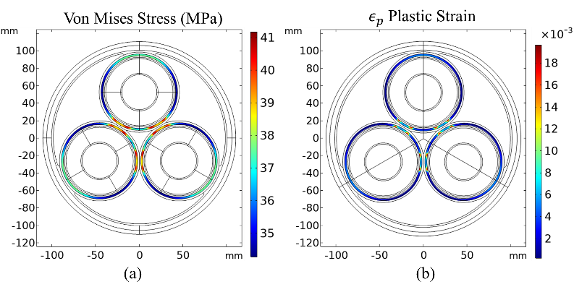
Figure 7. (a) Von Mises Stress Distribution in the sheath at Conductor Temperature of 90 ℃. (b)Sheath Plastic Strain at Conductor Temperature of 90 ℃.
When comparing the stress in both cases, it can be noticed that not only the stress distribution is different but also the stresses on the sheath in a 3C are higher than the stresses in the one core by 16%. Moreover, the plastic stain in a 3C is higher than the single core since it is more stressed mechanically. Table 2 highlights the main differences between the one core and the three core.
Table 2. Differences between one core and three core.
One core (Single) | Three core
Uniform temperature distribution | Un-uniform temperature distribution
Uniform thermo-mechanical stress on the sheath | Un-uniform thermo-mechanical stress on the sheath
The effect of the mechanical stresses from the other cores are neglected. | The effect of the mechanical stresses from the other cores are included.

analysis of model parameters and assumptions
In order to identify the sensitivity of the model to different parameters, a parametric sensitivity analysis was conducted using an L8 orthogonal array. Three studies were conducted. The aim of these studies is to recognize the parameters that affect the plastic strain of the sheath. In the first study, the effect of four factors are examined; elastic modulus (1.E_{XLPE}) and thermal expansion of XLPE (2.α_{XLPE}), filler’s elastic modulus (4.E_{filler}) and armour elasticity (7.E_{armour}). The columns that are defined as (1&2); represent the interaction of the two factors. An interaction effect happens when the effect of one factor is dependent on the level of another factor. The results of this study are presented in Figure 8. The results were obtained at a conductor temperature of 90℃. Cable insulation’s thermal expansion and elastic modulus have the highest impact on sheath plastic strain. The elasticity of the filler has a negative effect implying that when filler’s elasticity changes from low level to high, the sheath plastic strain decreases. This could be due to the filler’s ability to mitigate the effect of internal stress generated from the cores on the sheath. The elastic modulus of armour has the lowest effect on sheath plastic strain among the four main factors tested.
In Figure 9, the effect of yield stress (1.σ_{y}), strength coefficient (2.k) and hardening exponent (4.n) on the sheath plastic strain is presented. The yield stress and strength coefficient have a negative effect on the plastic strain. As yield stress increases, the plastic strain decreases. As mentioned earlier the values of these constants depend mainly on the nature of the material and additives used to strengthen the sheath.
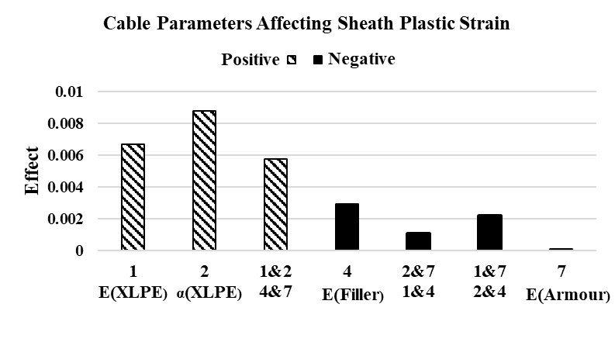
Figure 8. Plot of the Effect on Sheath Plastic Strain.

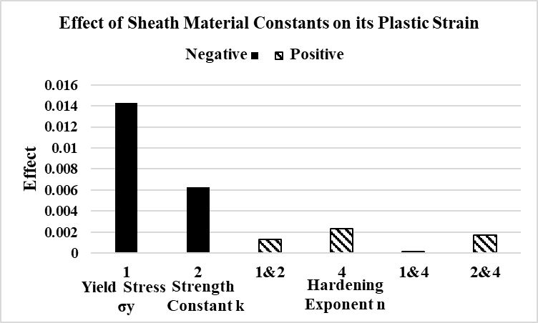
Figure 9. Results of Sensitivity Analysis

In the last two studies, the elastic modulus and thermal expansion of XLPE were assumed constant. The impact of assuming constant properties on sheath plastic strain is investigated. Table 3 shows that assuming constant mechanical properties leads to higher sheath plastic strain by 13% in comparison to temperature dependent properties.

Table 3. Impact of Varying Properties on Sheath Plastic strain (σ_{y}=30 MPa, k=33.61 MPa, n=0.27 [15]).
Factor |  | Plastic strain at 90 ℃
Elastic  Modulus | Thermal  Expansion
E(T) | α(T) | 0.0171
Constant E | α(T) | 0.0493
E(T) | Constant α | 0.0024
Constant E | Constant α | 0.0194

It is evident that temperature dependent properties must be taken into account for a relevant prediction of sheath plastic strain. Based on the results from these studies, it can be observed that the effect of XLPE’s thermal expansion on sheath plastic strain in radial direction is the highest among the other cable parameters.
Moreover, yield stress and the strength constant of the sheath will affect the sheath plastic strain significantly. Furthermore, it is important to consider temperature dependent properties when determining the deformations to avoid over estimation.

The effect of mechanical deformation on electric field
In this section, the deformed geometry from the thermomechanical model was imported into an electrical model. The electrical field distribution inside the deformed cable core is investigated.

heating and cooling
To calculate thermally induced deformations and stresses both the inertia and thermo-mechanical coupling terms in the governing equations which are ($ρ\frac{∂^{2}u}{∂t^{2}})$ can be neglected. The inertia effects become significant and need to be considered for those cases which face sudden rapid heating or thermal shock. In this work, thermal stresses under steady state temperature field are determined. In non-linear problems, load ramping is used to improve robustness. The input starts from zero and is increased incrementally by 10% reaching full value then it goes back to zero in the same manner.
Figure 10a shows the distribution of the total displacement in the cable at conductor temperature of 90 ℃. It can be noticed that the highest displacement for the cores near the filler side. The von Mises stress distribution within the cable is illustrated in Figure 10b. The regions of highest stresses are at the armour, conductors and sheath.
The effects the non-uniform distribution of temperature in the insulation have on the distribution of XLPE’s elastic modulus and thermal expansion is shown in Figure 11. As it can be seen from Figure 11a, the non-uniform distribution of temperature in the insulation resulted in a non-uniform distribution of thermal expansion and Young’s modulus within the cable insulation, as presented in Figure 11b and Figure 11c. At high temperature regions (closer to the conductor) the insulation’s elastic modulus is the lowest, while thermal expansion has the highest value at the same regions. Indeed this non-uniform distribution of temperature and properties is generating a non-uniform distribution of thermo-mechanical stresses affecting the cable sheath.
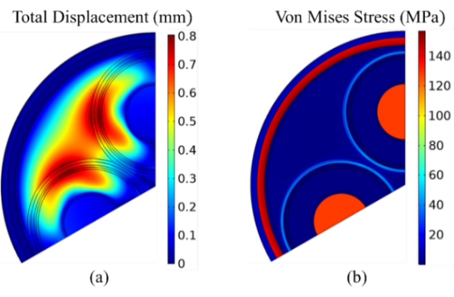
Figure 10. (a) Total displacement distribution in the cable at conductor temperature of 90℃. (b) Von Mises stress distribution in the cable at conductor temperature of 90℃.
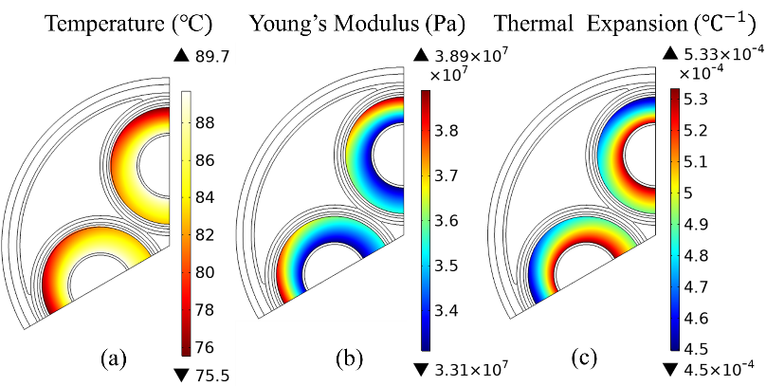
Figure 11. (a) Temperature Distribution at Conductor Temperature of 90℃. (b) Insulation Elastic Modulus Distribution at Conductor Temperature of 90℃. (c) Insulation Thermal Expansion Distribution at Conductor Temperature of 90℃.

During heating and at conductor temperature of 90℃ there are no signs of separation or gaps as shown in Figure 12. In Figure 13 the deformed mesh of the upper core after cooling is presented. It should be noted that the colour legend indicates the quality of the mesh. 1 indicates high mesh and 0 indicates no mesh. After cooling it can be noticed that there is a sign of separation between the water blocking tape and lead sheath.

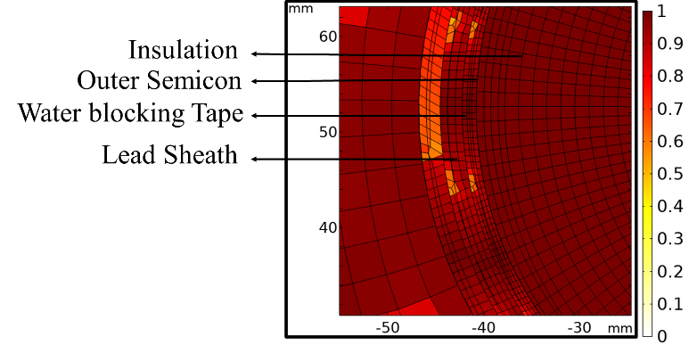
Figure 12. Deformed mesh plot of the upper core at Conductor Temperature 90℃.
It is worth noting that the gap started to appear when the insulation cooled down and went back to initial position since it is considered elastic.
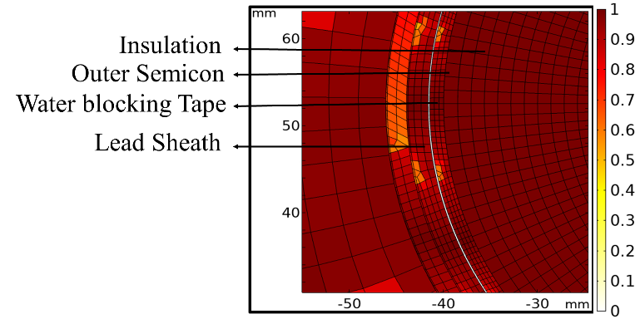
Figure 13. Deformed mesh plot of the upper core after cooling down to 20℃.
The bulk insulation (cable insulation + semicon + water blocking tape) has a high thermal expansion, causing the deformed regions at the interface to be filled during the heating period. The chances of any gaps being developed are reduced. Nevertheless, in the cooling stage, the insulation shrinks back as the temperature decreases. Due to sheath plastic deformation and the fact that there is no adhesive bond between the water blocking tape and sheath, a gap was created. It should be noted that during manufacturing process no special bond is applied between sheath and water blocking tape when extruding the metallic sheath. The sheath expanded during the heating period and did not fully recover to its original dimensions during the cooling period because of sheath plastic deformation. The adhesive bond between the bulk insulation and sheath should have the ability to absorb the expansion and contraction at the interface without losing its bond to the layers [16, 17]. If there is no bond like the case presented or the bond lost its adhesion or fails by delamination a gap is created during cooling. An electrical model is developed to study the electrical field distribution in the deformed geometry.

electrical model of deformed geometry
The calculation of the electric field distribution is determined using finite element method. The governing equations used to calculate electric fields are given as:
$$\begin{aligned}∇∙J=Q_{jv}\#\left(4\right)\end{aligned}$$
$$\begin{aligned}J=σE+jωD\#\left(5\right)\end{aligned}$$
$$\begin{aligned}E=-∇V,\#\left(6\right)\end{aligned}$$
where J is the current density (A.m⁻²), σ is the electric conductivity (S.m⁻¹), D denotes the electric displacement density (C.m⁻²), ω the angular frequency, E is the electric field (V.m⁻¹) and V is the electric potential (V). The boundary conditions of the electrical model are illustrated in Figure 14.
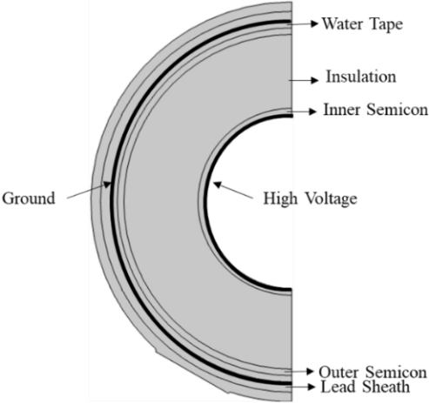
Figure 14. The Electrical Model of the Deformed Core.

Table 4 lists materials permittivity and resistivity used in the model. The effect of temperature on these parameters is not considered. The phase voltage U₀=77 kV at 50 Hz is applied at the high voltage boundary. Zero voltage is set at sheath boundary.
Table 4. Parameters of Materials in Electrical Model.
Material | Relative Permittivity | Resistivity [Ω·m]
Semi-con | >1000 [18] | 0.1-10 [18]
XLPE | 2.3 | 1×10¹⁸
Water blocking tape | >1000 | 1×10³[19]

electric field distribution
The deformed geometry is meshed as illustrated in Figure 15. The area and perimeter of the gap are 9.7 mm² and 227.8 mm, respectively. The maximum thickness calculated for this gap is 2.36×10⁻²mm as shown in Figure 16. It is noticed that the gap thickness is not uniform along the gap and this is expected because the non-uniform mechanical stresses generated. It should be noted that only the thermo-mechanical stresses are included. The effect of gravity is not considered. The thickness of the gap changes between (0-2.36×10⁻²mm) .In Figure 17, part of the mesh in the gap is shown with voltage drop across the gap.
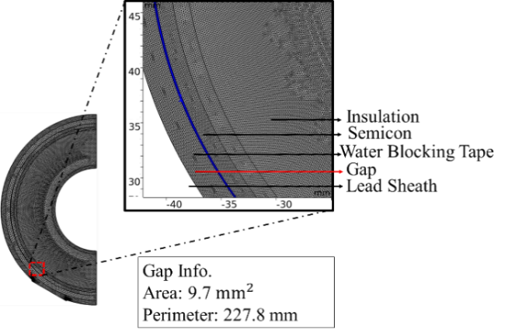
Figure 15. Geometry Mesh showing the air Gap created due to deformation

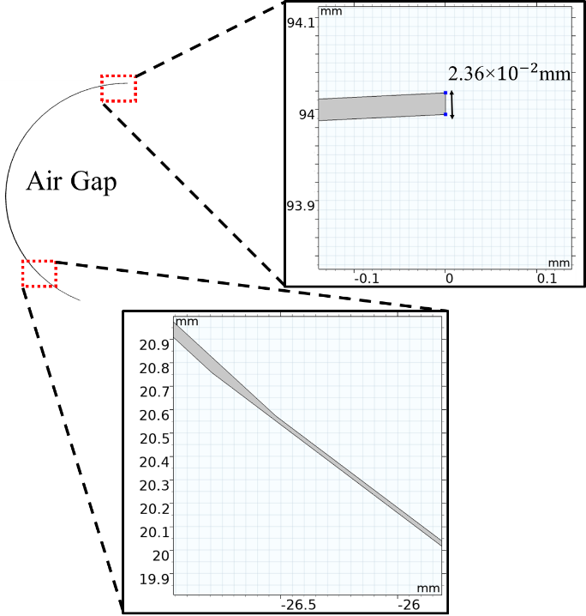
Figure 16. Air Gap Shape and Maximum thickness.

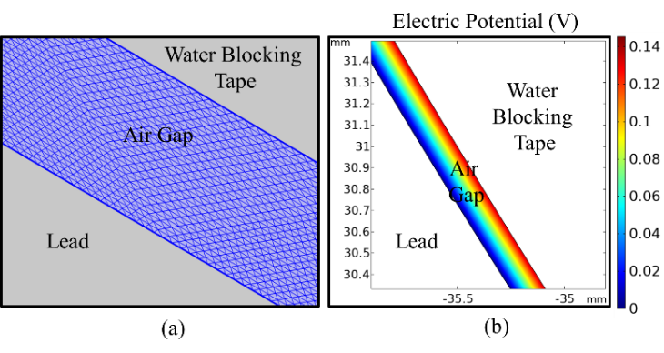
Figure 17. (a) Part of air Gap Mesh (b) Voltage drop in Air Gap.

In Figure 18, the electric field magnitude along the gap is determined. It is worth noting that the x-axis (log scale) represents the length of the circular arc from B to A. The electric field has the highest values at the locations with lowest thickness (< 1.31×10⁻⁴mm).
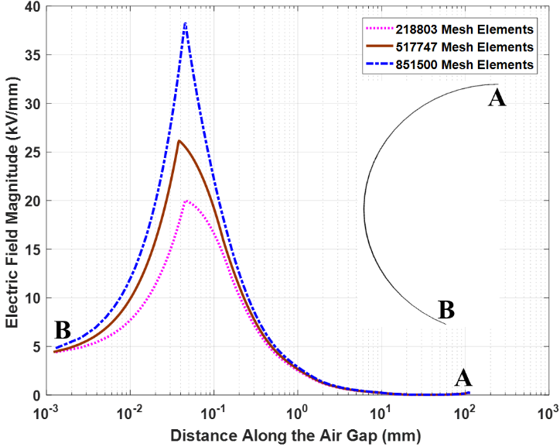
Figure 18. Electric Field along the air gap with increasing mesh density.

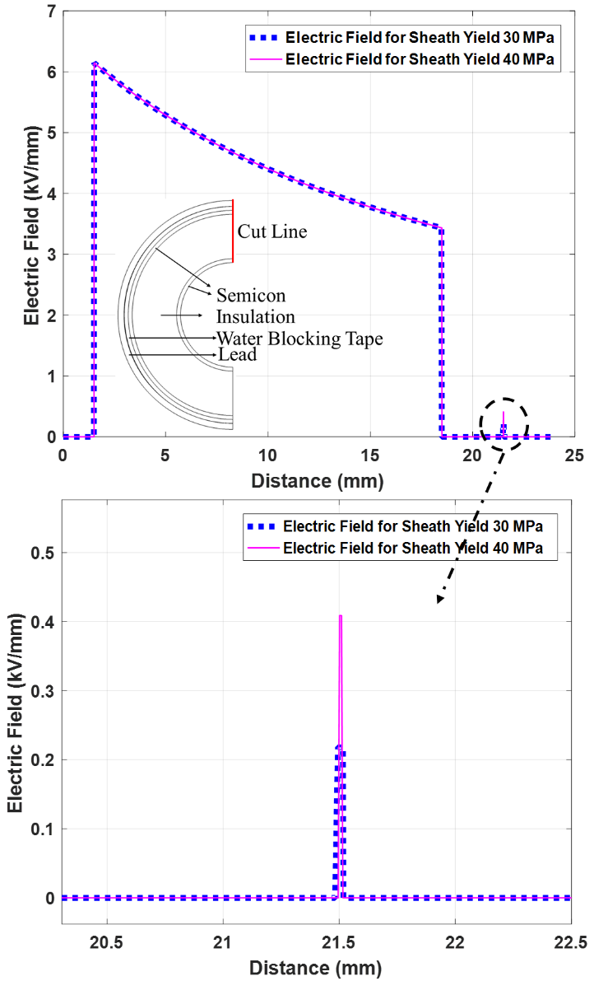
Figure 19. Effect of Sheath deformation on Electric Field in Air Gap.

To check the sensitivity of the model to mesh refinements, mesh density is increased. It is observed that areas where the gap is very thin are sensitive to the mesh refinements. Sharp edges and thin areas could lead to local singularities where the electric field appears to depend on the mesh. In other parts of the gap, simulations with increased mesh density in all regions resulted in a change in the electric field within 6%. Therefore, in case the highest values resulted in this simulation are disregarded since it could be considered as local singularities, the other values of electric field at other locations of the gap are worth considering. Most of the electric field values determined in these regions are in range of (3, 0.05) kV/mm. This is based on a water blocking tape having a resistivity of 0.1 MΩ.cm. Lower values are resulted if a tape with lower electrical resistivity is utilized. Water tapes must have sufficient mechanical strength to absorb the expansion of the cable core. In addition, the tape must be semi-conductive to allow charge transfer from the outer screen of the insulation to metallic sheath. However, there are no specific values or ranges recommended by standards concerning the water blocking tape resistivity. These parameters could be crucial especially if the sheath is plastically deformed. It is, thus, important to use a water blocking tape with as low electrical resistivity as possible. For the case presented, a resistivity of more than 0.5 MΩ.cm would be a concerning limit.
To compare the electric field between 30 and 40 MPa yield stresses, the electric field for a deformed geometry of the cable having a sheath yield stress of 30 and 40 MPa are illustrated in Figure 19. The cut line for Figure 18 is shown as well. It can be noticed that the electric field in the 40 MPa (0.408 kV.mm⁻¹) case is higher than the 30 MPa case (0.218 kV.mm⁻¹) at the air gap. This is because of gap thickness for 40 MPa is 0.008 mm and for 30 MPa case the thickness is 0.023 mm at the same point. The electric field values in the gap may increase as sheath yield stress increases since the plastic strain is expected to be lower and therefore the gap area smaller. However, with such a low potential difference of 0.14 V the associated risks are quite reduced. Moreover, it is difficult to make a unique conclusion since the gap has a non-uniform shape and thickness.

CONCLUSIONS
This paper uses finite element method to model thermomechanical stresses inside AC three core submarine cables. The results presented in this study are not intended to discuss any reported failures. The electric field values in the air gap are highly dependent on the deformation level and the quality of the materials used. The electric fields determined are found to be insufficient to trigger any degradation process. The key parameters that influence sheath plastic strain have been investigated. In addition, an electrical model has been developed to study the electrical field distribution in the deformed geometry. The main conclusions are summarized in the following: Sheath plastic deformation in the radial direction is highly influenced by XLPE’s thermal expansion and elastic modulus. When compared with temperature dependent properties, assuming a cable insulation with constant thermal expansion and a constant elastic modulus will result in an increase of 13.5% in calculated sheath plastic strain. Thus, temperature dependent properties assumption is required for an accurate prediction of sheath plastic deformation. The chances of developing a gap or layers being separated increases during cooling. XLPE’s high thermal expansion reduces this possibility during heating. The gap created could increase the electric field intensity inside the cable. However, the increase in the electrical field in the air gap is highly dependent on the deformation level (size of the gap). In case the gap is filled with water, water will act as connection and reduce the chances of partial discharge. If there is an adhesive bond between the water blocking tape and the sheath, this could reduce the chances of forming gaps. The chances of spotting a defect while testing the whole cable could be higher because of the higher thermo-mechanical stresses generated inside a three core. In case a sheath with a low yield stress or a water blocking tape with a high electric resistivity are used, testing the whole cable would expose the cores to higher thermo-mechanical stresses that will make it easier to identify a defect.

References

[1] T. Worzyk, Submarine Power Cables: Design,Installation,Repair Environmental Aspects, Springer, 2009.
[2] CIGRE WG B1.27-TB 490 Recommendations for testing of long AC submarine cables with extruded insulation for system voltage above 30 (36) to 500 (550) kV, 2012.
[3] CIGRE WG B1.43-TB 623 Recommendations for Mechanical Testing of Submarine Cables, June, 2015.
[4] Mechanical Effects on Extruded Dielectric Cables and Joints Installed in Underground Transmission Systems in North America, EPRI, Palo Alto, CA:, 1001849, 2004.
[5] X. Qi and S. Boggs, “Thermal and Mechanical Properties of EPR and XLPE Cable Compounds,” IEEE Electr. Insul. Mag., vol. 22, pp.19-24, 2006.
[6] T. Andritsch, A. Vaughan and G. Stevens, “Novel Insulation Materials for High Voltage Cable Systems,” IEEE Electrical Insulation Magazine, vol.33, pp. 27-33, 2017.
[7] Z. Y. Huang, J. A. Pilgrim, P. L. Lewin and S. G. Swingler “Dielectric Thermal-mechanical Analysis and Contrained High Voltage DC Cable Rating,” IEEE Transactions on Dielectrics and Electrical Insulation, vol.22, 2015.
[8] N.E. Dowling, Mechanical Behavior of Materials: Engineering Methods for Deformation, Facture and Fatigue, 4th Edition, PEARSON, 2013.
[9] M. A. Meyers and K. K. Chawla, Mechanical Behavior of Materials, 2nd edition, Cambridge University Press, 2009.
[10] S. Catmull, R. D. Chippendale, J. A. Pilgrim, G. Hutton and P. Cangy, “Cyclic Load Profiles for Offshore Wind Farm Cable Rating,” vol. 31, no.3, 2016.
[11] F. Yang, P. Cheng, H. Luo, Y. Yang, H. Liu and K. Kang, “3-D Thermal Analysis and Contact Resistance Evaluation of Power Cable Joint,” Applied Thermal Engineering 93, ELSEVIER, 2016. pp. 1183-1192.
[12] IEEE Guide for Selection and Design of Aluminum Sheaths for Power Cables IEEE Power Engineering Society IEEE Std 635™-2003.
[13] N. Amyot, E. David, S. Y. Lee and I. H. Lee, “Influence of Post Manufacturing Residual Mechanical Stress and Crosslinking By-products on Dielectric Strength of HV Extruded Cables,” IEEE Trans. on Dielectr. Electr. Insul., vol.9, pp. 458-466, 2002.
[14] T. Andrews, R. N. Hampton, A. Semdberg, D. Wald, V. Waschk and W. Weissenberg, “The Role of Degassing in XLPE Power Cable Manufacture,” IEEE Electrical Insulation Magazine, vol. 22, no.6, 2006.
[15] P. Christiansen, J. H. Hattel, N. Bay and P. AF Martins, “Physical Modeling and Numerical Simulation of V-die Forging Ingot with Central Void,” Journal of Mechanical Engineering Science, vol. 228, no. 13, 2014.
[16] IEEE Guide for the Selection, Testing, Application and Installation of Cables having Radial-Moisture Barriers and/or Longitudinal Water Blocking, IEEE Std 1142, 2009.
[17] R. Butterbach and R. Heucher, “Advantages of Hot Melt Adhesives for Overlap Bonding and Sealing in Power Cables,” Jicable 95, B5.5, 1995.
[18] B. Gustavsen, J. A. Martinez and D. Durbak, “Paramter Determination for Modeling System Transients-Part II: Insulated Cables, IEEE Transactions on Power Delivery, vol. 20, no. 3, 2005.
[19] GECA Tapes [Online], https://geca-tapes.com/products/, [Accessed 2019].

