A Systematic Review and Meta-Analysis of Sex/Gender Differences in Social Interaction and Communication in Autistic and Non-Autistic Children and Adolescents

Word count: 8226

Dr. Henry Wood-Downie^{a*}, Dr. Bonnie Wongª, Dr. Hanna Kovshoffª, Prof. Samuele Cortese^{abcd}, and Dr. Julie A. Hadwinª

ª Centre for Innovation in Mental Health – Developmental Lab, School of Psychology, University of Southampton, U.K.
^{b} Solent NHS Trust, Southampton, UK
^{c} New York University Child Study Center, New York, NY, USA
^{d} Division of Psychiatry and Applied Psychology, School of Medicine, University of Nottingham, Nottingham, UK

*Corresponding author: Henry.Wood@soton.ac.uk

Abstract
Background: Evidence increasingly suggests that ASD manifests differently in females than males. Previous reviews investigating sex/gender differences in social interaction and social communication have focused at the level of broad constructs (e.g., comparing algorithm scores from pre-existing diagnostic instruments) and have typically reported no significant differences between males and females. However, a number of individual studies have found sex/gender differences in narrow construct domains.
Methods: We conducted a systematic review and random effects model meta-analyses (in January 2019 and updated January 2020) that investigated sex/gender differences in narrow construct measures of social communication and interaction in autistic and non-autistic children and adolescents, and adults. Study quality was appraised using the Appraisal Tool for Cross-Sectional Studies (AXIS, Downes et al., 2016).
Results: Across 16 studies (including 2730 participants), the analysis found that female (versus male) individuals with ASD had significantly better social interaction and social communication skills (SMD = 0.39, p < .001), which was reflective of a similar sex/gender profile in non-autistic individuals (SMD = 0.35, p < .001). Non-autistic males had significantly better social interaction and communication than males with ASD (SMD = 0.77, p < .001). Non-autistic females also had significantly better social interaction and communication than females with ASD (SMD = 0.72, p = <. 001). Non-autistic males had better social interaction and communication than females with ASD, though this difference was not significant (SMD = 0.30, p = .07).
Conclusions: This systematic review and meta-analysis highlighted important sex/gender differences in social interaction and communication for individuals with ASD, likely not captured by pre-existing diagnostic instruments, which potentially contribute to the under recognition of autism in females, and may need to be reflected in the diagnostic process.
Keywords: Autism spectrum disorders; Sex differences; Gender difference; DSM; Meta-analysis

Introduction
Autism Spectrum Disorder (ASD) is a neurodevelopmental disability characterised by ‘persistent impairment in reciprocal social communication and social interaction, and restricted, repetitive patterns of behaviour, interests or activities’ (American Psychiatric Association, 2013, p. 53). As researchers have not yet been able to separate the effects of sex and gender on ASD presentation, the term ‘sex/gender’ is used throughout this paper to acknowledge the overlap between the two (Lai et al., 2015; Springer et al., 2012). In accordance with research suggesting there is no one preferred way of describing ASD within the broader ASD community, both person-first and identity-first language will be used (Kenny et al., 2016). Approximately 2% of the childhood population has a diagnosis of ASD (Maenner et al.,2020). The reported sex/gender ratio in ASD varies depending on the specific demographics – such as IQ – of the participants included in the study (Maenner et al.,2020). On average an approximate ratio of four males to every female child and adolescents are given an ASD diagnosis (Fombonne, 2009; Maenner et al.,2020).
Loomes et al. (2017) conducted a meta-analysis and compared active case-finding methods (i.e., studies which first screen a population in order to identify at-risk children, who then undergo professional diagnostic assessment) with passive case-finding methods (i.e., studies that review existing databases or contact parents to identify whether children have received a diagnosis of ASD). They found that the male-to-female ratio was significantly smaller in active case-finding studies than passive case-finding studies (3.25 vs 4.56). This difference suggests there is a diagnostic gender bias, such that there are females not known to clinical services but who, if assessed, would potentially meet diagnostic criteria for ASD (Loomes et al., 2017). This diagnostic gender bias has a number of potential sources, including the proposition of a distinct autistic female phenotype (Hull et al., 2020 for a review). It is argued, for example, that higher levels of camouflaging behaviours (i.e., strategies to appear less autistic in social interactions), contribute to an under recognition of autism in females (e.g., Hull et al., 2017; Hull et al., 2019; Wood-Downie et al., 2020). With respect to diagnostic bias, it is suggested that professionals may hold gender-based stereotypes (e.g., that autism is a male-condition), or differentially interpret behaviour (e.g., social withdrawal perceived as shyness in females, but an indicator of autism in males), meaning autism may be under-recognised in females, which has recently gained some empirical support (Whitlock et al., 2020).
Sex/Gender Bias in ASD Diagnostic Criteria and Instruments
Reliable physiological and/or genetic biomarkers are yet to be identified for ASD (Goldani et al., 2014). Consequently, diagnostic criteria are based predominantly on behavioural descriptors, such as difficulties with social-emotional reciprocity (APA, 2013). Current ‘gold-standard’ diagnostic instruments, such as the Autism Diagnostic Observation Schedule, Second Edition (ADOS-2, Lord et al., 2012) and Autism Diagnostic Interview-Revised (ADI-R, Rutter et al., 2003), have been developed and validated predominantly using samples of male individuals, raising the possibility that the formation of items underpinning diagnosis may be biased towards a male manifestation of the condition, (Lai et al., 2015; Kirkovski et al., 2013; Kreiser & White, 2014). For example, the validation sample for the original ADOS consisted of 170 males and only 36 females with ASD (Lord et al., 2000). In addition, McCrimmon and Rostad (2013) noted that the standardisation sample for the ADOS-2 was predominately male, and was mainly recruited through clinics, meaning that an ascertainment bias may be present via the exclusion of females who have not yet come to clinical attention.
More importantly, when used diagnostically, these instruments have been found to miss a disproportionate number of female (versus male) individuals with ASD. Lai et al., (2011) found that only 21% of adult females diagnosed with ASD in childhood met ADOS cut-off scores, compared with 58% of males, despite similarly low social-cognitive ability between genders. Consistently, Russell et al. (2011) analysed a longitudinal UK cohort study and found that girls with similar levels of autistic traits to boys, were significantly less likely to receive an ASD diagnosis. Further evidence has found that females with higher IQ were significantly less likely than males to meet diagnostic criteria on the ADI-R (Ratto et al., 2018). In addition, , girls (but not boys) who met diagnostic criteria showed higher levels of behavioural and/or cognitive difficulties than non-autistic peers with similarly high levels of autistic traits (Dworzynski et al., 2012) .
Overall, these findings indicate that the diagnostic criteria are biased towards a male-specific manifestation of ASD and suggest that female children and adolescents may be missed in the diagnostic process, and particularly if they do not present with comorbid behavioural or cognitive difficulties. This research may also partly account for why girls/young woman are often referred and given a diagnosis of ASD on average later than boys/young men (e.g., Rutherford et al., 2016).
Broad and Narrow Constructs in ASD
Deficits with social communication and interaction is one of the two core areas of difficulty from the DSM-5 ASD diagnostic criteria (APA, 2013). These areas are broken down into three subdomains: (1) deficits in social-emotional reciprocity, (2) deficits in nonverbal communicative behaviour used for social interaction, and (3) deficits in developing, maintaining, and understanding relationships. Social interaction and communication difficulties can be measured at either the level of ‘broad’ or ‘narrow’ construct (Lai et al., 2015). Broad constructs, including the DSM-5 criteria of deficits in social interaction and communication, define ASD abstractly. In contrast, narrow constructs are fine-grained subdomains of broad constructs that include the subdomains outlined above (e.g., deficits in social-emotional reciprocity), as well as associated psychological constructs (e.g., social attention), and co-occurring issues (e.g., social anxiety). Each narrow construct has a range of associated behavioural exemplars, such as difficulties engaging in back-and-forth conversations, atypical eye gaze patterns, and specific types of anxiety symptoms.
Reviews investigating sex/gender differences in social interaction and communication at the level of broad construct often find no sex/gender differences (Lai & Szatman, 2019). For example a meta-analysis by van Wijngaarden-Cremers et al. (2014) found no significant differences between autistic male and female individuals in the core domains of social interaction and communication, both across the sample as a whole, and when split into five different age categories (toddlers, pre-schoolers, children, adolescents, and adults). Two further meta-analyses similarly reported no significant differences between autistic male and female children and adolescents in terms of social interaction and communication difficulties (Mahendiran et al., 2019) or children, adolescents, and adults (Hull et al., 2017). Two recent and relatively large-scale studies (N = 967) also found autistic males and female individuals (ages ranged from 1 to 56 years) had similar overall social communication and interaction difficulties (Mussey et al., 2017; Ratto et al., 2018).
Existing studies have typically employed pre-existing diagnostic instruments – predominantly the ADOS-2 and ADI-R – and often report overall social interaction and communication scores (i.e., at the broad construct level). Because these instruments have been developed largely from samples of autistic males, they may not be sensitive to the way in which ASD manifests in female individuals (Hull & Mandy, 2017; Lai & Szatman, 2019). To overcome these limitations, Lai et al. (2015) and Lai & Szatman, (2019) recommended that sex/gender differences in ASD should be investigated by focusing on narrow constructs and behavioural exemplars of social communication and interaction, rather than by comparing algorithm scores from pre-existing diagnostic instruments.
In support of this focus, research using narrow social and communication constructs have demonstrated sex/gender differences. For example, girls with ASD were found to have higher levels of peer engagement on the playground (Dean et al., 2016), increased social motivation (Head et al., 2014) and social reciprocity (van Ommeren et al., 2017), and showed a greater use of pragmatic language markers (Parish-Morris et al., 2017). Friendships may also be experienced differently, with autistic girls more likely to be overlooked by peers than autistic males, who are more likely to be rejected ASD (Dean et al., 2014).
Current Study
The current systematic review and meta-analysis investigated sex/gender differences in narrow constructs and associated behavioural exemplars of social interaction and communication, based on DSM-5 symptom subdomains not measured using diagnostic/screening instruments. This analysis builds on existing research to address issues with diagnostic bias, as well as our understanding of the contradictory findings associated with reviews based upon broad constructs (that typically find minimal sex/gender differences), and individual studies based on narrow constructs which have found sex/gender differences. If the diagnostic profile of autistic male and female individuals differ in terms of social interaction and communication at the narrow construct/behavioural exemplar level, then diagnostic criteria should reflect these differences. Finally, based on previous theory and evidence which suggests developmental differences may moderate the effects of sex/gender differences, we also aimed to investigate whether sex/gender differences are influenced by age, (e.g., Hull et al., 2017; Lai et al., 2015; Van Wijngaarden-Cremers et al., 2014).
The systematic review/meta-analysis addressed the following three questions:
(1) Are there any sex/gender differences in narrow construct subdomains of the DSM-5 ASD diagnostic criteria of social interaction and communication?
(2) If found, do autistic sex/gender differences mirror those found in non-autistic individuals?
(3) Does age moderate the effects of sex/gender differences?
Given the exploratory nature of the meta-analysis, no a priori hypotheses were formulated.
Method
This review followed the Preferred Reporting Items for Systematic Reviews and Meta-Analyses statement (Moher et al., 2009), and was pre-registered on Prospero (registration number: CRD42019120804).
Search
A search of the databases PsychINFO, Medline, Psych Articles, CINAHL (Plus with Full Text), and PubMed databases was conducted on January 23rd 2019, and updated on January 24th 2020, based upon the DSM-5 ASD symptom subdomains of social interaction and communication, including the population terms ‘autis*’ and ‘ASD’; comparator terms 'sex difference*' and ‘sex/gender difference*’; and outcome terms ‘social reciprocity’, ‘conversation’, ‘turn-taking’, ‘eye contact’, ‘friend*’ and ‘nonverbal communication’ (see Table S1 for full search terms). No language restrictions were applied. In addition, reference lists of included studies were hand searched to detect any pertinent study possibly missed with the electronic search. This process was first conducted by the first author. To minimise bias, the second author independently completed title and abstract screening for 187 randomly selected studies and 23 randomly selected studies for full-text screening. Inter-observer agreement was 97% for title and abstract screening and 96% for full-text screening. Discrepancies were discussed until a consensus was reached.
Eligibility criteria
Table 1 provides the rationale for each inclusion and exclusion criterion and further detail (i.e., specific examples of the types outcome measures and instruments that were excluded) can also be found in Appendix S1.
[Table 1 about here]
Data extraction
We extracted data on sample characteristics (e.g., gender, age of participants; diagnostic criteria used) and on outcomes related to social interaction and/or communication levels. We did not have an a priori search list of measures. Instead, we used a data-driven approach and the measures were identified through the search process, based on our a priori inclusion and exclusion criteria. We contacted corresponding authors if social interaction and/or communication means and standard deviations were not available in the reported data. The first and second author extracted data (i.e., number of participants, age of participants, means, and standard deviations) and independently entered items. Inter-observer agreement ranged from 92%-98% and discrepancies were discussed until a consensus was reached
Study quality appraisal
The focus of the review was cross sectional studies, therefore, the quality of included studies was appraised using the Appraisal Tool for Cross-Sectional Studies (AXIS, Downes et al., 2016). Due to the lack of an appraisal tool for cross-sectional studies, the AXIS was developed through an international Delphi panel of 18 medical and veterinary experts; following three rounds of the Delphi process, there was consensus (81%) that all components were appropriate for non-experts. The AXIS tool consists of 20 questions, which require an answer of ‘yes’, ‘no’, or ‘do not know; score range = 0-20, with higher scores reflecting higher quality studies. Questions relate to the rationale for the study (‘were the aims/objectives of the study clear?’), methods (e.g., ‘was the sample size justified?’), results (e.g., ‘were the basic data adequately described?’), discussion (e.g., ‘were the limitations of the study discussed’), and other aspects of studies (e.g., ‘were there any funding sources or conflicts of interest that may affect the authors’ interpretation of the results?’). The first and second authors independently rated all studies and agreement was 96%.
Data analysis
Random effects model meta-analyses were performed using Review Manager 5.3 (The Cochrane Collaboration, 2014) for narrow construct measures of social interaction and communication. Standardised mean differences (SMD) were calculated for the following comparisons: (1) autistic males and females (2) non-autistic males and females (3) autistic and non-autistic males (4) autistic and non-autistic females. Where multiple measures were used in one study, pooled means and standard deviations were used when the measures reflected one individual construct (e.g., different scales from the same questionnaire or observational measure). Alternatively, the measures most similar to other studies were included (Table 2). Where heterogeneity tests were significant, a subgroup analysis was conducted to test for differences between studies that included only child (< 12 years), child and/or adolescent (12-19 years), and adult participants (> 19 years).
Results
Search results
Search results are presented in Figure 1 and further information (i.e., how many separate hits were produced in our original and updated search) can be found in Appendix S2. References and reasons for full-text article exclusion can be found in Table S2.
[Figure 1 about here]
Characteristics of included studies
The characteristics of included studies in the quantitative review is presented in Table 2. Peer relationships was the most frequent outcome measure (n = 4). Other studies measured social motivation (n = 2), social attention (n = 3), and social reciprocity (n = 1). The majority of studies included a mixture of children and adolescents (n = 7) or only children (n = 6). Diagnoses were confirmed in the majority (n = 13) of studies via clinical assessment and/or ADOS assessment. N = 9 studies used questionnaire data (Baron-Cohen & Wheelwright, 2003; Dean et al., 2014; Harrop et al. 2017; Head et al., 2014; Horiuchi et al., 2014; Knickmeyer et al., 2007; Sedgewick et al., 2016, 2018, 2019). Further studies used a range of different behavioural measures/tasks, including use of eye tracking to measure social attention (Chawarska et al., 2016; Harrop et al., 2018) and a novel drawing task to measure social reciprocity (van Ommeren et al., 2017).
Measurements across ten studies corresponded to the DSM-5 subdomain of developing, maintaining and understanding relationships (Baron-Cohen & Wheelwright, 2003; Dean et al., 2014, 2016; Harrop et al. 2017; Head et al., 2014; Horiuchi et al., 2014; Knickmeyer et al., 2007; Sedgewick et al., 2016, 2018, 2019), four to nonverbal communicative behaviour (Chawarska et al., 2016; Harrop et al., 2018; O'Connor et al., 2019; Parish-Morris et al., 2017), and two to social-emotional reciprocity (Cheng et al., 2016; van Ommeren et al., 2017).
[Table 2 about here]
Study quality
Table 2 shows that the scores for studies in the current review ranged from 12-15 out of 20. Further details of study quality can be found in Appendix S4.
Publication bias
Egger’s test was significant (p = .02) for the comparison between autistic males and females, suggesting publication bias was present, though appeared only marginally asymmetrical when visually inspecting the funnel plot (Figure S1). It was not possible to calculate Egger’s test for the other three comparisons because there were fewer than ten studies in the subgroups. Two of the remaining plots (autistic and non-autistic males; autistic and non-autistic females) showed marginal signs of asymmetry (Figures S2 and S3). The studies that were missing were in line with the main findings (i.e., higher scores in non-autistic males and females relative to autistic males and females), suggesting that the overall pattern of results would be the same if they were included. The final plot (non-autistic male and females) show that most studies clustered around the overall SMD, suggesting publication bias was not evident (Figure S4).
Comparison of autistic males and females
Figure 2 shows significantly better social communication and interaction skills in autistic females (compared with autistic males) (SMD = 0.39, 95% Confidence Interval (CI) = (0.26, 0.53), p < .001). Heterogeneity tests were non-significant, χ²(15) = 17.33, p = .30, indicating that across studies the pattern of results was similar.

[Figure 2 about here]

Comparison between non-autistic males and females.
Figure 3 shows that non-autistic females had significantly better social communication and interaction than non-autistic males (SMD = 0.35, 95% CI = (0.17, 0.54), p < .001), though heterogeneity tests were significant (χ²(15) = 29.87, p = .01). The moderating effect of age was significant (χ²(2) = 9.94, p = .007): females had better social communication and interaction skills than males for all three age groups, and the SMD between females and males increased with age (SMD child < SMD child/adolescent < SMD adult). Heterogeneity tests were non-significant for the three subgroups, suggesting that developmental differences explained heterogeneity when all studies where included.
[Figure 3 about here]

Comparison between autistic and non-autistic males
Figure 4 indicates that non-autistic males had significantly better social interaction and communication than autistic males (SMD = 0.77, 95% CI (0.47, 1.06), p < .001), though heterogeneity tests were significant (χ²(15) = 86.70, p < .001). The moderating effect of age was non-significant (χ²(2) = 1.23, p = .54), with non-autistic males having better social communication and interaction skills than autistic males for all three ages and the SMD was similar for the three age group.
[Figure 4 about here]

Comparison between autistic and non-autistic females
Figure 5 shows that non-autistic females had significantly better social interaction and communication than autistic females (SMD = 0.72, 95% CI (0.32, 1.12), p < .001), though heterogeneity tests were significant (χ2(15) = 139.07, p < .001). The moderating effect of age was significant (χ2(2) = 9.62, p = .008): Non-autistic females had better social communication and interaction skills than autistic females for all three ages and the SMD between them increased with age (SMD child < SMD child/adolescent < SMD adult). Heterogeneity tests, however, remained significant for infants/children and children/adolescents, suggesting other moderators may also be affecting the differences between studies.
[Figure 5 about here]
Comparison between autistic females and non-autistic males
Figure 6 shows that non-autistic males had better social interaction and communication than autistic females, but this difference was not significant (SMD = 0.30, 95% CI (-0.03, 0.63), p = .07); however, heterogeneity tests were significant (χ2(15) = 88.55, p < .001). Although the moderating effect of age was non-significant (χ2(2) = 0.23, p = .89), non-autistic males had non-significantly better social communication and interaction skills than autistic females for all three ages and the SMD was slightly greater for adults than the infant/children and child/adolescent groups (SMD child; SMD child/adolescent < SMD adult).
[Figure 6 about here]
Discussion
This systematic review and meta-analysis investigated sex/gender differences in social interaction and communication in autistic and non-autistic individuals across 16 studies. It also considered whether potential differences in autistic individuals were similar to those evident in non-autistic individuals, and if age moderated any difference. To overcome potential sex/gender diagnostic bias, we focused exclusively on narrow construct domains of social interaction and communication, rather than broad construct measures typically reflected in ‘gold-standard’ instruments. The review showed that there were a broad range of different outcome measures employed across studies (e.g., social attention; peer relationships; play behaviours). Most studies (n = 9) used questionnaires to measure social interaction and communication skills, with the remainder of studies using eye-tracking, observational measures, or behavioural tasks. The meta-analysis indicated that autistic females demonstrated significantly better social interaction and communication skills than autistic males, which reflected the pattern found for non-autistic individuals. Both autistic females and males had significantly lower social interaction and communication than their non-autistic female and male counterparts. The comparison between non-autistic males with non-autistic females, and autistic females with non-autistic females became more evident with increased age. Finally, non-autistic males had better social interaction and communication than autistic females, though this difference was not statistically significant.
Three previous meta-analyses found no significant social interaction and communication differences between autistic males and females (Hull et al., 2017; Mahendiran et al., 2019; van Wijngaarden-Cremers et al., 2014), based upon data predominantly derived from diagnostic instruments (e.g., ADOS-2). Researchers have argued that a focus on diagnostic instruments may be biased towards a male-specific manifestation of ASD (Lai et al., 2015; Lai & Szatman, 2019). Following Lai et al. (2015) and Lai & Szatman (2019) our analysis of sex/gender differences only included narrow construct measures of social interaction and communication, and a significant difference between autistic males and females was found in these domains. Significantly, although the majority of females within our sample had met diagnostic criteria for ASD and therefore broadly shared a similar set of difficulties to autistic males, sex/gender differences were apparent when examined on narrow-construct variables (Lai et al., 2015). This sex/gender difference suggests that, in certain social and communication domains, autism manifests differently in males and females. Moreover, the finding indicates that these differences may not be captured by pre-existing diagnostic instruments, and potentially contribute to the under-recognition of autism in females (Halladay et al., 2015; Lai & Szatmari, 2020).
The sex/gender difference supports the proposition raised by previous studies that autistic females are better able to camouflage social difficulties (e.g., Hull et al., 2019; Wood-Downie et al., 2020). Specifically, this interpretation is consistent with research that has found autistic females presenting as behaviourally more advanced than autistic males in certain contexts, despite having similar levels of underlying social-cognitive difficulties, and that this difference is likely to contribute to the under-recognition and later diagnosis of females (Hull et al., 2020 for a review; Lai et al., 2016). Another interpretation of these findings is that the more advanced social interaction/ communication profile in autistic females’ reflects normative sex/gender differences. Consistently, the current findings indicated that non-autistic females also had more advanced social interaction and communication skills than non-autistic males, and the SMD within autistic and non-autistic groups was similar.
In the current findings, heterogeneity tests indicated that there was significant variation in all analyses, apart from the comparison between autistic males and females. In the context of heterogeneity, age was found to be a significant moderating variable in two comparisons: autistic and non-autistic females and non-autistic males and females. In terms of autistic and non-autistic females, the difference between these groups increased in a stepwise manner, such that non-autistic females demonstrated better social interaction and communication than autistic females as they got older (which was not found when comparing autistic and non-autistic males). This finding is consistent with results from a recent longitudinal study which showed that found that adolescence was associated with an increase in autistic traits for females without a clinical diagnosis (and not males) (Mandy et al., 2018). The findings support the adolescent emergence hypothesis, that autistic traits in females become most evident in adolescence. Collectively, these results suggest that autism associated developmental difficulties become more visible with age. One interpretation is that camouflaging strategies may no longer be sufficient to meet increased social demands in adolescence, and this difficulty may be particularly pronounced for female adolescents (e.g., Cridland et al., 2014). A similar stepwise pattern was found for the comparison between non-autistic males and females, suggesting that better social and communication skills become more pronounced through development.
Autistic females had significantly better social interaction and communication than autistic males, which mirrored sex/gender differences found for non-autistic individuals. In addition, although non-autistic males had more advanced social communication and interaction than autistic females, this difference was non-significant, suggesting that females with social communication difficulties may be overlooked when being compared to males (with and without autism). Therefore, practitioners may want to more carefully consider normative sex/gender differences when assessing social and communication difficulties by comparing to same-gender peers (Hull et al., 2017). For example, a female with underlying social difficulties may appear behaviourally similar to non-autistic males – and more advanced than autistic males -in the same setting (e.g., class), perhaps making her less likely to be referred for assessment and given appropriate support.
The current findings indicate that reflection is needed in regard to potential implications for the diagnostic process. For example, increased social interaction and communication skills based on narrow construct measures evident for autistic females suggests that adjusting diagnostic criteria (e.g., having lower cut-off scores for females than males) may be important to account for these differences (Hull et al., 2017; Lai et al., 2015). The moderating impact of age for some analyses, (e.g., highlighting that the difference between autistic and non-autistic females increased as individuals got older) further suggests that lowering cut-off scores in the diagnostic process may be more important for younger (vs older) females.
The current findings have implications for understanding sex/gender in the ASD diagnostic process, however, our findings are limited to narrow construct measures, and not pre-existing diagnostic instruments. Indeed, a recent large scale and multi-site analysis found no social interaction and communication differences between autistic males and females based upon the ADOS and ADI-R (Kaat et al., 2020), providing some evidence that sex/gender dependent cut-off scores are unnecessary. Kaat et al. (2020) acknowledged, however, that a major limitation of their analysis was the inclusion of only individuals who already had clinical diagnoses of ASD. Specifically, the authors recognised that they were unable to evaluate sensitivity and specificity of these diagnostic instruments, particularly for those individuals who have milder ASD and/or differing behavioural presentations, which could include females. This illustrates the fundamental importance of future studies including participants who have not yet come to clinical attention, but who have high-levels of autistic traits and who would meet ASD diagnostic threshold (i.e., using active-case ascertainment methods), as well as including non-autistic male and female comparison groups, in order to make more substantive claims about diagnostic criteria and thresholds.
Strengths, limitations, and avenues for future research
This systematic review and meta-analysis represents a novel exploration of sex/gender differences in narrow construct measures of social interaction and communication between autistic and non-autistic male and female comparison groups. It addressed potential sex/gender diagnostic biases by extending existing reviews to exclude studies based only on pre-existing diagnostic instruments. The findings highlighting sex/gender differences in social interaction and communication are significant in developing our understanding of autism in females, with the aim of providing tailored intervention and support. In addition, they may help inform the diagnostic process with respect to understanding the social and communication profile between sex/gender.
One limitation of the meta-analysis is the relatively small number of studies included. The number of studies meant that we were not able to quantitatively estimate publication bias for three analyses, and the moderation analyses were relatively underpowered. In addition, some heterogeneity tests remained significant after moderator analysis, suggesting that future research should aim to understand other factors that could influence the magnitude of sex/gender differences in autism. Factors may include the type of social and communication measure used (e.g., questionnaire vs behavioural task), the specific narrow construct under investigation and the impact of any IQ differences (e.g., Loomes et al., 2017; Rutter et al., 2003). For example, previous studies have found that sex/gender differences are influenced by differences in IQ, where fewer females are diagnosed when considering individuals with higher IQ (Fombonne, 2009). Previous studies have also found that higher IQ is associated with greater levels of camouflaging (Livingston et al. 2018; Wood-Downie, 2020) and that camouflaging is more prevalent in females (e.g., Lai et al., 2016). Therefore, it is plausible that females with higher IQ are better able to camouflage underlying social-cognitive difficulties, as evidenced by more advanced social communication and interaction skills (as found in the current analysis), thereby making them less likely to receive a diagnosis. Future studies should attempt to systematically address the relationship between sex/gender, social and communicative behavioural presentation, underlying social-cognitive ability and/or neurobiology (Livingston and Happé, 2017), IQ, and likelihood of receiving a diagnosis.
In the current analysis, there was insufficient variability in IQ scores to investigate it as a potential moderating variable. Eight studies reported IQ and only one (Sedgewick et al., 2016) included participants with an IQ < 80. In all of the remaining studies, IQ scores were within the average range (88-110). Future research should investigate IQ as a potential moderating variable of sex/gender differences in narrow construct social communication and interaction variables. Additionally, there is a possibility of bias resulting from gender stereotypes in the present results. For example, females with autism may be perceived as being ‘shy’ or ‘immature’, as opposed to experiencing social difficulties (Attwood, 2006; Kresier & White, 2014). Some researchers have suggested that questionnaires may be particularly susceptible to these biases (Choi & Pak, 2005), reinforcing the need to employ more objective measurement tasks in the future for understanding sex/gender differences in autism (Lai et al., 2015).
Due to the limited number of studies, we were also unable to analyse separate subgroups for infants, toddlers, children, and adolescents, and instead we combined these into infant/children and children/adolescent groups respectively. A lack of studies to enable a comparison of specific developmental stages may partly account for some of the residual heterogeneity, and illustrates the need for more research to be conducted across the lifespan. Finally, four authors did not respond to requests for data.
Conclusion
This systematic review and meta-analysis investigated sex/gender differences in narrow construct measures of social interaction and communication based upon DSM-5 ASD diagnostic criteria. It provided evidence to support the proposition that females with ASD have more advanced social interaction and communication than autistic males, that mirrored sex/gender differences found in non-autistic individuals. In addition, non-autistic males and females had better social interaction and communication than autistic males and females. Finally, non-autistic males had better social interaction and communication than autistic females, though this finding was not significant. These results develop our understanding of autism in females, and go some way to explaining why girls with ASD are typically diagnosed at a later age than boys. We argue that the findings have potential implications for ASD diagnostic criteria. More research is needed to compare males and females with and without ASD on a broader range of narrow constructs, using active-case ascertainment, and to investigate other potential moderating variables.

Key points
- Research suggests that autism manifests differently in males and females.
- Previous meta-analyses in social interaction and communication have focused on the level of the broad construct, and have tended to report minimal differences between sex/gender.
- To overcome diagnostic bias and capture more subtle sex/gender differences, we conducted the first systematic review and meta-analysis that has focused exclusively on narrow constructs, not measured using pre-existing diagnostic instruments.
- Female (versus male) children and adolescents with ASD had significantly better social interaction and communication.
- The findings develop our understanding of autism in females, provide some explanation for why females are often diagnosed at a later age, and have potential implications for sex/gender differences in the diagnostic processes.
References
American Psychiatric Association. (2013). Diagnostic and Statistical Manual of Mental Disorders. Washington DC: American Psychiatric Association
Attwood, T. (2006) Asperger’s and girls. Jessica Kinglsey Publications.
Baron-Cohen, S., & Wheelwright, S. (2003) The Friendship Questionnaire (FQ): An investigation of adults with Asperger Syndrome or High Functioning Autism, and normal sex differences. Journal of Autism and Developmental Disorders, 33(5) 509-517. https://doi.org/0162-3257/03/1000-0509/0
Chawarska, K., Macari, S., Powell, K., Dinicola, L., & Shic, F. (2016). Enhanced Social Attention in Female Infant Siblings at Risk for Autism. Journal of the American Academy of Child & Adolescent Psychiatry, 55(3). https://doi.org/10.1016/j.jaac.2015.11.016
Cheng M., Kato M., & Tseng C. (2017) Gender and autistic traits modulate implicit motor
synchrony. PLoS ONE 12(9): e0184083. https://doi.org/10.1371/journal.pone.0184083
Choi, B. C., & Pak, A. W. (2004). A catalogue of biases in questionnaires. Preventing chronic disease, 2(1), 1-13.
Cridland, E. K., Jones, S. C., Caputi, P., & Magee, C. A. (2014). Being a Girl in a Boys’ World: Investigating the Experiences of Girls with Autism Spectrum Disorders During Adolescence. Journal of Autism and Developmental Disorders, 44(6), 1261-1274. https://doi.org/10.1007/s10803-013-1985-6
Dean, M., Harwood, R., & Kasari, C. (2016). The art of camouflage: Gender differences in the social behaviors of girls and boys with autism spectrum disorder. Autism, 21(6), 1-12. https://doi.org/1362361316671845.
Dean, M., Kasari, C., Shih, W., Frankel, F., Whitney, R., Landa, R., ... & Harwood, R. (2014). The peer relationships of girls with ASD at school: comparison to boys and girls with and without ASD. Journal of Child Psychology and Psychiatry, 55(11), 1218-1225. https://doi.org/ 10.1111/jcpp.12242
Downes, M., Brennan, M., Williams, H. and Dean, R. (2016). Development of a critical appraisal tool to assess the quality of cross-sectional studies (AXIS). BMJ Open, 6(12), 1-7. https://doi.org/ 10.1136/bmjopen-2016-011458
Dworzynski, K., Ronald, A., Bolton, P., & Happé, F. (2012). How different are girls and boys above and below the diagnostic threshold for autism spectrum disorders? Journal of the American Academy of Child & Adolescent Psychiatry, 51(8), 788-797. https://doi.org/10.1016/j.jaac.2012.05.018
Fombonne, E. (2009). Epidemiology of Pervasive Developmental Disorders. Paediatric Research, 65(6). 591-598. https://doi.org/0031-3998/09/6506-0591
Goldani, A. A., Downs, S. R., Widjaja, F., Lawton, B., & Hendren, R. L. (2014). Biomarkers in Autism. Frontiers in psychiatry, 5. 1-13. https://doi.org/10.3389/fpsyt.2014.00100
Halladay, A., Bishop, S., Constantino, J., Daniels, A., Koenig, K., & Palmer, K. et al. (2015). Sex and gender differences in autism spectrum disorder: summarizing evidence gaps and identifying emerging areas of priority. Molecular Autism, 6(1). https://doi.org/10.1186/s13229-015-0019-y
Harrop, C., Green, J., & Hudry, K. (2017). Play complexity and toy engagement in preschoolers with autism spectrum disorder: Do girls and boys differ? ASD, 21(1), 37-50. https://doi.org/10.1177/1362361315622410
Harrop, C., Jones, D., Zheng, S., Nowell, S. W., Boyd, B. A., & Sasson, N. (2018). Sex differences in social attention in autism spectrum disorder. Autism Research, 11(9), 1264-1275. https://doi.org/10.1002/aur.1997
Head, A. M., McGillivray, J. A., & Stokes, M. A. (2014). Gender differences in emotionality and sociability in children with autism spectrum disorders. Molecular Autism, 5(1), 5-19. https://doi.org/10.1186/2040-2392-5-19
Hiller, R. M., Young, R. L., & Weber, N. (2014). Sex differences in autism spectrum disorder based on DSM-5 criteria: evidence from clinician and teacher reporting. Journal of abnormal child psychology, 42(8), 1381-1393. https://doi.org/ 10.1007/s10802-014-9881-x
Horiuchi, F., Oka, Y., Uno, H., Kawabe, K., Okada, F., Saito, I., Tanigawa, T., & Ueno, S. (2014). Age- and sex-related emotional and behavioral problems in children with autism spectrum disorders: Comparison with control children. Psychiatry and Clinical Neurosciences, 68(7), 542–550. https://doi.org/10.1111/pcn.12164
Hull, L, & Mandy, W. (2017) Protective effect or missed diagnosis? Females with autism spectrum disorder. Future Neurology, 12(3) 159-169. https://doi.org/10.2217/fnl-2017-0006.
Hull, L., Mandy, W., & Petrides, K. V. (2017). Behavioural and cognitive sex/gender differences in autism spectrum condition and typically developing males and females. Autism, 21(6), 706-727. https://doi.org/1362361316669087
Kaat, A., Shui, A., Ghods, S., Farmer, C., Esler, A., & Thurm, A. et al. (2020). Sex differences in scores on standardized measures of autism symptoms: a multisite integrative data analysis. Journal of Child Psychology and Psychiatry. https://doi.org/10.1111/jcpp.13242
Kenny, L., Hattersley, C., Molins, B., Buckley, C., Povey, C., & Pellicano, E. (2016). Which terms should be used to describe autism? Perspectives from the UK autism community. Autism, 20(4), 442-462. https://doi.org/ 10.1177/1362361315588200
Kirkovski, M., Enticott, P. G., & Fitzgerald, P. B. (2013). A review of the role of female gender in autism spectrum disorders. Journal of Autism and developmental disorders, 43(11), 2584-2603. https://doi.org/ 10.1007/s10803-013-1811-1
Knickmeyer, R. C., Wheelwright, S., & Baron-Cohen, S. B. (2007). Sex-typical Play: Masculinization/Defeminization in Girls with an Autism Spectrum Condition. Journal of Autism and Developmental Disorders, 38(6), 1028-1035. https://doi.org/10.1007/s10803-007-0475-0
Kreiser, N. L., & White, S. W. (2014). ASD in females: are we overstating the gender difference in diagnosis? Clinical child and family psychology review, 17(1), 67-84. https://doi.org/10.1007/s10567-013-0148-9
Lai, M. C., & Szatmari, P. (2020). Sex and gender impacts on the behavioural presentation and recognition of autism. Current Opinion in Psychiatry, 33(2), 117-123. https://doi.org/10.1097/YCO.0000000000000575
Lai, M.-C., Lombardo, M. V., Pasco, G., Ruigrok, A. N. V., Wheelwright, S. J., Sadek, S. A., Chakrabarti, B., & Baron-Cohen, S. (2011). A Behavioral Comparison of Male and Female Adults with High Functioning Autism Spectrum Conditions. PLoS ONE, 6(6), e20835. https://doi.org/10.1371/journal.pone.0020835
Lai, M.C., Lombardo, M. V., Auyeung, B., Chakrabarti, B., & Baron-Cohen, S. (2015). Sex/Gender Differences and Autism: Setting the Scene for Future Research. Journal of the American Academy of Child & Adolescent Psychiatry, 54(1), 11–24. https://doi.org/10.1016/j.jaac.2014.10.003
Lai, M. C., Lombardo, M. V., Ruigrok, A. N., Chakrabarti, B., Auyeung, B., Szatmari, P., ... & Baron-Cohen, S. (2016). Quantifying and exploring camouflaging in men and women with autism. Autism, 21(6), 690-702, https://doi.org/1362361316671012

Livingston, L. A., & Happé, F. (2017). Conceptualising compensation in neurodevelopmental disorders: Reflections from autism spectrum disorder. Neuroscience & Biobehavioral Reviews, 80, 729–742. https://doi.org/10.1016/j.neubiorev.2017.06.005
Livingston, L. A., Colvert, E., Bolton, P., & Happé, F. (2018). Good social skills despite poor theory of mind: Exploring compensation in autism spectrum disorder. Journal of Child Psychology and Psychiatry, 60(1), 102-110. https://doi.org/10.1111/jcpp.12886

Loomes, R., Hull, L., & Mandy, W. (2017) What Is the Male-to-Female Ratio in Autism Spectrum Disorder? A Systematic Review and Meta-Analysis. Journal of the American Academy of Child & Adolescent Psychiatry, 56(6), 466 – 474. https://doi.org/10.1016/j.jaac.2017.03.013
Lord, C., Risi, S., Lambrecht, L., Cook, E., DiLavore, P,. Pickles, A., & Rutter, M. (2000) The Autism Diagnostic Observation Schedule—Generic: A Standard Measure of Social and Communication Deficits Associated with the Spectrum of ASD. Journal of Autism and Developmental Disorders, 30(3) 205-223, https://doi.org/10.1023/A:1005592401947
Lord, C., Rutter, M., DiLavore, P. C., & Risi, S. (2001). Autism Diagnostic Observation Schedule: Manual. Western Psychological Services.
Lord, C., Rutter, M., DiLavore, P. C., Risi, S., Gotham, K., Bishop, S., L. (2012) Autism Diagnostic Observation Schedule, Second Edition. Western Psychological Services.
Maenner, M., Shaw, K., Baio, J., Washington, A., Patrick, M., & DiRienzo, M. et al. (2020). Prevalence of Autism Spectrum Disorder Among Children Aged 8 Years — Autism and Developmental Disabilities Monitoring Network, 11 Sites, United States, 2016. MMWR. Surveillance Summaries, 69(4), 1-12. https://doi.org/10.15585/mmwr.ss6904a1
Mahendiran, T., Brian, J., Dupuis, A., Muhe, N., Wong, P.-Y., Iaboni, A., & Anagnostou, E. (2019). Meta-Analysis of Sex Differences in Social and Communication Function in Children With Autism Spectrum Disorder and Attention-Deficit/Hyperactivity Disorder. Frontiers in Psychiatry, 10. https://doi.org/10.3389/fpsyt.2019.00804
Mandy, W., Pellicano, L., St Pourcain, B., Skuse, D., & Heron, J. (2018). The development of autistic social traits across childhood and adolescence in males and females. Journal Of Child Psychology And Psychiatry, 59(11), 1143-1151. https://doi.org/10.1111/jcpp.12913
Moher, D., Liberati, A., Tetzlaff, J., Altman, D.G., & Prisma Group (2009). Preferred reporting items for systematic reviews and meta‐analyses: The PRISMA statement. PLoS Medicine, 6(7), 1-6. https://doi.org/10.1371/journal.pmed.1000097
Mussey, J. L., Ginn, N. C., & Klinger, L. G. (2017). Are males and females with autism spectrum disorder more similar than we thought? Autism, 21(6), 733-737. https://doi.org/10.1177/1362361316682621
O’Connor, R. A. G., Stockmann, L., & Rieffe, C. (2019). Spontaneous helping behavior of autistic and non‐autistic (Pre‐)adolescents: A matter of motivation? Autism Research, 12(12), 1796-1804. https://doi.org/10.1002/aur.2182
Parish-Morris, J., Liberman, M. Y., Cieri, C., Herrington, J. D., Yerys, B. E., Bateman, L., Donaher, J., Ferguson, E., Pandey, J., & Schultz, R. T. (2017). Linguistic camouflage in girls with autism spectrum disorder. Molecular Autism, 8(1). https://doi.org/10.1186/s13229-017-0164-6
Ratto, A. B., Kenworthy, L., Yerys, B. E., Bascom, J., Wieckowski, A. T., White, S. W., Wallace, G. L., Pugliese, C., Schultz, R. T., Ollendick, T. H., Scarpa, A., Seese, S., Register-Brown, K., Martin, A., & Anthony, L. G. (2018). What About the Girls? Sex-Based Differences in Autistic Traits and Adaptive Skills. Journal of Autism and Developmental Disorders, 48(5), 1698-1711. https://doi.org/10.1007/s10803-017-3413-9
Russell, G., Steer, C., & Golding, J. (2011). Social and demographic factors that influence the diagnosis of autistic spectrum disorders. Social Psychiatry and Psychiatric Epidemiology, 46(12), 1283-1293. https://doi.org/10.1007/s00127-010-0294-z
Rutherford, M., Mckenzie, K., Johnson, T., Catchpole, C., O’Hare, A., Mcclure, I., Forsyth, K., McCartney, D., & Murray, A. (2016). Gender ratio in a clinical population sample, age of diagnosis and duration of assessment in children and adults with autism spectrum disorder. Autism, 20(5), 628–634. https://doi: 10.1177/1362361315617879
Rutter, M., Caspi, A., & Moffitt, T. (2003). Using sex differences in psychopathology to study causal mechanisms: unifying issues and research strategies. Journal Of Child Psychology And Psychiatry, 44(8), 1092-1115. https://doi.org/10.1111/1469-7610.00194
Rutter, M., Le Couteur, A., & Lord, C. (2003). Autism Diagnostic Interview Revised. Western Psychological Services.
Sedgewick, F., Hill, V., Yates, R., Pickering, L., & Pellicano, E. (2016). Gender Differences in the Social Motivation and Friendship Experiences of Autistic and Non-autistic Adolescents. Journal of Autism and Developmental Disorders, 46(4), 1297-1306. https://doi.org/10.1007/s10803-015-2669-1
Sedgewick, F., Hill, V., & Pellicano, E. (2018). ‘It’s different for girls’: Gender differences in the friendships and conflict of autistic and non-autistic adolescents. Autism, 23(5), 1119–1132. https://doi.org/10.1177/1362361318794930
Sedgewick, F., Leppanen, J., & Tchanturia, K. (2019). The Friendship Questionnaire, Autism, and gender differences: a study revisited. Molecular Autism, 10(1). https://doi.org/10.1186/s13229-019-0295-z
Springer, K. W., Stellman, J. M., & Jordan-Young, R. M. (2012). Beyond a catalogue of differences: a theoretical frame and good practice guidelines for researching sex/gender in human health. Social science & medicine, 74(11), 1817-1824.
The Cochrane Collaboration (2014) Review Manager (RevMan) Version 5.3. [Computer software]. The Nordic Cochrane Centres
van Ommeren, T. B., Koot, H. M., Scheeren, A. M., & Begeer, S. (2017). Sex differences in the reciprocal behaviour of children with autism. Autism, 21(6), 795-803. https://doi.org/10.1177/1362361316669622
van Wijngaarden-Cremers, P. J., van Eeten, E., Groen, W. B., Van Deurzen, P. A., Oosterling, I. J., & Van der Gaag, R. J. (2014). Gender and age differences in the core triad of impairments in autism spectrum disorders: a systematic review and meta-analysis. Journal of Autism and Developmental Disorders, 44(3), 627-635. https://doi.org/10.1007/s10803-013-1913-9
Whitlock, A., Fulton, K., Lai, M., Pellicano, E., & Mandy, W. (2020). Recognition of Girls on the Autism Spectrum by Primary School Educators: An Experimental Study. Autism Research. https://doi.org/10.1002/aur.2316
Wood-Downie, H., Wong, B., Kovshoff, H., Mandy, W., Hull, L., & Hadwin, J. (2020). Sex/Gender Differences in Camouflaging in Children and Adolescents with Autism. Journal of Autism and Developmental Disorders. https://doi.org/10.1007/s10803-020-04615-z

Table 1
Rationale for Inclusion and Exclusion Criteria
Inclusion criteria | Rationale
Quantitative cross sectional studies | The review considered whether there were quantifiable differences between male and female individuals with and without ASD.
Peer reviewed studies | Publication bias was assessed using funnel plots.
Studies with both autistic and non-autistic males and females | To understand the implications of the results for diagnostic criteria, it was important to determine whether sex/gender differences in autistic individuals were also found in non-autistic individuals.
Studies that included a subdomain (narrow construct) of the APA (2013) ASD diagnostic criteria of social interaction and communication | Previous sex/gender difference reviews and meta-analyses (e.g., Hull et al., 2017) have predominantly been based on broad construct measures of social interaction and communication. However, there is a growing body of research investigating sex/gender differences in narrow construct domains. To date, there has been no attempt to systematically review studies that have only incorporated narrow construct measures of social interaction and communication.
Exclusion criteria | Rationale
Studies with ≤ 7 autistic females or males. | A sufficient number of participants in each group was needed to allow for statistical comparisons.
Studies with outcomes based on diagnostic/screening instruments. | Current diagnostic/screening instruments may not be sensitive to the ASD female phenotype and therefore may not capture sex/gender differences. For example, the formation of items instruments within these instruments may have been biased by the small amount of females (relative to males) included within their development and validation.

Table 2

Characteristics of included studies
Study Characteristics |  |  |  |  |  | Autistic |  |  | Non-autistic
Authors (date) Narrow  construct/  behavioural  exemplar  assessed |  | Measure used for Meta-Analysis (age classification for moderator analysis) | Diagnoses at the time of study | Diagnostic criteria used | How diagnosis confirmed | Males  (n) | Females  (n) | Mean age (years) | Males  (n) | Females  (n) | Mean age (years) | AXIS  Score
Baron-Cohen and  Wheelwright (2003) | Social motivation | Total FQ score (adult) | AS/HFA (proportions not reported) | DSM-IV criteria for  ASD/AS | Not reported | 51 | 17 | 34.4 | 27 | 49 | 40 | 12
Chawarska et al. (2016) | Social attention | Mean proportion of time spent  looking at faces averaged from 6, 9, and 12 months (infants/children) | Siblings of children with ASD (100%) | N/A | ADOS | 71 | 30 | 0.75 | 32 | 29 | 0.75 | 13
Cheng et al. (2017) | Interpersonal motor synchrony | Mean PTSR (adult) | N/A | N/A | AQ | 19 | 19 | 29.1 | 28 | 17 | 32 | 12
Dean et al. (2014) | Peer relationships | Mean of social preferences,  acceptance, and connections of FS (infants/children) | ASD (100%) | Not reported | Clinician assessment and ADOS | 25 | 25 | 7.5 | 25 | 25 | 7.8 | 14
Dean et al. (2016) | Peer engagement behaviours | Mean of Games, Joint engage, and Solitary scores of POPE (infants/children) | ASD (100%) | Not reported | ADOS-2 | 24 | 24 | 7.7 | 24 | 24 | 7.9 | 14
Harrop et al. (2017) | Play behaviours | Highest level of play reached (infants/children) | ASD (100%) | Not reported | ADI-R/ADOS | 14 | 14 | 3.8 | 14 | 12 | 2 | 15
Harrop et al. (2018) | Social attention | Average preference to face, with and without CI object (infants/children) | ASD (100%) | Not reported | SCQ and mixture of clinician assessment, ADOS, ADI-R and CARS | 23 | 22 | 9.0 | 16 | 16 | 7.8 | 14
Head et al. (2014) | Social motivation | Average FQ scores, based on child/adolescent report (children/adolescents) | ASD (not including LFA  or PDD-NOS; 100%) | Not reported | Not reported | 25 | 25 | 13.7 | 26 | 25 | 12 | 13
Horiuchi et al. (2014) | Peer difficulties | Total peer problems score of SDQ (children/adolescents) | ASD (100%) | DSM-IV-TR criteria for ASD | Clinician assessment | 129 | 44 | 7.9 | 129 | 44 | 7.9 | 13
Knickmeyer et al. (2007) | Play behaviours | Average of all play scores (children/adolescents) | Of those available (91% of  total sample):  AS (32%)  ASD (58%)  HFA (3%)  PDD-NOS (3%)  Atypical ASD (2%) | ICD-10 or DSM-IV | Not reported | 46 | 20 | 10.2 | 31 | 24 | 5.1 | 14
O'Connor et al. (2019) | Social attention | Looking behaviour (children/adolescents) | Not reported | DSM-IV-TR criteria | Clinician assessment and ADI-R | 72 | 16 | 12.4 | 60 | 85 | 12.5 | 13
Parish-Morris et al., (2017) | Social pragmatic hesitation markers | UM ratio (children/adolescents) | ASD (100%) | DSM-IV-TR criteria for ASD | Clinician assessment, ADOS and ADI-R | 49 | 16 | 10.0 | 8 | 9 | 11.3 | 13
Sedgewick et al. (2016) | Peer relationships | Average FQS scores (children/adolescents) | ASD (83%); AS (17%) | DSM-IV-TR or ICD-10  criteria for ASD/AS | Clinician assessment and  Statement of Special Educational  Needs indicating ASD | 10 | 13 | 13.9 | 10 | 13 | 13.8 | 13
Sedgewick et al. (2018) | Peer relationships | Average FQS scores (children/adolescents) | ASD (100%) | DSM-IV-TR or DSM-5 or ICD-10 criteria for ASD/AS/ASD | Clinician assessment, ADOS-2 and SRS | 26 | 27 | 14.4 | 23 | 26 | 14.4 | 13
Sedgewick et al. (2019) | Peer relationships | Total FQ scores (adult) | Not reported | Not reported | Self-report | 72 | 317 | 35.6 | 54 | 327 | 32.4 | 14
van Ommeren et al. (2017) | Social reciprocity | Total IDT scores (children/adolescents) | AD (22%), AS (8%), PDD-NOS (56%)  MCDD (14%) | DSM-IV-TR criteria for ASD | Clinician assessment and SRS | 114 | 32 | 13.8 | 55 | 24 | 11.4 | 13
Appendix S3 for table note

Figure 1
PRISMA flow diagram of study identification and selection
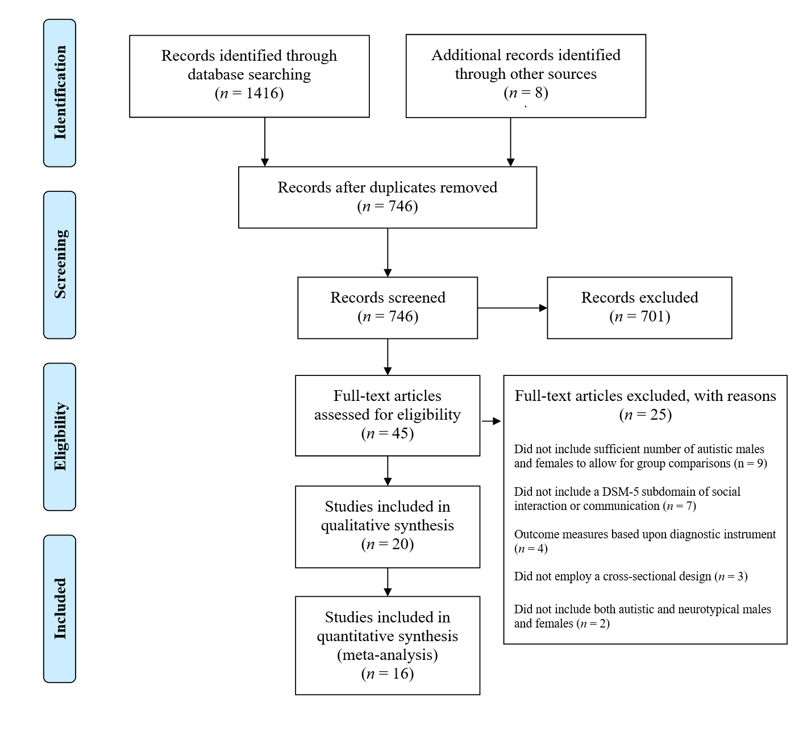
Figure 2
Forest plot for meta-analysis comparing autistic males and females on narrow construct measures of social interaction and communication.
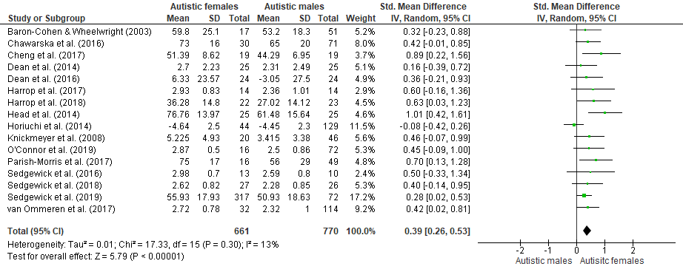

Figure 3
Forest plot and moderator analysis for meta-analysis comparing non-autistic males and females on narrow construct measures of social interaction and communication.
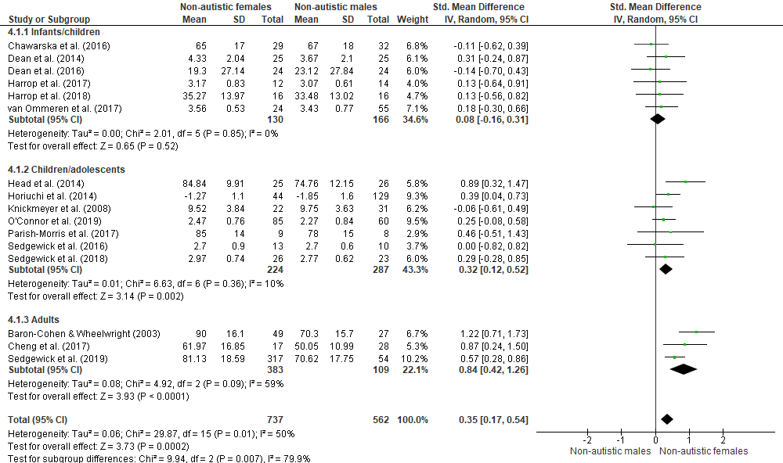

Figure 4
Forest plot and moderator analysis for meta-analysis comparing autistic and non-autistic males on narrow construct measures of social interaction and communication.
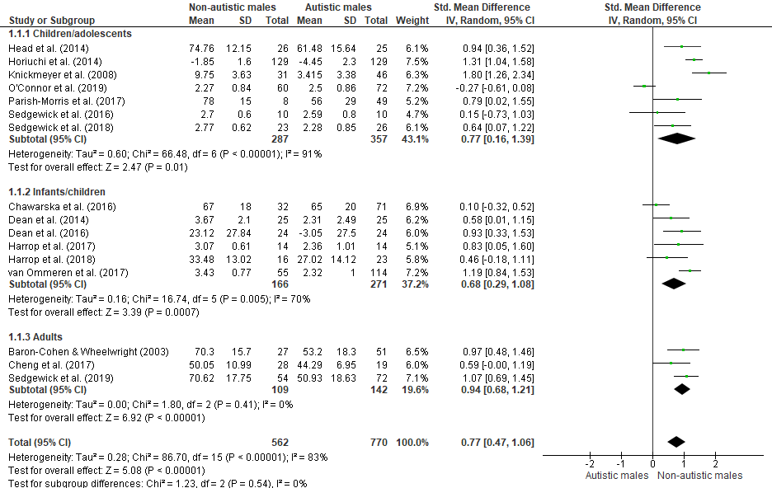

Figure 5
Forest plot and moderator analysis for meta-analysis comparing autistic and non-autistic females on narrow construct measures of social interaction and communication.
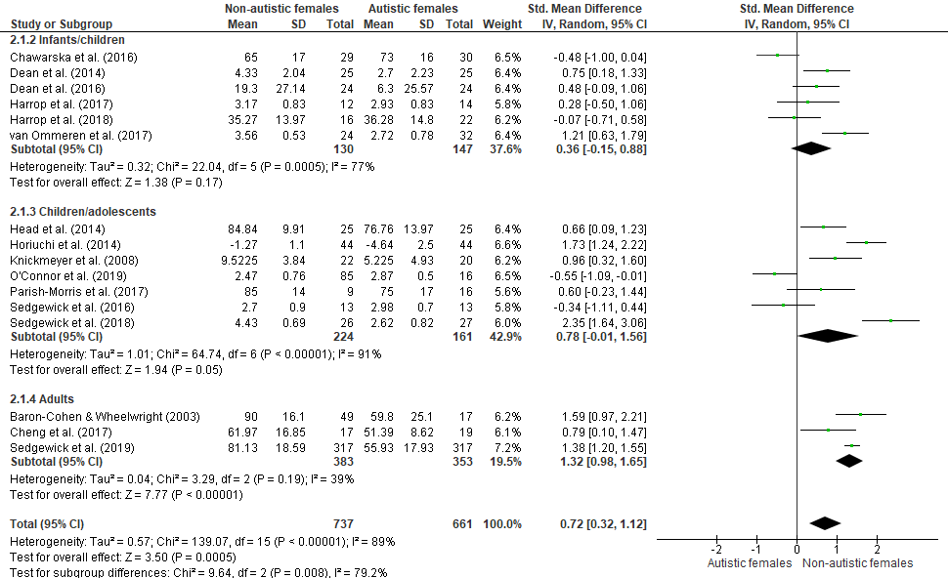

Figure 6
Forest plot and moderator analysis for meta-analysis comparing autistic females and non-autistic males on narrow construct measures of social interaction and communication.
