Semi-quantitative detection of inflammatory biomarkers using a laser-patterned multiplexed lateral flow device
Alice H. Iles*, Peijun J. W. He *, Ioannis N. Katis*, Panagiotis Galanis*, Anto K. John*, Paul Elkington‡, Robert W. Eason* and Collin L. Sones*
* Optoelectronics Research Centre, University of Southampton, SO17 1BJ, U.K.
‡ NIHR Biomedical Research Centre, Faculty of Medicine, University of Southampton, SO17 1BJ, U.K.
Corresponding author. E-mail address: a.iles@soton.ac.uk
Abstract
Inflammatory markers including C- reactive protein (CRP) and procalcitonin (PCT) have been shown to be useful biomarkers to improve triage speeds and prevent the inappropriate use of antibiotics for infections such as pneumonia. Here, we present a novel and exciting solution to guide the administration of antibiotic treatment via rapid, semi-quantitative and multiplexed detection of CRP and PCT using an advanced lateral flow device (LFD) designed to have multiple parallel flow-paths, produced via the precise laser-based partitioning of the single flow-path of a standard LFD. Each flow-path within this multiplexed LFD has a unique detection capability which permits tailored detection of CRP within a predefined cut-off range (20 µg/mL - 100 µg/mL) and PCT above a pre-defined threshold (0.5 ng/mL). We demonstrate the use of this LFD in the successful detection of CRP and PCT semi-quantitatively within spiked human serum samples. This multiplex near-patient assay has potential for development into a rapid triage and treatment of patients with suspected pneumonia.
Keywords: C-reactive protein, procalcitonin, lateral-flow device, multiplexed, semi-quantitative, point-of-care
- Introduction
Currently the lateral flow device (LFD) market is valued at 6.0 billion USD and with a compound annual growth rate (CAGR) of 7.7% it is expected to reach a value of 8.7 billion USD by 2023 {MR, 2018 #327}. LFDs are an attractive solution for point-of-care (POC) testing because they are cheap, easy to use and do not require skilled personnel or expensive equipment to operate. They do have two inherent inadequacies however: most commercially available LFDs are limited in their multiplexing capabilities and are generally designed to detect a single biomarker and furthermore the result presented is largely qualitative {Tsai, 2019 #228}.

Multiplexing, or the simultaneous measurement of multiple biomarkers using a single LFD has significant potential in increasing the diagnostic efficiency {Panhotra, 2005 #240}, and this is even more pertinent when the multiple biomarkers that need to be detected and quantified simultaneously to guide the treatment of a disease are inter-dependent {Corstjens, 2011 #241}. Consequently, the demand for POC multiplexed diagnostic assays has seen a dramatic increase.

The following methodologies have been reported for the implementation of multiplexing with LFDs - lamination (i.e. bringing together) of different individual LFDs {Martinez, 2007 #242;Fenton, 2009 #243;Hong, 2010 #345;Zhao, 2016 #346;Carrio, 2015 #347;Schenk, 2018 #348}; spatial separation of multiple test lines within the same flow-path (biobarcode) {Broto, 2017 #60;Leung, 2008 #58;Serebrennikova, 2017 #215;Fang, 2011 #117;Song, 2014 #330;Zhang, 2009 #331;Wang, 2018 #332;Oku, 2001 #333;Sun, 2018 #334;Zhang, 2018 #335;Li, 2013 #338;Chen, 2016 #339;Taranova, 2013 #340;Gantelius, 2010 #341;Chinnasamy, 2014 #342;Chinnasamy, 2014 #342;Dineva, 2005 #245} or by microarray assays with multiple smaller test sites within a single channel {Taranova, 2013 #340;Carter, 2007 #352;Gantelius, 2011 #353;Gantelius, 2010 #341}. Lamination is a relatively simple method, and reduces the risk of interference between assays, however the costs of fabrication, the test footprint, cassette (LFD housing) and volume of sample required all increase proportionally with the number of tests combined, leading to increased overall cost and processing time {Li, 2016 #344;Hong, 2010 #345}. The spatial separation approach involves the inclusion of multiple test lines and therefore requires little modification to the device architecture. However, the interpretation of the results is challenging due to the proximity of multiple test lines and their interference with each other. This can be mitigated by increasing the distance between the different test lines, but this in turn translates into an increased footprint as for the lamination method. Microarrays allow for more biomarkers to be detected in a smaller test footprint; however, this is at the expense of the tests’ robustness. The smaller detection sites are susceptible to flow variability and subsequent signal generation. Additionally, due to the higher number of detection sites in a small space a reader is required to interpret the results accurately.

Quantitative evaluation of the measured biomarker is known but relies on the use of readers {Li, 2010 #224;Xu, 2019 #351} and such measurement of the biomarker using a LFD, without a reader, is not only a prudent choice for many under-resourced countries across the world but is also a critical requirement. Smartphones are cheaper alternatives to proprietary readers for quantitation of paper-based sensors {Xu, 2021 #350}; however, they still necessitate the use of the same adapted phone model by all end-users, which would not be practical in real-world settings. In addition, specifically designed add-on tools/holders are required to adapt/align the LFD to the smartphone’s camera for imaging. As an example, smartphones could possibly be transformed into LFD readers for rapid, affordable and early detection of pneumonia in a developing nation such as India where pneumonia is the leading cause of mortality in children and accounts for 20% of the deaths {Pandey, 2020 #303}. However, as late as 2018 only 26% of the Indian population had a smartphone and this was only projected to rise to 31.7% in 2020 {Silver, 2019 #304}.

C-reactive protein (CRP) is a generic inflammatory biomarker which can be elevated from the healthy levels of <8 μg/mL to over 500 μg/mL in response to an infection {Black, 2004 #218}. As LFDs require only a small sample volume, a minimally invasive finger prick for blood is sufficient for the measurement of CRP. High concentrations of CRP in the bloodstream, though indicative of an underlying issue, cannot identify a specific condition or disease. A quantitative measurement instead provides valuable information for the diagnosis and treatment of a disease. As an example, for patients with suspected pneumonia the National Institute for Health and Care Excellence (NICE) in the U.K. specify the following treatment guidelines: where CRP ≤ 20 µg/mL, no antibiotics should be given; for CRP ranging between 20 µg/mL and 100 µg/mL, a delayed prescription should be provided at a later date if their symptoms do not improve; if the level of CRP is ≥ 100 µg/mL then antibiotics should be given immediately.

In addition to CRP, blood serum procalcitonin (PCT) is a useful marker that can guide the initiation and duration of an antibiotic treatment because PCT offers good sensitivity in differentiating between bacterial and viral infections. PCT has also been approved by the US FDA for guiding treatment of pneumonia as when measured in healthy patient serum it ranges from <0.1 ng/mL to 0.5 ng/mL {Meisner, 2014 #127}, but increases above 0.5 ng/mL during a systemic infection {Le Bel, 2015 #183;Lee, 2013 #125;Schuetz, 2012 #126;Simon, 2004 #247}. Furthermore, the levels of PCT can also be used as an antimicrobial stewardship tool for respiratory infections with levels above 0.5 ng/mL indicating a very likely bacterial infection {Harbarth, 2001 #248;Lee, 2013 #125}. In addition, the levels of PCT have been shown to have predictive power of disease prognosis and likelihood of hospitalization for community acquired pneumonia as well as death {Holm, 2007 #296;Keramat, 2018 #297}. Patient serum PCT levels, at hospital admission, have a strong association with their APACH II score, which is an ICU mortality prediction score {Hedlund, 2000 #298}. Although these are not the only biomarkers associated with pneumonia, there is abundant evidence to support their use to influence treatment and patient care when compared to other less significant markers such as IL-6, which are also mentioned in the literature {Toikka, 2000 #299}.

We have previously reported the use of LFDs with parallel flow-paths (as described in this manuscript) to circumvent these multiplexing-related limitations {He, 2018 #167}. Our multiplexing technology maintains the overall device footprint to that of a standard LFD and therefore not only maintains the size of the required sample volume, but also saves money on the reagents, cassette (housing), packaging, and shipment of the devices, with each LFD costing less than $1. Herein, we extend the multiplexing concept reported by He et al {He, 2018 #167}, to demonstrate, for the first time to our knowledge, a reader-less, multiplexed, semi-quantitative detection, on a LFD, of two inflammatory markers, CRP and PCT, using multiple parallel channels created within a single LFD.

- Materials and methods

2.1 Materials
The fluidic channels in the multiplexed LFD were fabricated within backed nitrocellulose membrane purchased from Sartorius (UniSart CN95). The membrane’s thickness is 240-270 µm and has an average pore size of 0.45 µm and a capillary speed that ranges from 65-115 s/40 mm. The absorbent pads were cellulose-based filter papers from GE Healthcare (CF4). For the CRP assay the capture antibody deposited at the test line was recombinant human C-reactive protein expressed in E. Coli (Sigma Aldrich C1617). The biotinylated anti-CRP detection antibody used was obtained from R&D systems (BAM17072). The antibody used to produce the control line was an anti-mouse goat IgG from R&D Systems (AF007). The streptavidin-conjugated gold nanoparticles (AuNPs), 40 nm, 10 OD, were obtained from Abcam (ab186864). The BSA and PBS used in the solutions were obtained from Sigma Aldrich (A2058, P3813). The capture and detection antibody for the PCT assay and the analyte were from the Human Procalcitonin DuoSet ELISA kit from R&D systems (DY8350). The antibody used at the control line was donkey anti-sheep IgG antibody from R&D systems (BAF016). The samples were prepared using sterile filtered human serum obtained from Sigma Aldrich (H4522).

2.2 Assays

2.2.1 Sandwich immunoassay
Although there are several immunoassay formats that can be implemented on LFDs the two most commonly used are the sandwich assay and the competitive assay {Koczula, 2016 #219}, and their general principles of operation can be seen in Figure 1B. For the sandwich immunoassay format, a monoclonal antibody is deposited onto the nitrocellulose membrane creating the test line and a further non-specific antibody is deposited to constitute the control line. The conjugate mixture contains the detection antibody bound to a colored signaling label, commonly a gold nanoparticle. When the sample is added to the conjugate mixture the analyte biomarker (PCT in this case) in the sample will bind with the labelled antibody. This is then introduced to the LFD and when this complex reaches the test line the analyte will bind to the pre-deposited antibody at the test line creating a sandwich of two antibodies with the biomarker bound in-between. As the detection antibody is labelled, the result can be visualized by the appearance of a colored test line. In the simplest format the presence of the test line indicates a positive result. The control line will appear in every test and the absence of this line indicates a void test. In the sandwich format, the color intensity of the test line is proportional to the concentration of biomarker in the sample.

2.2.2 Competitive immunoassay
The competitive assay format can be preferable when the concentration of the analyte of interest is high as it is less sensitive. For this assay, as shown schematically in Figure 1B, the biomarker (an antigen, CRP) is pre-deposited onto the membrane to produce the test line instead of a capture antibody. The biomarker (also CRP in this case) in the sample then directly competes with that antigen for binding to the tagged detection antibody. In the absence of the biomarker (CRP) in the sample, the gold-tagged detection antibody will bind directly with the immobilized antigen on the test line thereby producing a strong signal, and therefore in this case, the test line color intensity is inversely proportional to the concentration of biomarker in the sample. The usual control line is also present to validate that the test has worked correctly. Here we have utilized the competitive assay format to overcome the Hook effect which can result from a wide physiological range as with CRP {Kaiser, 2018 #328;Oh, 2014 #166}.

In this paper we present the implementation of immunoassays for CRP and PCT on a single LFD for the semi-quantitative detection of these markers for potential use for rapid POC triaging of pneumonia. To our knowledge this is the first report of semi-quantitative and multiplexed detection of pneumonia-related markers using an LFD, without the need of a proprietary test reader. This novel lateral flow device has three parallel channels in the nitrocellulose membrane section of the LFD. Channel 1 and channel 2 are for the detection of CRP: the detection cut-off value of channel 1 is 20 µg/mL while that of channel 2 is 100 µg/mL, and this allows for the semi-quantitative measurement of CRP using a competitive immunoassay. Channel 3 is for the detection of PCT, specifically with a cut-off of 0.5 ng/mL and uses a sandwich immunoassay format.

For this initial development work, we optimized a device without a conjugate pad. LFDs are often developed without the sample and conjugate pad during a research-phase study, and these are added later for the development of a commercial product. While developing this LFD, the use of a simpler device geometry is purely to save resources, as the need for large amounts of detection antibody dried onto the conjugate pad can make the development work prohibitive to undertake.
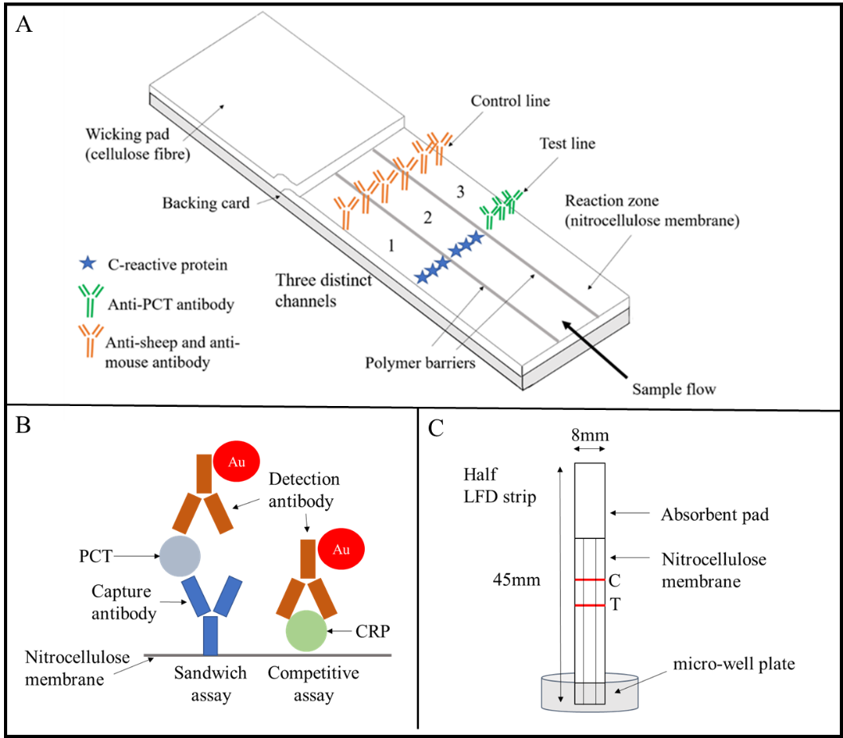

Figure 1 –Shows the schematic and details of A) A LDW-patterned three-channel multiplexed LFD created for simultaneous detection of CRP and PCT, B) The binding mechanisms associated with the sandwich and competitive assay used for the PCT and CRP assays respectively. C) The procedure used for testing, involving dipping the half LFD in a sample contained within a micro-well plate.

Initially the detection of CRP and PCT was investigated separately using individual single channel LFDs 2 mm in width and 45 mm in length. The CRP assay was developed in the competitive assay format whereas the PCT test used the sandwich assay format. The capture molecule (either CRP or anti-PCT antibody) was locally deposited to form a test line on the nitrocellulose membrane of a single-channel LFD. The test and control line deposition was performed using a XYZ3210 dispense platform from Biodot (Irvine, CA, USA) which allows for precise and consistent antibody distribution. Finally, the LFDs were left to dry at room temperature overnight.

2.3 LFD design and fabrication

2.3.1 Laser direct-write patterning
To combine the two assays and produce one compact multiplexed LFD (schematically described in Figure 1A) we have used a previously demonstrated laser direct-write (LDW) approach {Galanis, 2020 #250;He, 2015 #236;He, 2015 #91}. We have already shown the versatility and usefulness of this LDW technique in the patterning of diagnostic devices in porous materials such as cellulose {C. L. Sones , 2014 #221;He, 2016 #300} and nitrocellulose membranes {He, 2015 #91}. We have shown that we can create impermeable barriers that do not allow liquid to migrate across the channels therefore eliminating cross-reactivity {He, 2015 #236}. The schematic in Figure 2 describes the laser patterning protocol. A liquid photopolymer is first locally deposited onto the paper substrate with a deposition nozzle at locations pre-defined by the device design, and in this case of a multiplexed LFD, this is in the form of straight lines that extend along the length of the nitrocellulose membrane. A laser beam subsequently follows the deposition head and illuminates the deposited line pattern(s) thereby inducing photo-polymerization of the polymer, transforming it into a fully solidified polymeric wall that extends throughout the full depth of the membrane. The polymerized line patterns (with ~500 µm width) define the fluidic wall(s) that serve as impregnable demarcating barriers that define the boundaries of two parallel channels and serve to confine and transport the liquids within the channels of the paper devices. The speed used for deposition of the polymer lines on the paper substrate was 50 mm/s and the laser speed used to illuminate (and thereby polymerize) the polymer was 50 mm/s. A time delay of 15 seconds was introduced between the deposition of the polymer and the illumination by the laser light, to allow for the polymer to extend throughout the thickness of the nitrocellulose membrane. We had previously optimized these parameters to ensure complete penetration of the polymer within the nitrocellulose membrane and full polymerization of the polymer structures. The fabrication conditions including the photopolymer deposition speed, the laser scanning speed and the time delay that we used for the device processing herein are sufficient to fully polymerize the photopolymer producing impermeable polymeric structures. The photopolymer used was Desolite 3471-3-14 from DSM Desotech, Inc., Elgin, IL, USA, which is an acrylate-based photopolymer with a viscosity of 10,000 mPa·s at 25°C. The laser used for the LDW patterning process was a 405 nm continuous wave diode laser (MLDTM 405 nm, Cobolt AB, Stockholm, Sweden) with an output power of 60 mW. The dispensing platform used for the deposition of the photopolymer onto the nitrocellulose membrane was a PICO® PµlseTM system from Nordson EFD, UK.

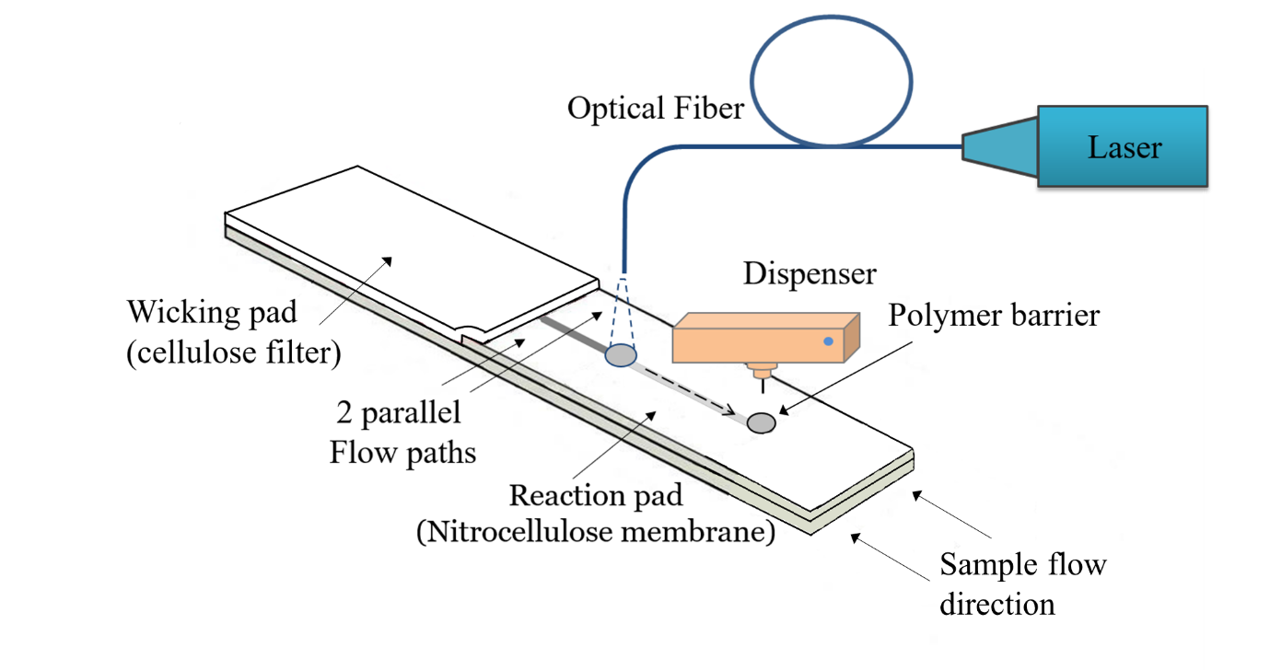
Figure 2 – Schematic of LDW patterning of a lateral flow device used to create two parallel flow channels.
2.3.2 Device assembly
Firstly, the components (cellulose wicking pad and LDW-patterned nitrocellulose membrane reaction pad) of the lateral flow devices were prepared and then assembled onto a backing card for stability ensuring appropriate (2-3 mm) overlap between these components for uninterrupted fluid movement. The devices were then cut to size using a CM5000 guillotine cutter (Biodot). To evaluate the LFD, it was dipped into a mixture of the sample, the detection antibody and the streptavidin-modified 40 nm AuNPs in the wells of a 96-well microtiter plate as shown in Figure 1C. The LFD was then left to stand for 3 minutes until the solution in the well had been wicked into the device all the way to the end of the absorbent pad. The device was finally dipped into 20 µL of PBS solution for another 5 min to allow the rest of the unbound reagent to be wicked through to the reaction pad, thereby minimizing or eliminating any background color that might develop across the device.

2.3.3 Results analysis
Although the test does not require the use of a reader, the intensities of the test line were measured during the initial development stage, using a scanner (Epson Perfection V800 Photo A4 Flatbed Scanner). The images captured using the scanner were processed with the ImageJ software (National Institutes of Health, USA) to extract the respective red color intensities produced at the test lines. Using the RGB function the program measures the mean color intensity of the pixels at the test line and the color intensity value for the control device was subtracted from the measured value to account for any background.

2.4 Calculation of Limit of Detection
The LOD was calculated as per the equations below {Tholen, 2004 #261}:
LoD = LoB + 1.645σs
Where the limit of the blank (LoB) is defined as:
LoB = µB +1.645σB
Here the μB is the mean LFD signal color intensity value for the negative control samples, and σB is the corresponding standard deviation, and σs is the standard deviation for the lowest detectable concentration. The corresponding concentration and associated 95% confidence intervals were then calculated using the fitted curve.
- Results
3.1 Standard CRP LFD
The initial experiments conducted were aimed at optimizing the single channel CRP LFD with the competitive assay format for specific detection values to align with the NICE diagnostic guidelines for pneumonia. As the required detection range for CRP is 0-100 µg/mL and the upper limit is a relatively high concentration, after initial experimentation it was decided to implement the competitive assay format to eradicate issues of the Hook effect on the test result {Amarasiri Fernando, 1992 #230;Vashist, 2018 #231}. Initially, we trialed different types of nitrocellulose membranes; CN95, CN140 and CN180, which all have different capillary speeds. As the aim of this assay was to raise the detection limit of the test in order to tailor the test for specific detection capabilities, the fastest membrane, CN95 was selected. The raised LOD was also achieved by changing the concentration of CRP deposited at the test line. The concentration of CRP deposited at the test line ranged from 100 µg/mL - 1 mg/mL, and 100 µg/mL was found to be the lowest concentration where a test line was still visible. At 250 µg/mL the test was only able to detect values above 20 µg/mL of CRP in the sample, and therefore this value was chosen as the capture concentration for the first channel. Different sample volumes were investigated during the initial experimentation and 1 µL was found to produce the best differentiation between the two LFDs to allow for a clear distinction in concentrations. The LFD for a detection limit of 20 µg/mL, seen in Figure 3A, was produced with a capture antigen concentration of 250 µg/mL of CRP at the test line. As shown in Figure 3A the first set of LFDs can only detect quantities of CRP in the sample above 20 µg/mL, indicated by the absence of a visible test line for the three LFDs on the right of this image. The second set of LFDs were optimized with a capture concentration of 1 mg/mL, and as seen in Figure 3B these LFDs can only detect values ≥100 µg/mL meaning the concentration of the analyte must be at least 100 µg/mL for the test to detect it via the non-appearance of a red colored test line. The higher concentration of antigen at the test line creates more competition for binding and therefore increases the limit of detection of the test. Both tests were optimized to operate with 1µL of sample to reduce further optimization needed when combining the channels. For the conjugate mixture, the AuNPs stock (40 OD) was firstly diluted in a volumetric ratio of 1:15 v/v using 0.5% Tween 20 in PBS. The final conjugate mixture was prepared by mixing this AuNP dilution with the detection antibody (5 µg/mL) in a volumetric ratio of 2:1 v/v. 10 µL of this conjugate mixture was used for testing a single LFD.

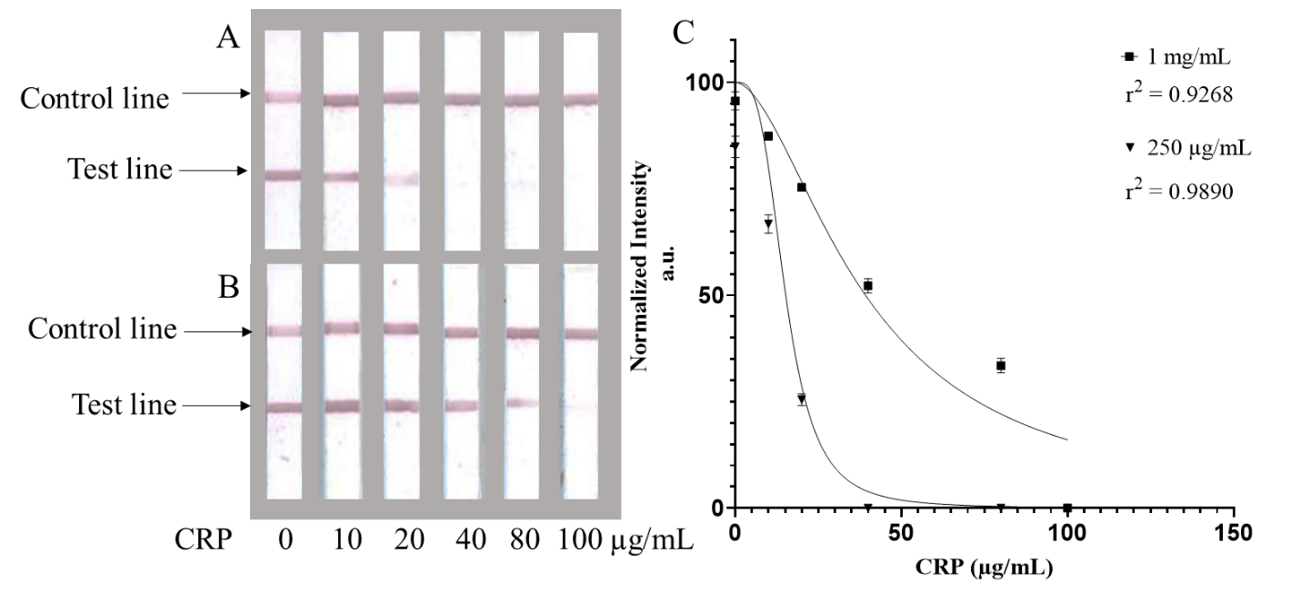

Figure 3 – Scanned images showing the nitrocellulose membrane section of six standard single channel CRP LFDs that implement a competitive CRP assay. The capture concentration of CRP deposited at the test line for all six devices shown in 3A) was 250 µg/mL and for devices in 3B) was 1 mg/mL. The respective analyte CRP concentrations in the sample are labelled below each device and shows that with an increase in the analyte CRP concentration the intensity of the test line decreases. For devices with a higher capture concentration in 3B a test line is visible only up to 80 µg/ml compared to only 20 µg/ml for devices with a lower capture concentration in 3A because of higher competition between the analyte CRP and the CRP at the test line. C) Shows a calibration curve of five repeat measurements for LFDs created with both 1 mg/mL and 250 µg/mL capture CRP concentrations; mean and error bars represent the relative standard deviations.

The non-linear, [inhibitor] vs normalized response – variable slope analysis indicated a good strength of relationship between the concentration of CRP in the sample and the test line intensity for both capture concentrations and in addition the relative standard deviation is small, suggesting precise and repeatable results. The sensitivity of test A was determined to be 20 µg/mL ± 3 µg/mL and for test B was 100 µg/mL ± 5 µg/mL.
3.2 Dual channel CRP LFD
Once the two individual single channel LFDs had been optimized, they were combined using the LDW technique into a dual channel single strip LFD as seen in Figure 4.

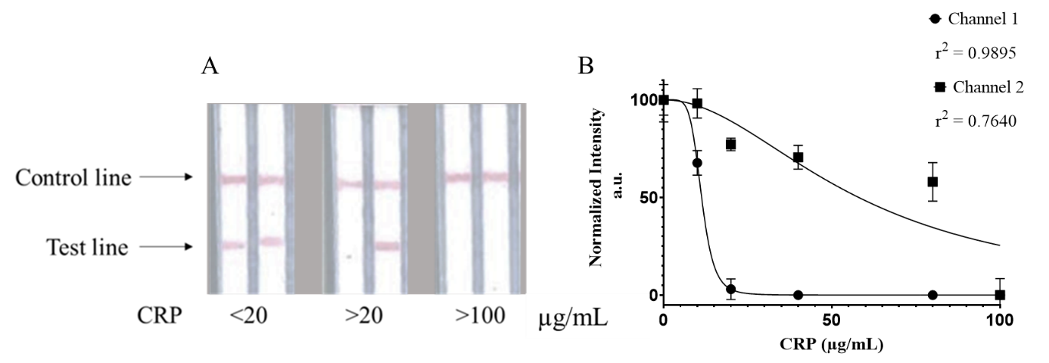
Figure 4 – A) Scanned images of the nitrocellulose membrane section of three dual channel CRP LFDs with a laser-patterned polymer line/wall separating the two adjoining channels. The capture concentration of CRP deposited at the test line was 250 µg/mL for the left channel and 1 mg/mL for the right channel and the analyte CRP concentration used to test these is shown below each device. The semi-quantitative determination of the analyte CRP concentration is inferred by the number of visible test lines present on the device. B) Calibration curve of five repeat measurements for both 1 mg/mL and 250 µg/mL capture concentrations; the mean and error bars represent the relative standard deviations.
The same capture concentrations from the single channel LFDs were used but now the two channels run in parallel while separated by the polymer barrier. The dual channel device utilizes the same reagents. The antigen was deposited into the channels at concentrations of 250 µg/mL and 1 mg/mL respectively, hence enabling the two channels to have different cut offs at 20 µg/mL and 100 µg/mL. The interpretation of the results is clear and can be analyzed quickly. Where both test lines are visible, the tagged detection antibody has bound to the capture CRP indicating that the concentration of CRP in the sample is less than or equal to 20 µg/mL; where only the second channel has a visible test line present, the concentration is greater than 20 µg/mL but must be less than 100 µg/mL; finally, the absence of any visual test line in either channel indicates that the concentration of CRP in the sample must be at least 100 µg/mL as it has bound all the tagged detection antibody leaving none remaining to bind at the test line. Figure 4B shows the calibration curve with its relative standard deviation and the small size of the error bars show that the measurements are precise and repeatable. After undergoing non-linear regression analysis, the dual channel LFD channels had an r² value of 0.9895 and 0.7640 respectively for the assays in the two channels. There is a strong relationship between the test line intensity and the CRP concentration in the sample after combining the channels.
3.3 Standard PCT LFD
Alongside the development of the single and dual channel LFDs for CRP detection, a successful single channel LFD for the detection of PCT was also developed. A sandwich immunoassay format was used to design this single channel LFD, constructed to only detect PCT concentrations of 0.5 ng/mL and above. The AuNPs were used in a ratio of 2:1 (v/v) to the detection antibody, the concentration of which was set at 3 µg/mL, determined after detailed optimization experiments. The capture antibody was initially tried at different concentrations between 100 µg/mL and 1 mg/mL to assess the detection capabilities for each concentration. After optimization, the capture antibody was set at 1 mg/mL and this allowed for the detection of PCT down to 0.5 ng/mL but any values below this would not be detected by the LFD. This was designed to keep the detection limits within the clinically relevant range for pneumonia triaging. Figure 5 shows such example LFDs with detection of different concentrations of PCT ranging from 0 ng/mL to 50 ng/mL. The limit of detection was found to be 0.5 ng/mL, and this can be seen in Figure 5 as below this concentration no visible test line is produced as in the case of the last two devices on the right of this image.
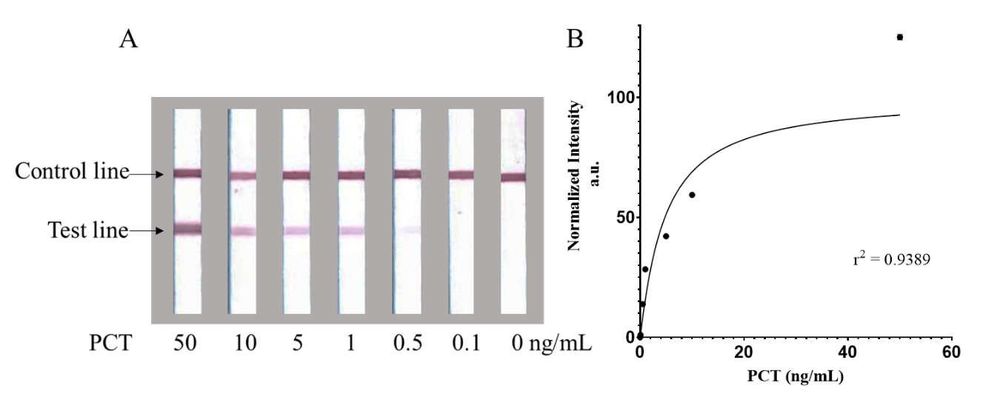
Figure 5 – A) Scanned images of the nitrocellulose membrane section of eight single channel LFDs showing the detection of PCT with concentrations ranging from 50 to 0 ng/mL B) Calibration curve showing the relationship between the normalised intensity of the test line and the PCT analyte concentration in the sample, for five repeat measurements.
After statistical analysis the LOD of the single LFD for PCT was found to be 0.54 ng/mL (95% CI of 0.117 ng/mL to 1.031 ng/mL). After undergoing non-linear regression, dose-response [agonist] vs normalized response – variable slope, it shows good strength of relationship between the concentration of PCT in the sample and the test line intensity and the relative standard deviation error bars are small which indicate good precision of data and repeatability. All statistical analysis was conducted in GraphPad Prism and is available in the supplementary data file.
  - Combined multiplexed semi-quantitative test for CRP and PCT
The final stage of the multiplexed test development involved combining the dual channel CRP LFD with the single channel PCT LFD for the simultaneous and semi-quantitative detection of CRP and PCT. To ensure the control line would appear in every channel, both the anti-goat and anti-mouse antibodies used for the PCT and CRP assays respectively were combined and deposited at the control line. It was then necessary to optimize the volume of the different reagents needed for a three-channel test. Channel 1 has a capture antigen concentration of 250 µg/mL for a cut-off of 20 µg/mL for CRP and channel 2 has a capture concentration of 1 mg/mL for the cut-off of 100 µg/mL for CRP. Finally, channel 3 has a capture concentration of 1 mg/mL for a cut-off value of 0.5 ng/mL for PCT. The final conjugate mixture was set to constitute 20 µL of AuNPs diluted at 1:15 and 5 µL of anti-CRP detection antibody (5 µg/mL) and 10 µL of anti-PCT detection antibody (3 µg/mL).

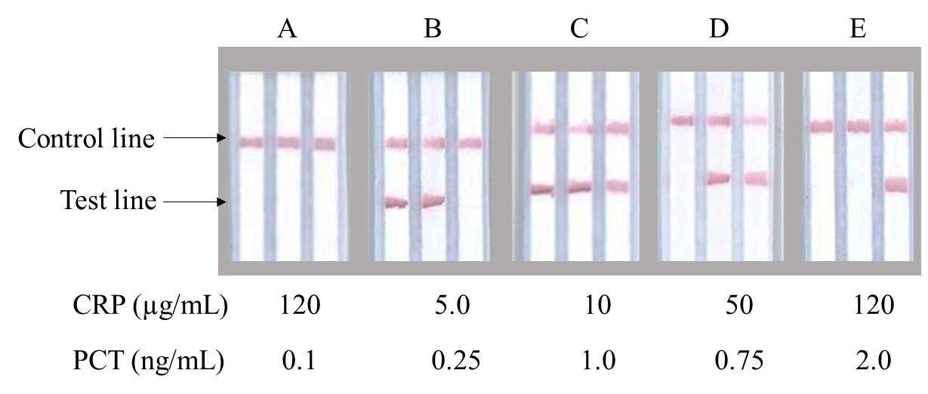
Figure 6 –Scanned images of the nitrocellulose membrane section of 5 multi-channel LFDs that measure both CRP and PCT within adjoining parallel flow channels created using the LDW patterning procedure. The first two channels from the left measure CRP while the last on the right measures PCT. The respective CRP (µg/mL) and PCT (ng/mL) concentrations in the samples used to test these devices in A -E are labelled below.

The final multiplexed LFD can be seen in Figure 6. These multi-channel devices measure both CRP and PCT within parallel flow-paths that were created using the LDW technique. The three-channel multiplexed device provides a clear and unambiguous result for the concentration range of the analytes present in the sample. As seen in Figure 6A-E there is a clearly visible control line in each of the three channels of the LFDs, indicating that the testing has worked correctly in all cases. For the LFD in Figure 6A there are no visible test lines in any of the three channels, and this indicates the sample had a concentration of CRP greater than or equal to 100 µg/mL and a concentration of PCT below 0.5 ng/mL. Figure 6B shows an LFD with visible tests lines in the first two channels. This indicates that the concentration of CRP in the sample is less than or equal to 20 µg/mL and no visible test line in the third channel means the concentration of PCT is less than 0.5 ng/mL. For the LFD in Figure 6C with visible test lines in all three channels, the CRP concentration is less than or equal to 20 µg/mL and that for PCT is at least 0.5 ng/mL. Figure 6D shows an LFD with no visible test line in the first channel indicating that the CRP concentration is greater than 20 µg/mL; however, test lines in the second and third channel indicate that the concentration of CRP is less than 100 µg/mL and that for PCT must be at least 0.5 ng/mL. Finally, for the LFD in 6E, the first two channels have no visible test lines and therefore the CRP concentration is greater than 100 µg/mL and PCT is at least 0.5 ng/mL.
There was found to be no cross-reactivity between CRP and PCT, and further evidence and results can be found in the supplementary data file.

- Discussion

The key to successful pneumonia treatment is quick and accurate diagnosis, facilitated by rapid POC testing that can be performed at the patient’s bedside. Currently, the available technology is insufficient to cater for the complexity of pneumonia triage, which requires both multiplexed biomarker detection and quantification. The results we present here show clear potential to fill the gap within this research field, especially in low resource countries where pneumonia is a huge problem and healthcare facilities are limited.

As we have shown in this study, a simple single 3-channel device - one channel for PCT detection and two for CRP with different capture concentrations is sufficient for rapid diagnosis of these two highly relevant biomarkers. The tests showed excellent correlation between the test line color intensity and the biomarker concentration in the sample for the relevant clinical concentration ranges, and this provides the necessary confidence and level of evidence that a single test delivering multiple separate results is of real value in the diagnostic sector.

Of critical importance is the fact that the above can be implemented with a straightforward LDW patterning technique in which multiple independent tests can be performed with no cross-reactivity or interference, and this was the motivation for undertaking this research for application to the area of pneumonia diagnosis in this case. The presented results clearly demonstrate that: 1) the control line appears in every channel independently of the result for the test line. 2) each channel acts as an individual, single LFD and the results in one channel are not affected by those in the adjacent channels. 3) the use of human serum for the experiment which increases the chance of successful transfer of the LFD from the laboratory to clinical use. Human serum is a complex matrix with multiple components and here we have demonstrated the capability of the LFDs to detect within this complex matrix without any cross-reactivity.

Although we presented results for a partial LFD (without the conjugate pad), the next step for this research would be the introduction and optimisation of the conjugate pad to complete the test. After initial testing with human serum in the laboratory it is our ambition to validate the complete test with patient samples for the diagnosis of pneumonia.
- Conclusion
In conclusion, we have presented a novel strategy for the multiplexed and semi-quantitative detection of the inflammatory markers CRP and PCT using parallel flow channel within LFDs. We have successfully developed and demonstrated a dual channel LFD that allows for the detection of CRP, below 20 µg/mL, above 20 µg/mL and above 100 µg/mL, as per the NICE guideline, defining the clinically relevant range for pneumonia. We have concurrently reported the development and demonstration of a single channel LFD that measured PCT down to a cut-off of 0.5 ng/mL, providing a rapid testing pathway that allows distinguishing between viral and bacterial causative agents. Combining these two markers into a single POC diagnostic test that can be used by healthcare professionals would not only improve the speed and accuracy of treatment for patients with pneumonia but would also assist in the campaign for prudent antimicrobial stewardship. Finally, as a proof of principle, we have successfully developed a multiplexed LFD for the detection of both CRP and PCT for use in future pneumonia triage. The multiple parallel flow-paths within the multichannel CRP-PCT LFD allows for not only the individual detection of different analytes but also their detection at different concentrations without any cross-interference. We believe this LFD has an excellent potential as a diagnostic tool. Future work will be required for the clinical validation of this test to triage patients with suspected pneumonia and determine the effect on outcome and antibiotic use.
Conflicts of interest
There are no conflicts to declare.
Acknowledgements
The authors acknowledge the funding received via the Engineering and Physical Sciences Research Council (EPSRC) Grant Nos. EP/N004388/1, EP/P025757/1 and EP/M027260/1. The underpinning RDM data for this paper can be found at https://doi.org/10.5258/SOTON/D1560
References

