**IMPACTS OF WEATHER VARIATION ON GLOBAL CROP YIELDS AND FOOD SECURITY**

Paolo Agnolucci(1), Chrysanthi Rapti(1), Peter Alexander(2), Vincenzo De Lipsis(1), Robert A. Holland(3,4), Felix Eigenbrod (4), Paul Ekins(1)

1. Institute for Sustainable Resources, University College London
2. School of Geosciences, University of Edinburgh
3. School of Biological Sciences, University of Southampton
4. School of Geography and Environmental Sciences, University of Southampton

**ABSTRACT**

Agriculture is exposed to weather variation, with implications for food security, land allocation, trade and economic activity. Understanding the impact of changes in temperature and precipitation on crop yields is a vital step in developing policy and management options to feed the world over the coming century. As the current literature has focused on a few staple crops, we implement global statistical models to examine the influence of weather and management practices on yields of 18 crops, accounting for 70% of crop production by area and 65% of calorific intake. We focus on the impact of temperature and find considerable heterogeneity in the responses of yields across crops and countries, by identifying winners and losers from warming trends. Irrigation is found to alleviate negative implications from temperature increases. Countries where increasing temperature cause the most negative impacts are typically those which are the most food insecure, having the lowest calorific food supply and the lowest crop yield. Our results suggest that, in these countries, it will be important to co-ordinate international actions to raise yields through improvement and modernization of agricultural practices to counteract future adverse impacts of climate change.

**Authors’ contributions**

* All authors developed the research methodology
* Paolo Agnolucci, Vincenzo De Lipsis and Chrysanthi Rapti collected the data collection and computed the variables used in the estimation
* Paolo Agnolucci and Chrysanthi Rapti implemented the estimation
* All authors contributed to writing up results

# INTRODUCTION

As part of the 17 UN Sustainable Development Goals (UN SDG), governments have agreed a target to end hunger and ensure access to sufficient, nutritious food by 2030 for the 850 million people globally who are classified as undernourished (UN 2015). Given their interlinked nature (Nilsson et al. 2016), failure to reach this target risks undermining many other SDGs. Achieving food security represent a significant challenge, bearing in mind increases in global population, rising levels of affluence, a shift towards diets consumed in OECD countries, and climate change (Alexander et al. 2016, Fujimori et al. 2019, Pastor et al. 2019, Stehfest et al. 2019). Indeed, the global food production system is particularly vulnerable to climate change, directly through the impact of temperature and precipitation (Agnolucci and De Lipsis 2019, Challinor et al. 2014), and indirectly through competition for land for negative emissions technologies and afforestation (Fuss et al. 2016, Holland et al 2019).

As the effect of climate change on crop yield is an established concern for global food security (Lobell and Asseng 2017), the impact of historical variation in weather has provided valuable insights (Challinor et al. 2014, Lobell et al. 2011, Schauberger et al. 2017, Moore and Lobell 2015), with both process-based and statistical models reaching similar conclusions about the impact of future climate (Liu et al 2016, Lobell and Asseng 2017 and Moore et al. 2017). As the current literature has focused on a few staple crops, there is an identified need to broaden our understanding across a wider range of crop types (Ciscar et al. 2018). The current study makes a substantial contribution by implementing statistical modelling to assess the impact of weather variation on crop yield for 18 crops. The empirical literature has primarily focused on the weather impact six major crops specifically wheat, maize and soybeans (Lobell et al. 2011, Lobell and Field 2007 and Schauberger et al. 2017), rice (Lobell et al. 2011, Lobell and Field 2007), barley (Moore and Lobell 2014, 2015 and Schauberger et al. 2017) and sugar beet (Moore and Lobell 2014, 2015). Our analysis extends this to include cassava, cotton, groundnuts, millet, oats, potatoes, pulses, rapeseed, rye, sorghum, sunflower and sweet potatoes. Together these crops represent 70% of the global crop area (Monfreda et al. 2008) and around 65% of global calorific intake. We extend the approach of Lobell et al. (2011) by modelling a much wider set of crops and accounting for additional factors affecting crop yield, including pesticides, fertilisers and irrigation, to provide insights into the role of agronomy in ameliorating the impacts of changing climate (Rockström and Falkenmark 2015). We focus discussion on the effect of temperature, as the empirical relationship of crop yield with temperature is much better understood than with other weather factors (Lobell and Asner 2003) and, in some cases, temperature was found to be the predominant factor in explaining crop yield variability (Lobell and Burke 2008).

# RESULTS

**MARGINAL IMPACT AND OPTIMAL GROWING CONDITIONS.** We estimated an inverted U-shaped relationship between temperature and crop yields for all 18 crops, with the values for the optimal temperature reflecting credible conditions of crop production (Table SI1). Statistical significant estimates for precipitation are harder to achieve, also reflecting previous results (Lobell and Tebaldi 2014, 2018). In 10 out of the 18 crops assessed in this study, an increase of 10 mm in precipitation induces a decrease in the yields, evaluated at the global mean, while in the remaining crops the impact is positive. Analysis of the impact of a 1°C rise on the set of 12 crops rarely assessed in the literature demonstrate that the majority of countries growing cassava, cotton, groundnuts, millet, oats, pulses and rye experience negative impacts from a 1°C increase in temperature. However, in this novel set of 12 crops, those with the highest levels of global consumption tend to be positively affected by a 1°C increase in temperature (potatoes, sweet potatoes, rapeseed and sorghum). Quite importantly considering the focus of the discussion below on existing level of productivity and food security, three crops widely consumed in developing countries tend to be either positively affected (sorghum and sweet potatoes) or suffer a small reduction in the yield (cassava) in presence of a 1°C increase. It is worth mentioning that the marginal effect described here assumes no changes in other factors when in reality, changes in temperature are likely to occur in presence of changes in other factors, such as precipitation. In some case, changes in temperature considered here could imply lack of analogue historical climatic conditions, as discussed by Pugh et al (2016), with increased uncertainty in relation the computed impact, as extrapolation occurs outside of the sample used in the estimation.

Our results support the role of adaptation in global agriculture, as we demonstrate that agricultural management practices such as irrigation can ameliorate the negative impacts on crop productivity. Pesticides and fertilisers are generally found to enhance crop productivity. The use of pesticides has a positive impact on the yield of about half of the crops in our sample, i.e. potatoes, pulses, rice, sugar beet, sunflower, sweet potatoes and wheat. Use of fertilisers contribute to increasing yields of sugar beet, sunflower and sweet potatoes. The impact of pesticides and fertiliser is modelled through a linear approximation without allowing for interaction with other factor such as temperature.

Figure 1 illustrates the functional relationship between crop yield of temperature, using one of this novel crops, cassava, as an example, in countries with low (black curve) and high irrigation (red curve). The curves are obtained by assigning value zero to the non-temperature variables in Table S1 (except irrigation), as using a different value for those variables would affect only the level of the yield but not the shape of the yield-temperature relationship. In the figure one can observe the gently sloping curves implying a relatively small variation in the marginal effect of temperature, i.e. the first derivative of the red an black curves. In fact, the impact of a 1°C increase in temperature across the globe varies between -3% and 1% in both the low-irrigated and high irrigated-countries. Irrigation allows higher optimal temperature, i.e. the vertex of the parabolas in the figure. These are about 26°C in countries with high levels of irrigation compared to about 20.5°C in the remaining countries.

Estimated optimal temperatures tend to occur near the global mean of a number f crops, see graphs in column A of Figure 2, implying that warming temperatures will deliver, at least initially, beneficial increases in the yield in some of the growing countries. The number of countries benefiting from temperature rises however decreases with the size of the rise, as more and more countries are pushed beyond the optimal level of temperature. A more detailed presentation of our results from the estimation of statistical crop yield models can be found in the Supplemental Information.



**Figure 1**. Functional relationship between temperature and crop yield of cassava . The red dots indicate the global mean (middle point) and the points which are 4°C colder and warmer than the global mean. The marginal effect of temperature increasing 1°C is indicated at these three points in column A of Figure 2. The functional relationship is indicated by the red curve when irrigation is low, and the black curve when irrigation is high.

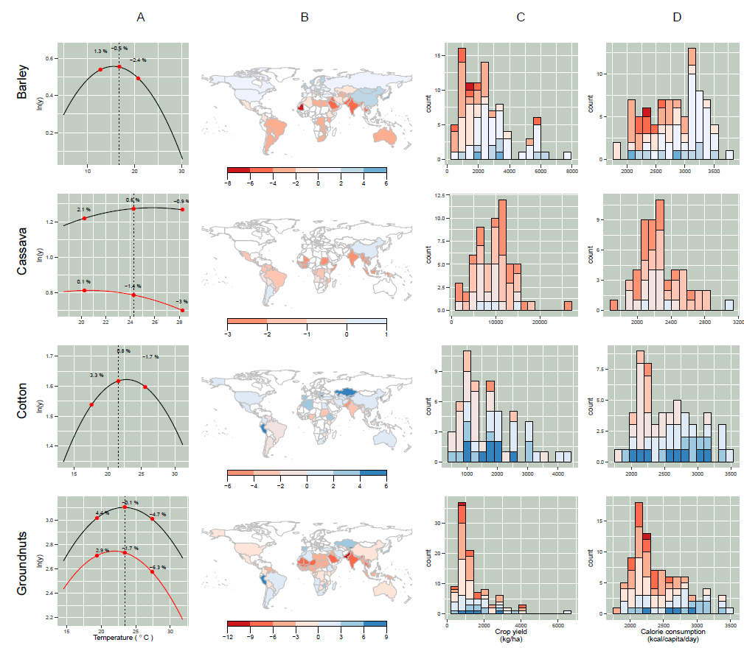

**Figure 2a**. **Column A**: Functional relationship between level of temperature and yield for the crops assessed in this study. The global temperature mean computed over 1986-2012 in the countries cultivating a specific crop is indicated by the central dot and vertical dashed line. The other two dots indicate temperatures 4 °C warmer and 4 °C colder than the global mean. The percentage next to the dots indicate the marginal effect, as explained in Figure 1. **Column B**: geographical distribution of the marginal effect related to a 1°C temperature rise. The colours indicate the percentage change in the crop yield for a country expected as a consequence of a change in 1°C. The range of the colour scale reflects the marginal sensitivity to temperature estimated in our study. **Column C**: frequency distribution of crop yield (kg/ha) by country with the marginal effect of 1°C temperature. For each point in the bars of the histogram, the colour points out the value of the marginal effect by using the colour scale in column B. **Column D**: frequency distribution of crop yield (kg/ha) by average calories intake (kcal/capita/day), using the same colour scheme as the one described for graphs in column C.

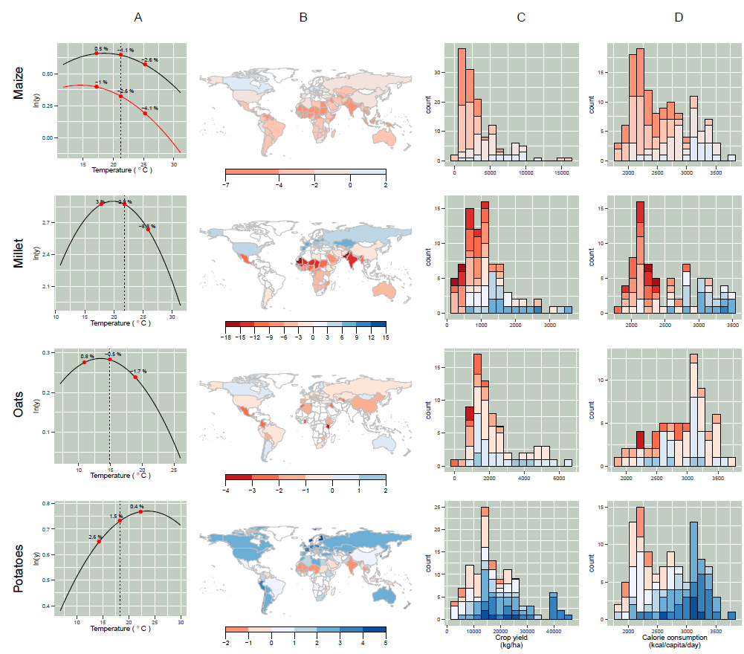

**Figure 2b**. Functional relationship between temperature and crop yield (column A), country-level marginal effect of temperature (column B), and distribution of country-level marginal effect by crop yield and calories consumption (column C and D respectively). More details can be found in the caption of Figure 2a.

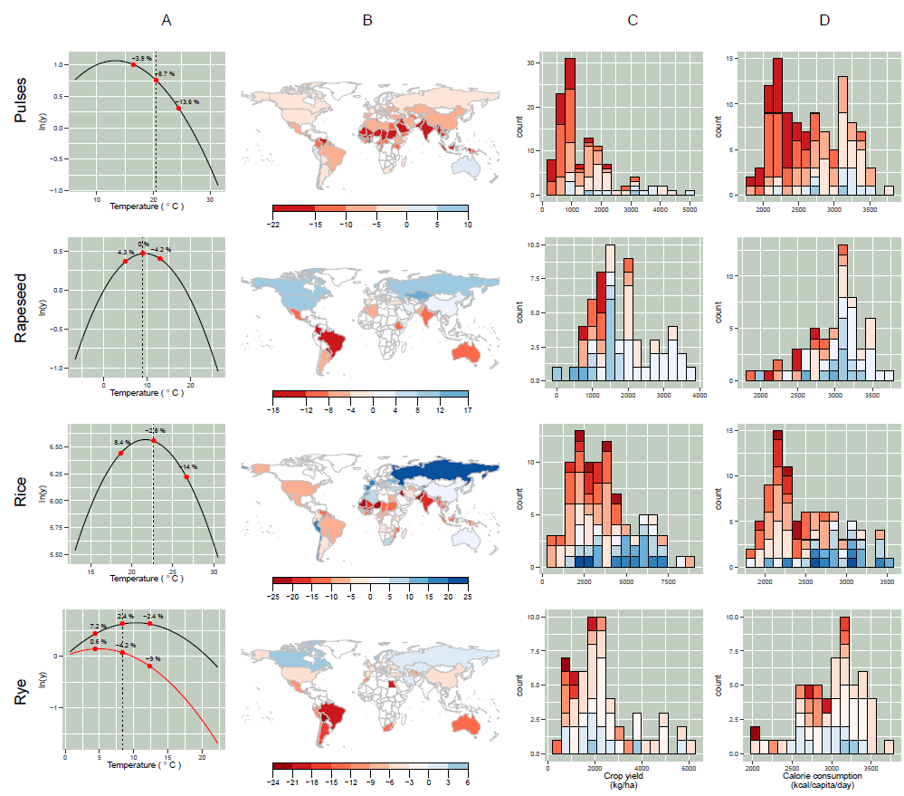

**Figure 2c**. Functional relationship between temperature and crop yield (column A), country-level marginal effect of temperature (column B), and distribution of country-level marginal effect by crop yield and calories consumption (column C and D respectively). More details can be found in the caption of Figure 2a.

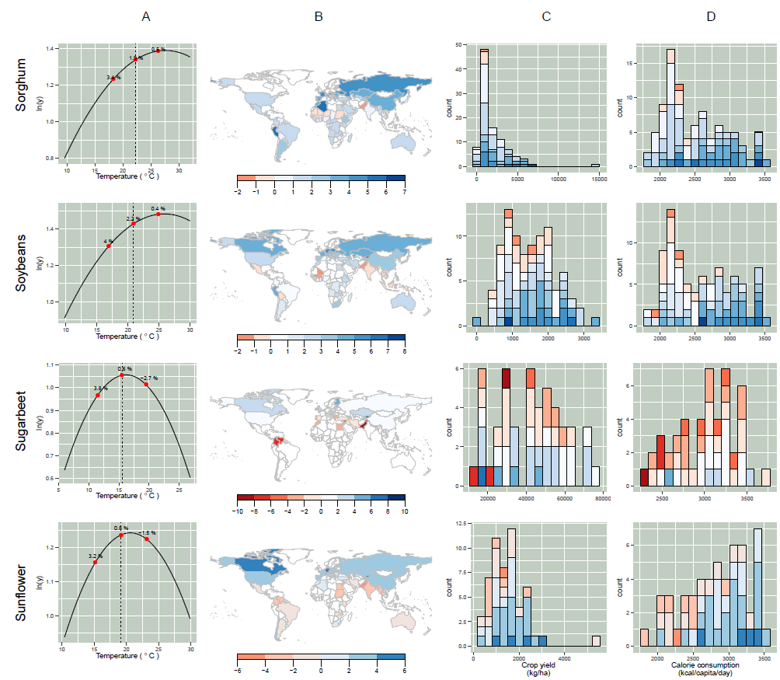

**Figure 2d**. Functional relationship between temperature and crop yield (column A), country-level marginal effect of temperature (column B), and distribution of country-level marginal effect by crop yield and calories consumption (column C and D respectively). More details can be found in the caption of Figure 2a.

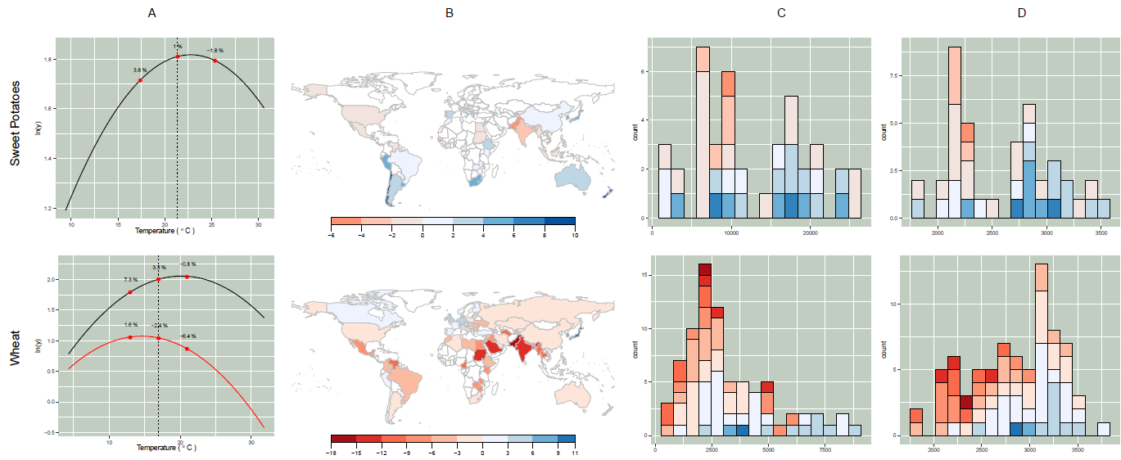

**Figure 2e**. Functional relationship between temperature and crop yield (column A), country-level marginal effect of temperature (column B), and distribution of country-level marginal effect by crop yield and calories consumption (column C and D respectively). More details can be found in the caption of Figure 2a.

**HETEROGENEOUS MARGINAL IMPACT OF TEMPERATURE ACROSS THE GLOBE.** Major crops tend to be negatively affected by a 1°C increase, as a 2.8%, 2.6% and 2.4% decrease in the yield is estimated for rice, maize and wheat, when evaluated at the global mean temperature of each crop. Yield of potatoes and soybeans, on the other hand, increases by 1.5% and 2.2%. Comparison of marginal effect at the global mean is reductive as the effect of temperature varies across countries, as discussed in the Supplemental Information. Winners and losers from raising temperatures can be identified by evaluating the marginal effect of 1°C increase from the mean observed in each country over the 1986-2012 sample (see Methods). The maps in column B of Figure 2 clarify that most countries are negatively (red countries) instead of being positively affected (blue countries). Maize, oats, pulses and wheat are widely impacted by rising temperatures, as yield decreases in almost all countries while potatoes, sorghum, soybeans and sugar beet overall benefit from rising temperatures. The plots in column B of Figure 2 also show the sensitivity of different crops to increases in the temperature. Ranges as wide as 30 percentage point can be observed in the case of millet, pulses, rapeseed, rice ad rye. Conversely, cassava, oats and potatoes are among the crops least affected by a 1°C increase, with the range of marginal impact being under 10% percentage points in all cases. However, crops with a highly diverse marginal impact of temperature tend have a much smaller range for the great majority of countries where crops are grown. As an example, the range of the marginal impact in 80% of the countries where rice is grown is only half the width shown in Figure 2.

**IMPACT ON FOOD SECURITY AND PRODUCTIVITY**. The wide productivity differences across countries will be exacerbated by rising temperatures, unless corrective action is taken. We explore this by assessing the relationship between prevailing yield and the marginal effect of temperature, as shown in column C of Figure 2. The highest positive marginal effects are quite scattered throughout the distribution of crop yield, while the most negative impacts tend to be in countries, such as those in sub-Saharan Africa, that have not benefited from the green revolution (Oladele et al. 2016). This is particularly strong in the case of barley, maize, millet, pulses, rice and wheat. A similar pattern can be observed in the case of the relationship between the daily intake of calories and the marginal impact of temperature – see column D of Figure 2, as most of the countries which are worst affected by warming temperatures have very low daily calorific intake. This is a concerning finding, as the countries with the worst level of food security (as measured by the daily intake of calories) are also worst affected by rising temperature.

# DISCUSSION

**CROP DEPENDENCE ON TEMPERATURE AND AGRONOMIC PRACTICE.** Weather variables significantly contribute to yield variability for the 18 crops studied here, confirming results from existing global studies focusing on a maize, rice , soybeans and wheat (Frieler et al 2017; Lobell and Tebaldi 2014 and Lobell et al. 2011). Potato, the most widely produced non-grain crop in the world, sorghum and soybeans were found resilient to moderate increases in temperature, confirming previous results in the case of soybeans (Araji et al. 2018). Estimated models show the importance of irrigation in determining the impact of weather variables across countries for a number of the crops modelled in this study. In five of the modelled crops, irrigation implies higher optimal temperatures and more positive impact of rising temperatures, confirming studies focused on the USA, such as Li and Troy (2018), Schauberger et al. (2017) and Troy et al. (2015). Irrigation can affect crop transpiration through maximising the functioning of the stomata, enhancing photosynthetic and yield efficiency (Fara et al. 2019), contain evapotranspiration demand related to heat stress (Lobell et al. 2013) and have cooling effects on the canopy temperature, reducing the impact of heat and drought stress on crop yield (Siebert et al. 2014). Some producers facing negative impact of temperature, e.g. Israel and Greece, have invested in irrigation, so that the effects of rising temperatures would have been worse without such schemes. Expansion of irrigation may be possible in some cases but in many countries, notably in Africa, expansion of land under irrigation is impractical or impossible (Rockström and Falkenmark 2015) but alternative options for the management of rainfall (e.g. through collection and soil management) exist and should be integrated into agricultural policy where appropriate (Rockström and Falkenmark 2015).

Countries with very low yields use a low amount of pesticides and fertilisers, while highly productive countries tend to consume higher than the average pesticides and fertilisers. In the case of wheat, for example, the yield in the 10 countries with the highest level of pesticides (4,177 kg/ha) is more than double the level (1,857 kg/ha) observed in the 10 countries with the lowest consumption. As pesticides and fertilisers have a strong effect in a number of crops, some of the difference in the yield across countries could be closed by increasing their use, although this may be associated with other environmental challenges. We observe that high use of fertilisers and pesticides may serve to even out the effect of management intensity across countries and called upon to compensate for decreases in the yield brought about by rising temperatures. Although not explored in this study, interaction between marginal impact of temperature and use of fertilisers and pesticides should be urgently addressed by empirical studies. As an example, Schlenker and Lobell (2010) found that the marginal effect of temperature is lower in African countries with low use of fertilisers. Similarly, as rising temperatures facilitates the diffusion of pests (see Deutsch al 2018 and Delcour et al 2015 for a more general review of the impact of climate change on pesticides), marginal impact of weather can be influenced by the level of pesticides. In both cases, future research should explore the suitability of non-linear functions, for example to consider decreasing marginal gains from the application of chemical inputs, or interact them with other factors such as temperature, rather than adopting the linear approximation discussed here. The level of pesticides and fertilisers could in principle proxy for other aspects of management such as mechanisation or advanced cultivars but only if the timespan of these factors is correlated to the time pattern of fertilisers or pesticides in a significant number of countries used in this study. This is probably not very likely to happen.

**ADDITIONAL ADAPTATION OPTIONS.** Development of crop varieties matched to not only current conditions but also those likely to develop in the coming decades is an area of substantial current research interest (Evenson 2003). Notably in Africa, which contains a great share of the countries worst affected by rising temperatures, the green revolution has been harder to establish due to a broad range of environmental and socio-economic factors (Oladele et al 2016). The yield of maize in the USA was found less sensitive to extreme heat days in hotter climates (Butler and Huybers 2013), results showing that response to temperature can be substantially reduced by the choice of cultivars. On the other hand, a trade off between the level of the yield and the robustness to heat has also been found in new varieties (Tack et al 2015). Associated with higher environmental or economic costs, increased use of agricultural chemicals and expansion of cropping area are obvious routes to addressing issues of food security, as it would decrease reliance on imports for countries challenged by food security. Certainly, from the environmental perspective these routes are problematic, and could be counterproductive in terms of the global communities’ ability to meet the UN SDGs.

With regard to changing growing season, early planting dates failed to increase the US yield of maize, millet and wheat (Ko et al. 2012), but higher yields of US maize could be obtained if high planting rates are combined with delayed planting dates (Carter et al. 2018). This seems an area where further research is urgently required, especially taking into consideration the impact of changing one crop’s planting and harvest dates on the crops which are planted after its harvest. Crop switching is another factor potentially reducing the impact of rising temperatures on crop yield. Negative welfare impact arising from the climate scenarios for Africa in 2100 could fully be counteracted by switching crops (Kurukulasuriya and Mendelsohn 2008). Qualitative studies focusing on specific locations however point out obstacles to crop switching, primarily influenced by economic, political, and social rather than climate factors (Mertz et al. 2009). Benefits arising from crop switching can be highly crop-dependent even when assessed for the same location (Gorst, Dehlavi and Groom 2018). The diversity in terms of marginal impact of temperature increases across crops discussed in this study suggests that substituting highly sensitive crops with those resilient to temperature increases is a potential adaptation to rising temperatures. Bearing in mind that this process would take place across countries, it may severely impact the diversity of crops used in agriculture . This is an aspect which should be assessed as a matter of urgency by empirical studies.

Another factor which might help counteract the negative impact of rising temperatures is CO2 fertilisation. C3 crops, i.e. rice, wheat, soybeans, rye, barley, cassava and potatoes, are more sensitive to CO2 compared to C4 crops, i.e. maize, sorghum and sugarcane, with low sensitivity in the latter due to CO2 being already saturated, although increases in transpiration efficiency might occur under dry conditions (Ainsworth et al. 2008, Long et al. 2006). Crop response to elevated CO2 remains the largest source of uncertainty in crop yield studies (Deryng et al 2014), but expected gains have been revised downwards by more credible Free-Air Concentration Enrichment (FACE) studies, compared to earlier work (Leaky et al. 2009). The impact of CO2 fertilisation was found to reduce or disappear under wetter, drier and/or hotter conditions when the forcing variable exceeded its intermediate regime (Obermeier et al 2017). In addition, increasing CO2 is expected to negatively affect the quality of grains by reducing the overall protein content (Taub D et al 2008) and may require large quantities of fertilisers (Long et al. 2006). Incorporating the effects of CO2 in empirical modelling is challenging, as CO2 does not have any spatial variation and changes only slowly across time. A number of potential avenues are discussed in Lobell and Asseng (2017). Introduction of CO2 fertilisation in process-based model is more straightforward but without more clarity on the impact of CO2 from FACE studies, coefficients used in process-based model are likely to be highly unreliable.

**IMPLICATIONS FOR FOOD SECURITY AND PRODUCTIVITY**. Our results on the relationship between impact of rising temperatures and existing level of crop yield considerably extend findings in the literature, presented for a limited number of crops and sometimes using proxy such as latitude (Rosenzweig et al 2014) and GDP (Deryng et al 2014). There are a number of institutional routes to address the impacts of warming temperatures on food security and productivity, although there may be substantial costs or barriers associated with them. These include increasing technology transfer to worst affected countries, and sharing targeted agronomic research. International donors might facilitate this process, and co-ordinated international actions to raise yields through improved agronomic practices and modernization of the agronomic system might be required, while managing the complications which intensification can itself originate (Dalin et al. 2017, Zhang et al. 2015).

This is particularly important in those countries with a prevailing low productivity and inadequate diet which have not benefited fully from the green revolution (Sanchez and Swaminathan 2005). Changing harvesting area is also an important consideration for food security and productivity. Our research can flag the countries which are likely to stop production of a certain crop, those with high marginal negative impact and low productivity. New marginal producers are also likely to start production, i.e. those countries having similar climatic condition to those with the highest positive marginal impact (Alexander e al 2018). Finally, the impact of international trade to help tackling the concerns related to food security should also be urgently explored, bearing in mind that rising temperatures are likely to impact international trading patterns as the absolute advantage to trade change across countries.

**CONCLUSION.** Based on historical variation in weather, crop yield and agronomic inputs we estimated the functional relationship between crop yield and its drivers and assess the impact of warming trends for 18 crops, responding to the call for more evidence in the agricultural and environmental community (Ciscar et al. 2018). This article analyses how marginal effects of temperature differ across crops, suggesting different degrees of resilience to rising temperatures, and countries, therefore identifying winners and losers from warming trends. Several countries with highly negative marginal impact of temperature are also characterized by low crop productivity and low caloric intake. Domestic food supply could be increased through increasing food imports, decreasing exports, or increasing the area of land used for crop production. Further advances in the insights from this article could be obtained through quantification of the relationship between marginal impact, food security and productivity or the creation of a weighted indicators incorporating opportunities and risks related to improved agronomic practice (fertilisers and pesticides), extension of irrigation, options offered by crops switching and changes in the harvest calendar as well as the possibility to move the harvest areas towards more favourable growing conditions. This indicator could be built based on the differences between one country and regional average in order to flag opportunities for improvement in baseline yields and calorific intake.

.

# METHODS

**Overview**. This article models crop yield at country level, as this spatial scale of analysis is predominantly used by studies centred on food security (Grassini et al. 2013). The models described below explore the sensitivity of crop yield to a number of factors, including weather, but also irrigation, and management practices such as the use of pesticides and fertilisers by making use of dataset covering the 1986-2012 time span. The analysis is implemented for 18 crops, namely barley, cassava, cotton, groundnuts, maize, millet, oats, potatoes, pulses, rapeseed, rice, rye, sorghum, soybeans, sugarbeet, sunflower, sweet potatoes and wheat. This set of crops is very exhaustive as it uses all the data (with the exception of yams) available in the gridded crop calendar in Sacks et al. (2010), which is required to compute weather variables as described below. The specification search, which follows the General-to-Specific framework (Hendry and Richard 1982, Hendry et al. 1984, Campos et al. 2005) in terms of modelling approach and the variables used in the model, incorporates considerations related to statistical significance, and therefore to the precision of the estimates, as well as the sign of estimated marginal impacts from agronomic literature and previous studies. The time period used in this article covers at most the years between 1986 and 2012, although the specific start and end years vary across countries and modelled crops. In addition, data for some of the variables used in this study are available for a shorter period of time, as described below. Overall, the time period used in this study is comparable to the timespan incorporated in previous contributions (Lobell et al. 2011, Tebaldi and Lobell 2018, Lobell and Tebaldi 2014, Moore and Lobell 2014, 2015, Schauberger et al. 2017), and judged adequate to study implications of weather factors on crop yields. Countries covered in the dataset vary across crops, reflecting requirements in terms of growing conditions and dietary habits.

**Data**. Crop yield is defined as the harvested production per unit of harvested area with data collected from the online dataset of the Food and Agriculture Organization of the United Nations (FAO), i.e. FAOSTAT Database Agricultural Production. These are annual time series at country level. Weather variables are included in terms of their monthly average weighted across the growing season. Data for irrigation, pesticides and fertilisers are available only for total agricultural activity, e.g. tons of fertilisers used in the agricultural sector as a whole, rather than in the cultivation of a specific crop. In addition, fertiliser data are available for a limited number of countries compared to the set of countries for which crop yield data are available. These are limitations of the available datasets which influence the way in which specification search is implemented, as discussed below.

* Information for **pesticides**, defined as the average use per area of cropland (kg/ha), is taken from FAOSTAT Database Inputs. Annual data are available at the earliest from 1990 onwards for 164 countries, although the actual start year of the dataset varies across countries;
* Data for **irrigation** (area irrigated in hectares) are obtained from the Global Map of Irrigation Areas (GMIA, Siebert et al. 2013) used by FAO's Information System on Water and Agriculture (AQUASTAT). This dataset is available for the year 2005 for 196 countries. We computed irrigated agricultural areas as a percentage of agricultural areas by using agricultural area retrieved from FAOSTAT Database Inputs and we then divided countries into two groups, those with intensive irrigation systems, i.e. countries with more than 10% of their agricultural area being irrigated (a group of 39 countries) and those not characterized by an intensive irrigation systems, i.e. countries with less than 10% of their agricultural area being irrigated (resulting in a set of 157 countries);
* Data for **fertilisers**, taken from IFASTAT of the International Fertilisers Association (IFA), are expressed as consumption (in metric tons) of Grand Total Nitrogen in 2005 for 109 countries. By using cropland information from FAOSTAT Database Inputs, we express consumption of fertilisers per hectare of cropland, so as to obtain data comparable to those available for pesticides;
* The **weather** variables include country-level temperature (measured in °C) and precipitation (measured in millimetres). We follow established practice in the literature (Lobell et al. 2011, Lobell and Field 2007) to construct weather variables by averaging monthly weather observations based on a constant crop growing season (Sacks et al. 2010) and areas where the crop is cultivated (Monfreda et al. 2008). In this way, only weather fluctuations specific to the production of each crop are considered, leading to a precise identification of the impact of temperature and precipitation on yield. This implies combining three different datasets:

1. monthly average of temperature and precipitation on a grid of 30min resolution, collected from the Climate Research Unit of the University of East Anglia (CRU TS v. 3.23, Harris et al. 2014),
2. a map of cropland at 5min resolution (Monfreda et al. 2008) and
3. a crop calendar, which provides the growing season for each crop on 5min resolution (Sacks et al. 2010).

The weather variables correspond to daily (or diurnal) average temperature and total precipitation, by combining monthly anomalies and monthly climatology (see Harris et al. 2014). All crops have one growing season in the crop calendar in Sacks et al. (2010), apart from maize, rice and wheat that have main and secondary season, for which we used the main season, similarly to Lobell et al (2011). The possibility of multiple cropping on the same land plot should not have an impact on the outcome of this analysis, as the focus is the crop yield and not land requirements for cropping.

Our analysis uses country-level datasets, due to the obvious difficulty of accessing global datasets at the sub-country level. The need to use datasets covering multiple countries also influenced our choice of weather variables. As historical hourly weather data are challenging to aggregate across a variety of growing regions (Troy et al. 2015), our study follows established practice of using monthly averages of temperature and precipitation in linear and quadratic terms (Ben-Ari and Makowski 2016,Lobell and Tebaldi 2014**,** Lobell et al. 2011, Moore and Lobell 2015, Schlenker et al. 2006). Such specifications align with the agronomic literature with regard to crops best growing within a range of temperature and precipitation, beyond which weather factors become harmful for production. We pool together all countries growing a specific crop, as previous analyses with specific country groups (Lobell et al. 2011) have shown that the estimated impact of temperature and precipitation is comparable across groupings.

The choice of the time span for this study (1986 to 2012) mirrors other studies in the literature (e.g. Lobell et al. 2011). However, for the models including pesticides, the start year of the sample in this study is 1990 due to data availability. Our analysis covers at most the timespan from 1986 to 2012 to maintain comparability with existing studies (e.g. Tebaldi and Lobell 2018, Schauberger et al. 2017, Moore and Lobell 2014, Lobell and Tebaldi 2014) and across models estimated in this article. We followed the majority of contributions in the literature by adopting panel approaches to benefit from much larger number of data points, dataset incorporating more variation compared to a single time series, ability to control for omitted variables, especially if their variation across time is limited (Hsiao et al., 1995). Estimation is also more straightforward as, from a statistical perspective, there is no need to deal with stochastic or deterministic trends, to the extent to which one need to do if dealing with a single times series. On the other hand, given the global coverage of our dataset and the possibility of large differences in cultivars and agronomic practice between countries, optimal growing condition could vary considerably. Evidence against this possibility has been explored in a dataset similar to the one used in this study by Lobell et al (2011). Subgrouping of countries in the panel was not found to be very influential on the results of their analysis. In addition, optimal temperature in the case of sugar beet provided estimated here are very similar to those we found in a set of single European countries, as part of the follow-up study to as Agnolucci and de Lipsis (2019). It is important to mention that a different location of the optimal temperature does not imply necessarily a change in the value of the marginal effect which is the key metrics in this study, as the marginal effect or a specific country is determined not only by the location of the optimal temperature but also by the curvature of the parabola being estimated.

**Statistical Models**. This study makes use of a comprehensive collection of panel models, with the subscripts $i$ and $t$ indicating country and year respectively). The most general model includes a country-specific quadratic trend $(t, t^{2})$, an individual specific time-invariant component, $α_{i},$ a common time-variant component, $λ_{t},$ as well as a set of observed variables potentially affecting crop yield, included in vector $X_{it}$. This specification, in which $y_{it}$ represents the logarithm of crop yield and $ε_{it}$ a random disturbance, reads as follows:

|  |  |
| --- | --- |
| $$y_{it}=α_{i}+λ_{t}+ρ_{1i}t+ρ_{2i}t^{2}+βX_{it}+ε_{it}$$ | (1) |

In the second-most general model, the common time-variant component, $λ_{t}$ is dropped so that:

|  |  |
| --- | --- |
| $$y_{it}=α_{i}+ρ_{1i}t+ρ_{2i}t^{2}+βX_{it}+ε_{it}$$ | (2) |

while by dropping the country-specific quadratic trend and reinserting common time-variant component, $λ_{t}$, one obtains:

|  |  |
| --- | --- |
| $$y_{it}=α_{i}+λ_{t}+βX_{it} +ε_{it}$$ | (3) |

It is worth noting that coefficients of the quadratic time trends are allowed to differ across countries, while the coefficients of all other components are assumed to be constant across countries, as implemented in Lobell et al. (2011). By including country specific time trends, we aim to account for factors like technological advance or other time-varying features that could possibly influence crop productivities. We capture country-based unobserved effects by estimating models using either fixed effects or random effects; the choice between the two is based on the Hausman test (Hausman 1978).[1] We also estimate models pooling the dataset and providing estimates based on country-specific averages across time (individual between estimator) or time-specific averages across countries (time effects between estimator).

**Set of Explanatory Variables**. In our analysis of the impact of weather factors and management practices on crop yield, the most general set of control variables, $X_{it}^{1}$ includes:

1. temperature and precipitation incorporated in both their levels and their squared terms as in Lobell et al. (2011);
2. an indicator for the extent to which irrigation is deployed in the whole agricultural sector, with the indicator taking a value equal to one for countries with more than 10% of their agricultural area being irrigated and a value equal to zero otherwise. This indicator is interacted with the linear terms of the weather variables, so that temperature and precipitation is allowed to have a different optimal value in countries making extensive use of irrigation;
3. use of pesticides and fertilisers in the whole agricultural sector.

|  |  |
| --- | --- |
| $$X_{it}^{1}=\left[{β_{1}Temp}_{it}^{2}+β_{2}{Temp}_{it}∙Irr_{i}+β_{3}{Temp}_{it}+{β_{4}Prec}_{it}^{2}+β_{5}{Prec}_{it}∙Irr_{i}+β_{6}{Prec}_{it}+β_{7}{Pest}_{it}+β_{8}{Fert}_{it}\right]$$ | (4) |

When the full vector of controls is not used, our attention is primarily focused on the interaction between irrigation and temperature, following recent studies exploring such a relationship (e.g. Schauberger et al. 2017). For this reason, we start dropping the factors related to management practice, i.e. ${Pest}_{it}$ and ${Fert}_{it}$, and only if no viable models are delivered by the search specification below, we drop the impact of irrigation on weather factors, i.e. ${Temp}_{it}∙Irr_{i}$ and ${Prec}_{it}∙Irr_{i}$ so that the set of variables included in the models are respectively:

|  |  |
| --- | --- |
| $$X_{it}^{2}=\left[{β_{1}Temp}_{it}^{2}+β_{2}{Temp}_{it}∙Irr_{i}+β_{3}{Temp}_{it}+{β_{4}Prec}_{it}^{2}+β_{5}{Prec}_{it}∙Irr_{i}+β_{6}{Prec}_{it}\right]$$ | (5) |
| $$X_{it}^{3}=\left[{β_{1}Temp}_{it}^{2}+β_{3}{Temp}_{it}+{β_{4}Prec}_{it}^{2}+β_{6}{Prec}_{it}+β_{7}{Pest}_{it}+β_{8}{Fert}_{it}\right]$$ | (6) |

Finally, the simplest set of explanatory weather variables include only weather factors:

|  |  |
| --- | --- |
| $$X_{it}^{4}=\left[{β_{1}Temp}_{it}^{2}+β_{3}{Temp}_{it}+{β_{4}Prec}_{it}^{2}+β_{6}{Prec}_{it}\right]$$ | (7) |

**Search specification**. We follow the General-to-Specific approach of Hendry and Richard (1982) both in terms of the set of explanatory variables and the statistical models being estimated. With regard to the statistical models discussed above, our methodology goes from the most general to the most specific model, by implementing models

1. with both country-specific quadratic time trends and common time effects, (1) above;
2. only country-specific quadratic time trends, (2) above;
3. only common time effects, (3), and eventually
4. models where data are pooled either across time or countries.

With regard to variables used in the estimation, the set of variables goes from the most general, i.e. $X_{it}^{1}$, to the most specific, i.e. $X_{it}^{4}$. During the search specification, a model is considered to be congruent to the underlying data generating process of crop yield, if

1. relationship between yield and temperature has an inverted-U functional shape;
2. coefficients on pesticides, fertilisers and irrigation indicators are statistically significant;
3. optimal temperature observed in countries with intensive irrigation systems is higher than the optimum in countries where irrigation use is low, and
4. the impact of pesticides on crop yield is positive.

Considering that data for irrigation, pesticides and fertilisers are observed for the agricultural sector as a whole rather than a specific crop, and these variables are available for a limited number of countries and time periods compared to the crop yield and weather datasets, condition 2) above is adopted so that these variables are retained only if they contribute to explaining the crop yield in a statistically significant fashion. We therefore use statistically significance to discern whether variables observed for the whole agricultural sector can be used as a proxy for the impact of intensification and management practices for the specific crop at hand, therefore tackling the limitation that crop-specific fertilisers, pesticides and irrigation data are not available at least at global scale. As further criteria to discern sensible impact of irrigation and pesticides we require optimal temperature observed in the countries with intensive irrigation systems to be higher than the optimal level in countries where irrigation use is low, based on evidence in Schauberger et al. (2017) – see condition 3 above. A positive relationship between the use of pesticides and protection of crop quality and yield is well established (Popp et al. 2013) so that we explicitly require coefficient on pesticides being positive – condition 4. On the other hand, evidence on the relationship between the use of fertilisers and crop yield is less conclusive (Lassaletta et al. 2014) so that we do not impose a similar requirement on the coefficient of fertilisers.[2] Condition 1) above arises from the fact that it reflects a plausible assumption for the growing conditions of crops; an assumption arising in economic studies (Deschênes and Greenstone 2007) and increasingly used in the econometric crop yield literature (e.g. Lobell et al. 2011, Moore and Lobell 2015, Tebaldi and Lobell 2018) to indicate that crops are benefited by moderate weather changes while are damaged under extreme circumstances. The effect of precipitation is harder to identify compared to the temperature effect, with precipitation coefficients being not statistically significant in studies like Lobell and Tebaldi (2014). Also climate models disagree on the sign of precipitation (Christensen et al. 2007), as sign of the uncertainty surrounding the impact of this factor n the yield. For this reason, we do not assume condition 1) for precipitation, with our procedure limited to dropping the quadratic term when the coefficient is positive.

Our search specification is therefore as follows:

1. We run each statistical model described above with the set of variables in (4) and assessed the suitability of the estimated models, i.e. the $N + P + I + W$ models in Figure3 (where $N, P, I, W$ stand for Nitrogen/Fertilisers, Pesticides, Irrigation and Weather respectively), based on the conditions above
2. If none of the models satisfies the search criteria above, we simplify the set of control variables by estimating the $(I + W)$ models, the $(N + P + W)$ models dropping either $N$ or $P$ if one contradicts conditions above, and the $W$ models in Figure4, in this order
3. As soon as the applicable requirements are met we stop the search procedure and select the final model. This occur in the case of all crops.

Models delivered by this search specification are comparable to those in the literature when assessed based on the amount of variation in the crop yield explained by the models. For instance, our adjusted $R^{2}$ is 57% and 35% for maize and sorghum, which compares well with the 47% and 29% in Lobell and Field (2007).

**N + P + I + W models**

**I + W models**

**N + P + W models**

**W models**

**Figure 5**. Relationship between the set of explanatory variables used in this study. $N + P + I + W$ models indicate models incorporating $X_{it}^{1}$ above; $I + W$ models incorporating $X_{it}^{2}$; $N + P+ W$ models incorporating $X_{it}^{3}$; and $W$ models incorporating $X_{it}^{4}$.

**Marginal effect and optimal level of weather factors**. For the final models identified through the search specification described above, we computed the optimal level of each weather factor, taking into account interaction with the irrigation dummies. In the case of temperature, as an example, the optimal temperature for countries where irrigation use is deemed negligible can be computed as $V_{TEMP}=-\frac{β_{3}}{{2β}_{1}},$ whereas for countries using high irrigation, the optimal level is equal to $V_{TEMP-IRR}=-\frac{{(β}_{2}+β_{3})}{{2β}_{1}}$. For each model, we compute the coefficient of determination $\left(R^{2}\right)$ with and without adjusting for the variables used in the regression. Standard errors robust to heteroscedasticity and serial correlation are estimated to assess the significance of the coefficients in the models.

In addition, for each model we compute the effect of temperature and precipitation in relation to a change of 1°C and 10 mm. As we estimated a quadratic relationship, the effect varies across the level of the weather factor at which the effect is computed. As an example, the impact of a 1°C temperature increase starting from the level T0 for countries where irrigation use is deemed negligible can be computed as:

$${ME}_{TEMP}^{1°C}={2β}_{1}+β_{3}T_{0}$$

while for countries using high irrigation, the impact of a 1°C temperature increase is equal to:

$${ME}_{TEMP}^{1°C}={2β}_{1}+\left(β_{2}+β_{3}\right)T_{0}$$

The impact of temperature increase different from 1°C is simply equal to ${TE}_{TEMP}^{1°C}$ multiplied by any specific increase in temperature. Table SI1 reports the marginal effect evaluated at the global mean, observed over the 1986 and 2012. In Table SI1, we also present the impact observed in correspondence of a change in temperature and precipitation equal to the average standard deviation, computed by averaging the standard deviation observed in each country in the sample used in this study, so as to obtain a global average of the standard deviation of the weather factors observed in each country . In terms of the functional relationship, this has been computed at the global mean.

**Code availability**

The scripts used in the preparation of the dataset, the estimation of the models and the production of the figures displayed in the paper is available in the following Github repository [**ADD WHEN READY**]

# REFERENCES

Agnolucci, P., De Lipsis, V. Long-run trend in agricultural yield and climatic factors in Europe. *Climatic Change* (2019). https://doi.org/10.1007/s10584-019-02622-3

Ainsworth, E. A., Leakey, A. D. B., Ort, D. R. and Long, S. P. (2008) “FACE-ing the facts: inconsistencies and interdependence among field, chamber and modeling studies of elevated CO2 impacts on crop yield and food supply, *New Phytologist*, 179, 5-9.

Alexander, P., Rabin, S., Anthoni, P., Henry, R., Pugh, T. A. M., Rounsevell, M. D. A., & Arneth, A. (2018). Adaptation of global land use and management intensity to changes in climate and atmospheric carbon dioxide. *Global Change Biology*, *24*(7), 2791–2809. <https://doi.org/10.1111/gcb.14110>

Alexander, P., Brown, C., Arneth, A., Finnigan, J. Rounsevell, M.D.A. (2016) “Human appropriation of land for food: the role of diet”, *Glob. Environ. Chang*., 41 (2016), pp. 88-98.

Araji, H.A., Wayayoka, A., Bavani, A.M., Amiri, E., Abdullah, A.F., Daneshian, J., Teh, C.B.S., (2018), “Impacts of climate change on soybean production under different treatments of field experiments considering the uncertainty of general circulation models”, *Agric. Water Manag*. 205.

Asseng, S, Ewert, F, Martre, P et al. (50 more authors) (2015) “Rising temperatures reduce global wheat production”, *Nature Climate Change*, 5 (2). pp. 143-147.

AQUASTAT (2016), Main Database, Food and Agriculture Organization of the United Nations (FAO).

Ben-Ari, T. and Makowski, D. (2016) “Analysis of the trade-off between high crop yield and low yield instability at the global scale”, *Environmental Research Letters*, vol. 11, no 10.

Butler, E. E. and Huybers, P. (2013) “Adaptation of US maize to temperature variations”, *Nature Climate Change*, 3, 68-72.

Campos, J., Ericsson, N., R. and Hendry D. F. (2005) “General-to-Specific Modelling: an overview and selected bibliography” *International Finance Discussion Papers*, 835, Board of Governors of the [Federal Reserve System](https://en.wikipedia.org/wiki/Federal_Reserve_System).

Carter E. K., Riha, S. J., Melkonian, J. and Steinschneider, S. (2018) “Yield response to climate, management, and genotype: a large-scale observational analysis to identify climate-adaptive crop management practices in high-input maize systems”, *Environmental Research Letters*, 13, 114006.

Christensen, J. H., Hewitson, B., Busuioc, A., Chen, A., Gao, X., Held, R., Jones, R., Kolli, R. K., Kwon, W., K., Laprise, R., Magana Rueda, V., Mearns, L., Menendez, C., G., Räisänen, J, Rinke, A., Sarr, A. ,Whetton, P., Arritt, R. ,Benestad, R. ,Beniston, M. ,Bromwich, D. , Caya, D. , Comiso, J. , de Elia, R. and Dethloff, K. (2007) “Regional climate projections” , *Climate Change*: The Physical Science Basis. Contribution of Working group I to the Fourth Assessment Report of the Intergovernmental Panel on Climate Change, University Press, Cambridge, Chapter 11, ISBN: 978-0-521-88009-1.

Challinor AJ, et al. (2014) “A meta-analysis of crop yield under climate change and adaptation”, *Nature Climate Change* 4(4):287–291.

Ciscar, J., Vanden, F., K. and Lobell, D., B. (2018) “Synthesis and Review: an inter-method comparison of climate change impacts on agriculture”, [*Environmental Research Letters*](https://iopscience.iop.org/journal/1748-9326), vol. 13, no 7.

Cook, B., I., Puma, M., J. and Krakauer, N., Y. (2011) “Irrigation induced surface cooling in the context of modern and increased greenhouse gas forcing”, [*Climate Dynamics*](https://link.springer.com/journal/382), vol. 37, issue 7-8, pp 1587-1600.

Dalin C., Wadas Y., Kastner T., Puma M. J. (2017) “Groundwater depletion embedded in international food trade”, *Nature*, 543, 700-04.

Delcour, I., Spanoghe P. and M. Uyttendaele (2015). Impact of climate change on pesticide use, [Food Research International](https://www.sciencedirect.com/science/journal/09639969) 68, Pages 7-15

Deschênes, O., and Greenstone, M. (2007) “The Economic Impacts of Climate Change: Evidence from Agricultural Output and Random Fluctuations in Weather”, *American Economic Review*, 97,354–85.

Deryng, D, Conway D., Ramankutty N., Price, J. & R. Warren (2014). Global crop yield response to extreme heat stress under multiple climate change futures, *Environmental Research Letters* 9. DOI: 10.1088/1748-9326/9/3/034011

Deutsch, C. A., Tewksbury J. J. et al (2018) Increase in crop losses to insect pests in a warming climate. Science 361: 916-919, : 10.1126/science.aat3466

Evenson, R.E. and Gollin, D. (2003) “Assessing the Impact of the Green Revolution, 1960 to 2000”, *Science*. vol.300 (5620):758–62.

FAOSTAT (2018), The Food and Agriculture Organization of the United Nations (FAO).

Fara, S. J., Delazari, F. T., Gomes, R. S., Araújo, W. L. and da Silva, D. J. H. (2019) “Stomata opening and productiveness response of fresh market tomato under different irrigation intervals”, *Scientia Horticulturae*, 255, 86-95.

Frieler, K. et al. (2017), Understanding the weather signal in national crop-yield variability, Earth’s Future, 5, doi:10.1002/2016EF000525

Fujimori, S. et al (2019) “A multi-model assessment of food security implications of climate change mitigation”, *Nature Sustainability*, pages386–396 (2019)

Fuss S, et al. (2016) Research priorities for negative emissions. *Environ Res Lett* 11(11):115007

Gorst A, Dehlavi A, Groom B (2018) Crop productivity and adaptation to climate change in Pakistan. Environ Dev Econ 23:679–701

Grassini, P., Eskridge, K., M. and Cassman, K., G. (2013) “Distinguishing between yield advances and yield plateaus in historical crop production trends”, *Nature Communications*, vol.4, no. 2918.

Harris, I., Jones, P., D., Osborn, T., J. and Lister, D., H. (2014) “Updated high resolution grids of monthly climatic observations—the CRU TS3.10 dataset”, *International Journal of Climatology*, vol. 34, pp 623–642.

Hausman, J., A. (1978) “Specification tests in econometrics”, *Econometrica*, 46 (6), pp. 1251--1271.

Hendry, D. F. and Richard, J., F. (1982) "On the Formulation of Empirical Models in Dynamic Econometrics", *Journal of Econometrics*, 20, 1, pp. 3-33.

Hendry, D.F., Pagan A. R., and Sargan, J. D. (1984) “A Dynamic specification”, Ch. 18 in Z. Griliches and M.D. Intriligator eds., *Handbook of Econometrics*, vol. 2, Amsterdam, North Holland.

Holland R.A., Scott K., Agnolucci P., Rapti C., Eigenbrod F., Taylor G. (2019) The influence of the global energy system on terrestrial biodiversity, Proceedings of the National Academy of Sciences, forthcoming

IFASTAT (2018), International Fertilizer Association (IFA).

Ko, J., Lajpat, R. A., Saseendran, S. A., Green, T. R., Ma, L., Nielsen, D. C. and Walthall, C., L. (2012) “Climate change impacts on dryland cropping systems in the Central Great Plains, USA”, *Climatic Change*, 111: 445-472.

Lassaletta, L., Billen, G., Grizzetti, B., Anglade, J. and Garnier, J. (2014) “50 year trends in nitrogen use efficiency of world cropping systems: the relationship between yield and nitrogen input to cropland”, [*Environmental Research Letters*](https://iopscience.iop.org/journal/1748-9326), [vol. 9](https://iopscience.iop.org/volume/1748-9326/9), [no. 10](https://iopscience.iop.org/issue/1748-9326/9/10).

Li, X. and Troy, T., J. (2018) “Changes in rainfed and irrigated crop yield response to climate in the western US”*,* [*Environmental Research Letters*](https://iopscience.iop.org/journal/1748-9326), [vol. 13](https://iopscience.iop.org/volume/1748-9326/13), [no. 6](https://iopscience.iop.org/issue/1748-9326/13/6).

Liu, B., Asseng, S., Muller, C., Ewert, F., Elliott, J., Lobell, D. B. and Zhu, Y. (2016). “Similar estimates of temperature impacts on global wheat yield by three independent methods”, *Nature Climate Change*, 6, 1130–1136.

Lobell, D., B. and Asner, G., P. (2003) “Climate and management contributions to recent trends in U.S. agricultural yields”, *Science*, 299 (5609): 1032.

Lobell, D., B. and Asseng, S. (2017) “Comparing estimates of climate change impacts from process-based and statistical crop models”, [*Environmental Research Letters*](https://iopscience.iop.org/journal/1748-9326), [vol. 12](https://iopscience.iop.org/volume/1748-9326/12), no. 1.

Lobell, D., B. and Burke, M., B. (2008) “Why are agricultural impacts of climate change so uncertain? The importance of temperature relative to precipitation*”, Environmental Research Letters*, vol. 3, no. 3.

Lobell, D., B. and Field, C., F. (2007) “Global scale climate–crop yield relationships and the impacts of recent warming”, *Environmental Research Letters*, vol. 2, no.1.

Lobell, D., B., Schlenker, W and Costa-Roberts, J. (2011) “Climate Trends and Global Crop Production Since 1980”, *Science*, vol. 333, 6042, pp. 616-620.

Lobell, D., B. and Tebaldi, C. (2014) “Getting caught with our plants down: the risks of a global crop yield slowdown from climate trends in the next two decades”, *Environmental Research Letters*, vol. 9, 074003.

Lobell, D., B. and Tebaldi, C. (2014) “Getting caught with our plants down: the risks of a global crop yield slowdown from climate trends in the next two decades”, *Environmental Research Letters*, vol. 9, 074003.

Long, S. P., Ainsworth, E. A., Leakey A. D. B., Nosberger, J. and Ort, D. R. (2006) “Food for thought: lower-than-expected crop yield simulation with rising CO2 concentration, *Science*, 312, 1918-21.

Kurukulasuriya, P. and R. Mendelsohn (2008) "[Crop switching as a strategy for adapting to climate change](https://ideas.repec.org/a/ags/afjare/56970.html)", [Afric*an Journal of Agricultural and Resource Economics*](https://ideas.repec.org/s/ags/afjare.html), 2: 1-22, March.

Mertz, O., Mbow, C., Reenberg, A. and Diouf, A. (2009) “Farmers’ perceptions of climate change and agricultural adaptation strategies in rural Sahel”, *Environmental Management*, Vol. 43, No. 5, pp. 804-816.

Monfreda, C., Ramankutty, N. and Foley, J., A. (2008) “Farming the planet: 2. Geographic distribution of crop areas, yields, physiological types, and net primary production in the year 2000”, *Global biogeochemical cycles*, 22 (1).

Nilsson M, Griggs D, Visbeck M (2016) “Policy: Map the interactions between Sustainable Development Goals”, *Nature* 534(7607):320–322.

Moore F., C. and Lobell D., B. (2015) “The fingerprint of climate trends on European crop yields”, [*Proceedings of the National Academy of Sciences of the United States of America*](https://www.bing.com/search?q=proceedings+of+the+national+academy+of+sciences+of+the+united+states+of+america&filters=ufn%3a%22proceedings+of+the+national+academy+of+sciences+of+the+united+states+of+america%22+sid%3a%22aa474c48-8e98-1604-c5b8-f46301b66e31%22), 112, pp 2670–5.

Moore, F., C. and Lobell, D., B. (2014). “The Adaptation Potential of European Agriculture in Response to Climate Change”, *Nature Climate Change*, 4, pp 610–614.

Moore, F., C., Baldos, U., L., C. and Hertel, T. (2017a) “Economic impacts of climate change on agriculture: a comparison of process-based and statistical yield models”, *Environmental Research Letters*, vol. 12, 065008.

Mueller, N., D., Gerber, J., S., Johnston, M., Ray, D., K., Ramankutty, N. and Foley, J., A. (2012) ”Closing yield gaps through nutrient and water management”, *Nature*, 490 254–7.

Oladele et al OI, Bam RK, Buri MM, Wakatsuki T. (2016) “Missing prerequisites for Green Revolution in Africa: Lessons and challenges of Sawah rice eco-technology development and dissemination in Nigeria and Ghana”, *Journal of Food, Agriculture & Environment*, 8, 1014-1018.

Pastor, A. V. et al (2019) “The global nexus of food–trade–water sustaining environmental flows by 2050”, *Nature Sustainability*, 2, pages 499–507.

Popp, J., Peto, K. and Nagy, J. (2013), “Pesticide productivity and food security. A review”, *Agronomy for Sustainable Development*, vol. 33, pp. 243–255.

Pugh, T. A., Müller, C., Elliott, J., Deryng, D., Folberth, C., Olin, S., … Arneth, A. (2016). Climate analogues suggest limited potential for intensification of production on current croplands under climate change. Nature Communications, 7, 12608, [doi.org/10.1038/ncomms12608](https://doi.org/10.1038/ncomms12608)

Ray, D. K., Gerber, J. S., MacDonald, G. K., & West, P. C. (2015) “Climate variation explains a third of global crop yield variability”, *Nature Communications*, 6, 5989.

Ray, D. K., Ramankutty, N., Mueller, N. D., West, P. C., & Foley, J. A. (2012) ”Recent patterns of crop yield growth and stagnation”, *Nature Communications*, 3, 1293.

Rockström J, Falkenmark M. (2015) “Agriculture: Increase water harvesting in Africa”, *Nature*, 519(7543):283–5.

Rosenzweig, C. et al. (2014) Assessing agricultural risks of climate change in the 21st century in a global gridded crop model intercomparison. *Proc. Natl Acad. Sci. USA* **111**, 3268–3273.

Sacks, W., J., Deryng, D., Foley, J., A., and Ramankutty, N. (2010) “Crop planting dates: an analysis of global patterns”, *Global Ecology and Biogeography*, 19 (5), pp 607-620.

Sanchez, P.A, Swaminathan M. S. (2005) “Hunger in Africa: the link between unhealthy people and unhealthy soils”, *The Lancet*, 365, p442-444.

Schauberger, B., Archontoulis, S., Arneth, A., Balkovic, J., Ciais, P., Deryng, D., Elliot, J., Folberth, C., Khabarov, N., Müller, C., Pugh, T., A., M., Rolinski, S., Schaphoff, S., Schmid, E., Wang, X., Schlenker, W. and Frieler, K. (2017) “Consistent negative response of US crops to high temperatures in observations and crop models”, *Nature Communications*, vol. 8, no. 13931.

Schlenker, W., Hanemann, W., M. and Fisher, A., C. (2006) “The impact of global warming on us agriculture: an econometric analysis of optimal growing conditions”, *Review of Economics and Statistics* 88 (1), pp 113–125.

Schlenker, W. and Lobell, D., B (2010) “Robust negative impacts of climate change on African agriculture”, *Environmental Research Letters*, 5, 014010.

Stehfest, E. et al (2019) “Key determinants of global land-use projections”, *Nature Communications*, vol. 10, Article number: 2166

Siebert, S., Henrich, V., Frenken, K. and Burke, J. (2013) “Global Map of Irrigation Areas”, version 5. *Rheinische Friedrich-Wilhelms-University, Bonn, Germany / Food and Agriculture Organization of the United Nations*, Rome, Italy.

Siebert, S. et al (2014) “Impact of heat stress on crop yield – on the importance of considering canopy temperature”, *Environmental Research Letters*, 9, 044012.

Sinclair, T., R and Rufty, T., W. (2012), “Nitrogen and water resources commonly limit crop yield increases, not necessarily plant genetics”, *Global Food Security*, vol. 1, pp 94–8.

Tack, J., Barkley, A. & Nalley, L. L. Eect of warming temperatures on US wheat yields. Proc. Natl Acad. Sci. USA 112, 69316936 (2015)

Taub D et al (2008) Effects of elevated CO2 on the protein concentration of food crops: a metaanalysis, Global Change Biology, 14 565–75

Tebaldi, C. and Lobell, D., B. (2018) “Estimated impacts of emission reductions on wheat and maize crops”, *Climatic Change*, vol. 146, issue 3-4, pp 533-545.

Troy, T., J., Kipgen, C. and Pal, I. (2015) “The impact of climate extremes and irrigation on US crop yields”, *Environmental Research Letters*, 10, 054013.

United Nations (2015) “Transforming our world: The 2030 agenda for sustainable development”.

Zhang X., Davidson E. A., Mauzerall D. L., Searchinger T. D., Dumas P., Shen Y. (2015) “Managing nitrogen for sustainable development”, *Nature* 528, 51:59.

# SUPPLEMENTAL INFORMATION

**HISTORIC VARIATION IN YIELDS AND MODEL PERFORMANCE.**

There is considerable diversity in the average crop yields, observed over 1986-2012 across countries. The average yield of maize, as an example, varies by two orders of magnitude, between 265 kg/ha (Botswana) and 16,000 kg/ha (Israel), with yields above 10,000 kg/ha recorded in Israel, Jordan, Belgium and New Zealand. For each crop, there tends to be a limited number of countries with yield considerably higher than the rest. manifesting themselves as a long right tail in the distributions of crop yield – see Figure SI 1. There is also diversity in the pattern of crop yield across time, reflecting the different evolution of environmental, social and economic growing conditions occurring across time in different countries, as shown for the 5 biggest producers (based on mean production during 1986-2012) in Figure SI2. In some cases, crop yields levels differ across countries but share a common pattern across time while for some other crops, there is no consistent trend across countries.

We model the relationship between yield and its determinants, focusing on temperature, precipitation, pesticides, fertilisers and irrigation, separately for the 18 crops we consider. We implement panel data models to take into account within country and across-countries variation but also similarities, as well as unobserved diversity through fixed or random effects. We also incorporate country specific time trends to proxy for factors that could positively (e.g. technological advance) or negatively (e.g. soil erosion) affect yield patterns and estimate models producing credible estimates while partially capturing the variation in the data either across countries or across time, as discussed in Methods.

We extend established approaches for modelling the effects of climate on crop yields (Lobell et al. 2011) by accounting for additional factors affecting crop productivity (fertilisers, pesticides and level of irrigation), and covering a larger number of crops, all studied for the first time at the global level (Methods). Estimated models studied explain a considerable part of the yield based on the computed coefficient of determination $\left(R^{2}\right)$- higher than 80% in the case of cotton, pulses, potatoes, rice, sunflower and wheat, and between 50 and 70% in the case of cassava, groundnuts, maize and oats.

**EFFECT OF WEATHER, IRRIGATION, PESTICIDES AND FERTILIZERS ON CROP YIELDS**.

We estimated an inverted U-shaped relationship between temperature and crop yields for all 18 crops, with the computed values for the optimal temperature reflecting credible conditions of crop production (Table SI1). Each plot in column A of Figure 2 reports the marginal effect of temperature estimated at the global mean and +/- 4°C. As agronomy differs between countries and crops in some instances we provide estimates for high inputs with irrigation and low input systems. As one can see in Figure 1, in the models including irrigation, the negative impact of temperature is mitigated so that the optimal level of temperature is higher in those countries with intensive irrigation systems. As an example, in the case of maize, optimal growing temperature is about 15°C in case of low irrigation and 18.5°C for countries with high irrigation – see Figure 2. This allows maize to develop higher resilience to temperature, which reduces the marginal effect on yield from -2.6% to -1.1% evaluated at the global mean. Moreover, in the case of wheat, intensive irrigation appears to turn the negative impact (-2.4%) into positive (3.3%), as optimal temperature increases from about 15 °C when irrigation does not play an important role to 20 °C when it is of high use.

With regard to the functional relationship between crop yield and precipitation, an inverted U-shaped relationship is estimated for 8 of the 18 crops. For the remaining crops, the effect appears to be linear, with both negative and positive effects observed across crops. The use of pesticides and fertilisers positively impacts crop yield, with these factors indicating intensification of crop production and improved management. More specifically, according to our results, an increase of one kg/ha of pesticides raises the yield of about half the crops modelled here, in the range between 4% in the case of sugar beet and 14% of potatoes, while in the case of the other crops, this factor was dropped, as being non-statistically significant or providing counterintuitive results. An increase of one kg/ha of fertilisers increases the yield between 0.2% in the case of sugar beet and 0.6% in the case of sunflower. Detailed results, including all estimated coefficients, are shown in Table SI1. Distribution of pesticides and fertilisers can be seen in Figure SI3.

Further details on the optimal level (indicated by ‘V’) and the marginal effect (indicated by ‘ME’) of temperature and precipitation can be found in Table SI1. The marginal effect represents the percentage change in crop yield in response to an increase in temperature by 1 °C or 1 standard deviation, and an increase in precipitation by 10mm or 1 standard deviation, evaluated at the global mean. Irrigation implies higher optimal temperature values and higher resistance to temperature, so that the negative impact of temperature on the yield is contained. As an example, temperature increases are beneficial for maize up to the optimal temperature of 14.6 °C, with a marginal impact (of 1 °C change in temperature) at the global mean of about -3%. However, the optimal level of temperature is higher (18.5°C) in countries with high irrigation, and the marginal impact at the global mean smaller (-1%) although still negative. Similarly, the optimal level of temperature for cassava is about 20.5 °C and the marginal impact at the global mean -1.4% while in presence of high levels of irrigation, the optimal temperature level rises to 25.8 °C and the marginal impact at the global mean is 0.6%.

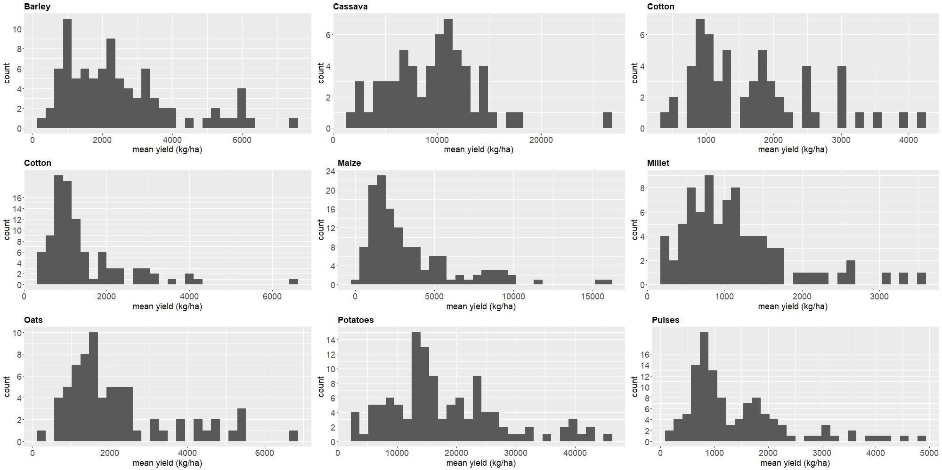

**Figure SI 1a.** **Distribution of country average yields, computed over the 1986-2012 time period**. Figures have been computed over the 1986-2012 period from FAOSTAT commodity balance data. The x-axis depicts the average crop yield (measured in kg/ha), and the y-axis the frequency of each value being observed in the dataset.

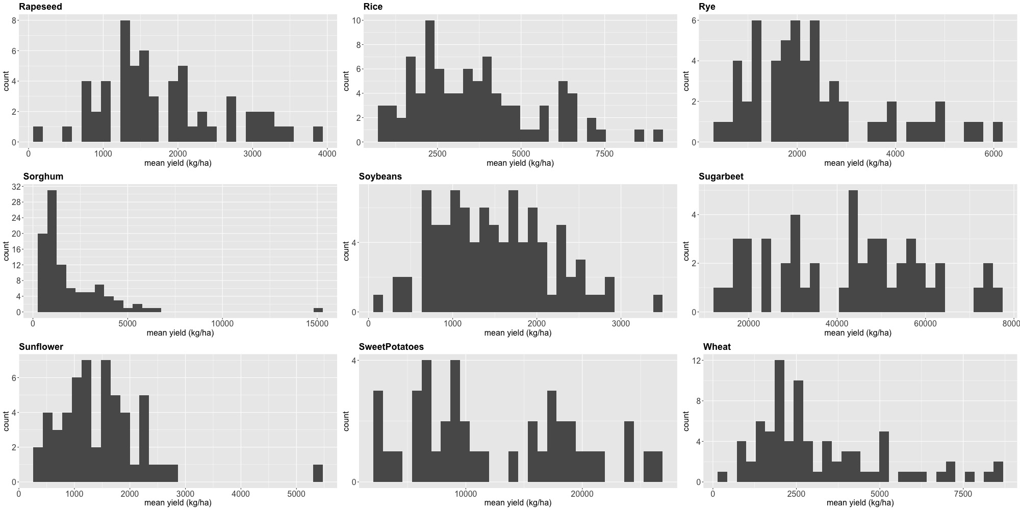

**Figure SI 1b.** **Distribution of country average yields, computed over the 1986-2012 time period**. Further note can be found in the caption of Figure SI 1a.

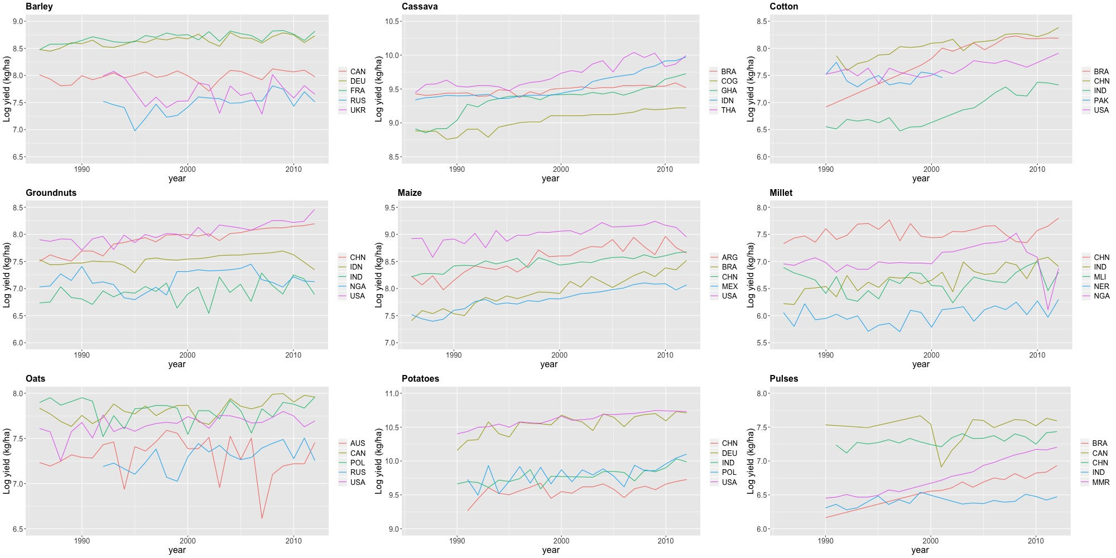

**Figure SI2**a. Pattern of historical yields for the 5 biggest producers. The acronyms in the figure indicate the following countries: Argentina (ARG), Australia (AUS), Brazil (BRA), Canada (CAN), China (CHN), Congo (COG), Germany (DEU), France (FRA), Germany (DEU), Ghana (GHA), Indonesia (IDN), India (IND), Mali (MLI), Mexico (MEX), Myanmar (MMR), Niger (NER), Nigeria (NGA), Pakistan (PAK), Poland (POL), Russia (RUS), Thailand (THA), Ukraine (UKR) and Unites States of America (USA).

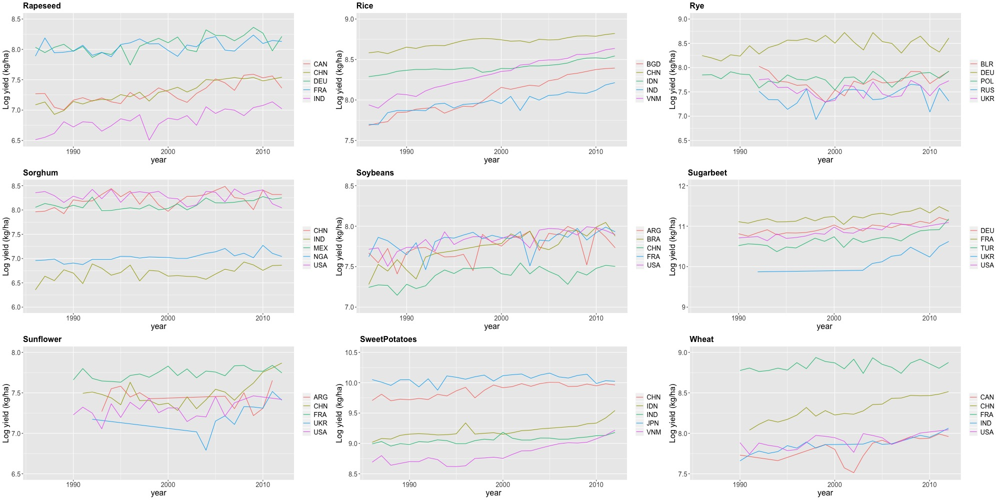

**Figure SI2b**. Pattern of historical yields for the 5 biggest producers. The acronyms in the figure indicate the following countries: Argentina (ARG), Bangladesh (BGD), Belarus (BLR), Brazil (BRA), Canada (CAN), China (CHN), Germany (DEU), France (FRA), Indonesia (IDN), India (IND), Japan (JPN), Mexico (MEX), Nigeria (NGA), Poland (POL), Russia (RUS), Turkey (TUR), Ukraine (UKR), Vietnam (VNM)and Unites States of America (USA).

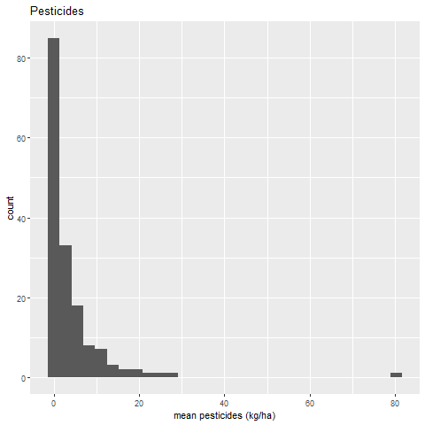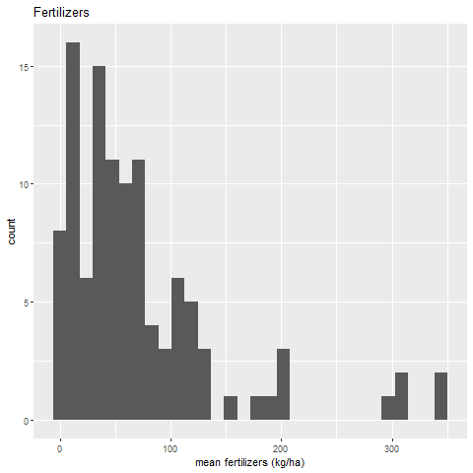

**Figure SI3.** **Distribution of average pesticides (left) and fertilizers (right)**. Figures have been computed over the 1986-2012 period. The x-axes depict the average use of pesticides (kg/ha) and fertilizers (kg/ha) and the y-axis the frequency of each value being observed in the dataset..

|  |  |  |  |  |  |  |
| --- | --- | --- | --- | --- | --- | --- |
|  | **Barley** | **Cassava** | **Cotton** | **Groundnuts** | **Maize** | **Millet** |
| Temp | 0.072** | 0.079 | 0.142 | 0.251* | 0.056 | 0.292 |
| Temp2 | -0.002** | -0.002*** | -0.003 | -0.006** | -0.002** | -0.007 |
| Prec | -2.213E-04 | 3.8E-04 | 7.03E-05 | -2.7E-04 | -2.0E-04 | -9.6E-04 |
| Prec2 |  |  | -1.91E-06 |  |  |  |
| Temp Irr |  | 0.020*** |  | 0.016** | 0.015** |  |
| Prec Irr |  |  |  | 0.000 |  |  |
| Pest |  |  |  |  |  |  |
| Fert |  |  |  |  |  |  |
|  |  |  |  |  |  |  |
| V Temp | 15.50 | 20.58 | 22.81 | 21.90 | 14.56 | 19.85 |
| V Temp Irr |  | 25.82 |  | 23.28 | 18.48 |  |
| V Prec |  |  | 18.38 |  |  |  |
| V Prec Irr |  |  |  |  |  |  |
|  |  |  |  |  |  |  |
| ME Temp (1°C) | -0.6% | -1.4% | 0.76% | -1.7% | -2.6% | -2.9% |
| ME Temp Irr (1°C) |  | 0.6% |  | -0.1% | -1.1% |  |
| ME Prec (10mm) | -0.22% | 0.4% | -0.34% | -0.3% | -0.2% | -1.0% |
| ME Prec Irr (10mm) |  |  |  | -0.1% |  |  |
|  |  |  |  |  |  |  |
| ME Temp (1sd) | -0.34% | -0.3% | 0.32% | -0.6% | -1.1% | -1.4% |
| ME Temp Irr (1sd) |  | 0.1% |  | 0.0% | -0.5% |  |
| ME Prec (1sd) | -0.30% | 0.7% | -0.51% | -0.5% | -0.4% | -1.7% |
| ME Prec Irr (1sd) |  |  |  | -0.2% |  |  |
|  |  |  |  |  |  |  |
| $R^{2}$ | 0.24 | 0.68 | 0.86 | 0.51 | 0.60 | 0.85 |
| $R_{adj}^{2}$ | 0.17 | 0.66 | 0.82 | 0.46 | 0.57 | 0.81 |
| *N* | 2179 | 1614 | 1455 | 2553 | 3412 | 1959 |
| *n* | 88 | 60 | 57 | 98 | 132 | 82 |
|  |  |  |  |  |  |  |
| *Wald test (Chi-square, p-value)* | 5.98  0.11 | 13.22  0.01 | 0.43  0.98 | 22.37  0.00 | 12.82  0.01 | 1.36  0.72 |

**Table SI1a.** Estimated models for the crops modelled in this study. Estimation is based on robust standard errors when the model accounts for within and across countries variation. ***, **, * indicate statistical significance at the 1%, 5% and 10% level, respectively. V Temp, ME Temp and V Prec, ME Prec represent vertices and marginal effects for temperature and precipitation respectively. V Temp Irr, ME Temp Irr, V Prec Irr and ME Prec Irr indicate vertices and marginal effects for temperature and precipitation in the high irrigation countries. Marginal effect of temperature and precipitation, evaluated at the sample average, are computed in response to a 1°C, 10mm and average 1 standard deviation (1sd), averaged across countries, of the weather factors they refer to. N and n denote the number of observations and the number of countries, respectively. The joint significance of weather factors is assessed through a Wald test.

|  |  |  |  |  |  |  |
| --- | --- | --- | --- | --- | --- | --- |
|  | **Oats** | **Potatoes** | **Pulses** | **Rapeseed** | **Rice** | **Rye** |
| Temp | 0.042 | 0.065 | 0.161 | 0.100*** | 0.606 | 0.059 |
| Temp2 | -0.002 | -0.001 | -0.006 | -0.005*** | -0.014 | -0.006** |
| Prec | 4.0E-04 | -0.002 | 8.2E-05 | 0.010 | 0.004 | 0.007** |
| Prec2 | -6.2E-07 |  | -5.4E-06 | --9.7E-06 | -9.9E-06 |  |
| Temp: Irr |  |  |  |  |  | 0.066** |
| Prec: Irr |  |  |  |  |  | -0.014*** |
| Pest |  | 0.142*** | 0.064** |  | 0.134*** |  |
| Fert |  |  |  |  |  |  |
|  |  |  |  |  |  |  |
| V Temp | 13.43 | 23.59 | 13.29 | 9.41 | 21.67 | 4.89 |
| V Temp Irr |  |  |  |  |  | 10.36 |
| V Prec | 318.88 |  | 7.61 | 499.29 | 223.73 |  |
| V Prec Irr |  |  |  |  |  |  |
|  |  |  |  |  |  |  |
| ME Temp (1C) | -0.5% | 1.5% | -8.7% | 0.02% | -2.8% | -4.2% |
| ME Temp Irr (1C) |  |  |  |  |  | 2.4% |
| ME Prec (10mm) | 0.3% | -1.6% | -1.1% | 8.5% | 1.6% | 7.3% |
| ME Prec Irr (10mm) |  |  |  |  |  | -6.8% |
|  |  |  |  |  |  |  |
| ME Temp (1sd) | -0.3% | 0.6% | -4.6% | 0.0% | -1.0% | -2.8% |
| ME Temp Irr (1sd) |  |  |  |  |  | 1.6% |
| ME Prec (1sd) | 0.4% | -2.5% | -2.2% | 7.6% | 3.2% | 6.7% |
| ME Prec Irr (1sd) |  |  |  |  |  | -6.2% |
|  |  |  |  |  |  |  |
| $R^{2}$ | 0.52 | 0.86 | 0.94 | 0.36 | 0.88 | 0.32 |
| $R_{adj}^{2}$ | 0.48 | 0.83 | 0.91 | 0.32 | 0.85 | 0.25 |
| *N* | 1704 | 1661 | 1629 | 1334 | 1209 | 1375 |
| *n* | 70 | 116 | 114 | 58 | 90 | 58 |
|  |  |  |  |  |  |  |
| *Wald test (Chi-square, p-value)* | 2.36  0.67 | 1.27  0.74 | 19.02  0.00 | 30.27  0.00 | 4.35  0.36 | 24.15  0.00 |

**Table SI1b.** Estimated models for the crops modelled in this study. Description of the contents of the table can be seen in the caption of Table SI1a

|  |  |  |  |  |  |  |
| --- | --- | --- | --- | --- | --- | --- |
|  | **Sorghum** | **Soybeans** | **Sugarbeet** | **Sunflower** | **Sweet Potatoes** | **Wheat** |
| Temp | 0.101 | 0.115 | 0.130 | 0.121 | 0.160 | 0.147** |
| Temp2 | -0.002 | -0.002 | -0.004 | -0.003 | -0.004 | -0.005** |
| Prec | 2.9E-04 | 2.9E-04 | 0.005 | 0.001 | 0.005 | 0.010*** |
| Prec2 | -9.8E-07 |  | -4.1E-05 |  | -2.8E-05 | -4.1E-05** |
| Temp: Irr |  |  |  |  |  | 0.057** |
| Prec: Irr |  |  |  |  |  | -0.005 |
| Pest |  |  | 0.043** | 0.120*** | 0.052* | 0.127*** |
| Fert |  |  | 1.651** | 6.033** | 3.494** | -2.633** |
|  |  |  |  |  |  |  |
| V Temp | 27.58 | 25.84 | 16.21 | 20.62 | 22.77 | 14.59 |
| V Temp Irr |  |  |  |  |  | 20.18 |
| V Prec | 147.60 |  | 61.22 |  | 96.59 | 117.11 |
| V Prec Irr |  |  |  |  |  | 55.22 |
|  |  |  |  |  |  |  |
| ME Temp (1C) | 1.9% | 2.2% | 0.6% | 0.8% | 1.0% | -2.4% |
| ME Temp Irr (1C) |  |  |  |  |  | 3.3% |
| ME Prec (10mm) | 0.1% | 0.3% | 0.0% | 0.9% | -1.3% | 3.5% |
| ME Prec Irr (10mm) |  |  |  |  |  | -1.5% |
|  |  |  |  |  |  |  |
| ME Temp (1sd) | 0.8% | 0.9% | 0.3% | 0.4% | 0.3% | -1.3% |
| ME Temp Irr (1sd) |  |  |  |  |  | 1.8% |
| ME Prec (1sd) | 0.1% | 0.6% | 0.0% | 1.2% | -2.4% | 4.7% |
| ME Prec Irr (1sd) |  |  |  |  |  | -2.1% |
|  |  |  |  |  |  |  |
| $R^{2}$ | 0.43 | 0.01 | 0.41 | 0.85 | 0.34 | 0.92 |
| $R_{adj}^{2}$ | 0.35 | 0.01 | 0.32 | 0.81 | 0.23 | 0.88 |
| *N* | 2450 | 2196 | 757 | 765 | 582 | 1208 |
| *n* | 99 | 91 | 49 | 54 | 41 | 78 |
|  |  |  |  |  |  |  |
| *Wald test (Chi-square, p-value)* | 3.26  0.51 | 4.35  0.23 | 13.52  0.01 | 0.48  0.92 | 3.82  0.43 | 28.65  0.00 |

**Table SI1c.** Estimated models for the crops modelled in this study. Description of the contents of the table can be seen in the caption of Table SI1a.

1. In the case of soybeans, omitted variable bias is absorbed by estimating the model in first differences. A global trend is included in this case, instead of a country-specific trend driven by the model’s fit which has been more challenging comparing to all other crops of our sample.
2. Lassaletta et al. (2014) outline that agricultural performance has improved in some countries due to fertilisers while it has deteriorated in others from an agronomic and environmental point of view.