A Numerical Study on the Effects of Constant Volume Combustion Phase on Performance and Emissions Characteristics of a Diesel-Hydrogen Dual-Fuel Engine
C.J. Ramsay, K.K.J. Ranga Dinesh,W. Fairney, N. Vaughan

1. Energy Technology Research group, Faculty of Engineering and the Environment, University of Southampton, Southampton, SO17 1BJ, UK.
2. Covaxe Ltd, Hawkesbury Upton, Gloucestershire, GL9 1AY, UK.
Corresponding author email address: dinesh.kahanda-koralage@soton.ac.uk
Telephone: +44 (0)23 8059 2872

Manuscript Prepared for the Submission of International Journal of Hydrogen Energy

Abstract
A detailed numerical study is carried out to investigate the performance of a diesel-hydrogen dual fuel (DF) compression ignition engine operating under a novel combustion strategy in which diesel injection and most of the combustion occur at a constant volume. A detailed validation of the numerical model for diesel-hydrogen DF engine operation has been carried out. Then a parametric study has been performed to investigate the effects of the constant volume combustion phase (CVCP) at up to 90% hydrogen energy share (HES) on engine performance and emissions at low and high load with comparisons to the conventional engine. The results demonstrate that the CVCP strategy can improve thermal efficiency at all HESs and load conditions with far lower carbon-based emissions. Conventional DF engines struggle at low load high HESs due to the reduced diesel injection failing to ignite the leaner premixed charge. Through use of a CVCP thermal efficiency at low load 90% HES increased from 11% to 38% with considerably reduced hydrogen emission due to the increased temperatures and pressures allowing for the wholesale ignition of the hydrogen-air mix. It was also found that increasing the time allowed for combustion within the CVCP, by advancing the diesel injection, can lead to even further thermal efficiency gains while not negatively impacting emissions.
Keywords: Diesel-Hydrogen, Dual-Fuel Engine, Constant Volume Combustion, Performance and Emissions, Modelling and Simulation

Nomenclature
BDC  TDC  CI | bottom dead centre  top dead centre  compression ignition | CV  CFD  SI |  | constant volume  computational fluid dynamics  spark ignition
CVCP | constant volume combustion phase | UHC  HRR |  | unburned hydrocarbons  heat release rate
CA  CO  CO₂ | crank angle  carbon monoxide  carbon dioxide | NO_{x}  DF  deg |  | nitrogen oxides  dual fuel  degree
EGR | exhaust gas recirculation | LL |  | low load
HES  LTC  DI | hydrogen energy share  low temperature combustion  direct injection | HL  PISO |  | high load  pressure-implicit with splitting of operators
EVC  IVO | exhaust valve close  inlet valve open | RCCI |  | reactivity controlled compression ignition
IVC  EVO | inlet valve close  exhaust valve open | PCCI  HCCI |  | premixed charge compression ignition  homogenous charge compression ignition

1. Introduction
Compression ignition (CI) internal combustion engines fuelled by diesel play a vital role in many heavy-duty transport, power generation and agricultural applications due to the various benefits of CI engine combustion and its operating cycle. These benefits include superior torque, greater power output, higher thermal efficiency, better fuel economy and reliability when compared with spark ignition (SI) engines [1,2]. Unfortunately, diesel engines emit higher levels of harmful pollutant emissions such as nitrogen oxides (NO_{x}), unburned hydrocarbon (UHC), carbon monoxide (CO) and soot [3] which can have severe consequences for human health and the wellbeing of the environment. For example, the European Union regulations limit new heavy duty diesel vehicles to 0.4g/kWh of NO_{x} production and 0.01g/kWh of soot production [4,5], with these standards set to become more stringent in the future. Despite the current critical issues, it is highly unlikely that heavy duty CI engines will disappear from service anytime soon as replacement options such as large scale production of fuel cells are still challenging and costly [6].

Utilisation of hydrogen fuel in heavy duty CI engines is an area of active research which can lead to a reduction in carbon-based emissions while maintaining or even improving CI engine performance [7, 8]. Many researchers have shown that hydrogen can be effectively utilised in CI engine under dual-fuel (DF) combustion technology [9-17]. The principle operation of a DF engine is based on using two different types of fuel: the first one is used as an ignition source and the second one a source of energy [18,19]. This means that a diesel-hydrogen DF engine utilises hybrid combustion modes, namely a non-premixed combustion mode representing the diesel combustion and a premixed combustion mode representing the gaseous hydrogen combustion. The high auto-ignition temperature of hydrogen means combustion in DF CI engines can generally only be achieved by use of another low auto-ignition fuel such as diesel as an ignition source [10]. A large number of experimental and numerical investigations addressed various issues relevant to the design and operation of diesel-hydrogen DF engines. Some of the key issues addressed in the literature include diesel-hydrogen DF combustion efficiency and performance [8-10, 13, 15, 20], exhaust emission analysis [21-24], different engine geometries and engine conditions [25, 26] and hydrogen gas injection strategies [11, 12, 27]. The findings in the literature indicate a reduction in soot, UHC and CO₂ emissions comparative to the pure diesel case as hydrogen energy share (HES) increases due to the inherent reduction in carbon within the chamber [13, 21]. At medium-high loads HES increase was shown to speed up the rate of combustion significantly and potentially lead to knocking/extreme pressure rise rates as well as a retardation of the start of combustion when compared to pure diesel operation but given the correct conditions can lead to increases in performance [25, 26]. Although utilising hydrogen in CI engines demonstrated significant benefits to the performance and carbon-based emissions, several issues still pose significant challenges to operate the engine at higher HESs. For example, recent investigations [16, 28] reported that engine performance generally deteriorates at low load (LL) operating conditions once a certain HES threshold is met due to poor ignition of the hydrogen-air mix by the reduced diesel injection and leaner hydrogen-air mixture relative to higher load conditions. This issue can cause increases to UHC, soot and unburned hydrogen emissions. The LL problem requires more attention as only two studies have focused on addressing the issue by using high rates of exhaust gas recirculation (EGR) and diesel fuel injection optimisation [16, 28]. The literature also reported higher NO_{x} levels at high HESs for medium-high engine loads due to the higher burning temperature and chamber wide combustion of the well-mixed hydrogen fuel [13, 14, 22, 23]. Nevertheless, several studies have addressed the increased NO_{x} problem at high and medium loads via low temperature combustion (LTC) strategies [29] such as EGR [24], combinations of reductions in compression ratio and water injections [30] and use of the likes of homogenous charge compression ignition (HCCI) [31], premixed charge compression ignition (PCCI) [24] and reactivity controlled compression ignition (RCCI) [32]. While LTC is clearly beneficial to NO_{x} emissions the likes of EGR, water injection and compression ratio reduction can lead to reduced performance and increases to soot and UHC emissions [24, 30, 33] and HCCI/RCCI/PCCI struggle with controlling combustion, and therefore performance and emissions, due to the reliance on auto-ignition timing and this can be especially problematic as load and engine speed are varied [10, 24, 34, 35].

Direct injection (DI) of both hydrogen and diesel is likely the end goal for diesel-hydrogen DF engines as it will allow for much more control over the combustion of the hydrogen, as injection timings and durations can be adapted to a given use case, e.g. hydrogen injection after diesel (mostly non-premixed combustion) or hydrogen injection before diesel (mostly premixed combustion similar to current dual-fuel operation) [36]. Several authors have explored hydrogen DI in SI engines [37-39] however the literature is lacking with regard to CI engines [36]. Promising results have been found for natural gas DI with a diesel pilot in CI engines with many researchers reporting improved performance and reduced emissions output [40-42]. Gas injector technologies, injection strategies and engine operation for gaseous DI CI engines are still in their infancy and further research and optimisation is required to ensure efficient, successful operation and further understanding of dual-fuel indirect hydrogen injection operation is still important for eventually informing these decisions [36].

One of the major operating points of conventional internal combustion engines is the piston dwelling near top dead centre (TDC) which increases the time allowed for combustion. Further increasing this dwell time has the potential to improve the quality of combustion and therefore increase performance while simultaneously reducing pollutant emissions such as soot and UHC. In theory the most efficient cycle for a given internal combustion engine is the Otto cycle [43]. While many combustion strategies aim to achieve the efficiency levels of the ideal Otto cycle, none in practice are able largely due to the lack of combustion occurring at a constant volume. Conventional internal combustion engines use simple crank-slider mechanisms to convert linear work to rotational torque which means that the piston can only move between TDC and bottom dead centre (BDC) at a frequency proportional to engine speed. Combustion however occurs over a fixed period and is largely unaffected by engine speed. This means that any combustion occurring before TDC incurs negative work and combustion occurring during the expansion does not reach its maximum thermal potential due to reductions in pressure and temperature since combustion is not occurring at a constant volume. Reducing crank rotational velocity greatly, or ideally completely, at TDC while increasing velocity during the expansion and or compression stroke to maintain average engine speed is one such practical way to allow for a greater amount of combustion to occur at a constant volume.

A number of authors have shown the advantages of increasing piston dwell time near TDC [44-49]. Chen et al. [44] controlled piston trajectories and rotational velocity with an electric motor/generator leading to an 11% increase in work output compared to conventional operation when piston velocity was slowed at TDC. Dorić et al. [45] modelled a SI engine which combined variable compression ratio and engine displacement to give increased amounts of constant volume combustion due to slower piston movement at TDC and BDC, leading to increased performance. Variable compression ratio engines are promising in this regard as they can be adjusted based on operating conditions of the cycle [46]. Zhang et al. [47] modelled a free piston engine with asymmetric piston trajectories and showed a reduction in NO_{x}, CO and UHC emissions and improvements to performance by increasing piston dwell time near TDC. The same group also showed the applicability of HCCI and hydrogen combustion when using similar piston trajectories [48, 49].

Use of a full constant volume combustion phase (CVCP) has the potential to increase CI engine performance and substantially reduce UHC and soot emissions. A CVCP allows for the ignition delay phase, premixed charge combustion phase and a large part of the mixing controlled combustion phase to all occur at top-dead centre [50]. This leads to a high quality complete combustion of the fuel-air mix, and allows for the full combustion pressure which is built at TDC to drive the piston, unlike in a conventional CI engine where a significant amount of combustion is still occurring during the power stroke and any combustion which happened during the compression stroke will have incurred negative work penalties [51,52]. The constant volume combustion strategy should benefit diesel-hydrogen DF combustion for similar reasons but also due to the higher in-cylinder temperature being maintained for an extended time which will aid in the ignition/flame spreading within the premixed hydrogen-air mix. Particularly, this strategy should also be able to tackle the aforementioned LL problem of diesel-hydrogen DF engines by improving the fuel burning efficiency. Fig.1 shows a comparison of pressure-volume diagrams for an Otto cycle, a conventional engine cycle and the proposed CVCP cycle, where the integration of pressure with respect to volume between BDC of the expansion stroke and BDC of the intake stroke gives the net-work output (area between the curves).
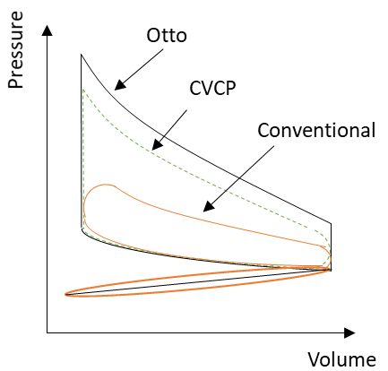
Fig.1. Pressure-Volume diagram for Ideal Otto, CVCP and conventional engine cycles.

In our previous investigation [53] we studied the effects of the duration and timing of the CVCP on thermal efficiency and emission of a diesel only CI engine. It was found that a CVCP increases thermal efficiency and reduces carbon-based emissions at both low and high load conditions. A combination of EGR and fuel injection optimisation was also shown to effectively counter NO_{x} emission increase under pure diesel CVCP operation. The present study is a continuation of our previous work [53] and focuses on numerical modelling of an engine cycle which implements a full CVCP (see CVCP cycle in Fig.1) in a diesel-hydrogen DF compression ignition engine. The objective of this numerical study is twofold: (1) to investigate the effects a CVCP strategy on combustion characteristics, performance and emissions of a diesel-hydrogen DF engine; (2) to potentially provide a solution to the LL performance issues diesel-hydrogen DF combustion suffers from. The present numerical study employed the four-stroke turbocharged diesel-hydrogen DF CI engine configuration experimentally conducted by Tsujimura et al. [13]. First, the numerical modelling framework was validated againt the conventional dual-fuel cycle (see conventional cycle in Fig.1), where diesel injection occurs when the piston is near TDC and then combustion with normal reciprocating motion. Then the conventional DF engine configuration of Tsujimura et al. [13] was theoretically/numerically modified by changing the piston profile to simulate the proposed CVCP cycle (see CVCP cycle in Fig. 1) under DF mode. In all CVCP test cases, fuel injection and combustion occur at TDC. The key findings of this parametric study will be effectively used to utilise hydrogen under diesel-hydrogen DF mode in a novel 2-stroke CI engine configuration which combines both axial and opposed piston geometries along with other necessary modifications to maintain a constant volume during fuel injection and combustion. Opposed piston engines benefit from having very high specific outputs, high power densities, good balance and lower material costs in a lot of cases compared to conventional engines [54]. While a fairly old concept, opposed piston engines fell out of favour due to the rise of turbocharging in 4-stroke engines. In recent years however, more attention has been given to them and a number of opposed piston engines are currently under development and testing has shown positive results with low pollutant emissions and high thermal efficiencies [54-59].

Fig. 2 shows the prototype opposed piston axial engine configuration in which fuel injection and combustion occurs at constant volume. As seen in Fig.2, the initial design of the engine consists of opposed pistons which drive two cams mounted directly on the main drive shaft. The pistons meet at TDC where fuel is injected and combustion takes place. The cams are profiled so as to hold the pistons together at TDC for the duration of fuel injection until combustion is virtually completed. The engine is designed to run under the CVCP cycle and aims to improve thermal efficiency due to higher in-cylinder pressures and temperatures while reducing carbon-based emissions due to a higher quality of combustion compared to the conventional cycle.

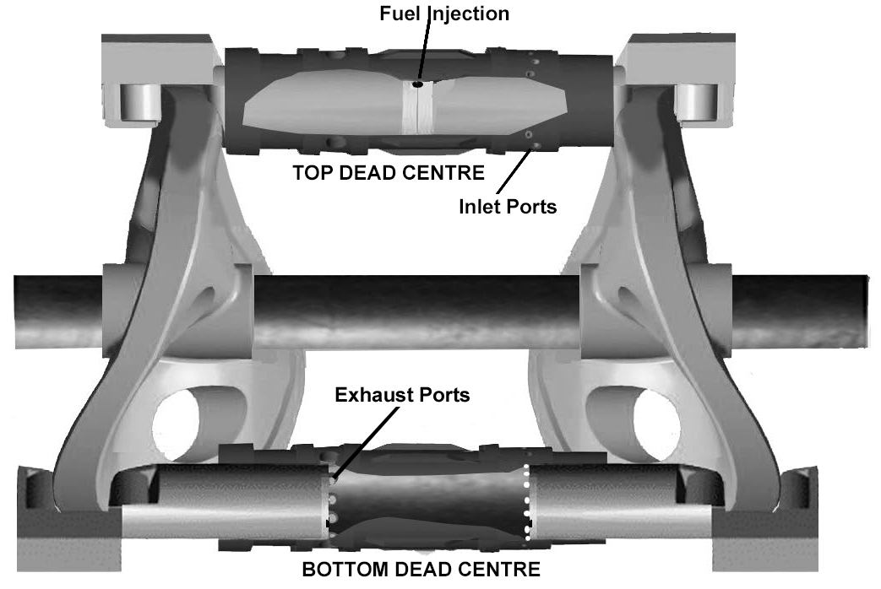
Fig.2. Schematic of the two stroke opposed piston CI engine configuration, where combustion occurs at TDC.

2. Numerical Methodology and Modelling Setup
The numerical simulations were carried out using three-dimensional unsteady Reynolds Averaged Navier-Stokes (URANS) approach. All simulations were set up from inlet valve close (IVC) to exhaust valve open (EVO). The simulations were performed on University of Southampton IRIDIS 4 high performance computing cluster by employing commercial computational fluid dynamics (CFD) software Fluent 19.1.

2.1. Governing Equations and Modelling
Simulations were carried out by solving compressible URANS equations for mass, momentum, energy and $N-1$species transport equations, where $N$ is the total number of species, in the main solver for a chemically reacting mixture using the finite volume method,.

Mass:
$\frac{∂ρ}{∂t}+\frac{∂ρ{\overline{u}}_{j}}{∂x_{j}}=S_{m},$ (1)
Momentum:
$\frac{∂ρ{\overline{u}}_{i}}{∂t}+\frac{∂ρ\overline{u_{i}u_{j}}}{∂x_{j}}=-\frac{∂\overline{P}}{∂x_{i}}+\frac{∂}{∂x_{j}}\left(μ\left(\frac{∂{\overline{u}}_{j}}{∂x_{i}}+\frac{∂{\overline{u}}_{i}}{∂x_{j}}-\frac{2}{3}δ_{ij}\frac{∂{\overline{u}}_{k}}{∂x_{k}}\right)\right)-\frac{∂ρ\overline{u_{i}^{'}u_{j}^{'}}}{∂x_{j}}+S_{i},$ (2)
Energy:
$\frac{∂ρ\overline{H}}{∂t}+\frac{∂ρ{\overline{u}}_{j}\overline{H}}{∂x_{j}}=\frac{∂}{∂x_{j}}\left(\frac{k_{eff}}{C_{p}}\frac{∂\overline{H}}{∂x_{j}}\right)+S_{h},$ (3)
Species:
$\frac{∂\left(ρY_{n}\right)}{∂t}+\frac{∂\left(ρ{{\overline{u}}_{j}Y}_{n}\right)}{∂x_{j}}=-\frac{∂J_{n}}{∂x_{j}}+R_{n}+S_{n}.$ (4)

The nitric oxide and soot emissions were calculated by solving the transport equations at a post-processing stage as this method was found to be computationally more efficient.
The transport equation for $NO_{x}$ mass fraction, $Y_{NO}$, is given by:
$\frac{∂ρ{\overline{Y}}_{NO}}{∂t}+\frac{∂ρ{\overline{u}}_{j}{\overline{Y}}_{NO}}{∂x_{j}}=\frac{∂}{∂x_{j}}\left(ρD\frac{∂{\overline{Y}}_{NO}}{∂x_{j}}\right)+S_{NO},$ (5)
The Moss-Brookes soot model [60] was employed to predict soot formation using acetylene as the inception species. This model solves a two transport equations for soot mass fraction, $Y_{soot}$, and normalised radical nuclei concentration, b*_{nuc}:
$\frac{∂ρ{\overline{Y}}_{soot}}{∂t}+\frac{∂ρ{\overline{u}}_{j}{\overline{Y}}_{soot}}{∂x_{j}}=\frac{∂}{∂x_{j}}\left(\frac{μ_{t}}{σ_{soot}}\frac{∂{\overline{Y}}_{soot}}{∂x_{j}}\right)+\frac{dM}{dt},$ (6)
$\frac{∂ρ{\overline{b^{*}}}_{nuc}}{∂t}+\frac{∂ρ{\overline{u}}_{j}{\overline{b^{*}}}_{nuc}}{∂x_{j}}=\frac{∂}{∂x_{j}}\left(\frac{μ_{t}}{σ_{nuc}}\frac{∂{\overline{b^{*}}}_{nuc}}{∂x_{j}}\right)+\frac{1}{N_{norm}^{*}}\frac{dN^{*}}{dt} ,$ (7)
where is the density of the fluid, is time, a component of the mean velocity vector, a component of the fluctuating velocity vector, a component of the position vector, the source term accounting for mass added by fuel spray, is pressure, is molecular viscosity, a component of the body forces, the Kronecker delta, the mean mixture fraction, the mass transfer from liquid fuel droplets to gas phase, the mean total enthalpy, the effective conductivity, the specific heat capacity of the fluid, the source term accounting for any further heat losses, $Y_{n}$ is the mass fraction of species $n$, $J_{n}$ is the diffusion flux of the given species, $R_{n}$ the net rate of production of the given species by chemical reaction, $S_{n}$ the rate of creation of the species by the discrete phase injection and any other sources, $D$ is the effective diffusion coefficient, $S_{NO}$is the source term for any other $NO_{x}$ production due to thermal or prompt mechanisms, $σ_{soot}$ is the turbulent Prandtl number for soot transport, M is the soot mass concentration, $σ_{nuc}$ is the turbulent Prandtl number for radical nuclei transport, N* is the soot particle number density and N*_{norm} is 10¹⁵ particles.

The standard turbulence model with standard wall functions is used to close the URANS equations. Transport equations for turbulent kinetic energy, , and dissipation rate, , are solved. The eddy viscosity,, where is a constant. The eddy dissipation concept (EDC) model is used to model the volumetric reaction rates needed to determine species mass fractions. EDC is an extension of the eddy dissipation model which allows for detailed Arrhenius chemical kinetics to be included in the modelling of turbulent reacting flows.

The diesel fuel chemistry is represented by an n-heptane mechanism consisting of 29 species and 52 reactions [61] which has been validated for engine relevant conditions. A more detailed hydrogen mechanism consisting of 15 species and 24 reactions [62] is then also incorporated. Liquid fuel injection is handled as a discrete phase which evaporates and then mixes with air in the chamber. Droplet diameters are assumed to be uniform and injection is controlled by mass flow rate and velocity profiles containing pilot and main injections (Fig.3).
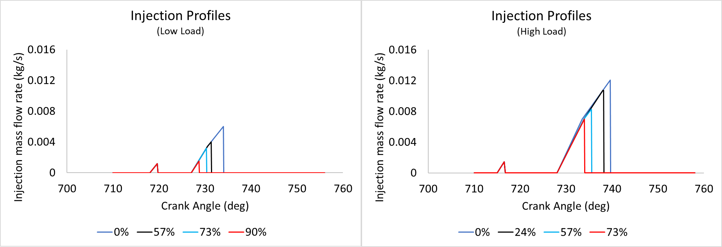
Fig.3. Liquid fuel injection profiles used for the simulations showing pilot and main injections.

An injector hole diameter of 0.15mm and included spray angle of 140deg are used. The discrete phase model analytically tracks injection droplets with the fluid flow time step and models their interaction with the continuous phase using stochastic collisions and breakup models. The intake inducted hydrogen is assumed to be well mixed at IVC and replaces a portion of the intake air in the species initialistion. Table 1 gives a summary of the numerical models.

Table 1. Numerical models used in this investigation.
Description | Model
Viscous
Energy/Species | Species transport generalised finite rate combustion  Eddy dissipation concept  Chemkin mechanism and thermodynamic database
Discrete Phase | Droplet particle  KHRT breakup  Stochastic collision  Wall-film boundary condition
$NO_{x}$ | Thermal  Prompt
Soot | Moss-Brookes
Dynamic mesh | Layering and Smoothing

A 3-D double precision analysis is carried out using the pressure based solver to compute the solution. Pressure-velocity coupling algorithms are used to derive an additional condition for pressure by reformatting the continuity equation and obtaining a pressure field. PISO scheme is used due to its accuracy and fast convergence. Second order upwind schemes are used for the spatial discretisation. Least squares cell-based method is used to compute gradients. First-order implicit time-stepping is employed due to the variable time step profile which refines time-steps at injection and throughout the main combustion phase. Convergence criteria are set to converge at residuals of 10⁻³ apart from energy and post-processed scalars which are set to 10⁻⁶ . Max iterations per time step are set to 50 with up to 10 post time-step iterations. Table 2 outlines a summary of numerical methods.

Table 2. Summary of numerical methods employed for the calculation
Description | Parameter | Method/Model/Value
Solver | General | Pressure-based
Pressure-velocity coupling | Flux type  Scheme  Skewness correction  Neighbour correction | Rhie-Chow  PISO  1  1
Spatial discretisation | Gradient  Density  Momentum  Energy  k  $ε$  Species (N-1 equations)  Pollutant NO_{x}  Pollutant soot mass  Pollutant soot nuclei | Least square cell based  Second order upwind  Second order upwind  Second order upwind  Second order upwind  Second order upwind  Second order upwind  Second order upwind  Second order upwind  Second order upwind
Temporal discretisation | Time | First order implicit

2.2.Numerical Setup and Validation
The present numerical investigation modelled the four-stroke turbocharged diesel-hydrogen DF CI engine experimentally developed and tested by Tsujimura et al. [13]. This engine configuration provides a range of experimental data for numerical set up and validation including data for engine geometry, in-cylinder pressure, heat release rate (HRR), injected fuel mass and injection timings. This engine specification shares a number of similarities with the CVCP engine described in section 1. Table 3 provides engine specifications for the reference engine at low and high load conditions.

Table 3. Engine specifications for the experimental reference engine at low and high load. [13].
Description | Low load | High load
Bore (mm) | 115 | 115
Stroke (mm) | 125 | 125
Compression ratio | 17.5 | 17.5
Initial absolute pressure (bar) | 1.1 | 1.6
Injector holes in full cylinder | 7 | 7
Engine speed (RPM) | 1500 | 1500
Pilot Signal Start of Injection (CA) | 713.1 | 710.1
Pilot Diesel Injection Volume ($mm^{3})$ | 1.0 | 1.2
Main Signal Start of Injection (CA) | 724.1 | 726.1
Main Diesel Injection Volume ($mm^{3})$ | 22-2.2 | 76-21
Total fuel energy (J) | 821 | 2756
IMEP (MPa) | 0.3 | 0.9

A 51.43deg geometry representing 1/7th of the full combustion chamber was created with SOLIDWORKS and then meshed using Ansys Workbench (Fig.4.). Meshing a sector allows for a large reduction in computational costs and is possible due to the symmetry of the 7 injector holes in the combustion chamber. The mesh is refined in the piston bowl region and inflation layers are added to the piston walls. A mostly hex mesh is used to reduce numerical diffusion and increase computational efficiency. Due to movement of the piston, a rigid dynamic mesh is used to model compression and power strokes. The dynamic mesh model allows for the boundaries of cell zones to move relative to other boundaries of the zone. A smoothing and layering method is utilised in this analysis.

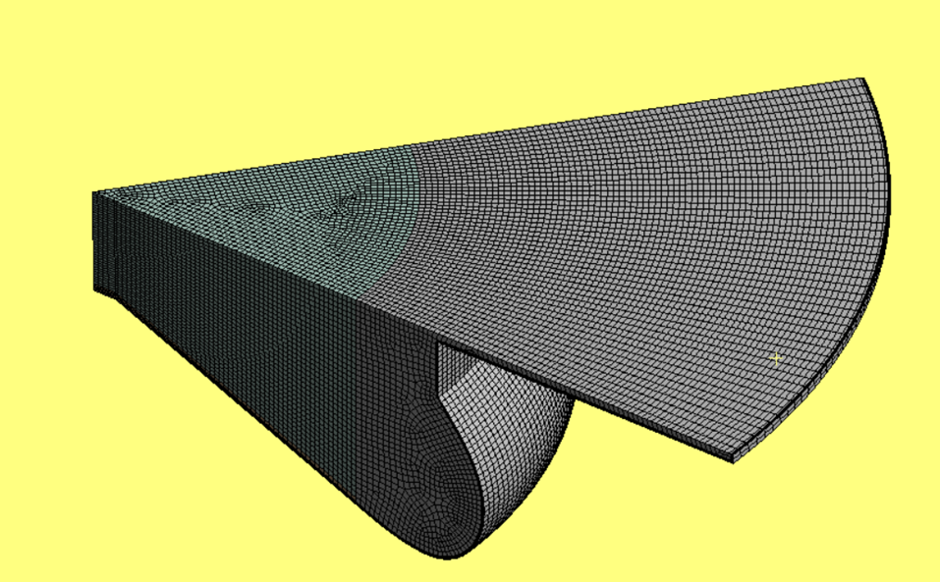
Fig.4. Fine density mesh at TDC.

Constant temperature boundary conditions (which assume the engine has already been run for a number of cycles) are applied to deal with heat transfer at the gas-solid boundaries, temperatures are provided in Table 4. Using the constant temperature condition means that the wall need not be meshed and is a reasonable assumption due to the relatively small time scales. No slip boundary conditions are also applied at the solid walls. The discrete phase model uses a wall film condition at the solid boundaries, which is described by the stanton-rutland impingement/splashing model. Periodic boundary conditions are specified along the side faces of the sector to simulate a full engine.

Table 4. Constant temperature boundary conditions.
Zone | Temperature (K)
Chamber main liner face | 500
Chamber top liner face
Piston liner face
Chamber top face | 600
Piston bottom face | 650

2.3 Validation and Mesh Sensitivity Analysis
Validation of the present numerical results including a mesh sensitivty analysis is carried out to ensure CFD results are accurate, in comparison to experimental data for the reference engine [13], and independent of mesh resolution. Mesh densities were varied by changing minimum element size and maximum face size. Table 5 details the number of elements in each mesh at BDC.

Table 5: Mesh densities for validation and mesh sensitivity anaylsis
Mesh Density | Elements
Coarse | 443868
Medium | 746063
Fine | 1104985
Very Fine | 1448346

Fig.5(a) shows the comparison of pressure and heat release rate (HRR) between the experimental reference [13] and the coarse and fine mesh densities for 0%, 24%, 57% and 73% HES at high load (HL). All mesh densities do a reasonable job at capturing the pressure and HRR profiles, with pre-combustion pressure, igniton delay, HRR and combustion pressure trends all being represented accurately at each HES apart from the 57% HES coarse simulation which does not accurately capture diesel pilot ignition of the premixed charge. In all mesh densities as HES increases the initial amounts of hydrogen which combusts at the same time as the diesel pilot are overpredicted which also leads to slightly higher than expected peak combustion pressures in the 57% and 73% cases. This is likely due to the reduced chemical mechanism implemented and could potentially be remedied by using a more detailed mechanism or one better adpated for dual-fuel combustion. While the medium mesh does a better job at capturing the early hydrogen combustion in the 57% case, power stroke pressure is generally overpredicted similar to those shown in the coarse mesh cases. The fine mesh better predicts the power stroke pressure and HRR timings and further mesh refinement did not offer any meaningful improvement to results. Therefore the fine mesh is chosen for the remainder of the simulations as it is adequately mesh independent and offers good agreement with experimental data.

Fig.5(b) compares emissions predictions at EVO in the simulations to those measured in the exhaust gases of the experimental engine. It should be noted that scaling of results with gross indicated work output and taking values at EVO rather than exhaust gases due to limitation of the simulations will have impacted values. H₂ trends are captured well with levels increasing up to 57% HES before decreasing at 73%. Soot levels are somewhat overpredicted but the decreasing trend as HES increases is captured well. NO_{x} and CO₂ emissions are underpredicted slightly but the correct trends are captured for the most part. Some discrepancies arise in the UHC predictions. Predicted UHC values decrease rapidly with increasing HES indicating that they are too heavily affected by the reduction of injected diesel whereas the lower injection penetration/mixing appears to outweigh this reduction in the experiments. It is much more difficult to capture accurate UHC values due to the many intermediate combustion products inolved, as noted by Kim et al. [63], and a more detailed reaction mechanism is likely required for accurate prediction. Consideration of UHCs in the initial species composition at IVC may also be required to reproduce experimental results. Generally, CFD results reasonably well predict in-cylinder combustion characteristics such as pressure, HRR and exhaust emissions NOx, H₂, CO₂, soot and UHC as observed in the experiments for each of the diesel-hydrogen DF test cases. This suggests that the numerical framework employed in this work is sufficient to perform a detailed parametric study on identifying the effects of CVCP strategy on combustion performance and emissions of a diesel-hydrogen DF engine with respect to hydrogen concentration at differing engine operating conditions.
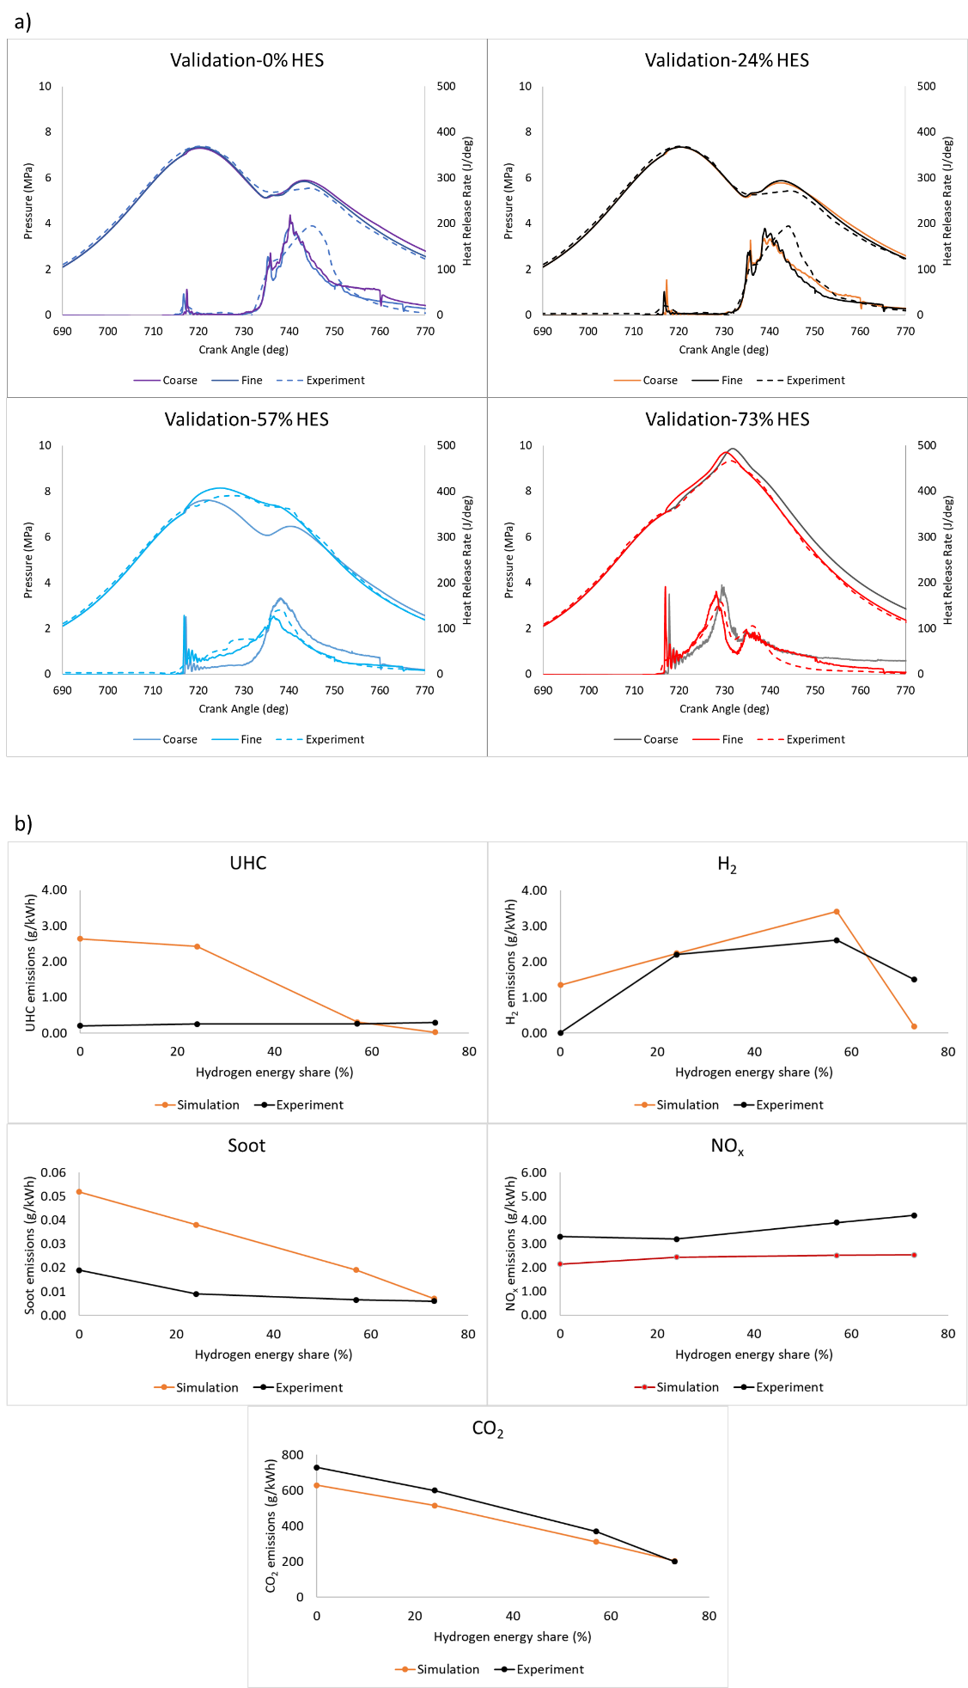
Fig.5. Validation for the simulations at 0%, 24%, 57% and 73% HES against the experimental reference [13] for (a) Pressure and heat release rate and (b) UHC, H₂, soot, NO_{x} and CO₂ emissions at high load.

3. Results and Discussion
In this work the effect of the implementation of a CVCP is investigated at both low and high loads in a diesel-hydrogen DF engine. Simulations of both conventional and CVCP cycles are carried out and combustion characteristics, efficiency and emissions are compared. Section 3.1 focuses on the effects of CVCP operation on a diesel-hydrogen DF engine at low and high load. Section 3.2 addresses the LL performance issues at high hydrogen substitution levels through fuel injection improvements and CVCP implementation.

Fig.6(a) shows the schematic of the conventional test cases where diesel injection occurs when the piston is near TDC and then combustion with normal reciprocating motion, while Fig.6(b) shows the schematic of a CVCP test cases where diesel injection and the majority of combustion occur at TDC. Fig.6 also shows the corresponding piston profiles used in the analysis and a valve timing diagram which highlights important parts of the engine cycle.

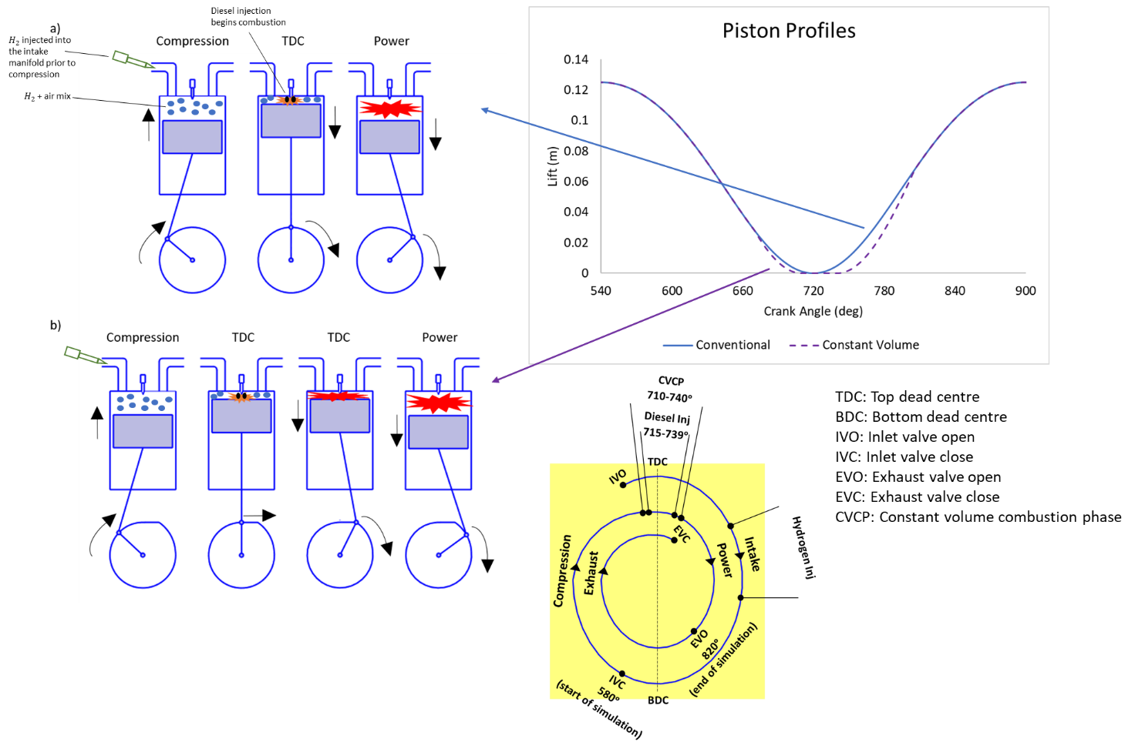
Fig.6 Schematic of (a) conventional test cases, (b) CVCP test cases, with the piston profiles used in the simulations and valve timing diagram.

3.1 CVCP Operation at Increasing HESs
The effect of the CVCP is investigated for 4 HESs at LL and HL conditions- 0%, 24%, 57% and 73% at HL and 0%, 57%, 73% and 90% at LL. The fuel-air equivalence ratio of the hydrogen-air mixes at HL are 0, 0.09, 0.21 and 0.27 for 0%, 24%, 57% and 73% HESs respectively and at LL 0, 0.12, 0.15 and 0.19 for 0%, 57%, 73% and 90% HESs respectively. The HL cases are selected as these align with those tested in the experimental paper. At LL, the experimental paper [13] states 57% HES was deemed the limit as any further increase caused unacceptable decreases to performance. However, we considered two additional cases at LL with 73% and 90% HES to examine the effectiveness of the CVCP on improving LL performance at high HESs. For all cases, a CVCP duration of 30deg is implemented spanning from 710CA to 740CA. This CVCP period is selected as it coincides with the diesel injection and our previous study [53] indicated that a 30deg duration should be sufficient for raising in-cylinder temperatures to the level needed for hydrogen auto-ignition.

3.1.1 Combustion Characteristics
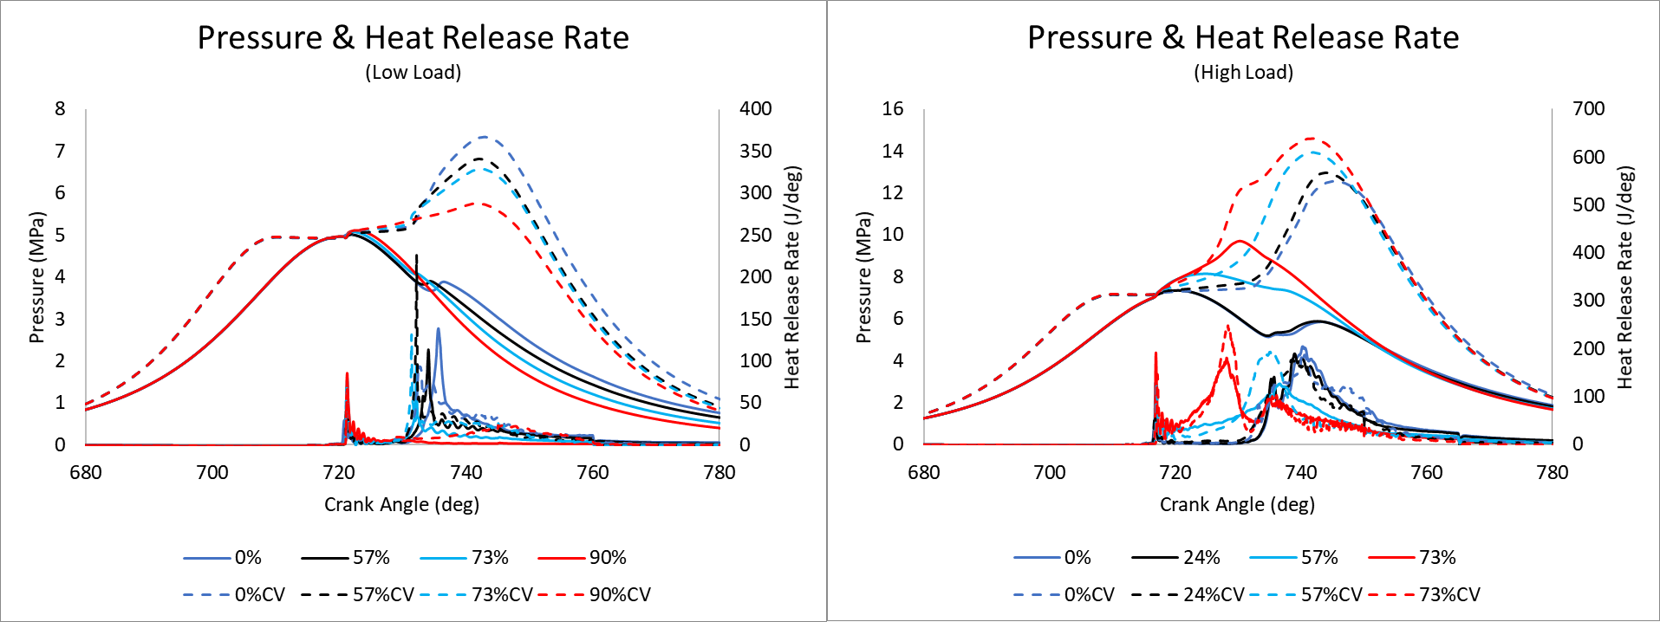
Fig.7. Pressure and HRR.

Fig.7 shows in-cylinder pressure and HRR curves at low and high load for the CVCP and conventional test cases. All cases at a given load condition have similar ignition delay timings with higher HES cases generally showing a small increase due to oxidiser substitution. CVCP does not have a considerable effect on ignition delay timing as thermodynamic conditions are much the same. Initial pilot injection HRR increases with HES increase due to small amounts of hydrogen becoming entrained in the diesel jet and combusting at this stage as well as the slightly longer ignition delay allowing for increased mixing of diesel, oxidiser and hydrogen.

At LL the pilot injection does not adequately ignite the premixed hydrogen-air charge in any test case. This is the result of a number of factors including: poor pilot injection penetration, small temperature increase in the cylinder due to only small injection volume and a fairly lean hydrogen-air mix even at high HESs due to there being less fuel needed at LLs. It is also observed that main injection heat release generally starts earlier as HES increases, which is likely a result of the increased temperatures caused by the initial increased HRR. In the conventional engine the main injections also struggle to ignite the hydrogen-air mix at LL, for the same reasons as the pilot, with the total amounts of heat release becoming progressively lower as HES increases. In the 90% case there is almost no ignition of the premixed charge and at 57% and 73% most of the heat release occurs around the same time as the diesel injection heat release indicating that the flame front does not properly spread and only hydrogen near to the injection site is combusting. With the introduction of the CVCP the 57%CV and 73%CV cases show higher peak HRRs and an extended phase of heat release after the initial peak indicating wholesale ignition of the hydrogen-air mix within the combustion chamber. This is the result of temperatures and pressures being built up allowing for much more of the cylinder to reach hydrogens auto-ignition temperature and not dropping below once the flame begins to spread. However, while there is some improvement to HRR in the 90%CV case clearly the main injections reduced quantity was not adequate to cause full ignition of the premixed-charge and further optimisation is still required. Each LL hydrogen case could benefit from a longer combustion period at TDC to allow for more temperature to build-up (achieved by increasing CVCP duration or advancing injections) prior to the end of the CVCP as afterwards in-cylinder temperatures drop and the hydrogen-air mix falls below its flammability limit. The highest amounts of heat release are observed in the pure diesel cases, in particular the 0%CV case where the higher temperatures and pressures caused by the holding of the pistons at TDC promote a higher quality of combustion.

At HL the pilot injection adequately ignites the hydrogen-air mix in all cases apart from the 24% and 24%CV cases where the relatively leaner mix means that the flammability limits are not met. At 73% HES there are two clear peaks (after initial pilot combustion), the first is due to the fast burning of the majority of the hydrogen as the high fuel-air equivalence ratio leads to a high flame speed and the second is when the main diesel injection occurs and combusts causing its own heat release with small amounts of remaining hydrogen combustion. In the 57% cases there is only one peak and this occurs at the same time as the main diesel injection. The lower fuel-air equivalence ratio of the hydrogen-air mix means the mixture has not had a chance to entirely combust prior to the diesel injection and thus the injection enhances the premixed charge combustion. The 24% cases show very similar HRR trends to those of the 0% hydrogen cases, with slightly earlier peak HRRs and faster fall offs. In general, the introduction of a CVCP leads to a slower initial ramp up to peak HRR but this is followed by a somewhat higher peak and faster fall off. The initially slower HRR is likely due to the reduced mixing of the diesel injection which is caused by the stationary piston (reduced turbulence and injection always targeted in the same area). The subsequent higher peak HRR is caused by a larger amount of the combustion chamber being at a high enough temperature for hydrogen auto-ignition due to the build-up of temperature, and is also somewhat enhanced by the reduced distance needed for the flame to travel due to the minimum combustion chamber volume being maintained. The faster fall off in HRR is largely due to the higher fuel utilisation and therefore less fuel/oxidiser availability.

CVCP cases have a slightly faster piston approach to TDC which leads to pre-combustion pressure peaking 10deg earlier. Peak pressures are higher in the CVCP cases compared to conventional, and all occur at the end of the CVCP, a result of the piston being held at TDC and therefore all the combustion energy is built up until the piston is released. Higher pressures are observed for most of the expansion stroke until around 50deg after the end of the CVCP in most cases.

At LL the initial amounts of high HRR observed in the high HES cases means that peak pressure increases slightly in the conventional engine as HES increases. However, the pilot not igniting the hydrogen-air mix and subsequently the main injection also struggling to ignite the mix leads to lower pressures in the power stroke as HES increases which will greatly impact engine performance. The addition of a CVCP leads to promising increases in combustion of hydrogen, especially for 57%CV and 73%CV, where pressures increase reasonably. 90%CV shows more combustion than the corresponding conventional case leading to a small rise in pressure during the CVCP, but optimisation is clearly required for further improvement to hydrogen utilisation.

At HL increasing HES leads to increases to peak pressure and peak pressure rise rate. The low HES cases follow similar trends to the pure diesel cases only with slightly increased pressures. At 57% and 73% HESs the conventional engine cases both initially have higher pressure rise rates than the corresponding CVCP cases but are overtaken once the combustion chamber temperatures in the CVCPs catch up and exceed them, leading to rapid hydrogen combustion. At 57% and 73% HES peak pressure occurs in the conventional engine prior to the main diesel injection which causes secondary smaller peaks. After the initial HRR peak the pressure rise in 73%CV levels off and increases at a slower rate up until the end of the CVCP, whereas for 57%CV the increase is much slower and picks up towards the middle of the CVCP before also levelling off.

Generally knocking is caused by hot spots within the combustion chamber which lead to early hydrogen ignition. Since simplified constant temperature boundary conditions are used at the walls for computational efficiency as well as only running a single cycle these hot spots do not exist in the simulations and the chamber temperatures prior to diesel injection do not reach a high enough temperature for hydrogen auto-ignition and thus knocking is not observed. Knocking was not experienced in the experimental reference paper [13] at the studied hydrogen energy shares and equivalence ratio of hydrogen and thus these assumptions are reasonable. The experimental reference paper [13] observed engine knocking when equivalence ratio of hydrogen exceeds about 0.35. It could also be argued that the increased pressure rise rates associated with the CVCP may cause undue engine noise, however, in the realistic CVCP engine the amounts of fuel and timings of injection will be adjusted to allow for the same increased efficiency without excessive pressure rise rates due to a reduction in required fuel per cycle. It should also be noted that in most cases HRR trends are fairly similar to the conventional engine and there are no extreme/sudden rises which would indicate abnormal combustion.

The pressure curves indicate several instances of “pressure dwell” at TDC in the CVCP cases. Utilising the full CVCP is important as work is not generated until the expansion begins and if expansion could start earlier work output would also increase. The first instance is the time between the start of the CVCP and the start of combustion. Injection timings are not properly optimised and all CVCP cases would likely benefit from an advancement of the injection timing to allow for the full phase to be utilised. This would be most beneficial at LL high HESs where allowing for temperatures to build for longer should also increase the likelihood of full ignition of the hydrogen-air mixes. The second instance is the time between pilot and main injections in cases where the pilot does not ignite the premixed charge. This leads to a stagnation in pressure which could be alleviated by advancing the main injection, combining the pilot and main or increasing pilot injection volume such that hydrogen-air combustion begins earlier. The third instance is the levelling off in pressure rise rate observed most obviously in the 73%CV case. At this HES it would be more beneficial to end the CVCP directly after the peak in HRR attributed to the hydrogen-air premixed charge combustion (just prior to main diesel injection) for maximum work output. Ending the CVCP earlier in this instance would also reduce NO_{x} emissions as there would not be any needless temperature build-up.
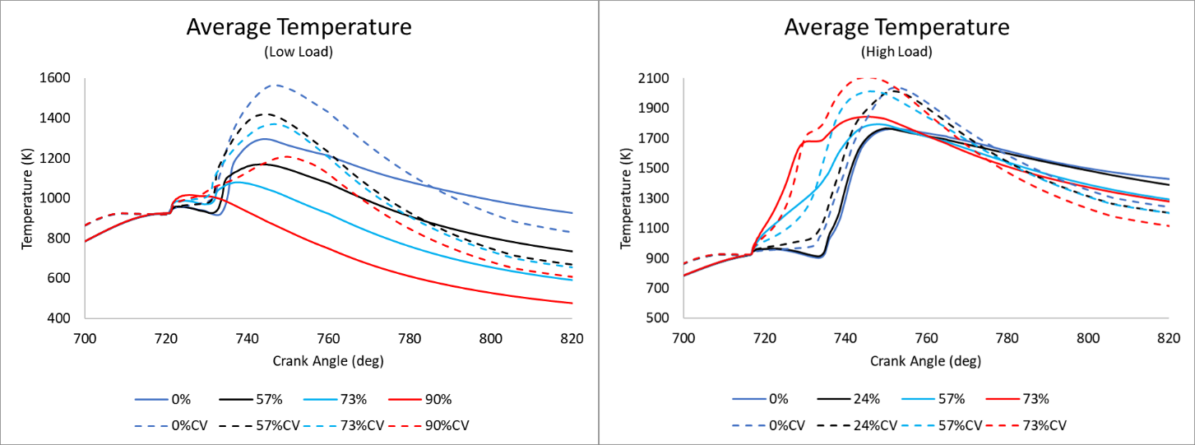
Fig.8. Average temperature.
Fig.8 shows the average in-cylinder temperatures for each case. As expected, average in-cylinder temperatures are mostly higher for all CVCP cases when compared to their conventional counterparts, with the conventional cases only having higher temperatures in the late power stroke. Average in-cylinder temperatures in the CVCP cases increase until the end of the CVCP due to the build-up of pressure and heat released by the combustion, but fall off more rapidly once the piston begins to move again, whereas the conventional cases peak during combustion of the main diesel injection and fall off more steadily. The rapid fall off in temperature in CVCP cases is due to higher amounts of heat loss to the walls, faster piston movement away from TDC and reduced amounts of excess fuel/oxidiser left for combustion when compared to the conventional cases. At LL average in-cylinder temperatures mostly decrease as HES increases due to the reducing quality/amount of combustion occurring. Whereas at HL the opposite trend is true and temperatures mostly increase with increasing HES, they do however decrease with HES increase in the late power stroke due to the chamber wide combustion causing greater amounts of heat loss to the walls. Peak temperatures also tend to occur earlier as HES increases at both load conditions.

3.1.2 Emissions
UHC emissions are a good indicator for the quality of combustion which the diesel went through as the lower the value the more complete the combustion and more diesel which was utilised. A number of factors can cause high UHC emissions including poor mixing of fuel and oxidiser, low temperatures, fuel getting caught in small crevices and fuel mixing with lubricating oil [64]. Fig.9(a) shows UHC emissions reduce dramatically with implementation of the CVCP at both load conditions indicating a much more efficient conversion of fuel to work. This is a result of large amounts of complete combustion occurring at a constant volume and the higher temperatures and pressures being ideal for high diesel combustion efficiencies. The reduced mixing caused by the stationary piston is clearly outweighed by the improved thermodynamic conditions. A reduction is also generally observed as HES increases due to a reduction in injected hydrocarbons. LL goes against this trend somewhat due to the reduction in performance leading to increasing specific output.

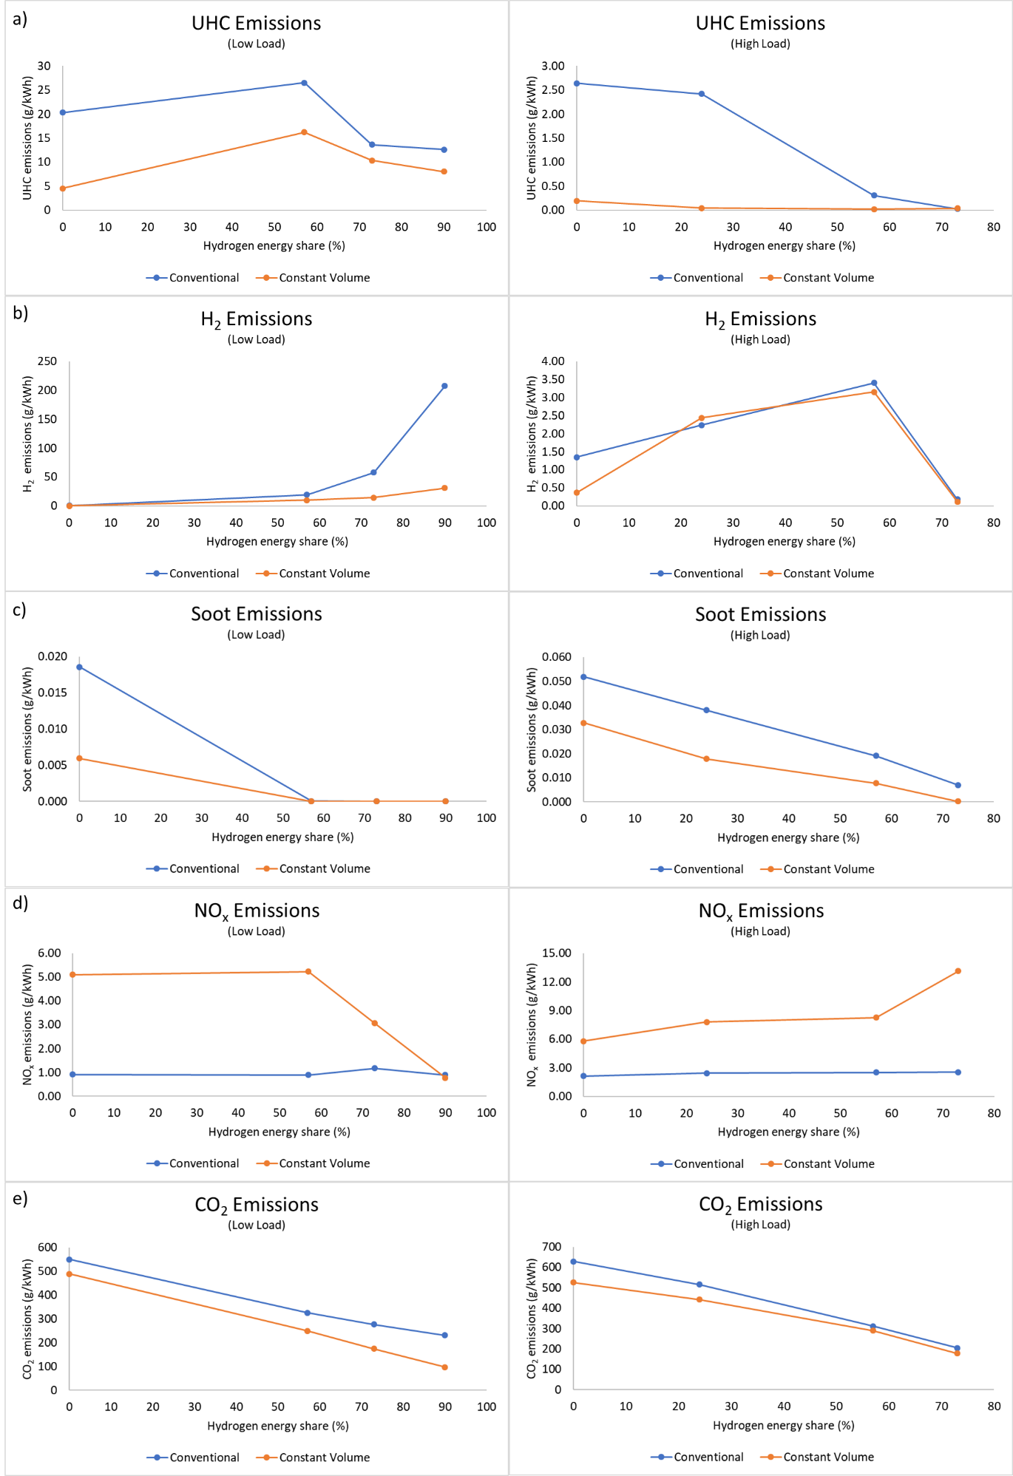
Fig. 9. Emissions levels at EVO for (a) UHC, (b) H₂, (c) soot, (d) NO_{x} and (e) CO₂.

H₂ emissions are also a good indicator of combustion quality and can be largely correlated with how well the diesel injection ignited the hydrogen-air mixture. At LL there is a clear and unacceptable increase in hydrogen emissions as HES increases in the conventional engine, Fig.9(b). This is a result of the deterioration of performance and general lack of combustion occurring when the injected diesel does not adequately ignite the mixture. The CVCP helps to alleviate the issue to an extent but still emits a large amount of hydrogen in the 90% case. Hydrogen emission at HL is much lower with the lowest emissions being that of the 73% cases due to high combustion quality as the flame manages to spread throughout the entire chamber (evidence by the two peaks present in the HRR graphs). CVCP does not meaningfully impact hydrogen emissions at HL because the diesel injection is adequate without need for the increased temperatures offered by the CVCP.

Soot emissions are sensitive to many factors, with the main cause of high soot production being areas of locally rich carbon and low temperatures [65]. Fig.9(c) shows the CVCP cases produce lower soot levels than the conventional setup. The low soot levels are due to the higher temperatures and high levels of combustion efficiency during the CVCP leading to very few rich distributions of carbon in the cylinder, as a large quantity of the injected diesel has gone through quality complete combustion. Reducing the amount of carbon injected into the cylinder also reduces soot levels due to there being a smaller chance for carbon rich distributions to occur so higher HESs improve emissions at both loads.

NO_{x} emission is sensitive to in-cylinder temperatures due to the thermal Zeldovich mechanism [66] with thermal NO_{x} production rate doubling with every 90K increase above 2200K but falling to much lower rates when temperatures are below 1800K [67]. As expected the prolonged higher temperatures associated with the CVCP strategy lead to a significant increase in NO_{x} emission, as shown in Fig.9(d). This increase is present at both loads and therefore is clearly one of the limiting factors when implementing a CVCP cycle and optimisation is required to reduce their level. NO_{x} emissions are shown to generally increase at higher HESs at HL due to the higher burning temperature of hydrogen and chamber wide increase in temperature due to premixed flame propagation, but specific output is somewhat offset by the corresponding performance increase. At LL NO_{x} decreases at higher HESs but this is due to the reduction in combustion which will lead to poor performance.

High levels of CO₂ are also an indicator that the diesel has undergone complete combustion as a larger quantity of CO in the chamber has been oxidised. While CVCP cases have higher CO₂ levels on a per cycle basis, the increased performance leads to a lower specific output, as shown in Fig.9(e). HES increase also leads to lower CO₂ emissions as there is less carbon being injected into the chamber and reduction of air intake, which contains CO_{2,} due to hydrogen substitution will also contribute a small amount.

3.1.3 Performance
Gross indicated performance characteristics are calculated and any further mention of performance, thermal efficiency, power and work refer to gross indicated values. Trapezoidal rule [68] is used to integrate and ﬁnd the area between P-V curves for each case, providing the
work and from this power and thermal eﬃciency were calculated. All gross indicated performance characteristics are linearly linked and therefore only thermal efficiency and cumulative heat release are presented in Fig.10.

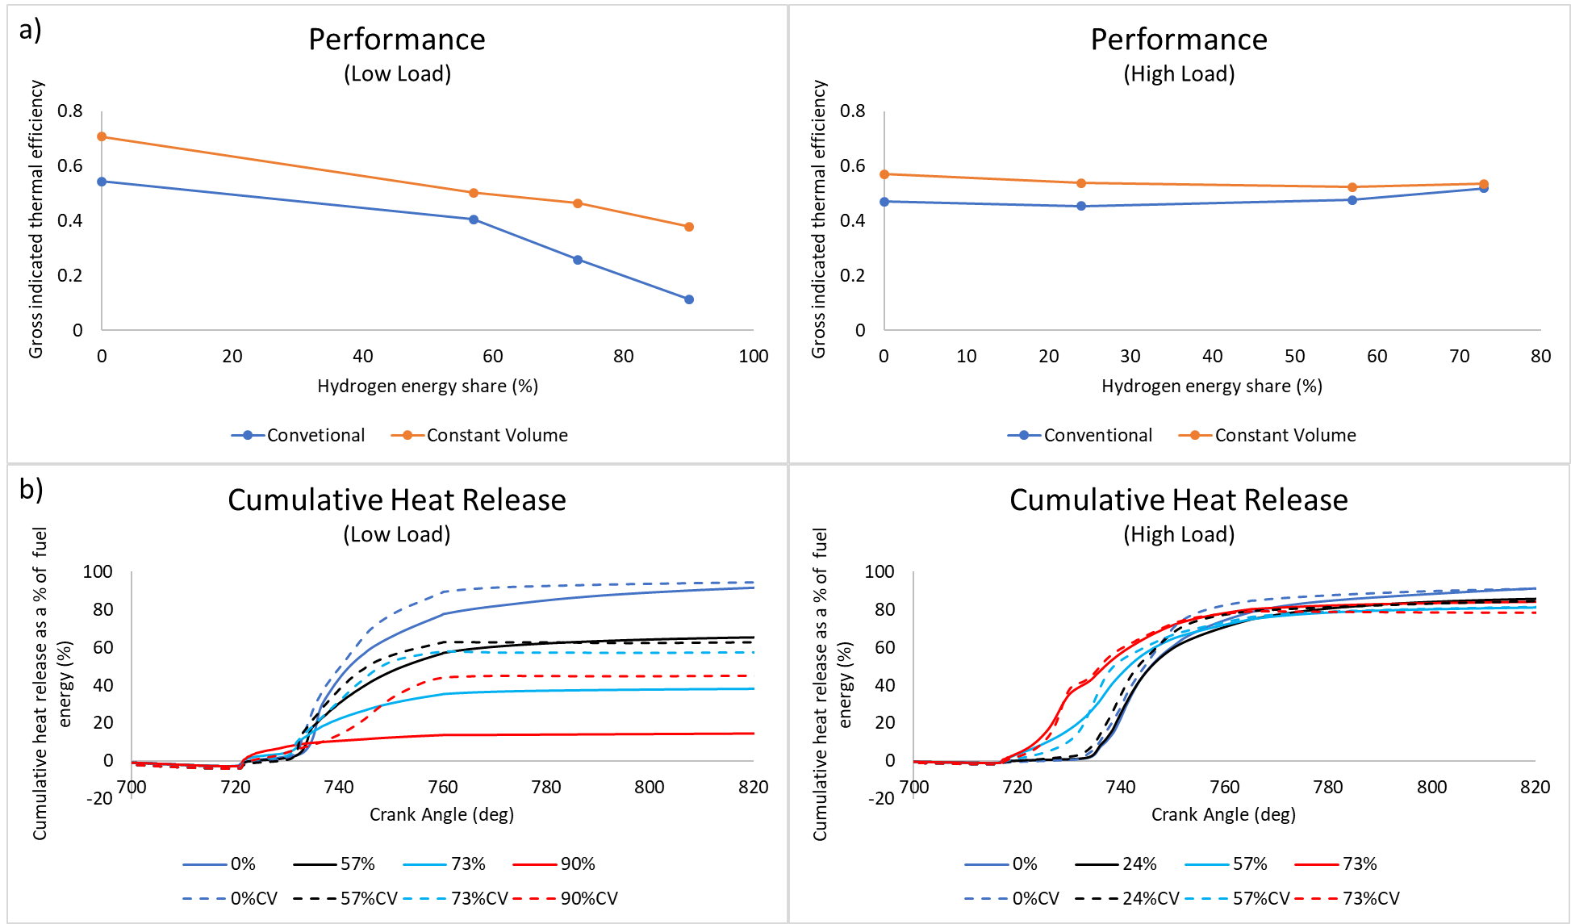

Fig. 10.(a) Performance characteristics for thermal efficiency and (b) cumulative heat release.

The implementation of a CVCP leads to performance increases across all cases, Fig.10(a). The increase in performance is caused by factors including: increased fuel utilisation, higher in-cylinder pressures and temperatures being built to drive the piston and increased amounts of combustion occurring at these conditions. At HL the relative performance increase of CVCP compared to conventional operation decreases as HES increases, while at LL the opposite is true. At HL in the 57% and 73% HES cases the pilot adequately ignites the hydrogen air mix without need for the CVCP so the performance increase largely comes from the increased pressures and not so much fuel utilisation. At HL in the conventional setup increasing HES leads to increases to performance, however performance decreases for the CVCP cases as HES increases due to the aforementioned pressure dwell and thus reduced expansion work as well as increased heat losses to walls. At LL increasing HES leads to a reduction in performance in both operational modes, a result of the diesel injection struggling to properly ignite the hydrogen-air mix. The reduction is less severe in the CVCP cases due to the increased temperatures increasing the likelihood of hydrogen combustion, but further improvements need to be made to completely negate the performance decrease.

As expected, Fig.10(b) shows cumulative heat release is higher under CVCP operation throughout combustion across all HESs at LL due to the much-increased fuel utilisation but total heat release decreases as HES increases. Also in the likes of the LL 0% and 57% CVCP cases there is clearly increased levels of initial heat release, however, HRR during the late power stroke is much lower due to greater amounts of wall heat losses and less fuel being available for combustion, i.e. cooling more rapidly, meaning total heat release at EVO is fairly comparable. These effects are amplified at HL in the 57% and 73% cases where the pilot adequately ignites the premixed charge without need for the CVCP, as evidenced by the very similar early cumulative heat release trends prior to 760CA. The higher in-cylinder temperatures caused by the CVCP and increasing levels of combustion across the entire chamber at higher HESs leads to lower total heat release at EVO for CVCP cases which decreases further as HES increases. This will have an impact on performance and optimising the CVCP such that wall heat losses are minimised requires further attention.

The CVCP performs reasonably across both load conditions at all HESs with good improvements to thermal efficiency and carbon-based emissions compared to the conventional engine. Given proper optimisation with regards to the reducing pressure dwell at TDC, reducing wall heat losses, further improvement to LL high HES performance and strategies to control NO_{x}, CVCP operation could prove useful in future diesel-hydrogen DF engines.
3.2 Low Load Performance Improvements at High HESs
As noted in the previous section several improvements can be made to engine operation which should lead to improved performance and emissions characteristics in the CVCP configuration. This section will focus on further improving LL performance at a high HES as this is one of the major outstanding issues with current diesel-hydrogen DF engines [16, 28]. Table 6 details the 90% HES test cases examined in this section.

Table 6: Details of ten different test cases considered for LL high HES improvement (5 test cases for the conventional engine and 5 test cases for the CVCP engine)
Case | 1/1CV | 2/2CV | 3/3CV | 4/4CV | 5/5CV
Description | Original  (LL 90%/ 90%CV) | Injections advanced by 7CA | Advanced and 3CA less dwell between pilot + main injection | Advanced and combined pilot + main injections | Advanced and combined pilot + main injections with higher velocity
Injection Period Pilot (CA) | 717-719 | 710-712 |  | - | -
Injection Period Main (CA) | 727-729 | 720-722 | 717-719 | 710-714 | 710-713
HES | 90%
Load | Low
3.2.1 Combustion Characteristics
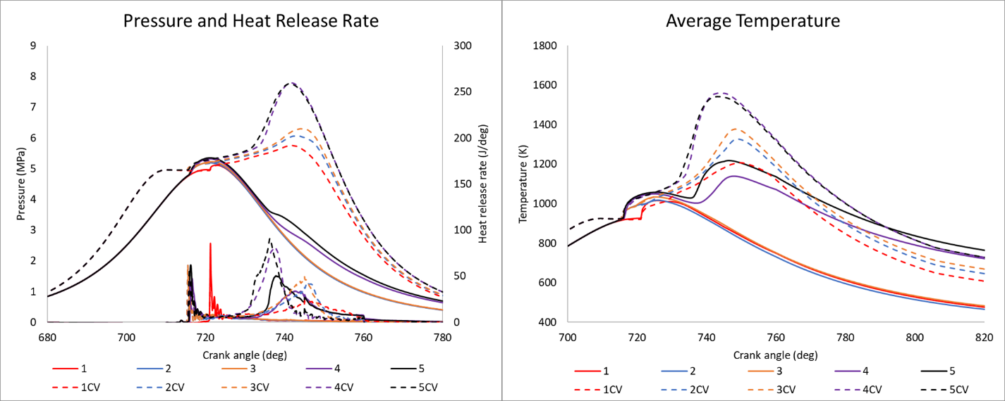
Fig.11. (a) Pressure and HRR, (b) average temperature.

Fig.11(a) shows pressure and HRR traces for each test case while Fig.11(b) shows the average in-cylinder temperatures. Cases 2 and 3 in the conventional engine show little to no improvement to hydrogen heat release compared to case 1, i.e. advancing injections does not lead to adequate ignition of the premixed charge. The only potential improvement comes from the advanced injection leading to higher pressures and temperatures at TDC but this is not enough to cause further hydrogen combustion. However, in the CVCP engine the advanced injections lead to considerable improvements. Earlier injections allow for more time for combustion to occur within the CVCP, leading to an extended temperature building phase and much more favourable conditions for hydrogen ignition. HRR/temperatures initially build slowly until enough combustion has occurred to heat the entire cylinder which then leads to rapid combustion of the remaining hydrogen. In comparison to 1CV, 2CV shows higher peak pressure, temperature and heat release while 3CV shows slightly higher levels of each compared to 2CV. The increases in 3CV are due to the shortening of the dwell time between pilot and main injections leading to even more time for combustion within the CVCP. The CVCP ends somewhat early in these cases however which means some hydrogen is left unburned as the flame extinguishes once temperatures begin to fall.
A combination of factors leads to much improved combustion and hydrogen utilisation in cases 4 and 5 in the conventional engine when compared to cases 1, 2 and 3. Increased levels of diesel premixed charge combustion, due to pilot removal, leads to a larger spike in initial HRR and temperature which increases the likelihood for hydrogen flame propagation. Furthermore, combining the pilot and main injections leads to the entire injection occurring earlier meaning a greater amount of combustion occurs close to TDC and therefore the higher temperatures and pressures which follow improves hydrogen ignition. Additionally, the diesel injection is more focused on one area which increases local temperatures and the chance for local hydrogen combustion which can potentially spread to the rest of the chamber if enough occurs. Compared to case 4, wholesale hydrogen ignition occurs earlier in case 5, indicated by the earlier larger secondary peak in HRR and subsequent increase in power stroke pressure. Clearly more fuel is utilised which suggests injection penetration is as important as expected.
Cases 4CV and 5CV show considerable improvements to combustion when compared to the other CVCP cases. Removal of the pilot increases the diesel premixed charge combustion phase which leads to an increase to in-cylinder temperatures as well as combustion occurring earlier since the overall injection has also been advanced. This means the temperature building phase begins earlier at a higher temperature and leads to the eventual wholesale ignition and rapid combustion of the bulk of the hydrogen-air mix at an earlier stage in the CVCP than the other cases. Due to the earlier combustion much more hydrogen is utilised and this is reflected in the increased HRR and pressure observed in 4CV and 5CV. Compared to 4CV, 5CV has an earlier and larger secondary peak in HRR which is likely largely due to the improved diesel penetration causing more early hydrogen ignition. Peak temperature is slightly lower in 5CV due to the diesel combustion being spread over a larger portion of the cylinder rather than being confined to one very high temperature region.
There is a considerable gap of roughly 15deg between the initial diesel combustion and wholesale hydrogen ignition in cases 4 and 5, indicating that further advancing the injection in the conventional engine would likely be beneficial. This would allow for hydrogen combustion to begin closer to TDC and therefore more would be utilised due to the higher in-cylinder temperatures and the increased pressure should lead to greater work output. This gap also exists in 4CV and 5CV but is smaller, roughly 10deg, and HRR peaks occur prior to the end of the CVCP indicating most of the hydrogen has been burned. This could be optimised by injecting the pilot prior to the CVCP and shortening the CVCP duration to allow for a greater amount of expansion work and should also reduce NOx levels considerably.
3.2.2 Emissions
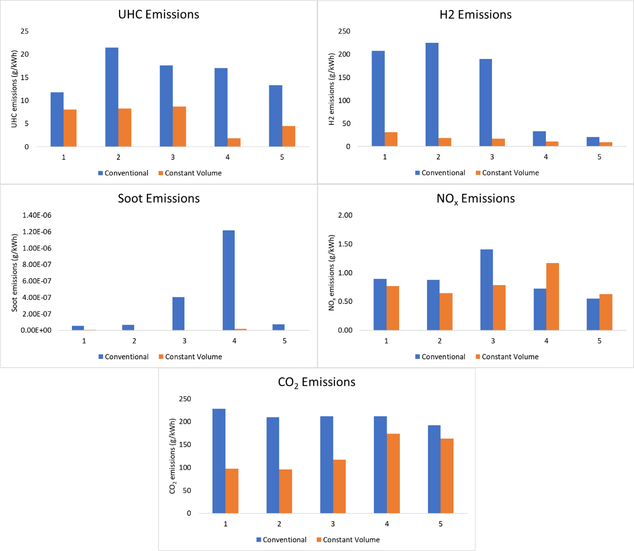
Fig.12. Emissions levels at EVO for (a) UHC, (b) H₂, (c) soot, (d) NO_{x} and (e) CO₂ .

Advancing the injection leads to an increase to UHC emissions in case 2 in the conventional engine, Fig 12(a). This is likely due to poorer combustion of the pilot injection as combustion occurs further away from TDC compared to case 1. This issue is somewhat alleviated in case 3 due to the main injection occurring before TDC and therefore higher amounts of diesel combustion occurring while pressures/temperatures are at their peak and a more complete combustion of the diesel follows. Case 4 completely removes the pilot which leads to an increase to UHC on a per cycle basis but the improved performance due to hydrogen utilisation reduces the specific output somewhat meaning levels are similar to case 3. Removing the pilot causes increased cylinder wetting due to the delayed combustion of the main diesel injection i.e. no pilot means higher ignition delay of the main injection and therefore more of the main injection meets the chamber walls and does not fully combust. Case 5 also suffers from wetting but the increased hydrogen utilisation, higher power stroke temperatures and increased mixing caused by the higher injection velocity leads to a reduction in UHC compared to 4. Case 2CV shows similar UHC emissions levels to 1CV indicating that there is likely an adequate amount of time for the diesel to combust without the earlier injection. Case 3CV also shows similar specific output but per cycle output is slightly higher due to a reduction in the effectiveness of the pilot. Cases 4CV and 5CV show lower UHC emissions compared to all other CVCP cases even though the pilot has been removed. This is likely due to the considerably higher temperatures caused by high levels of hydrogen combustion efficiency leading to improvements to the conversion of UHCs to CO₂ as well as the performance increases lowering specific output. The increase in 5CVs levels compared to 4CV are due to increased cylinder wetting caused by the higher injection velocity and stationary piston, without the benefit of comparatively higher power stroke temperatures unlike in the conventional engine.

Clearly the CVCP cases show much improved hydrogen consumption across the board compared to the conventional cases, Fig.12(b). Each case progressively advances the time at which all diesel is finished being injected and a correlation is observed with regard to hydrogen emissions decreasing with this advancement. This is due to the CVCP maintaining the conditions needed for hydrogen combustion to continue and once the phase ends the hydrogen flame extinguishes soon after as temperatures and pressures fall rapidly, so the earlier the combustion of hydrogen begins the better. Cases 1, 2 and 3 in the conventional engine show unacceptably high hydrogen emissions due to poor bulk mixture ignition. As noted previously, conventional engine cases 4 and 5 improve hydrogen utilisation considerably compared to other conventional cases due to higher amounts of premixed charge diesel combustion, combustion occurring closer to TDC and more focussed injection site. Cases 4CV and 5CV also show a reduction in hydrogen emissions for similar reasons along with the further advancement meaning the bulk of the mixture burns earlier in the CVCP. Increasing injection penetration also leads to a reduction in hydrogen emissions in both conventional and CVCP engines due to more combustion occurring earlier as well as increased mixing of diesel causing more local hydrogen ignition throughout the chamber.

In general soot levels are low in all cases at 90% HES, however, CVCP cases continue to show levels even lower than their conventional counterparts, Fig.12(c), a result of the increased temperatures and burning efficiency of both fuels. Reduction of the dwell time between pilot and main injections (3/3CV) leads to an increase in soot for both operational modes while complete removal of the pilot (4/4CV) leads to an even greater increase. The increase in 3/3CV is due to a reduction in premixed diesel combustion during the main injection, while the increase in 4/4CV is mostly due to the more focussed injection site meaning carbon distribution throughout the chamber is poorer and increased wall wetting also leads to soot development (these factors also contributed to 3/3CV to a lesser extent). Cases 5 and 5CV while not benefiting from the pilot show fairly low soot levels, a result of the increased injection velocity causing a more even carbon distribution throughout the chamber so soot does not form as easily. Case 5 also benefits from higher power stroke temperatures than other conventional cases which slows down the rate of soot production, negating the increases wall wetting may cause.

Cases 1, 2 and 3 show the highest NOx levels out of all conventional engine cases due to the extremely poor performance and thus specific output is higher even though temperatures are low, Fig.12(d). Hydrogen utilisation increases significantly in case 4 and even more so in case 5 which leads to increased temperatures and thus NO_{x} production, but the improved performance offsets the increase. Case 3 in both the conventional and CVCP engines shows NO_{x} increase with relatively little performance difference due to the reduction of the benefits which a pilot offers (lower combustion temperatures) when dwell time between pilot and main is reduced. This is also shown in 4CV where the removal leads to a considerable increase to NO_{x} levels. The increase in 4CV can also be attributed to the higher temperatures caused by the increased hydrogen consumption and much more rapid hydrogen combustion which causes a higher peak temperature. Case 5CV shows a decrease in NO_{x} compared to 4CV due to a slightly lower peak temperature and less of a concentrated high temperature zone due to less diesel combusting in one specific area.

CO₂ levels are lower across all CVCP cases compared to conventional cases, Fig.12(e). For all cases this is due to the improved performance leading to a lower specific output. For cases 4 and 5 the difference is much less as the vast improvements to hydrogen combustion lead to higher/equivalent temperatures in the late power stroke which aids in breakdown of UHCs and oxidation of CO, therefore much more similar CO₂ levels are observed. Performance increase also lowers the observed levels. Compared to 1CV, all other CVCP cases show increased CO₂ as a result of the longer time allowed for complete combustion within the CVCP and longer time between end of injection and EVO in general.

3.2.3 Performance
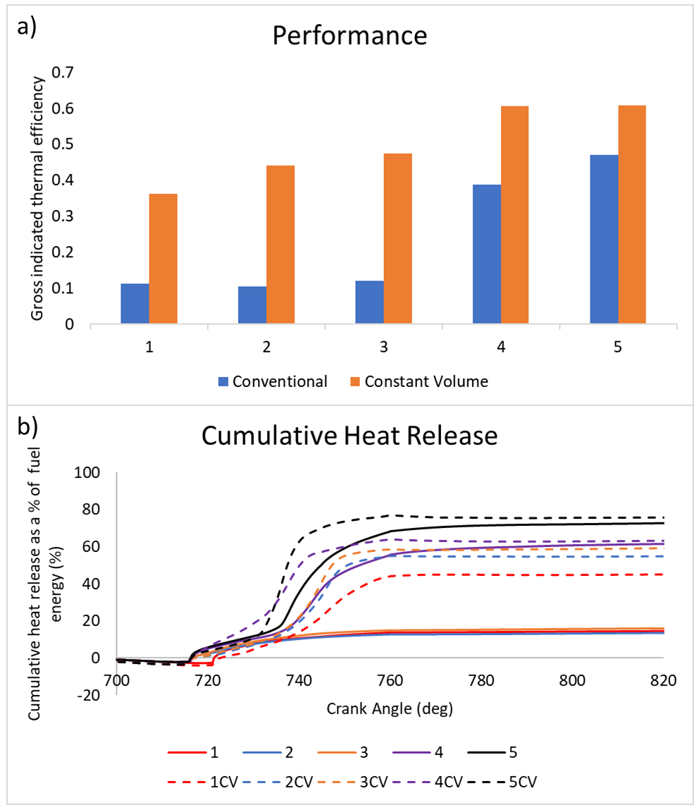
Fig.13. (a) Performance characteristics for thermal efficiency and (b) cumulative heat release.

In the conventional engine advancing the injection and reducing the dwell time between pilot and main does not have a meaningful impact on performance, as shown by cases 2 and 3 in Fig.13(a) as hydrogen utilisation is not improved. However, cases 4 and 5 show good increases to performance a result of the much-increased hydrogen combustion efficiency, and therefore higher combustion pressures, with case 5 showing the best conventional engine performance. Each case progressively advances injection and improvements to CVCP performance follows. In the CVCP engine advancing the injection leads to significantly more hydrogen utilisation as the temperature building phase extends, eventually allowing for wholesale ignition of the hydrogen-air mix within the bounds of the CVCP for cases 4CV and 5CV, which leads to very high peak pressures and therefore work output. Fig.13(b) backs up the findings by clearly showing the correlation between advancement of injection and increase to total heat release. Cumulative heat release trends also show that CVCP cases cause earlier wholesale ignition of the hydrogen-air mix compared to their conventional case counterparts. At LL 90% HES use of advanced injections and increased injection penetration in both the conventional and CVCP engines lead to performances on par with the 0% H₂ conventional engine, Fig.13 (Case 5=47.0%, Case 5CV=60.7% vs. 0%H₂=54.3%).
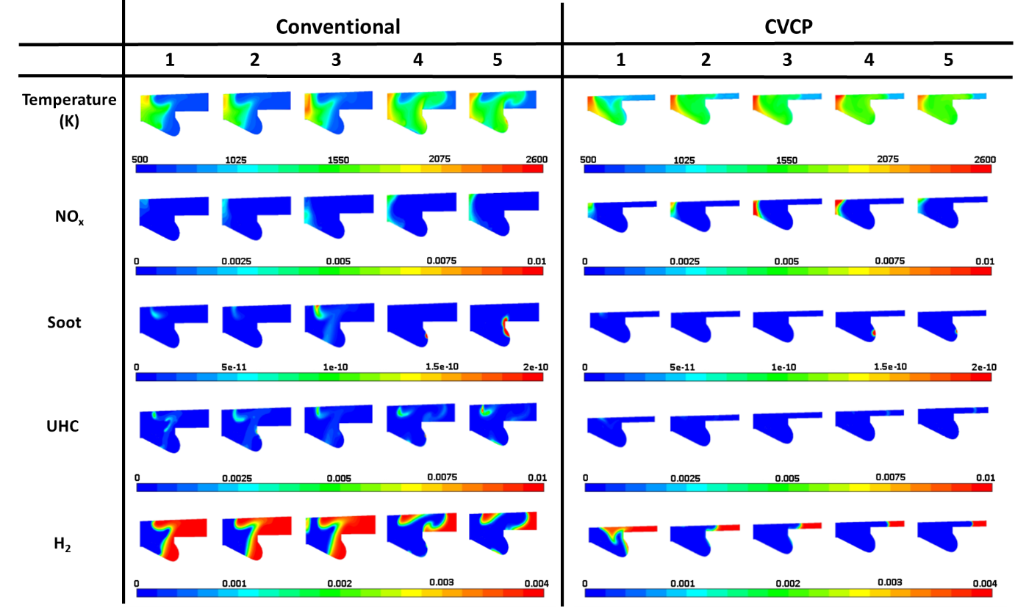
Fig.14. Contours of temperature, NO_{x ,} soot, UHC and H₂ at 750CA for conventional and CVCP configurations for the low load 90% HES test cases.

Fig.14 shows the contours of temperature, NOx, soot, UHC and H₂ at 750CA (30CA ATDC in the conventional engine and 10CA after CVCP ends in the CVCP engine) for the low load 90% HES test cases (see Table 6). Temperatures are generally highest close to where the diesel injection originated. Due to poor injection penetration diesel combustion is confined to this specific area and it is the only area in which both hydrogen and diesel combustion occurs. For cases 1, 2 and 3 in the conventional engine there clearly is not much of a temperature increase outside of this region and this is backed up by the large high hydrogen concentration areas in the contours. Cases 4 and 5 however show good amounts of temperature increase across nearly all of the cylinder due to the spreading of the hydrogen flame front away from the diesel injection site. Peak temperatures are in similar areas to those of the conventional engine in the CVCP cases but are mostly higher and there is a general increase in temperature across the entire cylinder due to the hydrogen flame front spreading well and only struggling to reach the cylinder liner side. There is a clear improvement to hydrogen consumption in all CVCP cases when compared to 1CV with the hydrogen flame spreading closer to the cylinder liner as injection advancement progresses. 5/5CV does not have as high a peak temperature close to the injector due to there being less diesel combustion occurring in this area. Cases 3 and 4 offer the highest temperatures in both the conventional and CVCP engines due to the diminishment of the pilot injection meaning both more combustion happening over a short period of time and more in the one specific area. As expected, higher NO_{x} concentration areas correspond to high temperature regions, generally close to the areas in which both diesel and hydrogen combustion occurred. UHC concentrations generally appear on the edge of the hydrogen flame front where oxygen has been consumed and correlate to areas in which soot production is beginning. Wall wetting is observed in the accumulations of UHCs close to the top/lip of the piston bowl in the cases without pilot injections with a combination of the UHCs and consumed oxygen in these regions causing the onset of soot development.
4. Conclusion
A comprehensive numerical modelling study has been carried out to assess the benefits of a constant volume combustion phase being implemented in a diesel-hydrogen dual-fuel compression ignition engine with focus on performance/efficiency and emissions. The numerical modelling framework has been validated with experimental data from a conventional turbocharged compression ignition diesel-hydrogen dual-fuel engine. The study examined the effects of hydrogen substitution increase at low and high load in the CVCP engine operating with a CVCP period of 30deg followed by a performance analysis at low load high hydrogen energy share.

Key findings are summarised as follows:
1. The CVCP strategy was shown to increase gross indicated thermal efficiency at all HESs at both loads compared to conventional engine operation.

2. The CVCP strategy leads to a large reduction in carbon-based emissions with soot, UHC and CO₂ emissions all falling compared to the conventional engine.

3. The CVCP strategy incurs an increase to NO_{x} emissions compared to conventional engine operation.

4. The CVCP strategy leads to higher peak in-cylinder pressures and temperatures compared to conventional engine operation.

5. Benefits of the CVCP strategy reduce as HES increases at high load. This is due to the diesel injection having no trouble igniting the relatively rich premixed hydrogen-air charge.

6. At LL high HESs the benefits of the CVCP strategy increase greatly. In the conventional engine the reduced diesel pilot injection cannot adequately ignite the lean premixed hydrogen-air charge. Under CVCP operation, however, the higher temperatures and pressures which are built due to the stationary piston allow for much more favourable conditions for dual-fuel pilot ignition and premixed hydrogen-air flame propagation. This is observed in the increased gross indicated thermal efficiency (38% vs. 11% at 90% HES) and considerably reduced levels of hydrogen emission.

7. With further diesel injection optimisation gross indicated thermal efficiencies of up to 61% are achieved at LL 90% HES under CVCP operation and hydrogen utilisation is further improved while not negatively impacting other emissions characteristics.

8. Diesel injection advancement plays a vital role in improving hydrogen utilisation and performance at LL high HESs when using the CVCP strategy. If more time is allowed for combustion within the CVCP the hydrogen-air flame will propagate further before the piston is released from TDC.

9. Injection penetration plays a much bigger role in conventional operation at LL high HESs. This is due to hydrogen combustion being more reliant on an adequate amount of diesel combustion happening throughout the chamber to increase the likelihood of hydrogen ignition. It was also found that increasing the amount of premixed charge diesel combustion and diesel injections occurring closer to TDC both improve hydrogen combustion significantly in the conventional engine.

The findings of this study will be considered in the utilisation of hydrogen fuel under diesel hydrogen dual-fuel combustion mode in a cam drive CVCP opposed piston engine currently being developed by Covaxe Group (see Fig.2).

References
[1] Wallington TJ, Lambert CK, Ruona WC. Diesel vehicles and sustainable mobility in the U.S. Energy Policy 2013;54:47–53. https://doi.org/10.1016/j.enpol.2011.11.068.
[2] Mwangi JK, Lee W-J, Chang Y-C, Chen C-Y, Wang L-C. An overview: Energy saving and pollution reduction by using green fuel blends in diesel engines. Appl Energy 2015;159:214–36. https://doi.org/10.1016/j.apenergy.2015.08.084.
[3] Gill SS, Tsolakis A, Herreros JM, York APE. Diesel emissions improvements through the use of biodiesel or oxygenated blending components. Fuel 2012;95:578–86. https://doi.org/10.1016/j.fuel.2011.11.047.
[4] Squaiella LLF, Martins CA, Lacava PT. Strategies for emission control in diesel engine to meet Euro VI. Fuel 2013;104:183–93. https://doi.org/10.1016/j.fuel.2012.07.027.
[5] European Union. COMMISSION REGULATION (EU) No 136/2014 of 11 February 2014. Off J Eur Union 2014. http://data.europa.eu/eli/reg/2014/136/oj.
[6] Staffell I, Scamman D, Abad AV, Balcombe P, Dodds PE, Ekins P, et al. The role of hydrogen and fuel cells in the global energy system. Energy Environ Sci 2019;12:463–91. https://doi.org/10.1039/C8EE01157E.
[7] Reitz RD. Directions in internal combustion engine research. Combust Flame 2013;1:1–8. https://doi.org/10.1016/j.combustflame.2012.11.002.
[8] White CM, Steeper RR, Lutz AE. The hydrogen-fueled internal combustion engine: a technical review. Int J Hydrog Energy 2006;31:1292–305. https://doi.org/10.1016/j.ijhydene.2005.12.001.
[9] Chintala V, Subramanian KA. A comprehensive review on utilization of hydrogen in a compression ignition engine under dual fuel mode. Renew Sustain Energy Rev 2017;70:472–91. https://doi.org/10.1016/j.rser.2016.11.247.
[10] Dimitriou P, Tsujimura T. A review of hydrogen as a compression ignition engine fuel. Int J Hydrog Energy 2017;42:24470–86. https://doi.org/10.1016/j.ijhydene.2017.07.232.
[11] Gomes Antunes JM, Mikalsen R, Roskilly AP. An experimental study of a direct injection compression ignition hydrogen engine. Int J Hydrog Energy 2009;34:6516–22. https://doi.org/10.1016/j.ijhydene.2009.05.142.
[12] Boretti A. Advantages of the direct injection of both diesel and hydrogen in dual fuel H2ICE. Int J Hydrog Energy 2011;36:9312–7. https://doi.org/10.1016/j.ijhydene.2011.05.037.
[13] Tsujimura T, Suzuki Y. The utilization of hydrogen in hydrogen/diesel dual fuel engine. Int J Hydrog Energy 2017;42:14019–29. https://doi.org/10.1016/j.ijhydene.2017.01.152.
[14] Chintala V, Subramanian KA. An effort to enhance HES in a compression ignition engine under dual-fuel mode using low temperature combustion strategies. Appl Energy 2015;146:174–83. https://doi.org/10.1016/j.apenergy.2015.01.110.
[15] Santoso WB, Bakar RA, Nur A. Combustion Characteristics of Diesel-Hydrogen Dual Fuel Engine at LL. Energy Procedia 2013;32:3–10. https://doi.org/10.1016/j.egypro.2013.05.002.
[16] Dimitriou P, Tsujimura T, Suzuki Y. Low-load hydrogen-diesel dual-fuel engine operation – A combustion efficiency improvement approach. Int J Hydrog Energy 2019;44:17048–60. https://doi.org/10.1016/j.ijhydene.2019.04.203.
[17] Chintala V, Subramanian KA. Experimental investigation of HES improvement in a compression ignition engine using water injection and compression ratio reduction. Energy Convers Manag 2016;108:106–19. https://doi.org/10.1016/j.enconman.2015.10.069.
[18] Karim GA. Combustion in Gas Fueled Compression: Ignition Engines of the Dual Fuel Type. J Eng Gas Turbines Power 2003;125:827–36. https://doi.org/10.1115/1.1581894.
[19] Wei L, Geng P. A review on natural gas/diesel dual fuel combustion, emissions and performance. Fuel Process Technol 2016;142:264–78. https://doi.org/10.1016/j.fuproc.2015.09.018.
[20] Senthil Kumar M, Ramesh A, Nagalingam B. Use of hydrogen to enhance the performance of a vegetable oil fuelled compression ignition engine. Int J Hydrog Energy 2003;28:1143–54. https://doi.org/10.1016/S0360-3199(02)00234-3.
[21] Liew C, Li H, Liu S, Besch MC, Ralston B, Clark N, et al. Exhaust emissions of a H2-enriched heavy-duty diesel engine equipped with cooled EGR and variable geometry turbocharger. Fuel 2012;91:155–63. https://doi.org/10.1016/j.fuel.2011.08.002.
[22] Subramanian KA, Chintala V. Reduction of GHGs Emissions in a Biodiesel Fueled Diesel Engine Using Hydrogen 2013:V002T02A005. https://doi.org/10.1115/ICEF2013-19133.
[23] Miyamoto T, Hasegawa H, Mikami M, Kojima N, Kabashima H, Urata Y. Effect of hydrogen addition to intake gas on combustion and exhaust emission characteristics of a diesel engine. Int J Hydrog Energy 2011;36:13138–49. https://doi.org/10.1016/j.ijhydene.2011.06.144.
[24] Park H, Kim J, Bae C. Effects of Hydrogen Ratio and EGR on Combustion and Emissions in a Hydrogen/Diesel Dual-Fuel PCCI Engine 2015. https://doi.org/10.4271/2015-01-1815.
[25] Hairuddin AA, Yusaf T, Wandel AP. A review of hydrogen and natural gas addition in diesel HCCI engines. Renew Sustain Energy Rev 2014;32:739–61. https://doi.org/10.1016/j.rser.2014.01.018.
[26] Gomes Antunes JM, Mikalsen R, Roskilly AP. An investigation of hydrogen-fuelled HCCI engine performance and operation. Int J Hydrog Energy 2008;33:5823–8. https://doi.org/10.1016/j.ijhydene.2008.07.121.
[27] Fang W, Huang B, Kittelson DB, Northrop WF. Dual-Fuel Diesel Engine Combustion With Hydrogen, Gasoline, and Ethanol as Fumigants: Effect of Diesel Injection Timing. J Eng Gas Turbines Power 2014;136. https://doi.org/10.1115/1.4026655.
[28] Dimitriou P, Kumar M, Tsujimura T, Suzuki Y. Combustion and emission characteristics of a hydrogen-diesel dual-fuel engine. Int J Hydrog Energy 2018;43:13605–17. https://doi.org/10.1016/j.ijhydene.2018.05.062.
[29] Dec JE. Advanced compression-ignition engines—understanding the in-cylinder processes. Proc Combust Inst 2009;32:2727–42. https://doi.org/10.1016/j.proci.2008.08.008.
[30] Chintala V, Subramanian KA. Experimental investigation of HES improvement in a compression ignition engine using water injection and compression ratio reduction. Energy Convers Manag 2016;108:106–19. https://doi.org/10.1016/j.enconman.2015.10.069.
[31] Mohamed Ibrahim M, Ramesh A. Investigations on the effects of intake temperature and charge dilution in a hydrogen fueled HCCI engine. Int J Hydrog Energy 2014;39:14097–108. https://doi.org/10.1016/j.ijhydene.2014.07.019.
[32] Mabadi Rahimi H, Jazayeri SA, Ebrahimi M. Hydrogen energy share enhancement in a heavy duty diesel engine under RCCI combustion fueled with natural gas and diesel oil. Int J Hydrog Energy 2020;45:17975–91. https://doi.org/10.1016/j.ijhydene.2020.04.263.

[33] SinghYadav V, Soni SL, Sharma D. Performance and emission studies of direct injection C.I. engine in duel fuel mode (hydrogen-diesel) with EGR. Int J Hydrog Energy 2012;37:3807–17. https://doi.org/10.1016/j.ijhydene.2011.04.163.

[34] Reitz RD, Duraisamy G. Review of high efficiency and clean reactivity controlled compression ignition (RCCI) combustion in internal combustion engines. Prog Energy Combust Sci 2015;46:12–71. https://doi.org/10.1016/j.pecs.2014.05.003.

[35] Hairuddin AA, Yusaf T, Wandel AP. A review of hydrogen and natural gas addition in diesel HCCI engines. Renew Sustain Energy Rev 2014;32:739–61. https://doi.org/10.1016/j.rser.2014.01.018.

[36] Yip HL, Srna A, Yuen ACY, Kook S, Taylor RA, Yeoh GH, et al. A Review of Hydrogen Direct Injection for Internal Combustion Engines: Towards Carbon-Free Combustion. Appl Sci 2019;9:4842. https://doi.org/10.3390/app9224842.

[37] Takagi Y, Keiichi K, Oikawa A, Sekine H, Yoshio S. Study on performance improvement by high-pressure direct injection hydrogen engine in rich mixture air-fuel mixture combustion by improving jet shape. Auto Eng Soc Proc 2013;44:1141–6. https://doi.org/10.11351/jsaeronbun.44.1141.

[38] Roy MK, Kawahara N, Tomita E, Fujitani T. Jet-guided combustion characteristics and local fuel concentration measurements in a hydrogen direct-injection spark-ignition engine. Proc Combust Inst 2013;34:2977–84. https://doi.org/10.1016/j.proci.2012.06.103.

[39] Mohammadi A, Shioji M, Nakai Y, Ishikura W, Tabo E. Performance and combustion characteristics of a direct injection SI hydrogen engine. Int J Hydrog Energy 2007;32:296–304. https://doi.org/10.1016/j.ijhydene.2006.06.005.

[40] Ishibashi R, Tsuru D. An optical investigation of combustion process of a direct high-pressure injection of natural gas. J Mar Sci Technol 2017;22:447–58. https://doi.org/10.1007/s00773-016-0422-x.

[41] McTaggart-Cowan G, Mann K, Huang J, Singh A, Patychuk B, Zheng ZX, et al. Direct Injection of Natural Gas at up to 600 Bar in a Pilot-Ignited Heavy-Duty Engine. SAE Int J Engines 2015;8:981–96. https://doi.org/10.4271/2015-01-0865.

[42] Ouellette P. Direct injection of natural gas for diesel engine fueling. PhD. The University of British Columbia, 1996 https://open.library.ubc.ca/cIRcle/collections/ubctheses/831/items/1.0080880.

[43] Heywood J. Internal Combustion Engine Fundamentals. McGraw-Hill Education; 1988.
[44] Chen R, Winward E, Stewart P, Taylor B, Gladwin D. Quasi-Constant Volume (QCV) Spark Ignition Combustion. Warrendale, PA: SAE International; 2009. https://doi.org/10.4271/2009-01-0700.
[45] Dorić JŽ, Klinar IJ. Efficiency of a new internal combustion engine concept with variable piston motion. Therm Sci 2014;18:113–27 https://doi.org/10.2298/TSCI110923020D.
[46] Shaik A, Moorthi NSV, Rudramoorthy R. Variable compression ratio engine: A future power plant for automobiles - an overview. Proc Inst Mech Eng Part J Automob Eng 2007;221:1159–68. https://doi.org/10.1243/09544070JAUTO573.
[47] Zhang C, Sun Z. Using variable piston trajectory to reduce engine-out emissions. Appl Energy 2016;170:403–14. https://doi.org/10.1016/j.apenergy.2016.02.104.
[48] Zhang C, Li K, Sun Z. Modeling of piston trajectory-based HCCI combustion enabled by a free piston engine. Appl Energy 2015;139:313–26. https://doi.org/10.1016/j.apenergy.2014.11.007.
[49] Zhang C, Sun Z. Trajectory-based combustion control for renewable fuels in free piston engines. Appl Energy 2017;187:72–83. https://doi.org/10.1016/j.apenergy.2016.11.045.
[50] Rabl S, Davies TJ, McDougall AP, Cracknell RF. Understanding the relationship between ignition delay and burn duration in a constant volume vessel at diesel engine conditions. Proc Combust Inst 2015;35:2967–74. https://doi.org/10.1016/j.proci.2014.05.054.
[51] Lapuerta M, Sanz-Argent J, Raine RR. Ignition Characteristics of Diesel Fuel in a Constant Volume Bomb under Diesel-Like Conditions. Effect of the Operation Parameters. Energy Fuels 2014;28:5445–54. https://doi.org/10.1021/ef500535j.
[52] Naber JD, Johnson JE. 8 - Internal combustion engine cycles and concepts. In: Folkson R, editor. Altern. Fuels Adv. Veh. Technol. Improv. Environ. Perform., Woodhead Publishing; 2014, p. 197–224. https://doi.org/10.1533/9780857097422.2.197.
[53] Ramsay CJ, Ranga Dinesh KKJ, Fairney W, Vaughan N. A numerical study of a compression ignition engine operating with constant volume combustion phase: Effects of constant volume phase on combustion performance and emissions. Fuel 2020;280:118657. https://doi.org/10.1016/j.fuel.2020.118657.

[54] Pirault J-P, Flint M. Opposed Piston Engines: Evolution, Use and Future Applications. SAE International; 2009.

[55] Salvi A, Hanson R, Zermeno R, Regner G, Sellnau M, Redon F. Initial Results on a New Light-Duty 2.7L Opposed-Piston Gasoline Compression Ignition Multi-Cylinder Engine, ASME; 2018, p. V001T03A010-V001T03A010. https://doi.org/10.1115/ICEF2018-9610.
[56] Sellnau M, Hoyer K, Petot JH, Kahraman E, Meissonnier G, Zermeno R, et al. Fuel Injection System for Opposed-Piston Gasoline Compression-Ignited (OP-GCI) Engines 2019. https://doi.org/10.4271/2019-01-0287.
[57] Callahan BJ, Wahl MH, Froelund K. Oil Consumption Measurements for a Modern Opposed-Piston Two-Stroke Diesel Engine, ASME Digital Collection; 2012, p. 1019–28. https://doi.org/10.1115/ICEF2011-60140.

[58] Hanson R, Salvi A, Redon F, Regner G. Experimental Comparison of Gasoline Compression Ignition and Diesel Combustion in a Medium-Duty Opposed-Piston Engine. J Energy Resour Technol 2019;141. https://doi.org/10.1115/1.4043825.
[59] Zhang Q, Xu Z, Liu S, Liu L. Effects of Injector Spray Angle on Performance of an Opposed-Piston Free-Piston Engine. Energies 2020;13:3735. https://doi.org/10.3390/en13143735.

[60] Hall RJ, Smooke MD, and Colket MB. Physical and Chemical Aspects of Combustion. Gordon and Breach 1997.
[61] Patel A, Kong S-C, Reitz RD. Development and Validation of a Reduced Reaction Mechanism for HCCI Engine Simulations. Warrendale, PA: SAE International; 2004. https://doi.org/10.4271/2004-01-0558.
[62] Kéromnès A, Metcalfe WK, Heufer KA, Donohoe N, Das AK, Sung CJ, Herzler J, Naumann C, Griebel P, Mathieu O, Krejci MC. An experimental and detailed chemical kinetic modelling study of hydrogen and syngas mixture oxidation at elevated pressures. Combust Flame 2013:160(6):995-1011. https://doi.org/10.1016/j.combustflame.2013.01.001.
[63] Kim H, Reitz RD, Kong SC. Modelling combustion and emissions of HSDI diesel engines using injectors with different included spray angles. SAE Technical Paper; 2006; 2006-01-1150. https://doi.org/10.4271/2006-01-1150.
[64] Musculus, MP, Lachaux, T, Pickett, LM, Idicheria CA. End-of-injection over-mixing and unburned hydrocarbon emissions in low-temperature-combustion diesel engines SAE Technical Paper 2007. https://doi.org/10.4271/2007-01-0907.
[65] Bobba MK, Genzale CL, Musculus MPB. Effect of Ignition Delay on In-Cylinder Soot Characteristics of a Heavy Duty Diesel Engine Operating at Low Temperature Conditions. SAE Int J Engines 2009;2:911–24. https://doi.org/10.4271/2009-01-0946.
[66] Hanson RK, Salimian S. Survey of Rate Constants in the N/H/O System. In: Gardiner WC, editor. Combust. Chem., New York, NY: Springer New York; 1984, p. 361–421. https://doi.org/10.1007/978-1-4684-0186-86.
[67] Turns SR. An Introduction to Combustion: Concepts and Applications. 3 edition. New York: McGraw-Hill Education; 2011.
[68] Pollard JH. A Handbook of Numerical and Statistical Techniques: With Examples Mainly from the Life Sciences. CUP Archive; 1979.

