**Brexit Uncertainty and Volatility Persistence in Tourism Demand[1]**

Anupam Dutta

School of Accounting and Finance, University of Vaasa, Vaasa, Finland.

Tapas Mishra

Southampton Business School, Southampton University, Southampton, UK.

Gazi Salah Uddin

Department of Management and Engineering, Linköping University, Linköping, Sweden.

Yang Yang

Department of Tourism and Hospitality Management, Temple University, Philadelphia, USA.

**Abstract**

Tourism has emerged as one of the leading components of aggregate economic growth in most developed economies, especially in the UK, where it is predicted to grow at an annual rate of 3.8% through 2025. Because tourism demand represents individuals’ choice between leisure and work, a persistence of negative shocks, such as Brexit uncertainty, can be detrimental to the growth of tourism via its impact on agents’ utility function of a directed consumption of leisure for a specific country. This paper fills a gap in the literature by providing an econometric estimate of time-varying volatility in tourism demand following Brexit-driven Economic Policy Uncertainty. Using seasonally adjusted and trend-extracted tourist arrival series along with Brexit uncertainty, we find a strong evidence of long-run persistence in (asymmetric) volatility in tourist arrival. In particular, the BREXIT referendum appeared to create ambiguity among international visitors to the UK. Our results have important policy implication.

**Keywords**: Tourism demand; asymmetric GARCH; structural breaks; volatility persistence; Brexit; Hamilton Filter**Introduction**

Lately, tourism growth is recognized as a fundamental driver of economic growth across nations worldwide. A recent study by Deloitte showed that for every 1% increase in total expenditure in UK tourism, a full-time equivalent employment raises by 0.89%. Due to its centrality in achieving ‘sustainable’ economic growth, a robust body of literature in recent years has focused on construction and estimation of tourism demand function has dominated the recent literature, a neglected dimension that requires attention, is to identify and model a predictive pattern from the observed tourism arrivals information. Higher volatility and its persistence leave an indelible impact on tourists’ psyche for a possible return to a country and/or planning a new trip for the first-time tourists. Volatility indeed matters – both psychologically and economically. For example, time-varying effects such as natural disasters, threats of global terrorism, financial crises or fears of viral infection often cause uncertainties in the tourism sector and hence it is essential to estimate such uncertainties accurately to formulate appropriate macroeconomic policy.

Indeed, as Hoti et al. (2007) argue, tourism earnings are an important source of foreign exchange and employment, hence precise estimates of the volatility of tourist arrivals play a crucial role in the decision-making process for different public and private sectors. Chan et al. (2005) also claim that proper measures of volatility in leisure industry could help tourism managers in assessing their business strengths and weaknesses periodically and noticing attractive opportunities.

This paper aims to contribute to the nascent literature by estimating a *time-varying conditional volatility* of tourism demand in the context of the UK. Recent extreme events, such as Brexit, which has proliferated uncertainty over a significant stretch of time, can leave indelible effects in tourism demand. We estimate such an effect by employing an asymmetric volatility persistence model, introducing policy uncertainty as an arbiter of asymmetry. To this end, we estimate two variants of generalized autoregressive conditional heteroskedasticity (GARCH) models where our primary interest is whether shocks to the tourist arrival series will have long-run impacts on the visitors. We further expand on our modelling by introducing multivariate dynamic conditional correlation GARCH (or MGARCH-DCC) model.

We recognize that the asymmetric impact of conditional volatility may well be influenced by break points in the data. For instance, tourism demand in the UK may be subject to fluctuations due to Brexit uncertainty and/or good or bad news, wars and recessions. Indeed, Hillebrand (2005) showed that structural breaks lead to an upward bias in estimated volatility persistence. To investigate thus, the impact of structural breaks on the volatility of tourist arrivals in the UK, we also estimate GARCH in the presence of a break point. Specifically, we examine whether the impact of good and bad news on the volatility of tourism demand changes when structural breaks are observed in the arrival data.

We finally examine whether BREXIT referendum leads to a drop in inbound tourism to the UK. Current estimates evidence that interest in visiting the UK since the BREXIT referendum has declined from 76% in August 2016 to 69% in autumn 2018. Such a drop could be attributed to a fall in interest among the Europeans, who account for two-thirds of overseas tourists.

1. **Methodology and Data**
2. ***Methodology***

We begin with an AR(1)-GARCH(1,1) model to study volatility persistence in tourism demand; the autoregressive (AR) term would capture the fact that past tourism demand determines a part of the current tourism demand (a persistence effect), whereas the time-varying volatility is presented by GARH(1,1) process. That is, the AR (1)-GARCH (1, 1) approach is:

$∆{Tour}_{t}=π+ϕ∆{Tour}_{t-1}+ε_{t}$ (1)

where, $∆{Tour}_{t}$ denotes the first-order difference of tourist arrivals at month *t*. The error term $ε_{t}$ is assumed to be normally distributed, but the conditional variance is presented by:

${ h}_{t}^{2}=ω+αε_{t-1}^{2}+βh_{t-1}^{2}$ (2)

Where $α$ and $β$ are ARCH and GARCH parameters, $h_{t}^{2}$ is the conditional variance at time *t*, and $ε_{t-1}^{2}$ denotes the news impact at time *t*-1. The persistence of volatility is measured as $α+β$. In case, we expect asymmetric effect of shocks, we adopt GJR-GARCH to examine whether positive or negative shocks (i.e., upward/downward shifts in the arrival series) have similar impacts on the conditional variance (*ht*):

(3)

where $γ$ is the asymmetric parameter, $S_{t-1}$ indicates a dummy variable taking the value 1 when $ε_{t-1}$ is negative and 0 otherwise. For this approach, the persistence of volatility amounts to $α+β+1/2γ$. Moreover, to accommodate the possibility of structural breaks in our tourist arrival series we employ multiple break point test as in Bai and Perron (1998, 2003a, b). We can then extend Equation 2 as follows

${ h}_{t}^{2}=ω+φ_{1}D_{1}+⋯+φ_{n}D_{n}+αε_{t-1}^{2}+βh_{t-1}^{2}$ (4)

where, $D_{1},⋯,D_{n}$ indicate the dummy variables which are equal to one for the break periods and zero elsewhere. The same extension applies to the GJR-GARCH process. Our assumed breakpoint is Brexit proposal, around which we would like to estimate the dependence structure of tourism demand as well as the dependence pattern in their volatilities.

Moreover, to observe the impact of BREXIT, we consider the following volatility equation:

${ h}_{t}^{2}=ω+δ{BREXIT}_{t}+αε_{t-1}^{2}+βh_{t-1}^{2}$ (5)

In Equation 5, *BREXIT* takes the value 1 after the BREXIT referendum and 0 otherwise. Furthermore, as a robustness we also provide multivariate DCC GARCH estimation as it allows estimation of the parameters of dynamic conditional correlation (DCC) within a multivariate setting of the generalized autoregressive conditionally heteroskedastic (MGARCH). We model the conditional variances by univariate GARCH models and the conditional covariances are modeled as nonlinear functions of the conditional variances.[2]

1. ***Data characteristics***

We use monthly data which span from January 1980 to December 2018, yielding a total of 468 monthly observations. [3] The choice of this sample is guided by two reasons; longer sample span with enough frequency to depict volatility and second, to capture the impact of asymmetric information following the uncertainty around Brexit Referendum. The tourists’ arrival data is gathered from Thomson Reuters DataStream database. Similarly, we follow Baker et al (2016) to measure economic policy uncertainty for the UK. The data is available from https://www.policyuncertainty.com/uk_monthly.html. Our break point test produces two potential breaks: June 2001 and January 2009. The possible reasons for these breaks could be the mouth and foot disease taking place in the UK during 2001 and the 2008 global financial crisis, respectively. Our econometric estimation precedes some necessary data transformation in the form of de-seasonalisation and trend extraction given that we have monthly data for tourists’ arrival and that the data spans 39 years. For trend extraction we have employed the recently developed Hamilton filter (Hamilton, 2018).

1. **Results**

Prior to our model estimation, we first-difference the data based on ADF, Phillips-Perron and DF-GLS tests. Table 1 summarizes results from estimation of various GARCH models: baseline GARCH, GARCH with breaks and GARCH with BREXIT impact. Results for baseline model suggest that the GARCH parameter ($β$) is highly significant in each case, while the ARCH parameter $(α)$ appears to be significant only for the GJR-GARCH process. These findings indicate that a shock to tourism demand will have long-term persistence. Note that the stationary condition is satisfied for both models implying that the Quasi-Maximum Likelihood Estimators (QMLE) for the UK arrival series are consistent and asymptotically normal. Hence, the inference based on the GARCH specifications is valid. Moreover, asymmetric effects are observed in the arrival data, as the $γ$ parameter is found to be significant for the UK index. The negative value of $γ$ suggests that if the anticipated arrivals are lower than expected, there will be a downward shift in the uncertainty levels.

The results of Table 1 further confirm that the degree of volatility persistence is reduced if structural changes are taken into consideration. For instance, the $β$ value for the baseline GARCH amounts to 0.9813, whereas the corresponding estimate after accounting for breaks equals 0.8718 suggesting that there is a significant drop in volatility persistence. Based on the AIC, BIC and log-likelihood values, we can also conclude that GARCH models accounting for structural breaks outperform the standard ones. We also observe that the effects of structural breaks ($φ_{1}$ and $φ_{2}$) appear to be positive implying that the presence of such breaks tends to raise uncertainty in the tourism industry.

Table 3 summarizes the impacts of good and bad news on the volatility of tourism demand (using unadjusted data)[4]. These results, based on the GJR-GARCH approach, reveal that the coefficients measuring the effects of good and bad news increase considerably when structural breaks are considered. These results suggest that the effect of good news amounts to 0.0124 when breaks are overlooked and 0.0326 when breaks are considered. The corresponding impacts of bad news ($α+γ$) are 0.1275 and 0.2391 respectively. Hence, bad news, when compared to good news, has more impact on the conditional volatility of tourist arrivals. We thus conclude that when structural breaks are ignored in the tourist arrival index, the volatility persistence is overestimated, and the news impact is underestimated.

Furthermore, the impact of BREXIT seems to be positive (although insignificant) implying that the BREXIT referendum tends to create ambiguity among international visitors to the UK. To shed further light on the BREXIT issue, we estimate the time-varying correlations between BREXIT-EPU index and tourist arrival series using the DCC-GARCH approach. Fig. 3, which depicts these correlations, demonstrates that such correlations are mostly negative suggesting that the number of visitors to the UK has reduced during the post BREXIT referendum period.

In Table 2, we have presented a re-estimation of a sample selected models as in Table 1 but using a de-seasonalized and trend-extracted data. In addition to the standard GARCH, we have also presented a multivariate DCC GARCH (MGARCH-DCC) estimation.[5] Similar to Table 1, we find significant degree of persistence using both conventional AR(1)-GARCH(1,1) process as well as GJR-GARCH(1,1) process. Our estimation of MGARCH-DCC also produced an estimated overall persistence of 0.987 and a component correlation between Brexit-Uncertainty and tourist arrival estimated at 0.893. For GJR-GARCH(1,1), using our modified data, we note that Brexit-uncertainty imparts significant positive effects on tourist arrival as it tends to create ambiguity among international visitors.

Overall, our findings reveal that shocks to the tourist arrival series have long run persistence. In addition, we find the evidence of asymmetric impacts in the UK arrival index. Our findings further suggest that structural breaks, emanating from extreme news or events, have significant effects on the volatility of tourist arrivals in the UK. Tourism managers could exercise these results to adopt active measures in order to minimize uncertainties in tourism demand and receive more attention from international tourists. Examples of such policies include stabilizing hotel prices, rebranding the country as an ultimate destination for foreigners and inventing new attractions for international tourists. To effectively implement these strategies, the UK government should establish well-organized monitoring systems in the country.

**References**

Bai, J., & Perron, P. (1998). Estimating and testing linear models with multiple structural changes. Econometrica, 66, 47-68.

Bai, J., & Perron, P. (2003a). Computation and analysis of multiple structural change models. Journal of Applied Econometrics, 18, 1-22.

Bai, J., & Perron, P. (2003b). Critical values in multiple structural change tests. Econometrics Journal, 6, 72-78.

Baker, Scott, Nicholas Bloom and Steven J. Davis, 2016. Measuring Economic Policy Uncertainty. Quarterly Journal of Economics, November.

Chan, F., Lim, C., McAleer, M., 2005. Modelling multivariate international tourism demand and volatility. Tour. Manag. 26, 459–471.

Corbet, S., O’Connell, J. F., Efthymiou, M., Guiomard, C., & Lucey, B. (2019). The impact of terrorism on European tourism. Annals of Tourism Research, 75, 1-17.

Hamilton, James D. (2018). Why you should never use the Hodrick-Prescott filter. Review of Economics and Statistics., Vol. 100, Issue 5, 831-843.

Hillebrand, E., 2005. Neglecting parameter changes in GARCH models. J. Econ. 129, 121–138.

Hoti, S., M. McAleer, and R. Shareel 2007 Modelling International Tourism and Country Risk Spillovers for Cyprus and Malta. Tourism Management 28:1472 –1484.

Pérez-Rodríguez, J. V., Ledesma-Rodríguez, F., & Santana-Gallego, M. (2015). Testing dependence between GDP and tourism’s growth rates. Tourism Management, 48, 268–282.

Silva, Emmanuel Sirimal, Hossein Hassani, Saeed Heravi, and Xu Huang. 2019. Forecasting with denoised neural networks. Annals of Tourism Research 74: 134–54

**Figure 1: Seasonal adjusted and Hamilton filtered cycle adjusted Visitors series**



**Fig. 2: Time Series Plot of UK Economic Policy and Brexit Uncertainty**

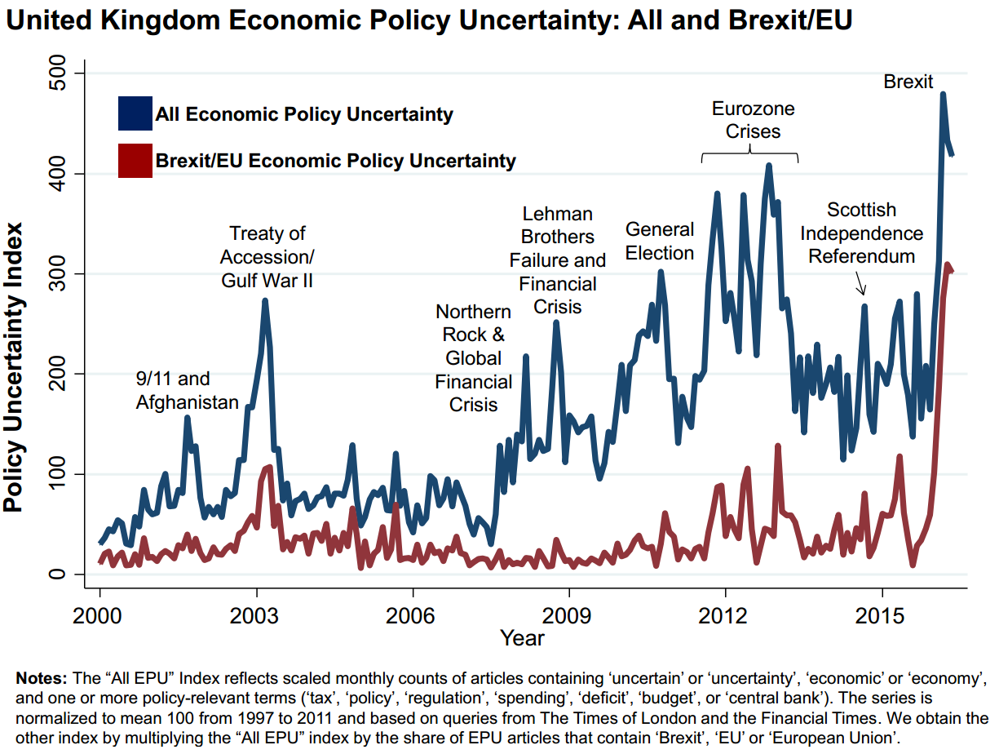

Source: http://www.policyuncertainty.com/brexit.html

**Fig. 3: Time-varying correlations between BREXIT-EPU index and arrival series**



**Table 1: GARCH estimates**

|  |  |  |  |  |  |  |  |  |  |
| --- | --- | --- | --- | --- | --- | --- | --- | --- | --- |
| Parameters/Models | Baseline GARCH | |  | GARCH with breaks | |  | GARCH with BREXIT impact | |  |
|  | GARCH | GJR-GARCH | | GARCH | GJR-GARCH | | GARCH | GJR-GARCH | |
| $$ω$$ | 233606.80*** | 53820.12*** | | 243180.61*** | 53820.12*** | | 223502.90*** | 85500.38** | |
| $$α$$ | 0.0169 | 0.0124*** | | 0.0081*** | 0.0326*** | | 0.0197* | 0.0308*** | |
| $$β$$ | 0.9813*** | 0.5956*** | | 0.8718*** | 0.5485*** | | 0.9768*** | 0.5542*** | |
| $$γ$$ |  | -0.1399*** | |  | -0.2717*** | |  | -0.2745*** | |
| $$φ_{1}$$ |  |  | | 197.66*** | 110.29*** | |  |  | |
| $$φ_{2}$$ |  |  | | 0.7875 | 0.0986 | |  |  | |
| $$δ$$ |  |  | |  |  | | 154715.3 | 0.1104 | |
| Persistence | 0.9982 | 0.5380 | | 0.8799 | 0.4451 | | 0.9965 | 0.4478 | |
| Log-likelihood | -3343.16 | -3360.29 | | -3332.86 | -3338.84 | | -3341.35 | -3374.09 | |
| AIC | 14.37 | 14.44 | | 14.34 | 14.39 | | 14.36 | 14.51 | |
| BIC | 14.41 | 14.50 | | 14.40 | 14.44 | | 14.41 | 14.57 | |

Notes: ***, ** and * indicate statistical significance at 1%, 5% and 10% levels, respectively. For GARCH (1,1) process, the persistence of volatility is measured as $α+β$. For GJR-GARCH approach, the persistence of volatility amounts to $α+β+1/2γ$. $φ_{1}$ and $φ_{2}$ measure the effects of structural breaks, while $δ$ measures the BREXIT impact.

**Table 2: (M)GARCH (DCC) estimates from seasonal adjusted and Hamilton-filtered trend extracted data (selected models)**

|  |  |  |  |  |  |  |  |  |  |
| --- | --- | --- | --- | --- | --- | --- | --- | --- | --- |
| Parameters/Models | Baseline GARCH | |  | GARCH with BREXIT-Uncertainty | |  | MGARCH-DCC | |  |
|  | GARCH | GJR-GARCH | | GARCH | GJR-GARCH | |  |  | |
| $$ω$$ | 86.659*** | 6891.279*** | | 5716.52*** | 85500.38** | | - 6721.762** |  | |
| $$α$$ | 0.035* | 0.671*** | | 0.713** | 0.693* | | 0.483*** |  | |
| $$β$$ | 0.953*** | 0.317*** | | 0.170* | 0.180** | | 0.504*** |  | |
| $$γ$$ |  | -0.048*** | |  | -0.023*** | |  |  | |
| $$δ$$ |  |  | | 0.669*** | 0. 977*** | |  |  | |
| Persistence | 0.980 | 0.964 | | 0.883 | 0.873 | | 0.987 |  | |
| Log-likelihood | -2523.76 | -2531.03 | | -5716.52 | -3250.24 | | -2232.381 |  | |
| Wald test | 4.990 | 6.860 | | 10.46 | 13.39 | | 15.68 |  | |
| *p*-value | 0.025 | 0.008 | | 0.005 | 0.005 | | 0.004 |  | |

Notes: ***, ** and * indicate statistical significance at 1%, 5% and 10% levels, respectively. For GARCH (1,1) process, the persistence of volatility is measured as $α+β$. For GJR-GARCH approach, the persistence of volatility amounts to $α+β+1/2γ$. $δ$ measures the BREXIT impact.

Adjustment values for MGARCH-DCC: lambda 1: 2283; lambda 2: 0.723. Correlation (tourist arrival, Brexit uncertainty) = 0.893 estimated using MGARCH CCC.

**Table 3: The magnitude of news impact on volatility**

|  |  |  |  |
| --- | --- | --- | --- |
| Models $→$ | Baseline GARCH | GARCH with breaks | GARCH with BREXIT impact |
| Good news | 0.0124 | 0.0326 | 0.0308 |
| Bad news | 0.1275 | 0.2391 | 0.2437 |

Notes: The effects of good and bad news are α and $\left|α + γ \right|$, respectively.

**Appendix A**

**Figure 1A**: Plot of Cyclical Components (Seasonal adjusted and Hamilton filtered seasonally adjusted Visitors series)



**Figure 1B**: Plot of Hamilton-filtered EPU_UK series against the unadjusted series



**Appendix B**

Unit root test results:

To begin with we performed conventional Augmented Dickey-Fuller (ADF) regression with a trend and an intercept (to our unadjusted and adjusted series). For the adjusted series, for instance we obtained the estimated Dickey-Fuller value of -2.162. With the estimated *p-*value of 0.511 we accept the null hypothesis of a unit root in the tourist arrival series. Since ADF test has low power against unit root null hypothesis, we decided to perform a high-powered unit root test, such as the DF-GLS test. The test rejected the unit root null hypothesis with at both 5% and 1% critical values for all lags up to 4 (the test value: -13.473 whereas the 5% critical value is -2.870 and 1% critical value is: -3.480). We arrived at the same conclusions for the unadjusted tourist arrival series. Furthermore, a test of short memory of the time series (viz., KPSS test) shows that our series is stationary, but could be characterized by a stationary long-memory process. To confirm, we further carried out Robinson’s semiparametric long-memory estimation and obtained the integration order of 0.84. Therefore, in view of the low power of the conventional unit root test and the mixed evidence of high-powered unit root and long-memory estimation, we have decided to run our GARCH family of estimation with a difference of the tourist arrival series ($∆{Tour}_{t}$)

1. Corresponding author: Yang Yang (E-mail: yangy@temple.edu); Anupam Dutta (E-mail: adutta@uwasa.fi); Gazi Uddin (E-mail: gazi.salah.uddin@liu.se) ; Tapas Mishra (E-mail: t.k.mishra@soton.ac.uk).
2. Thanks to an anonymous referee for suggesting this estimation.
3. All the data are sourced from Thomson Reuters DataStream database.
4. Our results from adjusted (de-seasonalized and trend extracted) data produce similar conclusions. Results are not reported here due to lack of space but are available with the authors.
5. Thanks to an anonymous referee for suggesting this estimation to lend robustness to our results.