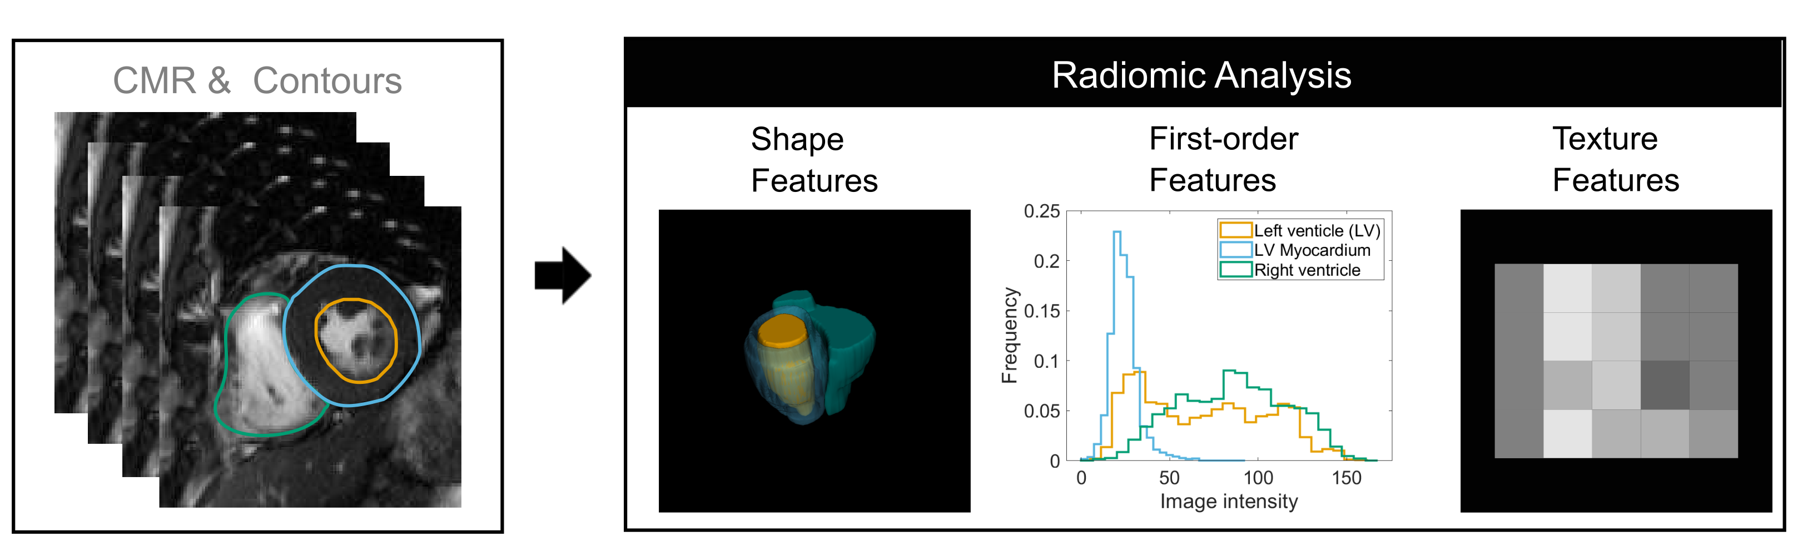
Figure 3*. Summary of typical cardiovascular magnetic resonance radiomics feature extraction workflow

*Figure 3 caption: Radiomics features may be extracted from a defined region of interest. In this example, the left (orange) and right (green) ventricular endocardial and left ventricular epicardial (blue) contours are drawn in end-systole on the short axis stack cine images. Thus, defining three regions of interest: left ventricular blood pool, right ventricular blood pool, and left ventricular myocardium. Radiomics shape features are extracted from a 3D image mask constructed from these contours. Histogram based first-order features and more complex texture features are derived from analysis of the distribution and pattern of voxel signal intensities in the defined regions of interest. Figure courtesy of: Dr. Polyxeni Gkontra and Prof. Karim Lekadir, University of Barcelona.

