Structural change metrics as indicators of chironomid community stability in high latitude lakes
Roseanna J. Mayfield ^{1*}, Peter G. Langdon ², C. Patrick Doncaster ³, John A. Dearing ⁴, Rong Wang ⁵, Larisa B. Nazarova ^{6,7,8}, Andrew S. Medeiros ⁹, Stephen J. Brooks ¹⁰
¹ Geography and Environmental Sciences, University Of Southampton, Southampton, SO17 1BJ, UK, R.Mayfield@soton.ac.uk
* Corresponding author
² Geography and Environmental Sciences, University Of Southampton, Southampton, SO17 1BJ, UK, P.G.Langdon@soton.ac.uk
³ Biological Sciences, Institute for Life Sciences, University Of Southampton, Southampton, SO17 1BJ, UK, cpd@soton.ac.uk
⁴ Geography and Environmental Sciences, University Of Southampton, Southampton, SO17 1BJ, UK, J.Dearing@soton.ac.uk
⁵ State Key Laboratory of Lake Science and Environment, Nanjing Institute of Geography and Limnology, Chinese Academy of Sciences, Nanjing, 210008, China, rwang@niglas.ac.cn
⁶ Potsdam University, Institute of Earth and Environmental Science, Am Neuen Palais 10, 14469 Potsdam, Germany, nazarova_larisa@mail.ru
⁷ Alfred Wegener Institute, Helmholtz Centre for Polar and Marine Research, Research Unit Potsdam, Telegrafenberg A43, 14473 Potsdam, Germany
⁸ Kazan Federal University, Kremlyovskaya str., 18, 420018 Kazan, Russia; Kazan Federal University, Kremlyovskaya str., 18, 420018 Kazan, Russia
⁹ School for Resource and Environmental Studies, Dalhousie University, Halifax, Canada, andrew.medeiros@dal.ca
¹⁰ Department of Life Sciences, The Natural History Museum, London SW7 5BD, UK, S.Brooks@nhm.ac.uk

Abstract
Understanding the effects of climate change on ecosystem structure and stability is challenging, especially in high latitude regions that are predicted to experience the largest increases in ambient temperature. Global warming is likely to be a key driver of ecosystem change in freshwater lakes. Increased temperature can positively or negatively affect lake community composition through the loss of cold-adapted taxa and the arrival of temperate or eurytopic taxa. Here, we analyse the likely effects of temperature-induced changes in taxonomic richness and compositional turnover of environmentally-sensitive chironomids (Diptera: Chironomidae) across three regions - northern North America, Norway, and Russia - using existing datasets. Structural parameters (beta diversity, compositional disorder, and network skewness) were applied to model-simulated and empirical chironomid datasets across a large spatial temperature gradient. The analyses of empirical datasets showed changes in community structure across temperature gradients, suggesting varying states of ecosystem stability or instability. The comparison with null models enabled assessment as to whether these stresses agreed with expected patterns due to covarying summer temperature conditions or whether they deviated from expectations suggesting additional stress on the ecosystems. For the North American and Norwegian datasets, the structural parameters indicated signs of anticipated stress at the coldest end of the temperature gradient and additional stress at the warmest end of the temperature gradient. For the Russian dataset, the ecological metrics were less indicative of stress at the extreme ends of the temperature gradient. For all three regions, lakes in the mid-temperature range showed most evidence of relative ecosystem stability, with greater beta diversity, compositional disorder, and skewness, unanticipated by the modelled simulations. This is most likely due to more diverse habitats across the ecotone boundaries and additional factors that can influence ecosystem structures. Thus, we show that structural changes typical for ecosystem stability can be detected through changes in community structure across temperature gradients. This is important for understanding how lakes may change under current and future climate change.
Key words: Chironomids, community structure, beta diversity, compositional disorder, network skewness

Introduction
High latitude lake ecosystems have already been exposed to global stress, with recent warming driving chironomid- and diatom-assemblage change and green-algae blooms in Arctic lakes (Smol et al., 2005; Rühland et al., 2013; Woelders et al., 2018). Current predictions show that high latitude regions will likely undergo an exaggerated level of warming due to polar amplification processes (Overpeck et al., 1997; Post et al., 2009; Pithan and Mauritsen, 2014). While lakes are frequently subjected to many interacting stressors (Christensen et al., 2006; Yan et al., 2008), it is thought that climate change is one of the most likely drivers of nonlinear responses and abrupt transitions in ecosystems (Grimm et al., 2013). Lakes facing continuous stress may increasingly lose resilience until they are unable to sustain their current ecosystem function (Scheffer et al., 2012) or transition into an alternate state (Wang et al., 2012). Understanding how lake ecosystems respond to increasing climate stress is a complex issue, yet is critical to forecasts of ecosystem trajectory and for predicting the vulnerability of lake ecosystems to abrupt ecological transitions.
Previous studies have predominantly investigated ecosystem stability in the frequency domain using time-series data, an approach that identifies fundamental shifts from one community state to another over time (Wang et al., 2012; Dakos et al., 2014; Holbrook et al., 2016). However, this requires long and detailed records, which can be difficult and expensive to obtain. Early warning signs (EWS) of ecosystem collapse have been identified through studies of variability in laboratory-controlled (Drake and Griffen, 2010), whole lake (Carpenter et al., 2011), and computer simulated experiments (Dakos et al., 2013). However, attempts to detect similar EWS in natural, real-world ecosystems have proved challenging. The frequency domain presents many issues, for example in data resolution (Wang et al., 2012), transitions with no EWS (Hastings and Wysham, 2010), and false-negative or false-positive EWS (Kéfi et al., 2013; Burthe et al., 2016).
The structural domain could provide greater potential for understanding how stress drives ecosystem structural changes as theory suggests that ecosystem resilience is strongly influenced by the structural changes in species associations (Strogatz, 2001; Scheffer et al., 2012). Scheffer et al. (2012) summarise and discuss fundamental ideas from network science, identifying key types of network structure in systems based on the organisation and connectivity of nodes. These concepts can be applied to networks of taxa in ecosystems. Systems comprised of weakly connected, heterogeneous nodes (taxa) respond to stress gradually due to the greater independence of the individual nodes; this allows each node to react to stress at their own rate (van Nes and Scheffer, 2005). Weakly connected systems are likely to be characterised by relatively high diversity and turnover rates, and redundancy in taxon functions. As a result, the loss of a single taxon can have little effect on ecosystem function and the response to stress will be linear (Scheffer et al., 2012). In contrast, systems composed of well connected, homogeneous nodes have an initial resistance to stress due to subsidiary inputs from the broader system minimising or counterbalancing the effects of local or short-term perturbations (Scheffer et al., 2012). This gives the perception of stability within the system, as the high connectivity of nodes is likely to reduce the turnover rate. Thus, the loss of a single taxon could have different effects on the wider system, depending on whether the taxon was highly or weakly connected. Under continued stress, an ecosystem is likely to reach a point, or threshold, where the network can no longer resist or counteract the disturbance and the nodes change synchronously causing an abrupt shift throughout the system (Dunne et al., 2002; van Nes and Scheffer, 2005).
Applying network science principles, such as those developed by Barabási and Albert (1999) and Strogatz (2001), to real-world ecosystems poses a number of challenges. Network theory typically assumes that a network starts in a fixed stable state with a singular environmental stress (Gao et al., 2016), whereas, in real-world systems, lakes are long-lived, dynamic systems subjected to continuous stresses. In principle, network theory can model links encompassing a wide range of associations between nodes (Zaheer et al., 2010). Defining such associations, while difficult, is imperative in ecosystems where the variety of connections includes predator-prey, nutrient cycling, and inter- and intra- species links (Quevedo et al., 2009; McCauley et al., 2012; Simões et al., 2012; Prado et al., 2016). However, few studies incorporate taxon interactions in their models when forecasting taxon distribution under future climate scenarios (Wisz et al., 2013; Cavieres et al., 2014; Bulleri et al., 2018).
A small number of studies have started to investigate ecosystem change using structural metrics in order to investigate whether the organisation of taxa and their interactions affects system response to stress. Doncaster et al. (2016) used compositional disorder, a measure of nestedness, as an indicator for instability in aquatic communities prior to ecosystem collapse; under increased stress, compositional disorder decreased indicating a decline in taxonomic turnover as the aquatic communities became more nested. In addition, Wang et al. (2019) used network skewness as a parameter of structural stability, indicating that aquatic ecosystems experienced a loss of structure under growing human pressure due to habitat homogenisation.
Here, we build on studies of community composition, by investigating whether structural metrics can indicate ecosystem stability in relation to temperature change, using data from modern lakes on temperature-sensitive chironomids (Diptera: Chironomidae; non-biting midges). We begin by generating presence-absence data on simulated chironomid taxa and lakes to produce null expectations of community composition and structural change across temperature gradients using three structural metrics: beta diversity, compositional disorder and network skewness. We then apply these metrics to three empirical datasets of chironomids across regional gradients of ambient temperature from northern North America (Fortin et al. 2015), Norway (Brooks and Birks, 2001; 2004), and Russia (Nazarova et al., 2011; 2015). Comparison of empirical to modelled outcomes reveals deviations from the null expectations, enabling us to assess whether the lakes have under gone additional stress from climate change or secondary drivers.

Materials and methods

2.1. Metrics of structural change
Three ecological metrics were selected as indicators of structural change in hypothesised and empirical chironomid assemblages to determine whether climate stress has affected ecosystem stability in high latitude regions. We chose beta diversity, compositional disorder, and network skewness as they have been used previously as ecological indicators of stress to measure taxonomic turnover (Baselga, 2010; Doncaster et al., 2016; Nazarova et al., 2020) and taxon organisation (Wang et al., 2019), which reflect ecosystem instability.
Beta diversity, originally defined by Whittaker (1960), describes the ratio between regional and local taxonomic diversity and can be used as a measure of taxonomic turnover. The metric is a valuable tool for understanding the processes of change in community composition across ecological gradients (Chave and Leigh, 2002; Soininen et al., 2007; Chase and Myers, 2011). The successful application of beta diversity can inform ecosystem managers of local versus regional ecosystem change (Socolar et al., 2016), local-scale resilience (Vellend et al., 2013; Dornelas et al., 2014) and global widespread extinction (Barnosky et al., 2011). Baselga’s (2010) calculation of beta diversity explores the variation in taxonomic assemblages across spatial datasets. It measures the dissimilarity between assemblages and attributes the changes in the assemblages to turnover (taxon replacement) and nestedness-type patterns (taxon loss). A larger beta diversity value indicates greater dissimilarity, or diversity, between neighbouring assemblages due to turnover and/or taxon loss. Here, beta diversity is used to indicate the dissimilarity of assemblages due to turnover and taxon loss as temperature increases.
Nestedness describes the hierarchical organization of systems, where neighbouring systems are subsets of a parent system (Mariani et al., 2019). It is normally applied to species-site systems and was originally devised from patterns of taxa occurrence across islands with increasing distance from the mainland (Patterson and Atmar, 1987). Each island further away from the mainland was a subset of the previous one, with the most isolated island having the most highly nested community, with low taxon richness and turnover. Doncaster et al. (2016) used compositional disorder, a measure of nestedness, as a proxy for unpredictability in community composition through time, to test for declining resilience and early warning of impending ecosystem collapse. Compositional disorder, expressed as degree of disorder (°disorder), indicates whether an assemblage is nested and predictable (low °disorder) from one sample to the next or unnested and unpredictable (high °disorder), on a scale from 0° to 100°. For example, in a highly disordered (weakly nested) community, it is difficult to predict which taxa are present from knowledge only of the composition of neighbouring samples. Here, °disorder is used to measure whether lake assemblages become more ordered and predictable (i.e. more nested with less taxonomic turnover) or more disordered and unpredictable (i.e. less nested with greater turnover) as temperatures warm.
Network skewness measures the distribution of nodes (taxa) and their connections within a network. It is calculated using degree distributions, where the nodal degree is the number of interactions a taxon has with other taxa and the degree distribution is the spread of these degrees over the whole network. Interactions between taxa are assumed to be well represented by associations of taxa co-occurring in the same microhabitat. Network skewness as a metric of system stability is based on the theory that new stresses will modify the distribution of nodal connections away from a theoretically positively skewed distribution produced through emergent, self-organisational processes (Wang et al., 2019). In low stress, heterogeneous environments, taxa self-organise into their preferred microhabitats, where the majority of taxa will have a small number of interactions, i.e. they are weakly connected. A few taxa will have a large number of interactions, i.e. they are strongly connected (Strogatz, 2001; Doncaster et al., 2016). Wang et al. (2019) tested the theory further, suggesting that when a lake becomes stressed, the environment becomes more homogenized reducing the number of micro-habitats. This causes taxon loss, with specialist or weakly-connected taxa being more likely to be lost first. As weakly connected taxa are lost, the proportion of highly-connected taxa increases leading to a less positively skewed distribution of taxa associations. Here, network skewness is used to identify relative differences in the community response to temperature stress.

Hypothetical datasets of structural change across a temperature gradient
Temperature is strongly associated with the distribution of chironomid taxa, with more taxa adapted to warmer temperatures (Eggermont and Heiri, 2012; Engels et al., 2020). Thus, it is thought that taxon richness should increase with temperature (Patalas, 1990; Hawkins et al., 2003), while turnover is also likely to influence taxonomic composition as cold-adapted taxa are lost (Theodoridis et al., 2018). While it is widely accepted that taxon richness and turnover are primary components of community composition change (Buckley and Jetz, 2008; Coelho et al., 2018), how these newly arrived taxa effect ecosystem structure is not fully understood.
Here, four hypothetical null models are developed using different matrix distributions of points to represent taxa existing along a temperature gradient. Each scenario is designed to simulate a plausible response to rising temperatures in a community as taxa become locally extinct or new taxa colonise. These scenarios represent reduced-stress ecosystems, where the modelled communities are in natural, stable states. Temperature change is the only stress driving community change, with no secondary drivers of stress taken into consideration. The model outputs will demonstrate how beta diversity, °disorder, and network skewness represent structural change across controlled temperature gradients. This will allow assessment of empirical chironomid datasets with regards to how the empirical datasets show a characteristic response to temperature rise (i.e. structural change comparable to the hypothetical modelled outputs), or show signs of greater disturbance from natural assemblage change due to additional stress. The following hypothetical scenarios were developed:
Scenario 1: Taxon richness increases linearly with temperature as new taxa arrive. Cold environments often have a lower taxonomic richness (Brodersen and Anderson, 2002; Brooks and Birks, 2004) due to the strong relationship between solar-derived energy and taxonomic richness (Hawkins et al., 2003). This scenario tests the effect of taxon richness, with minimal turnover, on ecosystem structure.
Scenario 2: Taxon richness remains constant with temperature while taxon-type changes. Taxon specialisms and niche adaptation suggest that it is unlikely that the same taxa will be present at all temperature intervals. Temperature directly affects chironomid physiological and biochemical processes such as development, growth, and respiration (Eggermont and Heiri, 2012), and it has long been known that lake surface water temperature affects the distribution of subfossil chironomid assemblages (Brundin, 1949; Thienemann, 1954). This scenario tests the effect of turnover, with minimal increase in taxon richness, on assemblage structure.
Scenario 3: Taxon richness increases overall with temperature, while taxon-type changes. In real-world scenarios, it is likely that both rising taxon richness and taxonomic turnover will occur as temperature increases. This scenario tests the combined effect of rising taxon richness and turnover.
Scenario 4: Taxon presence is random, unaffected by temperature. This scenario is designed as a control; the simulated assemblages change with no reference to temperature.
Taxon presence-absence matrices were simulated for each scenario in R statistical software v. 3.6.0 (R Core Team, 2019). Each matrix comprised a sample from each of 100 lake communities with up to 100 taxa per sample, for lakes distributed over a simulated temperature gradient of 2 to 20 °C. Taxonomic richness and replacement were independently manipulated based on the lake-specific probability of receiving a taxon and the independent probability of availability of each taxon in each lake. The product of these two probabilities gave the incidence probability of each taxon in each lake. The model-generated assemblages assume no temporal change. The model was run 100 times for each scenario. Output matrices were analysed for taxon richness, beta diversity, °disorder, and network skewness.

Statistical methods
Taxonomic richness was calculated as the sum of taxa present in each network. Beta diversity was calculated using Baselga and Orme’s (2012) betapart package for R statistical software v. 3.6.0 (R Core Team, 2019). Multi-site dissimilarity was calculated using a 10-sample working window along the temperature gradient, with the Sørensen index (β_{SOR}) as a measure for total beta diversity (Dice, 1945; Sørensen, 1948). The turnover (taxa replacement) component was calculated using Simpson’s dissimilarity index (β_{SIM}) (Simpson, 1943) and the nestedness-type (taxon loss) component was calculated using Sørensen’s dissimilarity (β_{SNE}) (Baselga, 2010). °Disorder was calculated using a 10-sample working window along the temperature gradient, following methods developed by Doncaster et al. (2016) in R statistical software v. 3.6.0 (R Core Team, 2019). Window sizes were tested for beta diversity and °disorder (Figure 1); the 10-sample window provided the best balance of accuracy, which depends on window size, and sensitivity to change, which depends on window frequencyfor both metrics. Network skewness was calculated in Matlab (MATLAB ver. R2017b) following the method developed by Wang et al. (2019). For each dataset, the most-frequently co-occurring taxa pairs were identified as the pairs occupying the upper two quartiles of positive values for Cramér’s association coefficient (Q2 of V+). Taxon degree was calculated for each taxon in an assemblage from the sum of its connected pairings within the assemblage. Network skewness was measured by the asymmetry in the frequency of co-occurrences between taxa (Wang et al., 2019).
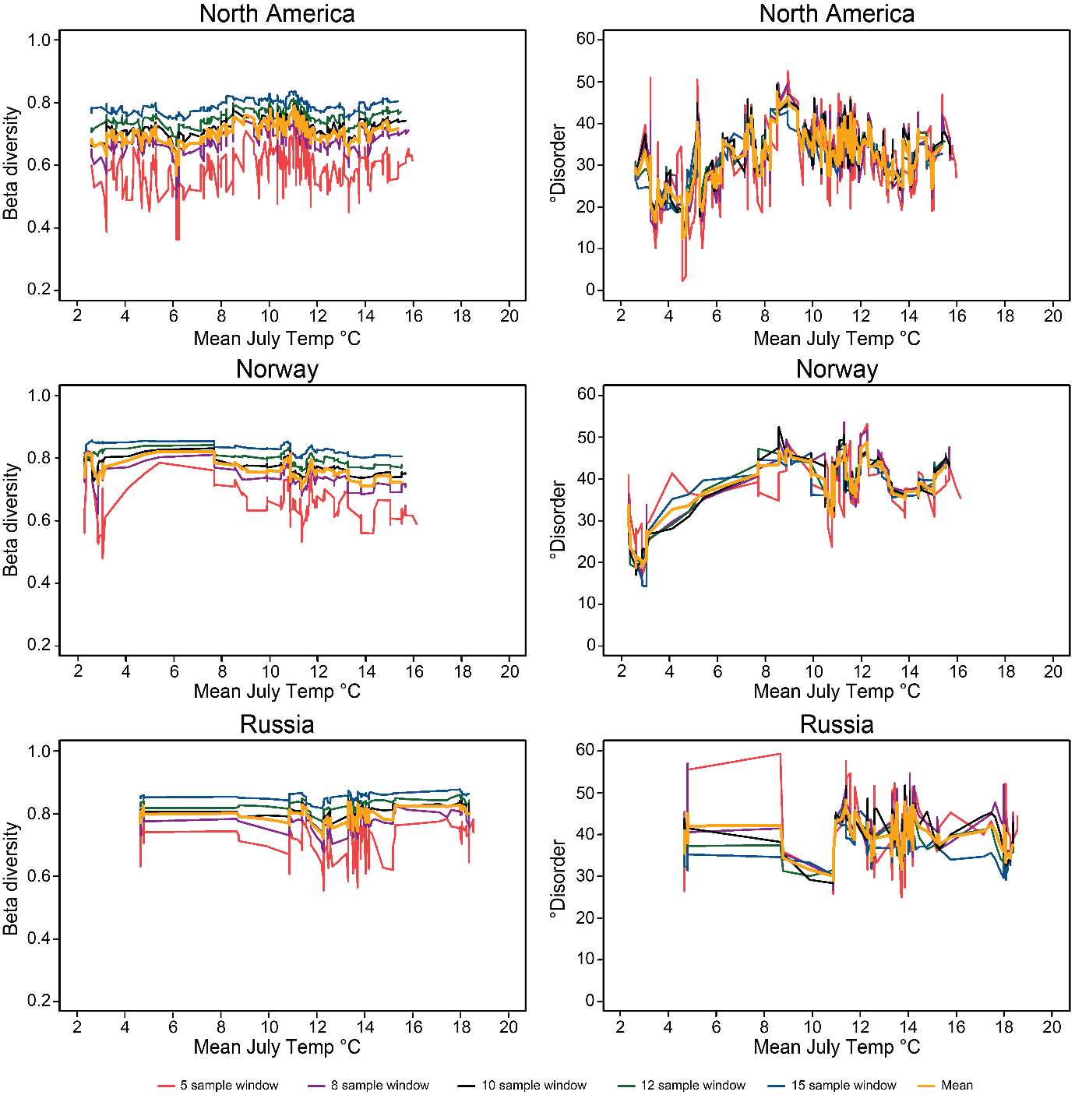
Figure 1 Comparison of window sizes for the calculation of beta diversity and °disorder. Multi-site dissimilarity compares the assemblage similarity between sites. °Disorder quantifies the orderliness of compositional change in an assemblage, based on the amount of same-type taxa present in consecutive samples. Both calculations thus require a window of samples. We considered windows of 5, 8, 10, 12 and 15 samples. All showed comparable trends in beta diversity and °disorder, with smaller window sizes (e.g. 5 or 8 samples) amplifying the changes in the metrics between samples, and larger window sizes (e.g. 12 or 15) smoothing the changes in the metrics around a similar running average.

2.4. Empirical chironomid datasets across spatial temperature gradients
Larval chironomid assemblages are used as ecological indicators of stability in three large spatial datasets, spanning North America (Fortin et al., 2015), Norway (Brooks and Birks, 2001; 2004) and Russia (Nazarova et al., 2011; 2015) (Figure 2, Table 1). Chironomid taxa are highly sensitive to mean July temperature and ubiquitous across high latitude regions, with numerous cold-adapted taxa making them a viable proxy in high latitude areas (Brooks, 2006a; Medeiros et al., 2011; Eggermont and Heiri, 2012). There is a growing interest into the power of spatial trends in chironomid diversity to help predict how assemblages might change with continued climatic warming (Engels et al., 2020).
Chironomid assemblage composition was ascertained for each lake surface sediment sample in the original studies of each region, with taxon identified to genus or species-morphotype level using standardised subfossil taxonomy (Brooks et al. 2007). Mean July temperature was identified as the primary influencing factor of taxon presence by the original authors. A canonical correspondence analysis indicated that mean July temperature explained the largest proportion of variance in the North American and Norwegian datasets, suggesting that mean July temperature was likely to be an important driver of taxonomic distribution (Figure 3). Distance from treeline appeared to explain the greatest amount of variance in the Russian dataset, with mean July temperature having the second largest influence on variance. Vegetation-type was also shown to influence cladoceran communities in northeastern Siberia (Frolova et al., 2014), and treeline position has often been shown to be related to climate in non-anthropogenically disturbed areas (MacDonald et al., 1998; 2000; Harsch and Bader, 2011). Distance from treeline data was not included in the original studies and was calculated using treeline location (Brown et al., 1998, revised 2001) in ArcGIS (ESRI, 2011) for this study.
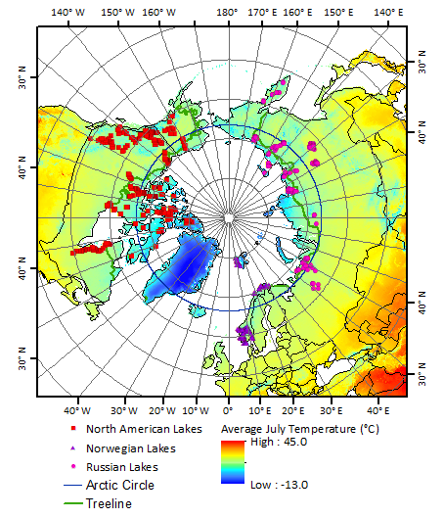
Figure 2 The North American (red squares), Norwegian (purple triangles) and Russian (dark blue circles) chironomid datasets span the arctic and subarctic, including island and mainland locations. The Norwegian dataset includes lakes on the Svalbard archipelago, which lies north of continental Norway in the Barents Sea between 10° and 3° E and 74° and 81° N. Background colour denotes mean July Temperature for the period 1970-2000. Temperature data from World Clim version 2 (Fick and Hijmans, 2017).

Table 1 Metadata for the North American, Norwegian and Russian chironomid datasets. The three datasets span a large geographic area; including arctic, subarctic and island locations. Altitudinal data was not available for all lakes in the North American dataset, thus was calculated using altitude data (EROS, 2014) in ArcGIS (ESRI, 2011) for the whole North American dataset. Key secondary environmental factors were identified by original authors for the North American and Russian datasets. Analyses to identify key secondary environmental factors for the Norwegian dataset were run as part of this study (Figure 3).
 | North America | Norway | Russia
Collection period | mid-1990s to 2007 | 1995 - 1999 | 1998 to 2011
Number of lakes | 434 | 157 | 193
Latitudinal range | 49.8 to 80.83° | 58.08 to 79.8° | 53.03 to 75.4°
Longitudinal range | -151.32 to -68.44° | 5.01 to 31.04° | 50.5 to 163.15°
Taxon richness range | 3 – 30 | 1 – 43 | 8 – 41
Total number of taxa | 78 | 141 | 174
Altitude range (m a.s.l.) | 1 – 1709 | 5 - 1594 | 1 – 805
Mean July temperature range | 2.6 – 16.9 °C | 2.3 – 16.5 °C | 4.5 – 19.0 °C
Other influential environmental factors,  as identified by original authors | August temperature, annual temperature, DOC, water depth, Fe, K, pH, and conductivity | Conductivity, pH, and water depth | Conductivity, pH, and water depth
Citation | Fortin et al. (2015) | Brooks and Birks (2001), Brooks and Birks (2004) | Nazarova et al. (2011), Nazarova et al. (2015)

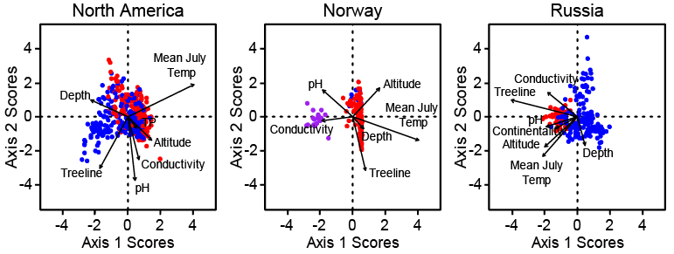
Figure 3 Canonical correspondence analyses (CCA) indicate which environmental variables help explain the variance within the datasets, and thus provides indication of which variables were likely to be important drivers of assemblage change. Blue dots indicate above-Arctic Circle lakes, red dots below-Arctic Circle lakes, and purple dots (Norway) Svalbard lakes. The strength of each variable is represented by the length of arrow. Mean July temperature appears to explain the greatest amount of variance in the North American and Norwegian datasets. However, treeline appears to have the greatest influence on variance in the Russian dataset, with mean July temperature having the second strongest influence on variance.
Modern mean July air temperatures were calculated for each lake using the CRU TS4 Google Earth interface to the nearest half-degree grid (Harris et al., 2014) for the periods 1981˗2011 for the North American and Russian datasets, and 1971˗2001 for the Norwegian dataset. Time periods were chosen to cover the data collection periods. The CRU TS4 dataset accounts for altitude, following New et al. (1999); however, in mountainous regions, there may be some error in the predicted temperatures for lakes with considerably lower or higher altitudes. These modern temperature gradients may conflate two processes; a cold to warm temperature gradient from the higher to lower latitudes, both in the present and past that represent natural boundary conditions not stresses, and secondly, incremental rises in temperature superimposed upon the natural gradient caused by global warming, where the higher latitude lakes have received greater warming stress than the lower latitude (i.e. the reverse of the natural gradient). A comparison of the modern 30-year mean July temperatures to mean July temperatures for the period 1901 to 1950 indicated that the majority of the lakes in this study had experienced warming since the beginning of the twentieth century (Figure 4). These modern temperatures are not yet boundary conditions and are more likely to represent stresses or transient conditions. There is also the possibility that the two effects are in some way cancelling each other. Characterisations obtained from the modelled simulations will be used to help interpret patterns seen in the empirical data; however, the matrix models only simulate the natural gradient, thus any variance between the real data and the models could be the effect of global warming or the interactions of other secondary environmental variables.
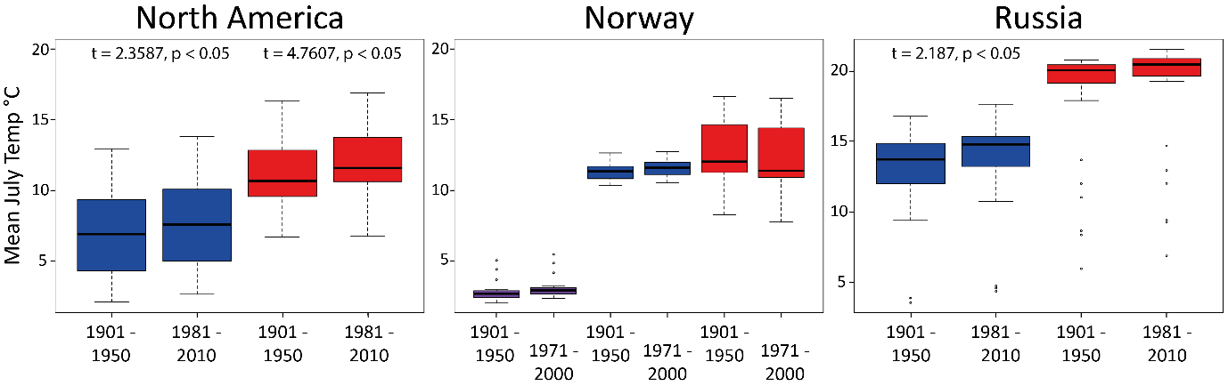
Figure 4 Boxplots displaying the change in mean July temperature from 1901–1950 to 1981-2010 (North America and Russia) and 1971-2000 (Norway) datasets. Blue boxes indicate above-Arctic Circle lakes, red boxes below-Arctic Circle lakes, purple boxes (Norway) Svalbard lakes. Significant differences (p < 0.05) between pairs of data using T-test statistics indicate lakes in North America and above-Arctic Circle lakes in Russia have undergone warming since 1950. All other differences between pairs are insignificant (p < 0.05).
Lake samples were ordered from cold to warm using the calculated CRU TS4 mean July air temperatures within the datasets. Changes in empirical community compositions across the temperature gradients were measured using taxon richness, beta diversity, °disorder, and network skewness, as described previously.

Results

3.1. Simulated structural change in assemblage composition
The simulation models revealed how different scenarios for the interaction of taxon richness with composition can affect ecosystem structure across gradual temperature gradients, where temperature is the only driver of assemblage change (Figure 5). Here, we describe the general trends and key findings from the models.
Scenario 1 (Figure 5.1): constantly rising taxon richness with rising temperature. Beta diversity, °disorder, and network skewness decline in response to rising taxon richness. Declining beta diversity indicates a reduction in turnover as taxon richness increases; however, this could be an artefact of the model, which minimises the effect of turnover. This model demonstrates that in the absence of turnover, increasing taxon richness allows the accrual of common taxa across assemblages, making the warmer lake assemblages more similar to the neighbouring assemblages. This is supported by declining °disorder; as the number of common taxa increase, the lake assemblages become more predictable from neighbouring assemblages. The declining trend in skewness means that as temperature increases and taxon richness rises, the system homogenises by losing weakly connected nodes.
Scenario 2 (Figure 5.2): constant shift in taxon composition with temperature. Generally, the beta diversity, °disorder, and skewness outputs for this scenario are variable with little directional change. Partly as a result of the model setup, taxon richness is lower at the extreme ends of the temperature gradient. This lower taxon richness produces slightly lower beta diversity and °disorder. Focusing on the mid-temperature sections where taxon richness is constant, total beta diversity is high and predominately explained by the turnover component. This is to be expected as the model is purposely simulating taxon turnover. °Disorder is highly variable with no directional change. This suggests that there is little accrual of common taxa and thus assemblages are unpredictable from neighbouring assemblages. However, as the turnover is constant and gradual, there are no sudden changes in the assemblages either, suggesting that the assemblages are not necessarily unstable. The trend in skewness has no directional change meaning a shift in taxon composition alone does not change the distribution of nodal degrees.
Scenario 3 (Figure 5.3): constant shift in taxon composition and rising richness with temperature. Overall beta diversity, °disorder, and network skewness decline. These responses in the metrics are closer to scenario 1 than 2, indicating that the metrics primarily reflect the increasing taxon richness. Beta diversity is highest in the colder end of the gradient, indicating that turnover has a greater influence on the taxon-poorer assemblages. Total beta diversity is predominantly controlled by the turnover component; however, the taxon loss component has a slightly larger influence at the colder end of the gradient. As taxon richness increases, beta diversity declines suggesting that the loss of individual taxa has a lesser impact on larger communities and the increase in common taxa reduces the dissimilarity between the assemblages. °Disorder is lowest (i.e. the assemblages are more nested) at the coldest end of the gradient where taxon richness is also the lowest. As taxon richness increases, °disorder rapidly increases suggesting greater unpredictability and turnover in taxa-type. °Disorder gradually declines with increasing temperature and taxon richness, decreasing the unpredictability as there is an increase in common taxa between the assemblages. The overall declining trend in network skewness indicates losses of weakly connected nodes as taxon richness increases. The upturn in skewness at the end of the temperature gradient might suggest a rise in assemblage stability as the effect of taxonomic turnover diminishes.
Scenario 4 (Figure 5.4): composition and richness independent of temperature. Metrics show little or no directional change; taxon richness has a small increase over the temperature gradient, however beta diversity, °disorder and skwness showed little change. This response is more comparable to scenario 2 than 1, indicating that the metrics primarily reflect turnover. Beta diversity and °disorder are high across the temperature gradient and the stationarity in skewness means that random changes in taxon composition alone do not affect the distribution of taxon nodal degree. All three of the metrics are less variable than in scenario 2.
Overall, within the simulation models the rising taxon richness allows for the accrual of common taxa, reducing the dissimilarity (lower beta diversity) and unpredictability (lower °disorder) of assemblages. Skewness generally declines in positivity with increasing taxon richness. Turnover, with minimal change in taxon richness, creates highly variable assemblages with high dissimilarity (high beta diversity), unpredictability (high °disorder), and stationary skewness. Scenario 3 was designed to represent empirical taxonomic assemblages, where there is an overall increase in assemblage richness and taxon-type changes with temperature, i.e. the cold-adapted taxa are lost as temperatures increased and the assemblage becomes dominated by a greater number of relatively warmer taxa. This produced an overall decline in beta diversity (dissimilarity) and °disorder (unpredictability), and an overall decline in skewness. Thus, if the empirical assemblages are responding primarily to a natural temperature gradient, similar trends in structural metrics would be expected in the empirical datasets.

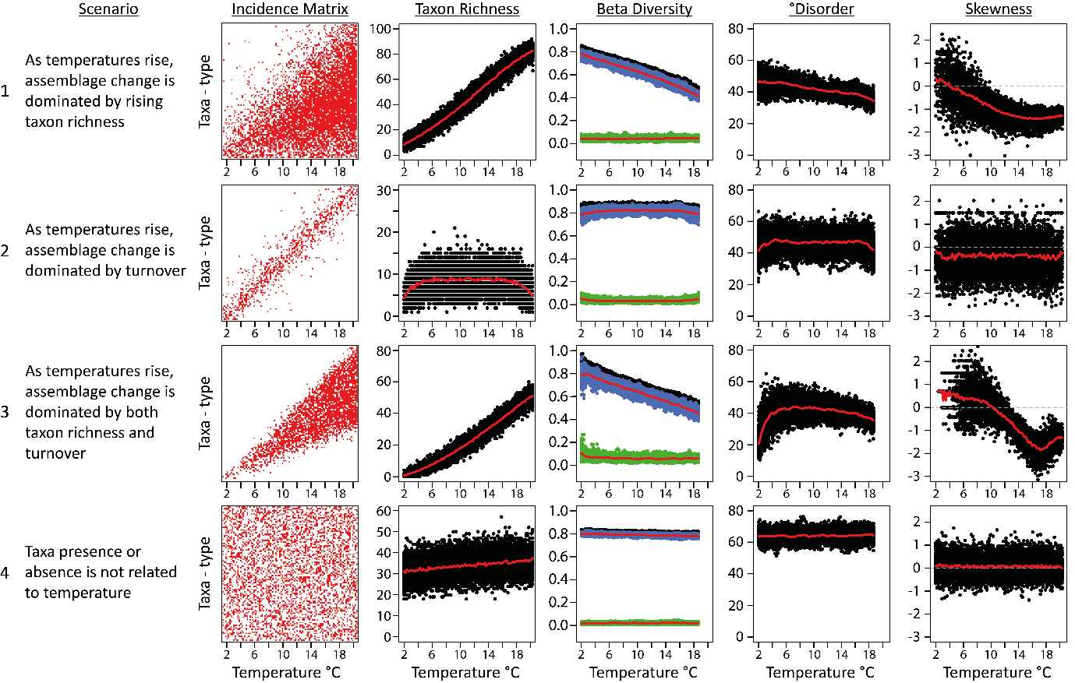
Figure 5 The relationship between temperature and taxa presence in four hypothetical scenarios, as described by an incidence matrix (column 1: red dots) and measured using four community structure metrics (columns 2-5) taxon richness, beta diversity, ºdisorder, and skewness in 100 simulations (black, blue and green dots). Total beta diversity (column 3) results are shown in black with changes attributed to taxon turnover (blue) and taxon loss (green). Red lines show mean values to illustrate general trends.

Structural change in empirical chironomid assemblages
The ecological metrics, beta diversity, °disorder, and network skewness, reveal changes in assemblage structure across the empirical datasets (Figure 6), with some similarities and variations from the simulated models.

North America
In the North American dataset, taxon richness was lowest in the coldest lakes and increased with temperature, comparable to hypothesised scenarios 1, 3 and 4. Beta diversity was lower in the colder lakes, with lakes situated on Victoria and Baffin Island having the lowest beta diversity. This indicates that the cold, taxon poor lakes were less dissimilar (i.e. they had more taxa in common with their neighbouring assemblages) with lower turnover. Beta diversity generally increased up to the mid-temperature range (c. 9 - 13 °C); indicating an increase in turnover, as cold-adapted taxa were lost and more temperate taxa arrived. Beta diversity declined at the warmer end of the temperature gradient (greater than c. 10 °C), suggesting that the lake assemblages were becoming more similar, due to the accrual of common taxa, and the loss or arrival of individual taxa was less influential in the larger assemblages. This second part of the trend is comparable to the pattern seen in hypothesised scenarios 1 and 3. The turnover component was the primary driver of total beta diversity across the temperature gradient (Figure 7); however, taxonomic loss had a larger influence on the cold, taxon poor lakes indicating that the taxa loss of was more influential on these smaller assemblages.
°Disorder presented a comparable trend to beta diversity, with lower °disorder at the cold end of the temperature gradient, a peak in °disorder at the mid-temperature range (c. 9 - 13 °C) and a subsequent gradual decline at the warmer end of the gradient (Figure 6). This pattern was more comparable to the °disorder trend seen in hypothesised scenario 3, suggesting that the changes in °disorder were driven by taxon richness and turnover. The lower °disorder values indicated that the assemblages were more nested and thus more predictable in colder lakes. As temperature and taxon richness increased, the assemblages became more disordered and unpredictable. This rise in °disorder was concurrent with the rise in beta diversity, indicating that taxon richness and turnover were both influencing the changing ecosystem structure. The decline in °disorder at the warmest end of the gradient indicated that the lakes were becoming more predictable as there was an accrual of common taxa and turnover was less influential on the assemblages.
Network skewness was predominately negative across the dataset, with 90.8 % of lakes having a negative value (Figure 6). The lakes show a trend towards more negative values with increasing temperature indicating losses of weakly connected taxa as seen in modelled scenarios 1 and 3 with increased richness.

3.2.2. Norway
In the Norwegian dataset, taxon richness was lowest in the coldest lakes and increased with temperature, comparable to hypothesised scenarios 1, 3 and 4. Beta diversity was high in the coldest lakes, which were from Svalbard. The mainland lakes had a higher beta diversity at the colder end of the gradient and beta diversity declined towards the warmest end of the gradient (after c. 12 °C, Figure 6). Beta diversity was lowest in the warmest lakes, where taxon richness was highest and the chance of common taxa was greater. This decline in beta diversity with temperature was comparable to the trends seen in modelled scenarios 1 and 3, where beta diversity was highest in the cold, taxon poor lakes, and lowest in the warmer, more taxon rich lakes. This suggests that the lake assemblages were changing due to taxon richness and turnover. Turnover was the primary driver of total beta diversity (Figure 7). Taxon loss had the greatest influence on total beta diversity in the lakes from Svalbard, due to the lack of common taxa between the lake assemblages.
°Disorder was lowest in Svalbard lakes and highest in the mainland Norwegian lakes (Figure 6). This pattern was comparable to the °disorder trend seen in hypothesised scenario 3 suggesting that the assemblage structure was influenced by taxon richness and turnover. However, scenario 3 indicated a gradual decline in °disorder in the warmest lakes, whereas °disorder remained high in the Norwegian dataset. The Svalbard lakes had the highest beta diversity values and lowest °disorder scores, suggesting these lakes had the most dissimilar yet predictable assemblages. This pattern was seen in modelled scenario 3 and most likely relates to the low taxon richness across Svalbard. The lakes had a limited number of potential taxa (19 taxa present across the 23 lakes from Svalbard) and a richness range of 1 to 11. This reduced probability of multiple Svalbard lakes having the same taxa, making the lakes highly dissimilar (high beta diversity), yet the low pool of taxa (19) meant that the lakes were more predictable (low °disorder). The mainland Arctic and Subarctic lakes were highly °disordered suggesting that the turnover of taxa maintained a high degree of unpredictability between neighbouring assemblages.
Network skewness was predominately negative across the temperature gradient with 88.5 % of having a negative value (Figure 3). The overall flat trend shows some evidence for a reducing trend towards more negative values after ~12 ºC perhaps indicating the relative loss of weakly connected nodes at higher temperatures as seen in modelled scenarios 1 and 3.

Russia
In the Russian dataset, taxon richness was lower in the lakes at both the ends of the temperature gradient. Taxon richness was more variable in the mid-temperature range lakes (c. 11 -15 °C), with some lakes having low richness, while other lakes had the highest taxon richness values of the dataset. Beta diversity was high and constrained at the two temperature extremes. In the mid-temperature range, beta diversity was generally high, but the range in values was greater, with some lakes having noticelably lower beta diversity. Lakes with the lowest beta diversity values were located in the high-Arctic and central Yakutia Republic (eastern Siberia), and just west of the Yakutia Republic - Taymyrsky Dolgano-Nenetsky District boarder (eastern Siberia). High beta diversity values signify greater dissimilarity between lake assemblages suggesting a lack of common taxa. This trend is more comparable to modelled scenarios 2 and 4, which were primarily controlled by turnover. Turnover was the most influential component on total beta diversity (Figure 7). Thus, it is likely that the Russian lake assemblages were more influenced by taxon turnover than rising taxon richness.
°Disorder values were high, with little directional change across the temperature gradient. This is comparable to trends seen in modelled scenarios 2 and 4. High °disorder indicates unpredictability between lake assemblages and high turnover, further supporting the idea that the Russian dataset was controlled by turnover, with little accrual of common taxa.
Network skewness was predominately negative across the temperature gradient with 81.3 % of lakes having a negative value. The overall flat trend shows some evidence for rising values towards less negative values after c.14 °C perhaps indicating the relative increases and stability of weakly connected nodes at higher temperatures as seen in modelled scenarios 3.
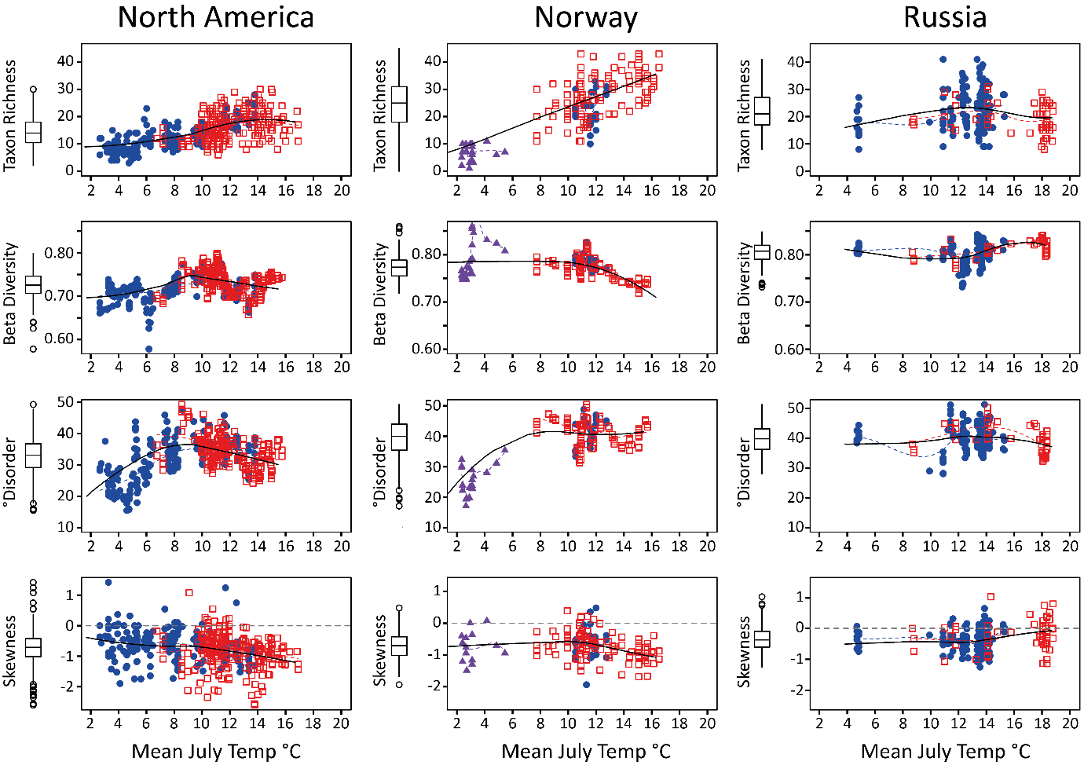
Figure 6 Relationships between mean July temperatures and community structure metrics (taxon richness, beta diversity, ºdisorder, and skewness) in the North American, Norwegian and Russian chironomid datasets. Lake sites above the Arctic Circle (66.56° N) are represented by blue circles and lakes below the Arctic Circle are displayed as hollow red squares. The Norwegian dataset was divided further, with lakes located on Svalbard shown as purple triangles. Smoothed loess regression curves (span = 0.90) are plotted in black. Regression lines for data subgroups are displayed as corresponding coloured dashed lines. Box and whisker plots (y-axes) show data spread, including data range, mean, interquartile range and outliers.

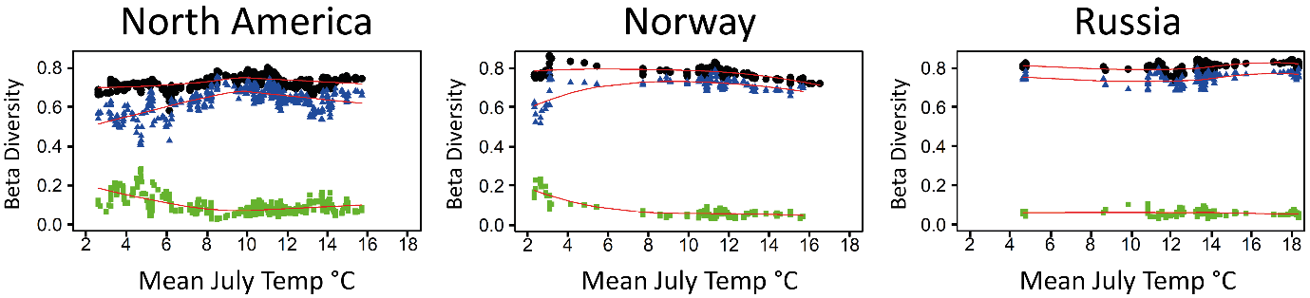
Figure 7 Relationships between July temperature and total beta diversity for the North American, Norwegian and Russian datasets. Individual values (black) can be attributed to changes in taxon turnover (blue) and taxon loss (green). Turnover is the most dominant component in all three datasets but taxon loss had a greater influence on beta diversity at the colder end of the temperature gradient in the North American and Norwegian lakes. Smoothed loess regression curves (span = 0.90) are shown in red.

Discussion
Climate change has already affected freshwater aquatic assemblages in the northern hemisphere (Woelders et al., 2018) and the majority of the lakes studied here have undergone some degree of temperature stress during the twentieth century (Figure 4). The ecological metrics provide information on assemblage structure at different points on the temperature gradient, indicating whether the assemblages were exhibiting signs of structural stress. The modelled simulations indicate potential changes in assemblage structure as temperatures increased at a gradual pace, with no secondary drivers of stress. There were some comparable and unparalleled trends between the empirical and modelled scenarios. Generally, the North American and Norwegian datasets showed comparable trends to modelled scenarios 1 and 3, suggesting that the changes within these datasets were driven by rising taxon richness and turnover across the temperature gradient. The Russian dataset showed little directional change across the temperature gradient, with the mid-temperature lakes having the largest variation in taxon richness, beta diversity, and °disorder. Some increase in skewness values at higher temperatures indicates relatively more weakly connected taxa and greater heterogeneity of the nodal distributions. These trends were more comparable to modelled scenarios 2 and 4, suggesting that turnover was more influential on the Russian assemblages than taxon richness. The similarities in the metrics between the empirical and modelled datasets could indicate that assemblages were under natural levels of stress expected for different temperature conditions, however, the differences may suggest additional ecosystem stress, possibly from a combination of secondary drivers or external drivers such as global warming. The relative speed of recent warming may be altering the lake ecosystem structures quicker than they would change naturally, and this could be further tested through long-term ecosystem changes from palaeoenvironmental archives in future studies.

. Ecosystem structure as an indicator of stress in chironomid assemblages

Lakes in cold, arctic environments
Climate change is predicted to have a greater impact in Arctic regions (Pithan and Mauritsen, 2014), therefore lakes with colder mean July temperatures should show a greater level of disturbance if they are reacting to heightened temperature stress.
In the North American dataset, lakes at the colder end of the temperature gradient (below c. 7 °C) had lower beta diversity and °disorder values; indicating reduced turnover and greater similarity/ predictability between assemblages. Lower beta diversity values were not simulated by the hypothesised models for the colder lakes, whereas scenario 3 did produce low °disorder values in the coldest lakes. Low beta diversity indicates greater similarity between assemblages and lower turnover, and low °disorder suggests more predictable, nested results. These metric outcomes can suggest stressed environments (Wang and Loreau, 2014). Nested communities (low °disorder) are more likely to have specialised taxa with narrow ecological tolerances and limited dispersal capabilities (McAbendroth et al., 2005). This can indicate poor local resilience; with communities being more prone to large shifts in community composition in the face of environmental stress (Okuyama and Holland, 2008; Scheffer et al., 2012). The taxon loss component of beta diversity had higher values at the colder end of the temperature gradient (Figure 7) further suggesting that the loss of taxa between assemblages had a stronger influence on diversity in these lakes (Viana et al., 2016). When low beta diversity and °disorder occurred simultaneously in modelled scenarios 1 and 3, skewness was negative. The lakes at the colder end of the gradient in the North American dataset were predominantly negatively skewed. Negative skewness signifies fewer weakly connected taxa, and therefore suggests stress, due to habitat homogenisation and few available niches (Wang et al., 2019). Thus, all three metrics show indication of assemblage instability, however, the similarities between the modelled and empirical datasets suggest that this instability might be an expected level of stress for cold, taxon-poor environments.
In the Norwegian dataset, the lakes with the coldest mean July temperatures, located in Svalbard, were indicating signs of stress. Taxon richness was low, beta diversity was high, °disorder was low, and skewness was predominantly negative. Low °disorder and negative skewness indicate that assemblages are under greater stress (Doncaster et al., 2016; Wang et al., 2019), whereas high beta diversity can indicate stability (Allan et al., 2011; Wang and Loreau, 2016). In this circumstance, the high beta diversity was likely to be a consequence of the relatively low pool of available taxa (19 taxa) and low taxon richness (1 – 11) across Svalbard reducing the chance of lakes having overlapping assemblages. However, these trends were comparable to modelled scenario 3, where assemblages at the cold end of the gradient were taxon poor and subjected to increasing taxon richness and turnover. This suggests that these lakes were experiencing an expected levels of stress, most likely as a result of Svalbard’s climate.
In the Russian dataset, lakes at the colder end of the temperature gradient (below c. 6 °C) showed signs of reduced stress. Beta diversity and °disorder were high, indicating higher levels of turnover and greater dissimilarity / unpredictability between lake assemblages. High beta diversity and °disorder suggest that lake habitats are heterogenic with a wide variety of niches (Wright et al., 2007), thus theory suggests that taxa should self-organise into their preferred habitats, creating a positive skewness (Wang et al., 2019). However, these lakes were negatively skewed. Negative skewness indicates increased taxonomic interaction, possibly due to greater environmental homogenisation and/or stress. This could suggest that the Russian lakes were reacting to different drivers of stress, as opposed to temperature driven stress. These lakes were located in the high-Arctic and islands in the Yakutia Republic. Most of the lakes in this area were shallow, thermokarst lakes, with a short ice free period, up to 120 days per year (Kumke et al., 2007). Such extreme climate conditions were likely to limit taxa able to survive in these lakes (Self et al., 2011).

Lakes in the mid-temperature range
Increasing mean July temperatures should create more microhabitats as lake conditions become more favourable for warm-adapted species, e.g. macrophyte presence can be closely associated with certain chironomid assemblages (Langdon et al., 2010). Taxon richness increased in the mid-temperature range for all three empirical datasets, suggesting that the lake environments were able to support greater variety of chironomids, as predicted by the hypothesised models.
Beta diversity and °disorder values were highest in the mid-temperature range lakes in the North American (c. 9 - 13 °C) and Norwegian (c. 11 - 13 °C) datasets, and were most variable (highest and lowest) in the mid-temperature range lakes in the Russian dataset (c. 11 - 15 °C). High beta diversity can indicate stability within ecosystems as communities are more diverse, supporting increased ecosystem functioning (Allan et al., 2011; Wang and Loreau, 2016). The taxon loss component of beta diversity was strongly reduced in these lakes (Figure 7); with cold-adapted taxa likely to have already been lost from the assemblages (Brooks et al., 2007). The turnover component almost entirely explained total beta diversity, suggesting that turnover was more influential on community composition in these lakes, as assemblages adapted to changes in environmental conditions (Viana et al., 2016). Higher beta diversity could also indicate a greater diversity in habitats, for example there was a range of Arctic and Subarctic lakes in the mid-temperature section of the gradient. Variations in the number of ice-free days, water pH or depth between lakes could influence the chironomid assemblages on a local scale (Brooks, 2006b) and increase the beta diversity between lakes on the larger temperature scale. This is supported by the peak in °disorder, which can also represent increased habitat diversity and niche development (Wright et al., 2007). Conversely, in the modelled scenarios, beta diversity and °disorder showed little directional change in the mid-temperature sections, with mid-range values for beta diversity in scenario 1 and 3, mid-range values for °disorder in scenario 1, and a plateauing of °disorder values in scenario 3. Thus, the peaks in beta diversity and °disorder in three empirical datasets were unanticipated from the hypothesised models.
Network skewness was primarily negative in all three empirical datasets, despite the potential for more microhabitats in the warmer environments. Greater niche diversity should allow taxa to self-organise into preferred habitats, reducing interactions and producing positively skewed degree distributions (Wang et al., 2019). There was a small peak in positively skewed lakes in the Norwegian dataset, a few positively skewed lakes in the North American dataset, and a rise in positively skewed lakes in the Russian dataset in these mid-temperature lakes, most likely as a consequence of increased environmental heterogeneity. This could further indicate greater ecosystem stability. In the mid sections of modelled scenarios 1 and 3, network skewness continued to decline, reaching its lowermost values before rising towards the warmest end of the gradient. Thus, the trends seen in skewness in the empirical datasets were also unanticipated from the hypothesised models.
There was little agreement between the metrics for the simulated and empirical lakes in the mid-temperature range. The purpose of the modelled scenarios was to identify what trends could be expected in the ecological metrics as assemblages changed with temperature. Assuming the model scenarios were appropriate, this suggests that mid-temperature range lakes were behaving unexpectedly or were experiencing additional stress. However, there was a mixture of Arctic and Subarctic lakes in these mid-temperature ranges. It is possible that beta diversity and °disorder were superficially increased by comparing lakes with similar mean July temperatures but different physical locations and lake attributes (Luoto et al., 2016). Ecotone transitional zones have also been shown to be more taxon rich and diverse (Nyman et al., 2005). The modelled scenarios only simulated the effect of temperature on taxon richness and turnover, therefore it is possible that the models were too simplistic to replicate the trend seen in the empirical datasets (Merow et al., 2014).

Lakes in warmer, subarctic environments
Lakes subjected to warmer mean July temperatures should be more productive with the potential to support a greater diversity of life (LeBlanc et al., 2004; Langdon et al., 2010). However, lakes in more southerly or less isolated locations could have increased disturbance from secondary drivers; for example, predation (Mousavi et al., 2002) or proximity to agriculture, urbanisation and pollution (Koperski, 2009; Mackintosh et al., 2015).
In the North American and Norwegian datasets, the lake assemblages indicated signals of ecosystem instability at the warmest end of the temperature gradient. Taxon richness was highest, in fitting with modelled scenarios 1 and 3, and demonstrating that these lakes were able to support a greater variety of taxa. Lower beta diversity was in agreement with hypothesised models 1 and 3, which suggested greater similarity (i.e. more common taxa) between the taxon-richer assemblages. °Disorder decreased in the North American dataset, suggesting the lake assemblages were becoming more nested and predictable, and in agreement with modelled scenarios 1 and 3. Whereas, °disorder remained high in the Norwegian dataset, suggesting more diverse assemblages and greater turnover. Decreased beta diversity and °disorder can indicate ecosystem instability. A decrease in beta diversity can signal a loss of local biodiversity and increased environmental homogenization at a regional scale (Wang and Loreau, 2014; 2016). Doncaster et al. (2016) suggest that undisturbed ecosystems should have high °disorder values, derived from the continual turnover of slow-growing and weakly competitive ‘canary taxa’ and a reduced presence of highly competitive ‘keystone taxa’. As an ecosystem becomes stressed, keystone taxa initially prevail at the expense of canary taxa, causing a decrease in °disorder values and decline in turnover. This restructuring increases the proportion of highly connected taxa, producing a less positively (or more negatively) skewed degree distribution, a sign of increased environmental stress (Wang et al., 2019). Skewness became more negative in the warmer lakes in the North American and Norwegian datasets, in accordance with network theory (Wang et al., 2019), indicating increased ecosystem instability. Modelled scenarios 1 and 3 suggested that skewness should rise in the most taxon rich assemblages. This disagreement between the modelled and empirical skewness outputs could suggest that the empirical lake assemblages were affected by additional environmental factors or indicated signs of stress.
Lakes at the warmer end of the temperature gradient in the North American and Norwegian datasets could be indicating signs of increased disturbance due to secondary drivers. There is limited knowledge of the extent of human induced pressure on the dataset lakes and the lakes were purposely selected for their reduced human influence. The CCA (Figure 3) analysis identified water pH and conductivity as secondary explanatory drivers of variance, suggesting these environmental factors may also have had significant influences on the dataset. This could be for a numer of reasons, for example pH, conductivity and DOC concentrations can change considerably in boreal zones due to vegetation change, such as paludification and an increase in coniferous trees (Rosén and Hammarlund, 2007; Pienitz et al., 2018). Changes in pH and conductivity could also indicate a rise in pollution from human inference on the catchment (Kazi et al., 2009). It is possible that these additional stresses could be responsible for the increase in disturbance seen in lakes at the warmer end of the gradient in the North American dataset. However, lakes at the warmer end of the temperature gradient in the Norwegian dataset were more acidic due to bedrock type, and therefore the increased influence of additional environmental factors could be an intrinsic feature of the assemblage data based on sample selection. No secondary drivers of stress were taken in to account in the hypothetical models, therefore there is no comparison as to how secondary drivers may affect the outcomes of the ecological metrics.
Lakes at the warmer end of the temperature gradient in the Russian dataset showed signs of greater stability. Taxon richness was lower in these warmer lakes, contrary to the hypothesised scenarios. Declining taxon richness has previously been used as a sign of environment degradation (McCann, 2000). However, these lakes are located in central Komi and Yakutia where they experience a continental climate with extreme differences between summer and winter temperature and limited precipitation, which is likely to influence which taxa are able to live in such environments (Self et al., 2011; Nazarova et al., 2017). High beta diversity values showed an increase in turnover and diversity, and thus greater stability and ecosystem functioning (Allan et al., 2011). °Disorder values were relatively high, suggesting diverse systems with high turnover, and indicating ecosystem stability (Doncaster et al., 2016). Modelled scenarios 2 and 4 indicate that high beta diversity and °disorder are not unexpected for assemblages largely impacted by turnover. Network skewness was less negative in these warmer lakes, with a number of positively skewed lakes. This trend was not anticipated by modelled scenarios 2 and 4, however, model 3 did predict a rise in skewness in the warmest lakes, in conjunction with higher taxon richness and turnover. The rise in skewness in the Russian dataset corresponded to a decline in taxon richness. Wang et al. (2019) indicated that taxon richness should not affect network skewness. Positive skewness occurs when there is a larger proportion of weakly connected taxa, as environmental heterogeneity provides a wider range of niches allowing taxa to self-organise into their preferred habitats (Wang et al., 2019). Thus, these Russian lakes may be demonstrating a stabilisation in community structure.

Taxonomic resolution
Chironomid larval head capsules recovered from lake sediments are often identified to genus or species-morphotype because a lack of diagnostic characters preclude species-level identification (Brooks et al., 2007). Chironomid taxonomic resolution is a known problem in palaeoenvironmental studies; for example, Procladius, Psectrocladius sordidellus-type and Chironomus anthracinus-type can include multiple species. It has been shown that greater taxonomic resolution typically produces more precise environmental and temperature reconstructions (Heiri and Lotter, 2010; Greffard et al., 2011). It is possible that the levels of taxonomic resolution affected the structural metrics in this study. For example, the primarily negative skewness values across the empirical datasets may be a consequence of low taxonomic resolution. Wang et al. (2019) found positive skewness values in the reduced impacted lakes in their study, however, there are very few positively skewed lakes in this study. Wang et al. (2019) used diatoms as an indicator of lake state; diatoms are highly abundant, sensitive and diverse, enabling the detection of subtle changes in water quality (Battarbee, 1986; Recasens et al., 2015). However, the hypothesised models in the present study also had a large proportion of negatively skewed lakes. Thus, the change in trend of skewness values, or ratio of positive to negative skewed lakes, may be more informative than the values themselves, e.g. the rise/ decline in skewness values at the warmest end of the temperature gradient in the empirical datasets in this study.
Improved taxonomic resolution may benefit structural analyses, such as the ones tested here, however, the potential for misidentification may also increase causing erroneous or confounding results (Heiri and Lotter, 2010). Analyses of chironomid assemblages based on samples of living larvae, rather than on the larval head capsules preserved in lake sediments can provide greater taxonomic resolution (Greffard et al., 2011), although samples of living assemblages suffer in comparison with sediment samples from difficulties in obtaining quantitative data and representative samples of all available habitats. Future development in techniques such as sedimentary DNA analysis may resolve issues such as low resolution or misidentification; for example, sedimentary ancient DNA analyses have increased the resolution of plant taxa identified in palaeoenvironmental studies (Alsos et al., 2016; Clarke et al., 2018). However, such techniques take time to develop (Domaizon et al., 2017). Nonetheless, chironomid studies have frequently been showed to provide valuable insight in to palaeoenvironmental studies (Brooks, 2006b; Brooks et al., 2012), even at the current levels of taxonomic resolution.

Future trajectories of structural change
Global warming has continued to affect the study locations since sampling and is expected to continue rising (IPCC, 2013). The ecosystem metrics presented here show a time-slice of the chironomid community compositions across space. In reality, ecosystems are dynamic and continually reacting to stress (Crone and Taylor, 1996). The lakes will have been in a state of transition since the sampling dates, some more than twenty years ago, thus it is unlikely that these metric outputs represent the current state of the lakes or document the effects of the most recent climate change. The metrics indicated some signs of expected stress, e.g. in the coldest environments, and some signs of unanticipated stress, e.g. in the mid-temperature and warmest range. As climates continue to warm and anthropogenic activities increase, it is likely that the lakes will continue to react to different types of stress, driving further assemblage changes. Chironomids are ubiquitous and can be found in arctic, temperate and tropical climates (Matthews-Bird et al., 2016; Wu et al., 2016; Chang et al., 2017), and in polluted (Madden et al., 1992; Wright and Burgin, 2009), acidic (Halvorsen et al., 2001; Rees and Cwynar, 2010) and eutrophic (Little et al., 2000; Langdon et al., 2006) lakes. Therefore, there is potential for more taxa to arrive in these high latitude regions, likely causing further structural changes in the lakes. Resampling these lakes (or a sample of these lakes) could provide further understanding of how warming and other environmental drivers can affect existing ecosystems and provide a temporal comparison of structural change between the original sampling dates and present. This could provide greater insight into the current health of high latitude lake ecosystems, indicating their resilience to modern warming and environmental change, and signifying whether they have undergone additional stress-driven structural change. Furthermore, exploring temporal records of assemblage change may increase our understanding of how individual lake assemblages change structurally over time; such as indicating whether assemblages exhibit signs of long-term or short-term stress. This may also enable the examination of the impact of secondary environmental factors on structural metrics; as Smol et al. (2005) argue - it is becoming increasingly unlikely to find Arctic lakes unaffected by human activity.

Conclusions
This study provides a new comparison of three ecological metrics of structural change with the aim of testing whether high latitude lakes have experienced temperature-related stress. Comparison between simulated model outputs and empirical datasets suggested that assemblage changes in the North American and Norwegian datasets were driven by increasing taxon richness and turnover, whereas assemblage change in the Russian dataset was primarily driven by turnover.
In the North American and Norwegian datasets, lakes at the cold end of the temperature gradient showed signs of stress, however the agreement between the hypothetical models and empirical dataset metrics indicated that this could be an expected level of stress for cold environments. The metrics indicated signs of higher ecosystem stability in the mid-temperature range; the higher levels of beta diversity and turnover in these lakes could be due to greater habitat diversity. However, these trends deviated from those predicted by the hypothetical models; this could be a sign of additional stress or model simplicity. Lakes at the warmest end of the temperature gradient also showed some signs of stress. Lower levels of beta diversity could indicate an accrual of common taxa between sites or a loss in local biodiversity, however the simulated models suggested this was not an unexpected trend. Skewness, however, was more negative in the warmest lakes, which is a sign of ecosystem stress and was unpredicted by the modelled scenarios. This could indicate signs of unanticipated stress in warmer lakes, or could suggest the influence of secondary factors, such as site selection limitations or human activity. In the Russian datasets, lakes at the extreme ends of the temperature gradients produced responses in the ecological metrics that were less indicative of temperature-driven stress. Changes in the Russian assemblages appeared to be more driven by turnover, perhaps relating to the large geographic area with greater habitat diversity.
Overall, these analyses showed that changes in community structure, detected by beta diversity, °disorder, and network skewness, can reveal patterns that are indicative of ecosystem stability or instability for chironomid communities. The comparison to null models enabled reflection as to whether these stresses were to be expected of the temperature conditions, or whether there was additional stress on the ecosystems.

Author contributions
R. J. Mayfield, P. G. Langdon, C. P. Doncaster, and J. A. Dearing discussed the research conceptualization and outcomes. C. P. Doncaster provided the original R code for the compositional disorder calculations and incidence matrix simulation R code used to create the theoretical data. R. Wang provided the original MATLAB network skewness code. R. J. Mayfield adapted the above codes, created the hypothetical datasets and ran all analyses on the simulated and empirical data. Chironomid data was provided by L. B. Nazarova, S. J. Brooks and A. S. Medeiros. New mean July temperatures were calculated for each lake using the CRUTEMP database by R. J. Mayfield, A. S. Medeiros provided some assistance with downloading individual temperature records. R. J. Mayfield generated additional lake data using ArcGIS. R. J. Mayfield wrote the first manuscript draft, on which all co-authors commented.

Acknowledgements
This study was supported by a Ph.D. studentship awarded to R. J. Mayfield provided by the UK National Environmental Research Council (grant no. NE/L002531/1). LN is supported by the Deutsche Forschungsgemeinschaft (DFG) Project NA 760/5-1 and by the grant of the Russian Science Foundation (Grant 16-17-10118). Thanks to A. S. Phillips for his assistance with mapping and J. J. Nieves for his assistance with R code loops. We would like to extend our thanks to H. J. B. Birks, A. Self, and K Gajewski and all contributors of the chironomid datasets. Thanks to Y. Axford for fruitful discussions on earlier versions of this work. We would like to thank two anonymous reviewers for their valuable comments and helping us improve this paper.

References
Allan, E., Weisser, W., Weigelt, A., Roscher, C., Fischer, M. and Hillebrand, H. (2011) More diverse plant communities have higher functioning over time due to turnover in complementary dominant species. Proc Natl Acad Sci U S A, 108 (41), 17034-17039. DOI: 10.1073/pnas.1104015108.
Alsos, I.G., Sjögren, P., Edwards, M.E., Landvik, J.Y., Gielly, L., Forwick, M., Coissac, E., Brown, A.G., Jakobsen, L.V., Føreid, M.K. and Pedersen, M.W. (2016) Sedimentary ancient DNA from Lake Skartjørna, Svalbard: Assessing the resilience of arctic flora to Holocene climate change. The Holocene, 26 (4), 627-642. DOI: 10.1177/0959683615612563.
Barabási, A.L. and Albert, R. (1999) Emergence of scaling in random networks. Science, 286, 509-512. DOI: 10.1126/science.286.5439.509.
Barnosky, A.D., Matzke, N., Tomiya, S., Wogan, G.O., Swartz, B., Quental, T.B., Marshall, C., Mcguire, J.L., Lindsey, E.L., Maguire, K.C., Mersey, B. and Ferrer, E.A. (2011) Has the Earth's sixth mass extinction already arrived? Nature, 471 (7336), 51-57. DOI: 10.1038/nature09678.
Baselga, A. (2010) Partitioning the turnover and nestedness components of beta diversity. Global Ecology and Biogeography, 19 (1), 134-143. DOI: 10.1111/j.1466-8238.2009.00490.x.
Baselga, A. and Orme, C.D.L. (2012) betapart: an R package for the study of beta diversity. Methods in Ecology and Evolution, 3 (5), 808-812. DOI: 10.1111/j.2041-210X.2012.00224.x.
Battarbee, R.W. (1986) Diatom analysis IN: Berglund, B.E. (ed.) Handbook of Holocene Palaeoecology and Palaeohydrology. New York: J. Wiley, 527–570.
Brodersen, K.P. and Anderson, N.J. (2002) Distribution of chironomids (Diptera) in low arctic West Greenland lakes: trophic conditions, temperature and environmental reconstruction. Freshwater Biology, 47 (6), 1137-1157. DOI: 10.1046/j.1365-2427.2002.00831.
Brooks, S.J. (2006a) Chironomid records: Late Pleistocene of Europe IN: Elias, S.A. (ed.) Encyclopedia of Quaternary Science. Elsevier Science,, 377-390.
Brooks, S.J. (2006b) Fossil midges (Diptera: Chironomidae) as palaeoclimatic indicators for the Eurasian region. Quaternary Science Reviews, 25 (15-16), 1894-1910. DOI: 10.1016/j.quascirev.2005.03.021.
Brooks, S.J., Axford, Y., Heiri, O., Langdon, P.G. and Larocque-Tobler, I. (2012) Chironomids can be reliable proxies for Holocene temperatures. A comment on Velle et al. (2010). The Holocene, 22 (12), 1495-1500. DOI: 10.1177/0959683612449757.
Brooks, S.J. and Birks, H.J.B. (2001) Chironomid-inferred air temperatures from Lateglacial and Holocene sites in north-west Europe: progress and problems. Quaternary Science Reviews, 20, 1723–1741. DOI: 10.1016/S0277-3791(01)00038-5.
Brooks, S.J. and Birks, H.J.B. (2004) The Dynamics of Chironomidae (Insecta: Diptera) Assemblages in Response to Environmental Change during the past 700 years on Svalbard. Journal of Paleolimnology, 31 (4), 483-498. DOI: 10.1023/B:JOPL.0000022547.98465.d3.
Brooks, S.J., Langdon, P.G. and Heiri, O. (2007) The Identification and Use of Palaearctic Chironomidae Larvae in Palaeoecology. Quaternary Research Association. ISBN: 9780907780717.
Brown, J., Ferrians, O.J., Jr., Heginbottom, J.A. and Melnikov, E.S. (1998, revised 2001) Circum-arctic map of permafrost and ground ice conditions. Boulder, CO: National Snow and Ice Data Center/World Data Center for Glaciology. Digital media. DOI: 10.3133/cp45.
Brundin, L. (1949) Chironomiden und andere Bodentiere der südschwedischen Urgebirgsseen. Drottningholm.
Buckley, L.B. and Jetz, W. (2008) Linking global turnover of species and environments. Proc Natl Acad Sci U S A, 105 (46), 17836-17841. DOI: 10.1073/pnas.0803524105.
Bulleri, F., Eriksson, B.K., Queiros, A., Airoldi, L., Arenas, F., Arvanitidis, C., Bouma, T.J., Crowe, T.P., Davoult, D., Guizien, K., Ivesa, L., Jenkins, S.R., Michalet, R., Olabarria, C., Procaccini, G., Serrao, E.A., Wahl, M. and Benedetti-Cecchi, L. (2018) Harnessing positive species interactions as a tool against climate-driven loss of coastal biodiversity. PLoS Biol, 16 (9), e2006852. DOI: 10.1371/journal.pbio.2006852.
Burthe, S.J., Henrys, P.A., Mackay, E.B., Spears, B.M., Campbell, R., Carvalho, L., Dudley, B., Gunn, I.D.M., Johns, D.G., Maberly, S.C., May, L., Newell, M.A., Wanless, S., Winfield, I.J., Thackeray, S.J., Daunt, F. and Allen, C. (2016) Do early warning indicators consistently predict nonlinear change in long-term ecological data? Journal of Applied Ecology, 53 (3), 666-676. DOI: 10.1111/1365-2664.12519.
Carpenter, S.R., Cole, J.J., Pace, M.L., Batt, R., Brock, W.A., Cline, T., Coloso, J., Hodgson, J.R., Kitchell, J.F., Seekell, D.A., Smith, L. and Weidel, B. (2011) Early Warnings of Regime Shifts: A Whole-Ecosystem Experiment. Science, 332 (6033), 1079-1082. DOI: 10.1126/science.1203672.
Cavieres, L.A., Brooker, R.W., Butterfield, B.J., Cook, B.J., Kikvidze, Z., Lortie, C.J., Michalet, R., Pugnaire, F.I., Schob, C., Xiao, S., Anthelme, F., Bjork, R.G., Dickinson, K.J., Cranston, B.H., Gavilan, R., Gutierrez-Giron, A., Kanka, R., Maalouf, J.P., Mark, A.F., Noroozi, J., Parajuli, R., Phoenix, G.K., Reid, A.M., Ridenour, W.M., Rixen, C., Wipf, S., Zhao, L., Escudero, A., Zaitchik, B.F., Lingua, E., Aschehoug, E.T. and Callaway, R.M. (2014) Facilitative plant interactions and climate simultaneously drive alpine plant diversity. Ecol Lett, 17 (2), 193-202. DOI: 10.1111/ele.12217.
Chang, J.C., Woodward, C. and Shulmeister, J. (2017) Reconstructing terrestrial temperatures in the Australian sub-tropics and tropics: A chironomid based transfer function approach. Quaternary International, 449, 136-148. DOI: 10.1016/j.quaint.2016.11.006.
Chase, J.M. and Myers, J.A. (2011) Disentangling the importance of ecological niches from stochastic processes across scales. Philos Trans R Soc Lond B Biol Sci, 366 (1576), 2351-2363. DOI: 10.1098/rstb.2011.0063.
Chave, J. and Leigh, E.G., Jr. (2002) A spatially explicit neutral model of beta-diversity in tropical forests. Theor Popul Biol, 62 (2), 153-168. DOI: 10.1006/tpbi.2002.1597.
Christensen, M.R., Graham, M.D., Vinebrooke, R.D., Findlay, D.L., Paterson, M.J. and Turner, M.A. (2006) Multiple anthropogenic stressors cause ecological surprises in boreal lakes. Global Change Biology, 12 (12), 2316-2322. DOI: 10.1111/j.1365-2486.2006.01257.
Clarke, C.L., Edwards, M.E., Brown, A.G., Gielly, L., Lammers, Y., Heintzman, P.D., Ancin‐Murguzur, F.J., Bråthen, K.A., Goslar, T. and Alsos, I.G. (2018) Holocene floristic diversity and richness in northeast Norway revealed by sedimentary ancient DNA (sedaDNA) and pollen. Boreas, 48 (2), 299-316. DOI: 10.1111/bor.12357.
Coelho, M.S., Carneiro, M.a.A., Branco, C.A., Borges, R.a.X. and Fernandes, G.W. (2018) Species turnover drives beta-diversity patterns across multiple spatial scales of plant-galling interactions in mountaintop grasslands. PLoS One, 13 (5), e0195565. DOI: 10.1371/journal.pone.0195565.
Crone, E.E. and Taylor, D.R. (1996) Complex dynamics in experimental populations of an annual plant, Cardamine pensylvanica. Ecology, 77 (1), 289-299. DOI: 10.2307/2265678.
Dakos, V., Carpenter, S.R., Van Nes, E.H. and Scheffer, M. (2014) Resilience indicators: prospects and limitations for early warnings of regime shifts. Philosophical Transactions of the Royal Society B: Biological Sciences, 370 (1659), 20130263-20130263. DOI: 10.1098/rstb.2013.0263.
Dakos, V., Van Nes, E.H. and Scheffer, M. (2013) Flickering as an early warning signal. Theoretical Ecology, 6 (3), 309-317. DOI: 10.1007/s12080-013-0186-4.
Dice, L.R. (1945) Measures of the Amount of Ecologic Association Between Species. Ecology, 26 (3), 297–302. DOI: 10.2307/1932409.
Domaizon, I., Winegardner, A., Capo, E., Gauthier, J. and Gregory-Eaves, I. (2017) DNA-based methods in paleolimnology: new opportunities for investigating long-term dynamics of lacustrine biodiversity. Journal of Paleolimnology, 58 (1), 1-21. DOI: 10.1007/s10933-017-9958-y.
Doncaster, C.P., Chávez, V.A., Viguier, C., Wang, R., Zhang, E., Dong, X., Dearing, J.A., Langdon, P.G. and Dyke, J.G. (2016) Early warning of critical transitions in biodiversity from compositional disorder. Ecology, 97 (11), 3079-3090. DOI: 10.1002/ecy.1558.
Dornelas, M., Gotelli, N.J., Mcgill, B., Shimadzu, H., Moyes, F., Sievers, C. and Magurran, A.E. (2014) Assemblage time series reveal biodiversity change but not systematic loss. Science, 344 (6181), 296 - 299. DOI: 10.1126/science.1248484.
Drake, J.M. and Griffen, B.D. (2010) Early warning signals of extinction in deteriorating environments. Nature, 467 (7314), 456-459. DOI: 10.1038/nature09389.
Dunne, J.A., Williams, R.J. and Martinez, N.D. (2002) Network structure and biodiversity loss in food webs: robustness increases with connectance. Ecology letters, 5 (4), 558-567. DOI: 10.1073/pnas.192407699.
Eggermont, H. and Heiri, O. (2012) The chironomid-temperature relationship: expression in nature and palaeoenvironmental implications. Biol Rev Camb Philos Soc, 87 (2), 430-456. DOI: 10.1111/j.1469-185X.2011.00206.x.
Engels, S., Medeiros, A.S., Axford, Y., Brooks, S.J., Heiri, O., Luoto, T.P., Nazarova, L., Porinchu, D.F., Quinlan, R. and Self, A.E. (2020) Temperature change as a driver of spatial patterns and long-term trends in chironomid (Insecta: Diptera) diversity. Global Change Biology, 26 (3), 1155-1169. DOI: 10.1111/gcb.14862.
Eros (2014) 30 arc-second DEM of North America (Data Basin Dataset). U.S. Geological Survey's EROS Data Center.
Esri (2011) ArcGIS Desktop: Release 10.6. Redlands, CA: Environmental Systems Research Institute.
Fick, S.E. and Hijmans, R.J. (2017) Worldclim 2: New 1-km spatial resolution climate surfaces for global land areas. International Journal of Climatology. DOI: 10.1002/joc.5086.
Fortin, M.-C., Medeiros, A.S., Gajewski, K., Barley, E.M., Larocque-Tobler, I., Porinchu, D.F. and Wilson, S.E. (2015) Chironomid-environment relations in northern North America. Journal of Paleolimnology, 54 (2-3), 223-237. DOI: 10.1007/s10933-015-9848-0.
Frolova, L., Nazarova, L., Pestryakova, L. and Herzschuh, U. (2014) Subfossil Cladocera from surface sediment in thermokarst lakes in northeastern Siberia, Russia, in relation to limnological and climatic variables. Journal of Paleolimnology, 52 (1-2), 107-119. DOI: 10.1007/s10933-014-9781-7.
Gao, J., Barzel, B. and Barabasi, A.L. (2016) Universal resilience patterns in complex networks. Nature, 530 (7590), 307-312. DOI: 10.1038/nature16948.
Greffard, M.-H., Saulnier-Talbot, É. and Gregory-Eaves, I. (2011) A comparative analysis of fine versus coarse taxonomic resolution in benthic chironomid community analyses. Ecological Indicators, 11 (6), 1541-1551. DOI: 10.1016/j.ecolind.2011.03.024.
Grimm, N.B., Chapin, F.S., Bierwagen, B., Gonzalez, P., Groffman, P.M., Luo, Y., Melton, F., Nadelhoffer, K., Pairis, A., Raymond, P.A., Schimel, J. and Williamson, C.E. (2013) The impacts of climate change on ecosystem structure and function. Frontiers in Ecology and the Environment, 11 (9), 474-482. DOI: 10.1890/120282.
Halvorsen, G.A., Heneberry, J.H. and Snucins, E. (2001) Sublittoral chironomids as indicators of acidity (Diptera: Chironomidae). Water, Air, and Soil Pollution, 130 (1-4), 1385-1390. DOI: 10.1023/A:1013975905893.
Harris, I., Jones, P.D., Osborn, T.J. and Lister, D.H. (2014) Updated high-resolution grids of monthly climatic observations - the CRU TS3.10 Dataset. International Journal of Climatology, 34 (3), 623-642. DOI: 10.1002/joc.3711.
Harsch, M.A. and Bader, M.Y. (2011) Treeline form - a potential key to understanding treeline dynamics. Global Ecology and Biogeography, 20 (4), 582-596. DOI: 10.1111/j.1466-8238.2010.00622.x.
Hastings, A. and Wysham, D.B. (2010) Regime shifts in ecological systems can occur with nowarning. Ecology Letters, 13, 464-472. DOI: 10.1111/j.1461-0248.2010.01439.x.
Hawkins, B.A., Field, R., Cornell, H.V., Currie, D.J., Guégan, J.F., Kaufman, D.M., Kerr, J.T., Mittelbach, G.G., Oberdorff, T., O'brien, E.M. and Porter, E.E. (2003) Energy, water, and broad‐scale geographic patterns of species richness. Ecology, 84 (12), 3105-3117. DOI: 10.1890/03-8006.
Heiri, O. and Lotter, A.F. (2010) How does taxonomic resolution affect chironomid-based temperature reconstruction? Journal of Paleolimnology, 44 (2), 589-601. DOI: 10.1007/s10933-010-9439-z.
Holbrook, S.J., Schmitt, R.J., Adam, T.C. and Brooks, A.J. (2016) Coral Reef Resilience, Tipping Points and the Strength of Herbivory. Sci Rep, 6, 35817. DOI: 10.1038/srep35817.
Ipcc (2013) Climate Change 2013 – The Physical Science Basis: Working Group I Contribution to the Fifth Assessment Report of the Intergovernmental Panel on Climate Change. Cambridge: Cambridge University Press. ISBN: 9781107057999.
Kazi, T.G., Arain, M.B., Jamali, M.K., Jalbani, N., Afridi, H.I., Sarfraz, R.A., Baig, J.A. and Shah, A.Q. (2009) Assessment of water quality of polluted lake using multivariate statistical techniques: a case study. Ecotoxicol Environ Saf, 72 (2), 301-309. DOI: 10.1016/j.ecoenv.2008.02.024.
Kéfi, S., Dakos, V., Scheffer, M., Van Nes, E.H. and Rietkerk, M. (2013) Early warning signals also precede non-catastrophic transitions. Oikos, 122 (5), 641-648. DOI: 10.1111/j.1600-0706.2012.20838.x.
Koperski, P. (2009) Reduced diversity and stability of chironomid assemblages (Chironomidae, Diptera) as the effect of moderate stream degradation. Polish Journal Of Ecology, 57 (1), 125–138.
Kumke, T., Ksenofontova, M., Pestryakova, L., Nazarova, L. and Hubberten, H.-W. (2007) Limnological characteristics of lakes in the lowlands of Central Yakutia, Russia. Journal of Limnology, 66 (1), 40. DOI: 10.4081/jlimnol.2007.40.
Langdon, P.G., Ruiz, Z.O.E., Brodersen, K.P. and Foster, I.D.L. (2006) Assessing lake eutrophication using chironomids: understanding the nature of community response in different lake types. Freshwater Biology, 51 (3), 562-577. DOI: 10.1111/j.1365-2427.2005.01500.x.
Langdon, P.G., Ruiz, Z.O.E., Wynne, S., Sayer, C.D. and Davidson, T.A. (2010) Ecological influences on larval chironomid communities in shallow lakes: implications for palaeolimnological interpretations. Freshwater Biology, 55 (3), 531-545. DOI: 10.1111/j.1365-2427.2009.02345.x.
Leblanc, M., Gajewski, K. and Hamilton, P.B. (2004) A diatom-based Holocene palaeoenvironmental record from a mid-arctic lake on Boothia Peninsula, Nunavut, Canada. The Holocene, 14 (3), 417-425. DOI: 10.1191/0959683604hl717rp.
Little, J.L., Hall, R.I., Quinlan, R. and Smol, J.P. (2000) Past trophic status and hypolimnetic anoxia during eutrophicaton and remediation of Gravenhurst Bay, Ontario: comparison of diatoms, chironomids, and historical records. Canadian Journal of Fisheries and Aquatic Sciences, 57, 333-341.
Luoto, T.P., Rantala, M.V., Galkin, A., Rautio, M. and Nevalainen, L. (2016) Environmental determinants of chironomid communities in remote northern lakes across the treeline – Implications for climate change assessments. Ecological Indicators, 61, 991-999. DOI: 10.1016/j.ecolind.2015.10.057.
Macdonald, G.M., Szeicz, J.M., Claricoates, J. and Dale, K.A. (1998) Response of the central Canadian treeline to recent climatic changes. Annals of the Association of American Geographers, 88 (2), 183-208. DOI: 10.1111/1467-8306.00090.
Macdonald, G.M., Velichko, A.A., Kremenetski, C.V., Borisova, O.K., Goleva, A.A., Andreev, A.A., Cwynar, L.C., Riding, R.T., Forman, S.L., Edwards, T.W.D., Aravena, R., Hammarlund, D., Szeicz, J.M. and Gattaulin, V.N. (2000) Holocene Treeline History and Climate Change Across Northern Eurasia. Quaternary Research, 53 (3), 302-311. DOI: 10.1006/qres.1999.2123.
Mackintosh, T.J., Davis, J.A. and Thompson, R.M. (2015) The influence of urbanisation on macroinvertebrate biodiversity in constructed stormwater wetlands. Sci Total Environ, 536, 527-537. DOI: 10.1016/j.scitotenv.2015.07.066.
Madden, C.P., Suter, P.J., Nicholson, B.C. and Austin, A.D. (1992) Deformities in chironomid larvae as indicators of pollution (pesticide) stress. Netherland Journal of Aquatic Ecology, 26 (2-4), 551-555. DOI: 10.1007/BF02255289.
Mariani, M.S., Ren, Z.-M., Bascompte, J. and Tessone, C.J. (2019) Nestedness in complex networks: Observation, emergence, and implications. Physics Reports, 813, 1-90. DOI: 10.1016/j.physrep.2019.04.001.
Matthews-Bird, F., Brooks, S.J., Holden, P.B., Montoya, E. and Gosling, W.D. (2016) Inferring late-Holocene climate in the Ecuadorian Andes using a chironomid-based temperature inference model. Climate of the Past, 12 (5), 1263-1280. DOI: 10.5194/cp-12-1263-2016.
Mcabendroth, L., Foggo, A., Rundle, S.D. and Bilton, D.T. (2005) Unravelling nestedness and spatial pattern in pond assemblages. Journal of Animal Ecology, 74 (1), 41-49. DOI: 10.1111/j.1365-2656.2004.00895.x.
Mccann, K.S. (2000) The diversity–stability debate. Nature, 405 (6783), 228. DOI: 10.1038/35012234.
Mccauley, D.J., Young, H.S., Dunbar, R.B., Estes, J.A., Semmens, B.X. and Micheli, F. (2012) Assessing the effects of large mobile predators on ecosystem connectivity. Ecological Applications, 22 (6), 1711-1717. DOI: 10.1890/11-1653.1.
Medeiros, A.S., Quinlan, R. and Sprules, G. (2011) The distribution of the Chironomidae (Insecta: Diptera) along multiple environmental gradients in lakes and ponds of the eastern Canadian Arctic. Canadian Journal of Fisheries and Aquatic Sciences, 68 (9), 1511-1527. DOI: 10.1139/f2011-076.
Merow, C., Smith, M.J., Edwards, T.C., Guisan, A., Mcmahon, S.M., Normand, S., Thuiller, W., Wüest, R.O., Zimmermann, N.E. and Elith, J. (2014) What do we gain from simplicity versus complexity in species distribution models? Ecography, 37 (12), 1267-1281. DOI: 10.1111/ecog.00845.
Mousavi, S.K., Sandring, S. and Amundsen, P.A. (2002) Diversity of chironomid assemblages in contrasting subarctic lakes-impact of fish predation and lake size. Archiv für Hydrobiologie, 461-484. DOI: 10.1127/archiv-hydrobiol/154/2002/461.
Nazarova, L., Herzschuh, U., Wetterich, S., Kumke, T. and Pestryakova, L. (2011) Chironomid-based inference models for estimating mean July air temperature and water depth from lakes in Yakutia, northeastern Russia. Journal of Paleolimnology, 45 (1), 57-71. DOI: 10.1007/s10933-010-9479-4.
Nazarova, L., Self, A.E., Brooks, S.J., Van Hardenbroek, M., Herzschuh, U. and Diekmann, B. (2015) Northern Russian chironomid-based modern summer temperature data set and inference models. Global and Planetary Change, 134, 10-25. DOI: 10.1016/j.gloplacha.2014.11.015.
Nazarova, L., Syrykh, L.S., Mayfield, R.J., Frolova, L.A., Ibragimova, A.G., Grekov, I.M. and Subetto, D.A. (2020) Palaeoecological and palaeoclimatic conditions on the Karelian Isthmus (northwestern Russia) during the Holocene. Quaternary Research, 95, 65-83. DOI: 10.1017/qua.2019.88.
Nazarova, L.B., Self, A.E., Brooks, S.J., Solovieva, N., Syrykh, L.S. and Dauvalter, V.A. (2017) Chironomid fauna of the lakes from the Pechora river basin (east of European part of Russian Arctic): Ecology and reconstruction of recent ecological changes in the region. Contemporary Problems of Ecology, 10 (4), 350-362. DOI: 10.1134/s1995425517040059.
New, M., Hulme, M. and Jones, P. (1999) Representing twentieth-century space–time climate variability. Part I: Development of a 1961–90 mean monthly terrestrial climatology. Journal of climate, 12 (3), 829-856. DOI: 10.1175/1520-0442(1999)012<0829:RTCSTC>2.0.CO;2.
Nyman, M., Korhola, A. and Brooks, S.J. (2005) The distribution and diversity of Chironomidae (Insecta: Diptera) in western Finnish Lapland, with special emphasis on shallow lakes. Global Ecology and Biogeography, 14 (2), 137–153. DOI: 10.1111/j.1466-822X.2005.00148.x.
Okuyama, T. and Holland, J.N. (2008) Network structural properties mediate the stability of mutualistic communities. Ecol Lett, 11 (3), 208-216. DOI: 10.1111/j.1461-0248.2007.01137.x.
Overpeck, J., Hughen, K., Hardy, D., Bradley, R., Case, R., Douglas, M., Finney, B., Gajewski, K., Jacoby, G., Jennings, A. and Lamoureux, S. (1997) Arctic Environmental Change of the Last Four Centuries. Science, 278 (5341), 1251-1256. DOI: 10.1126/science.278.5341.1251.
Patalas, K. (1990) Diversity of the zooplankton communities in Canadian lakes as a function of climate. Internationale Vereinigung für theoretische und angewandte Limnologie: Verhandlungen, 24 (1), 360-368. DOI: 10.1080/03680770.1989.11898759.
Patterson, B.D. and Atmar, W. (1987) Nested subsets and the structure of insular mammalian faunas and archipelagos. Biological journal of the Linnean society, 28 (1-2), 65-82. DOI: 10.1111/j.1095-8312.1986.tb01749.
Pienitz, R., Smol, J.P. and Macdonald, G.M. (2018) Paleolimnological Reconstruction of Holocene Climatic Trends from Two Boreal Treeline Lakes, Northwest Territories, Canada. Arctic, Antarctic, and Alpine Research, 31 (1), 82-93. DOI: 10.1080/15230430.1999.12003283.
Pithan, F. and Mauritsen, T. (2014) Arctic amplification dominated by temperature feedbacks in contemporary climate models. Nature Geoscience, 7 (3), 181-184. DOI: 10.1038/ngeo2071.
Post, E., Forchhammer, M.C., Bret-Harte, M.S., Callaghan, T.V., Christensen, T.R., Elberling, B., Fox, A.D., Gilg, O., Hik, D.S., Høye, T.T., Ims, R.A., Jeppesen, E., Klein, D.R., Madsen, J., Mcguire, A.D., Rysgaard, S., Schindler, D.E., Stirling, I., Tamstorf, M.P., Tyler, N.J., Van Der Wal, R., Welker, J., Wookey, P.A., Schmidt, N.M. and Aastrup, P. (2009) Ecological Dynamics Across the Arctic Associated with Recent Climate Change. Science, 325 (5946), 1355-1358. DOI: 10.1126/science.1173113.
Prado, A.V.R., Goulart, E. and Pagotto, J.P.A. (2016) Ecomorphology and use of food resources: inter- and intraspecific relationships of fish fauna associated with macrophyte stands. Neotropical Ichthyology, 14 (4). DOI: 10.1590/1982-0224-20150140.
Quevedo, M., Svanbäck, R. and Eklöv, P. (2009) Intrapopulation niche partitioning in a generalist predator limits food web connectivity. Ecology, 90 (8), 2263-2274. DOI: 10.1890/07-1580.1.
R Core Team, R. (2019) R: A language and environment for statistical computing. Available from: https://www.R-project.org/.
Recasens, C., Ariztegui, D., Maidana, N.I. and Zolitschka, B. (2015) Diatoms as indicators of hydrological and climatic changes in Laguna Potrok Aike (Patagonia) since the Late Pleistocene. Palaeogeography, Palaeoclimatology, Palaeoecology, 417, 309-319. DOI: 10.1016/j.palaeo.2014.09.021.
Rees, A.B.H. and Cwynar, L.C. (2010) A test of Tyler’s Line - response of chironomids to a pH gradient in Tasmania and their potential as a proxy to infer past changes in pH. Freshwater Biology, 55 (12), 2521-2540. DOI: 10.1111/j.1365-2427.2010.02482.x.
Rosén, P. and Hammarlund, D. (2007) Effects of climate, fire and vegetation development on Holocene changes in total organic carbon concentration in three boreal forest lakes in northern Sweden. Biogeosciences Discussions, European Geosciences Union, 4 (2), 1329-1352.
Rühland, K.M., Paterson, A.M., Keller, W., Michelutti, N. and Smol, J.P. (2013) Global warming triggers the loss of a key Arctic refugium. Proc Biol Sci, 280 (1772), 20131887. DOI: 10.1098/rspb.2013.1887.
Scheffer, M., Carpenter, S.R., Lenton, T.M., Bascompte, J., Brock, W., Dakos, V., Van De Koppel, J., Van De Leemput, I.A., Levin, S.A., Van Nes, E.H., Pascual, M. and Vandermeer, J. (2012) Anticipating critical transitions. Science, 338 (6105), 344-348. DOI: 10.1126/science.1225244.
Self, A.E., Brooks, S.J., Birks, H.J.B., Nazarova, L., Porinchu, D., Odland, A., Yang, H. and Jones, V.J. (2011) The distribution and abundance of chironomids in high-latitude Eurasian lakes with respect to temperature and continentality: development and application of new chironomid-based climate-inference models in northern Russia. Quaternary Science Reviews, 30 (9-10), 1122-1141. DOI: 10.1016/j.quascirev.2011.01.022.
Simões, N.R., Lansac-Tôha, F.A., Velho, L.F. and Bonecker, C.C. (2012) Intra and inter-annual structure of zooplankton communities in floodplain lakes: a long-term ecological research study. Revista de biología tropical, 60 (4), 1819-1836. DOI: 10.15517/rbt.v60i4.2183.
Simpson, G.G. (1943) Mammals and the nature of continents. American Journal of Science, 241, 1–31.
Smol, J.P., Wolfe, A.P., Birks, H.J., Douglas, M.S., Jones, V.J., Korhola, A., Pienitz, R., Ruhland, K., Sorvari, S., Antoniades, D., Brooks, S.J., Fallu, M.A., Hughes, M., Keatley, B.E., Laing, T.E., Michelutti, N., Nazarova, L., Nyman, M., Paterson, A.M., Perren, B., Quinlan, R., Rautio, M., Saulnier-Talbot, E., Siitonen, S., Solovieva, N. and Weckstrom, J. (2005) Climate-driven regime shifts in the biological communities of arctic lakes. Proc Natl Acad Sci U S A, 102 (12), 4397-4402. DOI: 10.1073/pnas.0500245102.
Socolar, J.B., Gilroy, J.J., Kunin, W.E. and Edwards, D.P. (2016) How Should Beta-Diversity Inform Biodiversity Conservation? Trends Ecol Evol, 31 (1), 67-80. DOI: 10.1016/j.tree.2015.11.005.
Soininen, J., Lennon, J.J. and Hillebrand, H. (2007) A multivariate analysis of beta diversity across organisms and environments. Ecology 88, 2830–2838. DOI: 10.1890/06-1730.1.
Sørensen, T. (1948) A method of establishing groups of equal amplitude in plant sociology based on similarity of species and its application to analyses of the vegetation on Danish commons. Kongelige Danske Videnskabernes Selskab, 5 (4), 1-34.
Strogatz, S.H. (2001) Exploring complex networks. Nature, 410 (6825), 268. DOI: 10.1038/35065725.
Theodoridis, S., Patsiou, T.S., Randin, C. and Conti, E. (2018) Forecasting range shifts of a cold-adapted species under climate change: are genomic and ecological diversity within species crucial for future resilience? Ecography, 41 (8), 1357-1369. DOI: 10.1111/ecog.03346.
Thienemann, A. (1954) Chironomus. Leben, Verbreitung und wirttschaftliche Bedeutung der Chironomiden. Stuttgart, E. Schweizerbart. ISBN: 978-3-510-40029-4.
Van Nes, E.H. and Scheffer, M. (2005) Implications of spatial heterogeneity for catastrophic regime shifts in ecosystems. Ecology, 86 (7), 1797-1807. DOI: 10.1890/04-0550.
Vellend, M., Baeten, L., Myers-Smith, I.H., Elmendorf, S.C., Beauséjour, R., Brown, C.D., De Frenne, P., Verheyen, K. and Wipf, S. (2013) Global meta-analysis reveals no net change in local-scale plant biodiversity over time. Proceedings of the National Academy of Sciences, 110 (48), 19456-19459. DOI: 10.1073/pnas.1312779110.
Viana, D.S., Figuerola, J., Schwenk, K., Manca, M., Hobaek, A., Mjelde, M., Preston, C.D., Gornall, R.J., Croft, J.M., King, R.A., Green, A.J. and Santamaría, L. (2016) Assembly mechanisms determining high species turnover in aquatic communities over regional and continental scales. Ecography, 39 (3), 281-288. DOI: 10.1111/ecog.01231.
Wang, R., Dearing, J.A., Doncaster, C.P., Yang, X., Zhang, E., Langdon, P.G., Yang, H., Dong, X., Hu, Z., Xu, M., Zhao, Y. and Shen, J. (2019) Network parameters quantify loss of assemblage structure in human-impacted lake ecosystems. Global Change Biology, 25 (11), 3871-3882. DOI: 10.1111/gcb.14776.
Wang, R., Dearing, J.A., Langdon, P.G., Zhang, E., Yang, X., Dakos, V. and Scheffer, M. (2012) Flickering gives early warning signals of a critical transition to a eutrophic lake state. Nature, 492 (7429), 419-422. DOI: 10.1038/nature11655.
Wang, S. and Loreau, M. (2014) Ecosystem stability in space: alpha, beta and gamma variability. Ecol Lett, 17 (8), 891-901. DOI: 10.1111/ele.12292.
Wang, S. and Loreau, M. (2016) Biodiversity and ecosystem stability across scales in metacommunities. Ecol Lett, 19 (5), 510-518. DOI: 10.1111/ele.12582.
Whittaker, R.H. (1960) Vegetation of the Siskiyou Mountains, Oregon and California. Ecological Monographs, 30 (3), 279-338. DOI: 10.2307/1943563
Wisz, M.S., Pottier, J., Kissling, W.D., Pellissier, L., Lenoir, J., Damgaard, C.F., Dormann, C.F., Forchhammer, M.C., Grytnes, J.A., Guisan, A., Heikkinen, R.K., Hoye, T.T., Kuhn, I., Luoto, M., Maiorano, L., Nilsson, M.C., Normand, S., Ockinger, E., Schmidt, N.M., Termansen, M., Timmermann, A., Wardle, D.A., Aastrup, P. and Svenning, J.C. (2013) The role of biotic interactions in shaping distributions and realised assemblages of species: implications for species distribution modelling. Biol Rev Camb Philos Soc, 88 (1), 15-30. DOI: 10.1111/j.1469-185X.2012.00235.x.
Woelders, L., Lenaerts, J.T.M., Hagemans, K., Akkerman, K., Van Hoof, T.B. and Hoek, W.Z. (2018) Recent climate warming drives ecological change in a remote high-Arctic lake. Sci Rep, 8 (1), 6858. DOI: 10.1038/s41598-018-25148-7.
Wright, D.H., Gonzalez, A. and Coleman, D.C. (2007) Changes in nestedness in experimental communities of soil fauna undergoing extinction. Pedobiologia, 50 (6), 497-503. DOI: 10.1016/j.pedobi.2006.08.007.
Wright, I.A. and Burgin, S. (2009) Effects of organic and heavy metal pollution on chironomids within a pristine upland catchment. Hydrobiologia, 635 (1), 15-25. DOI: 10.1007/s10750-009-9857-y.
Wu, J., Porinchu, D.F. and Horn, S.P. (2016) A chironomid-based reconstruction of late-Holocene climate and environmental change for southern Pacific Costa Rica. The Holocene, 27 (1), 73-84. DOI: 10.1177/0959683616652702.
Yan, N.D., Somers, K.M., Girard, R.E., Paterson, A.M., Keller, W., Ramcharan, C.W., Rusak, J.A., Ingram, R., Morgan, G.E. and Gunn, J.M. (2008) Long-term trends in zooplankton of Dorset, Ontario, lakes: the probable interactive effects of changes in pH, total phosphorus, dissolved organic carbon, and predators. Canadian Journal of Fisheries and Aquatic Sciences, 65 (5), 862-877. DOI: 10.1139/F07-197.
Zaheer, A., Gözübüyük, R. and Milanov, H. (2010) It's the connections: The network perspective in interorganizational research. . Academy of management perspectives, 24 (1), 62-77. DOI: 10.5465/amp.24.1.62.

