Note: this is a draft of the journal article:

Silvia Caggiari, Peter R. Worsley, Yohan Payan, Marek Bucki, Dan L. Bader (2020) “ Biomechanical monitoring and machine learning for the detection of lying postures.”

Clinical Biomechanics, accepted
The final, fully proofed and peer-reviewed journal article is available from the publisher online,

Manuscript File Click here to view linked References

Biomechanical monitoring and machine learning for the detection of lying

  - postures

  - Silvia Caggiari a,*, Peter R. Worsley a, Yohan Payan b, Marek Bucki c, Dan L. Bader a

  - a Skin Health Research Group, School of Health Sciences, Faculty of Environmental and Life

  - Sciences, University of Southampton, SO17 1BJ, United Kingdom

  - b University of Grenoble Alpes, CNRS, TIMC-IMAG, 38000 Grenoble, France

  - c TexiSense, France

  - *Corresponding author: E-mail address: S.Caggiari@soton.ac.uk (S. Caggiari)

9

- Word count abstract: 243

- Word count main text: 3957

- Abstract

- Background: Pressure mapping technology has been adapted to monitor over prolonged periods to

- evaluate pressure ulcer risk in individuals during extended lying postures. However, temporal

- pressure distribution signals are not currently used to identify posture or mobility. The present study

- was designed to examine the potential of an automated approach for the detection of a range of static

- lying postures and corresponding transitions between postures.

- Methods: Healthy subjects (n=19) adopted a range of sagittal and lateral lying postures. Parameters

- reflecting both the interactions at the support surface and body movements were continuously

- monitored. Subsequently, the derivative of each signal was examined to identify transitions between

- postures. Three machine learning algorithms, namely Naïve-Bayes, k-Nearest Neighbors and Support

- Vector Machine classifiers, were assessed to predict a range of static postures, established with a

- training model (n=9) and validated with new input from test data (n=10).

- Findings: Results showed that the derivative signals provided a means to detect transitions between

- postures, with actimetry providing the most distinct signal perturbations. The accuracy in predicting

- the range of postures from new test data ranged between 82%-100%, 70%-98% and 69%-100% for

- Naïve-Bayes, k-Nearest Neighbors and Support Vector Machine classifiers, respectively.

- Interpretation: The present study demonstrated that detection of both static postures and their

- corresponding transitions was achieved by combining machine learning algorithms with robust

- parameters from two monitoring systems. This approach has the potential to provide reliable

- indicators of posture and mobility, to support personalized pressure ulcer prevention strategies.

32

- Keywords: pressure ulcers, continuous pressure monitoring, actimetry systems, machine learning,

- postures detection

35

- 1. Introduction

- Systems capable of automatically classifying patterns of movement performed by a human subject

- e.g. wearable actimetry sensors, are widely used in many clinical and research applications in

- healthcare through advanced human-machine interfaces (Manini and Sabatini, 2010; Mathie et al.,

- 2003; Mohammed et al., 2016). Recently, their use has been shown to improve the provision of

- optimal turning critical for PU prevention (Ifedili et al., 2018; Pickham et al., 2018). Nonetheless,

- there are issues with compliance to body worn sensors, and the information gleamed from actimetry

- does not correspond to interface pressure measurements (Stinson et al., 2018), which currently

- represents one of the primary means to assess PU risk.

- In recent years, interface pressure measurements systems have been adapted to continuously monitor

- subject-support surface interactions, with the resulting data being used to indirectly classify a range of

- postures and movements (Duvall et al., 2019; Kim et al., 2018; Wai et al., 2010; Yousefi et al., 2011).

- However, the predictive power of these algorithms for early PU risk is largely dependent on the

- magnitude of the applied pressure in pre-determined areas of the pressure sensing mat (Wai et al.,

- 2010) and are commonly associated with arbitrary thresholds. Only a few studies have combined

- interface pressure measurements and actimetry signals for classifying postures, none of which were

- directly focused on pressure ulcers (Zemp et al., 2016).

- In a recent publication, the authors have identified a series of robust signals estimated from both

- continuous pressure mapping and actimetry systems, which can accurately track postures and mobility

- during different evoked postures (Caggiari et al., 2019). However, the signals in isolation

- demonstrated limited sensitivity and specificity, therefore a combined signal analysis approach was

- recommended. These signals resulted in large data sets (Bogie et al., 2008), which would benefit from

- intelligent data processing. While it is well known that actimetry systems can detect posture and

- mobility with a high degree of accuracy (Edwardson et al., 2016; Lyden et al., 2016), there is limited

- evidence that parameters estimated from pressure distribution could act as a surrogate for detecting

- both postures and corresponding transitions between postures during prolonged lying.

- Accordingly, the present study was designed to develop a robust methodology for detecting static

- postures and transitions between postures, using data acquired for pressure monitoring and actimetry

- systems. Three conventional machine learning algorithms, namely Naïve-Bayes (NB), k-Nearest

- Neighbors algorithm (KNN) and Support Vector Machine (SVM) classifiers, each of which have been

- adopted in previous research studies to classify range of postures (Chi-Chun et al., 2008; Duvall et al.,

- 2019; Foubert et al., 2012) were included in the evaluation.

- The accuracy for detecting a range of static postures and their corresponding transitions, namely

- changes in posture, were assessed using the following objectives:

- i) Perform data reduction and feature extraction of the raw actimetry and pressure

- monitoring signals

- ii) Create a methodology for the automatically detection of changes in posture from the set

- of data and

- iii) Apply the machine learning algorithms, cross-validated with leave-one-out testing, and

- evaluate their accuracy in classifying the range of prescribed lying postures.

76

  - 2. Methods

  - 2.1 Participants

  - The training data set was derived from the previous study evaluating the performance of pressure

  - monitoring and actimetry signals to distinguish postures (Caggiari et al., 2019), which was conducted

  - with institutional ethical approval (Ref: 26379). The data from nine of the healthy participants (5 male

  - and 4 female) were allocated into the training group, each of whom were observed to performed a

  - number of minimal postural adjustments during the static postures (Caggiari et al., 2019). Participants

  - were aged between 27-36 years (mean = 32 years) with an average height and weight of 1.70 m and

  - 72.0 kg (standard deviation = 0.1 m and 17.0 kg), respectively. The corresponding BMIs ranged

  - between 19 to 30 kg/m2.

  - A separate cohort of ten healthy participants (4 male and 6 female) were recruited into the test group,

  - under the same institutional ethics. Participants were aged between 27-56 years (mean = 34 years)

  - with an average height and weight of 1.73 m and 68.9 kg (standard deviation = 0.1 m and 15.7 kg),

  - respectively. The corresponding BMIs ranged between 19 to 28 kg/m2.

  - Exclusion criteria for both groups included participants with a history of skin conditions, neurological

  - or vascular pathologies that could affect tissue health or those were unable to lie in a supine posture

  - for a period of 2 hours. Informed consent was obtained from each participant of both groups prior to

  - testing.

  - 2.2 Test equipment

  - The equipment and test protocol has been described in the recent paper (Caggiari et al., 2019). To

  - review briefly, interface pressure measurements were recorded using a full body pressure monitoring

  - system (ForeSite PT, XSENSOR Technology Corporation, Canada). The fitted mattress cover

  - incorporates 5664 pressure measuring sensor cells, with a spatial resolution of 15.9 mm, covering a

  - sensing area of 762mm x 1880mm. Each sensor operates within a range of 5-200 mmHg (0.7-26.6

  - kPa) and an acquisition rate of 1 Hz. Three actimetry sensors (Shimmer Platform, Realtime

  - Technologies Ltd, Dublin, Ireland) were attached to the sternum and the left and right anterior iliac

  - crests with a Velcro strap. Each device represents a small wireless sensor (53mm x 32mm x 25mm),

  - integrating a tri-axial accelerometer and gyroscope, that records real-time calibrated Euler angles data

  - at 51 Hz (range = 2g).

106

- 2.3 Test Protocols

- All test procedures were performed in the Biomechanics Testing Laboratory in the Clinical Academic

- Facility in Southampton General Hospital, where room temperature was maintained at 24o.

- Participants were requested to wear loose fitting clothing and adopt a series of sagittal and lateral

- postures on a standard hospital bed frame (Hill-Rom, AvantGuardTM) and a castellated foam mattress

- (Solace Foam Mattress, Invacare UK). A continuous lateral rotational system (CLRS) (Vikta

- KomfitiltR) placed underneath the support surface enabled left and right 20-25o tilt of the overlying

- mattress in the lateral plane with an automated 10 min cycle time.

- Each of the subjects in the training group adopted a series of prescribed sagittal postures held for 10

- minutes, achieved by adjusting the head of the bed (HOB) in 10° increments to a maximum of 60o and

- then lowering by 10o to supine. In addition, lateral postures were evoked through a continuous lateral

- rotational system (CLRS). An adapted version of the protocol was used for the test group intended to

- evaluate the performance of the classifiers. Here, sagittal postures were held for 20 minutes starting in

- the supine posture followed by raising the HOB angle by 20° increments to a maximum of 60°. The

- HOB was then lowered in 20° increments to supine. Subsequently lateral postures were adopted

- through the CLRS system, as for the training group. Interface pressure distribution and actimetry data

- were continuously recorded throughout the two hours test period for both training and test groups.

- Participants were instructed to remain as still as possible on the mattress.

- 2.4 Outcome parameters

- The results of the previous study (Caggiari et al., 2019) involving a comprehensive ROC analysis

- revealed a number of parameters as the most accurate in detecting changes in posture, which included:

- • Tilt angles (TA) of the trunk with respect to the sagittal and the lateral planes and

- • Percentage variation of contact area (CA) of sensors recording a minimum threshold pressure

- of 20 mmHg estimated at the whole body ROI.

- These parameters were estimated for all subjects from both training and test groups. For the

- estimation of contact area, pressure readings equal or above a 20 mmHg (2.7kPa) threshold were

- included, as they were most indicative of evoked postural changes (Caggiari, 2020).

- Furthermore, signals from training group were adapted to consider static postures in 20o increments of

- HOB. As an example, Fig. 1 shows the temporal trend of the variations of contact area and the

- corresponding pressure distribution during sagittal and lateral postures, for one subject of the training

- group. It is evident that changes in the HOB angle are reflected in the incremental step changes in the

- signal and changes in the pressure distribution. In particular, the relative change in signal was

- dependent on the HOB angle, with angles <20o revealing reduced variation in contact area. This was

- also evident for lateral postures. In addition, it is evident that there were differences in the signal

- dependent on whether the HOB was increasing or decreasing corresponding to 20o HOB and supine

- postures (Fig. 1).

143

144 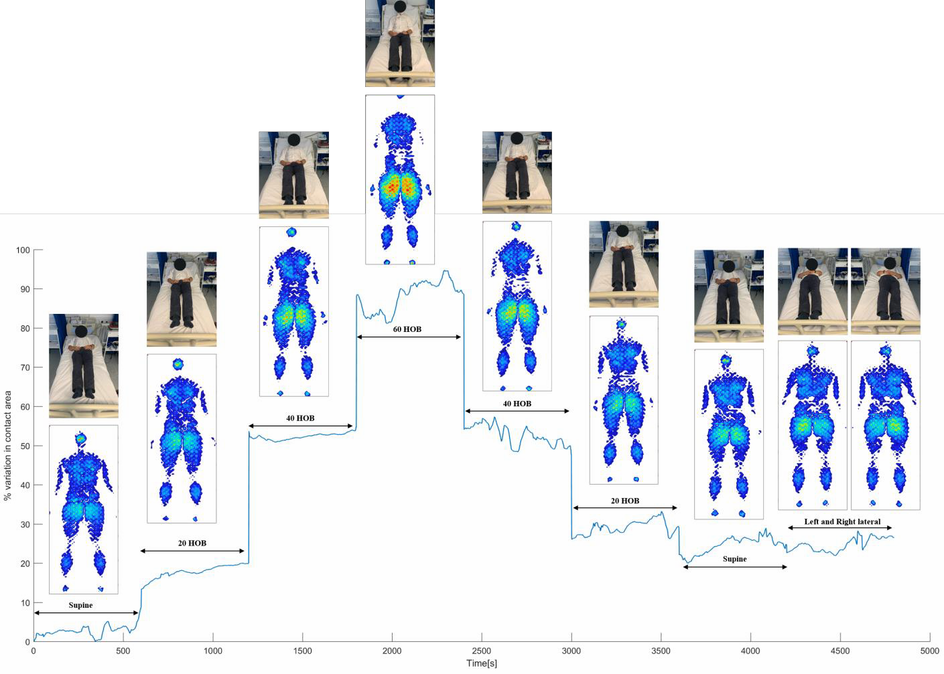

- Fig. 1: Temporal profile of the percentage variation of contact area at the whole body ROI and the

- corresponding pressure distribution for 8 sagittal and lateral postures, involving 20o HOB increments.

147

- 2.5 Post-processing of the signals from training group

- The flowchart in Fig. 2 illustrates the processing of the signals from both training and test groups.

- This included a moving average filter with a time window of 30 samples for the pressure data from

- both groups, to remove the high frequency noise. The corresponding actimetry signals, which were

- originally acquired at 51 Hz, were re-sampled at 1 Hz and filtered using a window of 15 samples

- (Caggiari et al., 2019).

- The signals from training group were then manually annotated, by denoting the beginning and the end

- of each evoked posture. The transitions between postures were not included as they contained noise

- due to natural adjustments in posture observed in all participants. Each of the signals was then

- interpolated in order to encompass 600 data points, for each posture, resulting in a total of 4800 data

- points per signal. The interpolation was applied in order to include signals and hence postures of an

- equivalent time period. All signals were then subjected to a fixed-width sliding window of 60 seconds

- to reduce the raw data by evaluating features i.e. mean and derivative values. Mean values were

- calculated within each sliding window for both trunk tilt angles and contact area signals, resulting in a

- 80 point data set for each signal. The reduced signals from all the subjects were allocated to the

- training data set. A principal component analysis (PCA) was performed and the training signals

- projected onto the PCs dimensional space.

165

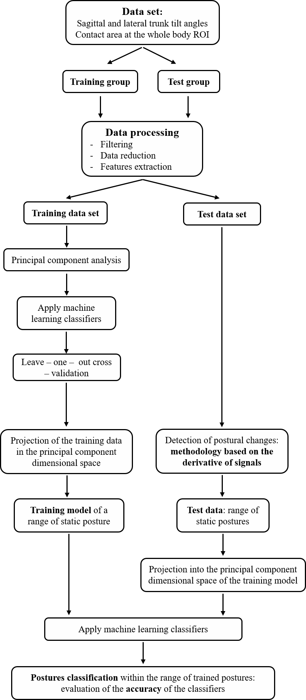

166

167 Fig. 2: Flow chart depicting the different processes for data acquisition for use with the classifiers.

168

- 2.6 Classifiers

- Three commonly used classifiers were employed, each of which adopts distinct approaches for event

- classification.

- 2.6.1 KNN classifier

- The KNN classification rule, first described by Cover and Hart (1967), depends on the distance metric

- between the new observation point and k nearest data point(s) (Short and Fukunaga, 1981). Given the

- nature of our data, the Euclidean distance was selected as the distance metric. Moreover, the

- parameter k determines how many neighbors will be chosen and its choice has a significant impact on

- the diagnostic performance of KNN algorithm. Accordingly, a sensitivity analysis was performed and

- k = 10 was identified to provide the highest accuracy and was therefore chosen for the current

- analysis.

- 2.6.2 Naïve-Bayes classifier

- The Naïve-Bayes classifier represents a probabilistic strategy based on Bayes’ theorem, which

- describes the probability of an event based on the prior knowledge that some other events have

- already occurred i.e. conditional probability. A Gaussian distribution was considered the most

- appropriate approach for assessing the conditional probability, which can be written as:

1
1 −1

185 P(H ¦ E) =
√det(2𝜋𝜎𝐸)
exp(−
(ℎ − 𝜇𝐸)𝑇𝜎𝐸
2
(ℎ − 𝜇𝐸))

- where H represents a new event and E is some observed event, µE is the mean and σE is the covariance

- matrix of the observed events.

- 2.6.3 Support Vector Machine (SVM) classifier

- The SVM (Burges, 1998) classifier is based on defining a hyperplane that divides the clusters of data.

- The optimal hyperplane is the one representing the largest distance to the nearest element of each

- cluster (support vectors). SVM projects the data into a higher dimension from the original space

- where the hyperplane can be derived from kernel functions. Gaussian kernel function was considered

- the most appropriate for the present data.

- 2.6.4 Cross-validation

- A leave-one-subject-out cross-validation was performed to test the robustness of the training model in

- detecting the range of static postures (Fig. 2). This consisted in training a model with data from 8 of

- the 9 subjects in the training cohort, who were randomly selected. The data of the excluded subject

- were then tested and the accuracy in postures classification was assessed. This process was repeated

- for each individual who has been used to test the trained model and the accuracy of the classifiers was

- determined. Subsequently, a training model was created with the set of data of all subjects in the

- training cohort. The accuracy of all classifiers was then assessed by applying data from subjects in the

- test cohort. This resulted in a percentage accuracy across all postures adopted in the test data. This

- percentage accuracy was established for each participant within the test group and calculated as the

- number of data points correctly classified for each posture with respect to the corresponding total

- number of points in the signals.

- 2.7 Test data sets

- After filtering, signals from test group were interpolated to encompass 9000 data points (2.5 hours of

- recording), including both static postures and the transition between postures. Signals corresponding

- to each participant represented a distinct data set to identify changes in posture and test the training

- model. Each of the test data sets was subjected to the 60-second sliding window for data reduction

- and both mean and derivative values were estimated within each window prior to identify the changes

- in posture and classify the corresponding static postures. The derivative signal of both contact area

- and trunk tilt angles in both sagittal and lateral planes were used for the detection of any change

- between two postures. The signals were subjected to a discriminant threshold to identify where the

- variations in the derivative occurred. Different thresholds were examined in order to identify the

- optimum value which accommodated all subjects. Once the changes in posture from the test data set

- were identified, the mean signals from the subsequent sliding windows were projected onto the

- training PCs dimensional space and subjected to posture classification.

219

- 3. Results

- 3.1 Leave-one-out cross-validation

- The cross-validation demonstrated an accuracy ranging between 85%-99% for classification

- performed with Naïve-Bayes. The corresponding accuracy using KNN and SVM ranged between

- 53%-95% and 59%-100%, respectively. Accordingly, it is demonstrated that the training data set

- could provide a robust means for detecting static postures with the test data set.

- 3.2 Detecting changes in posture

- Consistent variations in the derivative magnitude of the trunk tilt angles were identified in association

- with the sagittal changes in posture for all subjects. Smaller variations were also evident in the lateral

- plane when lateral postures were adopted (data not shown). They were subjected to processing which

- involved the signal rectification, in order to use a generic positive threshold. The rectified derivative

- signal for both sagittal and lateral trunk tilt angles were then summarised to obtain a single signal

- which included both sagittal and lateral changes in posture. An example of the rectified derivative

- profile of trunk tilt angles for one subject is illustrated in Fig. 3A. The corresponding derivative of the

- contact area is shown in Fig. 3B. The latter reveals that changes in posture were well distinguished in

- magnitude at high HOB angles, but less distinctive at lower HOB angles (<20°). Indeed, perturbations

- in magnitude were also observed during static postures, which did not enable the correct detection of

- all changes in posture (Fig. 3B). Accordingly, only the derivative of the trunk tilt angles was used and

- an appropriate discriminant threshold value of 0.10 for all subjects was selected for subsequent

- detection of the transitions between postures (Fig. 3A), resulting in 100% accuracy for all subjects.

240

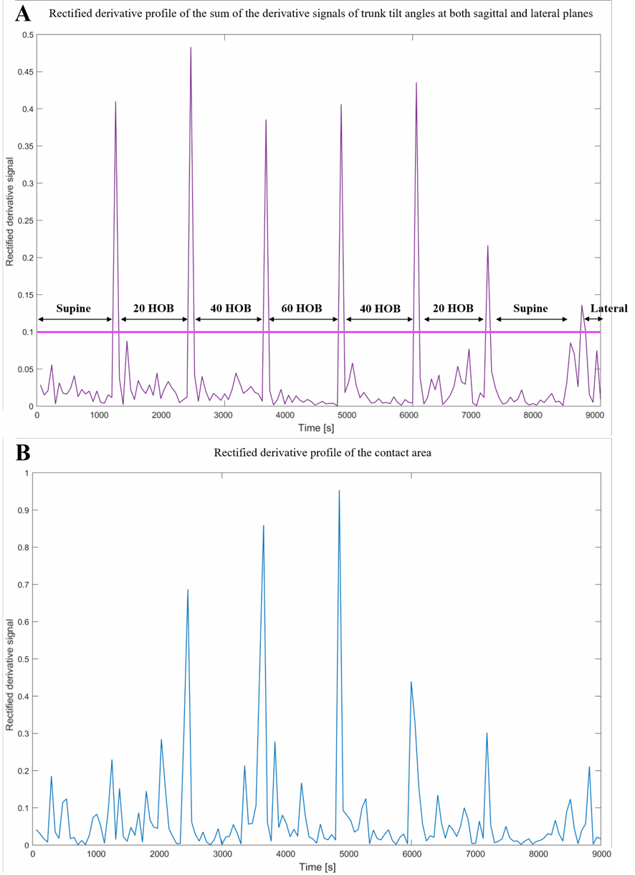241

- Fig. 3: Rectified derivative profile for subject #1 in the test cohort of A) the sum of the derivative

- signals of trunk tilt angles at both sagittal and lateral planes, B) contact area. Each data point in the

- signals corresponds to a derivative value calculated within the 60-second sliding window.

245

- 3.3 Accuracy in classifying the range of postures

- As illustrated in Fig. 4, static postures corresponding to signals for all subjects from the training group

- (n=9) resulted in clusters of points spatially distributed across the first and second PCA dimension,

- which contributed to 87% and 12% of the variance in the signals, respectively. This reflects the

- changes in signal magnitude associated with either increasing or decreasing the HOB angle (Fig 1). In

- particular, when a reduced variation in the step changes was observed e.g. HOB <20o, there is a

- reduced spatial distribution of adjacent clusters. This is particularly evident in the first principal

- component (PC1) (x-axis - Fig. 4). When the signals corresponding to the static postures of one

- subject from the test group are projected onto the training PCs space (data points in pink) separate

- clusters are observed. These clearly overlapped with the corresponding clusters of points from the

- training data.

- The estimated accuracies for each of the three classifiers are summarised in Table 1. It is evident that

- for increments of 20o in the HOB angles there was a high accuracy for each subject and all classifiers.

- In particular, the accuracy was >80% in classifying postures using the Naïve-Bayes classifier for all

- subjects. The corresponding accuracy using the KNN classifier resulted ≥90% in 8/10 subjects, with

- the remaining two subjects showing an accuracy value of 70% and 74%. SVM resulted in accuracy

- values of >80% in 8/10 subjects with the remaining two resulting in an accuracy of 71% and 69%,

- respectively.

264

265 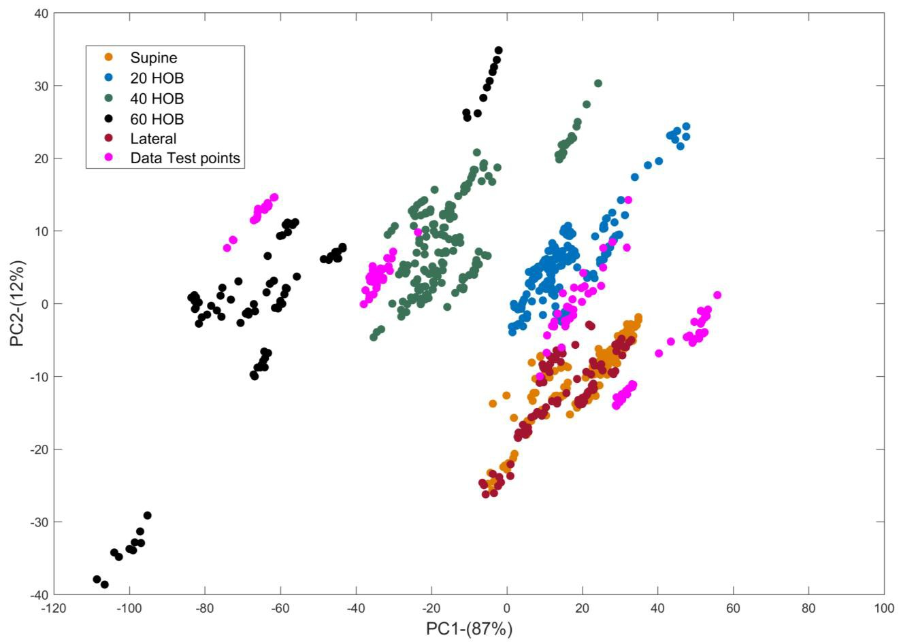

- Fig. 4: Signals corresponding to the training data set (9 subjects) projected onto the first two principal

- components, PC1 and PC2, with their corresponding variance in brackets. Each posture is represented

- by a spatially distributed coloured cluster. Signals from one subject from the testing group (data points

- in pink) were projected onto the training PCs dimensional space.

270

271

272

273

274

275

276

277 Table 1: Percentage accuracy in classifying the range of postures for all classifiers.

Accuracy [%]

 |  | Subjects | Naïve-Bayes | KNN | SVM
 |  | 1 | 90 | 94 | 97
 |  | 2 | 95 | 97 | 91
 |  | 3 | 98 | 90 | 86
 |  | 4 | 89 | 92 | 90
 |  | 5 | 97 | 93 | 97
 |  | 6 | 83 | 97 | 82
 |  | 7 | 93 | 90 | 97
 |  | 8 | 98 | 74 | 71
 |  | 9 | 100 | 98 | 100
 |  | 10 | 82 | 70 | 69
278
279 | 4. Discussion

- This study has detailed the application of intelligent data processing of biomechanical signals

- depicting changes in lying posture from angles of body segments (actimetry) and pressures measured

- at the interface between the body and support surface i.e. contact area of pressures >20mmHg. The

- derivative of signals was assessed to identify changes in posture in both sagittal and lateral planes. A

- series of machine learning algorithms in the form of Naïve-Bayes, KNN and SVM classifiers were

- applied to a set of data involving signals derived from an actimetry system and interface pressure

- distribution estimated from a high resolution sensing array. A cross-validation technique was applied

- using each machine learning algorithm, revealing that the training data could provide a robust means

- of classifying the data. Subsequently, an adapted protocol was used to provide test data, which was

- observed to correspond with the clusters derived from the training phase (Fig. 4). The resulting

- classification accuracy of the test data ranged between 82% 100%, 70%-98% and 69%-100% for the

- three classifiers, respectively (Table 1), with Naïve-Bayes classifier showing the highest accuracy in

- classifying the range of static postures. A value >80% could represent a benchmark by which the

- majority of the postures can be monitored.

- Findings revealed that the derivative of the signal representing the trunk tilt angles correctly identified

- the changes in posture for all subjects, as characterised by a transient increase in the magnitude of the

- derivative at each corresponding change in posture (Fig. 3A). By contrast, the derivative of the

- contact area signal generally revealed less distinct changes in magnitude when evaluating changes in

- posture involving HOB angles <20o and thus it proved problematic in identifying their occurrence

- (Fig. 3B). Accordingly, the trunk tilt angles derivative, resulting from the sum of sagittal and lateral

- signal derivatives, was considered to represent a more robust means to automate the detection of the

- changes in posture in the test data. Indeed this approach, based on the derivative of biomechanical

- parameters, has been applied in several other areas of the biomedical field, for example, for the

- detection of the different gait phases (Taborri et al., 2016).

- Previous research have utilised intelligent data processing from machine learning algorithms to

- classify a range of lying and sitting postures and their transitions from the distribution of pressure at

- the subject-support interface (Foubert et al., 2012; Kim et al., 2018; Matar et al., 2019; Rus et al.,

- 2017; Wai et al., 2010; Yousefi et al., 2011; Zemp et al., 2016). These approaches adopted and the

- results reported are summarised in Table 2.

309

310

311

312

313

314

315 Table 2: Summary of relevant studies classifying lying and sitting postures.

Study Data used for classification Classifier(s) Accuracy Changes in posture

  - Raw pressure values
> 70%

Wai et al. (2010) -
  - Eigen vectors > 50%

Lying postures
  - Mean, variance, standard deviation, root mean square estimated in 9 ROIs
SVM
✗
> 60%

Yousefi et al. (2011) -
Lying postures
Binary pressure images projected in PCA space

KNN > 97% ✗

Kim et al. (2018) -
Sitting postures

Heat map of pressure distribution

Naïve - Bayes SVM
> 85%
✗
> 90%

Duvall et al. (2019) -
Lying postures
Weight measured by four cells placed under the legs of the bed

KNN > 95% ✓

Zemp et al. (2016) -
Sitting postures
Median of the force data divided by the subject’s body weight and backrest angles

SVM > 70% ✗

Foubert et al. (2012) -
Lying to sitting
- WNAS

SVM and KNN
> 90%
✓

- COP displacements > 75%

Matar et al. (2019) -
Lying postures
Oriented gradient and local binary patterns estimated from pressure distribution

Artificial neural network

> 97% ✗

Present study
Eigen vectors estimated from biomechanical parameters derived from actimetry systems and pressure distribution
Naïve-Bayes > 80%

KNN ≥ 70% ✓
SVM ≥ 69%

316

- It is evident that the present findings are comparable with previous studies, with high accuracy values

- in postures classification reported for the detection of range of static postures. However, only two

- studies have detected the transition phases between static postures. Foubert et al. (2012) have used

- lateral and longitudinal displacements of the centre of pressure estimated from pressure distribution,

- reporting an accuracy of >90%. By contrast, a separate study utilised the total weight on the bed

- measured by using a system involving four load cells (Duvall et al., 2019). Their results reported that

- a change of 7lb (3.2kg) in the measured weight within a temporal window of 7secs was able to detect

- the changes in posture with an accuracy of 98%. Furthermore, limitations of many previous studies

- included the short-term estimation of the pressure distribution (up to tens of seconds) and the limited

- range of supine postures (i.e. supine, prone, left and right turn). There are, however, some studies

- which have evaluated a range of postures involving the elevation of the HOB angle (Yousefi et al.,

- 2011) and data derived from a longer period i.e. 5 minutes of pressure monitoring (Kim et al., 2018).

- In addition, Zemp et al. (2016) utilised a composite data set involving force values acquired at the

- support surface normalised to individual body weight and the corresponding backrest tilt angle

- estimated with actimetry positioned on the backrest, for the detection of sitting postures. However,

- both parameters were acquired at a single time point.

- The present study has applied an automated method to identify the occurrence and magnitude of

- movements based on signal derivative and machine learning algorithms. This could be achieved using

- either actimetry or pressure parameters. To date, these temporal data are unknown in many care

- settings.

- It is inevitable that the use of able- bodied cohorts in a lab-based study precludes generalising the

- present findings to individuals, from specific sub-populations, deemed to be at risk of developing

- pressure ulcers i.e. the elderly, spinal cord injured and those managed in intensive care units. The

- study protocol was also limited in selecting a pre-determined order of relatively small postural

- changes (20o HOB increments) maintained for a relative short period of 10-20 minutes. Thus, future

- studies should examine random postures involving different HOB increments and the side-lying

- lateral posture typically adopted in clinical settings. The current method would require an

- improvement in accuracy and validation to account for random postures on specialised mattresses

- used by patients in both acute and community clinical settings where the recommended frequency and

- magnitude of movements are not strictly followed (Defloor et al., 2005; Woodhouse et al., 2019). This

- would support clinicians when informing clinical decision-making.

- Technology to monitor individuals could provide critical means to detect posture and mobility.

- However, it is clear that the emergence of digital health strategies will necessitate the use of robust

- monitoring tools. Accordingly, continuous pressure monitoring represents an important tool which

- when integrated with support and feedback technologies could promote PU prevention through self-

- management and targeted care interventions (Tung et al., 2015). This would result in more efficient

- practice and a personalised approach. It could also be integrated with risk assessment to create a more

- objective means of PU risk. In addition, machine learning applied to large data sets derived from these

- technologies could provide a robust means for translation into indicators of posture and mobility

- associated with both frequency and magnitude of postures.

- 5. Conclusion

- The present study has defined a methodology for classifying static lying postures and identifying

- transitions in between different postures. The combination of biomechanical parameters acquired

- using pressure monitoring and actimetry technologies were combined using data reduction and

- machine learning approaches. The combination of monitoring technologies and advanced algorithms

- offers the potential to track posture and mobility in individuals at risk of pressure ulcers, informing

- personalised care strategies. Further research is needed to establish the accuracy of the posture

- prediction involving clinical data sets in sub-groups of patients at risk of pressure ulcers e.g. spinal

- cord injured.

- Acknowledgments

- The postgraduate researcher (SC) was supported by a UK Engineering and Physical Science Research

- Council Case award in association with Sumed International, who provided the pressure mapping

- system (ForeSite PT). SC was also supported by European Pressure Ulcer Advisory Panel (EPUAP)

- Research funding in collaboration with the University of Grenoble-Alpes to support the development

- of the present study. There were no conflicts of interest in this study.

- Ethical approval

- University of Southampton Ethics was granted for the study (Ref: 26379)

374

- References

- Bogie, K., Wang, X., Fei, B., Sun, J., 2008. New technique for real-time interface pressure analysis:

- Getting more out of large image data sets. J Rehabil Res Dev 45, (4): 523-535.

- Burges, C.J.C., 1998. A Tutorial on Support Vector Machines for Pattern Recognition. Data Mining

- and Knowledge Discovery 2, (2): 121-167.

- Caggiari, S., 2020. Bioengineering technologies to monitor movements in supported postures: a

- potential strategy to monitor pressure ulcers, University of Southampton, Faculty of Enviromental and

- Life Sciences. PhD thesis.

- Caggiari, S., Worsley, P.R., Bader, D.L., 2019. A sensitivity analysis to evaluate the performance of

- temporal pressure - related parameters in detecting changes in supine postures. Medical Engineering

385 & Physics 69: 33-42.

- Chi-Chun, H., Yu-Wei, H., Yu-Hsien, C., Chia-Hao, K., 2008. Bayesian classification for bed posture

- detection based on kurtosis and skewness estimation. HealthCom 2008 - 10th International

- Conference on e-health Networking, Applications and Services: 165-168.

- Cover, T., Hart, P., 1967. Nearest neighbor pattern classification. IEEE Transactions on Information

390 Theory 13, (1): 21-27.

- Defloor, T., Bacquer, D.D., Grypdonck, M.H.F., 2005. The effect of various combinations of turning

- and pressure reducing devices on the incidence of pressure ulcers. International Journal of Nursing

393 Studies 42, (1): 37-46.

- Duvall, J., Karg, P., Brienza, D., Pearlman, J., 2019. Detection and classification methodology for

- movements in the bed that supports continuous pressure injury risk assessment and repositioning

- compliance. Journal of Tissue Viability 28, (1): 7-13.

- Edwardson, C.L., Rowlands, A.V., Bunnewell, S., Sanders, J., Esliger, D.W., Gorely, T., O'Connell,

- S., Davies, M.J., Khunti, K., Yates, T., 2016. Accuracy of Posture Allocation Algorithms for Thigh-

- and Waist-Worn Accelerometers. Medicine & Science in Sports & Exercise 48, (6): 1085-1090.

- Foubert, N., McKee, A.M., Goubran, R.A., Knoefel, F., 2012. Lying and sitting posture recognition

- and transition detection using a pressure sensor array. 2012 IEEE International Symposium on

- Medical Measurements and Applications Proceedings: 1-6.

- Ifedili, I.A., Kennerly, S.M., Sabol, V.K., Yap, T.L., 2018. Implementing a visual cueing technology

- intervention in a nursing home: Nursing staff perceptions. Geriatric Nursing 39, (5): 607-609.

- Kim, Y., Son, Y., Kim, W., Jin, B., Yun, M., 2018. Classification of Children’s Sitting Postures Using

- Machine Learning Algorithms. Applied Sciences 8, (8): 1280.

- Lyden, K., John, D., Dall, P., Grant, M.H., 2016. Differentiating Sitting and Lying Using a Thigh-

- Worn Accelerometer. Medicine & Science in Sports & Exercise 48, (4): 742-747.

- Manini, A., Sabatini, A.M., 2010. Machine Learning Methods for Classifying Human Physical

- Activity from On-Body Accelerometers. sensors 10: 1154-1175.

- Matar, G., Lina, J., Kaddoum, G., 2019. Artificial neural network for in-bed posture classification

- using bed-sheet pressure sensors. IEEE Journal of Biomedical and Health Informatics: 1-1.

- Mathie, M.J., Coster, A.C.F., Lovell, N.H., Celler, B.G., 2003. Detection of daily physical activities

- using a triaxial accelerometer. Medical and Biological Engineering and Computing 41, (3): 296-301.

- Mohammed, S., Samé, A., Oukhellou, L., Kong, K., Huo, W., Amirat, Y., 2016. Recognition of gait

- cycle phases using wearable sensors. Robotics and Autonomous Systems 75: 50-59.

- Pickham, D., Berte, N., Pihulic, M., Valdez, A., Mayer, B., Desai, M., 2018. Effect of a wearable

- patient sensor on care delivery for preventing pressure injuries in acutely ill adults: A pragmatic

- randomized clinical trial (LS-HAPI study). International Journal of Nursing Studies 80: 12-19.

- Rus, S., Grosse-Puppendahl, T., Kuijper, A., 2017. Evaluating the recognition of bed postures using

- mutual capacitance sensing. Journal of Ambient Intelligence and Smart Environments 9, (1): 113 -

422 127.

- Short, R., Fukunaga, K., 1981. The optimal distance measure for nearest neighbor classification. IEEE

- Transactions on Information Theory 27, (5): 622-627.

- Stinson, M., Ferguson, R., Porter-Armstrong, A., 2018. Exploring repositioning movements in sitting

- with ‘at risk’ groups using accelerometry and interface pressure mapping technologies. Journal of

- Tissue Viability 27, (1): 10-15.

- Taborri, J., Palermo, E., Rossi, S., Cappa, P., 2016. Gait Partitioning Methods: A Systematic Review.

- Sensors (Basel) 16, (1): 66.

- Tung, J., Stead, B., Mann, W., Pham, B., Popovic, M., 2015. Assistive technologies for self-managed

- pressure ulcer prevention in spinal cord injury: A scoping review. The Journal of Rehabilitation

- Research and Development 52: 131-146.

- Wai, A.P., Foo, S.F., Huang, W., Biswas, J., Hsia, C.-C., Liou, K., Yap, P., 2010. Lying Posture

- Classification for Pressure Ulcer Prevention. Journal of Healthcare Engineering 1, (2): 217-238.

- Woodhouse, M., Worsley, P.R., Voegeli, D., Schoonhoven, L., Bader, D.L., 2019. How consistent

- and effective are current repositioning strategies for pressure ulcer prevention? Applied Nursing

437 Research 48: 58-62.

- Yousefi, R., Ostadabbas, S., Faezipour, M., Farshbaf, M., Nourani, M., Tamil, L., Pompeo, M., 2011.

- Bed posture classification for pressure ulcer prevention. 2011 Annual International Conference of the

- IEEE Engineering in Medicine and Biology Society: 7175-7178.

- Zemp, R., Tanadini, M., Pluss, S., Schnuriger, K., Singh, N.B., Taylor, W.R., Lorenzetti, S., 2016.

- Application of Machine Learning Approaches for Classifying Sitting Posture Based on Force and

- Acceleration Sensors. BioMed Research International 2016.

444

