Low-cost unmanned aerial vehicle-based digital hemispherical photography for estimating leaf area index: a feasibility assessment
Luke A. Brownª*, David H. Sutherlandª and Jadunandan Dashª
ªSchool of Geography and Environmental Science, University of Southampton, Highfield, Southampton, SO17 1BJ, United Kingdom
*Corresponding author: l.a.brown@soton.ac.uk
Low-cost unmanned aerial vehicle-based digital hemispherical photography for estimating leaf area index: a feasibility assessment
Unmanned aerial vehicles (UAVs) have the potential to provide highly detailed information on vegetation status useful in precision agriculture. However, challenges are associated with existing techniques for UAV-based retrieval of vegetation biophysical variables such as leaf area index (LAI), including variable illumination, bidirectional reflectance effects, and the need for image calibration, mosaicking, and normalisation. We investigated an alternative approach that avoids these challenges whilst still providing spatially explicit estimates of LAI, using UAV-based digital hemispherical photography (DHP). LAI estimates were obtained using a low-cost UAV-based DHP system over a winter wheat field in Southern England. Point-based estimates were interpolated to provide spatially continuous datasets, which successfully described patterns of vegetation condition. The UAV-based DHP data were compared to ground-based LAI estimates, demonstrating good agreement (root mean square error (RMSE) = 0.10, normalised RMSE (NRMSE) = 3%).
Keywords: 3DR Solo; drone; DHP; GoPro; LAI; multirotor; quadcopter; UAV

1. Introduction
Unmanned aerial vehicles (UAVs) have received increasing attention in recent years as a platform for obtaining information on vegetation cover and condition. In particular, much work has focussed on the potential of UAVs to provide highly detailed information to support applications in precision agriculture (Clevers, Kooistra, and van den Brande 2017; Vincini, Amaducci, and Frazzi 2014). These applications require biophysical and biochemical variables including leaf area index (LAI) and canopy chlorophyll content (CCC), which have typically been retrieved using the spectral information from UAV-mounted digital cameras and multispectral sensors. Retrieval approaches have included statistical and machine learning methods (Yuan et al. 2017; Candiago et al. 2015; Rasmussen et al. 2016; Revill et al. 2019), in addition to the inversion of coupled leaf and canopy radiative transfer models (Duan et al. 2014; Fenghua et al. 2017; Roosjen et al. 2018; Verger et al. 2014; Roth et al. 2018).
Despite their promise, several issues are associated with the use of UAV-mounted digital cameras and multispectral sensors for biophysical variable retrieval, including variable illumination during the course of data acquisition, bidirectional reflectance effects, and challenges related to image calibration, mosaicking and normalisation (von Bueren et al. 2015; Rasmussen et al. 2016; Hakala et al. 2018). Due to their empirical nature, the statistical and machine learning methods may compensate for these effects to some extent, but require training data specific to a given site and observation scenario. On the other hand, radiative transfer model inversion can provide a more generally applicable solution, but requires data in calibrated units of absolute reflectance.
In this study, we evaluate an alternative approach that avoids many of these challenges, whilst still being able to provide the spatially explicit estimates of LAI required in precision agriculture using low-cost hardware. The approach is based on digital hemispherical photography (DHP) – a widely used method for performing ground-based measurements of LAI (Jonckheere et al. 2004; Weiss et al. 2004; Bréda 2003; Garrigues, Shabanov, et al. 2008), which has received little attention from practitioners working with UAVs so far. The objective of the study is to provide a preliminary feasibility assessment of UAV-based DHP for estimating LAI in an agricultural context.

2. Materials and methods

2.1. Study site and data collection
UAV-based DHP data collection was carried out over a winter wheat (Triticum aestivum) field in Southern England (51.1925° N, 1.4550° W) on two dates (30 May 2018 and 13 June 2018). Three 200 m flight lines were established over the site in a north-south direction (Figure 1). The UAV-based DHP system adopted in this study was comprised of a 3DR Solo quadcopter equipped with a GoPro HERO4 Black digital camera, whose full-frame fisheye lens provides a 150° field-of-view across the diagonal of the 12 megapixel image (Figure 2). Recent work has demonstrated the potential of GoPro digital cameras for the purposes of DHP (Uribe, Mattar, and Camacho 2018), whilst their low cost and light weight are particularly advantageous in the context of UAV surveys.
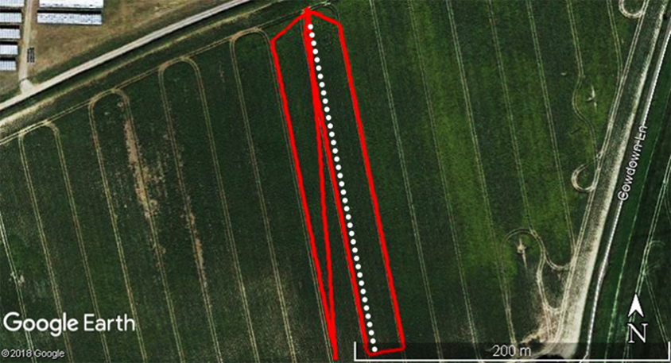
Figure 1. Flight lines (red) and ground sampling points (white) established over the study site and used in each survey.

All data were collected under uniform overcast skies to minimise shadowing in the acquired images. To ensure a useful measurement footprint and to prevent image blurring, flights were carried out at an altitude of 5 m above ground level and speed of 1 m s⁻¹. An image capture rate of 0.5 s was selected. Images were acquired at full resolution using the highest available quality setting. The spatial resolution of each pixel was approximately 0.3 cm at nadir. Approximately 1,000 images were collected by the UAV-based DHP system per survey. Due to shutter lag and the time taken to write images to storage media, the images were acquired at a spacing of approximately 0.6 m as opposed to the 0.5 m specified by the flight speed and capture rate.
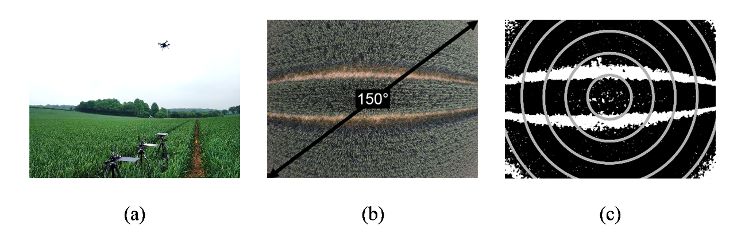
Figure 2. Image of the study site (a), example UAV-based DHP image indicating the 150° field-of-view across the diagonal (b), and resulting classification with indicative visualisation of analysis rings shown in grey (c).
On the same dates, ground-based data were collected against which the UAV-based DHP approach could be evaluated. Ground-based measurements of LAI were performed every 5 m along the central flight line (yielding 40 points per date), which was marked with survey flags (Figure 1). In this case, DHP was carried out using a Nikon Coolpix 4500 digital camera and FC-E8 fisheye lens, held above the canopy at shoulder height (approximately 1.5 m). As images were acquired facing downwards, automatic exposure was adopted, following Demarez et al. (2008). A Garmin eTrex 10 global positioning system (GPS) receiver with an uncertainty of less than 10 m was used to locate the transect in the field. Waypoint averaging was carried out to further increase positional accuracy, and given the study site was open and unobstructed (McCoy 2005; Hasegawa and Yoshimura 2003), the actual positional accuracy was likely to be considerably better than 10 m, which is an upper bound that represents the worst-case scenario. The mean spacing between each of the recorded ground-based GPS points was 5.2 m, indicating that over the study area, the relative positional accuracy was much better than 10 m.

2.2. Image processing and analysis
Each DHP image was automatically classified to derive multi-angular estimates of canopy gap fraction, and processed to yield an estimate of LAI. Given the bright soils experienced at the study site (Figure 2b), a simple condition based on typical spectral characteristics (i.e. increasing reflectance throughout visible wavelengths) proved sufficient to successfully distinguish the canopy from its background (Figure 2c). Qualitative evaluation indicated that over our study site, this approach performed better than a similar condition to identify green pixels, in addition to the classification approach proposed by Meyer and Neto (2008). Thus, soil pixels were identified using Equation (1):
${DN}_{red}>{DN}_{green}>{DN}_{blue}$ (1)
where ${DN}_{red}$, ${DN}_{green}$ and ${DN}_{blue}$ are the digital number values in the red, green and blue bands of the image. LAI was then determined according to Miller (1967). Each image was divided into six zenith rings with an arc length of 10°, and LAI was calculated according to Equation (2):
$LAI=2\sum_{i=1}^{6}{-[\ln{P(θ_{i})}]}\cos{θ_{i} w_{i}}$ (2)
where $w_{i}$ is determined according to Equation (3):

$w_{i}=\frac{\sin{θ_{i} dθ_{i}}}{\sum_{i=1}^{6}{\sin{θ_{i} dθ_{i}}}}$ (3)
and where $\ln{P(θ_{i})}$ is the natural logarithm of the gap fraction in zenith ring $i$, whose central zenith angle (in radians) is denoted $θ_{i}$. Because equally spaced zenith rings of 10° were used, in our case, $dθ_{i}$ is determined in radians as $π/{180}×10$. Note that because the effects of foliage clumping were not accounted for, the LAI estimates in this study represent effective LAI. However, for simplicity, we use the term LAI interchangeably with effective LAI throughout the paper.
Following the derivation of LAI, each UAV-based DHP image was geolocated by matching the time at which it was acquired with that of the quadcopter telemetry logs (timestamped locations were determined using the quadcopter’s GPS receiver). Once geolocated, the point-based estimates of LAI were interpolated to generate a spatially continuous dataset over the study area. Of several available interpolation methods, ordinary kriging was selected because it provides prediction uncertainties in addition to interpolated values (Cressie 1990). We used a spherical semivariogram model with a lag size of 0.6 m and a variable search radius using the nearest 12 points.

2.3. Evaluation of UAV-based DHP using ground-based measurements
Because of the relatively low accuracy of the handheld and quadcopter GPS receivers, direct comparison between UAV- and ground-based LAI estimates was deemed impractical. Instead, to reduce the impact of positional uncertainties, the 200 m ground-based transect was instead aggregated into ten 20 m segments (containing four ground-based DHP images per segment). The mean LAI derived from these four images was then compared to the mean LAI derived from the corresponding UAV-based DHP images within that segment (Figure 3).
Agreement between UAV- and ground-based LAI estimates was assessed using Pearson’s correlation coefficient (r) and the root mean square error (RMSE). The RMSE was also divided by the mean of the ground-based LAI values to derive a normalised RMSE (NRMSE). Bias was determined as the mean difference between UAV- and ground-based LAI estimates.
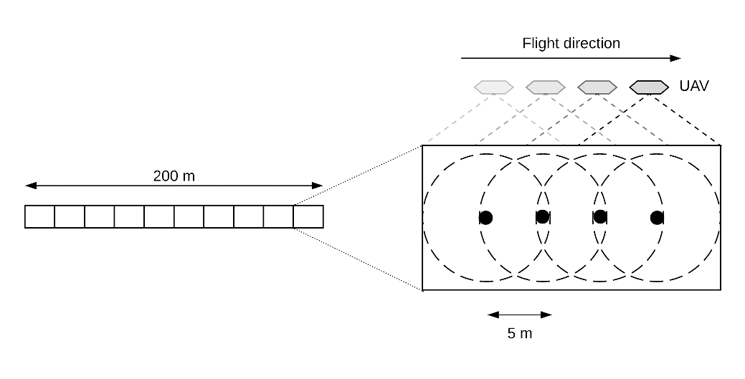
Figure 3. Schematic diagram illustrating the aggregation of UAV- and ground-based LAI estimates into 20 m segments for comparison (not to scale). Black dots represent ground-based samples, dashed lines represent approximate measurement footprints.

3. Results and discussion

3.1. Accuracy of LAI estimates from UAV-based DHP

Large differences in ground-based LAI estimates were not observed between the two survey dates, which had mean values of 3.34 and 3.26 respectively, although a slightly greater range of values was experienced on 13 June 2018, when LAI varied from 2.26 to 4.06 as opposed to 30 May 2018, when LAI varied from 2.79 to 4.08 (Table 1). The increased dispersion of values on 13 June 2018 (Figure 4) was reflected by a slightly larger standard deviation (0.43 as opposed to 0.32) (Table 1).
When compared against ground-based estimates, the UAV-based estimates of LAI demonstrated good agreement on both dates, providing strong correlations (r = 0.75 to 0.77) and low RMSE/NRMSE values (0.09 to 0.12, 2.75% to 3.42%) (Figure 5). Nevertheless, it should be noted that the UAV-based estimates tended to underestimate ground-based estimates on 30 May (bias = -0.18) (Figure 5a), but overestimate ground-based estimates on 13 June (bias = 0.26) (Figure 5b). This reduced the correlation when both dates were analysed together (r = 0.62). An overall RMSE of 0.10 (NRMSE = 3.11%) and bias of 0.04 was observed (Figure 5c).
Table 1. Summary statistics for ground-based LAI estimates on each survey date.
 | 30 May 2018 | 13 June 2018
Minimum | 2.79 | 2.26
Maximum | 4.08 | 4.06
Mean | 3.34 | 3.26
Standard deviation | 0.32 | 0.43
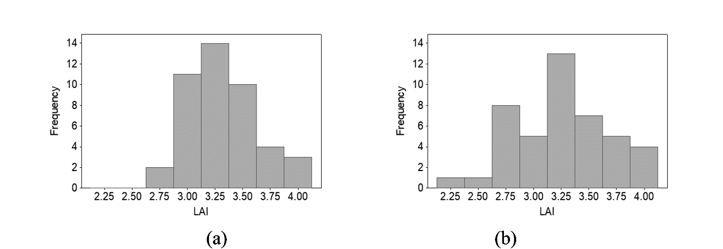Figure 4. Frequency distribution of ground-based LAI estimates on 30 May 2018 (a) and 13 June 2018 (b).

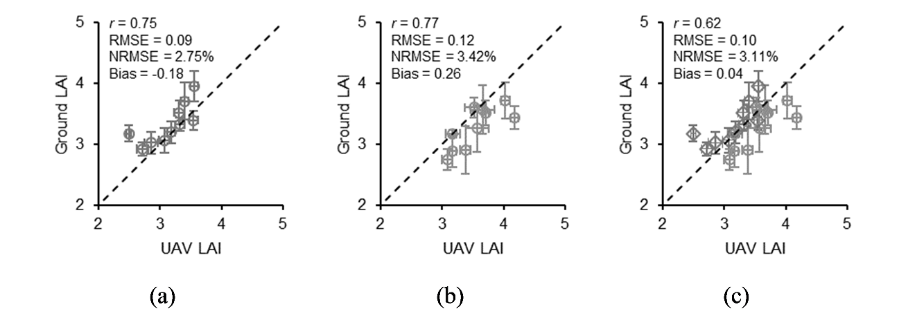Figure 5. Comparison of UAV- and ground-based estimates of LAI for 30 May 2018 (a), 13 June 2018 (b), and both dates combined (c). Error bars represent the standard deviation over each 20 m segment, whilst the dashed line represents a 1:1 relationship.
Given that the differences between each survey date were so systematic, one plausible explanation is that they were caused by differences in illumination conditions. Several studies have highlighted the sensitivity of DHP-derived LAI estimates to photographic exposure (Beckschäfer et al. 2013; Zhang, Chen, and Miller 2005; Macfarlane et al. 2000; Macfarlane et al. 2014), and given the lower quality of the GoPro HERO4 Black digital camera, it is possible that the UAV-based estimates of LAI were more sensitive to differences in illumination conditions than the ground-based estimates using the higher quality Nikon Coolpix 4500 (due to its more robust exposure metering).
Because the UAV-based DHP images are acquired from a higher altitude (and as a result of the presence of tractor lines) it is reasonable to expect they would include more soil than the ground-based images, which could lead to some apparent biases (even if the UAV-based images are the more representative of the wider area). Nevertheless, it is important to note that in all cases discrepancies between the UAV- and ground-based estimates were small; the largest observed difference was 0.56, which is well within the expected uncertainty of ± 1 unit typically ascribed to ground-based plot-level LAI measurements using optical techniques such as the LI-COR LAI-2000 (Garrigues, Lacaze, et al. 2008; Camacho et al. 2013; Fernandes et al. 2003). When compared to the uncertainty introduced by limited spatial sampling in traditional field campaigns (Weiss et al. 2004; Majasalmi et al. 2012), the comprehensive coverage potentially achievable by the UAV-based DHP approach is a key advantage. This is a particularly important consideration in agricultural environments, where logistical constraints may restrict access to field boundaries and tractor-lines to avoid damage to crops.
When assessed against previously investigated UAV-based LAI retrieval techniques using spectral information from digital cameras and multispectral sensors, the UAV-based DHP approach presented in this study provides comparable results. For example, making use of machine learning techniques, Revill et al. (2019) and Yuan et al. (2017) achieved an NRMSE of 8.8% (r = 0.94) and RMSE of 0.09 (r = 0.86) over winter wheat and soybean, respectively, whilst using radiative transfer model inversion approaches, an RMSE of 0.17 (r = 0.98) was reported by Verger et al. (2014) over wheat and rapeseed. Similarly, RMSE values of between 0.10 and 0.65 (r = 0.91 to 0.96) have been reported in radiative transfer model inversion studies over maize, potato, sunflower, rice and soybean (Duan et al. 2014; Roth et al. 2018; Roosjen et al. 2018; Fenghua et al. 2017).
Whilst weaker correlations were observed in our study than in previous experiments, we suggest this is likely due to the low range of LAI values observed, particularly given the fact that similar RMSE values were obtained, since previous experiments have tended to incorporate a wider range of growth stages and LAI values. Nevertheless, given that its performance in terms of RMSE is comparable to techniques using spectral information, an important advantage of the UAV-based DHP approach is the fact that ancillary data are not a necessity, and calibration, mosaicking and normalisation procedures are not required. This is a key consideration for routine use in precision agriculture, as such procedures are particularly time-consuming and require expertise that may not be readily available to end users (Rasmussen et al. 2016).

3.2. LAI maps derived from UAV-based DHP data
From the point-based estimates associated with each image, interpolation using ordinary kriging enabled spatial patterns in LAI to be captured over the site. A marked increase in LAI from north to south was observed (Figure 6a). The prediction uncertainties provided by the interpolation procedure demonstrated expected spatial patterns, in which lower uncertainties were observed within the convex hull of the measurements when compared to regions outside of the area covered by the flight lines (Figure 6b). Overall patterns of LAI and prediction uncertainties from both surveys were in agreement (Figure 6c-d). Within the convex hull itself, some variation in prediction uncertainties was also observed, manifested as distinct blocks of higher uncertainty. Since these patterns were consistent on both dates, we suggest this was likely due to increased variability in LAI over these areas of the study site.
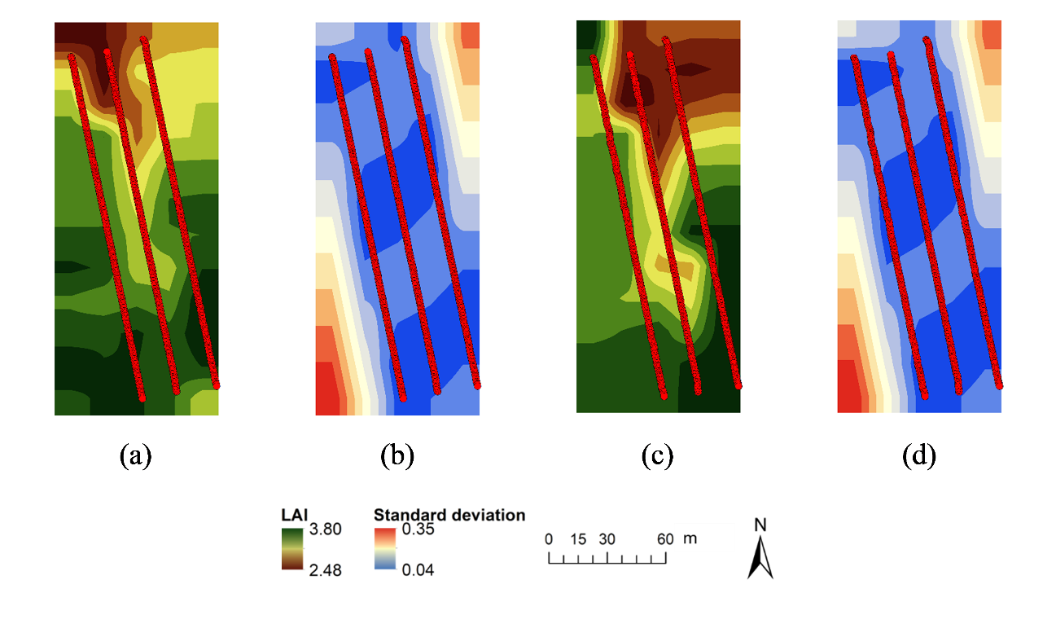Figure 6. Contour maps of spatially interpolated LAI and prediction uncertainties provided by ordinary kriging for 30 May 2018 (a-b) and 13 June 2018 (c-d). The red dots indicate point-based LAI estimates derived from UAV-based DHP images.

Our results demonstrate the potential of the UAV-based DHP approach to provide the spatially explicit information on canopy status needed in precision agriculture. For example, knowing that lower LAI values are observed at the north of the site would enable this area to be further investigated to determine the cause (e.g. nutrient deficiency, drainage, the presence of pests). Likewise, such information could be used to more efficiently target fertilisers or pesticides using variable rate application, or to inform which areas of the field are likely to need harvesting first (Clevers, Kooistra, and van den Brande 2017; Vincini, Amaducci, and Frazzi 2014). The fact that the adopted interpolation procedure provides uncertainty estimates is an additional benefit in the context of decision support, enabling the data to be appropriately weighed amongst any other available information or observations. It should be noted, however, that results are likely to be sensitive to the adopted interpolation method and associated parameters.
A further application of the UAV-based DHP system described in this study is in the validation of operational satellite-derived vegetation products. Due to their coarse spatial resolution (i.e. 300 m to 1 km), such products are challenging to directly compare with ground-based data (Morisette et al. 2006; Fernandes et al. 2014). By reducing the logistical constraints associated with traditional field campaigns, a UAV-based DHP system could be used to densely sample an entire coarse spatial resolution pixel. Alternatively, the interpolation procedure described here could also be used to generate high spatial resolution reference maps (which could then be aggregated the spatial resolution of the product being validated e.g. Martínez, García-Haro, and Camacho-de Coca 2009; Brown et al. 2019).
If UAV-based DHP data are to be spatially interpolated, an important consideration is the choice of sampling scheme. Since the main objective of our study was to provide a preliminary feasibility assessment, different sampling schemes were not investigated. In the sampling scheme we adopted, sampling is denser along the flight line, and it is possible that this could lead to biases in interpolation outputs. The key to avoiding these biases might be to design a flight plan that provides more even spatial sampling (for example by increasing sidelap or using two sets of flight lines that run at 90° to each other, forming an evenly spaced grid). A priority for future UAV-based DHP research would be the evaluation of such an approach amongst other available configurations.
Having proven the feasibility of the UAV-based DHP approach at a site with a limited range of conditions, future work is now required to confirm our results over a greater range of canopy densities, and at sites characterised by different vegetation and soil types. Whilst it is true the UAV-based DHP approach has the potential to acquire data over wide areas, it is also important to note that a low altitude (and, therefore, slow flight speed) is required to provide a useful measurement footprint, reducing the area that can be covered during the typical flight time of current consumer UAVs. Future research should, therefore, focus on professional-grade UAV platforms. In addition to their increased flight times, such platforms are also capable of carrying heavier payloads, opening up the opportunity to exploit higher quality digital camera systems than the GoPro HERO4 Black investigated in this study. Indeed, some professional-grade multirotor platforms such as the DJI Matrice 600 Pro are now specifically designed to carry high quality digital single-lens reflex (DSLR) cameras (DJI 2020).

4. Conclusions
In this study, we investigated the feasibility of UAV-based DHP for estimating LAI. Our results indicate that the approach can provide the spatially explicit estimates of LAI required in precision agriculture, whilst avoiding many of the challenges associated with existing UAV-based biophysical variable retrieval techniques. The good agreement with ground-based LAI estimates provides further confidence that the technique is comparable to established methods. A key strength of the UAV-based DHP approach is that it does not require ancillary data or the use of time-consuming image calibration, mosaicking and normalisation procedures. This makes it better suited to routine use by end users. Having assessed its feasibility over a limited range of conditions, future work is now required to confirm our results over a wider range of canopy densities, vegetation types, and soils.

Acknowledgements
This work was supported by the European Space Agency and a University of Southampton Vice-Chancellor’s Scholarship. The authors are grateful to Lord Camden, Gwyn MacFarlane and Steve Shean for facilitating access to Wherwell Farms, and also thank Peter Morgan and the University of Southampton School of Geography and Environmental Science laboratories team for field assistance.

References
Beckschäfer, Philip, Dominik Seidel, Christoph Kleinn, and Jianchu Xu. 2013. “On the Exposure of Hemispherical Photographs in Forests.” IForest - Biogeosciences and Forestry 6 (4): 228–237. doi:10.3832/ifor0957-006.
Bréda, N. J. J. 2003. “Ground-Based Measurements of Leaf Area Index: A Review of Methods, Instruments and Current Controversies.” Journal of Experimental Botany 54 (392): 2403–2417. doi:10.1093/jxb/erg263.
Brown, Luke A, Jadunandan Dash, Antonio L Lidon, Ernesto Lopez-Baeza, and Steffen Dransfeld. 2019. “Synergetic Exploitation of the Sentinel-2 Missions for Validating the Sentinel-3 Ocean and Land Color Instrument Terrestrial Chlorophyll Index Over a Vineyard Dominated Mediterranean Environment.” IEEE Journal of Selected Topics in Applied Earth Observations and Remote Sensing 12 (7): 2244–2251. doi:10.1109/JSTARS.2019.2899998.
Camacho, Fernando, Jesús Cernicharo, Roselyne Lacaze, Frédéric Baret, and Marie Weiss. 2013. “GEOV1: LAI, FAPAR Essential Climate Variables and FCOVER Global Time Series Capitalizing over Existing Products. Part 2: Validation and Intercomparison with Reference Products.” Remote Sensing of Environment 137 (October): 310–329. doi:10.1016/j.rse.2013.02.030.
Candiago, Sebastian, Fabio Remondino, Michaela De Giglio, Marco Dubbini, and Mario Gattelli. 2015. “Evaluating Multispectral Images and Vegetation Indices for Precision Farming Applications from UAV Images.” Remote Sensing 7 (4): 4026–4047. doi:10.3390/rs70404026.
Clevers, Jan, Lammert Kooistra, and Marnix van den Brande. 2017. “Using Sentinel-2 Data for Retrieving LAI and Leaf and Canopy Chlorophyll Content of a Potato Crop.” Remote Sensing 9 (5): 405. doi:10.3390/rs9050405.
Cressie, Noel. 1990. “The Origins of Kriging.” Mathematical Geology 22 (3): 239–252. doi:10.1007/BF00889887.
Demarez, Valérie, Sylvie Duthoit, Frédéric Baret, Marie Weiss, and Gérard Dedieu. 2008. “Estimation of Leaf Area and Clumping Indexes of Crops with Hemispherical Photographs.” Agricultural and Forest Meteorology 148 (4): 644–655. doi:10.1016/j.agrformet.2007.11.015.
DJI. 2020. “Matrice 600 Pro.” https://store.dji.com/product/matrice-600-pro.
Duan, Si-bo, Zhao-Liang Li, Hua Wu, Bo-hui Tang, Lingling Ma, Enyu Zhao, and Chuanrong Li. 2014. “Inversion of the PROSAIL Model to Estimate Leaf Area Index of Maize, Potato, and Sunflower Fields from Unmanned Aerial Vehicle Hyperspectral Data.” International Journal of Applied Earth Observation and Geoinformation 26 (February): 12–20. doi:10.1016/j.jag.2013.05.007.
Fenghua, Yu, Xu Tongyu, Du Wen, Ma Hang, Zhang Guosheng, and Chen Chunling. 2017. “Radiative Transfer Models (RTMs) for Field Phenotyping Inversion of Rice Based on UAV Hyperspectral Remote Sensing.” International Journal of Agricultural and Biological Engineering 10 (4): 150–157. doi:10.25165/j.ijabe.20171004.3076.
Fernandes, Richard, Chris Butson, Sylvain Leblanc, and Rasim Latifovic. 2003. “Landsat-5 TM and Landsat-7 ETM+ Based Accuracy Assessment of Leaf Area Index Products for Canada Derived from SPOT-4 VEGETATION Data.” Canadian Journal of Remote Sensing 29 (2): 241–258. doi:10.5589/m02-092.
Fernandes, Richard, Stephen Plummer, Joanne Nightingale, Fred Baret, Fernando Camacho, Hongliang Fang, Sebastien Garrigues, et al. 2014. “Global Leaf Area Index Product Validation Good Practices.” In Best Practice for Satellite-Derived Land Product Validation, edited by Richard Fernandes, Stephen Plummer, and Joanne Nightingale, 2.0. Land Product Validation Subgroup (Committee on Earth Observation Satellites Working Group on Calibration and Validation). doi:10.5067/doc/ceoswgcv/lpv/lai.002.
Garrigues, S., R. Lacaze, F. Baret, J. T. Morisette, M. Weiss, J. E. Nickeson, R. Fernandes, et al. 2008. “Validation and Intercomparison of Global Leaf Area Index Products Derived from Remote Sensing Data.” Journal of Geophysical Research 113 (June): G02028. doi:10.1029/2007JG000635.
Garrigues, S., N.V. Shabanov, K. Swanson, J.T. Morisette, F. Baret, and R.B. Myneni. 2008. “Intercomparison and Sensitivity Analysis of Leaf Area Index Retrievals from LAI-2000, AccuPAR, and Digital Hemispherical Photography over Croplands.” Agricultural and Forest Meteorology 148 (8–9): 1193–1209. doi:10.1016/j.agrformet.2008.02.014.
Hakala, Teemu, Lauri Markelin, Eija Honkavaara, Barry Scott, Theo Theocharous, Olli Nevalainen, Roope Näsi, et al. 2018. “Direct Reflectance Measurements from Drones: Sensor Absolute Radiometric Calibration and System Tests for Forest Reflectance Characterization.” Sensors 18 (5): 1417. doi:10.3390/s18051417.
Hasegawa, Hisashi, and Tetsuhiko Yoshimura. 2003. “Application of Dual-Frequency GPS Receivers for Static Surveying under Tree Canopies.” Journal of Forest Research 8 (2): 103–110. doi:10.1007/s103100300012.
Jonckheere, Inge, Stefan Fleck, Kris Nackaerts, Bart Muys, Pol Coppin, Marie Weiss, and Frédéric Baret. 2004. “Review of Methods for in Situ Leaf Area Index Determination.” Agricultural and Forest Meteorology 121 (1–2): 19–35. doi:10.1016/j.agrformet.2003.08.027.
Macfarlane, Craig, Michael Coote, Donald A. White, and Mark A. Adams. 2000. “Photographic Exposure Affects Indirect Estimation of Leaf Area in Plantations of Eucalyptus Globulus Labill.” Agricultural and Forest Meteorology 100 (2–3): 155–168. doi:10.1016/S0168-1923(99)00139-2.
Macfarlane, Craig, Youngryel Ryu, Gary N. Ogden, and Oliver Sonnentag. 2014. “Digital Canopy Photography: Exposed and in the Raw.” Agricultural and Forest Meteorology 197 (October): 244–253. doi:10.1016/j.agrformet.2014.05.014.
Majasalmi, Titta, Miina Rautiainen, Pauline Stenberg, and Hannu Rita. 2012. “Optimizing the Sampling Scheme for LAI-2000 Measurements in a Boreal Forest.” Agricultural and Forest Meteorology 154–155 (March). Elsevier B.V.: 38–43. doi:10.1016/j.agrformet.2011.10.002.
Martínez, B., F.J. García-Haro, and F. Camacho-de Coca. 2009. “Derivation of High-Resolution Leaf Area Index Maps in Support of Validation Activities: Application to the Cropland Barrax Site.” Agricultural and Forest Meteorology 149 (1): 130–145. doi:10.1016/j.agrformet.2008.07.014.
McCoy, R.M. 2005. “Finding Locations in the Field.” In Field Methods in Remote Sensing, 26–41. New York, New York, United States: The Guilford Press.
Meyer, George E., and João Camargo Neto. 2008. “Verification of Color Vegetation Indices for Automated Crop Imaging Applications.” Computers and Electronics in Agriculture 63 (2): 282–293. doi:10.1016/j.compag.2008.03.009.
Miller, JB. 1967. “A Formula for Average Foliage Density.” Australian Journal of Botany 15 (1): 141–144. doi:10.1071/BT9670141.
Morisette, J.T., Frédéric Baret, J.L. Privette, R.B. Myneni, J.E. Nickeson, Sébastien Garrigues, N.V. Shabanov, et al. 2006. “Validation of Global Moderate-Resolution LAI Products: A Framework Proposed within the CEOS Land Product Validation Subgroup.” IEEE Transactions on Geoscience and Remote Sensing 44 (7): 1804–1817. doi:10.1109/TGRS.2006.872529.
Rasmussen, Jesper, Georgios Ntakos, Jon Nielsen, Jesper Svensgaard, Robert N. Poulsen, and Svend Christensen. 2016. “Are Vegetation Indices Derived from Consumer-Grade Cameras Mounted on UAVs Sufficiently Reliable for Assessing Experimental Plots?” European Journal of Agronomy 74 (March): 75–92. doi:10.1016/j.eja.2015.11.026.
Revill, Andrew, Anna Florence, Alasdair MacArthur, Stephen Hoad, Robert Rees, and Mathew Williams. 2019. “The Value of Sentinel-2 Spectral Bands for the Assessment of Winter Wheat Growth and Development.” Remote Sensing 11 (17): 2050. doi:10.3390/rs11172050.
Roosjen, Peter P.J., Benjamin Brede, Juha M. Suomalainen, Harm M. Bartholomeus, Lammert Kooistra, and Jan G.P.W. Clevers. 2018. “Improved Estimation of Leaf Area Index and Leaf Chlorophyll Content of a Potato Crop Using Multi-Angle Spectral Data – Potential of Unmanned Aerial Vehicle Imagery.” International Journal of Applied Earth Observation and Geoinformation 66 (April): 14–26. doi:10.1016/j.jag.2017.10.012.
Roth, Lukas, Helge Aasen, Achim Walter, and Frank Liebisch. 2018. “Extracting Leaf Area Index Using Viewing Geometry Effects—A New Perspective on High-Resolution Unmanned Aerial System Photography.” ISPRS Journal of Photogrammetry and Remote Sensing 141 (July): 161–175. doi:10.1016/j.isprsjprs.2018.04.012.
Uribe, D., C. Mattar, and F. Camacho. 2018. “Estimación de Parámetros Biofísicos de La Vegetación En Praderas y Cultivos En Chile Mediante Fotografía Digital Hemisférica Obtenidas Por Una Cámara GoPro.” Revista de Teledetección, no. 52 (December): 1. doi:10.4995/raet.2018.9315.
Verger, Aleixandre, Nathalie Vigneau, Corentin Chéron, Jean-Marc Gilliot, Alexis Comar, and Frédéric Baret. 2014. “Green Area Index from an Unmanned Aerial System over Wheat and Rapeseed Crops.” Remote Sensing of Environment 152 (September): 654–664. doi:10.1016/j.rse.2014.06.006.
Vincini, Massimo, Stefano Amaducci, and Ermes Frazzi. 2014. “Empirical Estimation of Leaf Chlorophyll Density in Winter Wheat Canopies Using Sentinel-2 Spectral Resolution.” IEEE Transactions on Geoscience and Remote Sensing 52 (6): 3220–3235. doi:10.1109/TGRS.2013.2271813.
von Bueren, S. K., A. Burkart, A. Hueni, U. Rascher, M. P. Tuohy, and I. J. Yule. 2015. “Deploying Four Optical UAV-Based Sensors over Grassland: Challenges and Limitations.” Biogeosciences 12 (1): 163–175. doi:10.5194/bg-12-163-2015.
Weiss, M, F Baret, G.J. Smith, I Jonckheere, and P Coppin. 2004. “Review of Methods for in Situ Leaf Area Index (LAI) Determination Part II: Estimation of LAI, Errors and Sampling.” Agricultural and Forest Meteorology 121 (1–2): 37–53. doi:10.1016/j.agrformet.2003.08.001.
Yuan, Huanhuan, Guijun Yang, Changchun Li, Yanjie Wang, Jiangang Liu, Haiyang Yu, Haikuan Feng, Bo Xu, Xiaoqing Zhao, and Xiaodong Yang. 2017. “Retrieving Soybean Leaf Area Index from Unmanned Aerial Vehicle Hyperspectral Remote Sensing: Analysis of RF, ANN, and SVM Regression Models.” Remote Sensing 9 (4): 309. doi:10.3390/rs9040309.
Zhang, Yongqin, Jing M. Chen, and John R. Miller. 2005. “Determining Digital Hemispherical Photograph Exposure for Leaf Area Index Estimation.” Agricultural and Forest Meteorology 133 (1–4): 166–181. doi:10.1016/j.agrformet.2005.09.009.

