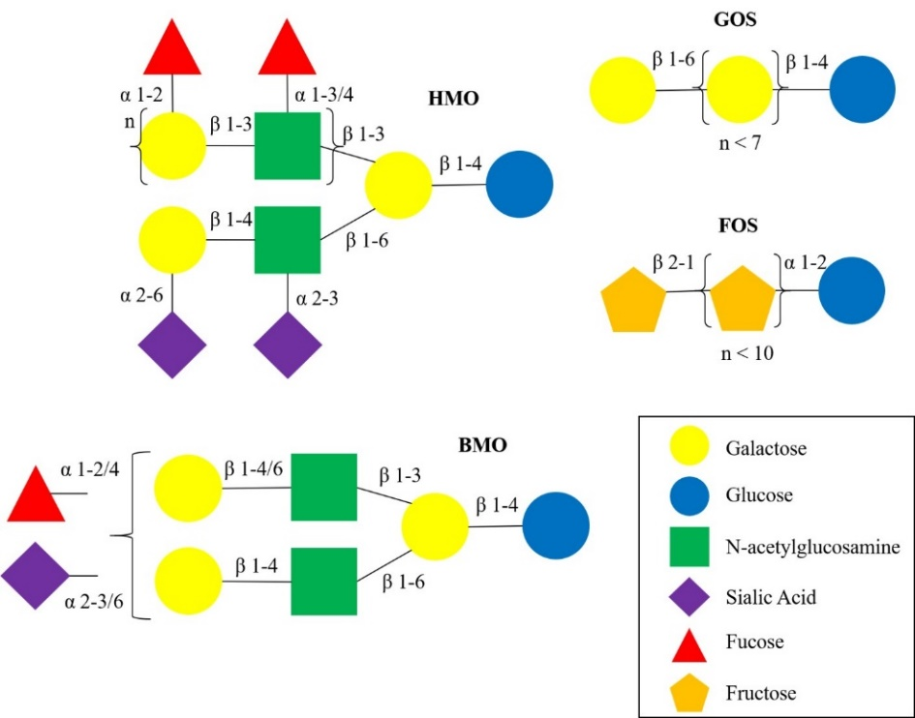
Figure 1. Structural schematics of HMO, BMO, GOS and FOS.The HMO structure is more complex and diverse compared to BMO and plat-derived oligosaccharides, GOS and FOS. HMO and BMO structures can be branched with various α- and β-linkages, GOS and FOS contain linear chains of repeating units of galactose (n < 7) and fructose (n < 10), respectively. Abbreviations: HMO, human milk oligosaccharide; BMO, bovine milk oligosaccharide; GOS, gallacto-oligosaccharide; FOS, fructo-oligosaccharide.

