Note: this is a draft of the journal article:

J Verberne, P.R.Worsley, D.L. Bader (2020) “A 3D registration methodology to evaluate the goodness of fit at the individual-respiratory mask interface.”

Computational Methods in Biomechanics and Biomedical Engineering, accepted
The final, fully proofed and peer-reviewed journal article is available from the publisher online,

A 3D registration methodology to evaluate the goodness of fit at the individual-respiratory mask interface
J.W.R Verbernea, P.R. Worsleyb and D.L. Badera,b
aDepartment of Biomedical Engineering, Eindhoven University of Technology, NL; bSchool of Health Sciences, University of Southampton, Southampton, UK

ARTICLE HISTORY
Compiled October 13, 2020

ABSTRACT
Respiratory masks are used to deliver non-invasive ventilation for cardiorespiratory pathologies. Masks must minimize skin tissue compression while maintaining a seal at the interface. Ill- fitting masks or those applied too tightly are implicated in pressure ulcer formation. This study aimed to analyse respiratory mask goodness of fit in a cohort of face shapes. A number of parameters were identified and analysed with a novel registration protocol. In the majority of cases, mask indentation exceeded the thickness of the interface material and significant gapping was observed. The size range was most appropriate for males, with only one size suitable for females.

KEYWORDS
Pressure ulcers; Medical Device-Related Pressure ulcers; 3D face scans; respiratory mask design; image registration

Introduction

In 2010, a study by Black et al. reported that over 30% of the Hospital-Acquired Pressure Ulcers were caused by the application of medical devices (Black et al. 2010). This was a find- ing that changed the historical view that pressure ulcers were predominantly associated with prolonged lying or sitting postures. Subsequently, other studies have described these Medical Device-Related Pressure Ulcers (MDRPUs) in a variety of clinical settings (Jackson et al. 2019; Blom-Ham et al. 2017; Alves et al. 2017; Jaul 2014; Tayyib et al. 2016). As an example, a detailed consensus on MDRPUs has recently been published (Gefen et al. 2020) and the re- cent International pressure ulcer guidelines have dedicated a major section to the topic, which now forms part of their official definition (European Pressure Ulcer Advisory Panel, National Pressure Injury Advisory Panel and Pan Pacific Pressure Injury Alliance 2019). Following these international drivers the importance of developing safer medical devices incorporating prophy- lactic strategies to reduce skin damage has become a key objective for clinicians, academics and industrialists (Gefen et al. 2020).
One of the major classes of medical devices implicated in skin damage is non-invasive venti- lation (NIV) masks (Gefen et al. 2020; Clay et al. 2018; Kayser et al. 2018). A respiratory mask is typically attached to an individual, often presenting with complex comorbidities and acute illness, using a strap to seal its contact with the face. It is important for efficient device function that there is no loss of seal to deliver positive airway pressure and pharmacological agents such as nebulizers. Creating an effective seal between the device and the face is challenging due to the variability in face shape and the limited number of mask geometries and sizes. Accordingly masks are regularly over-tightened resulting in high non-uniform pressures (Brill et al. 2017), particularly at bony locations of the face e.g. the bridge of the nose. These high pressures, which are often prolonged for many hours can result in skin damage in the form of pressure ulcers

(Visscher et al. 2015; Brill 2014; Maruccia et al. 2015; Sleilati et al. 2008). This highlights the importance of an effective fitting process prior to use, although this is limited by the design specification of the masks, with many devices unable to accommodate specific facial shapes and asymmetry. This is particularly the case for those of black and Asian ethnicities, as masks are traditionally designed according to the anthropometrics of an average white male face shape (Zhuang and Bradtmiller 2005).
The recent COVID-19 pandemic with the associated increase in MDRPUs presenting in hospitals has highlighted the importance of this area of research. Indeed, these events have not been limited to patients, as health professionals have been required to use respiratory protective equipment (RPE) for prolonged daily periods to manage vulnerable patients, resulting in MDRPUs. Indeed, Jiang et al. (2020) reported that 59.4% of Device-Related Pressure Injuries detected in medical staff were located on respiratory mask contact sites, i.e. the bridge of the nose and the cheeks. Such events can be particularly hazardous if they are associated with an increased risk of a foreign body invasion, e.g. SARS-Cov-2, entering the blood stream and endangering the professionals’ life (Gefen and Ousey 2020; Jiang et al. 2020).
CAD image registration and analysis has been used to design and evaluate bespoke medical device manufacture. The most common application to date has been for socket designs to treat individuals with amputations (Dickinson et al. 2016). This method provides the means to evaluate both the shape of the residual limb and design sockets to optimise the conditions at the interface for load transfer and to protect vulnerable skin sites (Steer et al. 2020). A similar approach has been used by Visscher et al. (2015) to evaluate the fit of NIV respiratory masks in a cohort of paediatric patients. Their results indicated a strong need for further investigations into mask flexibility, material properties as well as the interface pressures during mask wear.
This provides a motivation for the present study, which is designed to provide an analysis of goodness of fit of a commercial respiratory mask, in three sizes, on a cohort of individuals incorporating a range of ages and gender. A novel image registration process was required to establish parameters reflecting goodness of fit, in terms of both deformation of facial soft tissues as well as gapping at the mask-skin interface. This provided the means to identify factors that affect respiratory mask fitting and make recommendations for future design considerations.

Materials & Methods

Face Shape Database
A freely available dataset of face scans was utilized from a large database, involving UK resi- dents.(Dai et al. 2020) Of the 1519 scans, the following individual data sets were excluded from the subsequent analysis, namely:
- Individuals under the age of 18 at the time of the scans.
- Individuals with facial hair or spectacles, as both features could interfere with alignment.
- Poor quality scans which included missing data (significant gaps in the geometry).
- Individuals with a non-neutral facial expression.
- Individuals from a non-Caucasian background. (due to a limited number of non-Caucasian scans available)
The remaining 798 face scans were divided into 4 age groups, which included:
- ’young’ group, consisting of subjects between 18 and 40 years old.
- ’lower middle-aged’ group ranging from 40-55 years old.
- ’upper middle-aged’ group ranging from 55-70 years old.
- ’elderly’ group consisting of subjects older than 70 years.
In each age group there were 5 males and 5 females, who were randomly selected from the cohort of 798 scans. The 3D mesh files of the 40 scans were converted to binary .stl files using Meshlab (Cignoni et al. 2008). CAD geometries of a commercially available respiratory mask

with small, medium and large sizes were used in the study (FaceFit NiV, Intersurgical Ltd., Wokingham, UK). The 3D models were edited using FreeCAD (Riegel et al. 2002-2019) by removing all fixtures to leave the contact surfaces. The edited mask was subsequently meshed, ensuring that the distribution of vertices was uniform, with a maximum edge length of 2 mm for the small and medium mask, and 3 mm for the large mask. The meshes were subsequently converted to binary .stl files so that they could be imported into a python script where image registration was performed (Figure 1).

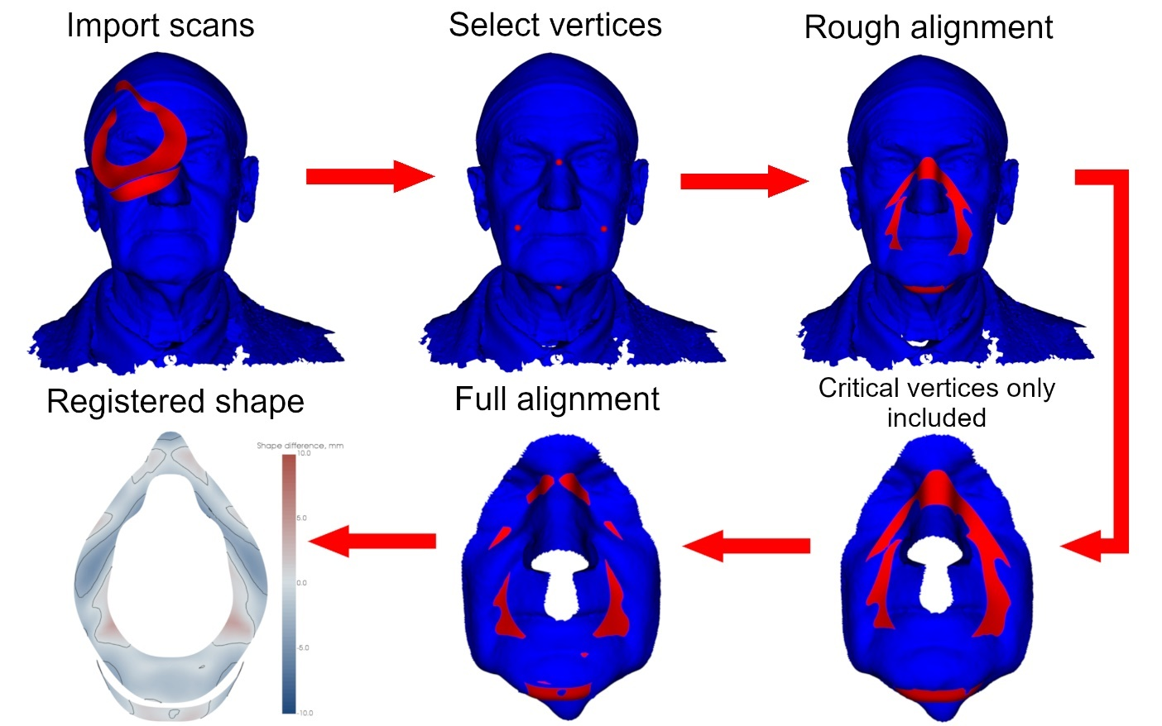
Figure 1. The processes involved in analysing each face/mask combination. This included a multi-step alignment and mesh cropping procedure.

Processing the face/mask combinations
A modified version of the python module Ampscan (Steer et al. 2020) was used to register and align the face and mask, providing the means to analyse the goodness of fit. As this module had originally been designed to evaluate the fit of a prosthetic socket to a lower limb, it was adapted to accommodate the process associated with aligning and analysing each face/mask combination, illustrated in Figure 1.

To review briefly, both the face and the mask models were loaded into Ampscan with the
.stl files. The following steps were then taken to align and register the mask onto the face; i) An initial rough alignment was performed using four points that were manually selected on the face (nasal bridge, cheeks and chin), corresponding to key reference points on the mask. ii) An Iterative Closest Point (ICP) algorithm was used to align the points to each other. Any of the face vertices that were at a distance of more than 20 mm from the mask were automatically removed to reduce the effective computational time. iii) An ICP algorithm was subsequently run to align the face to the entire mask interface. This algorithm was designed to minimize the mean absolute distance between all mask vertices and their nearest neighbour on the face. The mask was translated and rotated in each plane to achieve the closest fit. iv) A registration shape was generated depicting the distance between each mask vertex and its nearest neighbour on the face, using a colour contour plot. If the mask was displaced into the face, the distance value was multiplied by -1.

Goodness of fit Parameters
All parameters discussed below were derived from the distances between the mask vertices and their nearest neighbour on the face, henceforth referred to as d. The best fit was determined by four primary parameters, and two secondary parameters. The latter of which was used if the primary parameters did not provide a clear choice of the most appropriately sized mask.
The percentage of surface area on the mask where the distance value is negative and exceeds 3 mm, reflecting compression of the skin, was defined as HParea. In this case the cushioning material is compressed to a high degree potentially impinging vulnerable skin and soft tissue sites. This represents a primary parameter, with a low value corresponding to a better fit.

Nd<−3

HParea =
(1)
N

The percentage of surface area on the mask where the distance value is greater than 0 mm, is defined as Gaparea. In this area of the mask, there is a gap at the interface between the face and the mask, which can allow air to escape, potentially diminishing the delivery of the therapy e.g. positive air pressure. This is a primary parameter, and a low value is equivalent to a better fit.

Gaparea =
Nd>0 (2)
N

The sum of the distance values at areas where the distance is negative and exceeds 3 mm, divided by the total number of mask vertices, is defined as HPint. This primary parameter

represents the degree to which the mask is displaced into the face geometry, normalised by the total number of mask vertices. This normalization enables direct comparison of the differently sized masks, with a low value representing a better fit.

), di

HPint = di <−3
N
(3)

The minimum distance value is defined by HPmax. The negative value indicates the magnitude in which the mask has been displaced into the face geometry. This is a primary parameter, and a higher value is equivalent to a better fit.

HPmax = min(d) (4)

The percentage of surface area where the distance value is between -3 mm and 0 mm is defined by GFarea. The skin comes into contact with the mask in these areas, with a displacement into the face that can be accommodated by the cushioning material on the mask, ensuring a safe fitting. This represents a secondary parameter, with a higher percentage indicative of a better fit.

GFarea =
N−3<d<0 (5)
N

The standard deviation of the distance values is referred to as SD. A higher standard devia- tion indicates that the mask fit is less uniformly distributed across the face. This represents a secondary parameter, with a lower value equivalent to a better fit.
/),N

SD =
|
i=1 |di − d¯ 2
(6)

N

Identifying the locations of high mask displacement into the face
The spatial distribution of gapping and mask displacement into the face was visualized using a contour plot of the registration objects (bottom right in Figure 1). This, as well as the face/mask combination images (bottom left in Figure 1), were used to identify locations of high mask displacement, which were identified by a dark blue colour surrounded by a black line. These black lines are located at the thresholds of high displacement areas and gap areas, representing values below -3 mm and greater than 0 mm, respectively. These colour contours on the mask were subsequently cross-referenced with the face/mask combination images to identify the location on the face.

Defining an asymmetry index
In addition to the parameters associated with high mask displacement and uniformity, it was proposed that asymmetry could play a role in goodness of fit. This required the definition of an asymmetry index, using distance values that were extracted from the analysis. A minimum and a maximum distance point was found on the face. These points were subsequently compared to a similarly located minimum and maximum distance point on the other side of the face. The asymmetry index is defined as the mean of the ratio of the two minimums and maximums, where the lowest minimum and the highest maximum are the denominators.(Equation 7) The asymmetry index value ranged between 0 and 1, with a perfectly symmetrical face yielding a value of 1.

dmax,lowest
+ dmin,highest

asymmetryindex =
dmax,highest dmin,lowest
2
(7)

Results

The mask aligned to the face
A typical face shape (#895 from the young female group), aligned to the small mask, is shown in Figure 2a, from both an anterior and a posterior perspective. The mean absolute distance of this face/mask combination was 1.3 mm, with a standard deviation of 1.0 mm. The corresponding registration objects and associated histograms are illustrated for each of the three mask sizes in Figure 2b. For the small mask, it is evident that the distribution is fairly uniform with approx- imately equal positive and negative distances. There is a small area of high mask displacement into the face, indicated by dark blue, corresponding to the sides of the nostrils. The histogram shows that this HParea (distance less than -3 mm) only represented approximately 1.5% of the mask-face vertices. By contrast, there are three regions, corresponding to the bridge of the nose and beneath both cheeks, where the distance values are positive indicating a gap from the inside to the outside of the mask. On closer inspection, the HParea and HPmax parameters revealed that both the magnitude and percentage areas of high displacement were much higher when the face shape was matched to the medium and large mask sizes, compared to the small design.
Figure 2b also indicates the distance values on both sides of the face as a function of the radial coordinates of the mask vertices from nose to chin. The horizontal lines represent either a maximum or minimum point on the mask, and the vertical lines indicate the threshold distance between 0 mm and -3 mm where mask displacement is considered to result in a comfortable seal. This representation revealed distinct differences in the location of both gapping and dis- placement, between the three sizes of mask designs. Indeed, the medium and large variants were identified to be too large with, for example, the top of the large mask pressed against the forehead. The histograms also reveal that the distance values have a much wider distribution in the medium and large masks, with a higher proportion of mask vertices displaced into the face geometry below the -3 mm threshold.

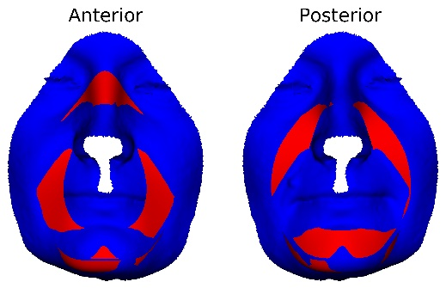A 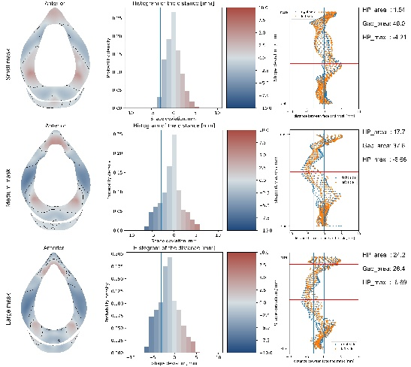B

Figure 2A. The face of subject #895 aligned to the small mask. On the left, from an anterior perspective and on the right a posterior perspective. (B) The registration objects are displayed on the left images, with the distance values represented by colours superimposed on the mask shapes. A negative displacement value corresponds to the mask vertex
compressing the contour of the face. In the middle images, a histogram of the distance values is displayed, with the vertical line representing the thresholds of the high displacement areas. The right image is a radial representation of the distance value of each vertex. The blue vertical lines represent the same distance thresholds as the contour lines in the left images. The horizontal red lines are at the locations of a maximum or minimum vertex.

The selection protocol
In order to demonstrate the effects of mask size on goodness of fit, the parameter values are presented for one sub-cohort in figure 3 (lower middle-aged female group). It is evident that for all primary and secondary parameters considered to represent the best fit, the best mask option was the small size. This is indicated in Table 1, which summarises values for the six parameters for each subject in the eight groups corresponding to the best fitting mask. Indeed, it is evident that for all 20 female face scans, the small mask is the preferred option. By contrast, the preferred option for the four groups of male face scans varies considerably between the small mask (5/20 cases), the medium mask (8/20 cases), or the large mask (7/20).

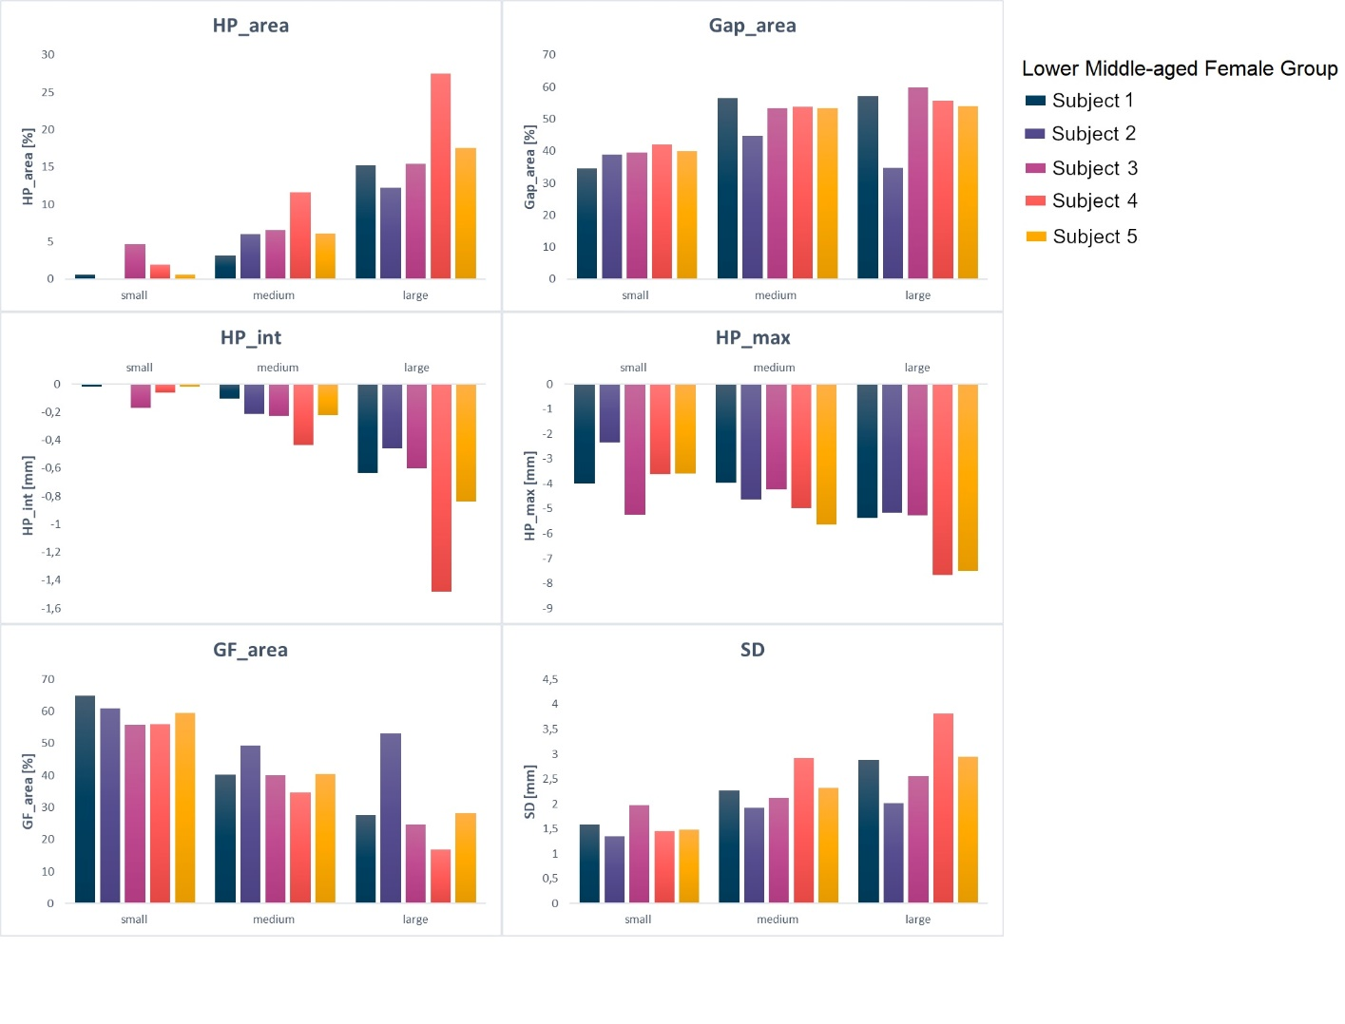
Figure 3. Histograms of the parametric values for all face/mask combinations for the five face shapes from the lower middle-aged female group. Each subject in this group is represented by a unique bar colour.

Table 1. A summary of the estimated values of the six parameters corresponding to the preferred size of the mask for each of the eight groups of face scans. The row highlighted in bold corresponds to the face scan (#895) illustrated in Figure 2.

optimal mask | HP max [mm] | Gap area [%] | HP area [%] | HP int [mm] | GF area [%] | SD [mm]
small | -3.72 | 45.6 | 1.67 | -0.06 | 52.8 | 1.12
small | -4.78 | 53.7 | 1.54 | -0.06 | 44.8 | 1.15
medium | -5.47 | 40.8 | 6.59 | -0.25 | 52.6 | 1.94 | Young Male
medium | -4.84 | 47.5 | 2.49 | -0.09 | 50.0 | 1.45
large | -4.56 | 50.6 | 4.97 | -0.17 | 44.4 | 1.74
small | -3.28 | 48.9 | 1.54 | -0.05 | 49.6 | 1.22 | Young Female
small | -4.10 | 47.2 | 8.47 | -0.29 | 44.3 | 2.29
small | -3.34 | 50.1 | 0.32 | -0.01 | 49.6 | 1.34
small | -4.21 | 48.0 | 1.54 | -0.05 | 50.5 | 1.66
small | -3.25 | 43.0 | 0.06 | 0.00 | 56.9 | 1.17
small | -4.41 | 46.4 | 5.07 | -0.18 | 48.5 | 1.54 | Lower Middle-Aged Male
large | -5.23 | 25.6 | 4.39 | -0.17 | 70.0 | 1.35
large | -4.14 | 50.9 | 3.46 | -0.12 | 45.7 | 1.37
large | -3.69 | 58.1 | 0.94 | -0.03 | 40.9 | 1.24
large | -3.32 | 48.9 | 0.50 | -0.02 | 50.6 | 1.27
small | -4.00 | 34.5 | 0.58 | -0.02 | 64.9 | 1.60
small | -2.33 | 39.0 | 0.00 | 0.00 | 61.0 | 1.35 | Lower Middle-Aged Female
small | -5.24 | 39.5 | 4.69 | -0.17 | 55.8 | 1.98
small | -3.62 | 42.1 | 1.93 | -0.06 | 56.0 | 1.45
small | -3.58 | 39.9 | 0.64 | -0.02 | 59.5 | 1.49
large | -5.36 | 36.0 | 9.29 | -0.37 | 54.8 | 1.66 | Upper Middle-Aged Male
medium | -6.18 | 26.0 | 8.95 | -0.35 | 65.0 | 1.59
small | -6.10 | 39.3 | 8.73 | -0.33 | 52.0 | 2.17
medium | -5.49 | 45.9 | 3.16 | -0.13 | 50.9 | 1.79
medium | -4.92 | 52.0 | 3.36 | -0.13 | 44.7 | 1.52
small | -4.47 | 43.4 | 3.79 | -0.13 | 52.8 | 1.69 | Upper Middle-Aged Female
small | -4.67 | 35.2 | 4.30 | -0.16 | 60.5 | 1.55
small | -4.22 | 45.1 | 3.21 | -0.11 | 51.7 | 2.15
small | -4.75 | 47.1 | 3.59 | -0.13 | 49.4 | 1.45
small | -7.02 | 55.3 | 9.18 | -0.42 | 35.5 | 2.22
medium | -5.39 | 34.9 | 4.85 | -0.18 | 60.3 | 2.03 | Elderly Male
large | -3.39 | 50.1 | 1.44 | -0.05 | 48.5 | 1.55
small | -4.65 | 39.9 | 11.23 | -0.39 | 48.9 | 2.07
medium | -6.82 | 29.4 | 12.85 | -0.54 | 57.7 | 1.77
medium | -5.39 | 42.5 | 8.95 | -0.36 | 48.6 | 2.22
small | -6.33 | 39.9 | 9.82 | -0.40 | 50.3 | 2.47 | Elderly Female
small | -3.81 | 48.4 | 2.37 | -0.08 | 49.2 | 1.59
small | -3.18 | 40.7 | 0.26 | -0.01 | 59.1 | 1.49
small | -3.55 | 48.5 | 1.41 | -0.05 | 50.1 | 1.50
small | -3.17 | 40.7 | 0.32 | -0.01 | 59.0 | 1.22

The locations of high displacement
Analysis of the registration objects revealed that there were four specific locations on the face where high mask displacement occurred, equivalent to distances which were lower than -3 mm. For each group, the number of face shapes which yielded high displacements in the four locations was estimated for both the best fitting mask option and the medium mask (Table 2). As an example, high displacements were particularly prevalent over the nose, where even with the best fitting mask, 75% of cases were predicted, compared with 93% with the medium mask. Other locations such as cheeks revealed a proportion of cases with high mask displacements of 20% and 60% for best fitting and medium masks, respectively. It is clear that for each of the four female groups the percentage of high displacement locations was generally increased when the simulation involved the medium masks.

Table 2. The number of face scans with high displacement areas in four locations of the face for each group when using the best fitting mask (top left value) and the medium mask (bottom right value). Total percentage values are indicated for each location in the bottom row. The row highlighted in bold corresponds to the group containing the face scan (#895) illustrated in Figure 2.
Best Fit  Medium Fit | Nose | Mouth Corner | Cheeks | Chin
Young Male (n/5) | 5  5 | 1  0 | 0  2 | 2  2
Young Female (n/5) | 2  4 | 2  2 | 1  5 | 0  0
Lower Middle-Aged Male (n/5) | 4  5 | 1  1 | 0  0 | 2  0
Lower Middle-Aged Female (n/5) | 3  5 | 0  0 | 1  5 | 0  4
Upper Middle-Aged Male (n/5) | 5  5 | 2  2 | 0  1 | 2  3
Upper Middle-Aged Female (n/5) | 4  4 | 1  1 | 3  5 | 1  3
Elderly Male (n/5) | 5  5 | 0  0 | 1  2 | 1  0
Elderly Female (n/5) | 3  4 | 0  0 | 2  4 | 0  1
Total (%) | 78  93 | 18  15 | 20  60 | 20  33

The asymmetry index
In the typical face scan associated with #895, the asymmetry index was estimated as 0.9, with an associated HParea value of 1.54. When the values for each of the face shapes are plotted, as illustrated in Figure 4, it is clear that there is no correlation between asymmetry index and the primary best fit parameter, HParea. There were no significant correlations apparent for all the other primary and secondary goodness of fit parameters (data not shown).

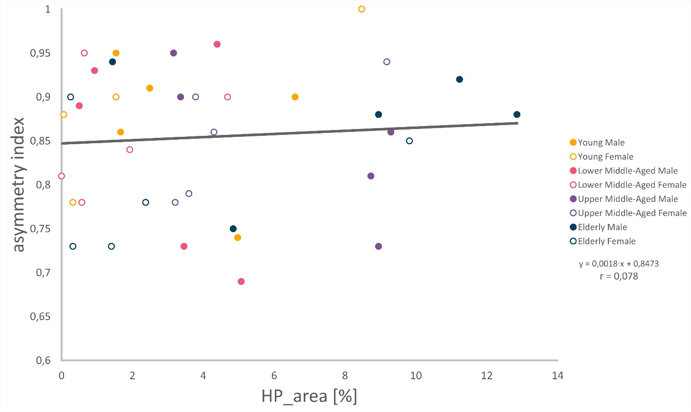

Figure 4. The asymmetry index of each face scan, plotted against the corresponding values of HParea. Different colours indicate individual face scans in each of these groups.

Discussion

The present study represents a distinctive analysis of goodness of fit of a commercial respiratory mask in three sizes using a cohort of 3D face shapes of different ages and genders from a national database. An adapted alignment and registration process was utilised to analyse 3D face scans and mask geometries (Figure 1). An optimal fitting mask was identified for each individual scan based on distinct goodness-of-fit parameters. These included mask gapping and displacements into the geometry of the face. The latter corresponds to areas where the mask is impinging on vulnerable skin and soft tissue sites. A threshold of -3 mm was used to indicate potential sites of excess displacement at the mask-skin interface, associated with the thickness of the silicone material used to provide a deformable contact surface of the mask. The parameters proved sensitive to identify critical trends in the mask fitting, including differences between genders. In addition, key regions of interest associated with high mask displacements corresponded with locations associated with skin damage from prolonged mask application. The novel mask fitting analysis indicates that better mask designs and thicker interface materials may be required to accommodate the range of face geometries that present across the varied clinical population requiring use of this critical medical device.
One of the primary parameters, HPmax reveals that all subjects in combination with their best fitting mask size, demonstrated a maximum displacement into the face geometry of over 3 mm, with some cases exceeding 7 mm (Table 1). This suggests the currently available mask sizes of the specific design could potentially cause skin damage, as the cushioning material is insufficient to accommodate the mismatch between geometries of the face and the mask. The predicted displacements could lead to skin impingement on the hard polymer outer material of the mask, creating high pressure gradients at the skin interface. This situation would indeed be exacerbated in the clinical situation where masks are often over-tightened using straps to minimize sites of gapping (Brill et al. 2017). Indeed in the cohort of scans the value for Gaparea ranged from 26% to 58% (Table 1). Large air leaks interfere with the effectiveness of the treat- ment, while small air leaks can irritate the patient, cause conjunctivitis or create unacceptable noise (Brill 2014; Brill et al. 2018).
Analysis of the registration objects showed that there were four main locations on the
face in which mask displacement exceeded 3 mm, namely, the nose, the cheeks, the corners of the mouth and the chin. Indeed, when the medium mask was used, over 90% of the subject scans demonstrated high displacements located on the nose, and 60% on one of the cheeks (Table 2). These locations of damage are associated with bony prominences and have been identified as sites of skin damage in clinical studies (Sleilati et al. 2008; Maruccia et al. 2015). Experimental studies have identified the bridge of the nose as a site most exposed to the highest interface pressures (Worsley et al. 2016; Brill et al. 2018). with its underlying cartilaginous and bony structures, creating a relatively rigid interface with the mask. By contrast, Visscher et al. (2015) found pressure ulcers occurring on the cheeks and chin of children wearing full face masks. The differences in damage locations are likely to result from the different geometries of young faces and mask designs, the latter of which are often based on scaled-down adult shapes. In addition, Visscher and colleagues hypothesised that some of the displacements could have resulted from face asymmetries. However, our present study revealed that none of the goodness of fit parameters were associated with a face asymmetry index (Figure 4). It is of note, that the present study included face shapes with no known significant asymmetries and thus further research is required to evaluate the effects of facial deformity or asymmetry on mask fitting.
The range of mask sizes from a single supplier were found to accommodate male face shapes better than females. In the latter case, only the small size was shown to be optimum, limiting the opportunity to create an optimum fit. This is an indication that the anthropometric standards by which these masks were manufactured might be insufficient in describing the female face shapes across the population. This issue has been previously addressed in studies analysing the goodness of fit for respiratory protective equipment (Zhuang and Bradtmiller 2005; Zhuang et al. 2010). Indeed the current use of limited anthropometric standards e.g. EN149 (single large male head), appears to disadvantage a large proportion of the patients requiring well-fitting masks, namely females and those of black or Asian ethnicity.
The present study is limited by its analysis of only one type of mask which does not nec- essarily represent other oral-nasal mask designs. Nonetheless the findings revealing problems in both gapping and excess displacements provide a strong indication for more widespread geom- etry issues in respiratory mask designs. In addition, this study was restricted to computational analysis and would have benefited from validation with experimental data, in a similar manner to that reported by the authors (Worsley et al. 2016). These involved measurements of pres- sures, micro-climate and skin physiology at the mask interface, which could be used to support the predictions of potential damage from the present model. Indeed, the 3D rigid shape analysis conducted in the present study does not represent the dynamic deformable mask-skin interac- tion, which can be simulated to some extent using advanced finite element models (Peko Cohen et al. 2019; Worsley et al. 2018. ). When masks are applied to the face, there can be movement during intra-mask pressure cycles, where positive and negative air pressures are applied for non-invasive ventilation support. This model did not account for this dynamic scenario and further research is required to assess the eﬀects of airﬂow, with evidence suggesting inspiration pressures may contribute to mask leakage (Rabec et al. 2009)

A further limitation was the use of Caucasian face shapes dictated, in part, by the available data. This clearly does not represent the ethnic diversity appropriate to patients requiring non- invasive ventilation masks in either hospital or community settings. To examine whether the developed computational strategy was generalizable, the registration and analysis process was applied to a face scan of one young Chinese female, as illustrated in Figure 5. As indicated previously with the female cohort, a small mask was observed to provide the best fit, according to the primary fitting parameters. I t is also evident that high displacement areas are present corresponding to the sides of the nose and the cheeks, similar to those previously found (Table 2). However, in contrast to the analysis described in Table 2, a full-length gap is evident at the bridge of the nose, corresponding to a nasal bridge that is lower in height when compared with a Caucasian geometry characteristic of Asian face shapes (Park et al. 2015). This is indicative that more research is required to establish specific mask fitting issues for individuals of black and Asian ethnicity.

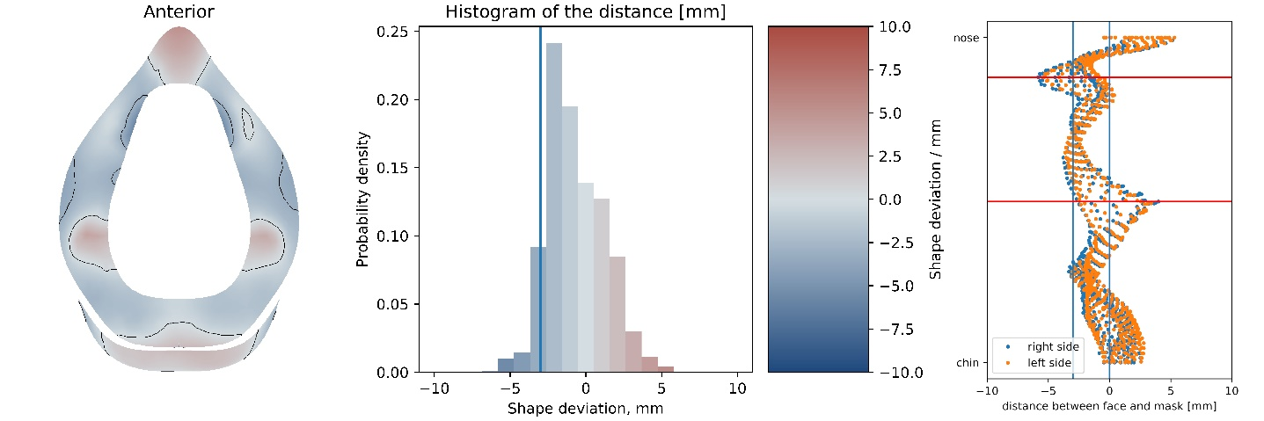
Figure 5. The registration object, the accompanying histogram and the radial graph of the small mask fit to a young female face shape of Chinese ethnicity.

The present study has identified a number of relevant parameters that can be derived from a
computationally efficient process of mask-face alignment. Subsequently, a choice can be made regarding the best option for an individual patient. I n this study, six parameters were identified, although a simplified metric might provide the best translation to support healthcare workers decision-making in a clinical setting. It is therefore proposed that HParea and Gaparea represent the most appropriate parameters, providing relevant information on excess displacement into the face and gapping. In addition, HPmax could be used as a potential indicator of the risk to skin damage in specific regions of interest. Indeed, it was found that by using these three parameters alone, the same mask sizes would be selected for all face shapes in the cohort (Table 1). The goodness of fit tool could also be used to support the optimisation of future mask design. For example, it could be used to identify the thickness of material required to accommodate mask application whilst minimizing the risk of skin damage. Indeed, if the interface material exceeded 3mm, a smaller proportion of the mask would be associated with the HParea parameter. The analysis could also be used to support novel mask designs, with matched personalised geometries. Additive manufacturing has already been proposed to address the issues associated with respiratory protective equipment through bespoke designs (Liu et al. 2020).

Future research is required to develop more bioengineering tools which can inform respi-ratory
mask design. These could include physical models, where prescribed mask loading and microclimate conditions can be interrogated to assess the boundary conditions between the mask and the face. I nformed by these boundary conditions, computational models could be used to accurately represent the 3D geometry of the face and the material properties of skin, soft tissues and mask designs to perform sensitivity analysis of device features which aim to protect skin health whilst maintaining functionality (Peko Cohen et al. 2019). These computational models could also incorporate statistical models of population face shapes e.g. NIOSH Anthropometric Data, informing mask geometries and size options which fit a wider proportion of the population (Steer et al. 2019).

Conclusion
An analysis has been described to estimate the goodness of fit of three different mask sizes using a representative sample of face shapes derived from both genders and different ages. I t was found that the geometry of these masks did not conform to face shapes, and that the internal cushioning of these masks is not sufficient to account for the mismatch between mask and face geometries. The locations of high displacement areas on the face were similar to those locations where device- related pressure ulcers regularly occur, namely, the bridge of the nose, cheeks and the chin, indicating a problem in geometry and cushioning thickness. The small mask was estimated to be the best-fitting option for all females in the cohort, which suggests that more size options specifically in the small range, or gender-specific options could be beneficial.

Acknowledgement(s)

We are grateful to Dr. Joshua Steer from Radii Devices for his suggestions regarding the changes made to Ampscan and to Professor Cees Oomens, who facilitated a long-standing productive collaboration between our two universities before his retirement.

Disclosure statement

There were no conflicts of interest in this study.

Funding

The work was supported by the EPSRC-NIHR “Medical Device and Vulnerable Skin” Network and NetworkPLUS (Refs. EP/M000303/1 and EP/N02723X/1), as well as the Fonds Internatial Experience of Eindhoven University of Technology.

References

Alves P, Eberhardt T, Soares R, Pinto M, Pinto C, Vales L, Morais J, Oliveira I. 2017. Differential diagno- sis in pressure ulcers and medical devices. Cˇ esk´a a Slovenska´ neurologie a neurochirurgie. 2017:S29–S35. Available from: http://hdl.handle.net/10400.14/26029.
Black JM, Cuddigan JE, Walko MA, Didier LA, Lander MJ, Kelpe MR. 2010. Medical device related pressure ulcers in hospitalized patients. International wound journal. 7(5):358–65. Available from: https://onlinelibrary.wiley.com/doi/abs/10.1111/j.1742-481X.2010.00699.x.
Blom-Ham W, Schoonhoven L, Schuurmans M, Leenen L. 2017. Pressure ulcers in trauma patients with suspected spine injury: A prospective cohort study with emphasis on device-related pressure ulcers. International Wound Journal. 14(1):104–111. Available from: https://onlinelibrary.wiley.com/doi/abs/10.1111/iwj.12568.
Brill AK. 2014. How to avoid interface problems in acute noninvasive ventilation. Breathe. 10(3):230–242.
Available from: https://breathe.ersjournals.com/content/10/3/230.
Brill AK, Moghal M, Morrell MJ, Simonds AK. 2017. Randomized crossover trial of a pressure sensing visual feedback system to improve mask fitting in noninvasive ventilation. Respirology. 22(7):1343– 1349. Available from: https://onlinelibrary.wiley.com/doi/abs/10.1111/resp.13074.
Brill AK, Pickersgill R, Moghal M, Morrell MJ, Simonds AK. 2018. Mask pressure effects on the nasal bridge during short-term noninvasive ventilation. ERJ Open Research. 4(2). Available from: https://openres.ersjournals.com/content/4/2/00168-2017.
Cignoni P, Callieri M, Corsini M, Dellepiane M, Ganovelli F, Ranzuglia G. 2008. MeshLab: an Open- Source Mesh Processing Tool. In: Scarano V, Chiara RD, Erra U, editors. Eurographics Italian Chapter Conference. The Eurographics Association.
Clay P, Cruz C, Ayotte K, Jones J, Fowler SB. 2018. Device related pressure ulcers pre and post identifica- tion and intervention. Journal of Pediatric Nursing. 41:77 – 79. Special Issue: Care of the Hospitalized Child; Available from: http://www.sciencedirect.com/science/article/pii/S0882596317305468.
Dai H, Pears N, Smith W, Duncan C. 2020. Statistical Modeling of Craniofacial Shape and Texture. Inter- national Journal of Computer Vision. 128(2):547–571. Available from: https://doi.org/10.1007/s11263- 019-01260-7.
Dickinson A, Steer J, Woods C, Worsley P. 2016. Registering methodology for imaging and analysis of residual-limb shape after transtibial amputation. The Journal of Rehabilitation Research and Devel- opment. 53(2):207–218. Available from: http://dx.doi.org/10.1682/JRRD.2014.10.0272.
European Pressure Ulcer Advisory Panel, National Pressure Injury Advisory Panel and Pan Pacific Pressure Injury Alliance. 2019. Prevention and treatment of pressure ulcers/injuries: Clinical practice guideline. Emily Haesler (Ed.). EPUAP/NPIAP/PPPIA.
Gefen A, Alves P, Ciprandi G, Coyer F, Milne CT, Ousey K, Ohura N, Waters N, Worsley P. 2020. Device-related pressure ulcers: Secure prevention. Journal of Wound Care. 29(Sup2a):S1–S52. Https://doi.org/10.12968/jowc.2020.29.Sup2a.S1; Available from: https://doi.org/10.12968/jowc.2020.29.Sup2a.S1.
Gefen A, Ousey K. 2020. Update to device-related pressure ulcers: Secure prevention. covid- 19, face masks and skin damage. Journal of Wound Care. 29(5):245–259. Available from: https://doi.org/10.12968/jowc.2020.29.5.245.
Jackson D, Sarki AM, Betteridge R, Brooke J. 2019. Medical device-related pressure ulcers: A systematic review and meta-analysis. International Journal of Nursing Studies. 92:109 – 120. Available from: http://www.sciencedirect.com/science/article/pii/S0020748919300379.
Jaul E. 2014. Cohort study of atypical pressure ulcers development. International Wound Journal.
11(6):696–700. Available from: https://onlinelibrary.wiley.com/doi/abs/10.1111/iwj.12033.
Jiang Q, Song S, Zhou J, Liu Y, Chen A, Bai Y, Wang J, Jiang Z, Zhang Y, Liu H, et al. 2020. The prevalence, characteristics, and prevention status of skin injury caused by personal protective equipment among medical staff in fighting covid-19: A multicenter, cross-sectional study. Advances in

Wound Care. 9(7):357–364. Available from: https://doi.org/10.1089/wound.2020.1212.
Kayser S, VanGilder C, Ayello E, Lachenbruch C. 2018. Prevalence and analysis of medical device-related pressure injuries: Results from the international pressure ulcer prevalence survey. Advances in skin & wound care. 31:276–285. Available from: https://doi.org/10.1097/01.asw.0000532475.11971.aa.
Liu DCY, Koo TH, Wong JKK, Wong YH, Fung KSC, Chan Y, Lim HS. 2020. Adapting re-usable elastomeric respirators to utilise anaesthesia circuit filters using a 3d-printed adaptor - a potential alternative to address n95 shortages during the covid-19 pandemic. Anaesthesia. 75(8):1022–1027. Available from: https://onlinelibrary.wiley.com/doi/abs/10.1111/anae.15108.
Maruccia M, Ruggieri M, Onesti M. 2015. Facial skin breakdown in patients with non-invasive ventila- tion devices: Report of two cases and indications for treatment and prevention. International Wound Journal. 12(4):451–455. Available from: https://onlinelibrary.wiley.com/doi/abs/10.1111/iwj.12135.
Park J, Sukh J, Nguyen AH. 2015. Nasal analysis and anatomy: Anthropometric proportional assessment in asians—aesthetic balance from forehead to chin, part ii. Seminars in Plastic Surgery. 29(4):226–231. Available from: https://europepmc.org/articles/PMC4656157.
Peko Cohen L, Ovadia-Blechman Z, Hoffer O, Gefen A. 2019. Dressings cut to shape alleviate facial tissue loads while using an oxygen mask. International Wound Journal. 16(3):813–826. Available from: https://onlinelibrary.wiley.com/doi/abs/10.1111/iwj.13101.
Rabec C, Georges M, Kabeya NK, Baudouin N, Massin F, Reybet-Degat O, Camus P. 2009. Evaluating noninvasive ventilation using a monitoring system coupled to a ventila- tor: a bench-to-bedside study. European Respiratory Journal. 34(4):902–913. Available from: https://erj.ersjournals.com/content/34/4/902.
Riegel J, Mayer W, van Havre Y. 2002-2019. Available from: http://www.freecadweb.org.
Sleilati FH, Stephan HA, Nasr MW, Riachy MA. 2008. An unusual pressure sore of the nasal bridge. British Journal of Oral and Maxillofacial Surgery. 46(5):411 – 412. Available from: http://www.sciencedirect.com/science/article/pii/S0266435607004512.
Steer J, Worsley P, Browne M, Dickinson A. 2019. Predictive prosthetic socket design. part 1: population- based evaluation of transtibial prosthetic sockets by fea-driven surrogate modelling. Biomechanics and Modeling in Mechanobiology. 19:1331–1346. Available from: https://doi.org/10.1007/s10237-019- 01195-5.
Steer JW, Stocks O, Parsons J, Worsley PR, Dickinson AS. 2020. ampscan: A lightweight python package for shape analysis of prosthetics and orthotics. Journal of Open Source Software. 5(48):2060. Available from: https://doi.org/10.21105/joss.02060.
Tayyib N, Coyer F, Lewis P. 2016. Saudi arabian adult intensive care unit pressure ulcer incidence and risk factors: a prospective cohort study. International Wound Journal. 13(5):912–919. Available from: https://onlinelibrary.wiley.com/doi/abs/10.1111/iwj.12406.
Visscher MO, White CC, Jones JM, Cahill T, Jones DC, Pan BS. 2015. Face masks for noninvasive venti- lation: Fit, excess skin hydration, and pressure ulcers. Respiratory Care. 60(11):1536–1547. Available from: http://rc.rcjournal.com/content/60/11/1536.
Worsley P, Prudden G, Gower G, Bader D. 2016. Investigating the effects of strap tension during non- invasive ventilation mask application: A combined biomechanical and biomarker approach. Medical Devices: Evidence and Research. 9:409–417. Available from: https://doi.org/10.2147/MDER.S121712. Worsley P, Rooijakkers T, Oomens C, Bader D. 2018. Finite element analysis of respiratory mask application: Implications for tissue health. 8th World Congress of Biomechanics; Available from:
https://app.oxfordabstracts.com/events/123/program-app/submission/20177.
Zhuang Z, Bradtmiller B. 2005. Head-and-face anthropometric survey of u.s. respirator users. Journal of Occupational and Environmental Hygiene. 2(11):567–76. Available from: https://doi.org/10.1080/15459620500324727.
Zhuang Z, Slice D, Benson S, Lynch S, Viscusi D. 2010. Shape analysis of 3d head scan data for u.s. res- pirator users. EURASIP J Adv Sig Proc. 2010. Available from: https://doi.org/10.1155/2010/248954.

