Fig 1: Scatterplot matrix showing the relationship between preliminary predictors and COVID-19 cases, and corresponding correlation value to identify insignificant predictors for the model

Fig. 2. The ROC curve for BRT model. The AUC value 0.9462 indicates that the forecasting ability for the model were very good and shows a high level of accuracy.
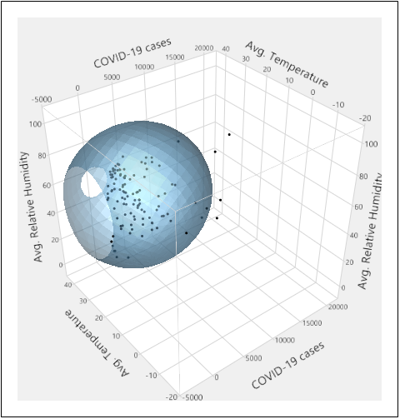
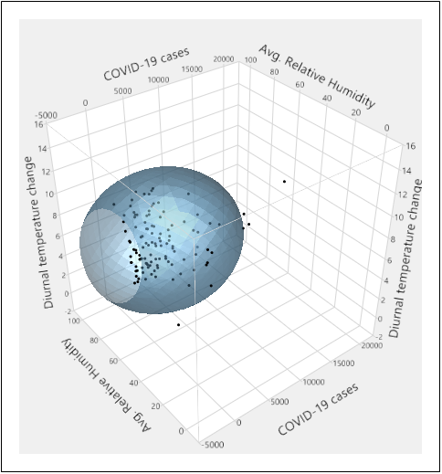
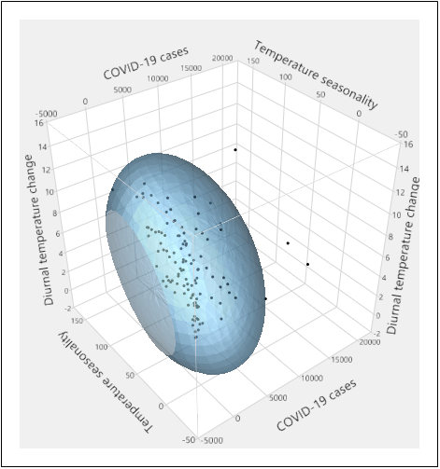
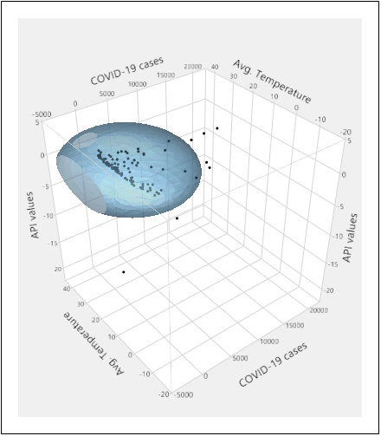
(c)
(d)
(b)
(a)
Fig 3: Relationship between selected climatic variables, number of international travelers and number of COVID-19 cases in the tropical region. Fig (a) CoVID-19, relative humidity, and temperature; (b) COVID-19, diurnal range of temperature, and relative humidity; (c) COVID-19, temperature seasonality, and diurnal temperature change; (d) COVID-19, average temperature and API values

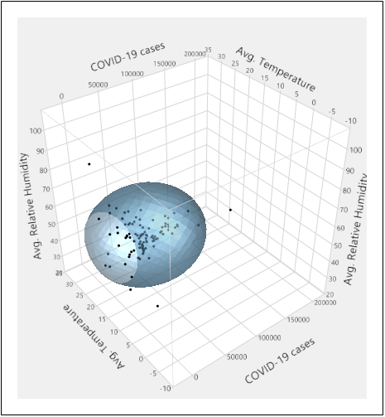
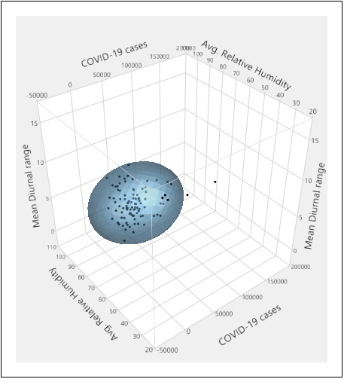
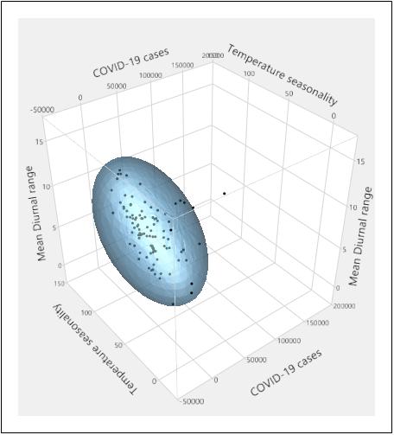
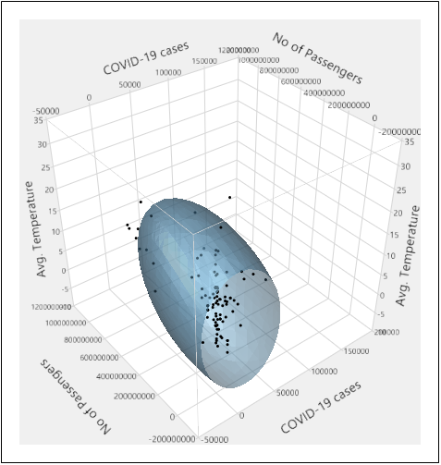
(b)
(a)

(d)
(c)

Fig 4: Relationship between selected climatic variables, number of international travelers and number of COVID-19 cases in the temperate region and same relationship have been observed for sub-tropical region. Fig (a) CoVID-19, relative humidity, and temperature; (b) COVID-19, diurnal range of temperature, and relative humidity; (c) COVID-19, temperature seasonality, and diurnal temperature change; (d) COVID-19, average temperature and API values

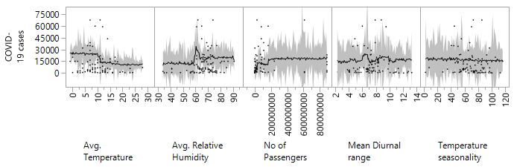

(a)

(b)

(c)

Fig. 5: Marginal dependence graphs for the five most influential predictors in the model for Coronavirus disease in tropical (a), sub-tropical (b), and temperate (c) region. For explanation of predictors and their units see table no 3. Y axes are showing COVID-19 cases and X axes represents important predictors. The predictor number of international travelers informations was omitted as a this is a primary source of infection, but it has no role in the community transmission. The values of API values considered only for tropical region, where most of the countries of this region are malaria prone. Shaded line shows the 95% confidence interval from the mean.

(a)

(b)

(c)

(d)

(e)

(f)

(g)

(h)

Fig. 6: Marginal dependence graphs for the four most influential predictors in the model for COVID-19disease in USA (a), Spain (b), Italy (c), France (d), Germany (e), UK (f), Turkey (g), Russia (h). For explanation of predictors and their units see table no 3. Y axes are showing COVID-19 cases and X axes represents important predictors. The predictor no of international travellers informations were omitted as a this is a primary source of infection but it has no role to community transmission. The value of API was also omitted for less malaria cases in the temperate region. Shaded line shows the 95% confidence interval from the mean.

(a)

(b)

Fig. 7: Marginal dependence graphs for the five most influential predictors in the model for Coronavirus disease in India (a), Brazil (b). For explanation of predictors and their units see table no 3. Y axes are showing COVID-19 cases and X axes represent important predictors. The predictor number of international travellers was omitted, as a this is a primary source of infection but has no role in community transmission. The value of API was considered as these countries are malaria prone. Shaded line shows the 95% confidence interval from the mean.

