Correlated at the Tail: Implications of Asymmetric Tail-dependence across Bitcoin Markets

Stelios Bekiros
European University Institute, Florence, Italy
E-mail: stelios.bekiros@eui.eu

Axel Hedström
Department of Management and Engineering,
Linköping University, Linköping, Sweden
E-mail: axel.hedstrom@liu.se

Evgeniia Jayasekera
National College of Ireland
E-mail: evakursk@gmail.com

Tapas Mishra
Southampton Business School
University of Southampton, UK
E-mail: t.k.mishra@soton.ac.uk

Gazi Salah Uddin
Department of Management and Engineering,
Linköping University, Linköping, Sweden
E-mail: gazi.salah.uddin@liu.se

Abstract
This paper is the first to fully characterize the relationship among cross-market Bitcoin prices to provide a complete picture of directional predictability of Bitcoin traded in various currencies across five developed markets. To exploit full-distributional dynamics, we employ Cross-quantilogram based Correlation and Dependence model to delve deep into the estimates an asymmetric tail dependence across quantiles would reflect on heterogeneous movement pattern of Bitcoin prices. A cross-quantilogram-based analysis reveals new empirical evidence of a heterogeneous tail dependence pattern: whereas Bitcoin-USD and the Northeast Asian market (viz., Japan) depicts a strong co-movement, smaller markets display weak connectedness and strong market-efficiency.

JEL classification:
Key words: Cross-quantilogram; Cross-market Bitcoin prices; Time-varying stability

- Introduction
Predicting Cryptocurrency price movements is one of the most challenging tasks an investor would embark on – thanks to the lack of a strong asset pricing theory, dominance of a largely unregulated market structure, and instrumental role of an implicit value of investors’ sentiments. Recent research in this regard demonstrates that a large part of variance in a cryptocurrency market, such as Bitcoin, is due to the sensitivity of investors to macroeconomic performances of a country (e.g., Corbet et al. 2019; Cheah et al. 2018, and Gillaizeau et al. 2019).
A common practice is to treat observed pattern of price movement as an ‘information set’, which an investor uses to ‘predict’ as his next strategy of investment. But, this information set conceals unaccounted for noisy signals arising out of, for instance, dynamic movements in macroeconomic fundamentals (representing economic parameter-driven sentimental values) from other markets. Eventually, a component of this ‘information set’ specific to a market, becomes a common component across other markets, because noises generally display transmissive and transformative effects (Gillaizeau et al. 2019). The problem most often neglected is that whilst it is the entire dynamic path of a cryptocurrency price and associated factors that determine the information set, but inference is based only on the centre of the distribution. There are essentially two ways to understand cross-market dynamic correlation: first, a systemic approach (such as estimation within a vector autoregression with/without long-memory), where interdependence across markets is assumed, but not modelled (Cheah et al. 2018). Yet, using this approach, one would be able to shed light on the ‘average’ dynamic effect, while being silent on what is happening on the other part of the distribution of this relationship. The second approach, which we propose in this paper, is a full-distributional approach where focus is laid on each part of the distribution of the variable; in our case, it is a study of a quantile-based dynamic correlation structure at various parts of the distribution of a cryptocurrency price.
Previous studies on the Bitcoin market is mainly focused on the application of several different types of methods and its implication on the price discovery, volatility modelling, directionality via causality, and through the application of daily or high frequency trading data. First, price discovery is important concept in the financial modelling on Bitcoin market (Brandvold et al 2015) and the long memory application via daily and trading data mechanisms (Phillip et al. 2018). Second, the study focused on the application of different GARCH-types modelling or Spillover approach in Bitcoin markets (Gillaizeau et al 2019; Corbet et al 2018; Symitsi and Chalvatzis 2018; Katsiampa, 2017; Guesmi et al 2019). Third, several studies focused on the cointegration and directionality and dependence approach in Bitcoin Market by utilizing Causality (Cheah and Fry 2015). Fourth, recent studies focused on the interdependence on the Bitcoin and several measures of uncertainties ( Mamun et al 2020) and Hedge or Safe Haven properties with respect to major asset classes (Kang et al 2019) and multifractal properties with respect to high frequency data (Stavroyiannis et al 2019).

To understand, assume that there are two markets for a cryptocurrency, viz., Bitcoin, traded for instance, in market A and market B with distinct exchange rates. Assume also that an investor – due to his pursuit of profit – will invest in a market that holds greater promise of return than the other. Each market is governed by macroeconomic and socio-political dynamics. Hence, the value of Bitcoin in that market is primarily a function of macroeconomic conditions, among others. Denote Bitcoin price in market A at time t as P_{t}^{A} = f(M_{t}^{A}, P_{t-1}^{A} ; error^{A}_{t}). Similarly, for market B, it is given by P_{t}^{B} = f(M_{t}^{B}, P_{t-1}^{A} ; error^{B}_{t}). Both P_{t-1} M_{t} make the information set (I_{t}). Since, like many asset prices, Bitcoin price reflects heavy tail, the distribution in the tail, depicts heterogeneous behaviour. For instance, the tail distribution of P_{t}^{A} at time t =i and that of P_{t}^{B} at t=j where i is not equal to j, may depict heterogeneous correlation structure. By modelling such a heterogeneity one would be able to gather complete information about the directional prediction pattern of one market over the other at different parts of the distribution of the tail. A further implication is that since ‘fat tailed’ distributions depict implicit ‘herd behaviour’ (generated by asymmetric and incomplete information plus bounded rationality of agents), the same asset traded in two different markets can depict different herd dynamics. It is only when one is able to fully characterise the correlation of this ‘herd’ dynamics, it is possible to create an exhaustive information set (I_{t}) that will be used to predict the dynamic path of one over the others. A quantile-based estimation of directional predictability (in contrast to the conventional mean-based estimation of spillover effects, such as Corbet et al. 2018) is useful in this regard. This paper fills a gap in the literature and is the first one to propose a complete characterisation of tail dependence across cryptocurrency market. Thus, our purpose is two-fold: (i) to lend credible value of directional predictability of a cryptocurrency, (ii) to design optimal investment strategy by evaluative distributional patterns of correlations at the tail. A theoretical expectation is that a dynamic correlation between the currency in market A and B, for instance, will be heterogeneous over the entire range of the distribution. By modelling such a heterogeneity one would be able to gather complete information about the directional prediction pattern of one market over the other at different parts of the distribution of the tail. We model directional predictability across markets over the entire distribution of prices and appears to be the first one to propose a complete characterisation of tail dependence across cryptocurrency market.
Cryptocurrency market, due to their extensive share in the financial market, has imminent economic implications. Any sizeable financial market has to correspond to certain monetary regulations and asset pricing theory. Since cryptocurrency does not have a real asset pricing theory, the economic implications of its volatility is huge. Investors might wish to substitute an asset market regulated stock with this highly volatile cryptocurrency market and this way can put the economic system to a systematic risk. The cross-quantilogram analysis of cryptocurrency envisions a predictive power not only for the asset market but also for the real economy as well.

The current paper aims to this nascent literature by studying directional predictability and their dynamic stable pattern across Bitcoin markets, exchanged in various currencies. To investigate further, in Section 2 we briefly present the cross-quantilogram approach. Section 3 presents data and discusses estimation results (along with robustness exercise). Section 4 concludes with the main findings and their implications for practitioners and policy.
2. Estimation
The Cross-quantilograms approach has several comparative advantages. First, in this given situation, the Cross-quantilograms approach is better able to capture the asymmetric tail-dependence over various quantiles of the return distribution. Second, this approach provide a spillover and dependence structure at the quantile level. Third, the lag-lead behavior of co-movement can be captured at quantile level. We incorporate the sensitivity of lag impact on the dependence dynamics. The motivation of sensitivity of lag explain the market efficiency. We extend Han et al. (2016) to estimate the cross-quantilogram (CQC) between two time series (two Bitcoin markets, for instance) over a rolling window so that sensitivity of correlation and dynamic dependence in the tail of a distribution can be gauged (Uddin et al. 2019). The Cross-Quantilogram correlation between y_{t} and x_{t}, proposed by Han et al. (2016) starts with a quantile distribution
(1)

One then forms quantile-hit processes for the two series, one at time t, and one at time t-k so that and . denotes the ‘receiver’ of the CQC while x_{t} is the ‘giver’. The CQC has the following direction where CQC is calculated by
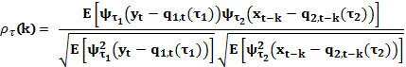 (2)
Because a major assumption concerns the time series need to be strictly stationary, we need to demean the quantile-hit process: . By iterating the CQC model for each lag, we can then create independent estimation of each lag. Bootstrap approach is then used to calculate confidence intervals (Politis et al. 1994). Finally, for the rolling estimations we utilise a two-year window covering 252 trading days per year (i.e., 504 observations). In total, we have roughly 1400-1600 subsamples depending on the market as they start at different times.

3. Data and results
Bitcoins are traded in a number of currencies in a number of exchanges across different countries. Following Gillaizeau et al. (2019), we choose five Bitcoin/currency pairs (the U.S. dollar (USD), Australian dollar (AUD), Canadian dollar (CAD), euro (EUR), and British pound (GBP)). Chosen sample period is March 12th, 2013 to January 31st 2018, due firstly to the availability of consistent data (from www.bitcoincharts.com), and second, to lend comparison to the work of Cheah et al. (2018) and Gillaizeau et al. (2019).
We have obtained Bitcoin prices from Bitcoinity.org . To check the accuracy of prices we have compared our sample spans with Quandle and bitcoicharts (Cheah et al 2018; Gillaizeau et al 2019). Note that to choose the ideal Bitcoin prices against each currency, we took into consideration the trading volume across all the platforms of each currency (e.g. USD, CAD, GBP, AUD and EUR) in Bitcoin markets. We found that the trading volume of USD in Bitfinexplatform has exceeded 185 Billion over the last five years, which makes the market share of the latter platform at around 40.98%, overtaking almost half the market in trading Bitcoin in USD. Kraken platform has executed transactions of BTC/EUR by around 32 Billion over the last five years, and the market share of trading Bitcoin/Eur via this platform was around 34%. GBP, CAD and AUD were traded intensively on Bit-x, Quadrigacx and Btcmarkets platforms respectively.

Figure 1 presents time series plots of the logarithm of cross-market Bitcoin prices. Figure 1 indicate that the Bitcoin market continuously exhibit extreme tail dependence characteristics with periods of dramatically high and low returns. In terms of long-run trend, the asymmetric nature of the Bitcoin market is more pronounced due to strong negative response to a positive response of equal magnitude. Under the extreme market condition, the Bitcoin market exhibit more left tail dependence. This implies that the Bitcoin market demonstrate asymmetric behavior in the tails of the distribution.
Most markets display excess skewness depicting concentration of dynamics at the tail is presented in Table 1. The series are stationary upon first difference as confirmed by unit root tests
Insert Table 1
Insert Figure 1

3.1 Rolling sample results of cross-quantilogram
Figure 2 presents rolling window estimates of cross-quantilogram correlation: BTC/USD to other BTC denominations, using a lag length of one to capture the short persistence of the crypto exchange market. A spike in Bitcoin prices during late 2017, might lead one to expect an increasing cross-quantilogram correlation in that time-period: the upper-to-upper quantile setting [0.95-0.95]. Thus the rising correlation is intrinsic to Bitcoin market and not an outcome of increasing information spillover between the markets (similar to Gillaizeau et al. 2019).
As expected, we detect heterogenous responses from the BTC/USD market to other Bitcoin markets: whereas BTC/AUD, BTC/CAD, and BTC/KRW have small but weak significant results in the left tails, other markets showed stronger CQC with higher consistency in the statistical significance perhaps due to exchange rate fluctuations during the period. For BTC/JPY, we observe significant and high CQC in all columns (around 40% for the lower tail in 2014, declined to around 30% in 2019). In the lower tails, other currencies (GBP, CNY, EUR) show significant correlation (around 20%) from 2015 and onwards indicating that different market shows varying degree of connectedness to the BTC/USD market owing to the distortions in the currency fluctuations and the fact that information transmission between bitcoins and hard currency markets are limited by institutional thresholds, see Brandvold et al. (2015).
In middle column we provide median-to-median responses: shows significant response for BTC/JPY and BTC/KRW throughout the period, whereas, the BTC/CNY and BTC/GBP depict fading cross-quantilogram correlation over time. The magnitudes indicate a stronger co-movement pattern between the US and Southeast Asian bitcoin markets, perhaps resulting from the lagged closing times of the markets. Finally, the right column displays the upper-to-upper tail cross-quantilogram correlation. For the larger markets the overall magnitude is low around 10%. However, the BTC/GBP show a rapid increase during 2016 which is probably related to the depreciation of the GBP after the Brexit election. Both BTC/GBP and BTC/EUR otherwise show a stable but declining CQC, thus the current trend indicates that movement in the upper tails could turn insignificant in the future. It might indicate declining significance of BTC/USD as a diversification tool. A similar trend is seen in the BTC/CNY market though related to a sharp decline in 2017-2018, perhaps related their ban on ICO and stricter policy of cryptocurrencies. The BTC/JPY market show strong upper tail CQC with high magnitude of around 0.25-0.3. Hence, the BTC/JPY is the most affected by changes in the BTC/USD market and unlike Urquhart and Zhang (2018) we find that it is not a hedge for bitcoin prices after controlling volatility.
Insert Figure 2
Insert Figure 3

3.2 Surface plot results (Figure 3)
In the lower tail (left column) there is an overall higher cross-quantilogram correlation in the earlier time periods than towards the end especially for, JPY, EUR, GBP and CNY. This shows that US bitcoin market had a larger impact in the earlier days towards other major markets. This could be due to institutional factors such as the BTC exchange in NYC making price discovery faster in BTC/USD.
In the right tail dependence there is a higher commonality in the pattern, especially for BTC/GBP and BTC/EUR markets with rather strong CQC in the first, weekly and biweekly lag. However, that pattern disappears by 2015 perhaps related to the closure of Bitcoin Center NYC that boosted price information in BTC/USD market, leading to unrealised arbitrage opportunities, see Makarov and Schoar (2018). The low arbitrage opportunities could also somewhat explain the overall low CQC. The lower quantile spillovers are also heterogeneous across markets and should therefore point to low systemic risk between USD and other markets. Hence, diversification across markets is potentially beneficial.

4. Conclusions and implications
Our rolling sample estimation of cross-quantilogram analysis suggests a stronger co-movement between the BTC/USD market and the Southeast Asian market, with especially the Japanese bitcoin market showing stronger connectedness to the BTC/USD market. Full characterisation using quantile dependence has relevance both to investors and policy makers. Greater correlation at higher quantiles between two Bitcoin markets reflect high synchronization between markets and a full cross-movement of volatility. A system-wide failure may result if investors disregard information content of correlation in other parts of the distribution.
References

Al Mamun, M., Uddin, G. S., Suleman, M. T., & Kang, S. H. (2020). Geopolitical risk, uncertainty and Bitcoin investment. Physica A: Statistical Mechanics and its Applications, 540, 123107.
Brandvold, M., Monár, P., Vagstad, K., & Valstad, O.C.A. (2015). Price Discovery on Bitcoin exchanges. Journal of International Financial Markets, Institutions & Money, 36, 18-35.
Cheah, E. T., & Fry, J. (2015). Speculative bubbles in Bitcoin markets? An empirical investigation into the fundamental value of Bitcoin. Economics Letters, 130, 32-36.
Corbet, S., Meegan, A., Larkin, C., Lucey, B., & Yarovaya, L. (2018). Exploring the dynamic relationships between cryptocurrencies and other financial assets. Economics Letters, 165, 28-34.
Gillaizeau, M., Jayasekera, R., Maaitah, A., Mishra, T., Parhi, M., & Volokitina, E. (2019). Giver and the receiver: Understanding spillover effects and predictive power in cross-market Bitcoin prices. International Review of Financial Analysis.(forthcoming)
Guesmi, K., Saadi, S., Abid, I., & Ftiti, Z. (2019). Portfolio diversification with virtual currency: Evidence from bitcoin. International Review of Financial Analysis, 63, 431-437.
Han, H., Linton, O., Oka, T., & Whang, Y. J. (2016). The cross-quantilogram: measuring quantile dependence and testing directional predictability between time series. Journal of Econometrics, 193(1), 251-270.
Kang, S. H., Yoon, S. M., Bekiros, S., & Uddin, G. S. (2019). Bitcoin as Hedge or Safe Haven: Evidence from Stock, Currency, Bond and Derivatives Markets. Computational Economics, 1-17.
Katsiampa, P. (2017). Volatility estimation for Bitcoin: A comparison of GARCH models. Economics Letters, 158, 3-6.
Makarov, I., & Schoar, A. (2018). Trading and arbitrage in cryptocurrency markets. Available at SSRN: https://papers.ssrn.com/sol3/papers.cfm?abstract_id=3171204.
Phillip, A., Chan, J. S., & Peiris, S. (2018). A new look at Cryptocurrencies. Economics Letters, 163, 6-9.
Politis, D. N., and Romano, J. P. (1994). The stationary bootstrap. Journal of the American Statistical Association, 89(428), 1303-1313.
Stavroyiannis, S., Babalos, V., Bekiros, S., Lahmiri, S., & Uddin, G. S. (2019). The high frequency multifractal properties of Bitcoin. Physica A: Statistical Mechanics and its Applications, 520, 62-71.
Symitsi, E., & Chalvatzis, K. J. (2018). Return, volatility and shock spillovers of Bitcoin with energy and technology companies. Economics Letters, 170, 127-130.
Uddin, G., Rahman, M., Hedström, A., & Ahmed, A. (2019). Cross-quantiologram-based correlation and dependence between renewable energy stock and other asset classes. Energy Economics, 80, 743-759.
Urquhart, A. & Zhang, H. (2018) Is Bitcoin a Hedge or Safe-Haven for Currencies? An Intraday Analysis. Available at SSRN: https://ssrn.com/abstract=3114108

Table 1: Descriptive statistics for Bitcoin returns
Variables | Observations | Mean (%) | SD | Skewness | Kurtosis | J-B | ADF | PP
BTC/USD | 3089 | 0.4% | 6.8% | 2.94 | 94.14 | 1075089.90*** | -20.01(6)*** | -54.69***
BTC/GBP | 2673 | 0.2% | 7.0% | 3.55 | 112.36 | 1339652.87*** | -21.30(4)*** | -56.55***
BTC/EUR | 2683 | 0.2% | 5.5% | 0.28 | 39.70 | 150816.96*** | -24.31(3)*** | -48.90***
BTC/JPY | 2683 | 0.2% | 8.4% | 4.87 | 144.08 | 2238956.14*** | -22.66(4)*** | -57.05***
BTC/CAD | 2120 | 0.2% | 20.6% | -0.65 | 660.76 | 38289935.60*** | -31.32(4)*** | -112.34***
BTC/AUD | 2121 | 0.2% | 8.6% | 0.18 | 20.17 | 26136.60*** | -45.66(1)*** | -71.90***
BTC/KRW | 1971 | 0.2% | 5.3% | 1.05 | 34.49 | 81997.75*** | -27.66(2)*** | -45.61***
BTC/CNY | 2677 | 0.2% | 6.4% | -1.00 | 33.00 | 101028.44*** | -58.54(0)*** | -59.10***
Notes: *** represents the 1% level of significance.

Figure 1: Log prices of the bitcoin markets

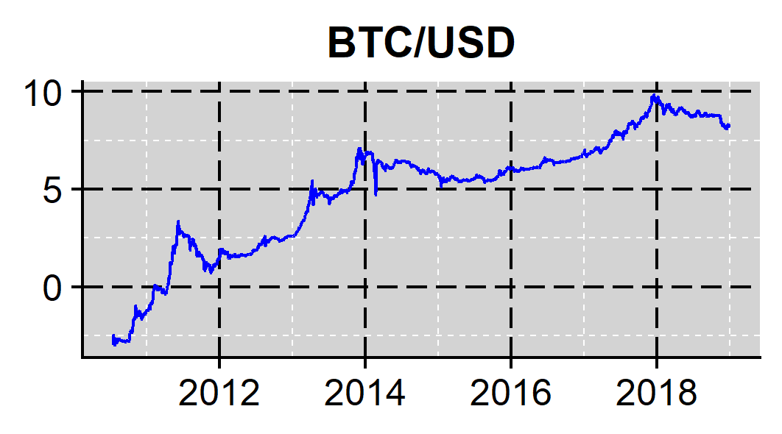 | 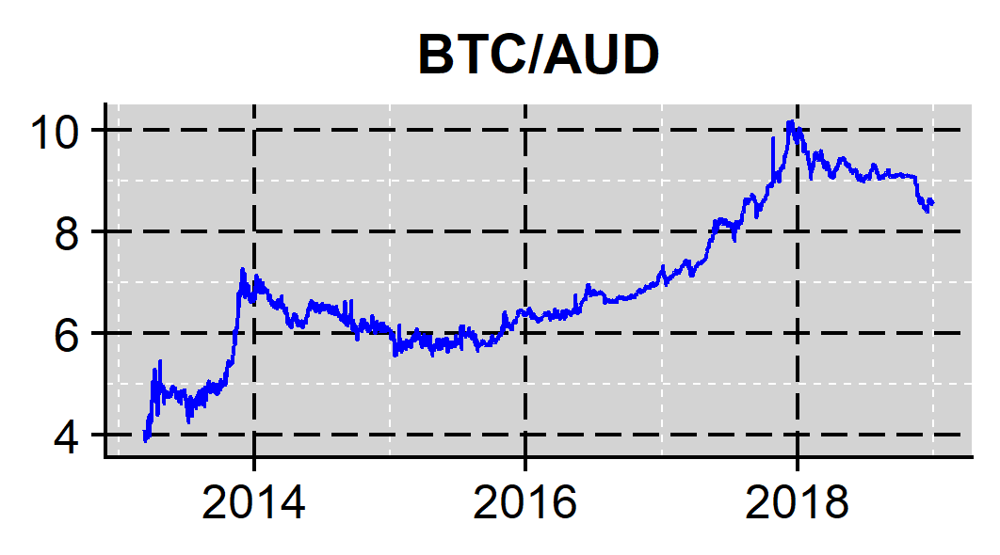
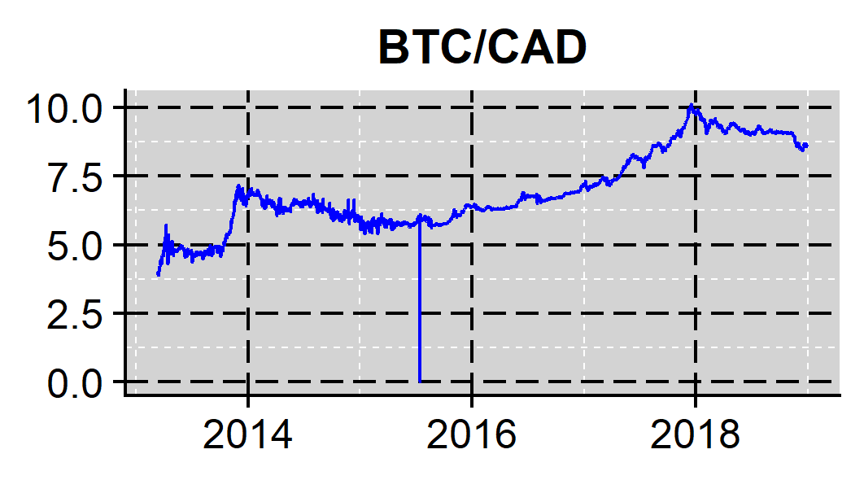 | 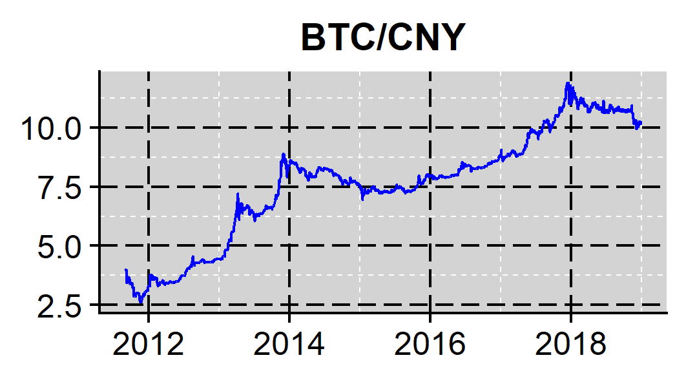
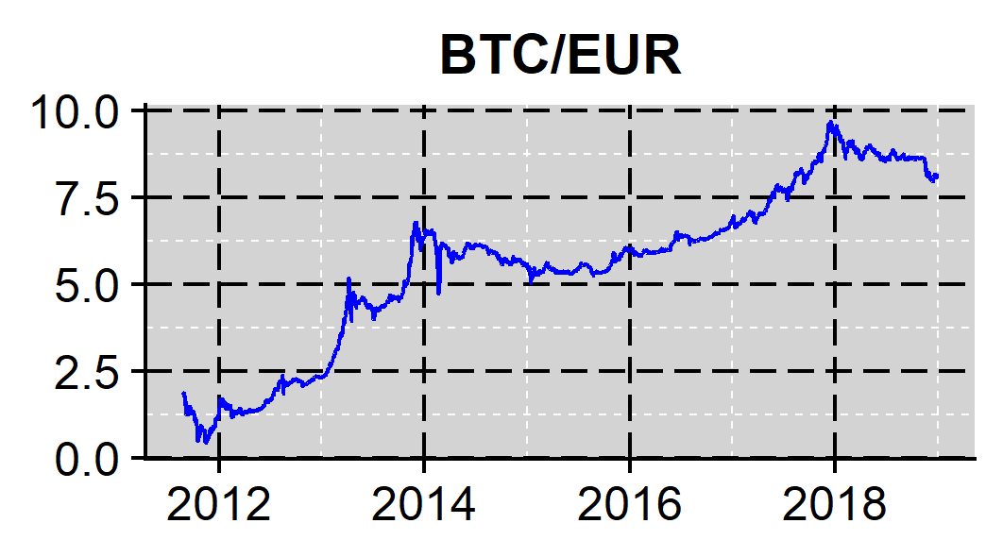 | 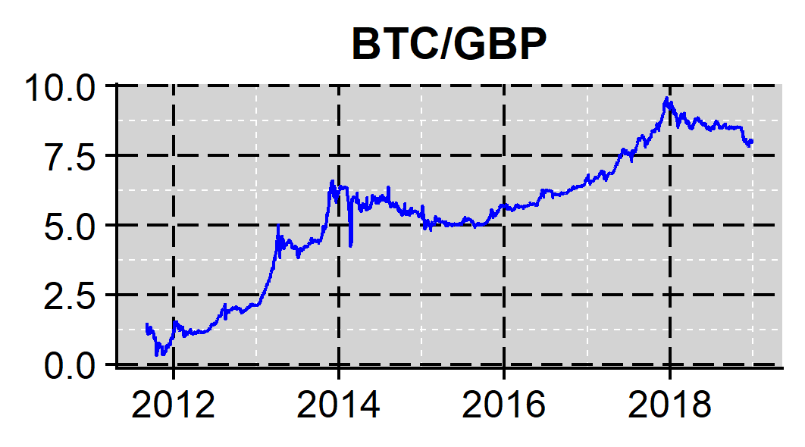
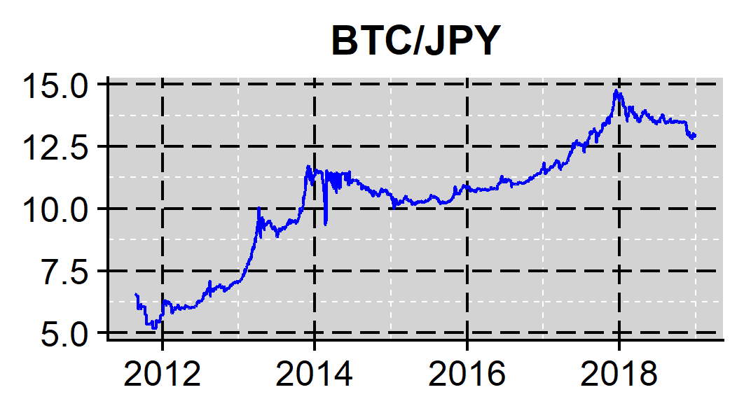 | 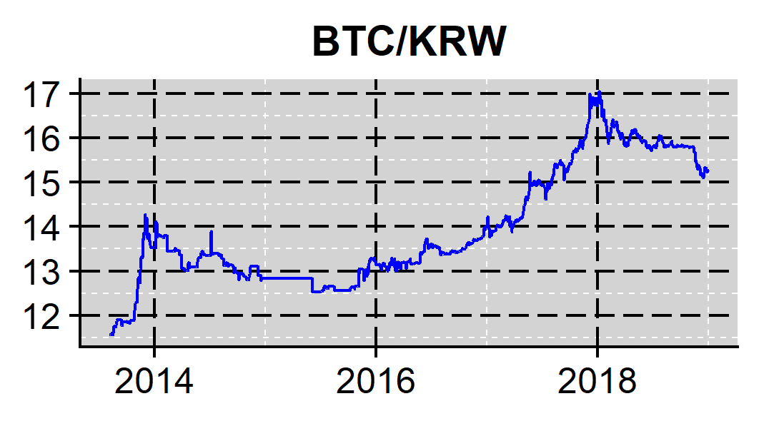

Figure 2: Bitcoin/USD cross-quantilogram correlation in a rolling sample

BTC/USD | [0.05-0.05] | [0.50-0.50] | [0.95-0.95]
BTC/AUD | 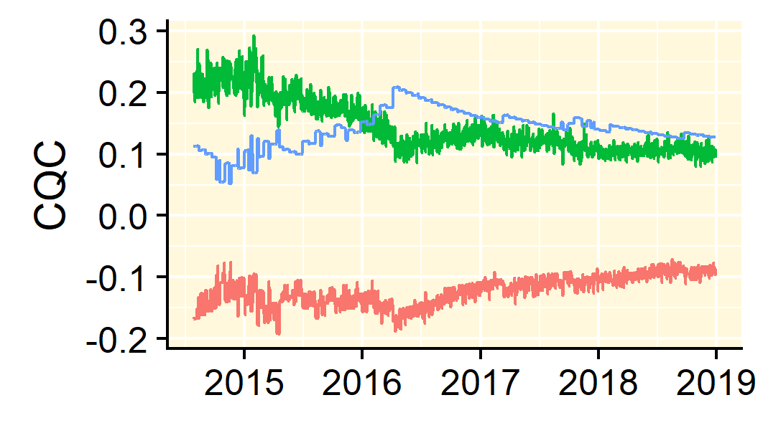 | 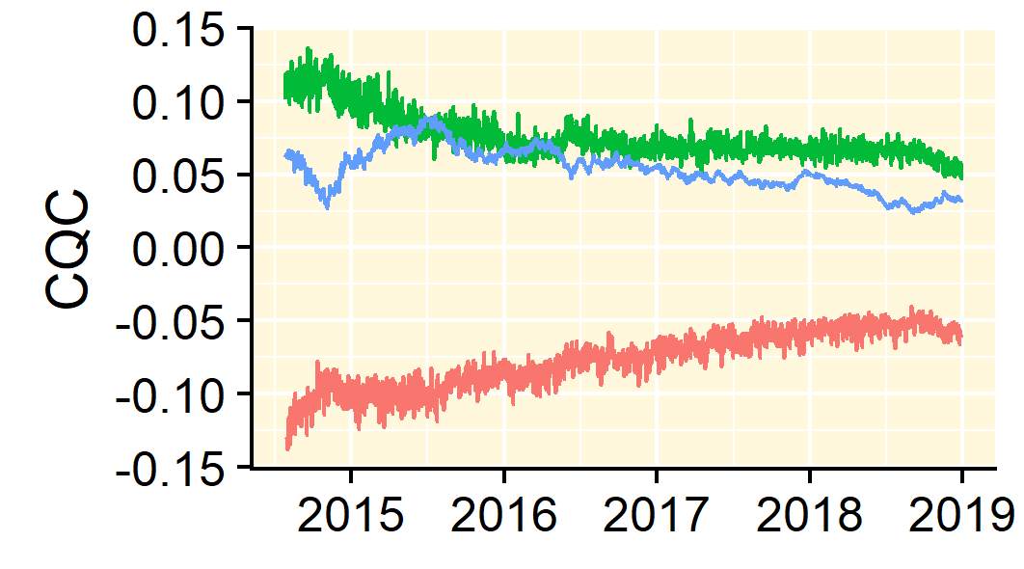 | 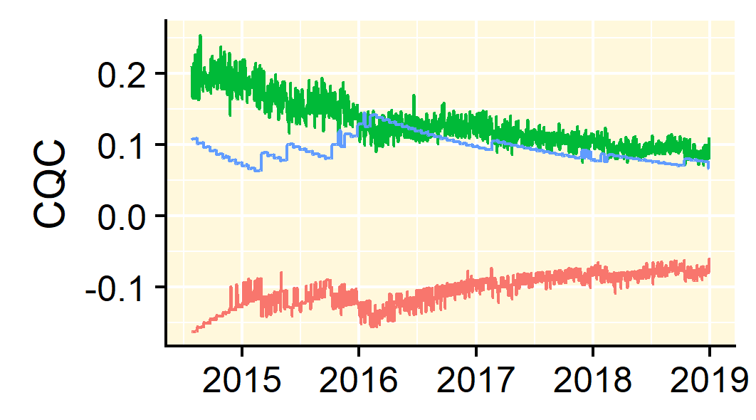
BTC/CAD | 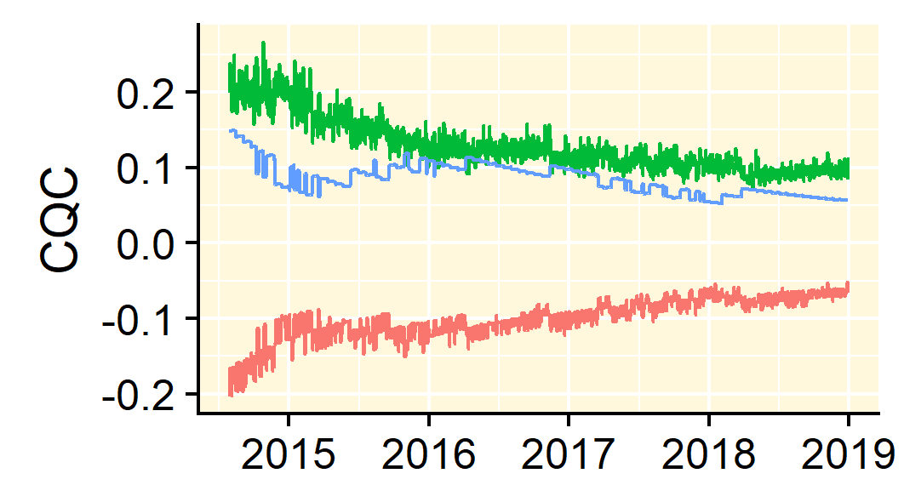 | 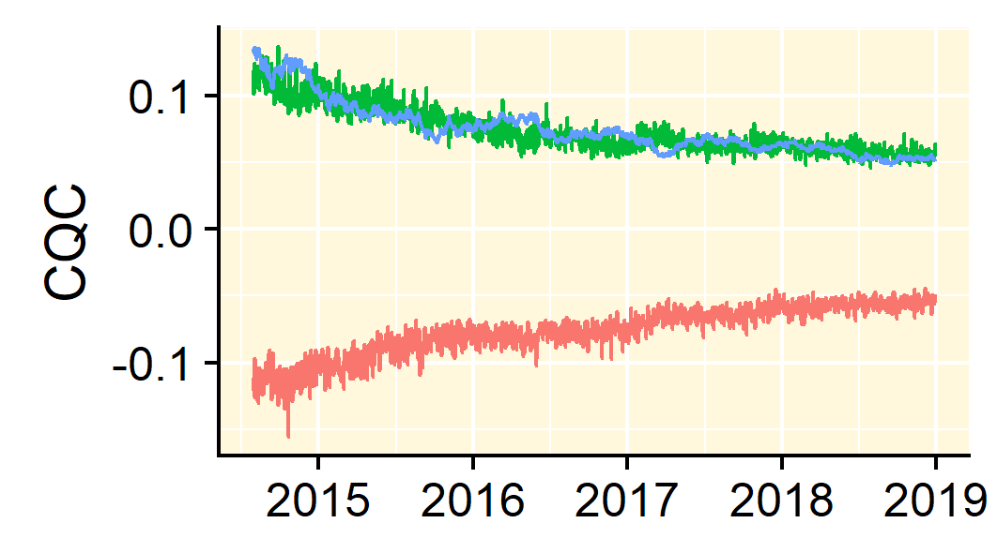 | 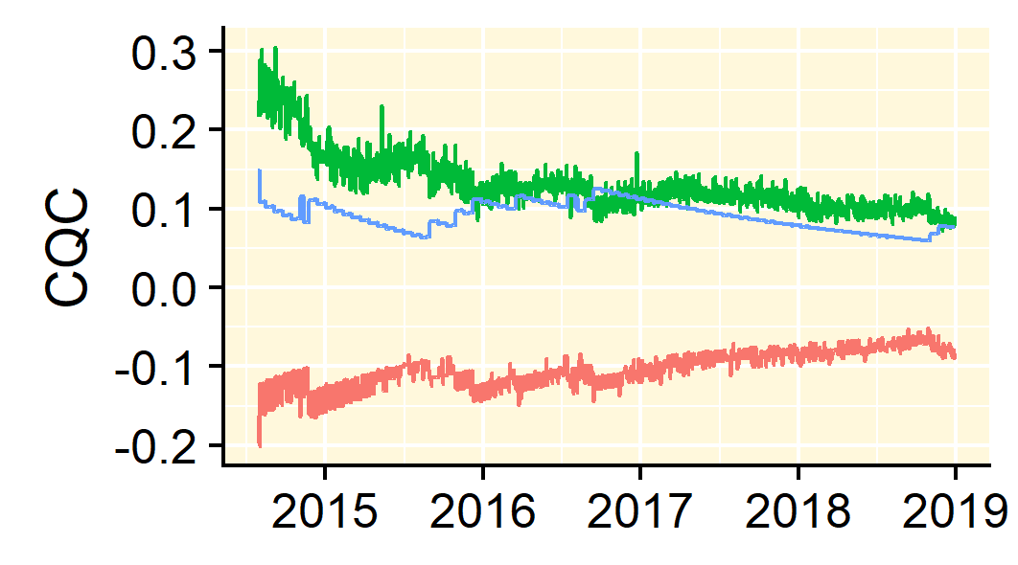
BTC/CNY | 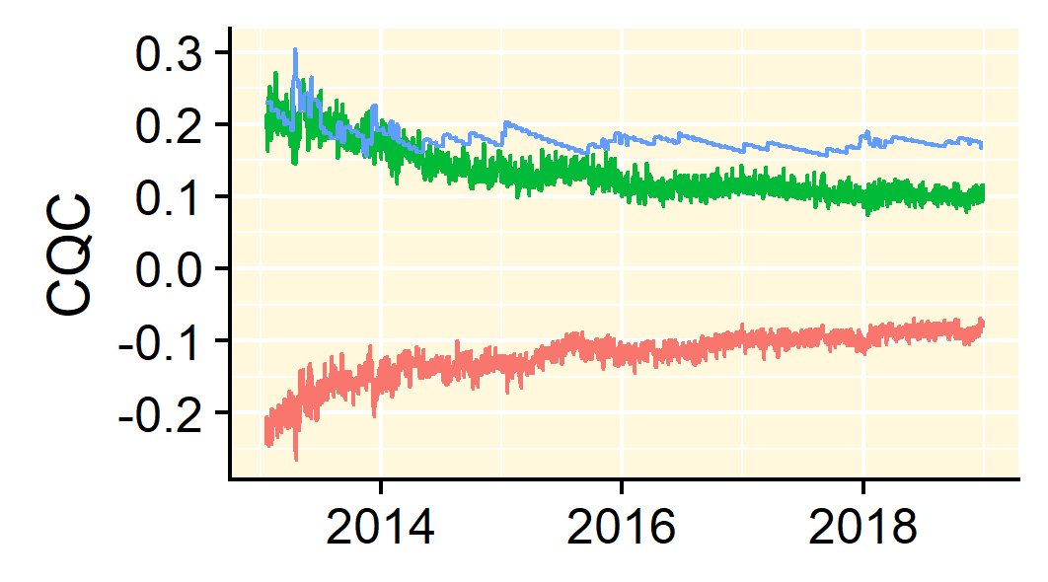 | 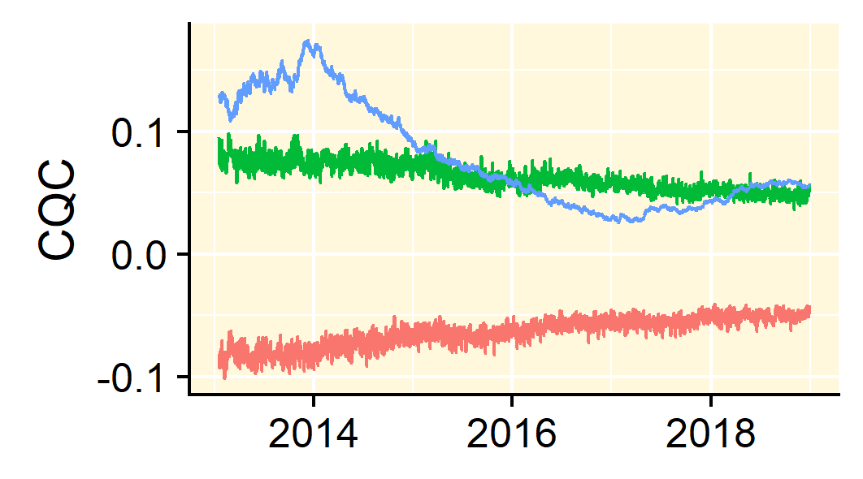 | 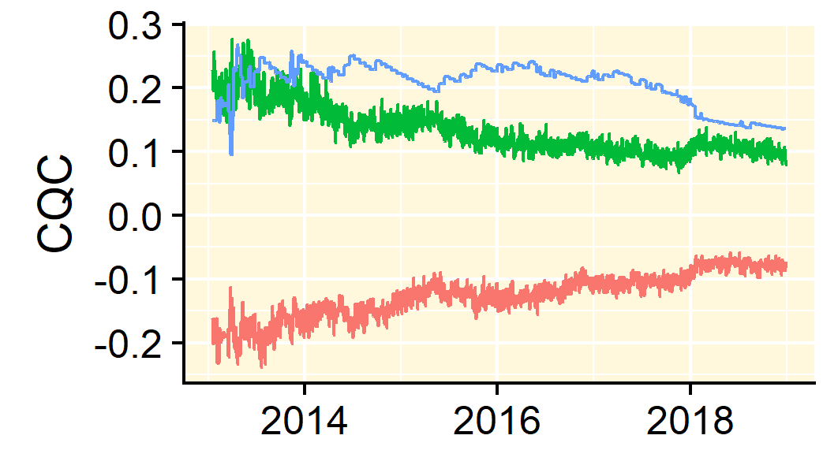
BTC/EUR | 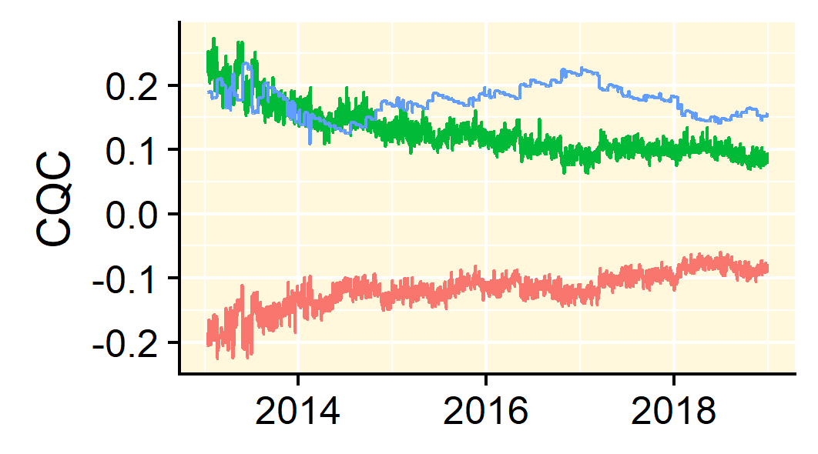 | 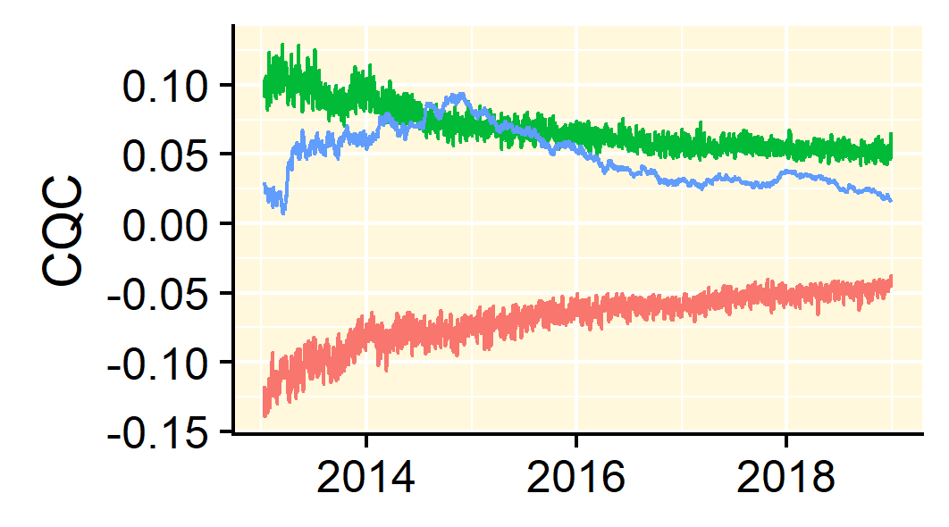 | 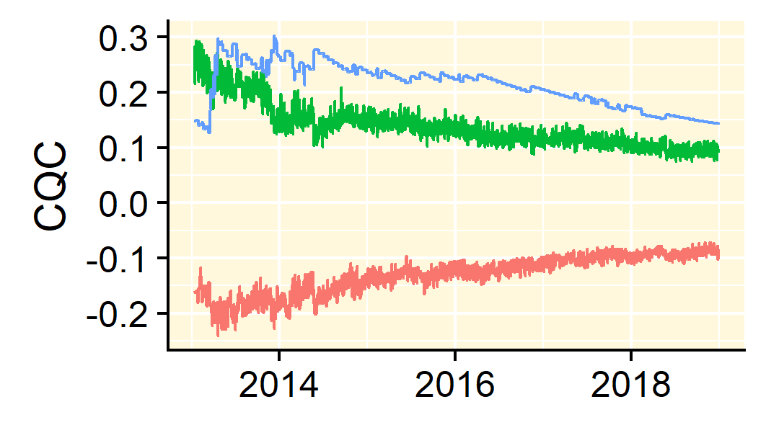
BTC/GBP | 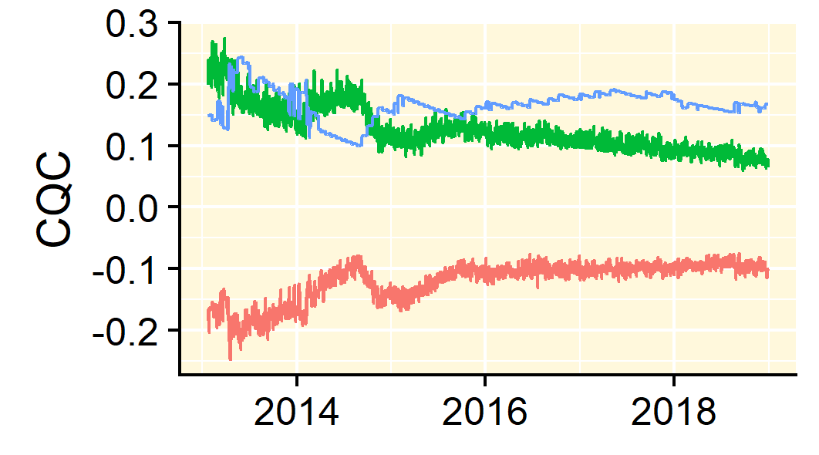 | 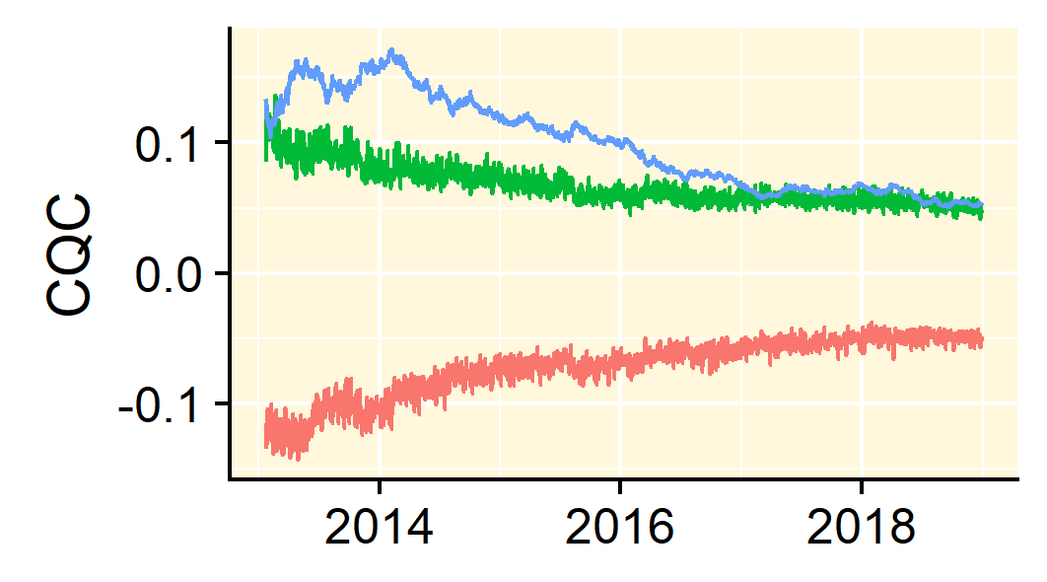 | 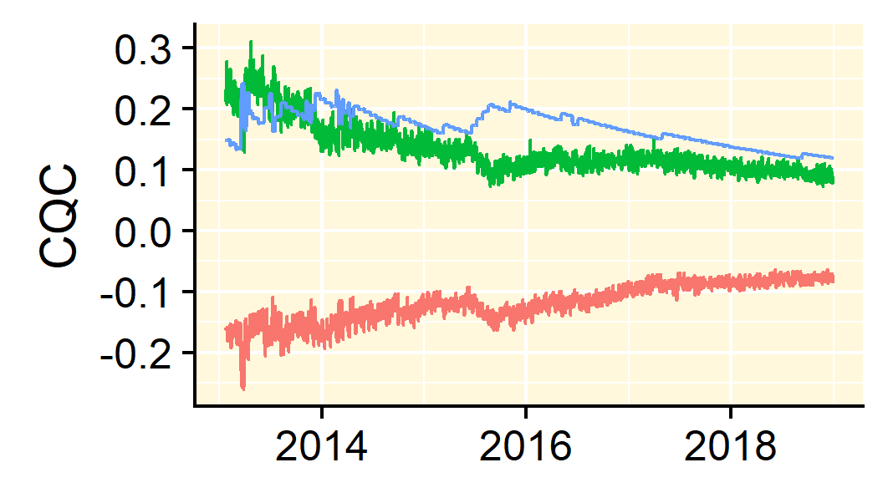
BTC/JPY | 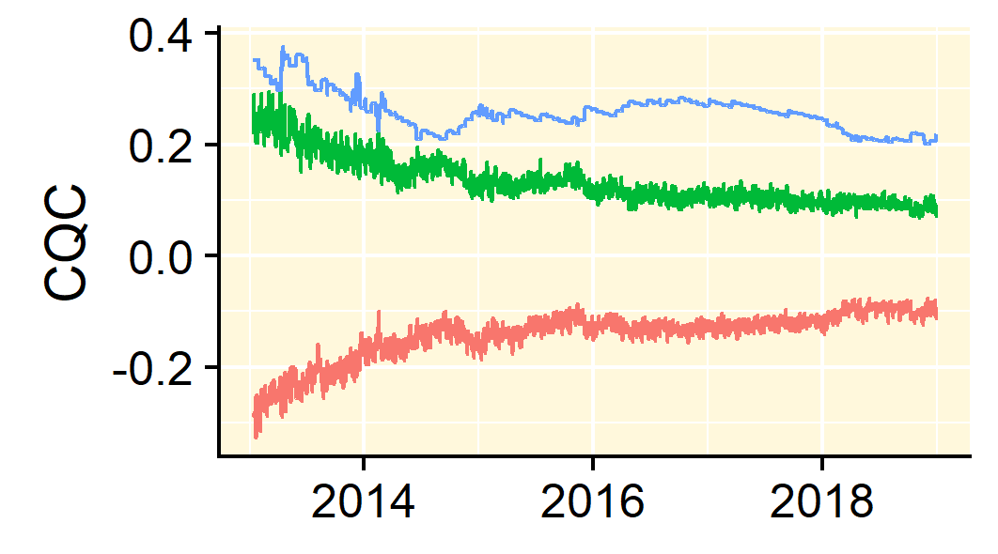 | 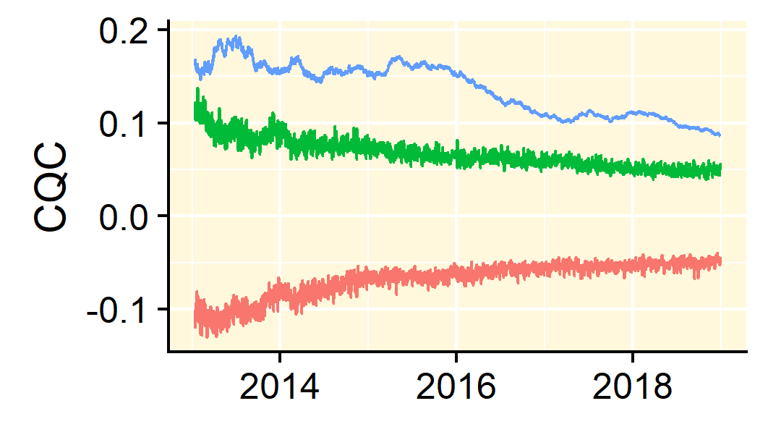 | 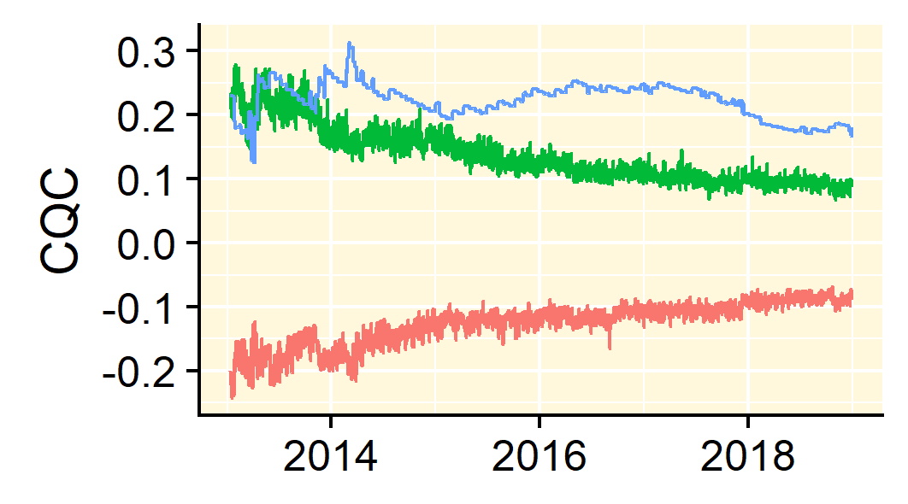
BTC/KRW | 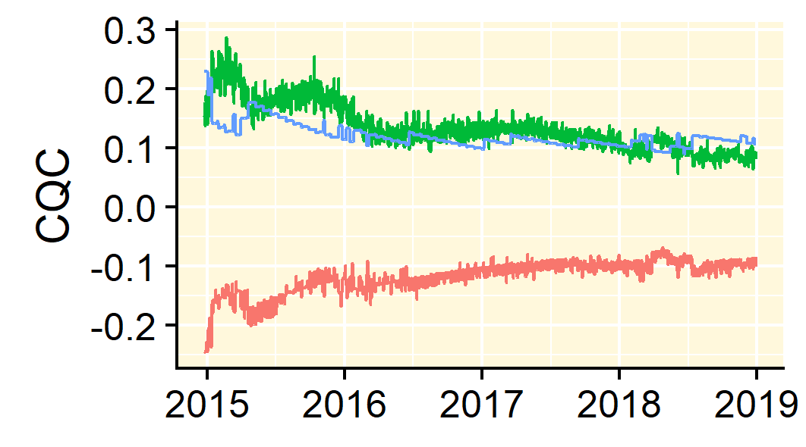 | 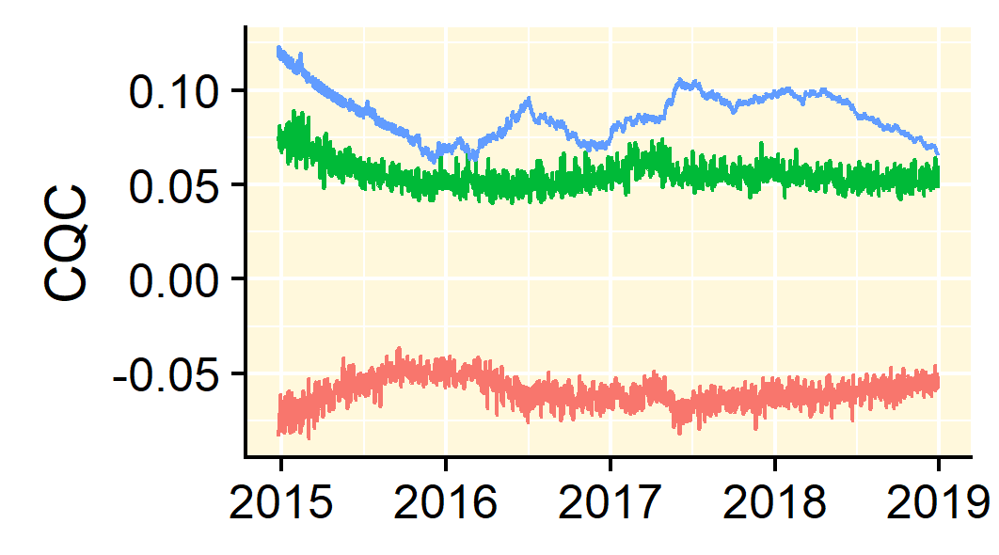 | 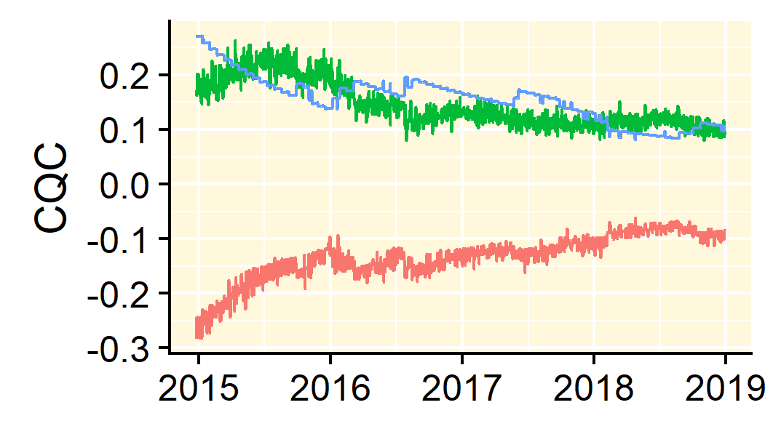

Notes: The confidence interval 95% (marked green) and 5% (marked red) and the cross-quantilogram correlation is marked by blue. If the CQC based blue line crosses either the green line from below or the red line from above indicate a 5% level of significance.

Figure 3: Surface tails plots of cross-quantilogram correlation

BTC/USD | [0.05-0.05] | [0.95-0.95]
BTC/AUD | 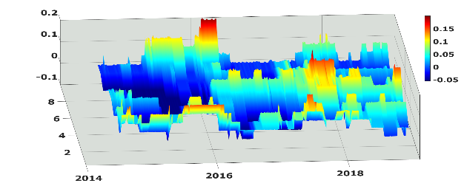 | 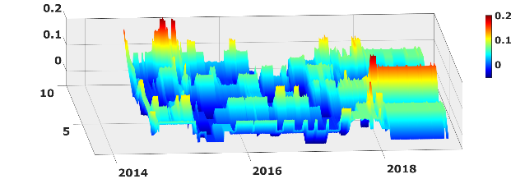
BTC/CAD | 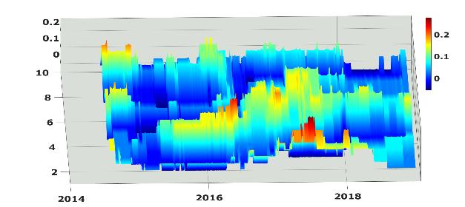 | 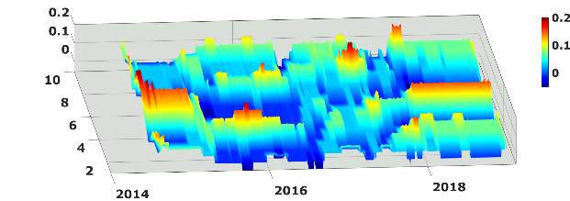
BTC/CNY | 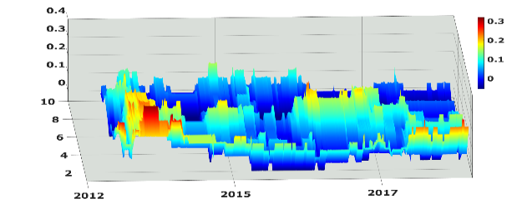 | 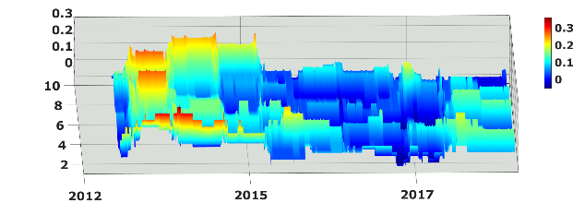
BTC/EUR | 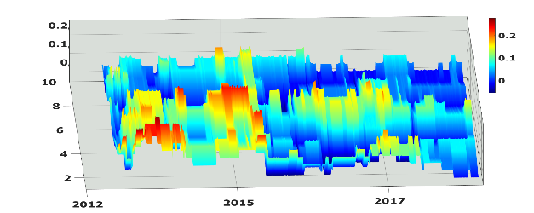 | 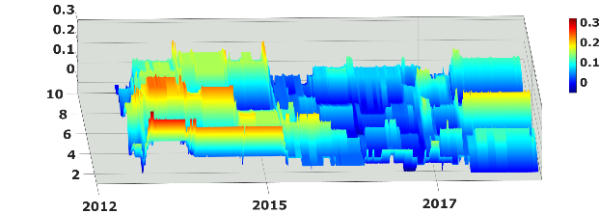
BTC/GBP | 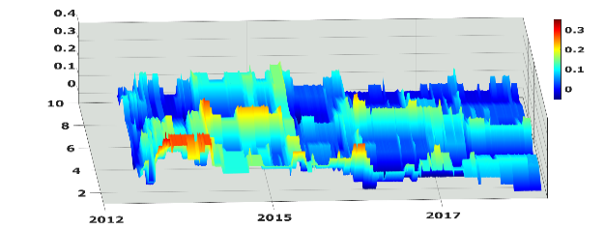 | 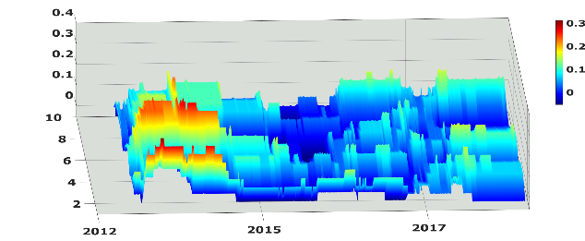
BTC/JPY | 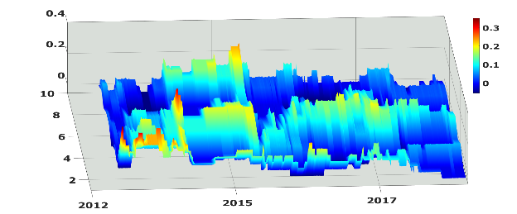 | 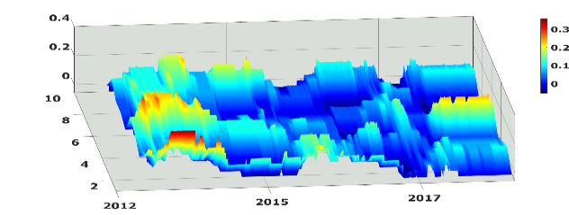
BTC/KRW | 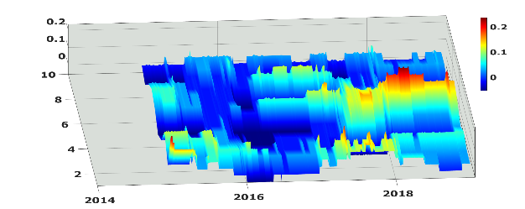 | 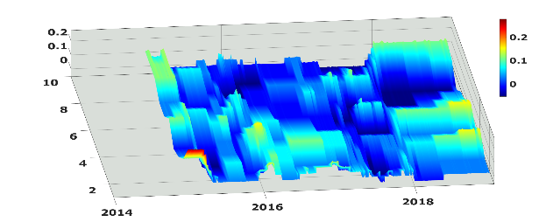
Notes: Surface plot of Bitcoin/USD cross-quantilogram correlation with other Bitcoin denominations in a rolling sample. The x-axis contains the CQC for lags 1-10, the y-axis is the rolling sample (504 days), and z-axis is the magnitude of the CQC. We also use colouring to represent the magnitude of the CQC and the values can be seen on the colour bars. The z-axis may vary to create better contrast.

It is a binary process: get a ‘hit’ in a specific-quantile or ‘miss’ it.
http://data.bitcoinity.org/markets/volume/30d?c=e\&t=b$).
https://www.reuters.com/article/us-china-cryptocurrency/china-wants-to-ban-bitcoin-mining-idUSKCN1RL0C4

