Managing perishable inventories in healthcare services

Doraid Dalalah
College of Engineering, University of Sharjah, United Arab Emirates
Industrial Engineering Department, College of Engineering, Jordan University of Science and Technology - Jordan

Udechukwu Ojiako
College of Engineering, University of Sharjah, United Arab Emirates
Hull University Business School, University of Hull, United Kingdom
UNIZIK Business School, Nnamdi Azikiwe University, Nigeria

Maxwell Chipulu
Southampton Business School, University of Southampton, United Kingdom

Abstract:
The management of perishable inventories is particularly challenging in healthcare field. One of the reasons lashing this is volatility, which is driven by irregular supply and stochastic demand. Exacerbated by a number of other factors such as the relatively short products shelf life, accelerated degradation and deterioration (premature expiration) and user specificity, such irregular supply and stochastic demand of perishable inventories bring additional challenges to the delivery of health services. This variability is likely to expose not only those in direct receipt of such healthcare products, but also the general population to insecure supplies. The norm in perishable products is to set an expiration date by which the product is best consumed. However, deterioration in products may accelerate, thereby; causing products to expire prematurely in random before their anticipated expiration date.

With this in mind, the aim of the study is to explore how best to mitigate against inventory volatility in perishable inventory, which is characterized by random premature expiration, random demand, irregular supply, age differentiated demand and custom replenishment guidelines. Through the adoption of simulation-optimization along with new settings and replenishment policies, the optimized quantity level of daily orders could be determined for this combination of inventory restrictions. Owed to their custom medical compatibility guidelines, and their notable accelerated expiration, blood platelets were considered here. As study outcome, the emergent model presents a perspective of supply chains and their healthcare imperatives that will enable healthcare supply chain managers not only to discern, but also to interpret and facilitate the management and implementation of optimal inventories.

Keywords: Random Aging; Differentiated Demand; Perishable Inventory; Blood Platelets; Simulation; Optimization.

1. Introduction
Operations management literature alludes to considerable scholarly interest in understanding how the inventory of perishable products may be best enhanced for efficient matching of irregular supply to stochastic demand (Bakker et al., 2012; Janssen et al., 2016; Ali et al., 2017). Perishable products are characterized by their limited shelf life. By shelf life, we mean the period of storage wherein functional integrity is maintained and the product is deemed safe for use without any impediments.

In the literature of inventory management problems, a significant research only considers items that can be stored indefinitely (Moonsoo et al., 2019). Among such deal of research on perishable inventory, hardly one can find a work that addresses random shelf lives, instead, the major assumption is a fixed shelf life and deterministic expiration dates as in (Nahmias, 2011; Chapman et al., 2004; Stanger et al., 2012a, 2012b). However, gradual deterioration, contamination and obsolescence unavoidably shorten the products’ shelf lives. This gradual loss in the functional integrity in the stored items makes their shelf life, not just shorter, but also stochastic. Deterioration results from different factors such as contamination, bacterial growth, damage, spoilage, dryness, vaporization, corrosion, …, etc., which all contribute to shorter shelf-lives of perishable products such as foods, green vegetables, human blood, photographic film and many others (Zeinab et al., 2016).

The management of perishable inventory that is characterized by: stochastic demand, stochastic supply, custom replenishment rules, age differentiated demand, and most importantly the stochastic shelf life, all make the decision of when and how much to order more difficult to quantify (Moonsoo, et al., 2019). Among the different approaches employed to manage such a problem, simulation has been used to address some of the above border conditions in perishable inventory, (Janssen, Sauer, et al., 2018b). However, few studies can be found that employ simulation-based optimization that tackles the inventory problem of single or multi objectives (Mualla and Hasan, 2018; Gabriel et al., 2020; Hasan et al., 2020).

Simulation and optimization combined, can provide realistic solutions of NP-hard problems that cannot be analytically optimized. In the context of simulation-optimization, different applications could benefit from such a framework such as multi-echelon inventory systems under uncertainty (Yunfei et al., 2015), multi-objective optimization (Shing and Si, 2017; Sebastian et al., (2020), network structure (Wenhe Ye, Fengqi You 2016), transportation (Bierlaire, 2015), maintenance (Alrabghi and Tiwari, 2015) and decision making (Afsahi, et al., 2020).

One such perishable product attracting attention is human blood (Osorio et al., 2015; Janssen et al., 2016; Ageron et al., 2018). In this health related inventory, the inability to match blood supply to demand creates the potential for not only shortages but also overstocking and therefore waste (Van Dijk et al., 2009; Gunpinar and Centeno, 2015; Baş Güre et al., 2018). Thus, blood inventory management is not only a major healthcare management matter, but also one with a significant cost and financial footprint. In general, simulation-optimization was not sufficiently explored for the benefit of managing inventories of extremely perishable products that are characterized by: stochastic demand, stochastic supply, custom replenishment rules, age differentiated demand, and stochastic shelf life such as blood components.

What we know so far is that due to irregular supply and stochastic demand, the management of perishable inventories such as blood platelets is particularly challenging. We are also aware that there are serious patient-specific but also society-wide ramifications if the irregular supply and stochastic demand of blood platelets cannot be adequately managed. Taking these factors and other peculiar characteristics (assumptions) associated with blood platelet inventory management into consideration, the aim of the study is to explore how best to mitigate against inventory volatility, taking blood platelets as a typical case study for age differentiated demand. Using simulation-Optimization and SA, such exploration will be undertaken through the adoption of different settings and replenishment policies that allow for the determination of an optimized quantity level of daily-orders. Specifically, the following combined settings will be considered: stochastic demand, stochastic supply, custom replenishment rules, age differentiated demand, and most importantly the stochastic shelf life.

The remainder of the paper is organized as follows, a literature review is presented in section 2.0 followed by the decision conditions in section 3.0. The model is formulated in section 4.0 followed by a demonstration of the search algorithm in section 5.0. Next in section 6.0, an analysis of different scenarios is laid out to demonstrate the experimental part of the model followed by a sensitivity analysis in section 7.0. Finally, the paper concludes in Section 8.0.

2.0 The literature
There is a good deal of literature studies that cope with inventory systems of perishables products.
These studies reveal the diﬃculty to determine the optimal parameters that provide a sound operation of the inventory while taking care of age categories of the on-hand quantities (Nahmias, 2011; Karaesmen et al., 2011). A number of scholars have sought to develop models to address the irregular supply and stochastic demand of perishable inventory to find such parameters. Among those, we would like to mention Prastacos (1984), Parlar (1985), Goyal and Giri (2001), Tekin, et al. (2001) and Bakker et al. (2012). Yet, in most settings of these studies, only deterministic shelf life is considered and the decision maker has a limited computational budget. The challenge thus is to establish a search procedure that consumes less computational time without the need for exhaustive search that may not be attainable for most of the cases. Accordingly, diverse approaches have been developed to deliver low-cost meta-models that seek to predict the profile of the objective function using the information attained from low number of point sampling, particularly for simulated scenarios. When the inventory problem advances by its border conditions, the analytical evaluation of the objective function may be unattainable. Such category can be stochastically simulated and simultaneously optimized to get the best solution via the so-called Simulation-Optimization.

Simulation-optimization refers to optimization via stochastic simulation (Chen & Lee, 2010). Simulation, which refers to the techniques and practices employed to imitate a specific behavior of a real system, is used to evaluate the objective function of an identified decision (solution vector). On the other hand, optimization is used to find the values of the solution vector that optimizes the objective function of interest. To search for the best solution vector, optimization techniques, regardless of their types, need to evaluate the objective function. Such an evaluation requires that the real system is operated (simulated) in every call of the optimization part. Since simulation can be demanding in terms of time and computational budget, the optimization should be guided to reduce the number of simulation calls. Simulation utilizes the knowledge, time, people to mimic systems, particularly when conducting real experiments is impractical or costly. Not only simulation can reduce the cost, it also accelerates the time without having to wait for a real operation of a system. By implementing Simulation-Optimization to develop an approach that efficiently searches the solution space, the search approach has to be custom-built to reduce the computational expenses while providing quality solutions. However, as stated by Wilson et al., (2020), problems of higher sizes of solution vectors result in a vast search space, thereby, exceeding the computational power and time available to complete all the possible solutions. This category of problems is considered as NP-hard (He et al., 2017; Herrmann, 2013).

According to Banks (1998), Chen et al. (2013), and Xu, Huang, Chen and Lee (2015), a simulation optimization problem is established by optimizing an expected value of some objective function. Simulation optimization has been considered in different research studies and applications. In the field of transportation for instance, Bierlaire (2015) presented a review of simulation optimization to in transportation. In maintenance, Alrabghi and Tiwari (2015) addressed the simulation optimization applied to maintenance systems. Similar simulation optimization research can be found on the problem of balancing assembly lines (Dagkakis et al., 2019). Patient schedule using simulation optimization can ber found in similar research of Rezaeiahari and Khasawneh (2020). Other applications that benefit from simulation optimization approaches include sustainably in ground water operations (Park et al., 2020). Not only the production field, simulation optimization has been also applied in the service sector, for instance, a stochastic simulation-optimization model for base-warranty and extended-warranty decision-making has been developed. Moreover, to solve different problems in renewable energy such as building thermal load management through integration of solar systems, simulation optimization was the approach of choice (Habib et al., 2020).

A recent review by Juan et al. (2015) talks about metaheuristics applied in simulation optimization and stochastic combinatorial problems. Another review can be found in the work of Kleijnen (2017) which addresses Kriging metamodeling in simulation. As for optimization, a review about different categories of search algorithms can be found in research of Xu et al. (2015). Their work addressed sample-path, gradient-based methods, stochastic constraints and multi-objective optimization. Unlike exhaustive search methods, metaheuristics are generic forms of the solution search process without guarantees of global optimality, however, with reduced computational time (Sörensen, 2015).

By considering platelets as typical items that are characterized by rapid ageing, compatibility, stochastic demand and premature expiration, a reliable optimization approach is required to solve this stochastic problem. Interested readers can find useful reviews on hybrid metaheuristics in (Lozano and Martinez, 2010; Blum et al., 2011). Among those metaheuristics is Simulated Annealing (SA) which has been found effective in many industrial and services applications (Munku et al., 2020; Novita et al., 2019). The interesting feature in Simulated Annealing is its ability to jump out of local minima and the ability to handle objective functions of coarse profiles. SA will be tailored to fit the proposed inventory policy of this study.

Considerable research efforts have been undertaken for perishable inventory management in the context of health, food and drug industry. For example, Parlar (1985) developed a model that categorized perishable inventory into two age categories with proportions of one category satisfying the other. In Duan and Liao (2013), a model was proposed to maintain old inventory ratios (OIR) for perishable inventory (blood platelets) that minimized system outdates’ costs. The literature also discusses novel allocation strategies for blood inventories that are able to explore the tradeoffs between age and transfused blood availability (see Atkinson et al., 2012).

2.1 Models focused on blood platelets as perishables
At this point, it is perhaps pertinent to explore what we mean by accelerated degradation and deterioration. Accelerated degradation and deterioration is a condition that can lead to early, in effect, premature expiration and spoliation (Bosman et al., 2008; Zubair, 2010; Williamson and Devine, 2013; Salins, 2015; Wong et al., 2016).

There are about four major components of blood that are entitled to be perishable – platelets, red and white blood cells and plasma. With the exception of plasma, blood components are generally perishable and have a relatively short shelf life (Nahmias, 2011; Chapman et al., 2004; Stanger et al., 2012a, 2012b; Kopach et al., 2008; Hess 2010; García-Roa et al., 2017).

Platelets (also known as thrombocytes) are a key blood component responsible for the clotting (coagulation) of blood following injury and bleeding (Machlus et al., 2014). Although only around 10% of total blood transfusions is platelet-specific, its availability and use is essential in healthcare. For example, cancer (leukemia) patients suffering bleeding complications often require platelet transfusions in order to prevent bleeding from ruptured blood vessels (Izak and Bussel, 2014). Platelets transfusion is also required to prevent bleeding for a range of other patients – for example, those undergoing organ transplants (Stroncek and Rebulla, 2007). These factors all mean that platelets remain an invaluable healthcare product.

In addition to the existing models on perishable products, there are existing models that specifically focus on blood platelets as perishables (Haijema et al., 2007, Van Dijk et al., 2009; Haijema, 2011; Zhou et al., 2011; Dalalah et al., 2018; Rajendran and Ravindran, 2019). For example, Haijema et al. (2007) explored the production of blood platelets utilizing dynamic programming that focused on age differences of platelets. In their more recent study, again utilizing dynamic programming, Haijema et al. (2009) developed a practical ‘order-up-to’ inventory rule for optimal blood platelet production. The rule requires an organization to regularly review its inventory position. Following such review, ‘orders’ are then issued to ensure that inventories are surfaced ‘up-to’ a specifically defined level (Chen and Disney, 2007). Zhou et al. (2011) appraised the dynamics of platelet inventory management finding that optimal costs were particularly impacted by uncertainty in a number of areas including demand uncertainty and the age of orders that were expedited. Duan and Liao (2013) study focused on the age factor and found that centralizing the supply chain greatly reduces platelet outdate rates by about 18.56%. In both Gunpinar and Centeno (2015) and Rajendran and Ravindran (2019), stochastic integer programming models were developed to reduce platelet scarcity and waste levels. In Dalalah et al. (2018), taking into consideration age-differentiated and stochastic demand, a model able to optimize stocking decision variables by minimizing the overall inventory costs was developed. Overall, it is observed that the models which emerge from these reviewed studies do not appear to have explicitly taken into consideration accelerated degradation and deterioration of platelets. However, the literature suggests that this phenomenon is part and parcel of perishable items such as blood platelets (Bosman et al., 2008). Our premise is that accelerated degradation and deterioration will lead to premature expiration of blood platelets kept in storage. This will ultimately create a condition where platelets are characterized by among other decision conditions, ‘Random inventory expiration lifetimes’. Thus, the main difference between Dalalah et al. (2018) and this present study is that in Dalalah et al. (2018), three inventory management decision conditions were considered. These decision conditions are (i) ‘Age-differentiated demand’ (ii) ‘Stochastic demand’ and (iii) ‘Specific inventory issuance policy’. In the present study, five decision conditions will be considered (i) ‘Age-differentiated demand’ (ii) ‘Customized replenishment decisions’ (iii) ‘Custom inventory and order fulfillment policy’ (iv) ‘Different costs considerations’ and most importantly (v) ‘Stochastic inventory expiration lifetimes’.

Blood components have relatively short shelf lives (Fontaine et al., 2009; Chandra et al., 2014; Civelek et al., 2015; Rajendran and Ravindran, 2019). To put this into perspective, with advances in technology, the shelf life of blood plasma is about 365 days (Prastacos, 1984; Schneider, 1995; Arya et al., 2011). Conversely, that of red blood cells is approximately 42 days (Cancelas et al., 2015; García-Roa et al., 2017). However, on average, the shelf life of platelets is approximately between 3 and 5 days or seven days at the very most (Chandra et al., 2014).

Premature expiration which results in shorter shelf life of platelets means that anything between 4% (Hess et al., 2000), 17% (AABB, 2011) and 20% (Haijema et al., 2007; Verma and Agarwal, 2009) of collected platelets samples is outdated. Inevitably, this implies that a substantial amount of blood platelets are wasted due to expiration while in storage (Van Dijk et al., 2009).

The demand for platelets in addition to its relatively limited shelf life is further complicated by its usage which is age-differentiated (Kok and Fisher, 2007; Acimovic and Graves, 2012). Indeed, the treatment of some medical conditions requires platelets of specific, but different ages. For instance, treatment of hematology and oncology conditions generally require new platelets (Haijema et al., 2007; Van Dijk et al., 2009; Civelek et al., 2015).

What we realized so far, is that the management of perishable inventories such as blood platelets is especially difficult due to intermittent supply and stochastic demand. We are all mindful that if the erratic supply and stochastic demand, premature expiration and differentiated demand of blood platelets can not be properly controlled, significant patient-related but even social consequences may be encountered. Taking these variables and other problem specific features associated with inventory control of blood platelets into consideration, this study comes with a purpose to examine how best to protect against inventory variability of blood platelets. Such research would be conducted by implementing various settings and replenishment policies using simulated annealing for optimization and discrete event systems for simulation that allow finding an optimum order quantity which minimizes the overall cost and demonstrates a smooth operation of the inventory.

3.0 The decision conditions
In order to achieve the study aim, a hybrid analytical perspective developed through a model that encompasses five decision conditions are now discussed. These decision conditions are (i) ‘Age-differentiated demand’ (ii) ‘Customized replenishment decisions’ (iii) ‘Custom inventory and order fulfillment policy’ (iv) ‘Different costs considerations’ and most importantly (v) ‘Stochastic inventory expiration lifetimes’.

3.1 Random aging and age-differentiated demand
When a platelet is in storage, it ages over time. Aging can be deterministic, resulting in a specific expiration date. It can also be stochastic resulting in what could be deemed as unanticipated premature expiration. While there is ample literature on perishable products of fixed shelf lives (Goyal and Giri, 2001; Kouki and Jouini, 2015; Gaukler et al., 2017; Firoozi and Ariafar, 2017), there is less literature available on randomized accelerated deterioration of perishable products.

A blood platelet arguably can lose its functional integrity any time earlier than its expected expiration date (Bosman et al., 2008). This can be shown as follows. Assume that a platelet has a shelf life of ‘A’ and denote the corresponding ages of a platelet by i =1, …, A in days, where ‘A’ is an integer number. Hence, platelets that are able to maintain their functional integrity beyond ‘A’ are deemed not to have expired. However, as expiration is stochastic, some platelets may expire prematurely before reaching A-days old. Spoilage will therefore result from premature expiration due to accelerated platelet degradation and deterioration.

The proposed approach can handle any shelf life of A > 0 at the expense of computational time. Here, we consider a shelf life duration of A=5 days, which fits the literature position on the lifetime of blood platelets in hospital storage (see Chandra et al., 2014). In effect, a platelet with a shelf life of five days (A=5 days) will go through five different ages each of its own daily demand. To better simplify this notation, the five ages may be referred to as ‘Fresh’ (…of 1 day old), ‘Young’ (…of 2 days old), ‘Mature’ (…of 3 days old), ‘Old’ (…of 4 days old) and ‘Elderly’ (…of 5 days old). Platelets deemed ‘Elderly’ (…of 5 days old) will exceed their shelf life if not used on the fifth day of storage. It is however important to note that ‘Elderly’ platelets are not the only platelets prone to spoilage. This is because, all platelets irrespective of age, may stochastically expire due to accelerated degradation and deterioration.

3.2 Customized replenishment decisions
Stock replacement need to be considered prior to expiration, therefore, the replenishment decisions within perishable inventory management are influential. Examples of replenishment decisions include ‘random issuing’, ‘youngest items first’ and ‘oldest items to leave first’. We sought to apply an easy-to-implement fixed-order quantity policy in the proposed study (see Kostic, 2009). Thus, only newer ‘Fresh’ platelets are replenished. No replenishment is carried out for other ages, as excess ‘Fresh’ platelets will age daily while in storage. Thus, sufficient quantities of ‘Fresh’ platelets will eventually meet demands for older platelets. The daily-order quantity of ‘Fresh’ platelets is the decision variable that has to be found for a planning period of T=365 days. We assume that the delivery time (lead-time) of ordered quantities does not consume from platelet lifetime, thereby; ‘Fresh’ platelets are only one day old.

When an exact age match is not found, patients who need newer platelets will have higher priority to receive substitutes. When platelets of a certain age, for example, ‘Mature’ are required, and the exact age specification is not available, the demand will be first satisfied by supplying the patient with platelets of the next age. In this scenario, the patient is first provided with ‘Old’ and then ‘Elderly’ platelets. Conversely, if these older aged platelets are not available, then demand by a patient requiring ‘Mature’ platelets will be satisfied by providing the patient first with ‘Young’ and then ‘Fresh’ Platelets. These replenishment decisions are illustrated in Table 1 (below). The table demonstrates a preference matrix for an utmost shelf life of ‘A’ (1 being most desirable ).

Table 1: Age preference for a maximum shelf life of “A” days
 |  | Demand by:
 |  | Age
 | age | 1 | 2 | 3 | $$…$$ | A-2 | A-1 | A
Supply from: | 1 | 1 | A | A | $$…$$ | A | A | A
 | 2 | 2 | 1 | A-1 | $$…$$ | A-1 | A-1 | A-1
 | 3 | 3 | 2 | 1 |  | A-2 | A-2 | A-2
 | $$⋮$$ | $$⋮$$ | $$⋮$$ | $$⋮$$ | $$⋱$$ | $$⋮$$ | $$⋮$$ | $$⋮$$
 | A-2 | A-2 | A-3 | A-4 |  | 1 | 3 | 3
 | A-1 | A-1 | A-2 | A-3 | $$…$$ | 2 | 1 | 2
 | A | A | A-1 | A-2 | $$…$$ | 3 | 2 | 1
*1 is most preferred, A is least preferred.

A special case of Table 1 results for platelets of a shelf life of 5 days. In Table 5, we show the preferences in compatibility when A=5. In this study, there is no protection provided against any demand for older platelets. In effect, a core assumption in this study is that newer platelets can be utilized without any limit to satisfy any demand for older platelets.

Table 2: Compatibility preference of the five ages
 |  | Demand by:
 |  | Age
 | age | Fresh | Young | Mature | Old | Elderly
 |  | 1 | 2 | 3 | 4 | 5
Supply from: | 1 | 1 | 5 | 5 | 5 | 5
 | 2 | 2 | 1 | 4 | 4 | 4
 | 3 | 3 | 2 | 1 | 3 | 3
 | 4 | 4 | 3 | 2 | 1 | 2
 | 5 | 5 | 4 | 3 | 2 | 1

3.3 Random inventory lifetimes
The proposed model takes two expiration factors into consideration. The first which is deterministic, assumes that the shelf life duration will be exceeded before any need for the platelets materializes (we refer to this as outdates). The second consideration assumes that not only can platelets experience accelerated degradation and deterioration (leading to premature expiration), but that due to the compounded nature of sample testing, treatment, manipulation and storage, different platelets will experience different acceleration rates of degradation and deterioration. Thus, the shelf life of platelets in this case can be modelled by different distributions. These activities can be shown utilizing a differential equation where quantity is N and the exponential decay constant (a positive rate) is λ:
$\frac{dN}{dt}=-N$ . (1)
The solution of the above is simply given by

$N\left(t\right)={N_{0}e}^{-t}$ , (2)

where $N_{0}$ is the initial inventory quantity. The percent of surviving quantities of platelets (that is, non-expired) by time t is shown as $\frac{N\left(t\right)}{N_{0}}=e^{-t}$, which resembles the exponential reliability function $R\left(t\right)=e^{-t}$. Note that, $R\left(t\right)=1-F(t)$, where$F(t)$ is the cumulative distribution of the lifetime. Therefore, the resulting lifetime distribution of such a reliability function is given by

$f\left(t\right)=e^{-t}, t>0$ (3)

and the mean lifetime is $\frac{1}{}$ . The hazard function $z(t)$ of exponentially distributed lifetime is constant; that is:

$z\left(t\right)=\frac{f(t)}{1-F(t)}=\frac{e^{-t}}{e^{-t}}=$. (5)

Considering degradation and deterioration, at the beginning of each day, we can compute the probability of a platelet maintaining its functional integrity given its current age by a conditional probability. The exponential conditional reliability gives the probability for platelet survival of t duration, having successfully accumulated T unit time of survival. The exponential conditional reliability function is

$R\left(t | T\right)=\frac{R(T+t)}{R(T)}=\frac{e^{-(T+t)}}{e^{-(T)}}=e^{-t}$ . (6)

The above suggests that the reliability function of exponential platelets deterioration is the same regardless of the time that the platelet has experienced while in storage. To simulate this aging process, the probability of a platelet maintaining its functional integrity for the next t days – given it has survived up to T – is given by $e^{-t}$. Therefore, we apply a stochastic model to probabilistically eliminate those platelets which may not be able to maintain their functional integrity. That is, each platelet will maintain functional integrity up to t with a probability of $e^{-t}$, and will prematurely experience degradation and deterioration with a probability of ${1-e}^{-t}$, where t = 1 if tested every day. For instance, suppose that five platelet units exhibiting a deterioration rate of 0.3 are currently available in the inventory (labelled 1 to 5). The conditional probability of maintaining functional integrity by one more day is given by $e^{-0.3*1}=0.74$. Suppose the following random number stream (i.e. uniform [0, 1] = 0.5, 0.8, 0.3, 0.9, 0.1) is considered as an instance to simulate platelets being able to maintain their functional integrity beyond their expiration date. Thus, platelet units 1, 3 and 5 will maintain their functional integrity to the next day. However, platelet units 2 and 4 will prematurely expire. This procedure is simulated for every platelet unit of every age in the inventory. Of note; other random number streams give other results; hence, Monte Carlo simulation is an essential tool for modelling lifetimes. This contends that platelet expiration discussed in the literature review will result in the need to consider premature expiration at a deterioration rate of 20%, which will result in λ=0.045 and a corresponding lifetime distribution of $f\left(t\right)=0.045e^{-0.045t}$ in days, where F(5)=0.2.

3.4 Inventory status and issuance policy
The demand probability distribution of platelets is likely to differ by age. For example, it is plausible for the demand of ‘Fresh’ platelet types to follow a Poisson distribution. On the other hand, demand for ‘Young’ platelet types may follow a normal distribution. The proposed model will take into consideration two inventory policies: the first, is where order fulfillment has only exact age match (in other words, ‘No-Compatibility’), and the second is where order fulfillment allows for age mismatch (‘With-Compatibility’).

On the start of each typical day, an inventory count is undertaken to record the age of all platelets’ units. Medical research suggests that, traditionally, platelet incompatibility was not construed to hinder use and, in fact, transfusion using age mismatched platelets has been common practice (see Djerassi et al., 1963). However, more recently, it will appear that medical science has begun to consider that incompatibility brings adverse consequences for platelet recipients (Valsami et al., 2015). Thus, on the basis that platelet substitution by compatibility is untenable, the available quantities of platelets per age will be counted at the beginning of each day, and then the demand will be satisfied by supplying users with platelets that meet their precise age requirements. If there is a shortage of a platelet of a specific age, that shortage is recorded. Hypothetically, if platelet substitution by compatibility is tenable, available supplies within the inventory are counted and demand is fulfilled by supplying users with an exact match first. If shortages in exact matches occur, a search is undertaken to find a compatible substitute from the remaining platelets held in storage. Substitution is achieved based on the preferences shown earlier in Table 1. On satisfaction of demand, shortages (if any) are recorded, prematurely expired platelets are then removed, and inventory of ‘Fresh’ platelets is replenished.

3.5 Different costs consideration
Pricing and costs is a major decisional condition that must be integrated into perishable inventory management decisions (Chen et al., 2014). Generally, pricing and costs in inventory may be of two types. The first is where prices and costs do not change over a period of time even when product demand (and/supply) changes over that same time period. The second type will generally allow for price and costs changes as a demand (and/supply) or inventory function over time. The second scenario is what organizations dealing with products that must be utilized with a specific fixed period of time (perishable products) usually experience. In this study, the cost components have been roughly estimated based on projected cost estimates of producing and storing platelets. For platelets of all ages, shortages costs are estimated to be US$500 while costs of outdates and premature expiration are US$200. The mismatch cost is US$20 (regardless of platelet age), while the holding cost is set to US$1/unit/day.

4.0 Formulation
When platelets survive only one day (i.e. A=1), the proposed model is reduced to a classical newsvendor problem. In contrast, when the lifetime is greater that one day (i.e. A>1), this means that each platelet will have a wider window in terms of time to be used/consumed. For consistency with periodic inventory counting, daily updates to the model is undertaken. Consequently, for a year - long planning period, 365 demand vectors are realized.

The following nomenclature are employed for model notations:

t : The planning period of a day T, t = 1,…,T.
i : Platelet age, where i = 1, …, A.
$D_{}^{t}$: The demand vector of all ages in day t, where, $D_{}^{t}$=[$d_{1}^{t}, { d}_{2}^{t},…, { d}_{A}^{t}]$.
$S_{i}^{t}$ : Platelet resulting shortage of age i, end of day t.
$O_{i}^{t}$ : Outdated platelets of age i, at day t end (only age A will outdate anyway).
$P_{i}^{t}$ : Prematurely expired quantity of age i end of day t.
$x_{i}^{t}$ : Platelets of age i beginning of day t that are available.
$X^{t}$ : The inventory status of platelets differentiated by “A” lifetime periods start of day t where, $X^{t}={\left[\begin{matrix}x_{1}^{t} & … & x_{A}^{t}\end{matrix}\right]}^{T}$.
${BL}_{i}^{t}$ : Accumulation of platelets of specific age i which is not satisfied by exact age match in day t.
${IC}_{i}^{t}$ : “Platelets Consumed” is the amount of the platelets of age i that have been used to satisfy demand of platelets of other ages, end of period t.
${IS}_{i}^{t}$ : “Platelets supplied” is the quantity of platelets of another age that is supplied in order to meet demand of platelet age i on day t.
$Q$ : The decision variable (order quantity). In our model, the only platelets that are restocked are one-day-old platelets.

The transition in the state of the inventory evolves daily according to the earlier identified decision conditions; that is (i) ‘Age-differentiated demand’ (ii) ‘Customized replenishment decisions’ (iii) ‘Custom inventory and order fulfillment policy’ (iv) ‘Different costs considerations’ and most importantly (v) ‘Stochastic inventory expiration lifetimes’. Given the current inventory state (the specific quantity of platelets available for use at the start of each day), a new inventory status is met by first meeting realized platelet demand by exact age match following which compatible substitutes are pursued. This daily accumulation of platelets by age i after being met (satisfied) by exact match, can be expressed as

$BL_{i}^{t}={\left[d_{i}^{t}-x_{i}^{t}\right]}^{+}, i=1,…, A$ , (7)

Where [z]⁺ is the max(z, 0). If$BL_{i}^{t}>0$, a substitute will meet BL of all ages, or up to the point that the on-hand inventory of platelets of compatible ages are used. The total quantity employed in meeting demand for platelets of age i by substitution (flowing only from compatibility) is denoted by ${IS}_{i}^{t}$. Thus, platelets shortage observed for age i at the end of day t is given by

$S_{i}^{t}={\left[BL_{i}^{t}-{IS}_{i}^{t}\right]}^{+}$, $i=1,…, A$ . (8)

Equation (8) must be undertaken on an age-by-age basis commencing with age 1. ${IS}_{i}^{t}$ is also updated in line with age based platelet use. Having said that, the state of inventory (which is represented as $x_{i}^{t}$) is updateable using quantities and ages. Generally, for every t,

Quantity update: ${\tilde{x}}_{i}^{t}={\left[{\left[x_{i}^{t}-d_{i}^{t}\right]}^{+}-IC_{i}^{t}\right]}^{+}-P_{i}^{t} i=1, 2, …, A$ (9)

Age update: $x_{i}^{t+1}=\left\{\begin{aligned}Q i=1 \\ { \tilde{x}}_{i-1}^{t} i=2, …, A\end{aligned}\right.$ (10)

Outdates end of t can also be shown as
$O_{A}^{t}=x_{A}^{'}$ . (11)

Equation (9) above indicates that a specific aged platelet is used based on it being either (i) a precise match, (ii) a substitute based on its compatibility, or (iii) following premature expiration. The outdated quantity of platelets at the end of day t is represented by the outstanding platelet units of age A shown by $O_{A}^{t}$. The prematurely expired quantity $P_{i}^{t}$ is found following the procedure presented earlier in equations (1) - (6).

In equation (10), all platelets become older by one day as their residual shelf life reduces and ‘Fresh’ platelets are replenished and taken into storage. Inevitably, the next day (t+1), the available inventory becomes the commencing inventory. The replenished quantity of platelets $Q$ will be available the next day. Note that, in the proposed model, an ‘order-up-to-level’ policy (see Chen and Disney 2007) will be construed in the same manner as a ‘fixed-order’ policy since the inventory “age 1” will always be empty at the time of replenishment.

Shortages of platelets of age i are shown as $S_{i}^{t}$. Conversely, system shortages over a period of planning T can be represented as $\sum_{t=1}^{T}{S_{i}^{t}}$; based on these, the entire system shortage of platelets of age i becomes

$SS_{i}=\sum_{t=1}^{T}{S_{i}^{t}}, i=1, …, A$. (12)

Premature expiration is experienced at the end of each day. The total premature expiration of platelets of each age is
$SP_{i}=\sum_{t=1}^{T}{P_{i}^{t}}, i=1, …, A$. (13)

Similarly, platelets reaching their expiration due to aging are only to those of age “A” where, $SO_{1}=SO_{2}=…=SO_{A-1}=0$; That is,

${SO}_{A}=\sum_{t=1}^{T}{O_{A}^{t}}$ . (14)

The cost of shortages of platelets of age i is represented as $sc_{i}$ and cost associated with outdating due to aging (which is the same as premature expiration cost) is denoted by $oc_{i}$. Denoted by h is the cost associated with holding platelets in inventory for one day. The holding cost is the multiplication of h times the average inventory, where the average inventory of platelets of age i over T is approximated by ${\overline{x}}_{i}=\frac{\sum_{t=1}^{T}{x_{i}^{t}}}{T}$. The average age of the inventory is also estimated by $\overline{A}=\frac{\sum_{t=1}^{T}{\sum_{i=1}^{A}{{ix}_{i}^{t}}}}{\sum_{t=1}^{T}{\sum_{i=1}^{A}{x_{i}^{t}}}}$. A substitution matrix can be established which exemplifies the amount of platelets of a specific age which are utilized to meet a specific demand. The matrix is shown as

$M^{t}=\overset{age 1 age 2 … age A}{\overbrace{\left[\begin{matrix}m_{11}^{t} & m_{12}^{t} & … & m_{1A}^{t} \\ m_{21}^{t} & m_{22}^{t} & … & m_{2A}^{t} \\ ⋮ & ⋮ & ⋱ & ⋮ \\ m_{A1}^{t} & … & & m_{AA}^{t}\end{matrix}\right]}}$ (15)

The matrix above suggests that platelets aged 1 are fulfilled by a quantity of precise match $m_{11}^{t}$, plus some aged 2 ($m_{12}^{t}$) and so on. At the same time, age “A” platelets are fulfilled by $\sum_{i=1}^{A}{m_{Ai}^{t}}$. For the entire planning period, the total substitution matrix $M=\sum_{t=1}^{T}{M^{t}},$which results in

$M=\left[\begin{matrix}M_{11}^{} & … & M_{1A}^{} \\ ⋮ & ⋱ & ⋮ \\ M_{A1}^{} & … & M_{AA}^{}\end{matrix}\right]$ . (16)

The matrix $M$ constitutes of the aggregate distribution of the amounts used for exact and compatible substitution. The quantity fulfilled by newer platelets is a summation of lower triangular elements, $L=\sum_{i=1}^{A}{\sum_{j=1}^{A}{M_{ij}}} , ∀i>j$, conversely, demand fulfilled by platelets that are older (upper triangular elements) are determined by $U=\sum_{i=1}^{A}{\sum_{j=1}^{A}{M_{ij}}} , ∀i<j$. Demand fulfilled by precise matches is designated the diagonal sum and represented as $\sum_{i=1}^{A}{M_{ii}}$. Mismatch (substitution) cost is shown as ${mc}_{a>b}$ for fulfilling age a platelets by those of age b, where a > b (i.e. cost of substitution by newer platelets). Similarly, the cost of substitution by older platelets is ${mc}_{a<b}$, where a < b. Recall the system shortage $SS_{i}$, the premature expiration $SP_{i}$, and outdates ${SO}_{A}$ from equations (12-14), it becomes possible to represent the cost objective function as a combination of six components, first, the holding cost $\sum_{i=1}^{A}{h×{\overline{x}}_{i}}$, second, the shortage cost $\sum_{i=1}^{A}{\left({sc}_{i}×SS_{i}\right)}$, third, the premature expiration cost $\sum_{i=1}^{A}{{SP}_{i}} oc_{i}$, fourth, outdates cost $SO_{A}oc_{A}$, fifth, mismatch cost due to order fulfillment with younger platelets $L×{mc}_{a>b}$, and finally the cost due to order fulfillment with older platelets $U×{mc}_{a<b}$, that is:

$\min{\sum_{i=1}^{A}{h×{\overline{x}}_{i}}+\sum_{i=1}^{A}{\left({sc}_{i}×SS_{i}\right)}+\sum_{i=1}^{A}{{SP}_{i}} oc_{i}+SO_{A}oc_{A}+L×{mc}_{a>b}+U×{mc}_{a<b}}$(17)

Table 3: Inventory of five days’ shelf life over a three day planning period
Initial inventory of all ages:  (5,2,3,7,0) |  | Day 1  Demand:  (2,3,3,1,0) | Day 2  Demand:  (3,1,0,0,0) | Day 3  Demand:  (1,1,4,0,1)
Inventory after exact match |  | 3,0,0,6,0 | 2,1,0,0,3 | 3,0,0,0,0
Backlog upon exact age match |  | 0,1,0,0,0 | 0,0,0,0,0 | 0,0,4,0,1
Inventory after age mismatch |  | 3,0,0,5,0 | 2,1,0,0,3 | 0,0,0,0,0
Shortage end of day t |  | 0,0,0,0,0 | 0,0,0,0,0 | 0,0,1,0,1
Premature expiration♣ |  | 1,0,0,2,0 | 1,1,0,0,1 | 0,0,0,0,0
Remaining inventory after premature expiration |  | 2,0,0,3,0 | 1,0,0,0,2 | 0,0,0,0,0
Outdates end of period t |  | -, -, -, -,0 | -, -, -, -,2 | -, -, -, -,0
Replenishment quantity♥ |  | 5 | 4 | 6
Inventory ready for next day |  | 5,2,0,0,3 | 4,1,0,0,0 | 6,0,0,0,0
 | Totals | Day 1 | Day 2 | Day 3
Shortage | 2 | 0 | 0 | 2
Premature Expiration | 6 | 3 | 3 | 0
Outdates | 2 | 0 | 2 | 0
Average inventory♠ | 7.000
Average age of inventory♠ | 1.714
Shortage cost ($)/day | 2×500/3=333.33
Premature exp. and outdate costs ($)/day | 8×200/3=533.33
Holding cost ($)/day | 7.00
Age mismatch cost ($)/day | 4×20/3=26.67
♣Premature expiration should be simulated. For the purpose of demonstration, the quantities provided in this example are by assumption.
♥Replenishment quantities by assumption.
♠Based on inventory ready for next days.
“-” means inapplicable quantity.

Table 3 (below) is an illustrative inventory status example for platelets of five days’ shelf life over a three-day planning period. Note that, premature expiration can only be attained via simulation following the procedure explained earlier in equations (1)-(6) while the replenishment quantities can only be attained by optimization. However, for demonstration purposes, both quantities (those are, premature expiration and replenishment quantities) are determined by assumption.

5.0 The search algorithm
Random demand streams will be generated via simulation in the proposed model. Similarly, to establish premature expiration, data of predetermined mean lifetimes will also be simulated. The inventory evolvement over time will also be simulated in order to find (i) shortage, (ii) premature expiration, and (iii) outdates. For these reasons, evaluation of the objective function articulated in equation (17) is only really plausible by simulation for every Q over a certain planning period T. Different replenishment quantities of platelets result in different objective functions; hence, we propose a custom designed search algorithm to guide the search for optimality.

Since platelets demand is random, which in turn affects the resulting daily on-hand inventory, the objective function becomes stochastic with possible local minima. However, because it is relatively smooth in its profile, search algorithm such as Simulated Annealing (SA) will be efficient in climbing local optima. Simulated Annealing (SA) is a probabilistic optimization approach (Kirkpatrick et al., 1983). The superiority of SA over other approaches is that SA is able to cater for cost functional arbitrariness associated with different profiles.

For every trial of SA, platelets inventory is simulated for T cycles as shown in the top right loop of Figure 1 (which is a diagrammatical representation of our simulation and optimization collaboration).

Figure 1: Schematic diagram of simulation-optimization frameworks
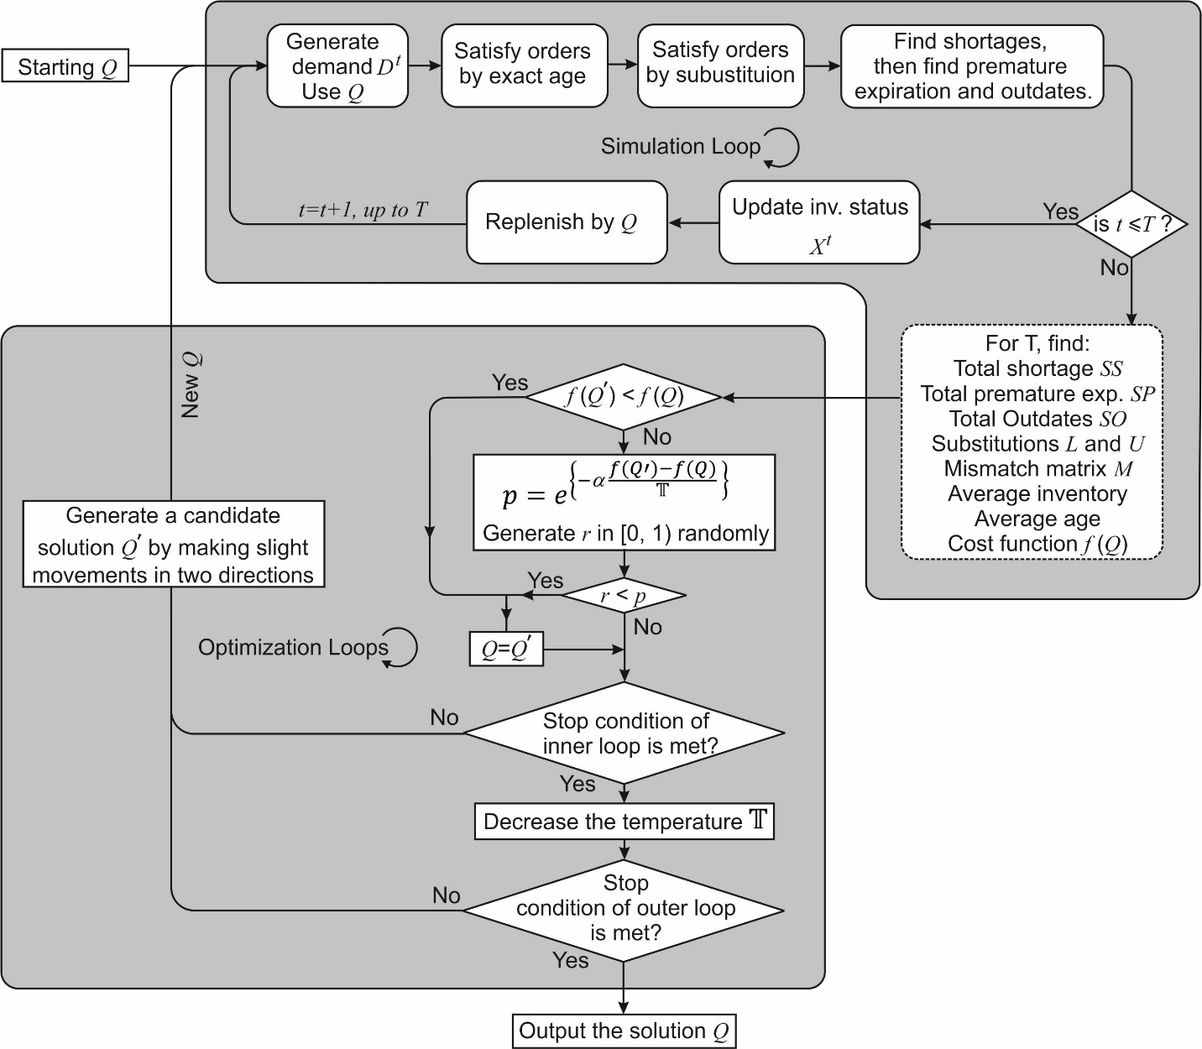

It must be noted that there is a complementary mutual concatenation between simulation and optimization. Each simulation run implements the decision vector (Q) to evaluate the objective function. The decision vector is determined following a search undertaken through optimization. What this means is that the search for the next move is guided by the output of simulation (emanating from the optimization algorithm). The output is transferred to the key SA optimization loop and the cycle repeats. There is a requirement for simulation to trigger daily random demands as well as for the operation of stochastic SA while MATLAB is employed to build a code library for the simulation and the search algorithm. The built code library can adapt to any platelet age settings. For this reason, it is possible to differentiate platelet demand by as many iterations of age as may be required. All stochastic parts in the model including premature expiration, random demand and stochastic search are dependent on random number generation such as Monte Carlo simulation.

Commencing with an initial solution $Q$, a simulation of platelet inventory is undertaken over the entire duration of planning. Next, a new solution neighborhood is found which can be located by considering the degree of shortages and outdates. Shortages guide the search to increase the quantity of platelet orders, while observed outdates guide the search to lower platelet quantities. If both shortages and outdates are observed (which is the most common scenario while searching), the higher quantity will have more influence on the search direction.

A neighborhood is identified by moving a step $s$ in some direction. During the search undertaken within the different neighborhoods, there is a variation with the step size that is dependent on a schedule. The step size is reset to its original value at any point in time that the algorithm proceeds to a new neighborhood. Simulation is utilized to test the value for objective function at every point in time moves are made. At any point an improved value emerges, the solution is accepted, otherwise, rejected with a probability given by $e^{\left\{- \frac{f_{new}-f_{old}}{T} \right\}}$, where the following nomenclatures are employed for notations:

$T$: Temperature
f: Value of cost function value (for both existing and new solutions – in effect, the decision variable).
α > 0: Tuning parameter.

As experienced in any conventional simulated annealing, there will be a cooling of temperatures while the search is being undertaken due to a multiplicative factor θ, where 0 <θ <1. The algorithm will generally cease to run at the point that no compelling enhancements to the objective function is ascertained or alternatively when the maximal number of search trials have been run. The solutions that are deemed viable will be those seen to fulfill non-negative upper and lower limits.

6.0 Analysis
6.1 The scenarios
For performance tests of the model that is proposed, a two-phased analysis is employed. First, the robustness of the search algorithm is tested by comparing the results with analytically solved models – in this case, the classical newsvendor. Second, analysis is undertaken based on testing the five conditions against four different inventory status and issuance policy scenarios. In all experiments below, the following search parameters where used: α = 0.9, θ = 0.5 and a starting temperature ($T$) of “1” which cools down as the algorithm advances in the search process.

6.2. Analysis 1 (Comparison with the classical newsvendor)
By considering platelets of a one-day shelf life, the proposed model will be reduced to the classical newsvendor problem in that platelets will need to be disposed if not used the same day. Considering normal distribution N(µ,σ) for the demand and equal overage and underage costs of the newsvendor problem, we can easily find the analytical solution which is given by $F\left(Q\right)=\frac{c_{0}}{c_{0}+c_{u}}$, where $F$ is the demand cumulative distribution, $Q$ is the order quantity, and$c_{0}$ and $c_{u}$ are the overage and underage costs, respectively.

For comparison purposes, we assumed that the overage and underage costs are the same with no holding costs. Table 4 (below) shows the outcomes of the analytical solution and those that emerged from the proposed model. The Mean Absolute Percent Error (MAPE) is less than 0.3% for the simulated case indicating accuracy in finding the optimality neighborhood in simulated scenarios.
Table 4: Comparison between the classical newsvendor and the numerical solutions
µ | σ | Analytical optimal value | Simulation optimal value | # of iterations | %Error
50 | 10 | 50 | 49.98 | 250 | 0.0004
100 | 20 | 100 | 100.24 | 250 | 0.0024
150 | 30 | 150 | 149.51 | 250 | 0.003267
200 | 40 | 200 | 200.56 | 250 | 0.0028
50 | 20 | 50 | 50.13 | 250 | 0.0026
100 | 30 | 100 | 100.58 | 250 | 0.0058
150 | 40 | 150 | 150.61 | 250 | 0.004067
200 | 50 | 200 | 199.47 | 250 | 0.00265
 |  |  | MAPE |  | 0.2998%

With the above results in mind, we undertake validation of the proposed model using real-life data.

6.3. Analysis 2 (against the five conditions)
The model is validated by utilizing data drawn from the blood platelet inventory of selected hospitals in the State of Kuwait. The data were obtained from publicly available information provided by the Kuwait Central Blood Bank.

The State of Kuwait has a population of nearly three million, although only around 30% of its population are nationals (Central Intelligence Agency, 2019). There are approximately 29 public hospitals and health-related centers in the country, all delivering multi-specialty high-quality care to patients (Kuwait Government Online, 2018). The Kuwaiti Ministry of Health administers all public hospitals, while the Kuwait Central Blood Bank is the main center responsible for obtaining, preserving and safely distributing blood supplies in the country. Although, public hospitals in Kuwait can seek and directly receive donated blood supplies, as the country covers a small geographical area (17,818 km²), the majority of public hospitals source their blood supplies from the Kuwait Central Blood Bank. While platelets may be extracted either following whole blood donation and component separation or directly via apheresis (Williamson and Devine, 2013), the Kuwait Central Blood Bank utilizes apheresis to obtain platelets (Kuwait Central Blood Bank, 2019). Although Apheresis is particularly expensive (when compared to blood component separation), it is generally considered to represent a more superior form of platelet extraction. The use of apheresis to extract platelets is also more likely to ensure that the functional integrity of platelets will not be interfered with during extraction (Burgstaler, 2006; Townsend and Li, 2019). In Table 5 (below), we show the highest observed demand of platelets in selected public hospitals (names have been anonymized) in Kuwait.

As mentioned above, we undertake the analysis on the basis of a period of planning of one calendar year (T=365 days). To build higher confidence into the results, each experiment will be repeated a total of 30 times utilizing different random data streams. Using a narrow Half Width HW of $10 (<5% error margin) for the objective function, thirty replications have been selected as it is a statistically acceptable number to provide good confidence in the results. Following an iterative approach for the first hospital using the expression $HW\left(R,α\right)=t_{\frac{α}{2},R-1}{\left(\frac{S}{\sqrt{R}}\right)}^{2}$ (Behnam et al., 2018; Muhammed et al., 2020), where S is the data standard deviation and R is the number of replications, the results are shown in Table 6. Of note, since this number will be used for different scenarios, we decided to increase the replications from 28 to 30, although the experiment with 28 replications have yielded a lower number (i.e., 27.07).

Table 5: The demand of platelets’ units (selected Kuwaiti public hospitals, 2016)
Hospital | Platelets Aph units |  | Average daily demand for platelets of different ages (Units/day)
 |  |  | Fresh | Young | Mature | Old | Elderly
A | 16829 |  | 18.4 | 13.8 | 6.9 | 4.6 | 2.3
B | 7164 |  | 7.9 | 5.9 | 2.9 | 2.0 | 1.0
C | 5748 |  | 6.3 | 4.7 | 2.4 | 1.6 | 0.8
D | 4859 |  | 5.3 | 4.0 | 2.0 | 1.3 | 0.7
E | 3084 |  | 3.4 | 2.5 | 1.3 | 0.8 | 0.4
F | 2700 |  | 3.0 | 2.2 | 1.1 | 0.7 | 0.4
G | 2662 |  | 2.9 | 2.2 | 1.1 | 0.7 | 0.4
H | 2526 |  | 2.8 | 2.1 | 1.0 | 0.7 | 0.3
I | 2079 |  | - | - | - | - | -
J | 1432 |  | - | - | - | - | -
K | 368 |  | - | - | - | - | -
L | 117 |  | - | - | - | - | -
M | 44 |  | - | - | - | - | -
“-” means inapplicable quantity.
“Aph” means Apheresis units.
Table 6: Number of replications.
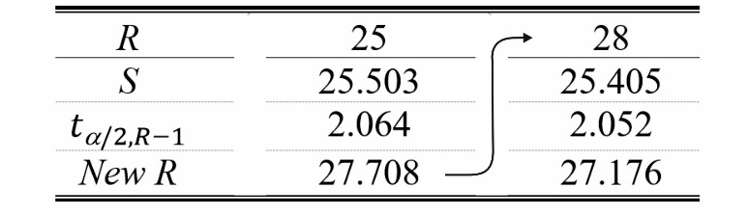

Four different Inventory status and issuance policy scenarios are used in the subsequent experiments. Recall earlier (in section 3.4) that ‘No-Compatibility’ referred to a policy where order fulfillment has only exact age match while ‘With-Compatibility’ implied where order fulfillment allows for age mismatch. For simplicity of notation, the four scenarios are designated as:

- Scenario 1 (‘No-Compatibility-No-Premature expiration’)
- Scenario 2 (‘No-Compatibility-With-Premature expiration’)
- Scenario 3 (‘With-Compatibility-No-Premature expiration’)
- Scenario 4 (‘With-Compatibility-With-Premature expiration’)

On inspection, it will appear that Scenario 4 is the most prevalent scenario in realistic applications. It is assumed that the demand for platelets in the eight selected hospitals follows Poisson distribution. Since the demand for blood components is usually discrete and in the form of units, Poisson distribution is applied to model the size of demand occurring within a given time interval. Each occurrence in Poisson distribution is independent of the other occurrences, a fact which coincides with the demand pattern of our model. Since the mean number of occurrences is constant for each specific day, Poisson distribution becomes the distribution of choice. Typically, Poisson distribution is used to model traffic flow and ideal gap distances. Note that both the mean and variance of Poisson distribution are the same. An estimate of the means of the demand associated with each platelet age as reported by each hospital is shown in Table 5. All Kuwaiti public hospitals adhere to JPAC (2019) recommendations for platelet shelf life of five days. For simplicity of designation, we employ the same notation as used during modelling assumptions; that is Fresh, Young, Mature, Old and Elderly. Table 2 shows the preferences in compatibility when A=5.

6.4 Impact of compatibility and premature expiration on cost:
Upon replicating the 4 scenarios above for 30 times, the results were presented in Figure 2. The optimal objective function values of each scenario are detailed to each hospital. Hospitals are ranked in a descending order depending on the level of platelet demands.

What we observe is that the cost of Scenario 3 is the lowest, followed by Scenario 4. While Scenario 2 exhibits the highest cost, Scenario 1 comes second highest. The first two scenarios assume that platelets retain their functional integrity until the end of the fifth day in storage. However, the other two scenarios appear more realistic if our contention that premature expiration is an inevitable consequence of storage. Premature expiration has a slight effect on increasing the cost; however, it is the compatibility which has the greatest impact. Indeed, ‘With-Compatibility’ will drastically reduce the objective function regardless of premature expiration status.

Figure 2: Average cost/day along with the distribution of the actual cost
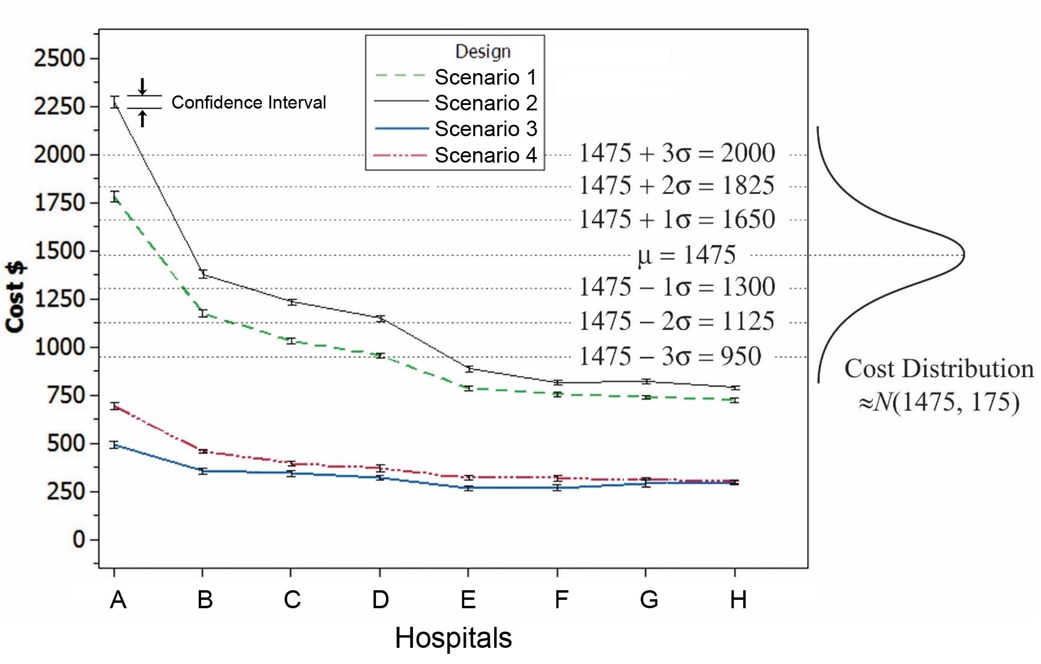

The tight confidence intervals (CIs) in Figure 2 suggest consistent results and a minimum chance of a local minima traps. The mean and standard deviation of the costs were gauged by approximately Norm (445, 53) Kuwaiti Dinars; in effect, Norm (1475, 175) US$. In Figure 2, this distribution is positioned to show the chances of the actual cost being less than the cost of the proposed policy under the assumption that the actual cost is stochastic, which is extremely unlikely especially when compatibility is allowed. For instance, taking scenario 4 as the most common case under premature expiration of hospital A, the cost is around $700, hence, this chance will be NORM.DIST(700,1475,175,1) = ${4.7}^{-6}$, that is almost 5 in million times.

6.5 Effect of compatibility and premature expiration on average inventory and inventory mean age:
With the descending order of the hospitals with respect to demand, Figure 3 also shows that low demand yields lower average inventory. Scenario 1 exhibits the highest average inventory, while Scenario 4 is the lowest, which is a reasonable conclusion since premature expiration reduces the amounts in inventory.

Figure 3: Average inventory (by four scenarios)
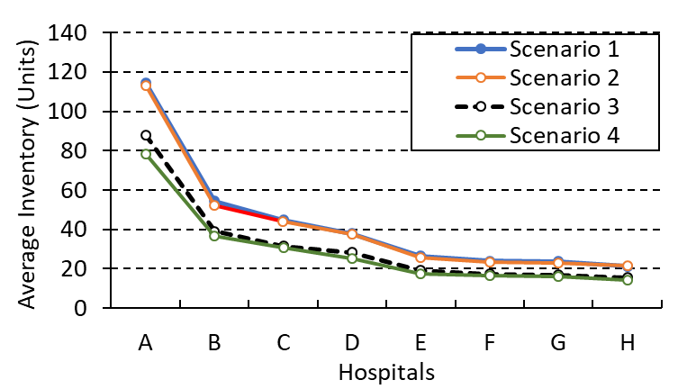
Moreover, the variance of the observed average ages increases in the case of the compatibility option. Figure 4 shows the average inventory age detailed to each hospital. The average age decreases by allowing compatibility; yet the confidence interval in Figure 4 increases at the same time.
Figure 4: Average inventory age detailed to each hospital
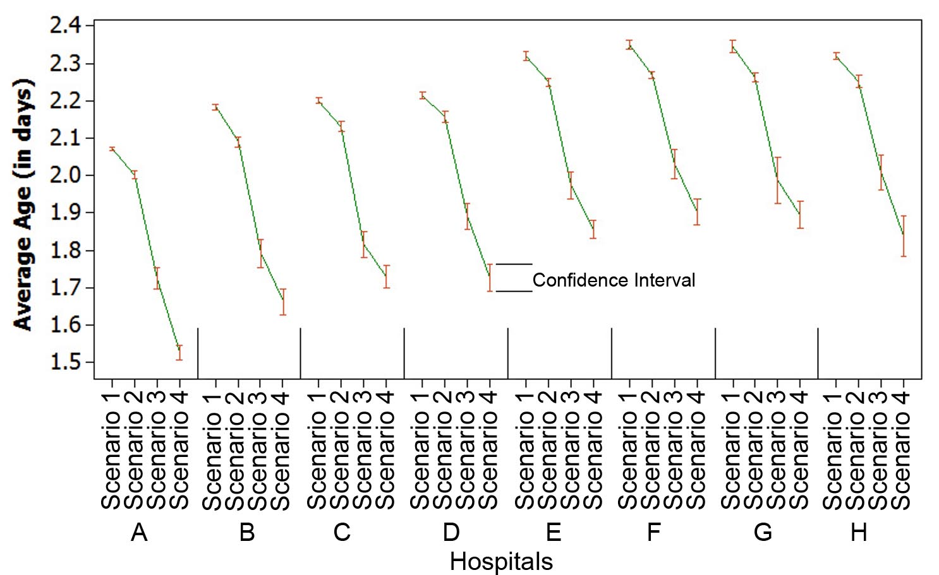

6.6 The effect of compatibility and premature expiration on the optimal quantities:
In Figure 5 (below), we show for the period of planning of one calendar year (T=365 days), the average of ordered platelets for the eight hospitals. As anticipated, it is observed that when substitution is allowed, as an increased number of mismatches are allowed, the quantity of ordered platelets will be less. Nevertheless, slight variations are observed in the ordered quantities between the four scenarios. This strongly suggests that the inventory policy has an impact on costs. Once again, lower demand entails lower ordered quantities.

Figure 5: Average order quantities of 30 trials
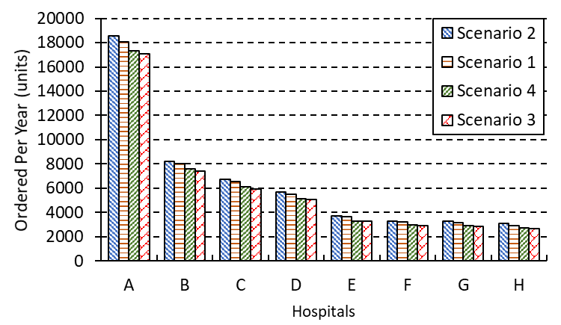
Figure 6-a (below) shows the average shortage for the five ages; from ‘Fresh’ right through to ‘Elderly’, for the case of Scenario 2. The average shortage of the five ages for Scenario 4 is shown in Figure 6-b (below). Clearly, Scenario 2 presents much higher shortages as only exact match is accepted here. Shortage in ‘Fresh’ platelets will be low because they not only have the highest priority in terms of substitute acquisitions, but also because they are the only platelet types that will receive replenishment. A slight decrease in shortage is observed in the ‘Elderly’ units primarily due to the fact that no subsequent ages will require platelets. Scattered shortage is observed in Scenario 4 due to induction of premature expiration. While in both scenarios, the shortage tends to increase by age, the impact of compatibility in reducing shortage is significant in every age.
Figure 6: Shortages of Scenario 2 and Scenario 4.
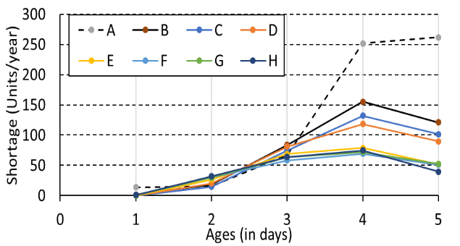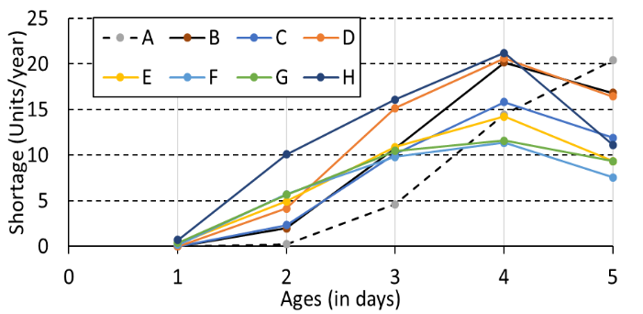
a) For Scenario 2, No compatibility but with premature expiration. | b) For Scenario 4, With both compatibility and premature expiration.
As for the premature expiration, higher expiration is observed in the case of ‘No-Compatibility’ (Figure 7-a) as compared to ‘With-Compatibility’ (Figure 7-b). This reassures us that compatibility is a key policy in reducing premature expiration cost. Hospitals of higher demands and blood circulation exhibit higher premature expiration (for example, Hospital ‘A’ is the highest, while Hospital ‘H’ is the lowest in both scenarios). Note that with compatibility in Figure 7-b, the premature expiration is lower than that without compatibility.

Figure 7: Premature expiration
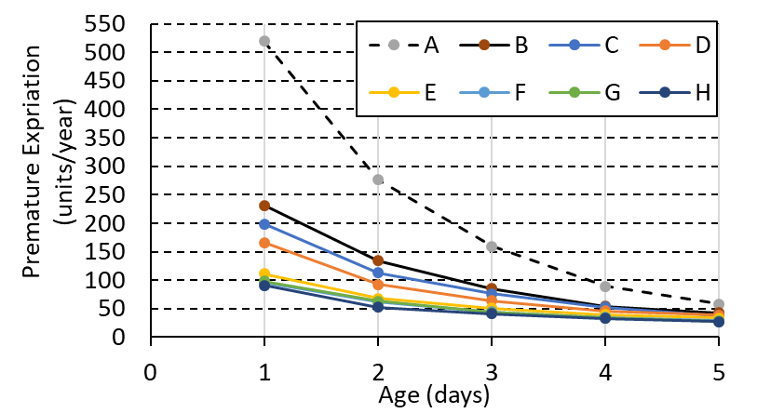 | 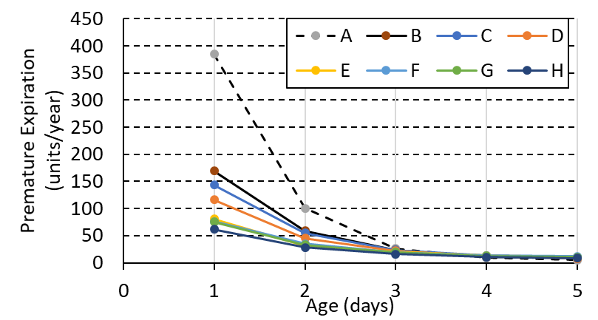
a) Premature expiration for Scenario 2 | b) Premature expiration for Scenario 4
In Table 7 and Figure 8, we show the outdate quantities for the entire planning period. What we do observe is that hospitals exhibiting lower demands such as Hospital ‘G’ and Hospital ‘H’, experience a lower level of outdates. The problem of outdating is increasingly pronounced in Scenario 1, followed by Scenario 2, Scenario 3 and finally Scenario 4, which presents the lowest outdates.
Figure 8: Outdates in units/year
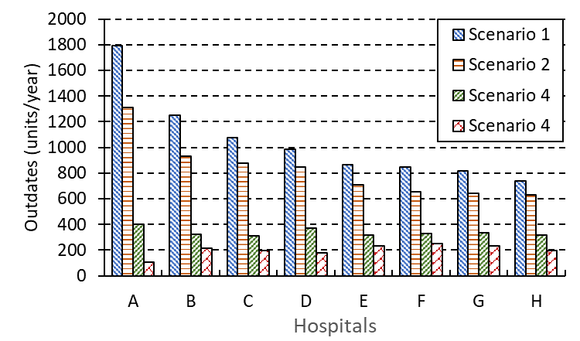

Table 7: The average outdates and their confidence intervals (units/year).
 | Inventory Policy
Hospital | NCNP | NCWP | WCNP | WNWP
‘A’ | 1793.37  [1745.54, 1841.19] | 1310.07  [1246.60, 1373.54] | 403.57  [359.03, 448.11] | 104.87  [90.33, 119.40]
‘B’ | 1251.23  [1222.22, 1280.25] | 930.20  [885.49, 974.91] | 321.07  [275.55, 366.58] | 212.73  [191.46, 234.01]
‘C’ | 1076.23  [1049.81, 1102.65] | 879.87  [835.28, 924.46] | 313  [273.93, 352.07] | 197.40  [178.77, 216.03]
‘D’ | 985.67  [953.32, 1018.01] | 846.10  [796.60, 895.60] | 371.33  [340.66, 402.01] | 179.13  [161.28, 196.98]
‘E’ | 862.53  [835.40, 889.67] | 707.33  [683.27, 731.40] | 318.17  [288.99, 347.35] | 233.47  [218.10, 248.83]
‘F’ | 846.97  [814.79, 879.15] | 651.67  [632.87, 670.46] | 328.17  [297.35, 358.98] | 251.03  [223.06, 279.00]
‘G’ | 814.27  [774.93, 853.61] | 639.87  [614.21, 665.53] | 336.93  [288.98, 384.88] | 231.57  [211.50, 251.63]
‘H’ | 740.87  [721.84, 759.90] | 627.90  [591.72, 664.08] | 317.20  [273.66, 360.74] | 196.40  [166.34, 226.46]

We undertake analysis based on five assumptions – (i) ‘Age-differentiated demand’ (ii) ‘Stochastic demand’ and (iii) ‘Specific inventory issuance policy’. In the present study, five decision conditions will be considered (i) ‘Age-differentiated demand’ (ii) ‘Customized replenishment decisions’ (iii) ‘Custom inventory and order fulfillment policy’ (iv) ‘Different costs considerations’ and most importantly (v) ‘Stochastic inventory expiration lifetimes’. These assumptions are tested against four scenarios.

6.7 Supply-demand Point of Views of different lifetimes
Figure 9 a and b show the percentage of platelets of a specific age that has its demand met by provision of an exact match for Scenarios 3 and 4. Of note, the compatibility option means that the demand is satisfied by the exact match first, then a compatible match. Thus, the entire demand for ‘Fresh’ units was fully met by supplying platelets of that age (i.e., 0% of ‘Fresh’ were satisfied by other ages). Approximately 80-95% of the demand for ‘Young’ platelet units was met with an exact match; 55-70% of ‘Mature’ demand was met with an exact match, while 35-45% and 20-35% of ‘Old’ and ‘Elderly’ demand, respectively, were met with an exact match. The demand for older items is satisfied by less exact match. Almost the same percentages are observed in both Scenario 3 and Scenario 4. Except for age “1”, the satisfaction by exact match tends to be lower with premature expiration.

Figure 9: Proportion (%) satisfied by exact match of each age for Scenario 3 and Scenario 4
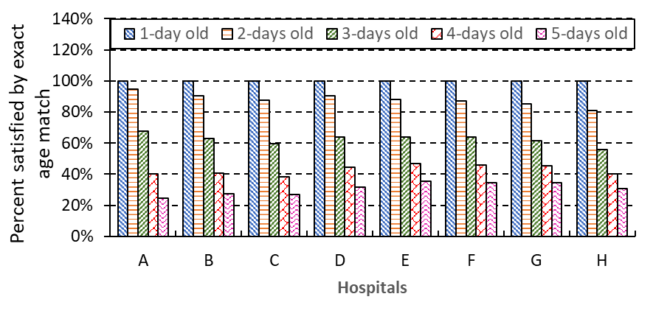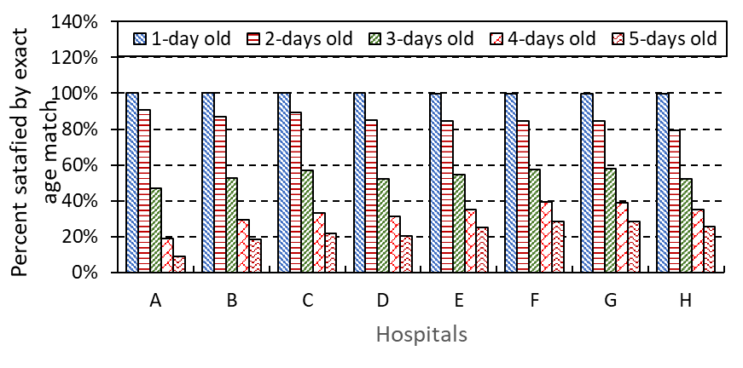
a) Proportion (%) satisfied by exact match against each age for Scenario 3 | b) Proportion (%) satisfied by exact match against each age for Scenario 4

As for the ability to satisfy the demand of platelet units of a specific age with those of another age (in other words, compatibility), Figure 10- a and b show the percent of each platelet type that was saved to meet the demand of other ages. Note that ‘Fresh’ units are not so generous in giving other ages, while ‘Elderly’ units (5 days old) participate most in covering other demands. Thus, it will appear that aged (or aging) units do present more opportunities for substitution when compared to those which are younger. By comparing scenario 3 with scenario 4, more generosity in giving can be noticed in the case of scenario 4 due to the increase in scarcity resulting from premature expiration.
Figure 10: Percent used to satisfy other ages
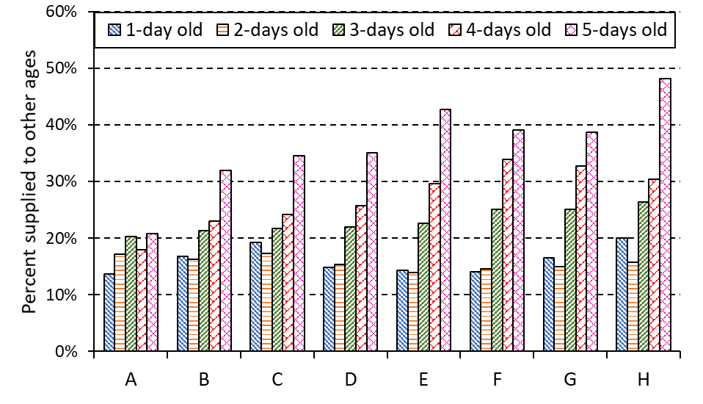
 | 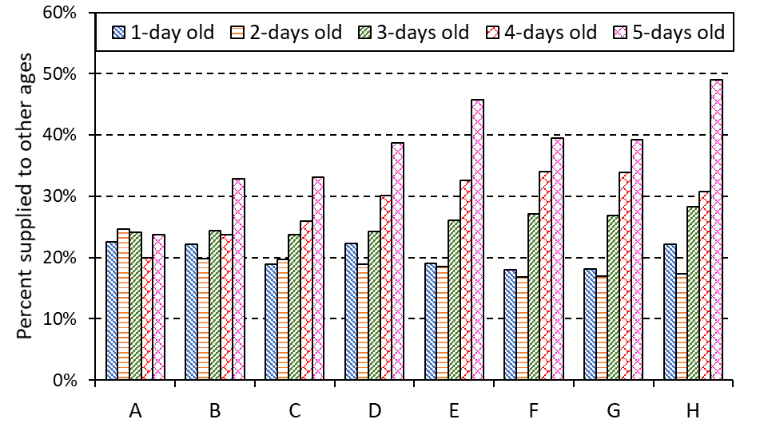
a) Scenario 3 (‘With-Compatibility-No-Premature expiration’) | b) Scenario 4 (‘With-Compatibility-With-Premature expiration’)

Lastly, we consider age mismatch which, as indicated in the literature, does contribute to inventory costs (Haijema et al., 2005; Duan and Liao 2013). To develop a sense on match options, we show in Figure 11-a and b substitution averages across the eight hospitals.

Figure 11: Substitution averages
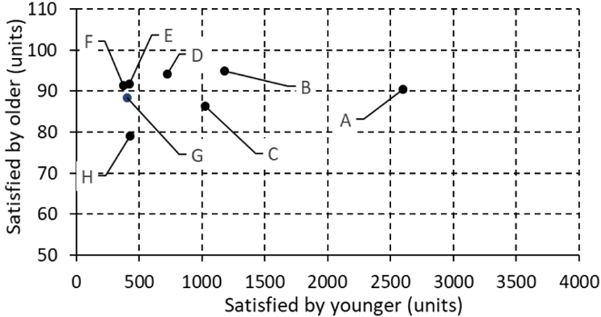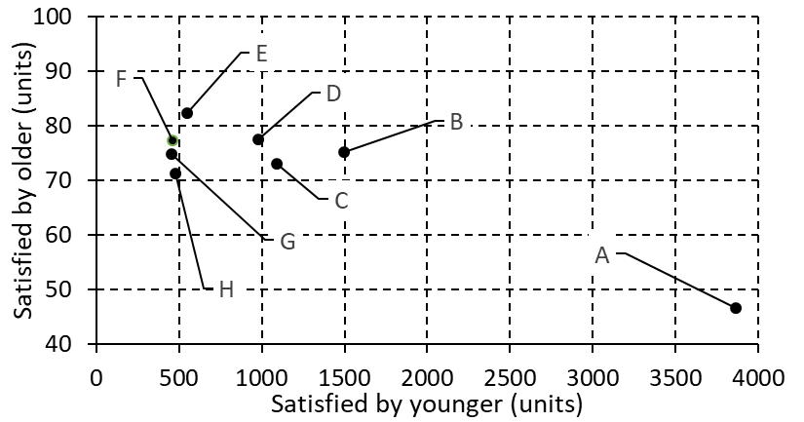

a) Average younger versus older substitution for all hospitals against Scenario 3 | b) Average younger versus older substitution for all hospitals against Scenario 4

Clearly, using younger platelet units to meet the demand is prominent in both compatibility scenarios. Recall that satisfying the demand for younger platelets is more desirable than meeting the demand for older ones. Figure 11 hence shows that higher demand results in higher age mismatch of younger platelets, while the magnitude of demand does not have much impact on substitution by older platelets. Compared to Scenario 3, Scenario 4 depends more on substitution by younger platelets. For instance, Hospital ‘A’ has an average of 2600/365=7.12 units/day satisfied by younger platelets and 0.25 units/day satisfied by older units for the case of Scenario 3, while these quantities are 10.6 and 0.13 in Scenario 4. Thus, it will appear that hospitals with higher platelet demand increasingly rely on substitution using younger platelets. Further comparison of the two figures shows a wider horizontal spread of the hospitals in scenario 4, which informs that higher numbers of orders is satisfied by younger ages due to experiencing premature expiration.

7.0 Sensitivity Analysis
The experimental part above presents different scenarios for different hospitals each of its own input. The different scenarios show the robustness of the model and its ability to cope with different demand patterns. For further sensitivity analysis, we show the convergence of the search algorithm given different initial temperatures of SA. Figure 12 shows the objective function vs. the number of runs being tested while searching for the best solution for the case of hospital ‘A’ where, α = 0.9, θ = 0.5. Clearly, higher temperatures could demonstrated lower costs, however with higher oscillations due to higher ability to skip local optima (the bottom line). On contrary, low temperatures result in less flexibility while searching the solutions’ neighborhoods and higher cost with less oscillations.

Figure 12: The valuation of the cost function vs. different iterations.
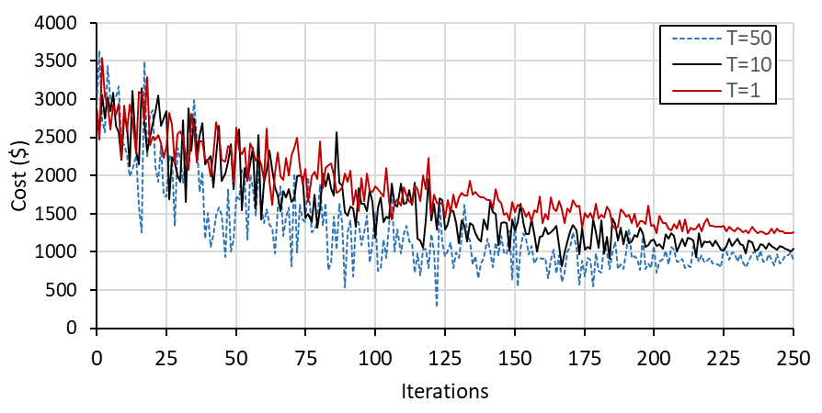

Similarly, by conducting experiments to test the effect of weighted costs, acceptable results could be found in Figure 13. The expiration and shortage costs were considered for the tradeoff between the two components for hospital “E”. When the cost of expiration is emphasized, low number of outdated units is observed while the shortage tends to increase due to its low cost. The opposite pattern can be observed where low shortage and higher expiration are observed for high shortage and low expiration weights. In our model general settings, the shortage cost is higher than the expiration cost which explains the high expiration compared to shortage.

Figure 13: The results of weighted shortage and expiration costs for hospital “A”.

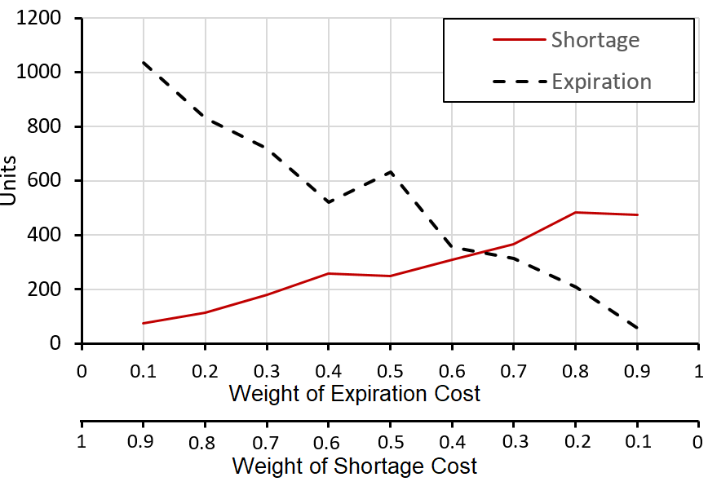

Finally, while to a certain extent age matching is employed in practice, particularly for patients who require exact ages as illustrated in section 1 and 2, the current practice does not consider systematic order fulfillment policies, resulting in inefficient inventory management. By employing the presented procedure for order fulfillment along with the resulting optimal quantities, costs can be reduced. It is important to note that blood is collected in custom-manufactured 500ml packs, while the resulting optimal quantities may have fractions due to continuous solution space. This may bring some practical difficulties in the implementation. Moreover, restricting the optimal quantities to integer numbers may result in worse solutions. As for premature expiration, the common practice does not include real-time monitoring of blood components, where tests are conducted only upon the inquiry of the quantities. Research is continuing on the issue of real-time monitoring of blood condition and the level of deterioration/contamination. Anyway, the proposed model is promising in terms of cost reduction due to shortage, outdating, random expiration and age differentiated demand. Lastly, the order fulfillment guidelines can be easily programmed in digitally monitored storage chambers.

8. Conclusions
As in the case of the wider operations and supply chain management arena, the need for optimal use of very limited products and services is essential to the healthcare services industry. The implications of this is that the use of simulation is now been widely utilized to address healthcare management challenges – one such challenge to which this study focuses upon is the need to minimize volatility in blood platelet supply and demand. Doing so will arguably not only save lives, but also ensures that the wider society is not exposed to contaminated blood supplies.

The context of blood supplies has retained considerable research interest among scholars. Noting a substantial amount of literature on deterministic lifetimes of blood as perishable inventory, but paucity in the studies on randomized accelerated deterioration, this study set out with the assistance of a simulation and optimization inventory management model, to explore how best to mitigate against inventory volatility in blood platelet. The study was set against five decision conditions, some like ‘Customized Replenishment decisions’, ‘Inventory status and issuance policy’ and ‘Different costs considerations’ have been prominently articulated in the academic literature, while others such as ‘Random aging and age-differentiated demand’ and ‘Random inventory expiration lifetimes’ appear to have been hardly explored. Utilizing data drawn from the blood platelet inventory of selected hospitals in the State of Kuwait, analysis was undertaken in the form of tests set against different inventory status and issuance policy scenarios. Findings from the study suggested that conditions where higher quantities of perishable products stocked in inventories will lead to experiencing premature expiration. Findings also suggests that in perishable inventories, higher levels of shortages and premature expiration will be experienced where there is an absence of product compatibility (substitution). Other findings suggested that older perishable products appeared to enjoy a higher likelihood of compatibility (substitution). Conversely, newer perishable products were more likely to be age-specific, and thus experience less compatibility (substitution). Taken together, this study is one of the very few that has addressed two relatively explored decision conditions in perishable inventory management, that is, ‘Random aging and age-differentiated demand’ and ‘Random inventory expiration lifetimes’. The reality that inventory management decisions may be dependent on these conditions should no longer be disregarded and should be of interest to future research.

In order to best determine the quantity of platelets to order, the number to replenish, orders to be fulfilled, when and which platelets to be utilized to meet demand, operations managers require a full and comprehensive picture of inventory levels and patterns. This is because more often than not, platelets of different ages are stored on the same shelf. Without this information, the successful management of platelet inventory becomes extremely challenging and near impossible. Arguably, the findings from the study serves as an appropriate platform to advance implications for operations management practice. The first being the desire for healthcare service provider to focus their attention on accelerated degradation and deterioration as assessed by both expiration due to aging and premature expiration of stored platelets. Apart from visual inspection (which requires experience), it may be possible to detect such early degradation and deterioration (expiration) through proactive screening (see Dreier et al., 2008). In essence, the management of platelet inventories requires constant inspection and monitoring. The versatility of the developed solution allows for its use and application beyond the realms of perishable inventory management in healthcare services settings. Certainly, the authors acknowledge that, to generalize the outcomes of the study, the model requires to incorporate scenarios and regulatory environments which differ not only across countries, but also between different healthcare settings. Nevertheless, the study does provide a firm foundation to allow managers from other industry sectors to apply this solution in order to enhance the management of their perishable inventories. This is possible because the decision conditions that served as the foundation for the study is not specific to the case. Instead, these conditions were derived from a wide review of perishable inventory literature. In effect, the five conditions can be used as decisional means to improve the performance of perishable inventories in other service environments such as the pharmaceutical industry where drug expiration of branded products remains a key challenge.

References
Acimovic, J., & Graves, S. (2012). Making better fulfilment decisions on the fly in an online retail environment. Working paper. Cambridge, MA: MIT, Sloan School of Management.
Ageron, B., Benzidia S., & Bourlakis, M. (2018). Healthcare logistics and supply chain – issues and future challenges. Supply Chain Forum: An International Journal, 19 (1), 1-3.
Ali, I., Nagalingam, S., & Gurd, B. (2017). Building resilience in SMEs of perishable product supply chains: enablers, barriers and risks. Production Planning & Control, 28(15), 1236-1250.
Alrabghi, A., & Tiwari, A. (2015). State of the art in simulation-based optimisation for maintenance systems. Computers and Industrial Engineering, 82, 167–182.
American Association of Blood Banks (AABB). (2011). Nationwide blood collection and utilization survey report. www.aabb.org, accessed 06/02/14.
Arya, R., Wander, G., & Gupta, P. (2011). Blood component therapy: which, when and how much. Journal of Anaesthesiology, Clinical Pharmacology, 27(2), 278-284.
Atkinson, M., Fontaine, M., Goodnough, L., & Wein, L. (2012). A novel allocation strategy for blood transfusions: Investigating the tradeoff between the age and availability of transfused blood. Transfusion, 52(1), 108 - 117.
Avci, M., & Selim, H. (2018). A multi-objective simulation-based optimization approach for inventory replenishment problem with premium freights in convergent supply chains. Omega, 80, 153-165.
Bakker, M., Riezebos, J., & Teunter, R. (2012). Review of inventory systems with deterioration since 2001. European Journal of Operational Research, 221(2), 275-284.
Banks, J. (1998). Handbook of simulation: Principles, methodology, advances, applications, and practice. John Wiley & Sons, Inc.
Baş Güre, S., Carello, G., Lanzarone, E., & Yalçındağ, S. (2018). Unaddressed problems and research perspectives in scheduling blood collection from donors. Production Planning & Control, 29(1), 84-90.
Bierlaire, M. (2015). Simulation and optimization: A short review. Transportation Re- search Part C: Emerging Technologies, 55, 4–13..
Blum C., Puchinger J., Raidl, G., & Roli, A. (2011). Hybrid metaheuristics in combinatorial optimization: a survey. Applied Soft Computing, 11 (6), 4135–4151.
Bosman, G., Lasonder, E., Luten, M., Roerdinkholder‐Stoelwinder, B., Novotný, V., Bos, H., & De Grip, W. (2008). The proteome of red cell membranes and vesicles during storage in blood bank conditions. Transfusion, 48(5), 827-835.
Burgstaler, E. (2006). Blood component collection by apheresis. Journal of Clinical Apheresis, 21(2), 142-151.
Cancelas, J., Dumont, L., Maes, L., Rugg, N., Herschel, L., Whitley, P., Szczepiokowski, Z., Siegel, A., Hess, J., & Zia, M. (2015). Additive solution‐7 reduces the red blood cell cold storage lesion. Transfusion, 55(3), 491-498.
Central Intelligence Agency (2019). The World Factbook- Kuwait. https://www.cia.gov/library/publications/the-world-factbook/geos/ku.html,accessed 24/05/19.
Chandra, T., Gupta, A., & Kumar, A. (2014). Extended shelf life of random donor platelets stored for 7 days in platelet additive solution at different temperatures. Biomedical Journal, 37(4), 211-217.
Chapman, J., Hyam, C., & Hick, R. (2004). Blood inventory management. Vox Sanguinis, 87, 143-145.
Chen, C-H., Jia, Q-S., & Lee, L. (Eds.). (2013). Stochastic simulation optimization for discrete event systems (1st edition). Pub. World Scientific
Chen, C-H., & Lee, L. (2010). Stochastic simulation optimization: an optimal computing budget allocation, Vol. 1, Pub. World Scientific.
Chen, X., Pang, Z., & Pan, L. (2014). Coordinating inventory control and pricing strategies for perishable products. Operations Research, 62(2), 284-300.
Chen, Y., & Disney, S. (2007). The myopic order-up-to policy with a proportional feedback controller. International Journal of Production Research, 45(2), 351-368.
Chu, Y., You, F., Wassick, J., & Agarwal, A. (2015). Simulation-based optimization framework for multi-echelon inventory systems under uncertainty. Computers & Chemical Engineering, 73, 1-16.
Civelek, I., Karaesmen, I., & Scheller-Wolf, A. (2015). Blood platelet inventory management with protection levels. European Journal of Operational Research, 243(3), 826-838.
Dalalah, D., Bataineh, O., & Alkhaledi, K., (2018). Platelets inventory management: A rolling horizon Sim–Opt approach for an age-differentiated demand. Journal of Simulation, https://doi.org/10.1080/17477778.2018.1497461, In Press.
de Sousa Junior, W., Montevechi, J., de Carvalho Miranda, R., de Oliveira, M., & Campos, A. (2020). Shop floor simulation optimization using machine learning to improve parallel metaheuristics, Expert Systems with Applications, 150, 113272,
Dreier, J., Störmer, M., Pichl, L., Schottstedt, V., Grolle, A., Bux, J. and Kleesiek, K. (2008). Sterility screening of platelet concentrates: questioning the optimal test strategy. Vox Sanguinis, 95(3), 181-188.
Duan, Q., & Liao, T. (2013). A new age-based replenishment policy for supply chain inventory optimization of highly perishable products. International Journal of Production Economics, 145, 658–671.
Farhan, H., Ali, M., Sheikh, N., Badar, A., & Mehmood, S. (2020). Building thermal load management through integration of solar assisted absorption and desiccant air conditioning systems: A model-based simulation-optimization approach. Journal of Building Engineering, 30, 101279.
Firoozi, Z., & Ariafar, S. (2017). A supply chain network design model for random-lifetime products. Journal of Industrial and Production Engineering, 34(2), 113-123.
Fontaine, M., Chung, Y., Rogers, W., Sussmann, H., Quach, P., Galel, S., Goodnough, L., & Erhun, F. (2009). Improving platelet supply chains through collaborations between blood centers and transfusion services. Transfusion, 49(10), 2040–2047.
Gabriel, G., Campos, A., Leal, F., & Montevechi, J. (2020). Good practices and deficiencies in conceptual modelling: A systematic literature review. Journal of Simulation, 1–17. https://doi.org/10.1080/17477778.2020.1764875, In Press
García-Roa, M., del Carmen Vicente-Ayuso, M., Bobes, A., Pedraza, A., González-Fernández, A., Martín, M., Sáez, I., Seghatchian, J., & Gutiérrez, L. (2017). Red blood cell storage time and transfusion: current practice, concerns and future perspectives. Blood Transfusion, 15(3), 222-231.
Gaukler, G., Ketzenberg, M., & Salin, V. (2017). Establishing dynamic expiration dates for perishables: An application of RFID and sensor technology. International Journal of Production Economics, 193, 617-632.
Georgios, D., Rotondo, A., & Heavey, C. (2019). Embedding optimization with deterministic discrete event simulation for assignment of cross-trained operators: An assembly line case study. Computers & Operations Research, 111, 99-115.
Gonzalez, S., Jalali, H., & Van Nieuwenhuyse, I. (2020). A multiobjective stochastic simulation optimization algorithm. European Journal of Operational Research, 284 (1), 212-226.
Goyal, S., & Giri, B. (2001). Recent trends in modeling of deteriorating inventory. European Journal of Operational Research, 134(1), 1–16.
Gunpinar, S., & Centeno, G. (2015). Stochastic integer programming models for reducing wastages and shortages of blood products at hospitals. Computers & Operations Research, 54, 129-141.
Haijema R. (2011). Optimal Issuing of Perishables with a Short Fixed Shelf Life. International Conference on Computational Logistics: ICCL 2011: Computational Logistics, 160-169.
Haijema, R., van der Wal, J. and van Dijk, N. (2005). Blood platelet production: A multi-type perishable inventory problem. In Operations Research Proceedings, 84-92. Springer, Berlin, Heidelberg.
Haijema, R., van der Wal, J., & van Dijk, N. (2007). Blood platelet production: Optimization by dynamic programming and simulation. Computers & Operations Research, 34 (3), 760–779.
Haijema, R., van Dijk, N., van der Wal, J. & Sibinga, C. (2009). Blood platelet production with breaks: optimization by SDP and simulation. International Journal of Production Economics, 121(2), 464-473.
Hanafiah, N., Wijaya, I., Xavier, S., Young, C., Adrianto, D., & Shodiq, M. (2019). Itinerary Recommendation Generation using Enhanced Simulated Annealing Algorithm, Procedia Computer Science, 157, 605-612.
Hasan, I., Bahalkeh, E., & Yih, Y. (2020). Evaluating intensive care unit admission and discharge policies using a discrete event simulation model. Simulation, 96(6), 501- 518.
He, Y., Liang, Y., Liu, Z., & Hui, C. W. (2017). Improved exact and meta-heuristic methods for minimizing makespan of large-size SMSP. Chemical Engineering Science, 158, , 359–369.
Herrmann, F. (2013). Simulation based priority rules for scheduling of a flow shop with simultaneously loaded stations. In Proceedings - 27th European Confer- ence on Modelling and Simulation, ECMS 2013 (pp. 775–781).
Hess, J. (2010). Conventional blood banking and blood component storage regulation: opportunities for improvement. Blood Transfusion, 8 (Suppl 3), s9-s15.
Hess, J., Rugg, N., Knapp, A., Gormas, J., Silberstein, E., & Greenwalt, T. (2000). Successful storage of RBCs for 9 weeks in a new additive solution. Transfusion, 40(8), 1007-1011.
Izak, M. and Bussel, J. (2014). Management of thrombocytopenia. F1000prime reports, 6.
Janssen, L., Claus, T. and Sauer, J. (2016). Literature review of deteriorating inventory models by key topics from 2012 to 2015. International Journal of Production Economics, 182, 86-112.
Janssen L., Sauer, T. Claus, U., & Nehls (2018). Development and simulation analysis of a new perishable inventory model with a closing days constraint under non-stationary stochastic demand. Computers & Industrial Engineering, 118 (2018), pp. 9-22
Juan, A., Faulin, J., Grasman, S., Rabe, M., & Figueira, G. (2015). A review of simheuristics: Extending metaheuristics to deal with stochastic combinatorial optimization problems. Operations Research Perspectives, 2, 62–72.
Kang, M., Hwang, L., & Kwon, B. (2020). Computationally efficient optimization of wavy surface roughness in cooling channels using simulated annealing, International Journal of Heat and Mass Transfer, 150, 119300.
Karaesmen, I. Z., Scheller Wolf,A., & Deniz, B. (2011). Managing perishable and aging inventories: Review and future research directions. In K. Kempf, P. Keskinocak, & R. Uzsoy (Eds.), Kluwer international series in operations research and management science: vol.151. Handbook of production planning (pp.393–436). Kluwer Academic Publishers.
Kleijnen, J. (2017). Regression and kriging metamodels with their experimental designs in simulation: A review. European Journal of Operational Research, 256 (1), 1–16.
Kok, A., & Fisher, M. (2007). Demand estimation and assortment optimization under substitution: Methodology and application. Operations Research, 55(6), 1001 - 1021.
Kopach, R., Balcıoğlu, B., & Carter, M. (2008). Tutorial on constructing a red blood cell inventory management system with two demand rates. European Journal of Operational Research, 185(3), 1051-1059.
Kostic, K. (2009). Inventory control as a discrete system control for the fixed-order quantity system. Applied Mathematical Modelling, 33(11), 4201-4214.
Kouki, C. and Jouini, O. (2015). On the effect of lifetime variability on the performance of inventory systems. International Journal of Production Economics, 167, 23-34.
Kuwait Central Blood Bank. (2019). Donation and Donors Affair Unit. https://kuwaitcentralbloodbank.wordpress.com/donation-and-donors-affair-unit/, accessed 24/05/19.
Kuwait Government Online, (2018). Government Hospitals. https://www.e.gov.kw/sites/kgoenglish/Pages/Visitors/TourismInKuwait/EssintialServicesHospitals.aspx, accessed 22/05/19.
Kyu, P., Kaown, D., & Lee, K-K. (2020). Development of a simulation-optimization model for sustainable operation of groundwater heat pump system. Renewable Energy, 145, 585-595.
Lozano M., & Garcia-Martinez C., (2010). Hybrid metaheuristics with evolutionary algorithms specializing in intensification and diversification: overview and progress report. Computers & Operations Research, 37 (3), 481–497.
Machlus, K., Thon, J., & Italiano, J. (2014). Interpreting the developmental dance of the megakaryocyte: a review of the cellular and molecular processes mediating platelet formation. British Journal of Haematology, 165 (2), 227 - 236
Mandana, R., & Khasawneh, M. (2020). Simulation optimization approach for patient scheduling at destination medical centers. Expert Systems with Applications, 140, 112881.
Michelson, A. (2013). Platelets. 3rd ed. London; Waltham, MA: Academic Press.
Mohsen, A., & Shafiee, M. (2020). A stochastic simulation-optimization model for base-warranty and extended-warranty decision-making of under- and out-of-warranty products. Reliability Engineering & System Safety, 197, 106772.
Nahmias, S. (2011). Perishable Inventory Systems. Pub. Springer International Series in Operations Research & Management Science.
Ordu, M., Demir, E & Tofallis, C. (2020). A decision support system for demand and capacity modelling of an accident and emergency department, Health Systems, 9:1, 31-56.
Osorio, A., Brailsford, S., &Smith, H. (2015). A structured review of quantitative models in the blood supply chain: a taxonomic framework for decision-making. International Journal of Production Research, 53(24), 7191-7212.
Parlar, M. (1985). Optimal ordering policies for a perishable and substitutable product – A Markov decision model. INFOR, 23(2), 182 - 195.
Prastacos, G. (1984). Blood inventory management: an overview of theory and practice. Management Science, 30(7), 777-800.
Rahimikelarijani, B., Abedi, A., Hamidi, M., & Cho, J. (2018). Simulation modeling of Houston Ship Channel vessel traffic for optimal closure scheduling. Simulation Modelling Practice and Theory, 80, 89-103.
Rajendran, S., &Ravindran, A. (2019). Inventory Management of Platelets along Blood Supply Chain to Minimize Wastage and Shortage. Computers & Industrial Engineering, 130, 714-730.
Salins, S. (2015). The danger of near-expiry blood. British Journal of Anaesthesia, 115(eLetters Supplement), https://doi.org/10.1093/bja/el_12843, accessed 19/05/19.
Schneider, A. (1995). Blood components: Collection, processing, and storage. Veterinary Clinics: Small Animal Practice, 25(6), 1245-1261.
Shin, M., Lee, H., Ryu,K., Choc, Y., & Sond, Y. (2019). A two-phased perishable inventory model for production planning in a food industry. Computers & Industrial Engineering, Volume 133, July 2019, Pages 175-185.
Sörensen, K. (2015). Metaheuristics-the metaphor exposed. International Transactions in Operational Research, 22 (1), 3–18.
Stanger, S., Wilding, R., Yates, N., &Cotton, S. (2012a). What drives perishable inventory management performance? Lessons learnt from the UK blood supply chain. Supply Chain Management: An International Journal, 17(2), 107-123.
Stanger, S., Yates, N., Wilding, R., &Cotton, S. (2012b). Blood inventory management: hospital best practice. Transfusion Medicine Reviews, 26(2), 153-163.
Stroncek, D., & Rebulla, P. (2007). Transfusion medicine 2: Platelet transfusions. The Lancet, 370(9585), 427 - 438.
Tekin, E., Gürler, U., &Berk, E. (2001). Age-based vs. stock level control policies for a perishable inventory system. European Journal of Operational Research, 134(2), 309 - 329.
Townsend, M. & Li, M. (2019). Apheresis Blood Component Collections. In Transfusion Medicine and Hemostasis, 3rd (ed), 39-41. Elsevier.
Tsai, S., & Chen, S. (2017). A simulation-based multi-objective optimization framework: A case study on inventory management. Omega, 70, 148-159.
Valsami, S., Dimitroulis, D., Gialeraki, A., Chimonidou, M., & Politou, M. (2015). Current trends in platelet transfusions practice: The role of ABO-RhD and human leukocyte antigen incompatibility. Asian Journal of Transfusion Science, 9(2), 117-123.
Van Dijk, N., Haijema, R., Van Der Wal, J., & Sibinga, C. (2009). Blood platelet production: a novel approach for practical optimization. Transfusion, 49(3), 411-420.
Verma, A., & Agarwal, P. (2009). Platelet utilization in the developing world: strategies to optimize platelet transfusion practices. Transfusion and Apheresis Science, 41(2), 145-149.
Williamson L., &Devine D. (2013). Challenges in the management of the blood supply. The Lancet, 381, 1866-1875
Wong, K., Sandlin, R., Carey, T., Miller, K., Shank, A., Oklu, R., Maheswaran, S., Haber, D., Irimia, D., Stott, S., & Toner, M. (2016). The role of physical stabilization in whole blood preservation. Scientific Reports, 6, https://www.nature.com/articles/srep21023, accessed, 14/07/18.
Xu, J., Huang, E., Chen, C-H., & Lee, L. (2015). Simulation optimization: A re- view and exploration in the new era of cloud computing and big data. Asia- Pacific Journal of Operational Research, 32 (3), 1550019.
Ye, W., & You, F. (2016). A computationally efficient simulation-based optimization method with region-wise surrogate modeling for stochastic inventory management of supply chains with general network structures. Computers & Chemical Engineering, 87, 164-179.
Zeinab Sazvar, Z., Sepehri, M., & Baboli, A. (2016). A Multi-objective Multi-Supplier Sustainable Supply Chain with Deteriorating Products, Case of Cut Flowers, IFAC-PapersOnLine, Volume 49, Issue 12, Pages 1638-1643.
Zhou, D., Leung, L. and Pierskalla, W. (2011). Inventory management of platelets in hospitals: Optimal inventory policy for perishable products with regular and optional expedited replenishments. Manufacturing and Service Operations Management, 13(4), 420 - 438.
Zubair, A. (2010). Clinical impact of blood storage lesions. American Journal of Hematology, 85(2), 117-122.

