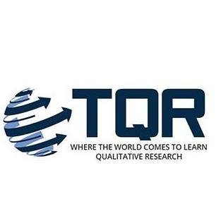
Supporting Indigenous and Non-Indigenous Research Partnerships

Rosalind Edwards
SSPC, University of Southampton, United Kingdom

With

Helen Moewaka Barnes
Whāriki Research Centre, Massey University, Aotearoa/New Zealand

Deborah McGregor
Osgoode Hall Law Faculty, York University, Canada

Tula Brannelly
Bournemouth University, United Kingdom

Abstract
This commentary discusses the framing of the production of a series of online text-based and visual resources aimed at researchers embarking on Indigenous and non-Indigenous research partnerships, and in particular supporting non-Indigenous researchers to think about our/their methods, assumptions and behaviour. We identify the tension in mainstream funding for such partnerships, and discuss the implications of Northern epistemological claims to agendas and universality as against Southern epistemologies acknowledging diversity and challenging oppressions. We note the distinct bases for Indigenous methodologies. Our commentary outlines and illustrates the online downloadable resources produced by our own Indigenous and non-Indigenous research partnership, including a video/audio recording, a comic, and blog posts, addressing decolonized collaborative practice.

Keywords:

Indigenous and non-Indigenous research partnerships; Northern epistemology; Southern epistemologies; Indigenous methodologies; decolonized collaborative practice

In this commentary we will be discussing the context for and content of a series of online text-based, audio and visual resources we have developed that are aimed at researchers who are embarking on Indigenous and non-Indigenous research partnerships, with a particular reference to qualitative methods. In particular, we produced the resources to support non-Indigenous researchers to think about our/their methods, assumptions and behaviour, which can also be used in the teaching of research methods. The resources were generated as a key element of the UK Research and Innovation Collaboration project on Indigenous and non-Indigenous Research Partnership initiative: https://www.indigenous.ncrm.ac.uk/.
The Partnership project built on existing international networking and prior collaborations between a team of non-Indigenous and Indigenous researchers. The team includes Ros Edwards, who facilitated the project in her role as a co-director of the UK’s Economic and Social Research Council’s National Centre for Research Methods; Helen Moewaka Barnes, who is director of the Whāriki research group at Massey University in New Zealand; Deborah McGregor, who holds a Canada Research Chair in Indigenous Environmental Justice at York University; and Tula Brannelly, at Bournemouth University UK, who has been involved in several Indigenous and non-Indigenous research partnership projects. This commentary is written from the perspective of Ros, but as integral members of the Partnership initiative, Helen, Deborah and Tula are co-authors. Other members of the Partnership team were Christine Garrington, a communications expert, and Olivia Hicks, a comic artist who produced the illustrations for the partnership resources, some of which, such as Figure 1, are included in this commentary.

Figure 1

UK Research and Innovation Collaboration Project on Indigenous and non-Indigenous Research Partnership Member Map

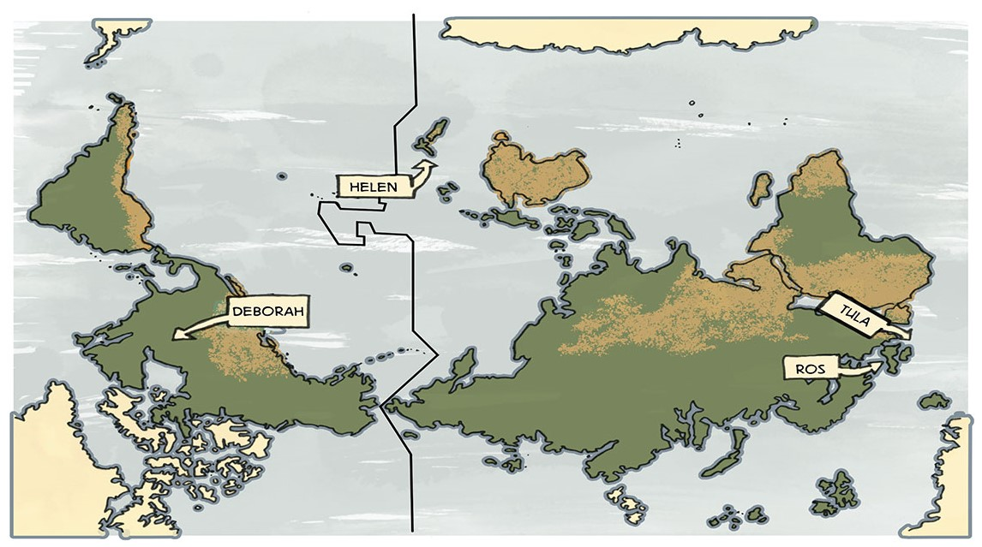

In this commentary we cover the funding, epistemological and collaborative framing for our project, before introducing some of the main audio, visual and textual resources we developed to support Indigenous and non-Indigenous research partnerships.

Funding, research skills and colonisation

The production of the Indigenous and non-Indigenous Research Partnership online resources was financed by UK Research and Innovation (UKRI: https://www.ukri.org/). UKRI is a quasi-autonomous umbrella national funding agency, underwritten by the UK government, that works in partnership with universities, research organisations, businesses, charities and government to invest in and foster research and development, and create a positive impact. Our team applied to UKRI for funding for our project under their International Collaboration scheme. The context for our project is the Global Challenges Research Fund (known as GCRF), which is part of the UK government’s Official Development Assistance (ODA) commitment. The GCRF funding supports research partnerships between UK and developing country researchers to address a set of defined challenges faced by developing countries.
At the time (2018), the GCRF aimed to “build a global community of researchers … to encourage and support new and existing partnerships.” On the one hand, the criteria advisory document for the GCRF promoted what was referred to as “meaningful and equitable relationships” and:

equitable partnerships between researchers, practitioners, and policy-makers in both developed and developing countries that will aspire to be world leading.
(UKRI 2017a, unpaginated)
(https://www.ukri.org/files/legacy/international/global-challenges-research-fundsagcriteria-pdf/)

On the other hand, however, it was clear where the problem identification and solution expertise lay in this. The GCRF strategy document pre-defined what the UK considers the eponymous global challenges (notably sustainable development, poverty eradication and good governance) and states that:

The GCRF will allow UK research excellence to be deployed in a strategic way to generate solutions to the most significant and complex problems faced by developing countries while at the same time strengthening their research capability.
(UKRI 2017b, unpaginated)
(https://www.ukri.org/files/legacy/research/gcrf-strategy-june-2017/)

Knowledge, expertise, and skills lie in the UK and in the dominant Euro-Western model of research then. This model has been challenged by the decolonisation movement and indigenous methodologies.
A context for the GCRF, and for the Indigenous and non-Indigenous research partnerships that our project is concerned with, is historical and ongoing colonisation. Historically there has been mainly Western migration to and settling on Indigenous lands. Settlers have ruled over and oppressed Indigenous peoples, appropriating and profiting from Indigenous people’s resources and knowledge, at the same time as denigrating Indigenous cultures and knowledge (Laidlaw & Lester, 2015). Academic Indigenous and non-Indigenous research partnerships can perpetuate this exploitative relationship. It can be replicated in how the research focus gets defined and in relationships between Indigenous and non-Indigenous researchers on the research team.

Northern and Southern epistemologies

All research methodologies are grounded in the specificities of people’s world views – their epistemologies (e.g., Connell, 2007; Santos, 2014). What is referred to as Northern epistemology assigns authority uniquely to knowledge production that is founded in Euro-Western dominant social viewpoints and histories of colonialism. The Western academy sets the agenda and constructs the rules by which the world, including the worlds of Indigenous peoples, is theorised, investigated and judged. This dominant system determines what knowledge is, what are legitimate research questions and answers. It assumes that this version of what counts as knowledge and how it should best be formed applies universally. This epistemology originates within and sees from the global North point of view. But the imperial cultural paradigm and social process of the global North, from which claims of abstracted universality spring, is rendered invisible. Indigenous knowledge production methods are subordinated and rendered inferior.
Southern epistemologies, however, are rooted in the societies and peoples of the global South. They detach what counts as knowledge, its production and how it is used, from imperialism and challenge power structures. Southern epistemologies acknowledge diverse and evolving sets of knowledges and intellectual traditions. The methodologies associated with this are contextualised and non-extractive ways of finding out about the world. Southern ways of thinking can advance plural conceptual and spiritual approaches to knowledge and ethical processes of inquiry. They do this in order to understand the constellation of oppressions and injustices stemming from colonialism; identify struggles and resistances to them; and address social and environmental process, relations and transformations.
In order to create a space for valuing Southern epistemologies when we pursue Indigenous and non-Indigenous research partnerships, we need to work at decolonising both research and researchers, and ultimately universities as homes of knowledge and research (Bhambra et al., 2018). Decolonising research is about dismantling the distortions and erasures in global Northern epistemologies and methodologies, and its positioning of researchers, and opening up to forms of knowing beyond Euro-Western modes of research. Decolonising involves challenging our assumptions and our position, freeing ourselves from the underlying global Northern academic culture, and offering alternative ways of understanding the world and relating to Indigenous peoples.
There is a growing and vibrant literature on Indigenous methodologies, for example Chilisa Bagele (2019); Deborah McGregor and colleagues (2018); Linda Tuhiwai Smith (2012); and Shawn Wilson (2008). Indigenous paradigms are richly diverse, running across the range of social, behavioural and natural sciences, and they embrace a variety of substantive issues. Notably, approaches span qualitative and quantitative research methods, but it is the case that there tends to be an emphasis on qualitative methods in the methodological literature, especially around storying. Interviews conducted within western modes of research, for example, are a different endeavour from what seems to be the same process of data creation enacted within an Indigenous methodological approach, such as yarning or talking circles. In an Indigenous knowledges paradigm one-to-one and group methods flow from a conversational method based on an oral story telling tradition (Chilisa, 2012; Kovach, 2010).
While there is no single Indigenous research paradigm, there are some common foundations in trusting relationships and transparent accountability, and an aim to fundamentally transform the whole nature of the research endeavour:

Thus it is not the method, per se, that is the determining characteristic of Indigenous methodologies, but rather the interplay (the relationship) between the method and paradigm and the extent to which the method, itself, is congruent with an Indigenous worldview ... when used in an Indigenous framework, a conversational method invokes several distinctive characteristics: (a) it is linked to a particular tribal epistemology (or knowledge) and situated within an Indigenous paradigm; (b) it is relational; (c) it is purposeful (most often involving a decolonizing aim); (d) it involves particular protocol as determined by the epistemology and/or place; (e) it involves an informality and flexibility; (f) it is collaborative and dialogic; and (g) it is reflexive. (Kovach, 2010, p. 40/43)

Margaret Kovach (2010) notes how preparation for research using what the dominant paradigms refer to as interviews may include western-based ideas about literature review, design of study etc., but that with Indigenous approaches there would also be preparations that were relational, such as participating in ceremonies, and clear planning for how the research and researcher will give back to the community. It is the latter that enables the method and research to become a transformative process. Western dominated mainstream research often aspires to be transformative in ways that are defined by powerful interests, such as government and business, as is evident in the Global Challenges Research Fund that I mentioned earlier. Indigenous research, though, aspires to critical, transformative and to benefit the community or collective grouping as they define that themselves. Western dominated research is often challenged as being deficit based, identifying needs and risks, and attempting to solve social problems that are identified as challenges by governments, again as illustrated by the GCRF. Indigenous research, though, may aspire to questions or purposes concerned with well-being, self-determination, sovereignty, rights and so on.

Why collaborate?

So, given the discussion above, why on earth would Indigenous researchers want to collaborate on research projects with non-Indigenous researchers? It is a question that Ros asked her Indigenous colleagues, Helen and Deborah. Ros could see the benefits to non-Indigenous researchers like herself and Tula. Research partnerships can involve non-Indigenous researchers in collegial and appropriate approaches to gaining knowledge about people’s lives. And this can give them a better understanding of a community’s needs and about how to meet those needs on the community’s own terms.
For Indigenous researchers such as Helen and Deborah, research partnerships with trusted non-Indigenous researchers can provide supportive allies in addressing the contemporary challenges that face Indigenous peoples. Collaborations can help towards gaining respect for Indigenous approaches and knowledges. And crucially, it is also that the systemic issues Indigenous researchers address are not just Indigenous “problems.” Non-indigenous researchers have accountabilities and an important role to play in addressing inequities and challenging colonisation.
While Euro-Western researchers as non-Indigenous people cannot practice Indigenous methods, they may be in alliance with them. In order for this to be the case however, it is important for researchers to think about their expectations and practices across the whole research process. This is why we produced the Indigenous and non-Indigenous Research Partnerships project’s set of online text, audio and visual resources.

Indigenous and non-Indigenous research partnership resources

The resources produced by the Indigenous and non-Indigenous Research Partnerships project are lodged on the project website: https://www.indigenous.ncrm.ac.uk/about/. The resources do not provide a definitive blueprint. Rather, our website introduces decolonising ways of understanding and researching, and a set of textual, audio and comic resources that can act as prompts to start thinking about the challenges and tensions in partnership working. We run through some of the main audio, visual and textual resources and provide tasters in the rest of this commentary.
One of key audio resources is an illustrated video/audio recording of our project team discussing good and bad practice in Indigenous and non-Indigenous research collaboration. In the team conversation we cover:

- how non-Indigenous researchers will be stepping outside their comfort zone in working in partnership with non-Indigenous researchers;
- the legacy of colonialism and how this continues to impact on the way research is undertaken on Indigenous communities;
- the dangers and risks inherent in researchers from predominantly Western backgrounds trying to enter into partnerships with Indigenous researchers and peoples;
- Indigenous researchers’ experiences of this;
- the lack of information on partnership working available to non-Indigenous researchers;
- methods, approaches and what works and what doesn’t in an Indigenous context; and
- what good collaborations look like, how they start, evolve and lead to research that can benefit Indigenous communities.

There is a transcript of the conversation available, and the following is an extract where Chris, our Communications producer, asks Ros and Helen about the risks involved in Indigenous and non-Indigenous research partnerships:

Chris: I want to ask you all now really what you think, I mean, I think in some respects we’ve hinted at it already, but what the dangers are that are inherent in researchers from predominantly Western cultures and with Western academic research backgrounds trying to enter into partnership with indigenous researchers and peoples. I want to start off with Ros, if I may.

Ros: Well, obviously I’m talking from a non-indigenous perspective here about the risks. So I suppose actually some non-indigenous researchers may see it as a risk to themselves, as a risk to their expertise. It is a sort of expertise to open yourself up, if you like, rather than be asserting your authority. In collaborations, so if you are going to sort of be asserting yourself as the authoritative expert, then the biggest risk, I should imagine, is that you’re getting it very wrong and perpetuating the sort of misleading and deficit ideas that Helen and Deborah have been talking about. And even more importantly, you’re not actually going to be addressing the real issue that would help communities rectify and societies rectify inequalities.

Helen: One of the risks is that it’s simply a waste of time and money, and of course, most of our research would be public-funded, so if that money’s being spent on research that doesn’t make any difference, then that’s a risk to everybody. It’s a risk to the whole country. The other thing is I think it’s a risk to the wellbeing of the people involved if it’s not done well, and that damage is usually accrued to the indigenous people involved in the research. And, you know, it’s a risk that if we don’t make a difference, we often tend to actually make things worse. How you come to the relationship, how you position that power, how you position the relationships between indigenous and non-indigenous people and between the different knowledge systems, determines really very strongly how that research is going to be designed, how the processes are going to be, how the findings are going to be interpreted, through whose eyes and in what way? So is it going to be deficit-framing? Is it going to be positioning indigenous people as a problem who are being helped by non-indigenous people? And that kind of positioning often sees Māori, for example, as being the vulnerable population that we need to protect, we need to help them, we need to try and solve their problems. So it perpetuates power imbalances and it perpetuates stereotypes. You know, we’re not just people who are vulnerable and fragile and who need to be protected. To understand power, you have to understand and value both knowledge systems and the strengths that both groups bring to it, and if you don’t do that, you just perpetuate this idea of indigenous people as needing to be helped, and who don’t have the ability to determine our own lives.

Another major resource is visual, in the form of a comic, for use in discussion about what effective collaboration could look like, vibrantly drawn and co-storied by our comic artist, Olivia. The narrative concerns researchers in the UK collaborating with an Indigenous Māori researcher in New Zealand learn that, to conduct good partnership research, they cannot rush the project without consulting with, listening to and respecting the knowledge and input of the Māori community, and how they go about doing this and working with their co-researcher. We provide some images of the cover and frames here (see Figures 2 and 3):

Finally, we have an ongoing series of blog posts where Indigenous and non-Indigenous researchers share their experiences. So far we have blogs on consent and accountability, ethics of writing, care-based approaches, rights-based frameworks, overviews of presentations, indigenous knowledges and intersectionality:

https://www.indigenous.ncrm.ac.uk/category/blog/.

Conclusion

The provision of a range of resources to support Indigenous and non-Indigenous research partnerships is crucial in a context where research funding streams are encouraging non-Indigenous research-led projects investigating global challengers in partnership with Southern researchers. It is also vital where there is a burgeoning social research focus on Indigenous methodologies and experiences of Indigenous researchers.
Our project itself is a demonstration of collaborative development of knowledge of Indigenous and non-Indigenous methodologies and research practices. Our Partnership project research team hope that this commentary has stimulated readers’ interest in the resources that our website provides.

Figure 2

Comic Cover

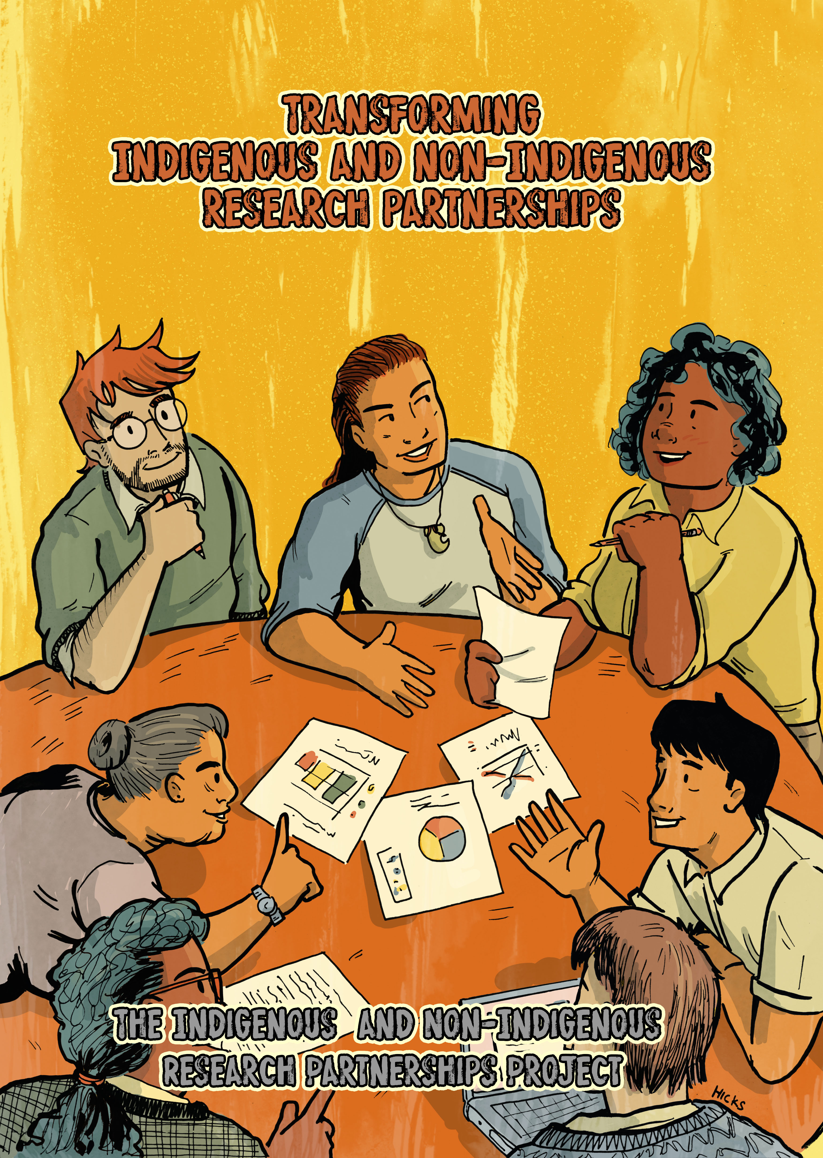
Figure 3

Comic Frames

References

Bhambra, G. K., Gebrial, D., & Nişancıoğlu, K. (Eds). (2018). Decolonising the university. Pluto Press.
Chilisa, B. (2019). Indigenous methodologies (2nd ed.). Sage.
Connell, R. W. (2007). Southern theory: Social science and the global dynamics of knowledge. Polity Press.
Kovach, M. (2010). Conversational method in Indigenous research. First Peoples Child and Family Review, 5(1), 40-48. https://fpcfr.com/index.php/FPCFR/article/view/172
Laidlaw, Z., & Lester, A. (Eds). (2015). Indigenous communities and settler colonialism: Land holding, loss and survival in an interconnected world. Palgrave Macmillan.
McGregor, D., Restoule, J.-P., & Johnson, R. (Eds). (2018). Indigenous research: Theories, practices, and relationships. Canadian Scholars Press.
Santos, B. de Sousa (2014). Epistemologies of the south: Justice against epistemicide. Paradigm.
Smith, L. T. (2012). Decolonising methodologies: Research and Indigenous peoples (2nd ed.). Zed Books.
UKRI (2017a). Global Challenges Research Fund (GCRF) Strategic Advisory Group: Criteria for GCRF funding. https://www.ukri.org/files/legacy/international/global-challenges-research-fundsagcriteria-pdf/
UKRI (2017b). UK Strategy for the Global Challenges Research Fund (GCRF). https://www.ukri.org/files/legacy/research/gcrf-strategy-june-2017/
Wilson, S. (2008). Research is ceremony: Indigenous research methods. Fernwood Publishing.

Author Note

Rosalind Edwards is Professor of Sociology, SSPC, University of Southampton, UK, a Fellow of the Academy of Social Sciences, and a founding and co-editor of the International Journal of Social Research Methodology. She has researched and published widely in the fields of family life and policies, as well as studying and writing about research methods. Rosalind can be reached at r.s.edwards@soton.ac.uk.
Helen Moewaka Barnes (Te Kapotai, Ngapuhi-nui-tonu) is Professor and Director of Whāriki and Co-director of the SHORE and Whariki Research Centre, Massey University, Aotearoa/New Zealand. She has worked on research in many areas; more recently relationships between the health of people and the health of environments, sexual coercion, alcohol and youth well-being and identity. Her work is both qualitative and quantitative and she is also involved in developing research within Māori paradigms. Helen can be reached at h.moewakabarnes@massey.ac.nz
Deborah McGregor is Canada Research Chair in Indigenous Environment Justice, Osgoode Hall law faculty, York University, Canada. Her research has focused on Indigenous knowledge systems and their various applications in diverse contexts including water and environmental governance, environmental justice, forest policy and management, and sustainable development. Deborah can be reached at dmcgregor@osgoode.yorku.ca
Tula Brannelly is a Principal Academic in Mental Health, Bournemouth University, UK. She has extensive experience in practice, research and education in mental health. Her research interest is about the experiences of care and outcomes of service provision on marginalised populations, shaped by an interest in ethics and citizenship. She can be reached at pbrannelly@bournemouth.ac.uk

Acknowledgements:

The Indigenous and non-Indigenous Research Partnerships project discussed in this article was funded by UK Research and Innovation under the NCRM grant ES/L008351/1

Copyright 2020: Rosalind Edwards and Nova Southeastern University.

Article Citation

Edwards, R. (with Moewaka Barnes, H., McGregor, D., & Brannelly, T.). (2020). Supporting Indigenous and non-Indigenous research partnerships. The Qualitative Report, 25(13), xxxx-xxxx.

Ros was a co-director of NCRM from 2010 to 2019: https://www.ncrm.ac.uk/.

