A review of metallic tanks for H₂ storage with a view to application in future green shipping

Zhenzhou Wang¹, Yikun Wang^{1*}, Sheida Afshan² and Johanna Hjalmarsson³

1. Maritime Engineering Group, Faculty of Engineering and Physical Sciences, University of Southampton
2. Infrastructure Group, Faculty of Engineering and Physical Sciences, University of Southampton
3. Institute of Maritime Law, Southampton Law School, University of Southampton
* yikun.wang@soton.ac.uk

Abstract
Increasing environmental legislation necessitates action within the marine industry to reduce the emission of greenhouse gases, sulphur oxides and nitrogen oxides. Several short-term/intermediate solutions have been introduced. However, the ultimate goal is to achieve complete green shipping. Insights gained from academic and industrial activities demonstrate tangible opportunities for adopting alternative fuels and/or energy sources for future ships, amongst which hydrogen is a promising option. Large scale bunkering of hydrogen on-board marine platforms is inherently risky. To determine the best practice and limitations of current techniques, this review summarises the state-of-the-art in storing hydrogen (fuel) for ships. This review focuses on the mechanical testing, selection of materials and failure mechanisms for cryo-compressed and liquid hydrogen tanks and their insulations. The review also discusses the regulatory aspects with a particular focus on the routes to approval. Knowledge gaps are identified to facilitate further research and development in this field.

Keywords: Hydrogen fuel for ships; Cryogenic hydrogen storage; Failure mechanisms; Material selection; Mechanical properties.

Acronyms
AUV Autonomous underwater vehicle
CcH₂ Cryo-compressed hydrogen
CVN Charpy V-notch
EMSA The European Maritime Safety Organisation
FC Fuel cell
FCEV Fuel cell electric vehicle
GH₂ Gaseous hydrogen
GHG Greenhouse gases
HFO Heavy fuel oil
HT-PEM High temperature proton exchange membrane
IGC code International Code of the Construction and Equipment
IGF code International Code of Safety for Ships using Gases or other Low-flashpoint Fuels
IMO International Maritime Organisation
LH₂ Liquid hydrogen
LNG Liquid natural gas
LPG Liquefied petroleum gas
MC Molten carbonate
MI Microsphere insulation
MLVI Multilayer vacuum insulation
NOx Nitrogen oxides
PA Phosphoric acid
PEM Proton exchange membrane
PTFE Polytetrafluoroethylene
SO Solid oxide
SOFI Spay on foam insulation
SOLAS Safety of Life at Sea
SOx Sulphur oxides
TRL Technology readiness level
VCS Vapour-cooled shield
VDMLI Variable density multilayer insulation

1. Introduction
Climate change is one of the world’s most imminent challenges. Since the first industrial revolution at the end of the 18th century, the global cumulative CO₂ emission has exceeded 1.5 trillion tonnes [1]. In addition, the levels of sulphur oxides (SOx), nitrogen oxides (NOx) and other types of greenhouse gases (GHG) such as methane emissions are continually increasing. The shipping sector emits around 940 million tonnes of GHG annually, accounting for 2.5% of the global emission. The annual global SOx and NOx emissions from shipping are estimated to be 10.6 million tonnes and 18.6 million tonnes, respectively; accounting for 12% and 13% of global emissions [2–4]. Within the European Economic Area, the latest publication by the EU Commission reveals that over 138 million tonnes of CO₂ was emitted from 11,600 ships in 2019, which contributed to 3.7% of total EU annual CO₂ emissions [5]. In terms of other emissions such as SOx and NOx, the percentages are much higher.

This is primarily due to ship engines burning heavy fuel oil (HFO), for which the technical and economic benefits have been overwhelmingly attractive so far. However, there is a strong drive in the marine industry to reduce these emissions. This move is accelerated at the international regulatory level. The International Maritime Organisation (IMO) GHG emission strategy envisages a reduction in the carbon intensity associated with international shipping. The strategy aims to reduce the average CO₂ emissions per transport work by at least 40% by 2030 and 70% by 2050 compared to the 2008 level [6]. It also targets to reduce the total annual GHG emissions by at least 50% by 2050 [6]. In addition, MARPOL aims to progressively reduce the SOx and NOx emissions from shipping. From January 2020, the global sulphur limit is reduced from 3.5% to 0.5% under the revised MARPOL Annex VI [7]. Fleet owners/operators are required to find suitable solutions to cut emissions drastically in order to meet these increasingly stringent regulations.

In response to these requirements and targets numerous solutions have been introduced in the shipping industry. The short-term/intermediate solutions have included: (i) engine improvements and modifications, (ii) optimisation in service conditions and (iii) exhaust gas after-treatment (scrubbers). New academic and industry activities have explored opportunities for adopting alternative fuels and/or energy sources for future ships (long-term solutions), amongst which hydrogen is a promising option. However, carrying large quantities of hydrogen on-board ship, in the harsh marine environment, is inherently a highly risky operation. Although there are some studies on hydrogen storage and fuel cells [8–28], the material selections and failure mechanisms of hydrogen storage tanks and insulation are not well understood for marine applications. Therefore, this paper reviews the state-of-the-art in storing hydrogen (fuel) with a view to application in future green shipping. It is focused on the mechanical testing, material selection and failure mechanisms for cryo-compressed and liquid hydrogen metallic tanks and their insulations. The identified knowledge gaps are summarised to prompt the research activities needed to facilitate the development of hydrogen fuelled ships in the near future.

2. Current developments and challenges
This section reviews the current development of ships storing hydrogen on board or using hydrogen as fuels. Challenges are highlighted in terms of both safety aspects and the route to approval.

2.1 Current development of hydrogen-fuelled ships
Han et al. [29] and van Biert et al. [16] summarised the basic principles and recent developments of six frequently used hydrogen fuel cells (FCs) for marine applications, these include: (1) the low temperature proton exchange membrane (PEM) FC; (2) the high temperature PEM (HT-PEM) FC; (3) phosphoric acid (PA) FC; (4) alkaline FC; (5) molten carbonate (MC) FC and; (6) solid oxide (SO) FC. The list of existing hydrogen-fuelled ships is presented in Table 1, where the majority are small-scale ships such as ferries and fishing boats. Figure 1 shows the timeline and the trend of maximum power and storage capacity of the ships listed in Table 1. From Table 1 it is evident that compressed gaseous hydrogen (GH₂) storage is more widely utilised for FC powered vessels, with power outputs ranging from 1.5 kW to 400 kW. Only one high speed passenger ferry, SF-BREEZE [19], uses liquid hydrogen (LH₂) storage. Similarly, metal hydrides are used for low power vessels, the 5 kW passenger ship (Hydra [30]), the 4 kW AUV (URASHIMA [31]) and the 10 kW yacht (Yacht XV 1 [32]). Metal hydrides can conveniently and safely generate sufficient hydrogen at room temperature to support relatively low power FCs (lower than 10 kW) by adding water. Compressed GH₂ storage may be required for relatively high power FCs (10 kW to a few hundred kW). As such, only cryogenic hydrogen storage is feasible for FCs with much higher power FCs that are needed for large ships.

Hydrogen FCs are believed to be the only feasible zero-emission power solution for large commercial ships in comparison with other renewable energy sources, such as solar, wind, bio-energy and batteries [3,16]. When compared with the second generation Li-ion battery, the cryogenic compressed hydrogen (CcH₂) at 60 K under 350 bar is 13 times lighter and takes five times smaller storage volume for the same energy output [33]. Furthermore, since the hydrogen fuel storage is separate from the FC, the cruising range of hydrogen FC powered ships is longer than Li-ion battery powered ships. In addition, rapid refuelling is another advantage of using hydrogen FCs since fast battery charging still remains a challenging problem even for moderate capacities such as for land-based electric vehicles [33]. To date, only two of the ships listed in Table 1 are registered with the Classification Societies. Yacht No. 1 [34] was the world’s first hydrogen powered yacht certified under the safety auditor Germanischer Lloyd (now DNVGL). The Hydroville [19,35] was the first Lloyd’s Register classified hydrogen powered passenger ship. The relatively few number of classified hydrogen powered ships suggests the lack of relevant codes/standards that can be used by the Classification Societies and/or other statuary bodies.

Table 1. Current applications of hydrogen fuel in ships
Ship category | Ship name | Time | Country | Power | Hydrogen storage | Remarks
Autonomous underwater vehicles (AUVs) | PC-14 [21] | 1989 | USA | 3 kW PEM FC | N/A | N/A
Autonomous underwater vehicles (AUVs) | URASHIMA [22] | 2004 | Japan | 4 kW PEM FC | Metal hydride | The world’s first longest continuous AUV cruising for 317 km;  Refuelled from mother ship
Autonomous underwater vehicles (AUVs) | DeepC [21] | 2004 | Germany | Two 60 kW PEM FCs | N/A | N/A
Autonomous underwater vehicles (AUVs) | URASHIMA 2nd generation [36] | 2009 | Japan | 10 kW high-efficiency multi-class FC | Metal hydride | 600 hours continuous electric power generation;  3000 km cruising range
Autonomous underwater vehicles (AUVs) | IDEF [36] | 2009 | N/A | 1.5 kW PEM FC | A 300 bar 50 L hydrogen pressure gas bottle | 300 km cruising range
Submarines | Class 212A and 214 submarines [24] | 2003 | Germany | 306 kW PEM FCs (30-50 kW per module on Class 212A, 120 kW per module on Class 214) | Pressure hull and outer light hull | N/A
Passenger ships/Ferries | Hydra [30] | 1999 | Germany | 5 kW alkaline FC | Metal hydride (33 m³ hydrogen) | 22 passengers
Passenger ships/Ferries | Hydroxy 3000 [37] | 2003 | Switzerland | Water-cooled 3 kW FC | 200 bar 76 L hydrogen pressure gas bottle
Passenger ships/Ferries | Xperiance NX [38] | 2006 | N/A | 1.2 kW PEM FC | Four exchangeable hydrogen gas tanks with 200 bar 30 L hydrogen gas in each | 12 passengers;  Can be refuelled with exchangeable tanks at a local hydrogen station
Passenger ships/Ferries | Tuckerboot [32] | 2007 | Germany | Two 1.2 kW PEM FCs | Exchangeable hydrogen pressure tanks | 8 passengers;  Can be refuelled at Hamburg airport hydrogen station
Passenger ships/Ferries | Ross Barlow [39] | 2007 | UK | 1 kW PEM FC, solar and wind power | Fixed hydrogen tanks and solid-state hydrogen store | N/A
Passenger ships/Ferries | ALSTERWASSER [19] | 2006-2010 | Germany | Two 48 kW FCs | 12 tanks of 350 bar 50 kg hydrogen | The world’s first commercial over 100-passenger hydrogen fuel cell powered inland ship;
Passenger ships/Ferries | Elding [40] | 2008 | Iceland | 10 kW FC for auxiliary power unit | High-pressure tanks (350 bar) | N/A
Passenger ships/Ferries | MF Vagen [19] | 2010 | Norway | 12 kW HT-PEM FC | N/A | N/A
Passenger ships/Ferries | Hornblower Hybrid [19] | 2011 | US | Hybrid (diesel, batteries, wind and PEM FC) | N/A | 600 passengers
Passenger ships/Ferries | Nemo H₂ [19] | 2012 | Netherlands | 65 kW PEM FC and 30-50 kW battery | 40 kg hydrogen in eight cylinders with a pressure of 350 bar | 100 passengers;  Can be refuelled at hydrogen station
Passenger ships/Ferries | Hydrogenesis [19] | 2013 | UK | 12 kW FC | N/A | N/A
Passenger ships/Ferries | SF-BREEZE [19,41] | 2015 | US | 41 120 kW PEM FCs (4.92 MW in total) | 1,200 kg LH₂ tank | 150 passengers
Passenger ships/Ferries | Hydroville [19,35] | 2017 | Belgium | Two hydrogen internal combustion engines | 12 hydrogen tanks at 200 bar (205 L each) | N/A
Yachts & sport boats | Yacht No.1 [34] | 2003 | Germany | Four 1.2 kW PEM FCs | Three hydrogen tanks with 6 kg hydrogen at 300 bar | The first hydrogen-powered yacht
Yachts & sport boats | Yacht XV 1 [32] | 2004 | N/A | Hybrid (10 kW PEM FC, two solar panels (600 W), one wind generator (90 W), 12 absorbent glass mat batteries, three house batteries and internal combustion engines) | Either metal hydride or compressed hydrogen with lightweight composite tanks | Hydrogen can be generated on-board;  Project note completed
Yachts & sport boats | Cobalt 233 Zet [19,42] | 2007 | Germany | Hybrid (50 kW batteries and PEM FCs) | Three 350 bar hydrogen tanks | N/A
Yachts & sport boats | Riviera 600 [43] | 2009 | Austria | 4 kW hydrogen FC | High-pressure tanks | N/A
Yachts & sport boats | Energy Observer [44] | 2017 | France | 114 kW hydrogen FC | Eight aluminium and carbon fibre tanks (62 kg hydrogen) | The first vessel, aiming for the energy autonomy, with zero GHG emissions or fine particles; the world’s first vessel producing its hydrogen from seawater
Fishing boats | N/A [45] | 2015 | Japan | Hydrogen FC | One 450 L tank | 12 passengers and sail at maximum 20 knots
Tow boats | RiverCell-Elektra [19] | 2019 | Germany | Two 200 kW HT-PEM FCs | 740 kg compressed hydrogen in six 500 bar tanks | The world’s first tow boat

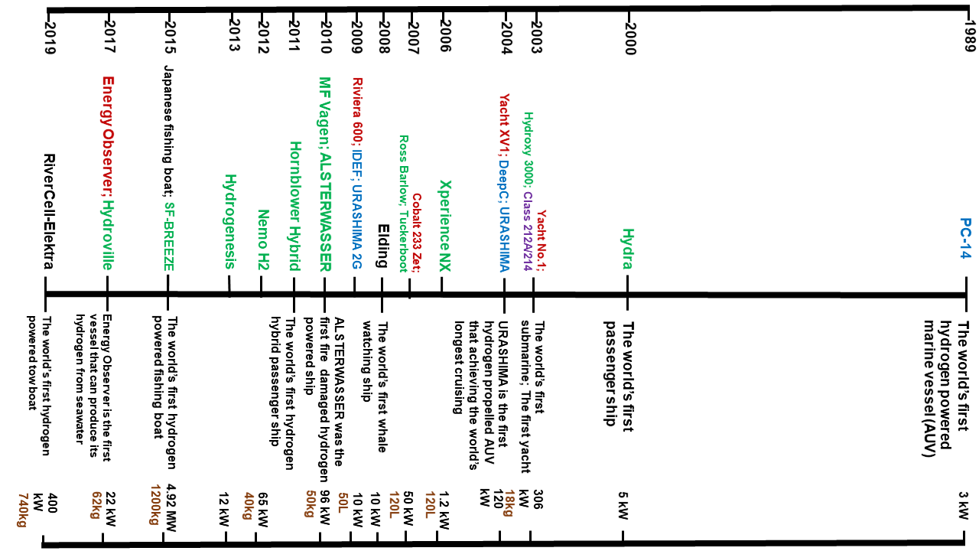
Figure 1. The timeline of hydrogen fuel powered ships (blue – under water vehicles; purple – submarines; green – passenger ships and ferries; red – yachts and sport vessels; black –others).

Hydrogen as a future fuel for shipping

2.2.1 Energy density
Figure 2 compares the gravimetric and the volumetric energy densities of hydrogen with other fuels. The gravimetric energy density of hydrogen is more than double that of methane, liquefied petroleum gas (LPG), gasoline and diesel of the same weight [17]. However, the volumetric energy density of LH₂ is only 25% of that for diesel. Compressed GH₂ at 700 bar is nearly half the volumetric energy density of LH₂. Compressed GH₂ at 150 bar requires a volume nearly six times greater than LH₂ [46].

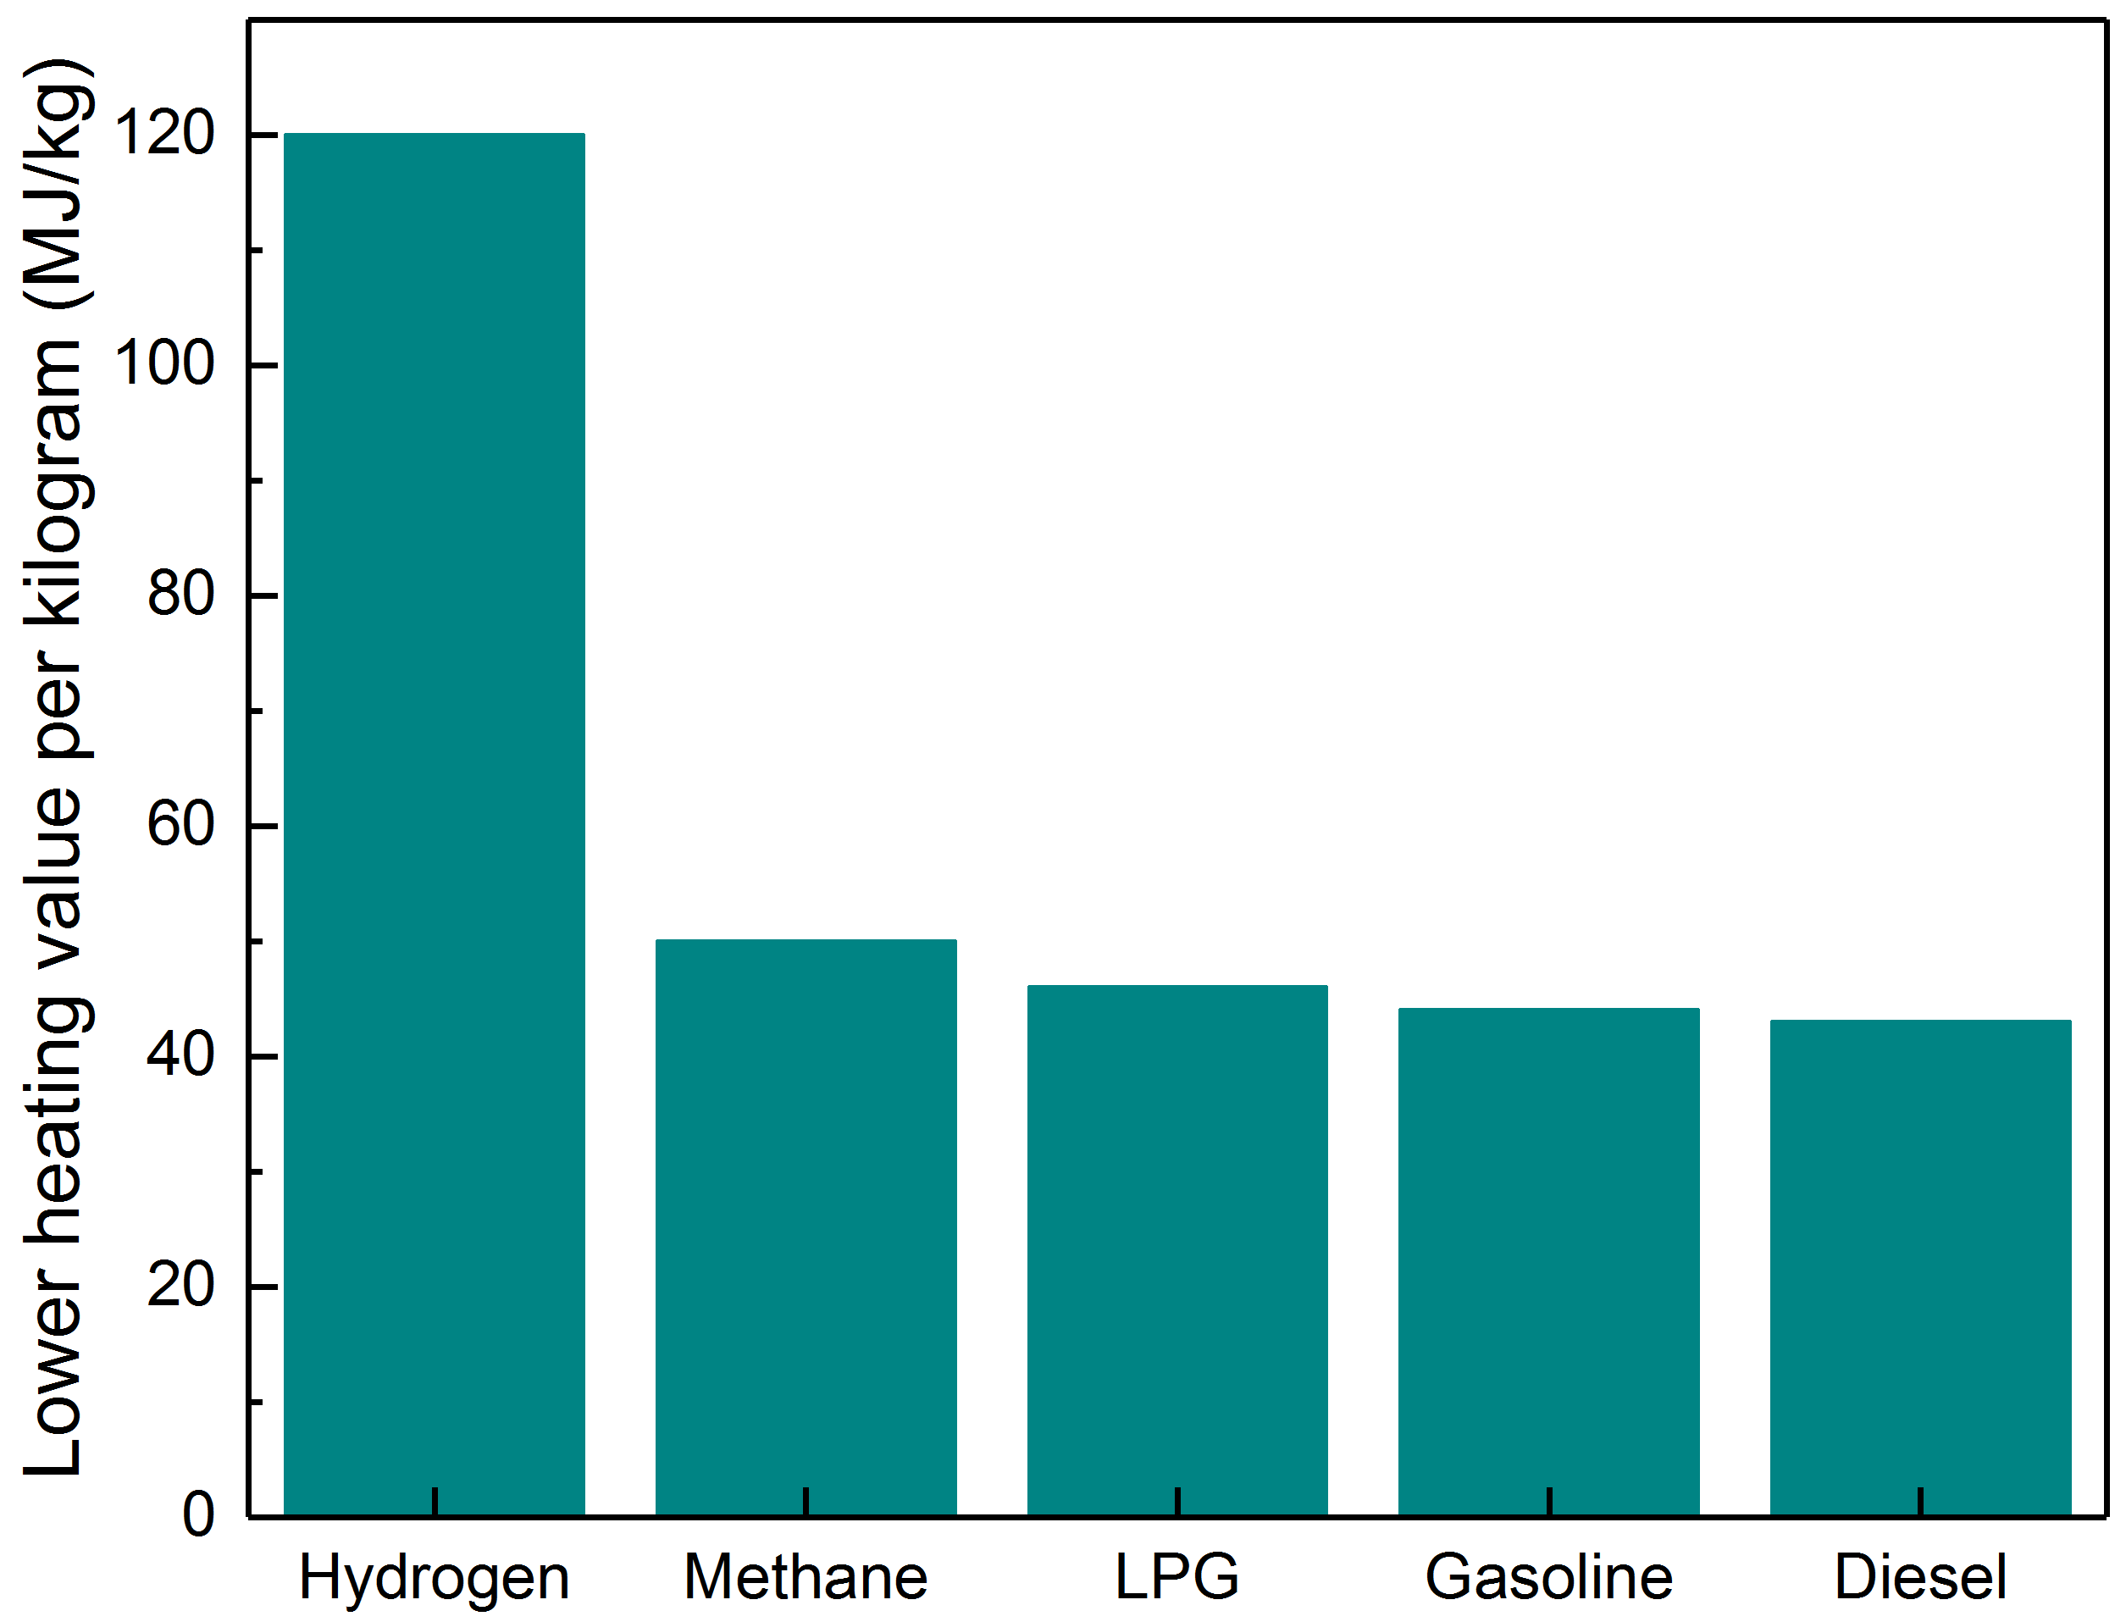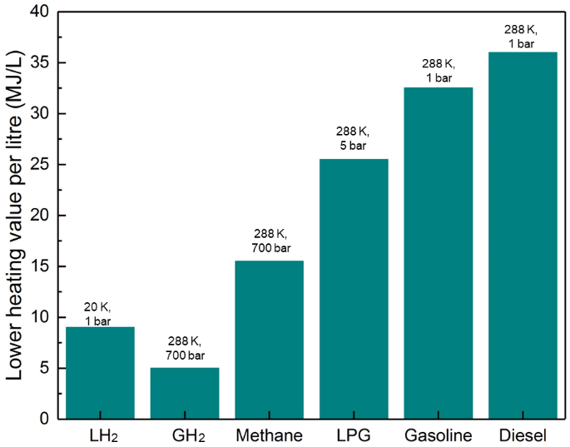
(a) (b)
Figure 2. (a) Gravimetric and (b) volumetric energy densities of different fuels [17].

Table 2 lists and compares the typical power/fuel requirements for land-based vehicles and small/large ships. To provide the same amount of power, the required quantity of HFO is 3.5 times greater than the corresponding quantity of hydrogen fuel. However, the fuel tank size will have to be increased if hydrogen is used to replace HFO. Using LH₂ instead of compressed GH₂ reduces the size of fuel tank. This difference in fuel tank size increases with increasing size of the ship. However, for higher pressure hydrogen fuel, thicker tank-wall will be required. For example, aluminium alloy tank-wall thickness for 700 bar compressed GH₂ storage tanks is at least two orders of magnitude greater than for LH₂ storage tanks [25]. Increased tank-wall thicknesses not only increase the total weight of the storage system, but also increases the total storage costs due to the extra material requirements.

Table 2. Comparison of vehicle power requirements (HFO and diesel versus hydrogen)
​ | Land-based vehicle | H₂-fuelled ship (Hydroville)​ | Capesize bulk carrier [47,48]​
Power [kW]​ | 90​ | 441​ | 15000​
Diesel/HFO quantity [kg] | 37– 67 (diesel) | 101 (diesel) | 1843452 – 3688957 (HFO)
H₂ quantity [kg]​ | 12.6 – 22.4 | 34​ | 504000 – 1008000
Diesel/HFO tank size [m³] | 0.05 – 0.08 (diesel) | 0.12 (diesel) | 1818 – 3637 (HFO)
350 bar compressed GH₂ tank size [m³]​ | 0.53 – 0.94 | 1.42 | 21088 – 42176
LH₂ tank size [m³] | 0.18 – 0.32 | 0.486 | 7200 – 14400

Typical hydrogen tank sizes of land-based vehicles, small passenger ships/yachts and aircrafts are 0.1 m³ [9,28], 0.5 – 32 m³ (Table 1) and 20 m³ respectively [46]. However, on large commercial ships such as Panamax container ships with typical HFO tank size above 4500 m³ [47], the size of LH₂ fuel storage would be more than 18,000 m³. If carrying LH₂ on a ship of a similar size of an LNG carrier, the typical size of LH₂ storage would be 175,000 m³. Furthermore, McKinlay et al. [49] investigated 108 voyages of long distance ships based on a dataset covering a period of 3 years and 2 months and stated that the maximum delivered energy for any given voyage is 9720 MWh. In order to generate this energy, the LH₂ storage would be larger than 6547 m³.

2.2.2 Storage methods
The methods for hydrogen storage can be categorised as physical-based and material-based [11,13,18,20–22,32,50,51]. Material-based methods store hydrogen as solid state compounds through chemical absorption and physical adsorption [15]. Chemical absorption includes ammonia, metal hydrides, formic acid, carbohydrate and liquid organic hydrogen carriers, whereas physical adsorption consists of carbon materials, zeolites, metal organic framework, glass capillary arrays, glass microspheres and organotransition metal complexes [21]. More details about the material-based storage methods can be found in [21]. Material-based methods are unlikely to be commercially used in the near future due to their low technology readiness level (TRL) compared to the physical-based methods. Chemical absorption methods are generally below TRL 5 [52] and the majority of the physical adsorption methods are currently at TRL 2 [52]. In comparison, compressed GH₂ storage, a physical-based method, is estimated to be TRL 8 to 9 [52]. In addition, material-based methods have a relatively low hydrogen storage capacity, which is up to 19.4 wt.% of solid state compounds [21]. Therefore, the current review focuses on the more viable physical methods of hydrogen storage.

Physical-based methods mainly consist of three storage types, i.e., LH₂, cryo-compressed hydrogen (CcH₂) and compressed GH₂ [11]. A comparison between these three hydrogen storage methods is summarised in Table 3 [11–13,21,32,50,53,54]. In the literature, there are several definitions of cryogenic hydrogen temperature range. Kunze and Kircher [55] considered the temperature of CcH₂ to be between 33 K and 233 K. The US Department of Energy hydrogen storage report defines the cryogenic temperature to be below 123 K and the cold temperature between 123 K and 233 K [56]. In Ref. [57] the cryogenic temperature of hydrogen is split into low-temperature cryogenic (below 77 K) and high-temperature cryogenic (77 K to 223 K). The former covers a similar range as defined by Rivard et al. [50] for CcH₂, which is between 40 K and 80 K. Therefore, the temperature range of CcH₂ is defined as 33 K to 77 K in this review.

Table 3. Comparison between compressed GH₂, CcH₂ and LH₂ storage methods [11–13,21,32,50,53,54]
Storage method | Temperature [K] | Pressure [bar] | Volumetric energy density [kWh/L] | Advantages | Limitations | Applications
Compressed gaseous hydrogen (GH₂) | 233 - 300 | 150 – 800 | 0.8 at 350 bar; 1.4 at 700 bar | Light-weight | Low energy density; up to 10% energy loss in the compression process | Small-scale storage; mobile applications such as hydrogen powered vehicles
Cryo-compressed hydrogen (CcH₂) | 33-77 | 150 – 350 | 2.6 at 38 K and 300 bar | High energy density; energy loss is lower than the liquefaction process | Require strict insulation | Medium to large-scale storage; transportation such as truck delivery and international hydrogen shipping
Liquid hydrogen (LH₂) | 20-33 | 1 – 12.76 | > 2.3 | High energy density | Require strict insulation; up to 40% energy consumption in liquefaction processes | Medium to large-scale storage; transportation such as truck delivery and international hydrogen shipping

Figure 3 compares LH₂, CcH₂ and compressed GH₂ in terms of their temperature, pressure and density characteristics [55,58]. The hydrogen density of a 350 bar pressure tank is 23.5 g/L and for a 700 bar tank is 39.5 g/L at 288 K (14.85 ºC) [55,58]. In order to achieve the same volumetric capacity as LH₂ (70 g/L at 20 K), the temperature has to be lowered to 63 K for 350 bar tanks and 113 K for 700 bar tanks. Considering the high density and volumetric energy density requirements for large ships, this review focuses on the storage of CcH₂ and LH₂.

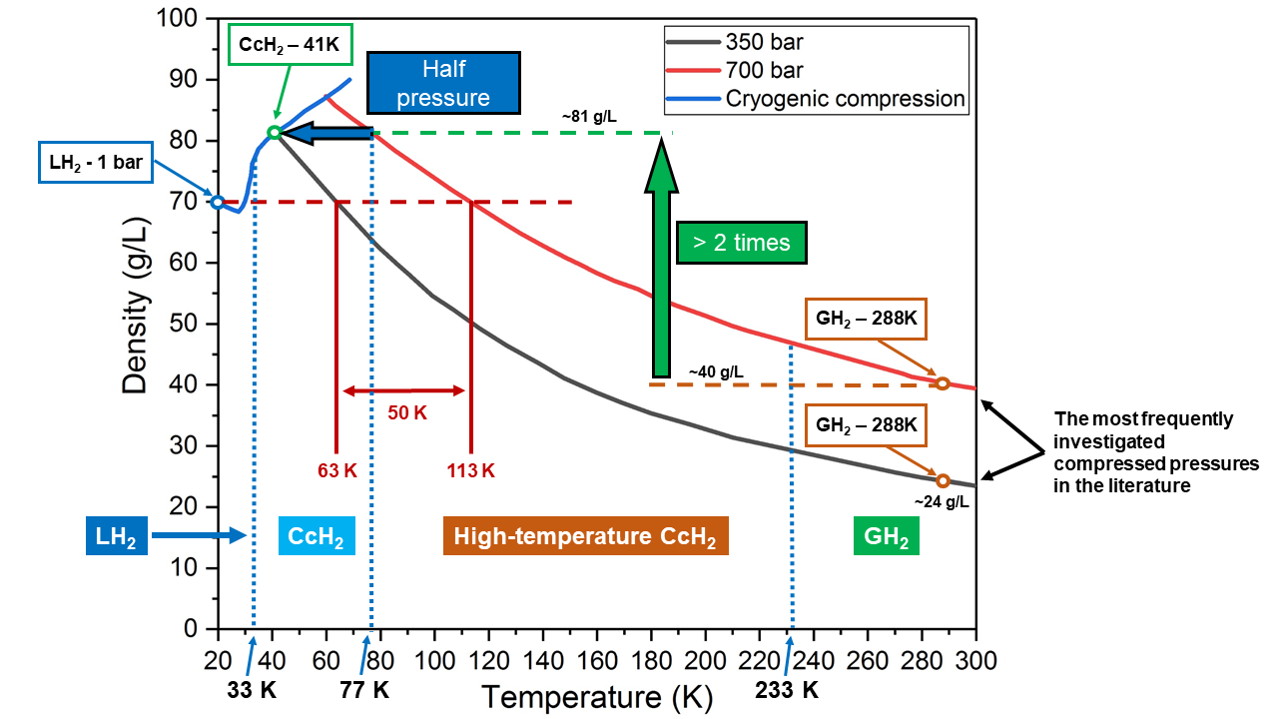
Figure 3. Density comparison between liquid, cryo-compressed and compressed gaseous hydrogen [55,58].

2.2.3 Supply chain and costs
Hydrogen gas can be produced from fossil fuel or renewable sources [59], as illustrated in Figure 4. Currently, the main hydrogen gas production uses fossil fuels, where processes such as natural gas reforming and coal gasification produce approximately 1.36 billion m³ hydrogen gas per day globally [60]. The produced pure hydrogen will be supplied through pipelines to large vacuum-insulated tanks or distributed from the plant to the end users, such as road transportation sector by cryogenic truck trailers [17]. Further details of the hydrogen gas supply chain are described in Ref. [59].

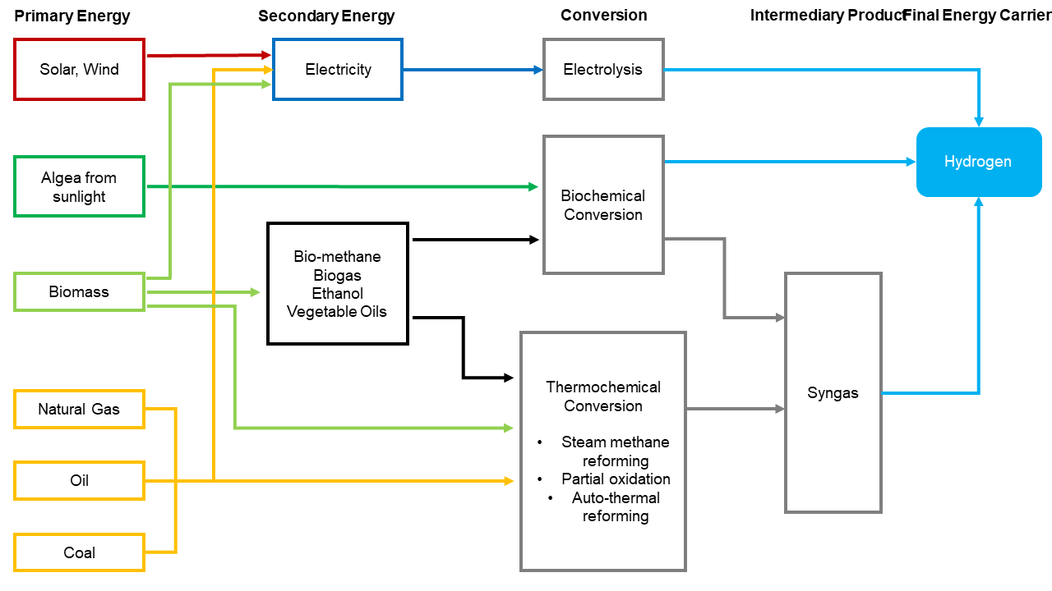
Figure 4. Hydrogen gas production processes [59].

The Shell Hydrogen Study [59] reported that the cost of hydrogen FC electric land-based vehicles would be over 10% lower than petrol-electric hybrid and petrol vehicles based on vehicle ownership costs at 200,000 kilometres mileage. However, there is no data showing a direct comparison between the cost of hydrogen fuel and HFO for ships. DNV GL [48] reported that the hydrogen cost produced from natural gas reforming is equivalent to US$ 800 to US$ 2,170 per tonne crude oil and the cost produced from electrolysers ranges between US$ 1,170 and US$ 2,770 per tonne crude oil in 2018. However, with potential taxation added to using HFO, e.g., $2 levy on every tonne of ships’ fuel suggested by ship owners [61], the cost of alternative fuels including hydrogen for shipping is expected to decrease in the future. Hydrogen storage costs vary depending on the storage method (LH₂, CcH₂ or compressed GH₂). The cost of storing LH₂ is generally the lowest, and highest for GH₂. A 4300 kg LH₂ tank is $5 per kWh and for a 100-litre LH₂ tank the cost is $11.58 per kWh [11,13,50,53]. Storing 300 bar CcH₂ costs $12 per kWh [11,13,50,53]. In addition, compared with LNG as a ship fuel, which is now considered a fully-developed technology, LH₂ has similar costs for energy conversion, piping, ventilation, heat exchanger and pumps [48]. However, the storage construction is more expensive due to the lower temperature and higher insulation requirements [48].

2.3 Challenges in safely storing hydrogen
Figure 5 shows the main hazards related to handling and storing hydrogen at cryogenic temperatures on a ship [62,63]. A primary concern is fire safety due to the wide range of ignition limits in air (4.1 to 74.2 vol.%). A combustion event requires the formation of combustion mixture and a source of ignition. Figure 6 summarises the general causes for each aspect [63]. It can be seen that material related issues (underlined in the figure) can result in leaks/spills and mechanical/thermal ignition, leading to fire or an explosion.

Figure 5. Main hazards related to handling and storing hydrogen on ships [62,63].

Figure 6. Causes for hydrogen combustion hazard (material related issues are underlined) [63].

Storage tank failure is primarily due to the physical hazards highlighted in Figure 5, i.e., material failure, excessive pressure due to leaks and/or pressure relief system failure if compressed GH₂ is stored. The most challenging areas include hydrogen permeation, hydrogen embrittlement, and heat transfer through simultaneous conduction, convection and radiation. The permeability of both composite and metallic tank material is raised with increased temperature [64,65]. This may lead to hydrogen gas cumulating and reaching to flammability limit in a closed environment outside the storage tank. It can also cause micro-cracks in the materials [25]. Hydrogen embrittlement means degraded fracture toughness and/or ductility of metallic materials [66]. This may result in reduced load bearing capacity and premature failures. Heat transfer is particularly relevant for storing LH₂ [67]. This is due to the temperature difference (over 10 times) between the LH₂ (20 K) and the ambient environment (300 K). Subsequently this causes boil-off gas during daily operation. The boil-off gas needs safe disposal by either diffusing into air, burning or capturing. Excessive boil-off is not acceptable since it is uneconomical, has the potential to cause fire and limits the cruising range of ships. Hydrogen tanks with spherical shape can minimise the heat transfer by reducing the thermal conduction and convection since the spherical shape provides minimum surface area for a given volume [25]. The heat transfer may also lead to thermal expansion of the storage tank materials. This is particularly pertinent for tanks made of hybrid composite and metallic materials. Since composites have lower coefficient of thermal expansion than metallic materials, using composite cryogenic hydrogen tank with metallic liner may lead to separation or fracture of the liner [57].

Kircher et al. [33] stated that LH₂ and CcH₂ have 6 to 15 times lower adiabatic expansion energies than compressed GH₂, as shown in Table 4. During a sudden failure of the pressure vessel, a significant fraction of the stored energy will be released in a short period of time when the adiabatic expansion energy is high, which can cause severe storage failures such as a tank burst [33]. This means that LH₂ and CcH₂ storage methods provide a potentially higher level of safety than compressed GH₂ method in the case of sudden pressure tank failure during refuelling [55].

Table 4. Adiabatic expansion energies for different physical storage methods [33]
Hydrogen form | Temperature [K] | Pressure [bar] | Adiabatic expansion energy [kWh/kg]
Liquid hydrogen (LH₂) | 26 | 4 | 0.010
Cryo-compressed hydrogen (CcH₂) | 48 | 250 | 0.053
Cryo-compressed hydrogen (CcH₂) | 80 | 300 | 0.130
Compressed gaseous hydrogen (GH₂) | 350 | 350 | 0.800
Compressed gaseous hydrogen (GH₂) | 288 | 700 | 0.650
Compressed gaseous hydrogen (GH₂) | 350 | 700 | 0.810

In addition to the general challenges mentioned above, there are specific technical barriers related to storing cryogenic hydrogen on ships (temperatures lower than 77 K), in either liquid or cryo-compressed form. The long service life of ships (typically 25 years) and complex service load place onerous demands on the strength and reliability of the storage system. There is limited experience and long-term operation data from the marine industry given the limited number of ships built carrying hydrogen (Section 1.2). There is a lack of understanding and available data related to the fundamental material and structural behaviour (failure modes) of hydrogen storage tanks in harsh service conditions. All of these barriers lead to a general lack of confidence in constructing and approving large-scale hydrogen storage on ships.

2.4 A route to approval
In granting registration of vessels, the flag state registry relies on classification societies to assess and approve the design and technology. The technology, once it exists, will require a route to approval for testing and subsequently deployment. Only an ad hoc route is currently available, based on engineering analysis and design methodology.

In the present review, the temperature range of LH₂ and CcH₂ is 20 K to 77 K. This range is not covered by the IMO’s most closely related codes, namely the International Code of Safety for Ships Using Gases or Other Low-flashpoint Fuels (IGF code) or the International Code of the Construction and Equipment of Ships Carrying Liquefied Gases in Bulk (IGC code) which are for using or carrying flashpoint fuels above 77 K [69–71]. In the absence of specific regulation, the flag state registry may approve new designs or technology through a procedure known as Alternative Design & Arrangement (AD&A). Such approvals are risk-based and case-by-case based, and the route is available for present purposes through SOLAS Chapter II-1, Construction - Structure, subdivision and stability, machinery and electrical installations. The relevant guidelines are contained in IMO Circular MSC.1/Circ.1212, entitled Guidelines on alternative design and arrangements for SOLAS Chapters II-1 and III. The latter define AD&A as ‘measures which deviate from the prescriptive requirement(s) of SOLAS chapters II-1 or III, but are suitable to satisfy the intent of that chapter’ [72]. The guidelines provide a methodology for the engineering analysis required for which the approval of an alternative design deviating from the otherwise prescriptive requirements is sought [72]. While IMO guidance is available on AD&A, more specific flag state or approval guidance may be lacking; for example the UK Marine and Coastguard Agency guidance on AD&A under these Guidelines states laconically: ‘None’ [73]. The classification society DNVGL has a detailed framework on AD&A [74], but classification society BV’s AD&A framework is limited to SOLAS Chapter III (life-saving appliances) [75]. The IMO Guidelines require a comprehensive hazard identification followed by quantitative risk analysis. This is an onerous task to achieve when historical data/experience is lacking.

Relevant international/national codes and standards from other sectors are summarised in Table 5. Specifically, the ISO Technical Committee TC197 focuses on hydrogen technologies (mostly on GH₂ usage), publications from which could be used as key terms of reference for marine applications. In addition, there are a range of codes and standards for fuel cell technologies, aerospace industry and land vehicles. However, the stipulated requirements should be used with caution due to different operational profiles.

Table 5. Available regulatory standards (not all directly applicable)
Standard/Code | Title | LH₂ | GH₂ | Storage
ISO TC 197 Hydrogen technologies
ISO 13984:1999 | Liquid hydrogen - Land vehicle fuelling system interface
ISO 13985:2006 | Liquid hydrogen – Land vehicle fuel tanks
ISO/TR 15916:2015 | Basic considerations for the safety of hydrogen systems
ISO 16110-1:2007 | Hydrogen generators using fuel processing technologies – Part 1: Safety
ISO 16110-2:2010 | Hydrogen generators using fuel processing technologies Part 2: Test methods for performance
ISO 16111:2018 | Transportable gas storage devices — Hydrogen absorbed in reversible metal hydride
ISO 17268:2020 | Gaseous hydrogen land vehicle refuelling connection devices
ISO 19880-1:2020 | Gaseous hydrogen - Fuelling stations Part 1: General requirements
ISO 19880-3:2018 | Gaseous hydrogen - Fuelling stations Part 3: Valves
ISO 19880-5:2019 | Gaseous hydrogen - Fuelling stations Part 5: Dispenser hoses and hose assemblies
ISO 19880-8:2019 | Gaseous hydrogen — Fuelling stations — Part 8: Fuel quality control
ISO 19881:2018 | Gaseous hydrogen — Land vehicle fuel containers
ISO 19882:2018 | Gaseous hydrogen — Thermally activated pressure relief devices for compressed hydrogen vehicle fuel containers
ISO 22734:2019 | Hydrogen generators using water electrolysis - Industrial, commercial, and residential applications
ISO 26242:2010 | Hydrogen detection apparatus — Stationary applications
ISO TC 220 Cryogenic vessels
ISO 20421-1:2019 | Cryogenic vessels — Large transportable vacuum-insulated vessels — Part 1: Design, fabrication, inspection and testing
ISO 20421-2:2017 | Cryogenic vessels — Large transportable vacuum-insulated vessels — Part 2: Operational requirements
ISO 21009-1:2008 | Cryogenic vessels— Static vacuum-insulated vessels Part 1: Design, fabrication, inspection and tests
ISO 21009-2:2015 | Cryogenic vessels— Static vacuum-insulated vessels Part 2: Operational requirements
ISO 21011:2008 | Cryogenic vessels - Valves for cryogenic service
ISO 21014:2019 | Cryogenic vessels — Cryogenic insulation performance
ISO 21028-1:2016 | Cryogenic vessels — Toughness requirements for materials at cryogenic temperature — Part 1: Temperatures below -80 degrees C
ISO 21029-1:2018 | Cryogenic vessels — Transportable vacuum insulated vessels of not more than 1 000 litres volume — Part 1: Design, fabrication, inspection and tests
ISO 21029-2:2015 | Cryogenic vessels — Transportable vacuum insulated vessels of not more than 1 000 litres volume — Part 2: Operational requirements
ISO 24490:2016 | Cryogenic vessels — Pumps for cryogenic service
ISO TC 22/SC 37 Electrically propelled vehicles
ISO 23273:2013 | Fuel cell road vehicles — Safety specifications — Protection against hydrogen hazards for vehicles fuelled with compressed hydrogen
ISO 23828:2013 | Fuel cell road vehicles — Energy consumption measurement — Vehicles fuelled with compressed hydrogen
ISO TC 58 Gas cylinders
ISO 11114-1:2012 | Gas cylinders — Compatibility of cylinder and valve materials with gas contents Part 1: Metallic materials
ISO 11114-2:2013 | Gas cylinders — Compatibility of cylinder and valve materials with gas contents Part 2: Non-metallic materials
ISO 11114-4:2017 | Transportable gas cylinders — Compatibility of cylinder and valve materials with gas contents Part 4: Test methods for selecting steels resistant to hydrogen embrittlement
International Electrochemical Commission (IEC) TC 105 Fuel cell technologies
IEC 62282-8-201:2020 | Energy storage systems using fuel cell modules in reverse mode - Test procedures for the performance of power-to-power systems
US National Fire Protection Association (NFPA)
NFPA 2 | Hydrogen Technologies Code
NFPA 55 | Compressed Gases and Cryogenic Fluids Code
Compressed Gas Association (CGA)
CGA C-10 | Guidelines to Prepare Cylinders and Tubes for Gas Service and Changes in Gas Service
CGA G-5.5-2014 | Hydrogen Vent Systems
The American Society of Mechanical Engineers (ASME)
ASME BPVC VIII-3 | Boiler and Pressure Vessel Code, Section VIII, Division 3
B31.12-2019 | Hydrogen Piping and Pipelines
Other
ANSI/AIAA G-095A-2017 | Guide to Safety of Hydrogen and Hydrogen Systems
SAE J2578_201408 | Recommended Practice for General Fuel Cell Vehicle Safety
SAE J2579_201806 | Standard for Fuel Systems in Fuel Cell and Other Hydrogen Vehicles
SAE J2600_201510 | Compressed Hydrogen Surface Vehicle Fuelling Connection Devices
SAE J2601/2_201409 | Fuelling Protocol for Gaseous Hydrogen Powered Heavy Duty Vehicles
SAE J2799_201912 | Hydrogen Surface Vehicle to Station Communications Hardware and Software
EN 1626:2008 | Cryogenic vessels — Valves for cryogenic service
ISO 6892-4: 2015 | Metallic materials — Tensile testing Part 4: Method of test in liquid helium
BS EN 60079-29-2:2015 | Explosive atmospheres. Gas detectors. Selection, installation, use and maintenance of detectors for flammable gases and oxygen

3. Materials and insulation for storing cryo-compressed and liquid hydrogen
With the hydrogen storage methods identified for future shipping, this section reviews existing tank and insulation techniques for cryo-compressed (CcH₂) and liquid hydrogen (LH₂) applications.

3.1 Existing storage tank types
There are four types of hydrogen storage tanks that are currently used, namely Type I, Type II, Type III and Type IV tanks [10,22,76].
- Type I is made of metal and it is the most technically mature method for storing CcH₂ [10,18];
- Type II is constructed by a metallic liner which is hoop wrapped with light-weight fibre-reinforced composite material using filament winding method;
- Type III is similar to Type II, where the only difference is using fully wrapped instead of hoop wrapped fibre-reinforced composites. This technology is mature for storage pressure under 350 bar and is under development for 700 bar;
- Type IV is made of a polymeric liner fully-wrapped with fibre-reinforced composite using the filament winding method. The most used liners are polyethylene and polyamide based polymers.

Rivard et al. [50] summarised the cost and gravimetric density for the four hydrogen storage tank types, as listed in Table 6. The gravimetric density is the proportion of hydrogen weight with respect to the total weight of a fully filled hydrogen tank. Compared to Type I, the total containment weight of the Type II tank is reduced. Type III tank has significantly higher costs compared to the Type I and Type II tanks [22]. BMW is currently validating Type III tank designed by Kircher et al. for hydrogen cars [33,55]. Compared with Type III tanks, the Type IV tank has a similar cost but lower weight.

Table 6. Cost and gravimetric density of Type I, II, III and IV tanks [50]
Type |  | Materials | Maximum pressure [bar] | Cost [$/kg] | Gravimetric density [wt %]
I | All-metal construction | Austenitic steels or aluminium alloys | 300 | 83 | 1.7
II | Metallic liner hoop wrapped by composite | Aluminium alloys liner and glass-, aramid- or carbon-fibre composites | 300 | 86 | 2.1
III | Metallic liner fully wrapped by composite | Aluminium alloys liner and glass-, aramid- or carbon-fibre composites | Mature for 350; development for 700 | 700 | 4.2
IV | All-composite construction | Polyethylene or polyamide based polymers liner and glass-, aramid- or carbon-fibre composites | Mature for 350; development for 700 | 633 | 5.7

3.2 Insulation methods and materials
Insulating CcH₂ and LH₂ tanks is essential for safe and economical operations [77]. To date, the majority of the experience has come from land-based vehicle applications. Maintaining a cryogenic temperature means low release energy of hydrogen. Insulation also prevents condensation and solidification of atmospheric gases onto the tank, which reduces the possibility of corrosion [25]. Poor insulation will lead to excessive evaporation in cryogenic tanks and hence loss of hydrogen fuel. Vaporisation in transfer lines critically reduces the carrying capacity and can lead to fracture of pipes.

Zhang et al. [24] considered the control of three heat transfer mechanisms for storing and transferring cryogenic hydrogen (radiation heat transfer, contact heat transfer and heat convection). The radiation heat transfer rate is proportional to the emissivity of the shields between the inside and outside surfaces; and negatively proportional to the number of insulation layers [24]. Consequently, a multilayer insulation (MLI) (superinsulation) is frequently used on CcH₂ and LH₂ tanks. To minimise radiation heat transfer, the MLI normally has 30 to 80 sandwich-structured layers. This also provides approximately three orders of magnitude lower thermal conductivity than fibre-glass insulation [78]. Each layer consists of two low-emissivity radiation shields, such as aluminium foil and aluminium Mylar, and a low-conductivity spacer in the middle using materials such as glass-fibre paper. The adjacent shields only touch at a few discrete points between the layers to minimise the contact heat conduction [24]. Furthermore, a vacuum between the outer and inner shells is frequently used to minimise the conductivity and heat convection. Support members are normally installed between the outer and inner shells to provide adequate mechanical strength. A higher vacuum level provides better thermal properties. However, maintaining a high vacuum level is challenging since the jacket vacuum system deforms when the vacuum level is increased [25]. One method to solve this problem is to use low-density polymer foams. Another frequently investigated insulation type is the variable-density multilayer insulation (VDMLI). It contains a spay on foam insulation (SOFI) layer and variable-density layers [79]. The SOFI is contacted with the cryogenic tank and wrapped by the variable-density layers with low-density layers on the inner side and high-density layers on the outer side. The lower density is defined as fewer layers within a fix thickness and the layers are separated by more discontinuities spacers than the high-density layers. The VDMLI is illustrated in Figure 7(a).

Mital et al. [25] compared the advantages and disadvantages of insulation methods using foam, perlite, aerogel, vacuum and multilayer vacuum insulation (MLVI) for aircraft LH₂ fuel tanks (typical size: 20 m³) [46]. It was concluded that the polymer foam insulation is the best choice due to its low cost and light weight. Additionally, it is easy to implement and hence is currently in use in the aviation industry. However, the foam materials used on aerospace LH₂ tanks have a heat flux between 65 W/m² and 185 W/m² when it is 293 K outside the tank and 77 K inside the tank, respectively [80]. Consequently, the polymer foam insulation is limited to short duration missions (hours to days) due to the excessive thermal conductivity [25].

Comparisons were also made for several insulation methods of LH₂ and CcH₂ tanks [67,79,81,82]. This includes MLVI, microsphere insulation (MI), VDMLI, MLI with vapour-cooled shield (MLI+VCS) and VDMLI with vapour-cooled shield (VDMLI+VCS), where the VCS uses self-evaporation gases from LH₂ containment to absorb some of the heat and avoid further warming the LH₂ through the vapour outlet [83–86]. Zheng et al. [82] stated that the sensible heat of GH₂ is larger when compared to the evaporation of other cryogenic liquids, which is a significant feature of LH₂ storage. Furthermore, the ratio between sensible heat of GH₂ from 20 K to 300 K and its vaporization heat is 7.82 at 1 bar and is significantly increased with increased pressure (23.70 at 12 bar) [82]. This large ratio makes the recovery of the GH₂ sensible heat become significant on improving the thermal insulation performance, which is the intention of using self-evaporation vapour-cooled shield on LH₂ tanks [82–86]. The illustration of VDMLI+VCS is shown in Figure 7(b).

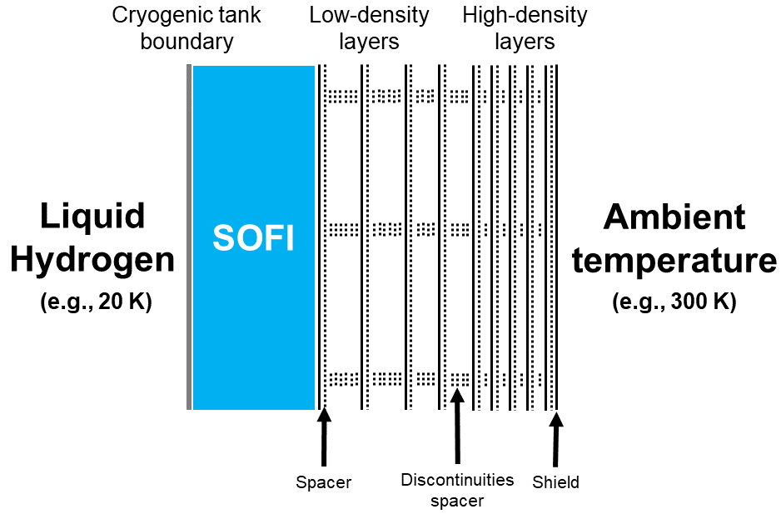
(a)
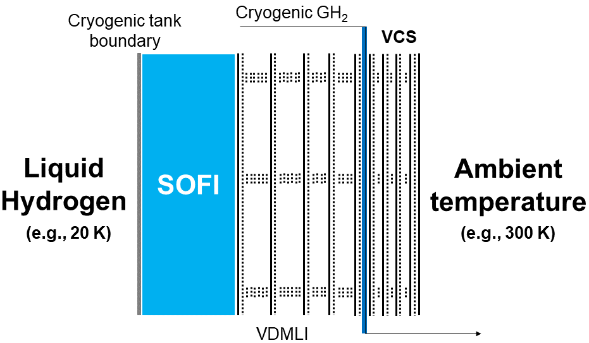
(b)
Figure 7. Illustrations of (a) VDMLI and (b) VDMLI+VCS.

The relative heat flux (with respect to MLVI, 0.4 W/m²) and boil-off loss are shown in Figure 8 [81,82]. It can be seen that using the MLI+VCS method could reduce 16% heat flux when compared against the VDMLI method. The VDMLI+VCS has nearly 60% lower heat flux than the MLI+VCS method. The VDMLI+VCS provides lowest heat flux (approximately 0.14 W/m²) when the vapour-cooled shield is at the 30% of the distance between the tank boundary and the ambient environment [82]. In terms of hydrogen loss, the VDMLI saves over 58% hydrogen loss compared to the MLVI in a 45-day test [82]; the latter resulted in 66% reduction in hydrogen loss compared to the MI in a 30-day test [81]. The VDMLI is also 74% lighter than the MLVI. The MLI+VCS reduces over 50% daily hydrogen boil-off loss when compared against MLVI [86]. Overall, the VDMLI+VCS provides the best insulation performance amongst the investigated insulation methods.

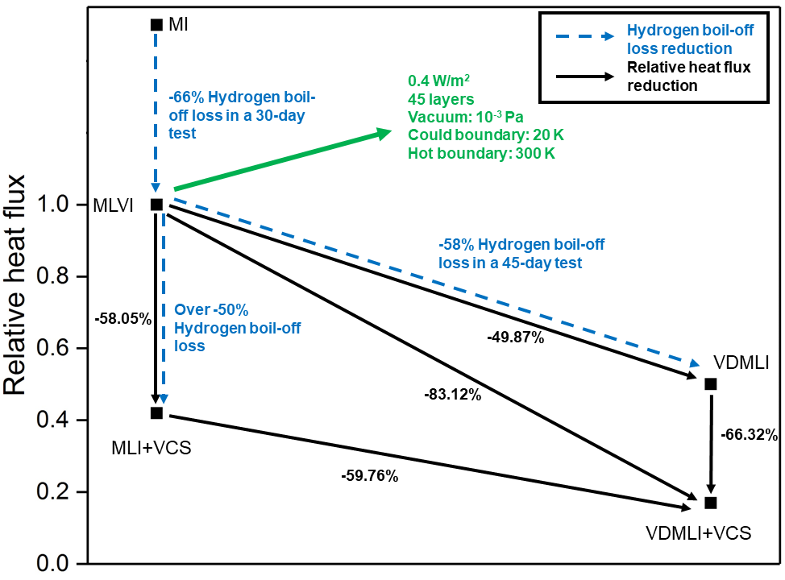
Figure 8. Relative heat flux (with respect to MLVI, 0.4 W/m²) and hydrogen boil-off loss of different insulation methods [81,82].

Although the existing hydrogen insulation methods are for vehicle and aviation applications, they are considered to also have potential for marine applications. For example, the polyurethane foam, normally used as the SOFI for LH₂ tanks on launch vehicles and spacecraft [80], is also widely used on LNG carriers. Other LNG tank insulation materials include phenolic resin foam composite panels and polystyrene panels [87–90]. The insulation panels are covered by aluminium face sheet, e.g., AA1050, and fixed by aluminium strip [87–90]. The heat flux of these foam insulations is approximately 5000 W/m². Purging/sweeping gases, such as nitrogen and LNG vapours, can be used to further reduce the heat flux of these foam insulations. Jiang et al. [84] stated the heat flux is reduced by 20% after implementing methane vapour as purging/sweeping gases on liquid methane tank. In comparison, the VDMLI+VCS method has extremely low heat flux, ranging from 0.1 W/m² to 10 W/m². The VDMLI+VCS consists a polyurethane foam layer (tens of millimetres thick), tens of layers of aluminium foil or aluminised Mylar shields, glass-fibre or Dacron spacers and a pipe system for inducing cold vent gas into the multilayer insulation. This makes it a more expensive method than the current foam-based insulation on LNG carriers. However, the low heat flux and reduced hydrogen boil-off losses could compensate the building cost in long term operations.

Within the open literature there are few studies on insulation failures. Moreno-Blanco et al. [91,92] investigated the failure of the outer metallic jacket as a consequence of insulation failure of CcH₂ tanks. They modelled the hydrogen pressurisation in a 113 L CcH₂ tank (at 57.8 K and 300 bar) with MLVI failure and remarked that the insulation failure increased the heat transfer into the tank by 100 times [91,92]. This led to the release of a large fraction of hydrogen, and hence a potential safety issue if the tank were to be located in an enclosed area. To mitigate the risk, Moreno-Blanco et al. [91] proposed a method to calculate the required capacity of FCs for consuming the released hydrogen based on the hydrogen extraction rates. This method helps to contain the released hydrogen without the need to release hydrogen outside the storage environment.

4. Attributes and mechanical properties of metallic materials in cryogenic hydrogen environments
According to the IGF and IGC codes, 9% nickel steels, high manganese austenitic steels (22 – 26 wt% Mn) and austenitic stainless steels including types 304, 304L, 316, 316L, 321 and 347 can be used for cryogenic tank structures at a design temperatures between 218 K (-55 ºC) and 108 K (-165 ºC) [69–71]. The impact test temperature required in the IGF/IGC codes for these materials is down to 77 K (-196 ºC). The most commonly used materials for CcH₂ and LH₂ tanks are austenitic stainless steels 304 and 316, iron-based super alloy A286 stainless steel and aluminium alloys 6061 and 7060 [18,51]. As mentioned in Section 2, the most frequently used metallic liner of Type II and III CcH₂ tanks is aluminium alloys [14,18,22]. The thermal conductivity and expansion of austenitic stainless steels and aluminium alloys (base metal) at cryogenic temperatures are summarised in Figure 9 and Appendix Table A1 [93–97]. It is found that the thermal conductivities of both materials are increased with increased temperature with higher gradient observed in aluminium alloys. The thermal expansion coefficients of austenitic stainless steels are lower than that of aluminium alloy AA6061. These two coefficients imply that aluminium tanks have great ability to conduct heat and have greater tendency to deform due to temperature increase. In comparison, austenitic stainless steel tanks are thermally more stable. Copper alloys could be used as valves and braze material since they have lower permeability than stainless steels [51,98]. However, they are not suitable as tank structures since they have significantly higher thermal conductivity than other metallic materials [51,98]. The typical thermal conductivity values for copper are 400 W/m/K at 4 K, 1950 W/m/K at 20 K and 550 W/m/K at 77 K [99].

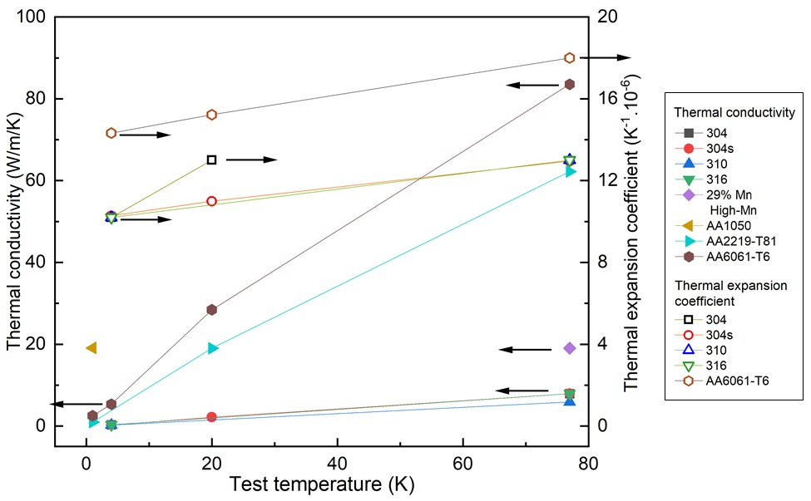
Figure 9. Comparison of thermal conductivity and thermal expansion coefficient of austenitic stainless steels and aluminium alloys at cryogenic temperatures (the arrows indicate the corresponding vertical axis for the data) [93–97].

The chemical composition of the materials tested for cryogenic hydrogen application in the literature [69,98,100–113] are summarised in Appendix Table A2. One important parameter associated with the chemical compositions is the nickel equivalent, Ni_{eq}, which is defined by Equation (1), where all elements are in weight percentages (%) [107]. The nickel equivalent is an index to evaluate the degree of austenite phase stability against strain-induced martensitic transformation and the tendency of forming the austenite phase [107,114], hence it reflects the material’s resistance to hydrogen embrittlement [107]. This will be discussed in more detail in Section 5.

$${Ni}_{eq}\left(\%\right)=Ni\left(\%\right)+0.65Cr\left(\%\right)+0.98Mo\left(\%\right)+1.05Mn\left(\%\right)+0.35Si\left(\%\right)+12.6C\left(\%\right). (1)$$

4.1 Tensile properties
Tensile tests at cryogenic temperatures are normally performed using a servo-hydraulic tensile test machine with a vacuum insulated container retaining cryogenic fluids. The container, grips, pull rods and cryogenic load frame are usually made of austenitic stainless steels (AISI 304LN), wrought nickel-base super alloys or titanium alloys (Ti-6AI-4V and Ti-5Al-2.5Sn) [115]. The specimen is required to be cooled to the test temperature and remains fully immerged in the cryogenic fluid during the test. A schematic illustration of the typical tensile test machine at liquid helium temperature (4 K) can be found in BS ISO 6892-4:2015 [115].

The tensile properties of metallic materials (unnotched) tested in LH₂ (20 K) are summarised in Figure 10 and Appendix Table A3, which include the 0.2% proof strength f_{p0.2} i.e. the strength corresponding to 0.2% plastic strain, the yield strength f_{y}, the ultimate tensile strength f_{u}, strain at fracture ε_{f} and the reduction area at fracture A_{f}. Similarly, the tensile properties of metallic materials (unnotched) in the CcH₂ environment (77 K) are summarised in Figure 11 and Appendix Table A4. It can be seen that in LH₂ condition (20 K), the proof strengths of aluminium alloys are marginally lower than the ultimate tensile strengths whereas the proof strengths of austenitic stainless steels are approximately half the values of the ultimate tensile strengths. In addition, the proof strengths of these two types of materials are comparable. No information is available on the reduction of area at fracture for aluminium alloys. This is primarily due to the fact that most of the tested samples were sheet alloys. It has been reported that the reduction of area at fracture is more related to the chemical composition of the material and hydrogen embrittlement influence rather than the cryogenic temperature effect [106,107,109]. The percentage elongations of aluminium alloys are much smaller than those of stainless steels. When tested in CcH₂ environment (77 K), only one set data is available for aluminium alloy AA2219. Its proof strength is of similar magnitude as the austenitic stainless steels. However, the ultimate tensile strengths and elongations of stainless steels are nearly three times higher than those of AA2219.

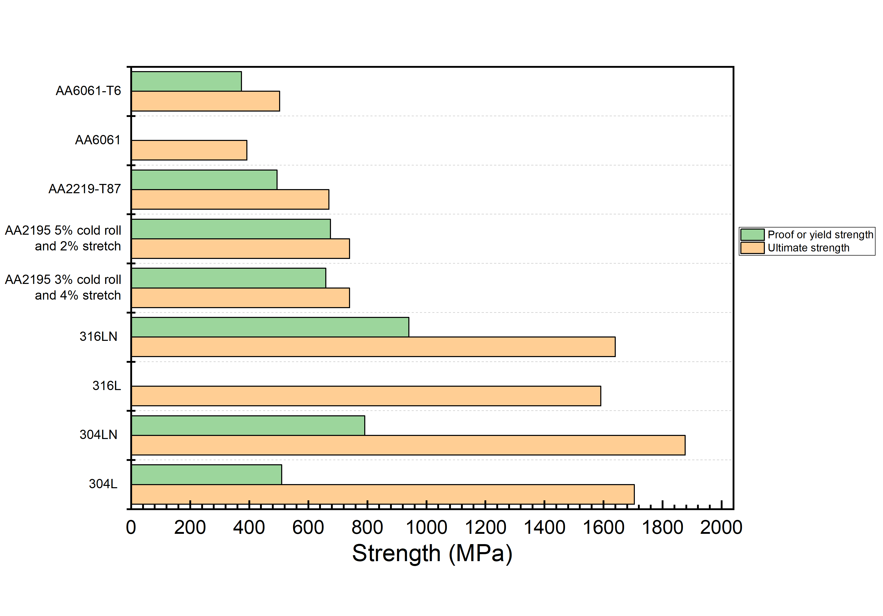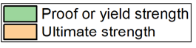
(a)
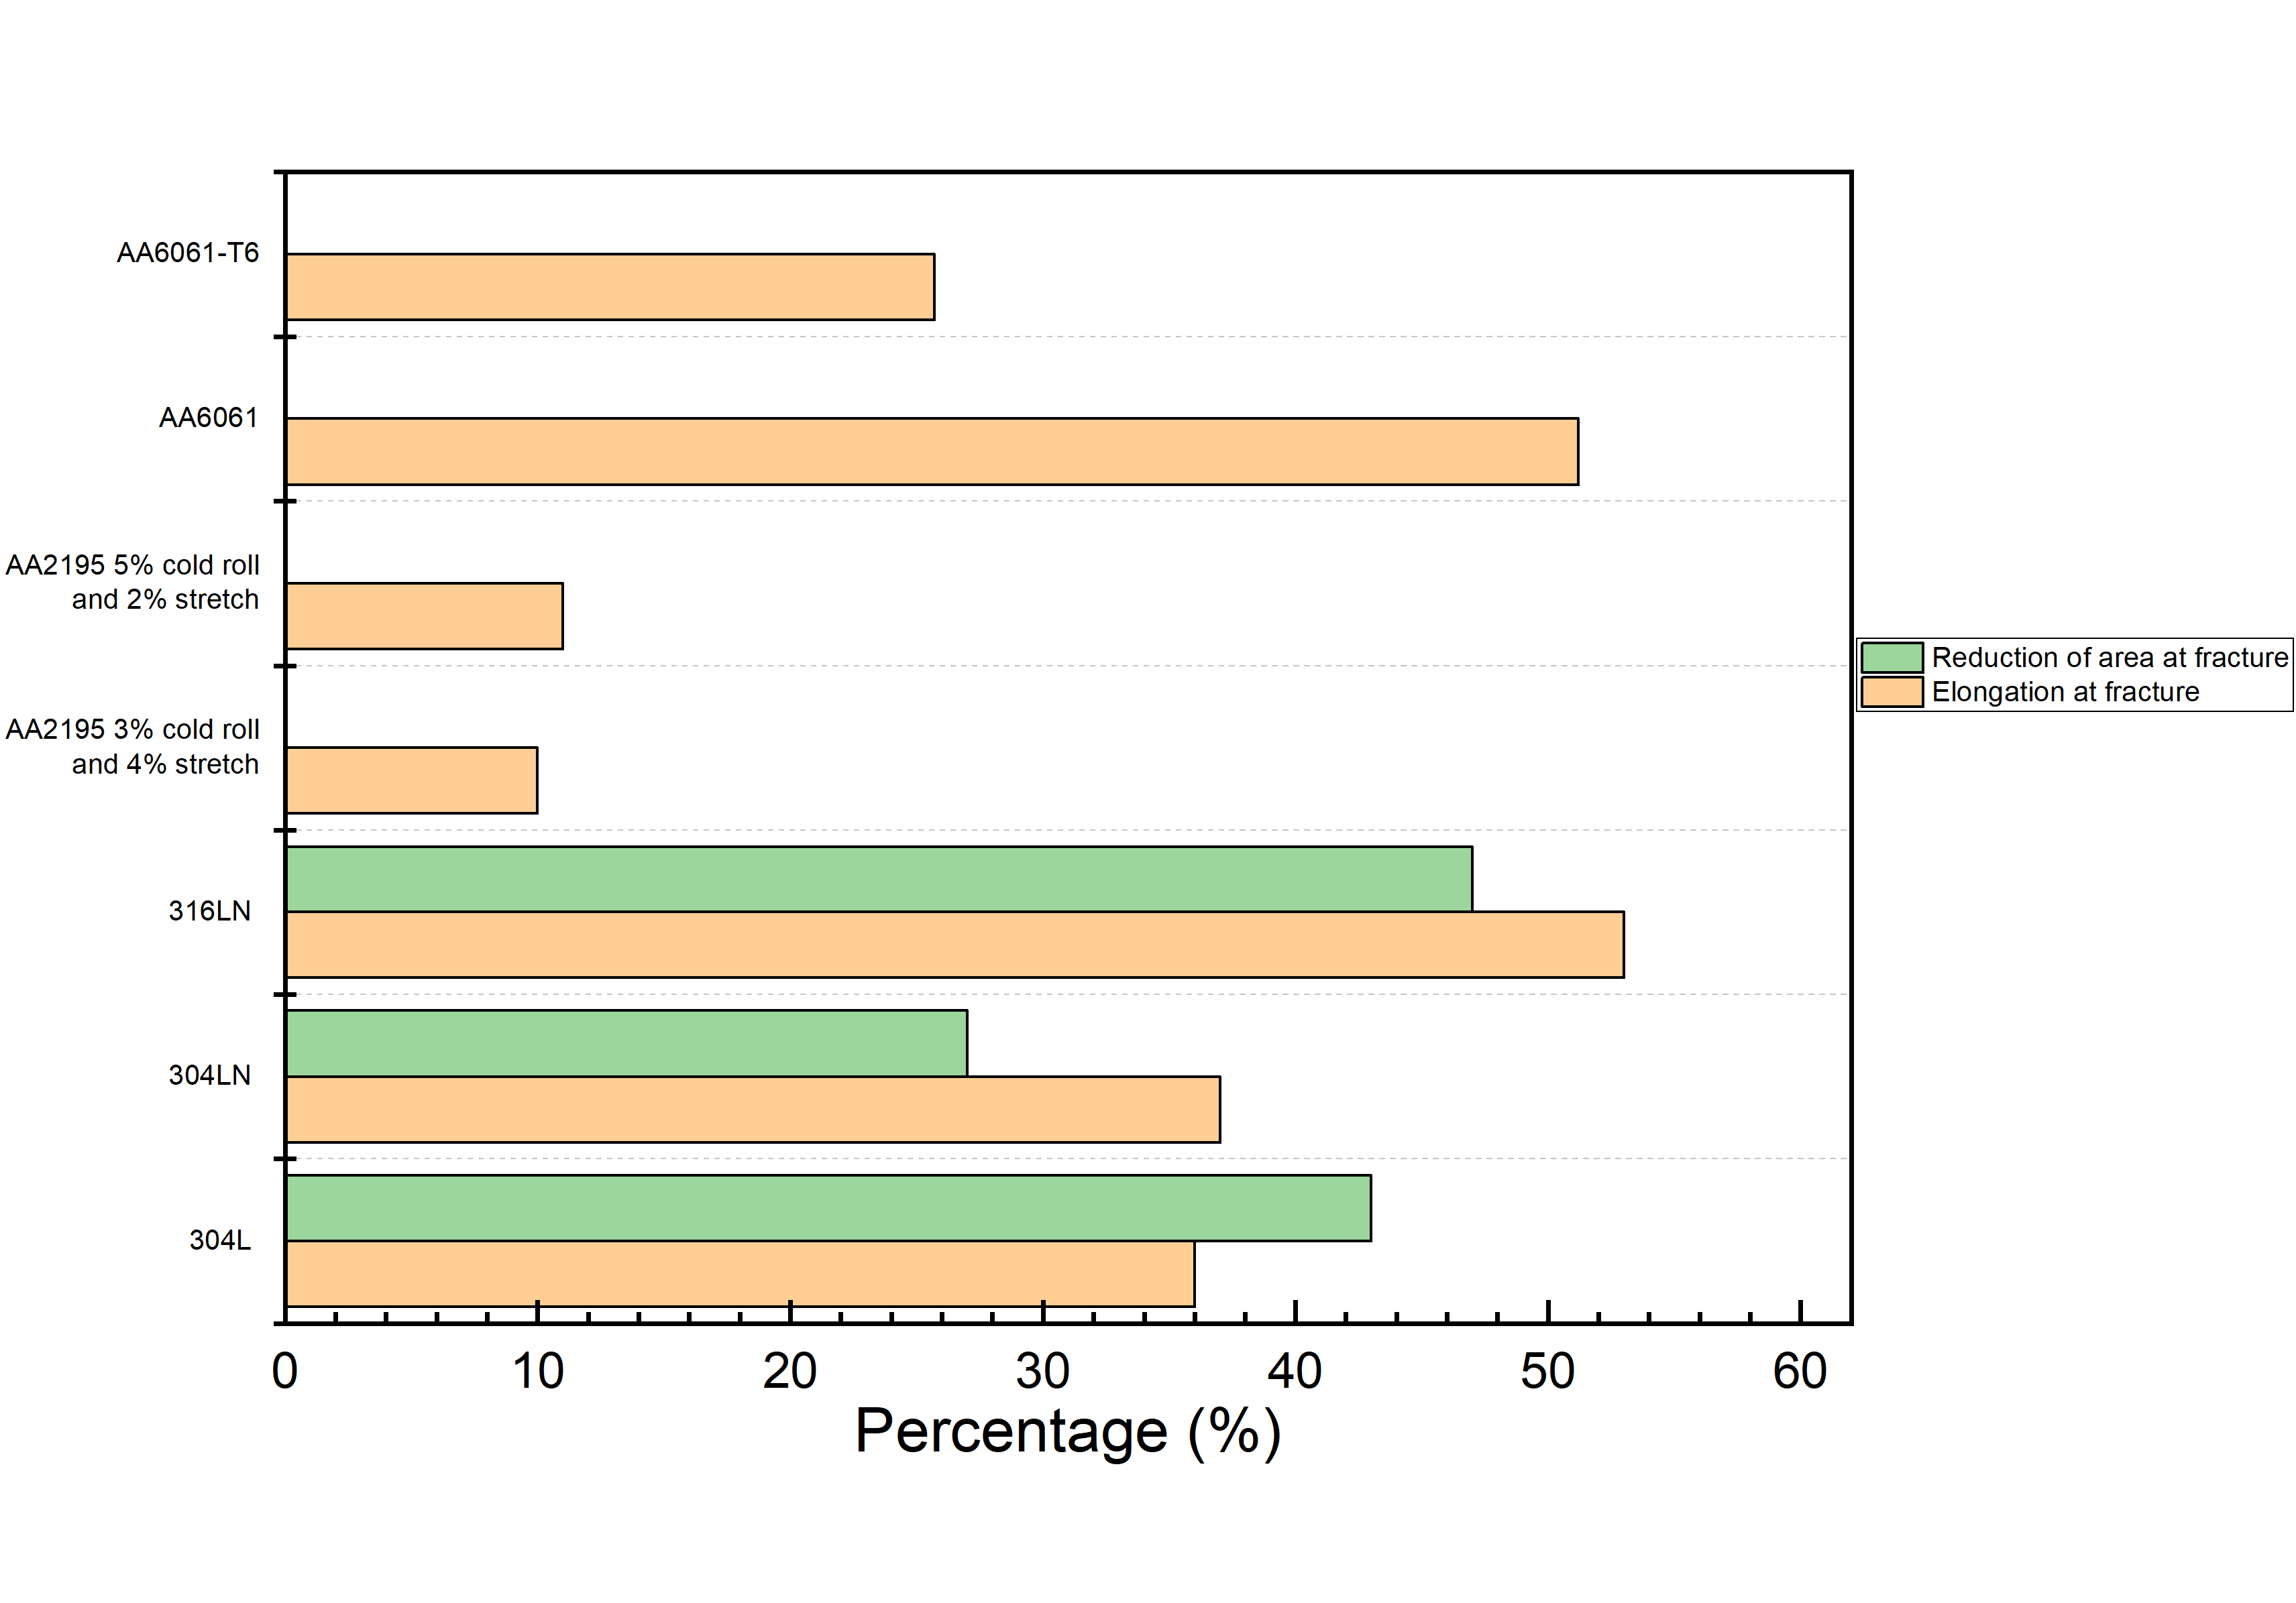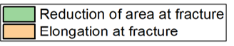
(b)
Figure 10. Tensile properties tested in LH₂ (20 K) [1–17]: (a) the 0.2% proof strength and the ultimate tensile strength; (b) elongation and reduction of area at fracture.

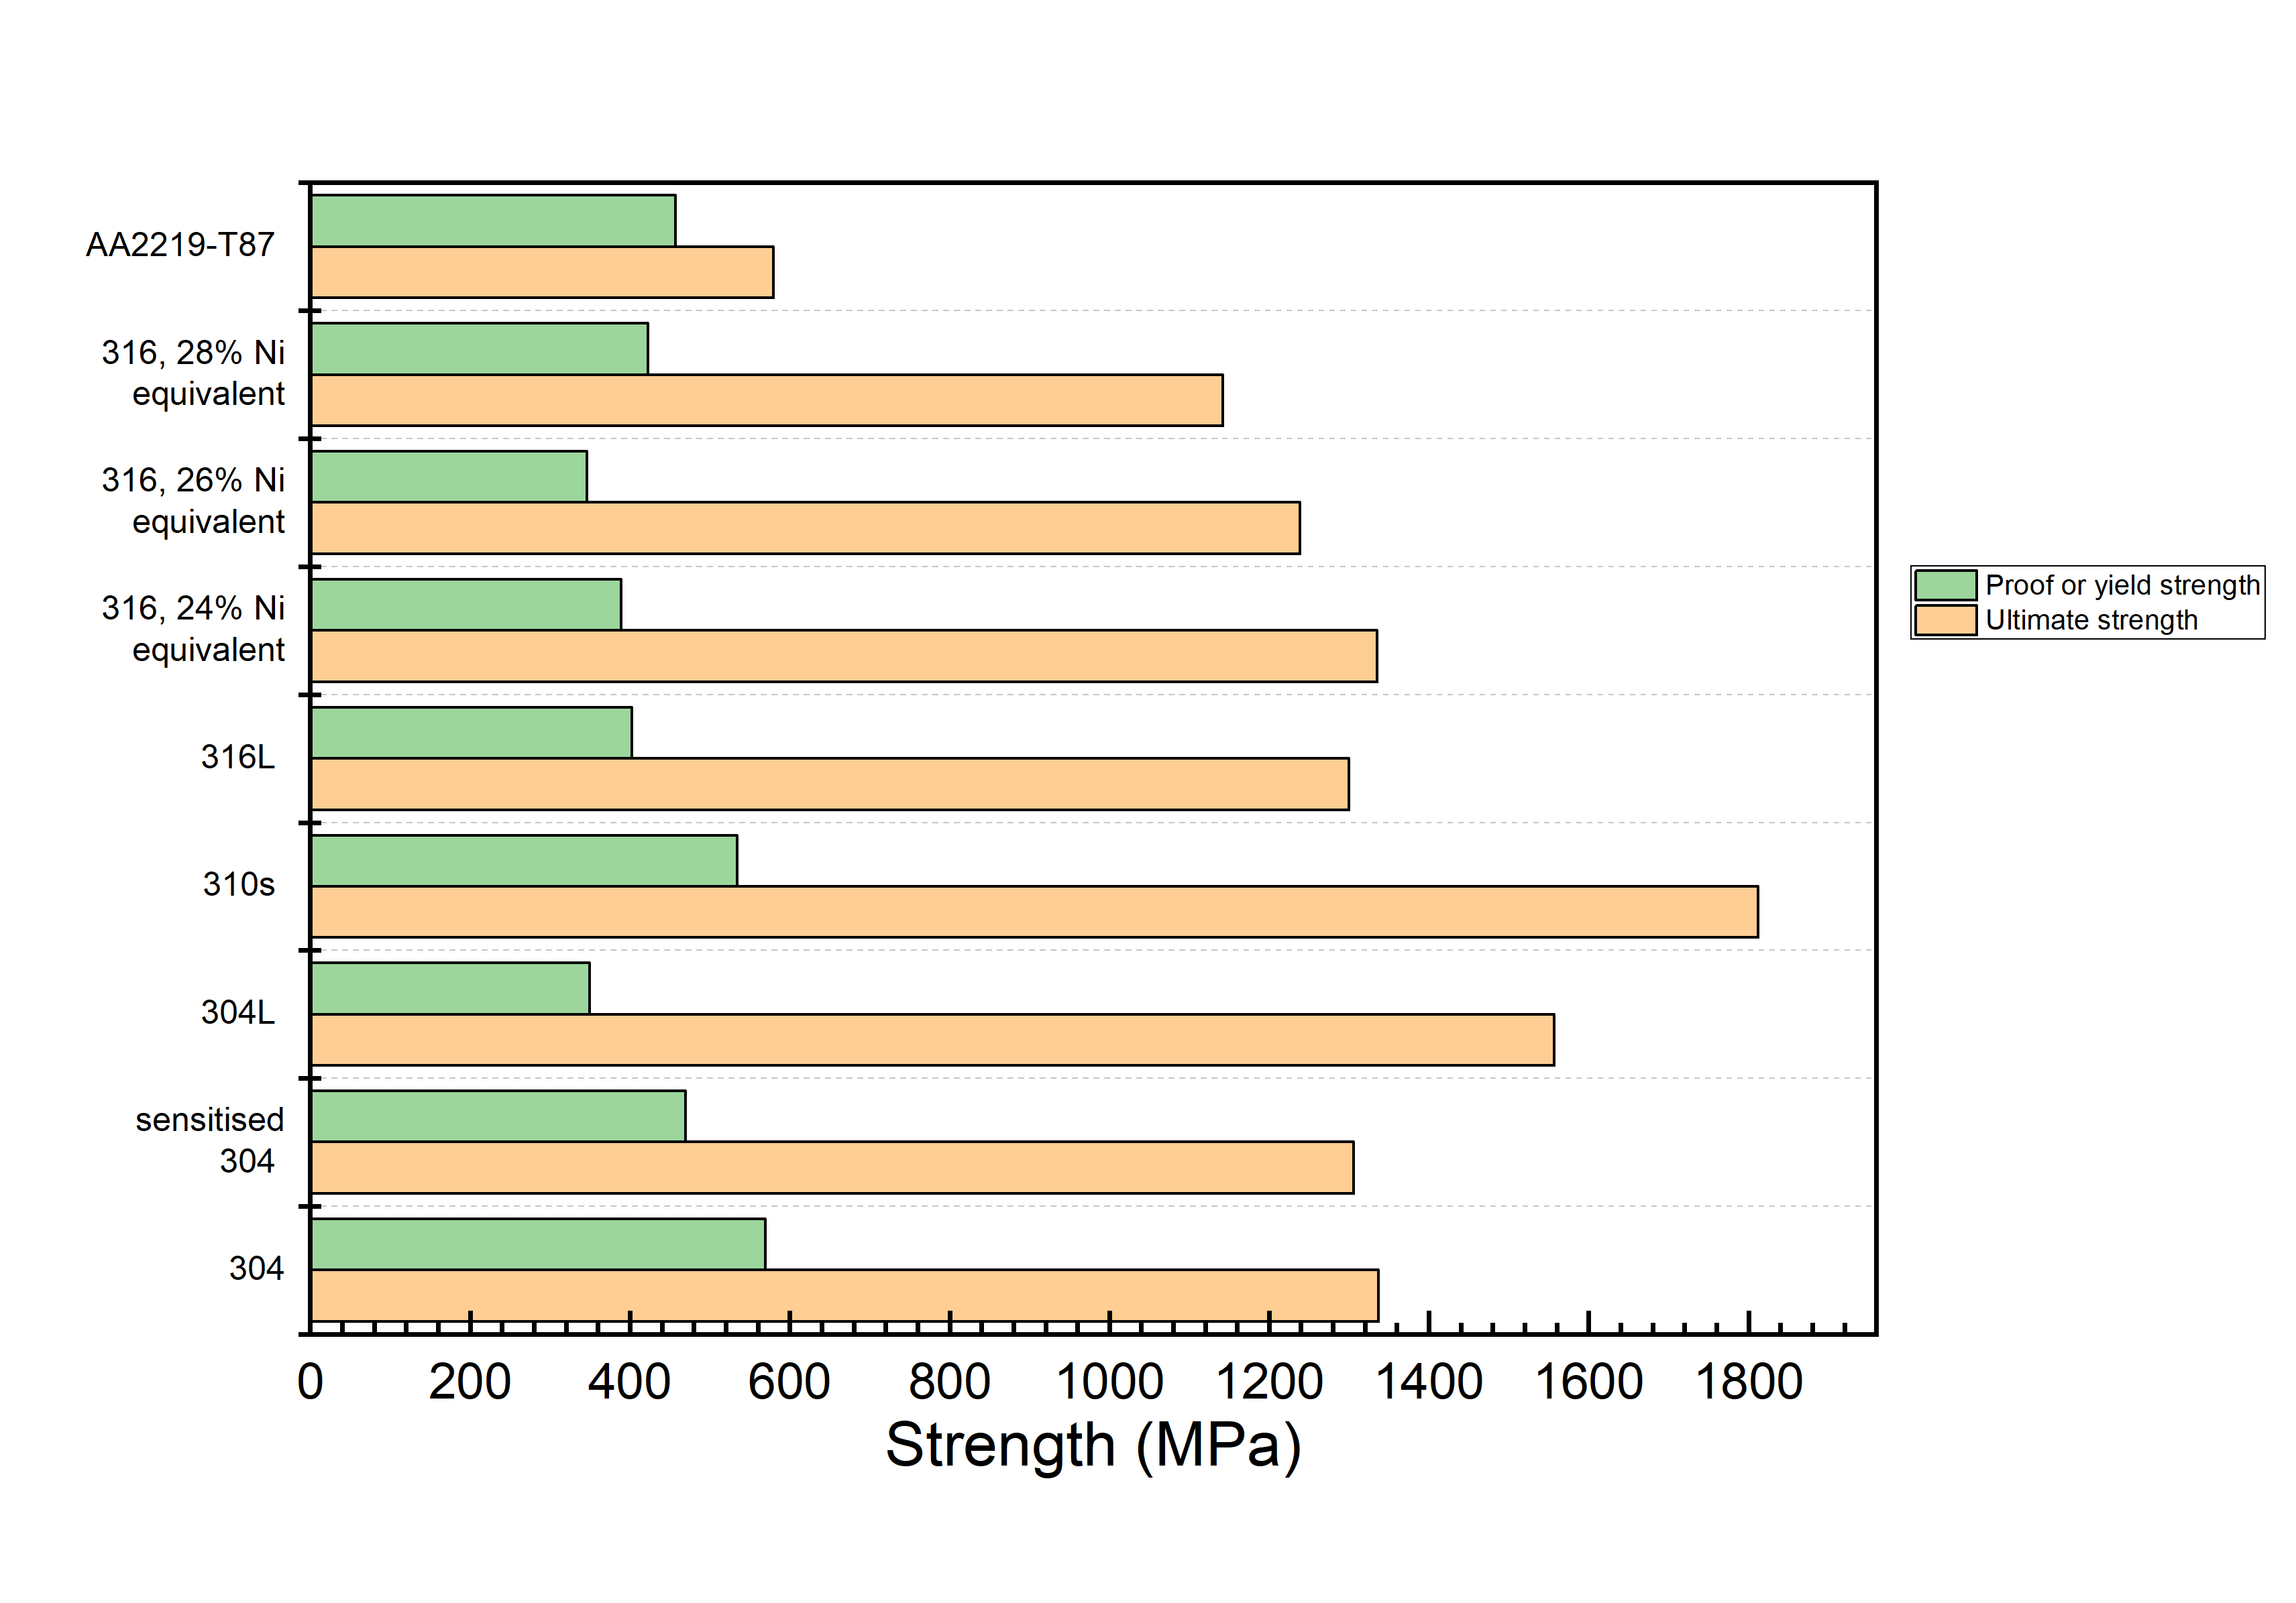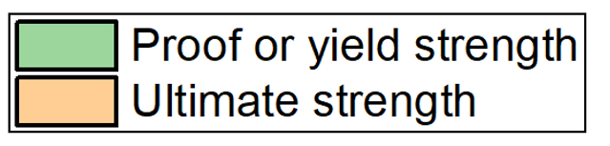
(a)
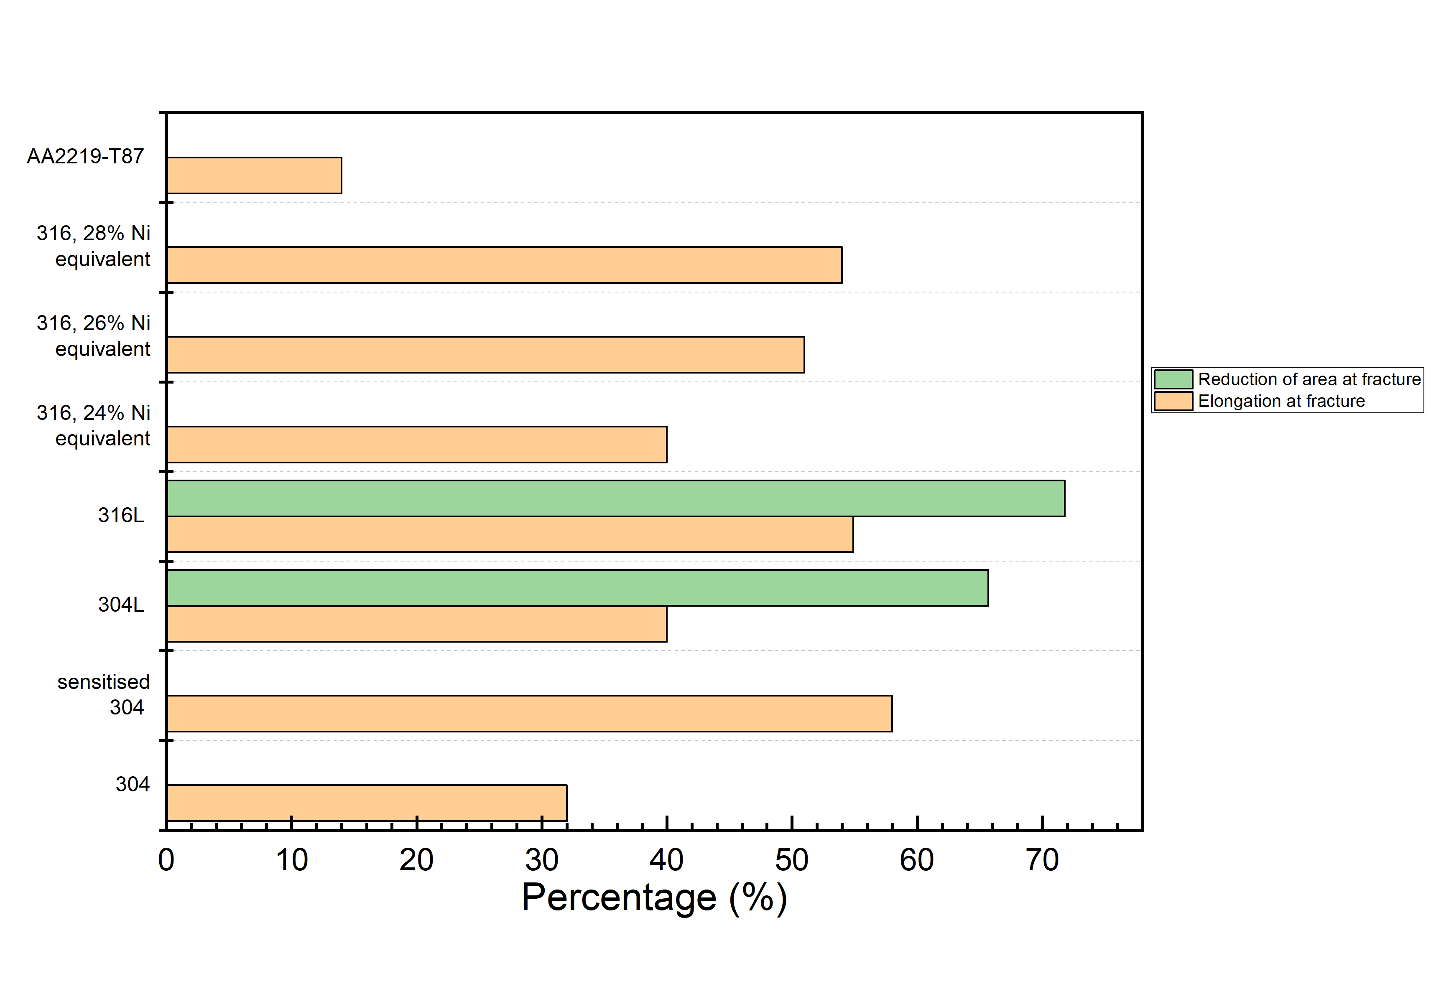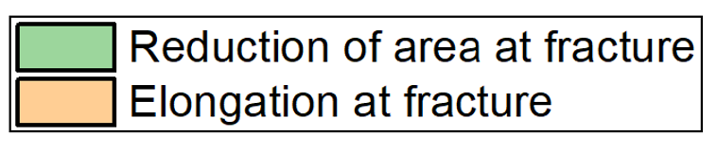
(b)
Figure 11. Tensile properties tested in CcH₂ (77 K) [1–17]: (a) the 0.2% proof strength and the ultimate tensile strength; (b) elongation and reduction of area at fracture

Figure 12 presents a direct comparison of proof strength and ultimate tensile strength of three materials (two austenitic stainless steels and one aluminium alloy) between LH₂ (20 K) and CcH₂ (77 K) environments. Despite the limited data from the literature, it can be seen that both strength values are lower at higher temperature. Also included are the current Lloyd’s Register Material Rule requirement [18] for 304L and 316L at a temperature no lower than -165 °C. The aluminium alloy AA2219-T87 is not included in the current material rules of classification societies, as this grade has been primarily used for aerospace applications [5].

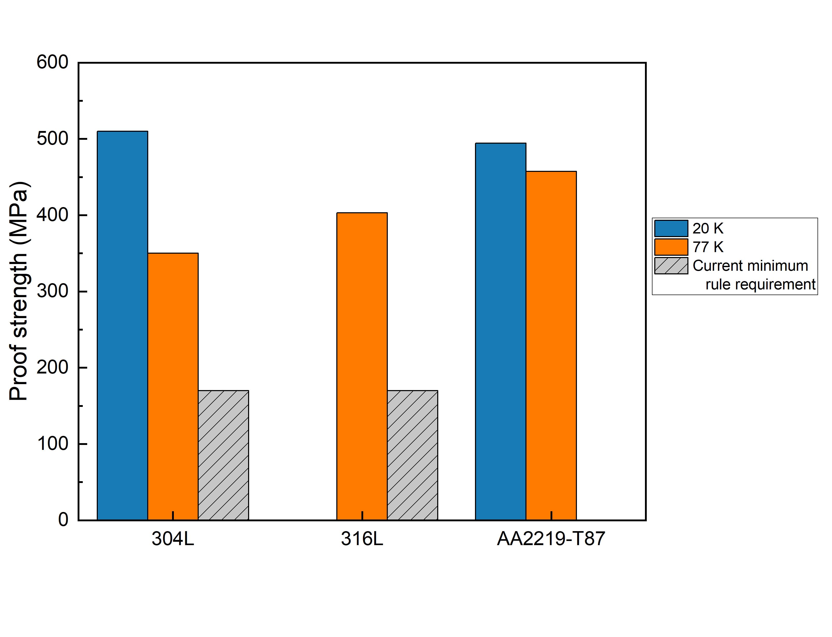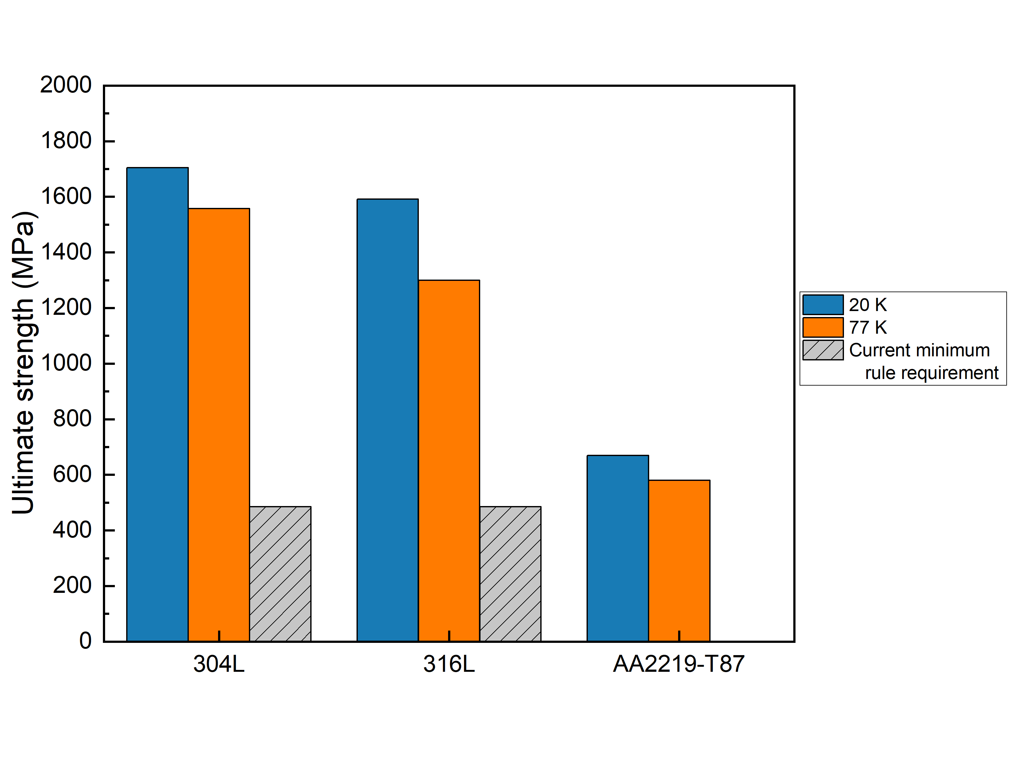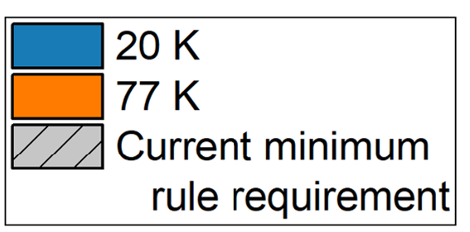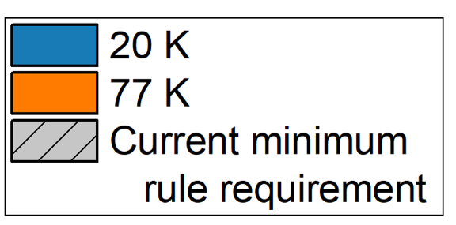
(a) (b)
Figure 12. Comparisons of the (a) proof strength and (b) ultimate tensile strength of austenitic stainless steel grades 304L, 316L and aluminium alloy AA2219 for LH₂ (20 K) and CcH₂ (77 K) environments together with the current Lloyd’s Register’s minimum rule requirements (for temperatures no lower than -165 °C).

4.2 Fatigue behaviour
Fatigue tests in LH₂ or CcH₂ environments are typically performed using servo-hydraulic machines with cryostats (similar to a tensile test setup). The force control is based on a sinusoidal cyclic form. Similar to the cryogenic tensile test mentioned in Section 4.1, the load cyclic frequency is kept low in order to avoid excessive heating. The cryogenic fatigue test parameters used in literature tests are listed in Table 7 [110–113,117]. Table 8 summarises the fatigue properties of different metallic materials at cryogenic temperatures [110–113,117]. The S-N curves of 304L and 316L are shown in Figure 13 [110–113,117]. For the austenitic stainless steels 304L, as the temperature is decreased, the fatigue strength is decreased and the number of cycles to failure is significantly reduced especially in the long life regime [112,113].

Table 7. Cryogenic fatigue test parameters [110–113,117]
Test machine | Servo-hydraulic machine
Cyclic load | Sinusoidal wave form
Frequency | 2 Hz – 15 Hz
Ratio of minimum stress over maximum stress (R) | 0.01 – 0.1

Table 8. Fatigue properties of austenitic stainless steels in cryogenic hydrogen environments [110–113,117]
Type | Condition | Temperature (K) | Cycles to failure | Fatigue strength (MPa)
304L | hot-rolled and solution-treated at 1323 K for 0.5 h | 20 | 1,000,000 | 358
304L | N/A | 77 | 10,000,000 | 791
316L | N/A | 77 | 10,000,000 | 487

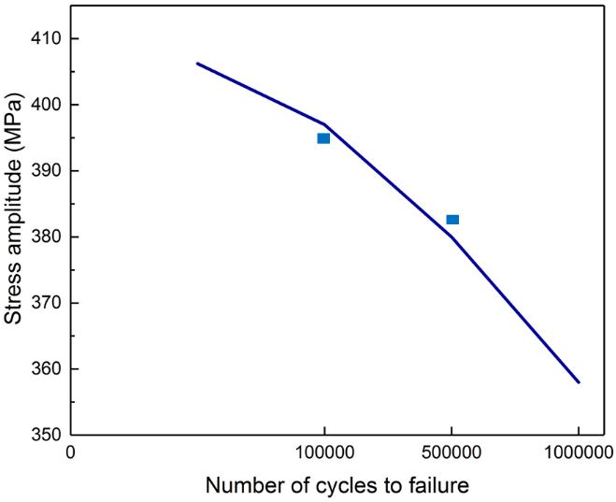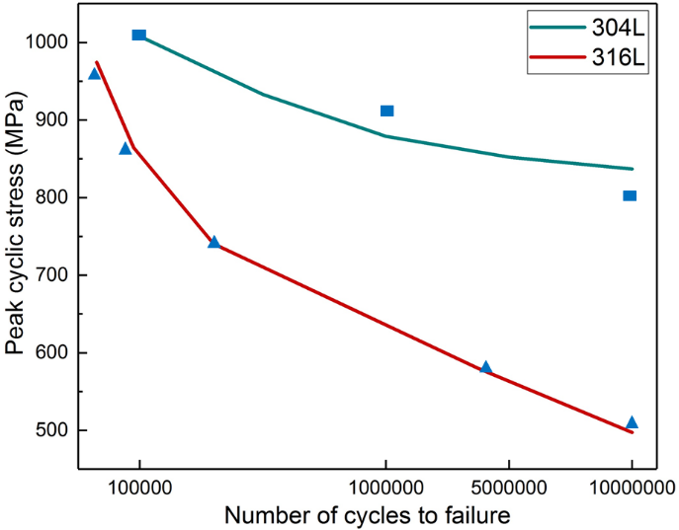
- (b)
Figure 13. The S-N curves of (a) hot-rolled and solution treated 304L at 20 K (R=0.01); (b) 304L and 316L at 77 K (R=0.01) tested in 10 bar hydrogen environment [110–113,117].

4.3 Fracture toughness
Only limited data has been found in the literature for quantifying the fracture toughness of metallic materials in cryogenic hydrogen. Witzell [119] measured the static plane strain fracture toughness of AA2219-T87 according to the ASTM Standard E813 (replaced by ASTM E1820) in LH₂ environment. Centre through cracked specimens were tested under tensile loadings. The specimens were pre-cracked under fatigue load at room temperature at gross stress levels below 20% of yield strength of the material [119]. The fracture toughness in the longitudinal direction (L-T) is 45 MPa√m and the value in the transverse direction (T-L) is 47 MPa√m. Although the author [119] remarked that the fracture toughness of AA2219-T87 was improved from 77 K to 4 K for L-T direction, there is lack of data to compare and illustrate the influence of LH₂ on the fracture toughness properties. Micheler et al. [104,118] tested the cryogenic Charpy V-notch (CVN) tests of austenitic stainless steel (grade 316 or 316L), stainless steel welds and braze materials according to ISO 148 in liquid helium and liquid nitrogen. However, there is no CVN test data available of those materials in CcH₂ or LH₂ environment.

Notched tensile tests are often employed to evaluate the fracture toughness of sheet alloys [20]. The ratio of notched tensile strength over unnotched tensile strength has been used as a toughness index. The notched-to-unnotched tensile ratio of austenitic stainless steel grades 304L and 316L, iron-based super alloy A286 and aluminium alloy AA6061 obtained under the LH₂ (20 K) condition are summarised in Table 9. The stress concentration factor, K_{T}, is the ratio of the maximum stress at the root of the notch to the nominal stress [20]. It has been reported that in cryogenic temperatures (without H₂), the ratio (K_{T} = 6.3) of austenitic stainless steel grade 301 ranges from 0.4 to 1.1 and the ratio is 0.9 to 1.1 for stable grade 310, depending on the test condition [20]. However, the amount of data tested in LH₂ is not sufficient to draw any definite trend/range in toughness.

Table 9. Notched-to-unnotched tensile ratio obtained in LH₂ (20 K) [8,9]
Material type | Specimen thickness (mm) | K_{T}  (Note 1) | Notched-to-unnotched tensile ratio
304L | N/A | N/A | 0.74
316L | N/A | N/A | 1.04
A286 | 7.8 | 3.5 | 0.97
A286 | 7.8 | 8.0 | 0.90
A286 | 1.6 | 7.2 | 0.86
AA6061 | 10 | 8.0 | 0.99
AA6061 | 6.3 | 8.0 | 0.97
AA6061 | 2 | 7.2 | 0.94
AA6061 | 6.3 | 13.0 | 0.90
AA6061 |  | 3.5 | 0.86
AA6061 |  | 21.0 | 0.81
Note 1: K_{T} is the ratio of the maximum stress at the root of the notch to the nominal stress in the specimen [20].

5. Material related failure mechanisms of cryo-compressed and liquid hydrogen tanks
The main failure mechanisms related to metallic materials in CcH₂ and LH₂ environments are cryogenic temperature embrittlement and hydrogen embrittlement. The extent of each of these failure mechanisms is largely dependent on the chemical compositions and the microstructure of the material as discussed hereafter.

5.1 Effect of chemical compositions

5.1.1 Cryogenic temperature embrittlement
Metallic materials may feature a ductile to brittle transition from room temperature to cryogenic temperature (lower than 77 K). This transition often occurs in austenitic stainless steels and is closely related to the temperature and the chemical composition of the material [123]. Refs. [123–125] investigated the effect of material composition on the cryogenic temperature embrittlement of austenitic stainless steels. The effect of Ni and N are summarised in Table 10 since their proportions were found to have a significant effect on the cryogenic embrittlement of austenitic stainless steels. The fracture energy was obtained from CVN impact tests [22] and the elongation was determined from tensile tests [20,21].

Table 10. Effects of chemical compositions investigated in Refs [123–125]
Chemical composition | Influences on fracture energy and elongation | References
Nickel (Ni) | 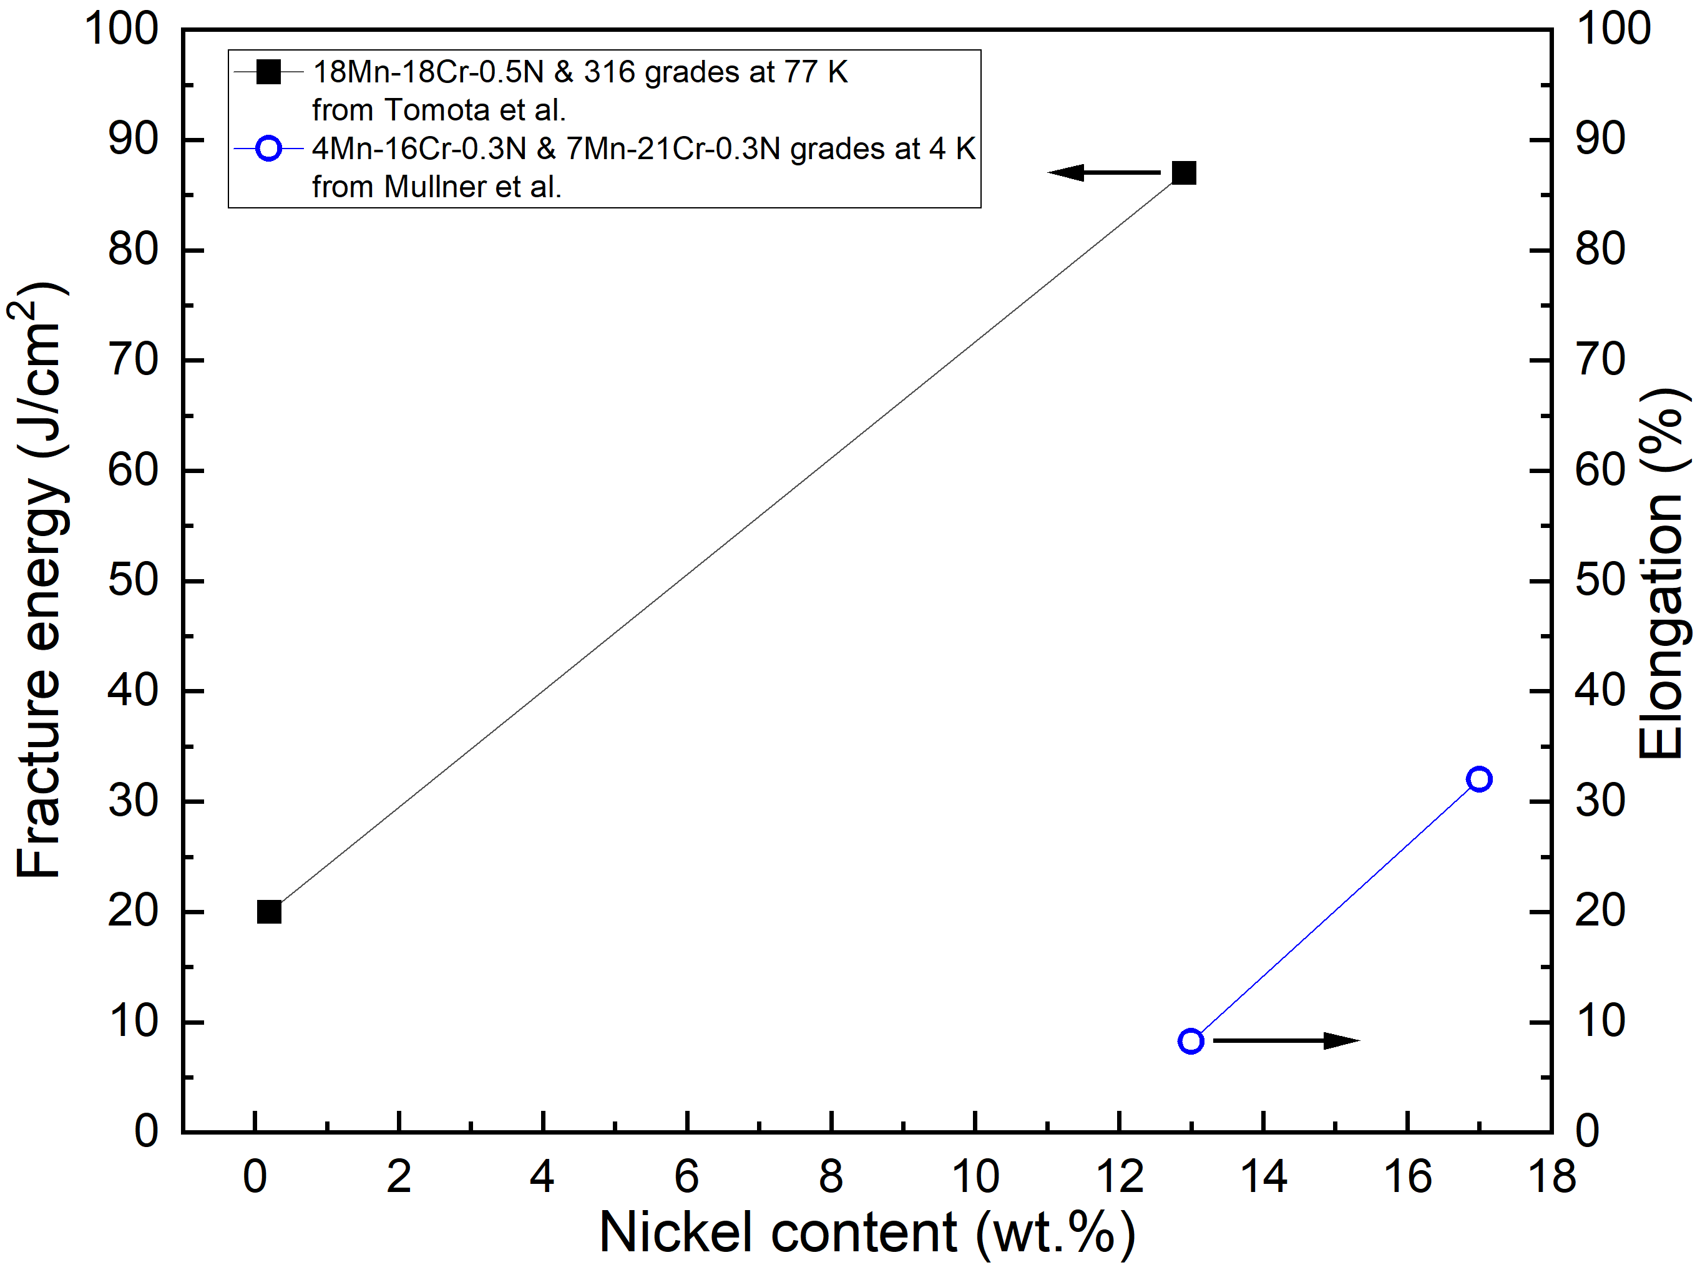 | Mullner et al. [21] Tomota et al. [22]
Nitrogen (N) | 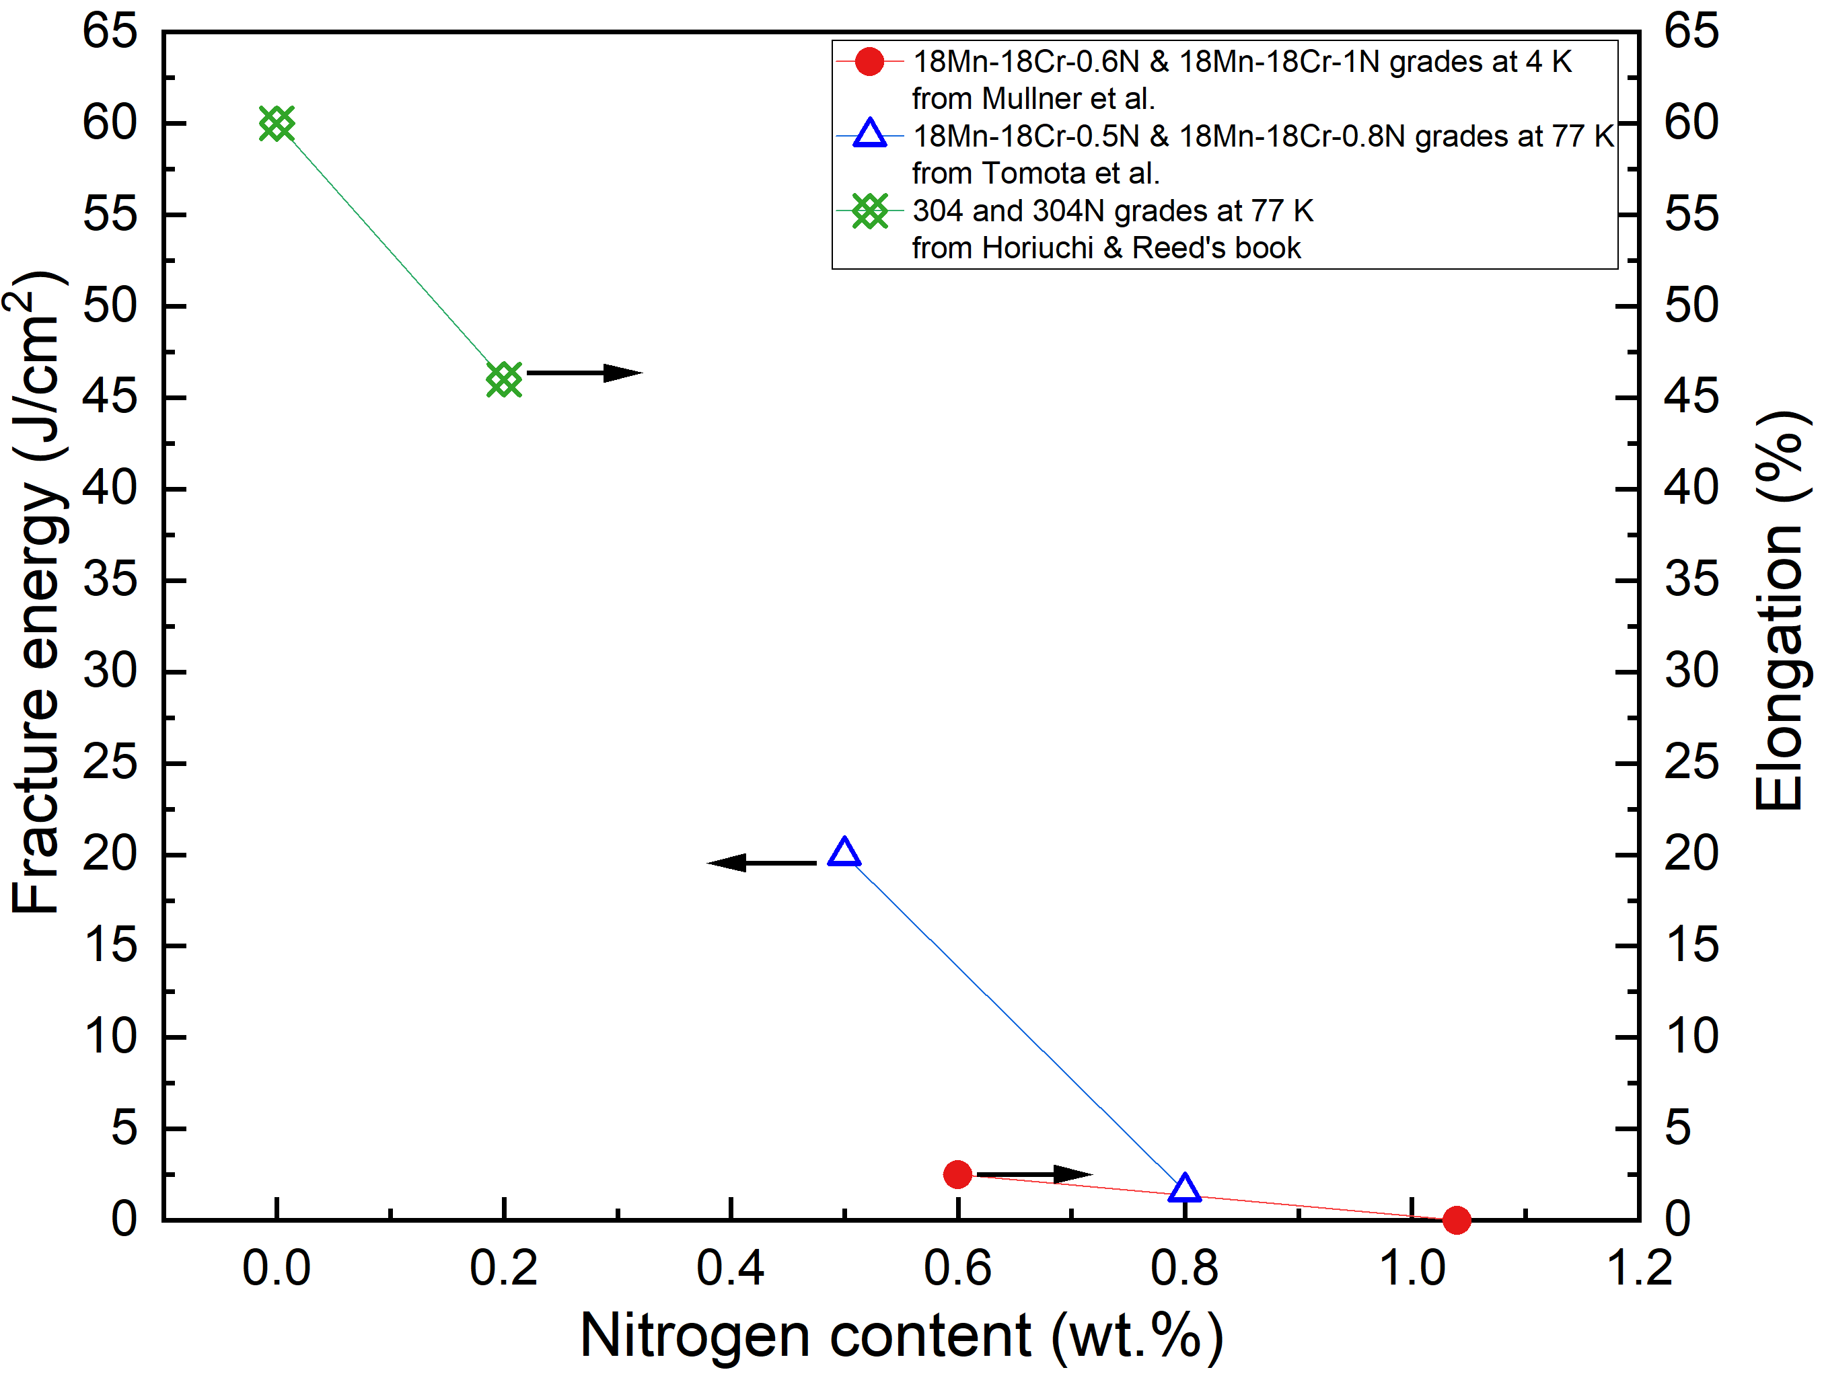 | Mullner et al. [21]  Tomota et al. [22]  Horiuchi & Reed [20]

It can be seen in Table 10 that the addition of Ni increases the fracture energy and reduces the chance of brittle fracture failure [123–125]. Grades 316 and 316L with high proportion of Ni (Appendix Table A2) are good at maintaining ductility and toughness at cryogenic temperatures. Although N enhances the strength and hardness, as well as the local corrosion resistance at room temperature, of austenitic stainless steels [124], it promotes brittle fracture [123]. This is because N reduces the stacking fault energy, which shifts the onset of twining to low strain levels with low total dislocation density [123]. Consequently, 316LN and 304LN austenitic stainless steels should be used with caution for cryogenic tanks, as they have higher N contents compared to 304, 304L, 316 and 316L grades. The addition of Mn has similar effect as N. Austenitic stainless steels with 7% Mn and 18% Mn were reported to become brittle when the temperature was lower than 77 K [123]. High-Mn austenitic stainless steels (22% - 26% Mn), which are allowed in the IGF code and IGC code for LNG tank structures [69–71], should be avoided for LH₂ tanks. In general, more data/tests are needed to confirm the abovementioned chemical composition effects on cryogenic embrittlement behaviour.

There are few studies investigating the influence of chemical composition of aluminium alloys on the cryogenic temperature embrittlement. Xu et al. [111] stated that the increased proportion of Zr improves the tensile strength, fatigue strength and ductility at 77 K. Furthermore, the aluminium alloy with 0.16% Zr eliminates the temperature effects on the fatigue strength in high-stress cycles when compared to the aluminium alloy with 0.02% Zr [111]. However, the number of fatigue life cycles for aluminium alloys is significantly reduced with higher Zr content. Further investigations are necessary to understand the effect of Zr and/or other alloying elements.

5.1.2 Hydrogen embrittlement
The fracture toughness and/or ductility of metallic materials can be degraded due to the presence of atomic hydrogen, which is called hydrogen embrittlement [66]. The mechanism can be categorised as hydrogen environmental embrittlement, internal hydrogen embrittlement and hydrogen reaction embrittlement [66]. The hydrogen environment embrittlement is caused by the combination of applied stress and exposure to a hydrogen environment, where the crack is frequently initiated at a surface defect [66]. The hydrogen reaction embrittlement is caused by the diffused atomic hydrogen reacting with the composition of the metallic material at elevated temperature and pressure, which is commonly found in titanium and zirconium alloys [66]. The internal hydrogen embrittlement is caused by unintentional introduction of atomic hydrogen into metallic materials during forming or finishing operations, such as pickling, electroplating and cathodic charging, where the crack is commonly initiated at the root of an internal defect with localised stress [66]. Figure 14 illustrates the relationship between the hydrogen embrittlement influencing factors i.e. hydrogen environment, applied stress and material type. Controlling any one of these three factors, such as by appropriate material selection, reducing hydrogen gas pressure or reducing external applied stress, will narrow the overlapping area in the Venn diagram, and hence reduces the extent of hydrogen embrittlement failure.

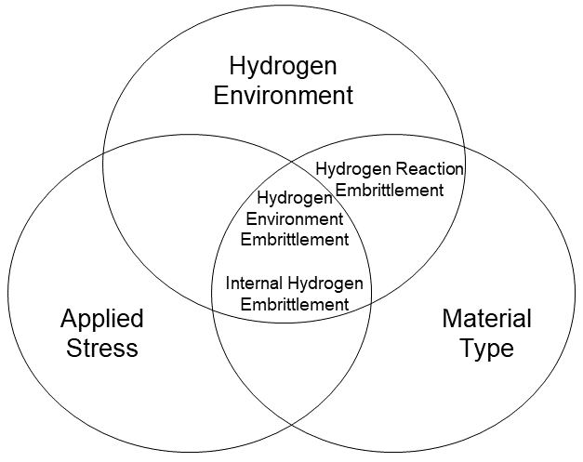
Figure 14. Three influencing factors and associated hydrogen embrittlement mechanisms [66].

For CcH₂ and LH₂ tanks on ships, the most concerned embrittlement mechanism is considered to be hydrogen environment embrittlement since tank materials are exposed to the hydrogen environment and to both internal/external mechanical stresses. The hydrogen environment embrittlement can be measured by conducting a disc test at room temperature, where the specimen, which has the shape of a disc, is subjected to a constantly increasing hydrogen gas pressure until it bursts or cracks [127]. The codified disc test procedures at room temperature are set out in the ISO/TS 11114-4 [127] standard. However, there is no codified method for measuring the hydrogen environment embrittlement at cryogenic temperatures. High pressure GH₂ directly increases the hydrogen environment embrittlement of metallic materials by increasing the atomic hydrogen per unit volume at a constant temperature [66]. The ductility of austenitic stainless steels can be significantly reduced in a high-pressure hydrogen environment, especially when the pressure is over 100 bar [66,128]. However, austenitic stainless steels with high Cr and Ni proportions, such as Type 316L steels, have a higher resistance against high-pressure hydrogen embrittlement [129]. Furthermore, Michler et al. [129] reported that aluminium alloys are not affected by a dry high-pressure GH₂ environment.

Most metallic materials will be embrittled by hydrogen at a certain cryogenic temperature range [22,66,107,112]. Specifically, austenitic stainless steels, being the most commonly used materials for cryogenic hydrogen tanks, are affected within the temperature range between 123.15 K (-150 ºC) and 173.15 K (-100 ºC) [22,66,107]. Below 123.15 K, there is negligible hydrogen embrittlement of austenitic stainless steels [22,66,107]. Lee [66] summarised the hydrogen environment embrittlement index of types 304L, 304N, 316 and 310 austenitic stainless steels, as shown in Figure 15. The index is the ratio of plastic elongation in hydrogen against that in air. It is found that the plastic elongation of types 304L and 304N austenitic stainless steels in hydrogen environment is only 20% of their plastic elongation in air environment when the specimens are at the maximum hydrogen environment embrittlement temperature, defined as the temperature at which the effect of hydrogen environment embrittlement is maximum. This implies significant embrittlement in these steels. In comparison, Type 310 austenitic stainless steel is not severely affected by hydrogen embrittlement in the same temperature range, with 10% reduction in elongation due to hydrogen. In addition to good performance in cryogenic temperature embrittlement due to high Ni content, the type 316 austenitic stainless steel also possesses relatively good resistance to hydrogen embrittlement, showing 70% of the air elongation retained in hydrogen environment. Indeed, Zhang et al. [107] and Ilola et al. [125] stated that increased nickel equivalent (Ni_{eq}) in austenitic stainless steels eliminates the hydrogen environment embrittlement, as shown in Figure 16. This conclusion was obtained by testing 11 types of 316 austenitic stainless steels (Ni_{eq} from 24.20% to 34.33%) at temperatures ranging from 77 K to 300 K at 10 bar. Tested within the range of 123.15 K to 173.15 K, the 316 grade with Ni_{eq} of 27.17% to 34.33% (as listed in Appendix Table A2) are not influenced by hydrogen environment embrittlement. Additionally, Hwang et al. [130] stated that using a polytetrafluoroethylene (PTFE) coating further enhances the hydrogen embrittlement resistance of austenitic stainless steels for LH₂ tanks.

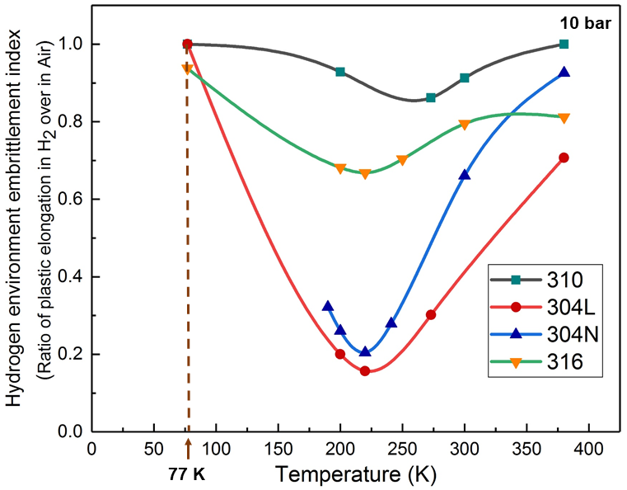
Figure 15. Hydrogen environment embrittlement index of types 304L, 304N, 316 and 310 austenitic stainless steels in 10 bar hydrogen environment [66].

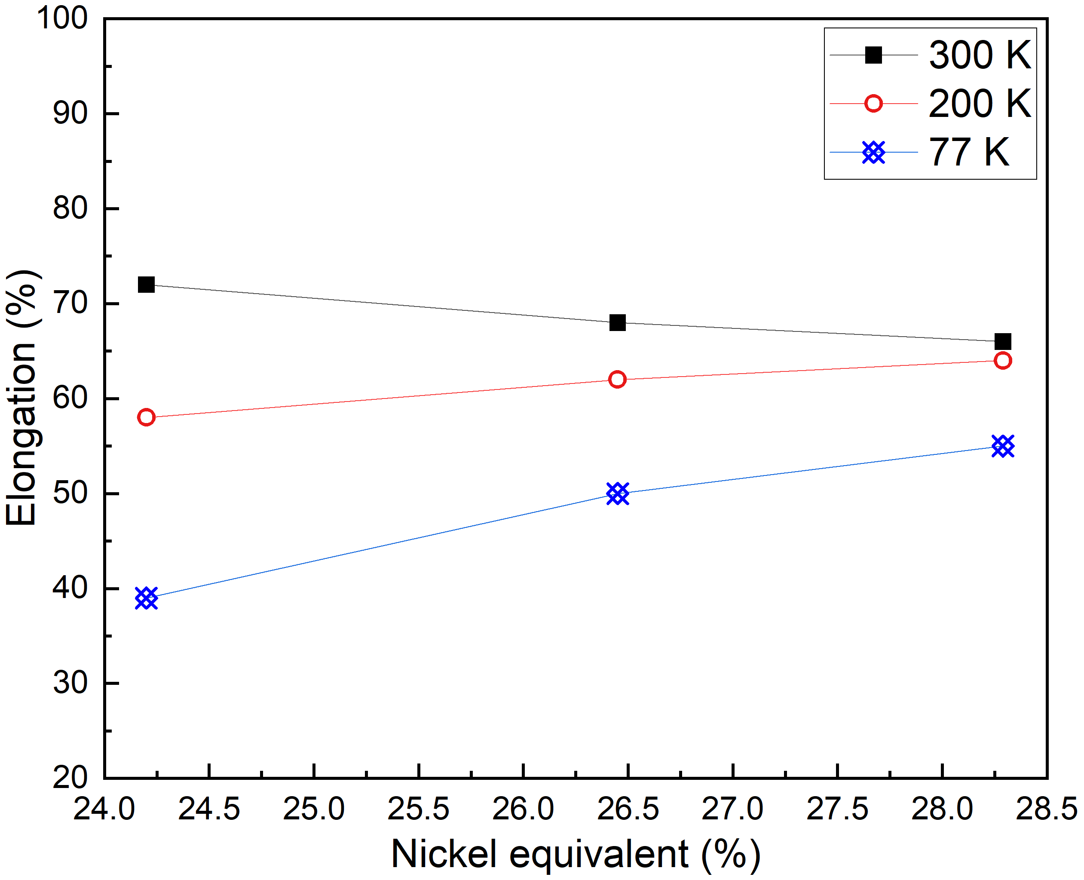
Figure 16. The effect of nickel equivalent on the elongation of austenitic stainless steel 316 from tensile tests [107,125].

5.2 At the microstructural level

5.2.1 Cryogenic temperature embrittlement
The ductile to brittle transition of austenitic stainless steels is due to the cleavage-like intergranular fracture and brittle transgranular fracture at cryogenic temperatures [124,125]. Flat facets containing linear traces were found at the fracture surface of these steels with small deformations, which is shown in Figure 17 [123–125,131].

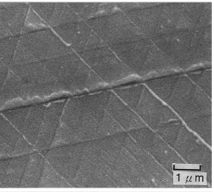
Figure 17. Flat facets contains linear traces at the cryogenic embrittled fracture surface [124].

For aluminium alloys at cryogenic temperatures, Xu et al. [111] remarked that the fracture morphology of aluminium alloys with 0.16% Zr was not significantly influenced by the decreased temperature. Higher Zr in the composition will change the fatigue failure mode from intergranular to transgranular fracture at 77 K [111]. Low temperature strengthens the interior of the grains while inducing localised failure at grain boundaries [116]. Large amount of secondary deep cracks were observed at fracture surfaces with minor variation in dimple size/morphology depending on the extent of cold work/stretch experienced by the specimen. Rod shaped Al₇CuFe₂ particles and spherical shaped Al₂Cu particles were visible in the voids located at either small constituent particles or locally deformed areas.

5.2.2 Hydrogen embrittlement
Environment embrittlement on a hydrogen-free material is caused by hydrogen molecules adsorbing on the surface and decomposing into atomic hydrogen. The atomic hydrogen can subsequently migrate across the surface and diffuse into the material when undergoing mechanical deformation [101,107]. The metal failure is determined by the hydrogen transportation and accumulation in the triaxial tensile field ahead of a crack tip. The transportation of hydrogen to the crack tip is governed by the microstructure and temperature [109]. In meta-stable/unstable austenitic stainless steels (Types 301, 304 and 316), the hydrogen embrittlement is commonly found along with the strain-induced martensite [101,106,107,109]. Scanning electron microscopy revealed transgranular cracks along the martensite laths and flat facets due to twin-boundary separation in the fracture surfaces of type 316 (Ni_{eq} 24.20%) and type 304L austenitic stainless steels fractured in hydrogen [101,107,109]. An example of the transgranular fracture is shown in Figure 18(a). Dimple rupture was also observed in type 316 austenitic stainless steels as shown in Figure 18(b). This is due to the much higher diffusion coefficient of hydrogen in bcc martensite compared to that for fcc austenite, which provides a rapid hydrogen transportation path into the material [109]. The flat facets on type 304L austenitic stainless steel’s fracture surface are smaller than those on type 316 (Ni_{eq} 24.20%) austenitic stainless steel’s fracture surface. This is corresponding to the higher ultimate tensile strength of type 304L austenitic stainless steels in hydrogen environment, which are shown in Figure 11. Another key condition to trigger hydrogen environment embrittlement is having a continuous or net-like martensite within the metal matrix for transporting hydrogen [106,107]. Zhang et al. [107] found that increased nickel content stabilises the austenite and limits the martensite to form discretely in the matrix during mechanical deformation. This effect is increased markedly when the nickel equivalent is above 27%. Therefore, the resistance to hydrogen environment embrittlement is improved with increasing nickel equivalent in iron-chromium-nickel alloys [107].

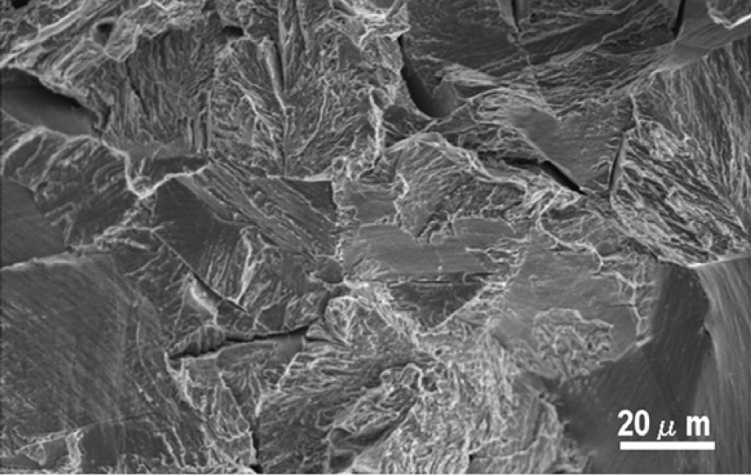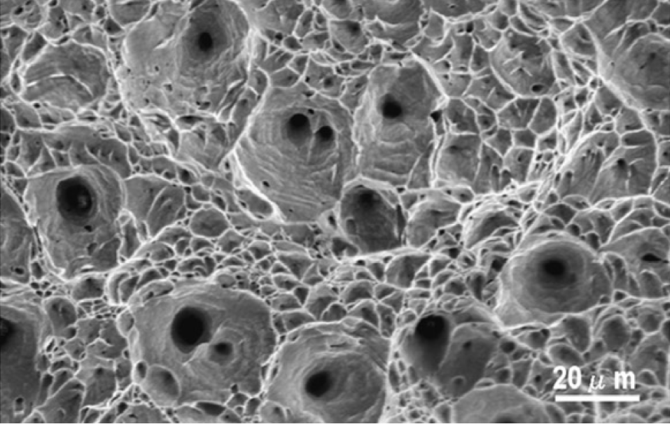
(b)
(a)

Figure 18. SEM of fracture surfaces of (a) the type 316 (Ni_{eq} 26.45%) austenitic stainless steel with transgranular cracks and (b) the type 316 (Ni_{eq} 28.29%) austenitic stainless steel with dimple rupture (both were tested in 10 bar hydrogen at 200 K) [107].

Zhang et al. [107] also found that the relative reduction of area of the type 316 austenitic stainless steels, which is the ratio of reduction of area in hydrogen over the reduction of area in helium, decreases with decreasing temperature until 200 K and then increases with further decrease in temperature. When the temperature is decreased, it is observed that the speed of generating strain-induced martensite is accelerated until the maximum hydrogen environment embrittlement temperature is reached [107]. When the temperature is lower than the maximum hydrogen environment embrittlement temperature, the amount of strain-induced martensitic transformation remains nearly constant. In addition, the hydrogen transport rate is decreased with decreasing temperature, hence making it difficult for hydrogen to accumulate in the high triaxial stress region. Therefore, the hydrogen environment embrittlement is decreased [107], as reflected in Figure 14.

Sensitised materials are easier to be influenced by the hydrogen environment embrittlement than solution annealed materials. In the sensitised types 304 and 316 austenitic stainless steels, M₂₃C₆ carbides precipitated along the grain boundaries, while the region adjacent to the carbides forms a zone depleted of Cr and C [109]. This depleted zone along the grain boundaries prompts the transformation of strain-induced martensite since austenite in this zone becomes unstable due the loss of Cr and C [101]. This process induces a short path of hydrogen transportation to the crack tip. Thus the formation of intergranular fracture is triggered [109]. Han et al. [109] investigated the influence of desensitising heat treatment on sensitised types 304 and 316 austenitic stainless steels. They found that the desensitisation eliminates the depleted zone and strain-induced martensite along the grain boundaries. The resistance to hydrogen environment embrittlement is significantly improved due to this process. For stable austenitic stainless steels such as type 310 and 309, there is no transformation of the strain-induced martensite observed in the mechanical test in hydrogen [103,109]. This is primarily due to the low stacking fault energy which inhibits cross slips [107]. However, embrittlement could occur when the materials are hydrogen charged through cathodic or thermal processes [107].

5.3 Other effects
The maximum internal and external stresses experienced in the tank structure/wall should be reduced. Lee [66] stated that static loads are more conducive to hydrogen damage than cyclic loads. In addition, internal residual stresses also prompt hydrogen damage, which are caused during the manufacturing processes of metallic materials and tank structure including material heat treatment, straightening and stretching and structure welding [66]. The heat affected zones are particularly susceptible to hydrogen embrittlement. Tests on type 301 stainless steels and Inconel 718 showed that crack growth in LH₂ is much greater in the welds than in the parent metal [63]. Relevant welding requirements include ASME BPVC and ANSI/ASME B31.3.

6. Knowledge gaps
The review conducted into the use of metallic tanks for hydrogen storage has highlighted a number of areas where further research is required to obtain a better understanding of the performance of metallic materials in cryogenic hydrogen environments. The identified knowledge gaps are grouped into five key areas and are presented hereafter:

- The focus of the current literature studies has predominantly been on hydrogen storage techniques for land-based vehicles and aviation applications, which typically have small hydrogen tank sizes that range from 0.1 to 20 m³. However, it is not clear whether the small-scale test/modelling results can be extrapolated to large-scale applications. Hence, experimental and numerical modelling studies investigating the material behaviour of metallic cylinders representative of larger-scale applications are required.
- The GH₂, CcH₂ and LH₂ storage tanks have been tested and validated for automotive applications [8,27,33,55,57,132–134]. However, there is lack of detailed technical information and performance data from the current hydrogen powered ships (Table 1). Furthermore, rules and standards are not available for such applications in the marine sector.
- The existing studies, though limited, have mainly investigated the mechanical properties of metallic materials at cryogenic temperatures and hydrogen environment. However, there is lack of data/understanding about the fracture behaviour in cryogenic hydrogen environments and fatigue performance due to thermal cycling for metallic materials.
- There is limited data on hydrogen tank insulation, in particular their failure mechanisms and mitigation strategies [91,92].
- The majority of the existing investigations on the effect of chemical compositions and microstructure on hydrogen/cryogenic embrittlement is focused on austenitic stainless steels, and only a few studies have been undertaken for aluminium alloys.

Regulation has been sub-characterised into law, social norms, markets and architecture (ecosystem) [135]. The long-term aim of a convention in the field must for the time being give way to shorter-term aims of developing available routes to approval through classification societies and flag states, and by supporting markets and ecosystems. The absence of regulation is unsurprising as regulation follows and is informed by existing or imminent, not future technology. The premature regulation of technology under development and untested technology would paradoxically risk holding back alternative research [136]. While a normative gap permits experimentation with alternative technologies, it also makes obtaining approval uncertain, may encourage risky approvals in the names of innovation and competition and risks discouraging investment [136]. As Abbott [137] has argued, the use of non-state actors – such as classification societies – are not a panacea due to difficulties in maintaining public trust in the regulation of risk. Here, the trust to maintain is primarily that of flag states and the shipping industry in the classification and the flag; but in view of the risk of an incident with safety or environmental consequences also that of the wider public. Yet as Abbot argues [137], the involvement of non-state actors is important so as not to hamper technological development. As technological capability in relation to hydrogen develops, the framework must also develop. Where new technologies are concerned, “inaction is a decision” [136].

7. Conclusions
The marine industry is committed to reduce the levels of GHG, SOx and NOx emissions. Although there are several short-term/intermediate solutions used to reduce these emissions, long-terms solutions such as using hydrogen as fuel remain under development. This review summarised the success and challenges in storing hydrogen on ships and focused on CcH₂ (below 77 K) and LH₂ (at 20 K) due to their high volumetric energy density and low thermal expansion coefficients. The performances of metallic materials and insulations associated with the CcH₂ and LH₂ tank constructions were reviewed. The main conclusions from this review are summarised as follows:
- The main failure mechanisms of metallic material storage tanks are the cryogenic temperature embrittlement and the hydrogen environment embrittlement;
- Austenitic stainless steels, such as types 304L, 310 and 316, are less susceptible to cryogenic hydrogen failure mechanisms when the temperature is below 200 K or beyond 220 K. When the nickel equivalent is above 27%, the mechanical properties of the materials are not influence by the presence of hydrogen, regardless of the temperature range;
- Austenitic stainless steels types 316 and 316L are better suited for storage tank constructions since they have relatively higher proportion of chromium and nickel content, which improves the ductility and the fracture toughness at cryogenic temperatures and reduces the hydrogen embrittlement failure;
- Increased manganese and nitrogen contents in austenitic stainless steels were found to enhance the brittle fracture behaviour at low temperatures and increase the ductile-to-brittle transition temperature;
- Unstable and sensitised austenitic stainless steels, e.g. 304s, were found to be prone to hydrogen embrittlement failure due to the formation of strain-induced martensite, which could lead to transgranular or intergranular fractures. In comparison, stable austenitic stainless steels, e.g. 310, do not show such martensitic transformation;
- Aluminium alloys, such as AA2090, are often used as the liner material for Type III CcH₂ storage tanks due to their high proportion of zirconium which improves the ultimate tensile strength, fatigue strength and ductility of the material at 77 K temperature;
- Amongst the current hydrogen storage tank insulation methods, the variable density multilayer insulation with vapour-cooled shield (VDMLI+VCS) has the best performance.

Acknowledgements
The authors greatly appreciate the technical advice from Mr James Cocks from Shell Shipping and Maritime and Mr Jaspal Nirankari from Lloyd’s Register. The author would also like to thank Prof Dominic Hudson for his support and acknowledge the funding from the UKRI HEIF Research Collaboration Stimulus Fund and Shell Shipping and Maritime.

Appendix

Table A1. Thermal conductivity and expansion coefficient of austenitic steels and aluminium alloys at cryogenic temperatures [93–97]
Material type | Temperature [K] | Thermal conductivity [W/m/K] | Thermal expansion coefficient [K⁻¹·10⁻⁶]
Austenitic stainless steels
304 | 4 | 0.28 | 10.20
304 | 77 | 7.90 | 13.00
304s (stabilised) | 4 | 0.27 | 10.28
304s (stabilised) | 20 | 2.17 | 10.99
304s (stabilised) | 77 | 7.92 | 12.95
310 | 4 | 0.24 | 10.20
310 | 77 | 5.90 | 13.00
316 | 4 | 0.28 | 10.20
316 | 77 | 7.90 | 13.00
High-Mn (29% Mn) | 77 | 19.00 | N/A
Aluminium alloys
1050 | 1 | 19.10 | N/A
2219-T81 | 1 | 0.96 | N/A
2219-T81 | 20 | 19.00 | N/A
2219-T81 | 77 | 62.20 | N/A
6061-T6 | 1 | 2.52 | N/A
6061-T6 | 4 | 5.35 | 14.32
6061-T6 | 20 | 28.43 | 15.22
6061-T6 | 77 | 83.53 | 18.00

Table A2. Chemical composition (wt %) of austenitic stainless steels and aluminium alloys for CcH₂ and LH₂ storage [69,98,108–113,100–107]
Materials | Chemical composition [wt %]
 | C | Si | Mn | P | S | Cr | Ni | Mo | Mg | Ti | Zr | Cu | Li | N | Fe⁽¹⁾ | Al⁽¹⁾
Austenitic stainless steel
316LN | 0.020 | 0.43 | 1.38 | 0.030 | <0.003 | 17.00 | 13.2 | 2.63 | - | - | - | - | - | 0.16 | bal | -
316L | 0.017 | 0.53 | 0.85 | 0.024 | 0.0006 | 17.44 | 12.19 | 2.09 | - | - | - | 0.21 | - | 0.051 | bal | -
316Ti | 0.031 | 0.46 | 1.30 | - | - | 16.62 | 11.08 | 2.135 | - | 0.3 | - | - | - | 0.014 | bal | -
316 (Ni_{eq} 24.20%) | 0.010 | 0.50 | 0.90 | 0.025 | 0.001 | 17.00 | 9.88 | 2.07 | - | - | - | 0.25 | - | - | bal | -
316 (Ni_{eq} 25.24%) | 0.010 | 0.50 | 0.90 | 0.027 | 0.001 | 16.90 | 10.97 | 2.08 | - | - | - | 0.25 | - | - | bal | -
316 (Ni_{eq} 26.45%) | 0.010 | 0.48 | 0.91 | 0.025 | 0.001 | 17.00 | 12.11 | 2.08 | - | - | - | 0.26 | - | - | bal | -
316 (Ni_{eq} 27.17%) | 0.010 | 0.50 | 0.89 | 0.025 | 0.001 | 16.96 | 12.90 | 2.05 | - | - | - | 0.26 | - | - | bal | -
316 (Ni_{eq} 28.29%) | 0.013 | 0.47 | 0.91 | 0.025 | 0.001 | 17.11 | 13.90 | 2.03 | - | - | - | 0.26 | - | - | bal | -
316 (Ni_{eq} 29.18%) | 0.009 | 0.49 | 0.90 | 0.026 | 0.001 | 16.98 | 14.88 | 2.07 | - | - | - | 0.25 | - | - | bal | -
316 (Ni_{eq} 30.27%) | 0.010 | 0.51 | 0.90 | 0.026 | 0.001 | 17.07 | 15.90 | 2.06 | - | - | - | 0.27 | - | - | bal | -
316 (Ni_{eq} 31.31%) | 0.010 | 0.52 | 0.90 | 0.027 | 0.001 | 17.05 | 16.96 | 2.06 | - | - | - | 0.27 | - | - | bal | -
316 (Ni_{eq} 32.42%) | 0.010 | 0.52 | 0.90 | 0.026 | 0.001 | 16.96 | 18.07 | 2.12 | - | - | - | 0.27 | - | - | bal | -
316 (Ni_{eq} 33.41%) | 0.011 | 0.52 | 0.91 | 0.026 | 0.001 | 17.08 | 18.98 | 2.10 | - |  | - | 0.27 | - | - | bal | -
316 (Ni_{eq} 34.33%) | 0.009 | 0.52 | 0.92 | 0.026 | 0.001 | 17.08 | 19.93 | 2.08 | - | - | - | 0.27 | - | - | bal | -
310s | 0.018 | 0.67 | 1.77 | 0.022 | 0.001 | 25.37 | 19.37 | 0.4 | - | - | - | 0.17 | - | - | bal | -
304LN | 0.020 | 0.40 | 1.45 | 0.024 | <0.003 | 17.1 | 9.6 | 0.34 | - | - | - | - | - | 0.16 | bal | -
304L | 0.017 | 0.56 | 0.87 | 0.031 | 0.0021 | 18.33 | 9.05 | 0.17 | - | - | - | 0.24 | - | 0.041 | bal | -
304 | 0.060 | 0.59 | 1.01 | 0.018 | 0.009 | 18.33 | 8.35 | - | - | - | - | - | - | - | bal | -
High-Mn | 0.2-0.6 | 0.1-1.0 | 22.0-26.0 | <0.03 | <0.01 | 0-20.0 | 28.0-48.0 | - | - | - | - | - | - | 0-0.15 | bal | -
Aluminium alloy
AA2090 | - | <0.05 | - | - | - | - | - | - | 0.22-0.23 | - | 0.02-0.17 | 2.40-3.00 | 1.88-2.60 | - | 0.05-0.12 | bal
AA2090-T81 | - | - | - | - | - | - | - | - | - | - | 0.12 | 3.05 | 2.16 | - | 0.08 | bal
⁽¹⁾ bal: balance

Table A3. Tensile properties of different metallic materials (smooth and notched) in LH₂ (20 K and 1 bar) [100,101,116–122,102,103,105–107,109,113,115]
Material Type | Condition | Notched specimen (Y/N) | Proof strength f_{p0.2} or yield strength f_{y} [MPa] | Ultimate strength f_{u} [MPa] | Elongation at fracture ε_{f} [%] | Reduction of area at fracture A_{f} [%]
Austenitic stainless steel
304L | Solution annealed | N | 510 | 1705 | 36 | 43
304L | N/A | Y | 500 | 1315 | 20 | –
304LN | Solution annealed | N | 792 | 1877 | 37 | 27
316L | N/A | N | – | 1591 | – | –
316L | N/A | Y | – | 1654 | 21.8 | –
316LN | Solution annealed | N | 941 | 1640 | 53 | 47
Iron-based super alloy (stainless steel)
A286 | N/A | N | 684 | 1242 | 56 | –
A286 | Solution treated, cold reduced and aged | N | 1329 | 1730 | 14 | –
A286 | Solution treated, cold reduced and aged | Y | – | 1648 | – | –
A286 | Solution treated and aged | Y | – | 1393 | – | –
Aluminium alloy
AA2195 | 3% cold roll and 4% stretch | N | 660 | 740 | 10 | –
AA2195 | 5% cold roll and 2% stretch | N | 675 | 740 | 11 | –
AA2219 | N/A | Y | – | 462 – 627 | – | –
AA2219-T87 | Cold stretched and aged | N | 482.8 – 506 | 655.9 – 684 | – | –
AA6061 | N/A | Y | – | 379 | – | –
AA6061 | N/A | N | – | 392 | 51.2 | –
AA6061-T6 | N/A | N | 374 | 503 | 25.7 | –

Table A4. Tensile properties of different metallic materials (unnotched) in CcH₂ hydrogen environment at 77 K [100,101,116–122,102,103,105–107,109,113,115]
Material Type | Condition | Pressure of hydrogen (bar) | Proof strength f_{p0.2} or yield strength f_{y} [MPa] | Ultimate strength (MPa) | Elongation at fracture (%) | Reduction of area at fracture (%)
Austenitic stainless steel
304 | Solution annealed at 1373 K for 3.6 ks and sensitised at 973 K for 86.4 ks | N/A | 427 | 1383 | 49 | –
304 | Solution annealed | 10 | 570 | 1337 | 32 | –
304 | Solution annealed and sensitised | 10 | 470 | 1306 | 58 | –
304L | Hot-rolled and solution-treated at 1313 K for 0.3 ks | 11 | 350 | 1557 | 40 | 65.7
310s | Cold-rolled and solution annealed | 10 | 534 | 1812 | – | –
316L | Hot-rolled and solution-treated | N/A | 403 | 1300 | 54.9 | 71.8
316 (Ni_{eq} 24.20%) | N/A | N/A | 389 | 1335 | 40 | –
316 (Ni_{eq} 25.24%) | N/A | N/A | 346 | 1239 | 51 | –
316 (Ni_{eq} 26.45%) | N/A | N/A | 423 | 1142 | 54 | –
Aluminium alloy
AA2219-T87 | Cold stretched and aged | N/A | 454.5 – 460 | 575 – 584.8 | 14 | –

References
[1] Ritchie H, Roser M. CO2 and Greenhouse Gas Emissions. Our World Data 2019. https://ourworldindata.org/co2-and-other-greenhouse-gas-emissions (accessed June 4, 2020).
[2] Reducing emissions from the shipping sector. Eur Comm n.d. https://ec.europa.eu/clima/policies/transport/shipping_en (accessed June 4, 2020).
[3] Schjølberg I. EMISSION REDUCTION IN SHIPPING USING HYDROGEN AND FUEL CELLS 2017:1–9.
[4] Ship emissions toolkit. 2018. https://doi.org/10.1017/CBO9781107415324.004.
[5] Commission publishes first annual EU report on CO2 emissions from maritime transport. Eur Comm n.d. https://ec.europa.eu/clima/news/commission-publishes-first-annual-eu-report-co2-emissions-maritime-transport_en (accessed June 4, 2020).
[6] Reducing greenhouse gas emissions from ships. Int Marit Organ n.d. http://www.imo.org/en/MediaCentre/HotTopics/Pages/Reducing-greenhouse-gas-emissions-from-ships.aspx (accessed June 4, 2020).
[7] Prevention of Air Pollution from Ships. Int Marit Organ n.d. http://www.imo.org/en/OurWork/Environment/PollutionPrevention/AirPollution/Pages/Air-Pollution.aspx (accessed June 4, 2020).
[8] Das LM. On-board hydrogen storage systems for automotive application. Int J Hydrogen Energy 1996;21:789–800.
[9] Schlapbach L, Züttel A. hydrogen-storage materials for Mobile Applications. Nature 2001:353–8. https://doi.org/10.1038/35104634.
[10] Kunowsky M, Marco-Lózar JP, Linares-Solano A. Material Demands for Storage Technologies in a Hydrogen Economy. J Renew Energy 2013;2013:1–16. https://doi.org/10.1155/2013/878329.
[11] Durbin DJ, Malardier-Jugroot C. Review of hydrogen storage techniques for on board vehicle applications. Int J Hydrogen Energy 2013;38:14595–617. https://doi.org/10.1016/j.ijhydene.2013.07.058.
[12] Pollet BG, Staffell I, Shang JL. Current status of hybrid, battery and fuel cell electric vehicles: From electrochemistry to market prospects. Electrochim Acta 2012;84:235–49. https://doi.org/10.1016/j.electacta.2012.03.172.
[13] Hwang HT, Varma A. Hydrogen storage for fuel cell vehicles. Curr Opin Chem Eng 2014;5:42–8. https://doi.org/10.1016/j.coche.2014.04.004.
[14] Petitpas G, Bénard P, Klebanoff LE, Xiao J, Aceves S. A comparative analysis of the cryo-compression and cryo-adsorption hydrogen storage methods. Int J Hydrogen Energy 2014;39:10564–84. https://doi.org/10.1016/j.ijhydene.2014.04.200.
[15] Rusman NAA, Dahari M. A review on the current progress of metal hydrides material for solid-state hydrogen storage applications. Int J Hydrogen Energy 2016;41:12108–26. https://doi.org/10.1016/j.ijhydene.2016.05.244.
[16] van Biert L, Godjevac M, Visser K, Aravind P V. A review of fuel cell systems for maritime applications. J Power Sources 2016;327:345–64. https://doi.org/10.1016/j.jpowsour.2016.07.007.
[17] Valenti G. Hydrogen liquefaction and liquid hydrogen storage. vol. 23. Elsevier Ltd.; 2016. https://doi.org/10.1016/b978-1-78242-362-1.00002-x.
[18] Barthelemy H, Weber M, Barbier F. Hydrogen storage: Recent improvements and industrial perspectives. Int J Hydrogen Energy 2017;42:7254–62. https://doi.org/10.1016/j.ijhydene.2016.03.178.
[19] Markowski J, Pielecha I. The potential of fuel cells as a drive source of maritime transport. IOP Conf Ser Earth Environ Sci 2019;214. https://doi.org/10.1088/1755-1315/214/1/012019.
[20] Züttel A. Hydrogen storage methods. Naturwissenschaften 2004;91:157–72. https://doi.org/10.1007/s00114-004-0516-x.
[21] Moradi R, Groth KM. Hydrogen storage and delivery: Review of the state of the art technologies and risk and reliability analysis. Int J Hydrogen Energy 2019;44:12254–69. https://doi.org/10.1016/j.ijhydene.2019.03.041.
[22] Barthélémy H. Hydrogen storage - Industrial prospectives. Int J Hydrogen Energy 2012;37:17364–72. https://doi.org/10.1016/j.ijhydene.2012.04.121.
[23] Conte M, Prosini PP, Passerini S. Overview of energy/hydrogen storage: State-of-the-art of the technologies and prospects for nanomaterials. Mater Sci Eng B Solid-State Mater Adv Technol 2004;108:2–8. https://doi.org/10.1016/j.mseb.2003.10.107.
[24] Zhang J, Fisher TS, Ramachandran PV, Gore JP, Mudawar I. A review of heat transfer issues in hydrogen storage technologies. J Heat Transfer 2005;127:1391–9. https://doi.org/10.1115/1.2098875.
[25] Mital SK, Gyekenyesi JZ, Arnold SM, Sullivan RM, Manderscheid JM, Murthy PLN. Review of Current State of the Art and Key Design Issues With Potential Solutions for Liquid Hydrogen Cryogenic Storage Tank Structures for Aircraft Applications. 2006.
[26] Felderhoff M, Weidenthaler C, Von Helmolt R, Eberle U. Hydrogen storage: The remaining scientific and technological challenges. Phys Chem Chem Phys 2007;9:2643–53. https://doi.org/10.1039/b701563c.
[27] Hua TQ, Ahluwalia RK, Peng JK, Kromer M, Lasher S, McKenney K, et al. Technical assessment of compressed hydrogen storage tank systems for automotive applications. Int J Hydrogen Energy 2011;36:3037–49. https://doi.org/10.1016/j.ijhydene.2010.11.090.
[28] Eberle U, Müller B, Von Helmolt R. Fuel cell electric vehicles and hydrogen infrastructure: Status 2012. Energy Environ Sci 2012;5:8780–98. https://doi.org/10.1039/c2ee22596d.
[29] Han J, Charpentier JF, Tang T. State of the art of fuel cells for ship applications. IEEE Int Symp Ind Electron 2012:1456–61. https://doi.org/10.1109/ISIE.2012.6237306.
[30] Brennstoffzellen-Boot Hydra. DieBrennstoffzelleDe n.d. http://www.diebrennstoffzelle.de/h2projekte/mobil/hydra.shtml (accessed June 4, 2020).
[31] Wakita N, Hirokawa K, Ichikawa T, Yamauchi Y. Development of Autonomous Underwater Vehicle (AUV) for Exploring Deep Sea Marine Mineral Resources. Mitsubishi Heavy Ind Tech Rev 2010;47:73–80.
[32] Chakraborty S, Dzielendziak A, Koroglu T, Yang K. Evaluation of smart eco-friendly public transport options in coastal cities : Towards a green future for the city of Southampton. vol. 2. 2013.
[33] Kircher O, Greim G, Burtscher J, Brunner T. VALIDATION OF CRYO-COMPRESSED HYDROGEN STORAGE (CCH2) - A PROBABILISTIC APPROACH. n.d.
[34] Fuelcell D. First yacht with certified fuel cell propulsion. Fuel Cells Bull 2003;2003:4–5. https://doi.org/10.1016/s1464-2859(03)00015-4.
[35] Hydroville. CMB n.d. http://www.hydroville.be/en/hydroville/ (accessed June 22, 2020).
[36] Mendez A, Leo TJ, Herreros MA. Current state of technology of fuel cell power systems for autonomous underwater vehicles. Energies 2014;7:4676–93. https://doi.org/10.3390/en7074676.
[37] Hydroxy 3000 : un bateau de plaisance mû par une pile à combustible. IESE n.d. http://iese.heig-vd.ch/projets/hydroxy-3000 (accessed June 4, 2020).
[38] Fuel cell boat at Dutch solar yacht race. Fuel Cells Bull 2006;2006:9. https://doi.org/10.1016/S1464-2859(06)71126-9.
[39] Book D. “Ross Barlow” Hydrogen-powered Canal Boat. 2013.
[40] Icelandic New Energy: Further steps to Hydrogen Society n.d. https://www.google.com/url?sa=t&rct=j&q=&esrc=s&source=web&cd=1&cad=rja&uact=8&ved=2ahUKEwj4jsag05_pAhVBolwKHYzJB2AQFjAAegQIAxAB&url=http%3A%2F%2Fnewenergy.is%2Fwp-content%2Fuploads%2F2018%2F12%2F2008-Smart-H2.pdf&usg=AOvVaw2UF5gWSzRiNYe0Wb2FY-nC (accessed June 4, 2020).
[41] Pratt JW, Klebanoff LE. Feasibility of the SF-BREEZE : a Zero-Emission , Hydrogen Fuel Cell , High-Speed Passenger Ferry. 2016.
[42] Cobalt 233 ZET – Zero Emission Technology for Runabouts on Lake Constance. PRESSEBOX n.d. https://www.pressebox.com/inactive/zebotec-gmbh/Cobalt-233-ZET-Zero-Emission-Technology-for-Runabouts-on-Lake-Constance/boxid/128356 (accessed June 22, 2020).
[43] Hydrogen for Frauscher Riviera 600 n.d. https://web.archive.org/web/20110722070434/http://www.yachtonline.it/events/hydrogen-for-frauscher-riviera-600 (accessed June 4, 2020).
[44] Energy Observer n.d. https://www.energy-observer.org (accessed June 4, 2020).
[45] Peng Y, Xu Z. Development of Hydrogen Fuel Cell Propulsion Technology for Ships. Strateg Study Chinese Acad Eng 2019;21:18–21. https://doi.org/10.15302/J-SSCAE-2019.06.003.
[46] Winnefeld C, Kadyk T, Bensmann B, Krewer U, Hanke-Rauschenbach R. Modelling and designing cryogenic hydrogen tanks for future aircraft applications. Energies 2018;11:1–23. https://doi.org/10.3390/en11010105.
[47] How much oil is on that ship? Off Response Restor 2016. https://response.restoration.noaa.gov/about/media/how-much-oil-ship.html (accessed June 14, 2020).
[48] DNV GL. Assessment of Selected Alternative Fuels and technologies. 2018.
[49] McKinlay CJ, Turnock SR, Hudson DA. Route to zero emission shipping: hydrogen, ammonia or methanol? Energy Policy 2020.
[50] Rivard E, Trudeau M, Zaghib K. Hydrogen storage for mobility: A review. Materials (Basel) 2019;12. https://doi.org/10.3390/ma12121973.
[51] Godula-jopek A, Jehle W, Wellnitz J. Hydrogen Storage Technologies. Wiley-VCH; 2012. https://doi.org/10.1136/aim.22.4.207.
[52] Ronnebro EC. Technology and manufacturing readiness of early market motive and non-motive hydrogen storage technologies for fuel cell applications. 2012.
[53] Riis T, Sandrock G. Hydrogen Storage – Gaps and Priorities. HIA HCG Storage Pap 2005:1–13.
[54] Züttel A. Materials for hydrogen storage. Mater Today 2003;6:24–33. https://doi.org/10.1016/S1369-7021(03)00922-2.
[55] Kunze K, Kircher O. Cryo-Compressed Hydrogen Storage. 2012.
[56] Hydrogen storage. 2017. https://doi.org/10.1017/CBO9780511635359.012.
[57] Zohuri B. Cryogenics and liquid hydrogen storage: Challenges and solutions for a cleaner future, 2019. https://doi.org/10.1007/978-3-319-93461-7.
[58] Ahluwalia RK, Peng JK. Dynamics of cryogenic hydrogen storage in insulated pressure vessels for automotive applications. Int J Hydrogen Energy 2008;33:4622–33. https://doi.org/10.1016/j.ijhydene.2008.05.090.
[59] Adolf J, Balzer C, Louis J, Schabla U. Shell Hydrogen Study: Energy of the Future? n.d.
[60] Mirza UK, Ahmad N, Harijan K, Majeed T. A vision for hydrogen economy in Pakistan. Renew Sustain Energy Rev 2009;13:1111–5. https://doi.org/10.1016/j.rser.2008.08.005.
[61] Harrabin R. $5bn fund unveiled for climate-friendly shipping. BBC News - Sci Environ 2019.
[62] Publication BSIS. BSI Standards Publication Basic considerations for the safety of hydrogen systems 2015.
[63] Safety use of hydrogen and hydrogen systems. NASA 2006. https://ntrs.nasa.gov/archive/nasa/casi.ntrs.nasa.gov/20070018005.pdf (accessed July 5, 2020).
[64] Makarov D, Molkov V. Modelling of dispersion following hydrogen permeation for safety engineering and risk assessment. II Int Conf "Hydrogen Storage Technol 2009:28–9.
[65] Feng Z, Anovitz L. permeation diffusion, solubility measurements: results and issues 2007.
[66] Lee J. Hydrogen embrittlement. 2016. https://doi.org/10.1016/B978-044452787-5.00200-6.
[67] Hedayat A, Hastings L, Brown T. Analytical modeling of variable density multilayer insulation for cryogenic storage. Adv. Cryog. Eng. Proc. Cryog. Eng. Conf., 2002, p. 1557–64. https://doi.org/10.1063/1.1472190.
[68] Record SS. LNG Ships. n.d.
[69] SUITABILITY OF HIGH MANGANESE AUSTENITIC STEEL FOR CRYOGENIC SERVICE AND DEVELOPMENT OF ANY NECESSARY AMENDMENTS TO THE IGC CODE AND IGF CODE. 2016. https://doi.org/10.1017/CBO9781107415324.004.
[70] International Code of Safety for Ships Using Gases or Other Low-Flashpoint Fuels (IGF Code). 2015.
[71] Lloyd G. Rules for Classification and Construction: Ship Technology. Ger Lloyd 2008.
[72] IMO. MSC.1/Circ.1212 Guidelines on alternative design and arrangements for SOLAS Chapters II-1 and III. 2006.
[73] Regulation 17 - Alternatie deisng and arrangements n.d. https://assets.publishing.service.gov.uk/government/uploads/system/uploads/attachment_data/file/460616/Regulation_17_-_Alternative_Design_and_Arrangements.pdf (accessed August 11, 2020).
[74] Lloyd GS. Rules for classification and construction V Analysis techniques 2 Risk analyses 2009.
[75] Bureau Veritas MD. Guidelines on alternative design and arrangements of life-saving appliances. 2010.
[76] Gaseous hydrogen and hydrogen blends \ Land vehicle fuel tanks. ISO/TS 15869 2009.
[77] Aceves SM, Berry GD, Martinez-Frias J, Espinosa-Loza F. Vehicular storage of hydrogen in insulated pressure vessels. Int J Hydrogen Energy 2006;31:2274–83. https://doi.org/10.1016/j.ijhydene.2006.02.019.
[78] Barron R, Nellis G. Cryogenic heat transfer. CRC press; 2016. https://doi.org/10.1017/CBO9781107415324.004.
[79] Martin JJ, Hastings L. Large-Scale of a Variable With a Foam Liquid Hydrogen Testing Insulation Density Multilayer Substrate. NASA 2001.
[80] Fesmire JE, Coffman BE, Meneghelli BJ, Heckle KW. Spray-on foam insulations for launch vehicle cryogenic tanks. Cryogenics (Guildf) 2012;52:251–61. https://doi.org/10.1016/j.cryogenics.2012.01.018.
[81] Aceves SM, Berry GD, Rambach GD. Insulated pressure vessels for hydrogen storage on vehicles. Int J Hydrogen Energy 1998;23:583–91. https://doi.org/10.1016/s0360-3199(97)00079-7.
[82] Zheng J, Chen L, Wang J, Xi X, Zhu H, Zhou Y, et al. Thermodynamic analysis and comparison of four insulation schemes for liquid hydrogen storage tank. Energy Convers Manag 2019;186:526–34. https://doi.org/10.1016/j.enconman.2019.02.073.
[83] Flynn T. Cryogenic Engineering. Marcel Dekker; 2005. https://doi.org/10.1017/CBO9781107415324.004.
[84] Jiang WB, Zuo ZQ, Huang YH, Wang B, Sun PJ, Li P. Coupling optimization of composite insulation and vapor-cooled shield for on-orbit cryogenic storage tank. Cryogenics (Guildf) 2018;96:90–8. https://doi.org/10.1016/j.cryogenics.2018.10.008.
[85] Zheng J, Chen L, Wang J, Zhou Y, Wang J. Thermodynamic modelling and optimization of self-evaporation vapor cooled shield for liquid hydrogen storage tank. Energy Convers Manag 2019;184:74–82. https://doi.org/10.1016/j.enconman.2018.12.053.
[86] Babac G, Sisman A, Cimen T. Two-dimensional thermal analysis of liquid hydrogen tank insulation. Int J Hydrogen Energy 2009;34:6357–63. https://doi.org/10.1016/j.ijhydene.2009.05.052.
[87] Blanchat T, Morrow C, Hightower M. LNG ship insulation experiments using large LNG pool fire boundary conditions. IGT Int Liq Nat Gas Conf Proc 2013;2:838–56.
[88] Yu YH, Kim BG, Lee DG. Cryogenic reliability of composite insulation panels for liquefied natural gas (LNG) ships. Compos Struct 2012;94:462–8. https://doi.org/10.1016/j.compstruct.2011.08.009.
[89] Yu YH, Kim BG, Lee DG. Cryogenic reliability of the sandwich insulation board for LNG ship. Compos Struct 2013;95:547–56. https://doi.org/10.1016/j.compstruct.2012.07.007.
[90] Chun MS, Kim MH, Kim WS, Kim SH, Lee JM. Experimental investigation on the impact behavior of membrane-type LNG carrier insulation system. J Loss Prev Process Ind 2009;22:901–7. https://doi.org/10.1016/j.jlp.2008.09.011.
[91] Moreno-Blanco JC, Elizalde-Blancas F, Gallegos-Muñoz A, Aceves SM. The potential for avoiding hydrogen release from cryogenic pressure vessels after vacuum insulation failure. Int J Hydrogen Energy 2018;43:8170–8. https://doi.org/10.1016/j.ijhydene.2018.02.150.
[92] Moreno-Blanco JC, Elizalde-Blancas F, Gallegos-Muñoz A, Aceves SM. Modeling of Hydrogen Pressurization and Extraction in Cryogenic Pressure Vessels Due To Vacuum. 4th IFSEH, 2016.
[93] Charles J, Berghezan A, Lutts A. High Manganese - Aluminum Austenitic Steels for Cryogenic Applications. Some Mechanical and Physical Properties. J Phys Colloq 1984;45:619–23. https://doi.org/10.1051/jphyscol:19841126.
[94] Woodcraft AL. Predicting the thermal conductivity of aluminium alloys in the cryogenic to room temperature range. Cryogenics (Guildf) 2005;45:421–31. https://doi.org/10.1016/j.cryogenics.2005.02.003.
[95] Woodcraft AL. Aluminium thermal conductivity at cryogenic temperatures 2005. http://reference.lowtemp.org/alkappa.html (accessed June 29, 2020).
[96] McHenry H. The properties of austenitic stainless steels at cryogenic temperatures. Austenitic Steels Low Temp., 1983, p. 1–28.
[97] Marquardt ED, Le JP, Radebaugh R. Cryogenic Material Properties Database. 11th Int. Cryocooler Conf., 2000, p. 681–7. https://doi.org/10.1007/0-306-47112-4_84.
[98] Marchi C, Somerday B. Technical Reference on Hydrogen Compatibility of Materials. 2012.
[99] Chelton D, Mann D. Cryogenic data book. University of California Radiation Laboratory; 1956.
[100] Shibata K. Notch Effect on Tensile Deformation Behavior of 304L and 316L Steels in Liquid Helium and Hydrogen 2004;137:137–44. https://doi.org/10.1063/1.1774562.
[101] Sun D, Han G, Vaodee S, Fukuyama S, Yokogawa K. Tensile behaviour of type 304 austenitic stainless steels in hydrogen atmosphere at low temperatures. Mater Sci Technol 2001;17:302–8. https://doi.org/10.1179/026708301773002509.
[102] Society R. On the effect of the temperature of liquid hydrogen (-252.8° C.) On the tensile properties of forty-one specimens of metals comprising (a) pure iron 99.85%; (b) four carbon steels; (c) thirty alloy steels; (d) copper and nickel; (e) four non-ferrous alloy. Philos Trans R Soc London Ser A, Contain Pap a Math or Phys Character 1933;232:297–332. https://doi.org/10.1098/rsta.1934.0009.
[103] Abraham DP, Altstetter CJ. The effect of hydrogen on the yield and flow stress of an austenitic stainless steel. Metall Mater Trans A 1995;26:2849–58. https://doi.org/10.1007/BF02669643.
[104] Michler T. Toughness and hydrogen compatibility of austenitic stainless steel welds at cryogenic temperatures. Int J Hydrogen Energy 2007;32:4081–8. https://doi.org/10.1016/j.ijhydene.2007.03.009.
[105] Chu D. Cryogenic mechanical behaviour of vintage III aluminium-copper-lithium alloy 2090-T81. University of Californic, 1990.
[106] Deimel P, Sattler E. Austenitic steels of different composition in liquid and gaseous hydrogen. Corros Sci 2008;50:1598–607. https://doi.org/10.1016/j.corsci.2008.02.024.
[107] Zhang L, Wen M, Imade M, Fukuyama S, Yokogawa K. Effect of nickel equivalent on hydrogen gas embrittlement of austenitic stainless steels based on type 316 at low temperatures. Acta Mater 2008;56:3414–21. https://doi.org/10.1016/j.actamat.2008.03.022.
[108] Fujii H, Ohmiya S, Shibata K, Ogata T. Effect of specimen diameter on tensile properties of austenitic stainless steels in liquid hydrogen and gaseous helium at 20K. AIP Conf Proc 2006;824 I:145–52. https://doi.org/10.1063/1.2192345.
[109] Han G, He J, Fukuyama S, Yokogawa K. Effect of strain-induced martensite on hydrogen environment embrittlement of sensitized austenitic stainless steels at low temperatures. Acta Mater 1998;46:4559–70. https://doi.org/10.1016/S1359-6454(98)00136-0.
[110] Yuri T, Ogata T, Saito M, Hirayama Y. Effect of welding structure and δ-ferrite on fatigue properties for TIG welded austenitic stainless steels at cryogenic temperatures. Cryogenics (Guildf) 2000;40:251–9. https://doi.org/10.1016/S0011-2275(00)00033-3.
[111] Xu YB, Zhang Y, Wang ZG, Hu ZQ. Fatigue and fracture behavior of aluminum-lithium alloys at ambient and cryogenic temperatures. Scr Metall Mater 1995;33:179–83. https://doi.org/10.1016/0956-716X(95)00154-N.
[112] Ogata T. Hydrogen environment embrittlement evaluation in fatigue properties of stainless steel SUS304L at cryogenic temperatures. AIP Conf Proc 2010;1219:25–32. https://doi.org/10.1063/1.3402310.
[113] Ogata T. Hydrogen environment embrittlement on austenitic stainless steels from room temperature to low temperatures. IOP Conf Ser Mater Sci Eng 2015;102:0–8. https://doi.org/10.1088/1757-899X/102/1/012005.
[114] Olson D. Prediction of austenitic weld metal microstructure and properties. Weld J 1985;64:281–95.
[115] BSI. BSI Standards Publication Metallic materials — Tensile testing Part 2 : Method of test at elevated 2011.
[116] Nayan N, Narayana Murty SVS, Jha AK, Pant B, Sharma SC, George KM, et al. Mechanical properties of aluminium-copper-lithium alloy AA2195 at cryogenic temperatures. Mater Des 2014;58:445–50. https://doi.org/10.1016/j.matdes.2014.02.024.
[117] Walsh R, Summers L, Sims J. The fatigue and tensile properties of dispersion strengthened copper at low temperatures (77 to 295K). Adv. Cryog. Eng. Proc. Cryog. Eng. Conf., 1996, p. 493–8.
[118] Michler T, Naumann J, Leistner W. Evaluation of braze materials used for automotive liquid hydrogen tanks with special respect to hydrogen embrittlement and low temperature toughness. Materwiss Werksttech 2007;38:43–50. https://doi.org/10.1002/mawe.200600088.
[119] Witzell W. Evaluation of mechanical property data on the 2219 aluminum alloy and application of the data to the design of liquid hydrogen tankage. vol. 158. 1977.
[120] McClintock RM, Gibbons HP. Mechanical Properties of Structural Materials at Low Temperatures: A Compilation from the Literature 1960.
[121] Sohn SS, Hong S, Lee J, Suh BC, Kim SK, Lee BJ, et al. Effects of Mn and Al contents on cryogenic-temperature tensile and Charpy impact properties in four austenitic high-Mn steels. Acta Mater 2015;100:39–52. https://doi.org/10.1016/j.actamat.2015.08.027.
[122] Cryogenic materials data handbook. U.S. department of commerce; 1960.
[123] Mullner P, Solenthaler C, Uggowitzer J, Speidel M. Brittle fracture in austenitic steel. Acta Metall Mater 1994;42:2211–7.
[124] Tomota Y, Xia Y, Inoue K. Mechanism of low temperature brittle fracture in high nitrogen bearing austenitic steels. Acta Mater 1998;46:1577–87. https://doi.org/10.1016/S1359-6454(97)00350-9.
[125] Ilola RJ, Hanninen H, Ullakko KM. Mechanical properties of austenitic high-nitrogen Cr-Ni and Cr-Mn steels at low temperatures. ISIJ Int 1996;36:873–7.
[126] Horiuchi T, Reed R. Austenitic Steels at Low Temperatures. Springer Science & Business Media; 2012.
[127] ISO/TS 11114-4 Transportable gas cylinders — Compatibility of cylinder and valve materials with gas contents. 2017.
[128] Rogers HC. Hydrogen Embrittlement of Metals. Science (80- ) 1968;159:1057–64. https://doi.org/10.1126/science.159.3819.1057.
[129] Michler T, Lindner M, Eberle U, Meusinger J. Assessing hydrogen embrittlement in automotive hydrogen tanks. Gaseous Hydrog Embrittlement Mater Energy Technol Probl Its Characterisation Eff Part Alloy Classes 2012:94–125. https://doi.org/10.1533/9780857093899.1.94.
[130] Hwang JS, Kim JH, Kim SK, Lee JM. Effect of PTFE coating on enhancing hydrogen embrittlement resistance of stainless steel 304 for liquefied hydrogen storage system application. Int J Hydrogen Energy 2020;45:9149–61. https://doi.org/10.1016/j.ijhydene.2020.01.104.
[131] Liu SC, Hashida T, Takahashi H, Kuwano H, Hamaguchi Y. Study on fractography in the low-temperature brittle fracture of an 18Cr-18Mn-0.7N austenitic steel. Metall Mater Trans A Phys Metall Mater Sci 1998;29 A:791–8. https://doi.org/10.1007/s11661-998-0270-3.
[132] Aceves SM, Espinosa-Loza F, Ledesma-Orozco E, Ross TO, Weisberg AH, Brunner TC, et al. High-density automotive hydrogen storage with cryogenic capable pressure vessels. Int J Hydrogen Energy 2010;35:1219–26. https://doi.org/10.1016/j.ijhydene.2009.11.069.
[133] Aceves SM, Berry GD. Analytical and experimental evaluation of pressure vessels for cryogenic hydrogen storage. ACS Div Fuel Chem Prepr 1998;43:570–3.
[134] Aceves SM, Livermore L. Analysis and experimental testing of insulated pressure vessels for automotive hydrogen storage 1999.
[135] Lessig L. The new Chicago school. J Legal Stud 1998;27:661–91.
[136] Kirby M. The fundamental problem of regulating technology. In: Weckert J, Lucas R, editors. Prof. Inf. Commun. Technol. Ind., ANU Press; 2013, p. 20–1.
[137] Abbot C. Bridging the gap - Non-state actors and the challenges of regulating new technology. J Law Soc 2012;39:329–58.

