Supplementary Online Content

eAppendix 1. Study protocol
eAppendix 2. CBT protocol
eFigure 1. CONSORT diagram
eFigure 2: ANOVA for memory consolidation – logical memory test
eFigure 3. Mean number of responses during the Alternative Beliefs Exercise by group
eFigure 4: Mean ratings of perceived helpfulness of CBT sessions by group
eFigure 5: Mean ratings of perceived change in distress following CBT session by group
eTable 1. Demographics and clinical characteristics of participants who completed study visits through week 12 vs non-completers.
eTable 2. Medication use in randomized study sample.
eTable 3. Linear Mixed Models for repeated measures (Primary analyses)
eTable 4. Linear regression analyses examining change in levels of distress and perceived benefit of CBT in predicting change in PSYRATS-D total score
eTable 5. Treatment-emergent side effects

eFigure 1: CONSORT Diagram
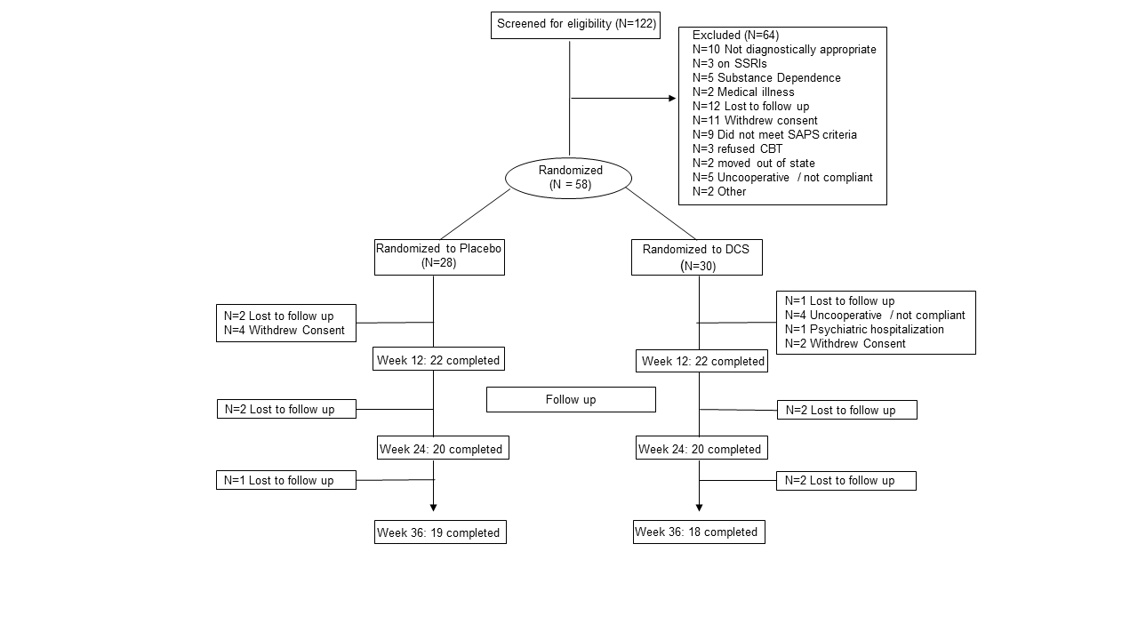

eFigure 2. ANOVA for memory consolidation – logical memory test
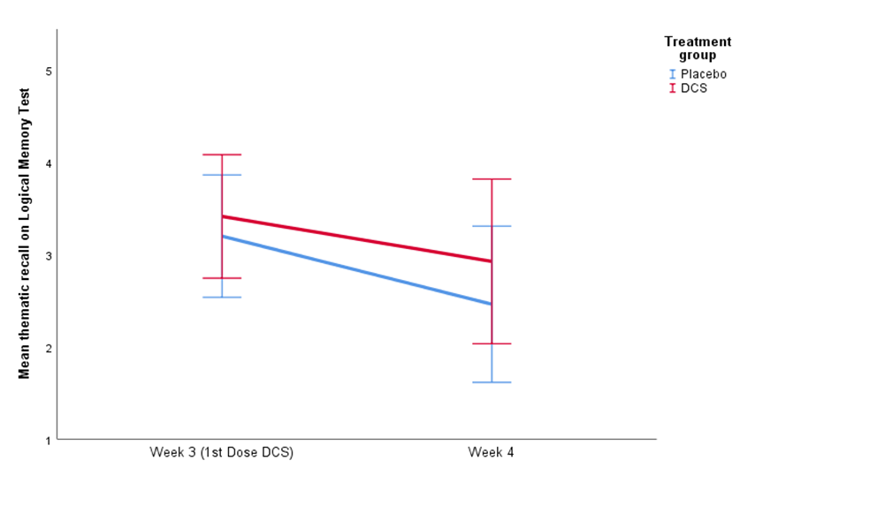

eFigure 3. Mean number of responses during the Alternative Beliefs Exercise by group

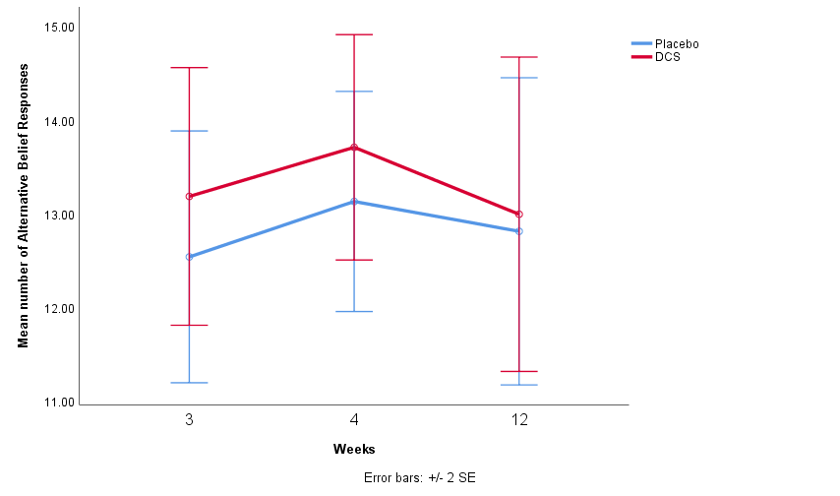
eFigure 4. Mean ratings of perceived helpfulness of CBT sessions by group

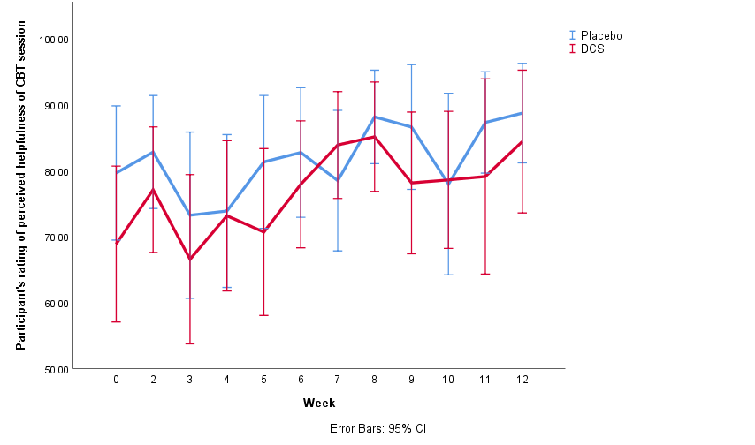

eFigure 5: Mean ratings of perceived change in distress following CBT session by group

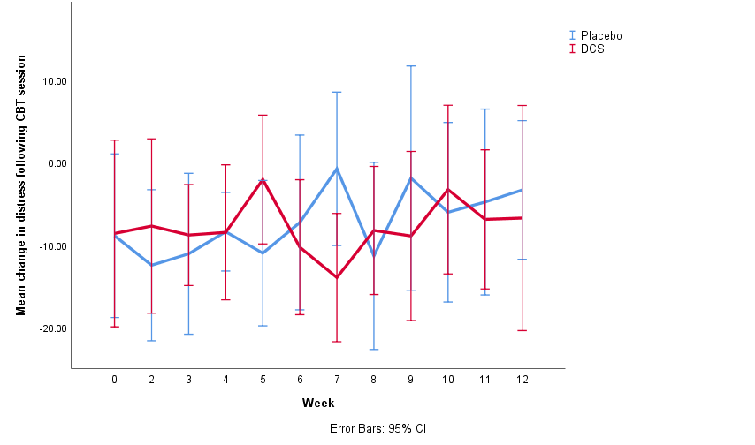

eTable 1. Demographics and clinical characteristics of participants who completed study visits through week 12 vs non-completers
 | Completers (N=44) | Non-completers (N=14) | t/X² | P
Sex  Women, N (%) | 17, (38.6) | 6, (42.9) | 0.78 (1) | 0.508
Race  Black  White  Hispanic  Asian  Other | 25 (56.8)  17 (38.6)  3 (6.8)  1 (2.3)  0 (0.0) | 7 (50.0)  7 (50.0)  2 (14.3)  0 (0.0)  0 (0.0) | 0.75 (1) | 0.348
Age, mean (SD) | 47.60 (12.0) | 37.07 (11.0) | -2.91 | 0.005
Education | 13.30 (2.7) | 12.79 (2.4) | -0.64 | 0.528
Employment status  Full-time  Part-time  Unemployed | 0 (0.0)  11 (25.0)  33 (75.0) | 1 (7.1)  1 (7.1)  12 (85.7) | 4.94 (2) | 0.085
AP treatment, mean (SD) | (N=16)  1807.06 (2233.8) | (N=4)  886.00 (639.4) | -0.80 | 0.433
PSYRATS Baseline, mean (SD) | 13.68 (4.2) | 10.79 (8.3) | -1.75 | 0.086
SANS Baseline, mean (SD) | 31.73 (9.5) | 31.21 (11.1) | -0.16 | 0.867
Note: SD=standard deviation; t=t-test statistic for continuous variables; p=p-value; X²⁼ Chi-square test statistic categorical variables; DUP=Duration of untreated psychosis; AP = Antipsychotic treatment

eTable 2. Medication use in randomized study sample
 | D-Cycloserine (N=30) | Placebo (N=28)
Antipsychotic Type, N (%)
First Generation | 7 (23.3) | 8 (28.6)
Second Generation | 16 (53.3) | 15 (53.6)
Antipsychotic
Aripiprazole | 5 (16.7) | 3 (10.7)
Asenapine | 1 (3.3) | 0 (0.0)
Fluphenazine | 1 (3.3) | 4 (14.3)
Haloperidol | 3 (10.0) | 3 (10.7)
Lurasidone | 1 (3.3) | 0 (0.0)
Olanzapine | 4 (13.3) | 4 (14.3)
Paliperidone | 2 (6.7) | 0 (0.0)
Perphenazine | 3 (10.0) | 1 (3.6)
Risperidone | 0 (0.0) | 3 (10.7)
Quetiapine | 1 (3.3) | 3 (10.7)
Ziprasidone | 2 (6.7) | 2 (7.1)
Medication free | 9 (19.9) | 7 (25.0)

eTable 3. Linear mixed model for repeated measures examining change in PSYRATS-D
 | β, (SE) | 95% CI | P Value
PSYRATS-D (N=53) | Model 1
Baseline (week 3)ª | -6.20, (3.88) | -14.09, 1.70 |  | 0.120
Week 4 | .351, (.823) | -1.28, 1.98 |  | 0.671
Week 6 | .151, (.823) | -1.48, 1.78 |  | 0.855
Week 8 | .734, (.827) | -900, 2.37 |  | 0.376
Week 10 | -.007, (.835) | -1.66, 1.65 |  | 0.993
Week 12^{b} | 11.49, (1.94) | 7.57, 15.42 |  | 0.001
Group difference at Week 12 | -.797, (1.32) | -1.82, 3.42 |  | 0.547
Information criteria Akaike | 1161.99
PSYRATS-D (N=49) | Model 2^{c}
Baseline (week 3)ª | -6.37, (3.90) | -14.32, 1.59 |  | 0.113
Week 4 | 1.04, (.799) | -.540, 2.62 |  | 0.195
Week 6 | .996, (.799) | -.584, 2.58 |  | 0.215
Week 8 | 1.36, (.804) | -.225, 2.95 |  | 0.092
Week 10 | .624, (.831) | -1.02, 2.27 |  | 0.454
Week 12^{b} | 10.93, (1.94) | 6.99, 14.87 |  | 0.001
Group difference at Week 12 | -.051, (1.33) | -2.70, 2.60 |  | 0.969
Information criteria Akaike | 1053.39
PSYRATS-D (N=53) | Model 3^{d}
SANS baseline | 6.02, (6.09) | -8.01, 20.05 |  | 0.352
Baseline (week 3)ª | -4.01, (8.74) | -25.80, 17.78 |  | 0.664
Week 4 | .126, (.843) | -1.54, 1.79 |  | 0.881
Week 6 | -.040, (.843) | -1.71, 1.63 |  | 0.962
Week 8 | .544, (.847) | -1.13, 2.22 |  | 0.522
Week 10 | -.318, (.861) | -2.02, 1.39 |  | 0.712
Week 12^{b} | 11.12, (5.45) | -1.18, 23.41 |  | 0.071
Group difference at Week 12 | -4.84, (2.09) | -9.69, .003 |  | 0.050
Information criteria Akaike | .980.145
Note: ªPSYRATS total at first administration of DCS (week 3) was included as a covariate in all models; ^{b}Intercept at week 12 represents the mean PSYRATS-D total for the reference group (DCS); Treatment group (Placebo, DCS) x study visit interaction terms were included in all models. Interactions were not significant; ^{c}Model 2, participants with SAPS < 3 at baseline were excluded from the analysis; ^{d}Model 3; SANS baseline score included as a covariate; all estimates and p-values refer to fixed effects in all models.

eTable 4. Linear regression examining change in distress (models 1-3) and perceived benefit of CBT (models 4-5) in predicting change on PSYRATS-D total score
Change in level of distress following weekly CBT session | R² | Β (SE) | p
Model 1 – Change in PSYRATS-D from week 3-12  PSYRATS-D Week 3  Average CBT ∆ distress  ∆ Distress x Group | 0.193  0.218 | -0.468 (0.156)  -0.018 (0.058)  -0.061 (0.085) | 0.005  0.755  0.476
Model 2 – Change in PSYRATS-D from week 3-24  PSYRATS-D Week 3  Average CBT ∆ distress  ∆ Distress x Group | 0.190  0.298 | -0.412 (0.127)  -0.034 (0.045)  0.140 (0.062) | 0.006  0.459  0.031
Model 3 – Change in PSYRATS-D from week 3-36  PSYRATS-D Week 3  Average CBT ∆ distress  ∆ Distress x Group | 0.163  0.198 | -0.488 (0.207)  0.069 (0.066)  -0.005 (0.092) | 0.025  0.303  0.960
Perceived benefit of weekly CBT session
Model 4 – Change in PSYRATS-D from week 3-12  PSYRATS-D Week 3  Average perceived benefit  Average perceived benefit x group | 0.193  0.200 | -0.451 (0.159)  0.002 (0.043)  0.008 (0.015) | 0.007  0.961  0.575
Model 5 – Change in PSYRATS-D from week 3-24  PSYRATS-D Week 3  Average perceived benefit  Average perceived benefit x group | 0.190  0.250 | -0.410 (0.129)  -0.018 (0.036)  -0.017 (0.011) | 0.003  0.614  0.136
Model 6 – Change in PSYRATS-D from week 3-36  PSYRATS-D Week 3  Average perceived benefit  Average perceived benefit x group | 0.163  0.194 | -0.501 (0.209)  -0.051 (0.050)  -0.005 (0.017) | 0.022  0.315  0.746

eTable 5. Treatment emergent side effects

Symptom | Placebo | DCS
Trouble sleeping | 10 | 5
Nightmares or sleep disturbances | 8 | 6
Drowsy or sleepy | 7 | 3
Nervous or hyper | 2 | 5
Weakness or fatigue | 11 | 4
Irritable | 7 | 5
Poor memory | 6 | 6
Trouble concentrating | 7 | 5
Feeling strange or unreal | 2 | 3
Hearing or seeing things | 2 | 0
Abnormal sensations | 2 | 3
Numbness or tingling | 3 | 3
Dizziness or faintness | 5 | 1
Headache | 3 | 6
Blurred vision | 5 | 2
Ringing in ears or trouble hearing | 2 | 1
Stuffy nose | 4 | 5
Dry mouth | 4 | 2
Drooling or increased salivation | 0 | 4
Muscle cramps or stiffness | 12 | 4
Muscle twitching or movements | 3 | 2
Trouble sitting still | 0 | 2
Tremor or shakiness | 2 | 1
Poor coordination or unsteadiness | 2 | 1
Slurred speech | 0 | 0
Heartbeat rapid or pounding | 0 | 2
Trouble catching breath or hyperventilating | 1 | 2
Chest pain | 3 | 4
Nausea or vomiting | 4 | 2
Stomach or abdominal cramps | 3 | 5
Constipation | 2 | 1
Diarrhea | 2 | 4
Difficulty starting urination | 2 | 3
Frequent need to urinate | 5 | 5
Menstrual irregularities | 0 | 0
Loss of sexual interest | 3 | 4
Problems with sexual arousal | 4 | 2
Delayed or absent orgasm | 5 | 2
Sweating excessively | 0 | 2
Fluid retention or swelling | 1 | 0
Appetite decreased | 1 | 0
Appetite increased | 5 | 6
Weight gain | 4 | 4
Weight loss | 1 | 1
Skin rash or allergy | 2 | 2
Diminished mental acuity or sharpness | 8 | 5
Difficulty finding words | 3 | 1
Apathy emotional difference | 2 | 2
Dizziness upon standing | 2 | 0
Bruising | 0 | 1
Hair thinning loss | 0 | 0
Hot flashes | 2 | 2
Clenching teeth at night | 1 | 2
Straight taste in mouth | 1 | 0
Unable to sit still | 0 | 2

Note: Side effects were assessed using the Systematic Assessment for Treatment Emergent Events (SAFTEE). Participant responses at each visit were compared to symptom responses at Week 2 (one week before baseline and the week prior to the start of medication administration). A side effect was defined as an increase of 2 points on an item on the SAFTEE. Individuals who reported a side effect in multiple weeks (i.e. at week 4 and 5) were only counted one time. Table reports the total number of participants reporting an increase in a side effect by 2 or more points on the SAFTEE at least one time during the study.

