The CEEDER database of evidence reviews: An open-access evidence service for researchers and decision-makers
ARTICLE TYPE: Short Communication
AUTHORS: Ko Konno¹, Samantha H. Cheng², Jacqualyn Eales³, Geoff Frampton⁴, Christian Kohl⁵, Barbara Livoreil⁶, Biljana Macura⁷, Bethan C. O’Leary^{8,9}, Nicola P. Randall¹⁰, Jessica J. Taylor¹¹, Paul Woodcock¹², Andrew S. Pullin¹
AFFILIATION:
¹CEE Centre UK, School of Natural Sciences, Bangor University, Gwynedd, LL57 2UW, UK
² CEE Centre USA, Center for Biodiversity and Conservation, American Museum of Natural History, New York City, NY, 10012, USA
³CEE Centre UK, European Centre for Environment and Human Health, College of Medicine and Health, University of Exeter, Knowledge Spa, Royal Cornwall Hospital, Truro, Cornwall, TR1 3HD
⁴Southampton Health Technology Assessments Centre (SHTAC), Faculty of Medicine, University of Southampton, Southampton Science Park, Southampton SO16 7NS, UK
⁵Institute for Biosafety in Plant Biotechnology, Julius Kühn-Institute, Federal Research Centre for Cultivated Plants, Erwin-Baur-Straße 27, Quedlinburg, Germany
⁶CEE Centre France, Coopaname, Le Luc en Provence, France
⁷CEE Centre Sweden, Stockholm Environment Institute, Linnégatan 87D, Stockholm, Sweden
⁸Department of Environment and Geography, University of York, YO10 5NG, UK
⁹School of Science, Engineering and Environment, University of Salford, Manchester, M5 4WX, UK
¹⁰CEE Centre UK, Centre for Evidence-based Agriculture, Harper Adams University, Newport, Shropshire, TF10 8NB, UK
¹¹CEE Centre Canada, Canadian Centre for Evidence-based Conservation, Carleton University, Ottawa, Ontario, Canada, K1S5B6
¹²Joint Nature Conservation Committee, UK
CORRESPONDING AUTHOR:
Ko Konno
CEE Centre UK, School of Natural Sciences, Bangor University, Gwynedd, LL57 2UW, UK (email: afuaad@bangor.ac.uk)

Highlights
- The number of evidence reviews is increasing but their rigour and risks of bias vary
- Easier access to rigorous evidence reviews may support evidence-informed decision-making
- CEEDER collates published evidence reviews into a searchable open-access database
- CEEDER assesses evidence reviews for their reliability using the CEESAT appraisal tool
- CEEDER will be further developed through co-production with evidence user organisations

Abstract
Evidence-informed decision-making aims to deliver effective actions informed by the best available evidence. Given the large quantity of primary literature, and time constraints faced by policy-makers and practitioners, well-conducted evidence reviews can provide a valuable resource to support decision-making. However, previous research suggests that some evidence reviews may not be sufficiently reliable to inform decisions in the environmental sector due to low standards of conduct and reporting. While some evidence reviews are of high reliability, there is currently no way for policy-makers and practitioners to quickly and easily find them among the many lower reliability ones. Alongside this lack of transparency, there is little incentive or support for review authors, editors and peer-reviewers to improve reliability. To address these issues, we introduce a new online, freely available and first-of-its-kind evidence service: the Collaboration for Environmental Evidence Database of Evidence Reviews (CEEDER: www.environmentalevidence.org/ceeder). CEEDER aims to transform communication of evidence review reliability to researchers, policy-makers and practitioners through independent assessment of key aspects of the conduct, reporting and data limitations of available evidence reviews claiming to assess environmental impacts or the effectiveness of interventions relevant to policy and practice. At the same time, CEEDER will provide support to improve the standards of future evidence reviews and support evidence translation and knowledge mobilisation to help inform environmental decision-making.
Keywords: Critical appraisal; Decision support tool; Evidence synthesis; Evidence-based; Policy making; Risk of bias

1. Introduction
Reviewing, collating and synthesising evidence is an essential prerequisite for supporting evidence-informed decision-making in environmental management (Pullin and Knight, 2001). Evidence reviews collate and synthesise data from primary studies with the aim of providing answers to specific questions for evidence users (i.e., anyone who uses evidence, such as policy-makers, managers, researchers, the general public, research funding agencies) (Collins et al., 2015; O’Leary et al., 2016). They are published under various names such as literature, critical, rapid or systematic reviews, as well as meta-analyses and evidence syntheses (Cook et al., 2017). Although enhanced provision of evidence is not guaranteed to lead to more evidence-informed decision-making, there have been many recent calls from the policy community for production of more rigorous and relevant evidence reviews (e.g. Donnelly et al., 2018; Morikawa, 2017; Uchiyama et al., 2018), and use of rigorous syntheses of ‘best available evidence’ is now widely recommended in policy-making (e.g. Research and Innovation, 2019; Science Advice for Policy by European Academies, 2019). There are also statements of intent by environmental organisations to use ‘best available evidence’ (e.g. Natural England, 2020), and many demand-driven evidence reviews have been (and are being) produced (e.g. impact of the COVID-19 pandemic on UK air quality; Air Quality Expert Group, 2020). If the global body of evidence reviews is reliable and accessible, then it can be an important option for supporting decision-making (Bayliss et al., 2012; Cook et al., 2013, 2010; Pullin and Knight, 2005). Unfortunately, many current environmental reviews are unlikely to be fit for the purpose of informing decision making due to lack of transparency and risk of bias (O’Leary et al. 2016).
To support the goal of producing reliable evidence reviews, the Collaboration for Environmental Evidence (CEE; www.environmentalevidence.org) has established standards for collating and synthesising evidence in environmental management (CEE, 2018). CEE provides freely available materials and tools for helping review authors to conduct rigorous, objective, replicable and transparent evidence reviews, such as step-by-step methodological guidelines (CEE, 2018), a set of reporting standards of review conduct (Haddaway et al., 2018) and an online tool for supporting conduct of evidence syntheses to follow the standards (Kohl et al., 2018). Such methods and tools are increasingly used for organising evidence (Dicks et al., 2014), as well as for raising the bar for standards in research, thereby contributing to scientific advances (Gurevitch et al., 2018).
However, the majority of currently published environmental evidence reviews do not meet CEE standards, and terminology referring to systematic review and meta-analysis is frequently misused (Haddaway et al., 2017; Koricheva and Gurevitch, 2014; O’Leary et al., 2016; Pullin et al., 2020; Roberts et al., 2006; Woodcock et al., 2017). As a result, many evidence reviews that claim to estimate impacts or effectiveness are less reliable, lacking rigour, transparency and/or objectivity (Haddaway et al., 2015; O’Leary et al., 2016; Woodcock et al., 2017). This is problematic for environmental decision-makers, as management efforts informed by unreliable evidence reviews may be ineffective, wasting limited resources and risking unintended consequences (Pullin and Knight, 2012).
Presently, evidence users face three challenges in finding relevant and reliable evidence reviews:
- First, evidence reviews themselves may be hidden in the sheer abundance of scientific publications (Forscher, 1963; Jinha, 2010; Johnson et al., 2018) with evidence users often having limited time available to search literature or access to databases to retrieve articles (Pullin et al., 2004; Pullin and Knight, 2005). While one of the major justifications for conducting evidence reviews is to collate primary studies for evidence users, as more and more are published, the problem of large volumes of literature extends to evidence reviews themselves (Gurevitch et al., 2018; Haddaway et al., 2015).
- Second, evidence users will increasingly have to choose which of the many evidence reviews on the same subject are the most reliable sources of evidence, and recognising strengths and weaknesses of evidence reviews takes time and training (O’Leary et al., 2017, 2016; Woodcock et al., 2017, 2014).
- Third, ‘synthesis gaps’ (i.e., unaddressed review questions or obsolete syntheses that need updating with new evidence) and ‘synthesis gluts’ (i.e., proliferation of similar reviews) are not easily identified, making it difficult to avoid redundancy of evidence reviews (O’Leary et al., 2017; Woodcock et al., 2017). In the health sector, unnecessary duplication of systematic reviews has already become a problem leading to research waste (Chalmers and Glasziou, 2009; Moher, 2013), and a similar trend could emerge soon for reviews in the environmental sector (O’Leary et al., 2017; Woodcock et al., 2017).
To address these problems and to help overcome some access-related barriers to evidence-informed decision-making, we introduce a new online and freely available evidence service: the CEE Database of Evidence Reviews (CEEDER: www.environmentalevidence.org/ceeder; Figure 1). CEEDER provides an interactive database that facilitates searching for relevant and reliable evidence reviews. CEEDER collates and indexes evidence reviews addressing questions relevant to environmental policy and practice (see eligibility criteria in Text S1), and independently assesses them against the methodological standards using an established assessment tool: CEE Synthesis Assessment Tool (CEESAT; described below). The assessment produces reliability ratings for each question addressed by a review, based on reported methodology. Here, we describe an overview of CEEDER (the evidence service) and the details of CEESAT (the assessment tool), and discuss how CEEDER benefits decision-makers in policy and practice, and supports evidence review production.
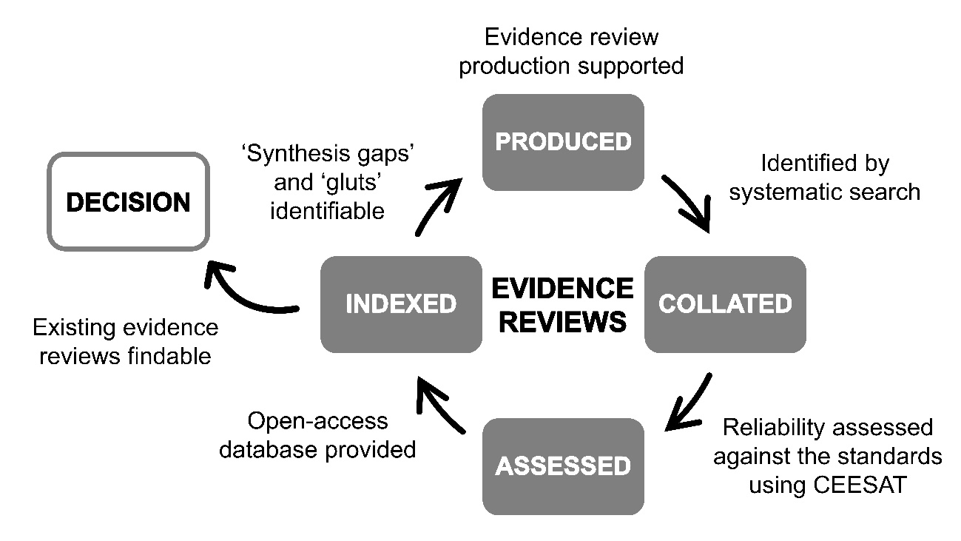
Figure 1. CEEDER logic model. Evidence reviews are collated, assessed and indexed in an open-access database for decision-makers and researchers.

2. The CEEDER evidence service

2.1 Aims and objectives
The principal aim of CEEDER is to enable evidence users to locate relevant environmental evidence reviews that have been independently and objectively assessed for their reliability in terms of transparency, level of procedural rigour (susceptibility to bias) and limitations of primary data for synthesis. CEEDER also aims to contribute to improving the conduct and reporting of evidence reviews across the environmental sector. Thus, intended users of the CEEDER evidence service (service users) are researchers, editors and peer-reviewers, as well as decision-makers.
The main objectives of CEEDER are:
- To provide an online, freely available service for evidence users to identify the most robust and reliable reviews of evidence suitable and relevant to their needs (e.g., for integration into policy and practice);
- To provide a measure of alignment of environmental evidence reviews with evidence needs in environmental policy and practice by identifying gaps and gluts in data and reviews; and
- To provide support to the research community to improve standards of environmental evidence synthesis.

2.2 Key actors in the evidence service
CEEDER is currently maintained by key actors who belong to specific divisions:
- CEEDER Executive Team
- CEEDER Editorial Team
- CEEDER Review College
The Executive Team developed CEESAT (Section 2.5), and provides strategic leadership of CEEDER. The Editorial Team administers the evidence service, and manages the CEEDER process (including assessments) and communications. The Review College is a large group of members, trained by experienced mentors, who assess evidence reviews for their reliability using CEESAT.

2.3 Scope of evidence reviews
The scope of evidence reviews included in CEEDER covers the global environmental sector. CEEDER is regularly updated (see Section 2.4) and includes evidence reviews dating from 2018. To be included in CEEDER, the review should: (1) address a question or a topic with relevance for environmental policy or practice; and (2) have the intent to synthesise primary studies (either narratively or quantitatively) and provide a measure or estimate of effect (e.g., impact of an activity or effectiveness of an intervention; see Text S1 for detailed criteria and methods). Reviews that simply describe a potential cause of impact or an intervention, or ‘expert’ opinion articles are not included unless the authors claim to provide a measure of effect. Configurative evidence reviews, that assess only distribution and abundance of evidence (e.g., overviews and systematic maps (CEE, 2018; Gough et al., 2012; James et al., 2016)), are therefore currently excluded although they may be included in the future (Section 3.4). The review questions included in the database therefore vary from broad global issues (e.g., impact of plastic waste on the marine environment) to precise cause and effect relationships in single species or restricted areas. Note many review articles address multiple questions of impact or effect, some of which may not be eligible for CEEDER and so assessment are made with respect to individual questions (Text S1). In addition to the source review article information, all of the eligible questions addressed in a review article are coded in a standard format for service users to easily find relevant evidence reviews (Section 2.6). Evidence reviews addressing subjects closely related to environmental management, such as human health and animal veterinary science are included when there is a significant environmental impact or intervention component in the question.

2.4 Workflow of the evidence service
CEEDER follows a specific workflow consisting of four key steps: (1) searching; (2) screening and data coding; (3) assessment (rating); and (4) data presentation. Each consists of a series of activities (Figure 2; Text S1). It starts with collecting potential evidence reviews by comprehensive searches of multiple bibliographic databases and grey literature followed by eligibility screening, data coding, and assessment of evidence reviews using CEESAT, and indexing evidence reviews in the database. To provide an up-to-date archive of evidence reviews, searches are updated monthly, and records are actively screened. The entire process provided in Figure 2 is overseen by the Editorial Team and the assessment is conducted by the Editorial Team and Review College members.
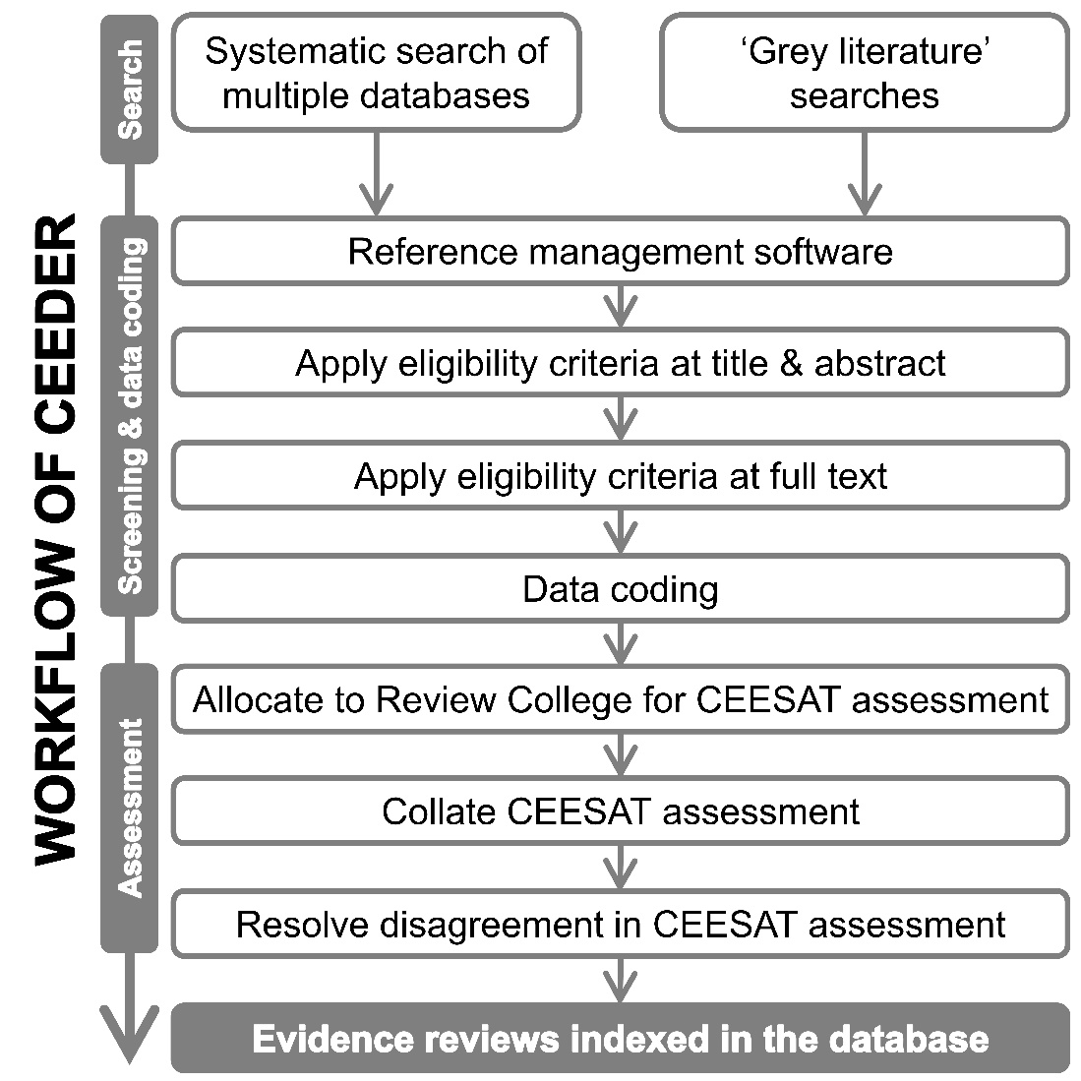
Figure 2. Workflow of CEEDER.

2.5 CEE Synthesis Assessment Tool (CEESAT versions 1 and 2)
The original tool, CEESAT v1, was developed in 2013 for assessing evidence reviews (see Woodcock et al., 2014), and has subsequently been tested and modified (O’Leary et al., 2017, 2016; Woodcock et al., 2017). An updated version, CEESAT v2, was produced following a two-day workshop in Stockholm in 2017; this is the version that is currently applied for assessment in CEEDER (see Table 1 for summary: full version is available at www.environmentalevidence.org/ceeder). In CEESAT v2, there are seven review components consisting of 16 elements. For each of the 16 elements, an evidence review is rated as either: Gold, Green, Amber or Red. The Gold and Green ratings equate to the high and minimum standards respectively recognised by CEE for evidence synthesis in environmental management (except for the elements 7.1, 7.2 and 7.3 that assess provision of statistical estimates, variances and heterogeneity which may not be possible because of limitations of primary data), while Red is regarded as unreliable. Note that CEESAT (v1 and v2) does not distinguish between lack of reporting of methodological steps in the review process and lack of implementation of them. For example, failure to report methods that might have reduced risk of bias is considered equivalent to not implementing them.
The question explored by each review is identified by the Editorial Team and provided to the Review College (this is often only a subquestion/subsection of the entire review). All question elements (known as ‘PICO’ or ‘PECO’ elements: Population (statistical or biological), Intervention/Exposure, Comparator and Outcome) required for measuring effect are determined by applying the eligibility criteria (Text S1), and then coded for allocations to the Review College. Review College members thus can identify what question they are being asked to assess for each review and service users can see the question for which the review was assessed. To provide consistent reliability ratings in CEEDER, at least two members from the Editorial Team/Review College independently assess each evidence review with disagreements checked and, if necessary, resolved by the Editorial Team.
Table 1. 16 Elements of CEESAT v2 criteria and corresponding review components.
Review components | 16 elements of CEESAT v2 criteria
1. Review question | 1.1 Are the elements of review question clear?
2. Method/Protocol | 2.1 Is there an a-priori method/protocol document?
3. Searching for studies | 3.1 Is the approach to searching clearly defined, systematic and transparent?
 | 3.2 Is the search comprehensive?
4. Including studies | 4.1 Are eligibility criteria clearly defined?
 | 4.2 Are eligibility criteria consistently applied to all potentially relevant articles and studies found during the search?
 | 4.3 Are eligibility decisions transparently reported?
5. Critical appraisal | 5.1 Does the review critically appraise each study?
 | 5.2 During critical appraisal was an effort made to minimise subjectivity?
6. Data extraction | 6.1 Is the method of data extraction fully documented?
 | 6.2 Are the extracted data reported for each study?
 | 6.3 Were extracted data cross checked by more than one reviewer?
7. Data synthesis | 7.1 Is the choice of synthesis approach appropriate?
 | 7.2 Is a statistical estimate of pooled effect (or similar) provided together with measure of variance and heterogeneity among studies?
 | 7.3 Is variability in the study findings investigated and discussed?
 | 7.4 Have the authors considered limitations in the synthesis?

2.6 Service platform
To provide a user-friendly, functional and useful service platform, we took a user-centred design approach where potential service users were engaged in multiple rounds of scoping and testing for developing the beta version of the platform (www.environmentalevidence.org/ceeder). A CEEDER workshop was held in Cardiff (UK) in July 2019 to engage with potential service users from Welsh Government and Natural Resources Wales. This engagement with stakeholders yielded pertinent information needs they wished to be displayed in the website and suggestions for functionality and visualisation. This beta version website features the evidence review database along with functionality for querying and visualising results. Further, we have invited potential service users from other governmental organisations for an online questionnaire survey via email and website. While this process is ongoing, we welcome further opportunities for co-production, discussion and comment from potential service users. Here, we describe the currently developed functionality and support for review authors, editors and peer-reviewers.

2.6.1 Search functionality
Service users can use keywords to search the database for: (1) titles, abstracts and keywords of the source article; (2) coded review questions; or (3) a combination of these two search options. Basic search functions such as some Boolean operators (AND and OR), wildcards, parentheses and quotation marks can be used.
Returned results feature bibliographic information and coded review question along with visual representation ratings for all 16 assessment criteria of CEESAT v2. Search results can be sorted by the reliability ratings of each of the 16 elements, enabling service users to find the most reliable evidence reviews based on categories they deem of importance to them. Further information about the evidence review, including title, abstract, year, authors and a link to the full text can be obtained. The website also allows service users to export the search results as, for example, a CSV file.

2.6.2 Support for authors, editors and peer-reviewers
We recognise that limitations in evidence reviews may be partly a consequence of the resources required to follow the most rigorous methodology, as well as perhaps lack of awareness of some aspects of these methods. To support improvements in the reliability of evidence reviews across the environmental sector, the CEEDER website provides guidance on what materials and tools are freely available to review authors, editors and peer-reviewers. Currently, this includes links to: CEE Guidelines and Standards for Evidence Synthesis (CEE, 2018); ROSES, a set of reporting standards (Haddaway et al., 2018); and CADIMA, an online tool for supporting the conduct of evidence syntheses (Kohl et al., 2018). In addition, the full assessment criteria of CEESAT (currently v2) are provided and authors, editors and peer-reviewers are encouraged to use them as a planning guide to support the standards expected of reliable evidence reviews.

3. Discussion
3.1 How CEEDER benefits evidence users
CEEDER provides an open-access database of independently assessed evidence reviews from which users can easily find relevant and reliable evidence reviews, and export their search results. The reliability ratings based on the 16 CEESAT criteria enable users to compare the reliability of evidence reviews. Although current licensing agreements do not allow us to provide the full texts of each assessed evidence review, CEEDER provides the necessary information and links for users to navigate to the original publication websites. We believe that using CEEDER would reduce the time required for locating relevant evidence reviews and screening them for rigour in comparison to using web-based search engines (e.g., Google Scholar, Google) or subscription-based bibliographic platforms (e.g., Scopus, Web of Science). CEEDER may offer a higher value to users, and we are committed to enabling easier location of relevant and reliable evidence reviews through further engagement and co-production.
Early stakeholder engagement suggests that evidence users would like to avoid consequences of unknowingly using unreliable evidence reviews. Indeed, they requested CEEDER to provide educational resources for deepening their understanding of the concept of risk of bias (CEE, 2018; Higgins et al., 2019). We are therefore planning to provide such resources and links to relevant literature and external websites for users. Thus, the evidence service will have the potential to support the policy and practice communities to build critical skills capacity (e.g., critical thinking of scientific claims and methods used) and to increase access to evidence reviews which might enable better evidence-informed decision-making (Aronson et al., 2019; Donnelly et al., 2018).

3.2 How CEEDER supports evidence review production
Another objective of CEEDER is to support review authors, editors and peer-reviewers in producing more reliable evidence reviews. To achieve this, CEEDER’s website provides guidance to users on materials and tools for building capacity to collate and synthesise evidence. It has been argued that the importance of formal training in environmental evidence reviews should be recognised in academia (Kareiva and Marvier, 2012). CEEDER is designed to raise awareness of the formally established evidence synthesis methodology and its value for the research community.
CEEDER will support more efficient and effective production of evidence reviews by providing users with a dynamic searchable database of reviews from which they can search for and identify reviews of interest. For example, reviews are coded by research question—so if users (say future review authors) were to check existing reviews on ‘climate change’, they could easily see what review questions are already addressed on the topic and determine where gaps remain to be filled and what areas have already been extensively and rigorously covered (gluts). Further, we are planning to provide visual exploration features in the service platform which may enable easier identification of gaps and gluts. The evidence service may also facilitate linkage between the production side and the user side of evidence reviews which in turn may motivate evidence review producers to generate reliable evidence reviews for unaddressed review questions (O’Leary et al., 2017), as well as to update existing evidence reviews (Bayliss et al., 2016; Pullin, 2014). CEEDER therefore provides an opportunity for evidence review producers to engage with evidence users, as well as to effectively and efficiently produce reliable evidence reviews for informing decisions.

3.3 Challenges and limitations
CEEDER itself is open-access; however, it cannot provide open-access to all articles since following links will often lead to a ‘paywall’. Consequently, it does not solve the problem of lack of access to scientific publications—a challenge faced by many organisations and individuals who may wish to use evidence for informing their work. Hopefully, with the increase in open-access publishing, this will become less of a problem over time.
There are challenges for users in interpretation of the CEEDER review appraisals and we plan to develop online help and training to address this. Currently, the CEEDER website provides advice on interpretation of overall review appraisals and the individual criteria. For example, the CEESAT estimate of reliability of each review is not equivalent to an estimate of the probability of the review findings being an accurate estimation of the truth. CEESAT does not identify specific errors (e.g., statistical or errors in searching and screening articles) or scientific fraud. Therefore, in the same sense that journals cannot guarantee the papers they publish do not contain errors or fraudulent claims, a high reliability rating cannot guarantee the findings of the evidence review are sound.
As mentioned above, CEEDER indexes evidence reviews published from 2018. For practical reasons, we are not planning to index reviews published in 2017 or before. However, this limitation is likely to become progressively less important as new primary research and review articles are published. Furthermore, evidence reviews published from 2018 onwards which are rated as being reliable (i.e., whose searches were likely to have been extensive) should capture (include, discuss or list) any pertinent evidence reviews published prior to 2018, subject to any date restrictions applied within the reviews themselves. Therefore, by identifying the most reliable recent evidence reviews, CEEDER may also assist service users in the location of older evidence reviews, if required.
3.4 Future development of CEEDER
CEEDER currently includes evidence reviews addressing only specific types of questions (Text S1). More diverse types of review question exist, and some of those may be included in the future. For example, environmental evidence reviews frequently assess interventions or exposures that are not compared against defined comparators, such as ‘what is the prevalence of rabies in European red fox populations?’ Collating reviews addressing this type of question might be useful for evidence users although it is not designed to answer causal effects or effectiveness of interventions.
CEEDER currently excludes reviews of qualitative research. Qualitative evidence syntheses can help evidence users contextualise environmental issues by addressing questions seeking qualitative data such as ‘why does an intervention work, for whom and in what circumstances?’ (CEE, 2018; Macura et al., 2019). However, CEESAT is designed to assess evidence reviews providing measure of effect, and therefore for CEEDER to index qualitative evidence syntheses, a dedicated assessment tool would need to be developed and tested.
Configurative evidence reviews, that only describe the nature of evidence and collate relevant primary studies but do not attempt to synthesise their findings (e.g., overviews and systematic maps (CEE, 2018; Gough et al., 2012; James et al., 2016)), are currently excluded from CEEDER. However, there could be potential benefits of including this type of evidence review since configurative reviews as well as aggregative reviews are prone to variation in reliability.
CEEDER is currently designed to cover evidence reviews of relevance to environmental policy and practice. Evidence reviews assessing scientific methods, as well as other subjects such as animal behaviour may be included in the future to expand the subject scope of the evidence service.

4. Conclusions
The CEEDER evidence service supports evidence-informed decision-making in the environmental sector by enabling the identification of pre-screened reliable evidence reviews in a searchable open-access database. CEEDER will also help to identify gaps and gluts in evidence reviews in environmental management and support production of more reliable evidence reviews by providing resources for authors, editors and peer-reviewers. We welcome further engagement with the CEEDER evidence service by users and user organisations to facilitate co-production of the service and ensure its relevance to their evidence needs.

Supplementary materials
Supplementary file S1. CEEDER methods

Acknowledgements
We thank the editors and two anonymous reviewers for their insightful comments that improved the manuscript.

Funding
This work is partly funded by an Impact Acceleration Account Impact Project Grant from the UK Economic and Social Research Council.

References
Air Quality Expert Group, 2020. Estimation of changes in air pollution emissions, concentrations and exposure during the COVID-19 outbreak in the UK, UK Air Information Resource.
Aronson, J.K., Barends, E., Boruch, R., Brennan, M., Chalmers, I., Chislett, J., Cunliffe-Jones, P., Dahlgren, A., Gaarder, M., Haines, A., Heneghan, C., Matthews, R., Maynard, B., Oxman, A.D., Oxman, M., Pullin, A., Randall, N., Roddam, H., Schoonees, A., Sharples, J., Stewart, R., Stott, J., Tallis, R., Thomas, N., Vale, L., 2019. Key concepts for making informed choices. Nature 572, 303–306. https://doi.org/10.1038/d41586-019-02407-9
Bayliss, H.R., Haddaway, N.R., Eales, J., Frampton, G.K., James, K.L., 2016. Updating and amending systematic reviews and systematic maps in environmental management. Environ. Evid. 5, 20. https://doi.org/10.1186/s13750-016-0073-8
Bayliss, H.R., Wilcox, A., Stewart, G.B., Randall, N.P., 2012. Does research information meet the needs of stakeholders? Exploring evidence selection in the global management of invasive species. Evid. Policy 8, 37–56. https://doi.org/10.1332/174426412X620128
CEE, 2018. Guidelines and Standards for Evidence Synthesis in Environmental Management VERSION 5.0. https://doi.org/http://www.environmentalevidence.org/information-for-authors
Chalmers, I., Glasziou, P., 2009. Avoidable waste in the production and reporting of research evidence. Lancet (London, England) 374, 86–9. https://doi.org/10.1016/S0140-6736(09)60329-9
Collins, A., Miller, J., Coughlin, D., Kirk, S., 2015. The Production of Quick Scoping Reviews and Rapid Evidence Assessments: A How to Guide.
Cook, C.N., Hockings, M., Carter, R. (Bill), 2010. Conservation in the dark? The information used to support management decisions. Front. Ecol. Environ. 8, 181–186. https://doi.org/10.1890/090020
Cook, C.N., Nichols, S.J., Webb, J.A., Fuller, R.A., Richards, R.M., 2017. Simplifying the selection of evidence synthesis methods to inform environmental decisions: A guide for decision makers and scientists. Biol. Conserv. https://doi.org/10.1016/j.biocon.2017.07.004
Cook, C.N., Possingham, H.P., Fuller, R.A., 2013. Contribution of systematic reviews to management decisions. Conserv. Biol. 27, 902–915. https://doi.org/10.1111/cobi.12114
Dicks, L. V., Walsh, J.C., Sutherland, W.J., 2014. Organising evidence for environmental management decisions: a ‘4S’ hierarchy. Trends Ecol. Evol. 29, 607–613. https://doi.org/10.1016/j.tree.2014.09.004
Donnelly, C.A., Boyd, I., Campbell, P., Craig, C., Vallance, P., Walport, M., Whitty, C.J.M., Woods, E., Wormald, C., 2018. Four principles to make evidence synthesis more useful for policy. Nature 558, 361–364. https://doi.org/10.1038/d41586-018-05414-4
Forscher, B.K., 1963. Chaos in the Brickyard. Science (80-. ). 142, 339–339. https://doi.org/10.1126/science.142.3590.339
Gough, D., Thomas, J., Oliver, S., 2012. Clarifying differences between review designs and methods. Syst. Rev. 1, 28. https://doi.org/10.1186/2046-4053-1-28
Gurevitch, J., Koricheva, J., Nakagawa, S., Stewart, G., 2018. Meta-analysis and the science of research synthesis. Nature 555, 175–182. https://doi.org/10.1038/nature25753
Haddaway, N.R., Land, M., Macura, B., 2017. “A little learning is a dangerous thing”: A call for better understanding of the term ‘systematic review.’ Environ. Int. 99, 356–360. https://doi.org/10.1016/J.ENVINT.2016.12.020
Haddaway, N.R., Macura, B., Whaley, P., Pullin, A.S., 2018. ROSES RepOrting standards for Systematic Evidence Syntheses: pro forma, flow-diagram and descriptive summary of the plan and conduct of environmental systematic reviews and systematic maps. Environ. Evid. 7, 7. https://doi.org/10.1186/s13750-018-0121-7
Haddaway, N.R., Woodcock, P., Macura, B., Collins, A., 2015. Making literature reviews more reliable through application of lessons from systematic reviews. Conserv. Biol. 29, 1596–1605. https://doi.org/10.1111/cobi.12541
Higgins, J., Thomas, J., Chandler, J., Cumpston, M., Li, T., Page, M., Welch, V., 2019. Cochrane Handbook for Systematic Reviews of Interventions version 6.0, Cochrane Handbook for Systematic Reviews of Interventions. Cochrane. https://doi.org/10.1002/9781119536604
James, K.L., Randall, N.P., Haddaway, N.R., 2016. A methodology for systematic mapping in environmental sciences. Environ. Evid. 5, 7. https://doi.org/10.1186/s13750-016-0059-6
Jinha, A.E., 2010. Article 50 million: an estimate of the number of scholarly articles in existence. Learn. Publ. 23, 258–263. https://doi.org/10.1087/20100308
Johnson, R., Watkinson, A., Mabe, M., 2018. The STM report: An overview of scientific and scholarly publishing.
Kareiva, P., Marvier, M., 2012. What Is Conservation Science? Bioscience 62, 962–969. https://doi.org/10.1525/bio.2012.62.11.5
Kohl, C., McIntosh, E.J., Unger, S., Haddaway, N.R., Kecke, S., Schiemann, J., Wilhelm, R., 2018. Online tools supporting the conduct and reporting of systematic reviews and systematic maps: a case study on CADIMA and review of existing tools. Environ. Evid. 7, 8. https://doi.org/10.1186/s13750-018-0115-5
Koricheva, J., Gurevitch, J., 2014. Uses and misuses of meta-analysis in plant ecology. J. Ecol. 102, 828–844. https://doi.org/10.1111/1365-2745.12224
Macura, B., Suškevičs, M., Garside, R., Hannes, K., Rees, R., Rodela, R., 2019. Systematic reviews of qualitative evidence for environmental policy and management: an overview of different methodological options. Environ. Evid. 8, 24. https://doi.org/10.1186/s13750-019-0168-0
Moher, D., 2013. The problem of duplicate systematic reviews. BMJ 347, f5040. https://doi.org/10.1136/bmj.f5040
Morikawa, M., 2017. Evidence of “Evidence-Based Policymaking” (Japanese), RIETI Policy Discussion Paper 17008.
Natural England, 2020. Natural England’s Science, Evidence and Evaluation Strategy (2020-2025). Natural England.
O’Leary, B.C., Kvist, K., Bayliss, H.R., Derroire, G., Healey, J.R., Hughes, K., Kleinschroth, F., Sciberras, M., Woodcock, P., Pullin, A.S., 2016. The reliability of evidence review methodology in environmental science and conservation. Environ. Sci. Policy 64, 75–82. https://doi.org/10.1016/j.envsci.2016.06.012
O’Leary, B.C., Woodcock, P., Kaiser, M.J., Pullin, A.S., 2017. Evidence maps and evidence gaps: evidence review mapping as a method for collating and appraising evidence reviews to inform research and policy. Environ. Evid. 6, 19. https://doi.org/10.1186/s13750-017-0096-9
Pullin, A., Knight, T., Stone, D., Charman, K., 2004. Do conservation managers use scientific evidence to support their decision-making? Biol. Conserv.
Pullin, A.S., 2014. Updating reviews: commitments and opportunities. Environ. Evid. 3, 18. https://doi.org/10.1186/2047-2382-3-18
Pullin, A.S., Cheng, S.H., Cooke, S.J., Haddaway, N.R., Macura, B., Mckinnon, M.C., Taylor, J.J., 2020. Informing conservation decisions through evidence synthesis and communication, in: Conservation Research, Policy and Practice. Cambridge University Press, pp. 114–128. https://doi.org/10.1017/9781108638210.007
Pullin, A.S., Knight, T.M., 2012. Science informing Policy – a health warning for the environment. Environ. Evid. 1, 15. https://doi.org/10.1186/2047-2382-1-15
Pullin, A.S., Knight, T.M., 2005. Assessing conservation management’s evidence base: A survey of management-plan compilers in the United Kingdom and Australia. Conserv. Biol. 19, 1989–1996. https://doi.org/10.1111/j.1523-1739.2005.00287.x
Pullin, A.S., Knight, T.M., 2001. Effectiveness in conservation practice: pointers from medicine and public health. Conserv. Biol. 15, 50–54. https://doi.org/10.1111/j.1523-1739.2001.99499.x
Research and Innovation, 2019. Scientific Advice to European Policy in a Complex World. https://doi.org/10.2777/80320
Roberts, P.D., Stewart, G.B., Pullin, A.S., 2006. Are review articles a reliable source of evidence to support conservation and environmental management? A comparison with medicine. Biol. Conserv. 132, 409–423. https://doi.org/10.1016/J.BIOCON.2006.04.034
Science Advice for Policy by European Academies, 2019. Making Sense of Science for Policy under Conditions of Complexity and Uncertainty. SAPEA, Berlin. https://doi.org/10.26356/MASOS
Uchiyama, Y., Kobayashi, Y., Taguchi, S., Koike, T., 2018. Evidence-Based Policy Making in the UK and the Implications for Japan from the Viewpoint of Supply and Demand for Evidence (Japanese), RIETI Policy Discussion Paper 18018.
Woodcock, P., O’Leary, B.C., Kaiser, M.J., Pullin, A.S., 2017. Your evidence or mine? Systematic evaluation of reviews of marine protected area effectiveness. Fish Fish. 18, 668–681. https://doi.org/10.1111/faf.12196
Woodcock, P., Pullin, A.S., Kaiser, M.J., 2014. Evaluating and improving the reliability of evidence syntheses in conservation and environmental science: A methodology. Biol. Conserv. 176, 54–62. https://doi.org/10.1016/j.biocon.2014.04.020

