Figure 2 – Box plots of HIV disclosure and social support outcome scores per visit and per trial arm, ANRS 12249 TasP trial
Figure 2a: Box plots of the HIV disclosure score per visit and per trial arm
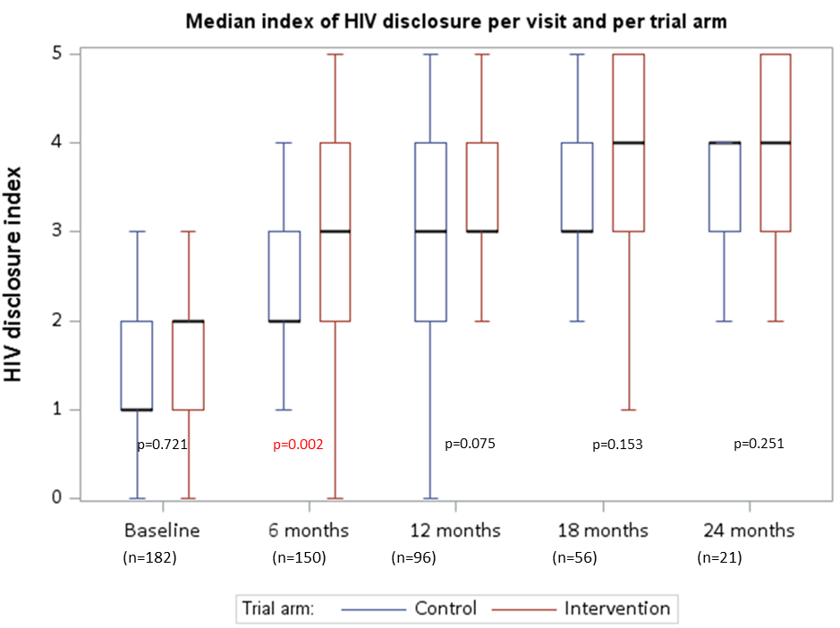
p-value: Wilcoxon rank-sum test

Figure 2b – Box plots of the social support score per visit and per trial arm
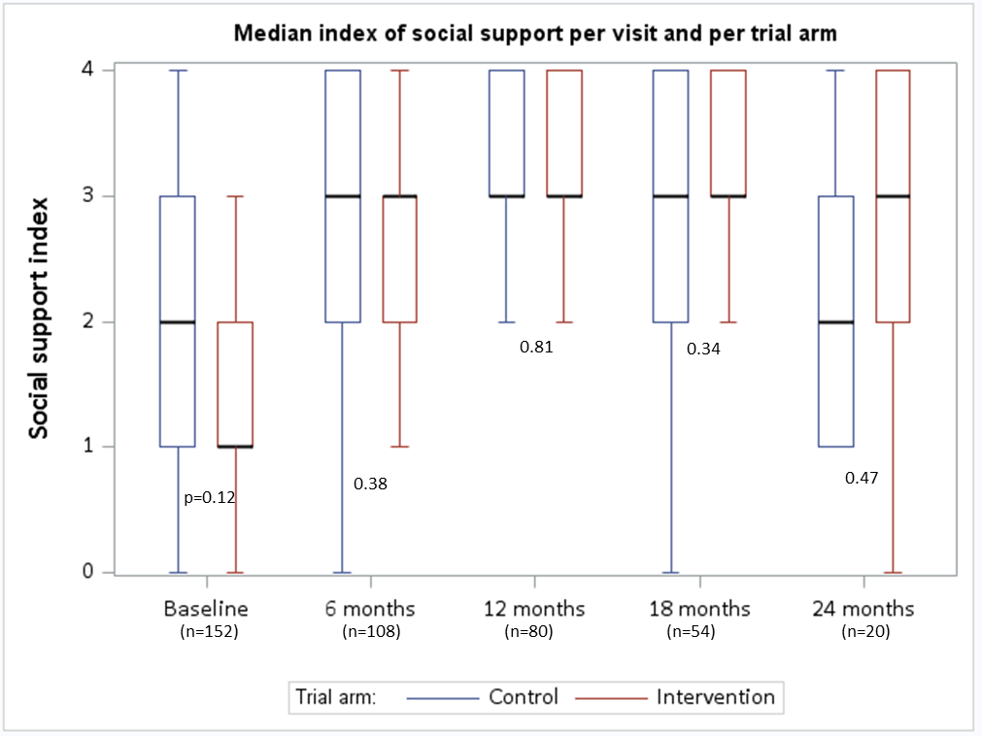
p-value: Wilcoxon rank-sum test

