An Optimal “Click” Formulation Strategy for Antibody-Drug Conjugate Synthesis
Erol C. Vatanseverª, Jeffrey Kang^{b}, Alfred Tuleyª, E. Sally Ward^{b,c,d,}* and Wenshe Ray Liu^{a,e,f,}*

ª The Texas A&M Drug Discovery Laboratory, Department of Chemistry, Texas A&M University, College Station, Texas 77843, United States
^{b} Department of Molecular and Cellular Medicine, Texas A&M University Health Science Center, College Station, TX 77843, USA
^{c} Department of Microbial Pathogenesis and Immunology, Texas A&M University Health Science Center, Bryan, TX 77807, USA
^{d} Centre for Cancer Immunology, Cancer Sciences Unit, Faculty of Medicine, University of Southampton, Southampton SO16 4YD, UK
^{e} Department of Biochemistry and Biophysics, Texas A&M University, College Station, TX 77843, USA
^{f} Department of Molecular and Cellular Medicine, College of Medicine, Texas A&M University, College Station, TX 77843, USA
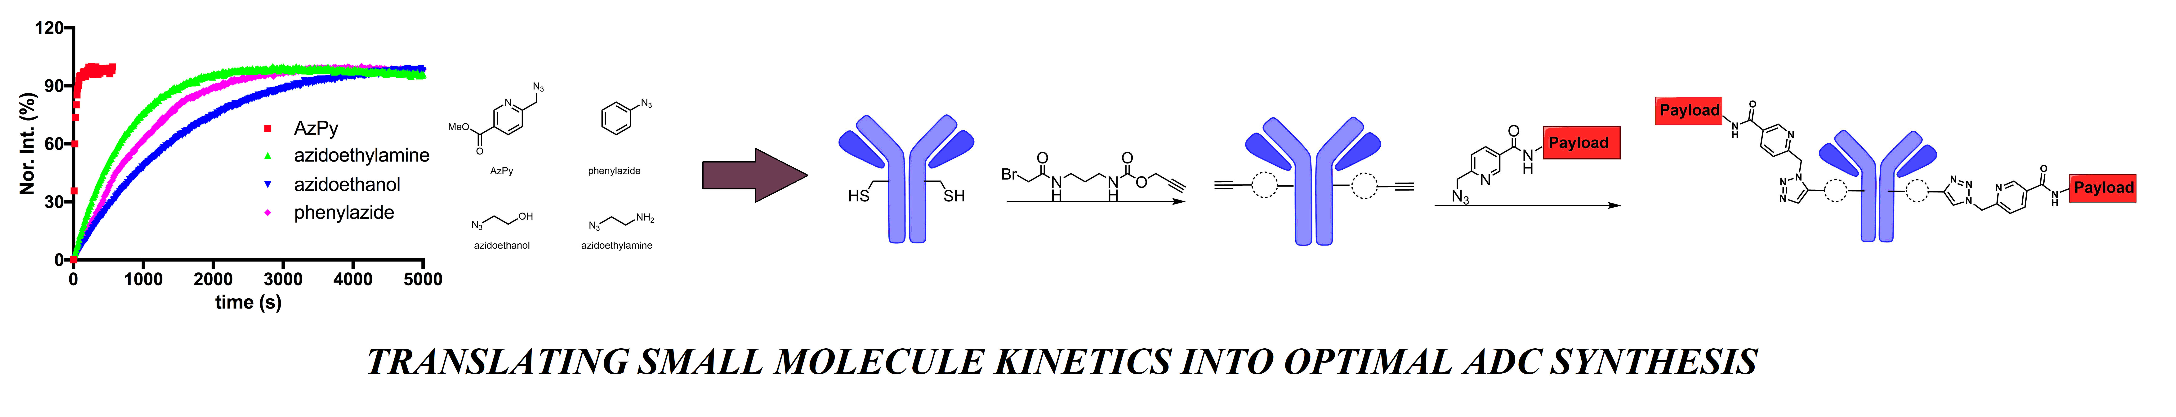
Leave this area blank for abstract info.

Bioorganic & Medicinal Chemistry
journal homepage: www.elsevier.com
An Optimal “Click” Formulation Strategy for Antibody-Drug Conjugate Synthesis
Erol C. Vatanseverª, Jeffrey Kang^{b}, Alfred Tuleyª, E. Sally Ward^{b,c,d,}* and Wenshe Ray Liu^{a,e,f,}*

ª The Texas A&M Drug Discovery Laboratory, Department of Chemistry, Texas A&M University, College Station, Texas 77843, United States
^{b} Department of Molecular and Cellular Medicine, Texas A&M University Health Science Center, College Station, TX 77843, USA
^{c} Department of Microbial Pathogenesis and Immunology, Texas A&M University Health Science Center, Bryan, TX 77807, USA
^{d} Centre for Cancer Immunology, Cancer Sciences Unit, Faculty of Medicine, University of Southampton, Southampton SO16 4YD, UK
^{e} Department of Biochemistry and Biophysics, Texas A&M University, College Station, TX 77843, USA
^{f} Department of Molecular and Cellular Medicine, College of Medicine, Texas A&M University, College Station, TX 77843, USA

ARTICLE INFO | ABSTRACT
Article history:  Received  Received in revised form  Accepted  Available online | As a versatile reaction for bioconjugation, Cu(I)-catalyzed alkyne-azide cycloaddition (CuAAC) has enormous potential in the synthesis of antibody-drug conjugates (ADCs). In order to optimize CuAAC-based ADC synthesis, we characterized kinetically different formulation processes by mimicking ADC synthesis using small molecules and subsequently revealed unique kinetic behaviors of different combinations of alkyne and azide conditions. Our results indicate that under ADC synthesis conditions, for an alkyne-containing drug, its concentration has minimal impact on the reaction rate when an antibody has a non-metal-chelating azide but is proportional to concentration when an antibody contains a metal-chelating azide; however, for an alkyne-containing antibody, the ADC synthesis rate is proportional to the concentration of a drug with a non-metal-chelating azide but displays almost no dependence on drug concentration with a metal-chelating azide. Based on our results, we designed and tested an optimal “click” formulation strategy that allowed rapid and cost-effective synthesis of a new ADC.  2009 Elsevier Ltd. All rights reserved.
Keywords:
Copper(I)-catalyzed alkyne-azide cycloaddition
click reaction
antibody-drug conjugate
metal-chelating azide
kinetic formulation

- Introduction
Antibody-drug conjugates (ADCs) consist of cytotoxic drugs that are covalently conjugated to antibodies. The antibody component of an ADC directs the binding to antigens expressed on tumor cells and enables the specific delivery of their conjugated drugs. Consequently, ADCs combine the anti-tumor efficacy of chemotherapeutic drugs, whilst minimizing their significant systemic cytotoxicity.¹ With 9 ADCs approved by FDA and more than 150 in clinical trials,² the development of ADCs has revolutionized cancer treatment. This rapidly expanding use of ADCs has largely overshadowed their manufacturing challenges. How exactly antibodies and drugs are conjugated plays a significant role in defining both the cost and therapeutic index of an ADC.^{3,4} To date, the most broadly used reaction for antibody-drug conjugation is the covalent addition of a cysteine thiolate in an antibody to a maleimide in a drug (Figure 1A).⁵ In comparison to random conjugation to lysine residues of an antibody that are more abundant than cysteine residues, this reaction typically leads to more homogenous ADCs. The fast reaction kinetics (734 M⁻¹s⁻¹)⁶ also allows the use of a low concentration of a drug (in the µM range) to achieve efficient coupling to the antibody, which significantly simplifies the manufacturing process of ADCs. Since most drugs used during ADC synthesis are complicated natural products and therefore expensive to produce, the use of a low drug concentration also substantially reduces the manufacturing cost of ADCs. However, although efficacious, the cysteine-maleimide reaction has pitfalls. Maleimide reacts with lysine at a low level to form side products.⁷ The reaction itself is also slowly reversible, which leads to the release of the conjugated drug that can contribute to systemic cytotoxicity.⁸ For these reasons, substantial efforts to either improve the cysteine-maleimide chemistry^{9, 10} or develop novel conjugation strategies have been made.¹¹⁻¹⁹ As the founding click reaction for bioconjugation, Cu(I)-catalyzed alkyne-azide cycloaddition (CuAAC) has been explored for ADC synthesis.²⁰ In this study, we show how this versatile reaction can be favorably optimized for this purpose.
- Results & Discussion
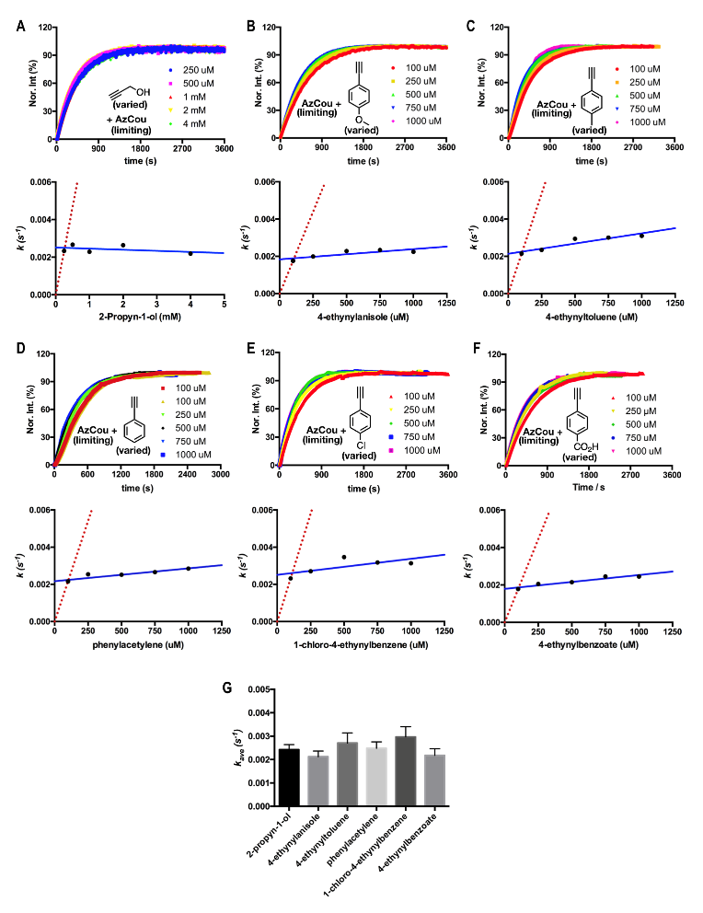
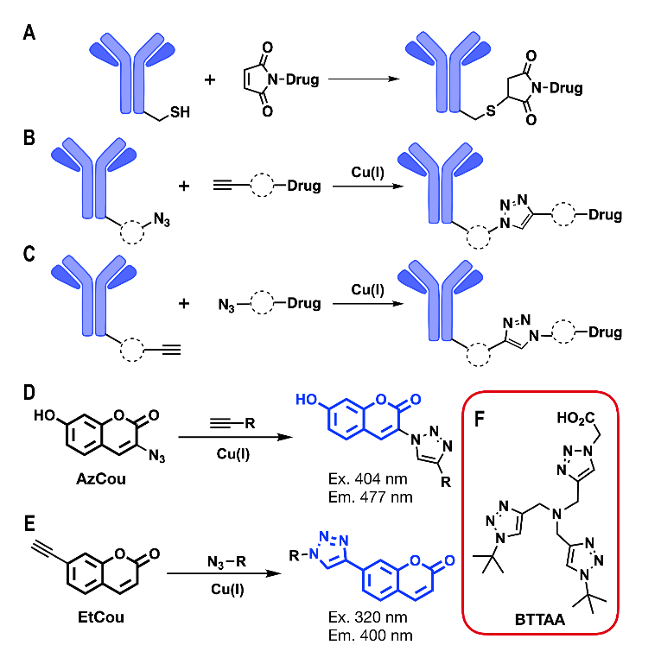
During the CuAAC synthesis of ADCs, small molecule drugs were provided in excess to achieve homogenous loading to antibody.²⁰ An additional manufacturing reason to use excessive drugs instead of excessive antibodies is that it is relatively straightforward to remove residual drugs but very difficult to separate unconjugated from conjugated antibodies. In order to use CuAAC to synthesize ADCs, two possible processes might be considered. The first one involves the reaction between an azide-containing antibody and an alkyne-containing drug (Figure 1B) and the second one between an alkyne-containing antibody and an azide-containing drug (Figure 1C). For both processes, we aimed to identify their most efficient processing conditions. To facilitate analysis, we chose to characterize two mimicking reactions as shown in Figure 1D-E, in which two fluorogenic compounds, 3-Azido-7-hydroxycoumarin (AzCou) and 7-Ethynylcoumarin (EtCou) become strongly fluorescent following their reactions with an alkyne and azide, respectively. To generate Cu(I) for the catalysis, we applied CuSO₄ and sodium ascorbate according to a published procedure^{21, 22} and preserved Cu(I) by providing a strong Cu(I)-chelating ligand BTTAA (Figure 1F).^{23, 24}
Figure 2.Reactions of AzCou with excessive alkyne concentrations. (A) The one-phase exponential increase of product fluorescence when a limiting concentration of AzCou (50 µM) was reacted with excess concentrations of 2-propyn-1-ol (0.25-4 mM). (B-F) The one-phase exponential increase of product fluorescence when a limiting concentration of AzCou (10 µM) was reacted with excess concentrations of five phenylacetylene derivatives (0.1-1 mM). (G) Average apparent reaction rate constants for all tested alkynes.

Figure 1. ADC conjugation strategies and small molecule mimicking reactions. (A) The cysteine-maleimide reaction for ADC conjugation. (B) The conjugation of an azide-containing antibody to an alkyne-containing drug. (C) The conjugation of an alkyne-containing antibody to an azide-containing drug. (D-E) Two fluorescence reactions that mimic the syntheses shown in B and C. (F) The soluble Cu(I) ligand used in the current study.

To test the ability of BTTAA to preserve Cu(I), we set up two parallel reactions in phosphate buffered saline (PBS) (pH 7.4), with and without 300 µM BTTAA, that also contained 1 mM 2-propyn-1-ol, 50 µM Cu(I), and 5 µM AzCou. The reaction in which BTTAA was present was rapidly completed and the addition of 5 µM AzCou consecutively, 4 times, over a time period of 3 h led to similar reaction trajectories and fluorescence intensity increases Supporting Information (SI, Figure S1), indicating that BTTAA was capable of maintaining the catalytic power of Cu(I) for a prolonged time. However, the reaction in which BTTAA was absent was very slow. The final product displayed fluorescence intensity that was much lower than that of the similar reaction in which BTTAA was present, indicating that Cu(I) totally lost its catalytic power before AzCou was consumed. Adding an additional 5 µM AzCou did not lead to any fluorescence change to the reaction. This preliminary test demonstrates that free Cu(I) cannot be directly applied for the CuAAC-based ADC synthesis due to its rapid loss of activity in water. However, BTTAA as a preserving reagent is able to maintain the catalytic power of Cu(I) to sustain the time required for ADC synthesis. We also compared catalytic activities of different ratios of Cu(I) to BTTAA by varying the BTTAA concentration and fixing all other conditions. It was evident that the catalytic activity of Cu(I) improved when the Cu(I)-to-BTTAA ratio was increased and reached its maximum when the Cu(I)-to-BTTAA ratio was 1 (SI, Figure S2). To balance both the preservation and the catalytic
activity of Cu(I), we maintained the Cu(I)-to-BTTAA ratios in all following studies at between 1:2 and 1:6.
To mimic the process of conjugating an azide-containing antibody to an alkyne-containing drug under conditions of limiting and excess reactants, respectively, during ADC synthesis, we first characterized the reaction kinetics of limiting AzCou with excessive 2-propyn-1-ol. We carried out reactions by varying the concentration of 2-propyn-1-ol and fixed all other conditions and maintained the 2-propyn-1-ol concentration at least 5 times greater than that of AzCou for the purpose of maintaining a pseudo first-order condition between the two reactants. The strong fluorescence of the product allowed its easy detection using a fluorimeter or fluorescent plate reader. For all tested 2-propyn-1-ol concentrations, the collected data of fluorescence intensity versus time fit perfectly to the one-phase exponential production formation model, indicating that AzCou followed first-order kinetics to convert to product under all tested conditions (Figure 2A). However, unexpectedly the reaction trajectories for all 2-propyn-1-ol concentrations were essentially the same and all of the determined apparent reaction rate constants were almost equal. We originally tested pseudo first order conditions²⁵ by varying the 2-propyn-1-ol concentration with the aim of determining a second order rate constant between an azide-alkyne bimolecular reaction under a fixed Cu(I)-ligand condition. Apparently, the reaction did not follow a simple bimolecular reaction model. The involvement of the Cu(I) catalyst complicated the process. The independence of determined apparent rate constants from 2-propyn-1-ol concentrations might have been due to the formation of an alkyne-Cu(I) resting state before the involvement of an azide, or two parallel alkyne-Cu(I) and azide-Cu(I) chelating processes in which the alkyne-Cu(I) chelation was significantly faster than the other process.
AzCou is a non-metal-chelating azide. The independence of the rate of its CuAAC reaction from the concentration of excessive 2-propyn-1-ol might represent a general feature of CuAAC reactions. To explore this possibility, we tested AzCou reactions with five other alkynes in a setup similar to that for 2-propyn-1-ol. We chose five phenylacetylenes due to their significantly different electrochemical features of p-substitutes that substantially influence their host compounds’ alkyne group.²⁶ Should a simple bimolecular model apply, they would behave very differently in reaction kinetics with AzCou. However, for all five phenylacetylenes, their reaction trajectories at different concentrations were very similar (Figure 2B-F). Although determined apparent k values at different alkyne concentrations showed some variations, they were very alike. They deviated far from predictions from a real bimolecular reaction in which we expected a linear dependence of a determined apparent k value on the concentration of an excessively used reactant. The average k values for all tested alkynes were also very similar, indicating that the reaction kinetics were minimally dependent on both the identity and concentration of excessive alkynes when they reacted with limiting non-metal-chelating AzCou.
Since both the identity and concentration of an excessive alkyne have minimal impacts on the CuAAC reaction kinetics of non-metal-chelating AzCou, we reasoned that in a similar setup the azide identity might significantly influence the reaction kinetics. In order to compare reactivities of different azides under the condition of a limiting azide and an excess alkyne concentration, we used EtCou. When we reacted 100 µM EtCou in excess with 20 µM concentrations of several different azides, we observed very different reaction trajectories (Figure 3A). For comparison, a
Figure 4. The one-phase exponential increase of product fluorescence when a limiting concentration (20 μM) of EtCou reacted with excess concentrations (100-500 μM) of azidoethylamine (A) and AzPy (B).
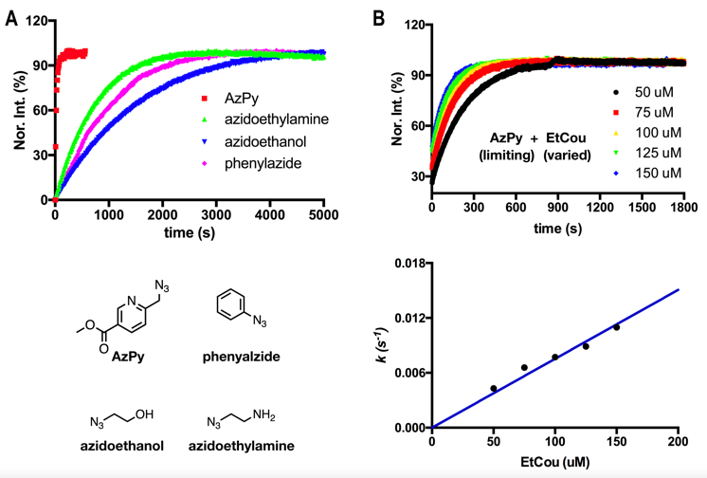
metal-chelating azide, AzPy²⁷ was also included in the analysis. Overall and consistent with earlier studies, AzPy reacted more rapidly than all other non-metal-chelating azides. For non-metal-chelating azides, azidoethylamine reacted faster than phenylazide and phenylazide reacted faster than azidoethanol. Azidoethylamine reacted more quickly than the other two compounds, probably due to the chelating propensity of its amine toward Cu(I). To confirm that the minimal dependence of the reaction kinetics on the concentration of an excessive alkyne when it reacts with a limiting non-metal-chelating azide is a general phenomenon, we carried out analyses of reactions between EtCou and different non-metal-chelating azides by fixing the azide concentration and varying the EtCou concentration. For azidoethanol, reactions were too slow to determine k but had similar trajectories (SI, Figure S3). For azidoethylamine and phenylazide, reactions displayed similar kinetics at different EtCou concentrations (SI, Figures S4-5). Based on all reactions we have analyzed between limiting non-metal-chelating azides and excess alkyne concentrations, we conclude that the minimal dependence of the reaction kinetics on the concentration of an alkyne is a general observation.
Figure 3. (A) CuAAC reaction trajectories between limiting concentrations of different azides (20 µM) and excess concentrations of EtCou (100 µM). (B) The one-phase exponential increase of product fluorescence when a limiting concentration (5 µM) of AzPy was reacted with excess concentrations of EtCou (50-150 μM).
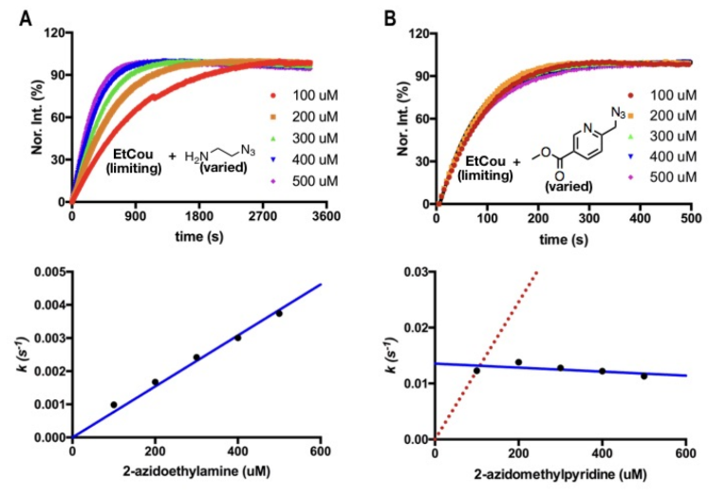
We have also carried out a similar test to mimic how an alkyne-containing drug may react with metal-chelating AzPy conjugated to an antibody. We reacted limiting AzPy with different concentrations of excessive EtCou and observed that the EtCou concentration significantly influenced the reaction rate (Figure 3B). The determined k values were linearly proportional to EtCou trajectories. It is obvious that metal-chelating and non-metal-chelating azides involve very different CuAAC reaction kinetics. The AzPy-Cu(I) chelation is apparently able to outcompete the rapid alkyne-Cu(I) formation, leading to the observed dependence of the alkyne concentration. Based on all the data related to limiting azides reacting with excessive alkynes, we can deduce that for the reaction between an azide-containing antibody and an alkyne-containing drug to generate an ADC, the most kinetically favorable option is to react a metal-chelating antibody azide with a drug alkyne and improve the kinetics by increasing the drug concentration. When a non-metal-chelating antibody azide is used, changing the drug concentration has little impact on the reaction kinetics and more favorable reaction kinetics can be achieved by changing the azide identity in the antibody for example, from a standard alkyl azide to an aromatic azide.
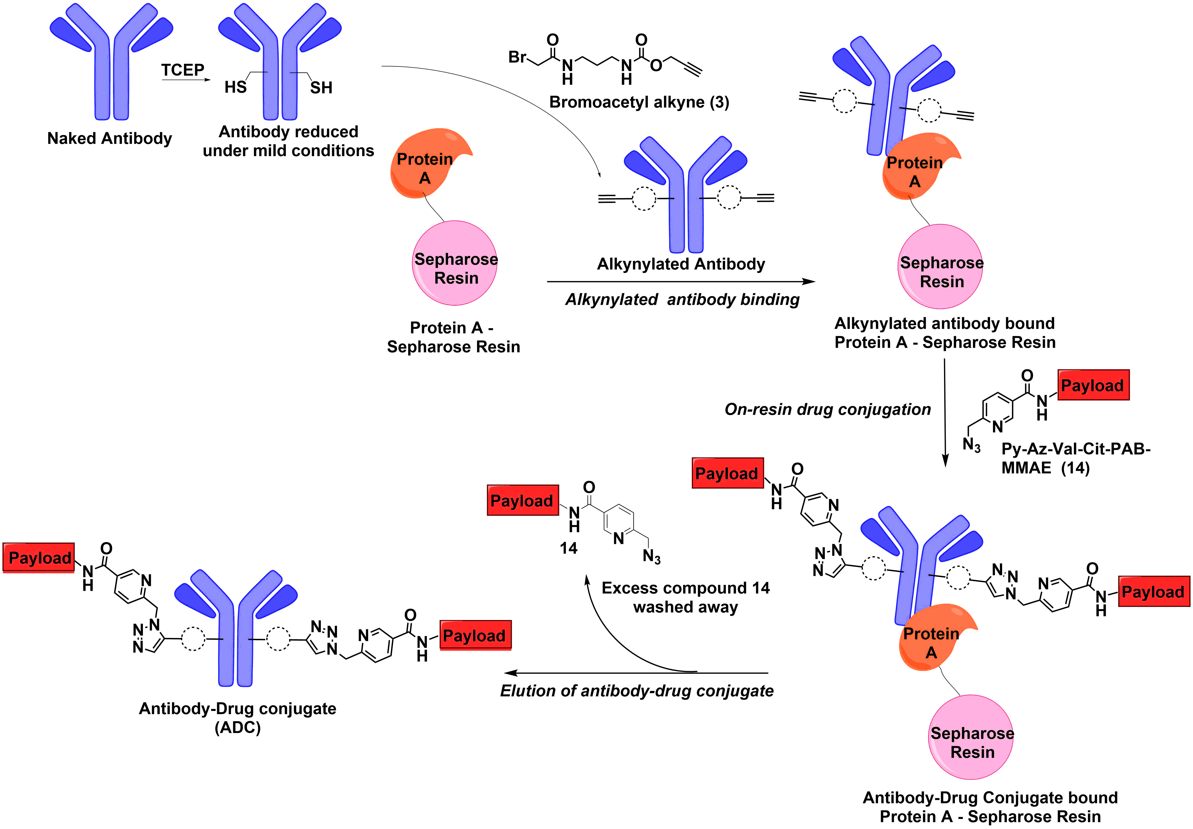
In order to mimic the process of conjugating an alkyne- containing antibody to an azide-containing drug that are present as limiting and excess reactant concentrations, respectively, we continued testing the reaction kinetics of limiting EtCou concentration with excess azidoethylamine concentration under pseudo first order conditions. By fixing the EtCou concentration and varying the azidoethylamine concentration, we observed that the azidoethylamine concentration significantly influenced the reaction kinetics and the determined apparent rate constants were linearly proportional to the azidoethylamine concentrations (Figure 4A). Similarly, we tested the reaction of limiting EtCou concentration with excess concentration of metal-chelating AzPy. Intriguingly, reactions at all AzPy concentrations displayed similar reaction trajectories and all determined k values were very similar (Figure 4B), indicating minimal influence of the azide concentration on the reaction kinetics under these conditions. Although we used substantially higher concentrations of Cu(I) in the EtCou-azidoethylamine reactions than in the EtCou-AzPy reactions, the reaction at the highest azidoethylamine concentration was still much slower than an EtCou-AzPy reaction, indicating that under these conditions a metal-chelating drug azide remains an optimal choice for favorable kinetics. We might also use the alkyne-Cu(I) resting state theory or two parallel alkyne-Cu(I) and azide-Cu(I) chelating processes to explain the observations in Figure 4. When a non-metal-chelating azide is used, the alkyne-Cu(I) chelation is so fast that the kinetic dependence on the azide is observable. However, when a metal-chelating azide is used, the azide-Cu(I) chelation outcompetes the alkyne-Cu(I) chelation so that the reaction kinetics is solely determined by the alkyne-Cu(I) chelation. The implication of the data shown in Figure 4 for ADC generation is obvious. For the reaction between an alkyne-containing antibody and an azide-containing drug to generate ADCs, the most kinetically favorable option is to react an antibody alkyne with a metal-chelating drug azide although changing the drug concentration does not influence the overall kinetics. When a non-metal-chelating drug azide is used, improving the drug concentration will significantly increase the reaction kinetics and one may also achieve more favorable reaction kinetics by changing the azide identity in the drug from a standard alkyl azide to an aromatic azide.
Figure 5. Catch-and-release strategy to synthesize ADCs
Next, we wanted to verify that the conditions used in small molecule kinetics can be translated to generate protein conjugates as well. In order to demonstrate this, we built a model system that allows us to monitor protein conjugation kinetics by FRET analysis. We site-specifically incorporated L-propargyl-lysine (ProcK)²⁸ into superfolder green fluorescent protein (sfGFP) to generate our model protein (sfGFP134ProcK). We synthesized compound (16) which is a metal-chelating azide with coumarin dye moiety. Therefore, chromophore of sfGFP and coumarin dye can form a FRET pair upon conjugation (SI, Figure S12). After our first conjugation attempt with 10 µM CuSO₄ and 20 µM BTTAA, we did not detect a FRET signal. This might be due to the presence of 6xHistag on the sfGFP134ProcK or another metal binding motif. Next, we tried the reaction with 40 µM CuSO₄ and 80 µM BTTAA and the reaction appeared to reach a plateau in 10 minutes (SI, Figure S13). This result showed us that, from a kinetics point of view, it is reasonable to keep the concentration of CuSO₄ around 50 µM when carrying out click reactions with proteins.
Table 1. Relationships of different alkyne-azide combinations for the ADC synthesis
Antibody | Drug | Reaction | Effect of drug concentration on the reaction rate
Non-metal-chelating azide | Alkyne | Slow | Minimal
Metal-chelating azide | Alkyne | Fast | Linear
Alkyne | Non-metal-chelating azide | Slow | Linear
Alkyne | Metal-chelating azide | Fast | Minimal

Based on all of the kinetic observations, we can summarize kinetic features of the CuAAC-based ADC synthesis as shown in Table 1. Given the nature of antibodies, an ADC conjugation procedure that requires a short reaction time and facile purification is optimal. For achieving a short reaction time, a metal-chelating azide either on an antibody or a drug is an apparent choice. When a metal-chelating antibody azide is used, one may also improve the reaction kinetics by increasing the drug alkyne concentration. However, loading a metal-chelating azide onto an antibody either through genetic incorporation or conjugation to antibody thiolates
will require conditions that may reduce the relatively labile azide functionality, leading to heterogeneity in the conjugated ADC. On the contrary, an antibody alkyne is far more stable. A cheaply produced alkyne such as bromoacetyl alkyne (compound 3 in Figure 5) can be rapidly coupled to an antibody by reaction with cysteine thiols. Using a catch-and-release method, exceedingly excessive bromoacetyl alkyne (3) can be added to achieve rapid synthesis of an alkyne-containing antibody and the residual alkyne compound can be quickly washed away. The coupled antibody alkyne can then react with a metal-chelating drug azide for the efficient synthesis of the ADC. Although the independence of the reaction kinetics during these conditions on the drug concentration does not allow the improvement of kinetics by increasing the drug concentration, it does provide a manufacturing benefit. This unique kinetic behavior means that only a minimally excessive metal-chelating azide is required for efficient ADC conjugation. Therefore, substantial manufacturing costs can be reduced with very low amounts of cytotoxic waste. To demonstrate all of these advantages related to reacting an antibody alkyne with a metal-chelating drug azide, we designed a catch-and-release synthetic route as shown in Figure 5.
In our study, we used the HER2 specific antibody, pertuzumab²⁹ as a model antibody. Pertuzumab is a monoclonal antibody used for the treatment of metastatic HER2-positive breast cancer. Wild-type pertuzumab has two disulfide bonds bridging the two heavy chains in the hinge region, and two disulfide bonds bridging each heavy chain hinge region with the two antibody light chains. These disulphides are reducible under mild conditions. To reduce the drug to antibody ratio, we used a mutated version of pertuzumab (pertuzumab-2C) which only has one reducible disulfide bond in the hinge region.³⁰ We first reduced pertuzumab-2C under mild conditions with TCEP then, reacted it with 4 mM bromoacetyl alkyne (3) for 30 mins to load the alkyne group. Next, we incubated the antibody with protein A-Sepharose and for 2 hrs to capture the alkynylated antibody on the resin. We subsequently washed out residual alkyne compound and provided 1.2 eq of AzPy-Payload (Py-Az-Val-Cit-PAB-MMAE, 14) compound per alkynylated cysteine (there are 2 alkynylated cysteines for each antibody molecule) in the antibody (see Experimental Methods section for details). The provided AzPy-payload concentration was deemed to be in excess. Following 2 hrs reaction, we washed out the residual AzPy-payload and eluted the conjugated pertuzumab. The overall preparation time of the ADC is 9 hours. We analyzed the eluted ADC using electrospray ionization mass spectrometry (SI, Figure S17) that showed close to quantitative conversion, demonstrating the high efficiency of this newly designed ADC synthetic route. The addition of the drug molecule to heavy chain was identified by the change in mass and the shift in retention time of the heavy chain. The conditions and chromatogram for the LC-MS analysis can be found in the SI.
- Conclusions
In conclusion, we have kinetically characterized CuAAC-based ADC conjugation processes using small molecule mimics. Our data reveal unique kinetic behaviors when different azide-alkyne combinations are used. During an ADC conjugation setup in which a limiting antibody concentration reacts with an excess drug concentration, our data indicates that a drug alkyne reacts slowly with a non-metal-chelating antibody azide and its concentration has minimal influence on the overall reaction kinetics, however it reacts rapidly with a metal-chelating antibody azide and its concentration is linearly proportional to the reaction rate constant. When a limiting antibody alkyne concentration is reacted with an excess concentration of azide-containing drug, our data implies that it reacts slowly when the drug azide is non-metal-chelating but the drug concentration is linearly proportional to the reaction rate constant. However, its reaction with a metal-chelating drug azide is exceedingly fast but not kinetically related to the drug concentration. Based on these observations, we designed an efficient and cost effective CuAAC-based ADC conjugation method and demonstrated that an ADC can be rapidly synthesized. The CuAAC-based linker is more stable than a traditional cysteine-maleimide linker leading to much lower non-targeted drug release.²⁰ Given the broad applications³¹ of CuAAC in many basic research and technological areas, we believe our kinetic observations will also assist widely in optimizing conditions for these applications.
- Experimental Methods
Organic synthesis procedures, on-protein kinetics, LC-MS data for characterization of ADCs can be found in the Supplementary Information.
4.1 General method for kinetics measurement

Stock solutions for all azide and alkyne compounds were prepared in 100x working concentrations in DMSO. BTTAA stock solutions were 250x the working concentration in DMSO. CuSO₄ stock solutions were 100x the working concentration. 250 mM sodium ascorbate stock solution in water was used in all analysis.
0.15M phosphate buffer, pH 7.0, 25% DMSO is added to the reaction well (or cuvette). Next, BTTAA, CuSO₄ were added successively followed by azide derivative. After that, ascorbate was added and the mixture was incubated for 60 seconds. Finally, alkyne was added to initiate the click reaction. After addition of each reagent, the reaction mixture was gently mixed by pipetting up and down. Unless otherwise stated, a plate reader was used for all measurements. For AzCou excitation at 404 nM and emission at 480 nM was used. For EtCou excitation at 320 nM and emission at 400 nM was used. Data were fit to the equation: I_{t} = I_{o} + I_{c} × (1- exp(-k × t)) where I₀ is the background fluorescent intensity, It the fluorescent intensity at a specified time, I_{c} the fluorescent intensity change when limiting reagent is fully converted to the product, and k the observed apparent rate constant.
Table 2. AzCou with excess alkyne concentrations (except 2-propyn-1-ol where 50 µM CuSO₄, 300 µM BTTAA and 50 µM AzCou, 2.5 mM sodium ascorbate used with 0.25, 0.5, 1, 2, 4 mM 2-propyn-1-ol)

Reagent | Final Concentration
CuSO₄ | 50 µM
BTTAA | 100 µM
AzCou | 10 µM
Sodium ascorbate | 2.5 mM
Alkyne Derivative | 100, 250, 500, 750, 1000 µM

Table 3. CuAAC reaction trajectories between different limiting azide concentrations and excess EtCou concentrations
Reagent | Final Concentration
CuSO₄ | 50 µM
BTTAA | 100 µM
Azide derivative | 20 µM
Sodium ascorbate | 2.5 mM
7-Ethynylcoumarin | 100 µM

Table 4. Limiting AzPy concentration reacted with excess EtCou concentrations (fluorometer was used)
Reagent | Final Concentration
CuSO₄ | 10 µM
BTTAA | 20 µM
AzPy | 5 µM
Sodium ascorbate | 2.5 mM
7-Ethynylcoumarin | 50, 75, 100, 125, 150 µM

Table 5. EtCou reacted with excess AzPy concentrations
Reagent | Final Concentration
CuSO₄ | 10 µM
BTTAA | 20 µM
AzPy | 100, 200, 300, 400, 500 µM
Sodium ascorbate | 2.5 mM
7-Ethynylcoumarin | 20 µM

Table 6. EtCou reacted with excess azidoethylamine concentrations
Reagent | Final Concentration
CuSO₄ | 10 µM
BTTAA | 20 µM
2-azidoethylamine | 100, 200, 300, 400, 500 µM
Sodium ascorbate | 2.5 mM
7-Ethynylcoumarin | 20 µM

4.2 Catch-and-release method

The pertuzumab antibody used in this study (Per-2C) has 2 reducible cysteines in its hinge region.³⁰
First, 100 µL 27 µM of Per-2C in PBS buffer was reduced by 200 µM TCEP at 37ºC for 2 hrs. Then, bromoacetyl alkyne compound (3) (400 mM stock solution in DMSO) was added to the solution at a final concentration of 4 mM. The reaction was incubated at room temperature for 30 minutes. Next, 100 µL Protein A-Sepharose resin slurry in PBS was added to this reaction mixture. The mixture was incubated on a shaker at room temperature for 2 hours.
After that, an empty spin column was used for the washing step. After initial centrifugation, 300 µL PBS were added to the slurry and the resin washed 5 times with 300 µL PBS. All the centrifugations were carried out at 1000g for 1 min at room temperature.
After the final centrifugation step, the total slurry volume was brought to 100 µL.

Table 7. The 2x click reaction mixture (200 μL reaction mix)
2 x Click Reaction mixture
172 µL PBS
16.7 µL DMSO
1.6 µL BTTAA (25 mM stock solution in DMSO)
4 µL Cu(II)SO₄ (5mM stock solution in sterile water)
1.3 µL azide (10 mM stock solution in DMSO)
4 µL sodium ascorbate (250 mM stock solution in sterile water)

The above mixture (2x click reaction mixture) was prepared in the given order and incubated for 1 min after sodium ascorbate addition. Next, 100 µL of the above solution was added to 100 µL resin suspension. The tube was covered in aluminum foil and placed on a shaker at room temperature for 2 hours.
Next, the slurry was added to a spin column for the final washing. After initial centrifugation, the resin was washed with 3 x 300 µL PBS containing 1mM EDTA. For the fourth and fifth washes, 1 mM phosphate buffer, pH 7.4, with 150 mM NaCl used reduce the trace amounts of phosphate in the slurry.
ADC was eluted from protein A-Sepharose using cidic 0.1M glycine, 150 mM NaCl, pH 2.8 buffer for ~30 seconds with gentle shaking.
Three sequential elutions (90 µL each) were carried out to elute the ADCs. Each 90 µL eluent was neutralized immediately by adding 15 µL 2M Tris, 150 mM NaCl, pH 8.0.
The three eluates were combined and EDTA added to a final concentration of 1 mM, followed by dialysis against PBS. The ADCs were characterized by LC-MS (SI, Figure S16, S17).
Acknowledgments
This work was supported in part by Cancer Prevention and Research Institute of Texas (grants RP170797, RP140141) and Welch Foundation (grant A-1715). We thank Sunshine Z. Leeuwon for proofreading the manuscript.
References
1. Lambert, J. M.; Berkenblit, A., Antibody-Drug Conjugates for Cancer Treatment. Annu Rev Med 2018, 69, 191-207.
2. clinicaltrials.gov, US National Library of Medicine. 2020.
3. Khongorzul, P.; Ling, C. J.; Khan, F. U.; Ihsan, A. U.; Zhang, J., Antibody-Drug Conjugates: A Comprehensive Review. Mol Cancer Res 2020, 18 (1), 3-19.
4. Leung, D.; Wurst, J. M.; Liu, T.; Martinez, R. M.; Datta-Mannan, A.; Feng, Y. Q., Antibody Conjugates-Recent Advances and Future Innovations. Antibodies 2020, 9 (1).
5. Birrer, M. J.; Moore, K. N.; Betella, I.; Bates, R. C., Antibody-Drug Conjugate-Based Therapeutics: State of the Science. Jnci-J Natl Cancer I 2019, 111 (6), 538-549.
6. Saito, F.; Noda, H.; Bode, J. W., Critical evaluation and rate constants of chemoselective ligation reactions for stoichiometric conjugations in water. ACS Chem Biol 2015, 10 (4), 1026-33.
7. Sharpless, N. E.; Flavin, M., The reactions of amines and amino acids with maleimides. Structure of the reaction products deduced from infrared and nuclear magnetic resonance spectroscopy. Biochemistry 1966, 5 (9), 2963-71.
8. Ponte, J. F.; Sun, X. X.; Yoder, N. C.; Fishkin, N.; Laleau, R.; Coccia, J.; Lanieri, L.; Bogalhas, M.; Wang, L. T.; Wilhelm, S.; Widdison, W.; Pinkas, J.; Keating, T. A.; Chari, R.; Erickson, H. K.; Lambert, J. M., Understanding How the Stability of the Thiol-Maleimide Linkage Impacts the Pharmacokinetics of Lysine-Linked Antibody-Maytansinoid Conjugates. Bioconjugate Chem 2016, 27 (7), 1588-1598.
9. Lyon, R. P.; Setter, J. R.; Bovee, T. D.; Doronina, S. O.; Hunter, J. H.; Anderson, M. E.; Balasubramanian, C. L.; Duniho, S. M.; Leiske, C. I.; Li, F.; Senter, P. D., Self-hydrolyzing maleimides improve the stability and pharmacological properties of antibody-drug conjugates. Nat Biotechnol 2014, 32 (10), 1059-+.
10. Schumacher, F. F.; Nunes, J. P. M.; Maruani, A.; Chudasama, V.; Smith, M. E. B.; Chester, K. A.; Baker, J. R.; Caddick, S., Next generation maleimides enable the controlled assembly of antibody-drug conjugates via native disulfide bond bridging. Org Biomol Chem 2014, 12 (37), 7261-7269.
11. Badescu, G.; Bryant, P.; Bird, M.; Henseleit, K.; Swierkosz, J.; Parekh, V.; Tommasi, R.; Pawlisz, E.; Jurlewicz, K.; Farys, M.; Camper, N.; Sheng, X. B.; Fisher, M.; Grygorash, R.; Kyle, A.; Abhilash, A.; Frigerio, M.; Edwards, J.; Godwin, A., Bridging Disulfides for Stable and Defined Antibody Drug Conjugates. Bioconjugate Chem 2014, 25 (6), 1124-1136.
12. Drake, P. M.; Albers, A. E.; Baker, J.; Banas, S.; Barfield, R. M.; Bhat, A. S.; de Hart, G. W.; Garofalo, A. W.; Holder, P.; Jones, L. C.; Kudirka, R.; McFarland, J.; Zmolek, W.; Rabuka, D., Aldehyde Tag Coupled with HIPS Chemistry Enables the Production of ADCs Conjugated Site-Specifically to Different Antibody Regions with Distinct in Vivo Efficacy and PK Outcomes. Bioconjugate Chem 2014, 25 (7), 1331-1341.
13. Kularatne, S. A.; Deshmukh, V.; Ma, J.; Tardif, V.; Lim, R. K. V.; Pugh, H. M.; Sun, Y.; Manibusan, A.; Sellers, A. J.; Barnett, R. S.; Srinagesh, S.; Forsyth, J. S.; Hassenpflug, W.; Tian, F.; Javahishvili, T.; Felding-Habermann, B.; Lawson, B. R.; Kazane, S. A.; Schultz, P. G., A CXCR4-Targeted Site-Specific Antibody-Drug Conjugate. Angew Chem Int Edit 2014, 53 (44), 11863-11867.
14. Maruani, A.; Smith, M. E. B.; Miranda, E.; Chester, K. A.; Chudasama, V.; Caddick, S., A plug-and-play approach to antibody-based therapeutics via a chemoselective dual click strategy. Nat Commun 2015, 6.
15. Ohata, J.; Ball, Z. T., A Hexa-rhodium Metallopeptide Catalyst for Site-Specific Functionalization of Natural Antibodies. J Am Chem Soc 2017, 139 (36), 12617-12622.
16. Oller-Salvia, B.; Kym, G.; Chin, J. W., Rapid and Efficient Generation of Stable Antibody-Drug Conjugates via an Encoded Cyclopropene and an Inverse-Electron-Demand Diels-Alder Reaction. Angew Chem Int Edit 2018, 57 (11), 2831-2834.
17. Vinogradova, E. V.; Zhang, C.; Spokoyny, A. M.; Pentelute, B. L.; Buchwald, S. L., Organometallic palladium reagents for cysteine bioconjugation. Nature 2015, 526 (7575), 687-691.
18. Yamada, K.; Ito, Y., Recent Chemical Approaches for Site-Specific Conjugation of Native Antibodies: Technologies toward Next-Generation Antibody-Drug Conjugates. Chembiochem 2019, 20 (21), 2729-2737.
19. Zimmerman, E. S.; Heibeck, T. H.; Gill, A.; Li, X. F.; Murray, C. J.; Madlansacay, M. R.; Tran, C.; Uter, N. T.; Yin, G.; Rivers, P. J.; Yam, A. Y.; Wang, W. D.; Steiner, A. R.; Bajad, S. U.; Penta, K.; Yang, W. J.; Hallam, T. J.; Thanos, C. D.; Sato, A. K., Production of Site-Specific Antibody-Drug Conjugates Using Optimized Non-Natural Amino Acids in a Cell-Free Expression System. Bioconjugate Chem 2014, 25 (2), 351-361.
20. VanBrunt, M. P.; Shanebeck, K.; Caldwell, Z.; Johnson, J.; Thompson, P.; Martin, T.; Dong, H. F.; Li, G. R.; Xu, H. Y.; D'Hooge, F.; Masterson, L.; Bariola, P.; Tiberghien, A.; Ezeadi, E.; Williams, D. G.; Hartley, J. A.; Howard, P. W.; Grabstein, K. H.; Bowen, M. K.; Marelli, M., Genetically Encoded Azide Containing Amino Acid in Mammalian Cells Enables Site-Specific Antibody-Drug Conjugates Using Click Cycloaddition Chemistry. Bioconjugate Chem 2015, 26 (11), 2249-2260.
21. Hong, V.; Presolski, S. I.; Ma, C.; Finn, M. G., Analysis and Optimization of Copper-Catalyzed Azide-Alkyne Cycloaddition for Bioconjugation. Angew Chem Int Edit 2009, 48 (52), 9879-9883.
22. Wang, Q.; Chan, T. R.; Hilgraf, R.; Fokin, V. V.; Sharpless, K. B.; Finn, M. G., Bioconjugation by copper(I)-catalyzed azide-alkyne [3+2] cycloaddition. J Am Chem Soc 2003, 125 (11), 3192-3193.
23. Besanceney-Webler, C.; Jiang, H.; Zheng, T. Q.; Feng, L.; del Amo, D. S.; Wang, W.; Klivansky, L. M.; Marlow, F. L.; Liu, Y.; Wu, P., Increasing the Efficacy of Bioorthogonal Click Reactions for Bioconjugation: A Comparative Study. Angew Chem Int Edit 2011, 50 (35), 8051-8056.
24. del Amo, D. S.; Wang, W.; Jiang, H.; Besanceney, C.; Yan, A. C.; Levy, M.; Liu, Y.; Marlow, F. L.; Wu, P., Biocompatible Copper(I) Catalysts for in Vivo Imaging of Glycans. J Am Chem Soc 2010, 132 (47), 16893-16899.
25. Rodionov, V. O.; Fokin, V. V.; Finn, M. G., Mechanism of the ligand-free CuI-catalyzed azide-alkyne cycloaddition reaction. Angew Chem Int Ed Engl 2005, 44 (15), 2210-5.
26. Penoni, A.; Palmisano, G.; Zhao, Y. L.; Houk, K. N.; Volkman, J.; Nicholas, K. M., On the Mechanism of Nitrosoarene-Alkyne Cycloaddition. J Am Chem Soc 2009, 131 (2), 653-661.
27. Uttamapinant, C.; Tangpeerachaikul, A.; Grecian, S.; Clarke, S.; Singh, U.; Slade, P.; Gee, K. R.; Ting, A. Y., Fast, Cell-Compatible Click Chemistry with Copper-Chelating Azides for Biomolecular Labeling. Angew Chem Int Edit 2012, 51 (24), 5852-5856.
28. Nguyen, D. P.; Lusic, H.; Neumann, H.; Kapadnis, P. B.; Deiters, A.; Chin, J. W., Genetic Encoding and Labeling of Aliphatic Azides and Alkynes in Recombinant Proteins via a Pyrrolysyl-tRNA Synthetase/tRNA(CUA) Pair and Click Chemistry. J Am Chem Soc 2009, 131 (25), 8720-+
29. Franklin, M. C.; Carey, K. D.; Vajdos, F. F.; Leahy, D. J.; de Vos, A. M.; Sliwkowski, M. X., Insights into ErbB signaling from the structure of the ErbB2-pertuzumab complex. Cancer Cell 2004, 5 (4), 317-328.
30. Kang, J. C.; Sun, W.; Khare, P.; Karimi, M.; Wang, X. L.; Shen, Y.; Ober, R. J.; Ward, E. S., Engineering a HER2-specific antibody-drug conjugate to increase lysosomal delivery and therapeutic efficacy. Nat Biotechnol 2019, 37 (5), 523-+.
31. Jiang, X. Y.; Hao, X.; Jing, L. L.; Wu, G. C.; Kang, D. W.; Liu, X. Y.; Zhan, P., Recent applications of click chemistry in drug discovery. Expert Opin Drug Dis 2019, 14 (8), 779-789.
Supplementary Material
Supplementary material is available.

