Impact of timing of adjuvant chemotherapy following radical cystectomy for bladder cancer on patient survival
Camilla M. Grunewaldª*, Alina Henn^{b}*, Matthew D. Galsky^{c}, Elizabeth R. Plimack^{d}, Lauren C. Harshman^{e}, Evan Y. Yu^{f}, Simon J. Crabb^{g}, Sumanta K. Pal^{h}, Ajjai Shivaram Alva^{i}, Thomas Powles^{j}, Ugo De Giorgi^{k}, Neeraj Agarwal^{l}, Aristotelis Bamias^{m}, Sylvain Ladoire^{n}, Andrea Necchiº, Ulka N. Vaishampayan^{p}, Cora N. Sternberg^{q}, Joaquim Bellmunt^{r}, Jack Baniel^{s}, Guenter Niegischª
*equally contributed

ª Department of Urology, Medical Faculty, Heinrich-Heine-University, Düsseldorf, Germany
^{b} Genetikum, Stuttgart, Germany
^{c} Department of Medicine, Icahn School of Medicine at Mount Sinai, Tisch Cancer Institute, New York, NY
^{d} Fox Chase Cancer Center, Philadelphia, PA
^{e} Lank Center for Genitourinary Oncology, Dana-Farber Cancer Institute, Boston, MA
^{f} University of Washington, Seattle, WA
^{g} Southampton Clinical Trials Unit, University of Southampton, Southampton, United Kingdom
^{h} City of Hope National Medical Center, Duarte, CA
^{i} University of Michigan, Ann Arbor, MI
^{j} Barts Cancer Institute, Queen Mary University of London, Royal Free NHS Trust, London, United Kingdom
^{k} Istituto Scientifico Romagnolo per lo Studio e la Cura dei Tumori (IRST) IRCCS, Meldola, Italy
^{l} Huntsman Cancer Institute, University of Utah, Salt Lake City, UT
^{m}Haematology-Oncology Unit, Department of Clinical Therapeutics, Alexandra Hospital, National and Kapodistrian University of Athens, Athens, Greece
^{n} Department of Medical Oncology, Center GF Leclerc, Dijon, France
º Fondazione IRCCS Istituto Nazionale dei Tumori, Milan, Italy
^{p} Wayne State University, Detroit, MI
^{q} Englander Institute of Precision Medicine, Weill Cornell Medicine, New York, NY
^{r} IMIM-Hospital del Mar Medical Research Institute, Barcelona, Spain
^{s} Rabin Medical Center, Petach Tikva, Israel

Word count: 3206
Corresponding author:
Dr. med. C. Grunewald
Department of Urology, Medical Faculty
Heinrich-Heine-University
Moorenstraße 5
40225 Duesseldorf
tel.: +49 211/81-18110
e-mail: camillamarisa.grunewald@med.uni-duesseldorf.de

Summary
Background: Trials of adjuvant chemotherapy following radical cystectomy generally require chemotherapy to start within 90 days postoperatively. However, it is unclear, whether the interval between surgery and start of adjuvant therapy (S-AC-interval) impacts the oncological outcome. Methods: Using the Retrospective International Study of Invasive/Advanced Cancer of the Urothelium (RISC) data base, we identified patients who underwent radical cystectomy for muscle invasive bladder cancer and subsequent adjuvant chemotherapy. Univariate analysis of patient characteristics, surgical factors and tumor characteristics regarding their impact on S-AC-interval was performed using Kruskal-Wallis testing and Fisher’s exact test. Uni- and multivariate analysis of progression-free and overall survival (starting from day 1 of adjuvant chemotherapy) was analyzed in relation to S-AC-interval (continuous and dichotomous with a cut-off at 90 days) using Kaplan-Meier method and COX regression analysis. Results: We identified 238 eligible patients (83.5% male, mean age: 63.4 years, 76.1% T3/T4, 66.4% pN+, 14.7% R+, 70.6% urothelial carcinoma, 71% cisplatin-based adjuvant chemotherapy). Median S-AC-interval was 57 days (IQR 32.8). S-AC-interval did not have consistent association with any patient/tumor characteristics or surgery related factors (type of surgery, urinary diversion). Survival analysis using continuous S-AC-interval revealed a trend towards an impact of S-AC-interval on OS (HR 1.004, 95% CI 0.9997-1.0084, p=.071). With regards to PFS, that impact was shown to be statistically significant (HR: 1.004, 95% CI: 1.0003-1.0075, p=.032). In multivariate analysis, however, S-AC-interval was negated by tumor and patient related factors (pathological T-stage, N-stage, ECOG performance status). Accounting for eligibility criteria defined in some clinical trials, we extended our analysis dividing S-AC-interval in ≤ 90 and > 90 days. Although we could confirm the trend towards better outcome in patients with a shorter S-AC interval in dichotomous analysis, neither differences in OS nor in PFS reached statistical significance (p=.438 and p=.056). Conclusions: Our data supports that adjuvant chemotherapy should generally be applied when clinically reasonable rather than at a fixed time point. There seems to be an advantage for adjuvant chemotherapy to be applied within a certain time frame without being able to define a precise cut-off. Regarding prognosis, tumor related pathological factors abrogated the importance of the S-AC-interval in our analysis.

Word count: 353
Keywords muscle invasive bladder cancer, adjuvant chemotherapy, RISC data base, locally advanced bladder cancer

- Introduction
Several phase III trials on Cisplatin-based neoadjuvant chemotherapy (NAC) have been shown to improve overall survival (OS) of patients undergoing radical cystectomy for advanced urothelial carcinoma [1-4]. For those patients who undergo primary surgery without prior NAC, there is supportive data for the use of adjuvant chemotherapy (AC) [5-8]. A major concern regarding AC following radical cystectomy, however, may be delayed delivery of chemotherapy due to perioperative complications and/or prolonged convalescence. Up to 60% of patients undergo complications following radical cystectomy including a considerable risk of high-grade complications (13–40%) [9-12]. Complication rates depending on type of surgery (open vs. robotic/laparoscopic) are comparable [13-15]. Most trials investigating AC following radical cystectomy defined a time-frame of about 3 months postoperatively for patients to be eligible. However, this time-frame is chosen rather arbitrarily than based on a biological context determining the “optimal” time-point for an adjuvant chemotherapy. In this context, we sought to evaluate the interval length between surgery and start of adjuvant chemotherapy in a “real-world” cohort. We evaluated surgery-dependent (e.g. diversion type) and surgery-independent factors (age, comorbidities, tumor-stage) which have an impact on timing of adjuvant chemotherapy. Our intention was to elucidate the impact of timing of adjuvant chemotherapy on patients´ outcome.

- Patients and Methods
2.1 Data acquisition
The Retrospective International Study of Cancers of the Urothelial Tract (RISC) is a retrospective database which was created to collect management and outcomes data on patients with urothelial carcinoma (cT2 or greater). RISC consists of consecutive patient series from 28 international centers compiled between 2005 and 2012. Patient baseline characteristics, laboratory and pathology information as well as treatment outcomes were collected. The RISC database was approved by the ethics committees at each participating institution and the design of this study was approved by the RISC consortium.
For the current analysis, patients with adjuvant systemic therapy following surgical resection of the primary tumor (muscle invasive bladder cancer (MIBC) of any histology, any pN, M0) with curative intent were included. Patients with prior neoadjuvant therapy were excluded, as well as those who received adjuvant therapy after more than 1 year from surgery.

2.2 Endpoints
The primary endpoint of this study was to determine the impact of the interval between surgery and start of adjuvant therapy (S-AC-interval) on progression-free (PFS) and overall survival (OS). Additional key secondary endpoints included the interval length between surgery and start of adjuvant chemotherapy according to surgery-dependent (e.g. diversion type) and surgery-independent factors (age, comorbidities, tumor-stage) which may impact timing of adjuvant chemotherapy.

2.3 Statistical analysis
Univariate analysis of patient characteristics, surgical factors and tumor characteristics regarding their impact on S-AC-interval was performed. S-AC-interval was assessed both continuously and dichotomously. For continuous analysis, we used Kruskal-Wallis testing. For dichotomous analysis, S-AC-interval was divided into ≤ 90 and > 90 days and Fisher’s exact test was performed.
Uni- and multivariate analyses of PFS and OS were performed in relation to S-AC-interval, patient characteristics, surgical factors and tumor characteristics. For this purpose, PFS and OS were assessed with S-AC-interval as a continuous variable as well as a dichotomous variable with a cut-off at 90 days. PFS and OS were calculated with 95% confidence intervals from day 1 of adjuvant therapy. Survival analysis was performed using Kaplan-Meier method and COX regression analysis, comparison between survival curves was performed using the log rank test.

As for multivariate analysis only patients with complete documented datasets for all examined variables can be included, our analysis was hampered due to missing data values. Depending on the chosen multivariate model a varying number of patients was either in- or excluded. For this reason, for variables with n ≥ 10 missing values (more than 4%), a separate factor level called “unknown” was incorporated in the analysis. The analysis was then done consistently with a number of 228 patients.

- Results

3.1 Patient selection
From 2005 to 2012 a total of 3024 patients with muscle invasive bladder cancer (MIBC) or upper urinary tract carcinoma (UTUC) were included in the RISC database. Of those, 355 patients underwent adjuvant systemic therapy without prior neoadjuvant therapy within 1 year following surgical resection of primary tumor (nephroureterectomy, nephrectomy, ureterectomy, radical cystectomy, urethrectomy) with curative intent. Of these, patients were excluded due to missing surgery date (n=20), missing start date of adjuvant chemotherapy (n=34), missing data on adjuvant chemotherapy (n=14), and primary upper tract disease (n=49). After these exclusions, 238 patients with MIBC were eligible for analysis. (Figure 1).

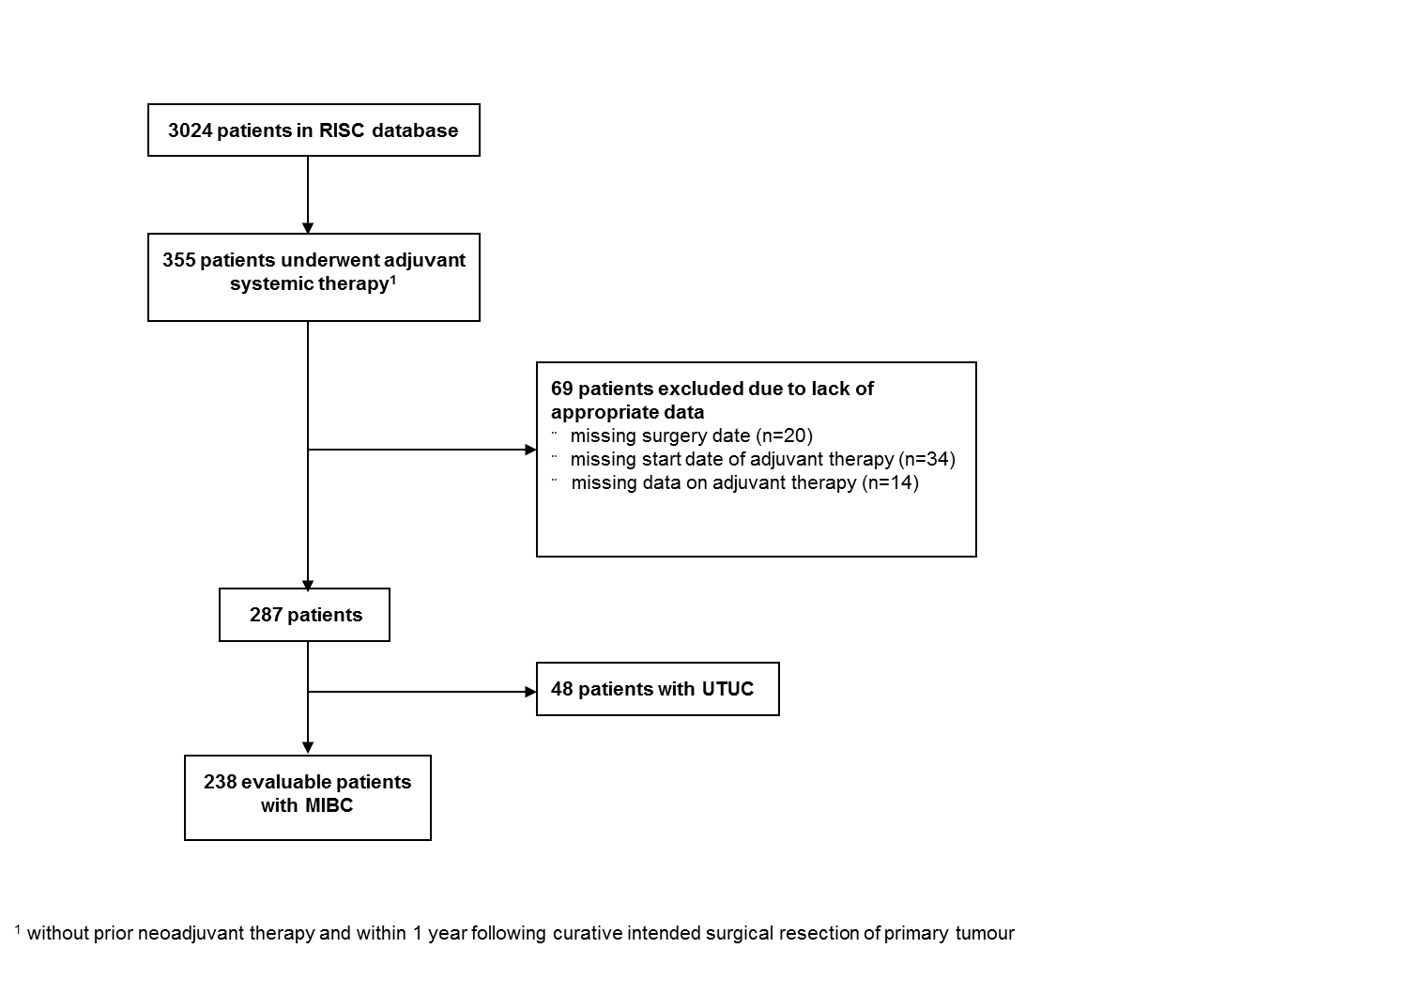
Figure 1: Consort diagram showing patients selected from the RISC database. MIBC, Muscle invasive bladder cancer. UTUC, Upper urinary tract carcinoma.

3.2 Patient characteristics
Patient characteristics are detailed in Table 1. For MIBC, 83.5% of the population was male with a mean age of 63.4 years (SD 9.5 years). More than 70% of patients presented with a Charlson Comorbidity Index (CCI) of ≤ 2 and an ECOG performance Status (ECOG) of ≤ 1. The majority of patients were smokers or former smokers (65.1%). 181 patients (76.1%) were diagnosed with ≥ pT3 with 158 patients (66.4%) presenting nodal disease and 35 patients (14.7%) with positive margins. Predominant histology was urothelial carcinoma (n=168, 70.6%). Other histology mainly consisting of mixed histology (i.e. urothelial with other features) was observed in 23.1% of patients (n=55) with missing histologic data in 15 patients (6.3%). Cisplatin-based adjuvant chemotherapy was administered in 71% (n=169) with the majority of patients receiving up to 4 cycles of adjuvant chemotherapy (median 4, IQR 1).
The median S-AC-interval was 57 days (IQR 32.8). The majority of patients started chemotherapy within 90 days (n=207, 87%) after surgery. The distribution of S-AC-interval is presented in Figure 2.

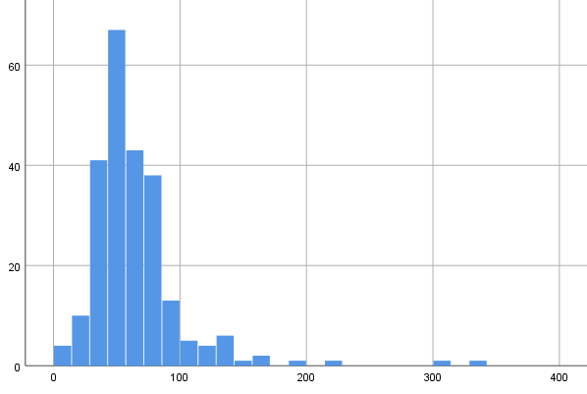
Number of Patients
S-AC-Interval (days)

Figure 2: Distribution of S-AC-interval for patients with muscle invasive bladder cancer.

3.3. Factors associated with timing of adjuvant chemotherapy
When considering S-AC-interval continuously, univariable analysis revealed CCI, smoking history, surgery and diversion type to have a significant impact on timing of adjuvant chemotherapy (p=.042, p=.037, p=.001 and p.003 respectively) (Table 1). However, for CCI and diversion type, analysis should be considered with caution as the statistically significant difference was only seen for the factor level “unknown” compared to all other factor levels (see section 2.3 for further information).
 | Number of patients (%) | S-AC-Interval in days |  | p - value
 |  | Mean | SD
Total | 238 (100) | 65.3 | 38.2
Sex |  |  |  | 0.584
Male | 197 (83.5) | 64.5 | 35.6
Female | 39 (16.5) | 63.2 | 25.9
Missing | 2 | n.a. | n.a.
Age |  |  |  | 0.182
< 65 | 123 (52.1) | 68.5 | 44.3
≥ 65 | 113 (47.9) | 61.9 | 30.2
Missing | 2 | n.a. | n.a.
Charlson Comorbidity Index |  |  |  | 0.042*
0 = no comorbidities | 95 (39.9) | 63.5 | 47.1
1-2 = mild comorbidities | 77 (32.4) | 64.3 | 27.9
≥3 = moderate to severe comorbidities | 46 (19.3) | 66.7 | 36.9
Unknown | 20 (8.4) | 73.8 | 27.8
ECOG Performance Status |  |  |  | 0.197
0 = Fully active | 111 (46.6) | 62.4 | 34.5
1 = Ambulatory strenuous activity restricted | 67 (28.2) | 62.4 | 29.3
2 = Can walk and take care of self; up >50% day | 11 (4.6) | 52.3 | 18.5
Unknown | 49 (20.6) | 78.7 | 54.5
Smoking History |  |  |  | 0.037
Current | 60 (25.2) | 59.3 | 25.5
Former | 95 (39.9) | 68.1 | 35.0
Never | 57 (23.9) | 61.0 | 46.9
Unknown | 26 (10.9) | 77.8 | 49.4
AC Regimen |  |  |  | 0.239
Gem + Cis | 131 (55) | 65.8 | 41.2
Gem + Carbo | 44 (18.5) | 73.8 | 42.5
MVAC | 38 (16.0) | 56.9 | 16.5
Other | 25 (10.5) | 60.3 | 35.7
Number of cycles |  |  |  | 0.505
≤ 2 | 34 (14.3) | 73.5 | 56.5
3-4 | 138 (58) | 63.6 | 25.9
> 4 | 52 (21.8) | 61.5 | 44.5
Unknown | 14 (5.9) | 75.2 | 57.0
pT |  |  |  | 0.676
< T2 | 6 (2.5) | 52.5 | 36.8
T2 | 41 (17.2) | 62.0 | 30.1
T3 | 121 (50.8) | 64.2 | 27.3
T4 | 60 (25.2) | 65.5 | 45.3
Unknown | 10 (4.2) | 97.2 | 94.4
pN |  |  |  | 0.412
0 | 56 (23.5) | 59.9 | 23.8
+ | 158 (66.4) | 65.8 | 36.1
x | 12 (5.0) | 60.2 | 39.2
Unknown | 12 (5.0) | 87.9 | 88.1
Histology |  |  |  | 0.774
Transitional Cell Carcinoma | 168 (70.6) | 66.0 | 40.1
Mixed/Other | 55 (23.1) | 61.9 | 27.5
Unknown | 15 (6.3) | 69.5 | 50.3
Surgical Margins |  |  |  | 0.225
Negative | 172 (72.3) | 66.4 | 39.4
Positive | 35 (14.7) | 63.5 | 28.3
Unknown | 31 (13) | 60.7 | 41.7
Surgery Type |  |  |  | 0.001
Open radical cystectomy | 194 (82.6) | 67.1 | 39.8
Laparoscopic cystectomy | 12 (5.1) | 73.4 | 21.3
Robotic cystectomy | 17 (7.2) | 63.2 | 33.9
Partial cystectomy | 12 (5.1) | 39.7 | 14.7
Missing | 3 | n.a. | n.a.
Diversion Type |  |  |  | 0.003*
Ileal conduit | 134 (56.3) | 63.6 | 28.5
Neobladder | 63 (26.5) | 70.7 | 44.6
Other | 9 (3.8) | 77.2 | 28.6
Unknown | 32 (13.4) | 58.4 | 57.5
Table 1: Patient characteristics according to S-AC-interval for patients with muscle invasive bladder cancer. * p<.05 due to inclusion of factor level “unknown”

Accounting for the cut-off value of 90 days used in several studies analyzing adjuvant treatment in bladder cancer, correlation between the independent variables and the dependent variable (S-AC-interval) was further investigated by dividing S-AC-interval into previously defined categories (≤ 90 and > 90 days) thereby extending the exploratory investigation to test the independence by performing the Fisher’s Exact Test with simulated p-value (based on 2000 replicates). In univariable analysis, ECOG performance status, smoking history and AC regimen showed a significant impact on S-AC-interval (p=.002, p=.005 and p<.001 respectively). However, again, when considering the impact of missing values, only AC regimen remained statistically significant (Table 2). Due to a rather unstable data set it was not possible to build an appropriate multivariate model for neither of both analyses.

 | S-AC-Interval in days |  | p - value
 | ≤ 90 | > 90
Total (%) | n= 207 | n= 31
Gender |  |  | 0.600
Male | 173 (84) | 24 (80)
Female | 33 (16.0) | 6 (20)
Missing | 1 | 1
Age |  |  | 1.000
< 65 | 107 (52.2) | 16 (51.6)
≥ 65 | 98 (47.8) | 15 (48.4)
Missing | 2 | 0
Charlson Comorbidity Index |  |  | 0.734
0 | 84 (40.6) | 11 (35.5)
1-2 | 67 (32.4) | 10 (32.3)
≥3 | 40 (19.3) | 6 (19.4)
Unknown | 16 (7.7) | 4 (12.8)
ECOG Performance Status |  |  | 0.002*
0 = Fully active | 101 (48.8) | 10 (32.3)
1 = Ambulatory strenuous activity restricted | 61 (29.5) | 6 (19.4)
2 = Can walk and take care of self; up >50% day | 11 (5.3) | 0 (0.0)
Unknown | 34 (16.4) | 15 (48.4)
Smoking History |  |  | 0.005*
Current | 57 (27.5) | 3 (9.7)
Former | 82 (39.6) | 13 (41.9)
Never | 51 (24.6) | 6 (19.4)
Unknown | 17 (8.3) | 9 (29.0)
AC Regimen |  |  | < 0.001
Gem + Cis | 116 (56.0) | 15 (48.4)
Gem + Carbo | 31 (15.0) | 13 (41.9)
MVAC | 38 (18.4) | 0 (0.0)
Other | 22 (10.6) | 3 (9.7)
Number of cycles |  |  | 0.138
≤ 2 | 28 (13.5) | 6 (19.4)
3-4 | 121 (58.5) | 17 (54.8)
> 4 | 48 (23.2) | 4 (12.9)
Unknown | 10 (4.8) | 4 (12.9)
pT |  |  | 0.215
< T2 | 4 (1.9) | 2 (6.5)
T2 | 36 (17.4) | 5 (16.1)
T3 | 108 (52.2) | 13 (41.9)
T4 | 52 (25.1) | 8 (25.8)
Unknown | 7 (3.4) | 3 (9.7)
pN |  |  | 0.107
0 | 53 (25.6) | 3 (9.7)
+ | 135 (65.2) | 23 (74.2)
x | 10 (4.8) | 2 (6.5)
Unknown | 9 (4.4) | 3 (9.6)
Histology |  |  | 0.558
Transitional Cell Carcinoma | 146 (70.5) | 22 (71.0)
Mixed/Other | 49 (23.7) | 6 (19.4)
Unknown | 12 (5.8) | 3 (9.6)
Surgical Margins |  |  | 0.749
Negative | 151 (72.9) | 21 (67.7)
Positive | 30 (14.5) | 5 (16.1)
Unknown | 26 (12.6) | 5 (16.1)
Surgery Type |  |  | 0.081
Open radical cystectomy | 170 (83.3) | 24 (77.4)
Laparoscopic cystectomy | 8 (3.9) | 4 (12.9)
Robotic cystectomy | 14 (6.9) | 3 (9.7)
Partial cystectomy | 12 (5.9) | 0 (0)
Missing | 3 | 0
Diversion Type |  |  | 0.489
Ileal conduit | 116 (56.0) | 18 (58.1)
Neobladder | 54 (26.1) | 9 (29.0)
Other | 7 (3.4) | 2 (6.5)
Unknown | 30 (14.5) | 2 (6.5)
Table 2: Patient characteristics according to S-AC-interval ≤ 90 and > 90 days for patients with muscle invasive bladder cancer.* p<.05 due to inclusion of factor level “unknown”

3.4 Timing of adjuvant chemotherapy and survival
When S-AC-interval was analyzed as a continuous variable, it correlated with OS (HR 1.004, 95% CI 0.9997-1.0084, p=.071). With regards to PFS, a shorter S-AC-interval correlated with a statistically longer PFS (HR: 1.004, 95% CI: 1.0003-1.0075, p=.032). However, when analyzed by different multivariate models, the impact of S-AC-interval on PFS was negated by tumor and patient related factors (pathological T-stage, N-stage, ECOG performance status).
On binary analysis, median OS in patients with an S-AC-interval of ≤ 90 days compared to patients with an S-AC-interval of > 90 days was 73 months (95% CI 45-87) vs 48 months (95% CI 15-n.a.), respectively but was not statistically significant (HR 1.285, 95% CI .682-2.418, p=.438). Median PFS with an S-AC-interval of ≤ 90 days was 35 months (95% CI 27-50) vs 24 months (95% CI 8-48) in patients with an S-AC-interval of > 90 days (Figure 3). PFS in patients starting AC earlier failed to reach statistical significance in dichotomous analysis. (HR 1.591, 95% CI .988-2.561, p=.056).

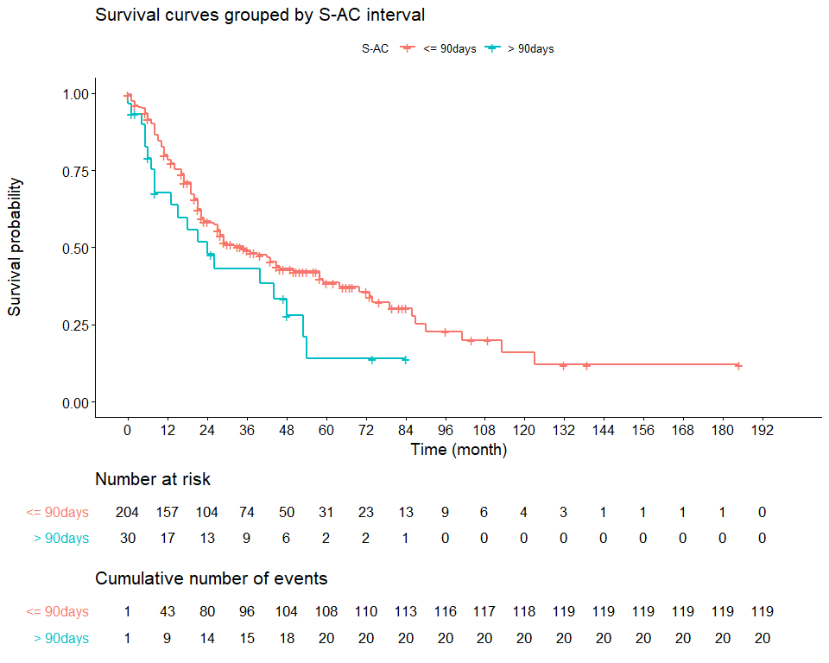
HR 1.591, 95% CI .988-2.561, p=.056
Figure 3: Progression-free survival of patients with S-AC-interval of ≤ 90 days (blue) compared to patients with S-AC-interval of > 90 days (red) for patients with muscle invasive bladder cancer.

- Discussion
Neoadjuvant cisplatin-based chemotherapy (NAC) is the gold standard in patients when eligible [1-4]. However, in patients, who undergo primary surgery without NAC, subsequent adjuvant cisplatin-based chemotherapy (AC) should be considered as there is data supporting enhanced outcomes not only for high risk patients (i.e. ≥pT3 or N+) [5-8, 16]. In the EORTC data set, in fact, the largest published adjuvant study to date, those who benefitted most were node negative [6]. Major advantages of AC are the avoidance of delayed cystectomy as well as overtreatment of patients who prove to have disease confined to the bladder (<=pT2) at resection. On the other hand, adjuvant chemotherapy may lead to treatment delay in patients harboring micrometastases. Most AC trials have therefore defined a time-frame of about 3 months postoperatively for patients to be eligible for chemotherapy. In a study from 2009 evaluating surgical complications after radical cystectomy, however, the authors stated that 30% of patients undergoing surgery experienced grade 2-5 complications between discharge and day 90, suggesting that those patients might not have been able to receive AC within 90 days due to surgical complications [17]. Yet, there is no clear evidence if receiving AC beyond 90 days postoperatively may still be beneficial from an oncological perspective in terms of survival or whether by that time chemotherapy is either unnecessary due to absence of disease or too late due to spread of micrometastases that have already occurred.
In our study, we evaluated the interval length between surgery and start of adjuvant chemotherapy (S-AC-interval) in a “real-world” cohort. The majority of patients started AC within 90 days post-surgery (n=207, 87%) with a median S-AC-interval of 57 days which is in line with other studies analyzing AC [6, 8, 18].
S-AC-interval was analyzed continuously as well as dichotomously (≤90 vs. >90).
In continuous analysis, risk factors for a prolonged S-AC interval were smoking history and surgery type. Current smokers and never smokers received AC earlier than former smokers (p=.037). Patients undergoing open or robotic cystectomy received AC earlier as compared to patients who underwent laparoscopic surgery (p=.001). However, the reasons for these findings and the according clinical significance of these finding could not be elucidated by the available data. In dichotomous analysis, patients receiving AC greater than 90 days from surgery tended to fulfil more high-risk criteria (i.e. N+ disease) compared to those patients receiving AC within 90 days. At the same time, statistically significantly more patients received inferior carboplatin-based chemotherapy in the S-AC-interval > 90 day group (p<.001). Together, our data suggests that these patients receiving delayed chemotherapy had a strong indication for AC whilst being in worse physical condition post operatively. The statistical significance seen for ECOG performance status or smoking history on S-AC-interval when analyzed dichotomously may be artificially significant due to a high proportion of patients with unknown.

The timing of AC had no statistically significant effect on OS in either the continuous or dichotomous analyses. However, there appeared to be a trend in both analyses with numerically longer OS in patients receiving AC ≤ 90 days post-surgery with a median OS of 73 months (95% CI 45-87) vs. 48 months (95% CI 15-n.a.) in patients receiving AC > 90 days (p=.438). Tendency towards longer OS for patients with comparatively shorter S-AC-interval aligns with the data of a National Cancer Database review by Jue et al. [19]. In this study, the authors found that an S-AC-interval of < 45 days was associated with a significant overall survival benefit compared to patients with MIBC who received adjuvant chemotherapy after 45 days or no adjuvant chemotherapy. When considering the cut-off value of 45 days employed by Jue et al, we did not observe any statistically significant difference in OS. For our data set the best OS was observed when AC was given 57 days after surgery, again without statistical significance (p=.105). Correlation between S-AC-interval and OS with the exact cut off for optimum S-AC-interval may vary on the underlying data set/clinical conditions. Regarding PFS, there was a statistically significant impact of S-AC-interval when performing continuous analysis (HR: 1.004, 95% CI: 1.0003-1.0075, p=.032), and supported by a similar trend in the additional dichotomous analysis (35 months PFS (95% CI 27-50) for S-AC-interval ≤ 90 days vs. 24 months PFS (95% CI 8-48) for S-AC-interval > 90 days).

There are some obvious limitations to this study. One major limitation is the retrospective nature of this analysis resulting in missing values due to imprecise or misleading documentation. Moreover, the group size in general was very heterogeneous with only 13% of patients receiving AC beyond 90 days post-surgery, making a comparison even more difficult.
The better outcome in patients with a shorter S-AC-interval could be influenced by a slightly lower proportion of patients with positive lymph nodes at the time of surgery in this group (65% vs. 74% in the S-AC-interval > 90 days group). In our analysis, patients with lymph node involvement generally showed a significant shorter PFS (HR: 1.796, 95% CI: 1.146-2.815, p=.011), whereas the effect on OS was not statistically significant (HR: 1.330, 95% CI: 0.800-2.213, p=.272). In agreement with this, the impact of S-AC-interval on PFS was negated by adjusting for N-stage on multivariate analysis. Addition of T-stage and ECOG performance status led to an even more precise model predicting PFS. The heterogeneity of chemotherapy regimens with approximately 25% of patients being treated without cisplatin may have also introduced bias. In the S-AC-interval > 90 days group, more than half of patients received non-cisplatin regimens, possibly driving the small benefit we saw to earlier treatment. To evaluate this possibility, we performed a subgroup analysis including only patients who received cisplatin-containing chemotherapy (n=166). In this subgroup analysis, there was again no statistically significant influence of the S-AC interval on OS (HR 1.003, 95% CI 0.997-1.009, p=.290). In addition, prior significance for PFS could not be confirmed (HR 1.002, 95% CI 0.998-1.007, p=.314) which could be due to the substantially reduced cohort size in this subgroup analysis. The trend towards better outcome with shorter S-AC-interval was maintained.

Conclusion
In summary, our data supports that adjuvant chemotherapy should generally be applied when clinically reasonable rather than at a fixed time point. There seems to be an advantage for AC to be applied within a certain time frame after surgery without being able to define a precise cut-off. From our point of view, preliminary chosen cut-off values (e.g. ≤ 90 and > 90 days) seem rather arbitrarily being especially dependent on the underlying data set which may explain discrepancies compared to other studies. Generally, tumor related pathological factors still remain more important than the S-AC-interval. For high risk patients who are unable to initiate chemotherapy within 90 days after surgery due to e.g. surgical complications, AC should still be considered.

Acknowledgements
None

Funding
This research did not receive any specific grant from funding agencies in the public, commercial, or not-for-profit sectors.

Conflicts of interest
None

References
1. Advanced Bladder Cancer Meta-analysis, C., Neoadjuvant chemotherapy in invasive bladder cancer: update of a systematic review and meta-analysis of individual patient data advanced bladder cancer (ABC) meta-analysis collaboration. Eur Urol, 2005. 48(2): p. 202-5; discussion 205-6.
2. Del Bene, G., et al., Neoadjuvant vs. Adjuvant Chemotherapy in Muscle Invasive Bladder Cancer (MIBC): Analysis From the RISC Database. Front Oncol, 2018. 8: p. 463.
3. International Collaboration of, T., et al., International phase III trial assessing neoadjuvant cisplatin, methotrexate, and vinblastine chemotherapy for muscle-invasive bladder cancer: long-term results of the BA06 30894 trial. J Clin Oncol, 2011. 29(16): p. 2171-7.
4. Grossman, H.B., et al., Neoadjuvant chemotherapy plus cystectomy compared with cystectomy alone for locally advanced bladder cancer. N Engl J Med, 2003. 349(9): p. 859-66.
5. Leow, J.J., et al., Adjuvant chemotherapy for invasive bladder cancer: a 2013 updated systematic review and meta-analysis of randomized trials. Eur Urol, 2014. 66(1): p. 42-54.
6. Sternberg, C.N., et al., Immediate versus deferred chemotherapy after radical cystectomy in patients with pT3-pT4 or N+ M0 urothelial carcinoma of the bladder (EORTC 30994): an intergroup, open-label, randomised phase 3 trial. Lancet Oncol, 2015. 16(1): p. 76-86.
7. L. G. Paz-Ares, E.S., E. Esteban, A. Saez, J. Gonzalez-Larriba, A. Anton, M. Hevia, F. de la Rosa, V. Guillem, and J. Bellmunt, Randomized phase III trial comparing adjuvant paclitaxel/gemcitabine/cisplatin (PGC) to observation in patients with resected invasive bladder cancer: Results of the Spanish Oncology Genitourinary Group (SOGUG) 99/01 study. Journal of Clinical Oncology, 2010. 28(18).
8. Cognetti, F., et al., Adjuvant chemotherapy with cisplatin and gemcitabine versus chemotherapy at relapse in patients with muscle-invasive bladder cancer submitted to radical cystectomy: an Italian, multicenter, randomized phase III trial. Ann Oncol, 2012. 23(3): p. 695-700.
9. Ramani, V.A., S.J. Bromage, and N.W. Clarke, A contemporary standard for morbidity and outcome after radical cystectomy. BJU Int, 2009. 104(5): p. 628-32.
10. Hautmann, R.E., R.C. de Petriconi, and B.G. Volkmer, Lessons learned from 1,000 neobladders: the 90-day complication rate. J Urol, 2010. 184(3): p. 990-4; quiz 1235.
11. Novara, G., et al., Complications and mortality after radical cystectomy for bladder transitional cell cancer. J Urol, 2009. 182(3): p. 914-21.
12. Aziz, A., et al., Prediction of 90-day mortality after radical cystectomy for bladder cancer in a prospective European multicenter cohort. Eur Urol, 2014. 66(1): p. 156-63.
13. Niegisch, G., P. Albers, and R. Rabenalt, Perioperative complications and oncological safety of robot-assisted (RARC) vs. open radical cystectomy (ORC). Urol Oncol, 2014. 32(7): p. 966-74.
14. Novara, G., et al., Systematic review and cumulative analysis of perioperative outcomes and complications after robot-assisted radical cystectomy. Eur Urol, 2015. 67(3): p. 376-401.
15. Lauridsen, S.V., et al., Complications and health-related quality of life after robot-assisted versus open radical cystectomy: a systematic review and meta-analysis of four RCTs. Syst Rev, 2017. 6(1): p. 150.
16. Leitlinienprogramm Onkologie (Deutsche Krebsgesellschaft, Deutsche Krebshilfe, AWMF): S3-Leitlinie Früherkennung, Diagnose, Therapie und Nachsorge des Harnblasenkarzinoms, Langversion1.1, AWMF-Registrierungsnummer 03 2/038OL, http://leitlinienprogramm-onkologie.de/Harnblasenkarzinom.92.0.html
17. Donat, S.M., et al., Potential impact of postoperative early complications on the timing of adjuvant chemotherapy in patients undergoing radical cystectomy: a high-volume tertiary cancer center experience. Eur Urol, 2009. 55(1): p. 177-85.
18. Galsky, M.D., et al., Effectiveness of Adjuvant Chemotherapy for Locally Advanced Bladder Cancer. J Clin Oncol, 2016. 34(8): p. 825-32.
19. Jue, J.S., et al., Timing of adjuvant chemotherapy and overall survival following radical cystectomy. Urol Oncol, 2019.

