**Selection of appropriate numerical models for modelling the stresses in mooring chains**

**G.M. Gemilang a,b*, P.A.S. Reed c, A.J. Sobey a,d**

**a** **Maritime Engineering Group, University of Southampton, Boldrewood Innovation Campus, Southampton SO16 7QF, UK**

**b** **Faculty of Infrastructure Planning, Department of Civil Engineering, Universitas Pertamina, Terusan Simprug, Jakarta, 12220, Indonesia**

**c Engineering Materials Group, University of Southampton, Highfield, Southampton SO17 1BJ, UK**

**d Marine and Maritime Group, Data-centric Engineering, The Alan Turing Institute, The British Library, London, NW1 2DB, UK**

**ABSTRACT**

Mooring chains are key components for floating platforms. The failure of these components can be catastrophic in terms of the economic and environmental impacts, especially when dealing with the potential failure of FPSOs. However, mooring failures have been regularly occurring much earlier in their service lives than expected, with almost 50% of the reported failures happening in the first 3 years of 20-year design lives. Although the operating stresses play a major role in determining the failure mechanisms of mooring chains, the methods of predicting the operating stresses in mooring chains vary in the openly available literature, and the accuracy of these different numerical methods for predicting types of mooring failures is unknown. There is currently little evidence provided for when one model is appropriate for a particular scenario. Therefore, this paper benchmarks the different available methods for modelling mooring chains under tension, including FE models found in the literature. These models are calibrated and verified against previous studies and compared with experiments and a developed FE explicit model. There is a significant difference in the way that the numerical models behave, which are discussed in terms of their applicability and limitations in modelling mooring chains. The results of this study show that the explicit modelling approach should be utilised for accurate assessment of mooring lines, as it provides the most realistic response, with a substantial reduction in the computational cost and without any convergence problems.

Keywords: Mooring Line Failures, Finite Element Method (FEM), Contact Stresses, Benchmarking.

1. Introduction

Mooring chains are critical components used to maintain vessel stability and operating location. However, in the past decades, mooring failures have occurred at a critically high rate. There were more than 23 mooring failures between 2000 to 2011, with roughly half of these occurring in the first three years of a 20-year design life [1][2]. Among these, there were eight cases of multiple lines being damaged, leading to vessel drifting. In addition to those failures, 16 mooring failures occurred in the period 2010-2014 on the Norwegian Continental Shelf [3]. These failures could be catastrophic in terms of both financial and environmental impacts. Single-line replacement costs can reach $2 million [4], and single-line breakage can cause neighbouring lines to fail, resulting in multiple mooring line replacements which can cost $15-$20 million [4]. The field shut down of two days due to failure and replacement of a mooring line could result in lost production costs of $3 million for an FPSO with a capacity of producing 50,000 barrels per day, while this cost could rise to $15 million when the FPSO has a capacity of 250,000 barrels per day [5]. These costs are calculated without the possibility of riser rupture, oil spill and FPSO damage, which can exceed $700 million [4]. For instance, an FPSO, Gryphon Alpha, broke four of its ten mooring chains and the insurance pay-outs reached nearly $570 million as the risers ruptured and the vessel drifted in a storm [6]. Industry surveys [1][7][8] have found various failure modes reported for mooring lines, as shown in Fig. 1, based on 107 reported failures from 72 assets [7]. Each of these failure modes needs to be accurately modelled to reduce the number of failures, and a better understanding of the stresses and strains exhibited in operation are required.

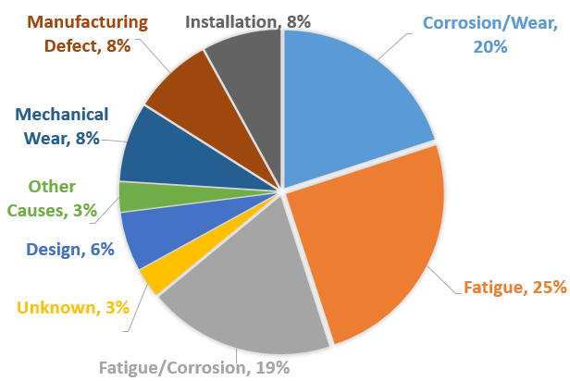

Fig. 1.Types of failure modes for mooring chains by the proportion of occurrence [7].

There are several methods available in the literature to predict the operating stresses and strains in the chains. Table 1outlines a number of different FE models reported in the literature, showing that the majority of numerical studies use an implicit FE formulation, while there is only one numerical study using the explicit method for mooring chain modelling [9]; although this method obtains a good agreement with experiments. These FE models use different element types, contact models and solvers (implicit/explicit). However, no evaluation of which model is appropriate for a particular failure mode has been made, and it is hard to determine from the literature when each of different models is appropriate.

The novelty of this paper is therefore to compare these different methods to understand how accurately each one models different types of failure modes. To allow this comparison, the different FE models from the literature are replicated, using the most similar meshing and modelling techniques available in ABAQUS. These models are then calibrated to match the published responses and are then compared with experiments [10], to determine their accuracy. The chain models are then benchmarked, intact without considering geometric changes due to failure mechanisms, to consider the effect of the resultant stress/strain relationships that would be important to different failure mechanisms to allow a comparison between the different methods.

Table 1: Summary of numerical analyses for mooring chains in the open literature.

|  |  |  |  |  |
| --- | --- | --- | --- | --- |
| Solution Method | Element Type | Material modelling | Loading Methods | Reference |
| Implicit | Hexahedral-Reduced integration | Elastic | Pressure Distribution | [11]* [12] [13] |
| Elastoplastic | Pressure Distribution | [11] [12] [13] [14]* |
| Elastoplastic | Contact Interaction | [11] [12] [13] [14] [15]* [16] [17] [18] [19] |
| Hexahedral-Incompatible Mode Integration | Elastoplastic | Contact Interaction | [20]* [21] [22] |
| Explicit | Hexahedral-Reduced integration | Elastoplastic | Contact Interaction | [9] |
| *: Selected verification papers | |  |  |  |

1. Finite Element model definition

The FE model was constructed in the ABAQUS 6.14 package and automated using a Python script. Hexahedral elements were selected over tetrahedral elements since they give superior performance in terms of convergence rate and accuracy of the solution [23][24][25]. The standardised dimensions for the chain geometry of a studless chain with diameter, *D*, are provided by IACS [26] where the total length, *L*, is equal to 6*D*, the total width, *W*, is 3.35*D* and the radius of the curved section, *R*, is 0.675*D,* as illustrated in Fig. 2.

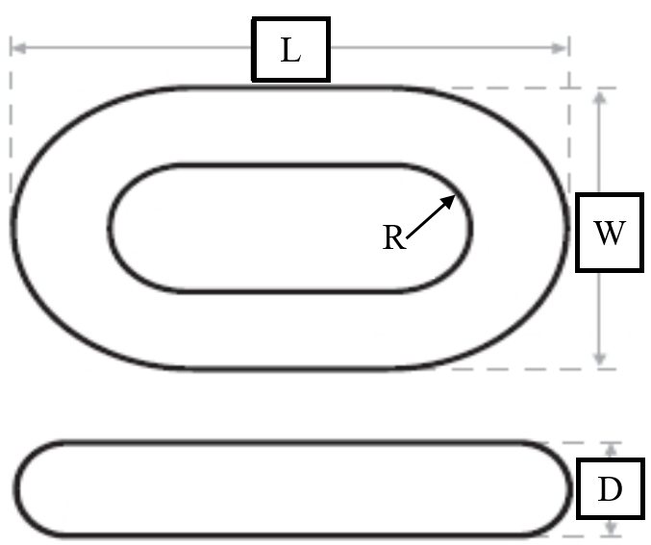

Fig. 2.The IACS specification for the design of a studless chain link [26].

DNV-OS-E302 standard [27] provides minimum mechanical properties for mooring chain steel grades, depending on the nominal tensile strength of the steels used for manufacture. Grades R3 and R4S are used to replicate previous studies with properties specified in the standard, DNV-OS-E302 [27], as shown in Table 2. The engineering material stresses and strains are converted into the true stress and logarithmic strain for input into ABAQUS. There are many nonlinear hardening models, e.g. Armstrong-Frederick, that can be used to reflect more complex cyclic material properties. However, as this study aims to replicate the response from the published analyses, the same material models used in these analyses are employed for the current simulations. The grade R3 material modelling is based on Pacheco et al. [11][14] and Bjørnsen [15] in which a bilinear isotropic hardening is used, where an elastic modulus (*E*) of 210 GPa and Poisson ratio (*v*) of 0.29 are used. The strain associated with the tensile strength is adopted as half the total elongation [14]. The grade R3 is used in sections 3.2, 3.3 and 4.2. The grade R4S material modelling is based on Kim et al. [20], where a Ramberg-Osgood curve is used with an isotropic hardening exponent of 0.597. An elastic modulus (*E*) of 209 GPa and Poisson ratio (*v*) of 0.3 are used. This grade R4S is used in section 3.4. Fig. 3 shows the stress-strain diagrams for both grades of steel, R3 and R4S, which are used as an input for ABAQUS. The model also considers geometric nonlinearities to consider large deformation effects.

Table 2: Minimum mechanical properties for chain materials [27].

|  |  |  |  |
| --- | --- | --- | --- |
| Steel grade | Yield stress (MPa) | Tensile strength (MPa) | Total elongation (%) |
| R3 | 410 | 690 | 17 |
| R4S | 700 | 960 | 12 |

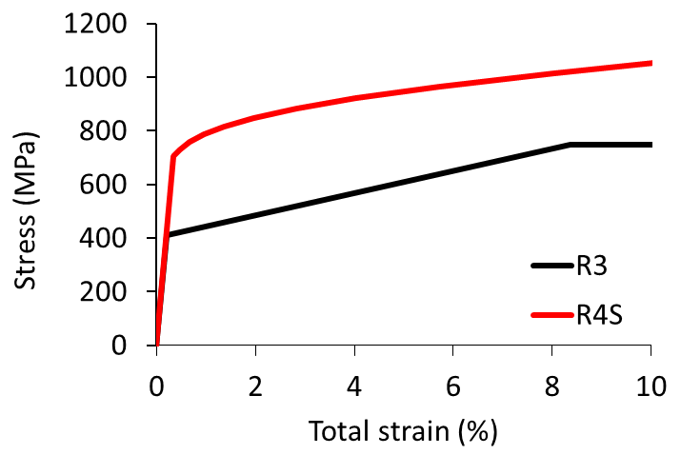

Fig. 3. Stress-strain diagrams of R3 and R4S grade steel.

Two types of contact loading method are investigated in the present study: (i) the pressure distribution method [11][14], which uses a pressure to replicate the contact force between the mooring links, and (ii) the contact interaction method [15], which is more consistent with the real chain interaction than using the pressure distribution. The pressure distribution method is replicated from [11][14], where the magnitude of the pressure is equivalent to the resultant load in the contact region. The pressure distribution varies linearly from a maximum value at the centre of the interlink contact area to zero at the border. The contact angle of 35o is used to represent the contact area from the axial direction, and the total area over which the pressure is applied is determined by a design parameter, H, as shown in Fig. 4(b). The pressure distribution is found by applying Eq.(1) to the ABAQUS analytical-fields,

|  |  |  |  |
| --- | --- | --- | --- |
|  | $f\left(x,y\right)=0.610865-\tan^{-1}\left(\frac{x}{y}\right)$, |  | (1) |

where *f*(*x*,*y*) is the function of pressure distribution, 0.610865 is the 35o in radian, and the origin of *x* and *y* is located at the centre of chain’s curved part, as indicated in Fig. 4(b).

In the contact interaction method, the contact discretisation is defined as surface-to-surface with a penalty contact constraint, as illustrated in Fig. 4(c). The surface-to-surface discretisation is used as this is suggested by ABAQUS [28] to provide more accurate stress and pressure results than node-to-surface discretisation. Finite sliding is considered, as the tension-tension simulation assumes no sliding of one surface along with the other, with a friction coefficient of 0.7 based on previous studies [11][14][15][20]. The upper chain is represented as the master model, and the lower chain is represented as the slave model, which has a finer mesh as this is where the resultant stresses/strains are extracted for analysis. The bottom surface of the slave model is fixed, while the upper surface of the master model is loaded using a uniformly distributed surface traction acting at the top, as indicated in red in Fig. 4(c).

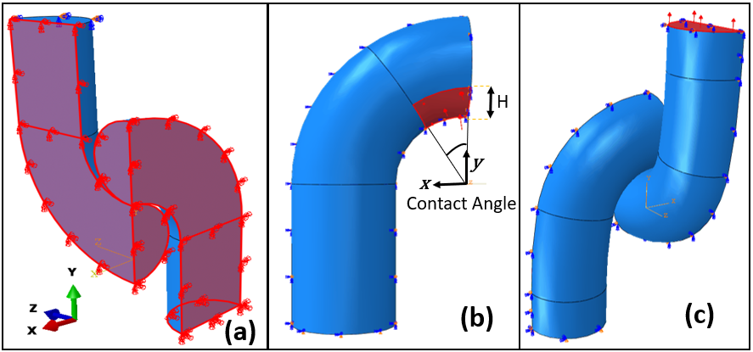

Fig. 4. Finite element definition: (a) symmetric boundary condition for chain modelling, (b) a model with pressure distribution, (c) a model with contact interaction.

The chain model has three planes of symmetry and so only a quarter of the chain model needs to be modelled. The symmetry boundary condition is assigned at the symmetry planes indicated in red inFig. 4(a) for the models using the pressure distribution method. For the models with contact interaction, the loaded surface at the top of the master model does not have this boundary condition, to allow the load to be applied in the axial direction. Six degrees of freedom are employed for each node, except for nodes on each of the symmetry planes, which have only three degrees of freedom, corresponding to the number used in the models taken from the literature. The symmetry boundary conditions constrain the displacement of nodes lying on each symmetry plane in the normal direction and the rotation in the other two directions. For example, the bottom surface of the slave model was constrained against displacement in the y-axis and against rotation in the x, z-axes.

The most probable locations for cracks are documented as being at the outer crown and the inner bend, also known as the Kt point [10][16][29]. Paths 1, 2 and 3, shown in Fig. 5 are selected to represent the key regions in the mooring line where the stresses and strains must be accurately modelled to predict the various failure mechanisms of the mooring chains: ultimate strength, corrosion, fatigue, fracture and permanent deformations. Path-1 is used to study the stress-strain field on the surface near the contact region. While paths 2 and 3 are used to study crack propagation; the cracks at the outer crown originate on the outside of the link and grow inwards along path-2, shown in Fig. 5(b), while the cracks at the inner bend hotspot originate on the inside of the link and grow outwards along path-3, Fig. 5(c) [10].

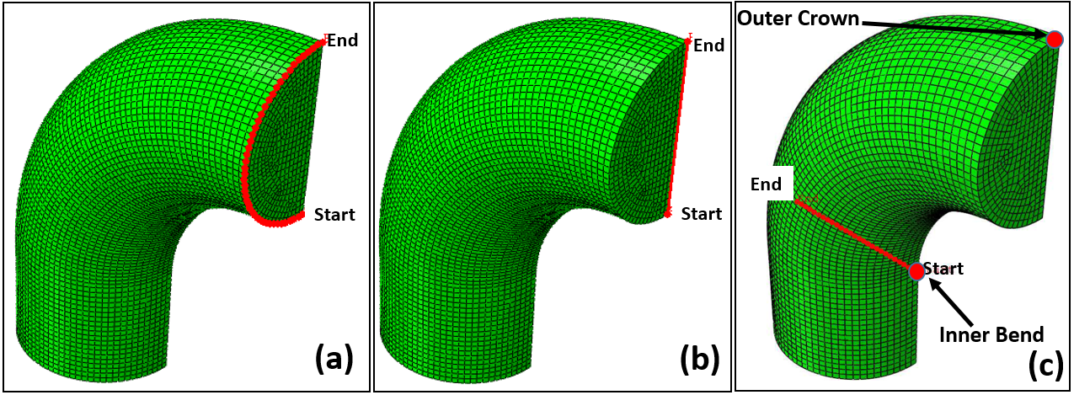

Fig. 5.Key paths for mooring line failure prediction: (a) path-1, (b) path-2 and (c) path-3.

1. Definition and calibration of the numerical models

The prior numerical models available from the literature are calibrated and verified based on the selected models, as indicated in Table 1. The analysis uses the same modelling inputs that are documented in the respective verification papers. During verification of the models, it is found that some utilise unconverged meshes, these meshes are used to compare to the original literature but are then converged before comparing to the experiments and the other numerical models.

* 1. Elastic model with pressure distribution, 20 node brick element with reduced integration (EP20R)

The elastic model with pressure distribution (EP20R) is calibrated and verified for a 76 mm studless chain with grade R3 steel material properties, Pacheco et al. [11]. The model was originally analysed using the finite element code, ANSYS, and the inputs are shown in Table 3. The element type is changed from the SOLID95 elements to the equivalent brick structural solid 20-node second-order element in ABAQUS, C3D20R.

Table 3: Original inputs for the elastic model with pressure distribution (EP20R).

|  |  |
| --- | --- |
| Design Parameter | Pacheco et al. [11] |
| Contact angle (°) | 35 |
| Elastic Modulus (GPa) | 207 |
| Poisson Ratio | 0.29 |
| Element Type | SOLID95 |
| Mesh size (mm) | 7.5 |
| Load Magnitude (kN) | 810.5 |

The results of the longitudinal stress are provided for a part of path-2, from a distance of 22 mm to 76 mm. The design parameter, H, shown in Fig. 4(b), is not documented, and therefore, a calibration is performed to replicate the result from the original paper shown in Fig. 6. A value of 11.3 mm is selected for H as it gives the lowest absolute mean difference compared to the original results across the whole path with an absolute mean difference of 2%.



Fig. 6. Calibration of H along path-2 for the longitudinal stress.

* 1. Elastoplastic model with pressure distribution, 20 node brick element with reduced integration (P20R)

The elastoplastic model with pressure distribution (P20R) is calibrated and verified for a 76 mm studless chain with grade R3 steel material properties, and the inputs are presented inTable 4, Pacheco et al. [14]. The model was also originally analysed using the finite element code, ANSYS, and the SOLID95 is again changed to C3D20R. The original paper [14] provides the results of the longitudinal stress along a part of path-2, from a distance of 19 mm to 76 mm.

Table 4: Original inputs for P20R.

|  |  |
| --- | --- |
| Design Parameter | Pacheco et al.[14] |
| Contact angle (°) | 35 |
| Elastic Modulus (GPa) | 207 |
| Poisson Ratio | 0.29 |
| Element Type | SOLID95 |
| Mesh (mm) | 7.5 |
| Load Magnitude (kN) | 3242 |
| True Yield Stress (MPa) | 410 |
| True Tensile Stress (MPa) | 748.65 |
| True Tensile Strength Strain | 0.0816 |

The design parameter H is again not documented, and therefore, the H value of 11.3 mm is chosen from the previous verification study. A comparison of the results using this value to the original results are shown in Fig. 7 and give an absolute mean difference of 3.5% across the whole path.



Fig. 7. Verification of H=11.3mm for the P20R model along path-2 for the longitudinal stress.

* 1. Elastoplastic model with contact interaction, 20 node brick element with reduced integration (C20R)

An elastoplastic implicit model with contact interaction and reduced second-order elements (C3D20R) is calibrated and verified for a 76 mm studless chain using grade R3 steel material properties based on Bjørnsen [15]. The input values are the same as used in the original analysis, shown in Table 5. However, the contact analysis in the implicit method has convergence problems as it tries to enforce the suddenly activated contact constraint, causing a severe discontinuous iteration. To resolve this issue, an initial boundary condition (IBC) is used where the displacement acting towards the load direction is applied and then removed after the surfaces are adequately constrained through contact with other components before applying the operational load as suggested by ABAQUS [30]. This initial boundary condition (IBC) is not documented and therefore, a parametric study is used to determine this value.

Table 5: Original inputs for C20R.

|  |  |
| --- | --- |
| Design Parameter | Bjørnsen [15] |
| Elastic Modulus (GPa) | 210 |
| Poisson Ratio | 0.29 |
| Element Type | C3D20R |
| Slave Model Mesh (mm) | 8 |
| Master Model Mesh (mm) | 10 |
| True Yield Stress (MPa) | 410 |
| True Tensile Stress (MPa) | 748.65 |
| True Tensile Strength Strain | 0.0816 |
| Interaction – Tangential | Penalty - 0.7 Friction |
| Interaction – Normal | Normal – Hard |
| Load Magnitude (kN) | 1221.075 |

The results of the parametric study are presented in Fig. 8 for path-1 and show a considerable difference from the original results in the first 5 mm. However, the initial boundary condition value of 5×10-4 m is selected since it gives the lowest absolute mean difference of 4% compared to the original paper.



Fig. 8. Calibration of the Initial Boundary Condition (IBC) for the maximum absolute principal stress along path-1.

* 1. Elastoplastic model with contact interaction, 8 node brick element with incompatible mode (C8I)

The elastoplastic implicit model with contact interaction and incompatible mode elements (C8I) is calibrated and verified for a 152 mm studless chain based on grade R4S steel material properties based on the Kim et al. [20]. The input values are the same as used in the original analysis, shown in Table 6.

Table 6: Original inputs for C8I.

|  |  |
| --- | --- |
| Design Parameter | Kim et al.[20] |
| Elastic Modulus (GPa) | 209 |
| Poisson Ratio | 0.3 |
| Element Type | C3D8I |
| Slave Model Mesh (mm) | 10 |
| Master Model Mesh (mm) | 10 |
| Yield Stress (MPa) | 700 |
| Tensile Stress (MPa) | 960 |
| Tangential interaction | Lagrange Multiplier - 0.7 Friction |
| Interaction – Normal | Normal – Hard |
| Load (kN) | 2705 |

The model is verified using the maximum stress concentration factor, the ratio between the maximum absolute value of the principal stresses within the chain and the nominal tensile stress. The nominal tensile stress is defined as the tensile load divided by the cross-sectional area of the chain’s round bars resulting in stress of 74.535 MPa. The FE model uses the implicit method, requiring contact initialisation to start the interlink contact in the FE modelling; the initial boundary condition (IBC) of 5×10-4 m from the previous model is checked and is selected. The maximum absolute value of the principal stresses within the chain predicted by the current FE model is 288.34 MPa, giving a maximum stress concentration factor of 3.87. This value is compared to the maximum stress concentration factor from the original paper [20], which is 3.9, which gives a 0.80% difference. The model is therefore considered to be correctly calibrated and verified.

* 1. Elastoplastic model with contact interaction, explicit solver 8 node brick element with reduced integration (CEx8R)

Recent research using the explicit method for studded chains shows good agreement with experiments [9], despite it not being documented for studless chains. This is in agreement with the literature [31][32][33][34][35][36][37][38] where the explicit solver is shown to provide accurate prediction to experiments, for solving different types of contact problems. In the explicit approach, a solution is solved in a dynamic formulation and is conditionally stable, assuming the time increment selected is small enough to maintain the stability limit. The stability limit is that the time increment must be less than a critical value of the smallest transition time for a dilatational wave to cross any element in the mesh [39]. The time increment is automatically set by ABAQUS/Explicit depending on the element dimensions and material properties [40]. In the implicit approach, a solution to the set of finite element equations is unconditionally stable involving iteration until a convergence criterion is satisfied for each increment. The unconditionally stable implicit method encounters some difficulties when a complicated three-dimensional model involving contact is considered [23][39][40][41].

To allow quasi-static analysis in the explicit method, the loading amplitude uses a smooth step, and the kinetic energy is checked so that it does not exceed 5% of its internal energy throughout the simulation. For the contact pair algorithm, the contact surface weighting is set to 1.0 to specify a pure master-slave relationship with the first surface as the master surface between links. The first-order hexahedral elements with reduced integration schemes (C3D8R) are used, and the final meshes are defined using a mesh convergence analysis. Mass scaling factors of 10, 100 and 1000 are evaluated in comparison to the same model without mass scaling using a chain model of 76 mm diameter and grade R3 material under 25% minimum breaking load. A mass scaling factor of 100 gives the optimum effect with 8.5 times lower computational time and the same memory usage. The resulting von Mises stresses along path-1 show a 0.1% mean absolute error with a maximum error of 0.9%.

1. Model selection

The differences between the FE models are documented in Table 7. An additional implicit method with C3D8R elements is included as C8R, Jones [42] and Zarandi [43], but there is no verification to determine its accuracy, but it is assumed that only changing the element type from the C20R model will not reduce the accuracy of the model. The final meshes for each model are defined using a mesh convergence analysis.

Table 7:Differences in modelling between the different FE models.

|  |  |  |  |  |  |  |
| --- | --- | --- | --- | --- | --- | --- |
| Model | EP20R | P20R | C20R | C8I | CEx8R | C8R |
| Solution Method | Implicit | Implicit | Implicit | Implicit | Explicit | Implicit |
| Contact Loading Method | Pressure distribution | Pressure distribution | Contact interaction | Contact interaction | Contact interaction | Contact interaction |
| Element type | C3D20R | C3D20R | C3D20R | C3D8I | C3D8R | C3D8R |
| Contact Tangential behaviour | N/A | N/A | Penalty | Lagrange Multiplier | Penalty | Penalty |
| Contact Normal behaviour | N/A | N/A | Hard contact | Hard contact | Hard contact | Hard contact |
| Mass Scaling | - | - | - | - | 100 | - |

* 1. Validation of the numerical models

To validate the accuracy of the different numerical models, they are used to simulate the experimental data from Tipton and Shoup [10]. The model geometry is defined to be the same where the chain diameter is 10 mm and the total length, *L*, is equal to 5*D*, the total width, *W*, is 3.6*D* and the radius of the curved section, *R*, is 0.8*D*. It should be noted that this geometry is different from the IACS [26] standard design. The chain for this experiment is manufactured according to the ANSI/ASTM A-391-86 standard specification for the alloy steel chain. The engineering stress-strain relationship, derived from the average of two tensile tests conducted at a constant stress rate of approximately 30 MPa per second [10], is converted to true stress-strain relationship for input into ABAQUS. Fig. 9 shows the true stress-strain relationship, where the elastic modulus (*E*) is 213745 MPa and Poisson ratio (*v*) is 0.29.

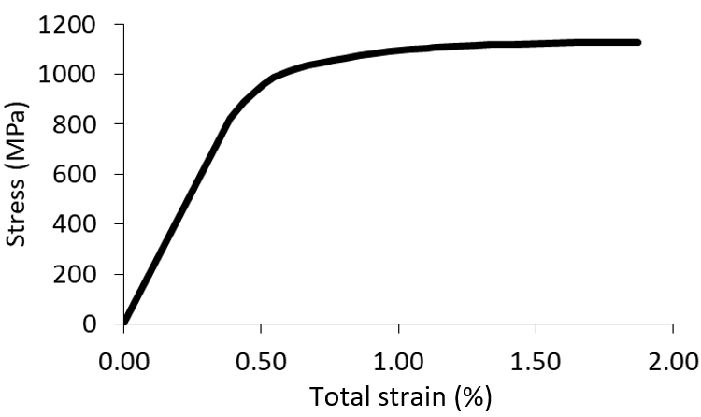

Fig. 9. Stress-strain relationship used in the current simulation derived from tensile tests [10].

In the experiments, the chains were initially heat-treated to relieve manufacturing residual stresses, and then proof loaded at 70%, 76% and 82% of the minimum breaking load, which is obtained from five break strength tests as 106.8 kN [10]. The proof load is given then released, resulting in a permanent elongation and residual stress at the outer crown. In this experiment, the permanent elongations are obtained from measurements, and the residual stresses are calculated by using the measured strains from strain gauges compared to the monotonic tensile stress-strain curve where the unloading strain is assumed elastic, and the constraint of transverse strains is assumed negligible. The documented permanent elongations are 0.512 mm, 1.021 mm and 1.682 mm for proof loads of 70%, 76% and 82% of the minimum breaking load, respectively. The documented residual stresses are -855 MPa and -648 MPa, for proof loads of 70% and 50% of the minimum breaking load, respectively.

Fig. 10 displays the comparisons of the normalised permanent elongations obtained by the FE analyses and experimental tests. The elastic model with pressure distribution (EP20R) is not included since it does not capture the material plasticity to model both normalised permanent elongation and normalised residual stress. The results of the predicted permanent elongations show a good agreement between the FE models and the experiments, as shown in Fig. 10. In general, as the permanent elongations increase at higher levels of proof load, the FE model results predict the experimental results more closely. It is assumed that this is because it is difficult to measure relatively small permanent elongations in the experiment. However, in the elastoplastic model with pressure distribution (P20R), the error in predicted permanent elongation increases with larger load levels. This is ascribed to the usage of the pressure distribution method, which is less consistent with real interlink interactions than the contact interaction method. The explicit model (CEx8R) provides the closest agreement in the prediction of permanent elongation for all load levels with the lowest mean error of 13% over the three tests, while the implicit reduced second-order model (C20R) gives the maximum mean error of 47%.



Fig. 10. The predicted permanent elongations of the different FE models normalised against experimental tests.

In general, the FE models concordantly underestimate the residual stresses with a mean error of 44% for the 70% test, which reduces to 35% for the 50% test. This is except for the elastoplastic model with pressure distribution (P20R) in the 70% test, which exhibits higher residual stresses that are closest to the experiments with normalised residual stress of 0.99. Therefore, the documented results for the residual stresses are considered to be inaccurate. The residual stress levels are determined from the measured strains by the strain gauges and the monotonic tensile stress-strain curve, where the unloading strain is assumed to be elastic according to Tipton and Shoup [10]. During the experiment, the strain gauge application is documented as being difficult due to the curved surface at the crown region, so this curvature, coupled with the plastic strains imposed by proof loading, may result in erroneous strain gauge applications, with potential for errors in the residual stress estimation. Additionally, the residual stress estimation does not account for some of the physical factors such as Poisson’s ratio effects and the constraint of the transverse strains, and strain gauge corrections were not used. The measurement method of the permanent elongations is not documented in the original paper, but it is assumed that they use visual measurement with length meters. Overall, these results provide validation for the different FE models. In general, the explicit model (CEx8R) provides the best predictions for the analysis of the permanent elongations and is therefore adopted as the reference for the remainder of the benchmarking studies, due to a lack of further validation material in the open literature.

* 1. Benchmarking of the numerical models

The accuracy of the stress within the chain model is explored to further demonstrate the comparison between the numerical models in the validation study. The stress along path-1 under the 50% minimum breaking load is shown in Fig. 11, where the region A signifies the contact area.



B

A

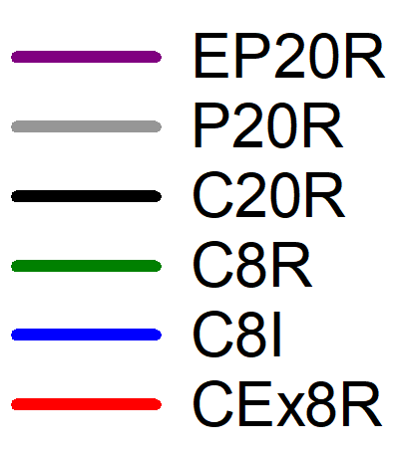

Fig. 11. Comparison of the von Mises stresses for the different FE models under 50% minimum breaking load along path-1.

In general, the results for all of the models with contact interaction (i.e. C20R, C8R, C8I, CEx8R) provide inconsistent results in region A, either through sharp changes in gradient or extreme stress values. The difference in results in this region is because of the local instabilities and convergence difficulties of the implicit solutions that make force equilibrium difficult to achieve over the contact area. However, the stress for all of the models converges at the end of path-1 under 50% of the minimum breaking load, apart from the elastic model (EP20R).

The oscillating stresses exhibited by the implicit models may pick up erroneous peak stresses, since these exhibited peak stresses may not exist. This may mislead any failure analyses of the mooring chain. However, the explicit model (CEx8R) predicts a smoother stress profile, which results in better predictions based on the prior validation study. For a strength failure analysis, the prediction of peak stress requires good accuracy. The prediction of peak stress is also essential for an analysis of mechano-electrochemical induced corrosion as the corrosion is influenced by many factors, one of which is the surface stress, which influences the corrosion rate [44]. In comparison to the explicit model (CEx8R), the implicit reduced first-order model (C8R) and the elastoplastic model with pressure distribution (P20R) predict similar peak stress within 0.7 mm. However, the implicit incompatible first-order model (C8I) overestimates the peak stress by 69% at the same location compared with the explicit model (CEx8R), while the implicit reduced second-order model (C20R) overestimates the peak stress by 28% at a location 0.8 mm from the explicit model (CEx8R).

The different numerical models are then compared using the standardised geometry (L=6D, W=3.35D), 76mm diameter and of grade R3 with an elastic modulus (*E*) of 210 GPa and a Poisson ratio (*v*) of 0.29 in order to be consistent with the current practice of offshore industries. The minimum breaking load for the standardised dimension is 4884 kN based on the IACS standard [26]. The simulation is a one-step analysis up to the maximum load. The analysis does not consider the effect of proof loading tests or residual stresses, to allow a comparison of the stress/strain modelling in the chain from the same initial condition. The comparison of the von Mises stress profile using the standardised geometry shows similar behaviour with the prior comparison of the von Mises stress profile. However, a difference is found for the results of the elastoplastic model with pressure distribution (P20R) in which it overestimates the peak stress by 12% and the stress at the end of path-1 by 19% compared to the explicit model (CEx8R) under 50% minimum breaking load in the standardised dimension.

For a fatigue failure analysis, the predictions of the stress range and the mean stress at the fatigue location must be accurate. The two locations susceptible to fatigue damage are the outer crown, the end of path-2, and the inner bend, the start of path-3. The comparison of the stresses at these locations are presented in Fig. 12, where the load levels of 25% and 50% minimum breaking load are defined as the minimum and maximum loading to simulate fatigue loading conditions. The models with contact interaction (i.e. C20R, C8R, C8I, CEx8R) have similar predictions for all of the comparisons with the largest difference, 5%, for the implicit reduced second-order model (C20R) at the outer crown. In comparison to the models with contact interaction, the elastoplastic model with pressure distribution (P20R) gives a mean difference of 46% for the stress range, which reduces to 8% for the mean stress at both locations; while the elastic model with pressure distribution (EP20R) predicts the stress range by more than 2.5 times, which reduces to 1.6 times of the other models with contact interaction, which could lead to inaccurate estimations of the fatigue life.



Fig. 12. Comparison of the stress range and mean stress for the different FE models at both critical locations for fatigue analysis.

The nominal stress is commonly used as a fatigue design parameter by offshore standards [45] to calculate the fatigue life of mooring chains based on S-N curves. The nominal stress is analytically calculated based on the corresponding tension divided by the total cross-sectional area of the chain’s round bars. The nominal stress predicted by the FE models is calculated by averaging the longitudinal stress in the mid-cross-section of the straight part of the chain. The models with contact interaction (C20R, C8R, C8I and CEx8R) result in less than a 1% difference to the analytical calculation, while the models with pressure distribution (EP20R and P20R) result in 5.5% difference since they do not capture the contact interactions.

In a crack propagation analysis, the local tensile stress field development over the crack path needs to be accurately modelled. The comparisons of the maximum principal stress under 50% minimum breaking load along path-2 and path-3 are examined since they are critical paths for fracture in mooring chains [10][16][29]. As shown in Fig. 13, the models with contact interaction (C20R, C8R, C8I and CEx8R) have considerable dissimilarities in the first 7 mm of path-2 due to their different performances in the contact area. The implicit incompatible first-order model (C8I) gives the largest value of -32 MPa; while the implicit reduced first-order model (C8R) gives the lowest value of -593 MPa. However, the stresses converge along most of path-2, especially at the important location at the end of path-2, where the crack initiates. The models with contact interaction also give the same results along the whole of path-3, indicating similar performances in fracture analysis simulations. However, the elastic and elastoplastic models with pressure distribution (EP20R and P20R) give absolute mean differences of 80% and 63% along path-2, which reduce to 43% and 11% along path-3, respectively, indicating their lack of ability to predict the stress field over the cross-sectional paths for fracture analysis.



Fig. 13. Comparison of the maximum principal stress for the different FE models under 50% minimum breaking load along path-2.

For the contact problem, ratcheting wear may cause interlink wear on the contact surface. The ratcheting wear is the accumulation of repeated plastic strain due to significant contact forces [46]. To investigate the plastic strain along the chain surface, the equivalent plastic strains (PEEQ) over path-1 under 50% minimum breaking load are shown in Fig. 14. The elastic model with pressure distribution (EP20R) is not included since it does not capture the material plasticity. In region A, the implicit incompatible first-order model (C8I) overestimates the peak plastic strain by 2.4 times more than the explicit model (CEx8R) at the same location, while the implicit reduced second-order model (C20R) underestimate it by 10% at a location 3.6 mm away from the explicit model. The implicit reduced first-order model (C8R) gives a similar peak plastic strain to the explicit model, but it shifts to the peak location by 3.8 mm. However, all of the models with contact interaction (C20R, C8R, C8I and CEx8R) converge in region B. The elastoplastic model with pressure distribution (P20R) fails to capture the peak plastic strain in region A and overestimates the plastic strain by 58% at the end of path-1, indicating it is not appropriate for ratcheting wear problems.



B

A

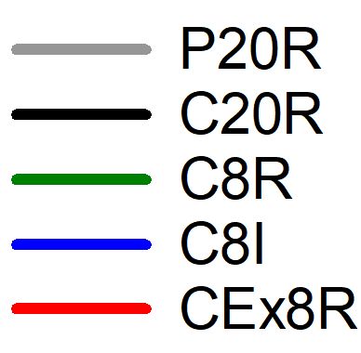

Fig. 14**.** Comparison of the equivalent plastic strains (PEEQ) for the different FE models under 50% minimum breaking load along path-1.

1. Discussion

A number of parametric studies are performed to allow a comparison of the numerical models for different failure modes. Table 8 is compiled to show when a numerical model is appropriate, where a circle indicates the results are within 10% of the explicit model (CEx8R) in predicting important parameters for that particular failure analyses and a cross indicates they are not. Here the explicit model is deemed appropriate based on the match to the available experimental data. Zarandi and Skallerud [47] measure the residual stresses in a mooring chain experimentally, which shows good agreement with a prediction from an FE model employing the implicit reduced eight-order model (C8R), supporting the fact that the FE models with contact interaction (C20R, C8R, C8I, CEx8R) are good for the residual stress prediction.

Table 8: Summary of appropriate models for different failure modes

|  |  |  |  |  |  |  |
| --- | --- | --- | --- | --- | --- | --- |
|  | EP20R | P20R | C8I | C20R | C8R | CEx8R |
| Nominal stress for S-N approach | O | O | O | O | O | O |
| Residual stress | x | x | O | O | O | O |
| Fatigue damage | x | x | O | O | O | O |
| Fracture of crack propagation | x | x | O | O | O | O |
| Ratcheting wear in contact area | x | x | x | O | O | O |
| Ultimate strength | x | x | x | x | O | O |
| Mechano-Electrochemical corrosion | x | x | x | x | O | O |
| Permanent elongation | x | x | x | x | x | O |

The elastic model with pressure distribution (EP20R) has been demonstrated to be poor at predicting any failure modes since it lacks material plasticity. The elastoplastic model with pressure distribution (P20R) can give similar results with other models with contact interaction under low load levels, e.g. under 25% minimum breaking load in the standardised dimensions. However, it is found that at higher load levels, 70% minimum breaking load, there is a larger difference to the models with contact interaction (C20R, C8R, C8I and CEx8R).

In general, all of the models with contact interaction (C20R, C8R, C8I and CEx8R) can accurately model most of the failure modes. However, convergence problems are a critical issue in the implicit models (C20R, C8R and C8I), requiring the user to apply unrealistic simplifications to the initial boundary condition to adjust the slave nodes be in contact with the master nodes in the first step [30]. The implicit incompatible first-order model (C8I) exhibits a much higher stress-strain field in the area of contact, although it manages to capture a similar stress-strain field to the other models (C20R, C8R and CEx8R) in regions far from the contact area, region B. This is because the incompatible mode elements are sensitive to mesh distortions due to significant contact forces in the contact area. The element distortions mean that the finite element interpolation functions cannot converge, making the elements too stiff and reducing the accuracy [48]. Therefore, care must be taken to ensure that the element distortions are minimal in the area of interests. Cases, where the incompatible mode elements can be used more appropriately, are bending/buckling analyses of thin members, for example, plate or pipe structures, where the element distortions are low, and this is supported in previous studies into these structures [49][50][51].

The implicit reduced second-order model (C20R) exhibits oscillating stresses in the contact area; even when the mesh size is reduced. This is due to the contact algorithm’s difficulties in determining if the force distribution represents constant contact pressure or an actual variation across the surface of the second-order elements, composed of curved edges. The directions of the consistent nodal forces resulting from the pressure load are not uniform in the two-contact surfaces of the second-order elements, making it difficult for the equivalent nodal forces to converge because they do not have the same sign for constant pressure. The convergence problems cause a severe discontinuity iteration until sufficiently small tolerances are satisfied, which is a complicated process, especially if both the contacting bodies are deformable [23]. The implicit first-order model (C8R) shows superior performance among the other implicit models because the equivalent nodal forces for the applied pressures on the surfaces of the first-order elements always have a consistent sign and magnitude; therefore, there is no ambiguity regarding the contact state represented by a given distribution of nodal forces [23]. However, obtaining convergence remains an issue for all elements in the implicit solver.

The results of this study show that the model that is the best for all scenarios is the explicit model (CEx8R), which predicts a smooth gradient of the stress-strain in the contact area. The explicit model (CEx8R) runs the contact interaction without any convergence problems. When contact occurs, the resisting forces and masses of all contacting nodes on the slave surface are distributed to the nodes on the master surface and add to the total inertial mass of the contacting interfaces. To maintain the stability of the contact enforcement, the explicit solver uses these distributed forces and masses to calculate an acceleration correction to obtain a corrected contact configuration [28]. The small-time increments used by the explicit solver ensure that the highly nonlinear material behaviour in the contact area can be captured by adjusting the displacements and velocities of surface nodes involved in contact to remove small initial overclosures to be kinematically correct.

Table 9: The computational costs and memory for the different FE models normalised against the explicit model.

|  |  |  |
| --- | --- | --- |
| Model | Simulation time | Memory usage |
| Elastic model with pressure distribution (EP20R) | 0.13 | 0.26 |
| Elastoplastic model with pressure distribution (P20R) | 0.38 | 0.37 |
| Implicit reduced second-order model (C20R) | 113.84 | 41.33 |
| Implicit incompatible first-order model (C8I) | 15.32 | 52.67 |
| Implicit reduced first-order model (C8R) | 5.88 | 4.75 |

Table 9 shows that the explicit model (CEx8R) has a lower computational cost compared to the implicit models with contact interaction (C20R, C8R and C8I). This is because the implicit models experience a number of discontinuity iterations. In addition, the mass-scaling is used in the explicit model to increase the time increment and consequently decrease the computational costs for running the simulation. However, the models with pressure distribution (EP20R and P20R) have much lower computational costs since they do not have interlink contact interactions and half of the models are used. This indicates some benefits in carefully selected simulations, such as reliability analysis with Monte Carlo simulations or numerical optimisation methods, where the results for the stress-strain analysis are shown to be of acceptable accuracy.

1. Conclusion

Mooring lines regularly fail much earlier in their service life than predicted. The methods for predicting the stresses in mooring chains vary, but currently, there are no comparisons of these methods to help determine when they are appropriate. A comparison of the different methods for mooring chain modelling under tension is investigated. The predictions of the different models are checked against experimental tests. The convergence rate is found essential for accurate predictions of the mooring chain. The explicit model has no convergence problems with the least computational cost while providing the strongest performance across all of the failure modes.

**Declaration of competing interest**

None.

**Acknowledgement**

The authors gratefully acknowledge the funding by the Indonesia Endowment Fund for Education (LPDP) and the support of the Lloyd’s Register Foundation (LRF). The authors also acknowledge the support of the University of Southampton for access to its IRIDIS5 High-Performance Computing Facility.

**References**

[1] K. Ma, A. Duggal, P. Smedley, D. L’Hostis, and H. Shu, “A Historical Review on Integrity Issues of Permanent Mooring Systems,” in *Offshore Technology Conference OTC-24025*, Houston, Texas, USA, 2013, p. 14.

[2] S. Majhi and R. D. Souza, “Application of Lessons Learned From Field Experience to Design, Installation and Maintenance of FPS Moorings,” in *Offshore Technology Conference OTC-24181*, Houston, Texas, USA, 2013, p. 15.

[3] A. Kvitrud, “Lessons Learned From Norwegian Mooring Line Failures 2010–2013,” in *ASME 2014 33rd International Conference on Ocean, Offshore and Arctic Engineering OMAE2014-23095*, San Fransisco, California, USA, 2014, p. 10.

[4] A. Ryu, Samsangsoo; Heyl, Caspar; Duggal, “Mooring Cost Sensitivity Study Based on Cost-Optimum Mooring Design,” in *Proceedings of Conference 2008 Korean Society of Ocean Engineers*, 2008, p. 5.

[5] Noble Denton Europe Limited, “RR444 - Floating production system: JIP FPS mooring integrity,” *Health and Safety Executive*, 2006. [Online]. Available: http://www.hse.gov.uk/research/rrpdf/rr444.pdf. [Accessed: 19-Jul-2018].

[6] R. Crighton, “Gryphon insurance payouts close to £440m,” *Energy Voice*, 2013. [Online]. Available: https://www.energyvoice.com/oilandgas/45369/gryphon-insurance-payouts-close-440m/. [Accessed: 04-Feb-2019].

[7] E. Fontaine, A. Kilner, C. Carra, D. Washington, K. Ma, and A. Phadke, “Industry survey of past failures, pre-emptive replacements and reported degradation for mooring systems of floating production units,” in *Offshore Technology Conference OTC-25273*, Houston, Texas, USA, 2014, p. 14.

[8] R. B. Gordon, M. G. Brown, and E. M. Allen, “Mooring Integrity Management: A State-of-the-Art Review,” in *Offshore Technology Conference OTC-25134-MS*, Houston, Texas, USA, 2014, p. 19, doi: 10.4043/25134-MS.

[9] A. Sachan and Y. S. Choo, “Mooring chain strength tests and ductile failure modeling using micromechanics and phenomenology based failure models,” *Ocean Eng.*, vol. 195, no. November 2019, p. 106663, 2020.

[10] S. M. Tipton and G. J. Shoup, “The Effect of Proof Loading on the Fatigue Behavior of Open Link Chain,” *J. Eng. Mater. Technol.*, vol. 114, no. 1, pp. 27–33, Jan. 1992.

[11] P. Pacheco, P. Kenedi, J. Jorge, M. Savi, and H. Santos, “Finite Element Residual Stress Analysis Applied to Offshore Studless Chain Links,” in *ASME 2004 23rd International Conference on Offshore Mechanics and Arctic Engineering OMAE2004-51508*, Vancouver, British Columbia, Canada, 2004, p. 10.

[12] P. Pacheco, P. Kenedi, J. Jorge, H. Santos, M. Savi, and A. Paiva, “Modeling Residual Stresses in Offshore Chain Links using Finite Element Method,” in *17th International Congress of Mechanical Engineering COBEM2003-0320*, Sao Paulo, Brazil, 2003, p. 10.

[13] P. Pacheco, P. Kenedi, and J. Jorge, “Elastoplastic Analysis of the Residual Stress in Chain Links,” in *21st International Conference on Offshore Mechanics and Arctic Engineering, Volume 3 OMAE2002-28083*, Oslo, Norway, 2002, p. 8.

[14] P. Pacheco, P. Kenedi, J. Jorge, and A. Paiva, “Analysis of the Influence of Mechanical Properties on the Residual Stress in Offshore Chain Links Using the Finite Element Method,” in *ASME 2003 22nd International Conference on Offshore Mechanics and Arctic Engineering OMAE2003-37205*, Cancun, Mexico, 2003, p. 10.

[15] E. Bjørnsen, “Chains in Mooring Systems,” M. S. Thesis, NTNU, Dept. Civil Engineering, Trondheim, Norway, 2014.

[16] P. Bastid and S. D. Smith, “Numerical Analysis of Contact Stresses Between Mooring Chain Links and Potential Consequences for Fatigue Damage,” in *ASME 2013 32nd International Conference on Ocean, Offshore and Arctic Engineering OMAE2013-11360*, Nantes, France, 2013, p. 8.

[17] P. M. Vargas, T. M. Hsu, and W. K. Lee, “Stress Concentration Factors for Stud-Less Mooring Chain Links in Fairleads,” in *23rd International Conference on Offshore Mechanics and Arctic Engineering OMAE2004-51376*, Vancouver, British Columbia, Canda, 2004, p. 9.

[18] X. Xue, N. Z. Chen, Y. Wu, Y. Xiong, and Y. Guo, “Mooring system fatigue analysis for a semi-submersible,” *Ocean Eng.*, vol. 156, pp. 550–563, 2018.

[19] X. Xue and N. Chen, “Fracture mechanics analysis for a mooring system subjected to Gaussian load processes,” *Eng. Struct.*, vol. 162, no. February, pp. 188–197, 2018.

[20] Y. Kim, M. S. Kim, and M. J. Park, “Fatigue analysis on the mooring chain of a spread moored FPSO considering the OPB and IPB,” *Int. J. Nav. Archit. Ocean Eng.*, vol. 11, no. 1, p. 24, 2018.

[21] L. Rampi, A. Bignonnet, C. Le Cunff, F. Bourgin, and P. Vargas, “Chain Out of Plane Bending (OPB) Fatigue Joint Industry Project (JIP) FEA Results and Multiaxiality Study Results,” in *ASME 2016 35th International Conference on Ocean, Offshore and Arctic Engineering OMAE2016-54198*, Busan, South Korea, 2016, p. 15.

[22] C. Edward and A. K. Dev, “Numerical Methods for Interlink Stiffness formulations and parameters sensitivity of out-of-plane Bending in Mooring Chains,” in *ASME 2019 38th International Conference on Ocean, Offshore and Arctic Engineering OMAE2019-96042*, Glasgow, Scotland, UK, 2019, p. 11.

[23] Dassault Systèmes Simulia Corp., *Abaqus/CAE User’s Manual, Theory Guide. Version 6.12*. Pawtucket, USA: ABAQUS, Inc., 2012.

[24] R. Tian and G. Yagawa, “Generalized nodes and high‐performance elements,” *Int. J. Numer. Methods Eng.*, vol. 64, pp. 2039–2071, Dec. 2005, doi: 10.1002/nme.1436.

[25] S. C. Tadepalli, A. Erdemir, and P. R. Cavanagh, “Comparison of hexahedral and tetrahedral elements in finite element analysis of the foot and footwear,” *J. Biomech.*, vol. 44, no. 12, pp. 2337–2343, 2011.

[26] IACS (International Association of Classification Societies), “W22 Offshore Mooring Chain,” *International Association of Classification Societies*, 2016. [Online]. Available: http://www.iacs.org.uk/publications/unified-requirements/ur-w/ur-w22-rev6-cln/. [Accessed: 04-Feb-2019].

[27] Det Norske Veritas, “DNV-OS-E302 Offshore Mooring Chain,” *DNV, Høvik, Norway.*, 2015. [Online]. Available: https://rules.dnvgl.com/docs/pdf/DNV/codes/docs/2009-10/OS-E302.pdf. [Accessed: 19-Jul-2018].

[28] Dassault Systèmes Simulia Corp., “Abaqus Analysis User’s Guide 6.13,” *ABAQUS, Inc.*, 2013. [Online]. Available: http://dsk.ippt.pan.pl/docs/abaqus/v6.13/books/usb/default.htm?startat=pt09ch36s03aus145.html. [Accessed: 19-Feb-2020].

[29] Ø. Gabrielsen, K. Larsen, and S. A. Reinholdtsen, “Fatigue Testing of Used Mooring Chain,” in *ASME 2017 36th International Conference on Ocean, Offshore and Arctic Engineering OMAE2017-61382*, Trondheim, Norway, 2017, p. 11.

[30] Dassault Systèmes Simulia Corp., “ABAQUS Documentation Version 6.6,” *ABAQUS, Inc.*, 2006. [Online]. Available: https://classes.engineering.wustl.edu/2009/spring/mase5513/abaqus/docs/v6.6/books/usb/default.htm?startat=pt09ch29s02aus124.html. [Accessed: 07-Mar-2020].

[31] J. Ye, Y. Yan, J. Li, Y. Hong, and Z. Tian, “3D explicit finite element analysis of tensile failure behavior in adhesive-bonded composite single-lap joints,” *Compos. Struct.*, vol. 201, pp. 261–275, 2018.

[32] F. J. Harewood and P. E. McHugh, “Comparison of the implicit and explicit finite element methods using crystal plasticity,” *Comput. Mater. Sci.*, vol. 39, no. 2, pp. 481–494, 2007.

[33] F. Vulliet, M. Ben Ftima, and P. Léger, “Stability of cracked concrete hydraulic structures by nonlinear quasi-static explicit finite element and 3D limit equilibrium methods,” *Comput. Struct.*, vol. 184, pp. 25–35, 2017.

[34] P. Liu, X. Cheng, S. Wang, S. Liu, and Y. Cheng, “Numerical analysis of bearing failure in countersunk composite joints using 3D explicit simulation method,” *Compos. Struct.*, vol. 138, pp. 30–39, 2016.

[35] F. Li, W. Hu, Q. Meng, Z. Zhan, and F. Shen, “A new damage-mechanics-based model for rolling contact fatigue analysis of cylindrical roller bearing,” *Tribol. Int.*, vol. 120, no. September 2017, pp. 105–114, 2018.

[36] H. W. Li, H. Yang, and Z. C. Sun, “A robust integration algorithm for implementing rate dependent crystal plasticity into explicit finite element method,” *Int. J. Plast.*, vol. 24, no. 2, pp. 267–288, 2008, doi: 10.1016/j.ijplas.2007.03.014.

[37] Z. Yang, X. Deng, and Z. Li, “Numerical modeling of dynamic frictional rolling contact with an explicit finite element method,” *Tribol. Int.*, vol. 129, pp. 214–231, 2019, doi: https://doi.org/10.1016/j.triboint.2018.08.028.

[38] H. Yu, I. W. Burgess, J. B. Davison, and R. J. Plank, “Numerical simulation of bolted steel connections in fire using explicit dynamic analysis,” *J. Constr. Steel Res.*, vol. 64, no. 5, pp. 515–525, 2008.

[39] J. S. Sun, K. H. Lee, and H. P. Lee, “Comparison of implicit and explicit finite element methods for dynamic problems,” *J. Mater. Process. Technol.*, vol. 105, no. 1, pp. 110–118, 2000.

[40] A. M. Prior, “Applications of implicit and explicit finite element techniques to metal forming,” *J. Mater. Process. Technol.*, vol. 45, no. 1, pp. 649–656, 1994.

[41] W. J. Qin and C. Y. Guan, “An investigation of contact stresses and crack initiation in spur gears based on finite element dynamics analysis,” *Int. J. Mech. Sci.*, vol. 83, pp. 96–103, 2014.

[42] J. Jones, “Finite Element Analysis of The Effect of Twist on Chain Fatigue Performance,” in *ASME 2019 38th International Conference on Ocean, Offshore and Arctic Engineering OMAE2019-95276*, Glasgow, Scotland, UK, 2019, p. 10.

[43] E. P. Zarandi and B. H. Skallerud, “Cyclic behavior and strain energy-based fatigue damage analysis of mooring chains high strength steel,” *Mar. Struct.*, vol. 70, p. 18, 2020.

[44] E. M. Gutman, *Mechanochemistry of solid surfaces*. Singapore: World Scientific Publishing Co., Pte. Ltd., 1994.

[45] Det Norske Veritas, “Offshore Standard DNV-OS-E301 Position Mooring,” *DNV, Høvik, Norway*, 2013. [Online]. Available: https://rules.dnvgl.com/docs/pdf/DNV/codes/docs/2013-10/OS-E301.pdf. [Accessed: 19-Jul-2018].

[46] I. M. Widiyarta, F. J. Franklin, and A. Kapoor, “Modelling thermal effects in ratcheting-led wear and rolling contact fatigue,” *Wear*, vol. 265, no. 9, pp. 1325–1331, 2008.

[47] E. P. Zarandi and B. H. Skallerud, “Experimental and numerical study of mooring chain residual stresses and implications for fatigue life,” *Int. J. Fatigue*, vol. 135, no. September 2019, p. 105530, 2020.

[48] Dassault Systèmes Simulia Corp., “ABAQUS Documentation Version 6.5,” *ABAQUS, Inc.*, 2004. [Online]. Available: https://classes.engineering.wustl.edu/2009/spring/mase5513/abaqus/docs/v6.5/books/gss/default.htm?startat=ch04s01.html. [Accessed: 09-Feb-2020].

[49] S. Gong, B. Sun, S. Bao, and Y. Bai, “Buckle propagation of offshore pipelines under external pressure,” *Mar. Struct.*, vol. 29, no. 1, pp. 115–130, 2012.

[50] C. C. P. Santos and C. P. Pesce, “An alternative strategy for offshore flexible pipes finite element analysis,” *Mar. Struct.*, vol. 65, pp. 376–416, 2019.

[51] M. A. Rabelo, C. P. Pesce, C. C. P. Santos, R. Ramos, G. R. Franzini, and A. Gay Neto, “An investigation on flexible pipes birdcaging triggering,” *Mar. Struct.*, vol. 40, pp. 159–182, 2015.