Assessing the role of the “estuarine filter” for emerging contaminants: pharmaceuticals, perfluoroalkyl compounds and plasticisers in sediment cores from two contrasting systems in the southern U.K.

Omar Celis-Hernandez^{1,2,3}, Andrew B. Cundy^{3*}, Ian W. Croudace³, Raymond D. Ward^{4,5}, Rosa Busquets⁶ and John L. Wilkinson⁷.
¹ Instituto de Ciencias del Mar y Limnología, Universidad Nacional Autónoma de México, Estación el Carmen, Campeche, C.P. 24157, Ciudad del Carmen, México.
² Dirección de Cátedras CONACYT. Av. Insurgentes Sur 1582, Alcaldía Benito Juárez, C.P. 03940, Ciudad de México.
³ School of Ocean and Earth Science, University of Southampton, National Oceanography Centre (Southampton), European Way, Southampton, SO14 3ZH, U.K.
⁴ Centre for Aquatic Environments, University of Brighton, Cockcroft Building, Moulsecoomb, Brighton BN2 4GJ, U.K.
⁵ Institute of Agriculture and Environmental Sciences, Estonian University of Life Sciences, Kreutzwaldi 5, EE-51014 Tartu, Estonia
⁶ Kingston University London, Faculty of Science, Engineering and Computing, Kingston Upon Thames KT1 2EE, U.K.
⁷ Department of Environment and Geography, University of York, Heslington, York, YO10 5NG, U.K.

*Corresponding author, A.Cundy@soton.ac.uk

ABSTRACT
The environmental occurrence, fate and ecotoxicity of emerging contaminants (ECs) has been the subject of increasing research, policy and public concern over the past two decades. While a wide range of publications have examined the environmental persistence and sediment/soil interactions of ECs following their discharge into aquatic environments, the extent to which ECs are sequestered in estuarine sediments, and the impact of this on their environmental persistence and supply to the ocean, in comparison remains unclear. This Article examines the environmental concentrations of seven, relatively water-soluble and environmentally mobile, ECs (including pharmaceuticals, perfluoroalkyl compounds, and plasticisers) in dated intertidal saltmarsh cores from two contrasting estuarine sites in the southern U.K. (one heavily urbanised/industrial, the other non-urbanised). Mean sediment EC concentrations are similar in both estuarine systems (in the range 0.1 (acetaminophen) to 17 (4-hydroxyacetophenone) ng/g dry weight). Despite their variable reported Log K_{ow} values (from ca. 0.5 to > 7), the ECs are all apparently mobile in the marsh systems studied, and where subsurface concentration maxima are present these most likely relate to local flushing or diffusive processes and cannot be clearly linked to likely input trends or changes in sediment geochemistry (including sedimentary organic carbon content). The “estuarine filter” here, at least with respect to intertidal saltmarsh sediments, shows reduced potential to sequester the seven ECs examined and mediate their supply to coastal and shelf environments.

Keywords: Emerging contaminants; saltmarsh; pharmaceuticals; perfluorinated compounds; plasticisers; estuary.

- Introduction
The environmental occurrence, fate and ecotoxicity of emerging contaminants (ECs - commonly defined as any compound, both synthetic and natural, in the environment whose presence is not routinely monitored and shows the potential to cause ecological disruption (Smital, 2008)), has been the subject of increasing research, policy and public concern over the past two decades (e.g. Kolpin et al., 2002; Petrie et al., 2015; Wilkinson et al., 2015; Costa et al., 2019; Gaston et al., 2019). Emerging contaminants include a wide range of pharmaceutical residues (inter alia illicit drug metabolites), perfluoroalkyl compounds, plasticisers, nanomaterials and microplastics derived from various sources, notably waste water treatment works, but also from non-point sources such as run-off from streets and agricultural land (Richardson and Ternes, 2018). Despite their presence at typically μg/L or sub-μg/L concentrations, residues of several ECs have been observed to cause biological disruption/dysfunction, and generational effects, in exposed organisms via a number of mechanisms including endocrine dysfunction (Chen et al., 2018; Thomas et al., 2018).
A wide range of publications have examined the environmental persistence, sediment/soil interactions and breakdown processes of ECs once discharged into aquatic environments, with several papers noting the interaction and burial / persistence of ECs in river bed and other sediments. Indeed, Thiebault et al. (2017) note the preservation of general trends in historical loading (over the last 50 years) of eight pharmaceutical products in dated sediment cores from urban sediment in Orleans, France. However, and despite the expected “salting out” effects observed for a range organic contaminants with increases in salinity (Turner, 2003; Munoz et al., 2017), this apparent long-term sequestration and historical preservation may be less effective in higher salinity settings such as estuaries (e.g. Labadie et al., 2007; Zhao et al., 2015). This is important as estuaries, and estuarine sediments, play an important role in mediating the transfer of a range of organic and inorganic contaminants to the ocean through the action of the so-called “estuarine filter”, where elements and compounds are sequestered in fine intertidal and subtidal sediments and thus prevented from directly entering marine environments (Cundy and Croudace, 2017). While a number of authors have reported sedimentary concentrations of various ECs in estuaries, the extent to which ECs are removed and sequestered in estuarine sediments, and the impact of this on their degradation and environmental persistence (particularly across the strong Eh/pH gradients observed in subsurface estuarine sediments) remains relatively unclear. Here, we adapt a recently developed analytical method (Wilkinson et al., 2016) using high performance liquid chromatography (HPLC) tandem mass spectrometry (MS/MS) to simultaneously examine the environmental concentrations of seven ECs (which have potential medium- to long-range mobility through fluvial to marine systems due to their relative hydrophilicity, including pharmaceuticals, perfluoroalkyl compounds, and plasticisers) in dated intertidal saltmarsh cores from two contrasting estuarine sites in the southern U.K. We examine the downcore distribution of these ECs to determine (a) to what extent they persist in the sediment column, (b) whether downcore trends in EC concentration can be correlated with local industrial and urban activity, and (c) the potential role of these sediments, and the estuarine filter as a whole, in mediating EC supply to coastal and shelf environments.
- Materials and Methods
2.1 Study area
Sediment cores were collected in 2016 from the Hythe saltmarsh system (on the western side of Southampton Water, U.K.), and the southern Beaulieu River (Figure 1). Southampton Water is a 10 km long and 2 km wide estuary that is one of the largest estuarine systems in the southern U.K. (Quaresma et al., 2007). The rivers Test and Itchen are the main contributors of fresh water to the estuary, supplying approximately 1.54 x 10⁶ m³ of fresh water per day (Hydes, 2000) and 2 x 10⁴ tons of total suspended sediment per year (Velegrakis et al., 1999). The estuary hosts a range of coastal ecosystems such as saline lagoons, saltmarshes and mudflats that support a range of breeding and migratory birds, crabs and other organisms (JNCC, 2017). The head of the estuary is highly urbanized, with the city of Southampton (population 256,459 (2018 data, Southampton City Council, 2019), covering an area approximately 51.8 km²) and Southampton port (the second largest container terminal in the U.K., which handles around 14 million tons of cargo each year). There is intensive industrial use of the western shore area with the large-scale Exxon Mobil oil refinery at Fawley and related industries that use the feedstock from the refinery. In contrast, the Beaulieu estuary is relatively undeveloped and lies in the New Forest National Park, an area of predominantly open heath and bog with little agriculture and very few urban areas (although it does receive sewage effluent discharges from 3 upstream continuous discharge WWTWs, with E. coli readings sufficiently high to historically close local clam fisheries (CEFAS, 2015)).
The Hythe marsh is a Halimione portulacoides dominated marsh system, with patchy Spartina spp. and Puccinellia maritima, which is 1−2 km North West of the chemical industrial complex and Exxon Mobil oil refinery at Fawley. This marsh area has been shown previously to retain relatively undisturbed (and laterally consistent) geochemical records of temporal contaminant input to Southampton Water (e.g. Cundy and Croudace, 2017). The Beaulieu site was a similar mixed Spartina spp. and Halimione portulacoides marsh, located 200m north of the Royal Southampton Yacht Club. Previous work in the Beaulieu marsh systems has also demonstrated that these marshes retain a relatively complete and consistent record of past contaminant inputs into the Beaulieu estuary (Cundy and Croudace, 1996; Thomson et al., 2002). Both sites cored are significantly below the main freshwater:seawater mixing zone in each estuarine system, and show near fully-marine salinities.
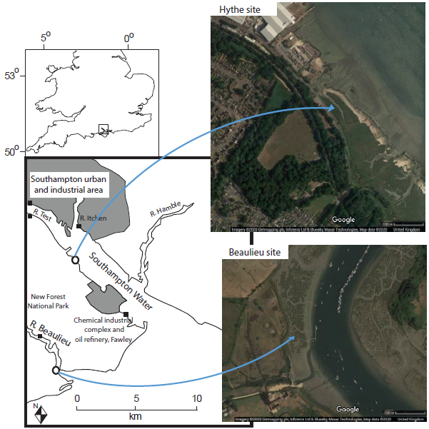
Figure 1. Study area: Southampton Water and the Beaulieu estuary, southern U.K. Aerial photographic images show detail of marsh areas sampled. Filled squares show locations of major wastewater treatment works (> 10,000 population equivalent) or site of smaller water company continuous wastewater discharge (Beaulieu River). Aerial photographic imagery Copyright 2020 Google. Map data Copyright 2020 Google.

2.2 Chemicals and materials
Solvents used for the extraction and chromatographic separation of the study compounds were of LC-MS grade (Honeywell Riedel-de Haën, Germany) and chemicals were of analytical quality (purity >96%) from Sigma-Aldrich (U.K.). The compounds selected for analysis, based on preliminary screening and chosen to represent a range of ECs chemistries, groups and potential sources (Table 1), included the pharmaceutical acetaminophen; monomers bisphenol-S (BPS), bisphenol-A (BPA) (and its biotransformation product 4′-hydroxyacetophenone (HAP)), and the perfluoroalkyl (PFASs) compounds: PFOA, PFNA, and PFBS.

Stock solutions of each compound were prepared at 1000 mg/L in acetonitrile. Stock solutions were further diluted to intermediate solutions containing a mixture of all compounds (25 and 5 mg/L) in acetonitrile, and further diluted in the same solvent to achieve the concentration levels of 4; 20; 100; 250; and 500 µg BPA/L; 2; 10; 50; 125; 250; and 500 µg BPS and HAP/L and 0.2; 1; 5; 13; 25; 50 and 100 µg/L for the rest of the study compounds. Standards were stored at 4ºC in a refrigerator until analysis.

Table 1: List of compounds assessed, their pKa, log K_{ow} and production/usage history.
Compound | Compound type | pKa | Log K_{ow} | History
Acetaminophen | Pharmaceutical | 9.38ª | 0.46ª | Pain reliever and fever reducer, first discovered 1866. Introduced to the U.K. in 1956.
Bisphenol A (BPA) | Crosslinker in polymers and thermal paper | 9.6ª, 9.44^{b} | 3.32ª, 1.65^{b} | Cross-linker in polycarbonate plastics and epoxy resins production and additive in polyvinyl chloride. Invented in 1891, first synthesis in 1905, expanded use from 1930s (epoxy resins) and 1950s (polycarbonate plastics).
4-hydroxyacetophenone (HAP) | Metabolite and degradation product from BPA | 8.12ª, 10.43^{b} | 3.31^{b} | Used in cosmetics and personal care products, also metabolite and biotransformation product of BPA.
Bisphenol S (BPS) | Crosslinker in polymers and thermal paper | 8.2ª, 8.47^{b} | 1.65ª, 3.19^{b} | Close analogue of Bisphenol A, first manufactured in 1869 as a dye. BPS has been used as a recent substitute for BPA in an increasing number of products.
Perfluorobutane sulfonic acid (PFBS) | Perfluoroalkyl and Polyfluoroalkyl Substance (PFAS) | .-3.31ª | 1.82^{c} | Surfactants used in various commercial and industrial applications since the 1940s.
Perfluorononanoic acid (PFNA) | Perfluoroalkyl and Polyfluoroalkyl Substance (PFAS) | <1ª, ~0^{d} | 4.84-7.27e
Perfluoroctanoic acid (PFOA) | Perfluoroalkyl and Polyfluoroalkyl Substance (PFAS) | 2.8ª, ~0^{d} | 6.30ª, 4.3^{f}
ª Derived from PubChem database, National Library of Medicine, National Center for Biotechnology Information, USA. https://pubchem.ncbi.nlm.nih.gov/, accessed July 2020.
^{b} Wang et al., 2002
^{c} https://www.epa.gov/tsca-screening-tools, accessed July 2020.
^{d} Goss, 2008
^{e} Howard and Meylan, 1997
^{f} Arp et al., 2006

2.3 Sample preparation and extraction - ECs.
Following collection, cores were split vertically, sub-divided into 1 cm depth increments and freeze-dried. Dried sediment samples (3g) were extracted with hexane and acetone (1:1) using microwave extraction (MARS 6 CEM microwave digester system, U.K.) following the EPA method 3546. For the determination of recovery rates in sediments from each site, and the repeatability of the extraction protocol and LC-MS analysis (Supporting Information), sediment samples (3g) were spiked with stock solution, containing a mixture of the study compounds to concentrations of 0, 50, 100, 200, and 300 ng contaminants/g sediment (in triplicate). Spiked samples were left in the dark for 24 hours before extraction to allow (a) for solvent evaporation and (b) for contaminant/sediment interaction. The slope between the amount of contaminant added and the amount found, expressed in %, was used to estimate recovery in the analysis and correct results for incomplete extraction and the effect of the matrix on the MS signal of the compounds. Enriched extracts obtained with microwave extraction were kept in 10 ml glass vials and preconcentrated to 0.5 ml with a gentle stream of nitrogen. The samples were then brought to 1 ml with methanol. Samples were analysed within 2 days and were kept in a refrigerator (4°C) until analysis. Extracts were filtered through Whatman GF/F-grade glass microfiber filters (diameter 47 mm, pore size 0.7 μm) from Fisher Scientific (Loughborough, U.K.) just before analysis. Recovery rates ranged between 7 and 28% (Table S1 – the relatively low recoveries are a consequence of the limited clean-up of compounds extracted from the sediments to ensure sub-LOD blank values – see further discussion in SI).

2.4 Sample analysis – LC-MS.
The chromatographic separation of the study compounds was carried out using a C₁₈ (150 mm × 2.1 mm) analytical column with a particle size of 2.6 μm, protected with a Securityguard ULTRATM UHPLC C₁₈ (4.6 mm ×2.1 mm) guard column, both from Kinetex® (Phenomenex, Macclesfield, U.K.). The separation was carried out with a 1260 Infinity LC (Agilent Technologies, US). Optimal separation was achieved with a binary mobile phase at a flow-rate of 0.2 ml/min. The elution program was: 20-65% of acetonitrile in water (v/v), 0-15 min; and return to the initial conditions in 5 min; followed by 5 min equilibration. The injection volume was 10 μl. The detection of the study compounds was carried out with a 6430 triple quadrupole mass spectrometer from Agilent Technologies (US), equipped with electrospray (ESI) ionisation operating in positive and negative mode depending on the analyte being eluted. Data acquisition was performed in multiple reaction monitoring (MRM) mode using the protonated molecular ion (for ESI + mode) and the deprotonated molecular ion (for ESI – mode) as precursor ion and two product ions for the quantification and confirmation of the analytes (See Table S2). Optimised ionisation source working parameters for the study compounds were: capillary voltage, ±4 kV; nebulizer gas 15 psi; curtain gas, 11 L/min, gas temperature, 300°C. Collision energy, fragmentor and electron multiplier voltage were optimised for two transition ions per target analyte and internal standard using electrospray ionisation (Table S2). The acquisitions software was Mass Hunter version B.04.00. The analytical method has previously been validated following ICH guidelines (ICH, 2005; Wilkinson et al., 2016). Limits of detection and limits of quantification for each of the target analytes are shown in Table S3. Quantification uncertainties ranged between 13 and 24% (Table S4).

Robust quality control measures were implemented throughout analysis. Before beginning each analytical run, the chromatography column was equilibrated using 15 injections of LC-MS grade water. Blanks, consisting of methanol, were injected after calibration standards and quality controls to ensure that cross contamination in the system did not occur. Furthermore, both quality controls and blanks were injected after every 5 environmental samples.

2.5 Sample analysis – radiometric dating, inorganic geochemistry, organic carbon and granulometry.
Sediment cores were vertically sub-sampled at 2 cm depth increments, and freeze-dried sediment samples counted for at least 16 hours on a Canberra well-type HPGe gamma-ray spectrometer to determine the activities of ¹³⁷Cs and other gamma-emitting radionuclides. Freeze-dried samples (as pressed pellets) were also analysed using a Philips Magix-Pro WD-XRF fitted with a 4 kW Rh target X-ray tube, to determine geochemical composition. Radiometric methods and XRF geochemical analysis methods are well established and reported in Croudace et al., 2012. Organic carbon content was estimated using the loss on ignition method (LOI, at 450˚C for 24 hours), and a carbon conversion factor for saltmarsh soils (Craft et al., 1991). Particle size distribution within sediment samples was determined using a Malvern Mastersizer 2000 laser particle size analyser. One gram of homogenized sediment was mixed with 10 mL of dispersant solution of sodium hexametaphosphate. The mixture was stirred for 5 min in order to deflocculate clay particles, after that time a small portion was taken for analysis.

2.6 Statistical analysis
A Pearson’s correlation coefficient analysis was performed to evaluate the relationships between the principal sedimentary variables (granulometry, organic carbon content), and the organic micropollutants (BPA, BPS, acetaminophen, PFOA, PFNA, PFBS and HAP) for each site. Following this, a Principal Component Analysis (PCA) was conducted using the sedimentary characteristics (including bulk geochemical data) and pollution data for all samples from both sites to evaluate trends in the data between sites. A cluster analysis (Q-mode) of the environmental variables was also conducted using the sediment characteristics and organic pollutant data for each site to evaluate the relationship between these factors on a site basis and identify differences between the sites. Variables included the 34 core variables evaluated (granulometry, concentrations of major and trace elements, organic carbon and emerging contaminants), which were classified in a hierarchical structure using the complete linkage 1-Pearson r method. All statistical analyses were conducted using Minitab 17 (PA, USA).

- Results and Discussion
3.1 Mean Emerging Contaminant (EC) concentrations.
Mean EC concentrations observed in saltmarsh sediments are statistically similar at Hythe and Beaulieu for all ECs examined (Table 2, p 0.05), ranging from 0.12 ng/g (acetaminophen), through 0.2-5.3 ng/g (perfluoroalkyl compounds) to 7.9-16.5 ng/g (BPA, BPS and HAP). All ECs examined, with the exception of PFBS, were detected at concentrations significantly above instrumental detection limits in 95% of samples analysed. For acetaminophen, concentrations observed at both Hythe and Beaulieu (Table 2) are significantly lower (< 10 times) than values reported for urban river sediments by Thiebault et al. (2017) and Wilkinson et al. (2018), and in estuarine and coastal sediments in New Zealand and South Korea (Kim et al., 2014; Stewart et al., 2014). For perfluoroalkyl compounds, a number of authors have noted the presence of very low (< 10 ng/g) concentrations of PFASs in estuarine and coastal sediments, near instrumental detection limits or at non-detectable levels. For example, in a study of the north Bohai sea region, China, Wang et al. (2011) recorded total concentrations of PFASs in sediments ranging from < LOQ to 4.3 ng/g dw, with a mean of 0.62 ng/g dw. Perfluorooctane sulphonic acid (PFOS) and PFOA were the dominant PFCs present. Mean sediment PFASs concentrations at Hythe and Beaulieu show similar relative enrichment in PFOA compared to other PFASs, but overall concentrations are significantly higher, and similar to concentrations at the upper range of those previously reported for more contaminated estuarine or river systems (e.g. Kyoto, Japan (Senthilkumar et al., 2007); Charleston, U.S.A. (White et al., 2015); sediments of three rivers in greater London, U.K. (Wilkinson et al., 2018); and Beibu Gulf, China (Pan et al., 2020), Table 2). Plasticizer concentrations (BPA, BPS, HAP) are broadly similar to those reported previously for sediment cores from other coastal and marine areas, including the Pearl River Estuary (BPA up to 12 ng/g, Peng et al., 2007), Sea of Japan (BPA up to 10 ng/g dw, Hong and Shin, 2009) and the southern Baltic Sea (BPA < 1-32 ng/g, Lubecki and Kowalewska, 2019) (Table 2). In the United Kingdom, Wilkinson et al. (2018) report mean concentrations of BPA, HAP and BPS ranging from 4.62-14.69 ng/g d.w. sediment, ND-5.65 ng/g d.w. sediment, and ND-1.4 ng/g d.w sediment respectively in three freshwater rivers in greater London. Unlike in the Wilkinson et al. (2018) study of urban freshwater rivers, however, concentrations of the biotransformation product 4′-hydroxyacetophenone were generally higher than those of its parent BPA in the estuarine systems studied here (discussed further below).

Table 2: Mean concentrations of each analyte at Hythe and Beaulieu saltmarsh sites. Previously reported data for other locations are also shown (see text for discussion).
 | Mean (SD) ng/g |  | Previously reported data (other locations) ng/g
Compound | Hythe | Beaulieu
Acetaminophen | 0.12 (0.02) | 0.13 (0.03) | <2-35 (Thiebault et al., 2017); <0.93–1.11 (Wilkinson et al., 2018); 5.5-88.5 (Kim et al., 2014); <50-145 (Stewart et al., 2014).
Bisphenol A (BPA) | 10.6 (4.8) | 7.9 (2.1) | 1-12 (Peng et al., 2007); <LOQ-10 (Hong and Shin, 2009); <1-32 (Lubecki and Kowalewska, 2019); 4.62-14.69 (Wilkinson et al., 2018).
4-hydroxyacetophenone (HAP) | 16.5 (3.7) | 11.9 (2.9) | <LOQ-5.65 (Wilkinson et al., 2018).
Bisphenol S (BPS) | 8.0 (1.4) | 7.94 (2.2) | <LOQ-1.4 (Wilkinson et al., 2018).
Perfluorobutane sulfonate (PFBS) | 0.2 (0.04) | 0.2 (0.06) | <1.13–10.7 (Wilkinson et al., 2018).
Perfluorononanoic acid (PFNA) | 3.6 (1.3) | 4.1 (0.7) | <0.75–78.6 (Wilkinson et al., 2018).
Perfluoroctanoic acid (PFOA) | 5.3 (1.2) | 4.9 (1.3) | <LOQ–0.54 (Wang et al., 2011); 1.3-3.9 (Senthilkumar et al., 2007); 0.02–2.52 (White et al., 2015); <1.13–15.4 (Wilkinson et al., 2018); <0.01-0.25 (Pan et al., 2020).

The similar mean concentrations (p 0.05) found between the Hythe and Beaulieu cores for all seven ECs examined indicate a relative ubiquity of these ECs in estuarine waters on the central southern U.K. coast, which are readily measurable even in less industrialised and urbanised settings (i.e. the Beaulieu estuary). The lack of clear enrichment in ECs in the heavily urbanised and industrialised Southampton Water system over those found in the Beaulieu estuary is most likely a consequence of (a) ECs input from a range of catchment sources, rather than a single main or point source, and (b) mixing of these inputs on the tidal circulation prior to deposition in the marsh systems. Pharmaceuticals and personal care products (e.g. acetaminophen) are most likely to enter these estuaries via wastewater treatment plants and overflows from combined sewers (Munro et al., 2019). There are five WWTPs directly discharging treated effluent into the wider Southampton Water system with a combined population equivalence of 359,489 people (Portswood WWTP- p.e. 72657, Millbrook WWTP- p.e. 134433, Marchwood WWTP- p.e. 74266, Woolston WWTP- p.e. 63622 and Ashlett Creek/Fawley WWTP- p.e. 14511). In addition, there are at least five more discharging into rivers within 10 km of Southampton Water. There are also at least nine combined sewage overflow points which will discharge untreated sewage directly into Southampton Water during times of heavy rainfall. In the Beaulieu River there are fewer wastewater sources, but there is a small WWTP just south of Beaulieu village and 4-6 domestic properties or farms along the Beaulieu river with discharge licences. There is also the Boldre WWTP which discharges into the Hatchet Stream which joins with the Beaulieu River near the Southampton Yacht Club. These (and other) sources have been linked with historical closure of local bivalve fisheries. In addition to inputs via WWTP discharge, PFASs are associated with areas of train traffic, airports, military and other training installations, port and boat activity and in storm runoff from built developments and roads (Zushi and Masunaga, 2009; Xiao et al., 2012; Ahrens et al., 2015; Yan et al., 2015; Anderson et al., 2016; Wilkinson et al., 2016). While Southampton Water is a much more urbanised and industrialised system, both study estuaries share a range of these input sources, particularly boating activity and boatyards. Similarly, another important source of plastic degradation products and PFASs are plastic water pipes (Schaefer et al., 2006; Wilkinson et al., 2016). These sources are likely to provide a continual discharge to both estuarine systems, which are then mixed by tidal and other currents prior to deposition in the marsh systems.

3.2 EC distribution with sediment depth, and retention of temporal trends in contaminant input.
The distribution of ECs with depth in each sediment core (Figure 2) is relatively irregular (Hythe-BPA and HAP, and PFASs) or quasi-linear with a slight decline in concentration with depth (remaining profiles). Acetaminophen shows a near-exponential decline in concentration with depth in the Beaulieu marsh, from surface concentrations of 0.2-0.24 ng/g dw to ca. 0.1 ng/g dw at -20 cm depth, although this pattern is not replicated in the Hythe marsh core. At both sites sampled, the seven ECs are present above respective LOD throughout the cored depth of 35+ cm. While slight inflections in the profiles frequently occur at similar depths, particularly when comparing different PFASs, where clear subsurface concentration maxima are present (e.g. Hythe core, for BPA, at -26 cm depth) these do not correlate with peaks in other contaminants, or with subsurface maxima in organic carbon content (Figure 2, Table S5). As noted above, concentrations of the biotransformation product HAP were generally higher than those of BPA, shown by a ratio > 1 at most sampled depths throughout the sediment cores (Figure 3). Higher ratios of HAP to the BPA parent compound (HAP:BPA ratio) may indicate greater transformation of BPA within WWTW, in-estuary or in-marsh degradation of BPA into HAP, or additional HAP sources in these systems. There is no evidence however of consistent changes of HAP:BPA with burial depth that may indicate increasing biotransformation of BPA with burial time in the marsh. At Hythe, HAP:BPA ratios increase to >4 at -15 cm depth, then decrease to <1 due to the prominent subsurface maximum in BPA at -26 cm depth. Although similar HAP:BPA ratios were previously observed within the first 5 cm of sediment depth in semi-rural stretches of the River Bourne in the U.K., those observed here were generally higher than in sediment of small urban rivers (Wilkinson et al., 2018). This may be partially driven by (a) diverse inputs of BPA into urban rivers (Osenbrück et al., 2007; Proctor et al., 2020) increasing the amount of the parent compound relative to metabolites and (b) degradation of BPA into HAP via sediment dwelling bacteria such as Pseudomonas putida (Eltoukhy et al., 2020) and Sphingomonas sp. (Zhang et al., 2013). BPA to BPS ratios were generally close to 1 (or less), with the exception of two samples at depth in the Hythe core – no consistent recent decrease in this ratio was observed which might record the documented replacement of BPA with BPS in industrial and commercial products.
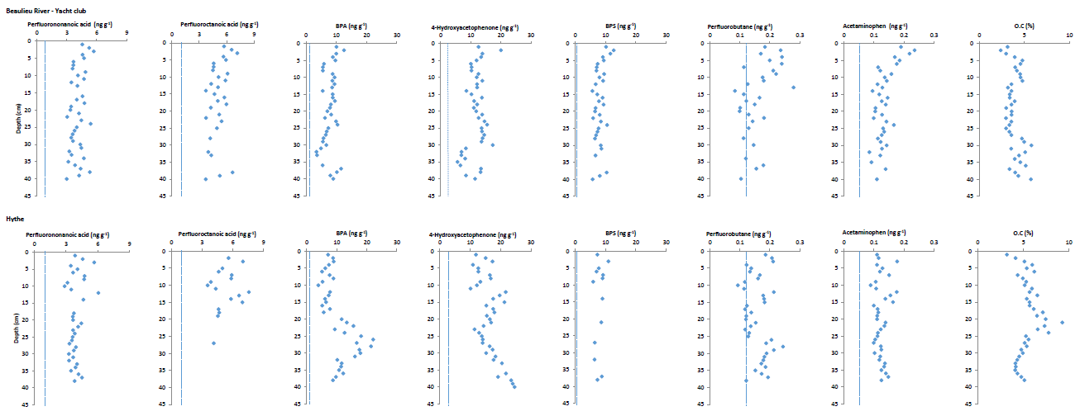 Figure 2: PFNA, PFOA, BPA, HAP, BPS, PFBS, acetaminophen and organic carbon (via LOI analysis) distribution with depth in Beaulieu (top) and Hythe (bottom) saltmarsh cores. Profiles are arranged from high to low K_{ow} (left to right). Dashed vertical line on selected graphs shows limit of detection, determined at a signal-to-noise ratio of 3 from injection of spiked soil sample extracts (Table S3).

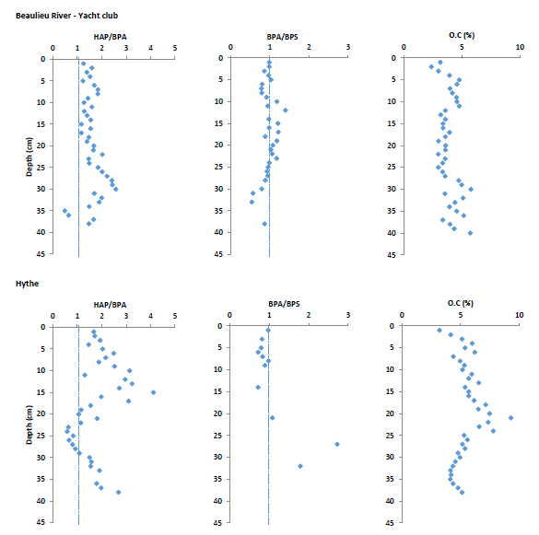
Figure 3: HAP/BPA and BPA/BPS ratios, and organic carbon (via LOI analysis), distribution with depth in Beaulieu (top) and Hythe (bottom) saltmarsh cores. Dashed vertical line on HAP/BPA and BPA/BPS graphs shows one to one ratio.
The sediment cores examined were dated via ¹³⁷Cs dating, supported (at Hythe only) by matching the vertical distribution of Cu in the sediment with the known discharge history of this heavy metal from the Fawley refinery (e.g. Cundy and Croudace, 2017). In both cores examined ¹³⁷Cs shows a prominent subsurface maximum at -28 cm (Beaulieu) and -23 cm (Hythe) (Figure 4), which in this region of the southern U.K. has been previously established to correspond to the 1963 fallout maximum from above ground nuclear weapons testing (Cundy and Croudace, 1996; Cundy et al., 1997; Cundy and Croudace, 2017). This provides a defined age marker in the sediment column, indicating a sediment accumulation rate of ca. 5 mm/year (Beaulieu) and ca. 4 mm/year (Hythe), in agreement with previously reported data for these and surrounding marsh systems (Cundy and Croudace, 1996; Cundy et al., 1997; Thomson et al., 2002; Cundy and Croudace, 2017). The broad subsurface maximum in Cu in the Hythe core between -20 and -25 cm reflects increasing Cu discharges from the Fawley refinery prior to additional effluent control measures in 1970/71 (Cundy and Croudace, 2017), indicating a sediment accumulation rate of 4 mm/year at Hythe, corroborating the ¹³⁷Cs-derived rate (NB. Cu concentrations at Beaulieu conform with local geogenic background, Croudace and Cundy, 1995). Given these dates and sediment accumulation rates, it is clear that all ECs analysed are present at above-LOD concentrations in sediments deposited prior to 1960, and potentially (if constant sediment accumulation rates are assumed) in pre-1950 sediments. Some ECs therefore are found at depths which pre-date their widespread environmental introduction (e.g. acetaminophen, PFASs, Table 1), which indicates their diffusion or transport to deeper, older sediment core horizons, possibly driven by tidal flushing (i.e. horizontal and vertical percolation of incoming water associated with tidal inundation). This, and the lack of any consistent subsurface maxima or trends in concentration (or in EC ratios, e.g. BPA:BPS) that can be correlated with their increasing production and use, industrial development or urbanisation activities (e.g. known timing of population increases, port and port traffic development, boating activity and WWTW construction) highlights that these sediments do not contain a record of likely historical contaminant loading each estuary, and do not record temporal trends in estuarine EC inputs. This finding contrasts both with sediment core data for ECs in freshwater (riverine) sediments presented by Thiebault et al., (2017) (and more recently by Mourier et al., 2019), and with the recorded retention of trends in historical inputs of various heavy metals, radionuclides and (for Southampton Water) hydrocarbon residues in the two estuaries studied here (Little et al., 1988; Croudace and Cundy, 1995; Cundy and Croudace, 1996; Thomson et al., 2002; Cundy and Croudace, 2017). Similar mobility for estrone (E1) has however been observed in clay-rich estuarine sediments in the Ouse estuary, U.K. (Labadie et al., 2007), while Peng et al., (2007) found that nonylphenol was quantifiably detected in sediments predating its widespread application (1940s) in the Pearl River estuary, suggesting the downward penetration of NP in the sediment column.
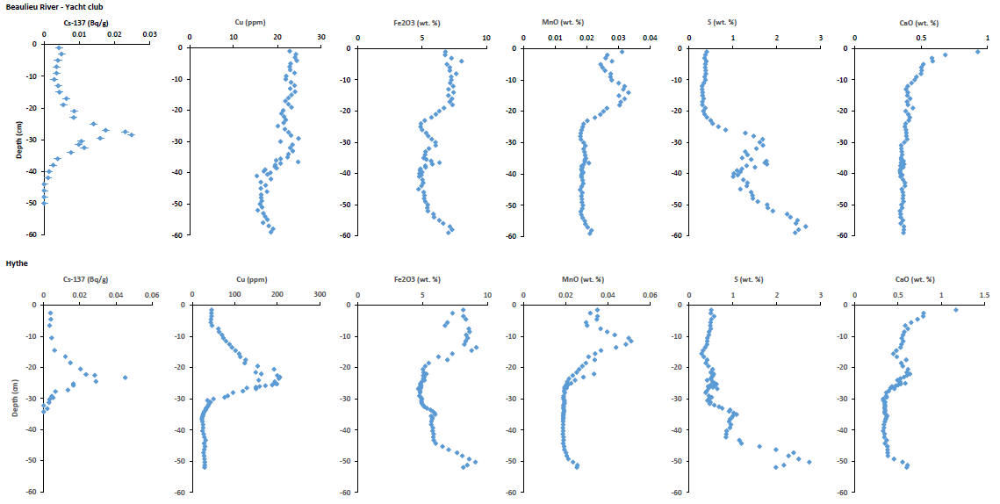
Figure 4: ¹³⁷Cs, Cu, Fe₂O₃, MnO, S, and CaO distribution with depth in Beaulieu (top) and Hythe (bottom) saltmarsh cores.
3.3 Geochemical associations of ECs, and effectiveness of the “estuarine filter”.
Consideration of bulk geochemical data for the redox-sensitive elements Fe, Mn and S (Figure 4) indicates that there is a relatively well-developed redox zonation in each core, with increases in solid phase sulphur at depth (>25 cm depth, Beaulieu, greater than 30 cm depth, Hythe) reflecting the development of anoxic conditions in deeper sections of the marsh, resulting in sulphate reduction and precipitation of Fe sulphides. This redox zonation shows no apparent relationship with ECs distribution or with HAP:BPA ratio. Calcium distribution shows a decline with depth from a surface maximum value, as observed elsewhere (e.g. Spencer et al., 2003) due to decalcification, which occurs in oxic saltmarsh sediments in response to a lowering of pH resulting from nitrification and decomposition of organic matter.
The application of PCA highlighted clear differences in composition and contaminant geochemistry between the sites, with higher scores along axis 1 identified for the Hythe site and lower values for the Beaulieu site (Figure 5). Axis 1 however only accounted for 35.9% of the variation in the data, and axis 2 accounted for 18.2% of the variation, which shows (a) the multiparametric character of the data, and (b) the lack of clear association of ECs with any one defined component of the sediment. The main factors influencing axis 1 were: K₂O, V, Pb, MgO, TiO₂, Ba, Sand, Al₂O₃, and S, whereas the main factors influencing axis 2 were Cl, I, Na₂O, P₂O₅, MnO, CaO, Cu, and OC (Figure 5). The principal factors that were found to differentiate the sites were those concerning sedimentary characteristics (e.g. granulometry, mineralogy, organic carbon, redox processes) with minor differences in the observed values of the organic pollutants between each studied estuary. This suggests that chemistry and contaminant binding is more complex than direct correlation (or direct interaction) of ECs with sedimentary particulate organic carbon – regardless of the individual contaminant’s functionality and hydrophobicity (Table 1, and Table S5). As observed by other authors, this may at least partly be an effect of colloidal association and transport of these ECs (e.g. Kalmykova et al., 2013). Cluster analysis noted two main groupings in each studied system. At Beaulieu, ECs are related with clay and silt (Figure 6a); whereas at Hythe they are distributed across all sediment fractions such as sand, silt and clay (Figure 6b). This suggests some degree of fine sediment association at Beaulieu, with supply of ECs associated with fine suspended material that may have been sourced from other areas in the estuary more impacted by industrial and leisure (e.g. boating) activity or WWTWs.

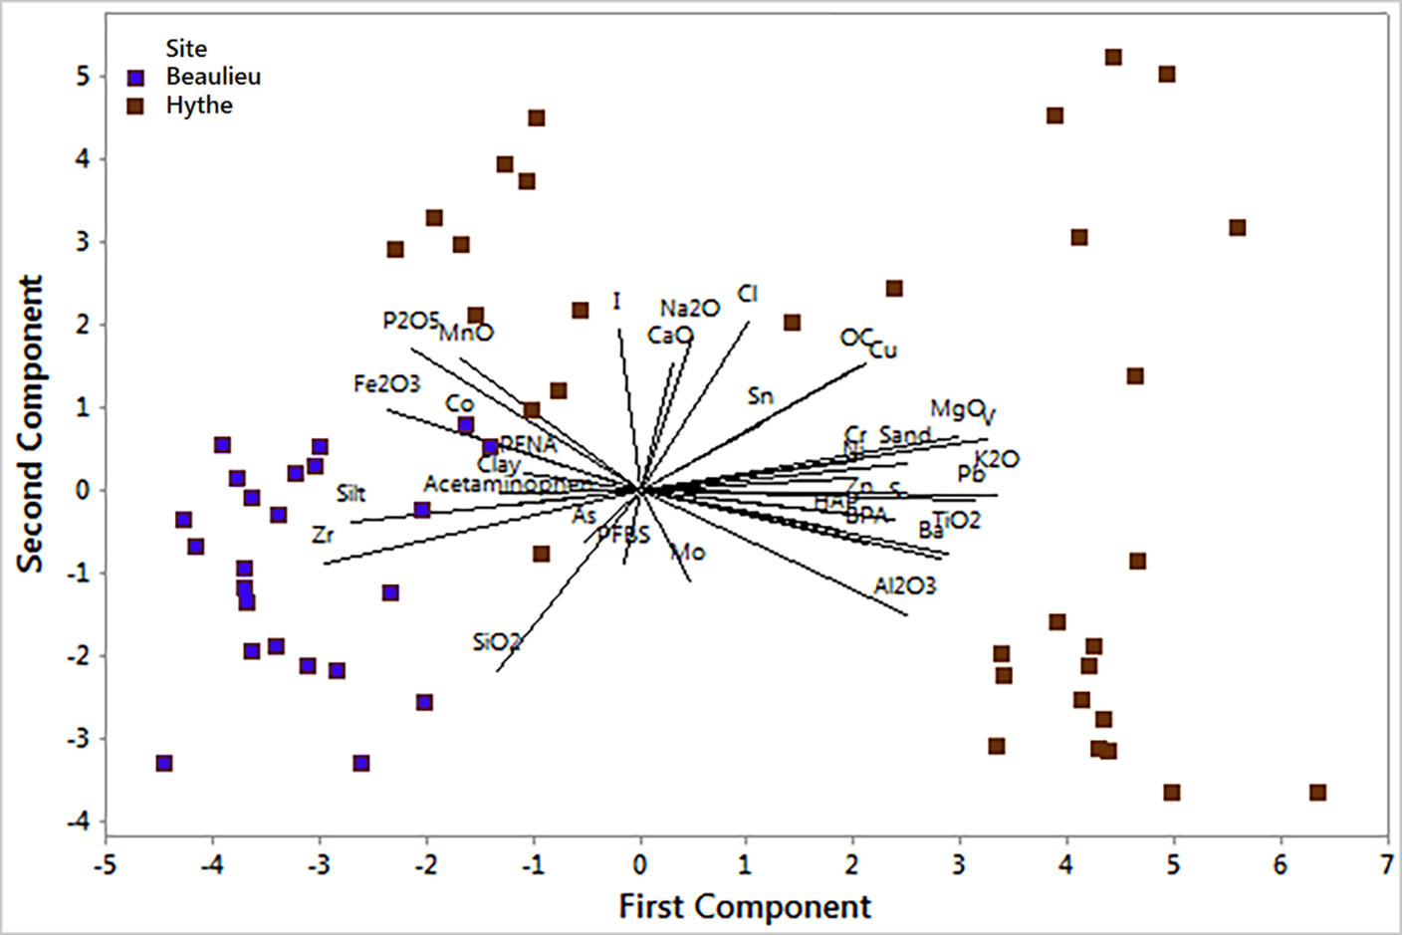
Figure 5: PCA ordination plot showing all subsamples from cores at Beaulieu and Hythe with environmental vectors.

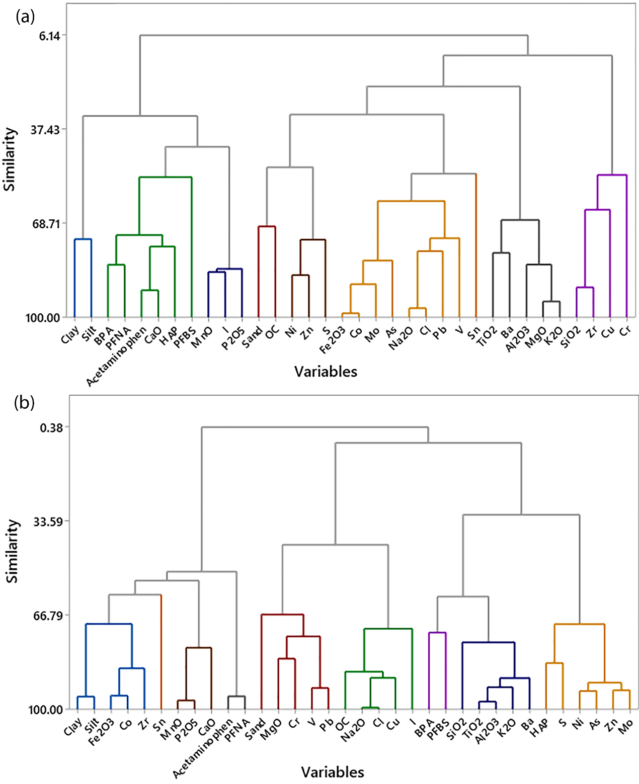
Figure 6: Tree diagram for the 34 core variables studied, derived from a cluster analysis using the complete linkage 1-Pearson r method. (a) shows data for Beaulieu and (b) shows data for the Hythe site.
At the seawater pHs observed around the sampling sites (7-8.5), both ionised and non-ionised forms of acetaminophen and the bisphenols will be present, although the neutral species will be the most abundant. In contrast, the anionic form of the perfluoroalkyl acids will dominate (ITRC, 2020). Hence the perfluoroalkyl species will be expected to have a more amphiphilic character under these environmental conditions: with a fluorinated tail participating in van der Waals and hydrogen bonding interactions with organic matter and negatively charged carboxylic groups, with a capacity also to participate in hydrogen bonding and/or interact ionically with cations (e.g amino groups from organic matter or free metals). In addition, sorption (e.g. to organic carbon) generally increases with increasing perfluoroalkyl tail length, indicating that long-chain PFASs (for example, PFOA) would be expected to be more strongly sorbed than their shorter-chain counterparts (e.g. PFBS) (ITRC, 2020). Despite these likely differences in sediment binding potential, the data presented here show little apparent long-term sequestration in intertidal sediments for any of the seven ECs examined – while sediments are clearly labelled with these contaminants, the ECs are apparently relatively mobile in the marsh systems studied, and a contaminant chronology or record of temporal inputs is not retained in the sediment cores. Where subsurface maxima are present (most prominently here for BPA at the Hythe marsh) these most likely relate to local flushing or diffusive processes and cannot be clearly linked to likely input trends or changes in sediment geochemistry. Unlike radionuclides and heavy metals, which are effectively sequestered and buried for long periods (depending on longer term sediment accumulation and marsh erosion trends, e.g. Cundy and Croudace (2017)), the “estuarine filter” here, at least for these intertidal saltmarsh sediments, shows reduced potential to sequester the seven ECs examined and mediate their supply to coastal and shelf environments.

- Conclusions
- Seven, relatively water-soluble and environmentally mobile, ECs were examined and found to be present in the ng/g range in both Hythe and Beaulieu saltmarsh sediments, with concentrations ranging from 0.12 ng/g (acetaminophen), through 0.2-5.3 ng/g (perfluoroalkyl compounds) to 7.9-16.5 ng/g (BPA, BPS and HAP).
- Broadly similar mean concentrations were found between the Hythe and Beaulieu sediment cores for all ECs examined, indicating a relative ubiquity of these ECs in estuarine waters on the central southern U.K. coast. The lack of clear enrichment in ECs in the heavily urbanised and industrialised Southampton Water (Hythe) system over those found in the non-urbanised Beaulieu estuary is most likely a consequence of ECs input from a range of catchment sources, rather than a single main or point source, and mixing of these inputs on the tidal circulation prior to deposition in the marsh systems.
- The ECs are apparently relatively mobile in the marsh systems studied, and where subsurface concentration maxima are present these most likely relate to local flushing or diffusive processes and cannot be clearly linked to likely input trends or changes in sediment geochemistry (including in sedimentary organic carbon content).
- Despite their likely differences in sediment binding potential (with reported Log K_{ow} values ranging from ca. 0.5 to > 7), the data presented here show little apparent long-term sequestration in intertidal sediments for any of the ECs assessed. Unlike radionuclides and heavy metals, which can be effectively sequestered and buried for long periods, the “estuarine filter” here, at least for these intertidal saltmarsh sediments, shows reduced potential to sequester the ECs examined and mediate their supply to coastal and shelf environments.

SUPPORTING INFORMATION.
Further information on background contamination and analyte recovery, and tables of quality parameters in the determination of ECs, mass spectrometry acquisition conditions, limits of detection and quantification for each studied EC analyte, uncertainties in the quantification of the study compounds, and correlation matrix including granulometry, organic carbon and organic pollutants for study sites.

AUTHOR INFORMATION.
Corresponding Author
* Corresponding author: Professor Andrew B. Cundy, School of Ocean and Earth Science, University of Southampton, National Oceanography Centre (Southampton), European Way, Southampton, SO14 3ZH, U.K. Email – A.Cundy@soton.ac.uk

ACKNOWLEDGEMENTS.
OCH is grateful to the Consejo Nacional de Ciencia y Tecnologia (CONACYT), Mexico for funding through the scholarship program (No 209683), and to the Universities of Southampton and Brighton for hosting the Fellowship under which this work was undertaken. RB acknowledges GCRF-UKRI funding received from Kingston University.

NOTES.
The authors declare no competing financial interest.

REFERENCES:
Ahrens, L.; Norström, K.; Viktor, T.; Cousins, A.P.; Josefsson, S. Stockholm Arlanda Airport as a source of per-and polyfluoroalkyl substances to water, sediment and fish. Chemosphere. 2015, 129, 33-38.
Anderson, R.H.; Long, G.C.; Porter, R.C.; Anderson, J.K. Occurrence of select perfluoroalkyl substances at US Air Force aqueous film-forming foam release sites other than fire-training areas: Field-validation of critical fate and transport properties. Chemosphere. 2016, 150, 678-685.
Arp, H. P.; Niederer, C.; Goss, K.-U. Predicting the partitioning behavior of various highly ﬂuorinated compounds. Environ. Sci. Technol. 2006, 40, 7298–7304.
CEFAS. Beaulieu River Sanitary Survey. Centre for Environment, Fisheries and Aquaculture Science, Weymouth, Dorset, UK, 2015; https://www.cefas.co.uk/publications-data/food-safety/sanitary-surveys/england-and-wales/.
Chen, L.; Hu, Ch.; Tsui, M.M.P.; Wang, T.; Peterson, D.R.; Shi, Q.; Lam, P.K.S.; Au, T.; Lam, J.C.W.; Zhou, B. Multigenerational Disruption of the Thyroid Endocrine System in Marine Medaka after a Life-Cycle Exposure to Perfluorobutanesulfonate. Environ. Sci. Technol. 2018, 52, 4432−4439.
Costa F.; Lago, A.; Rocha, V.; Barros, O.; Costa, L.; Vipotnik, Z.; Silva, B; Tavares, T. A Review on Biological Processes for Pharmaceuticals Wastes Abatement—A Growing Threat to Modern Society. Environ. Sci. Technol. 2019, 53, 7185-7202.
Craft, C.; Senega, E.; Broome, S. Loss on ignition and Kjeldahl digestion for estimating organic Carbon and total Nitrogen in estuarine marsh soils. Estuaries. 1991, 14(2), 175-179
Croudace I.W; Cundy A.B. A record of heavy metal and hydrocarbon pollution in recent sediments from Southampton Water, southern England: a geochemical and isotopic study, Environ. Sci. Technol. 1995, 29, 1288-1296.
Croudace I.W; Warwick, P.E.; Morris, J.E. Evidence for the Preservation of Technogenic Tritiated Organic Compounds in an Estuarine Sedimentary Environment. Environ. Sci. Technol. 2012, 46, 11, 5704-5712.
Cundy, A.B.; Croudace, I.W. Sediment Accretion and Recent Sea-level Rise in the Solent, Southern England: Inferences from Radiometric and Geochemical Studies. Estuar. Coast. Shelf S. 1996, 43, 449-467.
Cundy, A.B.; Croudace, I.W.; Thomson, J.; Lewis, J.T. Reliability of Salt Marshes as “Geochemical Recorders” of pollution Input: A Case Study from Contrasting Estuaries in Southern England. Environ. Sci. Technol. 1997, 31, 1093-1101.
Cundy A.B.; Croudace, I.W. The fate of contaminants and stable Pb isotopes in a changing estuarine environment: 20 years on. Environ. Sci. Technol. 2017, 51, 9488–9497.
Eltoukhy, A., Jia, Y., Nahurira, R., Abo-Kadoum, M.A., Khokhar, I., Wang, J. and Yan, Y. Biodegradation of endocrine disruptor Bisphenol A by Pseudomonas putida strain YC-AE1 isolated from polluted soil, Guangdong, China. BMC microbiology. 2020, 20, 11.
Gaston L.; Lapworth, D.J.; Stuart, M.; Arnscheidt, J. Prioritization Approaches for Substances of Emerging Concern in Groundwater: A Critical Review. Environ. Sci. Technol. 2019, 53, 6107−6122.
Goss, K-U. The pKa values of PFOA and other highly fluorinated carboxylic acids. Environ. Sci. Technol. 2008, 42, 456–458.
Hong, S.; Shin, K. Alkylphenols in the core sediment of waste dumpsite in the East Sea (Sea of Japan), Korea. Mar. Pollut. Bull. 2009, 58, 1566-1587.
Howard, P.H.; Meylan, W.M. (Eds.). Handbook of Physical Properties of Organic Chemicals, Part 1. Lewis Publishers, CRC Press, Baton Rouge, 1997, pp.2112.
Hydes, D. Nutrients in the Solent: Solent Science- A Review. Collins, M.B., Ansell, K., Eds; Progress in Marine Science; Elsevier Science; 2000; pp. 135-148.
ICH, 2005. International Conference on Harmonisation, Harmonised Tripartite Guideline Validation of Analytical Procedures: Text and Methodology Q2(R1)
Interstate Technology Regulatory Council (ITRC). Technical resource for addressing environmental releases of Per- and Polyfluoroalkyl substances (PFAS). ITRC, Washington DC, USA, 2020; https://pfas-1.itrcweb.org/# (accessed July 2020)
JNCC, 2017. Joint Nature Conservation Committee. http://sac.jncc.gov.uk/habitat/H1130 (accessed July 2020).
Kalmykova, Y.; Björklund, K.; Strömvall, A-M.; Blom, L. Partitioning of polycyclic aromatic hydrocarbons, alkylphenols, bisphenol A and phthalates in landfill leachates and stormwater. Wat. Res. 2013, 47, 1317-1328.
Kim, S.; Lee, S.; Kim, Ch.; Liu, X.; Seo, J.; Jung, H.; Ji, K.; Hong, S.; Park, J.; Khim, J.S.; Yoon, S.; Lee, W.; Park, J.; Choi, K. In vitro and in vivo toxicities of sediment and surface water in an area near a major steel industry of Korea: Endocrine disruption, reproduction on survival effects combined with instrumental analysis. Sci. Total Environ. 2014, 470-471, 1509-1516.
Kolpin, D.W.; Furlong, E.T.; Meyer, M.T.; Thurman, E.M.; Zaugg, S.D.; Barber, L.B.; Buxton, H.T. Pharmaceuticals, hormones, and other organic wastewater contaminants in US streams, 1999-2000: a national reconnaissance. Environ. Sci. Technol. 2002, 36 (6), 1202-1211.
Labadie, P.; Cundy, A.B.; Stone, K.; Andrews, M.; Valbonesi, S.; Hill, E.M. Evidence for the migration of steroidal estrogens through river bed sediments. Environ. Sci. Technol. 2007, 41, 4299 -4304.
Little, D.I.; Howells, S.E.; Smith, J.; Mangini, A. Time Sequence and Fate of Contaminants in Core Sediments of Southampton Water. Technical Report, FSC/OPRU/16/87, Field Studies Council, Pembroke, UK. 1988, DOI: 10.13140/RG.2.2.22701.64482.
Lubecki, L.; Kowalewska, G. Plastic-derived contaminants in sediments from the coastal zone of the southern Baltic Sea. Mar. Pollut. Bull. 2019, 146, 255-262.
Mourier, B.; Labadie, P.; Desmet, M.; Grosbois, C.; Raux, J.; Debret, M.; Copard, Y.; Pardon, P.; Budzinski, H.; Babut, M. Combined Spatial and Retrospective Analysis of Fluoroalkyl Chemicals in Fluvial Sediments Reveal Changes in Levels and Patterns over the Last 40 Years. Environ. Pollut. 2019, 253, 1117-1125.
Munoz, G.; Budzinski, H.; Labadie, P. Influence of Environmental Factors on the Fate of Legacy and Emerging Per- and Polyfluoroalkyl Substances along the Salinity/Turbidity Gradient of a Macrotidal Estuary. Environ. Sci. Technol. 2017, 51, 21, 12347–12357
Munro, K.; Martins, C.P.B.; Loewenthal, M.; Comber, S.; Cowan, D.A.; Pereira, L.; Barron, L.P. Evaluation of combined sewer overflow impacts on short-term pharmaceutical and illicit drug occurrence in a heavily urbanised tidal river catchment (London, UK). Sci. Total Environ. 2019, 657, 1099-1111.
Osenbrück, K.; Gläser, H.R.; Knöller, K.; Weise, S.M.; Möder, M.; Wennrich, R.; Schirmer, M.; Reinstorf, F.; Busch, W.; Strauch, G. Sources and transport of selected organic micropollutants in urban groundwater underlying the city of Halle (Saale), Germany. Wat. Res. 2007, 41, 3259-3270.
Pan, Ch., G.; Wang, Y., H.; Yu, K., F.; Zhang, W.; Zhang, J.; Guo, J. Occurrence and distribution of perfluoroalkyl substances in surface riverine and coastal sediments from the Beibu Gulf, south China. Mar. Pollut. Bull. 2020, 150, 110706.
Peng, X.; Wang, Z.; Mai, B.; Chen, F.; Chen, S.; Tan, J.; Yu, Y.; Tang, C.; Li, K.; Zhang, G.; Yang, C. Temporal trends of nonylphenol and bisphenol A contamination in the Pearl River Estuary and the adjacent South China Sea recorded by dated sedimentary cores. Sci. Total Environ. 2007, 384, 393-400.
Petrie, B.; Barden, R.; Kasprzyk-Hordern, B. A review on emerging contaminants in wastewaters and the environment: current knowledge, understudied areas and recommendations for future monitoring. Water Res. 2015, 72, 3-27.
Proctor, K.; Petrie, B.; Lopardo, L.; Camacho Munoz, D.; Rice, J.; Barden, R.; Arnot, T.; Kasprzyk-Hordern, B. Micropollutant fluxes in urban environment – A catchment perspective. J. Haz. Mat. 2020, 401, 123745.
Quaresma, V.S.; Bastos A.C.; Amos, C.L. Sedimentary processes over an intertidal flat: A field investigation at Hythe flats, Southampton Water (UK). Mar. Geol. 2007, 241, 117-136. Richardson, S.; Ternes, T.A. Water analysis: emerging contaminants and current Issues. Anal. Chem. 2018, 90, 398−428.
Schaefer, A.; Booth, B.; Lubick, N; Betts, K.S. Plastic pipes could contaminate water. Environ. Sci. Technol. 2006, 40, 23, 7108-7114 (news).
Senthilkumar, K.; Ohi, E.; Sajwan, K.; Takasuga, T.; Kannan, K. Perfluorinated compounds in river water, river sediment, market fish, and wildlife samples from Japan. B. Environ. Contam. Tox. 2007, 79, 427–431.
Smital, T. Acute and Chronic Effects of Emerging Contaminants. In: Barceló D., Petrovic M. (eds) Emerging Contaminants from Industrial and Municipal Waste. The Handbook of Environmental Chemistry, vol 5S/1. 2008, pp 105-142. Springer, Berlin, Heidelberg. https://doi.org/10.1007/698_5_105.
Southampton City Council, 2019. Southampton Strategic Assessment. https://data.southampton.gov.uk/ (accessed July 2020).
Spencer K.; Cundy, A.B.; Croudace, I.W. Heavy metal distribution and early-diagenesis in salt marsh sediments from the Medway estuary, Kent, U.K. Estuar. Coast. Shelf S. 2003, 57, 43-54.
Stewart, M.; Olsen, G.; Hickey, C.W.; Ferreira, B.; Jelic, A.; Petrovic, M.; Barcelo, D. A survey of emerging contaminants in the estuarine receiving environment around Auckland, New Zealand, Sci. Total Environ. 2014, 468-469, 202-210.
Thiebault, T.; Chassiot, L; Fougere, L.; Destandau, E.; Simonneau, A.; Van Beek, P.; Souhaut, M.; Chapron, E. Record of pharmaceutical products in river sediments: A powerful tool to assess the environmental impact of urban management? Anthropocene. 2017, 18, 47–56
Thomas, J.K.; Birceanu, O.; Sadoul, B; Vijayan, M.M. Bisphenol A in Eggs Impairs the Long-Term Stress Performance of Rainbow Trout in Two Generations. Environ. Sci. Technol. 2018, 52, 7951-7961.
Thomson, J.; Dyer, F.M.; Croudace, I.W. Records of radionuclide deposition in two salt marshes in the United Kingdom with contrasting redox and accumulation conditions. Geochim. Cosmochim. Ac. 2002, 66 (6), 1011-1023.
Turner, A. Salting out of chemicals in estuaries: implications for contaminant partitioning and modelling. Sci. Total Environ. 2003, 314-316, 599– 612.
Velegrakis, A.F.; Michel, D.; Collins, M.B.; Lafite, R.; Oikononow, E.K.; Dupont, J.P.; Huault, M.F.; Lecouturier M.; Salomon J.C.; Bishop, C. Sources, sinks and resuspension of suspended particulate matter in eastern English Channel. Cont. Shelf Res. 1999, 19, 1933-1957.
Wang, L.; Ying, G.C.; Zhao, J.L.; Liu, S.; Yang, B.; Zhou, L.J.; Tao, R.; Su., H.C. Assessing estrogenic activity in surface water and sediment of the Liao River system in northeast China using combined chemical and biological tools. Environ. Pollut. 2011, 159, 148-156.
Wang, X.; Yu, J.; Wang, Y.; Wang, L. Mechanism-based quantitative structure–activity relationships for the inhibition of substituted phenols on germination rate of Cucumis sativus. Chemosphere 2002, 46, 241–250.
White, N.D.; Bathis, L.; Kannan, K.; De Silva, A.; Wu, Q.; French, K.M.; Dougomah, J.; Spencer, CH.; Fair, P. Elevated levels of perfluoroalkyl substances in estuarine sediments of Charleston, S.C. Sci. Total Environ. 2015, 521-522, 79-89.
Wilkinson, J.L.; Hooda, P.S.; Barker, J.; Barton, S.; Swinden, J. Ecotoxic pharmaceuticals, personal care products, and other emerging contaminants: a review of environmental, receptor-mediated, developmental, and epigenetic toxicity with discussion of proposed toxicity to humans. Crit. Rev. Environ. Sci. Technol. 2015, 46 (4), 336-381.
Wilkinson J.L.; Swinden, J.; Hood, P.; Barker, J.; Bartons, S. Markers of anthropogenic contamination: A validated method for quantification of pharmaceuticals, illicit drug metabolites, perfluorinated compounds, and and plasticisers in sewage treatment effluent and rain runoff. Chemosphere. 2016, 159, 638-646.
Wilkinson, J.L.; Hooda, P.S.; Swinden, J.; Barker, J.; Barton, S.; Spatial (bio) accumulation of pharmaceuticals, illicit drugs, plasticisers, perfluorinated compounds and metabolites in river sediment, aquatic plants and benthic organisms. Environ. Pollut. 2018, 234, 864-875.
Xiao, F.; Simcik, M.F.; Gulliver, J.S. Perfluoroalkyl acids in urban stormwater runoff: influence of land use. Water Res. 2012, 46(20), 6601-6608.
Yan, H.; Zhang, C.; Zhou, Q.; Yang, S. Occurrence of perfluorinated alkyl substances in sediment from estuarine and coastal areas of the East China Sea. Environ. Sci. Pollut. R. 2015, 22(3), 1662-1669.
Zhang, W., Yin, K. and Chen, L. Bacteria-mediated bisphenol A degradation. Applied microbiology and biotechnology, 2013, 97, 5681-5689.
Zhao, Y.; Yang, Sh.; Li, H.; Wang, D. Adsorption behaviors of acetaminophen onto sediment in the Weihe River, Shaanxi, China. Int. J. Sediment. Res. 2015, 30, 263–271.
Zushi, Y; Masunaga, S. Identifying the nonpoint source of perfluorinated compounds using a geographic information system based approach. Environ. Toxicol. Chem. 2009, 28(4), 691-700.

GRAPHICAL ABSTRACT


