International Core Outcome Set for acute simple appendicitis in children: Results of a systematic review, Delphi study, and focus groups with young people

Max Knaapen M, MD¹; Nigel J Hall, PhD²; Darcy Moulin³; Johanna H. van der Lee, PhD^{4,5} Nancy J Butcher, PhD⁶; Peter C Minneci, MD⁷; Jan F Svensson, PhD⁸; Shawn D St. Peter, MD⁹; Susan Adams, MD¹⁰; Shireen A Nah, MD^{11,12}; Erik D Skarsgard, MD¹³; Augusto Zani, PhD^{14,15}; Sherif Emil, MD¹⁶; Janne S Suominen, PhD¹⁷; Dayang A Aziz, MD¹⁸; Rambha Rai, MD¹¹; Martin Offringa, PhD^{6,19};Ernst W van Heurn, PhD¹; Roel Bakx, PhD¹; Ramon R Gorter, MD, PhD¹ + On behalf of the pediatric appendicitis COS development group
- Department of Pediatric Surgery, Emma Children’s Hospital, Amsterdam UMC, University of Amsterdam & Vrije Universiteit, Amsterdam, The Netherlands
- University Surgery Unit, Faculty of Medicine, University of Southampton, Southampton General Hospital, Southampton, UK; Department of Paediatric Surgery and Urology, Southampton Children's Hospital, Southampton, UK
- Parent and Patient representative, USA
- Pediatric clinical Research Office, Emma Children’s Hospital, Amsterdam UMC, University of Amsterdam, Amsterdam, The Netherlands
- Knowledge Institute of the Dutch Association of Medical Specialists, Utrecht, The Netherlands
- Child Health Evaluative Sciences, The Hospital for Sick Children Research Institute, Toronto, Canada
- Center for Surgical Outcomes Research, Abigail Wexner Research Institute and Department of Surgery, Nationwide Children's Hospital, Columbus, OH, USA
- Department of Pediatric Surgery, Karolinska University Hospital, Stockholm, Sweden; Department of Women´s and Children´s Health, Karolinska Institute, Stockholm, Sweden
- Department of Surgery, Children's Mercy Hospital, Kansas City, MO, USA
- Department of Pediatric Surgery, Sydney Children’s Hospital, Randwick, NSW, Australia, School of Women’s and Children’s Health, University of New South Wales
- Department of Pediatric Surgery, KK Women's and Children's Hospital, Singapore, Singapore
- Division of Paediatric Surgery, Department of Surgery, Faculty of Medicine, University of Malaya, Kuala Lumpur, Malaysia
- Department of Pediatric Surgery, British Columbia Children’s Hospital, Vancouver, BC, Canada
- Division of General and Thoracic Surgery, The Hospital for Sick Children, Toronto, ON, Canada
- Department of Surgery, University of Toronto, Toronto, ON, Canada
- Harvey E. Beardmore Division of Pediatric Surgery, Montreal Children’s Hospital, Montreal, QC, Canada
- Department of Pediatric Surgery, Helsinki Children’s Hospital, Helsinki, Finland
- Department of Pediatric Surgery, Universiti Kebangsaan Malaysia Medical Centre, Kuala Lumpur, Malaysia.
- Department of Pediatrics, The Hospital for Sick Children, University of Toronto, Toronto, Canada.

Pediatric appendicitis COS development group
Francois I Luks, PhD - Hasbro Children's Hospital & Alpert Medical School of Brown University, Providence, USA
Olivier Abbo, MD - Hôpital des Enfants de Toulouse – CHU de Toulouse, France
Alexix P Arnaud, MD - Hôpital Sud, University Hospital, Rennes, France
Agostino Pierro, PhD - The Hospital for Sick Children & University of Toronto, Toronto, ON, Canada
Mark Stasiewicz, MsC - The Hospital for Sick Children & University of Toronto, Toronto, ON, Canada
Nadia Safa, MD - Montreal Children’s Hospital, Montreal, QC, Canada
Crystal Ng - British Columbia Children’s Hospital, Vancouver, BC, Canada
Zarina A Latiff MD - Department of Pediatric Surgery, Universiti Kebangsaan Malaysia Medical Centre, Kuala Lumpur, Malaysia
Marjmin Osman MD - Department of Pediatric Surgery, Universiti Kebangsaan Malaysia Medical Centre, Kuala Lumpur, Malaysia.
Azrina S K Zaman MD - Department of Pediatric Surgery, Universiti Kebangsaan Malaysia Medical Centre, Kuala Lumpur, Malaysia.

Address correspondence (also for reprints) to Max Knaapen, MD
Address: Emma Children’s Hospital, Amsterdam UMC, University of Amsterdam, Vrije Universiteit, Pediatric Surgical Centre, Amsterdam. PO Box 22660, 1100DD Amsterdam, the Netherlands.
Email: m.knaapen@amsterdamumc.nl
Telephone: +31 62 097 9124
Fax number: +31 20 566 9287

Conflicts of Interest and Source of Funding: This research was supported by the foundation of research and management projects in pediatric surgery (KCHOMP), from the department of pediatric surgery, Amsterdam UMC. None of the authors have any conflicts of interest to disclose.

Word count: 3497

Short running head: Core outcome set for simple appendicitis

INTRODUCTION
Appendicitis, the most common acute surgical condition in children, affects approximately one in every 12 people in the world, with the highest incidence between ages 10 and 19 years^{1,2}. While appendicitis may be complicated by rupture, most cases are uncomplicated, or ‘simple’. In the last decade, there has been interest in alternative minimally invasive approaches and non-operative treatment of simple appendicitis³.
Randomized clinical trials are needed to inform treatment strategies in clinical practice. However, applicability of trial results depends on the outcomes being measured and reported. In order to inform clinical decision-making, these outcomes need to be relevant to both clinicians and patients⁴. Inconsistent selection and reporting of outcomes limits the ability to adequately interpret and compare clinical trial results and subsequent meta-analysis^{5,6}. Between 1973 and 2013, 51 randomized controlled trials (RCTs), and nine systematic evaluating treatments of appendicitis in children reported a total of 115 unique outcomes⁷. This demonstrates the need for standardized outcomes that are relevant to both patients and clinicians. These outcomes should be measured and reported, as a minimum, in all clinical trials in specific areas of health or health care⁸. Core outcome sets (COSs) provide an evidence-based approach to standardize outcome selection and allow for unified measuring and reporting which in turn facilitates data synthesis^{9,10}.
While a COS for simple appendicitis in children has recently been developed for the UK¹¹, the differences between countries in treatment practices, resources, and cultural aspects, means there remains a need for a COS with an international scope. The aim of this study was to develop such an international COS to be measured and reported in all future clinical trials investigating any type of treatment for acute simple appendicitis in children, including surgical treatment and non-operative treatment.

METHODS

Study registration, methods and protocol
This study was registered with the COMET initiative (registration number: 1119) on February 11, 2018¹². Development consisted of four phases: (1) compilation of a list of outcomes for the Delphi study, by an update of the 2015 systematic review⁷, identifying all previously reported outcomes, (2) a two-round international Delphi study to identify a set of core outcomes for which there is consensus among parents (including, where appropriate, their child) and surgeons, (3) focus groups with young people to identify missing outcomes (4) international expert meetings with parents, surgeons, and researchers to ratify the final COS. A previously published protocol describes the study design, rationale, and methods in more detail¹³, including a completed COS-STAD (Core Outcome Set-STAndards for Development) recommendations checklist¹⁴. An updated protocol including the focus groups methodology has been published on the Open Science Framework¹⁵.

International Steering Committee
An international steering committee was established by contacting research groups involved in trials or trials that had been completed after 2014 on the treatment of simple acute appendicitis in children listed on ClinicalTrials.gov. Ten of the 13 identified countries agreed to participate. In addition to a lead investigator from each participating center, the steering committee consisted of the authors, and a parent/patient representative of the Dutch Foundation Children and Hospital, see supplement S1. The steering committee agreed on the final protocol and provided input throughout the project. Within the steering committee, a smaller study management group (Knaapen M, Hall NJ, Van der Lee JH, Butcher NJ, Offringa M, Bakx R, Gorter RR) met regularly in videoconference meetings.

Systematic review for Delphi survey
To develop a list of outcomes for the Delphi survey, we updated an earlier published systematic review⁷ to identify any new unique outcomes measured in trials evaluating treatments of simple appendicitis in children. Additional information on the search strategy/study selection and data extraction can be found in online supplement S2.

Participants Delphi study
Two stakeholder groups were invited to complete a two-round online Delphi survey: parents and surgeons. The parent group comprised of parents of children and young people (5-18 years) treated for acute simple appendicitis either with initial non-operative treatment or with surgery in the preceding 24 months. Parents were asked to discuss the answers they provided with their child whilst filling out the Delphi survey. Parents were included from 11 centers in eight countries: USA (Nationwide Children's Hospital, Ohio; Children's Mercy Hospital, Kansas City); Sweden (Karolinska University Hospital, Stockholm); Australia (Children's Hospitals Network, Sydney); Singapore (KK Women's and Children's Hospital, Singapore); Canada (British Columbia Children’s Hospital, Vancouver; The Hospital for Sick Children, Toronto; Montreal Children’s Hospital, Montreal); The Netherlands (Amsterdam University Medical centers, Amsterdam); Finland (Helsinki Children’s Hospital, Helsinki); Malaysia (Universiti Kebangsaan Malaysia, Kuala Lumpur).
The surgeon stakeholder group included general and/or pediatric surgeons who treat children in the specified age group. Surgeons were included from 10 countries: USA, Sweden, Australia, Singapore, Canada, The Netherlands, Finland, Malaysia, UK, and France. They were invited through their respective national pediatric surgical associations or directly by the local lead investigators.
All participating centers obtained ethical board approval as appropriate. Participants received an electronic invitation to register for the online Delphi study through DelphiManager¹⁶, a web-based Delphi survey system. All participants provided digital informed consent.

Delphi study
The list of outcome terms from the systematic review was formatted into questions, accompanied by a plain language summary for each outcome, see online supplement S3. The survey was piloted by a group of laypersons (n=10) to assure clarity. The English survey was translated into Dutch, French, Finnish, and Swedish by translators familiar with medical terminology. After deliberation with the local investigators, the English questionnaire was used in Malaysia and Singapore.
Participants were asked to score how important each outcome was to determine the effectiveness of a treatment for simple appendicitis using a 1 to 9 Likert scale. Each round had to be completed within 8 to 10 weeks. During that time, non-responders received a reminder email every two weeks. Participants who completed Round 1 were invited to participate in Round 2. It consisted of outcomes that did not reach consensus in the first round and additional outcomes suggested by participants. In Round 2 participants could see their individual score from round 1 combined with a histogram showing the scoring distribution for both stakeholder groups. Participants were then asked to re-score the remaining outcomes in the same manner as Round 1.
In the absence of a formal guideline but in accordance with common practice⁸, consensus was defined as follows:
“Consensus-in”:
- >70% of participants in both stakeholder groups scoring the outcome as 7-9 and <15% in both stakeholder groups scoring the outcome as 1-3.
- >90% of participants within one stakeholder group scoring the outcome as 7-9. Allowing inclusion of outcomes considered to be very important by only one stakeholder group.
“Consensus-out”:
- > 70% of participants in both stakeholder groups scoring the outcomes as 1-3 and <15% of participants in both stakeholder groups scoring the outcome as 7–9.
A country-weighted analysis was performed for each outcome to check for skewing as a result of divergent opinions from a single country with a larger group of respondents.

Focus groups - outcome prioritization with young people
Sixteen young people (12-18 years) treated for acute simple appendicitis in the Netherlands in the preceding 24 months were invited to participate by phone. Approval was provided by the Medical Research Ethics Committee of the Amsterdam UMC, location AMC, who waived the need for complete ethical review (W18_074 # 19.555). All participants and their parents gave written informed consent.
Two meetings were held to identify any outcomes important from the young peoples’ perspective. During the meeting, participants were asked what outcomes they consider important in determining the effectiveness of a treatment for simple appendicitis using a participation board game “All Voices Count” (Teela, Haverman et al. publication pending). Subsequently, participants prioritized the mentioned outcomes together with an adjusted list of outcomes from the Delphi survey considered relevant to young people, see online supplement S4 for the excluded Delphi outcomes.

Expert meetings
In April 2020 two separate videoconference meetings were held to accommodate different international time zones. Due to the COVID-19 pandemic, the initially planned face-to-face meeting was impossible¹⁴. All local lead investigators, parents, and surgeons from the Delphi study received an electronic invitation for the expert meeting. Both expert panels were asked to ratify the methodology and comment on the final set of outcomes.
The final COS was categorized according to the four core areas of the OMERACT 2.0 filter¹⁷ and the Dodd et al. outcome taxonomy to maximize data harmonization¹⁸. This study is reported in accordance with the COS-STAR (COS-STAndards for Reporting) statement¹⁹ and GRIPP2 (Guidance for Reporting on Involvement of Patients and Public) reporting checklist²⁰. The completed checklists can be found in the online supplements S5 and S6.

RESULTS

Systematic review for Delphi survey
The updated systematic review included 10 additional studies, published between January 2014 and November 2017, see online supplement S7 for the PRIMSA flowchart. It yielded 77 unique outcomes which were grouped to general and unique outcome terms. Fifty four of the 77 outcomes could be grouped to the original 38 outcome terms from the systematic review by Hall et al.⁷ For 23 of the 77 outcomes, eight new outcome terms were formulated (Figure 1). The final 43 outcome terms were mapped to the four core areas (death, life impact, resource use, pathophysiological manifestations), with adverse events of treatment labelled separately¹⁷.

Delphi study
A total of 566 parents and 546 surgeons received an invitation to participate in the Delphi study. Round was 1 completed by 148 parents from eight countries and 245 surgeons from 10 countries. During survey registration, 74 (50%) parents indicated they would complete the survey together with their child. Participants’ demographics are provided in Tables 1 and 2.
After Round 1, 7 of the 43 outcome terms met the threshold for “consensus-in” in both stakeholder groups (Table 3). None of the outcome terms met the “consensus-out” threshold. Country-weighted analysis showed no difference in consensus results. An overview of all scores per outcome, per country, is provided in online supplement S8. Two new outcome terms were identified from the outcomes suggested by parents and surgeons; “mental health problems”, and “intensive care admission”.
Round 2 consisted of 38 outcome terms, including the 36 outcome terms that had not yet reached consensus and the two newly suggested outcome terms. Round 2 was completed by 91 of 148 parents (61%), and 209 of 245 surgeons (85%) that completed Round 1. Three additional outcome terms met the threshold for “consensus-in” (Table 3). The outcome term “Need for appendectomy” only met the “consensus-in” threshold (>90%) in the parent stakeholder group. None of the outcome terms met the “consensus-out” threshold. Country-weighted analysis showed no difference in consensus results between countries. After two rounds consensus was reached on 10 of 45 (22%) outcome terms evaluated in the Delphi survey.

Focus groups - outcome prioritization with young people

Of the 16 Dutch young people invited, eight agreed to participate in the focus groups. They were aged 12-16 years, with 6/8 (75%) being male. They had been treated for acute simple appendicitis in the past one to 20 months, with three treated non-operatively with antibiotics and five had undergone appendectomy. Young people mentioned five outcomes not included in the Delphi survey. Both groups prioritized these five outcomes, together with the adjusted list of 22 outcome terms from the Delphi study. Both groups found six of the 10 ‘consensus in’ outcomes from the Delphi study to be important, see Table 4 for a summary of the prioritization. In addition, the young people found two outcomes important that had not reached “consensus-in” in the Delphi study; “pediatric quality of life”, and “time away from normal daily activities/school”. The young people found none of the five outcomes that were newly mentioned in the focus group to be very important.

Expert meetings
In total, 19 people took part in the two expert meetings, excluding the study management group. The group consisted of 11 pediatric surgeons (local lead investigators), six pediatric and general surgeons, and two parents. All attendees participated in both rounds of the Delphi survey. Both meetings ratified the study’s methodology and results. All experts agreed to add the outcomes found to be important by young people in the focus groups to the final COS: “return to school/normal activity” and, “quality of life”. After a discussion, it was decided that these two outcomes reflect an overlapping general quality of life concept, consistent with the comments made by young people during the focus groups. Therefore, “return to school/normal activity” and, “quality of life” were combined in the outcome “time to return to baseline health status”.

Final core outcome set
The four phases of this COS development process resulted in a final set containing 12 outcomes in five core areas¹⁸, see Table 5. The outcome “death” was further specified as “disease or treatment related mortality” because all-cause mortality did not seem relevant in pediatric simple appendicitis. The outcome “bowel obstruction” signifies obstruction as a result of mechanical obstruction, not functional or paralytic. “Reoperation” means requiring an operation for the second time; not including radiological drainage. The outcome “minor/major complications” was divided into two outcomes: “major complications”, and “minor complications”, major referring to a complication that occurred as a result of appendicitis or its treatment, requiring invasive treatment. Minor complications refers to complications that resolve with limited or no treatment.
Three of the included outcomes are primarily relevant to trials assessing non-operative treatment; “recurrent appendicitis”, “complex appendicitis” and, “unplanned appendectomy”. “Recurrent appendicitis” is defined as a diagnosis of appendicitis that occurs after a patient has recovered from simple appendicitis. “Complex appendicitis” is defined as a diagnosis of complex/complicated appendicitis after simple appendicitis was initially diagnosed and managed. This may be due to disease progression or as the result of error in the initial diagnosis. “Unplanned appendectomy” is defined as the performance of an appendectomy due to a medical indication or at the patients’ or parents’ request when the initial treatment plan was non-operative.

DISCUSSION
The development of this set of 12 core outcomes for use in clinical trials of children with acute simple appendicitis aims to reduce the current heterogeneity of outcomes measured in this population. This COS covers the key perspectives of children, parents and physicians on the impact appendicitis and its management, and goes beyond the traditional pathophysiological outcome indicators. It was developed in collaboration with most of the research groups currently undertaking trials on pediatric appendicitis across the world. The use of this international COS in future research should help improve the comparability of clinical trial results and allow for simpler data pooling and meta-analysis^{6,9}, maximizing trial utility and reducing research waste²¹. The fact that these outcomes are developed by an international group of stakeholders can also be used as information to be highlighted in the informed consent process of future clinical trials. Moreover, by identifying information that is considered important to stakeholders we can inform the pre-treatment informed consent process in routine clinical practice. Such so called Core Information Sets can be developed with methods similar to COS development^{22,23}, and can be conducted alongside a COS development²⁴.
Most outcomes in this international COS are similar to the recently published UK COS¹¹. However, five outcomes differ: “complicated appendicitis”, “time to return to baseline health status”, “adverse events as direct result of treatment”, and “major complication” and “minor complication”. The outcome “complicated appendicitis” was only first identified in the updated systematic review, likely reflecting the recent developments in non-operative treatment research. This is because “complicated appendicitis” is often reported as an adverse outcome of antibiotic treatment. The UK COS included “time away from full activity”, and “child’s quality of life”. In the international COS similar outcomes were integrated into “time to return to baseline health status”. “Wound infection, “wound complication”, “negative appendectomy”, “patient stress/psychological distress”, and “length of hospital stay” were part of our international Delphi survey, but not voted “consensus-in”, as opposed to the UK COS. However, “wound infection”, “wound complication” and “negative appendectomy” may be considered as components of “major and minor complications” which are included in the international COS. Some of the differences between these two COSs may be due to interpretation by study teams, and some may be the result of treatment practices, resources and cultural aspects familiar to the respondents²⁵. As such it seems appropriate to recommend this international COS be used for trials outside the UK, and specifically for countries with representation on the stakeholder panels.
This study has only established what outcomes should be measured, as the first step in COS development⁸. Additional research is needed to determine how some of these outcomes can be measured best, with which instruments, by whom and at what time point. We recommend that decisions on how to best measure the outcomes from this COS are informed by criteria from COSMIN (COnsensus-based Standards for the selection of health Measurement Instruments) guidelines²⁶. Until that time, the use of generally accepted measurement tools and classification systems is recommended particularly where validated for use in children. These suggested classifications and definitions have been listed in online supplement S9. For example, for the outcomes “major” and “minor complications”, the Clavien-Dindo scoring system is suggested^{27,28}. In this system, it is common to consider a score of III to V as a “major complication”, and I to II as a “minor complication”. Regarding “time to return to baseline health status”, it is suggested that children (or their parents, as appropriate) report the time they perceived it took to return to their pre-appendicitis health status (e.g., physical, social and school/work). As simple appendicitis is an acute disease with only little and transient impact on quality of life, quality of life questionnaires seems less useful.
Strengths and limitations
Including the views of parents and children and using the Delphi methodology are strengths of this study. Outcomes considered important by patients and their parents are essential to a meaningful and complete COS²⁹. The Delphi approach is an established method for reaching consensus in a large group of experts, including patients, without the need for face-to-face ^{10,30,31}. This Delphi survey was designed to be completed by parents with input from their children; half of parents involved in the Delphi study declared to have done so, although it is unknown to what extent parents complied with that instruction. To ensure no large discrepancies existed between the opinions of parents who participated together with their child and of young persons without their parents, we developed a focus group with prioritization methodology to involve young people directly. There was good agreement between the focus groups and the Delphi study. However, as the focus groups were only done with a small group of Dutch children, its results should be interpreted with caution. It was not feasible to organize prioritization meetings in all participating countries due to a lack of experienced interviewers and resources. However. more research is needed on the optimal methodology for including children in COS research³².
Respondents from 10 different countries participated in this international COS. Involving patients from different countries is not done in all COS developments. A study in 2017 found that only 23% of COS projects included patients from more than four countries²⁵. However, as can be seen in the Delphi consensus results per outcome, per country, in online supplement S8, there is quite some inter-country variability, especially amongst parents. For instance, the outcome “time away from normal daily activities/school” is only voted as critical by 23% of Finnish parents compared to 100% of Malaysian parents. These results emphasize the importance of including representatives from multiple countries to make a COS internationally applicable. With the exception of Malaysia, all included countries were high-income countries, which could limit the generalizability of our results to low and middle-income countries. Ideally a COS development would include countries from all continents, with a variety of resources and cultural backgrounds.
The protocol intended to achieve consensus on more than 80% of all outcome terms in the Delphi study¹⁴, if this was achieved after two rounds, a third round was not warranted. However, after two rounds consensus was only reached on 10 of 45 (22%) outcomes, it was decided in the expert meetings not to perform a third round, as this would most likely not result in the intended 80% consensus. Secondly, a low response rate in the third round could result in attrition bias.
A steering committee with research groups from 10 of the 13 countries involved in simple appendicitis research was assembled for this project. By including future implementers as stakeholders in the development of this COS, we hope to facilitate uptake. Research on COS uptake and implementation is limited^{8,33}. This COS will also be sent to relevant journal editors and funding bodies, for instance the National Institutes of Health (NIH) and UK Medical Research Council. A final step would be to introduce the COS as a requirement for future funding decisions or publication of simple appendicitis trials. Another area of implementation could be uptake and recording of these core outcomes in clinical databases, e.g., the American College of Surgeons National Surgical Quality Improvement Program (ASC-NSQIP) registry, or as a part of quality indicators for governmental oversight authorities or health insurance companies.
In conclusion, this international COS for simple appendicitis, developed using Delphi methods., consists of 12 outcomes that are important to children who suffered from simple appendicitis, their parents, and surgeons from four different continents. It is recommended this COS be incorporated in the design of future clinical trials evaluating treatments for acute simple appendicitis in children.
ACKNOWLEDGMENTS
The authors acknowledge Hester Rippen as the representative of the Dutch Foundation Children and Hospital for her advice and support in drafting the protocol. We would like to thank all children, young people, parents and health professionals who were willing to dedicate time to participate in the Delphi surveys and expert meetings.
Expert meeting participants
In addition to the lead investigators in our steering committee, we would like to thank the following people for being part of our expert panel; Saskia Koning (parent, Netherlands), Darcy Moulin (parent, USA), Ankush Gosain (surgeon, USA) and Henry E. Rice (surgeon, USA).
FIGURES
Figure 1. Schematic depiction of outcome term identification from SRs
RCTs = randomized controlled trials; SRs = systematic reviews.
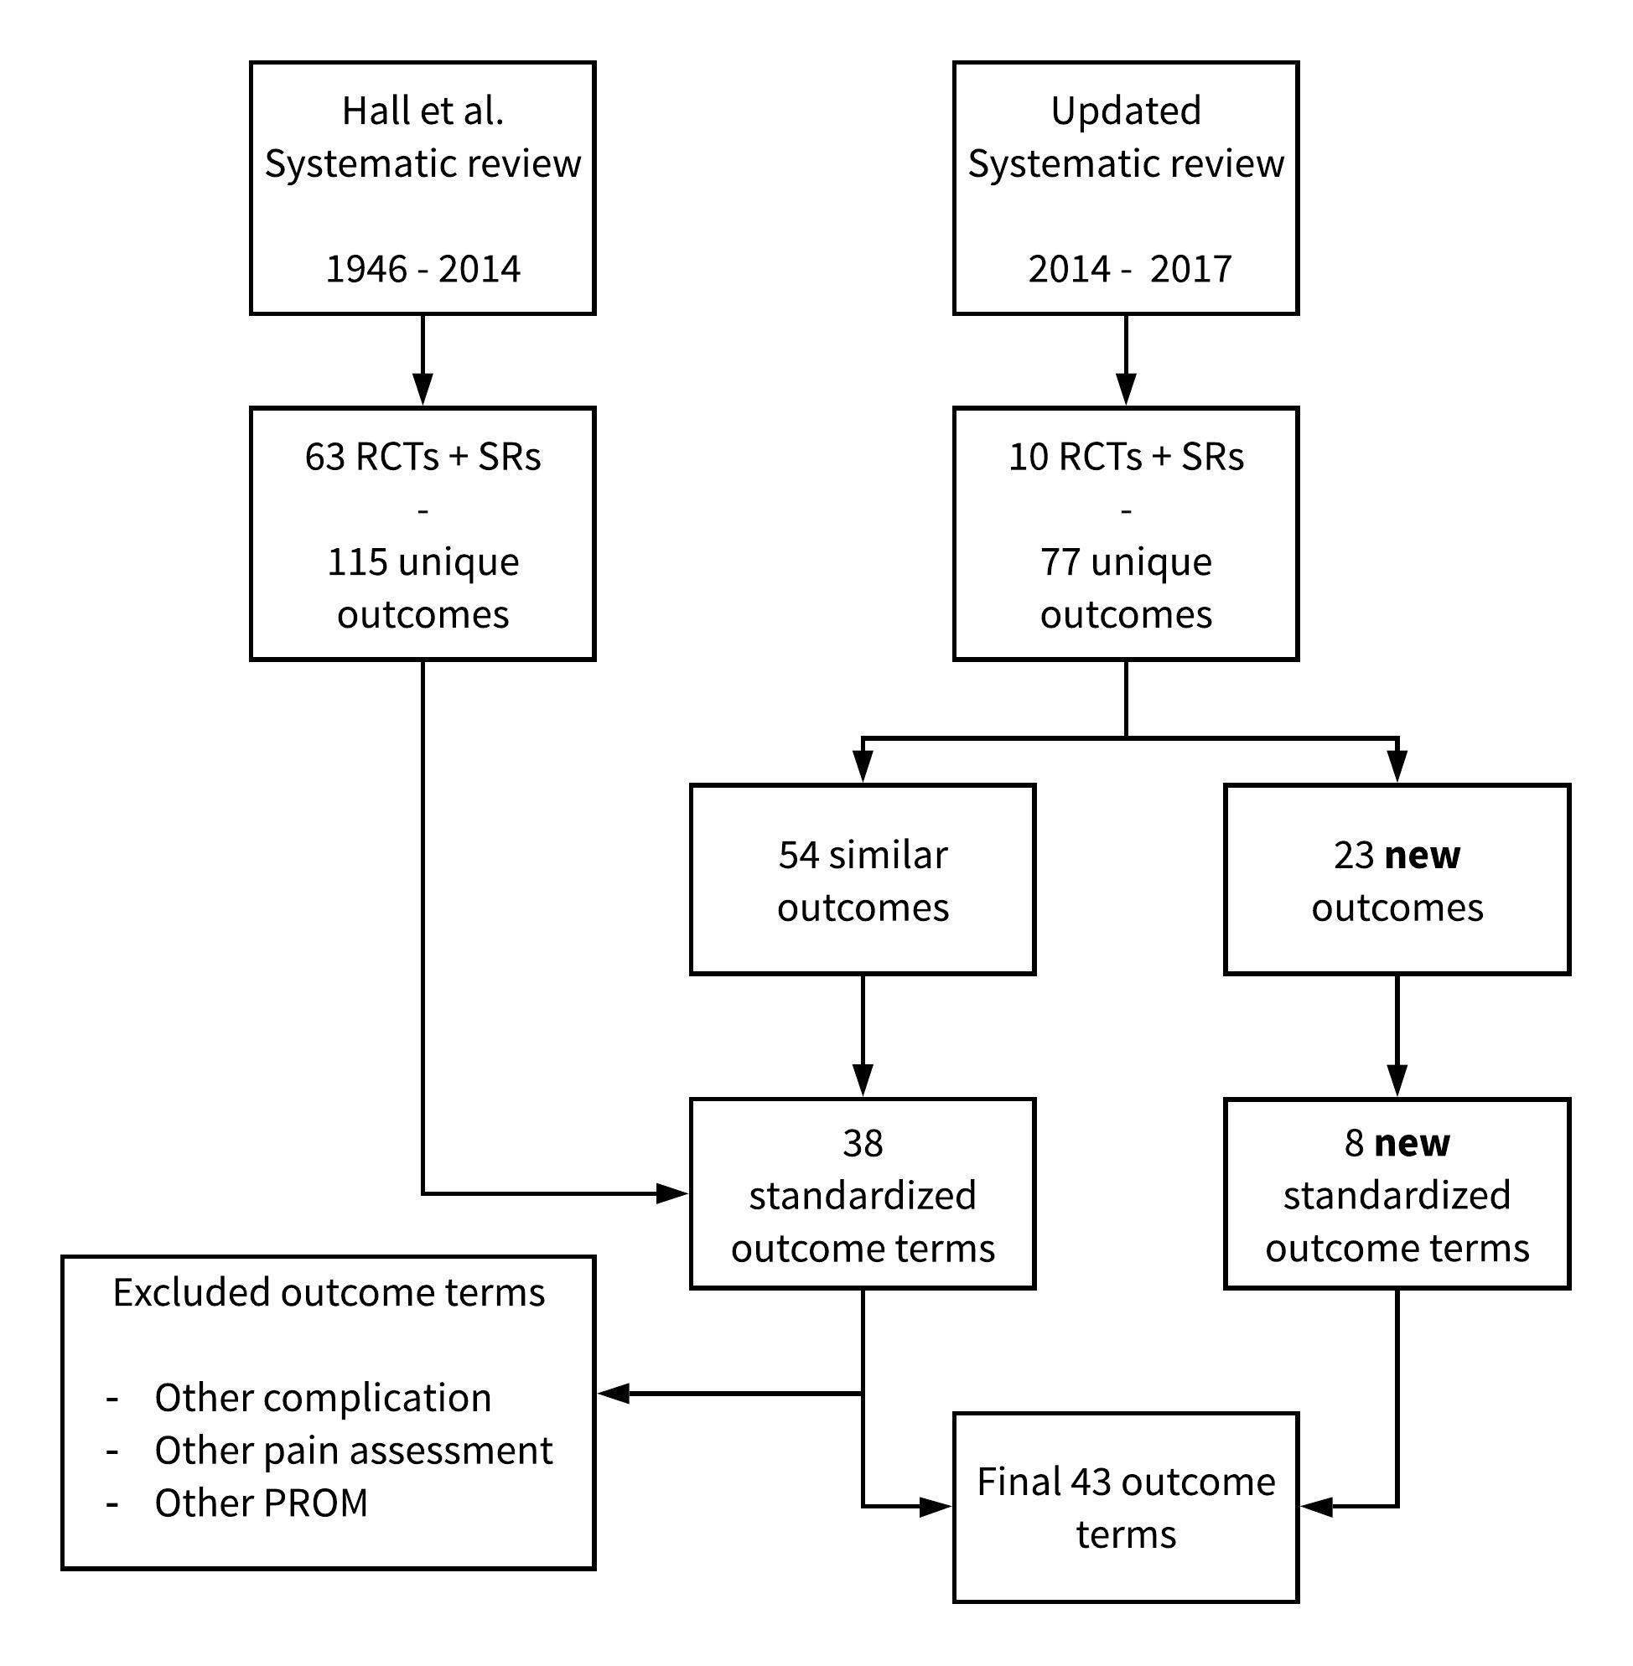
TABLES

Table 1: Participant demographics of parents completing the first Delphi round
Demographic | Total  (n = 148)
Male, n (%) | 34 (23)
Age parent in years, mean (SD) | 43 (7)
Geographic location, n (%)
- North America | 34 (23)
- Europe | 46 (31)
- Asia | 23 (30)
- Australia | 23 (16)
Education level n (%)
- Primary School | 1 (1)
- High School | 33 (22)
- College | 23 (16)
- Bachelor | 53 (36)
- Master | 24 (16)
- Other | 14 (10)
Age child in years, mean (SD) | 11 (4)
Time since diagnosis of child with appendicitis, n (%)
- 0 – 6 months | 50 (34)
- 7 – 12 months | 53 (36)
- 13 – 24 months | 35 (24)
- 25 – 48 months | 8 (5)
- Longer than 49 months | 2 (1)
Experience with NOT, n (%) | 27 (18)
Child involved in appendicitis research, n (%) | 35 (24)
Child suffered complications of appendicitis treatment, n (%) | 23 (16)

SD= Standard Deviation
NOT= Non-operative treatment

Table 2: Participant demographics of surgeons completing first Delphi round
Demographic | Total  (n = 245)
Male, n (%) | 144 (59)
Age in years, mean (SD) | 45 (10)
Geographic location, n (%)
- North America | 50 (20)
- Europe | 111 (45)
- Asia | 66 (27)
- Australia | 18 (7)
Type of surgeon, n (%)
Pediatric surgeon | 198 (81)
General surgeon | 47 (19)
Place of work, n (%)
- Academic/university hospital | 159 (65)
- Teaching hospital | 66 (27)
- Non-teaching hospital | 20 (8)
Years’ work experience as surgeon, n (%)
- Resident | 17 (7)
- 0 – 5 years | 51 (21)
- 5 – 10 years | 47 (19)
- 10 – 20 years | 67 (27)
- Longer than 20 years | 63 (26)
Children treated for appendicitis past year, n (%)
- 0 – 5 patients | 24 (10)
- 6 – 10 patients | 30 (12)
- 11 – 20 patients | 47 (19)
- 21 – 30 patients | 46 (19)
- 31 – 40 patients | 29 (12)
- 41 – 50 patients | 28 (11)
- More than 51 patients | 41 (17)
Experience with NOT, n (%) | 196 (80)
Involved in appendicitis research, n (%) | 162 (66)

SD=Standard Deviation
NOT= Non-operative treatment
0 to 30%
31 to 50%
51 to 70%
71 to 90%
91 to 100%
Table 3. Scoring for core outcome set of outcome terms in the Delphi Survey as critical
 | Core domain | Delphi round 1 |  |  | Delphi round 2
 | Outcome term | % Parents score 7-9 |  | % Surgeons  score 7-9 |  | % Parents score 7-9 |  | % Surgeons  score 7-9
Pathophysiological manifestations
1 | Intra-abdominal abscess
2 | Duration abdominal drainage
3 | Significant fever after treatment
4 | Recovery gastrointestinal function
5 | Inflammation markers
6 | Bacterial isolates during surgery
7 | Histologically normal appendixes
8 | Blood loss during surgery
9 | Bladder catheterization time
10 | Wound infection
11 | Bowel obstructions
12 | Complications directly related to treatment |  |  |  | N/A |  | N/A
13 | Children developing complicated appendicitis |  |  |  | N/A |  | N/A
14 | Major/minor complications |  |  |  | N/A |  | N/A
15 | Non-infectious wound complications
16 | Recurrent appendicitis |  |  |  | N/A |  | N/A
17 | Other infectious complications
Life impact
18 | Pain score
19 | Time away from normal daily activities/school
20 | Recovery to full activity/sport
21 | Cosmesis
22 | Time to ambulation
23 | Duration home healthcare
24 | Pediatric Quality of Life
25 | Parental quality of life
26 | Patient and/or parent satisfaction
27 | Mental health problems | N/A | N/A
Resource use
28 | Hospital length of stay
29 | Hospital re-admission |  |  |  | N/A |  | N/A
30 | Healthcare visits
31 | Total cost
32 | Cost effectiveness
33 | Parent days off work
34 | Duration surgery/anesthesia
35 | Duration antibiotic treatment
36 | Analgesia doses
37 | Imaging
38 | Interventional radiology procedure
39 | Central venous catheter
40 | (Unplanned) CT scan
41 | Need for re-operation |  |  |  | N/A |  | N/A
42 | Conversion laparoscopic to open surgery
43 | Need for appendectomy
44 | Intensive care admission | N/A | N/A
Death
45 | Death |  |  |  | N/A |  | N/A
N/A = Not applicable
Outcome terms that met threshold for “consensus-in” are in bold. None of the outcome terms met threshold for “consensus-out”. Outcome terms with “consensus-in” round 1 were not voted on in round 2. Outcome terms suggested by participants in round 1 were added to round 2.
Table 4. Outcome prioritization results of the focus groups with young people
Outcome term | Group 1  n = 4 |  | Group 2  n = 4 |  | Delphi Consensus-in
Very important
Recurrent appendicitis | Most important |  | Most important |  | Yes
Major/minor complications | Very important |  | Most important |  | Yes
Need for appendectomy | Most important |  | Important |  | Yes
Need for re-operation | Very important |  | Very important |  | Yes
Hospital readmission | Very important |  | Very important |  | Yes
Pediatric quality of life | Very important |  | Important |  | No
Time away from normal daily activities/school | Important |  | Very important |  | No
Complications directly related to treatment | Very important |  | Not important |  | Yes
Important
Recovery to full activity/sport | Important |  | Important |  | No
Pain score | Important |  | Important |  | No
Fear† | Important |  | Important |  | No
Hospital length of stay | Important |  | Important |  | No
Return to sport/full activity | Important |  | Important |  | No
Children developing complicated appendicitis | Important |  | Not important |  | Yes
Bowel obstructions | Important |  | Not important |  | Yes
Intra-abdominal abscess | Important |  | Not important |  | Yes

† New outcome from the focus group with young people not in the part of the Delphi survey

Table 5. Final Core outcome set for reporting treatment of simple appendicitis in children

Core Area/Domain¹⁸ | Outcome domain¹⁹ | Outcome
Death | 1. Mortality/survival | Disease or treatment related mortality
Physiological/clinical | 8. Gastrointestinal outcomes | Bowel obstruction
Physiological/clinical | 12. Infection and infestation outcomes | Intra-abdominal abscess  Recurrent appendicitis†  Complicated appendicitis†
Life impact | 31. Perceived health status | Time to return to baseline health status
Resource use | 35. Hospital | Hospital readmission
Resource use | 36. Need for further intervention | Reoperation  Unplanned appendectomy†
Adverse events | 38. Adverse events/effects | Adverse events as direct result of treatment  Major complication  Minor complication
† primarily for research involving non-operative treatment of appendicitis
For further explanations of each outcome’s meaning please see the “final core outcome set” section of the Results. Some suggestions for measurement tools can be found in the Discussion section and online supplement S8.

REFERENCES

1. Addiss DG, Shaffer N, Fowler BS, et al. the Epidemiology of Appendicitis and Appendectomy in the United States. Am J Epidemiol. 1990;132:910–925.
2. Anderson JE, Bickler SW, Chang DC, et al. Examining a common disease with unknown etiology: trends in epidemiology and surgical management of appendicitis in California, 1995-2009. World J Surg. 2012;36:2787–2794.
3. Podda M, Gerardi C, Cillara N, et al. Antibiotic Treatment and Appendectomy for Uncomplicated Acute Appendicitis in Adults and Children: A Systematic Review and Meta-analysis. Ann Surg. 2019;270:1028–1040.
4. Williamson PR, Altman DG, Blazeby JM, et al. Developing core outcome sets for clinical trials: issues to consider. Trials. 2012;13:132.
5. Pogue J, Yusuf S. Overcoming the limitations of current meta-analysis of randomised controlled trials. Lancet (London, England). 1998;351:47–52.
6. Kirkham JJ, Gargon E, Clarke M, et al. Can a core outcome set improve the quality of systematic reviews? – a survey of the Co-ordinating Editors of Cochrane review groups. Trials. 2013;14:21.
7. Hall NJ, Kapadia MZ, Eaton S, et al. Outcome reporting in randomised controlled trials and meta-analyses of appendicitis treatments in children: a systematic review. Trials. 2015;16:275.
8. Williamson PR, Altman DG, Bagley H, et al. The COMET Handbook: version 1.0. Trials. 2017;18:280.
9. Clarke M. Standardising outcomes for clinical trials and systematic reviews. Trials. 2007;8:39.
10. Sinha IP, Smyth RL, Williamson PR. Using the Delphi technique to determine which outcomes to measure in clinical trials: recommendations for the future based on a systematic review of existing studies. PLoS Med. 2011;8:e1000393.
11. Sherratt FC, Allin BSR, Kirkham JJ, et al. Core outcome set for uncomplicated acute appendicitis in children and young people. Br J Surg. . Epub ahead of print March 17, 2020. DOI: 10.1002/bjs.11508.
12. Protocol for the development of a global core outcome set for treatment of uncomplicated appendicitis in children :: Core Outcome Measures in Effectiveness Trials Initiative (COMET) Available from: http://www.comet-initiative.org/studies/details/1119. Accessed March 5, 2018.
13. Kirkham JJ, Davis K, Altman DG, et al. Core Outcome Set-STAndards for Development: The COS-STAD recommendations. PLOS Med. 2017;14:e1002447.
14. Knaapen M, Hall NJ, van der Lee JH, et al. Establishing a core outcome set for treatment of uncomplicated appendicitis in children: study protocol for an international Delphi survey. BMJ Open. 2019;9:e028861.
15. Knaapen M. OPEN SOURCE PROTOCOL INTERNATIONAL CORE OUTCOME SET FOR THE TREATMENT OF SIMPLE APPENDICITIS IN CHILDREN. Open Science Framework . Epub ahead of print 2020. DOI: 10.17605/OSF.IO/ZHY34.
16. COMET DelphiManager Available from: http://www.comet-initiative.org/delphimanager/. 2017. Accessed December 4, 2018.
17. Boers M, Kirwan JR, Gossec L, et al. How to choose core outcome measurement sets for clinical trials: OMERACT 11 approves filter 2.0. J Rheumatol. 2014;41:1025–30.
18. Dodd S, Clarke M, Becker L, et al. A taxonomy has been developed for outcomes in medical research to help improve knowledge discovery. J Clin Epidemiol. 2018;96:84–92.
19. Kirkham JJ, Gorst S, Altman DG, et al. Core Outcome Set-STAndards for Reporting: The COS-STAR Statement. PLoS Med. 2016;13:e1002148.
20. Staniszewska S, Brett J, Simera I, et al. GRIPP2 reporting checklists: tools to improve reporting of patient and public involvement in research. BMJ. 2017;358:j3453.
21. Chalmers I, Glasziou P. Avoidable waste in the production and reporting of research evidence. Lancet (London, England). 2009;374:86–9.
22. Main BG, McNair AGK, Huxtable R, et al. Core information sets for informed consent to surgical interventions: baseline information of importance to patients and clinicians. BMC Med Ethics. 2017;18:29.
23. Blazeby JM, Macefield R, Blencowe NS, et al. Core information set for oesophageal cancer surgery. Br J Surg. 2015;102:936–43.
24. McNair AGK, Whistance RN, Main B, et al. Development of a core information set for colorectal cancer surgery: a consensus study. BMJ Open. 2019;9:e028623.
25. Biggane AM, Brading L, Ravaud P, et al. Survey indicated that core outcome set development is increasingly including patients, being conducted internationally and using Delphi surveys. Trials. 2018;19:113.
26. Prinsen CAC, Vohra S, Rose MR, et al. How to select outcome measurement instruments for outcomes included in a “Core Outcome Set” – a practical guideline. Trials. 2016;17:449.
27. Dindo D, Demartines N, Clavien P-A. Classification of surgical complications: a new proposal with evaluation in a cohort of 6336 patients and results of a survey. Ann Surg. 2004;240:205–13.
28. Clavien PA, Barkun J, de Oliveira ML, et al. The Clavien-Dindo classification of surgical complications: five-year experience. Ann Surg. 2009;250:187–96.
29. Sanderson T, Morris M, Calnan M, et al. What outcomes from pharmacologic treatments are important to people with rheumatoid arthritis? Creating the basis of a patient core set. Arthritis Care Res (Hoboken). 2010;62:640–646.
30. Murphy MK, Black NA, Lamping DL, et al. Consensus development methods, and their use in clinical guideline development. Health Technol Assess. 1998;2:i–iv, 1–88.
31. Sinha IP, Smyth RL, Williamson PR. Using the Delphi Technique to Determine Which Outcomes to Measure in Clinical Trials: Recommendations for the Future Based on a Systematic Review of Existing Studies. PLoS Med. 2011;8:e1000393.
32. Sherratt FC, Bagley H, Stones SR, et al. Ensuring young voices are heard in core outcome set development: international workshops with 70 children and young people. Res Involv Engagem. 2020;6:19.
33. Akinremi A, Turnbull AE, Chessare CM, et al. Delphi panelists for a core outcome set project suggested both new and existing dissemination strategies that were feasibly implemented by a research infrastructure project. J Clin Epidemiol. 2019;114:104–107.

LIST OF SUPPLEMENTAL DIGITAL CONTENT
S1. Supplemental Table 1. International Steering Committee Pediatric Appendicitis Core outcome set Project
S2. Supplemental document 1. Systematic review search strategy, study selection and data extraction
S3. Supplemental Table 2. Delphi items including the explanatory text
S4. Supplemental document 2. List excluded outcomes prioritization meeting with young people
S5. Supplemental Table 3. Completed COS-STAR checklist
S6. Supplemental Table 4. Completed GRIPP2 short form
S7. Supplemental document 3. Systematic review PRIMSA flowchart
S8. Supplemental document 4. Percentage of parents and surgeons scoring outcome terms in the Delphi Survey as critical (score 7-9) per country
S9. Supplemental document 5. Suggested definitions or classification for outcomes in core outcome set

SUPPLEMENTAL DIGITAL CONTENT
S1. Supplemental Table 1. International Steering Committee Pediatric Appendicitis Core outcome set Project
Country | Committee member | Affiliation
Australia | Susan Adams | Department of Pediatric Surgery, Sydney Children’s Hospital, Randwick NSW
Canada | Erik D. Skarsgard | Department of Pediatric Surgery, BC Children’s Hospital, Vancouver, BC
Canada | Augusto Zani | Division of General and Thoracic Surgery, The Hospital for Sick Children, Toronto, ON
Canada | Sherif Emil | Department of Pediatric Surgery, Montreal Children’s Hospital, Montreal, QC
Canada | Martin Offringa* | Department of Pediatrics, The Hospital for Sick Children, Toronto
Canada | Nancy J Butcher* | Child Health Evaluative Sciences, The Hospital for Sick Children Research Institute, Toronto
England | Nigel J Hall* | Department of Paediatric Surgery and Urology, Southampton Children's Hospital, Southampton
Finland | Janne Suominen | Department of Pediatric Surgery, Helsinki Children’s Hospital, Helsinki
France | Olivier Abbo | Hôpital des Enfants de Toulouse – CHU de Toulouse
France | Alexis P Arnaud | Hôpital Sud, University Hospital, Rennes
Malaysia | Dayang Anita Abdul Aziz | Universiti Kebangsaan Malaysia Medical Centre, Kuala Lumpur
Netherlands | Ramon R Gorter* | Department of Pediatric Surgery, Emma Children’s Hospital, Amsterdam UMC
Netherlands | Hester Rippen | Representative of the Dutch Foundation Children and Hospital
Netherlands | Max Knaapen* | Department of Pediatric Surgery, Emma Children’s Hospital, Amsterdam UMC,  Amsterdam
Netherlands | Roel Bakx* | Department of Pediatric Surgery, Emma Children’s Hospital, Amsterdam UMC,  Amsterdam
Netherlands | Johanna H. van der Lee* | Pediatric clinical Research Office, Emma Children’s Hospital, Amsterdam UMC, Amsterdam
Singapore | Shireen A Nah / Rambha Rai | Department of Pediatric Surgery, KK Women's and Children's Hospital, Singapore
Sweden | Jan F. Svensson | Department of Pediatric Surgery, Karolinska University Hospital, Stockholm
USA | Peter C Minneci | Department of Pediatric Surgery, Nationwide Children's Hospital, Columbus, OH
USA | Francois I Luks | Hasbro Children's Hospital & Alpert Medical School of Brown University, Providence
USA | Shawn D St. Peter | Department of Pediatric Surgery, Children's Mercy Hospital, Kansas City, MO
* Also part of the study management group

S2. Supplemental document 1. Systematic review search strategy, study selection and data extraction

S3. Supplemental Table 2. Delphi items including the explanatory text
Kolom1 | Outcome | Explanatory text
1 | To measure the effectiveness of a treatment for uncomplicated appendicitis, how important is it to report how often children develop an intra-abdominal abscess? | An intra-abdominal abscess is a collection of pus or infected fluid that is surrounded by inflamed tissue inside the abdomen. An intra-abdominal abscess is caused by a bacterial infection and can be a result from an appendicitis, but also from surgery. The abscess will need to be removed by draining the fluid. Often antibiotics are needed as well, to treat the underlying infection.
2 | To measure the effectiveness of a treatment for uncomplicated appendicitis, how important is it to measure the NEED/DURATION OF ABDOMINAL ABSCESS DRAINAGE? | Abdominal abscess drainage is a procedure to drain fluid from the abdomen. This is needed in case a child with appendicitis develops an intra-abdominal abscess that has to be drained in order to heal. The drainage will be performed with a small catheter (a tube), which will be placed in the patient’s body and will have to stay in for at least a few days.
3 | To measure the effectiveness of a treatment for uncomplicated appendicitis, how important is it to report if a child develops a significant fever after receiving the treatment? | A significant fever is a body temperature of at least 100 °F (38°C) that is present for at least 12 hours.
4 | To measure the effectiveness of a treatment for uncomplicated appendicitis, how important is it to measure the amount of days it takes the digestive system to recover? | Treatment (especially an operation) affects the working of the digestive system. The passing of stool or passing gas can be delayed, or food intake is hindered due to nausea or vomiting.
5 | To measure the effectiveness of a treatment for uncomplicated appendicitis, how important is it to measure the presence of inflammation markers with a blood test? | The inflammation markers, white cell count and C-reactive protein (WCC/CRP), are indicators for an infection somewhere in the body. These markers can be found in your blood. By taking a blood sample with a blood test, we can check if you have an infection. The level of these markers tells us something about the severity of the infection.
6 | To measure the effectiveness of a treatment for uncomplicated appendicitis, how important is it to measure the presence of bacteria in the abdomen during surgery. | To identify if, and if so, which type of bacteria is causing an infection, a specimen will be taken from the child to do a bacteria culture test. This is usually done by taking some fluid from inside the abdomen during surgery. It is important to identify the type of bacteria to give the right type of antibiotics. However, it takes a few days to get the results and normally children will be discharged by then.
7 | To measure the effectiveness of a treatment for uncomplicated appendicitis, how important is it to report the number of NON-INFECTED (HEALTHY) APPENDICES THAT WERE UNJUSTLY REMOVED? | Sometimes the pre-operative diagnosis of appendicitis was incorrect. If a child with this incorrect diagnosis is operated, and no other causes for their complaints are found, sometimes the healthy (normal) appendix will be removed unjustly. The upside is that a child can no longer get an appendicitis later in life, however the surgery was unnecessary.
8 | To measure the effectiveness of a treatment for uncomplicated appendicitis, how important is it to measure the amount of blood a child loses during the operation? | When somebody is being operated, there will be some loss of blood. Surgeons will try to limit this amount, but sometimes, a more severe blood loss can occur. In rare cases a blood transfusion can even be necessary.
9 | To measure the effectiveness of a treatment for uncomplicated appendicitis, how important is it to measure the bladder catheterization time? | The bladder catheterization time is the number of hour/days a conduit (the catheter) is used to drain urine from the bladder of the patient into an attached bag or container. The catheter is inserted into a patient’s bladder through the urethra.
10 | To measure the effectiveness of a treatment for uncomplicated appendicitis, how important is it to report the number of children that develop a wound infection? | Surgery that involves a cut (incision) in the skin can lead to a wound infection after surgery. The infected wounds may have pus draining from them and can be red, painful or hot to touch. Sometimes antibiotics or removal of the stitches from a wound to drain the pus is necessary to treat this. In rare cases a second operation is needed.
11 | To measure the effectiveness of a treatment for uncomplicated appendicitis, how important is it to measure the number of children that develop bowel obstructions? | Bowel obstructions are possible complications from surgery or an abdominal infection. They are the result of (scar) tissue of the intra-abdominal wounds caused by surgery or infection. If a bowel obstruction occurs, food and fluids can no longer pass through the bowel. This will lead to nausea, vomiting and passage of stool will no longer be possible. As a results emergency surgery is sometimes necessary to remove the scar tissue or even remove part of the bowel.
12 | To measure the effectiveness of a treatment for uncomplicated appendicitis, how important is it to report the number of complications directly caused by operative or antibiotic treatment? | Complications of operative or antibiotic treatment are complications that are directly related to the received treatment. For example an allergic reaction to antibiotics or a perforation of the intestines during surgery. This means complications are not a direct result of the disease itself.
13 | To measure the effectiveness of a treatment for uncomplicated appendicitis, how important is it to measure the number of children that develop a complicated appendicitis? | There are two types of appendicitis; uncomplicated and complicated appendicitis. Sometimes the uncomplicated appendicitis can develop into a complicated appendicitis. This can be a ruptured appendix or the development of pus in the abdomen. This can happen when children are treated with antibiotics instead of surgery. Complicated appendicitis leads to a longer hospital stay and the need for treatments with antibiotics.
14 | To measure the effectiveness of a treatment for uncomplicated appendicitis, how important is it to measure the total number of major/minor complications? | Complications are divided into major and minor complications. Major complications are complications that have a serious effect on a patient’s health and minor complications are complications that will resolve without or with limited treatment.
15 | To measure the effectiveness of a treatment for uncomplicated appendicitis, how important is it to measure the amount of non-infectious wound complications? | Non-infectious wound complications are all the complications of a wound except an infection. For example: 1) How often does a wound split open (dehiscence) after surgery. 2) How often is there delayed healing of the wound. 3) How often is there an incisional hernia (An incisional hernia is a bulge through the (partially) healed incision of a previous surgery in your abdomen. The bulge is usually caused by a part of your intestine, but it may also be tissue or fat pushing through the weakness in the abdominal wall.)
16 | To measure the effectiveness of a treatment for uncomplicated appendicitis, how important is it to measure the number of children that develop a recurrent appendicitis? | Sometimes doctors treat appendicitis with antibiotics instead of surgery. This means there is a chance that the appendicitis can come back later in life. We call this a recurrent appendicitis.
17 | To measure the effectiveness of a treatment for uncomplicated appendicitis, how important is it to measure the amount of other infectious complications? | When the child is receiving the treatment for appendicitis, he/she can develop other infectious complications, such as pneumonia, a urinary tract infection (UTI) or sepsis.
18 | To measure the effectiveness of a treatment for uncomplicated appendicitis, how important is it to measure the number of children that DEVELOP MENTAL HEALTH PROBLEMS/PSYCHOLOGICAL CONSEQUENCES? | Sometimes a hospital admission, surgery or illness can have an effect on the mental health of a child. Examples include feelings of anxiety, depression, aggression, and irritability, a lack of interest in daily activities, difficulty concentrating, or unexplained physical problems such as headaches or dizziness.
19 | To measure the effectiveness of a treatment for uncomplicated appendicitis, how important is it to report the pain score? | Pain scores are used to measure the amount of pain a child is in. It could be assessed by using an assessment tool such as the visual analogue scale (VAS), see figure below, or in other ways like a full pain survey.
20 | To measure the effectiveness of a treatment for uncomplicated appendicitis, how important is it to report the number of days a child is away from normal daily activities or school? | Normal daily activities are activities where light physical effort is needed. For example taking a walk with the dog or going to piano lessons. When a child is recovering from its appendicitis, it could take some time before he or she is able to perform normal daily activities or return to school.
21 | To measure the effectiveness of a treatment for uncomplicated appendicitis, how important is it to report the amount of days it takes for a child to recover to full activity/sport? | When a child is back to full activity and could play sports again, it means that he is on the same physical level as before the treatment. He has no trouble with things as running and could play around on the playground without any difficulties related to the treatment.
22 | To measure the effectiveness of a treatment for uncomplicated appendicitis, how important is it to measure the effects of the treatment on cosmesis (bodily appearance/scars)? | The presence and appearance of scars after a treatment can burden a child and might affect the way they think about their appearance/body (cosmesis) after a treatment.
23 | To measure the effectiveness of a treatment for uncomplicated appendicitis, how important is it to report the number of days it takes a child to be able to get out of bed (ambulation)? | When a child is able to ambulate, it means he or she is able to get out of its bed by itself and walk around a little bit to go to the toilet for example.
24 | To measure the effectiveness of a treatment for uncomplicated appendicitis, how important is it to measure the number of days home healthcare is needed after a treatment? |  | In some cases, a child has recovered sufficiently to be discharged from the hospital but will still need home healthcare, which is then usually provided by a nurse. This situation is uncommon in cases in which children are treated for uncomplicated appendicitis.
25 | To measure the effectiveness of a treatment for uncomplicated appendicitis, how important is it to report the child’s quality of life during and/or after treatment? |  | The pediatric (child) quality of life is assessed by a measurement tool, usually questionnaires. They for instance score the quality of physical functioning, emotional functioning, and social functioning and school functioning.
26 | To measure the effectiveness of a treatment for uncomplicated appendicitis, how important is it to report the parent’s quality of life during and/or after treatment? |  | The parental quality of life assessment is assessed by measurement tools, usually questionnaires. These are able to score the quality of life of parents in relation to their child’s sickness.
27 | To measure the effectiveness of a treatment for uncomplicated appendicitis, how important is it to report the patient and or parent satisfaction with the treatment they received? |  | The patient and or parent satisfaction can be scored by measurement tools, usually questionnaires. These usually measure the extent to which a patient and or parent is content with treatment they received.
28 | To measure the effectiveness of a treatment for uncomplicated appendicitis, how important is it to report the number of children that need to be ADMITTED TO THE INTENSIVE CARE UNIT? |  | Intensive care is needed if a child is seriously ill and requires intensive treatment and close monitoring. Most children in an ICU have problems with 1 or more organs. For example, they may be unable to breathe on their own.
29 | To measure the effectiveness of a treatment for uncomplicated appendicitis, how important is it to report the number of days children have to stay in the hospital?
30 | To measure the effectiveness of a treatment for uncomplicated appendicitis, how important is it to report the number of times a child has to be re-admitted to the hospital?
31 | To measure the effectiveness of a treatment for uncomplicated appendicitis, how important is it to report the total number of healthcare visits a child attends after their initial treatment? |  | Healthcare visits are all the visits to the hospital/outpatient clinic or General Practitioner related to the appendicitis.
32 | To measure the effectiveness of a treatment for uncomplicated appendicitis, how important is it to report the total costs of a treatment?
33 | To measure the effectiveness of a treatment for uncomplicated appendicitis, how important is it to measure the cost effectiveness? |  | The cost effectiveness is analyzed to determine if the value of a treatment justifies the cost. For example, if a very expensive procedure only adds a minimal health benefit, the added costs might not be justified.
34 | To measure the effectiveness of a treatment for uncomplicated appendicitis, how important is it to report the number of days parents had to take off work? |  | Children might need extra care during and after their treatment, this could mean that parents might not be able to work for a few days. This can lead to missed earnings and might have an impact on daily life of the parent.
35 | To measure the effectiveness of a treatment for uncomplicated appendicitis, how important is it to report the duration of an operation/anesthesia? |  | The duration of the operation is the total time a child needs anesthesia. Anesthesia is use of medicine to prevent the feeling of pain during surgery or other painful procedures.
36 | To measure the effectiveness of a treatment for uncomplicated appendicitis, how important is it to report the duration of antibiotic treatment?
37 | To measure the effectiveness of a treatment for uncomplicated appendicitis, how important is it to report the total amount and type of painkillers that have been given to a child to treat its pain? |  | There are several types of painkillers a child might receive, for example acetaminophen, ibuprofen or morphine. Measuring the amount a child receives of each painkiller tells us something about how much post-treatment pain there was.
38 | To measure the effectiveness of a treatment for uncomplicated appendicitis, how important is it to measure the number of times imaging was used? |  | For instance, an ultrasound, X-ray, MRI or CT-scan. This has its effect both on the total costs, the burden on a child (also emotionally) and in case of x-rays of CT-scans the amount of radiation a child is exposed to.
39 | To measure the effectiveness of a treatment for uncomplicated appendicitis, how important is it to report the number of times an interventional radiology procedure was needed? |  | Sometimes a child with appendicitis develops an abscess in the abdomen which has to be drained in order to heal. With an interventional radiology procedure, a small catheter (a tube) will be placed into the patient’s body to drain the fluid. This is done under ultrasound or CT-scan guidance.
40 | To measure the effectiveness of a treatment for uncomplicated appendicitis, how important is it to report the number of times a central venous catheter has to be placed? |  | Sometimes a child becomes so sick that a regular intravenous tube (IV) is not sufficient. Especially if a child is not able to eat and needs to receive nutrients (food) directly into their bloodstream. In those cases doctors may need to place a central venous catheter into a large vein in the arm or neck. For this an operation or interventional radiology procedure is needed.
41 | To measure the effectiveness of a treatment for uncomplicated appendicitis, how important is it to report the number of CT-scans a child has to undergo? |  | A CT-scan is a form of imaging that uses radiation to look inside the body. If possible, this form of imaging is avoided in children because of the exposure to relatively high levels of radiation which in time can have negative effects on the child. However, sometimes a CT-scan cannot be avoided because more information is needed before choosing a treatment or because a complication occurs.
42 | To measure the effectiveness of a treatment for uncomplicated appendicitis, how important is it to report the number of times a child needed to be re-operated? |  | Sometimes a complication occurs for which it is necessary to operate a second time. For instance, a bowel perforation, severe wound infection or bowel obstruction.
43 | To measure the effectiveness of a treatment for uncomplicated appendicitis, how important is it to measure the number of times a conversion from laparoscopic (minimal invasive/keyhole) surgery to open surgery is needed? |  | Laparoscopic surgery is surgery when an operation is performed trough very small incisions (keyhole) with the aid of a camera. This means that it is a less invasive operation than with open surgery, where a larger incision is used to open the belly. Sometimes a surgeon needs to convert a laparoscopic surgery into open surgery. For instance, because of difficult anatomy, the presence of an abscess or intestinal perforation. This means the operation will no longer be performed using several small (0,5-1,5 cm) incisions (cut) but one larger incision is added, which is more invasive for the child.
44 | To measure the effectiveness of a treatment for uncomplicated appendicitis, how important is it to report if a child needed an (unplanned) appendectomy? |  | Sometimes doctors treat appendicitis with antibiotics instead of surgery. However, the antibiotics do not work in some cases and an appendectomy (an operation to remove the appendix) is needed. This can also happen if the appendicitis returns later in life.
45 | To measure the effectiveness of a treatment for uncomplicated appendicitis, how important is it to measure the number of children that did not survive the treatment of their appendicitis? |  | Although this is extremely rare, especially in the case of uncomplicated appendicitis, theoretically a child might die from appendicitis.

S4. Supplemental document 2. List excluded outcomes prioritization meeting with young people

- Death
- Duration home healthcare
- Parent quality of life
- Patient satisfaction
- Cost effectiveness
- Parents days of work
- Duration surgery/anesthesia
- Duration antibiotics
- Analgesia doses
- Interventional radiological procedure
- Central venous catheter
- Unplanned CT
- Conversion to open appendectomy
- Duration abdominal drainage
- Fever after treatment
- Recovery gastro-intestinal function
- Inflammation markers
- Bacterial isolates
- Histological normal appendix
- Blood loss
- Duration bladder catheterization
- Wound infection
- Non-infectious wound complications.

SECTION/TOPIC | ITEM No. | CHECKLIST ITEM | Page no.
TITLE/ABSTRACT
Title  Abstract | 1a | Identify in the title that the paper reports the development of a COS | 1
Title  Abstract | 1b | Provide a structured summary | abstract
INTRODUCTION
Background and objectives | 2a | Describe the background and explain the rationale for developing the COS | 3
Background and objectives | 2b | Describe the specific objectives with reference to developing a COS | 3
Scope | 3a | Describe the health condition(s) and population(s) covered by the COS | 3
Scope | 3b | Describe the intervention(s) covered by the COS | 3
 | 3c | Describe the setting(s) in which the COS is to be applied | 3
METHODS
Protocol/Registry Entry | 4 | Indicate where the COS development protocol can be accessed, if available and/or the study registration details | 4
Participants | 5 | Describe the rationale for stakeholder groups involved in the COS development process, eligibility criteria for participants from each group and a description of how the individuals involved were identified | PR, 5
Information sources | 6a | Describe the information sources used to identify an initial list of outcomes | 4
 | 6b | Describe how outcomes were dropped/combined, with reasons (if applicable) | PR, 7
Consensus process | 7 | Describe how the consensus process was undertaken | PR, 5
Outcome scoring | 8 | Describe how outcomes were scored and scores summarised | 5
Consensus definition | 9a | Describe the consensus definition | 6
 | 9b | Describe the procedure for determining how outcomes were included or excluded from consideration during the consensus process | 5
Ethics and consent | 10 | Provide a statement regarding the ethics and consent issues for the study | 5,6
RESULTS
Protocol deviations | 11 | Describe any changes from the protocol (if applicable), with reasons, and a describe what impact these changes have on the results | 11,12
Participants | 12 | Present data on the number and relevant characteristics of the people involved at all stages of COS development | Table 1 & 2
Outcomes | 13a | List all outcomes considered at the start of the consensus process | S3
 | 13b | Describe any new outcomes introduced and any outcomes dropped, with reasons, during the consensus process | 8,9
Core outcome set | 14 | List the outcomes in the final core outcome set | Table 4
DISCUSSION
Limitations | 15 | Discuss any limitations in the COS development process | 11
Conclusions | 16 | Provide an interpretation of the final COS in the context of other evidence, and implications for future research | 11,12
OTHER INFORMATION
Funding | 17 | Describe sources of funding, role of funders | 2
Conflicts of interest | 18 | Describe any conflicts of interest within the study team and how these were managed | 2
S5. Supplemental Table 3. Completed COS-STAR checklist

PR= Protocol publication.
Knaapen M, Hall NJ, van der Lee JH, et al. Establishing a core outcome set for treatment of uncomplicated appendicitis in children: study protocol for an international Delphi survey. BMJ Open. 2019;9:e028861.

S6. Supplemental Table 4. Completed GRIPP2 short form
Section and topic | Item | Reported on page No
1: Aim | Report the aim of PPI in the study | 11
2: Methods | Provide a clear description of the methods used for PPI in the study | 4, 5, 6 + PR
3: Study results | Outcomes—Report the results of PPI in the study, including both positive and negative outcomes | 7,8
4: Discussion and conclusions | Outcomes—Comment on the extent to which PPI influenced the study overall. Describe positive and negative effects | 10,11
5: Reflections/critical perspective | Comment critically on the study, reflecting on the things that went well and those that did not, so others can learn from this experience | 11
PPI=patient and public involvement
PR= Protocol publication.
Knaapen M, Hall NJ, van der Lee JH, et al. Establishing a core outcome set for treatment of uncomplicated appendicitis in children: study protocol for an international Delphi survey. BMJ Open. 2019;9:e028861.

S7. Supplemental document 3. Systematic review PRIMSA flowchart
Full-text articles assessed for eligibility
(n = 39)
Studies included in qualitative synthesis
(n = 10)
Full-text articles excluded, with reasons
(n = 29)

- 11 wrong study design
- 10 wrong population
- 5 wrong indication
- 3 wrong intervention

Records excluded
(n = 196)
Records screened
(n = 235)
Records after duplicates removed
(n = 235)
Additional records identified through other sources
(n = 215)

Identification

Eligibility

Included

Screening
Records identified through database searching
(n = 80)

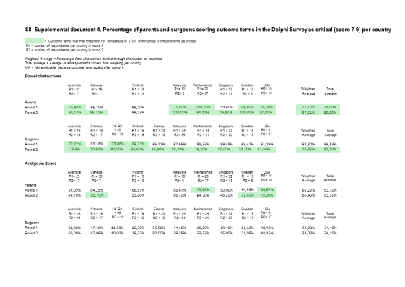
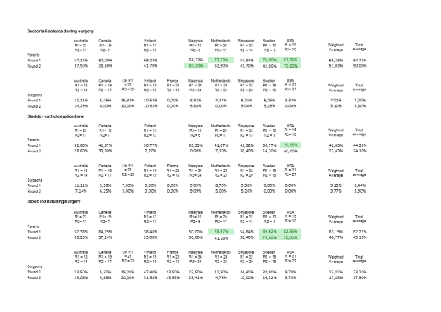
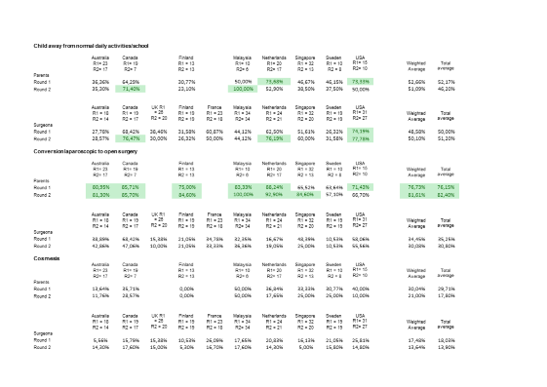

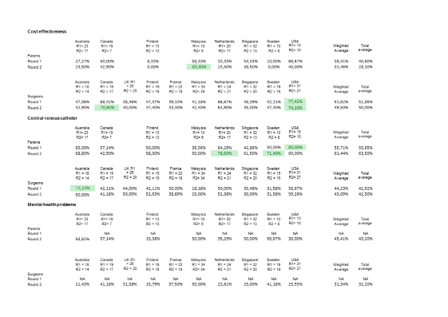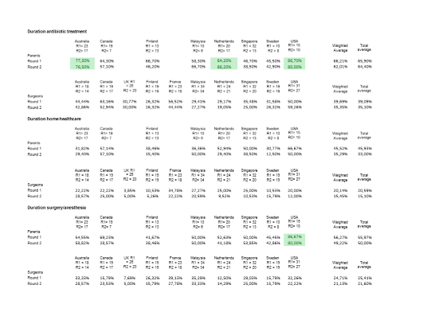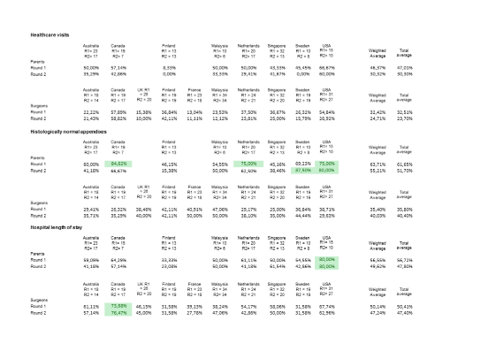
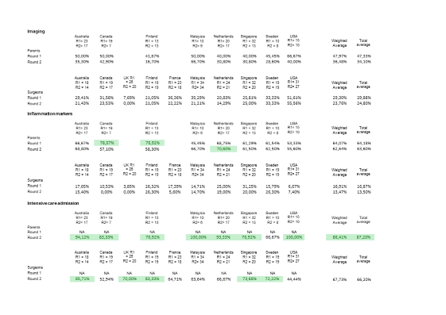

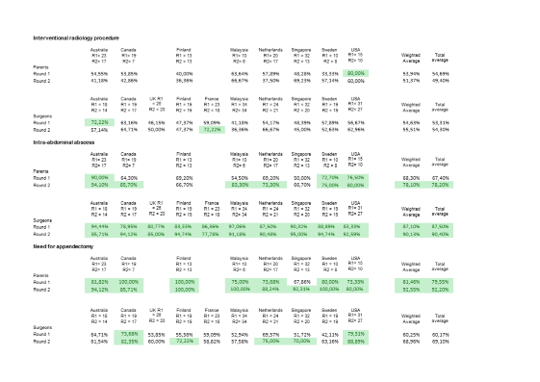

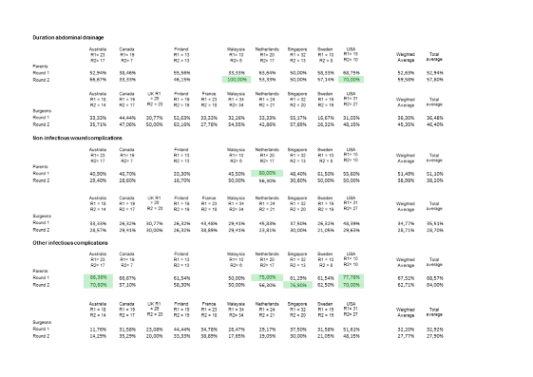

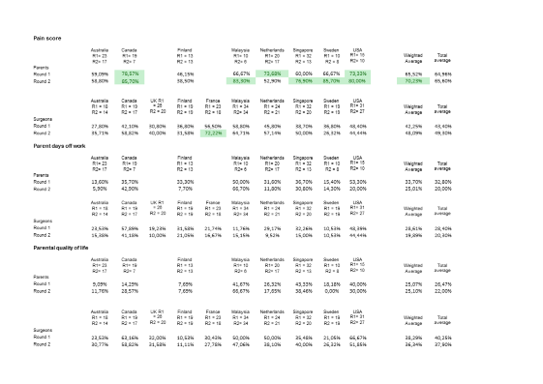

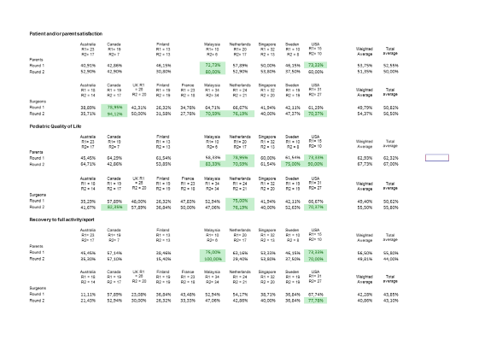
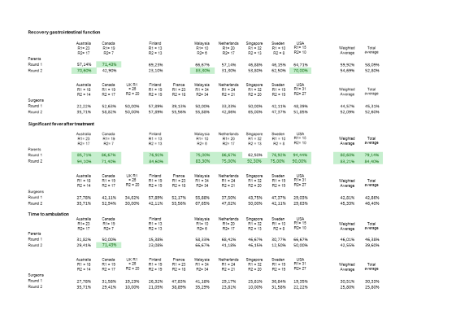

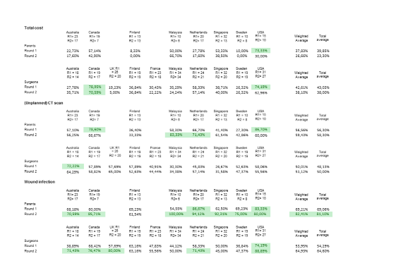

S9. Supplemental document 5. Suggested definitions or classification for outcomes in core outcome set
Please be aware that these are suggested definitions or classifications and are not the result of this study or the consensus process
Core Area/Domain | Outcome | Suggested definition or  classification for outcome
Death | Disease or treatment related mortality | Disease or treatment related mortality
Physiological/clinical | Bowel obstruction | Secondary bowel obstruction as a result of mechanical obstruction, not functional or paralytic obstruction
Physiological/clinical | Intra-abdominal abscess | Collection of pus or infected fluid that is surrounded by inflamed tissue inside the abdomen
Physiological/clinical | Recurrent appendicitis† | Diagnosis of appendicitis that occurs after a patient has recovered from acute simple appendicitis, use Bhangu classification for appendicitis types²⁹
Physiological/clinical | Complicated appendicitis† | Diagnosis of complex/complicated appendicitis that is made after acute simple appendicitis was initially diagnosed and managed, use Bhangu classification for appendicitis types²⁹
Life impact | Time to return to baseline health status | The time perceived by child (or their parent, as appropriate) it took to return to their pre-appendicitis health status (e.g., physical, social and school/work)
Resource use | Hospital readmission | Number of times a child was readmitted to hospital after their primary admission
Resource use | Reoperation | Requiring an operation for the second time, not including radiological drainage
Resource use | Unplanned appendectomy† | The performance of an appendectomy when the initial treatment plan was non-operative treatment
Adverse events | Adverse events as direct result of treatment | Complications directly related to the received treatment. For example allergic reaction to antibiotics or perforation of the intestines during surgery Not complications that are a direct result of the disease itself.
Adverse events | Major complication | Complication that occurred as a result of appendicitis or its treatment, requiring invasive treatment. Suggested is Clavien-Dindo^{30,31} score III to V.
Adverse events | Minor complication | Complications that resolve without or with limited treatment. Suggested is Clavien-Dindo^{30,31} score I to II.
† primarily for research involving non-operative treatment of appendicitis
29. Bhangu A, Søreide K, Di Saverio S, et al. Acute appendicitis: modern understanding of pathogenesis, diagnosis, and management. Lancet. 2015;386:1278–1287.
30. Dindo D, Demartines N, Clavien P-A. Classification of surgical complications: a new proposal with evaluation in a cohort of 6336 patients and results of a survey. Ann Surg. 2004;240:205–
31. Clavien PA, Barkun J, de Oliveira ML, et al. The Clavien-Dindo classification of surgical complications: five-year experience. Ann Surg. 2009;250:187–96.

