Evolution of wear on enamel caused by tooth brushing with abrasive toothpaste slurries
M Baig¹, R.B. Cook¹, J Pratten² and R Wood¹

¹University of Southampton, national Centre for Advanced Tribology (nCATS), Engineering and the Environment, University of Southampton, Highfield, Southampton, SO17 1BJ, UK
² GlaxoSmithKline, St Georges Avenue, Weybridge, KT13 0DE, UK

mb9g14@soton.ac.uk
Abstract. Maintaining good oral hygiene is vital to a healthy body and aesthetically attractive smile. Regular tooth brushing prevents cavities, tooth decay and gum disease which if left, can lead to serious health problems. However, cleaning your teeth comes with a drawback. Toothpastes contain abrasive particles, which in combination with the toothbrush, have the potential to wear tooth enamel. To optimise the cleaning efficiency of teeth and minimise the enamel wear it is essential to understand the science behind the tooth/toothpaste/toothbrush interface. An integrated approach is employed in this study to investigate the tribology of brushing, examining the friction and wear evolution. A reciprocating tribometer was modified to enable a toothbrush head to reciprocate against a bovine enamel disk to simulate the tooth brushing action, with a constant feed of either an abrasive free or a silica or alumina containing toothpaste slurry to the contact. The evolution of the friction with time during the brushing simulation as well as the changes in the enamel surface roughness were determined. The alumina slurry resulted in higher friction, increased wear depth and an increased roughening of the enamel surface compared to the silica slurries, with all abrasives causing 2 body grooving to the enamel surface. The spherical silica provided both the lowest friction and material loss of the slurries tested. The abrasive free slurry caused no wear or surface roughening but exhibited the highest friction during brushing.

Keywords: enamel; wear; friction; abrasive particles; toothbrush

Introduction
Toothbrushing is a complex tribological process in a multi-variant environment, the primary purpose of which is to remove any biofilm or plaque from the tooth enamel to prevent caries. To aid this abrasive cleaning process, most toothpastes contain abrasive particles, and it is the ability of the bristles to trap abrasive particles and keep them in contact with the tooth surface which will determine the extent to which plaque and stains are removed. However this cleaning process poses the potential to damage to the tooth enamel as the surface can be abraded when hard particles contact the tooth surface under load [1]. Previous studies into the tribology of tooth brushing [1-5] have previously avoided using enamel, due the comparatively low levels of wear which result and as such models have been developed using artificial surfaces to replicate the natural tooth surface and best match the appearance and strength of dental enamel.
Enamel is the hardest tissue in the human body and is formed by epithelial cells called ameloblasts. It is composed of 96% organic material and 4% inorganic material. The microstructure of enamel is anisotropic and its mechanical properties are influenced by the orientation (location and arrangement) of the rods. Enamel is composed of rods (also referred to as prisms), which are the primary unit of the enamel structure. The enamel rods lie perpendicular to the tooth surface and have a length of 6-8 microns and a width of 5µm. The enamel rod is made up of a head and a tail which resembles a key-hole shape. Hydroxyapatite crystals make up each rod, Figure 1. The chemical formula of the hydroxyapatite crystals is: Ca₁₀(PO4)₆.(OH)₂. The hydroxyapatite crystals are fibre-like structures which are 100nm – 500nm in length, 60nm in width and 30nm in thickness [6]. The hydroxyapatite crystals are aligned parallel to the long axis of the rods. The rods are perpendicular to the dentinoenamel junction (DEJ) and run from the dentinoenamel junction to the surface of the tooth.
Debate has arisen on the formation of the enamel rod. However, it has been reported that 3-4 ameloblasts form one rod. Fibres and a matrix are laid down by the ameloblasts and the matrix is deposited with hydroxyapatite crystals. The early deposit of hydroxyapatite crystals in the rod is referred to as the mineralisation stage of the enamel rod. The maturation stage is the second stage of calcification of the enamel rod and this is when the hydroxyapatite crystals grow and form a tightly packed structure [7].
An organic interspace is present between the enamel rods, which is called the rod sheath [8]. The rod sheath, is a thin layer of protein made up of 1% – 2% organic matter which surrounds and cements each rod [8]. The rod sheath is also referred to as an interrod substance or interrod enamel [7]. The thickness of enamel is in the region of 2.5mm.
A study conducted by Cuy et al. [9] reported the mechanical properties of enamel are influenced by the chemical composition, mineralisation and the location/ arrangement of the rods. The highest hardness of enamel was observed at the surface of enamel, with a hardness of 4.6GPa and a modulus of 91.9Gpa respectively. Moving away from the DEJ, this decreased to 3.4GPa for the hardness and 66.2GPa for the modulus. This finding was confirmed by Roy et al. [10] who reported a hardness value of enamel to be 3.5GPa at the surface and a drop in hardness to 2GPa – 2.5GPa, 100µm – 600µm away from the DEJ.
Nano-indentation has been carried out on the rods of enamel. A number of studies [11-14] reported the head of the rod to differ in hardness to the tail. For example, the head of the rod was found to have a hardness of 5GPa – 7GPa compared to 4 GPa for the tail of the rods [13].
The age of the tooth is another contributing factor to the difference in mechanical properties of enamel. It was found by Park et al. [15] that a higher hardness and elastic modulus of enamel was reported for an old permanent tooth compared to a young tooth. An explanation for this could be the reduced organic content and increased mineral content with the age of tooth.
Zhou et al. [14] carried out nano-scratch tests on a longitudinal section of human enamel. The scratch tests were carried out on the parallel and vertical axis of the enamel rod, at loads of 20mN, 50mN and 100mN to investigate the orientation effects of the enamel hydroxyapatite crystals. At a load of 5mN no pile up of enamel was observed. Increasing the load to 20mN resulted in slight pile up of enamel and at 50mN there was evidence of pile-up at the sides of the enamel scratch. The hardness and elastic modulus of interrod enamel, was found to be lower than the hardness and elastic modulus of the enamel rod and thus showed a lower wear resistance. The tests showed scratching the enamel surface caused the hydroxyapatite crystals to be broken into smaller crystals [14].
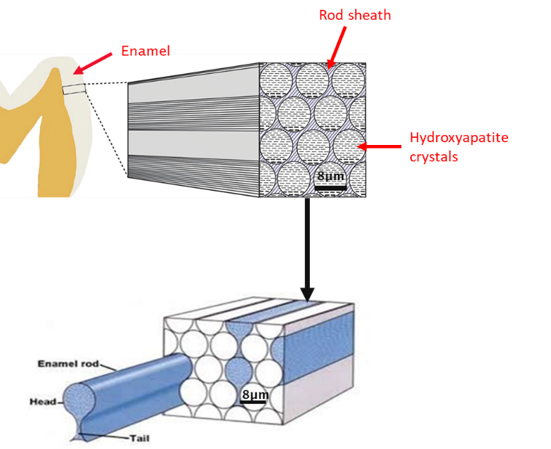
Figure 1: Schematic of enamel rods. Adapted from [16, 17].
The mechanical properties and structure of enamel and dentine are shown in Table 1 and Table 2.
Table 1 Mechanical properties of tooth tissues.
 | Enamel | Dentine
Density / kg/m³ | 2500  [18-20] | 2900 [19-21]
Young’s modulus / GPa | 62.7 - 98.3 GPa  [19, 20, 22] | 24.8 GPa [19, 20, 22]
Compressive strength / GPa | 0.095 – 0.386 [19, 20] | 0.249 – 0.315 [19, 20]
Tensile strength / GPa | 0.030 – 0.035 [19, 20] | 0.040- 0.276 [19, 20]
Poisson’s ratio | 0.29 [19, 20] | 0.11 [19, 20]
Hardness | 283- 374 HV [19, 23] | 53 – 63 HV [19, 23]

Table 2 Tooth structure information.
Dental tissue | Enamel | Dentine
Composition | 96% inorganic material  4% organic material and water [19] | 70% inorganic material  30% collagen and water [19]
Microstructure | Enamel rods, enamel rod sheath [24] | Dentine tubules, peritubular dentine, intertubular dentine [24]
The hard abrasives within the toothpastes are primarily either alumina (9.25 MSH), silica (5 MSH) particles both of which are harder than enamel (3.5 MSH) [25], with harder particles being noted to result in increased material loss [3, 5]. However, other factors including but not limited to the particle size, particle shape, bristle geometry, bristle mechanical properties, bristle tuft design and brushing technique all influence the ability of a particle to be trapped and abrade the enamel surface [26] [27].
The most common type of damage reported to dental tissues is 2 body grooving [3, 5, 28] where the abrasive particles have penetrated into the softer enamel surface during sliding resulting in material displacement or removal, leaving linear grooves. In the case of enamel micro-chipping/fracture of the enamel surface during grooving is the mechanism of material removal [28, 29].
This study aims to develop a testing method which would enable the comparative testing of the factors influencing enamel wear in a simulated toothbrushing contact and to use it to compare between the abrasively of angular alumina and silica compared to spherical silica containing toothpaste slurries.

Materials and Methods
Using human teeth for in vitro studies has many drawbacks such as gaining ethical approval by research committees which is difficult and can take a long time. The UK standard uses bovine teeth. Human teeth are available in many different shapes and forms so it is difficult to standardise them and to obtain human teeth of the correct size for studies is difficult. For this reason many studies now employ bovine teeth as a substitute for human teeth [30] .
Bovine teeth are readily available and can be acquired easily. They are an acceptable substitute for human teeth and are approved by the ethical board [31]. More control can be taken over the quality and age of bovine teeth when using them for studies. The size of bovine teeth allows them to be easily handled, unlike human teeth which are smaller in size [32]. Studies [30, 33-35] investigating fracture resistance, shear bond strength and microbiological properties have used bovine incisors as a substitute for human teeth and the results have been successful. Bovine teeth have been accepted as an industry standard [30].
Previous studies [36-39] found the enamel thickness, radio-density and the hardness of dentine is similar in both human and bovine teeth [30]. Bovine enamel discs, 25mm in length and 5mm thick, mounted in epoxy resin were supplied by GlaxoSmithKline. The enamel discs were prepared from central incisors of cattle aged between 5-6 years.
Table 3 shows the comparison of human and bovine teeth.
Table 3 Comparison between human and bovine teeth.
 | Human teeth | Bovine teeth
General | Not readily available. Extracted due to extensive caries lesions or wisdom teeth.  Ethical consent is required.  Difficult to obtain sufficient quantity and good quality. | Readily available in large quantities.  Accepted as industry standard.
Micro- morphology | Higher distribution of dentine [40] | More uniform composition  Larger diameter of crystallites [41]
Chemical composition | Calcium by weight – 36.8 % [42] | Calcium by weight – 37.9 %  Calcium distribution more homogeneous [42]
Physical properties | Small and curved surface | Relatively large flat surface [39]  Higher radiographic density [43]  Higher micro- hardness [39]
Dental abrasion | No difference in abrasion results [44-47]
Nine enamel discs 25mm in diameter were extracted from the facial side of a bovine central incisor and mounted in epoxy resin. Figure 3 shows where the bovine tooth was cut to produce the enamel disc. The bovine enamel disc is shown in Figure 4. Each disc was ground and polished until a 25mm diameter disk of enamel was available for testing, with a 1µm roughness (R_{a}) finish. The polished surface is the middle layer of the tooth. The performance of the inner and outer enamel area is the same. A method of grinding and polishing that is identical for all the samples has been carefully applied. An automated Struers polishing machine (Tegra-pol 15, Struers Ltd, UK) was used to ensure consistency of results. The bovine discs were prepared according to the guidelines provided by Struers, Table 4. The resultant average enamel thickness was 839um (+/-71um).
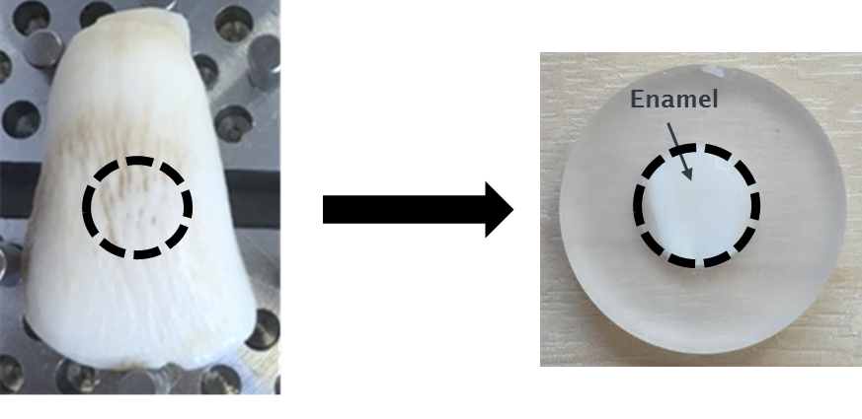
Figure 2: Position of bovine tooth cut for an enamel disc.

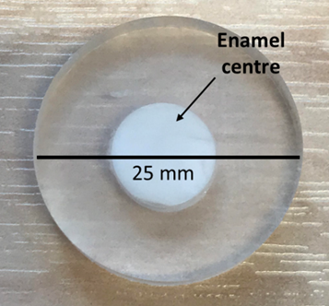
Figure 3: Bovine enamel disc mounted in epoxy resin supplied by GSK.
Table 4 Tailored preparation procedure provided by Struers for bovine teeth.
Grinding
Step | Plane grinding | Fine grinding 1 | Fine grinding 2 | Fine grinding 3
Surface | SiC foil #320 | SiC foil #500 | SiC foil #1200 | SiC foil #4000
Abrasive type | - | - | - | -
Lubricant type | Water | Water | Water | Water
Speed / rpm | 150 | 150 | 150 | 150
Force / N | 20 | 20 | 20 | 20
Holder direction | >> | >> | >> | >>
Time / minutes | 01:29 | 02:59 | 02:59 | 02:59
Polishing
Step | Plane grinding |  | Fine grinding 2
Surface | MD- Nap |  | MD- Chem
Abrasive type | DiaPro Nap R 1µm |  | OP- U, 0.04µm
Lubricant type
Speed / rpm | 150 |  | 150
Force / N | 15 |  | 10
Holder direction | >> |  | ><
Time / minutes | 04:28 |  | 02:59
The toothpaste slurry was made in accordance with BS EN ISO 11609:2010 [48], and consisted of a 0.5% Carboxymethyl cellulose (CMC) and 10% Glycerine (base) with a 20% abrasive loading, with a control slurry consisting of the same base but with no abrasive loading. The angular alumina and silica abrasives had mean particle sizes of 9µm (SD: 2.7) and 8µm (SD: 2.7) respectively, with the spherical silica having a mean particle size of 6.5 µm (SD:1.25). During testing a continuous slurry feed of 0.2 ml/s was supplied to the contact.
The toothbrush used for the study was the Tek Pro® firm toothbrush (Manufacturer – Dr Fresh, U.S.A, company- ProTek®), Figure 4. This is a generic hard graded toothbrush, with a flat geometry (uniform filament length) and filament design. The choice of selection for this toothbrush was due to the flat filament design (geometry) of the brush, which would result in all the filaments contacting the bovine surface evenly at any one given time. The toothbrush head was cut off the handle prior to the wear tests.
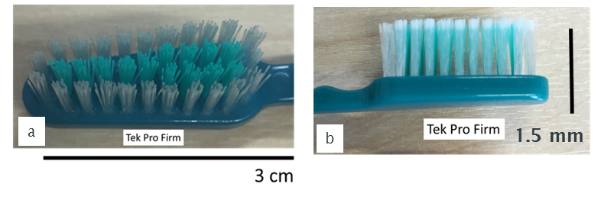
Figure 4: Tek Pro® firm toothbrush (a) top view; (b) side view.
The brushing setup used a TE77 reciprocating tribometer with a bespoke loading head capable of holding the toothbrush head and applying a static 5N brushing load. A Tek Pro® firm toothbrush with conical ended bristle tips was selected. The brushing stroke length was 4mm at a frequency of 4Hz. Friction force data was continuously captured during the experiment at 10Hz with the average friction value determined for each sample after the exclusion of the running in periods which occurred for each sample. High speed friction force data was captured every 10 minutes at 1 kHz throughout the experiment to enable more detailed assessment of the friction at different stages of the brushing experiment. The total brushing time per sample was 6 hours, but each experiment was stopped at 120 minute intervals, to allow for assessment of the surface roughness and materials loss.
The roughness and material loss measurements were performed using a Talysurf Form 1202 profilometer with a 2 µm radius diamond stylus. Five reference marks were applied to the epoxy resin surrounding the sample to allow for repeat site specific monitoring of the roughness evolution and the assessment of material loss during testing. The five profile measurements were taken perpendicular to the brushing direction, with the reference markings on the sample used to ensure the profiles were taken at the same location. The mean and standard deviation values of roughness (R_{a}), skewness (R_{sk}), valley depth (R_{v}) and total height of profile (R_{t}) were determined at each interval. Further post-test analysis of the sample surfaces to visualise the wear mechanisms was performed using a scanning electron microscopy (JCM 6000PLUS, JOEL).

Results

Surface roughness evolution
All the abrasives showed an increase in roughness parameters across the 6 hour period (Figure 5), with the alumina causing the greatest increase, followed by the angular silica, with the spherical silica showing the lowest roughness increase at all-time points. The saliva control samples showed no changes on roughness compared to the baseline values.
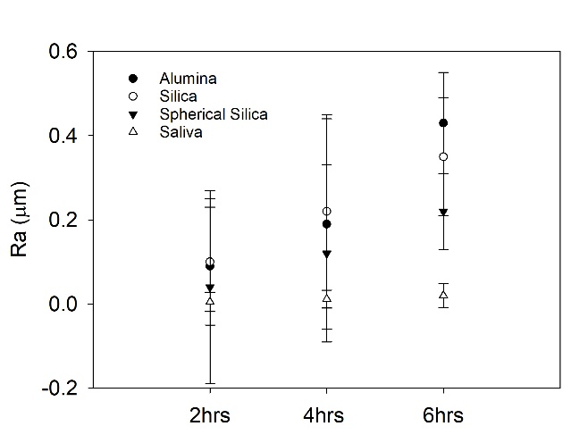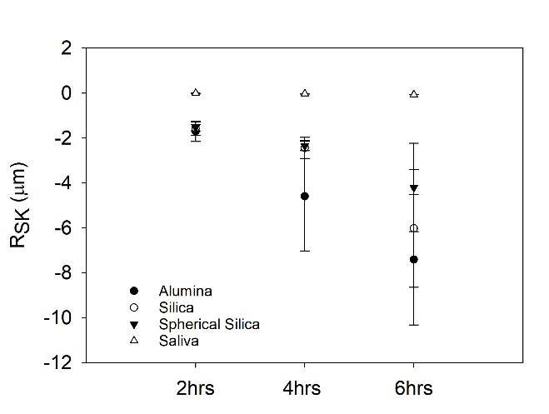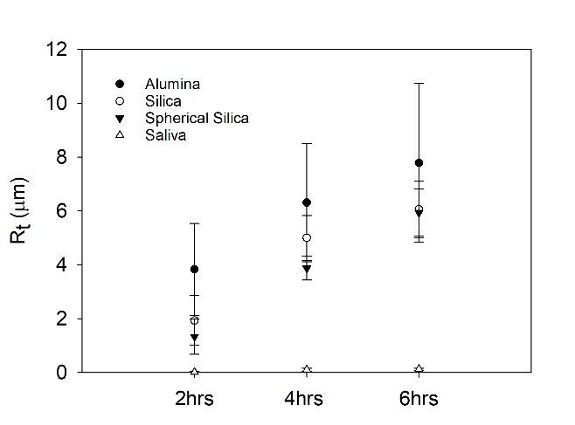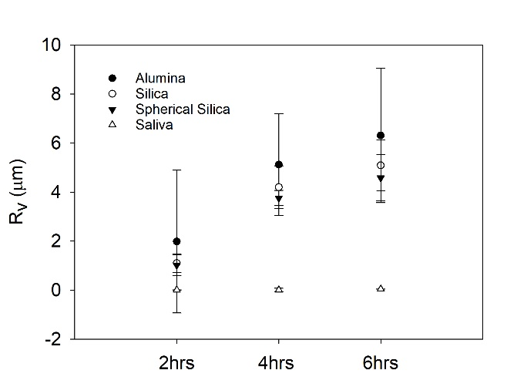
Figure 5. Roughness evolution during brushing

The average wear depth for alumina was 7.8μm (SD: 2.1μm), silica 5.4μm (SD: 1.7μm), spherical silica 3.5μm (SD: 1.4μm) and the control 0.007μm (SD: 0.024μm) after the 6 hours of brushing (Figure 6). This is 87%, 68% and 54% respectively of the size of the abrasive used. The mean wear depth was calculated by overlaying Talysurf traces. There was a significant difference in the roughness of the particle tests and the saliva test (p<0.05).
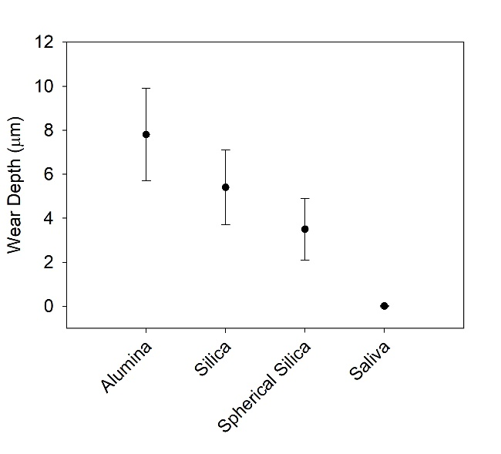
Figure 6 Wear depth after 6 hours brushing with the abrasive slurries

Friction measurements
The average friction values obtained for the alumina (0.071, SD: 0.001), silica (0.066, SD 0.001) and spherical silica (0.063, SD: 0.003) tests were all lower than the saliva control group (0.078, SD: 0.004), with the spherical silica providing the lowest friction off the slurries tested. The difference in the coefficient of friction between the particle tests and the saliva tests were statistically significant (p<0.005).

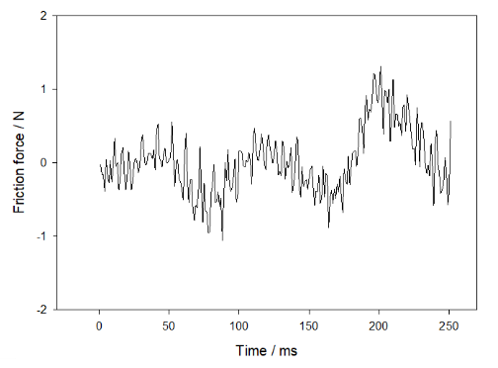
C
C
B
B
A
A
Figure 7 Alumina friction loop demonstrating the three phases of the brushing cycle
The high speed friction data enabled evaluation of the friction changes during the brushing cycles (Figure 7), which viewed in partnership with observations during brushing, demonstrated that each stroke in either direction can be split into three, labelled A, B and C on Figure 3. During section A, the friction value is negative for the given direction of travel as the bristles straighten, as the brush enters section B, the bristles begin to slide but also flex in the new direction of travel, with the friction force increasing as the bristle with agglomerated particles start to plough the surface, but also the brush stroke approaches its maximum sliding speed.
This is confirmed by observation during the wear test by eye. In section C the bristles are bent in the new direction of travel and sliding across the surface, but the stoke is decelerating to a stop, so the friction force reduces back to zero.
There is a variation in the magnitude of these effects between the slurries and the control, as the friction force value is a combination of the force associated with the bristle flex, but predominantly the force associated with the bristle/particle/surface interaction and in particular the damage occurring to the enamel surface. This is evidenced by the reduction in the average COF seen between the three slurries, the surface roughness evolution and the wear depth results. The asymmetric nature of the data between the forward and backwards travel has resulted from the slurry feed being located at one end of the stroke.
SEM of the bovine disc after brushing shows the surface consisted of various sizes of 2-body grooves in the shape and width of both the bristles and particles, with no rolling or three body wear evident on any of the test samples (Figure 8 – Figure 11). The SEM images are taken mid-stroke and show that bristles slide. The bristles with agglomerated particles attached to them damage the enamel surface.
Figure 8 Saliva Control
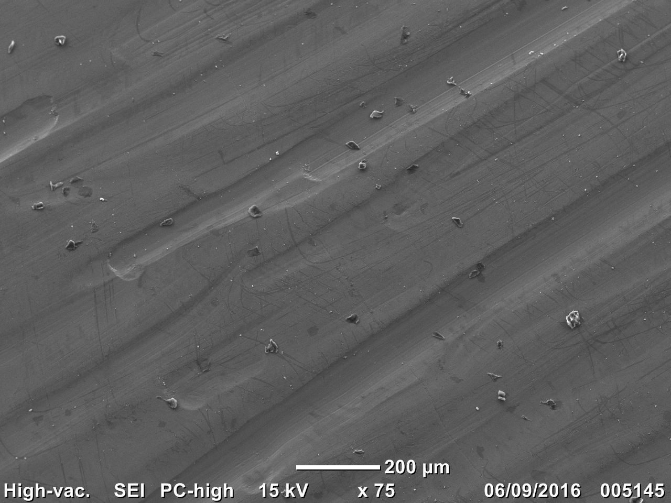
Figure 9 Angular silica
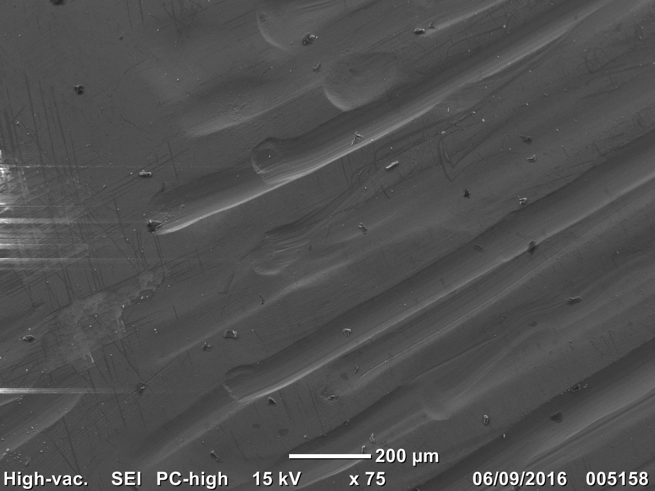
Figure 10 Alumina
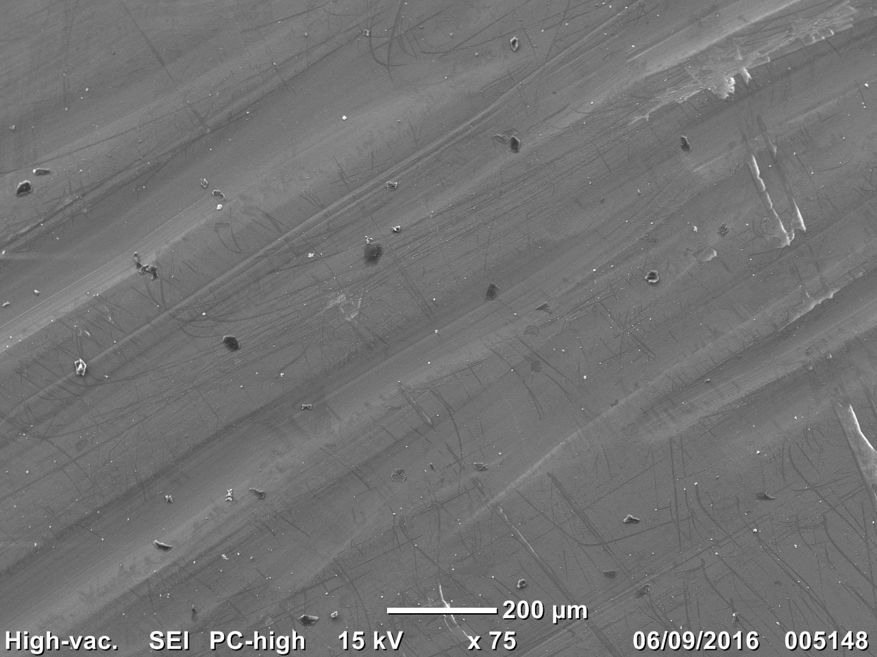
Figure 11 Spherical Silica
Many conditions such as the load, brushing action and deflection of bristles dictate if and how the abrasive particles are trapped in the bristles. Agglomerated particles are trapped in the bristle tips and stay wedged in the bristle tips during reciprocating movements (Figure 12). Figure 13 b, shows a single bristle after the wear test with particle agglomeration.
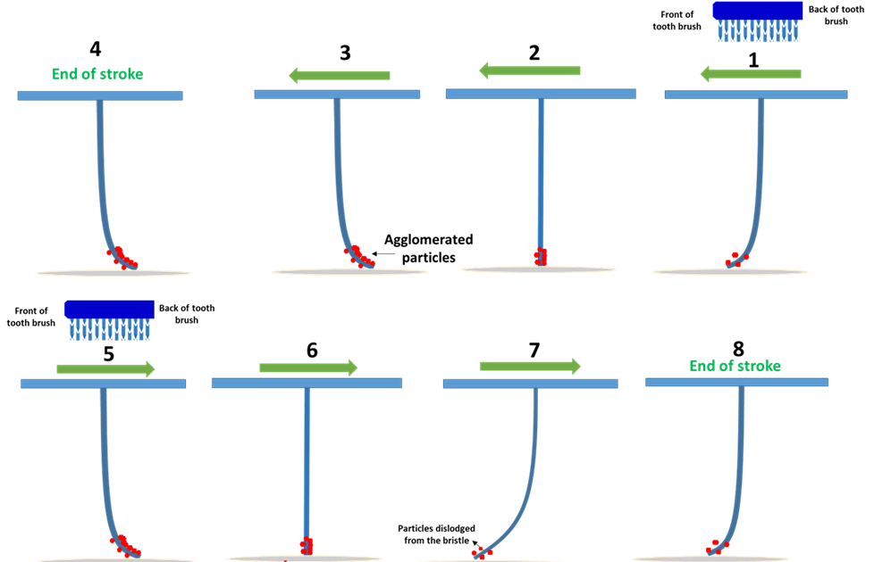
Figure 8
Figure 12 Schematic after several brushing strokes, after particle agglomeration.

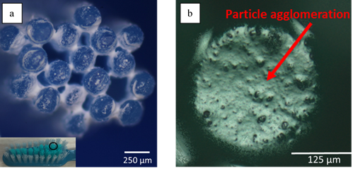
Figure 13 Particle agglomeration (a) alumina particles agglomerated in and around the bristles; (b) alumina particle agglomeration on a single bristle tip.

Discussion
Brushing your teeth is an essential activity to maintain and preserve one’s natural dentition. However, there is a fine balance between the abrasive processes necessary to remove the plaque and stains from the tooth surface and abrasion of the tooth’s enamel. Toothbrushing is a complex multi-factorial tribological process, however one of the key components to the abrasive process is the particles incorporated into the toothpaste formulations.

Friction
The coefficient of friction was measured over the duration of the tests. The saliva control tests generated the highest friction coefficient value which was unexpected. This is thought to be due to the high friction between hydrated enamel and nylon, compared to the particle tests where there is a particle is sliding against the hydrated enamel contact. A possible reason for this could be the inherent higher friction between wet nylon and hydrated enamel, compared to the friction between the particles and the enamel, Table 5.
Table 5 Coefficient of friction values and the standard deviation (σ) for the wear tests.
Mean coefficient of friction
GSK 9µm alumina | GSK 8µm silica | GSK 6.5µm spherical silica | Saliva
0.071  σ ± 0.001 | 0.066  σ ± 0.001 | 0.063  σ ± 0.003 | 0.078  σ ± 0.004

The average friction values obtained for the alumina (0.071, SD: 0.001), silica (0.066, SD 0.001) and spherical silica (0.063, SD: 0.003) agree with values from tests conducted by Zheng et al. [49] who reported the coefficient of friction values of enamel to be in the region of 0.026 – 0.87. Their study used loads in the region of 20N, whereas the present study conducted used a load of 5N. From the SEM images, the wear scar observed by Zheng et al. was two body grooving which is also confirmed in the present study, see later section. It was concluded that the removal of enamel was by a micro-cracking process [49, 50]. This observation is surprising as no micro-cracking was visible in the present study but could relate to the difference in test conditions and severity of abrasive/enamel contacts.
An explanation for the difference in run-in time for the particle groups could be due to the different levels of ploughing/ grooving depths resulting in different sliding abrasive forces to the total friction force. There was a noticeable drop in coefficient of friction after 10 minutes for the alumina, silica and spherical silica tests. This is referred to as the run in period; where the asperity peaks on the surface of the bovine disc are worn away by the abrasive particles or for the time it takes for the particles to build up on the bristles. There is no run-in period with the saliva test.
At the start and end of the brushing stroke the filament/enamel contact is likely to be in boundary lubrication. During the boundary lubrication phase, the coefficient of friction is the highest. As the sliding speed increases, the particle entrainment between the bovine disc and filaments increases which relieves the asperity contact; the coefficient of friction drops to a steady value. This is known as mixed lubrication and takes place in the middle of the brushing cycle. A mixed lubrication phase is desirable to avoid any wear [51]. Another factor to consider is the static and dynamic friction. The brushing test stops moving at each end of the brushing cycle which results in a steady value for the coefficient of friction.

Groove analysis
Agglomeration of particles can occur during the wear test. The particles that have entered the contact, have the ability to agglomerate to neighbouring particles in the slurry. When the particles are trapped between the filaments they make contact with the bovine disc. This process takes place by the deflection of filaments. The loaded particles act by grooving the surface of the bovine disc. This is two-body abrasion. The results from the tests show that 2-body grooving was observed on the bovine discs. Two-body grooving was also reported by Lewis et al. [5] who reported particles being spread evenly around the filament tips. The control saliva test showed no signs of wear highlighting the fact the filament alone is unable to damage the surface. Need to reference SEM images we have and particles on end of filaments etc.

Conclusion
Based on the present study of using the TE77 reciprocating tribometer to evaluate wear and friction performance of abrasive slurries on hydrated enamel, the following conclusions can be made:
- The coefficient of friction was higher for the saliva control test. A possibility of this is due to a high friction between wet nylon and hydrated enamel.
- Spherical silica tests generated the lowest wear rates compared to the alumina and silica tests and produced a smoother surface, with a Ra of 0.22µm.
- An important factor to consider is the agglomeration of particles on filaments. The use of dispersants should be considered to control agglomeration, or the use of super-hydrophobic surfaces/ coating on filaments, to stop particle agglomeration.
- A complex filament movement in the stroke leads to an asymmetric friction/ wear evolution. The middle coloured filaments have a different stiffness to the inner filaments influencing the wear rate.
- Increased groove formation during the duration of the test resulted in an increase in negative skewness (R_{sk}), valley depth (R_{v}) and total height of profile (R_{t}).
- The wear scratches formed on the bovine disc indicate a 2-body grooving mechanism. The wear on enamel appeared to be caused by the particles and filaments, showing that enamel removal is dominated by a micro-chipping action, where particles are embedded in the filament tips.
- The results show an increase in wear is produced on the bovine disc with alumina. Care should be taken when brushing with an alumina paste, to avoid an increased amount of enamel removal.
Future work will involve a larger test matrix using a brushing machine to better represent and provide a realistic model of the motion of tooth brushing in the mouth.

References
[1] S. Ranjitkar, J. M. Rodriguez, J. A. Kaidonis, L. C. Richards, G. C. Townsend, and D. W. Bartlett, "The Effect of Casein Phosphopeptide- Amorphous Calcium Phosphate on Erosive Enamel and Dentine Wear by Toothbrush Abrasion," Journal of Dentistry, vol. 37, pp. 250 -254, 2009.
[2] R. Lewis, R. S. Dwyer-Joyce, and M. J. Pickles, "Interaction Between Toothbrushes and Toothpaste Abrasive Particles in Simulated Tooth Cleaning," Wear, vol. 257, pp. 368 - 376, 2004.
[3] R. Lewis, S. C. Barber, and R. S. Dwyer-Joyce, "Particle Motion and Stain Removal During Simulated Abrasive Tooth Cleaning," Wear, vol. 263, pp. 188 - 197, 2007.
[4] A. Pena, E. Gallardo, A. Moran, J. Bravo, and M. Vite, "Micro-Abrasion Study of Some Dental Restorative Materials and Enamel," Journal of Engineering Tribology, vol. 227, no. 5, pp. 486 - 495, 2013.
[5] R. Lewis and R. S. Dwyer- Joyce, "Interactions Between Toothbrush and Toothpaste Particles During Simulated Abrasive Cleaning," Journal of Engineering Tribology, vol. 220, no. 8, pp. 755 - 765, 2006.
[6] I. R. Spears, R. van Noort, R. H. Crompton, G. E. Cardew, and I. C. Howard, "The effects of enamel anisotropy on the distribution of stress in a tooth.," Journal of Dental Research, vol. 72, no. 11, pp. 1526-31, 1993.
[7] R. W. Brand and D. E. Isslehard, "Anatomy of orofacial structures," Mosby, Ed. 7th ed. U.S.A: Mosby, 2003.
[8] L. W. Boushell and J. R. Sturdevant, Clinical significance of dental anatomy, histology, physiology and occlusion. 2015.
[9] J. L. Cuy, A. B. Mann, K. J. Livi, M. F. Teaford, and T. P. Weihs, "Nanoindentation Mapping of the Mechanical Properties of Human Molar Tooth Enamel," Archives of Oral Biology, vol. 47, pp. 281 - 291, 2002.
[10] S. Roy and B. Basu, "Mechanical and tribological characterisation of human tooth," Materials Characterisation, vol. 59, pp. 747 - 756, 2008.
[11] Y. R. Jeng, T. T. Lin, H. M. Hsu, H. G. Chang, and D. B. Shieh, "Human enamel rod presents anisotropic nanotribological properties," Journal of the Mechanical Behavior of Biomedical Materials, vol. 4, no. 4, pp. 515 -522, 2011.
[12] A. Braly, L. A. Darnell, A. B. Mann, M. F. Teaford, and T. P. Weihs, "The effect of prism orientation on the indentation testing of human molar enamel," Archives of Oral Biology, vol. 52, pp. 856- 60, 2007.
[13] S. Habelitz, S. J. Marshall, and M. Balooch, "Mechanical properties of human dental enamel on the nanometre scale," Archives of Oral Biology, pp. 173 - 83, 2001.
[14] Z. R. Zhou, H. Y. Yu, J. Zheng, L. M. Qian, and Y. Yan, Dental Biotribology. U.S.A: Springer, 2013.
[15] S. Park, D. H. Wng, D. Zhang, E. Romberg, and D. Arola, "Mechancial properites of human enamel as a fucntion of age and location in the tooth," Journal of Material Science: Materials in medicine, vol. 19, no. 6, pp. 2317 - 24 2008.
[16] A. Murad, "Structures of enamel ".
[17] A. R. Hand. (2015). Enamel structure, compostion and properties. Available: http://pocketdentistry.com/contact/
[18] S. M. Weidmann, J. A. Weatherell, and S. M. Hamm, "Variations of enamel density in sections of human teeth," Archives of Oral Biology, vol. 12, no. 1, pp. 85-97, 1967.
[19] R. Lewis and R. S. Dwyer- Joyce, "Wear of Human Teeth: A Tribological Perspective," Journal of Engineering Tribology, vol. 219, no. Part J, pp. 1 - 18, 2005.
[20] M. Braden, "Biophysics of the tooth," Frontiers of oral physiology, vol. 2, pp. 1 - 37, 1976.
[21] T. Komabayashi, G. Nonomura, L. G. Wananbe, G. M. Marshall, and S. J. Marshall, "Dentin Tubule Numerical Density Variations Below The CEJ," Journal of Dentistry, vol. 36, no. 11, pp. 953-958, 2008.
[22] H. Fong, M. Sarikaya, and S. N. White, "Nano-mechanical properties profiles across dentin-enamel junction of human incisor teeth," Material Science Engineering, vol. 7, pp. 119-128, 2000.
[23] K. Chun, H. H. Choi, and J. Y. Lee, "Comparison of mechanical property and role between enamel and dentin in the human teeth," Journal of Dental Biomechanics, vol. 5, 2014.
[24] Longisland. (2015, 17th March). Basic tooth anatomy Available: http://www.longislandfamilydental.com/dental-health/basic-tooth-anatomy/
[25] S. Ali, I. Farooq, F. Shahid, U. Hassan, and M. S. Zafar, "Common toothpastes abrasives and methods of evaluating their abrasivity," Journal of Oral Research, 2020.
[26] A. T. Ashcroft and A. Joiner, "Tooth Cleaning and Tooth Wear: A Review," Journal of Engineering Tribology, vol. 224, no. Part J, pp. 539 - 549, 2010.
[27] R. Lewis and R. S. Dwyer- Joyce, "Interactions Between Toothbrush and Toothpaste Particles During Simulated Abrasive Cleaning," Journal of Engineering Tribology, vol. 220, pp. 755 - 765, 2006.
[28] J. Zheng and Z. Z.R, "Friction and Wear Behavior of Human Teeth Under Various Wear Conditions," Tribology International, vol. 40, pp. 278 - 284, 2007.
[29] K. H. Zum Gahr, "Modelling of Two-Body Abrasive Wear," Wear, vol. 124, 1988.
[30] T. A. F. de Melo, G. S. L. Grundling, F. Montagner, R. K. Scarparo, J. A. P. Figueiredo, and F. V. Vier-Pelisser, "Are bovine teeth a suitable substitute for human teeth in in vitro studies to assess endotoxin load in root canals?," Microbiology, vol. 29, 2015.
[31] K. Tanaka, Y. Uchiyama, and S. Toyooka, "The mechanism of wear of PTFE," Wear, vol. 23, 1973.
[32] P. Laurance-Young et al., "A Review of the Structure of Human and Bovine Dental Hard Tissues and their Physicochemical Behaviour in Relation to Erosive Challenge and Remineralisation," Journal of Dentistry, vol. 39, pp. 266 - 272, 2011.
[33] L. A. Costa, "Evaluation of pH, ultimate tensile strength and micro-shear bond strength of two self-adhesive resin cements," Brazilian Dental Journal, vol. 28, no. 1, 2014.
[34] G. Rossi-Fedele and A. P. Roberts, "A preliminary study investigation the survival of tetracycline resistant Enteroccoccis faecalis after root canal irrigation with high concentration of tetracycline," International Endodontic Journal, vol. 10, pp. 772 - 7, 2007.
[35] L. M. Friroozmand, J. V. Brandao, and M. P. Fialho, "Influence of Microhybrid Resin and Etching Times on Bleached Enamel for the Bonding of Ceramic Brackets.," Brazilian Dental Journal, vol. 27, 2013.
[36] R. B. Fonseca, F. Haiter - Neto, A. J. Fernandes- Neto, G. A. S. Barbosa, and C. J. Soares, "Radiodensity of Enamel and Dentin of Human, Bovine and Swine Teeth," Archives of Oral Biology, vol. 49, pp. 919 - 922, 2004.
[37] C. H. Camargo, M. Sivieror, S. E. Camargo, S. H. de Oliviera, C. A. Carvalho, and M. C. Valera, "Topographical, diametral, and quantitative analysis of dentine tubules in the root canals of human and bovine teeth," Journal of Endodontics vol. 334, pp. 422-6, 2007.
[38] J. L. O. Tanaka et al., "Comparative Analysis of Human and Bovine Teeth: Radiographic Density," Brazilian Dental Journal, vol. 22, no. 4, pp. 346 - 51, 2007.
[39] G. H. Yassen, J. A. Platt, and A. T. Hara, "Bovine Teeth as Substitue for Human Teeth in Dental Research: A Review of Literature," Journal of Oral Science, vol. 53, no. 3, pp. 273 - 282, 2011.
[40] F. M. Lopes, R. A. Markarian, C. L. Sendyk, C. P. Duarte, and V. E. Arana- Chavez, "Swine teeth as potential substitues for in vitro studies in tooth adhesion: a SEM observation," Archives of Oral Biology, vol. 51, pp. 548-551, 2006.
[41] J. Arends, J. Christoffersen, J. Ruben, and W. L. Jongebloed, "Remineralisation of bovine dentine in vitro. The influence od the F content in solution on mineral distriution," Caries Research, vol. 23, pp. 309 - 314, 1989.
[42] C. L. Davidson, G. Boom, and J. Arends, "Calcium distribution in human and bovine surface enamel," Caries Research, vol. 7, pp. 349-359, 1973.
[43] J. L. O. Tanaka, E. M. Filho, J. A. P. Salgado, M. A. C. Salgado, L. C. de Moraes, and J. C. de Melo Castilho, "Comparative Analysis of Human and Bovine Teeth: Radiographic Density," Brazilian Oral Research, vol. 22, no. 4, pp. 346 - 351, 2008.
[44] D. Rios et al., "Effect of salivary stimulation on erosion of human
and bovine enamel subjected or not to subsequent abrasion: an in situ/ex vivo study.," Caries Research, vol. 40, 2006.
[45] T. Attin, F. Wegehaupt, D. Gries, and A. Wiegand, "The potential of deciduous and permanent bovine
enamel as substitute for deciduous and permanent
human enamel: erosion-abrasion experiments.," Jounral of Dentistry, vol. 35, 2007.
[46] F. Wegehaupt, D. Gries, A. Wiegand, and T. Attin, "Is bovine dentine an appropriate substitute for
human dentine in erosion/abrasion tests?," Journal of Oral Rehabilitation, vol. 35, 2008.
[47] F. J. Wegehaupt, R. Widmer, and T. Attin, "Is bovine
dentine an appropriate substitute in abrasion
studies?," Clinical oral investigation, vol. 14, 2010.
[48] Dentistry - Dentifrices - Requirements, Test Methods and Marking, 2010.
[49] J. Zheng, Z. R. Zhou, J. Zhang, H. Li, and H. Y. Yu, "On the Friction and Wear Behaviour of Human Tooth Enamel and Dentin," Wear, vol. 255, pp. 967 - 974, 2003.
[50] H. H. K. Xu et al., "Indentation Damage and Mechanical Propeties of Human Enamel and Dentin," Journal of Dental Research, vol. 77, no. 3, pp. 472 - 480, 1998.
[51] Fitch, J.C., R. Scott, and L. Leugner, The practical handbook of machinery lubrication. 2012.

