Note: this is a draft of the journal article:
Abiakam, Nkemjika; Worsley, Peter; Jayabal, Hemalatha; Mitchell, Kay; Jones, Michaela ; Fletcher, Jacqui; Spratt, Fran; Bader, Dan (2020) “Personal Protective Equipment related Skin Reactions in Healthcare professionals during COVID-19.”
International Wound Journal, accepted
The final, fully proofed and peer-reviewed journal article is available from the publisher online,

Title: PPE related Skin Reactions in Healthcare professionals during COVID-19

Nkemjika S. Abiakamᵃ, Peter R. Worsleyᵃ, Hemalatha Jayabalᵃ, Kay Mitchellᵇ, Michaela Jonesᵇ, Jacqui Fletcher^{c}, Fran Spratt^{b}, Dan L. Baderᵃ

ᵃ School of Health Sciences, University of Southampton, Southampton, UK
ᵇ University Hospital Southampton Foundation Trust, UK
^{c} NHS England and NHS Improvement, UK

Abstract
Since the outbreak of COVID-19 pandemic, clinicians have had to use personal protective equipment (PPE) for prolonged periods. This has been associated with detrimental effects, especially in relation to the skin health. The present study describes a comprehensive survey of healthcare workers (HCWs) to describe their experiences using PPE in managing COVID-19 patients, with a particular focus on adverse skin reactions.
A 24-hour prevalence study and multi-centre prospective survey were designed to capture the impact of PPE on skin health of hospital staff. Questionnaires incorporated demographics of participants, PPE type, usage time, and removal frequency. Participants reported the nature and location of any corresponding adverse skin reactions. The prevalence study included all staff in intensive care from a single centre, while the prospective study used a convenience sample of staff from three acute care providers in the UK.
A total of 108 staff were recruited into the prevalence study, while 307 HCWs from a variety of professional backgrounds and demographics participated in the prospective study. Various skin adverse reactions were reported for the prevalence study, with the bridge of the nose (69%) and ears (30%) being the most affected. Of the six adverse skin reactions recorded for the prospective study, the most common were redness blanching (33%), itchiness (22%), and pressure damage (12%). These occurred predominantly at the bridge of the nose and the ears. There were significant associations (p<0.05) between the adverse skin reactions with both the average daily time of PPE usage and the frequency of PPE relief.
The comprehensive study revealed that the use of PPE leads to an array of skin reactions at various facial locations of HCWs. Improvements in guidelines are required for PPE usage to protect skin health. In addition, modifications to PPE designs are required to accommodate a range of face shapes and appropriate materials to improve device safety.

INTRODUCTION
The outbreak of COVID-19 has resulted in clinical staff all over the world employing protective measures whilst providing care to patients. The use of Personal Protective Equipment (PPE) provides healthcare workers (HCWs) a level of safety by limiting the contact between clinical staff and patients [1]. However, the prolonged application of PPE during clinical shifts can affect skin health. Indeed, in order to provide protection against airborne particle transmission, devices such as respiratory protective equipment (RPE) are tightly fastened to the face to create an airtight seal. However, these masks are typically designed to a standard involving an average white male face shape, providing a limited range of size and geometry [2]. This can lead to overtightening to compensate for a poor fit, which is associated with soft tissue damage, as well as an increased risk of infection [3]. Staff are required to accommodate clinical duties under this challenging condition, with a limited number of breaks to permit skin recovery. Furthermore, staff are called to employ these devices for as much time as possible in order to mitigate PPE shortage issues [4].
When the PPE devices are applied it will create pressure, shear, and friction at the skin interface which can be sustained over an entire working shift e.g. 12 hours. In addition, due to the mental and physical stress on clinical staff who are managing COVID-19 patients, the skin can be further compromised by moisture, originating from excess sweating. Indeed, the exposure to moisture leads to the reduction of the strength and stiffness of the stratum corneum (SC), thereby reducing the overall tolerance to mechanical loading [5]. Particular anatomical regions are at risk, including, for example, the bridge of the nose, cheeks and ears. Indeed, research has revealed high interface pressures at the bridge of the nose during respiratory mask application [6]. The combination of altered microclimate at the skin-RPE device interface and prolonged exposure to pressure and shear forces result in device-related pressure damage to the skin and underlying tissues [7].
Although there are reports of skin damage from using PPE, there is a paucity of empirical evidence detailing factors associated with PPE related skin reactions in HCWs. Nonetheless, some recent studies have examined the proportion of HCWs reporting skin reactions from PPE [8, 9]. One quantitative study reported that indentation from marks was evident over the nasal bridge in 69% of HCWs. In addition, HCWs also reported dry skin (56%), itchiness (31%) and skin rashes (23%) as a result of prolonged latex gloves usage [10]. Despite this relatively high incidence of adverse skin reactions, there are no definite recommendations in terms of length and frequency of PPE usage by HCWs. In addition, there is a paucity of evidence pertaining to the types of devices (manufacturer and model) which commonly cause skin reactions, with a range of PPE devices being used both within and between different healthcare institutions.
The present study describes a comprehensive survey of HCWs with a focus on reporting the nature and frequencies of adverse skin reactions to PPE, as well as addressing factors which are implicated in compromising skin health.

METHODOLOGY

STUDY DESIGN
This prospective study, involving a number of UK NHS centres, was divided into distinct phases using a survey questionnaire. The first study was a 24-hour prevalence study of skin reactions from all HCWs using PPE conducted in high-risk departments, namely, general, neurological and surgical intensive care units and a surgical high dependency unit (SHDU) in a single care facility. This was complemented with a second study designed to capture the impact of PPE on skin health using a convenience sample of hospital staff from three acute care facilities during the COVID-19 pandemic in the UK.
Two distinct questionnaires were designed in order to meet the objectives of the studies. The surveys included details of each participant’s demographics, type and make of PPE employed, average time spent in PPE and the frequency of device removal. In addition, participants were asked about the comfort and pain levels associated with wearing their PPE, the nature and location of any skin adverse reactions and any preventive measures used. The questionnaire included closed-ended questions, including, multiple-choice answers, Likert rating scales, as well as some open-ended questions. The questions were based on previous literature, relevant guidelines and media reports [9, 11, 12]. The questionnaires were reviewed by a panel of experts consisting of clinical leads, nursing managers and experienced skin health researchers, who verified the content validity. The questionnaires were distributed electronically using a GoogleDocs platform, with all results held on a secure server.
Inclusion criteria consisted of hospital staff working in areas deemed necessary for PPE usage, namely, staff caring for suspected and/or infected with COVID-19 patients or staff at the frontline hospitality services i.e. receptionists, ushers. Exclusion criteria consisted of staff less than 18 years of age and those who were not required to use PPE during their working shifts. Participation was purely voluntary and informed consent was implied through the completion of the questionnaire. The project was approved by the University of Southampton ethics committee (ERGO-FOHS-56430).

DATA DISSEMINATION AND COLLECTION
The 24-hour prevalence sub-study data collection was carried out in June 2020. Questionnaires were distributed as hardcopies to staff after their shift and they were kindly asked to detail their experience by answering the survey questions. The data collection for the prospective experience sub-study was conducted from May 2020 to June 2020. Subsequently, a follow-up data collection was performed 3 weeks after the beginning of the study. Gatekeepers at each trust were recruited to disseminate the survey, which was completed on a voluntary basis. The participants were given the option to leave any question unanswered and, as such, the result for each question was calculated based on the total number of respondents.

STATISTICAL ANALYSIS
The data from both studies were imported into Microsoft Excel (Microsoft 365, USA). The collected data were reviewed prior and post analysis by experienced researchers to ensure consistency with the analytical method. Descriptive statistics (mean ± standard deviation (SD)) were used to represent continuous variables, while categorical data were presented as frequencies (percentages). Pivot tables were used to analyse the relationship between categories, and to examine trends within data. To examine the associations between dichotomous variables, Point-Biserial Correlation and Chi-Square Test of Independence were performed. Associations were considered to be statistically significant at the 5% level (p < 0.05).

RESULTS

24-HOUR PREVALENCE STUDY
A total of 108 questionnaires were completed and validated over a 24-hour period. The majority of participants were female (81%), who were equipped with full protection, including PPE (FFP3), eye protection, gloves, and gown. The cohort included 75% nurses, 9% doctors and 16% healthcare assistants (HCAs) or other health-related professions. In many cases, HCWs adopt new RPE in the same shift period, if available. A total of 119 PPE devices were used, with 75% of participants using 3M half respirators and the remaining using one or more designs from Alpha Solway, Medline Cardinal, Easy Fit 300, and Valmy. All the participants underwent fit testing prior to PPE application. The mean time spent using PPE was 9.2±2.6 hours. Although the average time in which PPE was removed (doffed) was 0.5+0.1 hours, 64% of participants reported wearing PPE for more than two hours without relief. 66% reported changes in their skin health after their shift. The anatomical sites most commonly affected were the bridge of nose (69%), ears (30%), cheeks (23%) and chin (20%). The relationship between the time of PPE usage and the adverse skin reactions are summarised in Table 1. The results highlighted an increase in the participants reporting adverse reactions, particularly redness blanching and pressure damage, in those wearing PPE for more than 8 hours. By contrast, there was a corresponding decrease in participants presenting with no adverse skin reactions with a longer period spent in PPE.

Table 1. The distribution of adverse skin adverse reactions across the time period of PPE usage by staff during a single working pattern at any given anatomical location. The corresponding percentages at each time period are calculated based on the total number of participants.
Hours of PPE usage | Redness blanching (%) | Pressure damage (%) | Itch. (%) | Rash (%) | Dry skin (%) | Spots (%) | ᵃOther (%) | No reaction (%) | Total  (n)
≤8 hours | 2 (11) | 2 (11) | 4 (21) | 2 (11) | 0 (0) | 0 (0) | 0 (0) | 13 (68) | 19
9 hours | 11 (69) | 5 (31) | 8 (50) | 5 (31) | 1 (6) | 2 (13) | 2 (13) | 3 (19) | 16
10 hours | 20 (40) | 11 (22) | 10 (20) | 5 (10) | 1 (2) | 3 (6) | 6 (12) | 16 (32) | 50
≥11 hours | 16 (70) | 9 (39) | 9 (39) | 4 (17) | 2 (9) | 1 (4) | 0 (0) | 5 (22) | 23
ᵃOthers= acne, blisters, allergic reactions and burning.

PROSPECTIVE MULTI-CENTRE SURVEY
A total of 307 participants from three different UK NHS acute settings responded to the prospective survey. Table 2 summaries their demographic details, their use of PPE, in terms of daily hours of use, consecutive days in PPE, as well as the pain perception while adopting the protective equipment. The majority of respondents were females, with nurses representing the largest professional group. Closer inspection between the recruitment centres revealed clear differences in terms of ethnicity of the recruited HCWs. Indeed, 91% of the participants from one acute setting were from the Black, Asian and Minority Ethnic (BAME) population, compared to a corresponding 12% present in the other two centres combined.
Table 2. Summary of demographics of participants and usage of PPE from the original survey.
Characteristics of participants
Gender
 |  | Male | Female |  | Total
 |  | 38 (12%) | 269 (88%) |  | 307
Profession
 | Doctors | Nurses | ᵃOthers
 | 51 (17%) | 209 (68%) | 47 (15%) |  | 307
Ethnicity
 | White (Caucasian) | Black/African/  Caribbean | Asian/Asian British | Mixed/Multiple backgrounds
 | 212 (79%) | 28 (10%) | 24 (9%) | 6 (2%) | 270
Age Range
20-29 (yrs) | 30-39 (yrs) | 40-49 (yrs) | 50-59 (yrs) | 60-69 (yrs)
43 (17%) | 72 (29%) | 74 (30%) | 55 (22%) | 6 (2%) | 250
Use of Personal Protective Equipment (PPE)
Number of consecutive days of usage
2 Days | 3 Days | 4 Days | 5 Days | ≥ 6 Days
63 (29%) | 83 (39%) | 34 (16%) | 23 (11%) | 12 (5%) | 215
Average daily hours of usage
< 6 hrs | 6-8 hrs | 8-10 hrs | 10-12 hrs | 12-13 hrs
65 (21%) | 94 (31%) | 39 (13%) | 80 (26%) | 27 (9%) | 305
Frequency of skin relief from PPE during a shift
Every 1 hr | Every 2 hrs | Every 3 hrs | Every 4 hrs | > Every 4 hrs
46 (18%) | 57 (22%) | 60 (23%) | 46 (18%) | 47 (18%) | 256
Pain perception scale while using PPE (0= no pain, 10= worst pain imaginable)
 | No pain (0) | Mild (1-3) | Moderate (4-6) | Severe (7-10)
 | 42 (16%) | 124 (48%) | 59 (23%) | 35 (13%) | 260
ᵃOthers included healthcare assistants, biomedical scientists and technicians.

SKIN ADVERSE REACTIONS DUE TO PERSONAL PROTECTIVE EQUIPMENT
Of the 307 survey responses, 269 participants (88%) identified a total of 1257 adverse skin reactions from PPE. These occurred specifically at five locations of the face, namely, the forehead, the bridge of nose, cheeks, chin and ears, as summarised in Table 3. This reveals many cases of multiple skin reactions at one of the anatomical locations, with the highest proportion of participant reports i.e. ~28% occurring at the bridge of the nose and the cheeks. It is worthy of note that the reactions at the forehead were primarily due to eye protective equipment. In addition, there was a clear change in the perceived health of the skin assessed on a 0-10 Likert scale, with 73% of the responders recording a relative decline in perceived skin health following PPE usage.

Table 3. The distribution of adverse skin adverse reactions at different anatomical sites on facial skin. The corresponding percentages at each site are calculated based on the total number of reactions.
Anatomical sites | Redness blanching (%) | Pressure damage (%) | Itch. (%) | Rash (%) | Dry skin (%) | Spots (%) | Total  (%)
Forehead | 47 (36) | 11 (9) | 25 (19) | 8 (6) | 24 (19) | 14 (11) | 129 (10)
Nose bridge | 135 (40) | 55 (16) | 67 (20) | 22 (7) | 37 (11) | 19 (6) | 335 (27)
Cheeks | 114 (32) | 25 (7) | 84 (23) | 36 (10) | 56 (16) | 45 (13) | 360 (29)
Chin | 41 (18) | 5 (2) | 54 (23) | 35 (15) | 33 (14) | 64 (28) | 232 (18)
Ears | 73 (36) | 55 (27) | 51 (25) | 7 (3) | 14 (7) | 1 (0) | 201 (16)
Total | 410 (35) | 151 (12) | 281 (22) | 108 (9) | 164 (13) | 145 (11) | 1257 (100)

FACTORS INFLUENCING SKIN ADVERSE REACTIONS
The association between the various skin adverse reactions was examined with respect to a selection of extrinsic factors associated with PPE usage.
Figure 1 reveals few substantive trends when the adverse skin reactions are correlated with the number of consecutive days of PPE usage, which varied from 1 to ≥6 days. However, it is evident that redness blanching was the most reported reaction at the bridge of the nose with a value of 50% of participants for those wearing PPE for 3 consecutive days (Figure 1A). The corresponding values were ~40% at the cheeks (Figure 1B) and <20% at both the chin (Figure 1C) and ears (Figure 1D).
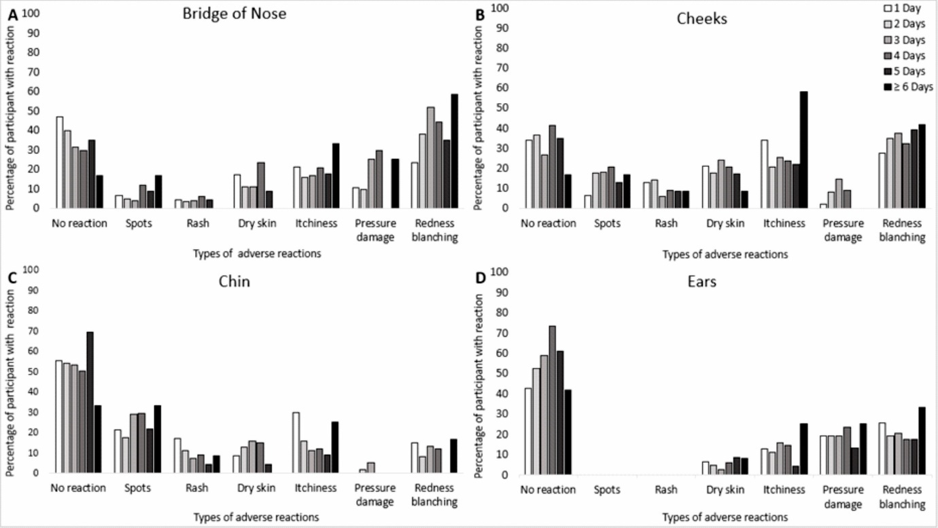
Figure 1. Correlation between number of consecutive days of PPE usage and skin reactions at different facial skin locations, namely, the nasal bridge (A), cheeks (B), chin (C) and ears (D).

With respect to the average daily hours spent using PPE, five separate groups were identified ranging from less than 6 hours to greater than 12 hours. The findings highlighted statistically significant correlations (p<0.05) between the average daily time of PPE usage and the manifestation of skin adverse reactions at the bridge of the nose, cheeks and ears (Figure 2). By contrast, those reporting no adverse skin reactions decreased with hourly usage at each site. However, there were distinct differences at the facial locations, for example, redness and pressure damage was most prevalent at the nose (Figure 2A) and the ears (Figure 2D). By contrast, the chin and cheeks were associated with a higher proportion of spots (Figure 2C) and itchiness (Figure 2B), respectively.

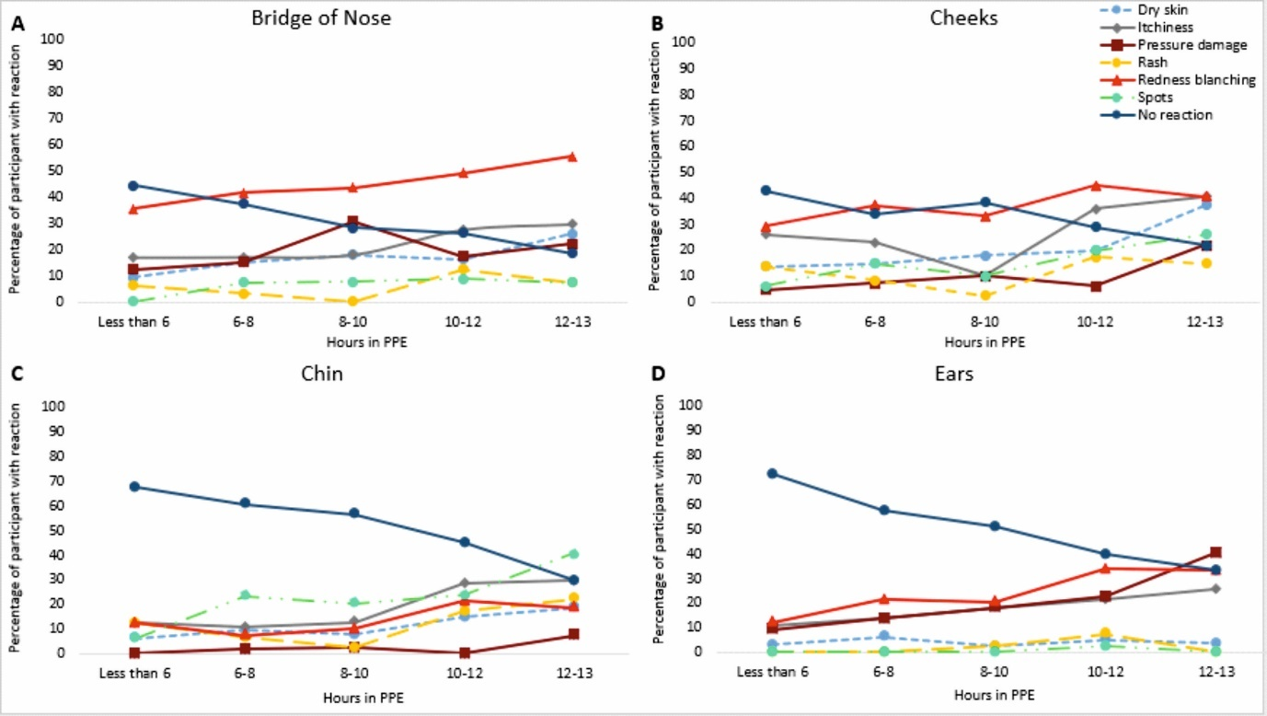
Figure 2. Correlation between the average daily time spent using PPE and skin reactions at different facial skin locations, namely, the nasal bridge (A), cheeks (B), chin (C) and ears (D). Hours spent in PPE is plotted against the percentage of respondents presenting with skin reactions.

With respect to time in between skin relief (doffing the PPE), the results from 256 participants were categorised into five time periods ranging from every 1 hour to in excess of 4 hours. There was a significant (p<0.05) increase in the reactions at both the bridge of the nose and ears and the time period between skin relief from PPE. Indeed, the results at the four facial sites, as illustrated in Figure 3, indicate that 50% of the respondents acquiring redness blanching on the nasal bridge corresponded to PPE usage in excess of three hours without relief (Figure 3A). Similar trends were also observed at the cheeks (Figure 3B) and the ears (Figure 3D). It is also noteworthy that pressure damage was reported on both the bridge of the nose and the ears in approximately 30% of participants when PPE was worn continuously for three or more hours.

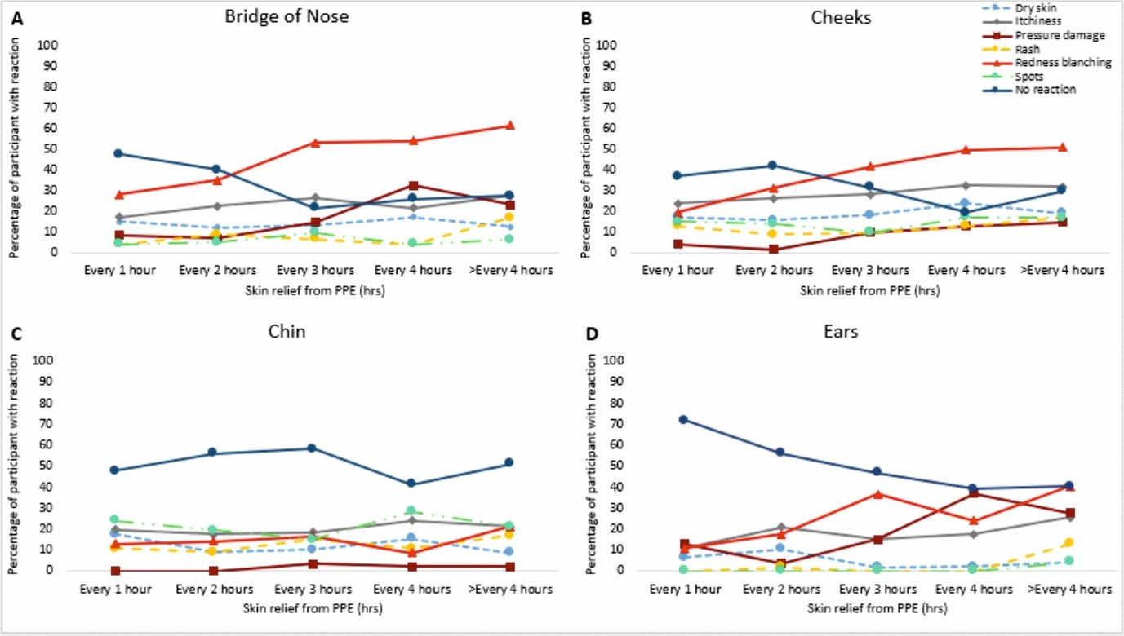
Figure 3. Correlation between the frequency of skin relief from PPE and skin reactions at different facial skin locations, namely the nasal bridge (A), cheeks (B), chin (C) and ears (D). Skin relied from PPE is plotted against the percentage of respondents presenting with skin reactions.

Different types of PPE devices were reported, including FFP3 respirators, FFP1, and other varieties of face protective equipment (Figure 4). The results at the four facial sites, reveal no outstanding performance attributed to the design of face protective equipment. Nonetheless, close examination reveals some trends, namely,
- With most device types, redness blanching was the most prominent skin adverse reaction, particularly over the bridge of the nose and the cheeks (Figures 4A and B), as exemplified by the 3M device, which was used by 46% of the cohort
- Pressure damage at the nose was relatively high for the 10% of the cohort, who used the Alpha and Sundstrom designs of face protectors.
- Itchiness at all anatomical sites was relatively high for the 7% of the cohort who used the Easy Fit and other designs of face protectors.
- Rashes were more prominent at the cheeks and chin for all mask designs, with absolute percentage occasionally exceeding 30%
- Spot was elevated on the chin with a value of 50% reported by Easy Fit users.

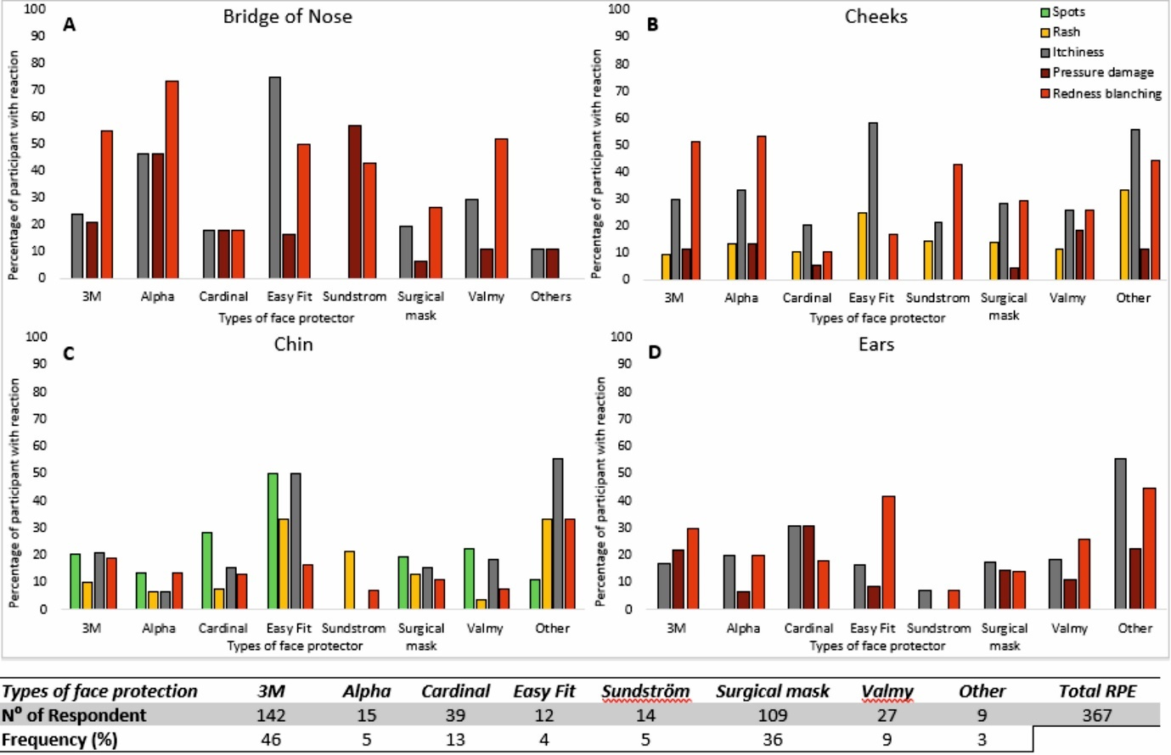
Figure 4. Correlation between various designs of face protective equipment and percentage incidence of adverse skin reactions at different facial sites, namely, the bridge of nose (A), cheeks (B), chin (C) and ears (D). The number of respondents and their distribution for each design of face protection equipment, with relative frequencies, calculated based on the total number of participants, is indicated at the bottom of the figure.

The responses to the other closed questions related to fit testing, skin care while using PPE, comfort and safety, are summarised in Table 4. It is evident that the majority of respondents i.e. 76% underwent fit testing before using PPE. However, this was not consistent between centres as one centre revealed that only 27% of their 33 respondents (mostly from the BAME community), attended fit testing prior to using RPE. The minority of participants employed skin protective measures, including moisturizers and/or preventive dressings. In addition, while most participants reported discomfort and breathing difficulties, the majority felt safe. It was also of note that although pressure damage was often reported, only 15% of HCWs presented with broken skin.

Table 4. Summary of the response related to skin care, comfort and safety, and facial skin health while using PPE.
Questions (?) | Yes (%) | No (%) | Total respondents
Fit tested | 235 (76) | 72 (24) | 307
SKIN CARE WHILE USING PPE
Use of cosmetics | 124 (52) | 116 (48) | 240
Use of moisturizer/cream | 80 (30) | 185 (70) | 265
Use of preventive dressing material | 31 (12) | 234 (88) | 265
Regular break taken from PPE | 214 (71) | 88 (29) | 302
COMFORT AND SAFETY WHILE USING PPE
Comfortable wearing PPE | 69 (26) | 194 (74) | 263
Breathe easily wearing PPE | 98 (37) | 165 (63) | 263
Feel safe & in control using PPE | 161 (61) | 102 (39) | 263

PROSPECTIVE MULTI-CENTRE SURVEY FOLLOW-UP
A total of 144 participants (47%) were followed up and 85% reported using the same equipment. The data revealed a small decrease in both the time spent per day and the number of consecutive days using PPE. A small number of HCWs (11%) reported struggling with their daily life activities as a result of PPE-related pain. Despite these difficulties, the skin protective practices remained substantively the same. A total of 380 adverse skin reactions were reported at follow-up, in a similar distribution of facial sites. Noticeably there was an overall 15% increase in redness blanching, but a 3-fold decrease in dry skin compared with the original survey. There were no other substantial differences in the skin responses reported at the different facial sites.

DISCUSSION
The worldwide spread of COVID-19 has imposed a considerable strain on both healthcare systems and professionals, who are required to adopt strict protective measures in order to ensure safety while managing affected patients. The present study included a single site prevalence study and a prospective survey of 307 HCWs from three acute UK hospital trusts to evaluate skin reactions from PPE use. The comprehensive survey identified the nature of the adverse skin reactions and their associations with PPE application time. Indeed, for both the prevalence and prospective studies, there was clear evidence that participants who spent more time in PPE presented with a higher proportion of adverse reactions at all skin locations (Table 1 and Figure 2). In addition, some distinct trends were observed between mask designs, associated with the various geometry, materials and fixation methods associated with PPE devices.
The data showed that more than 87% of the participants reported changes to skin health as a direct consequence of PPE usage. These findings are slightly lower than those recently reported [8], although this study examined a diverse range of skin locations including those away from the face of clinical staff. In the present survey, the bridge of the nose and the cheeks represent the most commonly affected locations (Table 3), which is in accordance with previous findings [10, 13]. Consecutive days of using PPE did not highlight specific differences, although peaks of adverse reactions were observed between days 3 and 4. This could be associated with a cumulative effect of repetitive insults, thereby decreasing skin tolerance to load. Indeed, all participants were exposed to repetitive insults to the skin, such as temperature, humidity, pressure and shear, all of which could lower the tolerance of skin to PPE application [14, 15]. Intrinsic factors such as age revealed very few trends in adverse skin reactions, despite the known loss of skin water content and elasticity with age [14]. Other factors such as psychological stress and hormones could have affected the likelihood to skin reactions.
The known association between pressure and time in relation to skin damage [16], could explain both the present findings and previous observations [8, 13], which identified the time in which PPE is applied corresponds with the reported skin reactions. The present study has also revealed compelling evidence that extended periods without skin relief from PPE was associated with the occurrence of adverse reactions. Figure 3 revealed that after 3 hours of continuous usage of protective equipment, up to 40% of respondents reported pressure damage at different facial locations. These findings are of fundamental importance as current guidelines lack specific information regarding the duration of PPE application and the frequency of relief required to protect skin health [17]. It was also observed that only a small proportion of participants (36%) adopted protective measures, in the form of moisturizers and/or preventive dressings, to ensure skin health (Table 4). This might be due to a lack of staff education on skin care and/or the paucity of information on appropriate prophylactic dressings [18] to fit under the face protection without compromising its function.
Implications of the make and design of RPE were also examined, in the light of previous studies which focused on the effects of N95 respirators [19, 20], which are classified as FFP2 devices and, as such, deemed inadequate in many high-risk settings. The present study, focussing on FFP3 clearly indicates that with prolonged use there was no specific mask design that maintained skin health over all face locations (Figure 4). Indeed, the bridge of the nose seemed to be particularly vulnerable to adverse reactions, in the form of redness blanching and pressure damage, when exposed to all designs. It is worthy of note that most RPE devices are designed for white male face shapes [21], incorporating stiff polymeric materials [22]. The one-size fits all principle that many RPE devices use could be a significant factor in the reported adverse reactions, limiting the conformity to different face shapes [23]. Although all manufacturers recommend fit testing prior to the use of FFP3 masks, it is clear that this was not consistently followed across each of the facilities. Indeed, close examination revealed that a high proportion (72%) of BAME respondents from one centre had not undergone a routine fit test of their RPE. This issue has been recently discussed in a computational-based study by the authors (Verberne et al. [23]), who highlighted the challenge of fitting face masks particularly for BAME individuals to minimise the risk of both gapping and indentation at vulnerable sites including the bridge of the nose, cheeks and chin. It is of critical importance that all HCWs undergo comprehensive fit testing to minimise the risk of infection from airborne particle transmission. Further investigation is needed to ensure that good practice is implemented within care settings across the world to protect HCWs from all ethnic backgrounds.
The study is clearly limited by gender diversity and ethical background. Indeed, the vast majority of participants were female of White (Caucasian) ethnicity. The sample size in the prospective study may not be reflective of the effective UK NHS workforce. In addition, there might be a self-selection bias, as staff with skin reactions might have been more prone to engage in the prospective survey. However, these limitations were in part mitigated with the prevalence study, which revealed a similar proportion of staff reporting adverse reactions and notable associations with the time of PPE usage (Table 1). The participants did not record the stages of pressure damage incurred at the different skin locations. Furthermore, the majority of participants in both prevalence and prospective studies used 3M masks, limiting adequate comparisons between different designs of FFP3 equipment.
Based on the findings of this study, we recommend medical staff to implement frequent relief from PPE, particularly during extended clinical shifts. Skin checks should be performed both within and between periods in PPE, with prevention strategies to maintain skin health. Where there are signs of an adverse reaction, we recommend adequate recovery periods and changes to PPE device selection to offload vulnerable skin sites. Collaboration with PPE manufacturers is required to identify new designs which incorporate a combination of soft material interfaces and include size ranges to accommodate face shapes of different genders and ethnicities.

CONCLUSION
A series of approaches were adopted to examine skin adverse reactions following periods of PPE usage. Increasing reports of adverse reactions were associated with the average daily time spent in PPE and the duration of PPE use without relief. Trends in skin adverse reactions were also associated with the number of consecutive days of PPE usage, as well as the type and model of RPE. There is a compelling need to improve the guidelines for PPE use and the design/materials of which the protective equipment are manufactured, in order to minimise the risk of skin damage to valuable healthcare workers.

ACKNOWLEDGEMENTS
The authors wish to thank the coordinators and all the healthcare workers at the participating hospital centres for the time dedicated to responding to these questionnaires, particularly in these unprecedented times.
FUNDING SOURCES
This work was supported by the European Union’s Horizon 2020 research and innovation programme under the Marie Skłodowska-Curie grant agreement No. 811965 (Project STINTS - Skin Tissue Integrity under Shear).

CONFLICTS OF INTEREST:
None

REFERENCES:
1. Honda, H. and K. Iwata, Personal protective equipment and improving compliance among healthcare workers in high-risk settings. Current opinion in infectious diseases, 2016. 29(4): p. 400-406.
2. Trades Union Congress, T. Personal protective equipment and women 2017; Available from: https://www.tuc.org.uk/sites/default/files/PPEandwomenguidance.pdf
3. Gefen, A. and K. Ousey, Update to device-related pressure ulcers: SECURE prevention. COVID-19, face masks and skin damage. Journal of Wound Care, 2020. 29(5): p. 245-259.
4. Ranney, M.L., V. Griffeth, and A.K. Jha, Critical Supply Shortages — The Need for Ventilators and Personal Protective Equipment during the Covid-19 Pandemic. New England Journal of Medicine, 2020. 382(18): p. e41.
5. Kottner, J., et al., Microclimate: a critical review in the context of pressure ulcer prevention. Clinical Biomechanics, 2018. 59: p. 62-70.
6. Worsley, P.R., et al., Investigating the effects of strap tension during non-invasive ventilation mask application: a combined biomechanical and biomarker approach. Medical devices (Auckland, N.Z.), 2016. 9: p. 409-417.
7. Worsley, P.R., F. Spratt, and D.L. Bader, COVID19: Challenging tissue viability in both patients and clinicians. Journal of tissue viability, 2020. 29(3): p. 153-154.
8. Lan, J., et al., Skin damage among health care workers managing coronavirus disease-2019. Journal of the American Academy of Dermatology, 2020. 82(5): p. 1215-1216.
9. Yan, Y., et al., Consensus of Chinese experts on protection of skin and mucous membrane barrier for health-care workers fighting against coronavirus disease 2019. Dermatologic Therapy, 2020. n/a(n/a): p. e13310.
10. Hu, K., et al., The adverse skin reactions of health care workers using personal protective equipment for COVID-19. Medicine, 2020. 99(24): p. e20603.
11. Foo, C.C.I., et al., Adverse skin reactions to personal protective equipment against severe acute respiratory syndrome – a descriptive study in Singapore. Contact Dermatitis, 2006. 55(5): p. 291-294.
12. Donovan, J., et al., Skin Reactions Following Use of N95 Facial Masks. Dermatitis, 2007. 18(2): p. 104.
13. Qixia Jiang, S.S., Jihong Zhou, Yuxiu Liu, Aihua Chen, Yuxuan Bai, Jing Wang, Zhixia Jiang, Yanhong Zhang, Haiying Liu, Jiao Hua, Jinli Guo, Qiuying Han, Yongli Tang, and Jiayu Xue, The Prevalence, Characteristics, and Prevention Status of Skin Injury Caused by Personal Protective Equipment Among Medical Staff in Fighting COVID-19: A Multicenter, Cross-Sectional Study. Advances in Wound Care, 2020. 0(0): p. null.
14. Coleman, S.R. and R. Grover, The anatomy of the aging face: volume loss and changes in 3-dimensional topography. Aesthetic surgery journal, 2006. 26(1_Supplement): p. S4-S9.
15. Gosain, A.K., et al., A volumetric analysis of soft-tissue changes in the aging midface using high-resolution MRI: implications for facial rejuvenation. Plastic and reconstructive surgery, 2005. 115(4): p. 1143-1152.
16. Gefen, A., Reswick and Rogers pressure-time curve for pressure ulcer risk. Part 1. Nurs Stand, 2009. 23(45): p. 64, 66, 68 passim.
17. NHS Improvement, N.E. Guidance on supply and use of Personal Protective Equipment (PPE) and other supplies. 2020; Available from: https://www.england.nhs.uk/coronavirus/publication/guidance-supply-use-of-ppe/.
18. Peko Cohen, L., et al., Dressings cut to shape alleviate facial tissue loads while using an oxygen mask. International Wound Journal, 2019. 16(3): p. 813-826.
19. Lam, U.-N., et al., N95 respirator associated pressure ulcer amongst COVID-19 health care workers. International Wound Journal, 2020. n/a(n/a).
20. Hua, W., et al., Short-term skin reactions following use of N95 respirators and medical masks. Contact Dermatitis, 2020. 83(2): p. 115-121.
21. Merson, A., Unions say coronavirus crisis has brought ‘into sharp focus’ the problem of women being expected to wear PPE designed for men. Press and Journal, 2020. 16.
22. Bader, D., P. Worsley, and A. Gefen, Bioengineering considerations in the prevention of medical device-related pressure ulcers. Clinical Biomechanics, 2019. 67: p. 70-77.
23. J. W.R Verberne, P.R.W., D.L. Bader, A 3D registration methodology to evaluate the goodness of ﬁt at the individual-respiratory mask interface. Computer Methods in Biomechanics and Biomedical Engineering 2020. Accepted in press.

