Integrated phytomanagement of a carbon tetrachloride-contaminated site in Murdock, Nebraska (USA)
Andrew B. Cundy^{a*}, Lorraine LaFreniere^{b}, R.Paul Bardos^{c,d}, Eugene Yan^{b}, Robert Sedivy^{b}, Caroline Roe^{e}
ª University of Southampton, Southampton, SO14 3ZH, UK.
^{b} Argonne National Laboratory, Lemont, Illinois 60439, USA.
^{c} r3 Environmental Technology Ltd, Reading, UK.
^{d} University of Brighton, Brighton BN2 4GJ, UK
^{e} U.S. Department of Agriculture / Commodity Credit Corporation, Washington D.C., USA

* Corresponding author: A.Cundy@soton.ac.uk

Highlights
- Large-scale phytomanagement was successfully applied at a CCl₄-impacted site
- Effective risk management has been achieved over the 10+ years since implementation
- Ca. 300g to 600g CCl₄ has been removed annually via plant uptake and translocation
- Effective design can realise significant socio-economic and environmental benefit

ABSTRACT.
The application of a large-scale (ca. 59,000 m²) integrated phytomanagement system at a carbon tetrachloride (CCl₄)-impacted site at Murdock, Nebraska, USA, was assessed in terms of its effectiveness in mitigating site risk, and realizing wider social and environmental benefits. Volatile Organic Compound (VOCs) concentrations (including CCl₄) measured in surface water, groundwater, air and vegetation samples show that the Murdock system has achieved effective risk management over the 10+ year period since its implementation, with the phytomanagement component of the remediation system (consisting of a mixed stand of dominantly Niobe willow (Salix x ‘Niobe’) and Eastern Cottonwood (Populus deltoides)) removing 300g to 600g of CCl₄ annually. Eastern Cottonwood played an increasing role in CCl₄ removal over time, from 55% of the total mass removal in 2008 to 69% in 2014. Using a site design focused on enhancement of the social and physical environment, in addition to risk mitigation, has enabled realization of a range of wider social and environmental benefits, which include carbon sequestration of ca. 77 tons CO₂/ha/y, and educational and recreational benefits. The phytomanagement system applied at Murdock has incurred significant installation, and on-going monitoring and maintenance, effort and costs (exceeding $1.5 million) highlighting the importance of (a) sustained stakeholder engagement to ensure continued local community support, and (b) effective site design to realize as full a range of core (i.e. risk mitigation) and wider benefits as possible, to increase the overall value proposition of such schemes.

Keywords: Phytomanagement; sustainable remediation; carbon tetrachloride; groundwater; phytoremediation; stakeholder engagement.
- Introduction
Over the past decade achieving sustainability has become a major influence in remediation decision-making at contaminated sites (Bardos et al., 2016a; ISO, 2017; Smith, 2019), alongside risk-based land management (Vegter et al., 2002). In parallel there has been increasing, or sometimes renewed, interest in the application of low input or “gentle” remediation approaches (Kennen and Kirkwood, 2015; Cundy et al., 2016; Bardos et al., 2020), which are particularly useful for circumstances where soil functionality needs to be maintained during and after site clean-up. One such gentle remediation approach is to utilize plants and their associated microorganisms (such as rhizosphere and endophytic bacteria) to reduce contaminant transfer to local receptors by in situ stabilization, and / or extraction, transformation or degradation of contaminants (i.e. phytoremediation).
As outlined in a number of recent publications, phytoremediation approaches can be applied as part of wider risk and land management strategies, either alone or in combination with other remediation techniques, to gradually mitigate or eliminate contaminant-induced health and environmental risks while simultaneously realising economic, ecosystem service and other benefits (Cundy et al., 2016; Gerhardt et al., 2017; Mench et al., 2018). These wider plant-based management strategies, termed phytomanagement, can offer significant benefits in terms of deployment costs (Vangronsveld et al., 2009; Kuppusamy et al., 2016; Gerhardt et al., 2017), as well as providing:
- rapid risk management via pathway control, through containment and stabilisation, and/or a longer term removal, destruction or immobilisation/isolation of contaminants (Schnoor et al., 1995; Friesl-Hanl et al., 2009; Herzig et al., 2014; Kiamarsi et al., 2020); and
- a range of wider environmental, social or economic benefits (Cundy et al., 2016; Kennen and Kirkwood, 2015; O’Connor et al., 2019).
These wider benefits may include CO₂ sequestration; water filtration, flood and drainage management; restoration or enhancement of plant and wildlife communities; opportunities for leisure and recreation; increase in surrounding property values; and biomass or biofeedstocks generation. The latter in particular may be important for local economic benefit, providing a valuable raw or processed material (e.g. Gomes, 2012; Alzeyadi et al., 2019), and several projects have proposed the use of biomass or biofeedstocks generation from phyto-based strategies at brownfield or contaminated sites to leverage re-use of economically marginal land (e.g. Bardos et al, 2011; Andersson-Skold et al., 2014).
Despite widespread use of “green” technologies such as landscaping, application of green cover, and reedbeds in remediation or industrial/urban regeneration projects however, the application of both phytoremediation and phytomanagement as a practical site risk management approach is still in its relative infancy (particularly on a commercial basis, Gerhardt et al., 2017), and there are considerable international differences in the adoption and promotion of practical, large-scale phytotechnology efforts. In the USA, the Interstate Technology & Regulatory Council (ITRC, 2009) listed 48 sites as hosting phytotechnology trials (as of 2007), ranging from relatively small-scale community-driven initiatives through larger “green-technology”-based remediation programmes at US Superfund sites. In contrast, in Europe most larger-scale applications have involved academic or research institute-led pilot or trial sites only. Cundy et al., (2013) note limited awareness and confidence in phytotechnologies, particularly in Europe, and highlight a clear requirement for large-scale, longer-term demonstration sites to provide evidence of the effectiveness of phytotechnologies under varying site contexts and conditions, data for economic and other assessments, and in particular to develop robust strategies for stakeholder engagement.
The latter is particularly important as the scale and range of interested parties for large area applications of phytomanagement, particularly where a “soft” end use of the site (e.g. in community parkland) is considered, is likely to be significantly larger than in many other remediation fields. This necessitates a robust, inclusive and transparent approach to stakeholder engagement to ensure timely and successful project implementation. However, a wide range of stakeholder benefits, as noted above, might also be achieved by well-executed projects which may be a key part of the value proposition of using phytomanagement over alternative remediation methods (Cundy et al., 2016; Bardos et al., 2016b; Coulon et al., 2017).
The objective of this study is to assess the application of a large-scale (14.5 acre, or ca. 59,000 m²) integrated phytomanagement system at a carbon tetrachloride (CCl₄)-impacted site at Murdock, Nebraska, USA, in terms of its effectiveness in mitigating site risk over a decadal timescale, and realizing wider social and environmental benefits. CCl₄ is a common toxic and stable contaminant that is difficult to remediate in groundwater, and a suspected carcinogen. While previous work has examined the specific uptake and degradation mechanisms of CCl₄ in smaller scale (pot and controlled field) conditions, here we assess the effectiveness (in terms of risk management) of CCl₄ phytomanagement using a large, well-instrumented and integrated field application, over 10+ years of implementation. We firstly examine risk management, and mass removal, of CCl₄ at the Murdock site, based on results from seasonal, biannual and annual groundwater, tree tissue, surface water and air sampling between 2005 and 2016. We then examine the effectiveness of the stakeholder engagement strategies used at the Murdock site, assess the wider social and environmental benefits realized, evaluate the overall economic cost of the remediation scheme, and discuss the wider implications for the effective design and application of phytomanagement approaches at other large contaminated sites.
1.1 Site description
Murdock is a small village approximately 20 miles northeast of Lincoln, Nebraska, in the Midwest USA (Figure 1). The village and its surroundings are underlain by the Lower Cretaceous Dakota Sandstone Formation, with thick, loessic, moderately well-drained silty soils (Culver, 1990). From the early 1950s to 1972 five acres of land at the south edge of the village were used as the site of a U.S. Department of Agriculture (USDA) grain storage facility. Stored grain was periodically treated with an “80/20” CCl₄/CS₂ fumigant. In 1985, through routine state-wide testing, the Nebraska Department of Health (NDOH) identified CCl₄ in the Murdock public water supply at levels (426 - 636 ug/l) exceeding the federal standard for this compound in drinking water (5 ug/l). Following confirmation of elevated CCl₄ (a U.S. Environmental Protection Agency (USEPA) Priority Pollutant and the main contaminant of concern here), the NDOH issued a health advisory, which in turn led to an Immediate Removal Action initiated by the USEPA. An alternative municipal water supply was established by the USEPA in February 1986. Sampling from September 1985 through August 1988 identified the source of the contamination as the former grain storage facility.

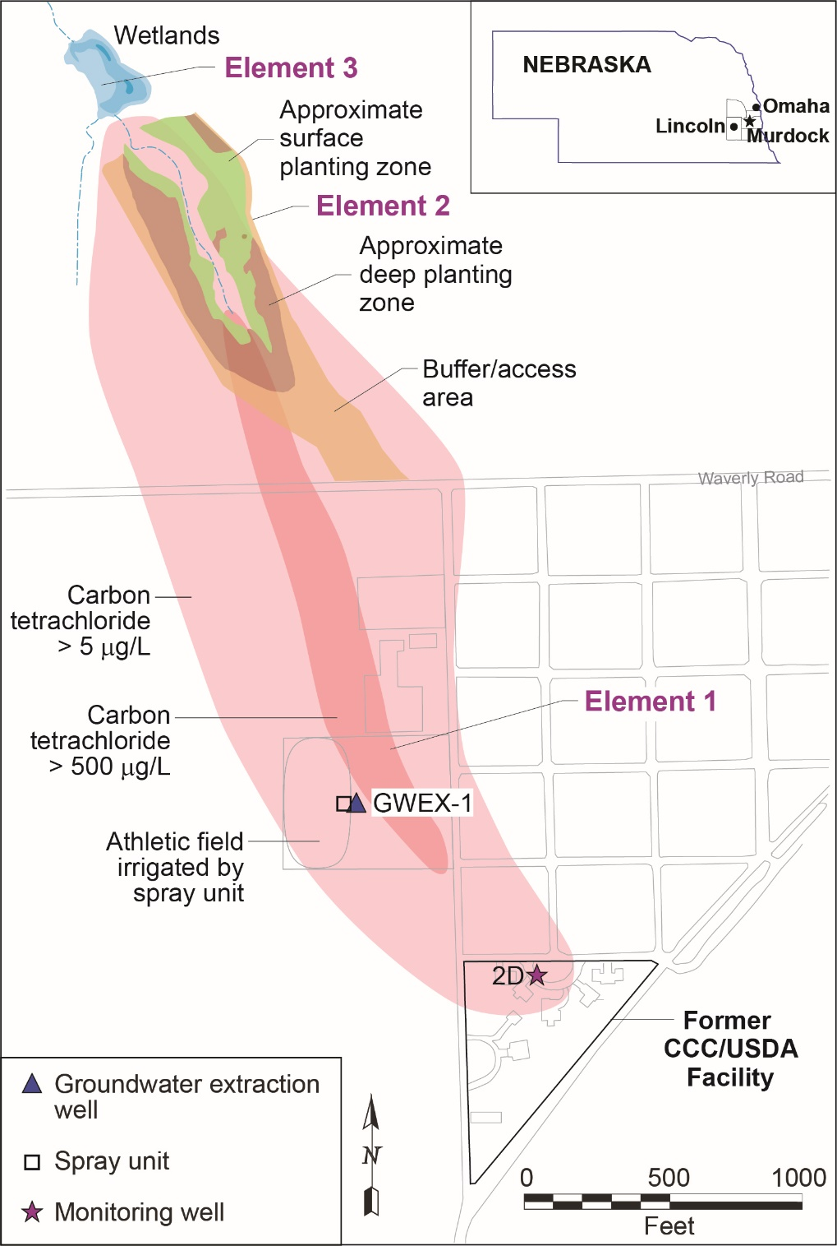

Figure 1: Murdock, Nebraska, USA, and the three components of the integrated groundwater remediation system applied at the site.

A three phase site characterisation programme found that the fumigant had migrated through the near-surface and vadose zone soils into groundwater at Murdock (LaFreniere, 2005), which discharges to the surface at Pawnee Creek (a tributary of the Platte river) north of the town. Owing to the presence of buildings and hard standing areas (i.e. areas under asphalt, concrete or other cover) at the former grain storage facility, direct source remediation was regarded as being difficult to implement using best available technologies, and a no-intervention / natural attenuation strategy was estimated as reaching compliance only after an 80 year period. Hence remediation system design focused on pathway management via treatment of the groundwater CCl₄ plume. Given the prior removal action undertaken to protect the municipal water supply, the key regulatory driver at the site was the protection of Pawnee creek from CCl₄ contamination, where a maximum concentration of 281 µg/L CCl₄ was determined in 2004 (against State limits of 44.2 µg/L). Following consideration of remedial alternatives through the use of site specific data and numerical modelling of groundwater flow and contaminant transport, an integrated remediation system was recommended by the USDA to permanently reduce CCl₄ concentrations in groundwater and hence protect downgradient surface waters (Argonne National Laboratory, 2006).
The integrated remediation system subsequently designed and implemented (in 2005) at the site involves three elements (Figure 1):
- Hot-spot control through seasonal recovery of groundwater from the contaminated aquifer using an extraction well, and treatment via a modified spray irrigation system to dissipate CCl₄ to the air (i.e. a form of air stripping, in which CCl₄ is volatilized from the groundwater as it is sprayed onto, and irrigates, School athletic fields);
- Phytoremediation, which uses plants (and associated microorganisms) to reduce CCl₄ concentrations in contaminated groundwater downgradient from the storage facility; and
- Supplemental (polishing) treatment of groundwater naturally discharged to the surface at Pawnee Creek by an in-stream engineered wetland downgradient of the contaminated zone.
The groundwater extraction component (1) was intended to remove highly contaminated water from the hot-spot near the source, and contain future releases from the source area, in a manner beneficial to the local community. The remaining CCl₄ contamination in the downgradient groundwater plume, to the area of groundwater discharge to Pawnee creek, was expected to be removed by the phytoremediation component (2). The engineered wetland component (3) was included to provide additional treatment of any residual contamination escaping from the phytoremediation area. The phytoremediation component is a key risk management element at the site, and here we focus on (a) its performance in removing CCl₄ from the groundwater plume and protecting the regulatory compliance point at Pawnee creek, and (b) the wider social and environmental benefits realized by its implementation.

- Materials and Methods.
Two thousand and forty six trees were planted in April – May 2005 over a ca. 18,000 m² area (Figure 1), from six species which were selected for their disease tolerance and rapid growth, and potential to degrade or remove CCl₄: Niobe willow (Salix x ‘Niobe’) (n=956); Black willow (Salix nigra) (n=86); Eastern Cottonwood (Populus deltoides) (n=444); Hybrid poplar (Populus deltoides x Populus nigra) (n=334); Green Ash (Fraxinus pennsylvanica) (n=165); and Northern catalpa (Catalpa speciosa) (n=61). Conventional planting was used where groundwater was shallow (< 1.5m). In areas where contaminated groundwater occurred at greater depths, trees (mainly Eastern Cottonwoods) were planted using the TreeWell® technology (http://www.treemediation.com/) in 60cm diameter boreholes lined with plastic sleeves to promote deep, focused root development (Figure 2). The spatial extent of this deep-planted zone is shown in Figure 1. A groundcover mixture including native prairie grasses and wildflowers was planted around the trees and in adjacent buffer zones, to limit soil erosion and to intercept rainwater and run-off to force the planted trees to draw water from the contaminated groundwater (Figure 2). The planted site was extensively instrumented to allow assessment of system performance. Nineteen permanent groundwater monitoring wells were installed at the former USDA facility and across the phytoremediation area, at locations selected to transect the CCl₄ groundwater “plume” and also monitor the surrounding aquifer. Geologic logs from the wells showed a surficial geology of near-surface silty clays (of varying thickness – ranging from 18m under the former grain storage facility, to 5m or less in the southern part of the phytoremediation area), overlying fine to medium sands at depth. Wells were sampled twice yearly, and supplemented by further targeted sampling from small diameter wells at individual trees to assess local groundwater characteristics and CCl₄ removal processes. Groundwater levels were measured automatically and continuously (at 4 h intervals) using downhole pressure transducers and data loggers. In order to assess the redox state of the groundwater, Oxidation Reduction Potential (ORP) was measured in-situ using sondes, while dissolved oxygen concentrations were determined titrimetrically following water sampling. Rainfall and other local climatic data were collected using an on-site weather station.
Surface water samples for Volatile Organic Compound (VOCs) analysis were collected quarterly at three locations: in the upgradient region of the phytoremediation zone; at the outflow of the phytoremediation zone; and directly downgradient of the outfall from the constructed wetlands area (SWM1, SWM2 and SWM3 respectively). Location SWM3 was designated by the USEPA as the critical surface water quality compliance point for drainage entering Pawnee Creek.
Ambient air samples were collected twice per year for VOCs analysis, at three locations: two in the phytoremediation area, and one at a nearby control site. Air samples were collected over an 8 hour period into specially prepared, pre-evacuated, stainless steel canisters from a height of 1.5m.
Sap flow monitoring by thermal dissipation probes (after Granier, 1985; 1988) was used to estimate transpiration rates and hence plant water usage following tree establishment, using the equation:
F_{s} = A_{s} x V x 3600
Where F_{s} = sap flow (cm³/h), A_{s} = sapwood cross-sectional area (cm²), V = sap flow velocity (cm/s). Standing biomass at the site was calculated using an allometric equation with literature-derived coefficients, validated through biomass measurement of 3 harvested Eastern Cottonwood trees (in 2008 and 2009) (Pastor and Bockheim, 1981; Perala and Alban, 1994; Ballard et al., 2000).
Vegetation was sampled for VOCs analysis during dormant and peak growing periods (4 times annually until 2009, with annual sampling thereafter) from a representative suite of trees in the phytoremediation area, on an approximate grid pattern in accordance with an EPA-approved monitoring strategy (Argonne National Laboratory, 2006). This involved the collection of tree tissue (branch or trunk, depending on tree age and characteristics, n>300 annually), leaf (n>10) and grass (n>25) samples, to assess spatial and temporal variability in CCl₄ uptake by the planted vegetation. Only tree tissue data, which form the most extensive and spatially and temporally complete available dataset, are reported here. Tree tissue samples were collected using steel corers, placed immediately in glass vials on dry ice, and shipped overnight to the Argonne National Laboratory for subsequent analysis. Two Eastern Cottonwood trees were sacrificially sampled in 2008 to assess the distribution of CCl₄ with height within the trees.
Water samples were analysed for CCl₄ and chloroform (CHCl₃; a degradation product of CCl₄) concentrations using a modification of USEPA method 524.2 (Munch, 1995, purge-and-trap method with analysis on a gas chromatograph-mass spectrometer system, using 10ml samples instead of the 5ml samples recommended by the method, and a Supelco DB-624 capillary column, 30 m long and 0.25 mm in diameter, to achieve the low detection limits required). Air samples were analysed using EPA Method TO-15 (EPA, 1999) on a gas chromatograph-mass spectrometer system. Tree tissue samples were analyzed for CCl₄ and CHCl₃ following EPA Method 5021 (Flores and Bellar, 1992, headspace analysis on a gas chromatograph with electron capture detection, using 1 – 3g of vegetation sample in 20ml headspace vials). Method quantitation limits were 0.1 μg/kg for CCl₄ and 0.75 μg/kg for CHCl₃ in solid phase samples, 1ug/l (for both compounds) in liquid samples and 1.3 and 0.98 ug/m³, respectively, for CCl₄ and CHCl₃ in air samples.
A summary of the sample collection and subsequent analysis methods for groundwater, surface water, air and vegetation samples is shown in Figure 3.
Data covering the period 2005 – 2016 are presented here to allow assessment of the remediation system risk management performance, and the realization of wider benefits, over an 11 year period of implementation, focusing particularly on the performance of the phytoremediation component.

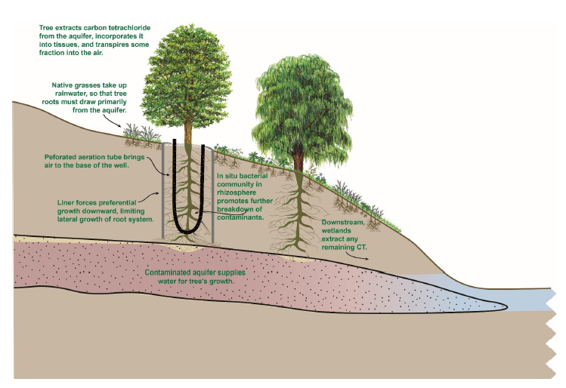
Figure 2: Schematic cross-section of the phytomanagement system applied at the Murdock site, showing key processes, and planting methods used: conventional (right) for shallow groundwater, and deep planting (left, using the TreeWell® technology) in areas where contaminated groundwater occurred at greater depths. CT = Carbon Tetrachloride.

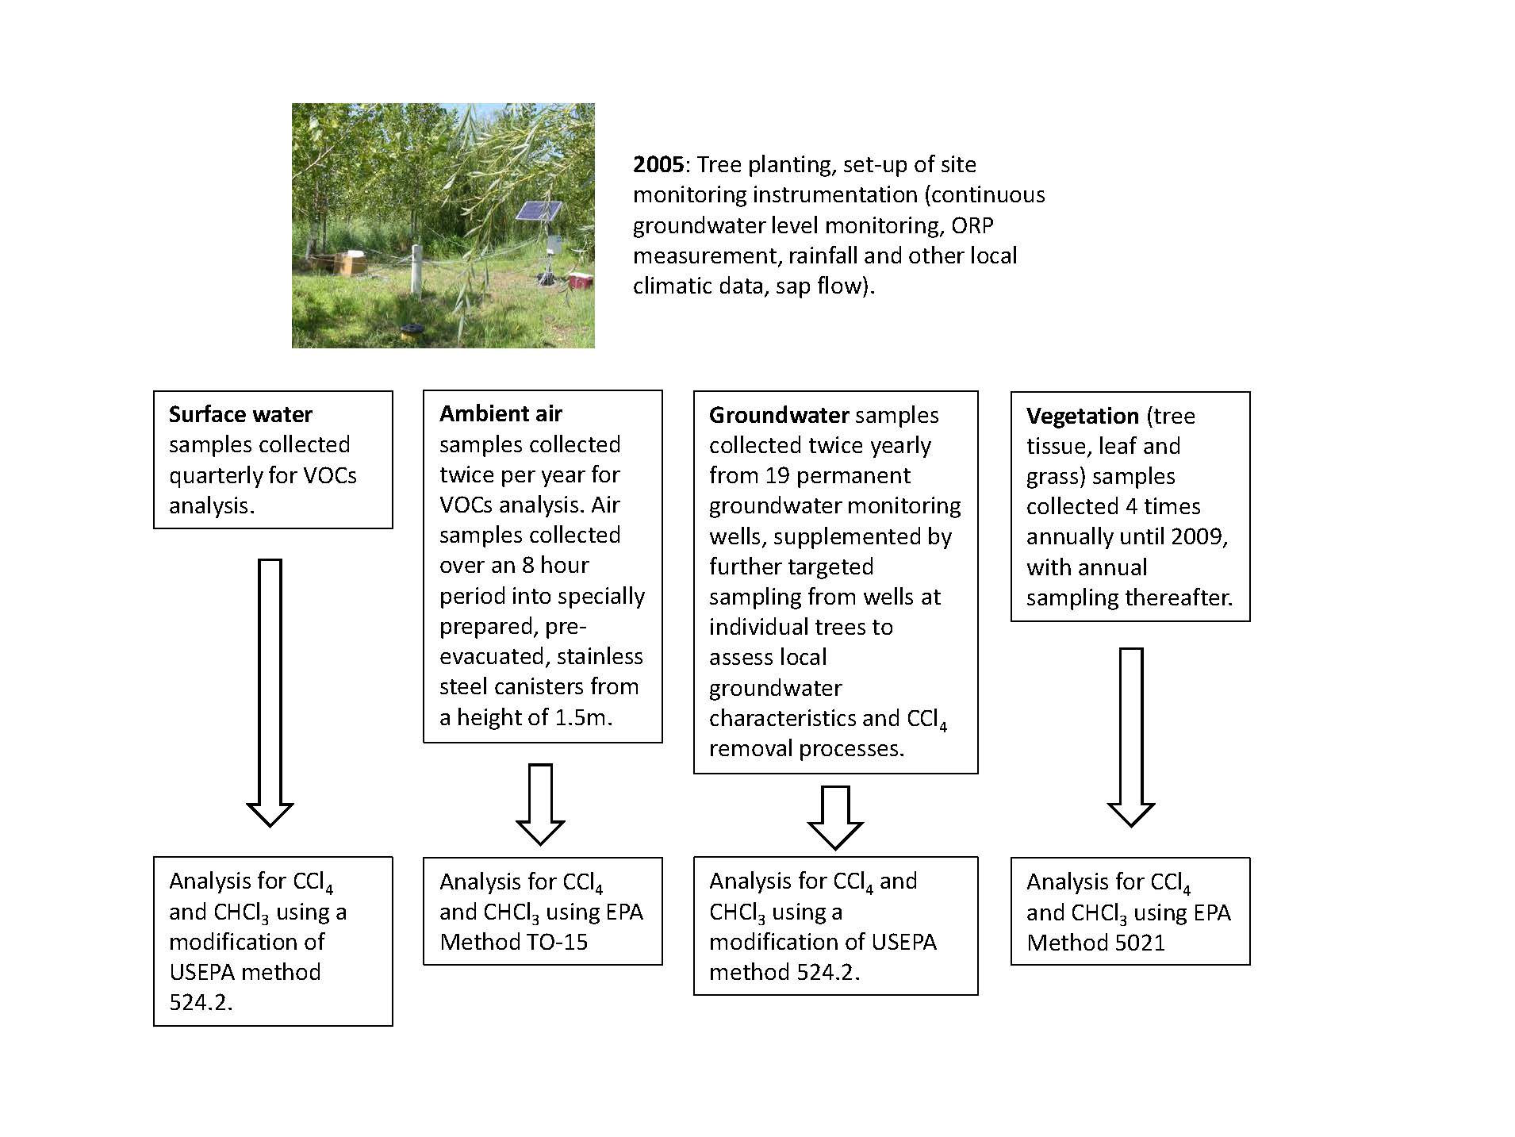
Figure 3: Overview of sampling and analysis methods used for surface water, ambient air, groundwater and vegetation samples. See text for full details.

2.1 Engagement strategies with the local population
The Murdock remediation project was delivered by a partnership involving the USDA Farm Service Agency, U.S. Department of Energy Argonne National Laboratory, the USEPA, the Nebraska Department of Environmental Quality (NDEQ, now the Nebraska Department of Environment and Energy), Stock Seed Co., the Village of Murdock, the Elmwood-Murdock Public School, local landowners, and others. Hence the local public, as well as regulators and site owners, were intimately involved in the project throughout planning, design and delivery, and ongoing monitoring. Full details of stakeholder engagement activities are given in Supporting Information (S1).

- Results and discussion.
3.1 Risk and groundwater pathway management: CCl₄ in groundwater, tree tissue and surface waters.
In the initial stages of the remediation scheme implementation (2005 – 2007) CCl₄ concentrations in groundwater from the upgradient part of the treatment zone were highly variable, reaching maximum concentrations of 3077 ug/l CCl₄ (Figure 4(a), well PMW1d). Post-2008, CCl₄ concentrations in this upgradient section of the groundwater, i.e. before entering the phytoremediation treatment zone, show a clear decrease over time (99.9% confidence, Mann-Kendell test, PMW1d data, Figure 4a) due to contaminant plume dispersion and the effects of the upgradient groundwater extraction used as component 1 of the remediation scheme. Within the phytoremediation treatment area itself groundwater CCl₄ concentrations, while much lower than those observed initially in groundwater from upgradient well PMW1d, are noticeably higher in the western portion than in the eastern portion (Figure 4, b-c). CCl₄ concentrations declined relatively uniformly in the east (as confirmed by a Mann-Kendell test, at 99% confidence); however a gradual increase in CCl₄ concentrations over time is observed at the western and northern wells (Figure 4 c-d). This increasing trend (99% confidence, Mann-Kendell test) reflects the blockage of a tile drain in the west of the area, which reduced direct discharge of groundwater in the western section of the CCl₄ plume.
In tree tissue samples in 2007 (Figure 5a) 20% of the samples (n = 145) showed CCl₄ concentrations in excess of 75ug/kg, and these were mostly located in the southwestern section of the phytoremediation treatment zone immediately downgradient from the peak groundwater contamination. The locations of the most contaminated tree tissue samples (> 1000 ug/kg CCl₄) varied seasonally (Figures 5a and 5b), reflecting seasonal variations in inflow from the source area, groundwater flow dynamics and also variable inputs from the agricultural tile drains which parallel or directly offset the main northwest-trending CCl₄ plume and so by-pass sections of the phytoremediation area. Despite this seasonal variation, CCl₄ concentrations in tree tissue show a broad decline over time between 2007 and 2016. By 2014, only 1 tree tissue sample from 74 showed concentrations of CCl₄ exceeding 75 ug/kg (Figure 5c); by July 2016, all samples (n = 59) recorded CCl₄ concentrations lower than 10 ug/kg (all but one sample showed concentrations < 1 ug/kg).
Quarterly sampling data for surface water monitoring locations SWM1, SWM2 and SWM3 show a clear downstream decrease in CCl₄ concentrations (Figure 6). At location SWM1 there is a significant decrease in surface water CCl₄ concentrations over time (99% confidence, Mann-Kendell test) over the 2005 – 2016 sampling period (Figure 6), due to the combined effects of groundwater extraction from the upgradient hot-spot area (component 1 of the remediation scheme) and CCl₄ removal in the southern part of the phytoremediation zone. This decrease in CCl₄ concentration (from > 300 ug/l (2006 data) to 2.9 ug/l CCl₄ (2016 data)) represents a 99% reduction in groundwater CCl₄ discharge to surface water at SWM1 over the period monitored. The surface water monitoring points SWM2 and SWM3 are located directly upstream and downstream of the engineered wetland (component 3 of the remediation scheme), respectively. Based on comparison of CCl₄ concentrations in the incoming groundwater at PMW1d (upgradient of the phytoremediation area) with those in the surface water at SWM2, the average reduction in CCl₄ concentration across the phytoremediation zone was ca. 99% over the period 2006-2012 (the main period of elevated CCl₄ concentrations in incoming groundwater, Figure 4a), during which the CCl₄ in the incoming groundwater ranged from 40 to 3077 ug/l. The further reduction of CCl₄ concentrations through the wetland is 79% on average over this period, based on CCl₄ concentrations in the quarterly samples from SWM2 and SWM3. The estimated mass removal of CCl₄ is discussed below.

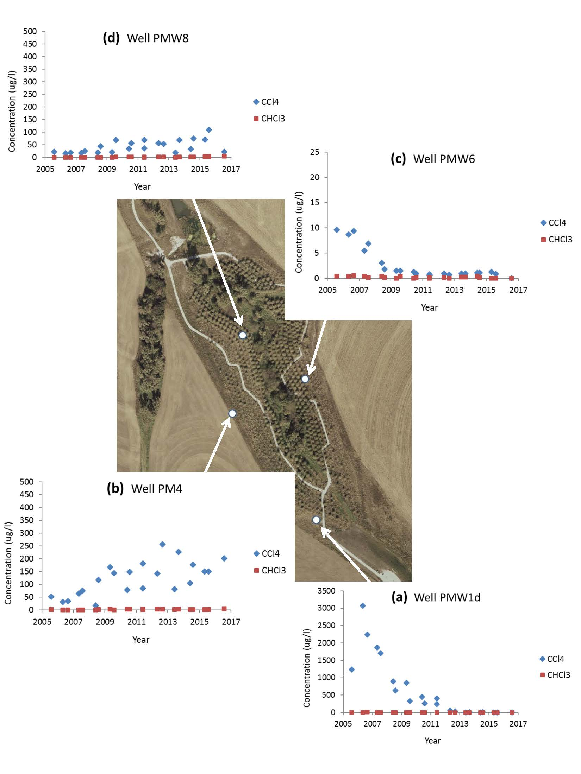
Figure 4: Trends in CCl₄ and CHCl₃ in selected groundwater wells within the phytoremediation treatment zone. (a) well PMW1d, at the southern limits (headwaters) of the phytoremediation zone, (b) well PMW4, at the western edge of the phytoremediation treatment zone, (c) well PMW6, at the eastern side of the phytoremediation treatment zone, and (d) well PMW8, in the central area of the treatment zone. Note difference in y-axis scales.

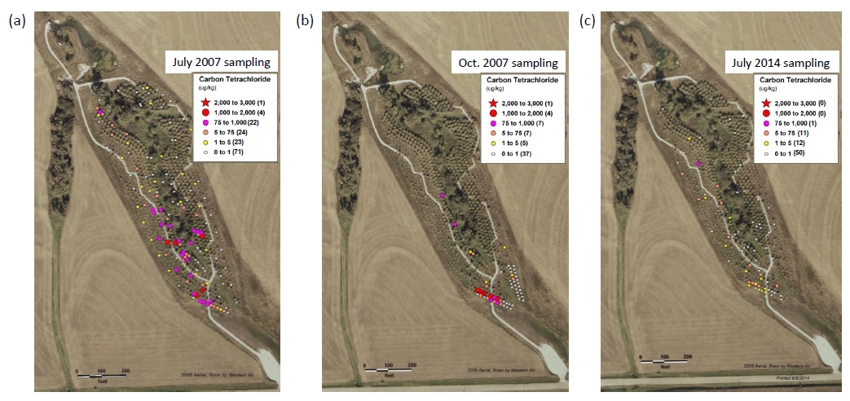
Figure 5: CCl₄ concentrations in tree tissue samples (taken approx. 30cm from tree base), July 2007 (a), October 2007 (b), and July 2014 (c). The 75ug/kg concentration used in the legend is the 80th percentile value based on CCl₄ concentration data for all tree tissue samples collected during the growing season of the peak uptake year (2007).

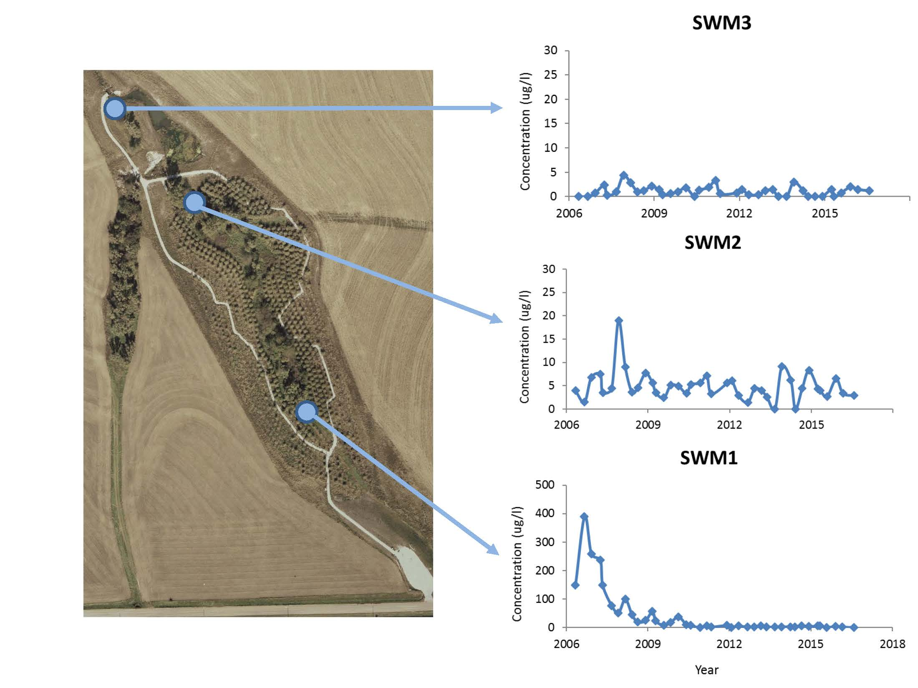
Figure 6: CCl₄ concentrations observed at surface water monitoring (SWM) stations between 2005 and 2016, based on quarterly sampling. Note difference in y-axis scales.

3.2 Mass removal of CCl₄.
CCl₄ uptake by vegetation is favored in oxic subsurface conditions, as found at Murdock, over in situ (bio)degradation reactions (i.e. reductive dechlorination, Schnoor et al, 1995; Jin and Englande Jr, 1997; Burken and Schnoor, 1998; Santharam et al., 2014). Dissolved oxygen concentrations in groundwater were variable but were typically in the range 2 – 10 mg/l, with 62 of 65 samples between 2005 and 2007 recording positive ORP values (data not shown). Variable CHCl₃ concentrations (a CCl₄ degradation product) were detected in groundwater samples from monitoring wells within the phytoremediation area, although these were typically 1% or less of the CCl₄ concentrations in the same samples (Figure 4). Methylene chloride (a degradation product of CHCl₃ via reductive dechlorination) was not detected in any groundwater samples. The main mechanism of CCl₄ removal in the phytoremediation treatment zone is therefore likely to be via uptake by plant roots followed by translocation and dispersion to air (hydraulic “pumping”), or degradation within root or above-ground plant tissues (e.g. Wang et al., 1999). There is evidence for some partial CCl₄ degradation either within plant tissues or in the root zone prior to uptake as VOCs data show a positive correlation (r = 0.96, n = 30) between CCl₄ and CHCl₃ concentrations in tree branch tissue, with CHCl₃ concentrations typically around 8% of the associated CCl₄ concentrations (based on August 2007 data, Supporting Information S2). In controlled field studies, Wang et al. (2004) argued (based on mass balance calculations) that the dominant CCl₄ removal mechanism in hybrid poplar cuttings was via uptake and mineralization (to Cl and CO₂) in root tissues, with negligible transport to above ground portions of the plants. While a full mass balance or detailed mechanistic assessment of CCl₄ removal processes was not possible under the field conditions at Murdock (as this was not the purpose of the monitoring regime employed), translocation of CCl₄ to above-ground plant portions clearly occurred at the site over the 10 years following installation, based on tree branch tissue sampling (e.g. Figure 5). CCl₄ concentrations in tree tissue showed a general decrease with height within the trees (Supporting Information S2). Sampling of ambient air in the phytoremediation area showed CCl₄ concentrations mainly below detection limits, although a fraction of the samples recorded CCl₄ ranging from 2 – 6 ug/m³, or 1 – 3% of the USEPA target for CCl₄ in air (192 ug/m³), likely derived from a combination of transpiration and direct volatilization. At a control location outside of the phytoremediation area, no CCl₄ was detected in ambient air samples.
Based on transpiration rates estimated from sap flow data collected during the growing season, total annual average groundwater usage by the tree stand was estimated at 25,200 gallons/day (2 SD range = 15,700 – 34,700 gallons/day, equivalent to 59,400 – 131,400 litres/day). Of this, 66% was used by Niobe willow, 30% by Eastern Cottonwood, and 3% by other species. While annual water abstraction has varied over time since planting (Figure 7), excluding 2010 data a general increase over time is apparent at an approximate rate of 19% per year, which is consistent with continuing plant growth over the period 2008-2014. The exceptionally high abstraction rate observed in 2010 was mainly associated with a Niobe willow planting area (Supporting Information S2) that suffered surface water ponding due to extremely high precipitation during this particularly wet year. Significant inter-species variation in water abstraction rates was observed (Supporting Information S2). Eastern Cottonwood was planted in areas of greater groundwater depth using the TreeWell® technology, and its groundwater usage increased by 68% per year, which is much higher than the 8% increase per year (excluding 2010 data) observed for Niobe willow, suggesting a steady downward root development that successfully improved annual groundwater uptake through the TreeWell® system in this period. The estimated mass of CCl₄ removed via plant uptake and translocation (assuming transpired water is mainly from groundwater) varied over the 2008-2014 period from 300g to 600g annually (Figure 7), or approximately 0.2 – 0.4 g/year/tree, except for an abnormal mass removal of CCl₄ (~800 g) in 2010. The latter may be significantly overestimated considering the surface water ponding observed in the Niobe willow area where groundwater abstraction could be significantly reduced due to uptake from the surface soil water and the ponded water. The CCl₄ annual mass removal results over the 2008-2014 period indicate that Eastern Cottonwood played an increasing role in CCl₄ removal, from 55% of total mass removal in 2008 to 69% in 2014 (Figure 7). While this is consistent with previous studies showing the effectiveness of CCl₄ removal by poplar species and hybrids (Wang et al., 1999; 2004) this also reflects increased groundwater uptake over time by Eastern Cottonwood planted via the TreeWell® technology, through development of deeper root systems (discussed above). Reports of contaminant removal rates by established, mature phytoremediation systems are rare in the published scientific literature, particularly for organic contaminants (Limmer et al., 2018), and calculated removal rates are strongly influenced both by contaminant (and tree) characteristics and groundwater contaminant concentrations. While the CCl₄ mass removal rates reported here are significantly lower than those obtained using more active remediation methods such as soil vapour extraction (e.g. Brusseau et al., 2010), they are broadly comparable in overall magnitude to those which have been previously reported for other chlorinated solvents in phytoremediation trials (e.g. Doucette et al., 2013, for trichloroethylene (TCE) removal, note 0.041 and 0.88 g/year/tree for Eucalyptus and hybrid poplar, while James et al., 2009 estimate a perchloroethylene (PCE) removal of 0.053 ± 0.037 g/year/tree for poplar).
The CCl₄ annual mass removal from the engineered wetland system was estimated based on stream flow measurements and CCl₄ concentrations in the surface water samples at the entrance (SWM2) and exit (SMW3) points of the wetland. Based on available flow data from 2008, the approximate CCl₄ removal is ~115 g, which is about 35% of the CCl₄ removal (325 g) via the phytoremediation treatment zone.

Figure 7: Mass removal of CCl₄ by phytoremediation system, 2008 – 2014. CT = Carbon Tetrachloride, NW = Niobe Willow, EC = Eastern Cottonwood.

3.3 Stakeholder acceptance, and realization of wider benefits
The involvement and collaboration with local stakeholders in planning, implementation and monitoring / maintenance of the Murdock project moves significantly beyond the more simple “inform and consult” strategies used in many phytoremediation projects (Cundy et al., 2013), and has been key in realizing wider environmental and social benefits from the project. While it is only possible to quantify and confirm some of these benefits based on data available from the Murdock site, these are discussed below to illustrate the range of benefits achieved here, and which could potentially be achieved at similar sites.

3.3.1 Wider environmental benefits
The developing tree canopy after planting, and the seeding of 13 grass and over 30 (native) wildflower species (Argonne National Laboratory, 2008) were designed to have a positive effect on floral species richness at the site, by revitalizing and re-establishing native prairie vegetation particularly in buffer zones. The phytoremediation element, together with the constructed wetland, also assists in groundwater and surface flood protection and control, via rainfall interception, groundwater extraction (in the order of 95,000 litres per day in the phytoremediation zone, see above) and flow buffering. As the site is located in an agricultural state in the USA and the phytoremediation area is surrounded by crop land, the high-transpiration plants installed may also reduce residual nutrients transport (from agricultural application) to Pawnee creek (e.g. Lowrance et al., 1984), although this was not a focus of surface water monitoring at the Murdock site.
Plant growth at the site also has carbon sequestration benefits. Estimated standing biomass (all tree species) increased at a rate of 42 ton/ha/y over the seven year period between 2008 and 2015 (from 72 tons/ha in 2008 to 359 tons/ha in 2015) (Figure 8). Assuming a dry biomass carbon content of 50% for the dominant tree species at the site (willow and Eastern Cottonwood, Chow and Rolfe, 1989; Stolarski, 2008), this equates at a first approximation to removal of 77 tons CO₂/ha/y (i.e. 42 x 0.5 x 3.6663 (ratio of atomic mass, CO₂ to C)), purely on the basis of plant biomass increase, although detailed analysis of soil carbon sequestration would be required for an accurate determination of the net carbon storage at the site.
Figure 8: Estimated standing biomass (in Ton/ha) in the Murdock phytoremediation system, 2008-2015.

3.3.2 Wider societal benefits
The phytoremediation (and constructed wetland) elements of the Murdock scheme provide additional aesthetic, recreational and educational value to the local community (and so wider cultural capital, i.e. from improving the social environment, Bardos et al., 2016b). An ADA-accessible trail has been installed at both the tree plantation and the constructed wetland for public use, with interpretive signs used to enhance visitor experience and facilitate the use of the site as an outdoor "living" classroom by the public and local schools. In 2007, these signs and a companion visitor guide won distinguished awards in both local and international Society for Technical Communication Competitions. These accomplishments have brought an element of recognition to the community, and have generated positive publicity in local and regional print and broadcast media. Local community groups are also involved in site maintenance, learning site management and conservation skills.

3.4 System Cost, and Wider Implications.
While the implementation of the Murdock remediation project has arguably increased the site’s natural and cultural value, it has also generated substantial ongoing operational and maintenance costs. Phytoremediation is often regarded as a low-cost remediation option but overall costs for the Murdock scheme have been significant: installation-related costs, including community relations activities, for the phytoremediation and wetland components were estimated as ca. $1.3 million, while routine operating and management (O&M) costs (including site monitoring and reporting, which form the bulk of the O&M costs – 84% on average) were initially ca. $350k/year, falling to ca. $150k/year in 2011-2016. This compares to typical estimated total capital costs of $1.9 million, and average annual operating costs of $62,000 (1999 prices), for pump-and-treat (P&T) operations at Superfund and RCRA corrective action sites in the USA (EPA, 2001). It should be noted that Argonne National Laboratory, as a governmental facility, may incur greater contracting and reporting costs than a private sector contractor aiming to accomplish the same clean-up goals, and that some of the higher costs at Murdock were attributable to increased sampling and analysis efforts to demonstrate proof of the phytomanagement (and wider risk management) concept. These costs illustrate, however, that effective phytoremediation application may incur non-negligible installation, monitoring and maintenance costs and effort. This highlights the importance of (a) sustained stakeholder engagement to ensure local community backing over the long-term, and (b) effective site design to realize as full a range of core (i.e. risk mitigation) and wider societal, environmental and economic services as possible (Cundy et al., 2016), to enhance the overall economic (and social/environmental) value proposition of phyto-based remediation schemes. It is essential that these wider benefits are effectively communicated, and ideally costed or quantified, at the planning / design or options appraisal stages. Decision support tools and systems aimed at supporting stakeholder engagement, options appraisal and site design strategies for phyto-technologies and soft end-use more generally (e.g. Cundy et al., 2015; Bardos et al., 2016b; Coulon et al., 2017)), and emerging approaches linking sustainability assessment with conceptual site models (Li et al., 2019) may be useful in these respects. These provide simple flowcharts, decision matrices and costing tools and frameworks which can be used to engage stakeholders and encourage identification, consideration and importantly valuation of wider services and benefits throughout the decision and design process. Such tools can also be used to identify those benefits that are likely to be of most importance for stakeholders at a particular site, so that monitoring and assessment of these benefits (via field data collection, social surveys, interviews etc.) can be built into ongoing management and monitoring programmes to clearly demonstrate that wider project value is being realized.

- Conclusions
- VOCs concentrations measured in surface waters and groundwater show that the integrated remediation scheme used at the Murdock site has achieved effective risk management over the 10+ year period since installation, in terms of mitigation of groundwater contaminant pathways for protection of the regulatory compliance point at Pawnee creek. The overall decrease in CCl₄ concentrations reaching the creek is over 99%, confirming the combined effects of the remediation scheme.
- The phytomanagement component of the remediation system removed an estimated 300g to 600g CCl₄ annually. Eastern Cottonwood (Populus deltoides) played an increasing role in CCl₄ removal over time, from 55% of total mass removal in 2008 to 69% in 2014.
- Using a site design which focused on enhancement of the social and physical environment has enabled the realization of a number of wider environmental and societal benefits, including re-establishing native prairie vegetation, groundwater and surface flood protection and control, carbon sequestration benefits (ca. 77 tons CO₂/ha/y), and educational and recreational benefits.
- The phytomanagement system applied at Murdock has incurred significant installation, and on-going monitoring and maintenance, costs and effort (exceeding $1.5 million) highlighting the importance of (a) sustained stakeholder engagement to ensure long-term local community support, and (b) effective site design to realize as full a range of core (i.e. risk mitigation) and wider benefits as possible, to increase the overall value proposition of such schemes.

Acknowledgements.
We thank the U.S. Department of Agriculture / Commodity Credit Corporation, Washington D.C., USA, for their sponsorship of the remediation work and monitoring performed at Murdock.
References
Alzeyadi, A.; Al-Ansari, N.; Laue, J.; Alattabi, A. 2019. Study of Biomass Bottom Ash Efficiency as Phosphate Sorbent Material. Civ. Eng. Jnl. 5, 2392-2401. DOI: 10.28991/cej-2019-03091419.
Andersson-Skold, Y.; Bardos, P.; Chalot, M.; Bert, V.; Crutu, G.; Phanthavongsa, P.; Delplanque, M.; Track, T.; Cundy A.B., 2014. Developing and validating a practical decision support tool (DST) for biomass selection on marginal land. J. Environ. Manage. 145, 113-121. DOI: 10.1016/j.jenvman.2014.06.012
Argonne National Laboratory, 2006. Final monitoring plan for site restoration at Murdock, Nebraska. Unpublished report, ANL/EVS/AGEM/TR-05-04, UChicago/Argonne LLC. https://www.osti.gov/biblio/925318 (accessed May 2020).
Argonne National Laboratory, 2008. Summary of Operations and Performance of the Murdock Site Restoration Project in 2007. Unpublished report, ANL/EVS/AGEM/TR-08-07, UChicago/Argonne LLC. http://www.ipd.anl.gov/anlpubs/2008/06/61658.pdf (accessed May 2020).
Ballard, B.D.; Stehman, S.V.; Briggs, R.D.; Volk, T.A.; Abrahamson, I.P.; White, E.H., 2000. Aboveground biomass equation development for five Salix clones and one Populus clone. New York Center for Forestry Research and Development (NYCFRD-99-01). Syracruse, NY: SUNY-ESF.
Bardos, R.; Bone, B.; Andersson-Skӧld, Y.; Suer, P.; Track, T.; Wagelmans, M., 2011. Crop-based systems for sustainable risk-based land management for economically marginal damaged land. Remediation, Autumn 2011, 11-33. DOI: 10.1002/rem.20297
Bardos, R.P.; Cundy, A.B.; Smith, J.W.N.; Harries, N., 2016a. Sustainable remediation. J. Environ. Manage. 184, 1-3 (Editorial). DOI: 10.1016/j.jenvman.2016.10.021
Bardos, P.; Jones, S.; Stephenson, I.; Menger, P.; Beumer, V.; Neonato, F.; Maring, L.; Ferber, U.; Track, T.; Wendler, K., 2016b. Optimising value from the soft re-use of brownfield sites. Sci. Total Environ. 563-64, 769-782. DOI: 10.1016/j.scitotenv.2015.12.002
Bardos, R.P.; Spencer, K.L.; Ward, R.D.; Maco, B.H.; Cundy, A.B., 2020. Integrated and sustainable management of post-industrial coasts. Front. Environ. Sci. 8:86. DOI: 10.3389/fenvs.2020.00086.
Brusseau, M.L.; Rohay, V.; Truex, M.J. 2010. Analysis of soil vapor extraction data to evaluate mass-transfer constraints and estimate source-zone mass flux. Ground Water Monit. Remediat. 30, 57–64. DOI: 10.1111/j.1745-6592.2010.01286.x
Burken, J.G.; Schnoor, J.L., 1998. Predictive relationships for uptake of organic contaminants by hybrid poplar trees. Environ. Sci. Technol. 32, 3379-3385. DOI: 10.1021/es9706817
Chow, P.; Rolfe, G.L., 1989. Carbon and hydrogen contents of short-rotation biomass of five hardwood species. Wood Fiber Sci. 21, 30-36.
Coulon, F.; Jiang, Y.; Campo-Moreno, P.; Longhurst, P.; Bardos, P.; Li, X.; Harries, N.; Jones, K.; Li, H.; Li, F.; Cao, Y.; Hu, Q.; Gao, J.; Zhu, Y-G; Cai, C., 2017. Promoting Sino-UK collaboration or developing low carbon and sustainable methodologies for brownfields and marginal lad re-use in China. Report from the China UK Partnership for Contaminated Land Management January 2017. Retrieved from http://cnukcontaminatedland.com/uk/downloads
Culver J.R., 1990. General soil map of Nebraska. US Department of Agriculture.
Cundy, A.B.; Bardos, R.P.; Church, A.; Puschenreiter, M.; Friesl-Hanl, W.; Müller, I.; Neu, S.; Mench, M.; Witters, N.; Vangronsveld, J., 2013. Developing principles of sustainability and stakeholder engagement for "gentle" remediation approaches: the European context. J. Environ. Manage. 129, 283-291. DOI: 10.1016/j.jenvman.2013.07.032.
Cundy, A.B.; Bardos, R.P.; Puschenreiter, M.; Witters, N.; Mench, M.; Bert, V.; Friesl-Hanl, W.; Mueller, I.; Weyens, N.; Vangronsveld J., 2015. Developing effective decision support for the application of “gentle” remediation options: The GREENLAND project. Remediation, Summer 2015, 101-114. DOI: 10.1002/rem.21435
Cundy, A.B.; Bardos, R.P.; Puschenreiter, M.; Mench, M.; Bert, V.; Friesl-Hanl, W.; Mueller, I.; Li, X.N.; Weyens, N.; Witters, N.; Vangronsveld J., 2016. Brownfields to green fields: Realising wider benefits from practical contaminant phytomanagement strategies. J. Environ. Manage. 184, 67-77. DOI: 10.1016/j.jenvman.2016.03.028.
Doucette, W.; Klein, H.; Chard, J.; Dupont, R.; Plaehn, W.; Bugbee, B. 2013. Volatilization of trichloroethylene from trees and soil: Measurement and scaling approaches. Environ. Sci. Technol. 47, 5813–5820. DOI: 10.1021/es304115c.
EPA. 1999. Air Method, Toxic Organics-15 (TO-15): Compendium of Methods for the Determination of Toxic Organic Compounds in Ambient Air, Second Edition: Determination of Volatile Organic Compounds (VOCs) in Air Collected in Specially-Prepared Canisters and Analyzed by Gas Chromatography/Mass Spectrometry (GC/MS). EPA 625/R-96/010b.
EPA, 2001. Cost analyses for selected groundwater cleanup projects: pump and treat systems and permeable reactive barriers. EPA 542-R-00-013, February 2001.
Flores, P.; Bellar, T., 1992. Determination of Volatile Organic Compounds in soils using equilibrium headspace analysis and capillary column Gas Chromatography/Mass Spectrometry. U.S. Environmental Protection Agency, Office of Research and Development, Environmental Monitoring Systems Laboratory, Cincinnati, OH.
Friesl-Hanl, W.; Platzer, K.; Horak, O.; Gerzabek, M.H., 2009. Immobilising of Cd, Pb, and Zn contaminated arable soils close to a former Pb/Zn smelter: a field study in Austria over 5 years. Environ. Geochem. Health. 31(5), 581-94. DOI: 10.1007/s10653-009-9256-3.
Gerhardt, K.E.; Gerwing, P.D.; Greenberg, B.M., 2017. Opinion: Taking phytoremediation from proven technology to accepted practice. Plant Science, 256, 170-185. DOI: 10.1016/j.plantsci.2016.11.016
Gomes, H.I. 2012. Phytoremediation for bioenergy: challenges and opportunities. Environ. Tech. Rev. 1, 59-66. DOI: 10.1080/09593330.2012.696715
Granier, A., 1985. Une nouvelle method pour la mesure du flux de seve brute dans le tronc des arbres. Annales Sciences Forestieres, 42, 193-200. hal-00882347f
Granier, A., 1988. Evaluation of transpiration in a Douglas-fir stand by means of sap flow measurements. Tree Physiol. 3, 309–320. DOI: 10.1093/treephys/3.4.309
Herzig, R.; Nehnevajova, E.; Pfistner, C.; Schwitzguebel, J.P.; Ricci, A.; Keller, C., 2014. Feasibility of labile Zn phytoextraction using enhanced tobacco and sunflower: Results of five- and one-year field-scale experiments in Switzerland. Int. J. Phytoremediation 16(7-8), 735-754. DOI: 10.1080/15226514.2013.856846.
Interstate Technology Regulatory Council (ITRC), 2009. Phytotechnology Technical and Regulatory Guidance and Decision Trees, Revised. Washington DC, USA, www.itrcweb.org.
ISO (International Organisation for Standardisation), 2017. Soil quality – sustainable remediation. ISO 18504:2017, Geneva, Switzerland, 23 pp.
James, C.A.; Xin, G.; Doty, S.L.; Muiznieks, I.; Newman, L.; Strand, S.E. 2009. A mass balance study of the phytoremediation of perchloroethylene-contaminated groundwater. Environ. Pollut. 157, 2564–2569. DOI: 10.1016/j.envpol.2009.02.033.
Jin, G.; Englande Jr, A.J., 1997. Biodegradation kinetics of carbon tetrachloride by Pseudomonas cepacia under varying oxidation-reduction potential conditions. Wat. Environ. Res. 69, 1094-1099. DOI: 10.2175/106143097X125812
Kennen, K.; Kirkwood, N., Phyto: Principles and resources for site remediation and landscape design. Routledge, London, 2015. DOI: 10.4324/9781315746661
Kiamarsi, Z.; Kafi, M.; Soleimani, M.; Nezami, A.; Lutts, S., 2020. Conjunction of Vetiveria zizanioides L. and oil-degrading bacteria as a promising technique for remediation of crude oil-contaminated soils. Journal of Cleaner Production, 253, 119719. DOI: 10.1016/j.jclepro.2019.119719
Kuppusamy, S.; Palanisami, T.; Megharaj, M.; Venkateswarlu, K.; Naidu, R., 2016. In-Situ Remediation Approaches for the Management of Contaminated Sites: A Comprehensive Overview. In: P. de Voogt (ed.), Reviews of Environmental Contamination and Toxicology, Volume 236, Reviews of Environmental Contamination and Toxicology 236, DOI 10.1007/978-3-319-20013-2_1. Springer International Publishing, Switzerland.
LaFreniere, L. M., 2005. Final report for targeted investigations at Murdock, Nebraska, in 2004. Unpublished report, ANL/ER/TR-04/007, UChicago/Argonne LLC. doi:10.2172/843180. https://www.osti.gov/biblio/843180 (accessed May 2020)
Li, X.; Bardos, R.P.; Cundy, A.B.; Harder, M.K.; Doick, K.J.; Norrman, J.; Williams, S.; Chen W., 2019. Using a conceptual site model for assessing the sustainability of brownfield regeneration for a soft reuse: A case study of Port Sunlight River Park (U.K.). Sci.Tot.Environ. 652, 810-821. DOI: 10.1016/j.scitotenv.2018.10.278
Limmer, M.A.; Wilson, J.; Westenberg, D.; Lee, A.; Siegman, M.; Burken, J.G., 2018. Phytoremediation removal rates of benzene, toluene, and chlorobenzene. Int. Jnl. Phytorem., 20, 666-674. DOI: 10.1080/15226514.2017.1413330
Lowrance, R., Todd, R., Fail, Jr. J., Hendrickson, Jr. O., Leonard, R., Asmussen, L., 1984. Riparian forests as nutrient filters in agricultural watersheds. Bioscience 34, 374-377. DOI: 10.2307/1309729.
Mench, M.J.; Dellise, M.; Bes, C.M.; Marchand, L.; Kolbas, A.; Le Coustumer, P.; Oustriere, N., 2018. Phytomanagement and Remediation of Cu-Contaminated Soils by High Yielding Crops at a Former Wood Preservation Site: Sunflower Biomass and Ionome. Front. Ecol. Evol., 04 September 2018, DOI: 10.3389/fevo.2018.00123.
Munch, J.W., 1995. Measurement of purgeable organic compounds in water by capillary column Gas Chromatography/Mass Spectrometry. Revision 4.1, U.S. Environmental Protection Agency, Office of Research and Development, Environmental Monitoring Systems Laboratory, Cincinnati, OH.
O'Connor, D., Zheng, X., Hou, D., Shen, Z., Li, G., Miao, G., O'Connell, S., Guo, M., 2019. Phytoremediation: Climate change resilience and sustainability assessment at a coastal brownfield redevelopment. Environment International, 130, 104945. DOI: 10.1016/j.envint.2019.104945
Pastor, J.; Bockheim, J.G., 1981. Biomass and production of an aspen-mixed hardwood-spodosol ecosystem in northern Wisconsin. Can. Jnl. of Forest Res. 11, 132-138.
Perala, D.A.; Alban, D.H., 1994. Allometric biomass estimators for aspen-dominated ecosystems in the Upper Great Lakes. Research paper NC-314. St.Paul, MN: USDA Forest Service.
Santharam S.; Davis, L.C.; Erickson, L.E., 2014. Biodegradation of carbon tetrachloride in simulated groundwater flow channels. Environ. Prog. and Sustain. Energy, 33, 444 – 453. DOI: 10.1002/ep.11808
Schnoor, J.L., Licht, L.A.; McCutcheon, S.C.; Wolfe, N.L.; Carreira, L.H., 1995. Phytoremediation of organic and nutrient contaminants. Environ. Sci. Technol. 29, 318A – 323A.
Smith, J., 2019. Debunking myths about sustainable remediation. Remediation Journal 29(2):7-15. DOI: 10.1002/rem.21587
Stolarski, M., 2008. Content of carbon, hydrogen and sulphur in biomass of some shrub willow species. J. Elementol. 13(4), 655-663.
Vangronsveld, J.; Herzig, R.; Weyens, N.; Boulet, J.; Adriaensen, K.; Ruttens, A.; Thewys, T.; Vassilev, A.; Meers, E.; Nehnevajova, E.; van der Lelie, D.; Mench, M., 2009. Phytoremediation of contaminated soils and groundwater: lessons from the field. Environ. Sci. Pollut. Res. Int. 16(7), 765-794. DOI: 10.1007/s11356-009-0213-6.
Vegter, J.; Lowe, J.; Kasamas, H. (Eds.), 2002. Sustainable Management of Contaminated Land: an Overview Report. Austrian Federal Environment Agency on behalf of CLARINET, Spittelauer Lände 5, A-1090 Wien, Austria, www.commonforum.eu/publications_clarinet.asp.
Wang X.; Newman L.; Gordon M.P.; Strand S.E., 1999. Biodegradation of Carbon Tetrachloride by Poplar Trees: Results from Cell Culture and Field Experiments. In: Leeson A, Alleman BC, eds, Phytoremediation and Innovative Strategies for Specialized Remedial Applications. Battelle Press, Columbus, OH, USA, pp 133–138.
Wang, X.; Dossett, M.P.; Gordon, M.P.; Strand S.E., 2004. Fate of carbon tetrachloride during phytoremediation with poplar under controlled field conditions. Environ. Sci. Technol. 38, 5744-5749. DOI: 10.1021/es0499187

Abbreviations used (in order of appearance): CCl₄ – carbon tetrachloride; VOCs – Volatile Organic Compound(s); CHCl₃ – chloroform; ORP – Oxidation Reduction Potential.

