Supporting Information S2.

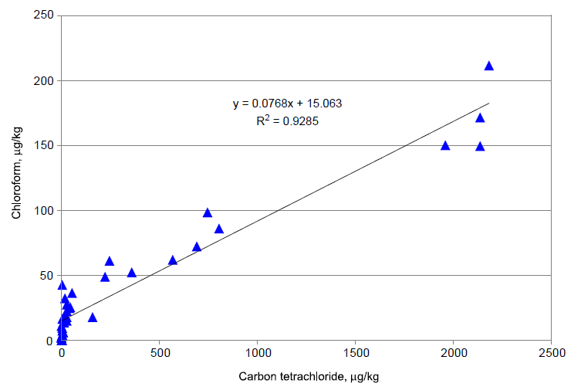
Correlation between carbon tetrachloride and chloroform concentrations in branch tissue samples collected at selected locations in four weekly sampling events in August 2007 (after ANL, 2008).

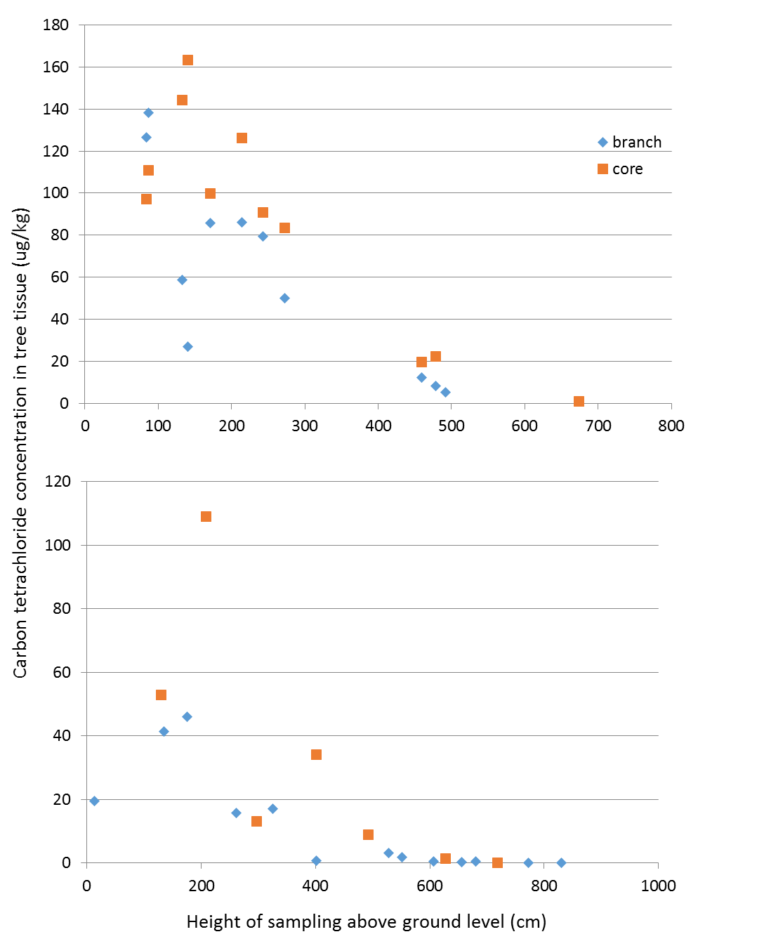
Variation in CCl₄ concentrations in tree tissue samples (removed from two Eastern Cottonwood specimens, summer 2008) with height of sampling, based on sacrificial sampling. Data points show branch (diamond) and core (square) samples

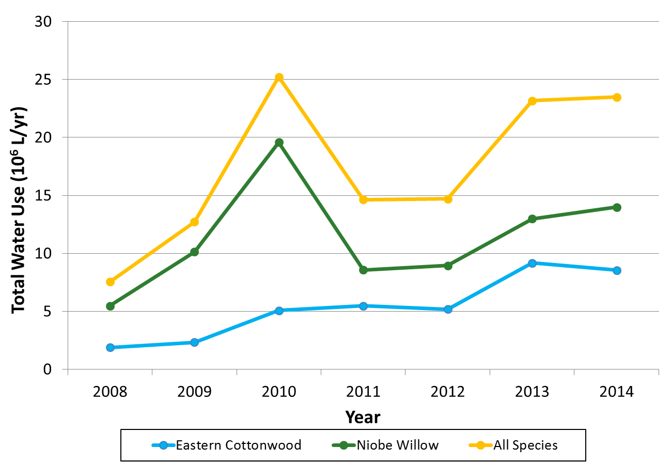
Total water use (10⁶L/y) by species in the Murdock phytoremediation system, 2008-2014. See main text for discussion.

References:
Argonne National Laboratory, 2008. Summary of Operations and Performance of the Murdock Site Restoration Project in 2007. Unpublished report, ANL/EVS/AGEM/TR-08-07, UChicago/Argonne LLC. http://www.ipd.anl.gov/anlpubs/2008/06/61658.pdf (accessed December 2018).

