On the World of the Virus:
Remaking Image Theory Anew

John Armitage

Abstract: This short article deals with the concept of the world, and that concept’s ability to engage with the impact of the coronavirus and the remaking of image theory anew. The concept of the world can, it is argued, be utilized to offer a sustained engagement with the influence of COVID-19, particularly as the concept of the world is manifested in the work of the philosopher Martin Heidegger. To understand Heidegger’s work on his most important idea of the world, we need to look briefly at image theory, at Heidegger’s introduction of the notion of the gigantic, at my own engagement with the gigantic in the microscopic image, and finally at how we can develop and revise our appreciation of the world of the virus.

Keywords: World, Virus, Image Theory, Martin Heidegger, The Gigantic, The Microscopic Image

Biography: John Armitage is Professor of Media Arts at Winchester School of Art, University of Southampton, UK.
Introduction
World, I suggest, is a central concept in the study of viruses, both as an indicator of our contemporary life-world and as a guide to the surrounding world. This short article offers readers an encounter with our shared world concerning one of the most important cultural and political debates of the twenty-first century, namely, the debate over the world of the virus, or, the development and meaning of the cultural world of the self and the causes and diseases in mammals and birds of the coronavirus, particularly since 2019. In exploring philosopher Martin Heidegger’s (1968; 2002: 57-85; 2012a: 99-105; 2012b: 106-109) influential ideas that I associate with living in a situation of the self and their entanglement with viruses causing respiratory tract infections, I trace their entwinement with our era through a brief study of the human coronavirus COVID-19, the world virus that can range from mild to lethal, and other key events such as COVID-19 illnesses and cases, our era’s varied symptoms, and their impact on the human species. I conclude with an assessment of the main changes in our place in the world of the virus and offer the outlines of a novel understanding of image theory as the gigantic in the microscopic image, of our era, our world, and the virus to critically and theoretically aware readers concerned with the contemporary world and with the human coronavirus that is COVID-19. But let us begin with the world of the virus.

On the World of the Virus
How are we to conceive of a worldview of viruses that cause disease? What should our image of viruses such as the coronavirus be when there are, at the time of writing, no vaccines or antiviral drugs to prevent or treat human coronavirus infections? The world of technoscience, of course, does have a view of or outlook on the worlds of respiratory tracts and viral sub-families, the realm of the genome, and the nucleocapsid (the nucleic acid of a coronavirus together with the protein coat that encloses it). But the image of the virus that the world of technoscience presents to the world, an image that is a theoretical view of the external world of helical symmetry, genome size, and viral characteristics, tells us little about what our view of a life lived within the world of the club-shaped spikes that project from the surface of coronaviruses could or should be (Figure 1).
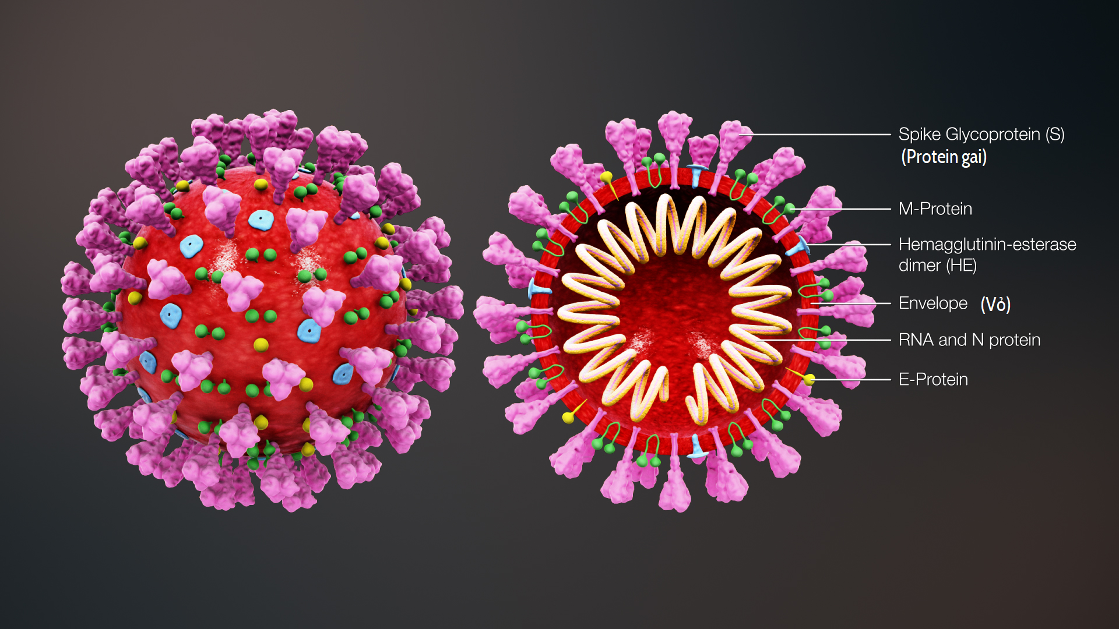
(Figure 1: This is a 3D medical illustration of 2019 Novel Coronavirus, derived from a Center for Disease Control [CDC] released image. It explains the ultrastructural morphology. This virus has four surface proteins E,S,M & HE labelled in the image. The S protein gives the crown-like appearance, for which the virus is named. The cross-section shows the inner components of the virus. This file was derived from: 3D medical animation coronavirus structure.jpg: https://commons.wikimedia.org/wiki/File:3D_medical_animation_coronavirus_structure_vie.png).

How are we to take a view of our position in the world of the virus, a world that can only be seen in high resolution electron microscopes that use a beam of accelerated electrons as a source of illumination? How should we act before such images? (Heidegger 2002: 57-59). Technoscientists with the same image of the world of the virus also hold different views of the world of the virus, and, as we have seen in the present period, enter conflict over, for example, the nature of the coronavirus, as well as over different naming conventions and their meanings. Yet such technoscientists remain within a common image of the world of the ‘corona’, of the crown, wreath, or garland, a term coined for certain viruses by June Almeida and David Tyrell who first observed and studied human coronaviruses (Tyrell and Fielder 2002). Moreover, such worlds not only conjure up images of ‘crowns’ but also the worlds of virology that are, in fact, not so much constituents of ‘nature’ as that of a world where viruses are viewed as appearances. According to my characterization we thus have three features in the structure of the worlds of the ‘virions’ (the infective forms of viruses) and their visual appearance under conditions provided by electron microscopes: our life experience of, for instance, virions, which have a fringe of large, bulbous surface projections, our own depiction of the world of such images, which are reminiscent of the solar corona or halo, and, arising from the relation of these, an ideal of life beyond this morphology created by the viral spike peplomers, which are the proteins on the surface of the coronavirus.
I am interested in the world of the virus and our views on respiratory infection because they are related to the human worlds of gasping and listlessness, and they contrast with the technoscience’s of bronchitis, hepatitis, and gastroenteritis if not with the philosophy of mortality. Does our place in the world of the virus essentially involve a world of discovery or a view of history? How is the world of the virus and our views on it related to our own transcendence, to our own going beyond the limits of our own experience and hence into the unknowable? How is the world of the virus connected to our view of philosophy? A philosophy founded on the world of the virus, on the point of view of the virus, seems impossible to imagine: how could we exemplify their differences? Any image would still bring them too close together. The world of the virus and our view of the virus is narrow and limits actual experience: yet a philosophy of the virus would open us up to new experiences, and for that reason cannot establish the history of the virus, its inoculation or its isolation. The medical world of the virus is continuously viewed as an end, typically an unaware or unintentional end. Any philosophy of the virus must, then, continually be a beginning that, unlike the virus, which necessitates inoculation and inactivation, requires its own overcoming to become a novel strain of philosophy. The world of the imaged virus is frequently viewed as random and peremptory even under conditions of electron microscopy. It can be individual, articulating, perhaps, the life experience and views of a specific virologist, or total, eclipsing all individual views. A total world of the virus cannot comprehend its own views, for this would put it in doubt. Therefore, the viruses’ own early ingenuity is rapidly redirected into ‘machination’, into being taken to be something that can be rendered electronic, if there is the determination to do it, and if there are exclusively what we can manipulate, calculate, and create microscopically (Heidegger 2012a: 99-105). Consider the electron microscope (Figure 2):

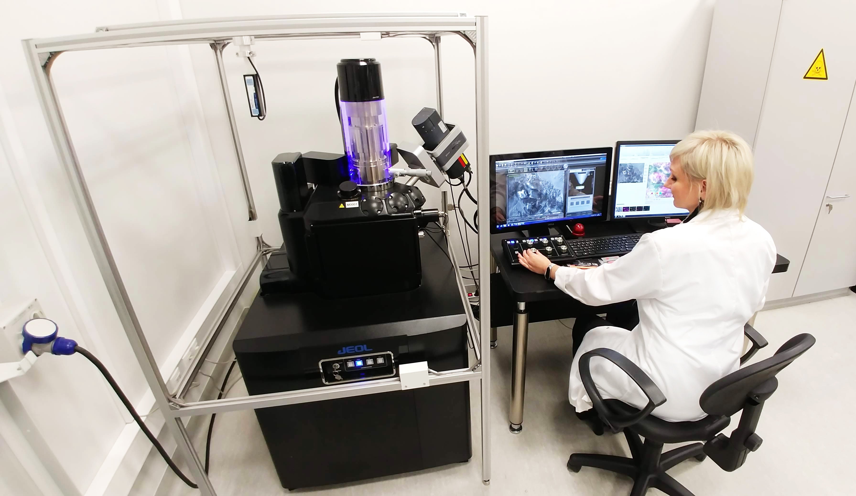

Figure 2: Scientist during work with Scanning Electron Microscope: https://commons.wikimedia.org/wiki/File:Scientist_during_work_with_Scanning_Electron_Microscope.jpg

Any opposition to the electron microscope is mere material for its growth. There may be difficulties using a beam of accelerated electrons and problems with this source of illumination, but nothing is questionable about wavelengths and electrons (in this lies the sources of its nihilism) as what ‘things’ such as microscopy are has been determined. They are ‘things’ such as beams made with the accelerated power of electrons to make other ‘things’, such as illumination. The machination of the electron microscope thus interprets us not just as objects of morphology, as biological forms and structures, but also, crucially, as organisms without any consideration of our functions, and thus, partially, as products of the distinctive club-like spikes of the virus, the outcome of a now technologized infection. Because questioning morphology cannot be eradicated, the era of the world virus as machination classifies what perseveres as questionable in the inoffensive form of, for example, the lived experience of the bronchitis virus. Yet the lived experience of the bronchitis virus, of gasping and listlessness, remains within the limits of machination by representing what is secretive and strange about the virus or enthralling to research groups of technoscientists, making it public (we think of the United Nations’ World Health Organization) and accessible to everybody, and therefore, for instance, making the isolation, grouping, and machination of the virus all the more essential. As the unconditional and exclusive supremacy of the creation of organ cultures and the naming of virus strains, such machination is the façade of true reality, empty of organic limits or cultural wonder. Taking itself as everlasting, machination protects and consequently reverberates the nullity of ourselves and our desertion of being ourselves to the worlds of novel viruses. Working under the plan of electronic microscopy and thus elucidating everything, perhaps by way of wavelengths, machination throws electrons together in the same way, leaving them alien to us because the wavelength of an electron can be up to 100,000 times shorter than that of visible light photons. The era of the world virus as machination, of what is called ‘thinking’ (Heidegger 1968), is the unconditional consummation of ourselves as the will to electronic power, and its microscopic destruction emerges, as it does elsewhere, in the shape of the quickest resolving power and widest sort of ‘progress’ in all microscopic preparation and the calculation of the revelation of the structures of ever tinier objects. It presents us with the chance to control the era of the world virus and its club-like spikes, totally reducing it to calculations of such ‘things’ as electrons and the ‘values’ of microscopy. Such machination requires of us a sort of ‘thinking’ that, like that of novel viruses themselves, is fundamentally rootless. Any philosophy of the virus must, therefore, not make a claim to totality, to total knowledge of ourselves, but, rather, repeatedly expound a self-surmounting philosophy of another beginning.
The contemporary image of the world of viruses entails numerous components: morphological technoscience; machine technologies, such as scanning transmission electron microscopes that can achieve ultra-high resolution and magnifications of up to 10,000,000 times; the diminution of ourselves to an object of appearance (Armitage 2012: 57); the idea of our activities as a culture of letters (‘COVID’) and numbers (‘19’) and as the fulfilment of microbiological ‘values’, the concern of a culturally structured ‘policy’ towards viruses; and a profane technoscience of viral spheres and particles, surfaces, and projections that coexists with the contemporary modernization of the world of perception, our views on machination, our liberation, our attempted conquest of the world of the virus, and the supremacy of reason as vital to this transformation (Heidegger 2012a: 99-105).
This will to the technologization of the world of the virus has already reached unconditional proportions in the twenty-first century. What typifies contemporary modernization in part is the way that we attempt to assert ourselves over every viral particle, every viral envelope, and every viral spike through their objectification. Having postulated the world of the virus as the world of producible objects in the shape of electron micrographs, today, we have set ourselves up as the creator of appearances concerning the world of the virus, and thus emerge into a fantasy location of unrestricted ascendency over the world of the virus, given that there are, as yet, no vaccines or antiviral drugs that can prevent or treat human coronavirus infections. One of the characteristics of contemporary modernity is therefore the endeavour to overcome or even defeat the world of the virus as an electronic image. Yet, for all its supposed sophistication, the image represented electronically for ‘producing’ the virus is relatively opaque because of the shortcomings of the electronic beam used to scan its particles. Inside the world of viral envelopes and images of viral layers and membranes, then, we deliberately fashion viral spikes and viral structures and uphold such processes through contemporary technoscience.
Motivating all this technoscience is the idea of the world of the virus as an image of viral ratios and averages, subsets, subgroups, and subunits. This idea implies an effort at a total mastery of the mediated image of the virus as a ‘world’ within itself wherein the world of viral envelopes, their activation, and fusion are, and can only be, imagined as images of viral envelopes and their structural shapes. We thus take ourselves today in such a way that we are not so much present as re-presented as the products of nucleocapsid proteins, of configurations of the virus, its host, and its cells. The appearance of the world of the virus and images of the human coronavirus positive-sense single-stranded Ribonucleic acid (RNA) - the polymeric molecule essential in various biological roles in coding, decoding, regulation and expression of genes - requires more than indispensable determinations about genome size or organization. For what is at stake is nothing less than essential decisions about ourselves, about how we want to seek and find ourselves beyond representations that reduce us to the status of a virus, to some ‘thing’ that has been framed and encoded. This world of imaged infection is distinctively contemporary. We are assigned our place within it by viral spike proteins attaching themselves to our host cell receptors. Amid this creative disorder we are not at the beck and call of ourselves or even of other people but entirely subservient to the cleavage or splitting and activation of receptor-attached spike proteins. Reducing our familiar world to images of host cells we become subject to an activation that allows the world of the virus to enter ‘our’ host cells by direct fusion of the viral envelope with the host membrane. The worlding and imaging of the virus are processes wherein we are subjected to various forms of corporeal attack and attachment, cleavage, and replication. No longer among human beings but among a world of complex images, any philosophical explanation we undertake must not be in terms of proteins and replication, complexity, and genomes. Rather, it must be in terms of how the meaning of the world of the virus is mediated, how it passes through the editorial functions and complex interpretive screens of, for instance, electron microscopes, before it is processed and received. We must, therefore, question, or at least be sceptical of, the ‘original’ and ‘authentic’ status (as ‘factually’, self-evidently, or scientifically ‘true’) of any electronically generated microscopic image.
Given that we are already immersed in the world of the electronically generated microscopic image, how is it possible for us to consider this world from a critical perspective? What should our position on this world be? How can we possibly conceive of its imagery? I am less concerned with taking a specific cultural position on this world or with setting up a view or a stance that must be adopted as a political posture in relation to complex viruses and their human environs. Instead, I am concerned with what our attitude should be towards the world of genetic recombination and the question of the imaging of that world. For our present position in the middle of the world of genomes and infected cells is seemingly predicated on a position that takes the whole human body – which is not only the very structure of our being but also composed of cells that create tissues and subsequently organ systems that ensure our homeostasis and viability – as its starting and end point as opposed to, for example, the determination of genetic variability within a human body. How, then, in the contemporary moment, are we to decide about the contents of the world of the coronavirus species, its imagery, and their arrangement? And, in deciding what our own position is to be regarding these contents, does that require positioning ourselves differently towards the world, taking up a new, perhaps ‘viral’ and/or multi-species position, in a way that no previous type of image theory has done? I think it does. Indeed, a new or contemporary image theory is required, I argue, because we increasingly belong to a new world wherein novel corona and other viruses are a part of our everyday lives and whose imagery is at once exact (electronic, microscopic, ultra-high resolution and magnification) and opaque when it comes to our general understanding of what an image is. My own position is not that we must try to wrest control over the world and imagery of the virus from technoscience, but that we must make a start on remaking image theory anew.

Remaking Image Theory Anew
Ordinarily, if we were to write of the image and of imagery, we would busy ourselves with terms such as representation, with the outward form of our subjective selves, with objects, or with a mental picture of either or both. Yet electronic and microscopic images of genomes and the imagery of viruses, whilst in some formal sense still representations, offer the inward form of our objective selves: indeed, ‘we’ are depicted as tiny proteins, as nucleocapsids, or as an accumulation of host cells. Symbols of such electronic occurrences are starting to emerge ubiquitously, and in the most diverse forms, of what Heidegger (2002: 71-72; 2012b: 106-109) calls the gigantic.
Here, contemporary processes of representation treat us as objects, without respect for our particular temporal and spatial relations. For Heidegger, representing ourselves as objects like this adds up to the introduction of the gigantic because such representations find no limit in the given. Quite the reverse, for the gigantic, ‘everything is humanly possible’, providing we are so represented, that is, as calculable objects whose circumstances, also part of the calculation, are furnished beforehand (Heidegger 2012b: 107). Thus, the appearance of the gigantic accords with the supremacy of representation as such (where, for example, the world of the virus becomes an image) and the objectification of ourselves begins. Simultaneously, though, the gigantic inadvertently offers another kind of representation, because what it actually represents is our abandonment of ourselves, although, as in the world of the virus, our abandonment of ourselves is at present largely unrecognized. However, albeit mainly unbeknownst to it and to us, the gigantic is the incalculable, and, as such, resonates not only throughout contemporary history but also throughout contemporary selfhood.
Whilst Heidegger describes numerous ways in which the gigantic takes hold (e.g. rendering everything homogeneous, eliminating the question of existence from questions worth posing), I want to introduce the way in which the gigantic in the microscopic image reduces us under the appearance and form of its unbounded growth while asserting the ability to control us, where almost nothing is unattainable. As one of the forms of the unrestricted ascendency of representing and producing, the gigantic in the microscopic image helps to bring to near completion our contemporary metaphysical attitude. Neither in control of ourselves nor aware of the reality of our contemporary historical situation the gigantic in the microscopic image is merely one of our many denials of ourselves in support of the rational and the given.
Think of the microscopic image of the coronavirus above (Figure 1) which has been distributed worldwide in newspapers, in magazines, on TV screens, and on social media. Hence, whilst the idea of the image remains a conceptual building block of media historical, cultural, and political discourse, the gigantic in the microscopic image surges onward in electronic forms which appear to make it vanish: in the representations of alien and distant infected worlds in their ’everyday’ transmission created apparently at will by infected human carriers shedding viruses into their environment. The gigantic in the microscopic image thus confuses us because, beyond the realms of technoscience, few of us have experience of or use for electronic images of the interaction of coronavirus spike proteins. All of which leads us to the problem of the theoretical value of such images. We may, of course, reject the term image or even image theory with the aim of offering an alternative account of the visual meaning and psychic processes at work when we are confronted with visual representations of cell receptors, human tissue, and infectivity. But, following Heidegger, my question is how does the increasingly gigantic quantity of electronic and microscopic images of viruses come to develop its own type of quality, becoming, thus, not clear, knowable images, but, instead, an extraordinary variety of the gigantic? The answer is that our historical era is in part ever more defined by its idea of the gigantic in the microscopic image of the coronavirus. For the gigantic in the microscopic image, I argue, does not show itself as fabricated signs from certain physical materials such as human cells but as the electronic calculation of the transmission of the coronavirus, of the microscopic establishing of its hosts, and the electronic safeguarding of a future beyond coronavirus for our species. A conventional understanding of the image or of a visual representation, of course, aims to understand how they attain certain meanings in specific situations. However, my understanding of the gigantic in the microscopic image focuses elsewhere: on the shift from identifying factors involved in the circuits of communication to identifying how the quantity of electronic images of human coronaviruses have taken on a singular quality wherein the gigantic in the microscopic image is less about the production, transmission, and consumption of images and more about how such microscopic images of the cells of the respiratory tract and so on pass from the realm of the calculable into the realm of the incalculable. Hence, my concern is unconventional in the sense that it does not consider the gigantic in the microscopic image of human coronaviruses in terms of photographic light, surface, projection, or lenses and so on but, rather, in terms of the incalculability of ‘infection’. For the gigantic in the microscopic image – say the gigantic in the microscopic image of the digestive tract – cannot, I suggest, be fully assessed as a recognisable type of subject matter (e.g. a photographic self-portrait) or easily treated in the same way as a photographic document that we take to be somehow ‘realistic’. This is because, whilst the gigantic in the microscopic image does belong to the history of electronic microscopic photography and other related visual media, it cannot straightforwardly be examined in terms of its appeal to large groups of general viewers for reasons of consumer entertainment and so forth but, perhaps, only in terms of its summoning up of coronavirus infection as an imperceptible darkening or even eclipse of everything we used to view as our subjective selves, our world, and its images.

Conclusion
In conclusion, the gigantic in the microscopic image or the darkening of our contemporary world points not to a visual space of human representation but to a visual space of viral mystification. It is a space wherein we retreat from our present existential conditions into a kind of homesickness for a world before the world of the coronavirus engulfed us, into a mirage, or into a sort of optical illusion wherein terms such as infection and virus, species, and bats are not quite so prevalent in our everyday lexicon. Why? Because, faced with the incalculability, the indeterminate nature, and the historical exceptionality of the gigantic in the microscopic image, we simply cannot believe it to be our current reality. Yet, by some technoscientific assessments (e.g. Wertheim, Chu, Peiris, Kosakovsky, and Poon 2013: 7039-45), coronaviruses are estimated not only to have originated as far back as 55 million years ago but - in an almost nihilistic reversal of Enlightenment science and its vision of infinite progress – are also never going to disappear. This eclipse, we tell ourselves, must somehow be a mere projection of our current knowledge of our co-evolution with bat and avian species, it must be unstable as history and untrustworthy as technoscience, and, finally, it must be something that we can easily politically refuse because, like bats and birds, the virus is bound to fly away shortly. However, our contemporary experience and thought processes concerning these internal viral mindscapes and external cultural landscapes are, on the one hand, the result of technoscience becoming the only way of knowing in the present period, and, on the other, the creation of a dream-like feeling of political refusal associated with our sense of the gigantic in the microscopic image as the negation of the contemporary era. In one way, and perhaps understandably, whilst this flight into the dream-like feeling of political refusal will achieve very little, and, even then, only for a short time, this shutting of the eyes to the negation of the contemporary era is not blindness concerning our historical era. More readily, it is a truthful and sensible recognition that the meaning of the world and the dissemination of the virus is most likely ultimately unknowable, incalculable, even untruthful, ingeniously resistant to our interrogation, and shaped by a power higher than our current ability to think, to analyse, and to conceive of a different world beyond that of the gigantic in the microscopic image. Yet, however many times we do reflect on the gigantic in the microscopic image in the hope of conveying ourselves to a different future, we must always insist on acknowledging the fact that, whatever our contemporary status as selves wedged somewhere in-between the pre- and the post – COVID 19 pandemic, the gigantic in the microscopic image will almost certainly always remain inexplicable which, for some, leads to a cultural politics of resignation if not outright nihilism. Nevertheless, just because the essence of the gigantic in the microscopic image, of calculation, and of the calculable, is not accessible to calculation does not mean that we cannot understand the world of the virus and remake image theory in a new and un-calculating way.

Acknowledgments
I would like to thank Ryan Bishop and Mark Featherstone for their valuable comments on an earlier draft of this article.

References
Armitage, John, 2012. Virilio and the Media. Cambridge: Polity Press.
Heidegger, Martin, 1968. What is Called Thinking? New York: Harper Perennial.
Heidegger, Martin, 2002. “The Age of the World Picture.” In Off the Beaten Track, edited and translated by Julian Young and Kenneth Hayes, 57-85. Cambridge: Cambridge University Press.
Heidegger, Martin, 2012a. “Machination.” In Contributions to Philosophy (Of the Event), translated by Richard Rojcewicz and Daniella Vallega-Neu, 99-105. Bloomington: Indiana University Press.
Heidegger, Martin, 2012b. “The gigantic.” In Contributions to Philosophy (Of the Event), translated by Richard Rojcewicz and Daniella Vallega-Neu, 106-109. Bloomington: Indiana University Press.
Tyrell, David, and Fielder, Michael, 2002. Cold Wars: The Fight Against the Common Cold. Oxford: Oxford University Press.
Wertheim, Joel O., Chu, Daniel K. W., Peiris, Joseph S. M., Kosakovsky, Sergei L. Pond, and Poon, Leo L. M. 2013. “A Case for the Ancient Origin of Coronaviruses.” Journal of Virology 87, no. 12: 7039-45: https://www.ncbi.nlm.nih.gov/pmc/articles/PMC3676139

