Coworking in homes – mitigating the tensions of the freelance economy
(Accepted manuscript in Geoforum)
Dr Darja Reuschke
University of Southampton
School of Geography & Environment Science
University Road
Highfield Campus
Southampton
SO17 1BJ
United Kingdom
Email: d.reuschke@soton.ac.uk
Phone: +44 (0)23 8059 2866
ORCID ID orcid.org/0000-0001-6961-1801

Prof Nick Clifton
Cardiff Metropolitan University
Cardiff School of Management
Western Avenue, Llandaff
Cardiff
CF5 2YB
UK
Email: nclifton@cardiffmet.ac.uk
Phone: +44 (0)29 2041 7159
ORCID ID https://orcid.org/0000-0001-8606-7369

Mr Michael Fisher
University of Southampton
School of Geography & Environment Science
University Road
Highfield Campus
Southampton
SO17 1BJ
United Kingdom
Email: mrf1g19@soton.ac.uk
Phone: +44 (0)23 8059 2250

Funding acknowledgement: This study was funded by the European Research Council, the Starting Grant WORKANDHOME (ERC- 2014-STG 639403)

Coworking in homes – mitigating the tensions of the freelance economy

Abstract
Coworking has increased in popularity in the digital knowledge economy with the rise of independent professional workers who often work from home and lack the social relations that provide feedback, referrals or social support. Rather than studying coworking as a new spatial, social and economic way of working in designated coworking spaces, this study explores coworking in residential homes – the earliest self-organised form of coworking that has received little attention although dedicated home-based coworking networks have developed since. Based on intensive fieldwork material from coworking groups of freelancers across Europe who meet in each other’s homes, we explore why people meet to cowork in homes – when at the same time coworking is driven by the social isolation of working alone in the ‘home office’ as emphasised in previous research on coworking spaces. Our findings highlight the need of freelance workers to learn how to be productive and maintain productivity. The shared experience of homeworking and awareness of the challenges of personalised professional work create cognitive proximity in home-based coworking. Coworkers commit to the production of an affective atmosphere which is facilitated by digital platforms, the role of hosts and the home environment. We discuss the implications of our findings for understanding coworking more generally.

- Introduction and background
Coworking – working in shared working environments – has increased in popularity as evidenced in a growing number of coworking spaces in cities and, more recently, in towns (Jamal, 2018). Coworking reflects significant changes in economic activity related to an increase in digital knowledge work and the associated increase in location independent work as well as the increase of independent professional workers or freelancers (Waters-Lynch et al., 2016). Against this background, coworking has attracted growing interest in research and urban planning as a new spatial and social phenomenon of economic activity that is based outside of the home, on the one hand side, and the traditional workplace in an office, on the other side, or what Oldenburg (1989) coined the ‘third place’.
Coworking spaces have become more popular in the digital knowledge economy as they create positive ‘externalities’ for those who otherwise work from home and lack the social relations that provide feedback, referrals or social support that self-organised careers in the new economy outside of companies depend on (Garrett et al., 2017; Gerdenitsch et al., 2016; Spinuzzi, 2012). These externalities are by definition not directly paid for (although fees are usually involved for using coworking spaces) but arise from proximity to other freelancers. Coworking spaces have therefore been conceptualised as ‘micro-clusters’ (Wijngaarden et al., 2020; Capdevila, 2013, 2015) that, similarly to agglomerations, provide what Marshall (1925) called an ‘industrial atmosphere’. This includes social networks that can be converted into economic benefits (collaboration, new projects, referrals etc.) particularly in relation to firm- or industry-focused specialisation (Marshall, 1925; Porter, 1990). However, there is ambivalence about why in many observed cases the economic benefits seem to be relatively low for coworkers while evidence supports more the existence of social externalities (feedback and help from others) in such micro-clusters. These ambivalences of coworking spaces around the benefits of proximity have become the focus of recent coworking research (Waters-Lynch and Duff, 2019; de Peuter et al., 2017).
Coworking has increasingly become commercialised and commodified through large, global space providers (Gandini and Cossu, 2019). One of the first coworking phenomena, however, goes back to the so-called Jellies initiative where, initially, the founders invited people to work in their apartment in New York City (Waters-Lynch et al., 2016). Here coworking was self-organised and practiced ‘bottom-up’ in an individualised way largely driven by young people and creative knowledge workers while coworking in commercial spaces of for-profit-companies has produced what has been labelled a ‘neo-corporate’ or ‘entrepreneurial’ model of coworking (Gandini and Cossu, 2019, Avidkos and Iliopoulou, 2019) although there is a large variation in business models (Spinuzzi, 2012). The emergence of ‘bottom-up’ or individualised coworking in the form of Jellies was at a time when cities (and more so other locations) did not provide flexible or shared workspaces. Hence, the fact that coworking did not start as a spatial separation between home and workspace could be either because it was not the prime motivation or because there was no alternative. The growing body of coworking research in the last decade instead has focused on the increasing rise of dedicated coworking spaces.
With an increasing rise of homeworking even before the COVID-19 pandemic (Reuschke and Felstead, 2020) and exponentially rising numbers of coworking spaces, home-based coworking has spread too. Coworking in homes has expanded from the initial Jellies initiative (Grossman, 2007) to dedicated home-based coworking networks (O’Sullivan, 2015). As described by Bradley and Pargman (2017), the Hoffice network, founded in 2014, addresses issues of independent workers who lack a separate workspace and colleagues. The short insight provided by these authors reveals parallels of home-based coworking with coworking in dedicated coworking spaces, in particular, the motivation to meet new people. It also suggests some potential differences. The Hoffice network, as described by the authors, is about all aspects of people’s work life including wellbeing, ‘friendship’ and ‘company’ (p. 237). This contrasts with the focus on professional collaboration and innovation in existing coworking studies. Hence, these home-based coworking groups may provide a fuller picture of the proximity benefits of coworking.
We therefore investigate in this study the under-researched type of coworking that takes place in residential homes. Our main aims are to understand this coworking phenomenon and to explore implications of this type of coworking for our understanding of coworking more generally. Insofar, we are studying one of the earliest self-organised phenomena of coworking that has received little empirical attention perhaps because it is largely invisible and/or because a significant interest in coworking stems from organisational and management studies in coworking as sites of management practices and the role of the space proprietors (Rese et al., 2020; Blagoev et al., 2019; Bouncken and Reuschl, 2018; Spinuzzi, 2012, 2019; Jakonen et al., 2017). The motivation of coworkers to overcome the social isolation of working in their homes has consistently been stressed in existing studies as a driver of coworking for independent knowledge workers (Merkel, 2015; Spinuzzi, 2012). Hence, the desire to work in a ‘third’ place in contrast to the own home has been inherent in the coworking movement. We therefore explore more specifically the question: Why coworking in residential homes – when at the same time independent knowledge workers seek coworking spaces as an escape from the home and the associated experiences of loneliness and isolation?
The empirical study is based on intensive fieldwork from coworking groups across Europe and a mix of data from participant observation, semi-structured interviews and social media posts. Findings suggest that one reason for the existing ambivalences of coworking lies in the focus of prior studies on cooperation and innovation as economic externalities of coworking. Rather than focussing on instrumental interactions as economic externalities, our empirical findings show how important the balance between the need to interact and the need to work effectively alone is for independent workers. The latter aspect has often been neglected in coworking research, with collaboration and interaction seen as an end in itself, with conversely little attention given to effective individual spaces. Cognitive proximity through the shared experience of homeworking is crucial for understanding home-based coworking.
The growing coworking literature has well-covered the motivations of working in shared working environments. Studies on coworking spaces also cover different cities and towns across continents. However, there is little to no empirical investigation of ‘grass-roots’ coworking based in people’s homes. We therefore focus our literature review on the increasingly revealed and discussed contradictions and ambivalences of coworking which helps us in approaching home-based coworking as an under-researched type of coworking.

- Literature review
2.1 Benefits or externalities of coworking
Informed by economic geography theory and cultural and creative studies, both the need for face-to-face interactions in the knowledge economy and the precarious working conditions of freelancers have been identified as key drivers of coworking that explain together the externalities or benefits of coworking. The precariousness of freelancers or ‘portfolio’ workers – who work on a variety of pieces of work for different clients and employers (Fraser and Gold, 2001) – lies mainly in their high personalised risk, uncertainty and exposure to variable earnings, particularly in the creative and cultural industries, as they are solely responsible for securing projects and contracts and maintaining clients. The uncertainty in work availability and income and the social isolation together cause daily frictions (Petriglieri et al., 2019; Clinton et al., 2006). At the same time, freelancers are often not embedded in the co-worker and supervisor relations through which workers in companies can receive social support and rewards (Luchman and González-Morales, 2013, Bakker and Demerouti, 2007).
Homeworking is an element of this precariousness and personal risk as due to the lack of a traditional workplace, for example in an office of a company, the nature of working in one’s own home hinders social contacts to people one could potentially work for or work with (Garrett et al., 2017; Hislop et al., 2015; Spinuzzi, 2012). Behind the difficulties of homeworking also lie struggles to create and negotiate boundaries between work and home (Brown, 2017; Spinuzzi, 2012). Issues of mental separation (e.g. being still in pyjamas by midday) also affect work motivation and work identity (Spinuzzi, 2012).
Formal and informal interactions are therefore key aspects of the face-to-face contacts that freelancers and independent knowledge workers are seeking in coworking spaces (Bouncken and Reuschl, 2018, Gerdenitsch et al., 2016). This desire is deeply embedded in the informality of their careers in the creative and cultural industries (Alakovska, 2018). The need for social support and feedback due to the lack of co-worker relations, also creates the desire for a feeling of belonging and a sense of community – feelings which have been strongly related to the concept of coworking (Garrett et al., 2017). Hence, the externalities or benefits that freelancers can gain from coworking are both economic and social (finding partners, advice, encouragement, referrals etc.) (Spinuzzi, 2012) which is essential for their careers and entrepreneurial projects.
However, the motivation of independent workers to come to coworking spaces has often not been primarily the proximity to other freelancers or entrepreneurs. They have also often not benefitted from collaborations as they had hoped for (Clifton et al., 2019; Brown, 2017). This ambivalence between the hypothesised benefits of coworking in the academic literature and the benefits of coworking as perceived by individual coworkers has been related in the literature to the neo-corporate or entrepreneurial coworking model itself (Gandini and Cossu, 2019; Avdikos and Iliopoulou, 2019).

2.2 Market-orientation of coworking spaces
The market-orientation of coworking spaces seems to support and attract two groups of independent workers according to Spinuzzi (2012). First is the ‘good-partner’ type who seeks business partners and collaborators in coworking spaces. The second type is the ‘good-neighbour’ who primarily comes to coworking spaces to meet with clients but does not necessarily seek to work with other coworkers. This latter type is driving the phenomenon often observed in coworking studies – that of people working alone together (Spinuzzi, 2012) or silence in coworking spaces (de Vaujany and Aroles, 2019). Independent professional workers and entrepreneurs fall into both groups, however, the market-orientation of the coworking spaces, which often comes with high fees, partly seems to attract more established freelancers who already have established networks and do not seek to build new networks with the help of coworking spaces. To contrast, for nascent entrepreneurs and young independent professionals who are still in a ‘growing-up’ phase, coworking spaces may be more beneficial for networking (Avdikos and Iliopoulou, 2019).
Commercialisation and market-orientation are also connected with a high turnover of the users of coworking spaces (Wijngaarden et al., 2020; Merkel, 2015) which runs somewhat counter the very notion of coworking as a community of freelancers (Spinuzzi et al., 2019; Merkel, 2015). Remote working employees also seem to be attracted to commercial coworking spaces (Jeske and Ruwe, 2019) who are likely to have different values and experiences to freelancers (Felstead and Henseke, 2017) hindering cognitive proximity in these spaces (Wijngaarden et al., 2020).

2.3 Managing coworking
Addressing the limitations of the market-oriented model of coworking, research has focussed on how encounters and interactions can be managed and spaces designed for encounters and serendipity (Weijs-Perrée et al., 2019; Merkel, 2015). Butcher (2018) regards coworking as a two-stage process of co-created situated learning and suggests that in the first stage coworkers need to learn how to cowork (a learning process which is supported by social events and spaces), with learning how to be entrepreneurial, for example, being the second stage. Others stress the importance of complementary skills and the proximity to ‘like-minded’ professionals which helps to develop collegiality and knowledge exchange (Brown, 2017).
Rather than managing social interactions or skills-sets, Waters-Lynch and Duff (2019) argue that atmosphere plays a vital role in coworking as it influences coworkers’ feelings and experiences, for example the feeling of vibrancy in a space that something inspiring could happen. Following the concept of the commons by Ostrom (1990) they conceptualise coworking spaces as commons with shared resources that a community both creates and consumes. Atmospheres are in this regard shared resources that coworkers co-constitute themselves and which in turn allow new shared values to be created. A vibrant or appealing atmosphere is therefore a collective product that the individual coworker needs to produce. The ambivalence concerning collaboration and community in coworking spaces in their view relates to the management of the social production of an affective atmosphere. If access to the commons is commodified without individuals being aware or committing themselves to the production and circulation of an affective atmosphere, feelings of community will not be produced or sustained. Hence, this is not a resource that is ‘in the air’ as per Marshall (1925) but it requires appropriate governance arrangements to maintain it. As a consequence, following this view, coworking spaces require an affective density of actively engaged people and they need to promote that their users are not working alone but commit themselves to commoning practices. Some coworking spaces, as described by Gandini and Cossu (2019), follow a strict ‘anti-alone togetherness’ policy according to which users are required to interact with others.

2.4 Nature of freelance work and precariousness
Besides the view that coworking needs to be managed, the literature also highlights that the focus on encounters and interactions in the academic and popular coworking literature neglects the very nature of freelance working and the inherent precariousness of the work. This contradiction is illustrated by Jakonen et al. (2017) who found that freelancers did not feel they could engage in social interactions in coworking spaces because they were paid by clients by the hour and thus experienced work pressures. Although there was awareness of a future benefit of social interactions, freelancers felt the need to prioritise their present project. Their pressured and individualised way of working also meant they had to be online all the time further hindering face-to-face interaction in the coworking space.
Related to this precariousness are observations that some coworkers primarily sought a place to work productively in the absence of a corporative workplace and as an alternative to working from home (Brown, 2017). It was also noted particularly after the Great Recession 2008 that independent workers and business start-ups were searching for coworking spaces in order to reduce the fixed costs of their own business premises (Avdikos and Iliopoulou, 2019).
Reasons for choosing a coworking space over homeworking – whether it is primarily for having a workplace or for the perceived economic/social externalities – are also likely to be impacted on by housing markets and individual circumstances. The social stratification of housing conditions and the spatial segmentation of housing stock means that the practices and experiences of working from home are shaped by pre-existing housing types and location. The home may little afford a working environment for individuals located in high density areas and associated small accommodations (Richardson, 2017), i.e. in areas where coworking spaces are concentrated (Waters-Lynch et al., 2016).

2.5 Location, access and inclusivity
The logic of markets does not only run counter to the notions of collaboration and community (Spinuzzi et al., 2019; Jamal, 2018; Waters-Lynch and Potts, 2017) but manifests itself spatially. The need of coworking spaces to be profitable lends itself towards dense, well connected urban places. Larger franchised coworking spaces are especially drawn to central locations along main transportation networks in order to access a large workforce (van de Vrande and Stam, 2017; Di Marino and Lapintie, 2017; Wang and Loo, 2017; Waters-Lynch et al., 2016; Spinuzzi, 2012). Hence, these spaces benefit from urbanisation economies (the ‘Jacobs’ externalities of agglomerations), which are conceptualised as people-focused and derived from diversity and variety (Jacobs, 1969; Frenken et al 2007), similar to firms with high dependence on tacit knowledge and dynamic markets.
At the same time, large cities also attract a diversity of coworking spaces including smaller, specialised ones (see Spinuzzi et al., (2019) and Merkel (2015) for examples) as they can exploit the benefits of localization economies (e.g. great number of specialised workers/entrepreneurs in a certain industry such as digital media). Entrepreneurial-led coworking spaces are therefore attracted to clusters of advanced business services and digital media (Mariotti et al., 2017) and tend to be embedded in entrepreneurial/start-up ecosystems rather than in neighbourhoods (Avdikos and Merkel, 2019).
Given this market-driven logic of location, it seems reasonable to suspect that there is some spatial mismatch between the location of coworking spaces and the residential location of some independent knowledge workers who may want to work in them. Even core members of the creative class as defined by Richard Florida (2002), seem to follow ‘standard’ central-peripheral residential patterns according to which younger workers tend to live in dense, diverse central locations and later in their life-course also knowledge workers tend to live in the periphery of cities (Lawton et al., 2013; Frenckel et al., 2013).
There is some variety in business models, with some coworking space providers pursuing an active mission to locate in peripheral places to reduce commuting needs and by extension retain more local spend (Clifton et al., 2019; Gandini and Cossu, 2019). However, a shortage of coworking spaces was noted in smaller cities and towns due to the lack of affordable and adequate spaces (Jamal, 2018). Furthermore, the increasing clustering of entrepreneurial-led coworking spaces has led to a decline in bottom-up, communal coworking spaces in inner cities (Avdikos and Merkel, 2019) which could also have contributed to an under-supply of spaces in central locations which cater more for workers who seek coworking spaces for a sense of community and peer support.
Inclusivity (and exclusion) may also be driven by the management of coworking spaces directly via the requirements of certain skills sets and more indirectly via the membership options and fees. Communal coworking spaces are not necessarily more open to everyone (Avdikos and Iliopoulou, 2019).

2.6 Summary of literature review
Based on the revealed ambivalences of coworking found in entrepreneurial-led/market-oriented coworking spaces, it might be that home-based coworking – the bottom-up, self-organised way of working in shared spaces – can be understood through what coworking spaces fall short in delivering. This seems to be mainly economic externalities (collaboration / instrumental interactions) (Wijngaarden et al., 2020). Social externalities (new contacts / informal interactions) are more often facilitated by coworking spaces through spaces and events of encounters. However, there often seems to be a lack of community and collegiality because of cognitive distance (Wijngaarden et al., 2020; Parrino, 2015). In this sense, home-based coworking might be able to foster communities of ‘like-minded’ independent professionals who share similar work experiences of precariousness (Merkel, 2019) on which basis collaboration or joint start-ups may develop. Following Waters-Lynch and Duff’s (2019) notion of an affective atmosphere as shared resource, it may also be that coworking takes place in homes because the space facilitates an affective or appealing atmosphere that again enhances economic and/or social externalities.
Given the specific geography of coworking spaces that favours economic business clusters and central locations in cities, home-based coworking may also be a response to a lack of supply in coworking spaces which can be assumed to be the case particularly away from inner-cities, in towns and rural areas. It could also be a niche market in more centrally located areas with entrepreneur-led coworking spaces that do not cater, however, to the specific needs of some professional freelancers.

- Research design
3.1 Selection of coworking groups and recruitment
We identified two coworking meta-networks through internet and social media search: Hoffice and Cohome. In both networks, the coworking takes place in homes. Hoffice, founded in Sweden, has a large geographical reach and received attention in the academic and popular literature (Bradley and Pargman, 2017; Grossman, 2007). In May 2018, it had 115 groups worldwide, with most groups being located in Europe, in particular Belgium, Sweden and Denmark. We include in our study a second network that at the time of the research was gaining popularity in France: Cohome. The inclusion of these two networks enables us to study home-based coworking in various European countries: Belgium, France, Sweden, Denmark, Germany and the United Kingdom (UK). Including two networks further allows us to investigate home-based coworking beyond one specific network and to search for commonalities.
Home-based coworking in these networks is organised via digital platforms. However, this was inherent in our search design. It is likely that because of security concerns home-based coworking is largely dependent on digital technology. It may be that home-based coworking is also practiced without the reliance on digital platforms, however, these forms of home-based coworking are not captured in this study.
The fieldwork took place between November 2016 and November 2018. As summarised in Table 1, ten coworking events were observed in practice, involving a total of 50 informants. In addition, we also collated data from some groups from online platforms. From five coworking groups, we exclusively collected online information of discussions of hosts and coworkers about coworking sessions (rather than observations of coworking activities) as it allows us to corroborate our findings on the motivations and practices of home-based coworking.

—Table 1—

3.1.1 Hoffice
Hoffice is organised using the social media platform Facebook through which individual hosts create an (usually closed) Hoffice group for their neighbourhood or region, and other individuals can sign up to join a coworking session (event). The Facebook interface allows hosts and coworkers to view who will be attending and to communicate with one another about coworking and related activities. Hoffice events are free to attend.
Home-based coworking groups were identified through the Hoffice website. While some groups had high numbers of members, this did not always correspond to how active the groups were. The most active groups were located in Belgium and Scandinavia. A total of 30 groups were contacted of which 15 groups accepted the request of the researchers to be a member of the (closed) group (for academic purposes). We were able to arrange participant observations with six groups (Table 1) including the largest Hoffice group and some of the smallest, reflecting the diversity of Hoffice groups generally. These six groups were among the most active of the 15 groups at the time of the study in terms of the number of coworking events and posts on their online platforms. Groups that allowed access to their online forum but where no observations of coworking sessions could be arranged were more active online than offline (Table 1).

3.1.2 Cohome
Cohome was initially (in 2015) operated through Facebook, before a dedicated platform was founded in 2016. Coworkers paid up to 10 Euros for a day of coworking, which was paid through the platform to the host, with the platform taking a small commission fee. The platform enabled those interested in hosting coworking events to upload descriptions of their homes onto the platform. Coworkers uploaded their profile onto the platform (which hosts could view) and book coworking sessions via the platform. The platform did not materialise as a business model and since its closure in November 2017 a Cohome Facebook group is used again.
Observations of coworking sessions were conducted at a time when the dedicated Cohome platform operated. The Cohome founder arranged contacts to hosts. This resulted in invitations to four Cohome sessions by three different hosts. In addition, online material was retrieved and used for the research from both the Cohome platform and after its closure from the Cohome Facebook group.

3.2 Participant observation
Through participating in coworking sessions (events), holistic insights could be gained into the practices of coworking in relation to our research aim – how can we understand this type of coworking, and more specifically: what is the motivation for coworking in residential homes when at the same time independent workers seek coworking spaces as an escape from the home and the associated experiences of loneliness and isolation? How important are the precariousness of freelancers, an affective atmosphere as shared resource, and a lack of coworking spaces in the local area?
The observations of coworking practices captured the entire coworking sessions, including the break activities. Interviews with the hosts often preceded the coworking session so that the observation also covered how the hosts ‘prepared’ their home for the sessions. The break activities allowed for informal conversations with coworkers and hosts.
In addition to field notes from coworking sessions, online material was collected on the relevant platforms (messages posted by hosts and members, conversations between members, blog posts). In particular, we included online material leading up to and proceeding coworking events which added insights into motivations for coworking, experiences of specific aspects of coworking such as break activities and reasons for how often coworking sessions were organised. The online observation included people that were not captured by the physical participant observation (Table 1). The Cohome booking platform did not allow for online discussion, but these were available from this network via the Cohome Facebook group.

3.3 Semi-structured interviews
In total, semi-structured interviews were conducted with 16 participants in the observed home-based coworking sessions. Interviews usually took place at the beginning or end of the coworking session or during a break period. Interviews ranged in length from 25 to 90 minutes. Ten interviews were recorded and transcribed verbatim whereas detailed notes were taken for six interviews.
Interviews enabled an understanding of the motivations for hosting or taking part in coworking, individual experiences of coworking and the personal and career-related circumstances of the informants. Informants were asked about their experiences of coworking in homes as well as their experiences with other forms of coworking. Interview participants were also asked about the meanings behind the actions that had been observed.

3.4 Visual data
Photographs were taken during the coworking sessions either by the researcher or informants in order to visually document practices of coworking, objects and homes. In addition, photographs were downloaded from the Hoffice Facebook groups, Cohome Platform and Cohome Facebook group. These included photographs taken and uploaded by hosts and coworkers of work and break activities during coworking events. A total of 51 photographs were included in the analysis representing all home-based coworking groups involved in this study (Table 1).

3.5 Data analysis
All data (photographs, notes from participant observation, interview transcripts and online text) were uploaded into a NVivo project database and coded. Thematic codes were used and developed in an iterative process. The same coding framework was applied to all data sources. A hierarchical coding structure was developed for the type of actions (e.g. silent working, yoga, walk), motivations for hosting/participating in coworking sessions, social relations (e.g. feedback, collaboration on projects, social chat), rules and structure of the event, artefacts (by home and work) and the home (by physical space, cognitive aspects, presentation, area/neighbourhood).
Photographs were coded by highlighting part or all of the image (Bazeley and Jackson, 2013). In addition, notes were added detailing the content of each image using the annotations feature (Saldaña 2015) so that connections could be made between the textual and visual data. Most of the images were coded for the (sub-)themes ‘actions’, ‘physical spaces of the home’ and ‘artefacts’.

- Empirical findings
  - Description of the coworking setting and coworking groups
Homes in which people meet for coworking are located in a variety of locations with a key distinction emerging between the Hoffice and Cohome networks. The French Cohome network is concentrated in the capital city Paris; scattered around but including in its most central parts. The Cohome coworking sessions observed in practice included locations in the 2nd and 3rd Arrondisments, in close proximity to business centres, urban amenities and transport networks. Other home locations were close to the La Défense business district or large business premises that included a WeWork coworking space. The locational pattern of Cohome coworking therefore was striking because of its similarity with the coworking pattern as we know it – close to transport networks, in the economic centre and in sub-centres outside of inner urban rings (Fiorentino, 2019; Mariotti et al., 2017; Spinuzzi, 2012). Reflecting residential living in Paris, coworking in the Cohome network was performed in small apartments. Despite being small, the home spaces and their objects were adaptable, for example a convertible bed used as a sofa.
The Hoffice network, in contrast, is not oriented towards centrally-located areas within cities. Some Hoffice groups on the network’s website are affiliated with metropolitan areas, but the locations of coworking sessions as observed in practice and advertised by hosts online rather seem to be anti-urban due to their suburban-esque appearance in terms of house type; spaciousness and overwhelmingly residential functions; proximity to farmland, nature reserves and the sea and, more significantly, how the groups embraced these non-urban features in their coworking practices through walks in the countryside, yoga on the beach or lunch in the garden. Hoffice coworking therefore takes place in large detached houses and farmhouses (Figure 1), in addition to apartments in residential areas at the outskirts of metropolitan areas, often with good access to main roads including to the city centre or larger settlements. We do not find entrepreneurial-led coworking spaces nearby Hoffice homes.

—Figure 1—

It appears then that Cohome is co-located with coworking spaces whereas Hoffice is typically concentrated in areas distant to coworking spaces. These locational differences are reflected in the demographic composition of those hosting and attending coworking sessions resembling well-known residential patterns. Cohome coworking sessions were attended/hosted by young independent professionals, mainly in their 20s and early 30s, i.e. those who are more likely to live in central, urban areas. Those hosting/attending Hoffice coworking tended to be older, often in their 50s, i.e. they were those who were most likely to live in suburban or rural areas. There was, however, little variation in the occupational profiles of coworkers between these two networks and compared to reports from coworking spaces (de Peuter et al., 2017) with most coworkers working in media, consultancy, marketing and arts. Those engaged in coworking in homes were freelancers, with some running their own one-person business and some were in transition between jobs or from jobs into independent professional work. Some were in the process of starting a business, others were more established as consultants. While Cohome attracted people in early career stages and nascent entrepreneurs, the Hoffice groups composed of both established freelancers and those who had more recently started an entrepreneurial endeavour or freelancer career.
In both, Cohome and Hoffice, coworking is often working alongside others (and pets) at dining tables in large open-plan kitchens overlooking gardens in the case of Hoffice (Figure 1) and in multiple use living/dining rooms in the case of Cohome. The groups were usually attended by four to six people. Cohome specifically sought to keep the group size small to enable interactions between participants. Some coworkers repeatedly participated in coworking events of the same or different groups. However, the coworking sessions take place on a rather infrequent basis, often once or twice a month (Table 1).

  - Motivations and benefits of home-based coworking
Home-based coworking in this study was driven by the desire of freelancers to increase their productivity. This meant for these freelancers to manage and improve their day-to-day performance – getting things done rather than being particularly innovative or enhancing creativity. The chance to meet with other professionals or start-up entrepreneurs and to receive emotional support, encouragement and feedback was seen as a secondary but still important motivation. This is similar to the argumentation by de Peuter et al. (2017) on coworking more generally but still different to the benefits most often cited in the literature that has stressed the role of contacts, partnerships and referrals (Spinuzzi, 2012) and the instrumental nature of social support (Gerdenitsch et al., 2016). Accordingly, the spaces were mostly described/advertised by the hosts through references to their work functionality (bright, calm, studious etc.) rather than the sociability of the space or the group of potential coworkers (skills etc.). Using the words of one host, home-based coworking is:
“… the sort of day when you can concentrate on a piece of work that needs focus. Maybe you need to write a newsletter, or plan out the next month, or work on scheduling your social media. The choice is yours.” [UK H]
Overall, this perspective echoed throughout the groups. Related to this key motivation was the expectation to have a quiet space to work.
Household distractions when working alone from home and social isolation were mentioned by the informants, in line with existing research (Brown, 2017; de Peuter et al., 2017; Merkel, 2015; Spinuzzi, 2012). However, informants did not present home-based coworking in opposing terms to working at home alone but rather reflected on the differences between working in the ‘home office’ and working alongside others in homes, for example as having “less freedom” and “more focus” when working alongside others [Belgium B]. Instead, contrasting experiences emerged in relation to coworking spaces. Some, but not all, informants had previously visited coworking spaces while only few informants mentioned that they were still using them. These coworking spaces were used for meeting clients [Belgium V] or for their “creative sociability” [Belgium B]. However, they were perceived as expensive and inflexible due to membership subscriptions [Belgium B]. The often-praised affordance of coworking spaces as sites of ‘serendipitous encounters’ (Merkel, 2015) rather provoked among some feelings of “being on the edge of an anonymous space” that encouraged “keeping your head down” [Belgium B]. In contrast, sociability as experienced in home-based coworking was felt as “comfortable” as fewer people were involved, making it easier to get to know other people [Belgium B] while “getting work done” [Belgium V].
In terms of the motivations of the hosts, these were similar to those of coworkers who did not host coworking sessions themselves. Hosts usually emphasised a mixture of both economic and social aspects – getting “that sense of connection that you would miss if you work at home alone”, to “get into a rhythm” and to get “help with getting a routine, getting more work done and having help from others” [Cohome]. Some had in addition more specific motivations such as marketing their own business to other freelancers [Cohome, UK H] and wanting to create a community of home-based freelancers [Belgium V]. The motivations, however, varied little between the hosts of Hoffice and Cohome groups or by urban versus rural areas.

4.3 Silence and working alone
The key focus of home-based coworking on increased productivity was facilitated by clear scheduling that created a highly structured/facilitated work day. Hoffice in particular provides ‘guidelines’ for coworking groups on how to structure the coworking event. These guidelines create strict schedules for arrival time, working time and break time which most hosts clearly communicate on the online platform ahead of the coworking sessions to those interested in coming. This is the agreement shared among those attending – a resource that Waters-Lynch and Duff (2019) regarded as lacking in many coworking spaces. However, these commitments are not focused on instrumental interactions but a mix of silent working and engagement in collective activities (group lunches etc.).
The structures which particularly the Hoffice groups followed included check-in and check-out talks, planned 45-minute work schedules and 15-minute break sessions (with variations) and an extended lunch break (Figure 2). The structure of the coworking sessions was often displayed (Figure 2) with the aim of avoiding disruptions of people’s work flows. This structure left little opportunity for ‘unplanned’ informal interactions. Conversations were often organised for the whole group, usually led by the host. Within this structured/facilitated framework, taking a call during the 45-minute work block or arriving late/leaving early often becomes a misconduct.

—Figure 2—
—Figure 3—

The temporal structure was facilitated by intended spatial segmentations between work and break activities. The work time was overwhelmingly spent in silence around the dining table (Figure 3), while during breaks the hosts encouraged coworkers to move away from the work zone into another part of the house, such as the lounge area (Figure 4). This spatial segmentation of activities coincided with a mental segmentation between work and a non-work break. The lack of spatial and mental segmentation that is usually perceived as a downside of freelancing in the ‘home office’ (Hislop et al., 2015), was here afforded by group actions and an organised structure.
The picture that thus emerges across both the Hoffice and Cohome groups, in urban and rural areas, is that of home-based coworking as silent working alongside others between group activities. “Everybody works on their own and yet it is also together.” [Belgium V] This togetherness is enhanced by the spaces such as everybody is sitting around one table without it being cramped which makes coworkers feel ‘cosy’ or ‘comfortable’:
“I think for me what’s important is that it’s, that there’s enough spaciousness in some sense that I judge it as spacious. That there’s lots of light. I would not at all feel comfortable and it wouldn’t help me be productive if it was a small space and if it wasn’t very bright. And I think the other two things that are important, one of them is that I like it to be a place where it’s encouraged to talk to each other and where there’s silence. If I want to concentrate on something, where there’s enough silence to be able to concentrate as well.” (Belgium B)

We found the strong focus on individual actions also in the planned break activities between the work sessions which included yoga exercises, dance, meditation and singing. Some planned activities did not encourage conversational interactions between the coworkers, but rather focused on ‘efficiency’ and ‘wellness’ that particularly the Hoffice network propagated.

—Figure 4—

4.4 Affective collective actions and atmosphere
Hosts often emphasised the importance of atmosphere and homeliness. We observed in both networks that the intimacy of the home was utilised and hosts ‘prepared’ the space for the coworking session, although with variations, through clearing and rearranging the dining table, moving furniture, making tea, lighting scented candles and arranging fresh flowers in the apartment.
Besides break-out sessions which often involved physical and quiet activities such as yoga and meditative exercises that were done alone but also often involved interactions with coworkers, other affective collective actions observed in most Hoffice groups were the planned check-ins and check-out activities at the beginning and end of the coworking sessions respectively. These had the purpose of social support – to reflect on one’s own feelings and personal achievements – and also practical support with individual work.
“We share support. I mean, that’s why I’m always asking those three questions in the check in: what’s your intention of the day, do you need anything and can you offer something? It’s also setting the tone a little bit for the day. I have my intention for the work and then do I need something; can I offer something.” [Belgium B]

Many home-based coworking sessions had coworkers bring their own packed lunch. Some hosts prepared lunch in advance to be shared with all coworkers. However, in contrast to lunch breaks as enablers of collaboration (Butcher, 2018; Jakonen et al., 2017), we found that these extended periods, which were also often connected with walks in the nearby area, were dominated by private conversations. These conversations at break times but also online were focused on homeworking, social isolation and time management. This is not to say that freelancers observed in home-based coworking did not identify as entrepreneurs and talk about their entrepreneurial endeavours. In some groups we found strong identities as ‘homepreneurs’ [UK H] and women entrepreneurs [Belgium V]. The lunch-time conversations, like the planned break-out sessions, contributed to the feeling of connectedness and thus to bonding as an intersubjective experience (Billow, 2003) that may lead to collaborations at a later stage.
In this sense, there is evidence of efforts towards the social production of an affective atmosphere of shared coworking practice largely enabled by the host through preparing the space, e.g. moving furniture and utilisation of homely artefacts as well as the organisation of affective collective actions. This contrasts to the exploitation of externalities that are ‘in the air’ and thus not diminished by their utilisation. We find that this production of an affective atmosphere was more embedded in Hoffice than the observed Cohome groups mainly because Hoffice groups are given clear guidelines so that coworkers are more aware of their commitment to group sessions and food sharing. The digital platform enabled communication about the expectations and rules set by the hosts before the session whereas the dedicated Cohome platform did not allow for conversations between hosts and coworkers or between coworkers.

4.5 Making sense of home-based coworking through the challenges of freelancing and homeworking
What we found in home-based coworking were relatively loosely connected freelancers rather than close-knit local communities of freelancers. Although some hosts in both the Hoffice and Cohome networks, in urban and more rural areas, envisaged to build local communities of independent workers or creative individuals through organising coworking sessions, these do not resemble the intense synergistic collaborative practices found in some coworking spaces (Capdevila, 2015, 2018) – because people worked on their own projects rather than joint endeavours. This type of coworking hence has little in common with ‘micro-clusters’ (Wijngaarden et al., 2020) nor ‘communities of practice’ or related conceptions of knowing/epistemic communities (Capdevila, 2018; Garrett et al., 2017; Schmidt and Brinks, 2017; Amin and Roberts, 2008) with their key focus on interactions as externality of proximity or benefit for the individual worker. The observed coworking events lack the intensity of information flow and the propagation of networking and innovation, on the one hand, and the stability of face-to-face interactions and problem-driven cooperation associated with communities of practice or knowing/epistemic communities on the other.
People who engaged in home-based coworking, however, had strong reciprocal perceptions and a mutual understanding of their everyday work experiences. Rather than their particular skills, as often displayed and capitalised in coworking spaces (Olma, 2012), it was the shared experience of the tensions of freelancing (Clinton et al., 2006) that motivated many to go to home-based coworking: working alone on projects, the dealing with administrative tasks alongside professional/creative work tasks (that were much more enjoyable), struggles with work identity and motivation but also the enjoyment of working flexibly and autonomously.
“It [the group’s social media site] says freelancer on it, but in fact it relates to people who do anything from home whether they’re, you know, I don’t know, a baker or whatever they’re doing.” [UK H]
Coworking in homes in this study has the strong purpose of establishing and maintaining work flow and motivation – and it supports these through the co-presence, although on an infrequent basis, of other workers with similar working experiences. The home affords this selectivity through its privacy – as controlled access – facilitated by digital platforms. This frames the observed collective actions in home-based coworking that are often intimate in nature (meditation/yoga). We did not observe that the hosts were selective in who could join the coworking sessions that they were organising. The Cohome platform also did not offer a search function for hosts to search for coworkers or for coworkers to search for hosts with specific characteristics. However, the online platforms advertised that the coworking sessions are for those who often work from home including “a stay-at-home mother who is writing a book, a job seeker, an employee who can often work from home, freelancers, entrepreneurs” which was one reason why the Facebook groups were ‘closed’ rather than open (Belgium V).
Coworking in homes is strongly embedded in the logic of freelance working and the often precariousness of this style of working. Some groups seek to be more open including to those out of work but in practice it is overwhelmingly professional freelancers who host and attend the coworking sessions. While organisations provide for their workers direction and support through shared norms, routines and social relations, the direct exposure to the market and lack of direction and support means for freelancers that they need to craft their own ‘holding environment’ in order to be and stay productive and to deal with emotional tensions between social isolation and autonomy (Petriglieri et al., 2019). Freelancers need to develop strategies to be at work and in work and consequently create a “productive self” (ibid., 9-10). Doing “enough work” and “the right kind of work” are key concerns of freelancers (ibid., 15-16) that contribute to the increased strain of this type of work where being unproductive and distracted often results in anxiety and feelings of failure (Schonfeld and Mazzola, 2015).
According to Petriglieri et al. (2019) connections to places, people, routines and sense of purpose are crucial for creating the personal holding environment. The coworking sessions, that are usually attended locally, help to make connections to people with whom similar experiences are shared and to learn routines (work and break times, spatial segmentation, relaxation exercises etc.). Collective actions practiced in home-based coworking, although with variation, fulfil in the first instance the purpose of dealing with the challenges of individualised work and the emotional tensions between social isolation and loneliness, on the one hand, and autonomy and job satisfaction, on the other, and to this end home-based coworking is about learning to be a ‘viable self’ rather than about ‘visibility’ (Merkel, 2019). Artefacts of homes (gardens, kitchen, sofa areas) are embedded in the coworking practices particularly of coworking groups in more rural and suburban areas and in larger houses with high amenities for the purpose of creating an appealing atmosphere in which people can work productively and socialise in turn. However, the rigidity of structures that hosts of Hoffice groups usually strictly follow, can better provide for learning of routines to be a viable self than Cohome which relied more on the “magic” of bringing like-minded professionals together [Cohome founder]. Although coworking sessions are rather infrequent compared to the intensity of coworking found in coworking spaces (Brown, 2017; Parrino, 2015), we found that people are able to take the benefits of this structure away with them as expressed by one host:
“It was a quiet Hoffice yesterday with just [co-worker name] and myself but we achieved a lot and have set ourselves some goals for the next fortnight.” (UK H)
The observations that these groups meet so relatively infrequently and that local communities of professionals are difficult to establish are related to the freelancer/portfolio work style. The conversations on the online platforms were dominated by problems of arranging a coworking session.
“And now I organise it myself like for twice a month, I tried twice a month on Thursday because I work also for the other… like for the company that takes a lot of my time also so I’m not in the position to organise a lot of these.” (Belgium V)
These challenges are similar to the pressures and perceived limitations for social interactions Jakonen et al. (2017) observed among freelancers in coworking spaces. However, in our study they extended to issues of combining work and personal lives.
“It is important to consider the reasons people don’t come to the Hoffice when they initially signed up to do so – often this is due to personal or family reasons, e.g. this time, one person couldn’t come because they had to take a pet to the vet, while 2 others had partners to take to hospital appointments.” (UK H)

- Conclusion
Coworking as observed in this study through home-based coworking groups rather than coworking spaces underlines that coworking cannot be understood in isolation from the individualised nature of independent work that creates the need for co-presence. Current debates about coworking have focused on the contradictions of coworking, specifically why formal interactions are often not happening in coworking spaces when their main purpose is to bring like-minded freelancers/professionals together? Many have argued that spatial proximity in itself is not sufficient for interactions and collaboration but that coworking spaces need to manage interactions (Brown, 2017; Merkel, 2015). Building on this idea, Waters-Lynch and Duff (2019) specifically suggested that coworking spaces need to manage an affective atmosphere which is a resource that coworkers actively need to create and share. Others instead have highlighted that the precariousness of the freelancer work style means that informal social interactions have to be restricted due to work pressures including in coworking spaces (Jakonen et al., 2017).
The rationale of home-based coworking and the coworking practices observed in this study relate to these two key issues. We find that in homes, often in very small groups of, for example, four people, the coworking is managed and animated through scheduled work and collective/social activities. Coworkers contribute to the creation of an appealing work and social atmosphere through their commitment to collective actions (e.g. pot lunches) and adhering to rules of quietness. Furthermore, the coworking practices and interactions embrace the challenges of homeworkers and freelancers and the organisation of the coworking events itself circles around the need to work on the present project but also to combine work with private life matters. However, and this is the main finding of this study, the primary motivation and purpose of home-based coworking is to share experiences with others who work at home, on their own projects and endeavours in order to learn how to be productive and maintain productivity. Coworkers do not in the first instance come to home-based coworking sessions for formal interactions, referrals and getting career development advice highlighted in previous research in relation to coworking spaces (Clifton et al., 2019; Merkel, 2019, 2015; Spinuzzi, 2012). They come first and foremost for silent work sessions and social interactions and to this end for learning work routines that promote and maintain productivity and wellbeing. The silence that dominates the coworking sessions is therefore more related to the desire to get work done and to learn from others how to structure a productive work day than to the presence of the ‘good-neighbour’ type of coworker (Spinuzzi, 2012) who is less dependent on new networks.
We find that the collective actions involved in coworking in homes (feedback sessions, yoga, lunch breaks, walks) did not serve the purpose of facilitating interactions, but these rather aim at providing a momentary support structure for deriving ‘work literacies’ (Sutherland et al., 2019). In contrast to previous work that highlighted social support in terms of instrumental support and exchange of information (Gerdenitsch et al., 2016), it is the sharing of experiences of social isolation, uncertainty and autonomy that is fundamental to the support provided in home-based coworking. Hence, we find that the often-propagated matching skill-sets among coworkers is much less important in home-based coworking than the cognitive proximity produced by the shared experience of homeworking and independent professional work.
Previous research has mentioned productivity as a motivation for coworking (Blagoev et al., 2019; Brown, 2017), however, the key contribution of our study is that productivity and learning how to be a productive self is in fact at the heart of coworking both for the motivation and the benefits for the individual worker. Learning routines, how to get things done and remain an efficient work style, has thus emerged as the key economic benefit for coworkers in our study – rather than collaboration and innovation per se. In homes, areas (‘zones’) of activities and objects were adaptable and afforded different functions for both individual and collective actions. This affords the high levels of individual concentration required for creative aspects of freelance working, while achieving interactions without excessive distractions.
The digital environment is important for home-based coworking, in contrast to previous coworking research that observed physical interactions and encounters. Digital platforms and virtual interactions create in our study predictability for meeting those with similar experiences of working in a personalised professional environment and with awareness of the challenges and ambivalences of personalised professional work (feelings of loneliness and anxiety of failure in particular). They also help in organising the coworking sessions given the constraints of independent work. However, in the case of the French Cohome network, the digital platform was similar to an AirBnB-like booking system which did not allow for contacts and discussions between hosts and coworkers and among coworkers which is likely to be one reason why this system was not sustainable.
Although our study covered home-based coworking in various countries across Europe, in this paper we could not investigate cultural differences, for example in relation to home and housing, work, entrepreneurship and gender, all of which may be associated with a number of issues relevant for understanding home-based coworking. There might be broader cultural differences at play regarding whether people would consider working in someone’s home or opening up one’s own home to the public. The French Cohome online discussions (after the dedicated platform closed) revealed intense debates about security and trust to an extent that was not the case in Hoffice, characterised by strong connections to Scandinavia where there was very little talk about restricting access and security but rather inclusivity. Moreover, at the time of writing we are in the midst of the COVID-19 crisis, impacting upon what constitutes a ‘normal’ working routine and environment, and considerations of personal safety both in terms of access to the home specifically, and more generally regarding the relative attractiveness of previously peripheral locations. We cannot predict for sure whether the present crisis will be a permanent shock to work practices that also affect coworking. Some argue that the pandemic is likely to increase the prevalence of homeworking in the longer-term (Felstead and Reuschke, 2020) and that the ‘working-from-home experiment’ is likely to increase freelance working (Blundell, 2020). The demand for coworking may therefore rise in the future and particularly so for coworking in smaller groups that enable those new to homeworking to learn how to productively work from home.
In terms of policy conclusions, the Hoffice coworking network suggests that there is an under-supply of affordable and flexible spaces that allow independent workers and entrepreneurs to learn from shared experiences how to be productive and a ‘viable self’. This viability is strongly based on both work efficiency and wellbeing. Rather than treating these issues as an ‘add-on’ to entrepreneurial programmes or after-work events (in coworking spaces) it emerges as an important element in the ‘guide of actions’ that individual workers need to develop. Indeed, working productively and being a viable self potentially feed directly into the very process of independent work and entrepreneurial activity itself.

References
Alakovska, A. (2018) Informal creative labour practices: A relational work perspective. Human Relations 71(12), 1563–589.
Amin, A. & Roberts, J. (2008) Knowing in action: Beyond communities of practice. Research Policy 37, 353–369.
Avdikos, V., & Iliopoulou, E. (2019). Community-led Coworking spaces: From co-location to collaboration and collectivization. In: Gill, R., Pratt, A. & Virani, T. (Eds.) Creative Hubs in Question (pp. 111–129). Palgrave Macmillan, Cheltenham.
Avdikos, V., & Merkel, J. (2019). Supporting open, shared and collaborative workspaces and hubs: recent transformations and policy implications. Urban Research & Practice 13(3), 348–357.
Bakker, A. B. & Demerouti, E. (2007). The Job Demands-Resources model: state of the art, Journal of Managerial Psychology 22(3), 309–328.
Bazeley, P. & Jackson, K. (2013). Qualitative data analysis with NVivo. London et al.: SAGE publications.
Billow, R. M. (2003) Bonding in Group: The Therapist’s Contribution. International Journal of Group Psychotherapy 53(1), 83–110.
Blagoev, B., Costas, J. & Kärreman, D. (2019). ‘We are all herd animals’: Community and organizationality in coworking spaces. Organization 26(6), 894–916.
Blundell, J. (2020) Covid-19 and the future of self-employment. CenterPiece Summer 2020. CEP LSE https://cep.lse.ac.uk/pubs/download/cp581.pdf (accessed on 8th September 2020).
Bouncken, R. B. & Reuschl, A. J. (2018). Coworking-spaces: how a phenomenon of the sharing economy builds a novel trend for the workplace and for entrepreneurship. Review of Managerial Science 12(1), 317–334.
Bradley, K. & Pargman, D. (2017). The sharing economy as the commons of the 21st century. Cambridge Journal of Regions, Economy and Society 10(2), 231–247.
Brown, J. (2017). Curating the “Third Place”? Coworking and the mediation of creativity. Geoforum 82, 112–126.
Butcher, T. (2018). Learning everyday entrepreneurial practices through coworking. Management Learning 49(3), 327–345.
Capdevila, I. (2015). Coworking spaces and the localized dynamics of innovation in Barcelona. International Journal of Innovation Management 19(3) https://doi.org/10.1142/S1363919615400046
Capdevila, I. (2018) Knowing communities and the innovative capacity of cities. City, Culture and Society 13, 8–12.
Clifton, N., Füzi, A. & Loudon, G. (2019). Coworking in the digital economy: Context, motivations, and outcomes. Futures https://doi.org/10.1016/j.futures.2019.102439
Clinton, M., Totterdell, P., & Wood, S. (2006). A Grounded Theory of Portfolio Working: Experiencing the Smallest of Small Businesses. International Small Business Journal 24(2), 179–203.
De Peuter, G., Cohen, N.S. & Saraco, F. (2017) The ambivalence of coworking: On the politics of an emerging work practice. European Journal of Cultural Studies 20(6), 687–706.
De Vaujany, F. X., & Aroles, J. (2019). Nothing happened, something happened: Silence in a makerspace. Management Learning 50(2), 208–225.
Felstead, A. & Henseke, G. (2017) Assessing the growth of remote working and its consequences for effort, well-being and work-life balance. New Technology, Work and Employment 32(3), 195–212.
Felstead, A. & Reuschke, D. (2020) Homeworking in the UK: Before and During the 2020 Lockdown. WISERD Reports and Briefings August 2020. https://wiserd.ac.uk/publications?search=&people=All&theme=All&type=569&date%5Bmin%5D=All&date%5Bmax%5D=&sort_by=field_publication_published_date_value (accessed on 8th September 2020).
Fiorentino, S. (2019) Different types of ‘co-working spaces’ and the contemporary dynamics of local economic development in Rome. European Planning Studies 27(9), 1768–1790.
Florida, R. (2002). Bohemia and economic geography. Journal of Economic Geography 2(1), 55–71.
Fraser, J. and Gold, M. (2001) ‘Portfolio Workers’: Autonomy and Control amongst Freelance Translators. Work, Employment and Society 15(4): 679–697.
Frenckel, A., Bendit, E., & Kaplan, S. (2013). Residential location choice of knowledge-workers: The role of amenities, workplace and lifestyle. Cities 35, 33–41.
Frenken, K., Van Oort, F. & Verburg, T. (2007) Related Variety, Unrelated Variety and Regional Economic Growth. Regional Studies 41(5), 685–697.
Gandini, A. & Cossu, A. (2019) The third wave of coworking: ‘Neo-corporate’ model versus ‘resilient’ practice. European Journal of Cultural Studies, 1-18
Garrett, L.E., Spreitzer, G.M. & Bacevice, P.A. (2017). Co-constructing a sense of community at work: The emergence of community in coworking spaces. Organization Studies 38(6), 821–842.
Gerdenitsch, C., Scheel, T.E., Andorfer, J. & Korunka, C. (2016). Coworking Spaces: A Source of Social Support for Independent Professionals. Frontiers in Psychology 7, 581 doi: 10.3389/fpsyg.2016.00581
Grossman, A.J. (2007) Freelancers Forgo Office Space for Casual Coworking. Download: https://www.wired.com/2007/07/freelancers-forgo-office-space-for-casual-coworking/ (accessed on 20.08.2020)
Hislop, D., Axtell, C., Collins, A., Daniels, K., Glover, J. & Niven, K. (2015) Variability in the use of mobile ICTs by homeworkers and its consequences for boundary management and social isolation. Information and Organization 25, 222–232.
Jacobs, J. (1969). The Economy of Cities. New York: Random House.
Jakonen, M., Kivinen, N., Salovaara, P. & Hirkman, P. (2017). Towards an Economy of Encounters? A critical study of affectual assemblages in coworking. Scandinavian Journal of Management 33(4), 235–242.
Jamal, A. C. (2018). Coworking spaces in mid-sized cities: A partner in downtown economic development. Environment and Planning A, 50(4), 773-788.
Jeske, D. & Ruwe, T. (2019) Inclusion through use and membership of co-working spaces. Journal of Work-Applied Management 11(2), 174–186.
Lawton P, Murphy E., & Redmond D (2013). Residential preferences of the creative class? Cities 31, 47–56.
Luchman, J. N. & González-Morales, M. G. (2013). Demands, control, and support: A meta-analytic review of work characteristics interrelationships. Journal of Occupational Health Psychology 18, 37–52.
Mariotti, I., Pacchi, C. & Di Vita, S. (2017). Co-working Spaces in Milan: Location Patterns and Urban Effects. Journal of Urban Technology 24(3), 47–66.
Marshall, A. (1925). Principles of Economics. 8th ed. London: Macmillan.
Merkel, J. (2015). Coworking in the city. Ephemera 15(2), 121–139.
Merkel, J. (2019). Freelance isn’t free. Co-working as a critical urban practice to cope with informality in creative labour markets. Urban Studies 56(3), 526–547.
Oldenburg, R. (1989) The great good place: Cafés, coffee shops, bookstores, bars, hair salons and the other hangouts at the heart of a community. Cambridge, MA: De Capo Press.
Olma, S. (2012) The Serendipity Machine: A Disruptive Business Model for Society 3.0. Creative Commons. Available online at https://www.seats2meet.com/downloads/The_Serendipity_Machine.pdf
Ostrom E (1990) Governing the Commons: The Evolution of Institutions for Collective Action. Cambridge: Cambridge University Press.
O‘Sullivan, F. (2015) Work from Home, Just Not Alone and Not in Your Own Home. Bloomberg CityLab. Download: https://www.bloomberg.com/news/articles/2015-02-02/work-from-home-just-not-alone-and-not-in-your-own-home (accessed on 20.08.2020)
Parrino, L. (2015). Coworking: assessing the role of proximity in knowledge exchange. Knowledge Management Research & Practice 13(3), 261–271.
Petriglieri, G., Ashford, S.J. & Wrzesniewski, A. (2019) Agony and Ecstasy in the Gig Economy: Cultivating Holding Environments for Precarious and Personalized Work Identities. Administrative Science Quarterly 64(1), 124–170.
Porter, M. (1990) The Competitive Advantage of Nations. London: Macmillan.
Rese, A., Kopplin, C. S. & Nielebock, C. (2020) Factors influencing members’ knowledge sharing and creative performance in coworking spaces. Journal of Knowledge Management, DOI 10.1108/JKM-04-2020-0243
Reuschke, D. & Felstead, A. (2020) Changing Workplace Geographies in the COVID-19 crisis. Dialogues in Human Geography 10(2), 208–212.
Richardson, L. (2017). Sharing as a postwork style: digital work and the co-working office. Cambridge Journal of Regions, Economy and Society 10(2), 297–310.
Saldaña, J. (2015). The coding manual for qualitative researchers. Sage: Los Angeles et al.
Schmidt, S. & Brinks, V. (2017) Open creative labs: Spatial settings at the intersection of communities and organizations. Creativity and Innovation Management 26, 291–299.
Schonfeld, I. S. & Mazzola, J. J. (2015) A Qualitative Study of Stress in Individuals Self-Employed in Solo Businesses. Journal of Occupational Health Psychology 20(4), 501–513.
Spinuzzi, C. (2012). Working Alone Together: Coworking as Emergent Collaborative Activity. Journal of Business and Technical Communication 26(4), 399–441.
Spinuzzi, C., Bodrozic, Z., Scaratti, G. and Ivaldi, S. (2019) “Coworking Is About Community”: But What Is “Community” in Coworking? Journal of Business and Technical Communication, 33(2), 112–140.
Stam, E., & van de Vrande, V. (2017). Solopreneurs and the rise of co-working in the Netherlands. In: van Ham, M., Reuschke, D., Kleinhans, R., Mason, C. & Syrett, S. (Eds.). Entrepreneurial Neighbourhoods (pp. 65–79), Edward Elgar Publishing: Cheltenham (UK) and Northampton (USA).
Sutherland, W., Jarrahi, M.H., Dunn, M. & Nelson, S.B. (2019). Work Precarity and Gig Literacies in Online Freelancing. Work, Employment and Society https://doi.org/10.1177/0950017019886511
Wang, B. & Loo, B.P. (2017). Hubs of Internet entrepreneurs: The emergence of co-working offices in Shanghai, China. Journal of Urban Technology 24(3), 67–84.
Waters-Lynch, J., Potts, J., Butcher, T., Dodson, J., & Hurley, J. (2016). Coworking: A transdisciplinary overview. Available at SSRN 2712217.
Waters-Lynch, J. & Potts, J. (2017) The social economy of coworking spaces: a focal point model of coordination. Review of Social Economy 75(4), 417–433.
Waters-Lynch, J. & Duff, C. (2019) The affective commons of Coworking. Human Relations, 1–22.
Weijs-Perrée, M., Van de Koevering, J., Appel-Meulenbroek, R. & Arentze, T. (2019). Analysing user preferences for co-working space characteristics. Building Research & Information 47(5), 534–548.
Wijngaarden, Y., Hitters, E., & Bhansing, P. V. (2020). Cultivating fertile learning grounds: Collegiality, tacit knowledge and innovation in creative co-working spaces. Geoforum 109, 86–94.
Table 1. Overview of home-based coworking groups involved in the study
Name of group | Type of field observation | Activity Level | Platforms for organising  coworking events | Number of members (at time of research)
Hoffice Belgium B | Physically & online | Active in 2018; met at least once a month; events organised by different members. | Meetup.com and Facebook (closed) | 281
Hoffice Belgium V | Physically & online | Active in 2018; met twice a month; at least 2 members organised coworking events. | Facebook (closed); members could invite other members. | 168
Hoffice Belgium L | Physically | Active in 2018; met once a month; one host organised events. | Facebook (closed) | 168 (part of Belgium V)
Hoffice  UK H | Physically & online | Active in 2018; met once a month; one host organised all events. | Facebook messenger open to members of the (closed) Facebook group | 411
Cohome France,  4 coworking events | Physically & online | Active in 2018; collectively met more than twice a month; at least 3 members organised events. | Facebook (closed); members could invite other members to their own events. | 91
Hoffice Sweden S | Physically | Active in 2018; at least 3 members organised coworking events. | Facebook (closed) and Buddler; members could invite other members to their own coworking events. | 2,086
Hoffice Sweden O | Physically | Active in 2018; 2 members organised coworking events. | Facebook (closed) | 17
Hoffice Germany B | Online | Active online in 2018 but no events. | Facebook (closed) | 147
Hoffice Denmark C | Online | Last active in 2017 | Facebook (closed) | 477
Hoffice Sweden J | Online | Active in 2018; one host organised coworking events. | Facebook (closed) | 94
Hoffice Sweden U | Online | Active online in 2018 but no events. | Facebook (closed) | 132
Hoffice Germany M | Online | Active online in 2018 but no events. | Facebook (closed) | 179
Source: Authors’ own compilation

Figure 1.
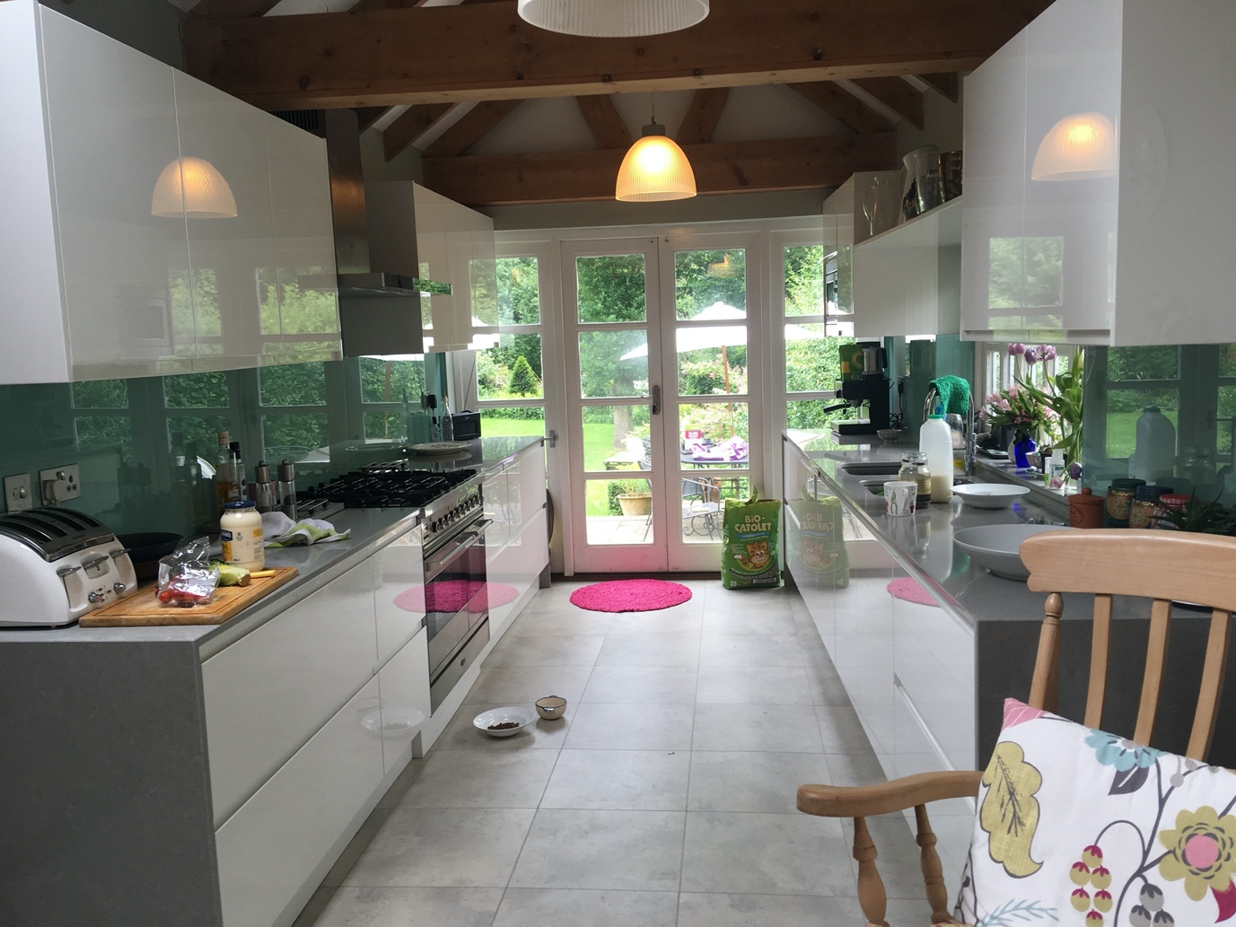

Figure 2.
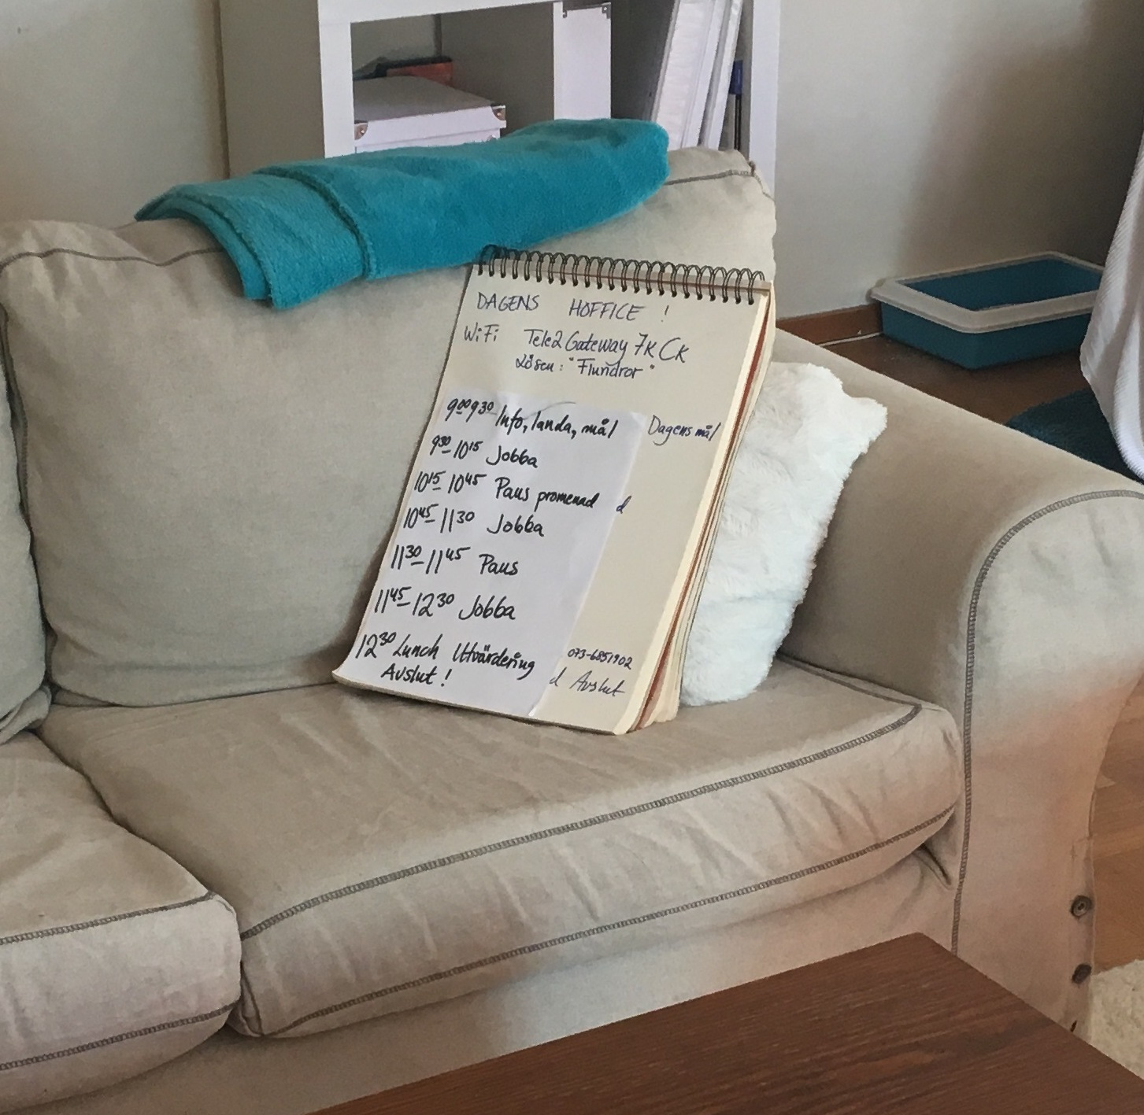

Figure 3.
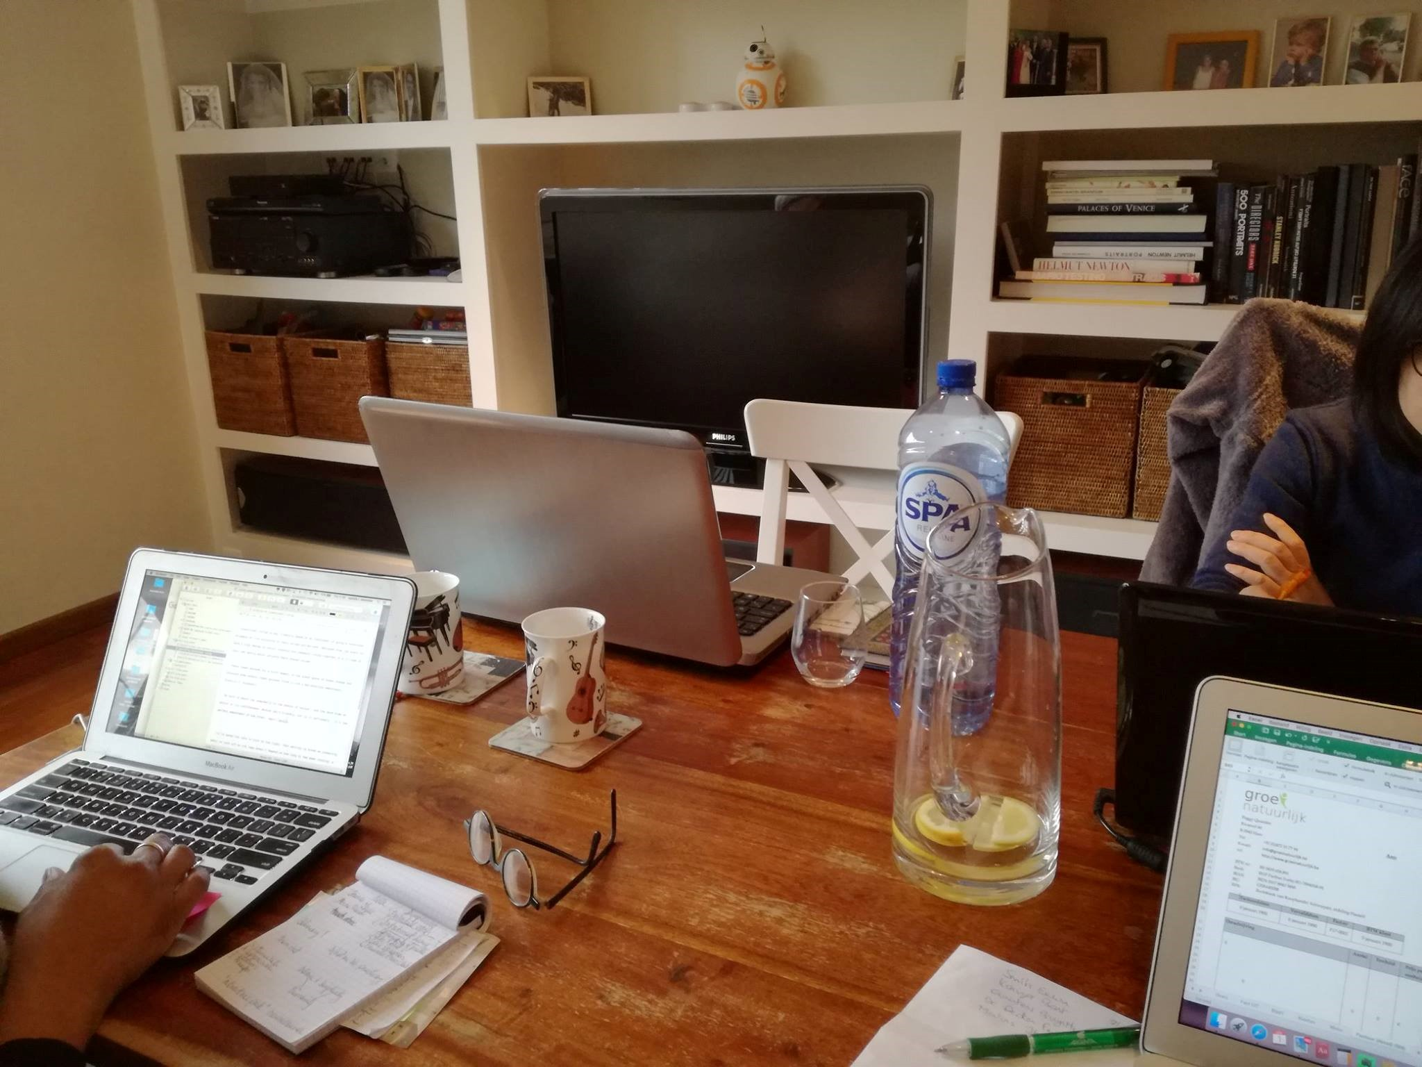

Figure 4.
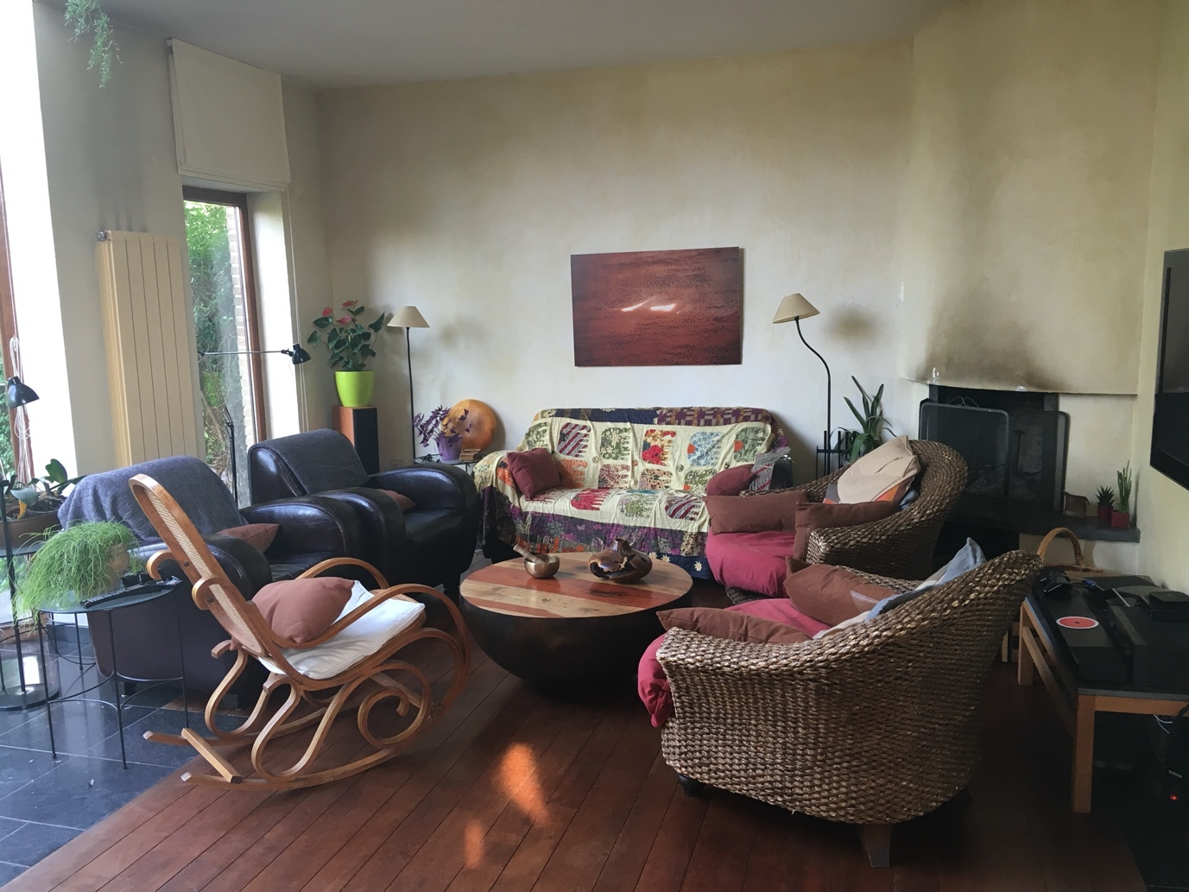

Hoffice website: http://hoffice.nu/en/find-or-start-a-hoffice-group/ (accessed on 22 December 2020)
http://hoffice.nu
We used Google Maps for analytical purposes but cannot publish a map because of risk of disclosure.

