**Title**

The influence of natural fire and cultural practices on island ecosystems: insights from a 4800 year record from Gran Canaria, Canary Islands

**Short running title: A 4800-year palaeoecological record from Gran Canaria**

Cesare Ravazzi1*, Michela Mariani1,2, Constantino Criado3, Lorena Garozzo1, Agustín Naranjo-Cigala4, Francisco J. Perez-Torrado5, Roberta Pini1, Alejandro Rodriguez-Gonzalez5, Sandra Nogué6, Robert J. Whittaker7,8, José María Fernández-Palacios9, Lea de Nascimento9

1 National Research Council of Italy, Institute of Environmental Geology and Geoengineering, Laboratory of Palynology and Palaeoecology, Piazza della Scienza 1, 20126 Milano, Italy

2 School of Geography, University of Nottingham, Nottingham, NG7 2RD, United Kingdom

3 Department of Geography and History, Facultad de Humanidades, Universidad de La Laguna (ULL), Campus de Guajara, 38200 La Laguna, Canary Islands, Spain

4 Department of Geography, University of Las Palmas de Gran Canaria, Calle Pérez del Toro, 1, 35003 Las Palmas de Gran Canaria, Spain

5 Instituto de Estudios Ambientales y Recursos Naturales (i-UNAT), Universidad de Las Palmas de Gran Canaria (ULPGC), 35017 Las Palmas de Gran Canaria, Spain

6 School of Geography and Environmental Science, University of Southampton, Southampton, SO17 1BJ, United Kingdom

7 School of Geography and the Environment, University of Oxford, South Parks Road, Oxford, OX1 3QY, United Kingdom

8 Center for Macroecology, Evolution and Climate, GLOBE Institute, University of Copenhagen, Universitetsparken 15, DK-2100 Copenhagen Ø, Denmark

9 Island Ecology and Biogeography Group, Instituto Universitario de Enfermedades Tropicales y Salud Pública de Canarias (IUETSPC), Universidad de La Laguna (ULL), Avda. Astrofísico Francisco Sánchez s/n, 38200 La Laguna, Canary Islands, Spain

* Correspondence: National Research Council of Italy, Institute of Environmental Geology and Geoengineering, Piazza della Scienza 1, 20126 Milano, Italy.

E-mail: cesare.ravazzi@cnr.it

**Acknowledgements**

This research has been funded by the Spanish Ministry of Economy and Competitiveness project CGL2012-39369, led by JMFP. The Short Term Mobility Program 2013-2014 (C.N.R. of Italy) supported C.R.’s visits to the University of La Laguna and University of Las Palmas de Gran Canaria. Thanks are due to Jardín Botánico Canario “Viera y Clavijo” – Unidad Asociada Centro Superior de Investigaciones Científicas (Cabildo de Gran Canaria), in particular the director Juli Caujapé-Castells, the herbarium curator, Águedo Marrero, and the leader of the reproductive biology group, Julia Pérez de Paz, for the detailed information about the modern flora and the pollen flora of Gran Canaria; to Patrizio Daina (Museum of Natural Sciences of Bergamo), for help during the field work; to Maria Antonia Serge (Laboratory of Palynology, CNR Milano), who made available unpublished modern analogues from moss polsters in Gran Canaria; to the technical staff of Estudios del Terreno S.L., for the drilling work; to the enterprise EMALSA for access to the site, and the Servicio de Medio Ambiente, Cabildo de Gran Canaria for permission to work at the Natural Special Reserve of Los Marteles, and especially to the Environmental Agent Roque López. The constructive comments by the reviewers W. Gosling and G. Jiménez-Moreno were greatly appreciated.

**Data accessibility**

The data that support the findings of this study are being uploaded onto the openly available Neotoma Palaeoecology Database at [https://www.neotomadb.org/]. Data can also be accessed through request to the corresponding author.

**Abstract**

**Aim:** Long-term ecological data provide a stepped frame of island ecosystem transformation after successive waves of human colonization, essential to determine conservation and management baselines. However, the timing and ecological impact of initial human settlement on many islands is still poorly known. Here we report analyses from a 4800-year sedimentary sequence from Gran Canaria (Canary Islands), with the goal ofdisentangling forest responses to natural fire from early human pressure on the island.

**Location:** La Calderilla, a volcanic maar caldera at 1770 m a.s.l. on Gran Canaria.

**Taxon:** plants and fungi.

**Methods:** A core from the caldera infill was analysed for sediment properties, pollen, micro- and macrocharcoal, with radiocarbon and biochronology dating. Fossil data were statistically zoned and interpreted with the help of cross-correlation and ordination analyses. Surface samples and a pollen–vegetation training set were used as modern analogues for vegetation reconstruction.

**Results:** Before human settlement (4800–2000 cal. yr bp), pine (*Pinus canariensis*) pollen dominated. Extensive dry pine forests characterised the highlands, although with temporary declining phases, followed by prompt (sub-centennial scale) recovery. Towards 2280 cal. yr bp there was a shift to open vegetation, marked by an increase in coprophilous spores. Coincidental with independent evidence of human settlement in the pine belt (2000–470 cal. yr bp) there was a decline of pine and a peak in charcoal. Following historic settlement (470–0 cal. yr bp), pollen producers from anthropogenic habitats, secondary vegetation and coprophilous fungi increased in abundance, reflecting higher pressure of animal husbandry and farming. Modern moss polsters reflect extensive reforestation since 1950 ce (Common Era).

**Main conclusions:** From 4800 cal. yr bp, the pristine vegetation covering the Gran Canaria highlands was a mosaic of dry pine forests and open vegetation. The pine forests sustained intense fires, which may well have promoted habitat diversity. Human interference was initiated around 2280 cal. yr bp probably by recurrent cultural firing and animal husbandry, triggering a steady trend of forest withdrawal and expansion of grasses and scrubs, until the final disappearance of the pine forest locally in the 20th century. Grasslands were found to be of ancient cultural origin in the summit areas of Gran Canaria, although they underwent an expansion after the Castilian Conquest.

**Keywords:** ancient grasslands, fire ecology, forest disturbance, human impact, island ecology, palaeoecology, *Pinus canariensis*, reforestation.

**Main text**

**1 Introduction**

Evidence of vegetation changes, as testified by sedimentary archives, has been used to detect signals of human settlement, climate change and to assess their impact on ecosystems (Willis and Birks, 2006; Whitlock, Colombaroli, Conedera & Tinner, 2017). One of the most promising research strategies for disentangling human from natural disturbances is a synoptic comparison of long-term ecosystem dynamics in oceanic islands (Connor et al., 2012). Because of their isolation, small area, strong elevational and climate gradients, and recent human colonization, oceanic islands offer a laboratory to reconstruct natural environments and to study the ecological consequences of human impact over the recent millennia (Nogué et al., 2017).

In the Canary Islands (Fig. 1a), analysis of long-term environmental change, e.g. the impact by volcanic activity and by climate change, and their interactions with the human history have been hampered by a paucity of well-preserved fossil archives (Anderson et al., 2009) and by poorly constrained archaeological record. In particular, the timing and circumstances of human colonization remain the subject of considerable uncertainty. An emerging view, supported by an array of evidence (archaeological, palaeontological, palaeoecological), places colonization towards the end of the first millennium bce (Atoche, 2008; Rando, Alcover, Galván & Navarro, 2014; Velasco et al., 2019; de Nascimento et al., 2020).

Recent palaeoecological analysis of sedimentary cores from three sites in Tenerife, La Gomera and Gran Canaria, have provided first insights into the vegetation history of the last 9000 years. The three sites are located on the mid-elevational belt (600 to 1250 m a.s.l.) and thus mostly featuring pollen types characteristic of the laurel forest and elements of the thermophilous woodland belt. The forest history recorded in the La Laguna basin in the humid belt of North Tenerife (Fig. 1b) highlighted a pre-anthropic laurel-dominated forest phase (de Nascimento, Willis, Fernández-Palacios, Criado & Whittaker, 2009). The onset of aboriginal disturbance at about 2000 cal. yr bp deeply impacted the forest ecosystems, well before the Castilian conquest in the 15th Century. An early aboriginal impact over dominant vegetation also emerged from our previously reported pollen sequence from Gran Canaria. The mid-elevation caldera sediments of Laguna de Valleseco (Fig. 1b) recorded a first change in vegetation 2300 years ago and reveal cereal fields as early as 1800 years ago (de Nascimento et al., 2016). The only pollen record extending as far back as the early Holocene is from a pond in the humid watersheds of La Gomera (Fig. 1b; Nogué, de Nascimento, Fernández-Palacios, Whittaker & Willis, 2013), showing 9600 years of climate change and vegetation dynamics. In that (comparatively) high-elevation sequence, a mid-Holocene climate change was indicated by a decrease in the hygrophilous *Phoenix-Salix* groves and an expansion of the *Morella-Erica* woody heath. At that site, there was no direct evidence of human-induced changes in the forest composition or of human-introduced plants.

Overall, fire evidence and other forest clearance proxies from the three islands is consistent with the onset of human impacts between 2300–1800 cal. yr bp. Archaeological and historical data suggests that between the 10th and 15th century ce the aboriginal population grew, settlement expanded and land use changed (Morales et al., 2009). The Castilian conquest (1402–1496 years ce) and the subsequent European acculturation are known to have had disruptive and immediate effects on forest ecosystems in most Canary Islands (Quirantes, Núñez, García & Viña, 2011; Santana, 2001).

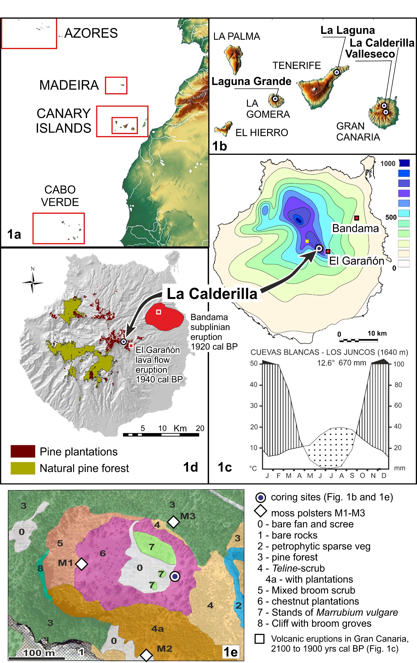

Figure 1 (a-b) Geographic position of the Canary Islands and location of palaeoecological sites mentioned in the text. (c) Average rainfall contour lines of Gran Canaria (mm year-1) for the 1949/50–2005/06 period (CIA, 2015) and climate diagram from Cuevas Blancas - Los Juncos in the most recent thirty years (1981–2012), nearby to La Calderilla (Gran Canaria) (AEMET, 2012). (d) Modern distribution of pine forest in Gran Canaria (del Arco et al., 2006); in red, areas affected by Bandama pyroclastic deposits, 1920 cal. yr bp (median probability), and by El Garañón lava flow, 1940 cal. yr bp (median probability) (Rodriguez-Gonzalez et al., 2009). (e) Detailed physiognomic vegetation map of La Calderilla (original).

In this paper we complement these research studies with a high-elevation site to analyse how pine forest responded to past environmental change. Our record extends up to the last sixty years of landscape change, allowing the comparison of vegetation changes in Canarian prehistory, post-Castilian conquest and up to very recent landscape dynamics. A view of the highland landscape in the Canary Islands in 1950 ce would have placed, at the upper timberline limit (2400 m a.s.l., Höllermann, 1978; timberline terminology according to Holtmeier, 2009), a wide range of open vegetation types. These include summit scrub, pachycaul herbs and dwarf shrubs forming petrophytic semi-deserts (del Arco et al., 2006) and grasslands, the latter especially developed in Gran Canaria, although its maximum elevation (1949 m a.s.l.) stands below the timberline ecotone. Geologic events (volcanic eruptions) and anthropic impacts, and consequent increased soil drought (Gieger & Leuschner, 2004), lowered the timberline, replacing pine and juniper by shrubby legumes or by grassland pastures. The usual narrative assumes that human-induced timberline depression began with the Castilian conquest (1478-1483 years ce in Gran Canaria), with pine forest exploitation and burning for fuel, tar for ship, livestock and crop husbandry, intensifying during the 16–17th centuries (Pérez de Paz et al., 1994; Viera y Clavijo, 1790) and resulting in the traditional treeless highland photographs of the 1940s. Reconstructions based on historical documentation in Gran Canaria suggest that, before the Castilian conquest, human interference was not intense (Santana, 2001). We present the first long-term record from the upper forest belt through an integrated palaeoecological analysis of the pine forest timberline ecotone with high elevation grasslands for the last 4800 years. We discuss driving factors such as human impact and volcanic activity, approaching a synoptic view with the other recently published records from the Canaries.

**2 Material and methods**

**2.1 Ecogeographical setting of Gran Canaria highlands**

Gran Canaria is the third largest Canary Island in area (1561 km2), reaching 1949 m a.s.l. (Pico de las Nieves). North-eastern ravines, with more than 400 mm year rainfall (Fig. 1c), host the remnants of a laurel forest belt and of thermophilous woodlands, but also xerophytic formations featuring *Dracaena* and groves of *Phoenix* and *Salix* (del Arco et al., 2006). The western and southern flanks preserve the best remnants of open pine forests (400–1500 m) (Fig. 1d), extending above a semi-desert lowland scrub. At the beginning of the 20th century, pine forest reached up the summit in only two locations (Tamadaba, top at 1444 m and Inagua, 1498 m), while most highlands were occupied by grasslands and scrub formed by endemic shrubs and bush legumes (*Teline microphylla* (DC.) P.E. Gibbs & Dingwall and *Adenocarpus foliolosus* (Aiton) DC.) (Naranjo-Cigala, 1995; Naranjo-Cigala, Salas & Almeida, 2001). A reforestation program, started in the 1950s, promoted pine plantations, which now occupy most of the highlands (Fig. 1d). The scrub characteristic of Tenerife and La Palma summits (Fernández-Palacios & de Nicolás, 1995) is missing in Gran Canaria, although several shrubs of diverse Canarian genera (e.g. *Argyranthemum*, *Sideritis, Erysimum, Echium* and *Pterocephalus*) characterize rocky habitats in its timberline ecotone (Naranjo-Cigala, 1992).

**2.2 Geological history and ecological setting of the volcanic complex of La Calderilla**

The volcanic complex of La Calderilla, originated around 88±5 ka (Guillou et al., 2004), was one of the last basaltic eruptions on Gran Canaria preceding the Holocene reactivation. It is composed of a phreatomagmatic maar (200 m in diameter, extending down to 1770 m a.s.l.), and a strombolian cone growing in its ESE flank. The sedimentary infill of the caldera formed during the Late Pleistocene and the Holocene, and accumulated to a depth of 14 m on the NE side (see Appendix S1 in Supporting Information). The most recent sedimentation has been generated by an alluvial fan, and by slope deposits mantling all the inner caldera slopes, including organic-rich andosols and their colluvial reworked products.

Mean annual precipitation in the last thirty years is estimated at 670 mm (Fig. 1c); the mean annual temperature being 12.6 °C. The vegetation today is dominated by planted *Pinus canariensis* C. Sm*.*, bush legumes (*Teline microphylla* and *Adenocarpus foliolosus*), and a petrophytic scrub formed by nanophanerophytes and chamaephytes (*Argyranthemum*, *Sideritis*, *Erysimum*, *Pterocephalus*) (Fig. 1e). The caldera bottom is occupied by therophytes, partly non-native herbs. Individuals of *Castanea* and *Malus* were planted in the 1950s. More chestnut trees and pine plantations occur outside the volcanic complex (del Arco et al., 2006), while on well-developed soils a few grassland patches merge with scrubby vegetation dominated by leguminous shrubs (Naranjo-Cigala, 1995).

**2.3 Sampling, dating and analysing**

In May 2013 we retrieved an 8.7 m sediment core by technical drilling (CAL1, Fig. 2, Appendix S1). The sedimentary sequence down to 6.3 m was sampled for geochemical (170 samples), sedimentological (30), palynological (55) and charcoal (55) analysis.

Thermogravimetric loss-on-ignition was determined on 1g sediment sample with an automated LECO TGA 601 analyser through four heating steps (in parentheses the parameter obtained): 105 °C (water content), and, in % over the dry height: 375 °C (non-pyrogenetic organic matter), 550 °C (total organic matter and sulphides, TOM), 980 °C (carbonates) and the residue (silicate rock fragments and oxides).

Seven samples of bulk sediment and charcoal were radiocarbon dated at the 14CHRONO Center at Queen’s University Belfast and Beta Analytic (Appendix S1, Table S1.1). Calibration was performed using the Intcal13 calibration dataset (Reimer et al., 2013). Geochronometric dating, independent biochronological markers and other stratigraphic tools (Appendix S1) served to constrain the age-depth model solutions, calculated using OxCal 4.2 (Bronk Ramsey, 2008). The biochronological evidence is presented in Table 1 and discussed in section 4.1.

Pollen extraction (1 cm3 sediment samples) followed chemical treatment, micro-filtration and acetolysis. *Lycopodium* spore tablets were added to calculate pollen and microcharcoal concentrations. At least 500 pollen grains for each sample have been identified, except for rare samples with poor concentrations. Ferns, green algae and fungal spores indicative of animal husbandry were also analysed (Appendix S2). Poaceae pollen grain size was measured, to detect evidence of grass crops introduced in the Canaries.

Percentage pollen diagrams were drawn in Tilia 1.7.16. Pollen zonation was obtained by a constrained incremental sum of squares cluster analysis, using Cavalli-Sforza's chord distance as the dissimilarity coefficient (package CONISS, Grimm, 1987).

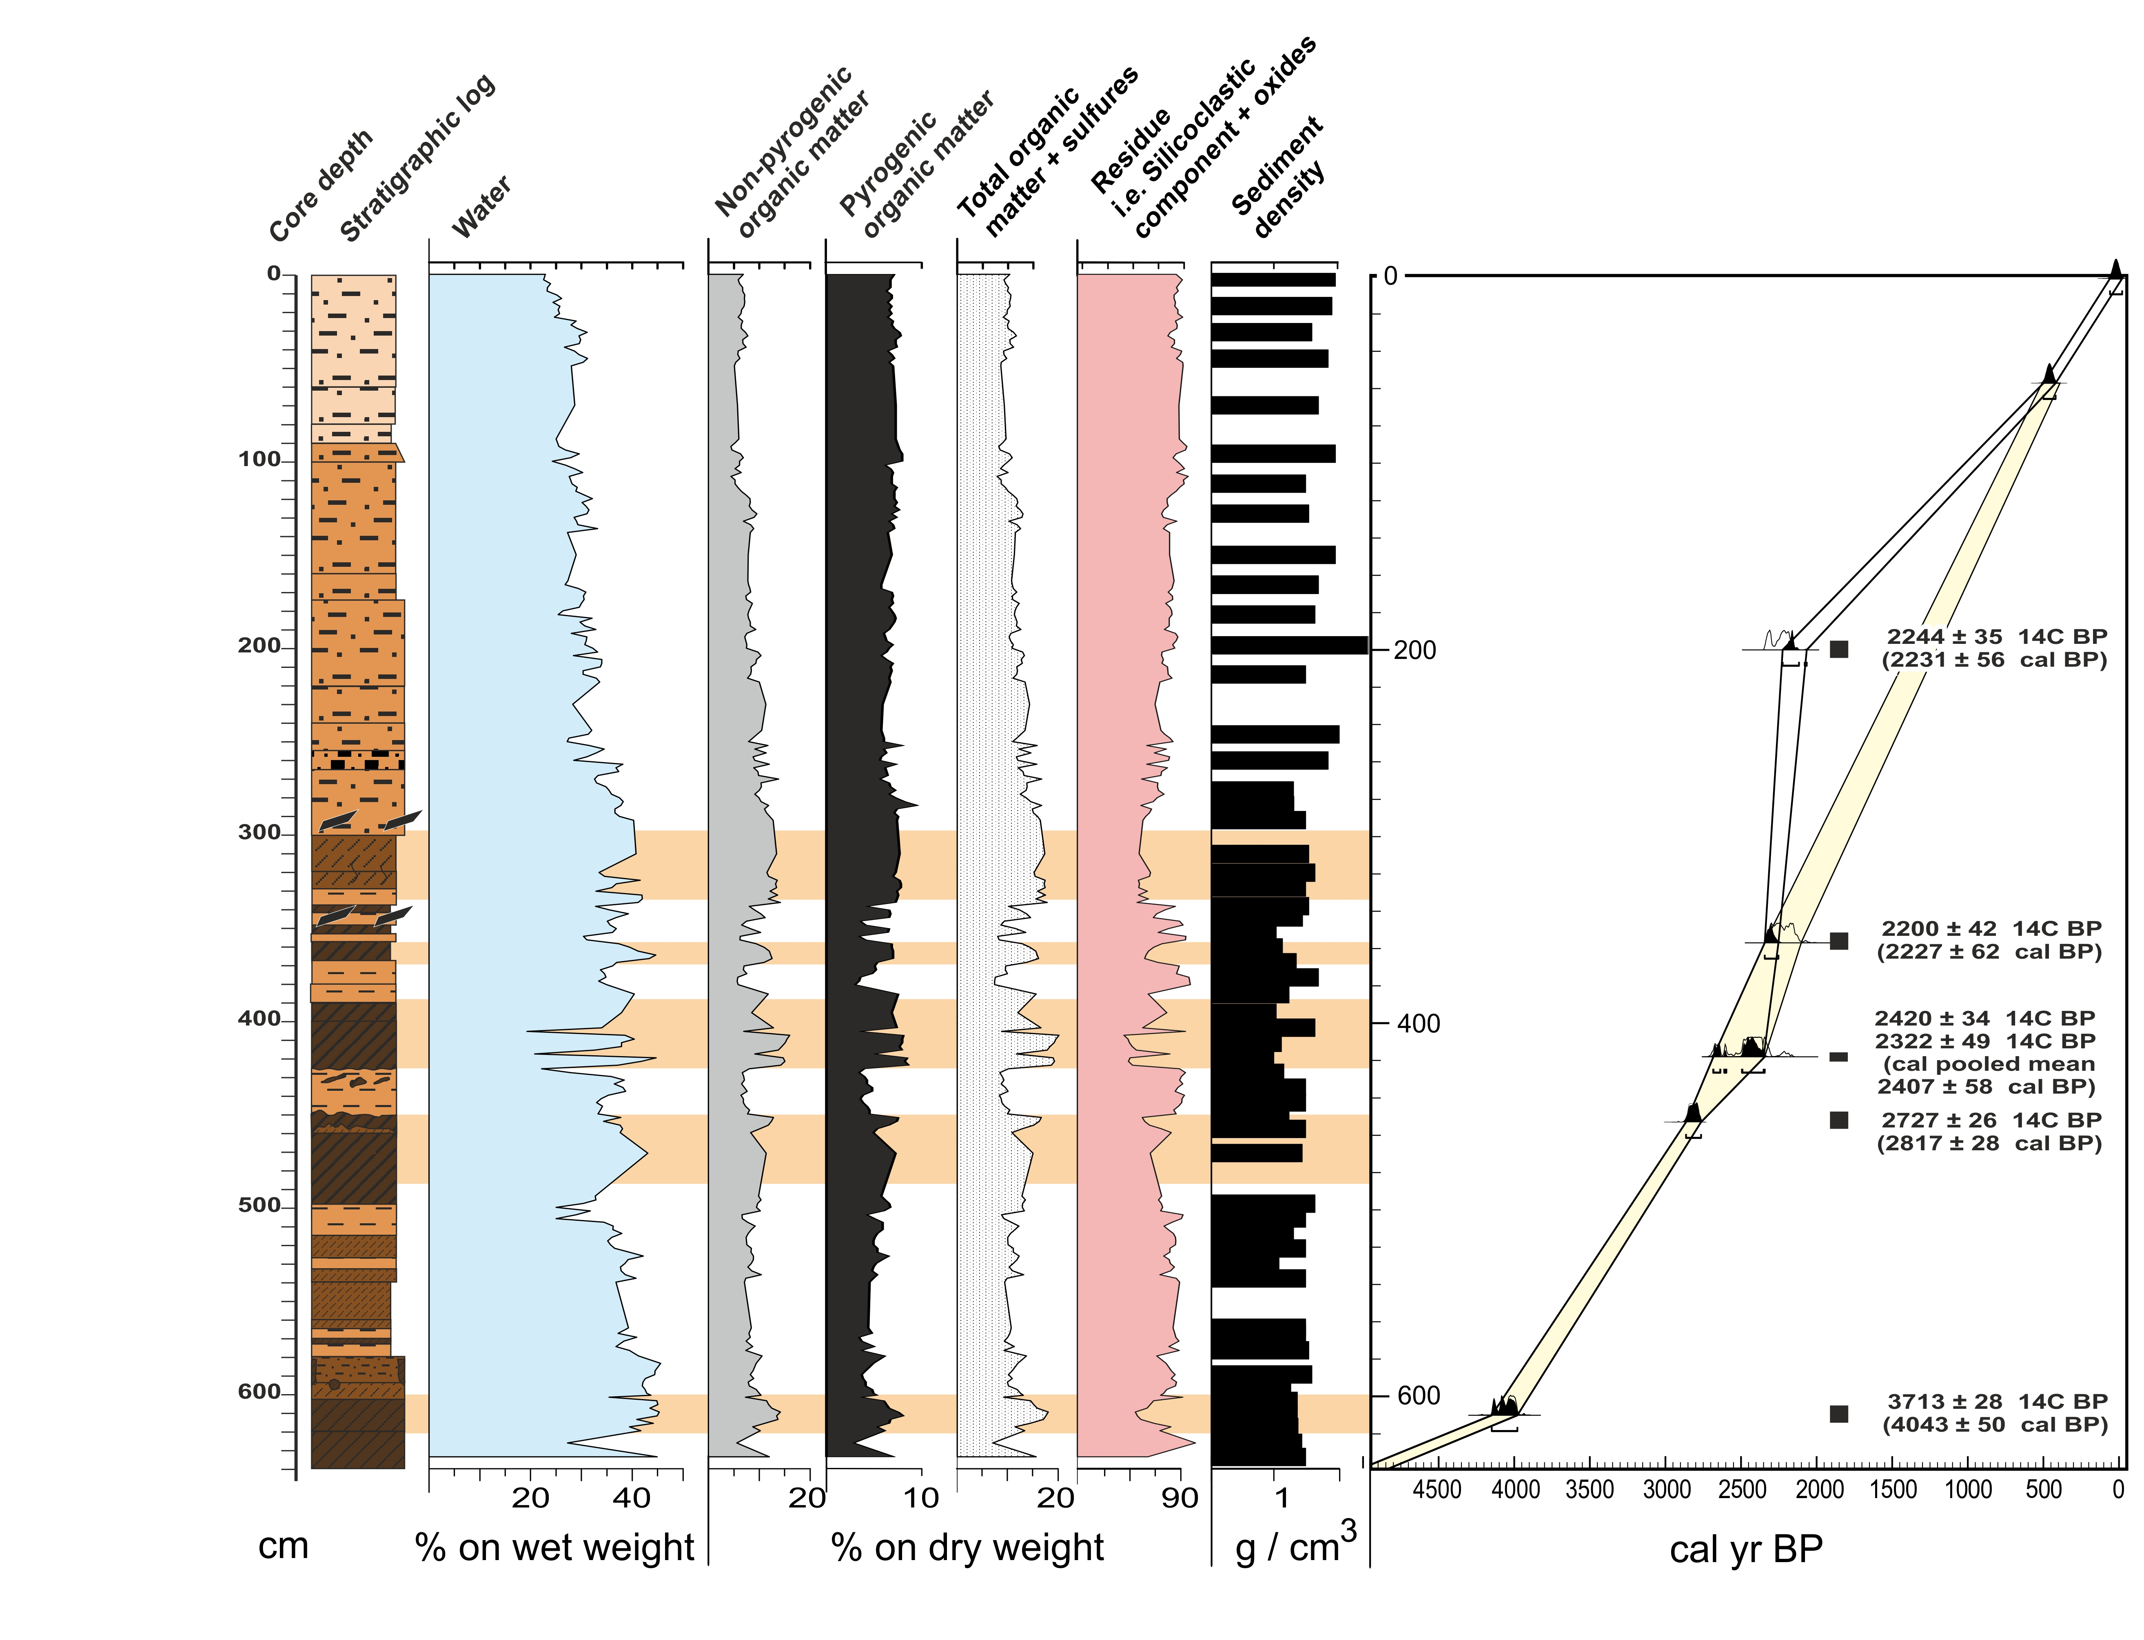A recent training set for pollen rain-vegetation calibration sampled in Tenerife (de Nascimento et al., 2015), coupled with moss polsters and vegetation data obtained at the studied site, was used to adjust pollen signals to modern vegetation and to evaluate changes that affected highland ecosystems in Gran Canaria (Appendix S3).

Figure 2 The studied core section CAL1 (La Calderilla, Gran Canaria) spanning the last 4800 years. Sedimentary log, thermogravimetric proxies and age–depth model. Dark horizontal banding highlights intervals of pyrogenetic organic matter, appearing as dark layers in the log. Most important dark layers also correspond to intervals of accumulation of charcoal fragments sized over 10 µm (see Fig. 3). The adopted age–depth model solution is shown by the yellow envelope. Refer to Appendix S1, for details on age–depth model and for the key to the lithological patterns.

Microcharcoal fragments (size-classes 10–50 and 50–150 μm) and coprophilous spores were counted during routine pollen analysis. Macrocharcoal fragments between 150 µm and 1 mm and > 1 mm were wet sieved from sediment samples (1 cm3) and counted under a stereomicroscope.

To check similarities between percentage pollen data of *Pinus canariensis* and macrocharcoal data series and to detect positive/negative/lead/lag relationships between them, we computed the cross-correlation function of the two time series using the software MYSTAT 12 (Systat Software Inc., CA, USA). In order to avoid non-stationarities and minimise the problem of unstable sedimentation rate, we computed offsets in distance between samples using short series, centred on charcoal accumulation events (Fig. 4). To analyse the temporally variable strength of the relationship between the same data series, Pearson correlation values (r) were obtained using a 10-interval moving-correlation (Fig. 7) using MS Excel.

The major compositional changes within fossil dataset and between fossil and modern surface samples were assessed with principal components analysis (PCA). Ordinations were carried out with PC ORD 4.2. To reduce asymmetry in the pollen dataset, square root transformation and range normalisation were performed before running the PCAs.

To compare palaeoecological results from La Calderilla with evidence of human occupation derived from the archaeological record, we compiled 253 radiocarbon ages from pre-Castilian archaeological sites (see Appendix S4) into a summed probability density function using OxCal 4.2.

**3 RESULTS**

**3.1 The caldera infill and chronology**

The lowermost section of the core (870–650 cm) is made up of slope deposits and associated andosols, incorporating abundant woody charcoal, formed on the wall of the strombolian cone. In the middle segment (650–290 cm) andosols are embedded with silty layers deposited after sheet flows. These fine silts form the complete uppermost caldera infill (290–0 cm). No true pyroclastic falls were noticed throughout the entire sequence; only sedimentary layers from reworked pyroclastic deposits occur (Fig. 2, Fig. S1.1).

Seven radiocarbon dates were obtained from bulk samples rich in charcoal particles, from dark soils and silty layers (Appendix S1, Table S1.1). Given that organic carbon consists mostly of charcoal (Fig. 2), without aquatic vegetation, no reservoir effect is expected for these 14C measurements. However, an overlap between the two uppermost ages is suspect, as they are separated by regular, partly laminated, fine sedimentation (Fig. 2). Reworking of charcoal particles most likely occurred in the uppermost interval, after the level of local charcoal accumulation event F4 (see section 3.4) dated 2200 ± 42 14C yr bp. Hence input of secondary “old” charcoal in the upper 350 cm makes 14C ages unreliable. An increase in pollen of cultural indicators allowed identification of the Castilian conquest of Gran Canaria (1478–1483 ce) in the sedimentary record matching the 57 cm depth statistical boundary. This biostratigraphic marker has been included in the final age-depth model, while the core top was given an age of 0 cal. yr bp on the base of its pollen content (Fig. 2, Appendix S3).

**3.2 Modern vegetation - pollen rain**

The pollen composition of moss polsters from the caldera rim and bottom (Fig. 1e) records the dominance (Appendix S3) by the main pollen producers currently widespread in the area (*Pinus, Castanea*, Brassicaceae*,* Asteraceae*, Teline*). We observed relationships between pollen rain and plants occurring within the caldera rim (diameter 160–220 m), which will be assumed as the relevant pollen source area. Important pollen producers from lower vegetation belts (*Artemisia, Quercus, Morella*) occur with low frequencies. The main anthropogenic pollen producers include *Artemisia*, Brassicaceae, Polygonaceae and Chenopodiaceae. The pollen composition of moss polsters displayed marked differences from the core top samples (Appendix S3, Fig. S3.5), pointing to large-scale vegetation cover changes in recent years.

**3.3 The long-term charcoal record**

The gravimetric percentage of pyrogenetic organic matter (3 ± 0.7%) over Total Organic Matter, TOM (12.1 ± 2.8%) (Fig. 2) indicates a significant and persistently high charcoal contribution to TOM. Peaks of macrocharcoal occur in zones Z1–Z4 (Fig. 3). The abundance of particles > 1 mm in these layers indicates local forest fires at a maximum distance of 100 m from fire margin for particles aerially transported (Ohlson & Tryterud, 2000). Considering the small size of the caldera watershed, slopewash and floods cannot have carried macrocharcoal from further distances.

The most prominent macrocharcoal accumulation events (Fig. 3) are: F1 (620–600 cm), F2 (498–450 cm), F3 (420–397 cm), F4 (340–320 cm) and F5 (276–240 cm). F1–F3 appear to correlate with temporary, coeval declines of pine pollen percentages, but only the F3 correlation values are significant. Decline is followed by a prompt recovery. The F4 event shows a strong correlation with the declining pine trend, without later recovery; finally, in F5, macrocharcoal and pine pollen do not show any significant correlation (Fig. 4). The highest charcoal peaks F4–F5 are lagged by a pronounced stratigraphic tail (320–214 cm), which includes pyrophytic fungi (*Gelasinospora*). The observed pattern fits the typical sequence of primary-to-detrital charcoal deposition caused by a local fire, starting with immediate charcoal input by direct fall-out, followed by microbiological decay of litter charcoal and by a secondary input of detrital charcoal driven by runoff (e.g. Colombaroli & Gavin, 2010). The prompt pine recovery after events F1–F3 represents novel fossil evidence for the Canarian pine forest’s known resilience to fire. But the missing recovery after event F4, enhancing runoff and protracting secondary deposition is intriguing.

Macrocharcoal input decreased in zones Z5 and Z6 to below 200 particles/cm3, mirrored by a further decline of pine pollen below 40% (Fig. 4). This may indicate limited fuel availability and further pine contraction in the local watershed. Persistently high microcharcoal supply can likely be linked to background secondary deposition and / or to regional fires.

Figure 3 Pollen diagram and record of other palaeoecological proxies from core CAL1 (La Calderilla, Gran Canaria) against age (cal. yr bp) and depth (cm). Data are expressed in percentage unless otherwise stated. The biostratigraphic discriminant cluster of taxa distinguishing zone Z6 was separated at the right side of the upper panel. These latter taxa include pollen types obtained by constrained clustering together with other palynomorphs also discriminant for zone Z6 (*Sporormiella*). Continuation in lower panel: sporadic pollen taxa (i.e. pollen types with average abundance below 2%), pollen zonation, charcoal proxies and charcoal events F1-F5.

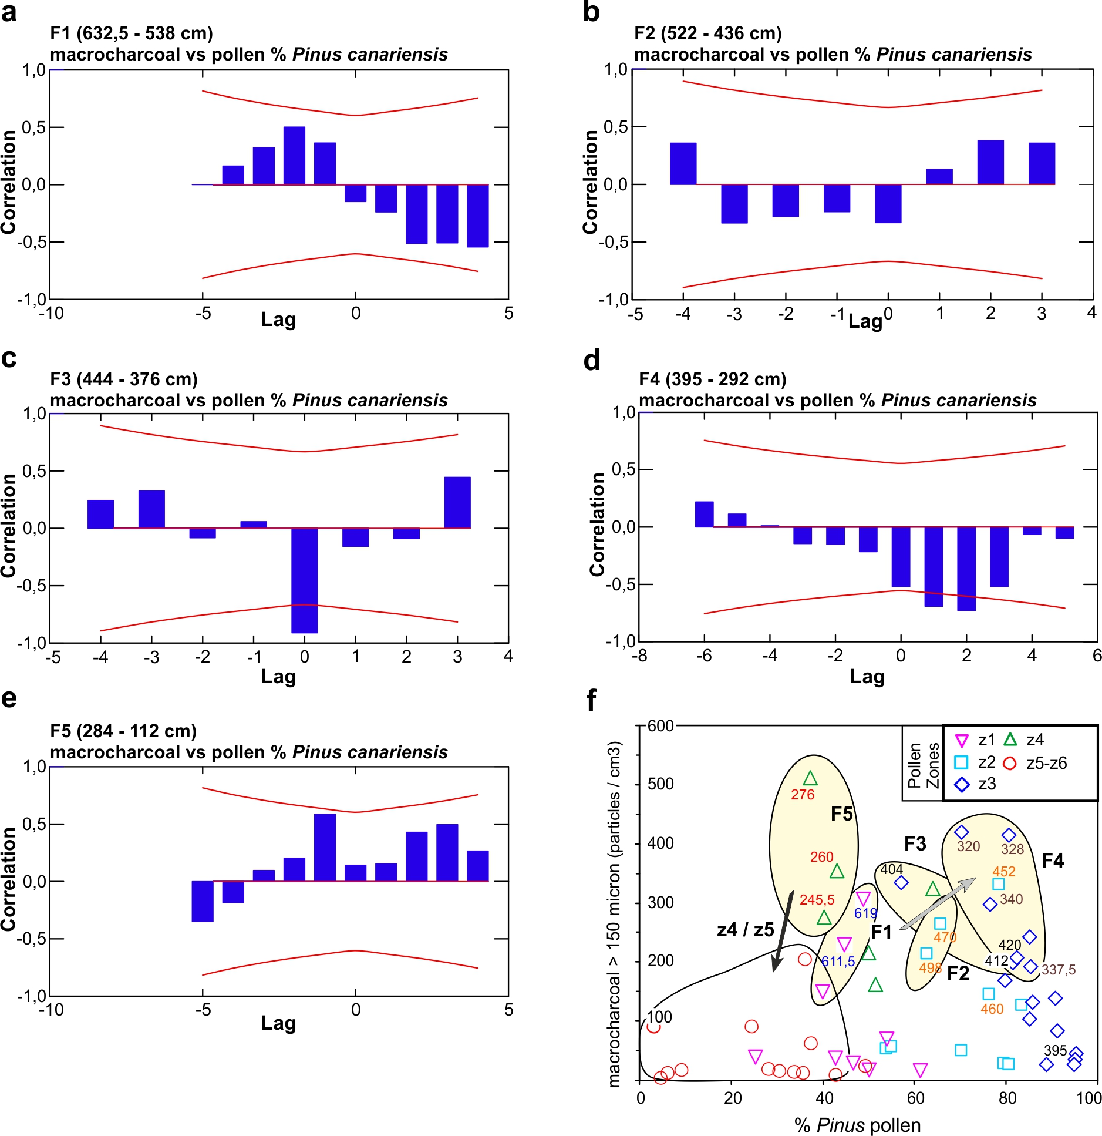

Figure 4 (a-e) Correlograms showing correlation between macrocharcoal abundance and pine pollen percentage at reduced time windows from core CAL1 (La Calderilla, Gran Canaria). Significance levels (*r* ≥ 0.5) are indicated by red lines. (f) Pine pollen abundance versus macrocharcoal concentration (particles / cm3). F1 to F5 main fire events (see Fig. 3). Notice the progression of *Pinus* percentage levels from events F1 to F4 (grey arrow); a pollen decline from F4 to F5, and the subsequent drop of macrocharcoal abundance at 40% pine pollen (black arrow), marking the transition between pollen zone Z4 and Z5. Sample labels are stratigraphic depths.

**3.4 The pollen record**

The pollen record (Fig. 3) is clustered in six pollen zones grouped into two major stratigraphic biozones (Table 1): the lower one (Z1–Z3, 4800–2000 cal. yr bp) characterized by high abundance of pine pollen with several oscillations; and the upper super-zone (Z4–Z6, 2000–0 cal. yr bp), with reduced pine and high proportion of Poaceae and Asteraceae pollen. A sharp transition at 337–318 cm (2300–2000 cal. yr bp), coeval to fire event F4, separates both groups. The transition interval is clustered in zone Z3.

|  |  |  |  |  |  |
| --- | --- | --- | --- | --- | --- |
| **Interval / Pollen Zone** | **Time Span** | **Pollen and NPP Types** | **AP**  **%** | **Vegetation Changes** | **Affecting Factors**  **(→ Possible Concurrent Triggers)** |
| Recent pollen deposition | Last 60 yrs | *Pinus canariensis* (48%, minimum = 40%), *Castanea sativa* (12%), Brassicaceae (14%), *Sporormiella,* Sordariaceae | **55** | Planted pine forest and secondary legume scrublands | Fire suppression, reforestation,  pasture abandoning |
| Z6 (57–0 cm) | 470–0 | Cichorioideae (30%), Brassicaceae (25%), Poaceae (20%), Fabaceae (<10%), *Sporormiella, Pinus canariensis* (6%, minimum 3%), Sordariaceae | **<10** | Pastures and shrublands. Timberline depression | Human caused fires, timber cutting, animal husbandry |
| Z5 (225–57 cm) | 1405–470 | *Pinus canariensis* (35%, minimum = 24%), Poaceae (30%), Cichorioideae (25%), Brassicaceae (5%), Sordariaceae | **35** | Residual open forest, scrubs, grasslands, petrophytic open vegetation | Human caused fires, timber cutting, animal husbandry |
| Z4 (318–225 cm) | 1997–1405 | *Pinus canariensis* (50%, mínimum = 37%), Poaceae (25%), Cichorioideae (20%), Sordariaceae | **50** | Forest withdrawal, shift towards open pine forest,  soil erosion | Human caused fires, timber cutting? animal husbandry  (**→** persistent climate drought?) |
| Z3 upper  (376–318 cm) | 2281–1997 | *Pinus canariensis* (85%, mínimum = 60%), Cichorioideae (5%), Poaceae (<10%) Sordariaceae | **80** | Signs of declining pine forest, early perturbation of the timberline ecotone | Intense fires  (**→** human caused), animal husbandry |
| Z3 lower  (447–357 cm) | 2746–2281 | *Pinus canariensis* (85%, mínimum = 60%), Cichorioideae (5%), Poaceae (<10%), *Glomus* | **85** | Dry pine forest full density | Wildfires  (**→** volcanic activity 1.9–2.1 ka?), human arrival in Gran Canaria |
| Z2 (567–447 cm) | 3705–2746 | *Pinus canariensis* (70%, mínimum = 55%), Cichorioideae (12%), Poaceae (<10%), *Glomus* | **70** | Dry pine forest canopy density oscillating | Wildfires  (**→** volcanic activity  3.3–2.3 ka ?) |
| Z1 (638–567 cm) | 4760–3705 | *Pinus canariensis* (45%, mínimum = 25%), Cichorioideae (35%), Poaceae (10%), *Glomus* | **45** | Post-fire open dry pine forest with scrubs and grasslands | Wildfires  (**→** volcanic activity between 4.7–4.5 ka ?) |

Table 1. Outline of the environmental history at La Calderilla (Gran Canaria) by pollen zone (Z1 to Z6), indicating time span (cal. yr bp, modelled medians of range limits), main pollen and non-pollen palynomorph (NPP) types (major components and ecological proxies) and percentage of arboreal pollen (AP) in the last 4800 years. Interpretation of the reconstructed vegetation changes, of intervening factors and possible triggers is summarized in the last two columns.

**3.5 Numerical analysis**

Fossil pollen and moss polster samples are shown in the PCA biplot (Fig. 5). Axis 1 (26% of variance) reflects a gradient from pristine forest cover, with *Pinus* and *Morella,* to herbs, cultivated trees, coprophilous spores and other anthropogenic indicators (*Artemisia*, Brassicaceae). Fabaceae are also associated with anthropogenic vegetation, since their pollen is absent in the pristine vegetation phase. Moss samples are plotted apart, along the second axis, adding further variance distinct from the palaeo-ecosystem signal. Moving-correlation analysis highlights significant negative correlation values between charcoal and *Pinus* pollen abundance during events of charcoal accumulation F1 (620–600 cm) and F3–F4 (420–320 cm) (Fig. 7a).

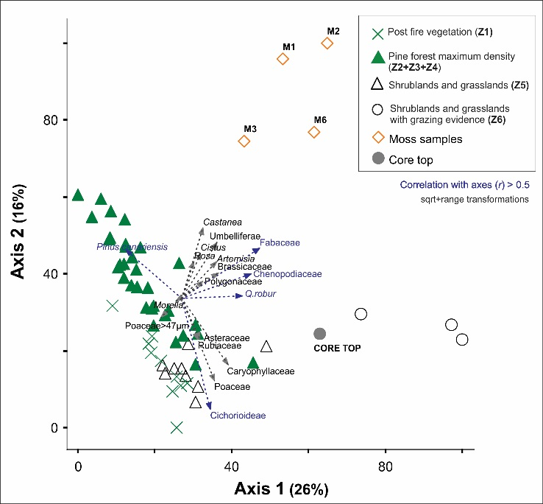

Figure 5 PCA biplot of La Calderilla (Gran Canaria) fossil and moss polsters. Taxa highlighted in blue show a significant correlation with the PCA Axes 1 and 2 (*r* > 0.5).

**4 DISCUSSION**

**4.1. Environmental reconstruction**

**Dynamics of the Canarian pine forest**

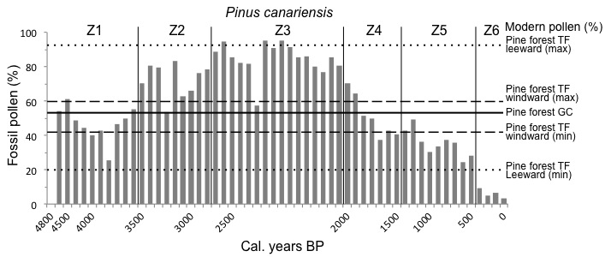The basal zone (Z1, 4800–3700 cal. yr bp) is characterized by *Pinus* and Asteraceae pollen. After the fire event F1 pine pollen decreases from 60 to 30%. These percentages, calibrated to the pollen–vegetation relationships in Tenerife pine ecosystems (de Nascimento et al., 2015) suggest relatively open pine woodland, corresponding with an average pine forest cover of 55% (Fig. 6). The high percentages and concentration peaks of Asteraceae (*Sonchus* type, *Carlina* type, *Argyranthemum* type), Poaceae, and Caryophyllaceae, likely represent the response of pioneer species to increased openness triggered by fire disturbance. Locally the site hosted an ephemeral puddle in the wet season, as shown by occurrence of *Ranunculus acris* type*, Spyrogyra* and other Zygnemataceae with low values.



Figure 6 *Pinus canariensis* pollen percentage fossil values from core CAL1 (La Calderilla, Gran Canaria, GC) compared with minimum and maximum threshold values determined in a training set of modern pollen rain from pine forest sites in Tenerife (TF) (de Nascimento et al., 2015).

The next zones (Z2, Z3, 3700–2000 cal. yr bp) record the recovery of pine forest. A high pine pollen proportion reached in zone Z3 (84%), coupled with a sharp reduction of open habitat *taxa*, and with the absence of wet pine forest indicators (*Erica, Morella*), points toward extensive dry pine forest cover. Pollen composition in modern Canarian pine forests is influenced by exposure to trade winds, with lower and less variable percentages of pine pollen typifying windward (wet) sites (Fig. 6). Thus, the observed high pine pollen values appear to indicate a dry pine forest reaching extensive cover but lower tree density. Further fire peaks (F2, F3) mark the progressive phase, coeval to temporary pollen declines of pine and increases of scrub plants. However, open vegetation maintained a significant pollen representation, suggesting that forest patches and rocky habitats kept their open structure within a mosaic landscape.

**Forest withdrawal and the emergence of grasslands**

At the Z3/Z4 boundary, a steady pine pollen decline is visible, initiated around 2280 cal. yr bp, from 80 to 35–40% and an opposing increase in Poaceae and Asteraceae, representing a shift from pine forest to more open vegetation, lasting up to recent times. This change is coeval to the main fire event F4. According to the morphometric data, only wild grasses are recorded. Medium to large-sized Poaceae pollen (40–47 µm, e.g. *Anisantha*, *Avena, Bromus, Hordeum* in the native flora) occur in low frequency. Following forest decline a shift towards small pollen-sized Poaceae suggests an expansion of wild grasses (Appendix S2, Fig. S2.4). There are no pollen indicators for cultivated fields in zones Z4–Z5, 2000–470 cal. yr bp. Nevertheless, the continuous record of Sordariaceae coprophilous spores, starting with a large peak around 2280 cal. yr bp, is indicative of animal husbandry. Sordariaceae, although sometimes occurring within forest soils, mostly grow on droppings, even at low levels of grazing pressure, replacing saprophytic fungi (Doyen & Etienne, 2016). For instance, modern mosses and soils in Gran Canaria that are occasionally visited by introduced herbivores, contain abundant Sordariaceae spores (Appendix S3, Fig. S3.5). Furthermore, this peak marks the decline of *Glomus*, an endomycorrhizal saprophytic fungus growing on organic matter, mostly restricted to earlier intervals with abundant decaying charcoal.

Overall, our findings indicated that by ca. 2280 cal. yr bp the local watershed of La Calderilla underwent an expansion of scrubs and grasslands, likely related to the introduction of animal husbandry, as corroborated by modern pollen/spores-vegetation relationships. This suggests that the emergence of open grassy vegetation in the summit landscape of Gran Canaria represents an ancient cultural landscape, not a secondary product of recent deforestation.

**Land use changes after the Castilian conquest**

The uppermost core section (Z5–Z6, 700 cal. yr bp to about 70 years ago) is marked by the appearance and expansion of *Artemisia,* Asteraceae*,* Brassicaceae, Caryophyllaceae and Fabaceae (*Teline* and *Adenocarpus* types), and by *Sporormiella* and Sordariaceae coprophilous spores (Fig. 3). There is a further decline of pine and appearance of *Quercus robur* type with very low values. The final step of pine decline in zone Z6 is unrelated to changes in charcoal, suggesting that most of the local pine population had been depleted at La Calderilla and that a regional forest reduction affected residual pine stands.

The statistical boundary Z5/Z6 at 57 cm (470 cal. yr bp) shows quantitative changes of the main pollen producers, i.e. pine and *Artemisia*, but also the expansion of wind-pollinated herbs and shrubs from ruderal habitats (*Artemisia*, *Polygonum,* Chenopodiaceae and Asteraceae), which today grow in most secondary vegetation zones of Gran Canaria, regardless of elevation. At the same time, an increase in Caryophyllaceae and Brassicaceae may be related to local weeds living today in grazed areas and on the caldera floor (Fig. 1). The evidence of animal husbandry in the caldera in the last 400 years is indicated by the increase of *Sporormiella* spores, which do not disperse far from source, being quantitative indicators of local livestock (Davis & Shafer, 2006).

The increase in anthropogenic indicators at the Z5/Z6 boundary, and its stratigraphic position, above the midpoint of the last two millennia, are consistent with land use changes and timing of the Castilian conquest and the subsequent rural development that affected Gran Canaria between 16th and the onset of 20th century ce (Naranjo-Cigala, 1995; Santana, 2001). Chestnut and walnut are absent throughout the core up to its top, dated to the 1950s or a little earlier (Appendix S3, Fig. S3.6). These trees were actually planted in the area only around the 1950s ce.

**4.2 Fire ecology and disturbance in Canarian pine forests**

The pollen and charcoal stratigraphy showed the occurrence of a pine forest in the higher areas of Gran Canaria for the past 4800 years, which changes in plant cover in response to fire.

The Canarian pine is considered to be adapted to high-intensity fires (Climent, Tapias, Pardos & Gil, 2004; Keeley & Zedler, 1998) through traits including: (1) thick bark insulating cambium; (2) epicormic resprouting; (3) serotinous cones. Tall growth habit, longevity, long needles and deep rooting add further adaptation to crown fires connected with great fuel accumulation. Modern pine forests experience both surface and crown fires, favouring understory biodiversity (Otto, García del Rey, Gil Muñoz & Fernández-Palacios, 2010), but the natural fire return interval is significantly longer than the estimated time of recovery (13 years) for natural stands of pine forest on the island of La Palma in at least the last 50 years (Morales, 2010). On the other hand, soil erosion and leaching in the first years after fire may lead to nutrient losses that are not recovered in a 20 years perspective (Durán, Rodríguez, Fernández-Palacios & Gallardo, 2008). The palaeoecological record presented here is the first to show how this fire disturbance regime could have been sustained at the millennial scale in a pre-anthropic scenario and how anthropic impacts may have disrupted this long-term equilibrium.

Throughout the forested interval (4800–2000 yr cal. bp) we recorded a high TOM and high rate of pyrogenetic organic matter, suggesting massive soil incorporation of woody charcoal. Stratigraphic continuity is not ensured, as we cored a colluvial wedge between the caldera floor and the nearby slope foot. Nonetheless, this 2800-year record contains an interesting succession of runoff and flood events, and the evidence for three fire events, triggering forest cover oscillations and driving slope-wash movements. High rate of organic matter incorporation improved water retention capacity and soil water balance, well exploited by the deep rooting of the Canarian pine. Furthermore, fire clearance and runoff increased habitat diversification.

It has previously been debated (e.g. Naranjo-Cigala, 1995) whether endemic shrubs, such as *Sideritis, Erysimum, Pterocephalus,* represented by several species in the summits of the highest islands (Tenerife and La Palma) (Kunkel, 1991), survived and evolved in Gran Canaria highlands. Alternatively, they may be seen as orographic relicts from a presumed treeless coenocline indicative of a disrupted summit ecosystem, which may have existed under Pleistocene colder climates. Our data suggest that, even under pre-anthropic Holocene pine forest cover, fire disturbance maintained long-term open habitats with shrubs and herbs on denudated ridge tops, walls and caldera floors.

The resilient dry pine communities of the highlands were sustained by intense natural fires for more than two millennia between 4800 and 2000 cal yr bp. In general, our historical reconstruction agrees with the potential vegetation model of the Gran Canaria highlands envisaged by modern bioclimatology and based on relationships between instrumental climatologies and vegetation (del Arco et al., 2006). The success of pine plantations in re-afforesting this zone over the last 60 years (Appendix S3, Fig. S3.6) provides further support for this conclusion.

**4.3 Triggering forest withdrawal since 2.2 ka: volcanic eruptions and humans**

The palaeoecological record of La Calderilla displays a long history of forest decline in the timberline ecotone, so that at the time of the Castilian arrival the high elevation pine forest was considerably depleted both in the pollen and macrocharcoal source area. A fire phase at 2200–2000 cal. yr bp appears to have initiated forest decline and soil degradation, continuing until recent times without signs of recovery. This event disrupted millennial dynamics in a pine forest that had previously sustained several intense fire episodes and allowed the emergence of open grassy vegetation. We may therefore hypothesize a forcing external to the natural ecosystem dynamics, either an irreversible impact by early human interference (e.g. as recorded in many Pacific Islands, Prebble & Wilmshurst, 2009), or a harsh warming period, triggering severe droughts, e.g. in old pine forests of U.S. (Pierce, Meyer & Timothy Jull, 2004), or an explosive pyroclastic eruption.

Figure 7 Summary figure showing (a) La Calderilla record 10-intervals moving-correlation values between charcoal > 150μm and *Pinus canariensis* pollenpercentage. (b) La Calderilla record charcoal > 150μm counts. (c) La Calderilla record pollen PCA Axis 1 summarising forest cover changes. (d) La Calderilla record *P. canariensis* pollen %; e) Chronology of Middle to Late Holocene volcanic eruptions and of intervening quiescent periods (Rodriguez-Gonzalez et al., 2009). In red – strombolian eruptions; in violet – subplinian eruption (Bandama volcanic complex). (f) Human peopling of Gran Canaria before the Castilian Conquest according to the archaeological and documentary record. Probability density function of radiocarbon ages from pre-Castilian archaeological sites (see Fig. S4.7). This panel also shows the time spanned (arrow) by the quote reported by Pliny the Elder about settlement ruins as well as the age of the grindstone found under the Bandama eruption lapilli fall (Barroso & Hansen, 2008). All panels are plotted on the original chronostratigraphic scale of La Calderilla core.

Archaeological research showed that the aboriginal population of Gran Canaria grew significantly following initial occupancy, although arrival and early settlement phases remain poorly constrained by radiocarbon ages. According to radiocarbon chronology (Appendix S4), settlements reliably dating to the 3rd–4th centuries ce occur in the pine belt, at Risco Chimirique and Cueva del Rey and at Artenara (Martín, 2000; Velasco, 2014). These prehistoric settlements, located in the highlands at 1000–1500 m elevation, imply the existence of pre-historic highland grazing, affecting pine forests (Jiménez, 1999). Anthracological evidence shows the importance of pine as a wood resource for the aboriginal population, since at least 1700 cal. yr bp (Jorge-Blanco, 1989; Machado, 2009).

There is further evidence indicating that Gran Canaria was actually occupied earlier (Fig. 7). The first reliable historical report of human settlements in Gran Canaria before the onset of the Common Era is given by Pliny the Elder’s *Naturalis Historia* (Fig. 7f, Appendix S4). Another early, but generally neglected, date (ca. 1900 cal. yr bp) originates from a grindstone found under a pyroclastic flow during the volcanic eruption of Bandama (Barroso & Hansen, 2008; location in Fig. 1d; timing in Fig. 7e).

The palaeoecological evidence from La Calderilla suggests an even older onset of human impact, in agreement with the mid-elevation caldera record of Laguna de Valleseco (Fig. 1b). Here, there is a first change in vegetation 2300 years ago and in situ cereal fields settled 1800 years ago (de Nascimento et al., 2016). Consistent evidence of increasing fire frequency is found in Tenerife, La Gomera and Valleseco in Gran Canaria (de Nascimento et al., 2009, 2016; Nogué, de Nascimento, Fernández-Palacios, Whittaker & Willis, 2013) about the same time as in La Calderilla, and all these events are dated (between 2300 and 1800 years ago) very close to the timing of forest decline we recorded in the Gran Canaria highlands.

It has been shown worldwide that often, when humans reach new areas and occupy natural forest, there tends to be an immediate drop in forest biomass, in excess of that caused by other potential concurrent factors (e.g. McWethy et al., 2010; Pini et al., 2017). In this perspective, we cannot exclude a multifactorial explanation, such as firing in connection with a drought phase, and recurrently, with a frequency high enough to prevent resprouting and regeneration. This technique was effectively practiced by Mediterranean shepherds since the introduction of animal husbandry in the Neolithic, to clean up large landscapes and increase the productivity of their husbandry activities (Walsh, 2013). In the studied record we clearly observed grasslands replacing the pine forest, with indicators of animal husbandry at low levels of grazing pressure. Thus, more frequent (cultural) fires would have impeded the pine forest recovery, although the site experienced only a low human pressure until the time span of European settlement from the 15th Century onwards.

The second hypothesis based on the influence of an eruptive phase is not to be discarded. Several strombolian eruptions affected the northern flank of Gran Canaria in the Late Holocene (Fig. 7e). They may have enhanced fire frequency and charcoal plume dispersal on the windward slope of the highlands, also affecting the area of La Calderilla. Thus, strombolian and lava flow activity may be included in the natural disturbance driving the observed long-term dynamics of pine forests. Actually, the time around the beginning of the Common Era was marked both by a nearby strombolian eruption of low explosiveness (El Garañón, median age = 1940 cal. yr bp, Fig. 1d), and by a very explosive event (Bandama, median age = 1920 cal. yr bp, Fig. 1d, Fig. 7e). Pyroclastic flows are known to produce immediate effects on plant cover, but explosive volcanic disturbance is generally followed by swift recovery, whenever primary or secondary ecological succession is allowed to proceed unhindered (Whittaker, Bush & Richards, 1989). Furthermore, expanding pyroclastic flows from Bandama to La Calderilla would conflict with their rheology and dominant trade winds. These flows typically collapse down-slope from the eruption centre toward the south (Fig. S1.2) or south east, while the uplands were at much higher elevation than the Bandama volcano (about 570 m) and west-oriented.

The initiation of the forest decline (calibration extremes 2σ age range = 2218–2332 cal. yr bp, median age = 2228) and the early peak of coprophilous spores (modelled median age = 2281 cal. yr bp) both substantially pre-date these volcanic events, thus excluding a causal link, while being consistent with the timing of early forest clearance at the nearby site of Valleseco (calibration extremes 2σ age range = 2259–2474 cal. yr bp, median age = 2368) (de Nascimento et al., 2016; Fig. 1c).

From the overall evidence, we argue for an explanation external to the natural ecosystem dynamics for this early forest decline, most probably triggered by recurrent human burning. We infer that the alteration of the timberline ecotone was initiated by aborigines with cultural firing and by wood collection, producing an enhanced signal of fires in the early stage of island colonization, marking intensification of human activities in the summit. The introduction of large herbivores (goat and sheep) to the island’s ecosystems and the practice of firing woodlands for land use, including pastures, are considered to have had a great impact on the ecology of these islands (de Nascimento et al., 2009; Morales et al., 2009). Pressure over the timberline belt persisted during aboriginal times, along with later fires possibly triggered by the most recent volcanic events, and then, finally, after the Castilian conquest, the intensification of wood collection for ships, houses and tools, fuel, tar production and sugarmills caused the final reduction of the timberline in the Gran Canaria highlands.

**4.4 Conclusions**

This study provides the first historical ecological insights into the last 4800 years of the pine forest dynamics of the highlands of the Canary Islands. The record indicates that extensive pristine communities of dry pine forests characterised the Gran Canaria highlands for more than two millennia from the start of the record. Pine forests appear to have been resilient to recurrent disturbance by natural fires. Alteration of the timberline ecotone was initiated around 2280 years ago, most probably by anthropogenic burning practices that increased 2000 years ago, and lasted until recent times. The early phase of this landscape alteration appears to be coeval, within the dating uncertainties, with the first charcoal peak in a previous study from a middle elevation site in Gran Canaria (de Nascimento et al., 2016), while failing to match the timing of volcanic eruptions and predating the earliest known, dated, human settlements on the island. These data suggest that people were on the island several centuries earlier than recorded by archaeological dates so far available. Recurrent cultural fires and animal husbandry appear to have impeded the pine forest recovery since then. Pressure in the timberline zone persisted, along with later fires triggered by the most recent volcanic events, and finally, the Castilian conquest caused a definitive depression of the timberline. The evidence of remaining “pristine” stands of pine forests in the Gran Canaria highlands supports a bioclimatic rationale for the reforestation program carried out in the 20th century. It appears that some of the sites converted in the 20th century to pine plantations were a 2000 years old cultural landscape of relatively diverse highland grasslands established soon after initial human colonization.

**References**

AEMET, Agencia Estatal de Meteorología (2012) *Climate atlas of the Archipelagos of the Canary Islands, Madeira and the Azores*. Agencia Estatal de Meteorología de España, Ministerio de Agricultura, Alimentación y Medio Ambiente.

Anderson, C.L., Channing, A. & Zamuner, A.B. (2009) Life, death and fossilization on Gran Canaria – implications for Macaronesian biogeography and molecular dating. *Journal of Biogeography*, 36, 2189–2201.

Atoche, P. (2008) Las culturas protohistóricas canarias en el contexto del desarrollo cultural mediterráneo: propuesta de fasificación. In R. González, F. López & V. Peña (Eds.), *Los Fenicios y el Atlántico* (pp. 317–344). Madrid: Centro de Estudios Fenicios y Púnicos.

Barroso, V. & Hansen, A.R. (2008) Los primeros canarios. In A.R. Hansen & C.J. Moreno (Eds.) *El Gran Volcán – La Caldera y El Pico de Bandama* (pp. 193–216). Gran Canaria: Consejería de Medio Ambiente y Aguas del Cabildo de Gran Canaria.

Bronk Ramsey, C. (2008) Deposition models for chronological records. *Quaternary Science Reviews*, 27, 42–60.

CIA-Consejo Insular de Aguas de Gran Canaria (2015) *Gran Canaria hydrological plan*. <http://www.aguasgrancanaria.com/>

Climent, J., Tapias, R., Pardos, J.A. & Gil, L. (2004) Fire adaptations in the Canary Islands pine (*Pinus canariensis*). *Plant Ecology*, 171, 185–196.

Colombaroli, D. & Gavin, D.G. (2010) Highly episodic fire and erosion regime over the past 2,000 y in the Siskiyou Mountains, Oregon. *Proceedings of the National Academy of Sciences*, 107, 18909–18914.

Connor, S.E., van Leeuwen, J.F.N., Rittenour, T.M., van der Knaap, W.O., Ammann, B. & Björck, S. (2012) The ecological impact of oceanic island colonization – a palaeoecological perspective from the Azores. *Journal of Biogeography*, 39, 1007–1023.

Davis, O.K. & Shafer, D.S. (2006) *Sporormiella* fungal spores, a palynological means of detecting herbivore density. *Palaeogeography, Palaeoclimatology, Palaeoecology*, 237, 40–50.

de Nascimento, L., Willis, K.J., Fernández-Palacios, J.M., Criado, C. & Whittaker, R.J. (2009) The long-term ecology of the lost forests of La Laguna, Tenerife (Canary Islands). *Journal of Biogeography*, 36, 499–514.

de Nascimento, L., Nogué, S., Fernández-Lugo, S., Méndez, J., Otto, R., Whittaker, R.J., …, Fernández-Palacios, J.M. (2015) Modern pollen rain in Canary Island ecosystems and its implications for the interpretation of fossil records. *Review of Palaeobotany and Palynology*, 214, 27–39.

de Nascimento, L., Nogué, S., Criado, C., Ravazzi, C., Whittaker, R.J., Willis, K.J. & Fernández-Palacios, J.M. (2016) Reconstructing Holocene vegetation on the island of Gran Canaria before and after human colonization. *The Holocene*, 26, 113–125.

de Nascimento L., Nogué S., Naranjo-Cigala A., Criado C., McGlone M., Fernández-Palacios E., Fernández-Palacios J.M. (2020) Human impact and ecological changes during prehistoric settlement on the Canary Islands. *Quaternary Science Reviews*, 239. doi.org/10.1016/j.quascirev.2020.106332

del Arco, M.J., Wildpret, W., Pérez de Paz, P.L., Rodríguez, O., Acebes, J.R., García A, ..., García, S. (2006) Mapa de Vegetación de Canarias. Santa Cruz de Tenerife: GRAFCAN.

Doyen, E. & Etienne, D. (2016) Ecological and human land-use indicator value of fungal spore morphotypes and assemblages. *Vegetation History and Archaeobotany*, 26, 357–367.

Durán, J., Rodríguez, A., Fernández-Palacios, J.M. & Gallardo, A. (2008) Changes in soil N and P availability in a *Pinus canariensis* fire chronosequence. *Forest Ecology and Management*, 256, 384–387.

Fernández-Palacios, J.M. & de Nicolás, J.P. (1995) Altitudinal patterns of vegetation variation on Tenerife. *Journal of Vegetation Science*, 6, 183–190.

Gieger, T. & Leuschner, C. (2004) Altitudinal change in needle water relations of *Pinus canariensis* and possible evidence of a drought-induced alpine timberline on Mt. Teide, Tenerife. *Flora*, 199, 100–109.

Guillou, H., Pérez Torrado, F.J., Hansen, A.R., Carracedo, J.C. & Gimeno, D. (2004) The Plio-Quaternary volcanic evolution of Gran Canaria based on new K-Ar and magnetostratigraphy. Journal of Volcanology and Geothermal Research, 135, 221-246.

# Grimm, E.C. (1987) CONISS: a FORTRAN 77 program for stratigraphically constrained cluster analysis by the method of incremental sum of squares. *Computer & Geosciences,* 13, 13–35.

Höllermann, P. (1978) Geoecological aspects of the upper timberline in Tenerife, Canary Islands. *Arctic and Alpine Research*, 10, 365–382.

Holtmeier, F. (2009) *Mountain Timberlines*. The Netherlands: Springer Netherlands.

Jiménez, J.J. (1999) *Gran Canaria Prehistórica*. Santa Cruz de Tenerife: Centro de la Cultura Popular Canaria.

Jorge-Blanco, M.S. (1989) Restos vegetales de un túmulo arqueológico de la necrópolis de Arteara, Gran Canaria. *Botánica Macaronésica*, 18, 47–58.

Keeley, J.E. & Zedler, P.H. (1998) Evolution of life histories in *Pinus*. In D.M., Richardson (Ed.) *Ecology and Biogeography of Pinus* (pp. 219–250). Cambridge: Cambrige University Press.

Kunkel, G. (coord., 1991) *Flora y Vegetación del Archipiélago Canario. Tratado florístico de Canarias.* *2° parte. Dicotiledóneas*. Las Palmas: Edirca.

Machado, M.C. (2009) El combustible: la antracologia. In P. González, M.A. Moreno & A.M. Jiménez (Eds.) *El yacimiento arquelógico de La Cerera, un modelo de ocupación en la isla de Gran Canaria* (pp. 299–317). Las Palmas de Gran Canaria: Cabildo de Gran Canaria.

Martín, E. (2000) Dataciones absolutas para los yacimientos de Risco Chimirique (Tejeda) y Playa de Aguadulce (Telde). *Vegueta,* 5, 29–46.

McWethy, D.B., Whitlock, C., Wilmshurst, J.M., McGlone, M.S., Fromont, M., Li, X., …, Cook, E.R. (2010) Rapid landscape transformation in South Island, New Zealand, following initial Polynesian settlement. *Proceedings of the National Academy of Sciences*, 107, 21343–21348.

Morales, G. (2010) Análisis del impacto del fuego en la composición específica, estructura y función del pinar canario a lo largo de una cronosecuencia de incendios en la isla de La Palma (Canarias). PhD thesis. Santa Cruz de Tenerife: Universidad de La Laguna.

Morales, J., Rodríguez, A., Alberto, V., Machado, C., Criado, C. & Rando, J.C. (2009) The impact of human activities on the natural environment of the Canary Islands (Spain) during the pre-Hispanic stage (3rd–2nd Century BC to 15th Century AD): an overview. *Environmental Archaeology*, 14, 27–36.

Naranjo-Cigala, A. (1992) Evolución del paisaje vegetal en la Cumbre Central de Gran Canaria (Islas Canarias). Una aproximación a la dinámica recolonizadora de la vegetación. *Vegueta*, 0, 263–278.

Naranjo-Cigala, A. (1995) *Evolución del paisaje vegetal en la Cumbre Central de Gran Canaria (1960-1992)*. Las Palmas: Universitad de Las Palmas de Gran Canaria.

Naranjo-Cigala, A., Salas, M. & Almeida, R.S. (2001) La vegetación del Paisaje Protegido de Las Cumbres (Gran Canaria-Islas Canarias): el matorral de leguminosas (Telino-Adenocarpion, Andryalo-Ericetalia, Pruno-Lauretea). *Vieraea*, 29, 59–70.

Nogué, S., de Nascimento, L., Fernández-Palacios, J.M., Whittaker, R.J. & Willis, K.J. (2013) The ancient forests of La Gomera, Canary Islands, and their sensitivity to environmental change. *Journal of Ecology*, 101, 368–377.

Nogué, S., de Nascimento, L., Froyd, C.A., Wilmshurst, J.M., de Boer, E.J., Coffey, E.E.D., ..., Willis, K.J. (2017) Island biodiversity conservation needs palaeoecology. *Nature Ecology & Evolution*, 1, Article number: 0181.

Ohlson, M. & Tryterud, E. (2000) Interpretation of the charcoal record in forest soils: Forest fires and their production and deposition of macroscopic charcoal. *The Holocene*, 10, 519–525.

Otto, R., García del Rey, E., Gil Muñoz, P. & Fernández-Palacios, J.M. (2010) The effect of fire severity on first-year seedling establishment in a *Pinus canariensis* forest on Tenerife, Canary Islands. *European Journal of Forest Research*, 129, 499–508.

Pérez de Paz, P.L., Salas, M., Rodríguez, O., Acebes, J.R., del Arco, M.J. & Wildpret, W. (1994) *Atlas cartografico de los pinares canarios. IV. Gran Canaria*. Santa Cruz de Tenerife: Viceconsejeria de Medio Ambiente, Gobierno de Canarias.

Pierce, J.L., Meyer, G.A. & Timothy Jull, A.J. (2004) Fire-induced erosion and millennial scale climate change in northern ponderosa pine forests. *Nature*, 632, 87–90.

Pini, R., Ravazzi, C., Raiteri, L., Guerreschi A., Castellano, L. & Comolli, R. (2017) From pristine forests to high-altitude pastures: an ecological approach to prehistoric human impact on vegetation and landscapes in the western Italian Alps. *Journal of Ecology*, 105, 1580–1597.

Prebble, M. & Wilmshurst, J.M. (2009) Detecting the initial impact of humans and introduced species on island environments in remote Oceania using palaeoecology. *Biological Invasions*, 11, 1529–1556.

Quirantes, F., Núñez, J.R., García, D.A. & Viña, A. (2011) *Los montes de Tenerife a través de su historia*. La Laguna: Universidad de La Laguna.

Rando, J.C., Alcover, J.A., Galván, B. & Navarro, J.F. (2014) Reappraisal of the extinction of *Canariomys bravoi*, the giant rat from Tenerife (Canary Islands). *Quaternary Science Reviews*, 94, 22–27.

Reimer, P.J., Bard, E., Bayliss, A., Beck, J.W., Blackwell, P.G., Bronk Ramsey, C., …, van der Plitch, J. (2013) IntCal13 and MARINE13 radiocarbon age calibration curves 0-50000 years cal BP. *Radiocarbon*, 55, 1869–1887.

Rodriguez-Gonzalez, A., Fernandez-Turiel, J.L., Perez-Torrado, F.J., Hansen, A., Aulinas, M., Carracedo, J.C., ..., Paterne, M. (2009) The Holocene volcanic history of Gran Canaria island: Implications for volcanic hazards. *Journal of Quaternary Science*, 24, 697–709.

Santana, A. (2001) *Evolución del paisaje de Gran Canaria*. Las Palmas de Gran Canaria: Ediciones del Cabildo de Gran Canaria.

Velasco, J. (2014) El tiempo de los antiguos canarios. Boletín Electrónico de Patrimonio Histórico, 2, 12–14.

Velasco J., Alberto V., Delgado T., Moreno M., Lecuyer C. & Richardin P. (2019) Poblamiento, colonización y primera historia de canarias: el C14 como paradigma. Anuario de Estudios Atlánticos, 66, 1–24.

Viera y Clavijo de, J. (1790) Extracto de las actas de la Real Sociedad Económica de Amigos del País de Las Palmas (1777-1790). Las Palmas de Gran Canaria: Real Sociedad Económica de Amigos del País de Gran Canaria.

Walsh, K. (2013) The Archaeology of Mediterranean Landscapes. Human-Environment Interaction from the Neolithic to the Roman Period. Cambridge University Press.

Whitlock, C. & Millspaugh, S.H. (1996) Testing assumptions of fire history studies: an examination of modern charcoal accumulation in Yellowstone National Park. The Holocene, 6, 7–15.

Whitlock, C., Colombaroli, D., Conedera, M. & Tinner, W. (2017) Land‐use history as a guide for forest conservation and management. Conservation Biology, 32, 84–97.

Whittaker, R.J., Bush, M.B. & Richards, K. (1989) Plant recolonization and vegetation succession on the Krakatau Islands, Indonesia. *Ecological Monographs*, 59, 59–123.

Willis, C. & Birks, H.J.B. (2006) What is natural? The need for a long-term perspective in biodiversity conservation. *Science*, 314, 1261–1265.

**Biosketch**

Cesare Ravazzi is a researcher working at the National Research Council in Milano, leading a group on vegetation, climate, and human interactions.

Author contribution: J.M.F.-P., L.d.N., C.C. and R.J.W. initiated the project; C.R. coordinated the research; M.M. carried out most pollen counting, and contributed to data analysis and figures; M.M., L.G., R.P. analysed pollen, charcoal and thermogravimetric data; C.C., F.J.P.-T., J.M.F.-P., A.N., L.d.N., M.M. and C.R. contributed to coring, sampling and interpreting chronological data and volcanic and sedimentary environments; A.N. interpreted the contemporary vegetation dynamics; M.M., C.R. and R.P. made statistical analysis; C.R. and M.M. wrote the paper with the help of all co-authors.

**Supporting Information**

**Appendix S1 Introductory geology, litho- and chronostratigraphic information on La Calderilla (Gran Canaria) core CAL1**

Introductory geology to La Calderilla (Gran Canaria).

Sedimentary log and sedimentary environments from La Calderilla (Gran Canaria) core CAL1.

Geochronometry, biochronological markers and age-depth model design of La Calderilla (Gran Canaria) core CAL1.

**Appendix S2 Bibliographical reference for pollen, spores and charcoal analysis; morphometry of Poaceae pollen**

List of references for the identification of palynological taxa, algae and fungi, and of macrocharcoal morphotypes.

Morphometric analysis of Poaceae pollen.

**Appendix S3 Information on pollen rain – modern vegetation and land use relationships**

Pollen rain of individual pollen types recorded from mosses and modern vegetation.

Land use changes in the last 60 years in La Calderilla (Gran Canaria).

**Appendix S4 Radiocarbon archaeological chronology and early historical record of Gran Canaria**

Early historical record of nature features and human artifacts on Gran Canaria at the onset of Current Era (Pliny the Elder).

Probability density function of radiocarbon ages from pre-Castilian archaeological sites of Gran Canaria.