Appendix S1 – Introductory geology; litho- and chronostratigraphic information on La Calderilla (Gran Canaria) core CAL1.

Introductory geology to La Calderilla (Gran Canaria)

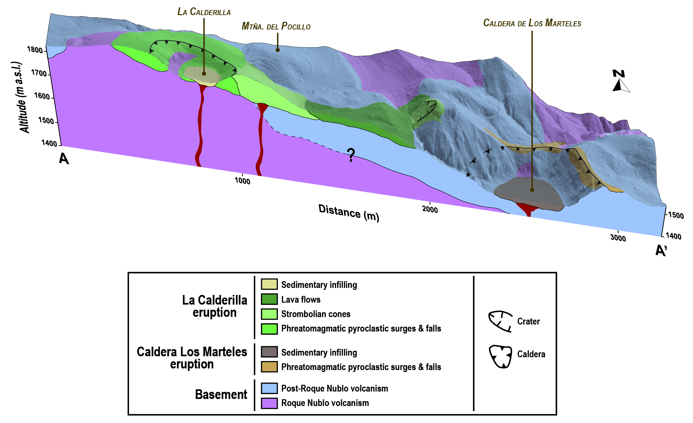

Figure S1.1 - 3D geological section A-A1 across the easternmost highlands of Gran Canaria including the calderas “La Calderilla” and “Los Marteles”.

Guillou, H., Pérez Torrado, F.J., Hansen, A.R., Carracedo, J.C. & Gimeno, D. (2004) The Plio-Quaternary volcanic evolution of Gran Canaria based on new K-Ar and magnetostratigraphy. Journal of Volcanology and Geothermal Research, 135, 221–246.

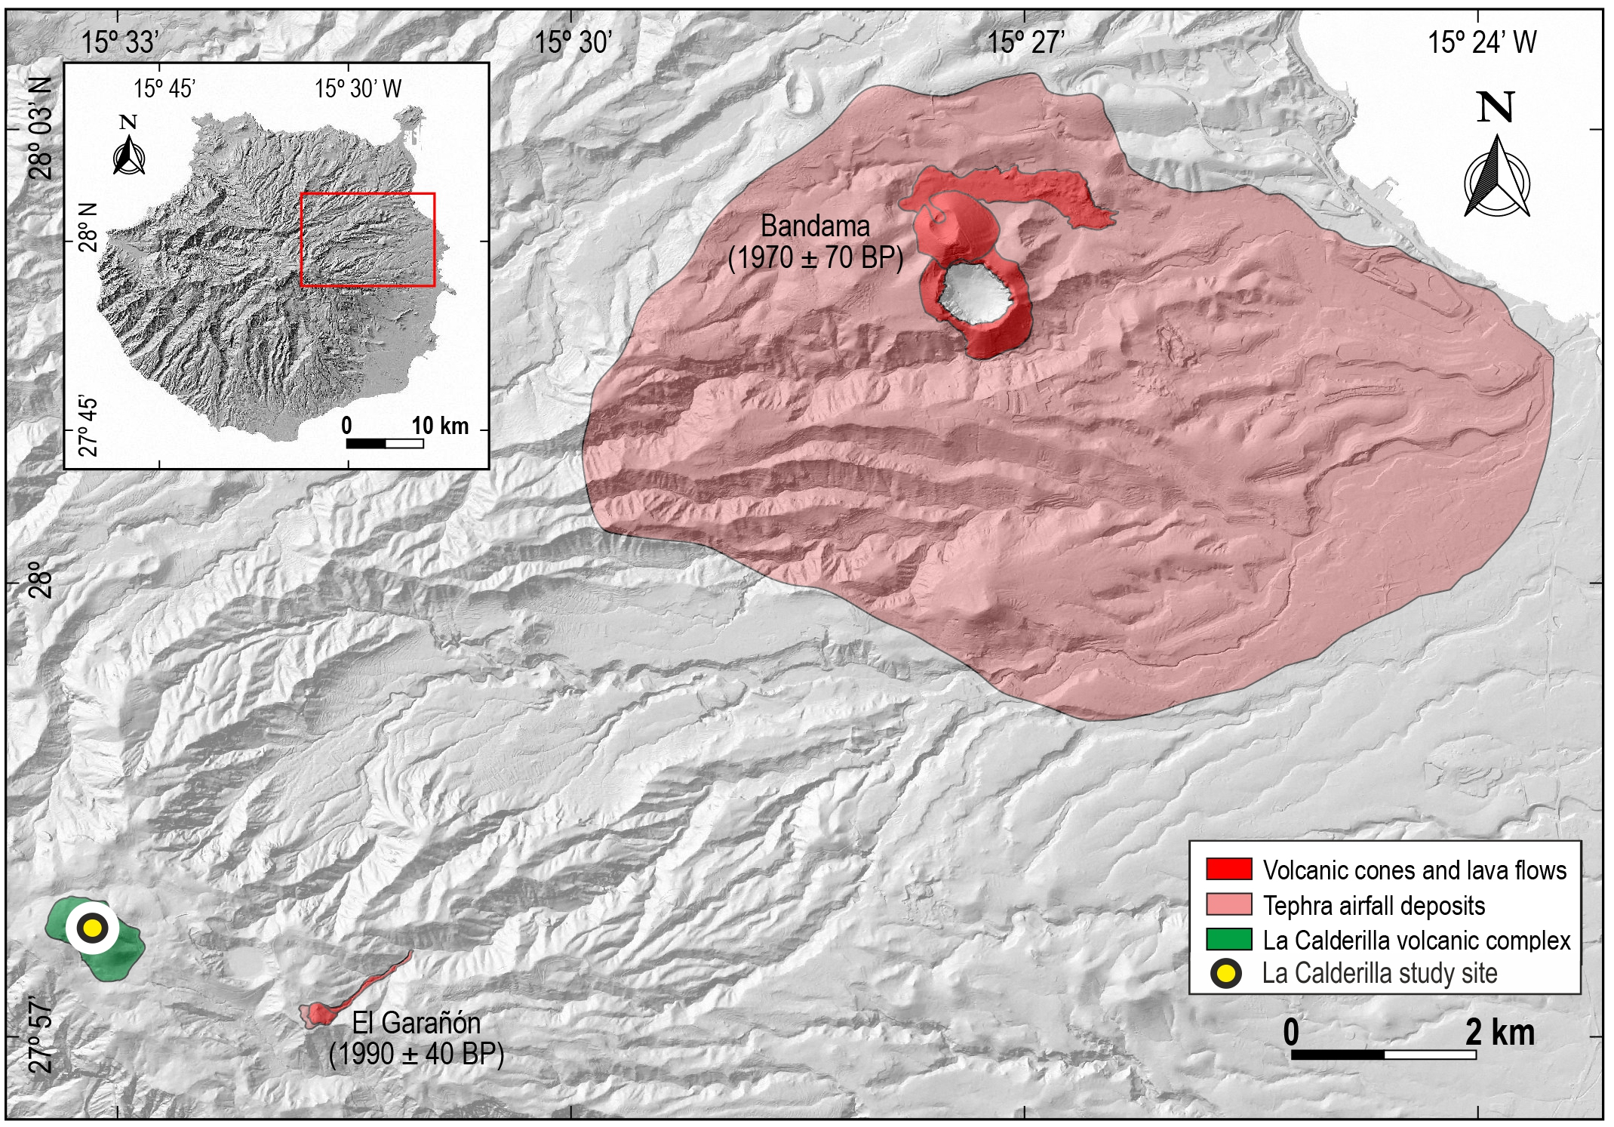

Fig. S1.2 – Spatial distribution of the volcanic activity close to the La Calderilla study site during the Late Holocene. Bandama airfall deposits dated 1920 cal. yr bp (median probability); El Garañon cone and lava flow dated 1940 cal. yr bp (median probability).
Sedimentary log and sedimentary environments from La Calderilla (Gran Canaria) Core CAL1

We present here the detailed stratigraphy of the CAL1 coring. This is the first technical drilling in a caldera in Gran Canaria, which sedimentary infill was so far unexplored.
The studied core was drilled on 22.5.2013 on the eastern depressed border of the caldera bottom (27°57'44.90"N, 15°33'8.74"O, coordinates WGS 84). According to sediment facies and physical properties, the core CAL1 record includes four lithostratigraphic units and deposition environments.

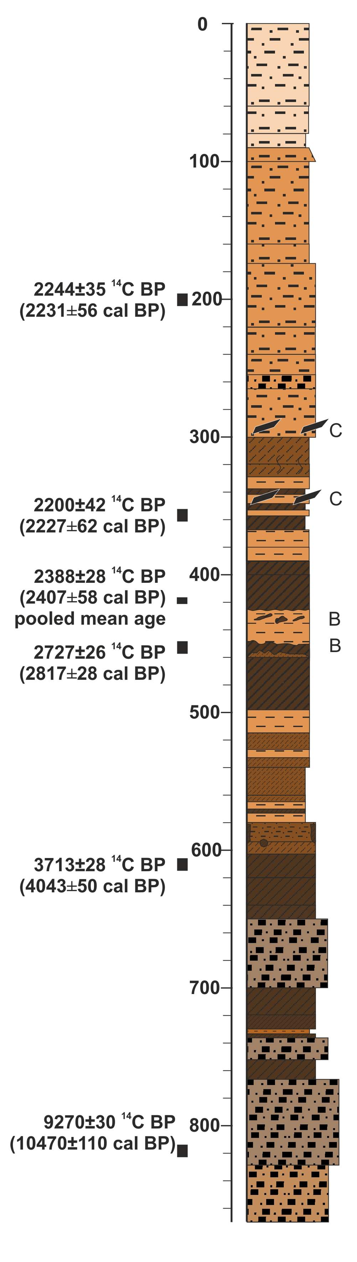 | The uppermost segment (140 cm depth to surface) is formed by floods in an ephemeral pool, excluding woody vegetation. The floods are still supplied by the development of the fan, which nowadays occupies the entire floor.
 | The upper middle segment (290–140 cm depth) is formed by fine silts, partly laminated and again supplied by the fan affecting the phonolite bedrock. Woody vegetation was excluded from local sedimentary environment. Charcoal and organic matter overall decrease.
 | The lower middle segment (650–290 cm depth) consists of an alternation of irregular, though well visible, dark to light layers. Dark layers represent andosols incorporating abundant charcoal fragments and supporting forest vegetation, in situ or colluviated from the wall of the basaltic strombolian cone. They are embedded with light silty layers originated from sheet flows from the phonolite bedrock on the northern caldera rim. Dark layers formed in a terrestrial environment; sheet flows deposited in an ephemeral pool, without a permanent water column.
 | The lowermost segment (870–650 cm depth) is made up of slope deposits and associated soils formed on the wall of the strombolian cone, in a terrestrial environment. Palynomorph preservation is poor, thus this interval was discarded for palaeoecological analysis.

Figure S1.3 – La Calderilla, core CAL 1, radiocarbon ages (see Table S1.1 for details), sedimentary log, sedimentary environments. Key of lithological patterns.
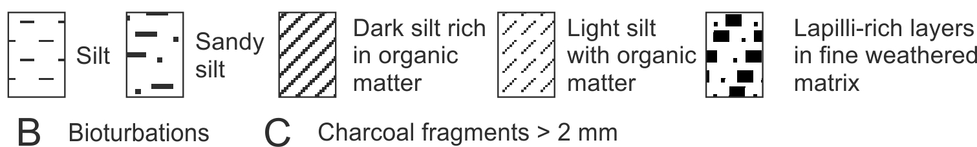
Geochronometry, biochronological markers and age−depth model design of La Calderilla (Gran Canaria) Core CAL1

Lab code | Sample depth (cm) | Material type | Age ¹⁴C | 2σ range  cal. bp | median probability  cal. bp
UBA-25487 | CAL 200 | Bulk sediment  (mainly charcoal particles) | 2244±35 | 2153 - 2274 | 2232
UBA-24108 | CAL 357 | Bulk sediment  (mainly charcoal particles) | 2200±42 | 2118 - 2332 | 2228
UBA-21296 | CAL 418 | Charcoal fraction,  150 µm to 1 mm | 2322±49 | 2157 - 2488 | 2342
UBA-21295 | CAL 418 | Charcoal fraction,  > 1 mm | 2420±34 | 2351 - 2698 | 2452
UBA-24109 | CAL 453 | Bulk sediment  (mainly charcoal particles) | 2727±26 | 2766 - 2867 | 2818
UBA-25488 | CAL 610 | Bulk sediment  (mainly charcoal particles) | 3713±28 | 3978 - 4102 | 4044
Beta-394947 | CAL 822 | Bulk sediment  (mainly charcoal particles) | 9270±30 | 10299 - 10566 | 10458
UBA 21295+21296  Pooled mean | CAL 418  Pooled mean | Macrocharcoal particles | 2388±28 | 2349 - 2465 | 2399
(modelled age) | CAL 638 |  |  | 4070 - 6210 | 4760

Table S1.1 - ¹⁴C ages and modelled ages obtained from core CAL1 (La Calderilla, Gran Canaria).

We designed a Bayesian deposition model for the timing of the caldera infill using the Oxcal 4.2. program (Bronk Ramsey, 2008) adopting a Poisson sequence with a low flexibility, i.e. low K parameter (K = 0.05). We computed seven radiocarbon AMS age distributions (Table S1.3) plus the age of the pollen event (biochronological marker) related to the peaking expansion of main pollen producer weeds (Artemisia, Polygonaceae, Brassicaceae) expected at the time of the Castilian Conquest of Gran Canaria (1478–1483 years CE). Uncertainty of the pollen event timing was expressed by a Gaussian distribution, fixing the maximum probability of the pollen event at the time of the Castilian Conquest with a 2σ range of 140 years (i.e. 1480 ± 70 years CE). This range takes into account the environmental alteration and weed expansion that likely started in Gran Canaria in the first half of the XV century, after incursions of Juan de Bethencourt in the year 1403 CE, i.e. seventy years before the Castilians established settlements into coastal thermophilous woodlands in 1478 CE (Abreu Galindo, 1632; Lobo Cabrera, 2012). The stratigraphic boundary level of this pollen event, which is coincident with zone Z2 / Z1 boundary at 57 cm depth in core CAL1, was obtained by clustering. Two ages were obtained from level 418 cm core depth, after separating microcharcoal (UBA-21296) and macrocharcoal fractions (UBA-21295). Their distributions were pooled after being confirmed by a T test to be statistically indistinguishable (Table S1.3).
We modeled two solutions in Figure 2, either retaining (white envelope) or discarding (yellow envelope) the uppermost ¹⁴C age, which is affected by reworking of charcoal particles. Reworking of charcoal particles is found to have affected the uppermost interval, after the local fire dated 2200 ± 42 ¹⁴C yr bp (UBA 24108, i.e. event F4, see section 3.3). The yellow envelope model obtained after discarding the age derived from reworked charcoal (UBA 24108) is also consistent with the average sedimentation rate of the Late Holocene infill of La Calderilla (Figure 2) and is therefore retained in the present work.

de Abréu Galindo F.J. 1632 Historia de la Conquista de las Siete Islas de Gran Canaria. Ed. Imprenta Isleña, Santa Cruz de Tenerife (1848).
Bronk Ramsey, C. (2008) Deposition models for chronological records. Quaternary Science Reviews, 27, 42–60.
Lobo Cabrera M. (2012) La conquista de Gran Canaria (1478-1483). Ediciones del Cabildo de Gran Canaria, Las Palmas de Gran Canaria.
Appendix S2 – Bibliographical reference for pollen, spores and charcoal analysis and morphometry of Poaceae pollen

List of references for the identification of palynological taxa, algae and fungi, and of macrocharcoal morphotypes

Identification benefited from the reference pollen collections of the Ecology Laboratory at the University of La Laguna, of the Laboratory of Palynology and Palaeoecology at the CNR-IDPA of Milano and from specific papers and atlases.

Pollen identification

Gosling, W.D., Miller, C.S. & Livingstone, D.A. (2013) Atlas of the tropical West African pollen flora. Review of Palaeobotany and Palynology, 199, 1–135.
La-Serna Ramos, I.E., Méndez Pérez, B. & Gómez Ferreras, C. (1999) Aplicación de nuevas tecnologías en Mieles Canarias para su tipificación y control de calidad. Santa Cruz de Tenerife: Confederación de Cajas de Ahorros.
Pérez de Paz, J. (1981) Estudio preliminar de los generos Maraconesicos Bencomia, Marcetella y Dendropoterium (Rosaceae: Sanguisorbinae). Botánica Macaronesica, 8–9, 41–58.
Pérez de Paz, J. (2004) Rosaceae-Sanguisorbeae de Macaronesia: Géneros Marcetella, Bencomia y Dendriopoterium. Palinología, biogeografía, sistemas sexuales y filogenia. Botánica Macaronésica, 25, 95–126.
Reille, M. (1992–1998) Pollen et spores d’Europe et d’Afrique du Nord. Vol. 1, Suppl. I-II. Laboratoire de Botanique Historique et Palynologie, Université de Marseille.

Fungal spores identification

Cugny, C., Mazier, F. & Galop, D. (2010) Modern and fossil non-pollen palynomorphs from the Basque mountains (western Pyrenees, France): the use of coprophilous fungi to reconstruct pastoral activity. Vegetation History and Archaeobotany, 19, 391–408.
Lundqvist, N. (1972) Nordic Sordariaceae s. lat. Symbolae Botanicae Upsaliensis, 20, 1–374.
van Geel, B., Coope, G.R. & van der Hammen, T. (1989) Palaeoecology and stratigraphy of the Lateglacial type section at Usselo (The Netherlands). Review Palaeobotany Palynology, 60, 25–129.
van Geel, B., Buurman, J., Brinkkemper, O., Schelvis, J., Aptroot, A., van Reenen, G. & Hakbijl, T. (2003) Environmental reconstruction of a Roman period settlement site in Uitgeest (The Netherlands), with special reference to coprophilous fungi. Journal Archeological Sciences, 30, 873–883.

Identification of macrocharcoal morphotypes

Conedera, M., Tinner, W., Neff, C., Meurer, M., Dickens, A.F. & Krebs, P. (2009) Reconstructing past fire regimes: methods, applications, and relevance to fire management and conservation. Quaternary Science Reviews, 28, 435–456.
Jensen, K., Lynch, E.A., Calcote, R. & Hotchkiss, S.C. (2007) Interpretation of charcoal morphotypes in sediments from Ferry Lake, Wisconsin, USA: do different plant fuel sources produce distinctive charcoal morphotypes? The Holocene, 17(7), 907–915.
Whitlock, C. & Larsen, C. (2001) Charcoal as a fire proxy. In Smol, Birks, Last, (Eds.) Tracking environmental change using lake sediments. Volume 3: Terrestrial, algal, and siliceous indicators. The Netherlands: Kluwer Academic Publishers, Dordrecht.

Morphometric analysis of Poaceae pollen

In all studied samples we separated “large Poaceae” from “small Poaceae”, using a limit of 47 µm (grain diameter), while a discriminant pair threshold combining it with pore diameter of 11 µm was used to distinguish domesticated, large-pollen bearing cereal genera, from wild grasses. This restrictive criterion leaves just a few wild Avena in the cereal group of continental Europe (Andersen, 1979; Beug, 2004; Joly et al., 2007). The use of a combined 47 / 11 µm criterion is not intended for identification of individual cereal grains in the Canaries. Only a high proportion of large-sized Poaceae pollen grains can be taken as an evidence of cereal fields in the pollen source area. We analyzed changes in frequency distribution of grain and pore diameters, to infer changes in grass composition (e.g. Schüler and Behling, 2011).
Results of morphometric analysis of Poaceae fossil pollen from La Calderilla core CAL1 are shown in Fig. S2.3.

Andersen, S.T. (1979) Identification of wild grass and cereal pollen. Danmarks Geologiske Undersøgelse, Årbog, 69–92.
Beug, H.J. (2004) Leitfaden der Pollenbestimmung für Mitteleuropa und angrenzende Gebiete. München: Verlag Dr. Friedrich Pfeil.
Joly, C., Barillé, L., Barreau, M., Mancheron, A. & Visset, L. (2007) Grain and annulus diameter as criteria for distinguishing pollen grains of cereals from wild grasses. Review Palaeobotany Palynology, 146, 221–233.
Schüler, L. & Behling, H. (2011) Poaceae pollen grain size as a tool to distinguish past grasslands in South America: a new methodological approach. Vegetation History and Archaeobotany, 20, 83–96.

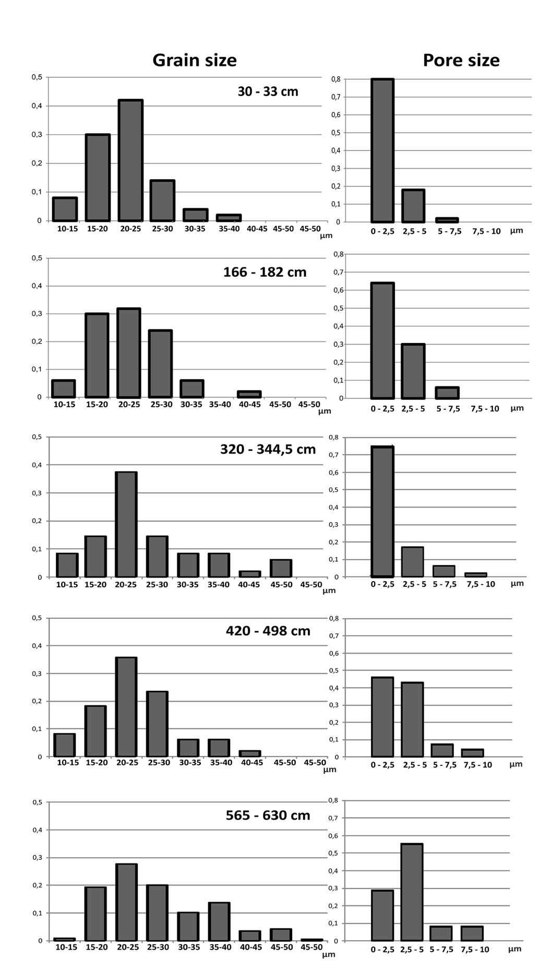

z6 (1 sample)

z5 (2 samples)

z3 (5 samples)

z2 (8 samples)

z1 (10 samples)

Figure S2.4 – La Calderilla core CAL1 pollen record. Morphometric analysis of Poaceae pollen. Horizontal panels show average grain and pore size frequency distribution measured over a subsample in four pollen zones.
.
Appendix S3 – Information on pollen rain – modern vegetation and land use relationships

Pollen rain of individual pollen types recorded from mosses and modern vegetation

We analyzed three moss polsters collected in the La Calderilla caldera catchment (M1-M3) and from one additional grassland site (M6). The location is given in Table S3.2 and in Figure 1e. For each plot, we estimated modern vegetation cover in buffers of 10, 100, 200 and 1000 m radii, as the percentage of soil covered by individual species. Taxa were grouped into pollen types to allow comparing percentage plant cover with pollen proportions. Only the most important pollen taxa are presented in this short report (Figure S3.4).

MOSS POLSTER | Latitude N | Longitude W | COLLECTING DATE | VEGETATION
M1 La Calderilla | 27°57'45.46" | 15°33'14.93" | 4.7.2014 | Bush legumes and therophytic herbs
M2 La Calderilla | 27°57'38.41" | 15°33'7.04" | 4.7.2014 | Summit scrub and bush legumes
M3 La Calderilla | 27°57'47.26" | 15°33'7.69" | 4.7.2014 | Pine forest and bush legumes
M6 Monte Constantino | 28° 0'46.32" | 15°35'52.95" | 4.7.2014 | Grassland and pine forest
CALD 1 core | 27°57'44.90" | 15°33'8.74" | 22.5.2013 | Therophytic herbs and bush legumes

Table S3.2 – Moss polsters location (WGS 84) and contemporary vegetation physiognomy

Currently, Artemisia thuscula, Quercus robur, Q. ilex, Q. suber and Q. rotundifolia can be found in rural landscapes and “barrancos” at middle elevations in Gran Canaria (Kunkel, 1991; Acebes et al., 2009; Jardin Botánico Canario, 2015). Hence the presence of Artemisia and Quercus in the moss-polsters is indicative of an extra-local input of these pollen types (Artemisia 2–3%; Q. robur-cerris types 0–1.5%) from the lower vegetation belts. Similarly low pollen abundances of Artemisia and Quercus were encountered in a modern pollen rain high elevation plot on Tenerife (de Nascimento et al., 2015). Exotic pollen types, i.e. that must be considered indicative of continental vegetation (e.g. Cedrus) are absent.
Shrubby legumes (Teline, Adenocarpus) are under-represented in the pollen spectra (3 ± 2%) when compared to their current plant cover in a radius of 200 m (15%) and 1 km (10%) from the site, suggesting a low overall contribution of Fabaceae in the pollen rain of the high elevation pine forest belt. Pinus canariensis is proportionally represented (47 ± 7 pollen % versus 50 current plant cover % within 200 m distance and 70% within 1 km), while Castanea is by far overrepresented (19 ± 2% versus 3% within 200 m distance and 3% within 1 km). These figures are in general agreement with pollination syndromes and with modern pollen rain data from Tenerife (de Nascimento et al., 2015).
An additional moss polster (M6) from a highland Poaceae-dominated grassland (Monte Constantino), fringed by a legume (Adenocarpus foliolosus) summit scrub, shows both Fabaceae and Poaceae under-representation. Grasses are represented by small-Poaceae pollen only, despite high Avena barbata cover in the grassland.

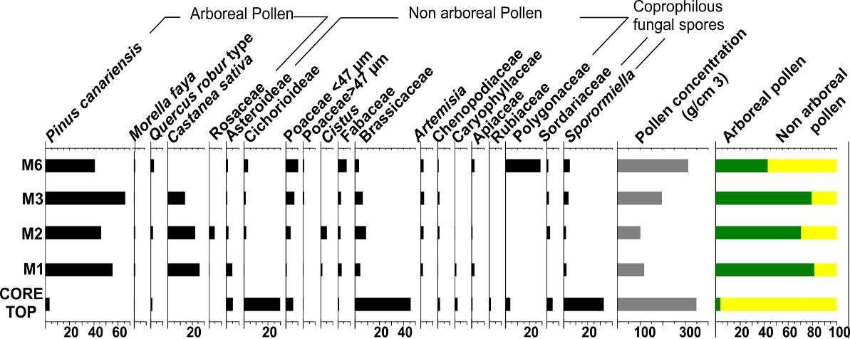
Figure S3.5 - Pollen rain estimated from moss polsters collected from rocks at the caldera edge (M2) and bottom (M1) and from pine forest understory (M3) in La Calderilla, Gran Canaria. An additional sample is from a grassland site (M6). The sediment sample at core top CAL1 (La Calderilla) is shown for comparison. Values are expressed as pollen percentage (%) and concentrations (pollen grains per cm³).

The pollen composition of moss polsters display marked differences from the core top samples (Fig. S3.4). Given that the accumulation period by moss samples is usually between 2 and 15 years (Pardoe et al., 2010), we argue that the studied moss polsters recorded the very last years of pollen deposition. The core top, by contrast, reflects treeless vegetation. Large-scale vegetation cover changes occurred in the highlands of Gran Canaria during the last 60 years - from treeless pastures towards planted pine forests and legume bushes (see Appendix S3.2). These vegetation and land use changes account for the observed offset in pollen spectra. Sedimentation in the caldera bottom did not record the most recent changes. This may be the consequence of missing sedimentation and / or wind erosion over the caldera floor during recent years. Accordingly, the core top was given an age of 0 yr cal. bp (1950 ce).

Acebes, J.R., León, M.C., Rodríguez, M.L., del Arco, M., García, A., Pérez, P.L., Rodríguez, O., Martín, V.E. & Wildpret, W. (2009) Pteridophyta, Spermatophyta. In Arechavaleta, M., Rodríguez, S., Zurita, N. & García, A. (Eds.) Lista de especies silvestres de Canarias. Hongos, plantas y animales terrestres (pp. 119–172). Gobierno de Canarias.
Kunkel, G. (1991) Fagaceae. In Kunkel G. & coordinators. Flora y Vegetación del Archipiélago Canario. Tratado florístico de Canarias. 2° parte. Dicotiledones (pp. 30–31). Las Palmas: Edirca.
Jardín Botánico Canario (2015) Flora de Gran Canaria. Quercus robur L., Quercus suber L., Quercus ilex subsp. rotundifolia (Lam.) Schwarz ex Taborda de Morais (Fagaceae); Poaceae. http://www.jardincanario.org/flora-de-gran-canaria (browsed 10.2015 / 2.2016).
Pardoe, H.S., Giesecke, T., van der Knaap, W.O. et al. (2010) Comparing pollen spectra from modified Tauber traps and moss samples: examples from a selection of woodlands across Europe. Vegetation History Archaeobotany, 19, 271–283.

Land use changes in the last 60 years in La Calderilla (Gran Canaria)

We present a sequence of scaled aerial photographs (source: GRAFCAN) spanning the period 1954–2013, to compare plant cover changes (Figure S3.5). The photograph taken in 1954 show a treeless landscape having only recently been planted, with rocky slopes inside the caldera rim and grazed areas, partly terraced and being invaded by Fabaceae-scrub. A photograph taken in 2013 documents the progress of pine woodland and wide surfaces covered by Fabaceae-scrub. These scrub stands started expanding before the second world war, after abandonment of pastures and crops (Naranjo-Cigala, 1995), while pine plantations were started in the 1950s just after the Decreto de repoblación forestal obligatoria, dated 1953 (Pérez de Paz et al., 1994).

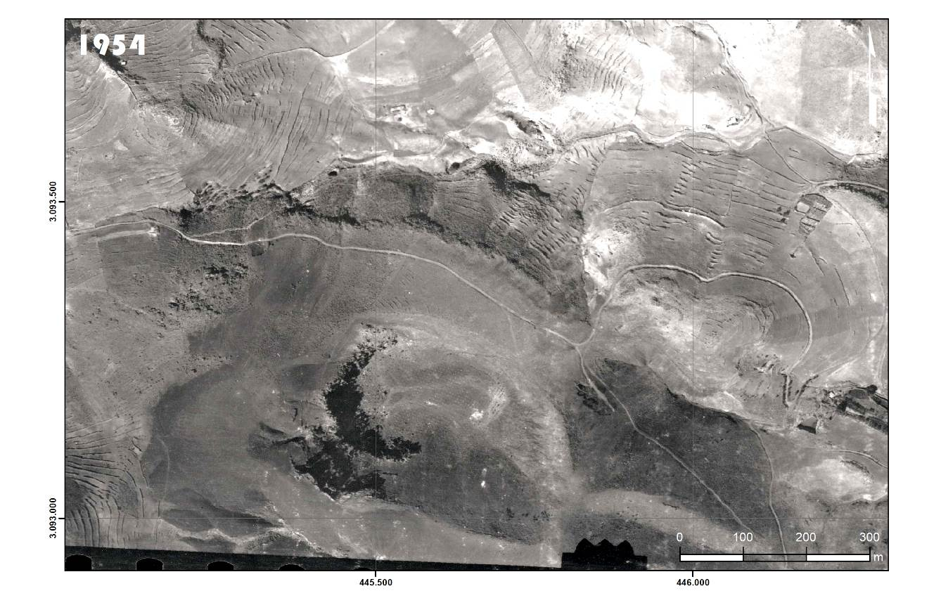
Figure S3.6 – Comparative sequence of aerial photographs. The oldest available historical aerial photograph of La Calderilla caldera (Gran Canaria) (1954 ce).

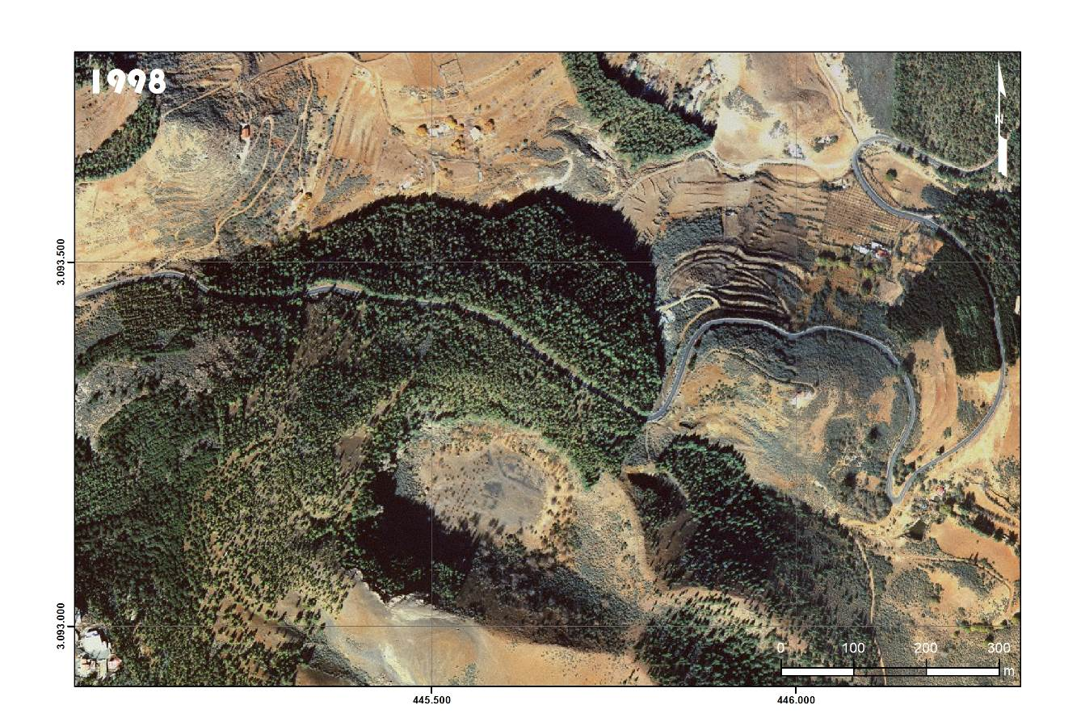
Figure S3.6 – continued (1998 ce).

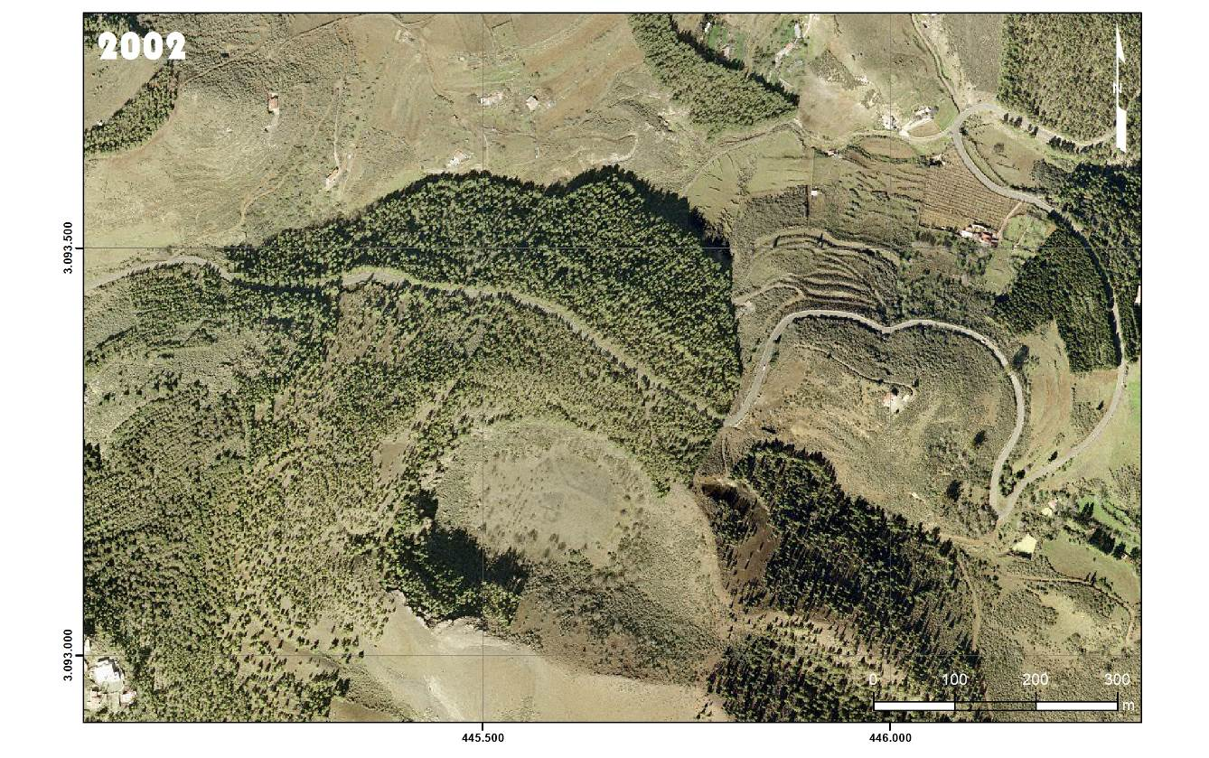
Figure S3.6 – continued (2002 ce).

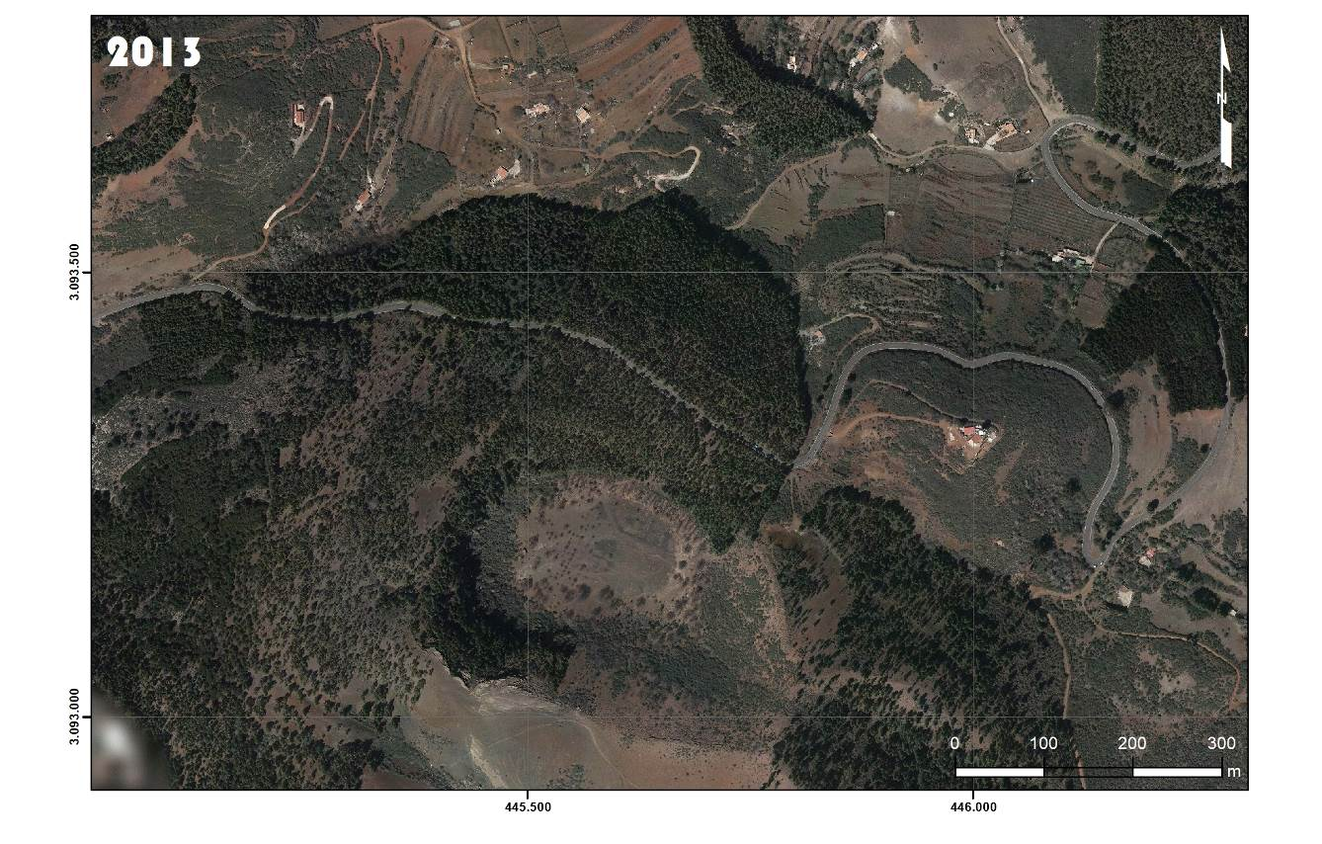
Figure S3.6 – continued (2013 ce).

Appendix S4. Radiocarbon archaeological chronology and early historical record of Gran Canaria

Early historical record of nature features and human artefacts on Gran Canaria at the onset of Current Era (Pliny the Elder)

Pliny the Elder’s Naturalis Historia contains a specific passage (VI, 203–205) describing natural features of the Canary Archipelago around the onset of the Common Era, and marking the distinctiveness of Gran Canaria, together with traces of ancient human buildings specifically mentioned for this island. Plinio reports information collected by Juba II, king of Mauritania between 46 bce and 20 ce. Here we take up the Latin text (VI, 204–205, Barchesi et al. translation, Einaudi, 1982), and discuss its significance for the reconstruction of pristine environments and of early human peopling.

(204) “Alteram insulam Iunoniam appellari; in ea aediculam esse tantum lapide exstructam. Ab ea vicino eodem nomine minorem, deinde Caprariam, lacertis grandibus refertam. In conspectu earum esse Ninguariam, quae hoc nomen acceperit a perpetua nive, nebulosam. Proximam quae ei Canariam vocari a multitudine canum ingentis magnitudinis – ex quibus perducti sunt Iubae duo – apparere ibi vestigia aedificiorum. Cum omnes autem copia pomorum et avium omnis generis abundent, hanc et palmetis caryotas ferentibus ac nuce pinea abundare; esse copiam et mellis, papyrum quoque et siluros in amnibus gigni. Infestari eas beluis, quae expellatur adsidue, putrescentibus”.

"Canaria" is found to be the island close to the one having the top covered by permanent snow and foggy, i.e. the Teide island, Tenerife ("Ninguaria"). Among the Fortunatae (Canary Islands) Canaria is the island with "very big dogs", "which preserves remains of buildings" and "is especially rich of date palms and pines", compared to the other islands Fortunatae. All of them are reported to be rich in fruits, birds, papyrus (this may have been actually Scirpus), honey, but - as far as settlement visibility, pine and palm abundance are concerned - these are given as distinctive features for Gran Canaria.

We corroborate the identification of Gran Canaria, as only two islands would have had lot of palms due to their geomorphological configuration dominated by “barrancos”, i.e. La Gomera and Gran Canaria. In turn, La Gomera is expected to have had pines but not a lot of pines, due to a lack of young pyroclastic deposits (no Quaternary volcanic activity), and to its lower elevational range compared to Gran Canaria. Hence, the island close to the Teide Island should be Gran Canaria.

In conclusion, the passage by Plinio highlights the importance of an upper pine belt and of a lower themophilous, palm-dominated ecosystem in the natural vegetation of this island. He also speaks for the existence of a human civilization there before the explorations carried out during the Roman imperial time, i.e. before the onset of Current Era.

Barchesi A. et al. (1982) – Historia Naturalis by Gaio Plinio Secondo. Vol. VI – Asia. Turin: Giulio Einaudi ed.

Probability density function of radiocarbon ages from pre-Castilian archaeological sites of Gran Canaria.

Probability density function obtained from the complete dataset of the radiocarbon archaeological chronology of Gran Canaria available in June 2020. The following published sources have been considered: Alberto & Hansen (2008), Martín de Guzmán et al. (1994), Fontugne et al. (1999), Jiménez (1999), Martín (2000), Mireles et al. (2005), Alberto & Velasco (2009), González et al. (2009), Morales (2010), Cabildo de Gran Canaria (2014), Morales et al. (2014), Morales et al. (2017), Velasco et al. (2019) and http://dataciones.grancanariapatrimonio.com/. They include a total of 253 radiocarbon ages, among which 145 were considered fully reliable. We also retained ages considered partly reliable (108), i.e. dates missing acronym or of doubtful quality, or ages obtained on bones missing pre-treatment information, or ages obtained on charcoal missing stratigraphic information. A few ages (5 in total) were discarded i.e. obtained on shell material.

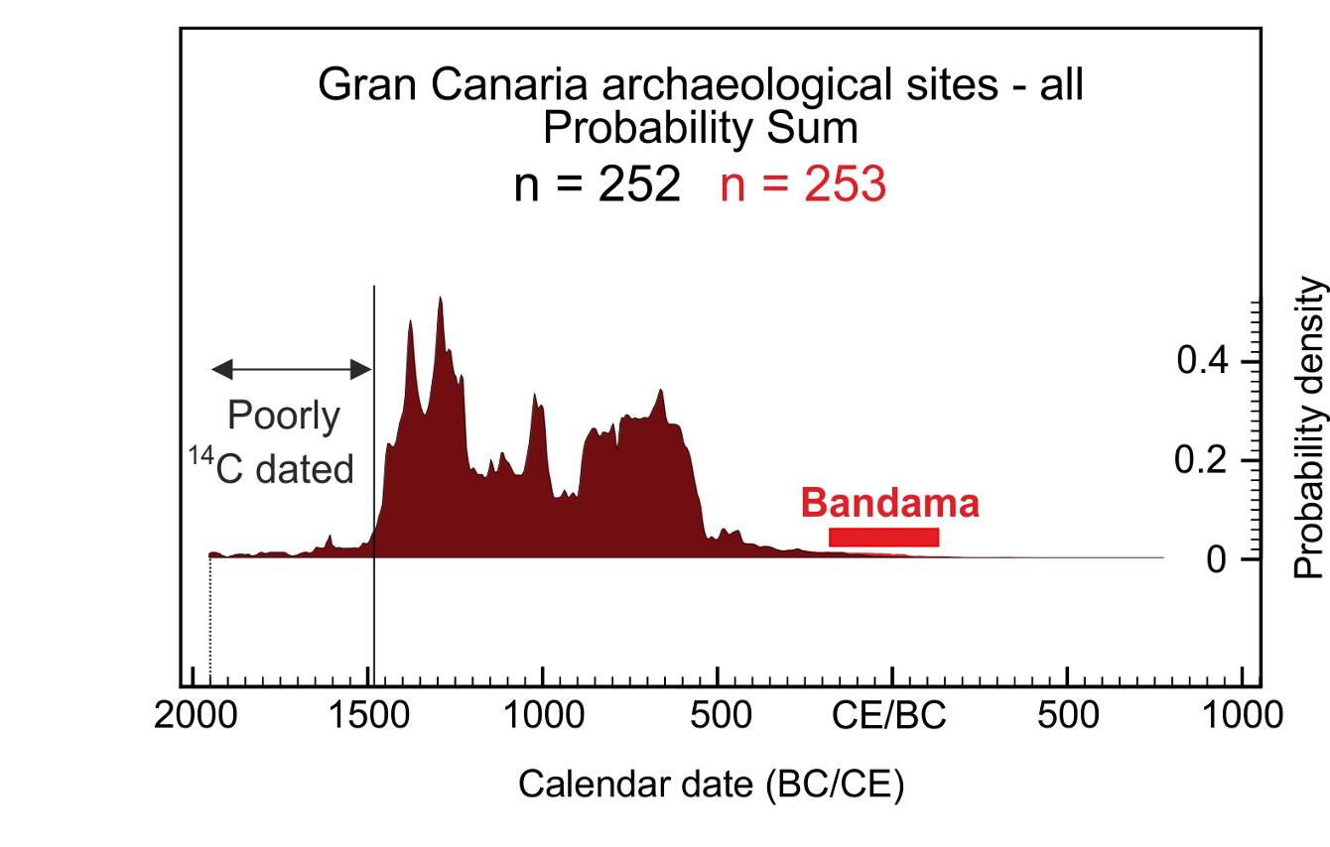

Fig. S4.7 - Probability sum obtained from the complete dataset of the radiocarbon archaeological ¹⁴C chronology of Gran Canaria available in June 2020 (dark infill below the black curve, n =252). The probability distribution of the burial by the Bandama pyroclastic fall (122 cal. yr bce to 178 cal. yr ce, 2σ range; median 30 cal. yr ce) is cumulated over in a separate red infill and curve (n =253). The last 540 years (1480-2020 yr ce) following the Castilian Conquest (1478-1483 yr ce) have not been intensively ¹⁴C-dated in the Canaries.

References to the dataset of radiocarbon ages used for probability sum calculation

Alberto, V. & Hansen, A.R. (2008) Los primeros canarios. In A.R. Hansen & C.J. Moreno (Eds.) El Gran Volcán – La Caldera y El Pico de Bandama (pp. 193–216). Gran Canaria: Consejería de Medio Ambiente y Aguas del Cabildo de Gran Canaria.
Alberto, V. & Velasco, J. (2009) El espacio funerario de Lomo Caserones (La Aldea de San Nicolás, Gran Canaria). Nuevos datos para su comprensión arqueológica. Estudios canarios, Anuario del instituto de estudios canarios, 52, 11–40.

Cabildo de Gran Canaria (2014) Novedades sobre dataciones en Gran Canaria. Boletín electrónico de Patrimonio Histórico. Gran Canaria C14. Los antiguos canarios y el carbono 14, 2, 51–54.
Fontugne, M., García, A., Hatté, Ch., Núñez, M.A., Olmo, S., Onrubia, J., Pérez, G., Rodríguez, C.G., Sáenz, J.I., Soler, V., García, C., Mireles, F., Moreno, R.M. & Martín, I. (1999) Parque Arqueológico Cueva Pintada (Gáldar, Gran Canaria). Programa de intervenciones e investigaciones arqueológicas. Avance de los trabajos efectuados entre los años 1995-1997. Investigaciones Arqueológicas, 6, 489–561.
González, P., Moreno, M. & Jiménez, A. (2009) El yacimiento arqueológico de la Cerera. Un modelo de ocupación en la isla de Gran Canaria. Cuadernos de Patrimonio Histórico, 9. Cabildo de Gran Canaria.
http://dataciones.grancanariapatrimonio.com/. Website last accessed on August 30th, 2018.
Jiménez, J.J. (1999) Gran Canaria Prehistórica. Santa Cruz de Tenerife: Centro de la Cultura Popular Canaria.
Martín de Guzmán, C. & Onrubia, J. (1990) Excavaciones en el Parque Arqueológico Cueva Pintada (Gáldar, Gran Canaria). Avance de las actuaciones de 1987 y 1988. Investigaciones Arqueológicas de Canarias, II 135–156.
Martín de Guzmán, C., Onrubia, J. & Sáenz, J.I. (1994) Trabajos en el Parque Arqueológico Cueva Pintada de Gáldar, Gran Canaria (Avance de las intervenciones realizadas entre julio de 1990 y diciembre de 1992). Anuario de Estudios Atlánticos, 40, 17–115.
Martín, E. (2000) Dataciones absolutas para los yacimientos de Risco Chimirique (Tejeda) y Playa de Aguadulce (Telde). Vegueta, 5, 29–46.
Mireles, F., Olmo, S., Rodríguez, A. (2005) El poblado prehispánico costero de Playa de El Burrero y su entorno arqueológico (Ingenio, Gran Canaria). El Museo Canario, 60, 31–94.
Morales, J.B. (2010) El uso de las plantas en la prehistoria de Gran Canaria: alimentación, agricultura y ecología (Monografías Cueva Pintada, 1). Las Palmas de Gran Canaria: Cabildo de Gran Canaria.
Morales, J., Rodríguez-Rodríguez, A., González-Marrero, M.C., Martín-Rodríguez, E., Henríquez-Valido, P. & del-Pino-Curbelo, M. (2014) The archaeobotany of long-term crop storage in northwest African communal granaries: a case study from pre-Hispanic Gran Canaria (cal. AD 1000-1500). Vegetation History and Archaeobotany, 23, 789–804.
Morales, J., Rodríguez-Rodríguez, A. & Henríquez-Valido, P. (2017) Agricultura y recolección vegetal en la arqueología prehispánica de las Islas Canarias (siglos III-XV d.C.): la contribución de los estudios carpológicos. In Fernández, J., Mujika, J.A., Arrizabalaga, A., García, M. (Coord.) Miscelánea en homenaje a Lydia Zapata Peña: (1965-2015) (pp. 189–218). Servicio Editorial de la Universidad del País Vasco.
Velasco, J., Alberto, V., Delgado, T., Moreno, M., Lecuyer, C. & Richardin, P. (2019) Poblamiento, colonización y primera historia de canarias: el C14 como paradigma. Anuario de Estudios Atlánticos, 66, 1–24.

Additional references to papers in Gran Canaria archaeology considered for the reconstruction of the stratigraphical setting of dated samples

Arco, M.C (2011) En el lugar de Mogán. Estudios arqueológicos en el poblado de la Puntilla (Barranquillo de los Gatos, Playa de Mogán, Gran Canaria). Canarias arqueológica, 19, 1–203.
Atoche, P. (2013) Consideraciones en relación con la colonización protohistórica de las Islas Canarias. Anuario de Estudios Atlánticos, 59, 519–562.
Several Authors (2012) Guía del Patrimonio arqueológico de Gran Canaria. Gran Canaria: Ediciones de El Cabildo de Gran Canaria.
Moreno, M.A. (2014) Tiempo y espacio: La cronología de Gran Canaria y el territorio. Boletín Electrónico de Patrimonio Histórico, 2, 39–46.
Velasco, J. (2014) El tiempo de los antiguos canarios. Boletín Electrónico de Patrimonio Histórico, 2, 12–14.

