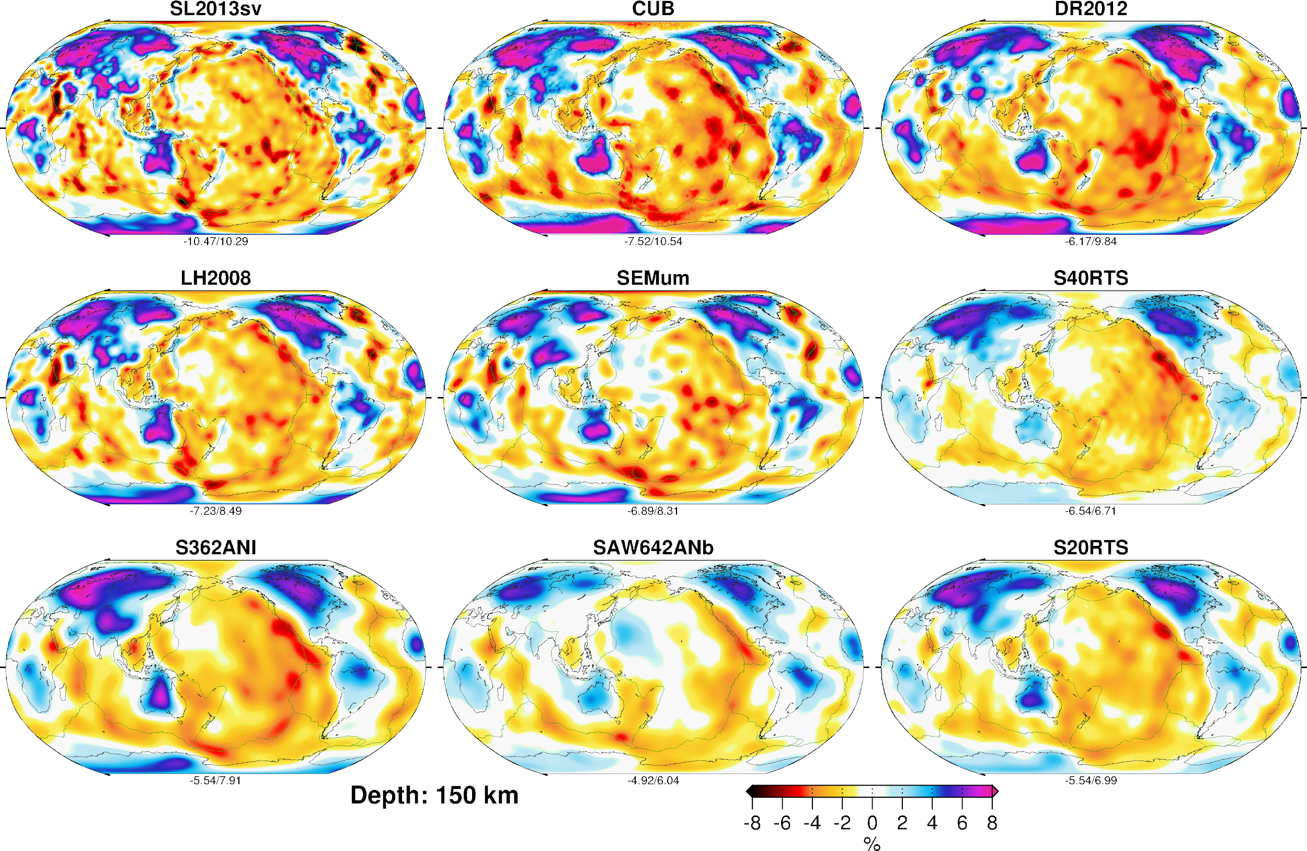
Figure 1. From Schaeffer and Lebedev (2015). Comparison of velocity anomalies from nine global tomographic models at a depth of 150 km. The models are: SL2013sv (Schaeffer and Lebedev, 2013), DR2012 (Debayle and Ricard, 2012), SEMum (Lekic and Romanowicz, 2011), S40RTS (Ritsema et al., 2011), SAW642ANb (Panning et al., 2010), LH2008 (Lebedev and van der Hilst, 2008), S362ANI (Kustowski et al., 2008), S20RTS (Ritsema et al., 2004), and CUB (Shapiro and Ritzwoller, 2002). Percentages indicate perturbations with respect to the mean absolute shear velocity of the model, and the same color scale is used throughout. Minimum and maximum perturbations are indicated beneath each map.

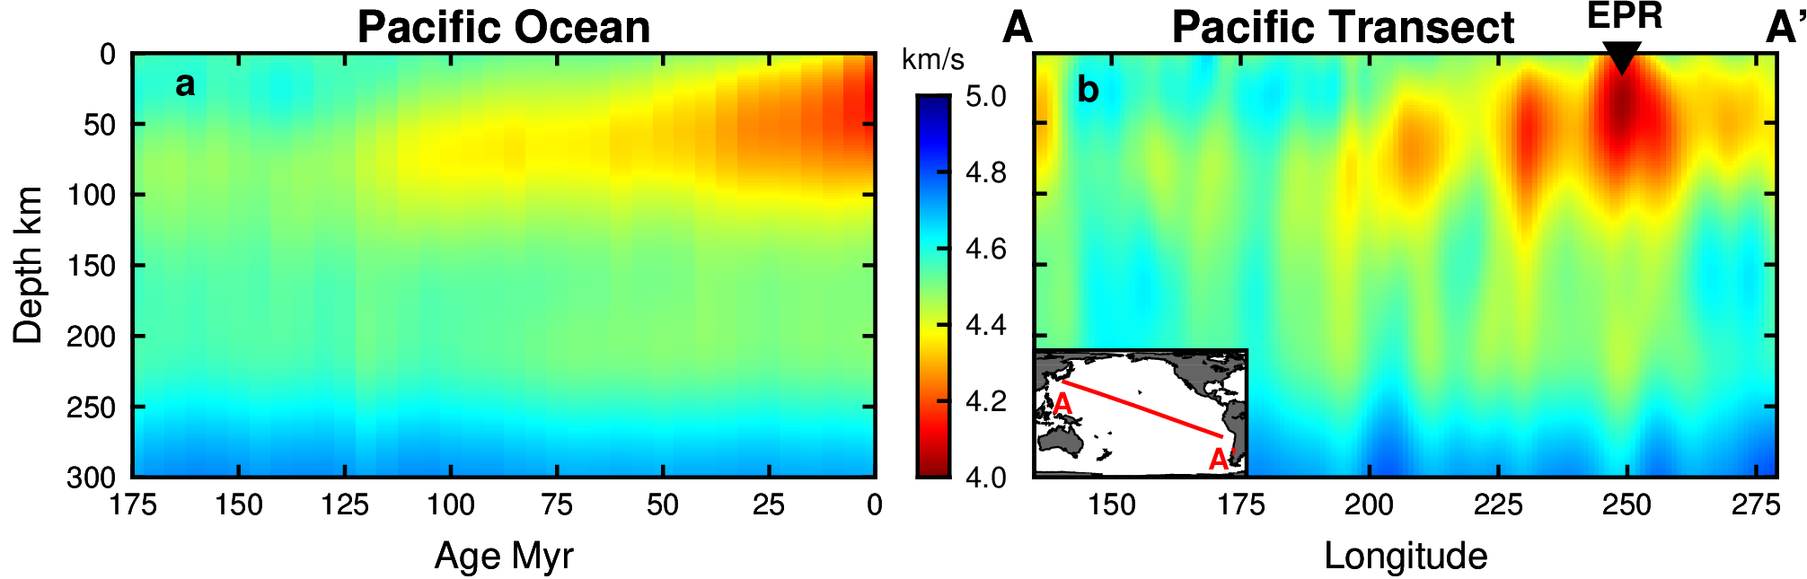
Figure 2. From Rychert et al. (2018). Voigt averaged shear velocities beneath the Pacific from SEMum2 (French et al., 2013). (a) The Pacific averaged by age in 5 Ma bins and (b) a single northwest–southeast transect. Triangle indicates location of the East Pacific Rise (EPR).
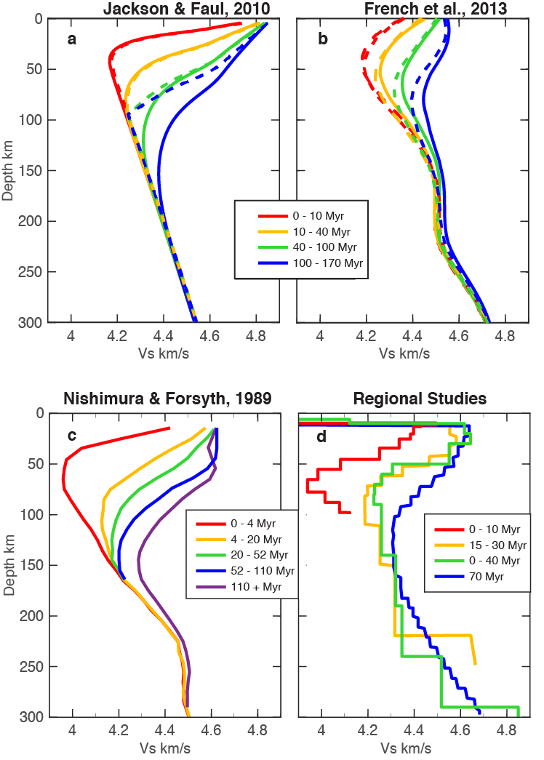

Figure 3. Depth profiles of shear velocity in the oceanic upper mantle. (a) Predictions using the anelastic parameterization of Jackson and Faul (2010) assuming a grain size of 10 mm applied to thermal profiles calculated with HSC (solid) and the plate model with 95 km plate thickness (dashed). (b) Globally averaged V_{SV} (dashed) and Voigt-averaged isotropic V_{S} (solid) profiles across the PAcific from SEMum2 (French et al., 2013). (c) Average VSV Pacific profiles from Nishimura and Forsyth (1989). (d) Regional studies are as follows: 0 – 10 Myr GLIMPSE (Harmon et al., 2009); 15 – 30 Myr Shikoku Basin (Takeo et al., 2013); 0 – 40 Myr PI-LAB (Rychert et al., 2019); and 70 Myr NoMelt (Lin et al., 2016).

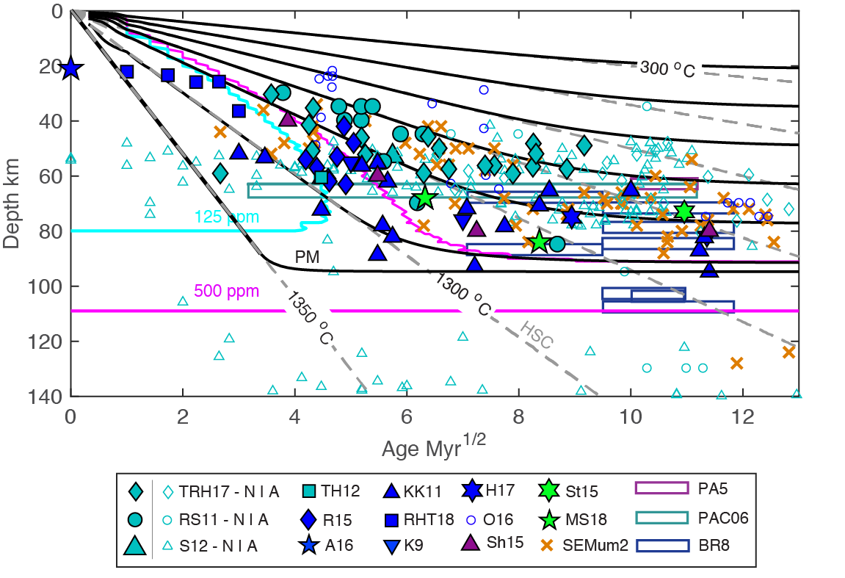
Figure 4. Compiled discontinuity depths from scattered/reflected waves and other seismic methods plotted versus age compared to cooling model predictions and surface wave velocities. Isotherms for the half‐space cooling model (HSC; gray dashed) and plate model assuming plate thicknesses of 95 km (PM; black solid) are shown. Isotherms are plotted every 200 ℃ including an isotherm very near the mantle potential temperature of 1350 ℃. The solidi for a mildly hydrated mantle are shown for 125 ppm and 500 ppm water (cyan and pink lines, respectively) (Katz et al., 2003). Depths of the minimum shear velocity in the SEMum2 model beneath the Pacific (French et al., 2013) (orange x’s) are not age-averaged, resulting in some variation at given ages. Depths are plotted relative to the seafloor with results corrected from the depth beneath sea surface by the amount listed, if any. SS precursor results from the entire Pacific including TRH17 (Tharimena et al., 2017), RS11 (Rychert & Shearer, 2011), and S12 (Schmerr, 2012) are sorted into normal lithosphere (N, solid cyan) and anomalous (A, outline cyan) lithosphere affected by hotpots (Korenaga and Karato, 2008). Depths from a sS precursor result, TH12 (Tonegawa & Helffrich, 2012) (cyan star), and a Po/So result, Sh15 (Shito et al., 2015) (purple triangle), are shown. Receiver function results (solid blue symbols) include RHT18 (Rychert et al., 2018b) (−3 km), R15 (Reeves et al., 2015) (−3 km), O16 (Olugboji et al., 2016), KK11 (Kumar & Kawakatsu, 2011), K09 (Kawakatsu et al., 2009), H17 (Hannemann et al., 2017), and A16 (Audet, 2016). Transect studies that encompass a range of ages are shown as boxes with fixed thickness (5 km), including PAC06 (Tan & Helmberger, 2007) (green), PA5 (Gaherty et al., 1996) (−5 km) (purple), and BR08 (Bagley & Revenaugh, 2008) (−4 km) (blue). Active source studies (solid green symbols) include MS18 (Mehouachi & Singh, 2018) (−4 km) and St15 (Stern et al., 2015). The depths of the minimum low velocity zone velocity beneath the Pacific from the surface wave/long period waveform model SEMum2 (French et al., 2013) (−4 km) are shown as orange x’s.

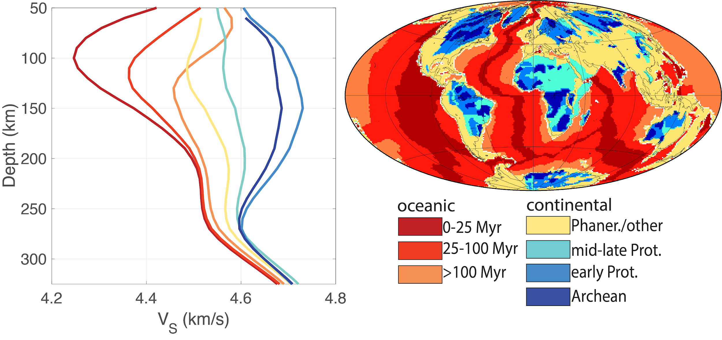

Figure 5. left) Velocity (V_{sv} ) profiles from the SEMum2 model (French and Romanowicz, 2014). Each profile corresponds to a global average of mantle structure beneath crust of a given age. right) Age classification of crust from the Crust1.0 model (Laske et al., 2013). Ages on map and for velocity profiles are color-coded according to the legend in the lower right.

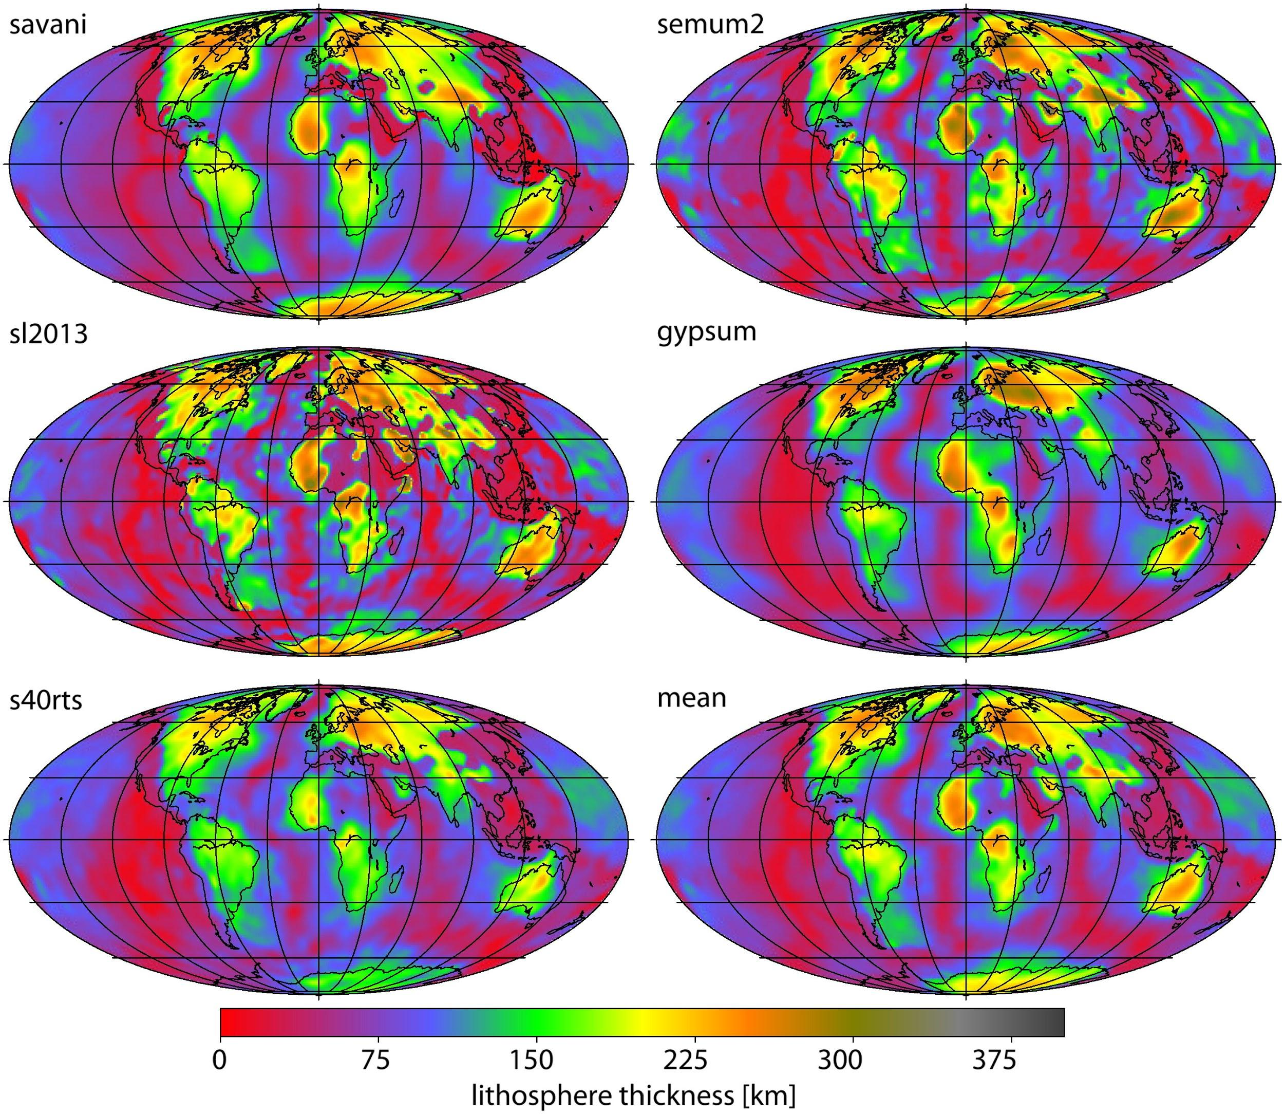

Figure 6. From Steinberger and Becker (2018). Maps of the thermal thickness of the lithosphere based on different global tomography models: gypsum (Simmons et al., 2010), s40rts (Ritsema et al., 2011), savani (Auer et al., 2014), SEMum2 (French and Romanowicz, 2014), and sl2013 (Schaeffer and Lebedev, 2013). The mean model is an average of these ﬁve models.
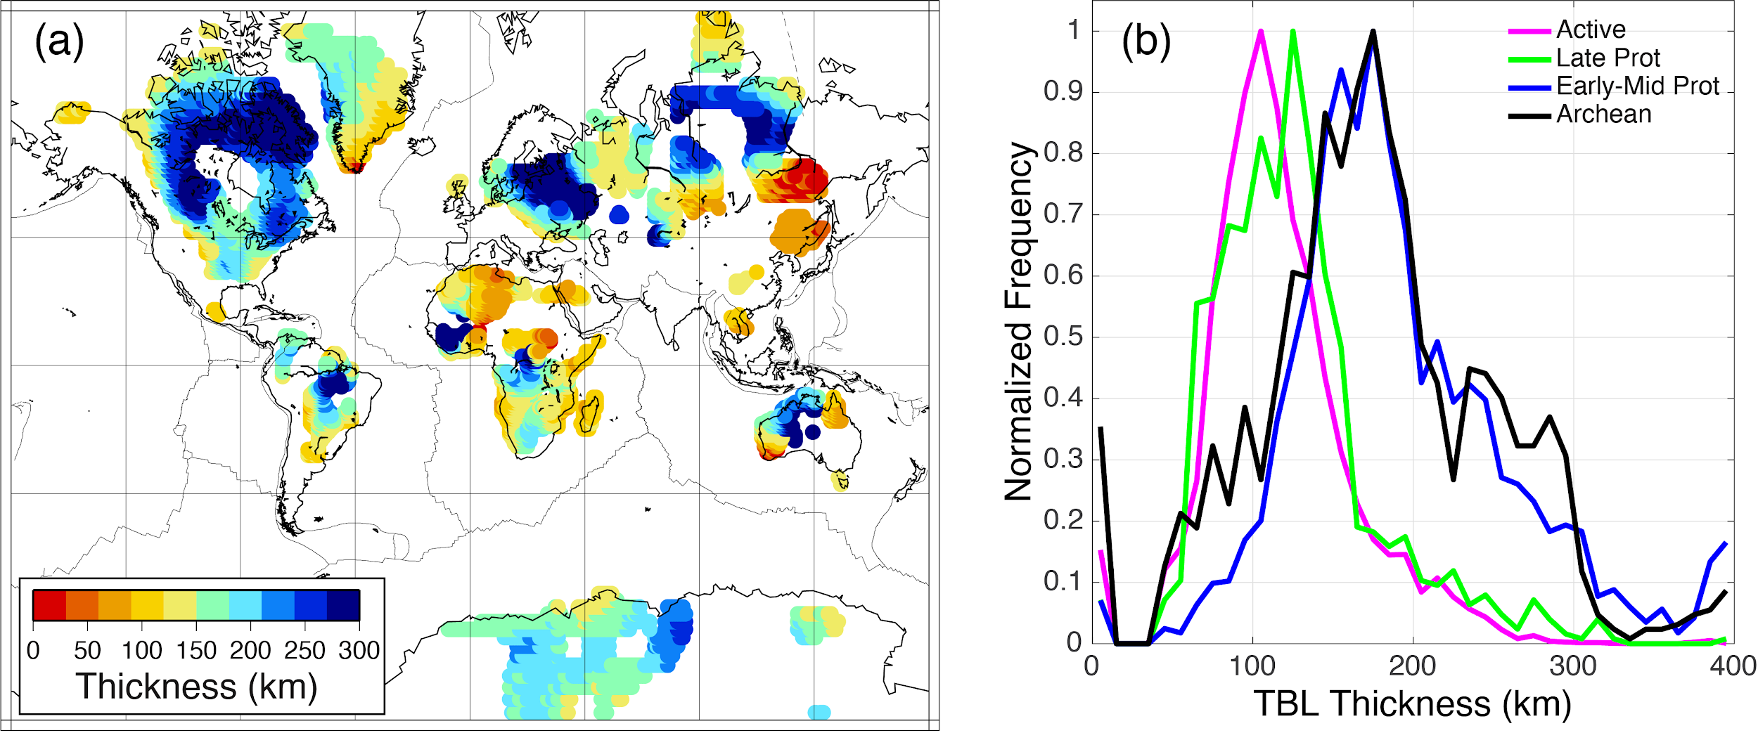

Figure 7. From Dalton et al. (2017). a) Map of thermal boundary layer thickness determined from global Rayleigh wave attenuation data for the continental lithosphere in regions of Archean and Proterozoic crust. Blank regions correspond to either younger crust or to Precambrian regions where fits between thermal models and attenuation structure did not meet misfit criteria. b) Distributions of thermal boundary layer (TBL) thickness globally averaged for different crustal ages.

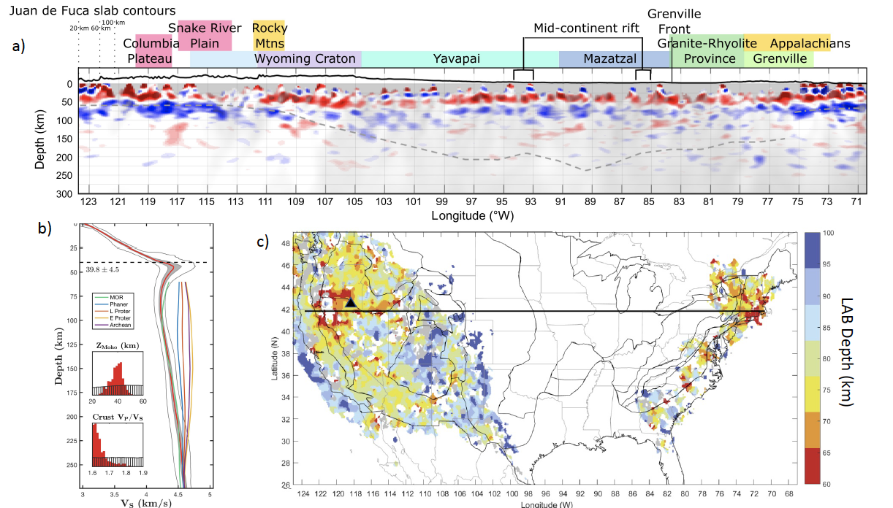

Figure 8. a) From Hopper and Fischer (2018). E-W profile across the U.S. at 41.8˚N showing the mean of a bootstrapped Sp common conversion point stack (4-100 s). Grey dashed lines: LAB estimate from Cammarano and Guerri (2017) geotherms, where the base of the lithosphere is defined by the contour at 1132°C (as in Steinberger and Becker, 2018). The eastern margin of thick cratonic lithosphere was estimated from regional tomography (Wagner et al., 2018; Pollitz and Mooney, 2016). East of this point a dot-dashed grey line marks possible LAB depth from the Sp CCP stack. Grey overlay grades from completely transparent to completely opaque with decreasing log₁₀(sampling). Cross sections are plotted at 2x vertical exaggeration. Topography is plotted at 10x vertical exaggeration. b) From Eilon et al. (2018). Shear-velocity model for station WVOR in Oregon, obtained by transdimensional hierarchical Bayesian inversion of Rayleigh wave phase velocities and Sp and Ps converted waves. Red lines: average model. Grey lines: 2σ bounds. Insets show posterior (red) versus prior (white) estimates for Moho depth and crustal V_{p}/V_{s} ratio. Overlaid lines show shear velocities from global model SEMum2 (French et al., 2013) averaged by age of the continental crust (Phanerozoic, Late Proterozoic, Early-Mid Proterozoic, Archean) and beneath 0-25 Myr seaﬂoor. c) From Hopper and Fischer (2018). Colors indicate the depth of the LAB velocity gradient measured from the Sp common conversion point stack. The LAB depth is defined as the deepest local Sp phase indicative of a negative velocity gradient with depth, if that velocity gradient is within 20 km depth of the tomographically estimated LAB depth (Cammarano and Guerri, 2017; Wagner et al., 2018). Black line shows the location of the profile in (a). Black triangle shows the location of station WVOR in (b).
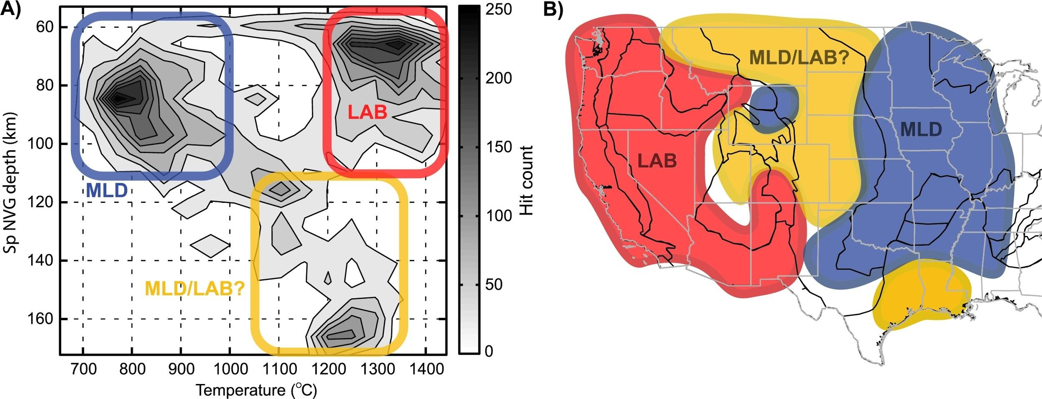

Figure 9. From Hansen et al. (2015). Thermal classiﬁcation of negative velocity gradients observed in a Sp receiver function stack. a) The mantle temperature (inferred from seismic velocities) at each negative velocity gradient pick is plotted as a depth–temperature histogram; thermal classiﬁcations are labeled. b) The approximate geographic distribution of the classiﬁed negative velocity depths in (a). The modal peak at 1345˚C and 66 km depth is largely from the thin lithosphere regions of the western U.S. and is interpreted as the LAB. The peak at 770˚C and 84 km depth occurs in the thick lithosphere regions in the central U.S. and is interpreted as MLD. A third smaller peak near 1230˚C and 165 km depth is interpreted as deep MLD beneath the northern Rockies and Plains.

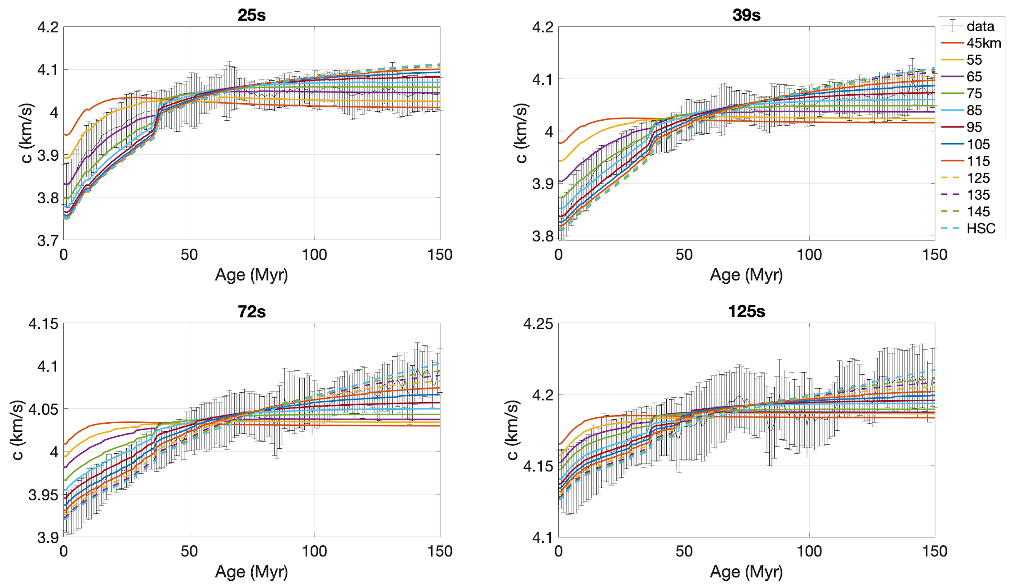
Figure 10. Comparison of observed (error bars) and predicted (colored lines) phase velocities for the Pacific Ocean at four periods (25 s, 39 s, 72 s and 125 s). Observed phase velocities are sampled from the GDM52 phase velocity maps of Ekström (2011) in 11,586 1ºx1º cells. Predictions are shifted to have the same median velocity over the age range 0-150 Myr to compare to the observations. Error bars show the median phase velocity, determined in a sliding 2-Myr-wide age bin, with height equal to twice the standard deviation. These predictions are based on plate cooling thermal models with a mantle potential temperature of 1350˚C and a grain size of 10 mm for the anelastic calculation. Different colors correspond to different assumptions about the asymptotic plate thickness, including the end-member case of half-space cooling (HSC).

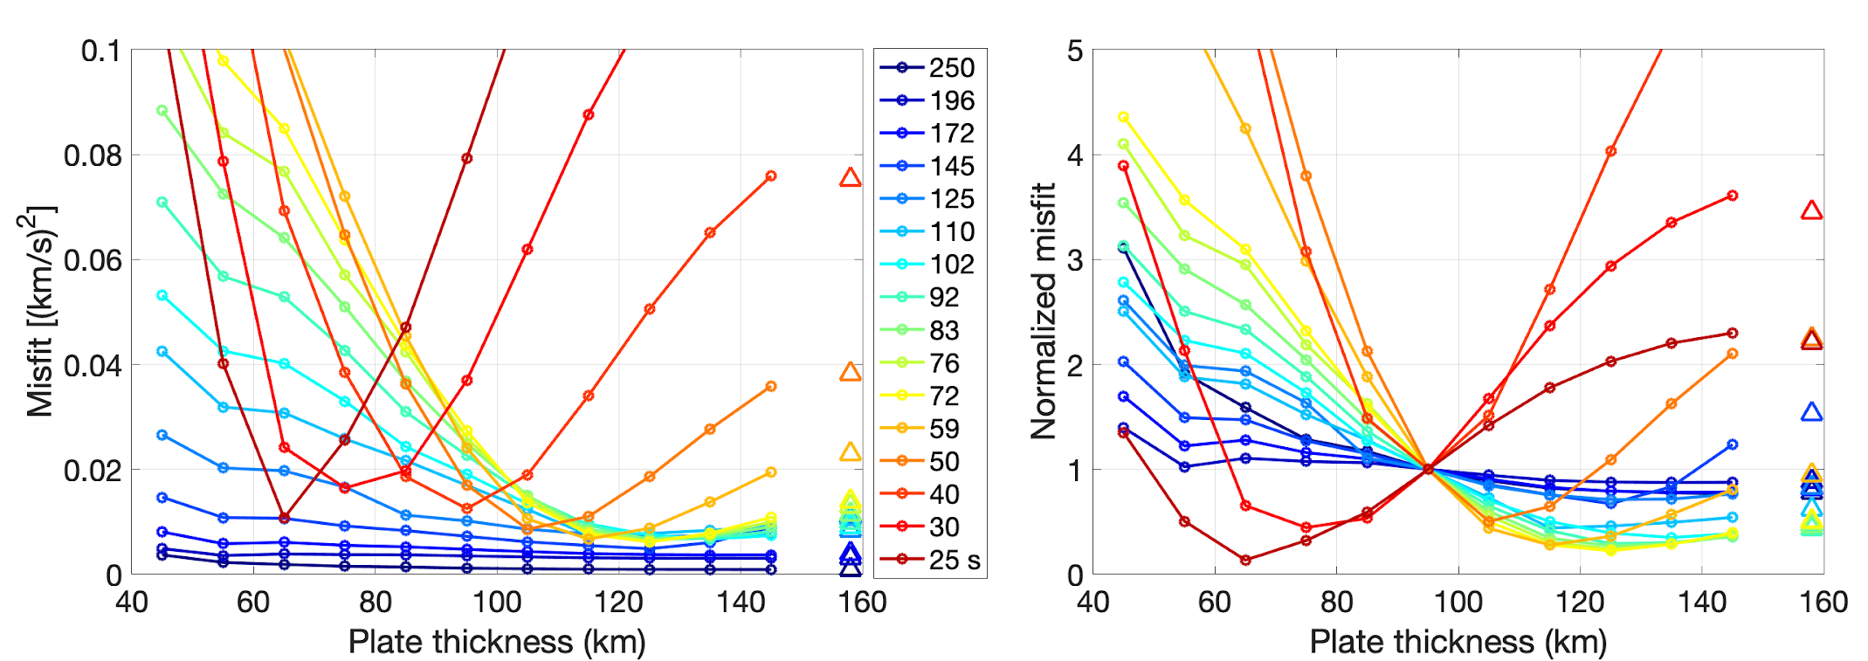
Figure 11. Misfits between predicted and observed phase velocities, where the median observed velocity in a sliding 2-Myr-wide age bin is used. Misfit is defined as the sum over the age range 35-150 Myr of the squared difference for a given period (line color) and plate thickness (horizontal axis). (Left) Total misfit between predicted and observed phase velocities. (Right) As in (left) but here misfit at each period has been normalized by its value for a 95 km plate thickness. Triangles show misfit for HSC. All models assume a mantle potential temperature of 1350˚C and a grain size of 10 mm.

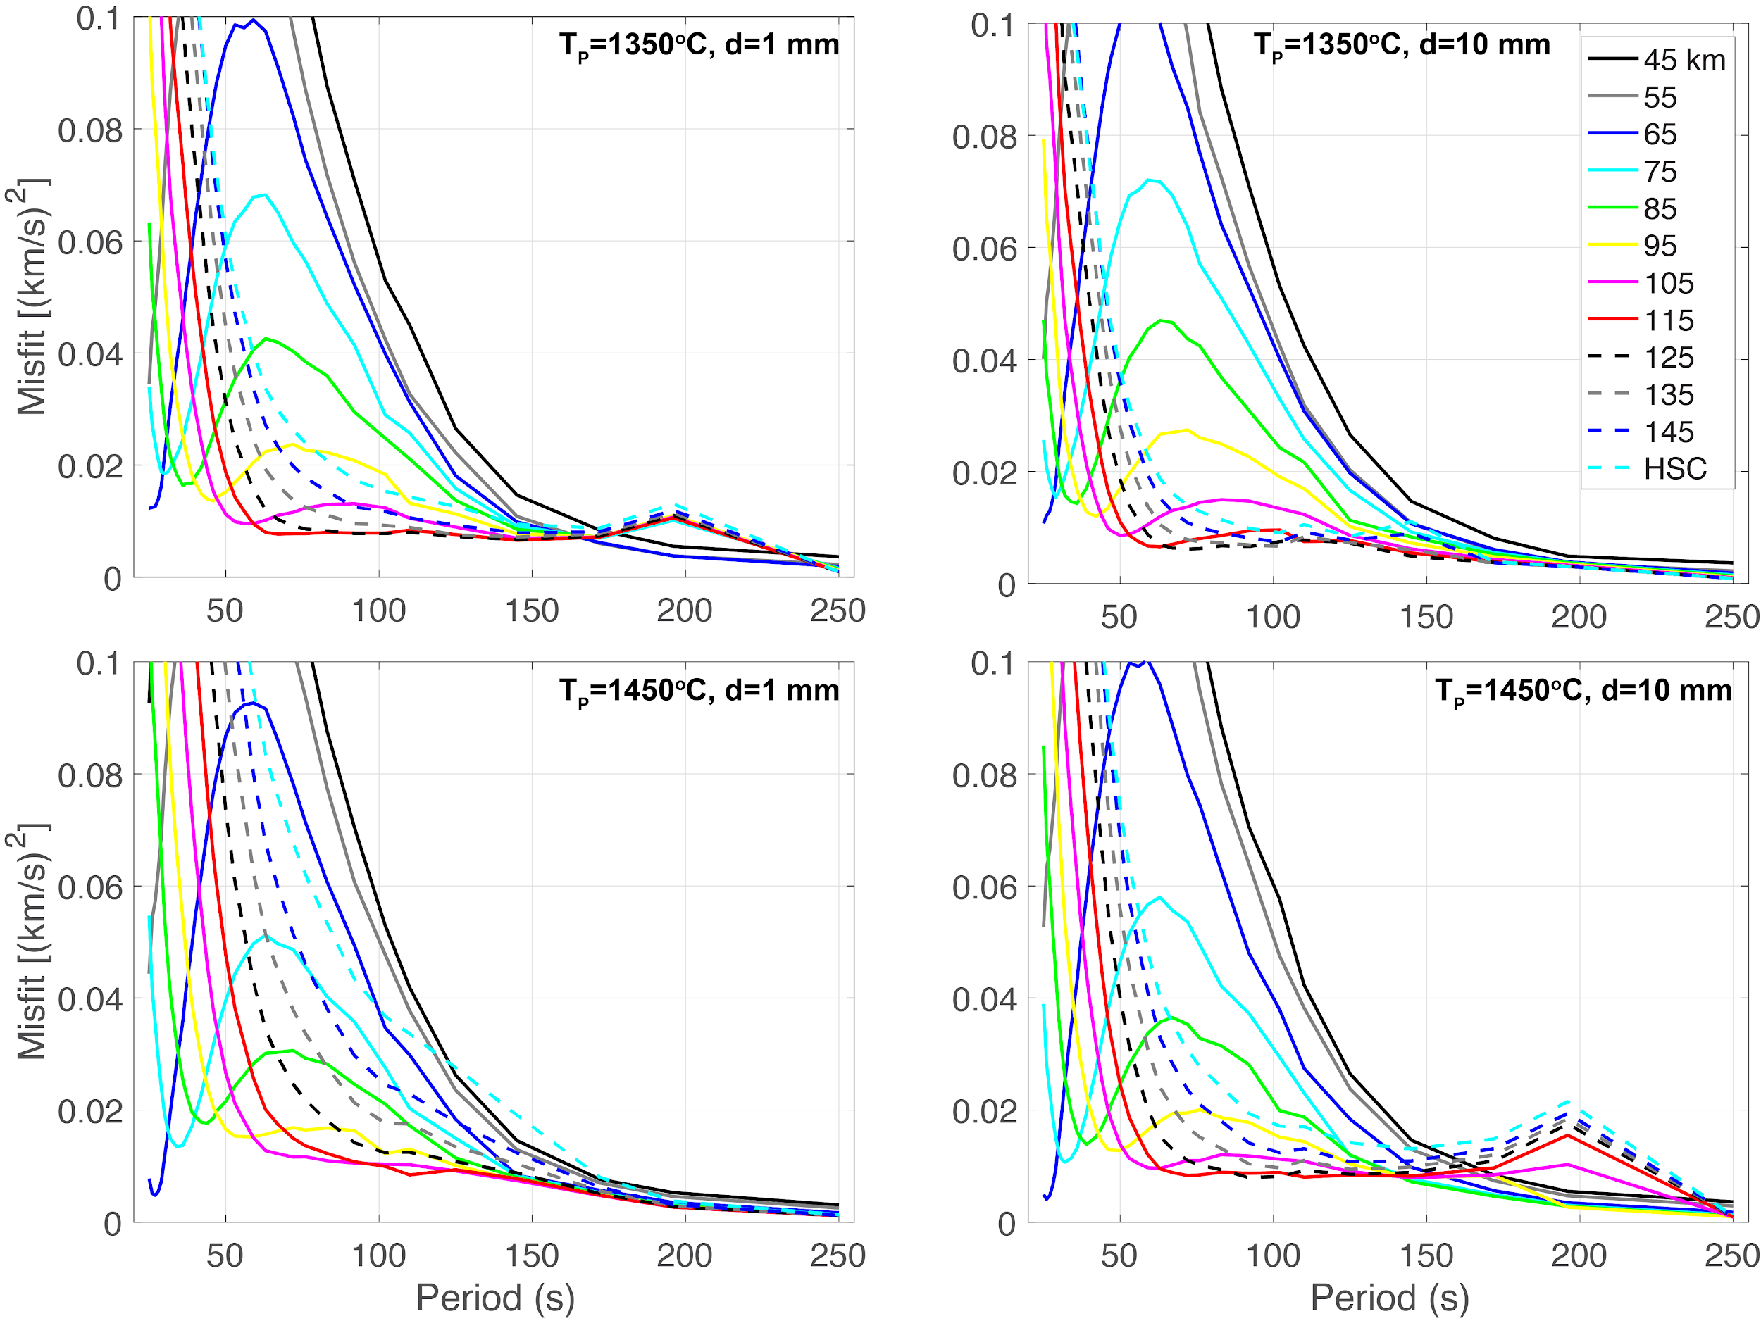
Figure 12. Misfit versus period for models with: (upper) 1350˚C and (lower) 1450˚C mantle potential temperature with (left) 1 mm grain size and (right) 10 mm grain size. Different colors correspond to different assumptions about the asymptotic plate thickness, including half-space cooling (HSC). Misfit is calculated as in Figure 11.

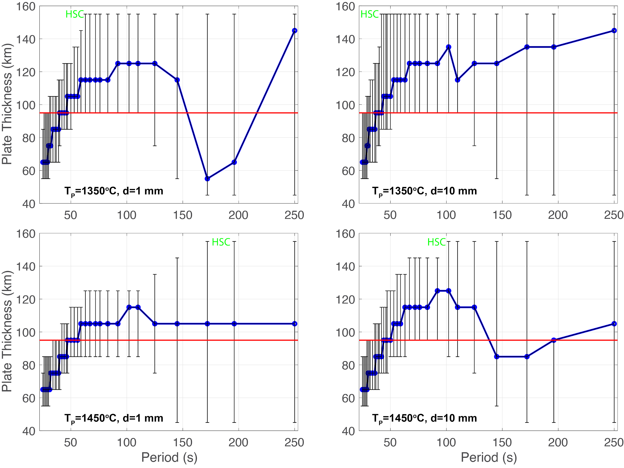
Figure 13. Best-fitting asymptotic plate thickness as a function of Rayleigh wave period for 35-150 Myr-old lithosphere. Results are shown for thermal models with: (upper) 1350˚C and (lower) 1450˚C mantle potential temperature with (left) 1 mm grain size and (right) 10 mm grain size. Blue curve shows plate thickness corresponding to the minimum misfit at each period. Error bars show the range of plate thickness for which predicted phase velocity falls within one standard deviation of the observed median value (e.g., Fig. 11). For plotting purposes only, results for half-space cooling are shown as plate thickness = 155 km. In all cases, plate thicknesses of 85-95 km overlap the confidence limits. Results for ages limited to 0-70 Myr-old lithosphere are very similar.
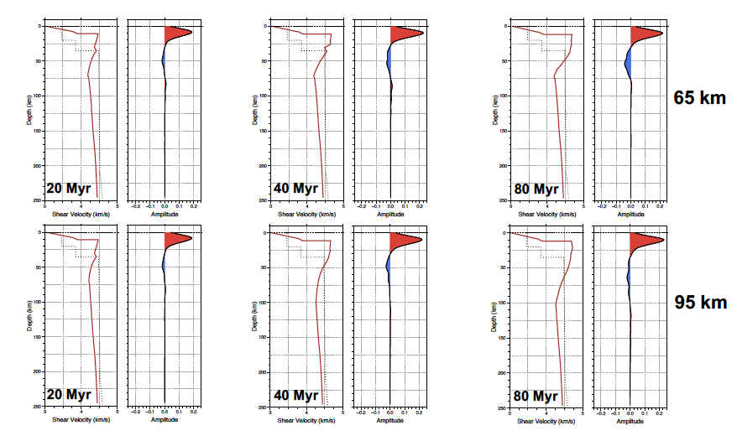
Figure 14. In each pair, plots show shear velocity models predicted by asymptotic plate thicknesses of 65 km and 95 km, seafloor ages of 20 Myr, 40 Myr, and 80 Myr, an asthenospheric temperature of 1350˚C, and a 10 mm grain size. Dotted lines show the AK135 reference model (Kennett et al., 1995). Plots on right show Sp receiver functions assuming a dominant period of 8 s, a bandpass filter from 100 s to 2 s, and time domain deconvolution (Ligorria and Ammon, 1999) with a 0.8 s Gaussian. The polarity of the Sp phases has been reversed to agree with the Ps convention, where positive phases correspond to velocity increases with depth, and negative phases show velocity decreases with depth. The large red (positive) phase corresponds to the oceanic Moho, and the blue (negative) arrival beneath it is from the LAB velocity gradient. The effects of sediment and water layers are ignored by replacing them with basement velocities. Depth in these plots is measured from the sea surface. LAB phases for 40 Myr and for the 65 km plate model at 80 Myr are large enough to be potentially observable. LAB amplitudes for other conditions are too small and would likely be swamped by noise in real data.
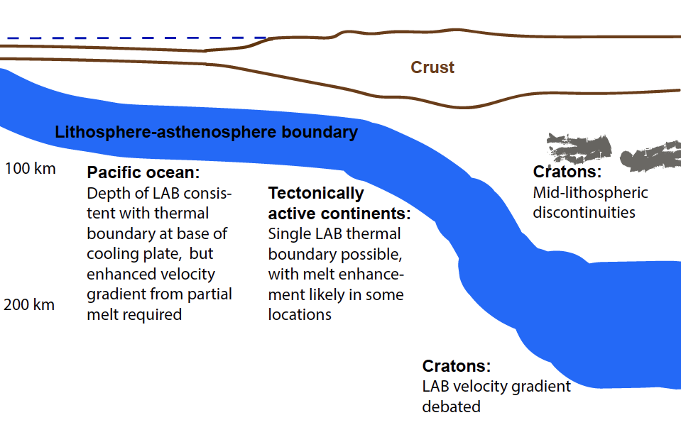
Figure 15. Schematic figure showing interpretation of LAB properties that are consistent with constraints from Rayleigh waves and converted and reflected body wave phases.

