Title: Growth of marine ectotherms is regionally constrained and asymmetric with latitude
Running Title: Global growth of marine ectotherms

Adam J. Reed¹, Jasmin A. Godbold¹, Laura J. Grange², Martin Solan¹
^{1.} School of Ocean and Earth Science, National Oceanography Centre Southampton, University of Southampton, European Way, Southampton, SO14 3ZH
^{2.} School of Ocean Sciences, Bangor University, Bangor, Gwynedd, LL57 2DG

ORCID ID
AJR, 0000-0003-2200-5067; JAG, 0000-0001-5558-8188; LG, 0000-0001-9222-6848; MS, 0000-0001-9924-5574

Corresponding Author: Adam Reed (adam.reed@noc.soton.ac.uk)
Keywords: macrophysiology; biogeography; physiology; climate change; resource management

Biosketch
Adam J. Reed has a background in reproduction and growth of marine invertebrates and specialises in polar and deep-sea environments. His research at the University of Southampton UK, investigates reproductive and physiological plasticity of a range of invertebrate taxa in polar and temperate regions, across wide biogeographic areas, and in response to environmental change. He is currently involved in long-term studies investigating changes in the reproduction and growth of molluscs from different locations in the Antarctic and across the Arctic polar front.

Author Contributions
AJR conceived the idea and extracted the data for analysis. JAG, AJR and MS analysed the data and AJR and JAG produced the figures. AJR wrote the manuscript and MS, JAG, and LG and reviewed and provided critical commentary on the manuscript prior to submission.

Acknowledgments
Supported by “The Changing Arctic Ocean Seafloor (ChAOS) - how changing sea ice conditions impact biological communities, biogeochemical processes and ecosystems” project (NE/N015894/1 and NE/P006426/1, 2017-2021) funded by the Natural Environment Research Council (NERC) in the UK.

Title: Growth of marine ectotherms is regionally constrained and asymmetric with latitude

Running Title: Global growth of marine ectotherms

Abstract
Aim
Growth rates of organisms are routinely used to summarise physiological performance, but the consequences of local evolutionary history and ecology are largely missed by analyses on wide biogeographic scales. This broad approach has been commonly applied to other physiological parameters across terrestrial and aquatic environments. Here, we examine growth rates of marine bivalves across all biogeographic realms, latitude, and temperature, with analyses to determine regional effects on growth on global scales.
Location
Global: Marine Ecosystems
Time Period
1930–2018
Major Taxa
Bivalves
Methods
We use a comprehensive data-set of bivalve growth parameters (n=966, 243 species) representing all biogeographic realms to calculate overall growth performances. We use these data with environmental temperature to analyse global patterns in growth, accounting for regional primary productivity and phylogeny using general additive mixed and linear models. The Arrhenius relationship and corresponding activation energies are used to quantify the sensitivity to temperature in each biogeographic realm and province.
Results
Our analyses show that bivalve growth demonstrates latitudinal asymmetry and exhibits non-linear relationships with latitude. We find that overall growth performance is affected by temperature and particulate organic carbon, but the form of these relationships differ with phylogeny. Growth is slower and more sensitive to increasing temperature in the Antarctic than it is in the Arctic, and decrease with increasing temperature in some tropical realms, a previously unidentified and fundamental difference in growth and physiological sensitivity.
Main Conclusions
Our findings provide compelling evidence that the widely used curvilinear relationship between temperature and growth rates in marine ectotherms is an inappropriate descriptor of thermal sensitivity, because it normalises regional variations in physiological performance. Without a more detailed assessment of global physiological patterns, the responses of species to local variations associated with climate change will be under-appreciated in global assessments of climate risk, minimising the effectiveness of management and conservation.

Keywords: biogeography, climate change, growth, macroecology, physiology, regionally constrained, resource management

Introduction
Air and sea temperatures are rising globally, and modelled projections indicate that this trend will continue leading to significant risks of extinction in terrestrial and aquatic systems (Thomas et al., 2004; Urban, 2015), that are likely to disproportionately affect ectothermic (Deutsch et al., 2008; Ohlberger, 2013) and marine organisms (Pinsky, Eikeset, McCauley, Payne, & Sunday, 2019). However, global warming is not uniformly expressed (Brierley & Kingsford, 2009; Seneviratne et al., 2018), and observed ecological responses often reflect the thermal range and physiology of species (Burrows et al., 2011; Hoegh-Guldberg & Bruno, 2010; Root et al., 2003) rather than the expectation derived from the pooling of laboratory based studies that focus on acute thermal shock response (Peck, Webb, & Bailey, 2004; Pörtner, 2001). Further, some fundamental physiological assumptions, such as variation in lifespan (Moss et al., 2016), metabolic rates (Heilmayer, Brey, & Pörtner, 2004), growth (Pörtner, Storch, & Heilmayer, 2005), and acclimation capacity (Seebacher, White, & Franklin, 2014) over wide geographical ranges are based on data with poor spatial resolution and/or are fitted with curvilinear models that do not adequately account for variation in regional environmental conditions. However, incorporation of local processes is vital, as environmental history and setting affects how individuals respond to altered environmental conditions (Calosi, De Wit, Thor, & Dupont, 2016; Gladstone-Gallagher, Pilditch, Stephenson, & Thrush, 2019; Deutsch, Penn & Seibel, 2020; Spence & Tingley, 2020) and affect ecosystem functioning (Godbold & Solan, 2013; Wohlgemuth, Solan, & Godbold, 2016).
The Arrhenius relationship defines how increasing temperature accelerates metabolic processes by speeding up reaction rates (Clarke, 2017), and derived activation energies quantify the sensitivity of the response measured (Peck, 2018). This relationship of log rate against inverse temperature produces a straight line, and is often used to fit the latitudinal temperature gradient to facilitate understanding of whole animal physiology (Heilmayer, Brey & Pörtner, 2004; Peck, 2018), yet departures from the projected relationship have been identified (Peck, 2016) and have typically been explained by constraints imposed by subtle ecological distinctions (Deutsch et al., 2008), evolutionary history (Moss, Ivany, Silver, Schue, & Artruc, 2017), or molecular constraints (Peck, 2016). These deviations are integral to the determination of relevant ecosystem responses to climate change (Godbold & Solan, 2013), and are especially important in regions where human well-being is highly dependent on ecosystem services (van der Schatte Olivier et al., 2018).
Measuring physiological variation across large spatial scales provides a definitive means to understand species-specific physiological responses to a dynamic environment, but is logistically challenging and not commonly achieved in aquatic systems (Osovitz & Hofmann, 2007). A pragmatic alternative is to use growth rates in natural populations (Reed, Linse, & Thatje, 2014) and, as growth is a trade-off with metabolic rates and reproduction, it represents a reasonable approximation of whole animal physiology (Clarke, 2003; Pörtner et al., 2001). Here, we use overall growth performance (OGP, the point of inflection in a von Bertalanffy growth curve; Brey, 1999) in marine bivalves to quantify growth constraints between biogeographical realms. Marine bivalves are globally distributed and their growth is integrated within their shells (Moss et al., 2016). OGP is preferential to the more frequently used growth constant (k) as it takes into consideration the theoretical maximum shell length of individuals, allowing comparisons between taxa (Brey, 1999). By calculating activation energies in biogeographical realms we quantify the thermal sensitivity of regional growth and identify realms at greater risk to projected temperature change based on how local species growth differs across local temperature ranges. We anticipate that regional disparities will expose a fundamental misunderstanding of physiological responses in regions at the upper and lower thermal limits of these species, especially where previous efforts have pooled data or not taken into account evolutionary history or unique local ecologies. By exploring the spatiotemporal distribution of physiological characteristics across the globe (Osovitz & Hofmann, 2007), physiological projections within distinct regions can be determined (Chown, Sinclair, Leinaas, & Gaston, 2004; Pörtner & Knust, 2007; Somero, 2010), shifting paradigms that are likely to benefit conservation and management efforts (Stuart-Smith, Edgar, Barrett, Kininmonth, & Bates, 2015).
Methods
We searched the Thomson Reuters Web of Science collection (http://www.webofknowledge.com, accessed July, 2019) using the search terms “(“bivalve”, “growth”, and “von Bertalanffy”)” in the titles, keywords and abstracts of all document types from 1950-2018. Further relevant publications were obtained by manually checking references cited by the authors of the returns from our search. We excluded all publications that were based on data from cultured or artificially reared populations, but data from PhD theses or ‘grey literature’ were included after critical examination of the methodology to ensure consistency with published growth parameters. A list of the data sources is found in Appendix S1.
Growth data
Citation returns were manually searched for reported values of parameters of growth from von Bertalanffy growth functions (k, L∞, and, if possible, L_{T}). A total of 429 peer-reviewed publications revealed 966 growth parameters for 243 species of bivalve from 143 Genera, 44 families and three subclasses (Reed et al. 2020). As well as taxonomic information, geographical location, depth, and temperature were extracted when available (see Environmental Data). When the location of a study was not provided, latitude and longitude coordinates and/or water depth were retrieved from Google Earth (http://earth.google.com/) and manually cross referenced with site descriptions within the source publication. Taxonomy was verified and updated to latest classification using the World Register of Marine Species (WoRMS Editorial Board, 2020)
Where specific size-at-age values were not presented in the original publication and had to be derived, values were extracted from graphical summaries using Web Plot Digitiser (https://automeris.io/WebPlotDigitizer/). We determined the required growth data using these data by applying the von Bertalanffy model as described by Brey 1999:
L_{t}=L∞(1-e^{-k(t-to)})

where k is the growth constant and L∞ is the asymptotic length.
In contrast to previous publications on global growth data, we were able to calculate Overall Growth Performance (OGP) as we only included publications with growth parameters from a von Bertalanffy growth curve. Previous global studies comparing growth have only used single parameters directly derived from the growth curve and typically use k (The Brody growth coefficient) as a measure of growth between species (Moss et al., 2016; Peck, 2016). However, growth is non-linear and it is not appropriate to compare growth using single parameters from the growth function in a statistical analysis (Brey, 1999). OGP derived from the Bertalanffy growth function makes growth comparable between populations and species by removing individual variation and is defined as the point of inflection on the Bertalanffy growth curve (Brey, 1999). Overall Growth Performance is calculated from the equation:

OGP = log(k L∞)
Environmental data
When temperature data was not reported, bottom water temperatures were extracted from Ocean Data View v. 5.1.0 and the World Ocean Atlas 2013 database (Locarnini et al., 2013) at a resolution of 0.25 degrees and using coordinates from the corresponding paper. We only used recorded bottom temperatures and not sea surface temperatures which are commonly used in global marine studies, as the bottom temperatures are more representative of the benthic environment.
OGP data was grouped based on Spalding’s classification of biogeographical latitude zones, realms, and provinces (Spalding et al., 2007). While all biogeographic realms are represented in our data-set, provinces with no samples are not included in our maps and are shown as data deficient gaps. Unlike previous studies examining physiological patterns across wide geographic areas, we differentiate OGP between the different biogeographical latitude zones, realms, and provinces which allows a higher resolution and critical examination of regional OGP.
POC flux to the seafloor, a proxy for food availability, was derived by applying a vertical flux attenuation equation to satellite-derived export fluxes. The export flux is calculated from satellite-derived primary production (Carr, 2001) and sea surface temperature using the relationship defined in Henson et al. (2011). Flux attenuation is described by "Martin's b" parameter (Martin et al., 1987) and is estimated globally using a collation of deep moored sediment trap data as described in Henson et al. (2012). Seafloor depth is taken from the ETOP01 global relief model (Amante and Eakins, 2009). All data are spatially averaged onto a 1x1 degree grid prior to analysis. POC flux to the seafloor (in gC m⁻² yr⁻¹) is extracted from the global data at each sample location using a nearest neighbour approach. The POC flux to seafloor could not be estimated at several shallow shelf locations due to the limitations of satellite-derived data and the flux model in very shallow waters. In these instances, the nearest geographical point (linear Euclidean distance) with data was supplemented.
Arrhenius Relationship
The Arrhenius relationship relates chemical reaction rates to temperature, and is expressed by;
$k=Ae(\frac{-Ea}{RT})$
Where k is the rate constant, R is the gas constant, T is absolute temperature, and E_{a} is the activation energy. Physiological processes have been proven to respond predictably by following the Arrhenius relationship within normal biological temperature ranges (Clarke & Johnston, 2003; Heilmayer et al., 2004). We calculate activation energies (ev) from the linear relationship between absolute temperature and overall growth performance to represent the sensitivity of OGP to temperature. These values can be used to directly compare biological reaction rates and processes such as growth. For biological processes activation energies can range between 0.2 and 1.2ev (Gillooly, Brown, West, Savage, & Charnov, 2001) but usually vary between 0.6 and 0.7ev (Dell, Pawar, & Savage, 2011).
Statistical data analysis
To determine the direction and significance of the relationship between OGP and latitudinal zone between Realms, we used a generalised additive model (GAM) with a Gaussian distribution using “REML” estimation. We further account for regional differences in temperature and primary productivity (POC gC m⁻² yr⁻¹; ln transformed) and test for any differences in growth rates of related species occurring at similar temperatures but in different regions (Subclass, 2 levels: Heterodonta and Pterimomorphia; the subclass Protobranchia (9 observations) were excluded from the analysis). To investigate the relationship between OGP, temperature and ln(POC) we used a Generalized Additive Mixed Model (GAMM) incorporating the factor “Realm” as a random effect. To estimate the optimal amount of smoothing in both analyses (s(latitude) and s(temperature), s(ln(POC)) we used cross-validation (Zuur, Ieno, Walker, Saveliev, & Smith, 2009; Zuur, Saveliev, Ieno, 2015) followed by optimisation of k following Wood et al. (2017). Smoothers for Latitude and ln(POC) were fitted with cubic spline regression (cs), whilst the smoother for temperature was fitted with thin plate regression (tp). For both analyses final best models were based on Akaike Information Criterion (AIC) and residual fits were examined (Zuur, Saveliev, Ieno, 2015; Wood et al. 2017). Predicted values and 95% Confidence Intervals of final models were determined and fitted following Zuur, Saveliev & Ieno (2015).
To determine the importance of latitudinal zone and the Arrhenius model on ln(OGP) we developed an ANCOVA model containing latitudinal zone as a nominal explanatory variable with 4 levels (Antarctic, Arctic, Temperate and Tropical) and the Arrhenius model represented by inverse temperature (Kelvins) as a continuous explanatory variable. We visually assessed model assumptions (homogeneity of variances and normality) which revealed patterns in the residual spread. To model the heteroscedasticity in the variance structure we incorporated the variable “latitude” as a variance covariate using varIdent (Pinheiro & Bates, 2000).
Latitude and longitude coordinates of the individual data points were used to visually assess the effects of spatial autocorrelation using bubble plots (Pebesma & Graeler 2019) and variograms (Zuur et al., 2009). Analyses were conducted in R (R Development Core Team 2018) using the “nlme” library for the extended linear model (Pinheiro, Bates, DebRoy, & Sarkar, 2018), the “mgcv” library for the additive (mixed) models (Wood, 2019) and “gstat” for investigating spatial autocorrelation (Pebesma et al., 2019).
Results
We established 966 measurements of bivalve growth parameters spanning 243 species and representing all 12 biogeographic realms. Measurements of overall growth performance (OGP) ranged from 0.01 to 2.68 and extended from 80 °N to 77 °S and from 176 °W to 175 °E. Depth was rarely reported in the literature, however most growth measurements were from species known from the coast or shelf (<200 m) regions with 8 species specifically reported from deeper waters (250 – 4600 m) and no observations from hadal depths. The distribution of data corresponds mostly to the Temperate North Atlantic Realm, (n = 367), followed by the Temperate North Pacific (n = 173) and Temperate South America (n = 148) Realms, and indicates that most observations emanate from the northern hemisphere (73.3%). Temperate Latitude Zones are highly represented (n = 737), followed by Tropical (n = 124) and Polar (n = 105) Latitude Zones.
Using these data, our analyses reveal that OGP in marine bivalves increases with decreasing latitude and, for the first time, we show that the form of this relationship is non-linear (GAM, edf= 8.651, F = 13.927 p<0.0001, Figure 1a) and that OGP differs between Realms (GAM, F = 10.13, p <0.0001, Figure 1b). Specifically, we find that there is an increase in mean OGP in the North Atlantic above 50°N driven by species in the Northern European Seas, whilst the Mediterranean Sea is characterised by lower mean OGP (1.14 ± 0.31 , Figure 1c, Figure S2.1). In the Southern Hemisphere, the highest mean OGP (± 95% CI) is observed in the tropical regions of the Central and East Indo-Pacific (1.93 ± 0.16 and 1.67 ± 0.20, respectively), decreasing towards the temperate realms and into the Southern Ocean (0.57 ± 0.17). In the Northern Hemisphere, the results indicate a second peak in OGP (Figure 1a) at around 50°N in the Temperate North Pacific and North Atlantic realms. Between latitudinal zones, mean OGP (± 95% CI) was lowest in the Antarctic and Arctic (0.575 ± 0.173 and 0.930 ± 0.073, respectively) and highest in Tropical areas (1.569 ± 0.078) (Figure 1a), albeit influenced by a high mean OGP in the Central and East Indo-Pacific realms (Figure 1b).
Our analyses confirm a positive relationship between temperature and decreasing latitude (Figure S2.2). Whilst OGP increases with temperature (GAMM, edf=7.821, F = 14.21, p<0.0001), we find a non-linear, stepwise relationship (Figure 2a) that broadly corresponds to Polar (-2 to 6°C), Temperate (7 to 17°C), and Tropical (18 to 27°C) latitudinal zones. Furthermore, the requirement to incorporate Realm as a random effect confirms the important role of biogeographical divisions in determining temperature dependent OGP. We found that particuate organic carbon levels are highest in temperate latitude zones and overlap with the Arctic, whilst are low throughout the Antarctic and tropical areas (Figure S2.3), but that the shape of the relationship between OGP and ln(POC) differs between the two Subclasses of bivalves and is only significant for the Pteriomophia (ln(POC) : Pteriomorphia: edf = 5.9, F = 10.142, p<0.0001; Heterodonta: edf = 1, F = 1.506, p = 0.22). For the Pteriomophia (8 families, n = 408) there is a peak in OGP at intermediate levels of ln(POC), whilst for the Heterodonta (29 families, n = 549) there is no difference in OGP with changing ln(POC) (Figure 2b). Overall, OGP is significantly higher in the Pteriomorphia (mean = 1.409 ± 0.047, n = 407) than the Heterodonta (mean = 1.228 ± 0.032, n = 550; GAMM, t = 11.55, p <0.0001; Figure 2c., Figure S2.4; S2.5).
We fitted an Arrhenius model using inverse temperature (1000/T in Kelvins) and ln(OGP), and their interaction, to test OGP against the expected physiological relationship with temperature (Figure 3a) We find that ln(OGP) is positively affected by the independent effects of latitude (GLS, L. ratio = 33.561, d.f. = 1, p < 0.0001) and inverse temperature (GLS, L. ratio = 31.967, d.f. = 3, p < 0.0001), but deviate from the expected relationship in the Antarctic at temperatures <0°C (Figure 3b). The activation energies which quantify the Arrhenius relationship within each biogeographical Latitudinal Zone and Realm (Figure 4) reveal high sensitivity to temperature in the Antarctic Latitude Zone (0.987 ev) and low sensitivity across the Tropical Latitude Zone (0.035 ev) (Figure 4a; Figure S2.6). However, between the biogeographical realms the heterogeneity within tropical and polar zones becomes more apparent, with values between -0.770 ev and 0.987 ev (Figure 4b; Figure S2.7). These data show a negative relationship of OGP with increasing temperature in East Indo-Pacific, West Indo-Pacific, Tropical Pacific and Temperate Australia, indicating reduced growth in species in these regions with increasing temperatures, while all temperature and polar biogeographic realms show a positive relationship with temperature.
Discussion
This global database of overall growth performance (OGP) in marine bivalves confirms that growth increases with decreasing latitude (Moss et al., 2016; Pörtner, Storch, & Heilmayer, 2005), but we reveal that the form of this relationship is non-linear and depends on biogeographical context. Latitudinal variation of physiological parameters has previously been associated with seasonality and genetic adaptations to a specific temperature range (Yamahira & Conover, 2002), although temperature dependent hypoxia may also have a major role in determining biogeographical patterns (Deutch, Penn, & Seibel, 2020). Regional disparities observed here can, however, be linked to specific circumstances; for example, the lower mean OGP found in the Mediterranean is likely related to growth limitation through lower food availability in this largely oligotrophic region (Siokou-Frangou et al., 2010), a view supported by laboratory experiments on bryzoans (Svensson & Marshall, 2015) and Antarctic bivalves (Román-González et al., 2017). Such observations emphasise that, whilst deviation from the global mean can form an important means of determining local effects that are driven by subtle ecological variation, spatial analysis of a larger biogeographical range can highlight variation in physiological characteristics otherwise invisible in studies conducted over smaller scales (Chown, Gaston, & Robinson, 2004; Parmesan & Yohe, 2003). This is important as unique local environmental chracteristics and history may have a greater affect than previously recognised when data has been pooled from perceived identical environments.
Whilst our analysis confirms that overall growth performance at lower temperature deviates from the expected thermodynamic relationship (e.g. Peck, 2016), we identify a critical difference between Arctic and Antarctic environments that has not been previously recognised or distinguished (Heilmayer et al., 2004; Peck, 2016). Specifically, when average bottom temperatures are < 0°C, the growth of Arctic bivalve species are consistent with physiological expectations, whereas the growth of Antarctic bivalve species deviates below the expected relationship. The only exception to this pattern is the Antarctic scallop Adamussium colbecki which remains within expectation and uplifts mean OGP in the Southamern Ocean while increasing variability. Higher OGP in A. colbecki most likely reflects a species specific adaptation in shell morphology that has been driven by evolutionary history at cold temperatures (Berkman et al. 2004; Watson et al. 2017; Dell’Acqua et al. 2019). This revelation is striking, because A. colbecki is routinely used as a model species for physiological studies in the Antarctic (Moro et al., 2019), meaning that a priori assessments of the physiological responses of polar ecosystems to climate warming may underestimate species vulnerability in the Antarctic whilst overestimating species vulnerability in the Arctic. Further, differences in growth performance between subclasses are likely to be reflected in their overall physiology (Pörtner et al., 2001); the subclass Pteriomorphia contains fewer, but larger, families, which include commercially valuable species (van der Schatte Olivier et al., 2018), such as Mussels (Mytillidae), Oysters (Ostreidae), and Scallops (Pectinidae), which may dominate regional assessments of physiological fitness. Should a high proportion of studies focus on a limited subset of regionally adapted species, or physiological typology, there is potential for model projections to perpetuate skewed conclusions about the most likely effects of climate change at larger scales (Wernberg, Smale, & Thomsen, 2012). These observations are consistent with other research in global marine environments that has shown regional and temporal differentiation in the severity and direction of effects associated with climatic forcing (Dijkstra, Westerman, & Harris, 2011; Godbold & Solan, 2013).
Although our analyses confirm a positive relationship between sea temperatures and decreasing latitude, it is important to emphasise that sea temperature is also influenced by local environmental cycles and other phenomena (e.g. depth, upwelling, El Niño) which can affect regional physiological responses. In this respect, it is noteworthy that the large degree of overlap of the Arctic and Temperate latitudinal zone reflects the boreal origins of many benthic species (Piepenburg, 2005), and that the large degree of overlap in high POC in the Arctic and Temperate regions reflects food availability to the benthos and species distribution (Solan et al. 2020). A key characteristic of the Arctic is the Atlantic influence and overlap of species distributions and physiological responses over the polar front (Piepenburg, 2005; Richard, Morley, Deloffre, & Peck, 2012), which contrasts to the Antarctic which is effectively isolated by the Antarctic Circumpolar Current from the southern Temperate Zone (Clarke & Crame, 2010) resulting in a relatively long evolutionary isolation of the Southern Ocean (Chown et al., 2015; Crame et al., 2014; Clarke, Barnes, & Hodgson, 2005). Isolation over evolutionary relevant timescales in the Antarctic has led to unique fauna and adaptations in response to low temperature (Barnes, Fuentes, Clarke, Schloss, & Wallace, 2006) which slow their biological processes beyond expectations (Peck, 2016; Peck, Heiser, & Clark, 2016). Hence, we observe greater thermal sensitivity and reduced OGP in the Antarctic relative to the Arctic (Richard et al., 2012). An important implication of this finding is that the common practice of pooling data from realms that are perceived as being similar to one another in order to overcome paucity of data is undesirable, as species responses are unlikely to be uniform across ecoregions.
The activation energies, representing all the reactions involved in the synthesis of proteins for growth, and calcification of the shell, strongly indicate that tropical realms and the Southern Ocean will be disproportionately affected by projected climate change in the 21st Century (IPCC, 2018), albeit with different population responses. A decrease in growth rate with increasing temperatures suggests that species may be beyond their thermal optimum, and is supported by theories of tropical species living close to their thermal limits (Dell, Pawer, & Savage, 2011; Amarasekare and Savage, 2012). Despite the importance of temperature however, the maximum rates of growth in an individual is unlikely to be achieved because of, for example, resource limitation (Siokou-Frangou et al., 2010) or highly seasonal food input (Zuo, Moses, West, Hou, & Brown, 2012). The regions of negative or very high activation energy in our study reflect these two environmental conditions. In the Antarctic, where temperature variations are very small, seasonality in metabolism can positively relate to food input in species of sponge (Dayton, Robilliard, Paine, & Dayton, 1974), echinoderm (Brockington & Clarke, 2001), and bryozoan (Barnes, 1995), which show faster growth and metabolic rates than expected during periods of high food availability. However, immature Southern Ocean A. colbecki show no uncoupling of metabolic rate from temperature, suggesting an ontogenetic component to relationships between somatic growth, food availability, and temperature (Heilmayer et al., 2005). The Arctic is also food limited with an observed mismatch between shell growth and body mass in the bivalves Serripes groenlandicus and Chlamys islandica before the onset of phytoplankton bloom (Blicher, Rysgaard, & Sejr, 2010; Carroll et al., 2011). Here, food quality rather than quantity is shown to be fundamental factor, and can be observed through the transition of lower quality phytoplankton to nutrient rich sea ice algae during the seasonal sea ice retreat, and a projected negative response to warming related changes in sea ice primary production in Arctic fjords (Carroll et al., 2011).
An alternative explanation to the constrained growth in Antarctic bivalves is protein synthesis, a vital process in somatic growth widely hypothesised to be limited at low or high temperatures (Dell, Pawer, & Savage, 2011; Peck, 2016). How this might be negated at low temperatures by projected warming is, however, currently unclear (Clark et al., 2019). The pathways involved in the synthesis and folding of functional proteins, generally occurs faster as temperatures increase and is widely postulated to be expensive and sensitive at low temperature (Clarke, 2017; Fraser & Rogers, 2007). However, adaptive changes within the genome can overcome protein efficiency to some extent (Chen et al., 2008). The sensitivities of growth performance to warming in the tropical and polar biogeographical realms may reflect these molecular constraints, however, research into protein function and synthesis is marine organisms is still in its infancy (Tomanek, 2011). This emerging area of research may well elucidate the molecular mechanisms behind limitations to growth in the lowest and highest temperature environments, and identify the constraints that maintain their sensitivity to temperature changes (Clark et al., 2019), especially when comparing the contrasting physiological responses from the Arctic and Antarctic realms from an evolutionary perspective (Feder, Bennett, & Huey, 2000).
Macroecological approaches to examine growth rates of important marine ectotherms, as used here, form an essential link between laboratory experiments and appropriate regionally adjusted assessment of risk (Chown, Gaston, et al., 2004; Chown, Sinclair, et al., 2004). The non-linear relationship of OGP with temperature and latitude suggests that other ecological and phylogenetic constraints will exist across a latitudinal gradient and between ecological realms (Parmesan & Yohe, 2003), but these may be underestimated or ignored when traditional assumptions on thermal relationships are applied in isolation (Spence & Tingley, 2020). This carries implications to the way we assess physiological responses to climate change scenarios (Clarke, 2003; Feder et al., 2000) as the consequences of climate change will differ at local scales (Stuart-Smith et al., 2015), or across species distributions (Deutch, Penn, & Siebel, 2020). Climate change is not consistently expressed across latitude ranges and while experimental approaches have persistently shown the greatest severity of warming on physiology to be within tropical (Deutsch et al., 2008; Tewksbury, Huey, & Deutsch, 2008) and across both polar realms (Peck et al., 2004; Pörtner, Peck, & Somero, 2007), contradictory linear relationships with greatest thermal capacity at the tropics have also been identified (Seebacher et al., 2014). With this in mind, identification of where management and conservation efforts should be focussed can be achieved by using better fitting statistical models, which do not assume linearity in thermal relationships with physiological parameters. Linking regional and global physiological patterns with acclimation capacity, plasticity, and ultimately adaptation to projected environmental change will be essential to ameliorating the consequences of climate change on ecosystem function to protect against the loss of ecosystem services.
Data Accessibility
The growth and corresponding environmental data (Particulate Organic Carbon and Temperature) used in this study is available through figshare with appropriate descriptors (https://doi.org/10.6084/m9.figshare.9943058.v1)

References
Amante, C. and B.W. Eakins, 2009. ETOPO1 1 Arc-Minute Global Relief Model: Procedures, Data Sources and Analysis. NOAA Technical Memorandum NESDIS NGDC-24. National Geophysical Data Center, NOAA. doi:10.7289/V5C8276
Amarasekare, P., and Savage, V. (2012) A framework for elucidating the temperature dependance of fitness, American Society of Naturalists, 179), 178 – 191. doi: 10.1086/663677
Barnes, D. K. A. (1995). Seasonal and annual growth in erect species of Antarctic Bryozoans Journal of Experimental Marine Biology and Ecology, 188(2), 181-198. doi:10.1016/0022-0981(95)00003-a
Barnes, D. K. A., Fuentes, V., Clarke, A., Schloss, I. R., & Wallace, M. I. (2006). Spatial and temporal variation in shallow seawater temperatures around Antarctica. Deep-Sea Research Part Ii-Topical Studies in Oceanography, 53(8-10), 853-865. doi:10.1016/j.dsr2.2006.03.008
Berkman, P. A., Cattaneo-Vietti, R., Chiantore, M., & Howard-Williams, C. (2004). Polar emergence and the influence of increased sea-ice extent on the Cenozoic biogeography of pectinid molluscs in Antarctic coastal areas. Deep Sea Research Part II: Topical Studies in Oceanography, 51(14), 1839-1855. doi:https://doi.org/10.1016/j.dsr2.2004.07.017
Blicher, M. E., Rysgaard, S., & Sejr, M. K. (2010). Seasonal growth variation in Chlamys islandica (Bivalvia) from sub-Arctic Greenland is linked to food availability and temperature. Marine Ecology Progress Series, 407, 71-86. doi:10.3354/meps08536
Brey, T. (1999). Growth performance and mortality in aquatic macrobenthic invertebrates. Advances in Marine Biology, 35, 153-223.
Brierley, A. S., & Kingsford, M. J. (2009). Impacts of Climate Change on Marine Organisms and Ecosystems. Current Biology, 19(14), R602-R614. doi:10.1016/j.cub.2009.05.046
Brockington, S., & Clarke, A. (2001). The relative influence of temperature and food on the metabolism of a marine invertebrate. Journal of Experimental Marine Biology and Ecology, 258(1), 87-99. doi:10.1016/S0022-0981(00)00347-6
Burrows, M. T., Schoeman, D. S., Buckley, L. B., Moore, P., Poloczanska, E. S., Brander, K. M., . . . Richardson, A. J. (2011). The Pace of Shifting Climate in Marine and Terrestrial Ecosystems. Science, 334(6056), 652-655. doi:10.1126/science.1210288
Calosi, P., De Wit, P., Thor, P., & Dupont, S. (2016). Will life find a way? Evolution of marine species under global change. Evolutionary Applications, 9(9), 1035-1042. doi:10.1111/eva.12418
Carr, M.‐E. (2001) Estimation of potential productivity in Eastern Boundary Currents using remote sensing, Deep Sea Research., Part II, 49(1–3), 59–80, doi:10.1016/S0967‐0645(01)00094‐7
Carroll, M. L., Ambrose, W. G., Levin, B. S., Locke, W. L., Henkes, G. A., Hop, H., & Renaud, P. E. (2011). Pan-Svalbard growth rate variability and environmental regulation in the Arctic bivalve Serripes groenlandicus. Journal of Marine Systems, 88(2), 239-251. doi:10.1016/j.jmarsys.2011.04.010
Chen, Z., Cheng, C.-H. C., Zhang, J., Cao, L., Chen, L., Zhou, L., . . . Chen, L. (2008). Transcriptomic and genomic evolution under constant cold in Antarctic notothenioid fish. Proceedings of the National Academy of Sciences, 105(35), 12944-12949. doi:10.1073/pnas.0802432105
Chown, S. L., Clarke, A., Fraser, C. I., Cary, S. C., Moon, K. L., & McGeoch, M. A. (2015). The changing form of Antarctic biodiversity. Nature, 522(7557), 431.
Chown, S. L., Gaston, K. J., & Robinson, D. (2004). Macrophysiology: large-scale patterns in physiological traits and their ecological implications. Functional Ecology, 18(2), 159-167. doi:10.1111/j.0269-8463.2004.00825.x
Chown, S. L., Sinclair, B. J., Leinaas, H. P., & Gaston, K. J. (2004). Hemispheric asymmetries in biodiversity - A serious matter for ecology. PLOS Biology, 2(11), 1701-1707. doi:10.1371/journal.pbio.0020406
Clark, M. S., Suckling, C. C., Cavallo, A., Mackenzie, C. L., Thorne, M. A. S., Davies, A. J., & Peck, L. S. (2019). Molecular mechanisms underpinning transgenerational plasticity in the green sea urchin Psammechinus miliaris. Scientific Reports, 9(1), 952. doi:10.1038/s41598-018-37255-6
Clarke, A. (2003). Costs and consequences of evolutionary temperature adaptation. Trends in Ecology & Evolution, 18(11), 573-581. doi:10.1016/j.tree.2003.08.007
Clarke, A. (2017). Principles of thermal ecology: temperature, energy and life: Oxford University Press.
Clarke, A., Barnes, D. K., & Hodgson, D. A. (2005). How isolated is Antarctica? Trends in Ecology & Evolution, 20(1), 1-3.
Clarke, A., & Crame, J. A. (2010). Evolutionary dynamics at high latitudes: speciation and extinction in polar marine faunas. Philosophical Transactions of the Royal Society B-Biological Sciences, 365(1558), 3655-3666. doi:10.1098/rstb.2010.0270
Clarke, A., & Johnston, N. M. (2003). Antarctic marine benthic diversity. Oceanography and Marine Biology, Vol 41, 41, 47-114.
Crame, J. A., Beu, A. G., Ineson, J. R., Francis, J. E., Whittle, R. J., & Bowman, V. C. (2014). The Early Origin of the Antarctic Marine Fauna and Its Evolutionary Implications. Plos One, 9(12), e114743. doi:10.1371/journal.pone.0114743
Dayton, P., Jarrell, S., Kim, S., Thrush, S., Hammerstrom, K., Slattery, M., & Parnell, E. (2016). Surprising episodic recruitment and growth of Antarctic sponges: Implications for ecological resilience. Journal of Experimental Marine Biology and Ecology, 482, 38-55. doi:10.1016/j.jembe.2016.05.001
Dayton, P. K., Robilliard, G. A., Paine, R. T., & Dayton, L. B. (1974). Biological Accommodation in the Benthic Community at McMurdo Sound, Antarctica. Ecological Monographs, 44(1), 105-128. doi:doi:10.2307/1942321
Dell, A. I., Pawar, S., & Savage, V. M. (2011). Systematic variation in the temperature dependence of physiological and ecological traits. Proceedings of the National Academy of Sciences, 108(26), 10591-10596.
Dell’Acqua, O., Trębala, M., Chiantore, M., & Hannula, S.-P. (2019). Robustness of Adamussium colbecki shell to ocean acidification in a short-term exposure. Marine Environmental Research, 149, 90-99. doi:https://doi.org/10.1016/j.marenvres.2019.06.010
Deutsch, C. A., Tewksbury, J. J., Huey, R. B., Sheldon, K. S., Ghalambor, C. K., Haak, D. C., & Martin, P. R. (2008). Impacts of climate warming on terrestrial ectotherms across latitude. Proceedings of the National Academy of Sciences, 105(18), 6668-6672. doi:10.1073/pnas.0709472105
Dijkstra, J. A., Westerman, E. L., & Harris, L. G. (2011). The effects of climate change on species composition, succession and phenology: a case study. Global Change Biology, 17(7), 2360-2369. doi:10.1111/j.1365-2486.2010.02371.x
Feder, M. E., Bennett, A. F., & Huey, R. B. (2000). Evolutionary Physiology. Annual Review of Ecology and Systematics, 31(1), 315-341. doi:10.1146/annurev.ecolsys.31.1.315
Fraser, K. P. P., & Rogers, A. D. (2007). Protein Metabolism in Marine Animals: The Underlying Mechanism of Growth. Advances in Marine Biology, 52, 267-362. doi:10.1016/S0065-2881(06)52003-6
Gillooly, J. F., Brown, J. H., West, G. B., Savage, V. M., & Charnov, E. L. (2001). Effects of Size and Temperature on Metabolic Rate. Science, 293(5538), 2248.
Gladstone-Gallagher, R. V., Pilditch, C. A., Stephenson, F., & Thrush, S. F. (2019). Linking Traits across Ecological Scales Determines Functional Resilience. Trends in Ecology & Evolution. doi:10.1016/j.tree.2019.07.010
Godbold, J. A., & Solan, M. (2013). Long-term effects of warming and ocean acidification are modified by seasonal variation in species responses and environmental conditions. Philosophical Transactions of the Royal Society B-Biological Sciences, 368(1627). doi:10.1098/rstb.2013.0186
Heilmayer, O., Brey, T., & Pörtner, H. O. (2004). Growth efficiency and temperature in scallops: a comparative analysis of species adapted to different temperatures. Functional Ecology, 18(5), 641-647.
Heilmayer, O., Honnen, C., Jacob, U., Chiantore, M., Cattaneo-Vietti, R., & Brey, T. (2005). Temperature effects on summer growth rates in the Antarctic scallop, Adamussium colbecki. Polar Biology, 28(7), 523-527. doi:10.1007/s00300-005-0716-7
Henson, S., R. Sanders, E. Madsen, P. Morris, F. Le Moigne and G. Quartly (2011), A reduced estimate of the strength of the ocean’s biological carbon pump, Geophysical Research Letters, 38, L04606, doi:10.1029/2011GL046735
Henson, S., R. Sanders and E. Madsen (2012), Global patterns in efficiency of particulate organic carbon export and transfer to the deep ocean, Global Biogeochemical Cycles, 26, GB1028, doi:10.1029/2011GB004099
Hoegh-Guldberg, O., & Bruno, J. F. (2010). The Impact of Climate Change on the World's Marine Ecosystems. Science, 328(5985), 1523-1528. doi:10.1126/science.1189930
IPCC. (2018). Global Warming of 1.5° C: An IPCC Special Report on the Impacts of Global Warming of 1.5° C Above Pre-industrial Levels and Related Global Greenhouse Gas Emission Pathways, in the Context of Strengthening the Global Response to the Threat of Climate Change, Sustainable Development, and Efforts to Eradicate Poverty: Intergovernmental Panel on Climate Change.
Locarnini, R. A., Mishonov, A. V., Antonov, J. I., Boyer, T. P., Garcia, H. E., O. K. Baranova, . . . Seidov, D. (2013). World Ocean Atlas 2013, Volume 1: Temperature (Vol. 73): NOAA Atlas NESDIS.
Martin, J. H., G. A. Knauer, D. M. Karl, and W. W. Broenkow (1987), VERTEX: Carbon cycling in the Northeast Pacific, Deep Sea Research., Part A, 34(2), 267–285, doi:10.1016/0198‐0149(87)90086‐0
Moro, G., Buonocore, F., Barucca, M., Spazzali, F., Canapa, A., Pallavicini, A., . . . Gerdol, M. (2019). The first transcriptomic resource for the Antarctic scallop Adamussium colbecki. Marine Genomics, 44, 61-64. doi:10.1016/j.margen.2018.09.007
Moss, D. K., Ivany, L. C., Judd, E. J., Cummings, P. W., Bearden, C. E., Kim, W. J., . . . Driscoll, J. R. (2016). Lifespan, growth rate, and body size across latitude in marine Bivalvia, with implications for Phanerozoic evolution. Proceedings of the Royal Society B-Biological Sciences, 283(1836), 7. doi:10.1098/rspb.2016.1364
Moss, D. K., Ivany, L. C., Silver, R. B., Schue, J., & Artruc, E. G. (2017). High-latitude settings promote extreme longevity in fossil marine bivalves. Paleobiology, 43(3), 365-382. doi:10.1017/pab.2017.5
Ohlberger, J. (2013). Climate warming and ectotherm body size – from individual physiology to community ecology. Functional Ecology, 27(4), 991-1001. doi:10.1111/1365-2435.12098
Osovitz, C. J., & Hofmann, G. E. (2007). Marine macrophysiology: Studying physiological variation across large spatial scales in marine systems. Comparative Biochemistry and Physiology Part A: Molecular & Integrative Physiology, 147(4), 821-827. doi:10.1016/j.cbpa.2007.02.012
Parmesan, C., & Yohe, G. (2003). A globally coherent fingerprint of climate change impacts across natural systems. Nature, 421(6918), 37.
Pebesma, E., Graeler, B., & Pebesma, M. E. (2019). Package ‘gstat’.
Peck, L. S. (2016). A Cold Limit to Adaptation in the Sea. Trends in Ecology & Evolution, 31(1), 13-26.
Peck, L. S. (2018). Antarctic Marine Biodiversity: Adaptations, Environments and Responses to Change: An Annual Review.
Peck, L. S., Heiser, S., & Clark, M. S. (2016). Very slow embryonic and larval development in the Antarctic limpet Nacella polaris. Polar Biology, 39(12), 2273-2280. doi:10.1007/s00300-016-1894-1
Peck, L. S., Webb, K. E., & Bailey, D. M. (2004). Extreme sensitivity of biological function to temperature in Antarctic marine species. Functional Ecology, 18(5), 625-630. doi:10.1111/j.0269-8463.2004.00903.x
Piepenburg, D. (2005). Recent research on Arctic benthos: common notions need to be revised. Polar Biology, 28(10), 733-755. doi:10.1007/s00300-005-0013-5
Pinheiro, J., & Bates, D. (2000). Mixed-effects models in S and S-PLUS. New York, LCC: Springer Verlag.
Pinheiro, J., Bates, D., DebRoy, S., & Sarkar, D. (2018). R Core Team (2018). nlme: Linear and nonlinear mixed effects models. R package version 3.1-124. In.
Pinsky, M. L., Eikeset, A. M., McCauley, D. J., Payne, J. L., & Sunday, J. M. (2019). Greater vulnerability to warming of marine versus terrestrial ectotherms. Nature, 569(7754), 108-111. doi:10.1038/s41586-019-1132-4
Pörtner, H. O. (2001). Climate change and temperature-dependent biogeography: oxygen limitation of thermal tolerance in animals. Naturwissenschaften, 88(4), 137-146.
Pörtner, H. O., Berdal, B., Blust, R., Brix, O., Colosimo, A., De Wachter, B., . . . Zakhartsev, M. (2001). Climate induced temperature effects on growth performance, fecundity and recruitment in marine fish: developing a hypothesis for cause and effect relationships in Atlantic cod (Gadus morhua) and common eelpout (Zoarces viviparus). Continental Shelf Research, 21(18-19), 1975-1997.
Pörtner, H.O., Storch, D., & Heilmayer O. (2005). Constraints and trade-offs in climate dependant adaptation: energy budgets and growth in a latitudinal cline. Scientia Marina, 69, 271 - 285
Pörtner, H. O., & Knust, R. (2007). Climate change affects marine fishes through the oxygen limitation of thermal tolerance. Science, 315(5808), 95-97.
Pörtner, H. O., Peck, L., & Somero, G. (2007). Thermal limits and adaptation in marine Antarctic ectotherms: an integrative view. Philosophical Transactions of the Royal Society B-Biological Sciences, 362(1488), 2233-2258. doi:10.1098/rstb.2006.1947
Reed, A. J., Linse, K., & Thatje, S. (2014). Differential adaptations between cold-stenothermal environments in the bivalve Lissarca cf. miliaris (Philobryidae) from the Scotia Sea islands and Antarctic Peninsula. Journal of Sea Research, 88, 11-20.
Reed, A. J., Godbold, J. A.,Grange, L.J., Solan, M. (2020): A global database of marine bivalve growth rates and parameters derived from von bertalanffy growth curves. figshare. Dataset. https://doi.org/10.6084/m9.figshare.9943058.v1
Richard, J., Morley, S. A., Deloffre, J., & Peck, L. S. (2012). Thermal acclimation capacity for four Arctic marine benthic species. Journal of Experimental Marine Biology and Ecology, 424, 38-43. doi:10.1016/j.jembe.2012.01.010
Román-González, A., Scourse, J. D., Butler, P. G., Reynolds, D. J., Richardson, C. A., Peck, L. S., . . . Hall, I. R. (2017). Analysis of ontogenetic growth trends in two marine Antarctic bivalves Yoldia eightsi and Laternula elliptica: Implications for sclerochronology. Palaeogeography, Palaeoclimatology, Palaeoecology, 465, 300-306. doi:10.1016/j.palaeo.2016.05.004
Root, T. L., Price, J. T., Hall, K. R., Schneider, S. H., Rosenzweig, C., & Pounds, J. A. (2003). Fingerprints of global warming on wild animals and plants. Nature, 421(6918), 57.
Seebacher, F., White, C. R., & Franklin, C. E. (2014). Physiological plasticity increases resilience of ectothermic animals to climate change. Nature Climate Change, 5, 61. doi:10.1038/nclimate2457
Seneviratne, S. I., Rogelj, J., Séférian, R., Wartenburger, R., Allen, M. R., Cain, M., . . . Warren, R. F. (2018). The many possible climates from the Paris Agreement’s aim of 1.5 °C warming. Nature, 558(7708), 41-49. doi:10.1038/s41586-018-0181-4
Siokou-Frangou, I., Christaki, U., Mazzocchi, M. G., Montresor, M., d'Alcala, M. R., Vaque, D., & Zingone, A. (2010). Plankton in the open Mediterranean Sea: a review. Biogeosciences, 7(5), 1543-1586. doi:10.5194/bg-7-1543-2010
Solan, M., Ward, E.R., Wood, C.L., Reed, A.J., Grange, L.J. and Godbold, J.A. (2020). Climate-driven benthic invertebrate activity and biogeochemical functioning across the Barents Sea polar front. Philisophical Transactions of the Royal Society, 378:20190365. doi/10.1098/rsta.2019.0365
Somero, G. N. (2010). The physiology of climate change: how potentials for acclimatization and genetic adaptation will determine 'winners' and 'losers'. Journal of Experimental Biology, 213(6), 912-920. doi:10.1242/Jeb.037473
Spalding, M. D., Fox, H. E., Allen, G. R., Davidson, N., Ferdaña, Z. A., Finlayson, M., . . . Lourie, S. A. (2007). Marine ecoregions of the world: a bioregionalization of coastal and shelf areas. AIBS Bulletin, 57(7), 573-583.
Spece, A.R.& Tingley M.W. (2020). The challenge of novel abiotic conditions for species undergoing climate-induced range shifts. Ecography, 43, 1571-1590. doi.org/10.1111/ecog.05170
Stuart-Smith, R. D., Edgar, G. J., Barrett, N. S., Kininmonth, S. J., & Bates, A. E. (2015). Thermal biases and vulnerability to warming in the world's marine fauna. Nature, 528(7580), 88. doi:10.1038/nature16144
Svensson, J. R., & Marshall, D. J. (2015). Limiting resources in sessile systems: food enhances diversity and growth of suspension feeders despite available space. Ecology, 96(3), 819-827. doi:10.1890/14-0665.1
Team, R. C. (2018). R: A language and environment for statistical computing. Vienna, Austria. Retrieved from https://www.R-project.org/
Tewksbury, J. J., Huey, R. B., & Deutsch, C. A. (2008). Putting the Heat on Tropical Animals. Science, 320(5881), 1296. doi:10.1126/science.1159328
Thomas, C. D., Cameron, A., Green, R. E., Bakkenes, M., Beaumont, L. J., Collingham, Y. C., . . . Hannah, L. (2004). Extinction risk from climate change. Nature, 427(6970), 145.
Tomanek, L. (2011). Environmental Proteomics: Changes in the Proteome of Marine Organisms in Response to Environmental Stress, Pollutants, Infection, Symbiosis, and Development. Annual Review of Marine Science, 3(1), 373-399. doi:10.1146/annurev-marine-120709-142729
Urban, M. C. (2015). Accelerating extinction risk from climate change. Science, 348(6234), 571-573. doi:10.1126/science.aaa4984
van der Schatte Olivier, A., Jones, L., Vay, L. L., Christie, M., Wilson, J., & Malham, S. K. (2018). A global review of the ecosystem services provided by bivalve aquaculture. Reviews in Aquaculture, 0(0). doi:10.1111/raq.12301
Watson, S. A., Morley, S. A., & Peck, L. S. (2017). Latitudinal trends in shell production cost from the tropics to the poles. Science Advances, 3(9), 8. doi:10.1126/sciadv.1701362
Wernberg, T., Smale, D. A., & Thomsen, M. S. (2012). A decade of climate change experiments on marine organisms: procedures, patterns and problems. Global Change Biology, 18(5), 1491-1498. doi:10.1111/j.1365-2486.2012.02656.x
Wohlgemuth, D., Solan, M., & Godbold, J. A. (2016). Specific arrangements of species dominance can be more influential than evenness in maintaining ecosystem process and function. Scientific Reports, 6, 39325. doi:10.1038/srep39325
Wood, S. (2019). Package ‘mgcv’: Mixed GAM Computation Vehicle with Automatic Smoothness Estimation. R Package version 1.8 - 29.
WoRMS Editorial Board (2020). World Register of Marine Species. Available from http://www.marinespecies.org at VLIZ. Accessed 2019-09-01. doi:10.14284/170
Yamahira, K., & Conover, D. O. (2002). Intra- vs. Interspecific latitudinal variation in growth: Adaptation to temperature or seasonality? Ecology, 83(5), 1252-1262. doi:10.1890/0012-9658(2002)083
Zuo, W., Moses, M. E., West, G. B., Hou, C., & Brown, J. H. (2012). A general model for effects of temperature on ectotherm ontogenetic growth and development. Proceedings of the Royal Society B: Biological Sciences, 279(1734), 1840-1846. doi:10.1098/rspb.2011.2000
Zuur, A., Ieno, E. N., Walker, N., Saveliev, A. A., & Smith, G. M. (2009). Mixed effects models and extensions in ecology with R: Springer Verlag, New York, LLC.
Zuur, A., Saveliev, A.A., Ieno, E.N. (2015) A Beginner’s Guide to Generalised Additive Mixed Models with R. Highland Statistics Ltd.

Figure Legends
Figure 1. Variation in overall growth performance with latitude, realm, and biogeographic province a) Trend in overall growth performance with latitude, b) Mean overall growth performance (± 95% confidence intervals) in each biogeographical Realm, and c) Global map of mean overall growth performance within each biogeographic Province and data points overlaid with colour representing mean annual average bottom temperature. In a) Model prediction (solid line) and 95% confidence intervals (dotted line) for changes in overall growth performance with latitude are shown, with data point colours representing the four latitudinal zones.
Figure 2. Trends in overall growth performance of bivalves with a) average annual bottom temperature (°C) and b) particulate organic carbon (ln g C m⁻² yr⁻¹) and in c) overall growth performance for each Subclass. In a) and b) model predictions (solid lines) and 95% confidence intervals (dashed lines) are shown for changes in overall growth performance for the Subclasses Heterodonta (light blue) and Pteriomorphia (light blue); c) median is indicated at the midpoint, the upper and lower quartiles are indicated by the hinges, and open circles indicate outliers. Data points are superimposed.
Figure 3. Geographically differentiated relationships of overall growth performance and absolute temperature a) Arrhenius model of global overall growth performance values against inverse temperature (in Kelvins) (n.b. temperature scale from high to low); b) Arrhenius model using Arctic (dark blue) and Antarctic (red) data points with regression line of the global relation of overall growth performance to inverse temperature (in Kelvins).
Figure 4. Activation energies derived from Arrhenius models for geographic regions a) Activation energy (ev) as calculated from the slope of the line in each latitude zone; b) Activation energy (ev) as calculated from the slope of the line within each geographical Realm. Realm codes given in parenthesis; 1 – Arctic; 2 – Temperate North Atlantic; 3 – Temperate North Pacific; 4 – Tropical Atlantic; 5 – West Indo-Pacific; 6 – Central Indo-Pacific; 7 – East Indo-Pacific; 8 – Tropical East Pacific; 9 – Temperate South America; 10 – Temperate South Africa; 11 – Temperate Australia; 12 – Southern Ocean.

Supplementary Appendix 1
References relating to the meta-analysis data set.

Supplementary Appendix 2 Figure Legends
Figure S2.1. Overall growth performance in each biogeographical Province. In each case, the median is indicated at the midpoint, the upper and lower quartiles are indicated by the hinges, lines represent the spread and open circles indicate outliers. Data points are superimposed.
Figure S2.2 Relationship of temperature (derived from World Ocean Atlas 2013) and latitude based on each data point used in this study. Geographic realms are indicated by colour (see inset legend).
Figure S2.3 Relationship of particulate organic carbon and latitude for each data point used in this study. Geographic realms are indicated by colour (see inset legend).
Figure S2.4 Relationship of overall growth performance in the subclasses Pteriomorphia (blue), Heterodonta (red) and Protobranchia (green) with a) temperature; b) latitude; c) Particulate Organic Carbon.
Figure S2.5 Relationship of overall growth performance at the taxonomic resolution of family (indicated below panels) within the subclasses Pteriomorphia (top panel), and Heterodonta (bottom panel) with Temperature, Latitude, and Particulate Organic Carbon.
Figure S2.6. Linear regressions of inverse temperature (Kelvins) and natural log of Overall Growth Performance, representing the Arrhenius Relationship in four biogeographic latitude zones a) Tropical; b) Temperate; c) Arctic; d) Antarctic.
Figure S2.7. Linear regressions of inverse temperature (Kelvins) and natural log of Overall Growth Performance, representing the Arrhenius Relationship, in twelve biogeographic realms.

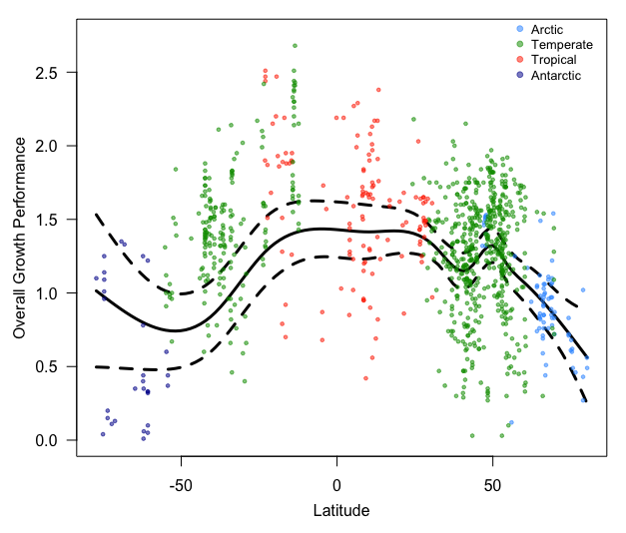Figure 1
a
c
b
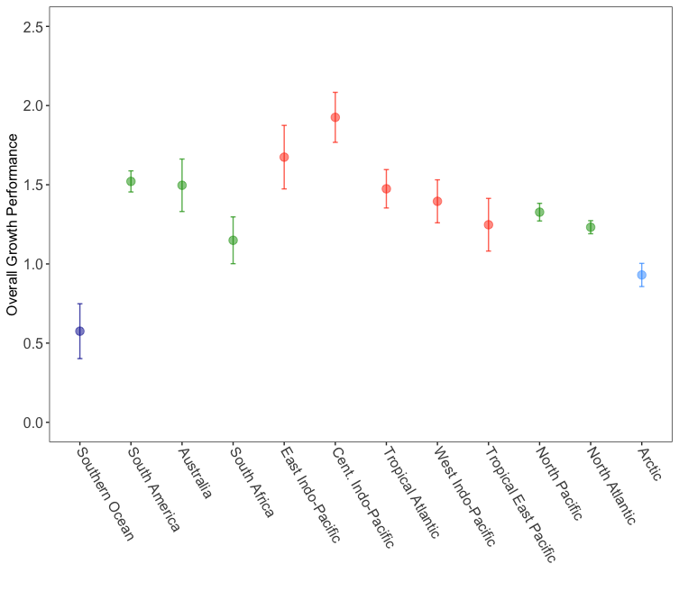
c

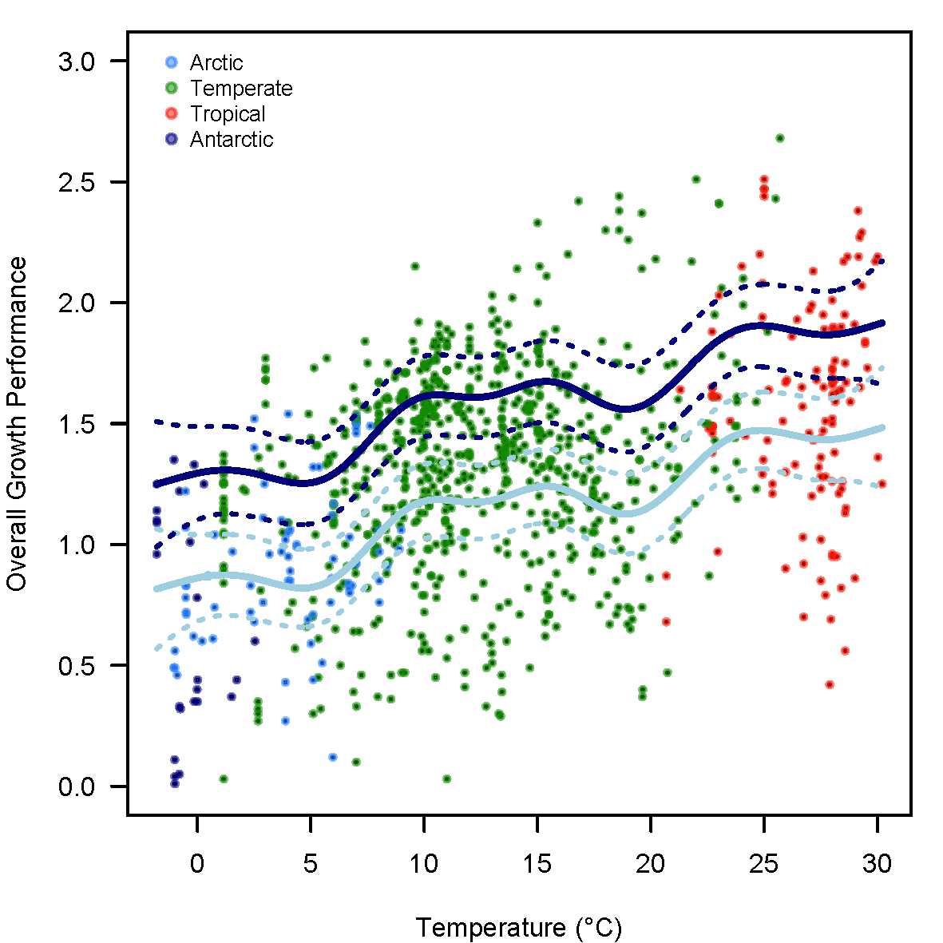Figure 2
c
b
a
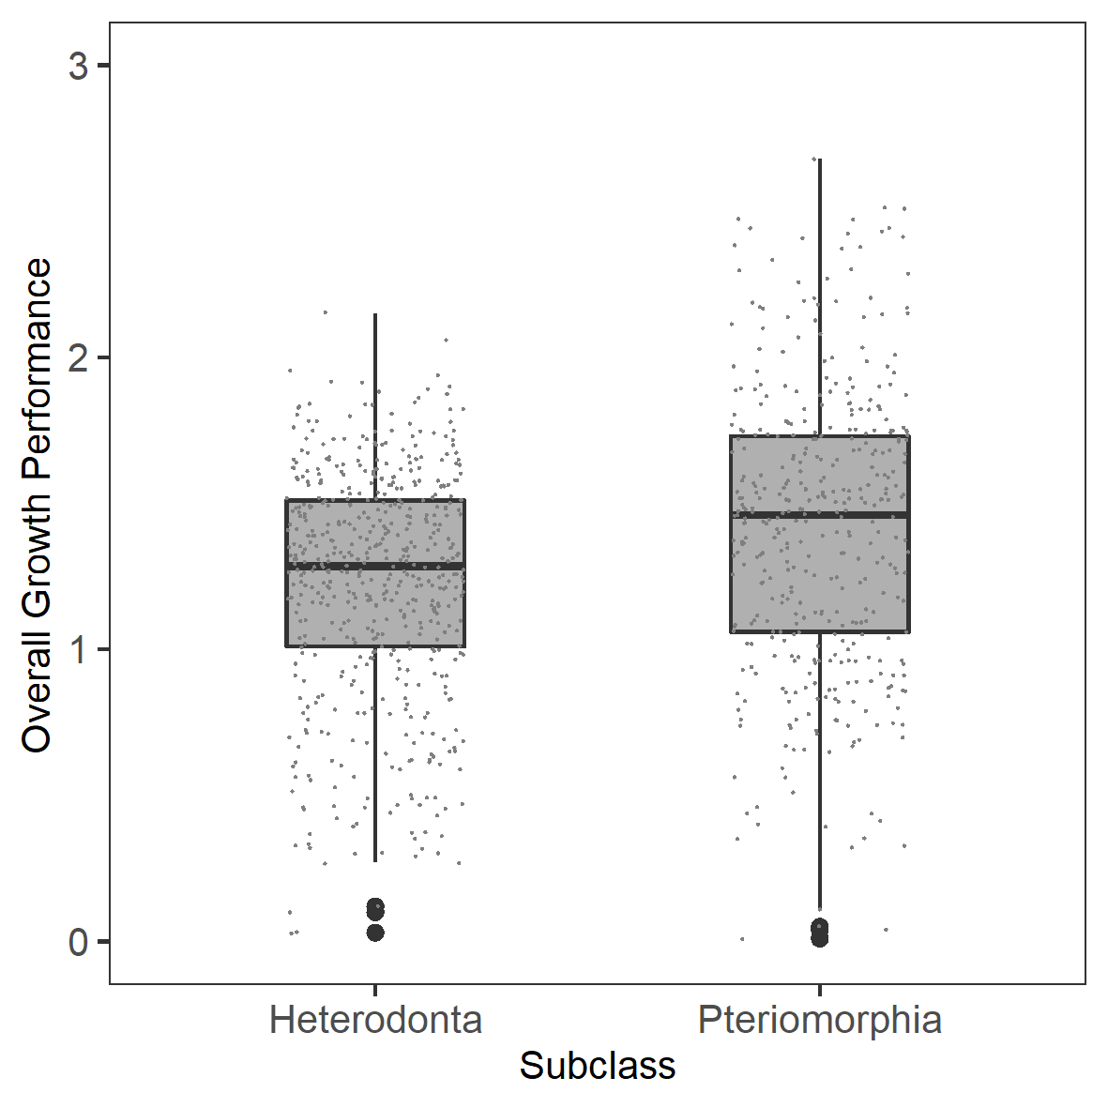

Figure 3
a

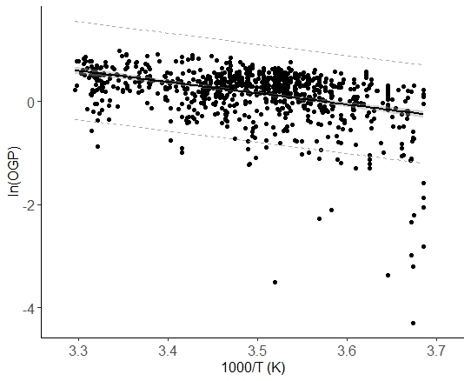

b

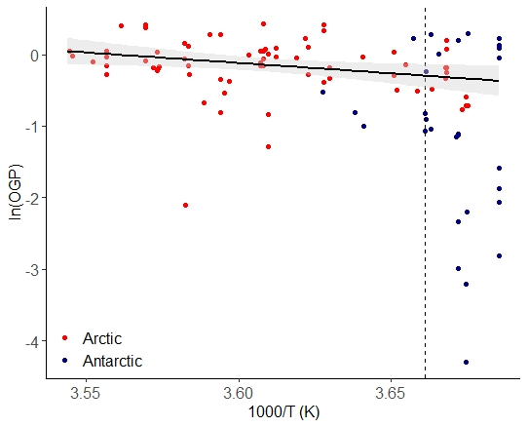

Figure 4
a
b

