The effect of high-pressure torsion on the microstructure and outstanding pseudoelasticity of a ternary Fe-Ni-Mn shape memory alloy

Hamidreza Koohdar ^{a, *}, Mahmoud Nili-Ahmadabadi ^{b, c}, Faezeh Javadzadeh Kalahroudi ^{b}, Hamid Reza Jafarianª, Terence G. Langdon ^{d}
ª School of Metallurgy and Materials Engineering, Iran University of Science and Technology (IUST), Narmak, Tehran, Iran
^{b} School of Metallurgy and Materials Engineering, University of Tehran, P.O. Box 14395-731, Tehran, Iran
^{c} Center of Excellence for High Performance Materials, School of Metallurgy and Materials Engineering, University of Tehran, Tehran, Iran
^{d} Materials Research Group, Department of Mechanical Engineering, University of Southampton, Southampton SO17 1BJ, UK

∗ Corresponding author: Tel. / Fax: +98 21 73228865. Email address: hkoohdar@iust.ac.ir

Abstract
Experiments were conducted to examine the effect of high-pressure torsion (HPT) processing on the microstructure and pseudoelastic behavior of a ternary Fe-10Ni-7Mn (wt.%) shape memory alloy in both the solution-annealed and intercritically-annealed conditions. X-ray diffraction (XRD) patterns and electron backscatter diffraction (EBSD) analyses showed that the initial microstructure of the alloy in the solution-annealed condition was a fully lath α′-martensite which partially transformed to a strain-induced austenite (α′→γ) by HPT processing. Also, the austenite formed in the dual phase (α′+γ) specimens after intercritical annealing treatment at 600°C for 7.2 ks underwent a γ→ε→α′ transformation during subsequent HPT processing such that a multi-phase microstructure was formed consisting of α′-martensite, austenite and ε-martensite. The HPT processing led to a significant increase in the microhardness value to ∼690 Hv due to a high density of dislocations and the associated grain refinement of the microstructure. Cyclic loading-unloading tensile tests at room temperature revealed a strain hysteresis and pseudoelastic behavior in the HPT-processed specimens with different initial microstructures. Outstanding pseudoelasticity values of about 67% and 75% were obtained at the fourteenth loading-unloading cycle after 20 HPT turns in the solution-annealed and intercritically-annealed specimens, respectively.

Keywords: High-pressure torsion; Microstructural evolution; Pseudoelastic behavior; Strain hysteresis; Ternary Fe-Ni-Mn shape memory alloy.

1. Introduction
In recent years, the use of Fe-based shape memory alloys (SMAs) in commercial and engineering applications has increased due to several advantages such as low cost, good workability, high strength, stability of the recovery stresses and an appropriate elastic modulus [1-3]. These materials can be widely used as clamping or coupling devices in mechanical engineering and for the reinforcement of concrete and girders by internally activated pre-stressing in civil engineering applications [4-6]. The shape memory effect (SME) in these alloys is attributed to the austenite (fcc) to ε-martensite (hcp) transformation under deformation and its reversion (hcp to fcc) through heating up to an appropriate temperature [7, 8]. In addition, the Fe-based SMAs were reported as demonstrating the unique property of pseudoelasticity [9,10]. In pseudoelastic behavior, under a cyclic loading-unloading tensile test, the specimen shape goes back to the first shape with a strain hysteresis loop in its route to the zero point of strain. Initially, it was believed that this behavior took place only at temperatures above the austenite start temperature (A_{s}) but recently it was discovered that this behavior could be observed at temperatures below A_{s} which was illustrated by the reversible movement of fcc/hcp interfaces [9].
In the past two decades, much attention has been assigned to enhancing the SME and pseudoelastic behavior of Fe-based SMAs. These various investigations focused on the enhancement of the properties by alloy design [11,12], pre-straining value and temperature [12,13], thermo-mechanical processing [14] and precipitation strengthening [15, 16].
The ternary Fe-10Ni-7Mn (wt. %) shape memory alloy has a lath martensitic microstructure in the solution-annealed (SA) condition which shows good age hardenability by formation of nano-size θ-NiMn precipitaties [17, 18]. For observing the SME and pseudoelasticity in the studied alloy, it is obligatory to stabilize the austenite phase in the martensitic microstructure [8, 19]. It is reported that cold working is a promising way for introducing the austenite phase in a martensitic microstructure at ambient temperature. Under these conditions, the deformation-induced austenite can be nucleated by a diffusionless (shear) mechanism in the martensitic microstructure [20-22]. The other method for introducing the retained austenite in the microstructure of the alloy at ambient temperature is through intercritical annealing treatment at the two phase (α+γ) region [19,23-25]. The reverse transformation of martensite to austenite may take place through either diffusional and/or diffusionless mechanisms during this heat treatment [23-25]. Recent reports confirmed that the Fe-10Ni-7Mn (wt. %) alloy could display pseudoelastic behavior after severe cold rolling [21,22] and a combination of intercritical annealing and subsequent ageing [19].
High pressure torsion (HPT) processing is one of the severe plastic deformation (SPD) methods in which a sample, generally in the form of a thin disk, is subjected to torsional shear straining under a very high hydrostatic pressure [26,27]. One of the main advantages of this process is that it can generate samples with extremely high shear strains [28]. In recent decades, many researchers have been attracted to HPT processing due to its significant properties such as the production of exceptional grain refinement [29], a high density of lattice defects including dislocations, vacancies and free volumes [30-32], high strength and hardness [33-35], reasonable thermal stability [36,37], excellent superplastic properties [38,39], SME and psuedoelasticity [40,41] and numerous other features.
Accordingly, the present research was initiated in order to examine the effect of HPT processing on the microstructure evolution, microhardness measurements and pseudoelastic behavior in a ternary Fe-10Ni-7Mn (wt. %) shape memory alloy in both the solution-annealed (SA) and the intercritically-annealed (IA) conditions.
2. Experimental materials and procedures
An ingot of ternary Fe-10Ni-7Mn (wt. %) shape memory alloy was produced by double-casting in vacuum induction melting and vacuum arc re-melting furnaces. The chemical composition of the alloy is given in Table 1. The prepared ingot was forged at 1200 °C to break the dendritic cast structure and then homogenized at 1150 °C for 86.4 ks in a vacuum furnace. Thereafter, solution annealing was carried out at 950 °C for 3.6 ks followed by water quenching to gain a fully lath α′-martensite microstructure.
Table 1. Chemical composition of the alloy.
Element | Fe | Ni | Mn | C | S | P | Al | N
Wt. % | Bal. | 10.53 | 6.94 | 0.005 | 0.006 | 0.006 | 0.004 | 0.004

Afterwards, some samples were cut from the SA ingot and then intercritically-annealed in the dual phase (α+γ) region at 600 °C for 7.2 ks followed by water quenching in order to obtain a dual phase microstructure of α′-martensite and reversed austenite (α′+γ).
In order to apply HPT processing, disk-shape specimens with diameters of 10 mm and thicknesses of 0.8 mm were cut from the SA and IA samples. These disks were severely deformed at room temperature through total numbers of 3, 10, and 20 turns using quasi-constrained HPT [42] under pressure of 6.0 GPa with a rotation speed of 1 rpm.
X-ray diffraction (XRD) analysis with Cu-K_{α} radiation was conducted to precisely examine the phase composition. The XRD was carried out using step scanning in the angular range of 2θ = 40-100° with a rate of 0.02° per 3.6 s. Microstructural observations were performed using a field emission scanning electron microscopy (FE-SEM/JEOL-7100F) coupled with an electron backscatter diffraction (EBSD) system. The EBSD data were analyzed by TSL-OIM analysis software. The sections of the specimens for microstructural characterization and EBSD observation were mechanically polished followed by electropolishing in a solution with chemical composition of 90% CH₃COOH + 10% HClO₄ at voltage of 20 V for 0.02 ks to remove the deformed layer introduced by mechanical polishing. The region for phase evaluation and microstructural observations is illustrated in Fig. 1.
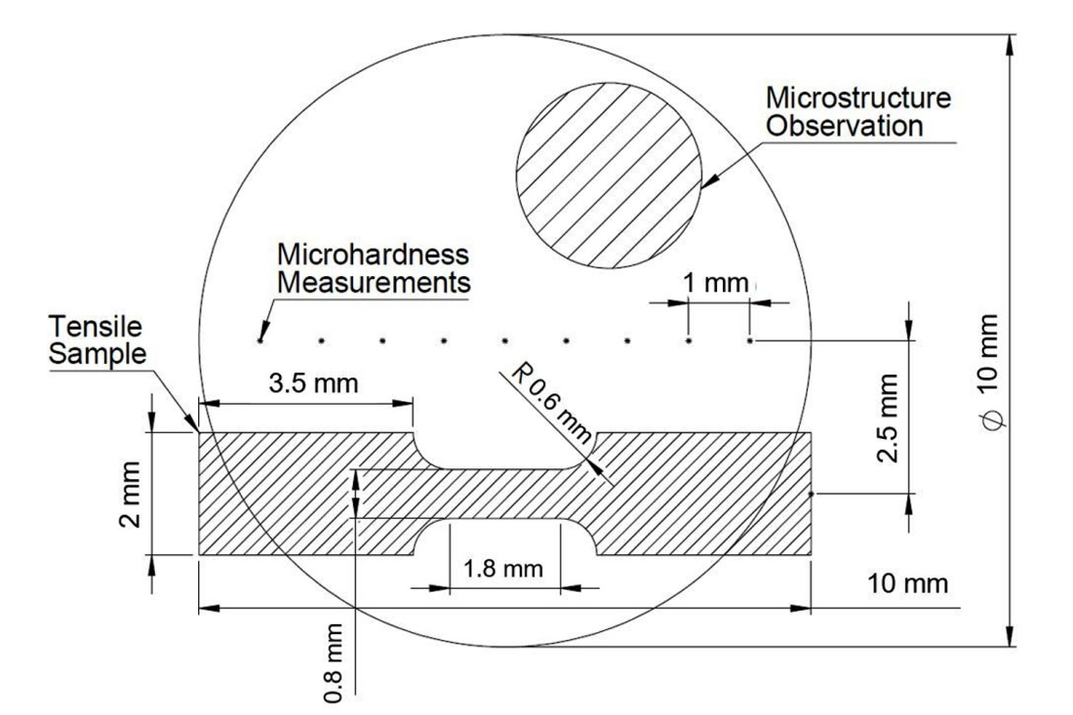
Fig. 1. Dimensions of disk specimen including positions for microstructure observation, microhardness measurements and cyclic tensile test sample.

Microhardness measurements were taken through a Vickers hardness tester with a load of 100 gf and dwell time of 10 s. These measurements were taken across the diameters of the disks at separations of 1 mm as shown in Fig. 1. The average values of microhardness, Hv, were obtained from the average of five separate hardness values.
The pseudoelastic behavior of specimens was investigated using a SANTAM tensile testing machine by cyclic tensile loading-unloading testing at room temperature with an initial strain rate of 5.0 × 10⁻⁴ s⁻¹. The samples for pseudoelastic examination were cut at a distance of 2.5 mm from the centers of the HPT-processed disks as a rectangular shape with gauge length of 1.8 mm, width of 0.8 mm and thickness of 0.5 mm according to the configuration shown in Fig. 1. The pseudoelasticity performance (PE %) in each cycle was measured from the engineering stress-strain curve as depicted in Fig. 2 with the relationship:
$PE\left(\%\right)=({CD}/{AD})×100$ (1)
As indicated in Fig. 2, it appears that the unloading part of the curve consists of a linear portion immediately after unloading and a non-linear portion which started immediately after the linear part and shows the pseudoelasticity. In order to determine the PE performance in Fig. 2, the BD line was placed adjacent to the linear part of the unloading curve as a tangential line with a slope equal to the slope of the linear part.
The cyclic loading-unloading tensile test result is the average of two tensile tests for each specimen before and after HPT processing. The results showed that the obtained data were reproducible.
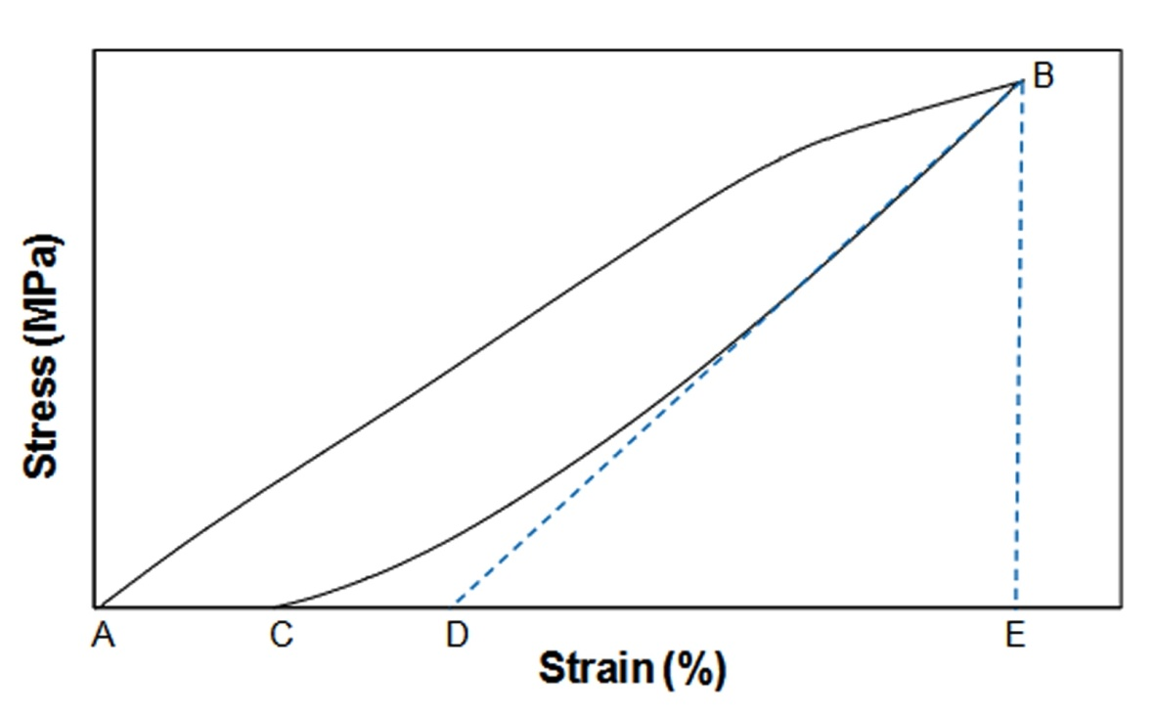
Fig. 2. Schematic of the engineering stress-strain curve for calculating the pseudoelasticity performance (PE %).

3. Experimental results
3.1. Microstructures before and after HPT
3.1.1. X-ray diffraction (XRD)
The XRD patterns of the specimens in the SA and IA conditions before and after HPT processing for 3, 10 and 20 turns are illustrated in Fig. 3. According to Fig. 3(a) for the SA specimens, before and after HPT processing only the α′-martensite peaks are revealed and no strain-induced austenite peaks are visible in the deformed specimens. In Fig. 3(b) for the IA specimens, the microstructure consists of α′-martensite and about 43% of the reversed austenite whereas after post HPT processing for 3 and 10 turns small peaks of ε-martensite are also observed. By increasing the numbers of turns to 20, the microstructure is then fully α′-martensite.
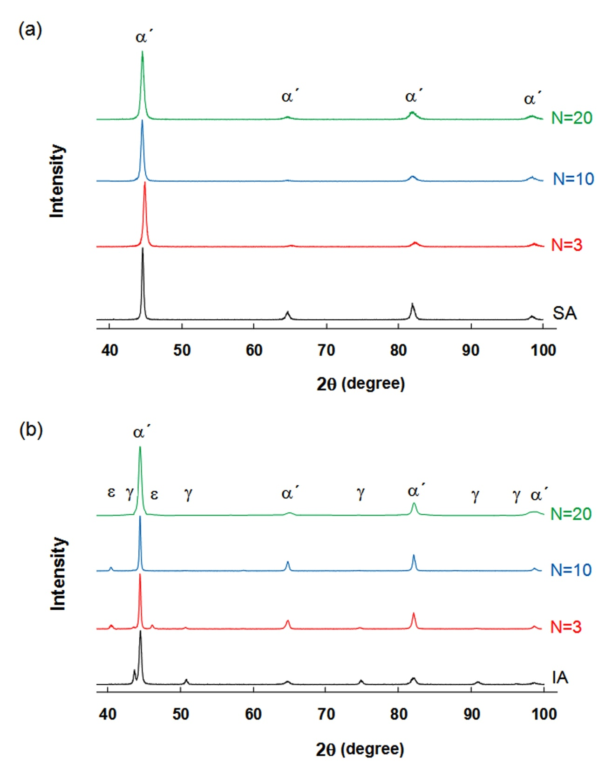
Fig. 3. XRD patterns of the specimens in (a) SA and (b) IA conditions before and after HPT processing for 3, 10 and 20 turns.
3.1.2. Electron backscatter diffraction (EBSD)
Fig. 4 represents the grain boundary overlap on phase maps for the specimens in the SA and IA conditions before and after HPT processing for 3 and 20 turns in which the pink, green and yellow colors denote the α′-martensite, austenite and ε-martensite phases, respectively. The superimposed black and red lines correspond to high-angle grain boundaries (HAGBs) and low-angle grain boundaries (LAGBs), respectively. According to Fig. 4(a), the SA specimen phase map reveals that the microstructure consists of typical lath α′-martensite including packet and block as a substructure of lath martensite with a high fraction of LAGBs. After HPT processing of the SA specimens for 3 and 20 turns (Figs. 4(b) and (c)), the phase map data indicate a minor fraction of austenite phase with a volume fraction that tends to increase with increasing numbers of turns. This result appears inconsistent with the XRD results in Fig. 3(a) and this apparent discrepancy will be addressed in section 4.1. Also, the HPT processing significantly decreases the grain size of α′-martensite from ∼5.5 µm in the SA specimen to ~185 nm after 20 turns and, as indicated in Fig. 4(d), the microstructure of the IA specimen consists of α′-martensite and reversed austenite phases in which the austenite is uniformly distributed in the martensite matrix. From the EBSD result, the amount of the reversed austenite was obtained at about 45% which is consistent with the XRD measurement. After 3 turns of HPT processing of the IA specimen in Fig. 4(e), there is an elongated microstructure including a mixture of the α′-martensite, austenite and ε-martensite phases. By increasing the HPT turn to 20 (Fig. 4(f)), the microstructure evolves to a combination of equiaxed and elongated grains in which the volume fractions of austenite and ε-martensite decrease drastically. In this case, the microstructure consists of ∼88% of α′-martensite with an average grain size of ∼220 nm accompanied by very few nano-grains of austenite and ε-martensite. Full details for the volume fractions of the different phases achieved from the EBSD analysis are given in Table 2.
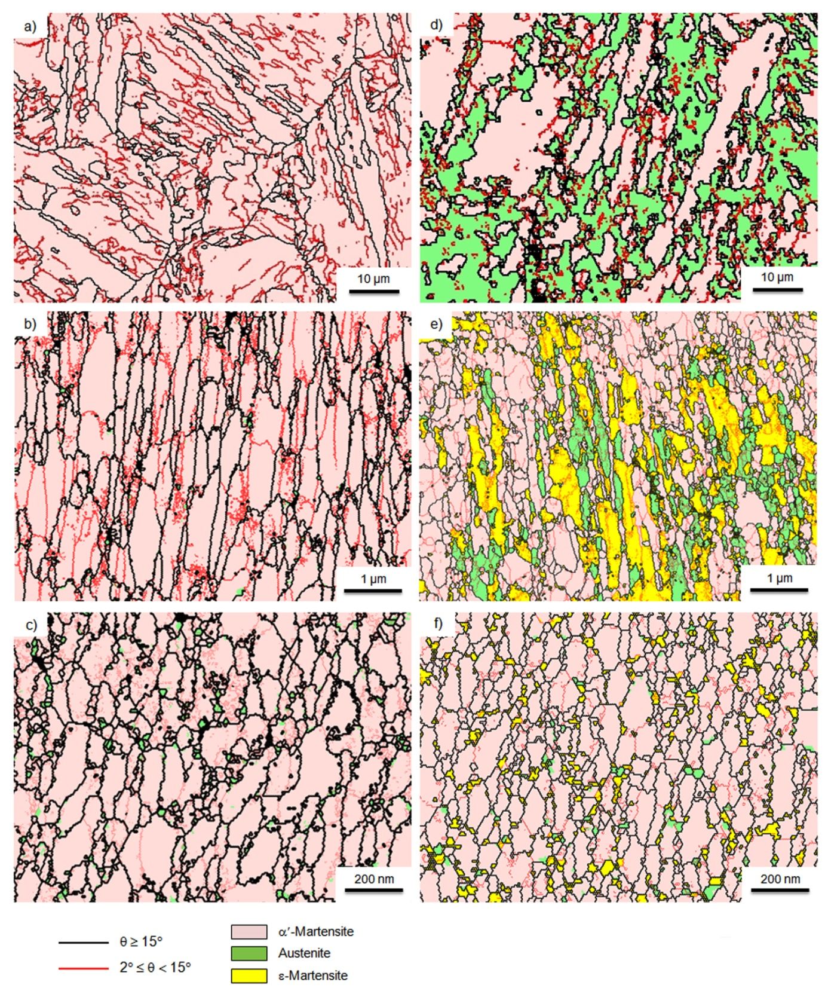
Fig. 4. Grain boundary overlap on phase maps for the specimens in (a-c) SA and (d-e) IA conditions before (a and d) and after HPT processing for 3 (b and e) and 20 (c and f) turns.

Table 2. Volume fractions of the different phases achieved from EBSD results of the specimens in SA and IA conditions before and after HPT processing for 3, 10 and 20 turns.
 | α′-martensite  (vol%) | austenite  (vol%) | ε-martensite  (vol%)
SA | 100 | - | -
SA + HPT (N = 3) | 98 ± 0.5 | 2 ± 0.5 | -
SA + HPT (N = 10) | 95 ± 1 | 5 ± 1 | -
SA + HPT (N = 20) | 95 ± 1 | 5 ± 1 | -
IA | 55 ± 2 | 45 ± 2 | -
IA + HPT (N = 3) | 56 ± 2 | 13 ± 1 | 31 ± 1
IA + HPT (N = 10) | 74 ± 1 | 7 ± 0.5 | 19 ± 0.5
IA + HPT (N = 20) | 88 ± 1 | 5 ± 0.5 | 7 ± 0.5

3.2. Microhardness measurements
Fig. 5 shows microhardness distribution of (a) the SA and (b) the IA specimens before and after HPT processing for 3, 10 and 20 turns where the hardness values in the SA and IA conditions are indicated by the lower dashed lines. Although the discrete error bars are not inserted on the various datum points, the average error for each point was typically of the order of ∼2%. According to Fig. 5(a), the initial hardness value for the SA specimen is ∼270 Hv but the hardness increases significantly with increasing numbers of turns so that for all straining conditions the measured hardness near the edge of each disk reaches to ∼690 Hv. In addition, it is readily apparent that in the early stages of straining the hardness is inhomogeneous across the disc diameters with higher hardness values recorded near the edges whereas by increasing the number of HPT turns to 20, the degree of inhomogeneity is reduced. From Fig. 5(b) for the IA condition, the hardness values after 3 turns of HPT processing display a sharp increase by comparison with the initial IA sample of ∼288 Hv and this increase is more significant at the periphery where it is ~580 Hv compared with a lower value of ~500 Hv in the central region. By further straining, the measured values increase both in the center and the periphery and ultimately reach a maximum value of ∼685 Hv at the edge of the sample which is similar to the SA specimen.
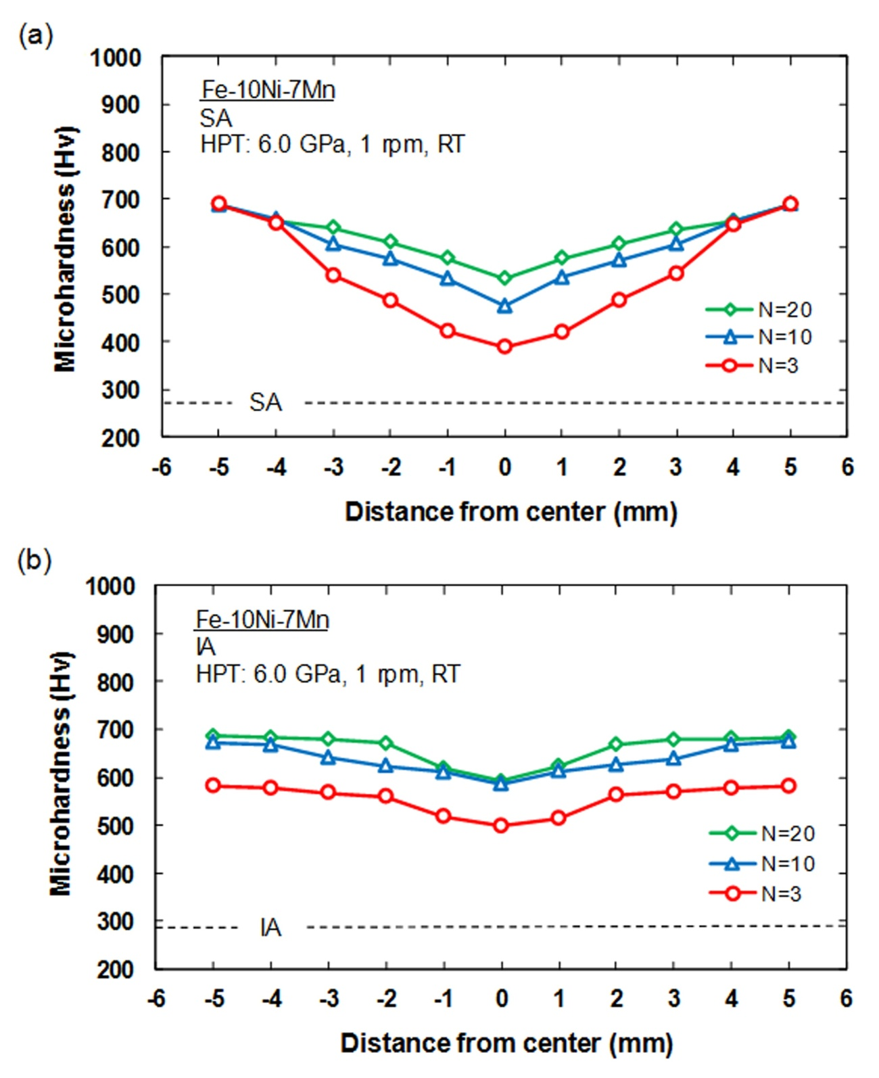
Fig. 5. Microhardness distribution measured across the diameter of the specimens in (a) SA and (b) IA conditions before and after HPT processing for 3, 10 and 20 turns.

Thus, the hardness distributions tend towards homogeneity across the disk diameters after only 20 turns of HPT processing for the Fe-10Ni-7Mn SMA where this tendency towards homogeneity after higher numbers of turns is a fundamental characteristic of HPT processing although the numbers of turns required to attain saturation is critically dependent upon the material and the testing conditions. For example, experiments on high-purity aluminum showed that hardness homogeneity was achieved across the disk diameter after 20 turns [43] whereas a recent investigation showed that 100 turns was required in order to achieve true homogeneity across the disks of nanostructured metastable aluminum-magnesium samples [44].
3.3. Pseudoelastic behavior
The engineering stress-strain curves of cyclic loading-unloading for the SA specimens before and after HPT processing for 3, 10 and 20 turns are shown in Fig. 6. According to Fig. 6(a), for the initial SA sample there is only a linear elasticity without a strain hysteresis and this is reasonable because the microstructure is fully martensitic. In addition, as is evident in Figs. 6(b) to (d), after HPT processing the spring-back strain is nonlinear at the low stresses and there is a hysteresis between the unloading and re-loading curves which develops by increasing the applied strain. It is evident that the observed pseudoelasticity is associated with the existence of strain-induced austenite having a fine grain size accompanied by a high dislocation density.

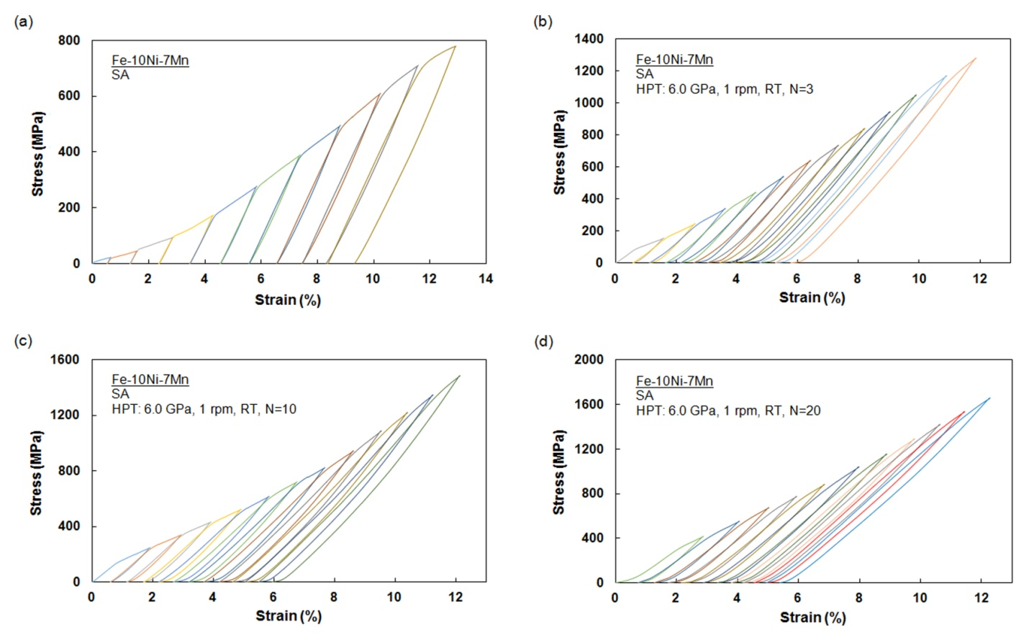
Fig. 6. Cyclic engineering stress-strain curves with increasing the strain for specimens (a) SA and HPT-processed for (b) 3, (c) 10, (d) 20 turns.

Fig. 7 shows the cyclic engineering stress-strain curves for the IA specimens before and after HPT processing for 3, 10 and 20 turns. Again there are no traces of pseudoelastic behavior as well as strain hysteresis for the initial IA specimen in Fig. 7(a). Thus, although the austenite phase is present in the microstructure of this sample after intercritical annealing, it has a soft nature which is reasonable for the easy glide of dislocations. Therefore, slip is the main deformation mechanism in this sample instead of the strain-induced ε-martensite transformation (γ→ε). After HPT processing according to Figs. 7(b) to (d), the pseudoelastic effect is present due to the strengthening of the microstructure by grain refinement and the associated difficulties for dislocation glide.

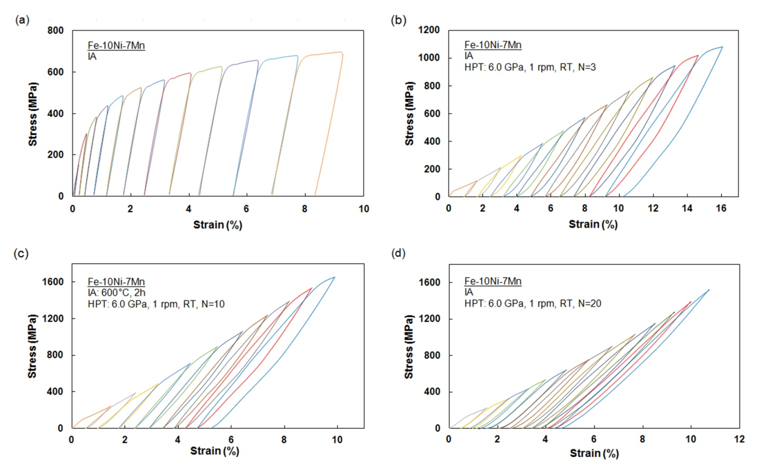
Fig. 7. Cyclic engineering stress-strain curves with increasing the strain for specimens (a) IA and HPT-processed for (b) 3, (c) 10, (d) 20 turns.

Fig. 8 shows the measured PE performances for (a) the SA and (b) the IA specimens after HPT processing for 3, 10 and 20 turns. It follows from Fig. 8(a) that for the SA specimen after 3 turns of HPT processing, the PE performance first rises up to a value of ∼55% in the tenth cycle and then decreases to lower values in higher cycles. For specimens processed by HPT for 10 and 20 turns there is an increase in PE performance up to a maximum value of ∼67% in the 14th cycle followed by a decrease in the following cycles. For the IA specimens after HPT processing for different turns as shown in Fig. 8(b), it is clear that the trend of PE performance with increasing numbers of loading-unloading cycles is similar to the SA samples. The measurement of PE performance demonstrates that the highest value of pseudoelasticity is ∼75% which is obtained in the 14th cycle of loading-unloading in the HPT specimen processed by 20 turns.
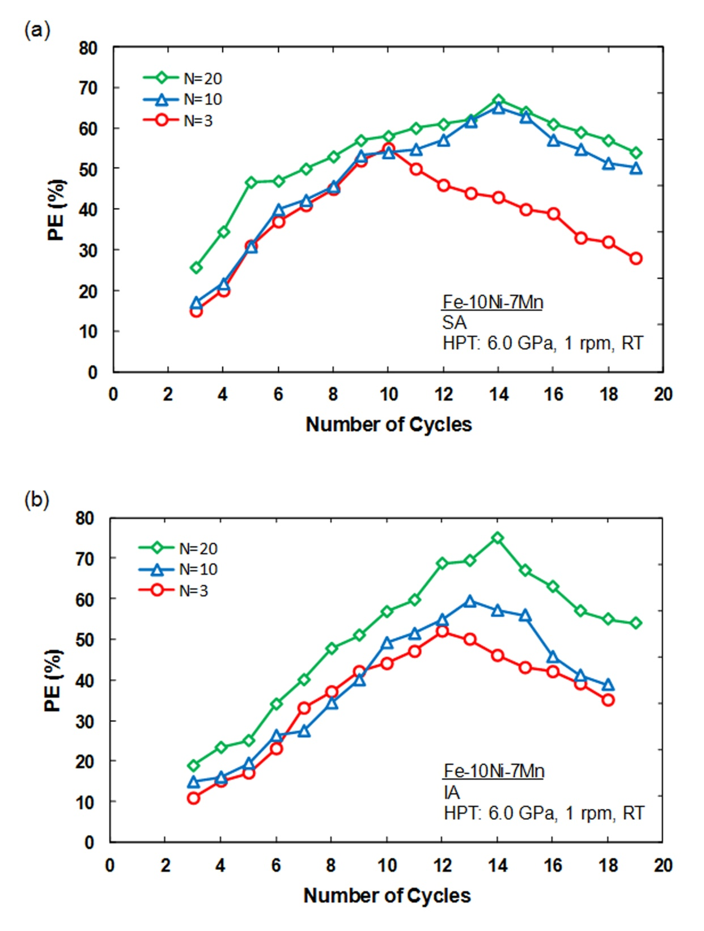
Fig. 8. Pseudoelasticity performance (PE %) versus loading-unloading cycle for the specimens in (a) SA and (b) IA conditions after HPT processing for 3, 10 and 20 turns.

4. Discussion
4.1. Microstructures before and after HPT
According to the EBSD phase maps in Fig. 4(a), it is apparent that the microstructure of the specimen in the SA condition is a fully lath α′-martensite having a large fraction of LAGBs because of the initial high density of dislocations. During HPT processing for 3 turns, a noteworthy fraction of the LAGBs transforms to HAGBs and elongated martensitic grains are produced oriented along the shear direction as in Fig. 4(b). Thereafter, as indicated in Fig. 4(c), after 20 turns the microstructure evolves a mixture of equiaxed and elongated martensitic fine grains with an average size of ~185 nm. In addition, it is clear that the HPT processing induces a very fine and limited austenite grain structure within the initial martensitic microstructure and this is not detected by XRD in Fig. 3(a) due to the very small size and low volume fraction of the austenitic phase.
The nucleation of an austenite phase in the martensitic microstructure is attributed to the strain concentration and the consequent rise in temperature during SPD processing. Thus, the austenite formation as a result of a strain-induced reverse transformation (α′→γ) in Fe-10Ni-7Mn alloy was reported in earlier publications [20-22, 45]. In addition, the EBSD images in Figs. 4(d) to (f) reveal that during HPT processing of the IA specimen the high fraction of the inverted austenite transforms to the α′-martensite. Earlier reports demonstrated that the austenite can transform to the α′-martensite directly (γ→α′) and/or indirectly (γ→ε→α′) during SPD processing [29, 46, 47]. According to Fig. 4(e), the presence of ε-martensite in the microstructure of the HPT-processed specimen confirms that the phase transformation of the reversed austenite to α′-martensite occurs indirectly with the sequence of γ→ε→α′. The development of ε-martensite as an intermediate phase is explained due to the low stacking-fault energy (SFE) of the present alloy which is calculated as about 10 mJ/m² [19, 21, 45]. Since an SFE below 12 mJ/m² is necessary for the austenite to ε-martensite transformation under deformation [48,49], it is reasonable to conclude that the present alloy is susceptible to exhibiting this phase transformation during straining. The ε-martensite finally transforms to α′-martensite at higher strains through a mechanism in which the α′-martensite forms at microscopic shear band intersections such as faults, twins and ε-martensite [50, 51]. Since the number of these intersections increases with applied strain, the volume fraction of α′-martensite also increases by increasing the HPT straining and finally reaches a maximum value of ∼88% after 20 turns (Fig. 4(f) and Table 2). The high density of dislocations together with the phase transformations that occurs during HPT processing of the IA specimens may contribute to a significant reduction in the final grain size.
4.2. Microhardness measurements
Based on the microhardness measurements of the HPT-processed SA and IA specimens in Fig. 5, and also examining the EBSD images in Fig. 4, it appears that the hardness value initially increases at the disk peripheries due to the very high density of dislocations and the related grain refinement induced by the higher imposed strain in this region. Subsequently, by increasing the numbers of HPT processing turns, the region of higher hardness gradually develops towards the central part of the specimen and therefore produces an almost complete homogeneity across the sample. This evolution in hardness is consistent with the microhardness data reported in the HPT processing of many other materials [52]. Finally, the hardness saturates when there is essentially a balance between the rise in hardness due to dislocation accumulation and the decline in hardness due to recovery as reported earlier [29, 53].

4.3. Pseudoelastic behavior
The main source of the pseudoelastic behaviour in Fe-based SMAs lies in the austenite (fcc) to ε-martensite (hcp) transformation under loading and its subsequent reversion (hcp to fcc) after unloading [7, 9, 19]. The transformation of fcc to hcp is prompted by the glide of Shockley partial dislocations. Initial studies suggested that the pseudoelastic behavior in these alloys cannot be interpreted by conventional theory of the transformation pseudoelasticity because the specimen temperature during the tensile test is lower than A_{s}. Thus, it appears that the strain-induced martensite is thermodynamically stable and there is no driving force for the reverse martensitic transformation. However, by considering the created back-stress around the tips of the growing martensite plates due to the large pile-ups of Shockley partial dislocations with similar sign, the pseudoelasticity can be described as a reversible movement of the fcc/hcp interfaces [9].
In order to achieve the pseudoelasticity in Fe-based SMAs, some key factors are essential. First, it requires the presence of an austenite phase in the microstructure of the material. In the austenite phase, besides the glide of perfect dislocations, other mechanisms of plastic deformation are feasible such as mechanical twinning or the formation of ε-martensite taking place under straining. Since the mechanisms of plasticity depend on the SFE, the transformation of austenite to ε-martensite is possible in the alloy as the relevant SFE of 10 mJ/m² [19, 21, 45], is lower than the critical value [48, 49]. Therefore, the low SFE is the second prominent factor for observations of pseudoelasticity in Fe-based SMAs. The third crucial factor is the necessity to strengthen the austenite phase in order to inhibit the glide of perfect dislocations.
The cyclic engineering stress-strain curves for the SA specimen in Fig. 6(a) show no traces of any pseudoelasticity or strain hysteresis due to the lack of the austenite phase in the microstructure. Nevertheless, from the cyclic tensile test results in Figs. 6(b) to (d), it is apparent that there is a pseudoelastic behavior in the SA specimens after HPT processing which is attributed to the presence of strain-induced austenite with a fine grain size and a high dislocation density. Dislocation generation in the formed austenite with a fine grain size under HPT processing leads to an increase in the flow strength and promotes the transformation of austenite to ε-martensite rather than slip deformation under the cyclic tension.
According to Fig. 7(a), no sign of pseudoelasticity is apparent in the IA sample which can be deduced from its low strength. After applying HPT processing and noting its considerable impact on dislocation generation, grain refinement and consequently on strength enhancement in the austenite phase, the phase transformation of austenite to ε-martensite is promoted rather than slip deformation and therefore the yielded strain hysteresis and pseudoelasticity is significant as in Figs. 7(b) to (d).
Earlier studies confirmed the pseudoelacticity in the present alloy in the SA condition after cold rolling [21, 22] and it was reported there was a maximum PE performance of ∼33% after 70% cold rolling which was attributed to the existence of shear-formed austenite having a high dislocation density [21]. Also, in an investigation of the effect of precipitation hardening on the pseudoelastic behavior of the present alloy in the IA condition, the maximum PE performance was about 40% in the 6th cycle in the specimen heat treated at 600 °C for 7.2 ks followed by subsequent ageing at 480 °C for 3.6 ks [19]. According to the available results, the presence of θ-NiMn precipitates in the microstructure promotes the pseudoelasticity by strengthening the austenite phase and helping the reversible motion of the fcc/hcp interface through a back stress produced on the growing martensite. In the present work as depicted in Figs. 8(a) and (b), the maximum values of the PE performance are obtained as ∼67% and ∼75% for the SA and the IA specimens, respectively, after a subsequent 20 HPT turns. This outstanding enhancement can be attributed to the extreme grain refinement together with the high density of dislocations which leads to an improvement of austenite strength after HPT processing by comparison with cold rolling or precipitation hardening. Furthermore for the IA condition, despite the fact that the volume fractions of austenite are higher in the 3 and 10 turn HPT-processed specimens compared to the 20 turn specimen (Fig. 4 and Table 2), the latter sample displays higher pseudoelasticity. It is reasonable to assume that by further straining the austenite phase becomes more strengthened due to the ultra-fine grains and the large pile-up of dislocations. Therefore, all available and limited austenite can play a significant role in the phase transformation of austenite to ε-martensite and thereby intensively improve the pseudoelastic behavior.
In addition, according to Fig. 8, the PE performance calculations display an ascending trend to a peak following by a descending mode which appears in well consistent with an earlier report [19]. It is important to note that in the initial cycles of loading and unloading the austenite can become stronger due to strain hardening and this will facilitate reversible motion of the fcc/hcp interfaces and lead to an improvement in the measured values for the PE performance. After reaching a maximum in the medial cycles, there is a very clear decline in the PE performance. This decline is ascribed to the fact that in further cycles the applied stress to the samples gradually increases so that, in addition to the phase transformation of austenite to ε-marteniste, other deformation mechanisms such as perfect dislocations slip may be promoted. Moreover, it can be assumed that the ε-martensite produced in each cycle may not entirely transform to austenite during the unloading step so that in the next cycle a smaller volume fraction of austenite is available for the occurrence of the phase transformation. Since the amount of austenite is one of the key factors in this phenomenon, the value of the measured PE performance will diminish progressively. However, it is expected that the PE performance will gradually merge to a plateau value due to structural stability as is apparent in the IA sample after 20 turns and 18 cycles.
5. Summary and conclusions
Experiments were conducted to examine the effect of HPT processing on the microstructure and pseudoelastic behavior of a ternary Fe-10Ni-7Mn (wt. %) shape memory alloy in both the SA and IA conditions. The results led to the following conclusions:
- HPT processing of the SA specimen produced strain-induced austenite with a fine grain size and high dislocation density in the microstructure.
- It was confirmed by EBSD that during HPT processing of the IA specimen the reversed austenite significantly transforms to α′-martensite with the sequence of γ→ε→α′ so that a multi-phase microstructure consisting of α′-martensite, austenite and ε-martensite is achieved after 20 turns.
- Cyclic tensile testing revealed strain hysteresis and pseudoelastic behavior in the SA and the IA specimens after subsequent HPT processing due to the presence of the austenite phase with a fine grain size and high dislocation density.
- The maximum amounts of pseudoelasticity were measured as ∼67% and ∼75% at the 14th loading-unloading cycle for the SA and the IA specimens, respectively, followed by 20 HPT turns. These are the highest values reported to date for pseudoelasticity in this shape memory alloy.

Acknowledgments
One of the authors (HK) expresses his thanks to Iran National Science Foundation (INSF) for partial financial support of this research. Another author was supported by the European Research Council under ERC Grant Agreement No. 267464-SPDMETALS (TGL).
Data availability
The raw/processed data required to reproduce these findings cannot be shared at this time as the data form part of an ongoing study.

References
[1] A. Cladera, B. Weber, C. Leinenbach, C. Czaderski, M. Shahverdi, M. Motavalli, Iron-based shape memory alloys for civil engineering structures: an overview, Const. Build. Mater. 63 (2014) 281-293. https://doi.org/10.1016/j.conbuildmat.2014.04.032.
[2] T. Maruyama, H. Kubo, I. Ohkata, K. Tsuchiya, S. Miyazaki, Ferrous (Fe-based) shape memory alloys (SMAs): properties, processing and applications, shape memory and superelastic alloys: technologies and applications, Woodhead Publishing LTD., Cambridge, 2011, pp. 141-159. https://doi.org/10.1016/B978-1-84569-707-5.50012-2.
[3] H. Rojob, R. El-Hacha, Self-prestressing using iron-based shape memory alloy for flexural strengthening of reinforced concrete beams, ACI Struct. J. 114 (2017) 523-532. https://doi.org/10.14359/51689455.
[4] C. Czaderski, M. Shahverdi, R. Bronnimann, C. Leinenbach, M. Motavalli, Feasibility of iron-based shape memory alloy strips for prestressed strengthening of concrete structures, Const. Build. Mater., 56 (2014) 94-105. https://doi.org/10.1016/j.conbuildmat.2014.01.069.
[5] W.J. Lee, B. Weber, C. Leinenbach, Recovery stress formation in a restrained Fe-Mn-Si-based shape memory alloy used for pre-stressing or mechanical joining, Const. Build. Mater., 95 (2015) 600-610. https://doi.org/10.1016/j.conbuildmat.2015.07.098
[6] M. Izadi, A. Hosseini, J. Michels, M. Motavalli, E. Ghafoori, Thermally activated iron-based shape memory alloy for strengthening metallic girders, Thin-Walled Struct., 141 (2019) 389-401. https://doi.org/10.1016/j.tws.2019.04.036.
[7] S. Watanabe, S. Sato, K. Miura, An unique feature of mechanical property of iron-nickel-manganese alloy, J. Mater. Process. Technol., 53 (1995) 467-76. https://doi.org/10.1016/0924-0136(95)02003-5.
[8] S. Kajiwara, Characteristic features of shape memory effect and related transformation behavior in Fe-based alloys, Mater. Sci. Eng. A 273 (1999) 67-88. https://doi.org/10.1016/S0921-5093(99)00290-7.
[9] T. Sawaguchi, T. Kikuchi, S. Kajiwara, The pseudoelastic behavior of Fe-Mn-Si-based shape memory alloys containing Nb and C, Smart Mater. Struct. 14 (2005) S317-S322. https://doi.org/10.1088/0964-1726/14/5/022.
[10] A. Baruj, G. Bertolino, H.E. Troiani, Temperature dependence of critical stress and pseudoelasticity in a Fe-Mn-Si-Cr pre-rolled alloy, J. Alloys Compd. 502 (2010) 54-58. https://doi.org/10.1016/j.jallcom.2010.04.123.
[11] H. Otsuka, H. Yamada, T. Maruyama, H. Tanashi, S. Matsuda, M. Murakami, Effects of alloying additions on Fe-Mn-Si shape memory alloys, ISIJ Int. 30 (1990) 674-679. https://doi.org/10.2355/isijinternational.30.674.
[12] J.H. Yang, H. Chen, C.M. Wayman, Development of Fe-based shape memory alloys associated with face-centered cubic-hexagonal close-packed martensitic transformations: Part I. Shape memory behavior, Metall. Mater. Trans. A 23 (1992) 1431-1437. https://doi.org/10.1007/BF02647326.
[13] Q. Gu, J. Van Humbeek, L. Delaney, A review on the martensitic transformation and shape memory effect in Fe-Mn-Si alloys, J. Phys. IV 4 (1994) 135-144. https://doi.org/10.1051/jp4:1994319.
[14] H.C. Lin, K.M. Lin, S.K. Wu, T.P. Wang, Y.C. Hsiao, Effects of thermo-mechanical training on a Fe₅₉Mn₃₀Si₆Cr₅ shape memory alloy, Mater. Sci. Eng. A 438 (2006) 791-795. https://doi.org/10.1016/j.msea.2006.02.119.
[15] S. Kajiwara, D. Liu, T. Kikuchi, N. Shinya, Remarkable improvement of shape memory effect in Fe-Mn-Si based shape memory alloys by producing NbC precipitates, Scr. Mater. 44 (2001) 2809-2814. https://doi.org/10.1016/S1359-6462(01)00978-2.
[16] Z. Dong, U.E. Klotz, C. Leinenbach, A. Bergamini, C. Czaderski, M. Motavalli, A novel Fe-Mn-Si shape memory alloy with improved shape recovery properties by VC precipitation, Adv. Eng. Mater. 11 (2009) 40-44. https://doi.org/10.1002/adem.200800312.
[17] S. Hossein Nedjad, M. Nili-Ahmadabadi, T. Furuhara, Transmission electron microscopy study on the grain boundary precipitation of an Fe-Ni-Mn maraging steel, Metall. Mater. Trans. A 39 (2008) 19-27. https://doi.org/10.1007/s11661-007-9407-z.
[18] M. Yodogawa, Precipitation behaviour in Fe-Ni-Mn martensitic alloys, Trans. JIM. 17 (1976) 799-808. https://doi.org/10.2320/matertrans1960.17.799.
[19] H.R. Koohdar, M. Nili-Ahmadabadi, M. Habibi-Parsa, H.R. Jafarian, Development of pseudoelasticity in Fe-10Ni-7Mn (wt. %) high strength martensitic steel by intercritical heat treatment and subsequent ageing, Mater. Sci. Eng. A 621 (2015) 52-60. https://doi.org/10.1016/j.msea.2014.10.049.
[20] H. Ghasemi-Nanesa, M. Nili-Ahmadabadi, H.R. Koohdar, M. Habibi-Parsa, S. Hossein Nedjad, S.A. Alidokht, T.G. Langdon, Strain-induced martensite to austenite reverse transformation in an ultrafine-grained Fe-Ni-Mn martensitic steel, Phill. Mag. 94 (2014) 1493-1507. https://doi.org/10.1080/14786435.2014.886785.
[21] H.R. Koohdar, M. Nili Ahmadabadi, M. Habibi-Parsa, H.R. Jafarian, H. Ghasemi-Nanesa, H. Shirazi, Observation of pseudoelasticity in a cold rolled Fe-Ni-Mn martensitic steel, Mater. Sci. Eng. A 658 (2016) 86-90. https://doi.org/10.1016/j.msea.2016.01.113.

[22] H.R. Koohdar, M. Nili Ahmadabadi, M. Habibi-Parsa, H. Ghasemi-Nanesa, Investigating on the reverse transformation of martensite to austenite and pseudoelastic behavior in ultrafine-grained Fe-10Ni-7Mn (wt %) steel processed by heavy cold rolling, Adv. Mater. Res., 829 (2014) 25-29. https://doi.org/10.4028/www.scientific.net/AMR.829.25.
[23] H.R. Koohdar, M. Nili Ahmadabadi, M. Habibi-Parsa, H.R. Jafarian, T. Bhattacharjee, N. Tsuji, On the stability of reversely formed austenite and related mechanism of transformation in an Fe-Ni-Mn martensitic steel aided by electron backscattering diffraction and atom probe tomography, Metall. Mater. Trans. A 48 (2017) 5244-5257. https://doi.org/10.1007/s11661-017-4288-2.
[24] Y.K. Lee, H.C. Shin, D.S. Leem, J.Y. Choi, W. Jin, C.S. Choi, Reverse transformation mechanism of martensite to austenite and amount of retained austenite after reverse transformation in Fe-3Si-13Cr-7Ni (wt.%) martensitic stainless steel, Mater. Sci. Thechnol. 19 (2003) 393-398. https://doi.org/10.1179/026708303225009742.
[25] S.J. Lee, Y. Park, Y.K. Lee, Reverse transformation mechanism of martensite to austenite in a metastable austenitic alloy, Mater. Sci. Eng. A 515 (2009) 32-37. https://doi.org/10.1016/j.msea.2009.02.010.
[26] A.P. Zhilyaev, T.G. Langdon, Using high-pressure torsion for metal processing: Fundamentals and applications, Prog. Mater. Sci. 53 (2008) 893-979. https://doi.org/10.1016/j.pmatsci.2008.03.002.
[27] K. Edalati, Z. Horita, A review on high-pressure torsion (HPT) from 1935 to 1988, Mater. Sci. Eng. A 652 (2016) 325-352. https://doi.org/10.1016/j.msea.2015.11.074.
[28] R. Pippan, High-pressure torsion–features and applications, in: M.J. Zehetbauer, Y.T. Zhu (Eds.), Bulk Nanostructured Materials, Wiley-VCH, Weinheim, Germany, 2009, pp. 217-232. https://doi.org/10.1002/9783527626892.ch9.
[29] S. Shi, Z. Zhang, X. Wang, G. Zhou, G. Xie, D. Wang, X. Chen, K. Ameyama, Microstructure evolution and enhanced mechanical properties in SUS316LN steel processed by high pressure torsion at room temperature, Mater. Sci. Eng. A 711 (2018) 476-483. https://doi.org/10.1016/j.msea.2017.11.064.
[30] J. Gubicza, M. El-Tahawy, Y. Huang, H. Choi, H. Choe, J.L. Labar, T.G. Langdon, Microstructure, phase composition and hardness evolution in 316L stainless steel processed by high-pressure torsion, Mater. Sci. Eng. A 657 (2016) 215-223. https://doi.org/10.1016/j.msea.2016.01.057.
[31] X.H. An, Q.Y. Lin, G. Sha, M.X. Huang, S.P. Ringer, Y.T. Zhu, X.Z. Liao, Microstructural evolution and phase transformation in twinning-induced plasticity steel induced by high-pressure torsion, Acta Mater. 109 (2016) 300-313. https://doi.org/10.1016/j.actamat.2016.02.045.
[32] J. Čižek, M. Janeček, T. Vlasák, B. Smola, O. Melikhova, R.K. Islamgaliev, S.V. Dobatkin, The development of vacancies during severe plastic deformation, Mater. Trans. 60 (2019) 1533-1542. https://doi.org/10.2320/matertrans.MF201937.
[33] T. Muller, M.W. Kapp, A. Bachmaier, P. Felfer, R. Pippan, Ultrahigh-strength low carbon steel obtained from the martensitic state via high pressure torsion, Acta Mater. 166 (2019) 168-177. https://doi.org/10.1016/j.actamat.2018.12.028.
[34] F.J. Kalahroudi, H.R. Koohdar, H.R. Jafarian, Y. Haung, T.G. Langdon, and M. Nili-Ahmadabadi, On the microstructure and mechanical properties of an Fe-10Ni-7Mn martensitic steel processed by high-pressure torsion, Mater. Sci. Eng. A 749 (2019) 27-34. https://doi.org/10.1016/j.msea.2019.02.002. https://doi.org/10.1016/j.msea.2019.02.002.
[35] J.K. Han, K.D. Liss, T.G. Langdon, M. Kawasaki, Synthesis of a bulk nanostructured metastable Al alloy with extreme supersaturation of Mg, Sci. Rep. 8 (2019) 17186. https://doi.org/10.1038/s41598-019-53614-3.
[36] T. Muller, A. Bachmaier, A. Stark, N. Schell, R. Pippan, Nanostructured low carbon steels obtained from the martensitic state via severe plastic deformation, precipitation, recovery, and recrystallization, Adv. Eng. Mater. 21 (2019) 1800202. https://doi.org/10.1002/adem.201800202.
[37] M. El-Tahawy, Y. Huang, H. Choi, H. Choe, J.L. Lábár, T.G. Langdon, J. Gubicza, High temperature thermal stability of nanocrystalline 316L stainless steel processed by high-pressure torsion, Mater. Sci. Eng. A 682 (2017) 323-331. https://doi.org/10.1016/j.msea.2016.11.066.
[38] C. Xu, S.V. Dobatkin, Z. Horita, T.G. Langdon, Superplastic flow in a nanostructured aluminum alloy produced using high-pressure torsion, Mater. Sci. Eng. A 500 (2009) 170-175. https://doi.org/10.1016/j.msea.2008.09.049.
[39] H. Shahmir, F. Naghdi, P.H.R. Pereira, Y. Huang, T.G. Langdon, Factors influencing superplasticity in the Ti-6Al-4V alloy processed by high-pressure torsion, Mater. Sci. Eng. A 718 (2018) 198-206. https://doi.org/10.1016/j.msea.2018.01.091.
[40] H. Shahmir, M. Nili-Ahmadabadi, Y. Huang, J.M. Jung, H.S. Kim, T.G. Langdon, Shape memory effect in nanocrystalline NiTi alloy processed by high-pressure torsion, Mater. Sci. Eng. A 626 (2015) 203-206. https://doi.org/10.1016/j.msea.2014.12.056.
[41] H. Shahmir, M. Nili-Ahmadabadi, M. Mohammadi, Y. Huang, M. Andrzejczuk, M. Lewandowska, T.G. Langdon, Effect of Cu on amorphization of a TiNi alloy during HPT and shape memory effect after post-deformation annealing, Adv. Eng. Mater. 22 (2020) 1900387. https://doi.org/10.1002/adem.201900387.
[42] R.B. Figueiredo, P.H.R. Pereira, M.T.P. Aguilar, P.R. Cetlin, T.G. Langdon, Using finite element modeling to examine the temperature distribution in quasi-constrained high-pressure torsion, Acta Mater. 60 (2012) 3190-3198. https://doi.org/10.1016/j.actamat.2012.02.027.
[43] M. Kawasaki, R.B. Figueiredo, T.G. Langdon, An investigation of hardness homogeneity throughout disks processed by high-pressure torsion, Acta Mater. 59 (2011) 308-316. https://doi.org/10.1016/j.actamat.2010.09.034.
[44] J.K. Han, K.D. Liss, T.G. Langdon, J.I. Jang, M. Kawasaki, Mechanical properties and structural stability of a bulk nanostructured metastable aluminum-magnesium system, Mater. Sci. Eng. A 796 (2020) 140050. https://doi.org/10.1016/j.msea.2020.140050.
[45] H. Ghasemi-Nanesa, M. Nili-Ahmadabadi, H. Shirazi, S. Hossein Nedjad, S. H. Pishbin, Ductility enhancement in ultrafine-grained Fe-Ni-Mn martensitic steel by stress-induced reverse transformation, Mater. Sci. Eng. A 527 (2010) 7552-7556. https://doi.org/10.1016/j.msea.2010.08.028.
[46] K. Yan, D. Bhattacharyya, Q. Lian, S. Kabra, M. Kawasaki, D.G. Carr, M.D. Callaghan, M. Avdeev, H. Li, Y. Wang, X. Liao, T.G. Langdon, K.-D. Liss, R.J. Dippenaar, Martensitic phase transformation and deformation behavior of Fe-Mn-C-Al twinning-induced plasticity steel during high-pressure torsion, Adv. Eng. Mater. 16 (2014) 927-932. https://doi.org/10.1002/adem.201300488.
[47] M. El-Tahawy, J. Gubicza, Y. Huang, H.L. Choi, H.M. Choe, J.L. Lábár, T.G. Langdon, Evolution of microstructure, phase composition and hardness in 316L stainless steel processed by high-pressure torsion, Mater. Sci. Forum 879 (2017) 502-507. https://doi.org/10.4028/www.scientific.net/MSF.879.502.
[48] S. Allain, J.P. Chateau, O. Bouaziz, S. Migot, N. Guelton, Correlations between the calculated stacking fault energy and the plasticity mechanisms in Fe-Mn-C alloys, Mater. Sci. Eng. A 387-389 (2004) 158-162. https://doi.org/10.1016/j.msea.2004.01.059.
[49] N. Cabanas Poy, Compositional effects on structure-property relationships in Mn-based austenitic ferrous alloys, Ph.D. thesis, Ghent University, 2004.
[50] C.X. Huang, G. Yang, Y.L. Gao, S.D. Wu, S.X. Li, Investigation on the nucleation mechanism of deformation-induced martensite in an austenitic stainless steel under severe plastic deformation, J. Mater. Res. 22 (2011) 724-729. https://doi.org/10.1557/jmr.2007.0094.
[51] L. Murr, K. Staudhammer, S. Hecker, Effects of strain state and strain rate on deformation-induced transformation in 304 stainless steel: Part II. Microstructural study, Metal. Trans. A 13 (1982) 627-635. https://doi.org/10.1007/BF02644428.
[52] M. Kawasaki, Different models of hardness evolution in ultrafine-grained materials processed by high-pressure torsion, J. Mater. Sci. 49 (2014) 18-34. https://doi.org/10.1007/s10853-013-7687-9.
[53] Y. Todaka, Y. Miki, M. Umemoto, C.H. Wang, K. Tsuchiya, Tensile property of submicrocrystalline pure Fe produced by HPT-straining, Mater. Sci. Forum 584-586 (2008) 597-602. https://doi.org/10.4028/www.scientific.net/MSF.584-586.597.

Table captions
Table 1. Chemical composition of the studied alloy.
Table 2. Volume fractions of the different phases achieved from EBSD results of the specimens in SA and IA conditions before and after HPT processing for 3, 10 and 20 turns.

Figure captions
Fig. 1. Dimensions of disk specimen including positions for microstructure observation, microhardness measurements and cyclic tensile test sample.
Fig. 2. Schematic of the engineering stress-strain curve for calculating the pseudoelasticity performance (PE %).
Fig. 3. XRD patterns of the specimens in (a) SA and (b) IA conditions before and after HPT processing for 3, 10 and 20 turns.
Fig. 4. Grain boundary overlap on phase maps for the specimens in (a-c) SA and (d-e) IA conditions before (a and d) and after HPT processing for 3 (b and e) and 20 (c and f) turns.
Fig. 5. Microhardness distribution measured across the diameter of the specimens in (a) SA and (b) IA conditions before and after HPT processing for 3, 10 and 20 turns.
Fig. 6. Cyclic engineering stress-strain curves with increasing the strain for specimens (a) SA and HPT-processed for (b) 3, (c) 10, (d) 20 turns.
Fig. 7. Cyclic engineering stress-strain curves with increasing the strain for specimens (a) IA and HPT-processed for (b) 3, (c) 10, (d) 20 turns.
Fig. 8. Pseudoelasticity performance (PE %) versus loading-unloading cycle for the specimens in (a) SA and (b) IA conditions after HPT processing for 3, 10 and 20 turns.

