High number of door openings increases the bacterial load of the operating room

Shan S. Lansinga, James P. Moleya, Mary S. McGratha, Paul Stoodleyb,c, Ajit Chaudharic,d,e, Carmen E. Quatmanc

aThe Ohio State University College of Medicine, 370 W 9th Ave, Columbus, Ohio, USA

bThe Ohio State University Department of Microbial Infection and Immunity, 460 W 12th Ave, Columbus, Ohio, USA

cThe Ohio State University Wexner Medical Center, Department of Orthopaedics, 376 W 10th Ave, Columbus, Ohio, USA

dThe Ohio State University, School of Health & Rehabilitation Sciences, 453 W 10th Ave, Columbus, Ohio, USA

eThe Ohio State University, Department of Biomedical Engineering, 1080 Carmack Rd, Columbus, Ohio, USA

Author email addresses:

Shan.Lansing@osumc.edu

James.Moley@osumc.edu

Mary.McGrath@osumc.edu

Paul.Stoodley@osumc.edu

Ajit.Chaudhari@osumc.edu

Carmen.Quatman@osumc.edu

Corresponding Author:

Shan Lansing, MS

The Ohio State University College of Medicine

370 W 9th Ave, Columbus, Ohio, 43210

Shan.Lansing@osumc.edu

Highlights:

* OR traffic increases the number of airborne bacteria in the OR and viable bacterial on OR surfaces.
* Door openings increase the bacterial load throughout the OR, regardless of distance from the door.
* The iOS app presented provides real-time feedback of the number of OR door openings during a case.

ABSTRACT

*Background*: Operating Room (OR) traffic and door openings have emerged as potential modifiable risk factors for the development of surgical site infections.

*Methods*: This study compared the microbial load of a Control OR without traffic versus a Simulated OR with the traffic in a typical orthopaedic surgery case. Air Particle Counts and Colony Forming Units were measured. A novel iOS app was developed to provide real-time door counts.

*Results*: There were 1862 particles >5.0 µm in the Simulated OR compared to 56 in the Control OR. The CFUs from plates in the Simulated OR ranged from 4-22 (on BHI), 2-266 (on MSA), and 1-19 (on PIA), while all plates in the Control OR grew 0-1 CFUs.

*Conclusions*: High number of door openings leads to more airborne bacteria in the OR and viable bacterial on OR surfaces. The increased bacterial load throughout the OR was independent of distance from the door.

KEYWORDS

* Surgical site infection
* Room traffic
* Door openings
* Automatic door counter
* Real-time feedback

SHORT SUMMARY

This study compared the microbial load of a Control OR without room traffic versus a Simulated OR with the number of door openings in a typical orthopaedic surgery case. Bacterial load was quantified by Air Particle Counts and Colony Forming Units on non-selective Brain Heart Infusion agar, Mannitol Salt Agar, and Pseudomonas Isolation Agar. The increased number of door openings in the Simulated OR lead to more airborne bacteria in the OR and more viable bacterial on OR surfaces.

INTRODUCTION

Surgical site infections (SSIs) account for 14-20% of hospital acquired infections, and represent a major cause of perioperative morbidity and mortality.1–3 As many as 5% of patients undergoing surgery develop a SSI, with more than 780,000 occurring in the United States annually.4,5 These infections increase length of stay by 5.7-13.7 days and increase costs by $6700-$37,500 per patient.6 More than 90,000 readmissions due to SSI occur in the United States every year, accounting for nearly $700 million. Overall, SSIs are believed to account for up to $10 billion in annual healthcare costs.7

In recognition of the costly impacts of SSIs, there has been a growing effort to identify perioperative risk factors. These risk factors fall into 3 main categories: patient characteristics (e.g. age and comorbidities), characteristics of the surgical procedure (e.g. operative time, antibiotic prophylaxis, contamination class), and the operating room (OR) environment (e.g. room traffic, type of air flow, prepping and draping of the patient).8 Recently, specific emphasis has been placed on operating room traffic as hospitals noticed an increasing number of personnel in the OR as well as an increase in movement into and out of the OR during surgical procedures.9 Although some amount of room traffic is essential to the surgical case, high OR traffic has gained particular interest as a modifiable risk factor for SSIs.

Recent reviews have found that the rate of door openings in orthopaedic surgeries ranges from 0.21-0.69/min, the upper end of this range translates to over 80 door openings in a 2 hour case.10–12 While efforts have been taken to decrease OR traffic, these have achieved limited long-term success. Simply telling OR personnel that door openings are being monitored (as well as having an observer in the OR as a physical reminder) has not been shown to produce a long-term reduction in room traffic.13,14 However, it is suspected that an automatic door counter – especially with real-time feedback – may discourage non-essential door-openings.12,13 Beyond serving as a physical reminder to dissuade nonessential room traffic, automatic door counters tell OR personnel exactly how many times the OR doors have been opened during a case and can change screen color to show when critical threshold of door openings is approaching.

The purpose of this study was to 1) implement an automatic OR door counter with real-time feedback, and 2) measure the Colony Forming Units (CFUs) and Air Particle Counts (APCs) seen with the number of door openings in a typical orthopaedic case. We will use three agars to measure CFUs: non-selective Brain Heart Infusion agar, Mannitol Salt Agar, and Pseudomonas Isolation Agar. A recent analysis of 79 orthopaedic surgeries complicated by SSI found that among the most common bacterial causes were *Staphylococcus* species (present in 21% of SSIs studied) and *Pseudomonas* species (present in 19% of SSIs studied).15 We hypothesize that the Simulated OR will have significantly more APCs than the Control OR, which would indicate an increased bacterial load due to room traffic. Additionally, we expect that the agars placed in the Simulated OR will grow more CFUs than those in the Control OR, with the agar plates that are furthest from the OR doors growing the fewest CFUs.

METHODS

*OR Location and Description*

This work was part of a larger quality improvement initiative at a high-volume academic center. The study was IRB exempt as no human subjects were evaluated. Two OR suites were used for all aspects of the experiment. Both ORs are approximately 600 ft2 and can be accessed through three different, one-way doors. One door allows access (A) to the core hallway for supplies, another (B) to the scrub room, and a third (C) to the main external hallway used to navigate between other ORs, pre-operative holding areas, waiting rooms, and other hospital facilities (see Figure 1). The OR contains standard features that were present during this study such as a patient bed, case cart, anesthesia machine, and computer monitors. The room temperature was monitored and held constant at 69° Fahrenheit throughout the experiment. This experiment was conducted in Ohio, USA during the summer months.

*Particle Counters and Microbial Collection Plates*

To detect air particles, a Handilaz Mini Particle Counter (Aimil Ltd., Delhi, India) was placed on a small table adjacent to the patient bed. It was set to continuously measure particles at three different sizes (0.3 µm, 0.5 µm, and 5.0 µm) for the duration of the 90-minute experiment. To study airborne microbial counts and type, groups of three microbial collection plates (Corning, Inc., USA) were placed throughout the OR. In each group, one plate contained 1.5% Brain Heart Infusion (BHI; Sigma Aldrich, USA) agar, one contained Staphylococcus-selective 1.5% Mannitol Salt Agar (MSA; Sigma Aldrich, USA) agar, and one contained Pseudomonas-selective 1.5% Pseudomonas Isolation Agar (PIA; Sigma Aldrich, USA). BHI is a general purpose, non-selective, nutrient agar, while MSA and PIA are selective agars for growth of *Staphylococcus* species and *Pseudomonas* species, respectively. One group was placed within two feet of each OR door, one on the patient bed, one on the case cart, and one in the farthest corner of the OR as shown in Figure 1.

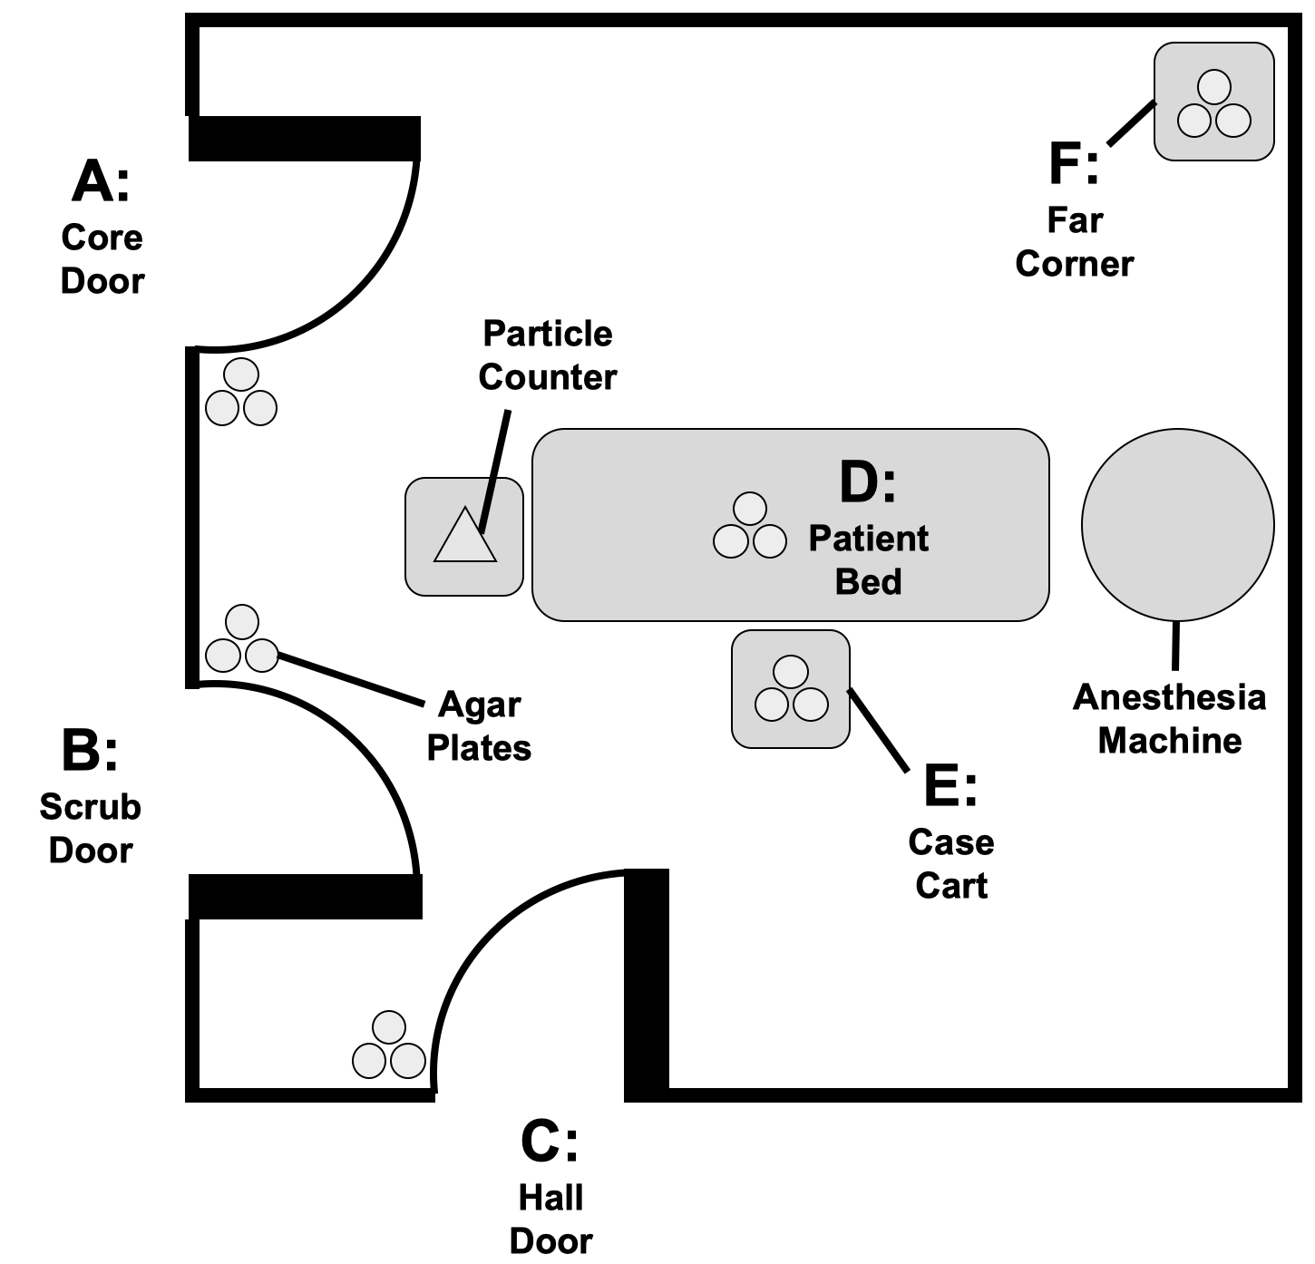

**Figure 1**. Floor plan of OR showing location of doors A, B, and C as well as patient bed (D), case cart (E), far corner (F) particle counter, microbial collection plates, and anesthesia machine. Each grouping of microbial collection plates included one containing BHI, one with MSA, and one with PIA.

*Simulation Experiment and Control*

A simulated, mock operation was completed following the protocol and script previously established by Gormley et al.16 with the following modifications. Medical student and undergraduate volunteers were used to simulate the various roles in the OR. All students had observed orthopaedic surgery cases prior to this mock surgery, and were assigned roles for this mock surgery to regulate their movement. No surgical instruments such as electrocautery, suction, or drills were used. The simulation was carried out over 90 minutes with 100 door openings. The openings were divided among the three doors according to ratios determined by preliminary observation data from OR cases: 30 were through the Core Door, 60 were through the Scrub Door, and 10 were through the Hall door. Of the opening through the Hall Door, 3 were held for approximately 60 seconds to represent patient entering, C-arm entry, and patient exiting.

The Control OR was tested on a separate day when no other operations were scheduled in the OR. All equipment was present in the room but no research personnel or volunteers were in the Control OR for 90 minutes of data collection.

*Pulse of the OR Application*

Door openings were monitored with the “Pulse of the OR” application, a custom-developed electronic monitoring system that provides door counts and color-coded feedback to OR staff. This iOS application receives real-time feedback from door sensors with embedded accelerometers to measure the number and speed of door openings. An individual accelerometer is adhered to each OR door, and a baseline position is set by the user in with the door closed. When the accelerometers detect a change from baseline, this information is sent to the iOS app via Bluetooth technology and a door opening is recorded for the door corresponding to the accelerometer. Depending on how long the door is held open (and the accelerometer is away from baseline) either a “quick” or a “held” opening is recorded. The time threshold for a held opening is entered into the app by the user. The app also includes the ability for users to log timed events of interest such as case cart opening, first incision, patient entering the room, and other events with the option to include free text.

A screenshot of the application interface is included for reference in Supplementary Material (Figure S1). This application was developed and tested during five orthopaedic cases. Accurate door counting ability of the accelerometers was previously verified against manual counts of door openings, included in Supplementary Material (Table S1). During the simulation, a tablet running the app was displayed in the OR to track door openings. The number of desired openings per door for the Simulated OR was chosen by averaging the counts of previously measured cases and applying the timed averages to fit the simulation time frame of 90 minutes.

*Data Collection and Analysis*

To compare air particle movement and size between the experimental and control simulations, Air Particle Counts (APCs) of 0.3 µm, 0.5 µm, and 5.0 µm were measured as described previously. To test microbial content at various locations within the OR, Colony Forming Units (CFUs) were counted for each microbial collection plate at 12, 24, 48, and 72 hours incubation. Data analysis for determining bacterial load in the Simulated OR versus the Control OR included a direct comparison of APCs and CFUs.

RESULTS & DISCUSSION

The purposes of this study were to compare the air particle counts (APCs) and colony forming units (CFUs) seen with the OR traffic of a typical orthopaedic case to a control without door openings as well as to monitor the number of door openings with an automatic counter that would display the progress on an iPad tablet.

*Particle Counts*

The particle counts were measured at sizes of 0.3 µm, 0.5 µm, and 5.0 µm for both the Simulated OR and Control room. Counts of 1.1x106 (Simulation) and 1.6x106 (Control) were observed for the 0.3 µm particles. For 0.5 µm particles, 2.7x105 were counted in the Simulated OR compared to 7.9x104 0.5 µm particles in the Control OR. Particles of 5.0 µm accounted for a total of 1862 in the Simulated OR compared to 56 in the Control OR. Airborne biologic particle size depends on a number of factors, including temperature and class of organism; in general, airborne bacteria are between 1-7.5 µm, sometimes existing in clumps.17 With this is mind, the 5 µm particle count being ~29x higher in the Simulated OR than in the Control OR suggests that increasing the number of door openings significantly increases the amount of airborne bacteria in the OR.

*Microbial Collection Plates*

Table 1 shows the CFU counts for all microbial plates in both the Simulated OR and Control OR. Higher counts were observed at all time points in all but three plates in the Simulated OR compared to the Control. The highest count in any plate in the Control OR was 1 CFU. The Control OR had no door openings to determine what portion of the airborne particles and bacteria on surfaces was due to the OR environment, such as bacteria left in the OR from the previous patient or particles introduced to the OR from heating, ventilation, and air conditioning. Given that in the Control OR the highest CFU on any agar plate was 1, we can assume that any increase in CFUs seen in the Simulated OR were due to personnel entering, as opposed to the innate microbes that may be present due to environmental factors.

**Table 1**. CFU counts for control and experimental rooms at progressive incubation time points in groups of three agars (BHI, MSA, and PIA). Location A represents the plates near the core hallway door Location B the scrub room door, Location C the external hallway door, Location D the patient bed, Location E the case cart, and Location F the farthest corner of the room. There were 100 door openings over the course of the 2-hour mock surgery in the Simulated OR. Of these door openings, 30 were through the Core Door, 60 were through the Scrub Door, and 10 were through the Hall door. Of the opening through the Hall Door, 3 were held for approximately 60 seconds to represent patient entering, C-arm entry, and patient exiting.

|  |  |  |  |  |  |  |  |  |  |
| --- | --- | --- | --- | --- | --- | --- | --- | --- | --- |
|  | | Control OR | | | | Simulated OR | | | |
| 12h | 24h | 48h | 72h | 12h | 24h | 48h | 72h |
| Location A | BHI | 1 | 1 | 1 | 1 | 4 | 3 | 4 | 4 |
| MSA | 0 | 0 | 0 | 0 | 3 | 5 | 6 | 6 |
| PIA | 0 | 0 | 0 | 0 | 0 | 0 | 1 | 2 |
| Location B | BHI | 0 | 0 | 0 | 0 | 15 | 16 | 16 | 19 |
| MSA | 0 | 0 | 0 | 0 | 3 | 3 | 116 | 266 |
| PIA | 0 | 0 | 0 | 0 | 0 | 1 | 7 | 7 |
| Location C | BHI | 0 | 0 | 0 | 0 | 12 | 15 | 17 | 22 |
| MSA | 0 | 0 | 0 | 0 | 5 | 11 | 16 | 17 |
| PIA | 0 | 0 | 0 | 0 | 10 | 11 | 17 | 19 |
| Location D | BHI | 0 | 0 | 1 | 1 | 11 | 11 | 12 | 12 |
| MSA | 0 | 0 | 0 | 0 | 9 | 9 | 9 | 10 |
| PIA | 0 | 0 | 0 | 0 | 0 | 1 | 1 | 1 |
| Location E | BHI | 1 | 1 | 1 | 1 | 3 | 3 | 3 | 4 |
| MSA | 0 | 0 | 0 | 0 | 2 | 4 | 5 | 7 |
| PIA | 0 | 0 | 0 | 0 | 0 | 1 | 1 | 1 |
| Location F | BHI | 1 | 1 | 1 | 1 | 6 | 6 | 6 | 7 |
| MSA | 0 | 0 | 0 | 0 | 3 | 4 | 4 | 4 |
| PIA | 0 | 0 | 0 | 0 | 3 | 4 | 4 | 5 |

As seen in Table 1, in the Simulated OR the highest counts were recorded outside the scrub door, with the hallway door and patient bed showing the next highest counts. The fewest CFU counts were recorded outside the core door. There were 100 door openings over the course of the 2-hour mock surgery in the Simulated OR. Of these door openings, 30 were through the Core Door, 60 were through the Scrub Door, and 10 were through the Hall door. Of the opening through the Hall Door, 3 were held for approximately 60 seconds to represent patient entering, C-arm entry, and patient exiting.

When considering agar types, in three of the six locations BHI plates showed the highest CFU counts, followed by MSA and then PIA. We believe these CFUs to represent bacteria, though because we did not use a fungal growth suppressor on the BHI plates, the CFUs could represent fungal colonies. There was one plate (MSA at location B, outside the scrub room) that showed exceptionally high counts. This measurement stands out as a possible contaminate as the CFUs measured at 266 (compared to less than 25 CFUs on all other agars in all locations). Given that this drastic increase in CFUs was seen between the 24-48 hour incubation period, it is likely that the contamination arose during sample handling. In all cases, CFUs after 72 hours from dishes in the Simulated OR were greater than the corresponding plates in the Control OR (Figure 2). The Control OR that had no door openings had little to no growth after 72 hours (3 locations grew 1 CFU on the nonselective BHI agar); this suggests that viable bacteria in the OR can be reduced by minimizing room traffic.

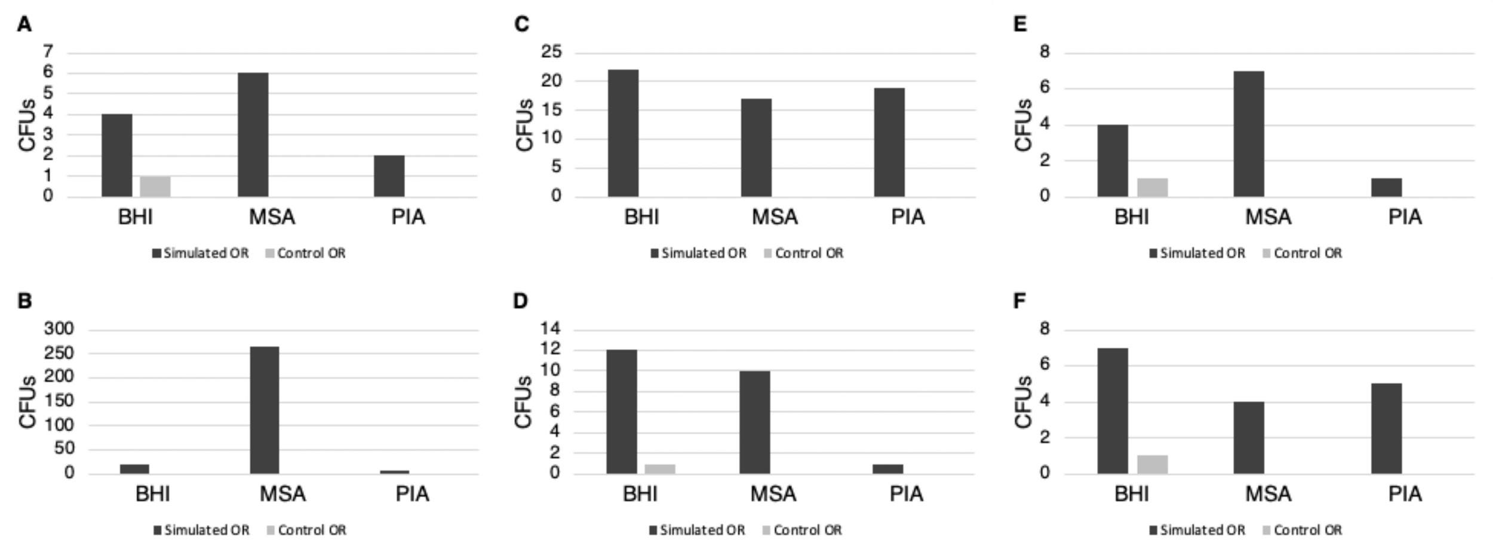

**Figure 2**. Growth after 72 hours exposure for the Simulated OR and the Control OR on BHI, MSA, and PIA. A represents the plates near the core hallway door, B the scrub room door, C the external hallway door, D the patient bed, E the case cart, and F the farthest corner of the room.

*Microbial Load of the OR*

These results lend themselves to the growing body of evidence that high OR room traffic may be an independent risk factor for the development of a surgical site infection (SSI). When included in a bundle of interventions (including door openings, perioperative antibiotics, hair removal before surgery, and perioperative normothermia), decreasing door openings leads to decreased SSIs.18,19 Taaffe et al. videotaped surgical procedures to determine areas of high traffic and plotted them against microbial load measured by the air samplers and by settle plates. They concluded that microbial load was correlated with the physical movement of people in the same area but not with the number of door openings.20 Given these findings, we had hypothesized that the Location F dishes, those furthest from the majority of the room traffic, would have the least growth. Figure 4 shows the bacterial growth on BHI after 72 hours in relation to the location of the dish within the operating room. There was substantial growth in Location F, even though there was close to no foot traffic in this area and it was away from OR doors and the patient bed. These results indicate that increased room traffic had an effect on bacterial load throughout the OR, regardless of distance from the door, likely because of OR airflow.



**Figure 3**. Bacterial growth in relation to the location of the plates within the operating room. CFUs after 72 hours on BHI. Numeric values presented in Table 2.

*Pulse of the OR app and Real-Time Feedback*

Given the growing evidence that high OR room traffic increases bacterial load, there have been efforts to determine the etiology of these door openings in order to direct interventions. Surprisingly, multiple studies have identified that a significant portion of door openings during surgeries had no clear reason. Andersson et al. determined that one-third of the door-openings in the procedures observed were unnecessary.11 Table 2 summarizes findings from three recent articles that sought to determine the primary reason for OR door openings. In each case, a substantial portion of the room traffic could be avoided by reducing the number of door openings that occur for reasons that are not obvious and using telephones/intercoms to collect information. Furthermore, the rate of door openings ranged from 0.21/min-0.69/min. One study found that it took the door approximately 20 seconds to fully close, resulting in as much as 15 to 20 minutes of every hour of the sterile procedure occurring with the door open.21

Table 2. Results from a literature review on etiology of OR door openings.

|  |  |  |  |  |  |  |  |
| --- | --- | --- | --- | --- | --- | --- | --- |
| Study | N | Setting | Rate | Info | Breaks | Supplies | Unknown/ No reason |
| Lynch et al.21 (2009) | 28 | USA (Cardiac, Orthopaedic, Plastic, and General surgery) | 0.59/min | 27-54% | 20-26% | 11-22% | 6-10% |
| Panahi et al.12 (2012) | 116 | USA (Orthopaedic surgeries) | 0.69/min | 14.5% | 1.5% | 23.3% | 47.3% |
| Andersson et al.11 (2012) | 30 | Sweden (Orthopaedic surgeries) | 0.21/min | 14.2% | 20.4% | 25.9% | 17.6% |

Efforts have been made to educate OR staff about the effects of high room traffic, however there has limited long-term success to reducing door openings by education or passive monitoring. Future directions of this project aim to use the automatic monitoring system employed in this study to count the number of door openings during surgical cases and provide real time feedback to the OR staff. This technology can also be expanded to include real-time monitoring of multiple ORs simultaneously from a central control board, allowing for institution-wide installation and implementation. The “Pulse of the OR” app screen is able to change colors from green to orange to red as the number of door openings gets closer to the set limit. With this visual feedback, OR personnel may be more inclined to adjust their patterns of behavior to avoid unnecessary door openings. In the future, the orange or red screen of the Pulse of the OR app may prompt OR personnel to ask themselves if their next door opening is necessary. This effort must be balanced against growing concerns of alarm fatigue in hospitals and ORs, dictating the need for further discussion and observation of the technology in use.22 The “Pulse of the OR” technology has potential to provide more granular data such as length of door openings and door opening acceleration (which is also likely correlated with the velocity of a person entering the OR) which would be expected to have an effect on air turbulence and thus also the spread of airborne bacteria and fomites.

*Limitations*

Our study is limited by the simulated design; although the setting of an OR was replicated, we lacked a patient which would introduce new bacteria – especially in the case of a contaminated trauma. Additional limitations are introduced by the single experiment design, and could be strengthened by validating in multiple operating rooms. Finally, our Control OR did not have any door openings; while the reduction of bacterial growth shows promise, it is not feasible to perform a surgery without opening the door. The critical capacity of door openings that would pose unacceptable risk of SSI to the patient is not yet known. However, one study found that any door opening increased the expected number of CFUs by almost 70%.4 Additional work is needed to determine the number of door openings per case that is both practicable and safe for patients.

CONCLUSIONS

High numbers of OR door openings increases the bacterial load within the operating room and could translate to an increased risk for development of a surgical site infection. Targeted interventions at reducing OR room traffic should be employed in an effort to decrease the number of new organisms being introduced into the OR. The Pulse of the OR iOS app presented here with real time and color feedback is one such potential intervention to lessen OR traffic and SSI risk.

DISCLOSURES

Authors have no conflicts of interest or financial ties to disclose.

FUNDING

This research did not receive any specific grant from funding agencies in the public, commercial, or not-for-profit sectors.

REFERENCES

1. Smyth ETM, McIlvenny G, Enstone JE, et al. Four Country Healthcare Associated Infection Prevalence Survey 2006: overview of the results. *J Hosp Infect*. 2008;69(3):230-248. doi:10.1016/j.jhin.2008.04.020

2. Emori TG, Gaynes RP. An overview of nosocomial infections, including the role of the microbiology laboratory. *Clin Microbiol Rev*. 1993;6(4):428-442. doi:10.1128/CMR.6.4.428

3. Ban KA, Minei JP, Laronga C, et al. American College of Surgeons and Surgical Infection Society: Surgical Site Infection Guidelines, 2016 Update. *J Am Coll Surg*. 2017;224(1):59-74. doi:10.1016/j.jamcollsurg.2016.10.029

4. Smith EB, Raphael IJ, Maltenfort MG, Honsawek S, Dolan K, Younkins EA. The Effect of Laminar Air Flow and Door Openings on Operating Room Contamination. *J Arthroplasty*. 2013;28(9):1482-1485. doi:10.1016/J.ARTH.2013.06.012

5. Cheadle WG. Risk Factors for Surgical Site Infection. *Surg Infect (Larchmt)*. 2006;7(s1):s7-s11. doi:10.1089/sur.2006.7.s1-7

6. de Lissovoy G, Fraeman K, Hutchins V, Murphy D, Song D, Vaughn BB. Surgical site infection: Incidence and impact on hospital utilization and treatment costs. *Am J Infect Control*. 2009;37(5):387-397. doi:10.1016/j.ajic.2008.12.010

7. Anderson DJ, Podgorny K, Berríos-Torres SI, et al. Strategies to prevent surgical site infections in acute care hospitals: 2014 update. *Infect Control Hosp Epidemiol*. 2014;35(6):605-627. doi:10.1086/676022

8. Birgand G, Saliou P, Lucet J-C. Influence of Staff Behavior on Infectious Risk in Operating Rooms: What Is the Evidence? *Infect Control Hosp Epidemiol*. 2015;36(1):93-106.

9. Esser J, Shrinski K, Cady R, Belew J. Reducing OR Traffic Using Education, Policy Development, and Communication Technology. *AORN J*. 2016;103(1):82-88. doi:10.1016/j.aorn.2015.10.022

10. Dibartola AC, Patel PG, Scharschmidt TJ, et al. Operating room team member role affects room traffic in orthopaedic surgery: A prospective observational study. *Curr Orthop Pract*. 2017;28(3):281-286. doi:10.1097/BCO.0000000000000501

11. Andersson AE, Bergh I, Karlsson J, Eriksson BI, Nilsson K. Traffic flow in the operating room: an explorative and descriptive study on air quality during orthopedic trauma implant surgery. *Am J Infect Control*. 2012;40(8):750-755. doi:10.1016/j.ajic.2011.09.015

12. Panahi P, Stroh M, Bs DSC, Parvizi J, Austin MS. Operating Room Traffic is a Major Concern During Total Joint Arthroplasty. *Clin Orthop Relat Res*. 2012;470:2690-2694. doi:10.1007/s11999-012-2252-4

13. Parikh SN, Grice SS, Schnell BM, Salisbury SR. Operating Room Traffic: Is There Any Role of Monitoring It? *J Pediatr Orthop*. 2010;30(6):617-623. doi:10.1097/BPO.0b013e3181e4f3be

14. Teter J, Guajardo I, Al-Rammah T, Rosson G, Perl TM, Manahan M. Assessment of operating room airflow using air particle counts and direct observation of door openings. *Am J Infect Control*. 2017;45(5):477-482. doi:10.1016/J.AJIC.2016.12.018

15. Al-Mulhim FA, Baragbah MA, Sadat-Ali M, Alomran AS, Azam MQ. Prevalence of surgical site infection in orthopedic surgery: A 5-year analysis. *Int Surg*. 2014;99(3):264-268. doi:10.9738/INTSURG-D-13-00251.1

16. Gormley T, Markel TA, Jones HW, et al. Methodology for analyzing environmental quality indicators in a dynamic operating room environment. *Am J Infect Control*. 2017;45(4):354-359.

17. Tham KW, Zuraimi MS. Size relationship between airborne viable bacteria and particles in a controlled indoor environment study. *Indoor Air*. 2005;15(s9):48-57.

18. Crolla RMPH, van der Laan L, Veen EJ, Hendriks Y, van Schendel C, Kluytmans J. Reduction of Surgical Site Infections after Implementation of a Bundle of Care. Manchikanti L, ed. *PLoS One*. 2012;7(9):e44599. doi:10.1371/journal.pone.0044599

19. van der Slegt J, van der Laan L, Veen EJ, Hendriks Y, Romme J, Kluytmans J. Implementation of a Bundle of Care to Reduce Surgical Site Infections in Patients Undergoing Vascular Surgery. Morgan D, ed. *PLoS One*. 2013;8(8):e71566. doi:10.1371/journal.pone.0071566

20. Taaffe K, Lee B, Ferrand Y, et al. The Influence of Traffic, Area Location, and Other Factors on Operating Room Microbial Load. *Infect Control Hosp Epidemiol*. 2018;39(04):391-397. doi:10.1017/ice.2017.323

21. Lynch RJ, Englesbe MJ, Sturm L, et al. Measurement of Foot Traffic in the Operating Room: Implications for Infection Control. *Am J Med Qual*. 2009;24(1):45-52. doi:10.1177/1062860608326419

22. Konkani A, Oakley B, Bauld TJ. Reducing hospital noise: A review of medical device alarm management. *Biomed Instrum Technol*. 2012;46(6):478-487. doi:10.2345/0899-8205-46.6.478