ESI for:

Low temperature CVD of thermoelectric SnTe thin films from the single source precursor [nBu3Sn(TenBu)]

Fred Robinson, Daniel W. Newbrook, Peter Curran, C. H. (Kees) de Groot, Duncan Hardie, Andrew L. Hector, Ruomeng Huang and Gillian Reid

**Contents:**

**Figure S1** NMR spectra for [nBu3Sn(TenBu)] in CDCl3 at 295 K.

**Figure S2** Isothermal step TGA experiment of Bu4Sn used for vapour pressure calculation.

**Figure S3** Grazing incidence XRD data for SnTe samples FR148T8 (black), FR148T7 (red), FR146T5 (green), FR173T4 (blue) and ICSD-188457 (bottom red).1

**Table S1** Lattice parameters calculated from decomposition analysis of XRD patterns of thin films of SnTe, crystallite sizes acquired using the Halder-Wagner method and literature values.

**Figure S4** Lower magnification SEM images of films deposited by CVD onto fused SiO2 substrates showing uniform film deposition and the corresponding EDX spectra for; tile (a) deposition 1 tile 2, (b) deposition 2 tile 1, (c) deposition 2 tile 2 and (d) deposition 3 tile 1.

**Figure S5** Halder-Wagner plots with trend lines obtained by linear regression analysis.

**Figure S1** NMR spectra for [nBu3Sn(TenBu)] in CDCl3 at 295 K.

**Figure S1.1** The 1H NMR spectrum.



**Figure S1.2** The 13C{1H} NMR spectrum.



**Figure S1.3** The 2D HSQC NMR spectrum.

**Figure S1.4** The 119Sn{1H} NMR spectrum.



**Figure S1.5** The 125Te{1H} NMR spectrum.

**Figure S2** Isothermal step TGA experiment of Bu4Sn used for vapour pressure calculation. 

**Figure S3** Grazing incidence XRD data for SnTe samples deposition 2 tile 2 (black), deposition 2 tile 1 (green), deposition 1 tile 1 (purple), deposition 3 tile 1 (blue) and ICSD-188457 (bottom red).1

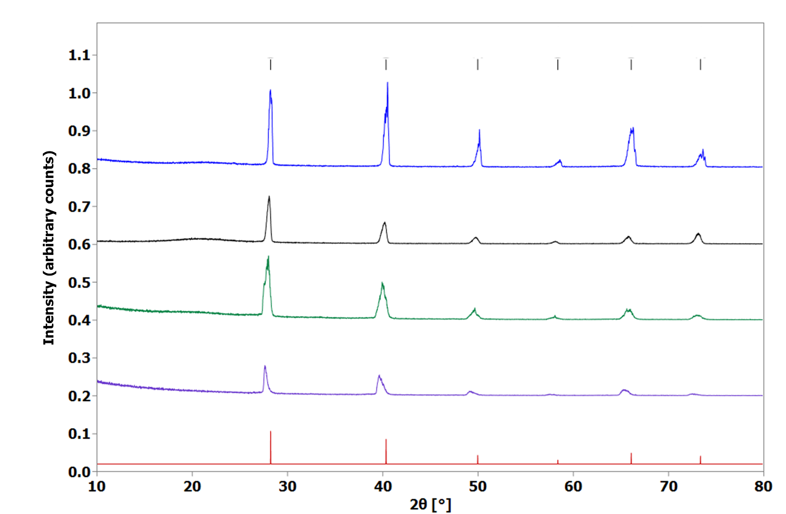

**Table S1** Lattice parameters calculated from decomposition analysis of XRD patterns of thin films of SnTe, crystallite sizes acquired using the Halder-Wagner method and literature values. *Lanthanum hexaboride standard used and matched to a literature pattern.2

|  |  |  |  |  |  |
| --- | --- | --- | --- | --- | --- |
| **Data** | **Deposition Temperature (◦C)** | **a (Å)** | **Rwp%** | **Rp%** | **Crystallite size (nm) with standard\*** |
| Deposition 1 Tile 1 | 404 | 6.3881(3) | 14.30 | 9.82 | 110(30) |
| Deposition 2 Tile 1 | 410 | 6.35250(18) | 15.50 | 10.82 | 100(10) |
| Deposition 2 Tile 2 | 355 | 6.3304(4) | 12.59 | 9.29 | 210(110) |
| Deposition 3 Tile 1 | 434 | 6.30301(19) | 12.73 | 9.75 | - |
| Bulk SnTe1 | - | 6.318(3) | 13.70 | 13.60 | - |

**Figure S4** Lower magnification SEM images of films deposited by CVD onto fused SiO2 substrates showing uniform film deposition and the corresponding EDX spectra for; tile (a) deposition 1 tile 2, (b) deposition 2 tile 1, (c) deposition 2 tile 2 and (d) deposition 3 tile 1.

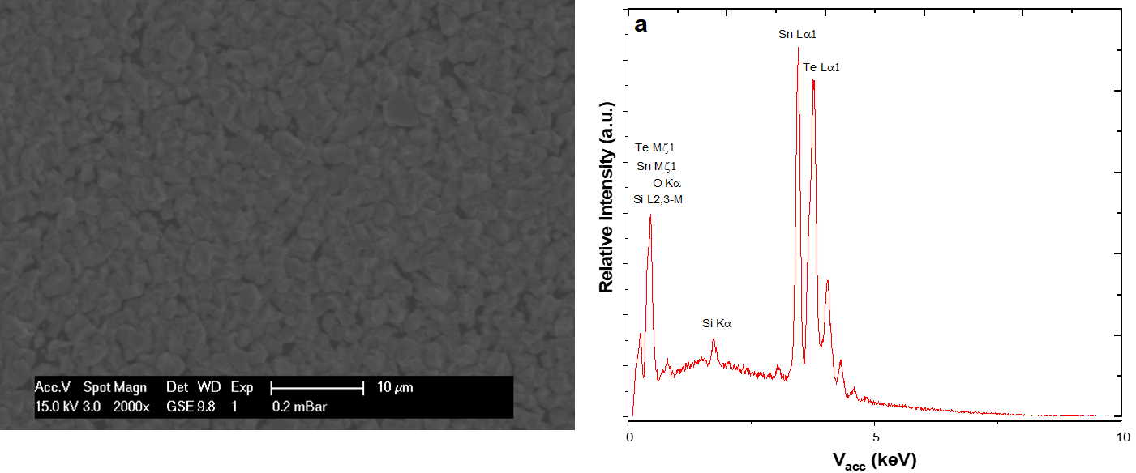

aaaaa

(b) 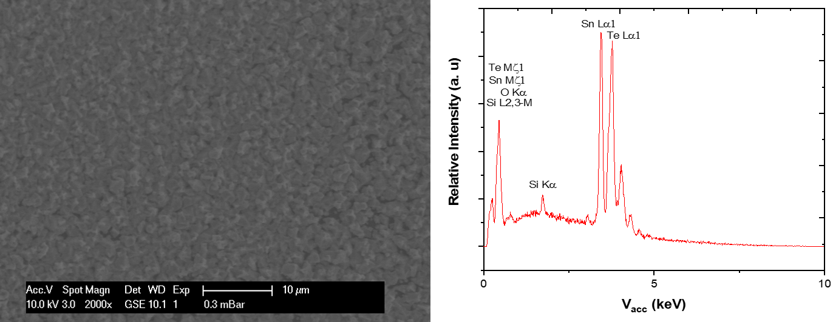

(c)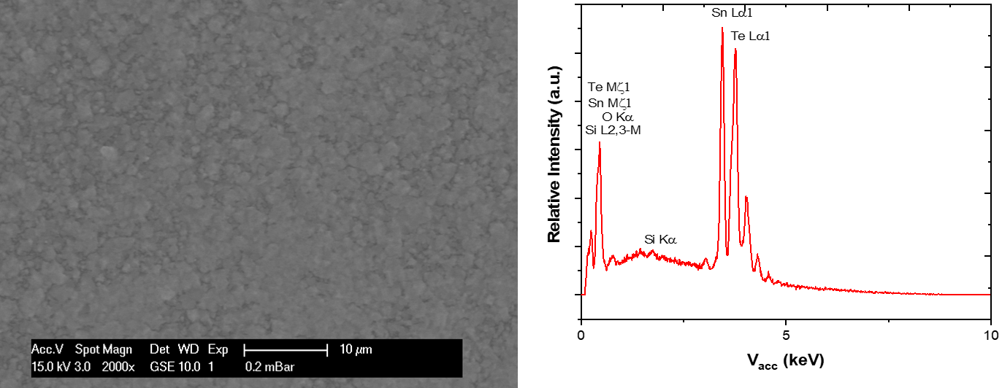

(d)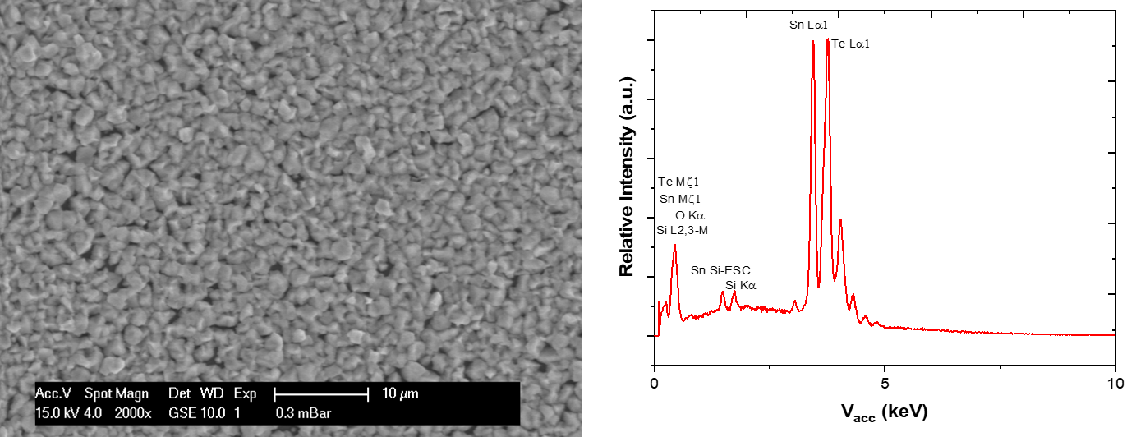

**Figure S5** Halder-Wagner plots with trend lines obtained by linear regression analysis and compared to a lanthanum hexaboride standard to account for instrumental peak broadening.

**Figure S5.1** Plot for Deposition 1 tile 1.

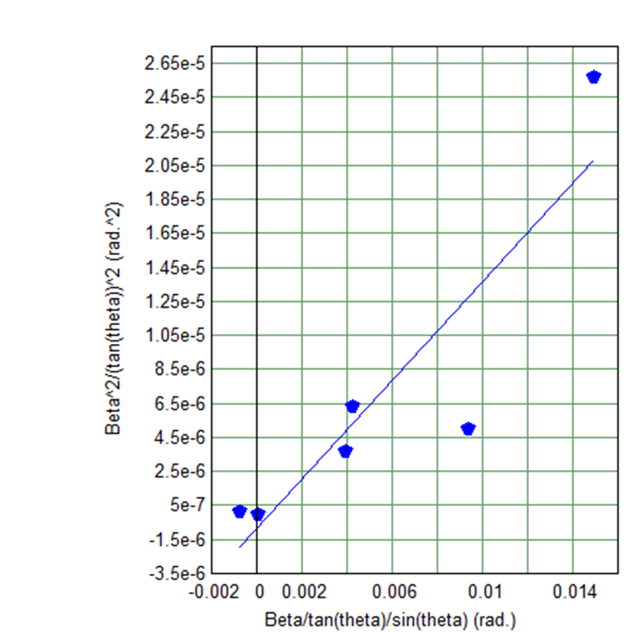

**Figure S5.2** Plot for Deposition 2 tile 1.

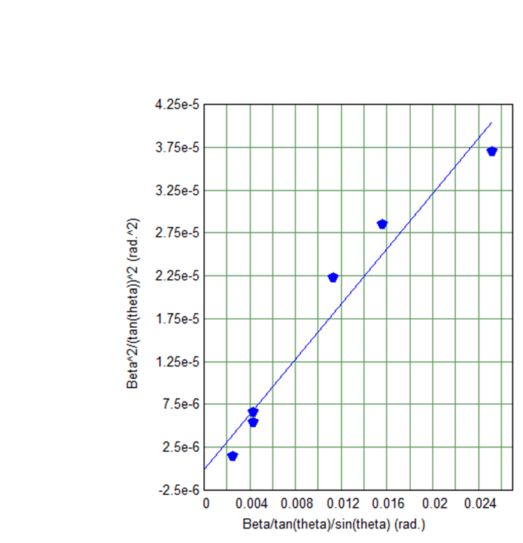

**Figure S5.3** Plot for Deposition 2 tile 2.

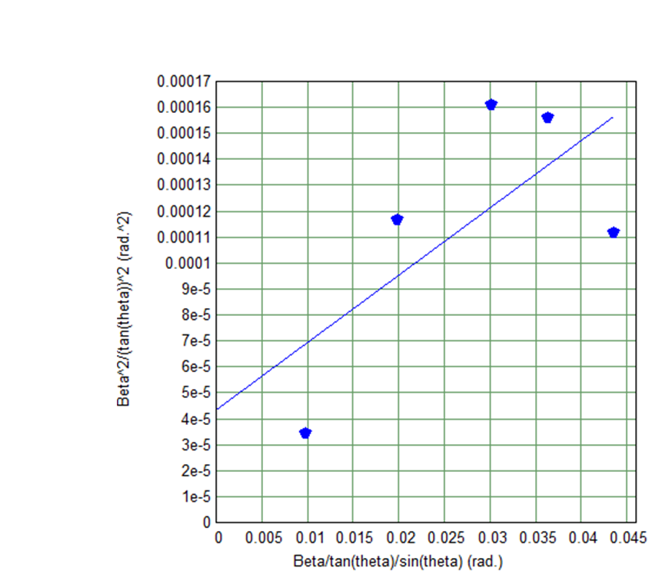

**Figure S5.4** Plot for Deposition 3 tile 1.

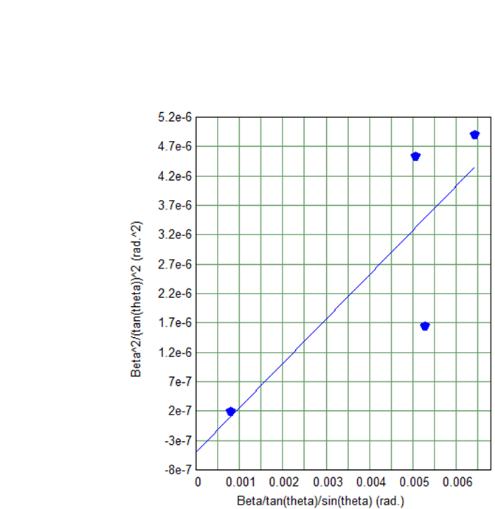

**References**

1 P. Bauer Pereira, I. Sergueev, S. Gorsse, J. Dadda, E. Müller and R. P. Hermann, *Phys. status. Solidi B*, 2013, **250**, 1300.

2 A. A. Eliseev, G. M. Efremmov, V A Kuz’micheva, E. S. Konovalova, V. I. Lazorenko, Y. B. Paderno and S. Y. Khlyustova, *Kristallografiya*, 1986, **31**, 803.