Global impact of landscape fire emissions on surface level PM_{2.5} concentrations, air quality exposure and population mortality

Roberts, G^{1*} and Wooster, M. J.^{2, 3}
*corresponding author

1) Geography and Environmental Science, Building 44, University of Southampton, Southampton, SO17 1BJ, UK
2) Leverhulme Centre for Wildfires, Environment and Society, Department of Geography, King’s College London, Aldwych, London WC2B 4BG
3) National Centre for Earth Observation, King’s College London, Aldwych, London WC2B 4BG.

Abstract
Airborne fine particulate matter (PM_{2.5}) represents the greatest ambient air pollution risk to health. Wildfires and managed burns, together referred to hereafter as ‘landscape’ fires, are a significant PM_{2.5} source in many regions worldwide, able to affect air quality in areas far away from the fires themselves. We use 0.125°, 3 hourly outputs (2016-2019) from the Copernicus Atmospheric Monitoring System (CAMS) to investigate patterns of global population exposure to ambient surface level PM_{2.5}, and specifically to the contribution coming from landscape fires. We calculate both the air quality impacts and annual average mortality at the level of the nation state, and our analysis highlights both the burden of poor air quality and the significance of landscape fire sources in developing nations in particular. We find 143 countries to have an average population weighted (PW) total PM_{2.5} surface level concentration exceeding the 10 µg.m⁻³ guideline recommended by WHO, with 67.2 million people annually exposed to PM_{2.5} levels classed as ‘hazardous’ (> 250.5 µg.m⁻³) according to the US Environmental Protection Agency (EPA) air quality index (AQI). Landscape fires alone result in 44 million people annually being exposed to air quality considered unhealthy (PM_{2.5} > 55 µg.m⁻³), and 4 million to that considered ‘hazardous’ to health (> 250.5 µg.m⁻³). Populations in central and west Africa and south and south east Asia are most affected by the landscape fire smoke, and eight countries exceed the WHO annual mean 10 µg.m⁻³ guideline from this source only - with the contribution from fires highest in Laos (61% of the total PM_{2.5}), Democratic Republic of Congo (45%) and Sierra Leone (44%). Combining published dose-response functions with these landscape-fire PM_{2.5} contributions, we estimate that 677,745 premature deaths annually result from exposure to landscape fire smoke, with almost 39% of these in children under five. This mortality represents between 8 and 21% of the estimated 3.2 to 8.9 million people dying annually from outdoor air pollution exposure, highlighting landscape fires as a significant contributor. Our results indicate that environmental programmes aimed at lessening the use of fire in land clearance and agricultural residue management in developing nations would very likely result in significant co-benefits for health.

1. Introduction
Despite clean air being long identified as necessary for good public health and well-being, outdoor (ambient) air pollution remains the world’s greatest environmental health risk (WHO, 2016). Outdoor air pollution in many developing nations is a growing problem, greater even than indoor air pollution whose influence is forecast to decrease over the coming decades as people transition away from burning solid fuels for cooking and heating (Li et al., 2020; Chafe et al., 2010). Outdoor air pollution comes from a variety of anthropogenic and natural sources, with estimates of annual average mortality (premature deaths) resulting from total ambient PM_{2.5} and O₃ exposure varying from around 3.2 to 8.9 million (Giannadaki et al., 2017; WHO, 2016, Lelieveld et al., 2015; Burnett et al. 2018), with adverse health effects felt by hundreds of millions more (WHO, 2016). Populations in Asia seem most affected in terms of mortality (Lelieveld et al., 2015), and in 2010 70% of global total excess deaths due to outdoor air pollution were reported as being in Asia (Giannadaki et al., 2017).

Ambient air pollution comprises gases such as tropospheric ozone (O₃), nitrogen dioxide (NO₂), volatile organic compounds (VOCs), carbon monoxide (CO), and sulphur dioxide (SO₂), along with particulate matter (PM) size fractions such as PM₁₀ and PM_{2.5}. The finer PM_{2.5} particles represent the greatest ambient air pollution risk to health (WHO, 2006), and in 2010 anthropogenic sources such as residential combustion and industrial processes accounted for 59% of global total PM_{2.5} emissions (Klimont et al., 2017). In certain countries however, large amounts of PM_{2.5} are produced by landscape fires, many of which are ignited deliberately for land clearance or land management purposes – for example for clearing forest for agriculture or when removing agricultural residues after harvest (Reddington et al., 2015; Zhang et al., 2017; Cusworth et al., 2018). In many developing countries, such landscape fires may actually represent the single largest PM_{2.5} source (Colbeck and Lazaridis, 2010), and in many cases buoyant fire plumes can help the smoke travel far away from the source region, sometimes becoming transboundary in nature to significantly affect air quality in neighbouring nations (e.g. Ikeda and Tanimoto, 2015; Demoah et al., 2004). The extreme impacts that can result from such transboundary transport of biomass burning emissions is perhaps best highlighted by the regional ‘haze’ episodes that occur sporadically in southeast Asia, which are largely related to fires in degraded tropical peat swamps that have become far more flammable due to forest clearance and swampland drainage (Kiely et al., 2019; Reddington et al., 2014; Wooster et al., 2018). Certain (model-based) estimates of the regional PM_{2.5} exposure of populations during such episodes suggest the possibility of many tens of thousands of additional deaths resulting from the most extreme events (Crippa et al., 2016). Here we extend this type of health impact study across the globe, using outputs from a state-of-the-art global atmospheric composition modelling and monitoring system - the Copernicus Atmospheric Monitoring Service (CAMS).

A number of approaches exist for quantifying air quality and its effect on population health. Surface monitoring stations provide probably the most accurate and also highest temporal resolution air quality measurements, enabling the impact of long-term ambient exposure to air pollutants to be quantified (e.g. Miller et al., 2007; Samet et al., 2000). However, the density of the surface station network maybe relatively sparse, particularly in least developed and developing countries. Brauer et al. (2019) highlight the expense involved in developing surface air quality stations in India, comparable to that found the USA and China and estimated as having annual running costs of US $212 (540) million for 1600 (4000) stations. To obtain more complete spatial coverage, surface station measures have been spatially interpolated (Beelen et al., 2008; Ahmed et al., 2018) and combined with satellite data and sometimes also with the outputs of atmospheric modelling (Brauer et al., 2016; Shaddick et al., 2018). Whilst benefitting from the high temporal resolution of the surface station network data, these methods are still constrained by the network density, and the integration/calibration required to relate satellite and surface observations is non-trivial, particularly since the satellite data often provide column integrated values (e.g. of aerosol optical depth) whereas the station network provides surface values (Li et al., 2015). Computational developments have seen increased application of atmospheric chemical transport models, such as Weather Research and Forecasting (WRF) - Community Multiscale Air Quality Modeling System (CMAQ; Appel et al., 2017). These models can linked to emissions inventories (anthropogenic and fire emissions etc) and to enable the quantification of different emissions sources to overall air quality (e.g. Reddington et al., 2015; Lelieveld et al., 2015). The models also provide complete spatial coverage and can do so at a comparatively high spatial resolution, but they are computationally intensive which often limits their application to regional scales and\or shorter timeframes (e.g. Zhang et al., 2014; Baldassarre et al., 2015; Appel et al., 2010; Wong et al., 2012). In this study we use the model outputs from the CAMS global model, which runs on a very high performance supercomputer and which are available globally at moderate spatial (0.125°) and temporal (3 hourly) resolution. We use CAMS outputs to understand the global surface-level ambient atmosphere PM_{2.5} concentrations, the influence of landscape (comprising wildfire and managed burns) fire emissions on these and on the levels of air quality that result, and the degree to which premature mortality results from exposure to the fire emitted PM. Our work builds on methodologies previously employed by Johnston et al. (2012) to estimate global mortality due to landscape fire PM_{2.5} emissions, but we use outputs from the more recent CAMS system and study more recent years, quantifying the air quality and health impacts globally but also at the scale of the nation state. Whilst we focus on exposure to PM_{2.5} emitted by landscape fires, we also assess population exposure to all source PM_{2.5} in order to put the landscape fire source properly in context.

2. Models and Datasets
2.1 The Copernicus Atmospheric Monitoring Service (CAMS)
The CAMS is supported by the Copernicus Programme of the European Union (EU), and has six focus areas providing near continuous monitoring of Earth’s atmosphere at regional and global scales using a combination of satellite data, in situ observations and atmospheric modelling, the latter primarily conducted using the Integrated Forecasting System (IFS) of the European Centre for Medium Range Weather Forecasting (ECMWF). The IFS is a state-of-the-art global data assimilation, modelling and forecasting system providing atmospheric composition data (aerosols, greenhouse gases, reactive gases) at 6 hourly intervals and forecasts at 3 hourly intervals for a maximum forward look of 5 days. The current IFS cycle operates with 137 vertical levels from the surface up to 0.01 hPa at a nominal horizontal resolution of ~40 km. Modelled data outputs can be resampled up to 0.125° resolution using the Meteorological Interpolation and Regridding scheme (MIR, Malardel et al., 2016). We are here primarily concerned with the surface-level PM_{2.5} abundances, which include contributions from fine and coarse nitrate and ammonium aerosols, sea salt covering three size distributions (0.03-0.5 µm, 0.5- 5 µm, 5- 20 µm), dust (0.03-0.55 µm, 0.55-0.9 µm, 0.9-20 µm), and sulphate, organic matter (OM) and black carbon (BC) aerosols emitted from both anthropogenic and natural sources. Biomass burning emissions are confined to the BC and OM components, and in no part of this study do we include the fine and coarse nitrate and ammonium aerosols since they were only recently introduced into the IFS (July 2019).

The specific aerosol model used within the IFS (IFS Cycle 45R1; 06/2018) is detailed in Remy et al. (2018) and only a brief overview is provided here. PM_{2.5} is calculated using aerosol mass mixing ratios (kg.kg⁻¹) of the different components, following Remy et al. (2020):

${PM}_{2.5}=ρ(\frac{{SS}_{1}}{4.3}+0.5\frac{{SS}_{2}}{4.3}+{DD}_{1}+{DD}_{2}+0.7×OM+BC+0.7×SU)$ [1]

where ${DD}_{1}$ and ${DD}_{2}$ are dust aerosols (0.03-0.55 µm and 0.55-0.9 µm), ${SS}_{1}$ and ${SS}_{2}$ are sea salt aerosols (0.03-0.5 µm and 0.5-5.0 µm), $SU$ is sulphate aerosol, $OM$ and $BC$ are the organic matter and black carbon aerosols (both hydrophobic and hydrophilic) and $ρ$ is the air density calculated via:

$ρ=\frac{P}{RT}$ [2]

where for a given model level, $P$ is the pressure (hPa), $T$ is the temperature (K) and $R$ is the specific gas constant (287.058, J.Kg K).

Anthropogenic aerosols come from the MACCity and CAMS-GLOB-ANT emissions inventories (Granier et al., 2011; 2019), and cover transportation, energy, industries, ships, residential, solvents, and agricultural activities. These in turn are based on an extension of the historical emissions from the atmospheric chemistry and climate model intercomparision project (ACCMIP). Landscape fire emissions come from the Global Fire Assimilation System (GFASv1.2; Kaiser et al., 2012), which is driven by satellite-derived fire radiative power (FRP) estimates made at the location of actively burning fires. At present these global FRP data come from observations made multiple times per day by the MODIS instruments operating onboard the Terra and Aqua polar-orbiting satellites (Giglio et al., 2016). Small scale field experiments (e.g. Wooster et al., 2005; Kremens et al., 2012) found a strong relationship between the rate of thermal radiation emission by fires (i.e. the FRP) and the rate of fuel consumption. This relationship has been exploited to estimate fuel consumption from spaceborne data (e.g. Roberts et al., 2018; Li et al., 2019; Andela et al., 2016), and in GFAS the FRP density (W.m²; calculated by normalising the FRP by the grid cell area, m²) is the metric used to do this. Following the approach of Wooster et al. (2005), FRP density is used to calculate the rate of dry matter (DM) fuel consumption (kg.s⁻¹.m⁻²), which when multiplied by the appropriate emissions factors provides trace gas emissions rate estimates. In total, 51 parameters are provided by GFAS, including surface flux (kg.m².s⁻¹) estimates of 41 species contained within the landscape fire smoke (both aerosols and trace gases). GFAS-derived biomass burning emissions used in the CAMS model outputs employed herein were released at the surface up until July 2019, after which CAMS uses a plume injection height formulation based also on the fires FRP and local meteorology to prescribe the placement of the emissions above the surface (Sofiev et al., 2012). However, though the plumes from large very intensely burning landscape fires maybe lofted high into the atmosphere and very occasionally even the stratosphere (Val Martin et al., 2010), such events represent a very small minority of total landscape fire plumes (Val Martin., 2018).

Figure 1a shows the global mean annual average surface level PM_{2.5} concentration output from CAMS at a grid cell size of 0.125°, calculated over the period 2016 to 2019. Figure 1b shows the FRP-derived measure of fire activity (the total MODIS-measured FRP areal density calculated at the same grid cell size and for the same period as Figure 1a). Whilst some areas show high surface level PM_{2.5} concentrations and relatively low fire activity (e.g. a few industrial regions of Southern Africa and parts of East Asia), there exist many more areas where elevated values of both metrics point to a potential relationship between mean PM_{2.5} concentrations and landscape fires. This is explored further in Figure 2, which shows a reasonably strong positive correlation between daily mean surface level PM_{2.5} and fire activity, with a Pearson correlation coefficient (R) of between 0.86 and 0.92, for continents outside of Africa and Oceania where dust and sea salt sources are very significant. Whilst in the other continents the PM_{2.5} particles also come from a variety of sources, the relations shown in Figure 2 provide evidence that landscape fire emissions maybe driving a significant fraction of their surface level PM_{2.5} variability. It seems likely that maybe the case in parts of Africa as well (notwithstanding the dust sources) since, despite the fuel loads in savannas and grasslands often being lower than those found in e.g. forested landscapes (Van Leeuwen et al., 2014), it is the continent where the largest area of landscape burning occurs (Giglio et al., 2010, Figure S1 in the supplementary material). Elucidating the link between landscape fires and air pollution in the form of PM_{2.5}, and using this to estimate the air quality and health impacts of landscape fire activity, is the key aim of our work. For comparison, Figure S2 shows the mean annual (2016-19) average daily total PM_{2.5} concentration and the daily total GFAS FRP density (W.m⁻²) on a continental basis (excluding Antarctica).

(a)
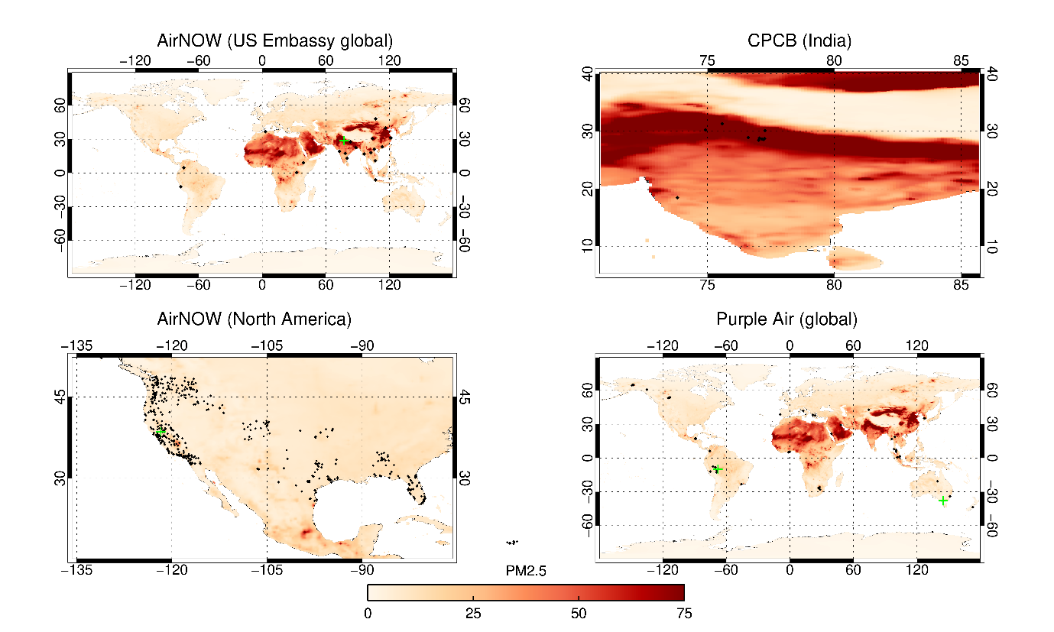

b)
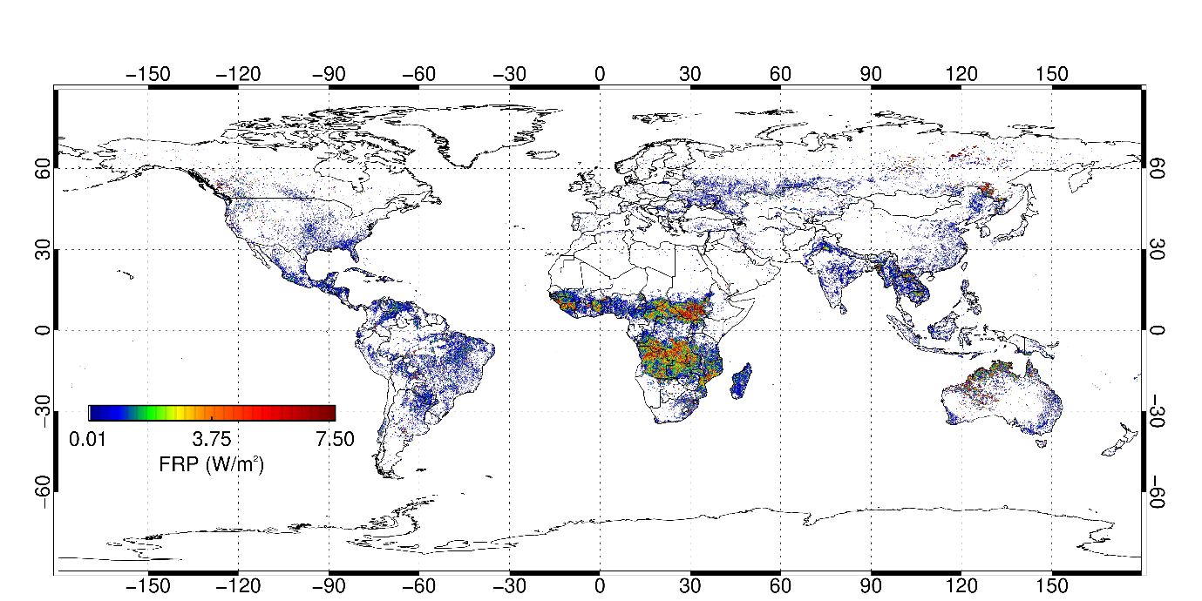

Figure 1: Globally mapped outputs (0.125°) from the Copernicus Atmosphere Monitoring Service (CAMS) calculated over the period 2016-2019, along with in (a) the location of air quality monitoring stations used herein. (a) Daily mean PM_{2.5} surface level concentration (µg.m⁻³), (b) GFAS Fire Radiative Power (FRP) areal density (W.m⁻²) (Kaiser et al., 2012), derived using MODIS FRP data from the MODIS active fire product (MCDML14; Giglio et al., 2016). Panels in (a) include as black dots the location of each of the in-situ surface air quality monitoring stations whose use is described in Section 3. These stations are respectively part of the US EPAs ‘AirNOW’ US Embassy network (22 sites), the Indian Central Pollution Control Board [CPCB]), the US EPAs ‘AirNOW’ North America network (442 sites), and the Purple Air network (84 sites). Green crosses mark the locations of the AirNOW and Purple Air sites at Werribee, New Delhi, Rio Branco and UC Davis whose data are shown in detail in Figure 3.
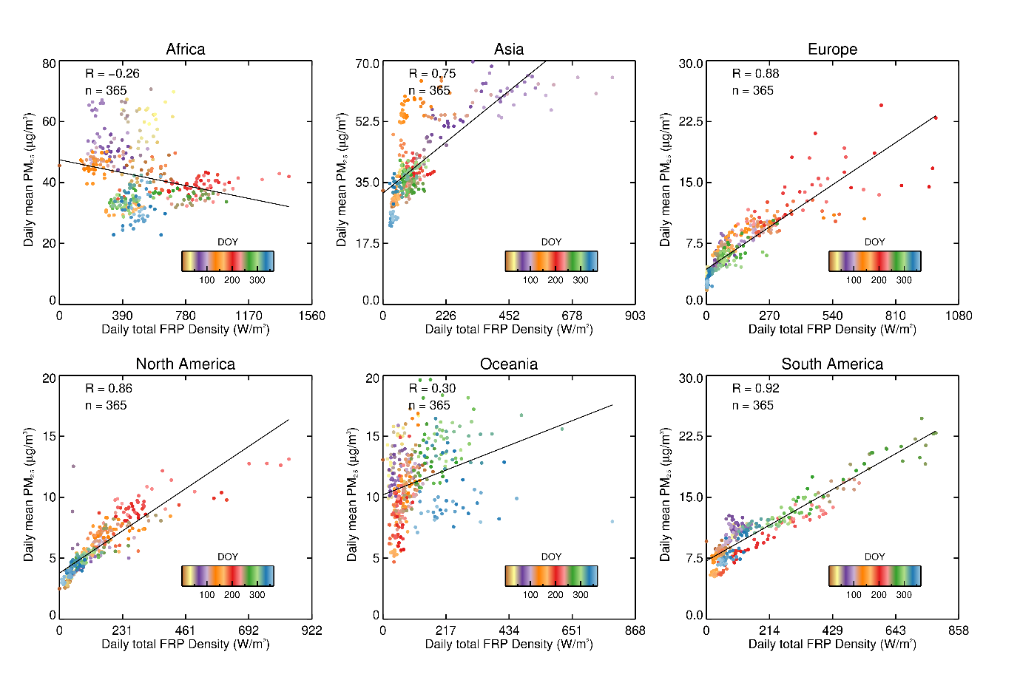
Figure 2: Relationships between 2016-19 daily mean surface level PM_{2.5} concentration and the corresponding total daily FRP density (W.m⁻²) for all continents excluding Antarctica. Colours indicate day of year (DOY). Each point represents data from one CAMS 0.125° grid cell, with the OLS linear best fit to the data from all cells in each continent included.

2.2 Additional Datasets
In addition to the CAMS data themselves, a series of in situ surface level PM_{2.5} concentrations were also deployed here to help evaluate the modelled CAMS values, both generally and at times of landscape fires. These in situ data come primarily from the US Environmental Protection Agency’s (EPA) AirNOW network (https://www.epa.gov/outdoor-air-quality-data), which in 2019 has access to 9143 sites - 90% of which provide hourly data. We selected data from 442 sites in California, Oregon, Washington State, Colorado, Kansas, Alabama, Florida, Georgia, Louisiana, Mississippi, Texas and Idaho (Figure 1) as they are located in areas of sometimes highly significant fire activity in agricultural and forested regions (McCarty et al., 2007; Korontzi et al., 2008; Dennison et al., 2014), as well as from stations located at 12 US Embassy and Consulates distributed across South America, Africa and Asia. These data are complemented by PM_{2.5} observations at 84 sites from the Purple Air network (https://www.purpleair.com/) for 2019. The Purple Air station data occasionally contain spurious signals (values > 2000 µg.m⁻³) which were removed from the analysis. We supplemented these global data with that from ten stations operated by the Indian governments Ministry of Environment and Forests Central Pollution Control Board (CPCB), India being a country where crop residue burning, widely varying anthropogenic emissions, and the monsoon bring air quality conditions that vary widely in space and time (Dey et al., 2012; Jethva et al., 2019; Sembhi et al., 2020). Combined, the surface station data enable the assessment of CAMS PM_{2.5} estimates in regions that experience high and low PM_{2.5} concentrations due to anthropogenic and/or landscape fire emissions. The location of each air quality measurement station used in this study is marked in Figure 1a. We also used global population data, again mapped to the CAMS 0.125° spatial grid, taken from the age and gender stratified global population dataset of 2018 developed by the WorldPop Project (www.worldpop.org/; Tatem, 2017).

3. Assessing CAMS Surface Level PM_{2.5} Data QUALITY
Before outlining the results of the comparison between the CAMS and in situ PM_{2.5} concentration data, four globally distributed sites are selected which are influenced by anthropogenic and/or landscape fire emissions to varying extents by way of example. Figure 3 presents results for sites located at Werribee (2019), south-east Australia (37.89° S, 144.64° W), New Delhi (2019), India (28.61° N, 77.20° W), Rio Branco (2019), Brazil (9.89° S, 67.86° E) and UC Davis (2018) (California, 38.54° N, -121.74° W).

The air quality in Werribee and New Delhi is influenced by emissions from anthropogenic activities and landscape fires which occur between November and March around Werribee (Dennekamp et al., 2015) and in April/May and October/November around Delhi (Lui et al., 2018). New Delhi has a strong PM_{2.5} annual cycle with the highest concentrations seen in the northern hemisphere winter months whilst PM_{2.5} concentration in Werribee tends to be more stable throughout the year although increases in winter occur due to domestic heating (Bennett et al., 2007). The CAMS data capture both the dynamics and magnitude of the in-situ measures at the Werribee site (R=0.54), with a low bias (1.73 µg.m⁻³) albeit a higher RMSE (6.02 µg.m⁻³). Over Delhi, CAMS captures the temporal dynamics of the surface PM_{2.5} concentrations very well, and though the bias of -11.5 µg.m⁻³ is relatively high, a large part of this is attributable to the intense PM_{2.5} concentration maxima seen in the point-based in situ measurements around DOY 40.

The air quality in Rio Branco is affected by landscape fire emissions during the fire season between August and October. The comparison shows that, the CAMS overestimates PM_{2.5} at the start of the year but captures the trend and concentrations during the fire season with a moderate bias (3.6 µg.m⁻³) and RMSE (12.7 µg.m⁻³) and good correlation (R = 0.71). Davis (California) is a semi-rural area influenced by anthropogenic emissions which are <10 µg.m⁻³ for much of the year. The CAMS estimates are typically a little higher than the in situ measurements resulting in a bias of 8.9 µg.m⁻³, this site is subject to occasional influences from Californian fires. Around DOY 205 (24th July) and 313 (7th November) noticeable PM_{2.5} concentration increases related to landscape burning are evident in the modelled and in situ data. Comparison to the in situ data shows that CAMS captures the timing and surface level PM_{2.5} concentration increases resulting from the Camp (Brewer and Clements, 2020) and Montecedo fires extremely well, demonstrating excellent performance of the CAMS system in this fire-affected region.
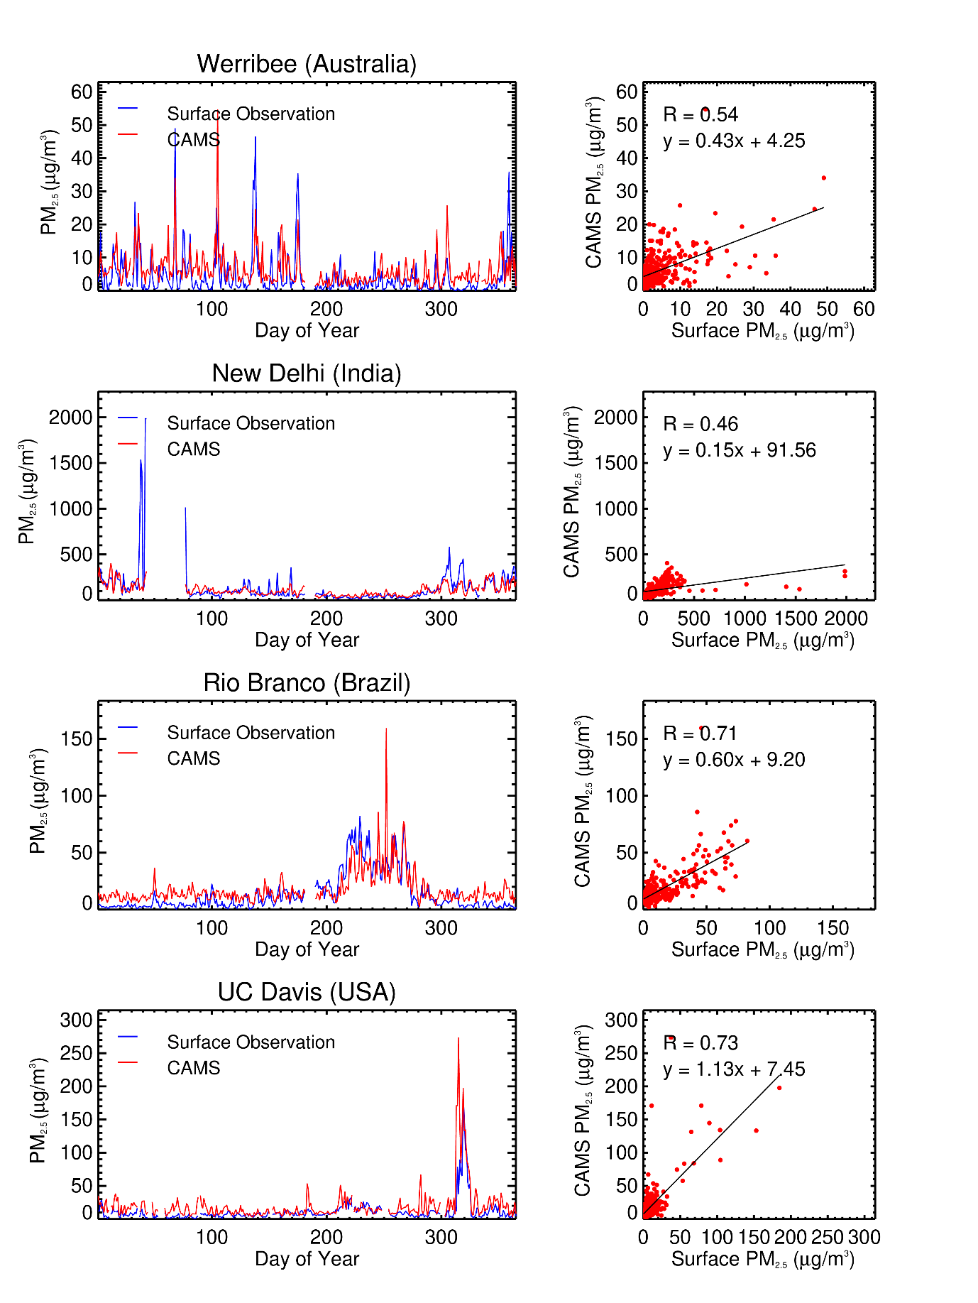
Figure 3: Daily mean modelled (CAMS) and measured (in situ) surface level ambient atmospheric PM_{2.5} concentration for locations containing Purple Air and AirNOW stations in Werribee [2019], New Delhi [2019], Rio Branco [2019] and UC Davis [2018]. For the UC Davis station, the effect of smoke coming from the extreme Camp fire of November 2018 is clearly seen.

Christophe et al. (2019) have already evaluated CAMS-generated surface level PM_{2.5} concentration data between March and May 2019, comparing them to in situ records from 160 ‘background sites’ across Europe and North America. They found CAMS estimates to be on average around 54% higher than the in situ measures in North America, but 17% lower in Europe. In Table 1 we present the statistical summary of our comparisons between the mean monthly CAMS-derived surface level PM_{2.5} concentration and those from the globally distributed set of in situ stations mapped in Figure 1a (548 stations in total). Since there is considerable variation between years, we present data for 2016, 2017, 2018 and 2019 separately in Table 1. We present both the mean bias and the Modified Normalised Mean Bias (MNMB, Wagner et al., 2015), the latter being robust to outliers and taking a value between 2 and -2, with values close to zero being optimum:
$MNMB=\frac{2}{N}\sum_{i}{\left(\frac{M_{i}-O_{i}}{M_{i}+O_{i}}\right)}$ [3]

where $N$ is the number of observations, $M_{i}$ is the model estimate at step $i$ and $O_{i}$ is the in situ observation.

The average annual MNMB ranges between 0.56 and -0.38 – indicating that the CAMS data over (under) estimates by 56% (38%) depending on the year, and overall overestimates PM_{2.5} on average by 24%. Over North America the MNMB in 2018 (0.48) is slightly higher than that (0.32) found by Remy et al., (2019) over the same region using a larger number of sites (>1000). Greater underestimation is seen at the Embassy and Consulate sites in 2016 and the cause is unclear, but could be related to the fact that it was only in June of this earliest year of our study that CAMS began using the MACCity inventory (Remy et al., 2019), previously relying on the Emission Database for Global Atmospheric Research (EDGAR, Olivier et al., 1994). Reddington et al. (2019) compared WRF-CHEM-derived PM_{2.5} surface level concentrations and in situ data at sites in south and south-east Asia, finding a similar level of correspondence (R=0.55) to that found here for sites in the same region. Reddington et al. (2019) also quantified model performance and found WRF-CHEM-derived surface level PM_{2.5} marginally overestimated (MNMB =0.09, equivalent to overestimation by a factor of 1.09) but with regional variations over for example China (MNMB =0.33) and underestimation (e.g. Bhutan, MNMB = −0.63). In our work we find the ‘all year’ MNMB for sites in Asia and SE Asia to be 0.2, indicating CAMS overestimation by on average 20%. Of course, it is not possible for CAMS to characterise the local scale effects and potentially heterogeneous PM_{2.5} surface level concentrations found around specific in situ stations (Wagner et al., 2015). Our comparison between the CAMS outputs and the surface station PM_{2.5} measures aims to illustrate the correspondence between these data over the time period of our study (2016-2019). Our comparison builds on that of the European and North American focused study of Remy et al. (2019), adding further North American sites (total of 442) covering areas (e.g. southern states) and where air quality is affected by less common US fire types - such as agricultural burning – and including data from the global Purple Air network (84 in total) located in areas experiencing a wider range of landscape fires that are found in North America and Europe alone (e.g. tropical peatlands and topical forest, as well as temperate forest and agricultural areas). Together with the US Embassy sites, many of these locations experience PM_{2.5} concentrations far higher than typically is found in the sites focused on by Remy et al. (2019). Overall we agree with Remy et al. (2019) that the CAMS performance shows reasonable skill in forecasting surface level PM_{2.5} concentrations given the difficulties in comparing a point-based (in situ) and area-averaged (modelled) values, especially in areas of high concentration variability and given the constraints of the CAMS aerosol scheme (e.g. that it does not explicitly represent internal mixing and coagulation; Remy et al., 2019).

Table 1: Summary statistics detailing the degree of correspondence between the mean monthly modelled (CAMS) and measured (in situ) surface level PM_{2.5} concentrations from the AirNOW, Central Pollution Control Board and Purple Air quality monitoring stations of Figure 1. The values in brackets in the Purple Air comparison are those from the data without outliers removed. MNMB ranges between -2 and +2, with values closer to zero indicating better agreement.

 | Correlation (R) | Average RMSE (µg/m³) | Average Bias (µg/m³) | Modified normalised mean bias (MNMB) | Number of Sites
AirNOW USA
2016 | 0.49 | 10.6 | 4.1 | 0.24 | 394
2017 | 0.52 | 13.1 | 5.3 | 0.27 | 439
2018 | 0.65 | 8.9 | 5.7 | 0.47 | 442
2019 | 0.40 | 5.1 | 2.8 | 0.3 | 426
AirNOW Embassy’s
2016 | 0.58 | 37.3 | -20.1 | -0.38 | 19
2017 | 0.37 | 54.6 | 18.6 | 0.19 | 22
2018 | 0.45 | 76.3 | 31.7 | 0.39 | 20
2019 | 0.61 | 44.0 | 14.2 | 0.25 | 24
Central Pollution Control Board
2017 | 0.66 | 85.8 | 42.5 | 0.31 | 5
2018 | 0.78 | 90.4 | 69.3 | 0.56 | 8
Purple Air
2019 | 0.58 (0.56) | 13.2 (22.6) | 0.12 (-3.7) | 0.07 (0.06) | 84

4. AIR QUALITY INDICIES (AQI) AND GLOBAL PM_{2.5} POPULATION EXPOSURE

4.1 All-Source AQI AND PM_{2.5} Exposure Estimates
Figure 1a maps CAMS-derived annual mean surface level PM_{2.5} concentrations, calculated from data covering 2016 to 2019. The continents showing the highest concentrations are Africa (35.7 µg.m⁻³), Asia (36.2 µg.m⁻³) and North America (13.5 µg.m⁻³), each exceeding the annual mean of 10 µg.m⁻³ recommended by the World Health Organisation (WHO, 2016). Rather than reporting absolute concentrations however, levels of air pollution are often expressed to the public via air quality indices (AQIs) (EPA, 2009). These are generally based on a range of pollutants, such as O₃, PM_{2.5}, PM₁₀, CO, SO₂ and NO₂ averaged over a set period (e.g. 24-hr means). The US EPA’s Air Quality Index (AQI) is one of the most commonly used AQI’s, originally named the Pollutant Standards Index (PSI, Ott and Hunt, 1976). It has breakpoint concentrations for the different AQ classes which are lower than those used in indices applied elsewhere. In India for example the AQI often used (IND-AQI; Sahu and Kota, 2016) defines ‘good’ and ‘severe’ air quality as having an average PM_{2.5} concentration between 0-30 and >250 µg.m⁻³ respectively. Care must be taken when interpreting AQI values therefore, and herein in we also report the PM_{2.5} concentration range corresponding to the AQI category. The AQI is designed to provide a consistent metric to characterise the degree of health impact coming from O₃, PM_{2.5}, PM₁₀, CO, SO₂, NO₂ via a piece-wise linear function (Plaia and Ruggieri, 2010):

$AQI=\frac{I_{h}-I_{l}}{P_{h}-P_{l}}\left(P-P_{l}\right)+I_{i}$ [4]

where $I$ is the air quality index, $P$ is the pollutant concentration (ppm, ppv or µg.m⁻³ depending on the pollutant), $P_{h}$ is the pollutant concentration breakpoint that is ≥ $C$, $P_{l}$ is the pollutant concentration breakpoint that is ≤ $C$, $I_{h}$ is the index breakpoint corresponding to $P_{h}$ and $I_{l}$ is the index breakpoint corresponding to $P_{l}$.

The AQI takes a range between 0-500 in six breakpoints (shown it Table S1) that describe the air quality classes of good, moderate, unhealthy for sensitive groups, unhealthy, very unhealthy, and hazardous (which occupies two ranges). The AQI representing PM_{2.5} is based on 24-hour mean values, with 0-12 µg.m⁻³ classed as ‘good and 250-500 µg.m⁻³ as ‘hazardous’. To best use measures of ambient air pollution within studies of health effects, we use the per country population weighted PM_{2.5} metric of Gui et al. (2019):

${PW}_{{PM}_{2.5 }}^{c}=\frac{\sum_{i=0}^{n}{{PM}_{2.5}^{c,d}×{POP}^{c,d}}}{\sum_{i=0}^{n}{{POP}^{c}}}$ [5]

where ${PW}_{{PM}_{2.5}}$ is the population weighted PM_{2.5} in country $c$, ${PM}_{2.5}$ is the daily $d$ PM_{2.5}, ${POP}^{c,d}$ is the population in country $c$ affected by PM_{2.5} on day $d$ and $POP$ is the total country population derived from the WorldPop dataset for 2018.

Figure 4a presents the mean (2016-19) population weighted PM_{2.5} per country, highlighting the significant impact poor air quality has on developing nations. Many populations in northern Africa and the Middle East are exposed to annual average PM_{2.5} concentrations well above the WHO annual guideline, largely due to dust aerosols. Populations in South and South-east Asia are exposed to poor air quality as a result of numerous sources, but the anthropogenic component often dominates (Reddington et al., 2019). Figure 5a highlights this by showing the 15 countries that are impacted to the greatest extent by ‘hazardous’ air quality (PM_{2.5} >250 µg.m⁻³). Anthropogenic emissions provide the largest contribution to this poor air quality, including India and China (Crippa et al. 2018), but natural PM_{2.5} emissions sources (e.g. dust) also play a key role. When assessed against the WHO’s annual mean guideline of 10 µg.m⁻³, 90%, 92%, 75%, 69% and 48% of countries in Africa, Asia, South America, North America and Europe respectively exceeding this limit.

(a)
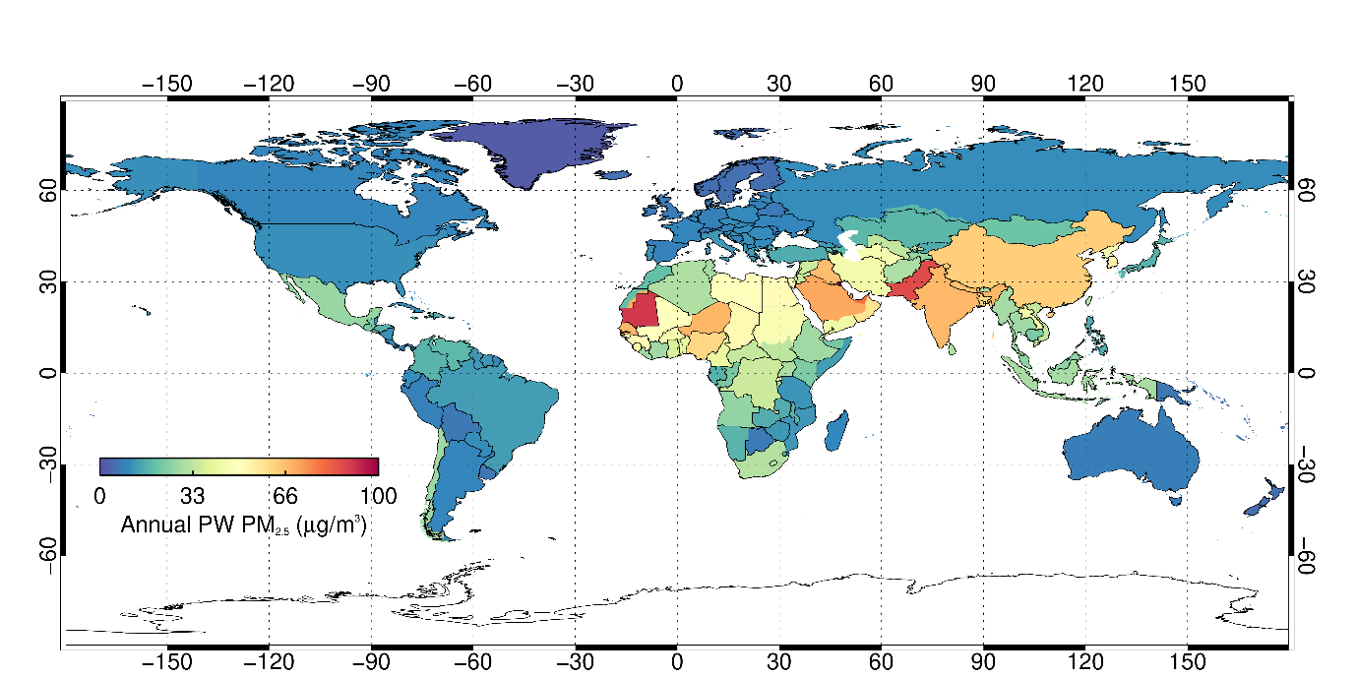
(b)
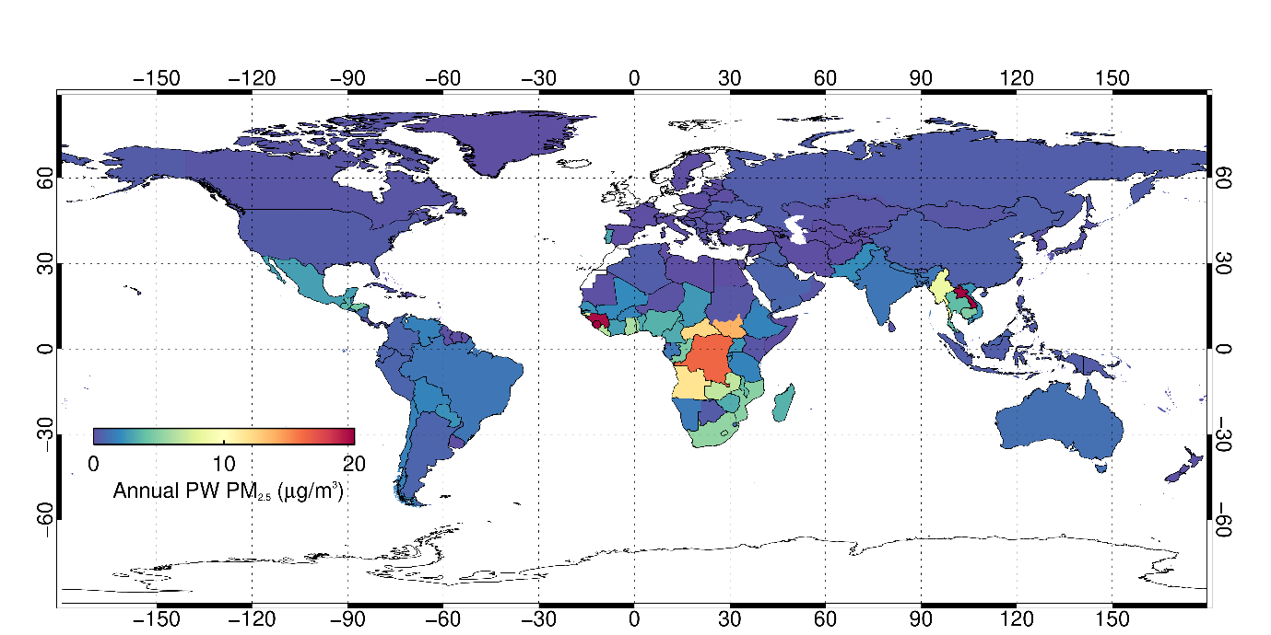
Figure 4: (a) Population weighted mean annual surface level PM_{2.5} concentration for individual nations, as derived from CAMS. (b) Same as (a) but now only including PM_{2.5} coming from landscape fires as calculated in Section 5. Both are derived from data over the period 2016-19.

The daily AQI values were then used to calculate the percentage of the national population exposed to different levels of air quality on a mean (2016-19) annual basis. When assessed in terms of the percentage of their national populations (Figure 5b), the severely dust affected countries of Kuwait, Mauritania and Western Sahara have the greatest percentage of people exposed to hazardous air quality. On average, 45% of the people in these countries are exposed to air quality considered ‘unhealthy’ (PM_{2.5} >55.5 µg.m⁻³) or worse.

a)
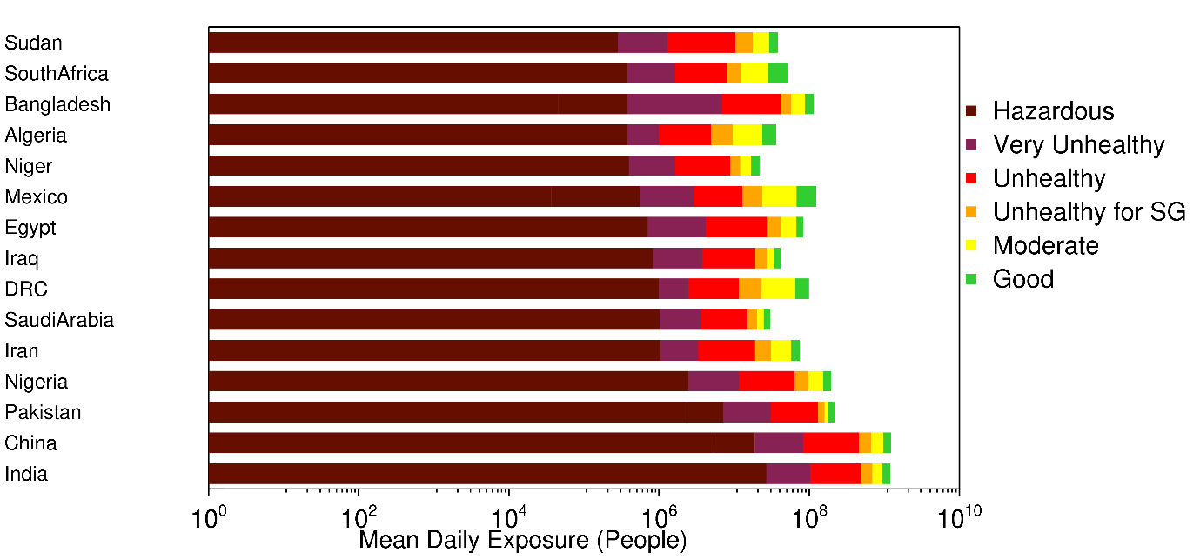
b)
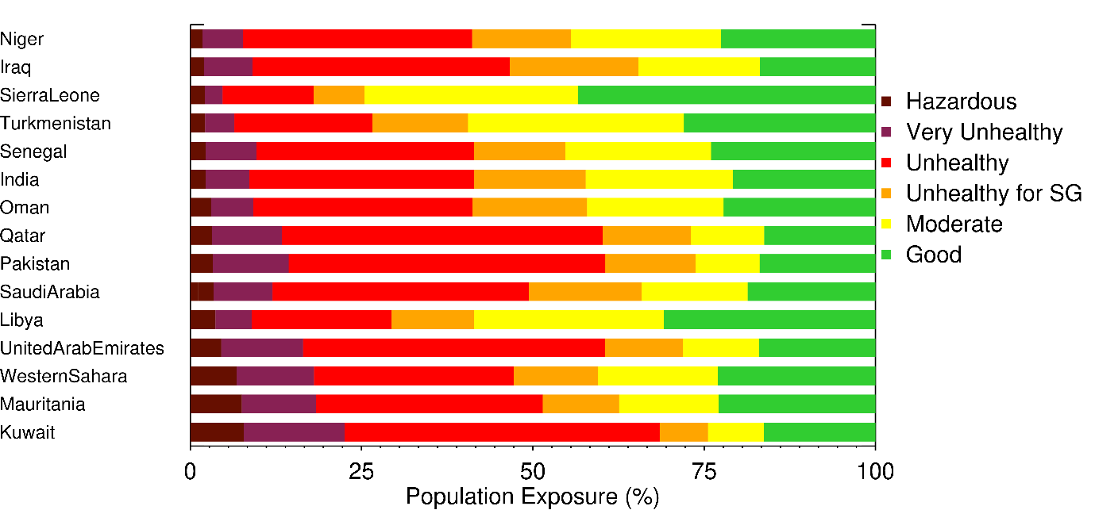
Figure 5. Countries whose populations have the greatest exposure to harmful levels of ambient atmospheric PM_{2.5} according to our analysis and the US EPA’s Air Quality Index (AQI) definitions of PM_{2.5} exposure (Table S1). (a) Top 15 countries having the greatest numbers of people exposed to hazardous air quality, and (b) top 15 countries with the greatest percentages of their populations exposed to hazardous air quality. Note that the x-axis is reverse logarithmic in (a).

5. Landscape Fire PM_{2.5} Contributions and Derived AQI
To isolate the impact of landscape fire emitted PM_{2.5} on regional air quality, and to estimate population exposure to this air pollution source, we needed to remove the influence of non-fire PM_{2.5} sources on the data shown in Section 4. This is not simply a matter of looking at the fire emissions in a grid cell compared to the emissions of other sources, because emissions can be transported to affect areas well away from their source region (e.g. Colarco et al., 2004; Dirksen et al., 2009; Kaskaoutis et al., 2014; Saarnio et al., 2010). Instead the calculation could be based on re-running the CAMS models without the landscape fire emissions source included, and differencing the resulting concentrations from those including all sources. However, this approach is typically constrained to regional scales or seasonal time periods due to the high computational costs involved (Crippa et al., 2016; Reddington et al., 2014; Lee et al., 2018; Sembhi et al., 2020). Instead we used an approach similar to that implemented by Cusworth et al. (2018) when estimating the baseline (non-fire) contribution to PM_{2.5} surface level concentrations in Delhi. Our strategy involved identifying periods when CAMS grid cells were affected by smoke from landscape fires (‘the fire affected season’), and then estimating and subtracting the anthropogenically generated PM_{2.5} contribution from the concentration data of these grid cells to enable isolation of the landscape fire contribution. The anthropogenically generated PM_{2.5} contribution was estimated based on the mean surface level concentration seen in the month immediately prior to and subsequent to the ‘fire affected season’, interpolating between these to provide the values to subtract from the overall PM_{2.5} concentration of each ‘fire affected’ month. The basis for calculating the mean background PM_{2.5} concentration using the months immediately prior and after the ‘fire affected season’ is to account for seasonal variation in anthropogenic emissions. All calculations were performed using the PM_{2.5} surface concentrations coming out of Equation [1] but limited to the BC and OM fractions only, since these are sourced only from landscape fires and anthropogenic (e.g. industrial) sources.

Months where the air quality of each 0.125° grid cell is considered ‘fire affected’ were selected based on levels of fire activity in both it and the immediately surrounding grid cells. An additional daily classification was based on levels of fire activity observed in both the grid cell and in the wider 20 × 20 grid cells surrounding it. For any day where the total FRP aerial density within this latter window was greater than 0.5 W.m⁻² (see Figure 1b) the central grid cell was classified as potentially affected by landscape fire smoke. Months where this ‘potentially fire affected’ classification occurred for more than 30% of days led to those months being classed as part of the ‘fire affected season’. Globally, regions were identified as fire affected for generally between 2 and 7 months of the year, although some regions (e.g. southern Brazil and northern Australia) it was as high as 10 months. The months immediately prior to and subsequent to those that represented the ‘fire affected season’ were then used to estimate the background (non-fire) atmospheric concentration of PM_{2.5}. Fires sometimes still occurred in the surrounding grid cells in these months – just not enough for the month to be identified as part of the fire season. To reduce the potential for such potentially smoke affected days being used in the calculation of ‘background’ PM_{2.5}, the FRP aerial density and the 2m U and V wind vectors from the surrounding grid cells containing fires were used to identify ‘fire unaffected’ days for the grid cell. From these ‘fire unaffected’ days in the month immediately prior to and subsequent to the ‘fire affected’ season, the mean grid cell surface level PM_{2.5} concentration was taken as an estimate of the anthropogenically generated (non-fire) PM_{2.5} concentration. These two concentrations were then interpolated between to identify the anthropogenically generated (non-fire) background PM_{2.5} concentration for each month of the ‘fire affected season’. Subtraction of these monthly ‘background’ values from the total PM_{2.5} concentration for each month finally enabled the PM_{2.5} concentration contributions of landscape fires for each month of the ‘fire affected season’ to be isolated.

Fire affected regions were classified on a monthly basis, matching the temporal frequency of the underlying anthropogenic emissions inventories (MACCity and CAMS-ANTH) whose contribution to the overall (OM+BC) PM_{2.5} surface concentration of a region we were attempting to identify - such that the biomass burning contribution could then be isolated. We used an FRP density threshold to select these regions, and as this threshold was increased from 0.1 (low fire activity) to 2.0 W.m⁻² (highly significant fire activity) the mean number of days a region was identified as being fire affected decreased from 132 to 74 globally. Constraining fire affected areas to those with reasonably significant fire activity (FRP density >0.5 W.m⁻²) identified regions where on average 94 days were fire affected. Identifying a month as being part of the fire season when it has 30% of days being fire affected results in 42%, 31% and 17% of land surface grid cells being classed as such during the year using FRP density thresholds of 0.1, 0.5 and 2.0 W.m⁻² respectively (Figure S3). The window size defines the spatial extent over which fire activity is assessed and population exposure determined. The window size (21 x 21 grid cells) used here covers a NS and EW distance of ∼ 150 km, which is smaller than the 200 km used by Liu et al. (2018) but greater than the mean smoke plume length (26 ± 20km) found over North America using Multi-angle Imaging Spectroradiometer (MISR) imagery (Val Martin et al., 2010). We assessed the sensitivity to window size using three different window sizes (11 x 11, 21 x 21 and 31 x 31), equating to between 78 and 221 km distance. As window size increases, the number of days classed annually as fire affected increased from 74 to 116, whilst the number of land surface grid cells classed being fire affected increased from 14% to 45%.

We conducted a further sensitivity analysis related to the population weighted (PW) PM_{2.5} calculation, as this metric characterises both the spatial variation and magnitude of surface PM_{2.5} concentrations. Mean continental PW PM_{2.5} decreases by a factor of three between use of the FRP density threshold of 0.1 W.m⁻² and 2.0 W.m⁻², due to the reduced inclusion of areas of low fire activity. With our selected threshold of 0.5 W.m⁻², mean continental PW PM_{2.5} is 1.4× lower than with 0.1 W.m⁻². Larger national PW PM_{2.5} differences are seen when changing between FRP density thresholds of 0.1 and 0.5 W.m⁻² are found in Pakistan (21.1 µg.m⁻³), India (6.8 µg.m⁻³) and China (5.3 µg.m⁻³), areas where smaller and lower intensity fires associated with agricultural burning are often dominant (Zhang et al., 2017). Increasing the threshold to 2.0 µg.m⁻³ results in far less change (2.1, 1.0 and 0.1 µg.m⁻³ in Pakistan, India and China respectively). A sensitivity analysis to the number of days required for a month to be defined as being part of the fire season was conducted using percentage thresholds of 10, 30, 50, 70 and 90% respectively, together with our selected FRP density threshold of 0.5 W.m⁻². As percentage threshold increases, the mean number of days identified as fire affected globally decreases (from 117 to 65 days), as does the national PW PM_{2.5}. The decrease in PW PM_{2.5} varies with the extent of landscape fire activity. In India, decreases from 3.2 to 0.32 µg.m⁻³ are seen when switching between a 10% and 90% threshold, whilst in Angola where fire activity is confined within a very intense fire season a decrease from 13.3 to 8.5 µg.m⁻³ occurs. The 0.5 W.m⁻² and 30% of days threshold applied to identify fire affected months used in this analysis omits regions that experience lower intensity and/or sporadic landscape fire activity. Examples include parts of the south-east USA and eastern China (Figure S3), where agricultural landscape fires occur with typically small/lower intensity characteristics. The potential health impacts of landscape fire smoke on populations residing in these regions is therefore largely unaccounted for. Window size influences the spatial extent of the area we find is impacted by smoke emissions, and as window size increases from 11 x 11 to 31 x 31 the global average PW PM_{2.5} increases from 1.8 to 2.3 µg.m⁻³. The largest increase (from 0.6 to 1.74 µg.m⁻³) is found in south Asia. In India, for example, the PW PM_{2.5} increases from 0.8 to 3.8 µg.m⁻³ with this change in window size. Smaller differences are found over Africa, where fire activity is more spatially extensive, with the continual average PW PM_{2.5} increasing from 3.3 to 4.7 µg.m⁻³ using the same 11 x 11 to 31 x 31 window size change. Over Canada and Russia, a larger increase in the PW PM_{2.5} (0.25 to 1.05 µg.m⁻³) is found with increasing window size because fire activity there is more spatially separated into discrete events.

Figure 6 shows for Delhi (Northern India) and Pontianak (Sumatra, Indonesia) in 2018 the CAMS-generated surface level PM_{2.5} concentration timeseries (BC+OM only), along with our estimate of the anthropogenic background (non-fire) PM_{2.5} signal (green line) subtracted to generate the fire-contribution for each month of the fire affected season. The ‘fire affected season’ itself is indicated by the grey bars, and for Delhi the temporal offset seen between this and the fire activity (upper plot) result from fires south of the city which do not transport smoke in the direction of Delhi. Our anthropogenic background estimate for Delhi captures the surface level PM_{2.5} trend very well, and the difference between this and the overall PM_{2.5} surface level concentration represents our estimate of the PM_{2.5} contribution coming from landscape fire sources (which are located west of Delhi in the Punjab and Haryana, Sembhi et al., 2020). The November ‘fire affected’ season we identify for Delhi is related to rice residue burning in these Indian States, and the baseline background is estimated to be 197 µg.m⁻³, which falls within the 130–290 µg.m⁻³ range found for Delhi by Cusworth et al. (2018) and is similar to the 15 year average 171 – 202 µg.m⁻³ calculated by Chowdhury et al. (2019). In Pontianak the non-fire source is far lower than in Delhi and appears reliably estimated based on the non-fire season values, and in Portugal (not shown) our annual average PM_{2.5} baseline background varies between 0.04 (2018) and 6.3 (2017) µg.m⁻³, consistent with the estimates of Kollanus et al. (2017) for a high fire year (3-5 µg.m⁻³; 2005) and a low fire year (0.01-0.03 µg.m⁻³; 2008).

Brauer et al. (2019) previously used the GFED v4.1 fire emissions inventory and the National Aeronautics and Space Administration (NASA) Goddard Institute for Space Studies (GISS) climate model to estimate the contribution of landscape fires to global surface level PM_{2.5} concentrations for the year 2016. Comparison of our results to those of this study at a 2.5 x 2.0° grid cell scale indicate a moderately low bias of 1.7 µg.m⁻³, though a relatively high RMSE and scatter at 5.9 and 5.7 µg.m⁻³ respectively. Frequency distribution analysis of the intercomparison data indicates that 77% of grid cells are within +/- 3 µg.m⁻³ of one another, but 20% of CAMS estimates are higher by more than 4 µg.m⁻³, whereas only 2% of the NASA GISS estimates are higher by the same amount. On a continental basis (Table S2), the greatest difference is found in Africa, where the bias and RMSE are 4.1 and 7.51 µg.m⁻³ respectively. It is also clear that the correspondence between the two datasets is quite variable, perhaps reflecting differences in the fire emissions inventories used by the two approaches and the differing methods used for estimating fire contributions to the surface level PM_{2.5} concentrations. A similar analysis is conducted over the Pacific Northwest (an area ~ 20° × 10°) using landscape fire emitted PM_{2.5} surface concentration estimates from the US Forest Service Airfire BlueSky dataset (O'Neill, et al., 2018), this being based on a modelling framework coupling fuel consumption (CONSUME), meteorological (WRF) and dispersion (CALPUFF or HYSPLIT) models to predict fire growth and forecast PM_{2.5} emissions from landscape fires (Larkin et al., 2009). Hourly PM_{2.5} surface level concentrations were available between July and September 2018 and were used to calculate mean PM_{2.5} over this time frame, these being regridded from 4 km to 0.25° to account for any offset between them and the CAMS datasets. Comparison to CAMS values reveals a large difference, with average PM_{2.5} concentrations of 14.8 µg.m⁻³ and 0.29 µg.m⁻³ for the CAMS and BlueSky respectively – leading to a bias and RMSE of 14.5 µg.m⁻³ and 29.8 µg.m⁻³ respectively. Maximum daily PM_{2.5} surface level concentrations show similar temporal dynamics, though the CAMS estimates are on average 15× higher and frequently exceeding 1000 µg.m⁻³ in contrast to a peak of <320 µg.m⁻³ in the BlueSky dataset. These differences will in part be due to the differing fire emissions inventories employed (e.g. Strand et al., 2012; Lui et at 2020; Vongruang and Primonsree, 2020), but also by the fact that the smoke is released at the surface in CAMS (up until July 2019) whereas in the BlueSky they are released at a height of 100m. Surface PM_{2.5} concentration is very sensitive to the plume rise scheme applied, with higher injection heights lowering the surface concentration (Li et al., 2020; Majdi et al, 2019). The more intense fires in the Pacific Northwest typically result in greater smoke emissions rates than those found in (e.g.) Africa and Australia, which may explain the large discrepancies in landscape fire PM_{2.5} concentrations found. Li et al. (2020) illustrate the variability found in surface PM_{2.5} concentrations from landscape fires due to the use of different meteorological fields, fire emissions inventories and the plume rise schemes, which together resulted in a maximum range of 1000 µg.m⁻³. In addition to differences in the magnitude of the surface level PM_{2.5} concentrations, the area affected by the smoke is also quite different between the two methods - with the CAMS area being on average 69% smaller than that estimated by the BlueSky system. This highlights a limitation in the methodology applied herein when landscape fires that affect a grid cell occur at distances further away than the window size (~150km), which is more is likely to be the case in north America and the Boreal region where long-range transport of smoke from particularly intense fires can occur (e.g. Saarnio et al., 2010; Dirksen et al., 2009; Brey et al., 2018).
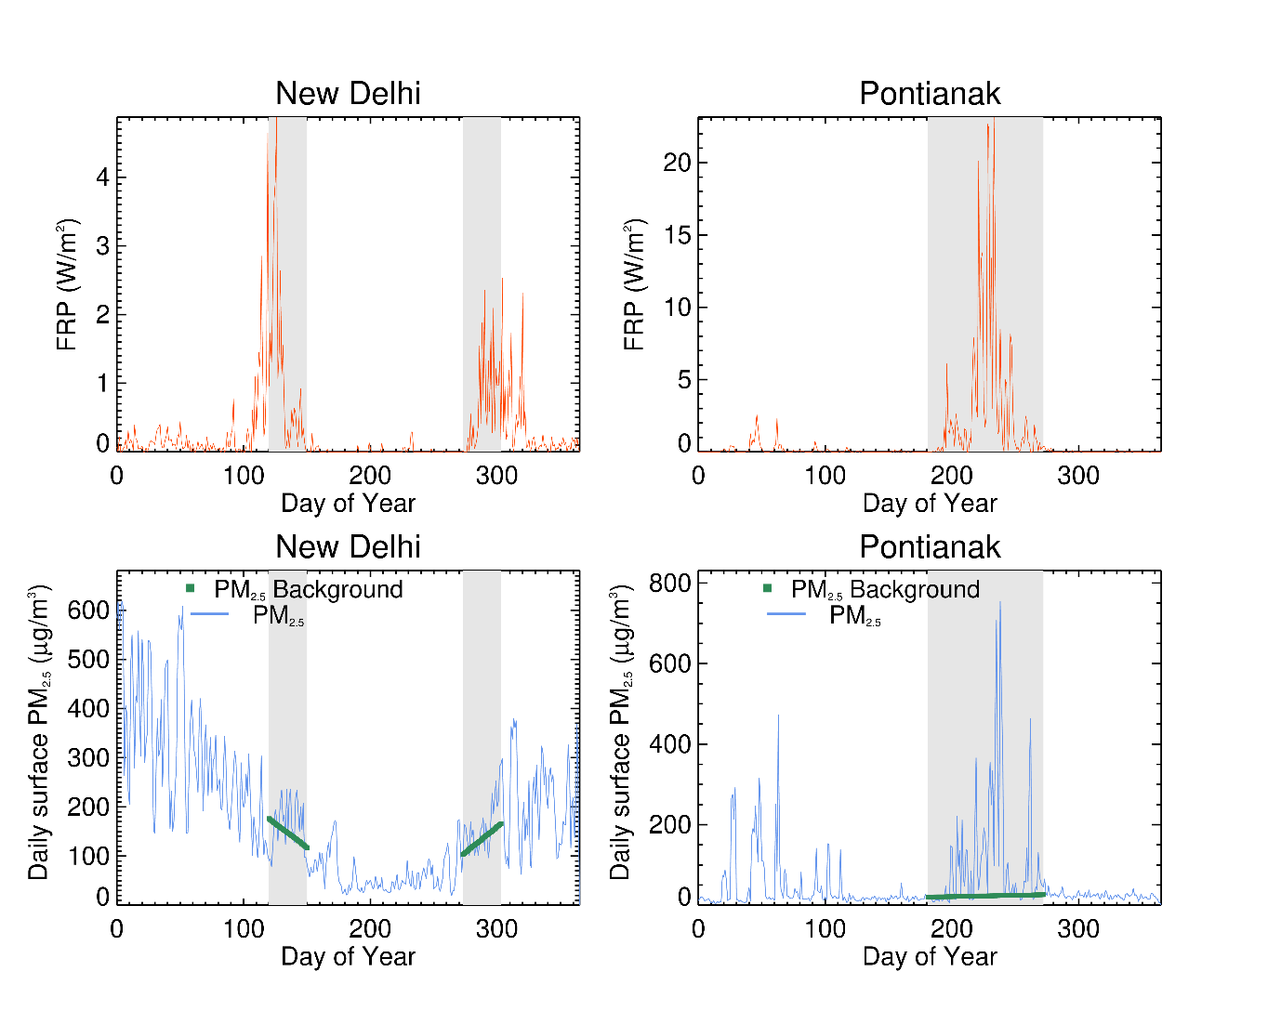
Figure 6: CAMS-derived time-series of daily fire activity (top row) and PM2.5 surface level concentration (bottom row) in 2018 for two locations. Top row shows fire radiative power areal density (W.m⁻²), accumulated within a window of 21 × 21 0.125° gridcells surrounding (a) New Delhi (India) and (b) Pontianak (Sumatra). Bottom row shows ambient atmospheric surface level PM_{2.5} concentration for (b) New Delhi and (b) Pontianak (Sumatra), with the contribution from non-fire sources during the fire-affected period identified and shown by the green lines (see main text). ‘Fire affected’ period is based on the FRP data shown in (a) and (b) and is indicated by the grey bar. Temporal offsets between fire activity and the smoke affected period result in Delhi from fires south of the city, which unlike those in the West do not transport smoke in the direction of Delhi.

Our mapping of the mean annual PM_{2.5} surface level concentration contributed to by landscape burning is shown in Figure 7a, and it is important to realise that this is not representing just the fire emissions in each grid cell, but those coming in from surrounding areas and even surrounding countries. Figure 7b shows the fraction of the overall mean annual PM_{2.5} surface level concentration contributed to by landscape fires. It is mostly in parts of the boreal and tropical forests and the tropical savannahs where landscape fires contribute most (Figure 7b). For 2016-19 we calculate an overall global mean excess PM_{2.5} surface level concentration of 3.2 µg.m⁻³ coming from landscape fires, and whilst 90% of gridcells have fire-contributions of less than 15 µg.m⁻³ parts of the Boreal forest (Canada and Russia) and the tropical or sub-tropical areas of southeast Asia, central and West Africa and the Amazon show contributions of up to 80 µg.m⁻³. For example, in northern Laos concentrations peak at around 100 µg.m⁻³ (Figure 1a) and represent almost the entire PM_{2.5} source for this area (Figure 7b), and is associated with shifting cultivation, rice residue burning and large-scale land clearance of forests (Muller et al., 2013). By comparison, savannah and grassland regions in South America, southern Africa and northern Australia show typical landscape fire-sourced PM_{2.5} concentrations of less than 30 µg.m⁻³, even though they are the location of significant fire activity (Figure 1b). Such differences are likely to be driven by the far higher forest and peatland fire PM_{2.5} emissions factors (Akagi et al., 2011; Wooster et al., 2018; Andreae et al., 2019) and fuel consumption rates and totals (Van Leeuwen et al., 2014; Huijnen et al., 2016; Roberts et al., 2018; Ivanova et al., 2019) compared to those of grassland and savanna fires.

a)
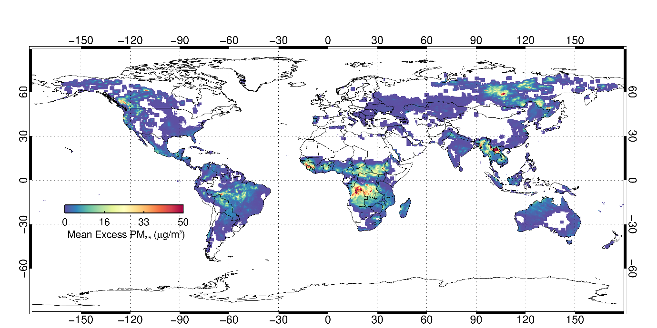

b)
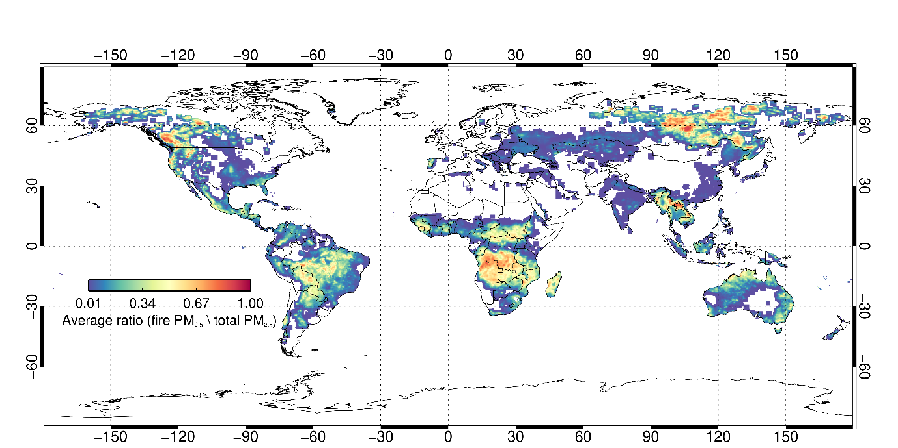
Figure 7: (a) Mean annual PM_{2.5} surface level concentrations resulting from landscape fire-emitted PM_{2.5}, and (b) the fraction of the overall mean annual PM_{2.5} surface level concentration (OM+BC) resulting from landscape fires.

6. nations and populations most impacted by landscape fire emissions

The population weighted (PM) PM_{2.5} concentrations due fire emissions are understandably lower than those from all emissions sources but remain comparatively high in many places. Countries in Asia, such as China, India, Nepal and Pakistan experience poor air quality due to both fire and anthropogenic sources. In contrast, Laos, Myanmar, Cambodia, and Thailand are affected mostly by landscape fire emissions, with population weighted PM_{2.5} ranging from 4 – 28 µg.m⁻³. The spatial distribution of PW PM_{2.5} in Africa is like that shown for all sources in Figure 4a as anthropogenic emissions are low in many countries. Six countries exceed the WHO annual 10 µg.m⁻³ guideline; with the worst fire-sourced air quality found in countries in Africa including Sierra Leone, Guinea and DRC, with annual PW PM_{2.5} concentrations exceeding 17 µg.m⁻³.

Our data confirm that landscape biomass burning is the largest contributor to the population weighted PM_{2.5} concentration in many countries. Figure 7b presents the ratio of fire emitted PM_{2.5} to total PM_{2.5} which highlights the significant contribution that landscape fires play in controlling surface level atmospheric PM_{2.5} concentrations in the boreal region, central Africa and central South America. In Africa, on average fire emitted PM_{2.5} makes up 14.2% of national annual average PM_{2.5} atmospheric concentrations, and the largest contributor by percentage is in DRC where they make up 45% of PM_{2.5} sources. Fire emitted PM_{2.5} has a lower contribution on average in Asia at 4.3%, with a maximum of 61% (Laos) and minimum of <<1% in Afghanistan. In Europe, North America and South America, the average contribution of fire emissions to the national total PM_{2.5} annual mean concentration is 2.5%, 7.1% and 9.1% respectively. Figure 8a shows the populations exposed to fire emitted PM_{2.5} where India again features prominently and hosts the greatest number of people worldwide exposed to landscape-fire generated ‘hazardous’ (PM_{2.5} > 250 µg.m⁻³) air quality. However, unlike for the all-source values, the Democratic Republic of the Congo (DRC) is identified as a particularly affected location – something that can be also identified on the map of Figure 7a.

Overall our analysis shows that the vast majority of the global population (6.5 billion) reside in areas where landscape fires make a minimal contribution to overall air quality (< 12 µg.m⁻³, AQI related to fire sources classed as ‘good’), but 43.9 million people live in areas classed as ‘unhealthy’ (PM_{2.5} >55 µg.m⁻³) due to landscape fires. Globally, 4 million people on average are exposed to ‘hazardous’ (PM_{2.5} >250 µg.m⁻³) air quality for at least one day per year as a direct result of landscape fires, with 84% of these being in countries listed in Figure 8a, dominated by Africa and south and south-east Asia. When assessed in terms of the percentage of the population exposed (Figure 8b), Laos (2.5%) and Sierra Leone (2.5%) have the greater percentage of their population at risk from ‘hazardous’ (PM_{2.5} >250 µg.m⁻³) air quality coming from landscape fire sources. The temporal variation of global average (2016 – 2019) population weighted PM_{2.5} (Figure S4) due to landscape fire emissions indicates March and April as being the worsted affected months. During this time, fires are prevalent across the tropics north of the equator (Figure S5) with south and SE Asia particularly affected. Fire occurrence in North Africa and northern South America elevate PW PM_{2.5} concentrations between November and February whilst biomass burning in southern hemisphere Africa and South America have greatest impact between May and September. Figure S6 shows the annual average daily PW PM_{2.5} in four countries (India, DRC, Laos and Brazil), which experience landscape fire activity during different times of the year. India broadly had two fire seasons with the greatest impacts in March/April and November, whilst Laos has a single fire season in April but which results in significantly degraded air quality. The extreme magnitude of the PW PM_{2.5} in Laos and Myanmar, which peaks at ~90 µg.m⁻³ over the same timeframe, significantly contribute to the increased global mean PW PM_{2.5} shown in Figure S4 at this time. In Brazil, the greatest exposure to PM_{2.5} occurs in August and September whilst, in the DRC, PM PM_{2.5} concentrations are influenced by the fire seasons in both northern (February/March) and southern hemisphere Africa (May-August). It is clear from Figure S6 that the landscape fire PM_{2.5} display significant daily variations, depending on the strength of the emissions source and the population density.

a)
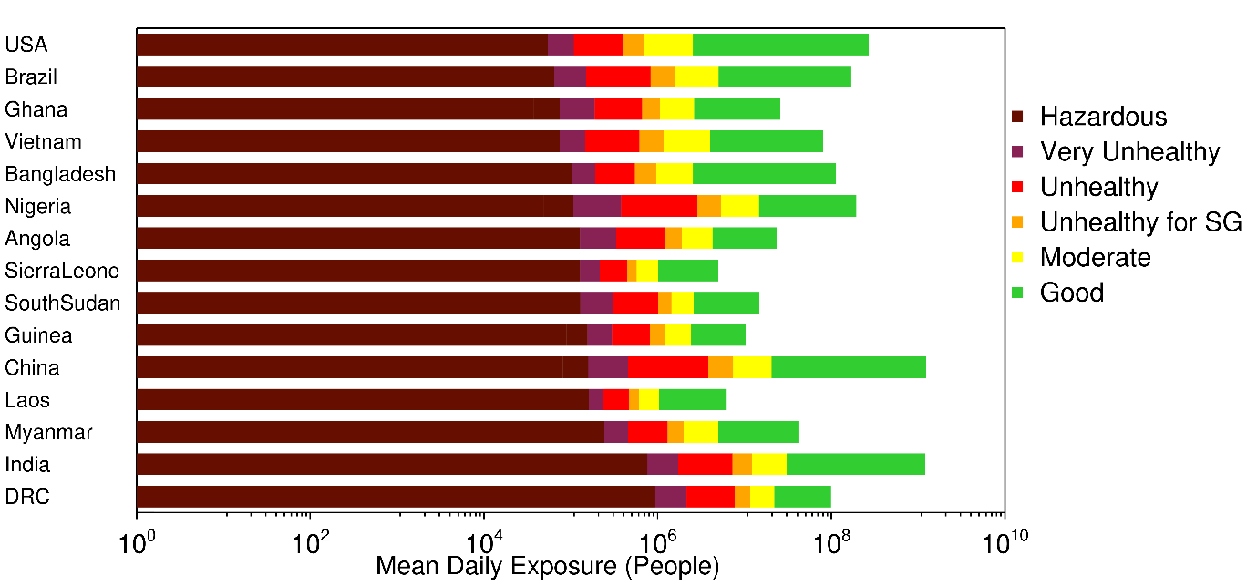
b)
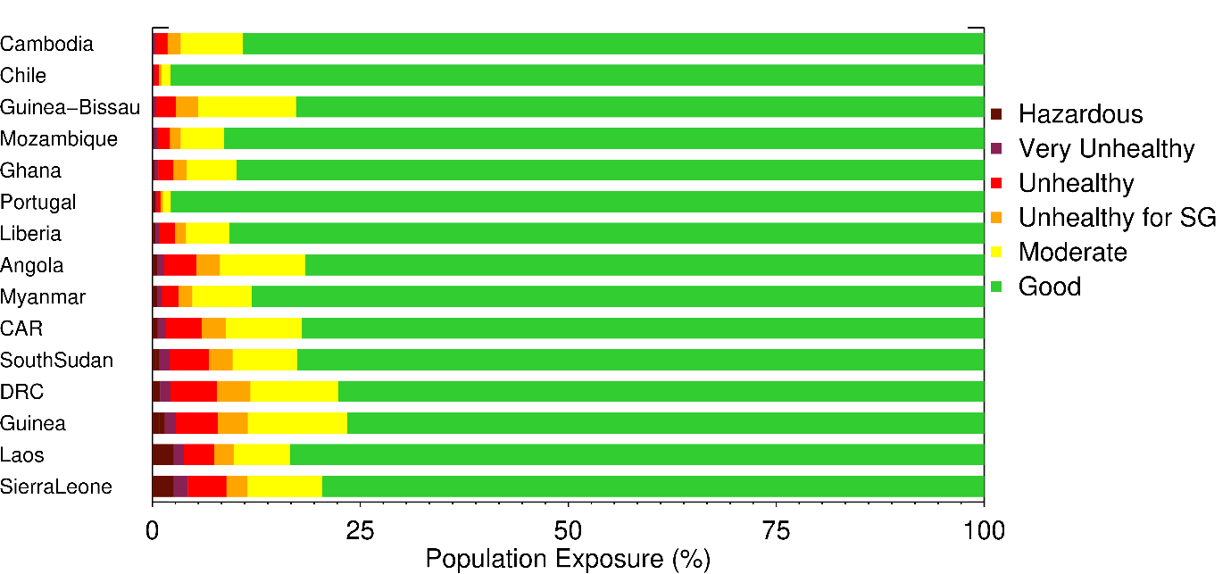
Figure 8. Countries whose populations have the greatest exposure to harmful levels of landscape fire-emitted ambient atmospheric PM_{2.5} according to our analysis and the US EPA’s Air Quality Index (AQI) definitions of PM_{2.5} exposure (Table S1). (a) Top 15 countries having the greatest numbers of people exposed to hazardous air quality due to landscape fire emissions, and (b) top 15 countries with the greatest percentages of their populations exposed to ‘hazardous’ (PM_{2.5} >250 µg.m⁻³) air quality due to landscape fire emissions. Note that the x-axis is reverse logarithmic in (a).

7. Global Burden of Disease Estimation
Sections 4 and 6 have highlighted the extent to which national populations are exposed to poor air quality as a result of both all source and fire emitted PM_{2.5} contributions. In the most extreme case, such exposures can result in mortality of individuals. The methodology developed by the Global Burden of Disease initiative (GBD 2010, 2013; Lim et al., 2012; Vos et al., 2015) to quantify the health impacts caused by air pollution uses annual average atmospheric PM_{2.5} concentrations and applies to these integrated exposure–response functions (IERs) for specific causes of death (e.g. ischaemic heart disease, lung cancer) (Cohen et al., 2015; Brauer et al., 2016). Key limitations are that the annual average PM_{2.5} concentration may not adequately represent regions exposed to smoke during only part (or even all) of the fire season, and cause-specific IERs may not be appropriate for landscape fire emitted PM_{2.5}. Instead of this approach, we used the methodology of Johnston et al. (2012), accounting for both short-term ‘sporadic’ exposure and longer-term ‘chronic’ exposure. As with Johnston et al. (2012), we first classed cells to be affected by landscape fire smoke if their fire-emitted PM_{2.5} surface level concentration (Figure 7a) exceeds the 90th percentile of the log-normally distributed PM_{2.5}, which we find to be 3.9 µg.m⁻³. This is close to the 3 µg.m⁻³ found by Johnston et al. (2012), even though that work was based on a different fire emissions inventory (GFED), a different atmospheric model (GEOS-Chem) and was calculated over an earlier set of years (1997-2006) to that used here (2016-2019). Using this metric, we find nearly half a million (475,992) 0.125° CAMS grid cells whose air quality is significantly fire affected, equating to 0.9 % of total global land area (not including Greenland or Antarctica). We split these cells into those that are chronically affected and those that are sporadically affected by smoke from landscape fires, using criteria defined by Johnston et al. (2012). Chronically affected cells are defined as those where our mean monthly fire-sourced PM_{2.5} surface level concentration (Section 5) exceeds the 3.9 µg.m⁻³ threshold for three months per year in three out of the four years examined, and this is relevant to 156,282 CAMS grid cells globally. The remaining 319,710 fire-affected cells are classed as sporadically affected by landscape fire smoke. We also performed a second calculation, restricting chronically affected cells to those affected for three months per year in all four years. This identifies fewer cells (93,204) as being chronically affected, with the remainder (382,788) again classed as sporadically affected.

For the grid cells classed as having their air quality sporadically affected by landscape fire smoke, we followed Johnston et al. (2012) and estimated smoke-related mortality (M) as a function of the number of days per year that the fire-emitted excess PM_{2.5} concentration exceeds a series of thresholds (300, 200, 100, 50, 40, 30, 20, 10, 5, 4, 3, 2, and 1 µg.m⁻³):

$\sum_{PM}^{n}{\left[{ D}_{PM}×\frac{M}{365}×({RR}_{SI}\left(PM\right)-1)\right]}$ [6]

where $M$ is the annual mortality in each cell, $PM$ is the PM_{2.5} smoke threshold of $n$ possible thresholds, ${ D}_{PM}$ is the number of days between $PM$ and ${PM}_{n+1}$, and ${RR}_{SI}$ is the relative rate exposure estimate for short-term exposure. The annual mortality estimate ($M$) is based on the WHO national scale all-age (0 - 60 years) mortality rates for 2016 which is integrated with the WorldPop age-gender distributed dataset introduced in Section 2.2. Johnston et al. (2012) calculated ${RR}_{SI}$ as the mean of values from a series of past studies looking at PM_{2.5} exposure and health impacts, finding for PM_{2.5} concentrations between 5 and 200 µg.m⁻³ a linear response of a 0.11% increase in mortality per 1 µg.m⁻³ increment of PM_{2.5}. Impacts coming from PM_{2.5} < 5 µg.m⁻³ are omitted, whilst those from PM_{2.5} > 200 µg.m⁻³ are fixed at that value.

Similarly, as per Johnston et al. (2012), the mortality rate of cells identified as chronically affected by landscape fire smoke is determined via:

$M×(\left[{RR}_{CI}\left(PM-CF\right)\right]-1)$ [7]

where $PM$ is the average annual background PM_{2.5}, $CF$ is the counterfactual concentration and ${RR}_{CI}$ is the relative rate for long-term exposure, taken as a linear response of 0.64% per 1 µg.m⁻³ increment applied to the mean annual PM_{2.5} concentration up to 50 µg.m⁻³, after which concentrations are set to 50 µg.m⁻³. The counterfactual concentration is an estimate of the fire emitted PM_{2.5} surface level atmospheric concentration that would exist naturally in the absence of anthropogenically set fire (Bowman et al., 2011). Unlike Johnston et al. (2012), who calculated the counterfactual concentration on a WHO sub-regional basis, here we calculate it here at both a 0.125 ° grid cell-based and national scale as the minimum monthly running mean PM_{2.5} concentration.

Identifying the chronically affected grid cells as those which have three months classed as smoke affected in three out of four years, and estimating the counterfactual concentration on a national basis, we calculate the annual mortality due to fire emitted PM_{2.5} to be close to three quarters of a million citizens (677,745). This is 0.52% of total global mortality according to the WHO 2016 national mortality rate, but between 8 and 21% of global annual mortality ascribed to ambient air pollution (Giannadaki et al., 2017; WHO, 2016, Lelieveld et al., 2015; Burnett et al. 2018). The highest mortality levels resulting from landscape fire emissions occurs in Africa (338,494) and Asia (278,879), with far fewer (59,033) in the Americas and Europe combined. Locations identified as being chronically affected by landscape fire smoke emissions account for the vast majority (97%) of these figures. The African country with the highest average annual mortality related to landscape fire emitted PM_{2.5} is the DRC (106,487) and in Asia it is China (89,369). However, when stratified according to the percentage of their overall mortality levels, populations in Sierra Leone and Laos respectively suffer the greatest health consequences in Africa and Asia respectively, with 10.6% and 11.8 % of their annual average overall mortality (due to all causes of mortality; WHO, 2016) respectively caused by fire-emitted PM_{2.5}.

Looking at the sensitivity of these results to the use of the counterfactual concentration, when the counterfactual is calculated on a gridcell basis rather than a national basis, the annual average global mortality estimate due to landscape fire smoke drops by 3% to 655,792, whereas when no counterfactual is applied it rises to 1.22 million. The latter highlights the potential maximum impact that we estimate landscape fire emissions have on human mortality, even from fires that are a ‘natural’ part of ecosystems and not instigated by human actions. Mortality estimates derived when chronically affected gridcells are defined as being fire-affected for three months in all four years are 25% lower (513,685) but which still equates to between 6 and 16% of global annual mortality ascribed to ambient air pollution (Giannadaki et al., 2017; WHO, 2016, Lelieveld et al., 2015; Burnett et al. 2018)

8. Summary and CONCLUSIONS
We have assessed the global impact of surface level PM_{2.5} on air quality and human exposure to ambient air pollution, using outputs from the Copernicus Atmospheric Monitoring Service (CAMS). Analysis of the spatial distribution of annual surface level PM_{2.5} highlights the degraded air quality experienced by populations of arid regions in north Africa, the Middle East and south Asia, where dust aerosols dominate and elevate the mean annual population weighted PM_{2.5} above 50 µg.m⁻³, well above the WHO annual recommended limit of 10 µg.m⁻³. Countries in south Asia, particularly India and China, also show similarly high (>50 µg.m⁻³) annual average population weighted PM_{2.5} levels (Figure 4a) largely due anthropogenic emissions, principally from residential, energy and industrial sources (Zhang et al., 2007; Upadhyay et al., 2018). Consequently, the greatest number of people exposed to hazardous air quality throughout the year are found in India and China. Approximately, 59% of countries world-wide have an annual average population weighted PM_{2.5} exceeding the WHO annual 10 µg.m⁻³ guideline, and globally on average 1.5 billion people are subjected to ‘unhealthy’ (>55 µg.m⁻³) air quality and 67.2 million of these to ‘hazardous’ (>250.5 µg.m⁻³) air pollution.

Using an approach to isolate the contribution that landscape burning makes to overall PM_{2.5} surface level concentration, we calculated the impact of landscape fires on air quality and the degree of human exposure to PM_{2.5}. In Laos, Myanmar, Cambodia and Thailand, fire emissions were found to account for 61%, 29%, 22% and 14% respectively of the mean annual surface level PM_{2.5} concentrations, which compares to 30%, 24%, 13% and 16% respectively found by Reddington et al. (2019) in 2014/15 using the WRF-Chem model and the EDGAR and Fire Inventory from NCAR (FINN) inventory. Conibear et al. (2018) estimate the population weighted PM_{2.5} concentration related to biomass burning in India (2014) as 1.6 µg.m⁻³, essentially the same as estimated herein (1.56 µg.m⁻³). Globally, we find for 2016-19 an overall global mean excess PM_{2.5} concentration of 3.2 µg.m⁻³ contributed to by landscape fires, with the largest contributions in parts of the Boreal forest (Canada and Russia) and tropical or sub-tropical areas of southeast Asia, central and West Africa and the Amazon. The highest values are found in northern Laos, where values peak at 100 µg.m⁻³ and are likely to be associated with shifting cultivation and rice residue burning and possibly the large-scale land clearance of forests. Population weighted PM_{2.5} exposure exceeds 25 µg.m⁻³ in Laos and is also close to that in Sierra Leone. Using the approaches previously adopted by Johnson et al. (2012) we estimated annual average mortality related to exposure to fire emitted PM_{2.5} to be 677,745, with highest mortality in Asia (278,879) and Africa (338,494). 267,382 of these deaths (39%) are related to children less than 5 years old according to the intersection of our data with those from the WorldPop population database. Countries in Africa and Asia with the highest average annual mortality from fire-emitted PM_{2.5} are the DRC (106,487) and China (89,389) respectively. However, when stratified according to the percentage of national all-cause mortality due to fire emitted PM_{2.5}, the nations of Sierra Leone (10.6%) and Laos (11.8%) in Africa and Asia respectively suffer the greatest health consequences. To place this in context, as of 10th July (2020), 554,721 deaths had resulted from the corona virus pandemic (European Centre for Disease Prevention and Control, 2020). Our estimate of nearly three quarters of a million excess deaths annually from landscape fire emissions is 50% higher than the 339,000 estimated by Johnston et al. (2012). Lelieveld et al. (2015) estimate 234,000 premature deaths in Africa (2010) due to all-source PM_{2.5}, 90,000 of which occur in those less than 5 years old. Our corresponding mortality estimate for Africa and the mortality rate for those under 5 are somewhat higher for the fire-only sources, at 338,494 and 201,212 respectively, with 34% of the latter occurring in the DRC (68,590). Kollanus et al. (2017) estimate 1,080 deaths in Europe in 2005 (an average fire year, see Figure S1) which is close to our estimate (1159). It is clear that significant differences exist between these mortality estimates, arising from methods applied to estimate PM_{2.5} concentrations from source emission estimates, differences in the assumed populations at risk and the relationship between mortality rate and PM_{2.5} exposure. The landscape fire PM_{2.5} concentrations estimated here are higher than those of other studies which will contribute to the differences in mortality totals. We find that landscape fires represent between 8 and 21% of global mortality related to ambient air pollution, so is certainly a significant contributor (Giannadaki et al., 2017; WHO, 2016, Lelieveld et al., 2015; Burnett et al. 2018). Whilst we have estimated excess deaths using published dose response functions used previously in similar works, there are limited studies of the long-term health effects of landscape fire smoke exposure and future health consequences of the younger generation are uncertain. Nonetheless, this study has highlighted the impact that landscape fire emissions have on air quality and annual mortality at the national scale and the role that systems such as CAMS can play in better understanding these interactions. The method developed herein is not directly able to be applied in close to real-time to estimate landscape fire emissions health impacts, even though the surface level PM_{2.5} concentration data is provided in near real time by CAMS. For example, currently we use data either side of the fire season to estimate the non-fire sourced contribution to the surface level PM_{2.5} concentrations. However, the approach could be adapted – for example to use only the pre-fire PM_{2.5} concentrations to estimate the non-fire contribution, or if the CAMS data were updated to record the PM_{2.5} concentration coming from different sources. Furthermore, the health impacts due to total ambient atmosphere PM_{2.5} concentrations could be estimated now in NRT, including in forecast mode up to five days ahead, based on their being appropriate exposure–response functions.

9 Acknowledgements

The PM_{2.5} and GFAS data were provided by the Copernicus Atmosphere Monitoring Service (CAMS, https://atmosphere.copernicus.eu/). The MACCITY and CAMS-ANTH emissions inventories were provided by the Emissions of atmospheric Compounds and Compilation of Ancillary Data (ECCAD, https://eccad.aeris-data.fr/). The population datasets were provided by WorldPop (https://www.worldpop.org/). The MODIS active fire (MCD14) and burned area (MCD64) data were obtained through the NASA Reverb service (http://reverb.echo.nasa.gov/reverb/). The surface station air quality data were obtained from the AirNOW (https://www.airnow.gov/), Purple Air (https://www2.purpleair.com/) and CPCB (https://cpcb.nic.in/) air quality networks. We would like to thank the reviewers for their constructive comments which helped improve the manuscript. Funding for certain aspects of this research was provided by NERC National Capability funding to the National Centre for Earth Observation (NE/Ro16518/1) and by the Leverhulme Centre for Wildfires, Environment and Society through the Leverhulme Trust, grant number RC-2018-023.

10 References

Ahmed, S.O., Mazloum, R. and Abou-Ali, H., 2018. Spatiotemporal interpolation of air pollutants in the Greater Cairo and the Delta, Egypt. Environmental research, 160, pp.27-34.

Appel, K.W., Napelenok, S.L., Foley, K.M., Pye, H.O., Hogrefe, C., Luecken, D.J., Bash, J.O., Roselle, S.J., Pleim, J.E., Foroutan, H. and Hutzell, W.T., 2017. Description and evaluation of the Community Multiscale Air Quality (CMAQ) modeling system version 5.1. Geoscientific model development, 10(4), p.1703.

Appel, K.W., Roselle, S.J., Gilliam, R.C. and Pleim, J.E., 2010. Sensitivity of the Community Multiscale Air Quality (CMAQ) model v4. 7 results for the eastern United States to MM5 and WRF meteorological drivers. Geoscientific Model Development, 3(1), p.169.

Atkinson, R.W., Kang, S., Anderson, H.R., Mills, I.C. and Walton, H.A., 2014. Epidemiological time series studies of PM2. 5 and daily mortality and hospital admissions: a systematic review and meta-analysis. Thorax, 69(7), pp.660-665.

Andela, N., Werf, G.R., Kaiser, J.W., Leeuwen, T.T.V., Wooster, M.J. and Lehmann, C.E., 2016. Biomass burning fuel consumption dynamics in the tropics and subtropics assessed from satellite. Biogeosciences, 13(12), pp.3717-3734.

Ayres, J., Smallbone, K., Holgate, S. and Fuller, G., 2011. Review of the UK air quality index.

Baldassarre, G., Pozzoli, L., Schmidt, C.C., Unal, A., Kindap, T., Menzel, W.P., Whitburn, S., Coheur, P.F., Kavgaci, A. and Kaiser, J.W., 2015. Using SEVIRI fire observations to drive smoke plumes in the CMAQ air quality model: a case study over Antalya in 2008. Atmospheric Chemistry and Physics, 15(14), pp.8539-8558.

Beelen, R., Hoek, G., van Den Brandt, P.A., Goldbohm, R.A., Fischer, P., Schouten, L.J., Jerrett, M., Hughes, E., Armstrong, B. and Brunekreef, B., 2008. Long-term effects of traffic-related air pollution on mortality in a Dutch cohort (NLCS-AIR study). Environmental health perspectives, 116(2), pp.196-202.

Beljaars, A.C.M. and Viterbo, P., 1998. Role of the boundary layer in a numerical weather prediction model. Clear and cloudy boundary layers, pp.287-304.

Bennett, C.M., Simpson, P., Raven, J., Skoric, B., Powell, J., Wolfe, R., Walters, E.H. and Abramson, M.J., 2007. Associations between ambient PM2. 5 concentrations and respiratory symptoms in Melbourne, 1998–2005. Journal of Toxicology and Environmental Health, Part A, 70(19), pp.1613-1618.

Bowman, D.M., Balch, J., Artaxo, P., Bond, W.J., Cochrane, M.A., D’antonio, C.M., DeFries, R., Johnston, F.H., Keeley, J.E., Krawchuk, M.A. and Kull, C.A., 2011. The human dimension of fire regimes on Earth. Journal of biogeography, 38(12), pp.2223-2236.

Brauer, M., Guttikunda, S.K., Nishad, K.A., Dey, S., Tripathi, S.N., Weagle, C. and Martin, R.V., 2019. Examination of monitoring approaches for ambient air pollution: A case study for India. Atmospheric Environment, 216, p.116940.

Brauer, S.E., Im, U., Mezuman, K. and Gao, C.Y., 2019. Desert Dust, Industrialization, and Agricultural Fires: Health Impacts of Outdoor Air Pollution in Africa. Journal of Geophysical Research: Atmospheres, 124(7), pp.4104-4120.

Brauer, M., Freedman, G., Frostad, J., Van Donkelaar, A., Martin, R.V., Dentener, F., Dingenen, R.V., Estep, K., Amini, H., Apte, J.S. and Balakrishnan, K., 2016. Ambient air pollution exposure estimation for the global burden of disease 2013. Environmental science & technology, 50(1), pp.79-88.

Brey, S.J., Ruminski, M., Atwood, S.A. and Fischer, E.V., 2018. Connecting smoke plumes to sources using Hazard Mapping System (HMS) smoke and fire location data over North America. Atmospheric Chemistry & Physics, 18(3).

Burnett, R., Chen, H., Szyszkowicz, M., Fann, N., Hubbell, B., Pope, C.A., Apte, J.S., Brauer, M., Cohen, A., Weichenthal, S. and Coggins, J., 2018. Global estimates of mortality associated with long-term exposure to outdoor fine particulate matter. Proceedings of the National Academy of Sciences, 115(38), pp.9592-9597.

Chafe, Z.A., Brauer, M., Klimont, Z., Van Dingenen, R., Mehta, S., Rao, S., Riahi, K., Dentener, F. and Smith, K.R., 2014. Household cooking with solid fuels contributes to ambient PM2. 5 air pollution and the burden of disease. Environmental health perspectives, 122(12), pp.1314-1320.

Chowdhury, S., Dey, S., Di Girolamo, L., Smith, K.R., Pillarisetti, A. and Lyapustin, A., 2019. Tracking ambient PM2. 5 build-up in Delhi national capital region during the dry season over 15 years using a high-resolution (1 km) satellite aerosol dataset. Atmospheric Environment, 204, pp.142-150.

Chen, Y., Li, Q., Randerson, J.T., Lyons, E.A., Kahn, R.A., Nelson, D.L. and Diner, D.J., 2009. The sensitivity of CO and aerosol transport to the temporal and vertical distribution of North American boreal fire emissions. Atmospheric Chemistry and Physics, 9(17), pp.6559-6580.

Christophe, Y., M. Ramonet, A. Wagner, M. Schulz, H. J. Eskes, S. Basart, A. Benedictow, Y. Bennouna, A.-M. Blechschmidt, S. Chabrillat, E. Cuevas, A. El-Yazidi, H. Flentje, K.M. Hansen, U. Im, J. Kapsomenakis, B. Langerock, A. Richter, N. Sudarchikova, V. Thouret, T. Warneke, C. Zerefos, Validation report of the CAMS near-real-time global atmospheric composition service: Period March – May 2019, Copernicus Atmosphere Monitoring Service (CAMS) report, CAMS84_2018SC1_D1.1.1_MAM2019_v1.pdf, September 2019, doi:10.24380/1t4q-1h53.

Cohen, A.J., Brauer, M., Burnett, R., Anderson, H.R., Frostad, J., Estep, K., Balakrishnan, K., Brunekreef, B., Dandona, L., Dandona, R. and Feigin, V., 2017. Estimates and 25-year trends of the global burden of disease attributable to ambient air pollution: an analysis of data from the Global Burden of Diseases Study 2015. The Lancet, 389(10082), pp.1907-1918.

Colarco, P.R., Schoeberl, M.R., Doddridge, B.G., Marufu, L.T., Torres, O. and Welton, E.J., 2004. Transport of smoke from Canadian forest fires to the surface near Washington, DC: Injection height, entrainment, and optical properties. Journal of Geophysical Research: Atmospheres, 109(D6).

Conibear, L., Butt, E.W., Knote, C., Arnold, S.R. and Spracklen, D.V., 2018. Residential energy use emissions dominate health impacts from exposure to ambient particulate matter in India. Nature communications, 9(1), pp.1-9.

Colbeck, I. and Lazaridis, M., 2010. Aerosols and environmental pollution. Naturwissenschaften, 97(2), pp.117-131.

Crippa, P., Castruccio, S., Archer-Nicholls, S., Lebron, G.B., Kuwata, M., Thota, A., Sumin, S., Butt, E., Wiedinmyer, C. and Spracklen, D.V., 2016. Population exposure to hazardous air quality due to the 2015 fires in Equatorial Asia. Scientific reports, 6(1), pp.1-9.

Crippa, M., Guizzardi, D., Muntean, M., Schaaf, E., Dentener, F., van Aardenne, J.A., Monni, S., Doering, U., Olivier, J.G., Pagliari, V. and Janssens-Maenhout, G., 2018. Gridded emissions of air pollutants for the period 1970–2012 within EDGAR v4. 3.2. Earth System Science Data, 10(4), pp.1987-2013.
Crippa, M., Guizzardi, D., Muntean, M., Schaaf, E., Dentener, F., van Aardenne, J.A., Monni, S., Doering, U., Olivier, J.G., Pagliari, V. and Janssens-Maenhout, G., 2018. Gridded emissions of air pollutants for the period 1970–2012 within EDGAR v4. 3.2. Earth Syst. Sci. Data, 10(4), pp.1987-2013.

Cusworth, D.H., Mickley, L.J., Sulprizio, M.P., Liu, T., Marlier, M.E., DeFries, R.S., Guttikunda, S.K. and Gupta, P., 2018. Quantifying the influence of agricultural fires in northwest India on urban air pollution in Delhi, India. Environmental Research Letters, 13(4), p.044018.

Dennekamp, M., Straney, L.D., Erbas, B., Abramson, M.J., Keywood, M., Smith, K., Sim, M.R., Glass, D.C., Del Monaco, A., Haikerwal, A. and Tonkin, A.M., 2015. Forest fire smoke exposures and out-of-hospital cardiac arrests in Melbourne, Australia: a case-crossover study. Environmental health perspectives, 123(10), pp.959-964.

Dey, S., Di Girolamo, L., van Donkelaar, A., Tripathi, S.N., Gupta, T. and Mohan, M., 2012. Variability of outdoor fine particulate (PM2. 5) concentration in the Indian Subcontinent: A remote sensing approach. Remote sensing of environment, 127, pp.153-161.EPA, A.Q.I., 2009. A guide to air quality and your health. USA: EPA.

Dirksen, R.J., Folkert Boersma, K., De Laat, J., Stammes, P., Van Der Werf, G.R., Val Martin, M. and Kelder, H.M., 2009. An aerosol boomerang: Rapid around‐the‐world transport of smoke from the December 2006 Australian forest fires observed from space. Journal of Geophysical Research: Atmospheres, 114(D21).

European Centre for Disease Prevention and Control, https://www.ecdc.europa.eu/en/geographical-distribution-2019-ncov-cases, last accessed 18/0-6/2020

Flemming J, Huijnen V, Arteta J, Bechtold P, Beljaars A, Blechschmidt AM, Diamantakis M, Engelen RJ, Gaudel A, Inness A, Jones L. Tropospheric chemistry in the Integrated Forecasting System of ECMWF. Geoscientific model development. 2015 Sep 1;8(9).

Freeborn, P.H., Wooster, M.J., Roy, D.P. and Cochrane, M.A., 2014. Quantification of MODIS fire radiative power (FRP) measurement uncertainty for use in satellite‐based active fire characterization and biomass burning estimation. Geophysical Research Letters, 41(6), pp.1988-1994.

Gan, C.M., Hogrefe, C., Mathur, R., Pleim, J., Xing, J., Wong, D., Gilliam, R., Pouliot, G. and Wei, C., 2016. Assessment of the effects of horizontal grid resolution on long-term air quality trends using coupled WRF-CMAQ simulations. Atmospheric Environment, 132, pp.207-216.

Giannadaki, D., Lelieveld, J. and Pozzer, A., 2017. The impact of fine particulate outdoor air pollution to premature mortality. In Perspectives on Atmospheric Sciences (pp. 1021-1026). Springer, Cham.

Giglio, L., Descloitres, J., Justice, C. O., and Kaufman, Y. J., (2003) An enhanced contextural fire detection algorithm for MODIS. Remote Sensing of Environment. 87. 2-3. 273-282.

Giglio, L., 2007. Characterization of the tropical diurnal fire cycle using VIRS and MODIS observations. Remote Sensing of Environment, 108(4), pp.407-421.

Giglio, L., Loboda, T., Roy, D.P., Quayle, B. and Justice, C.O., 2009. An active-fire based burned area mapping algorithm for the MODIS sensor. Remote Sensing of Environment, 113(2), pp.408-420.

Giglio, L., Randerson, J.T. and van der Werf, G.R., 2013. Analysis of daily, monthly, and annual burned area using the fourth‐generation global fire emissions database (GFED4). Journal of Geophysical Research: Biogeosciences, 118(1), pp.317-328.

Giglio, L., Schroeder, W. and Justice, C.O., 2016. The collection 6 MODIS active fire detection algorithm and fire products. Remote Sensing of Environment, 178, pp.31-41.

Granier, C., Bessagnet, B., Bond, T., D’Angiola, A., van Der Gon, H.D., Frost, G.J., Heil, A., Kaiser, J.W., Kinne, S., Klimont, Z. and Kloster, S., 2011. Evolution of anthropogenic and biomass burning emissions of air pollutants at global and regional scales during the 1980–2010 period. Climatic Change, 109(1-2), p.163.

Granier, C., S. Darras, H. Denier van der Gon, J. Doubalova, N. Elguindi, B. Galle, M. Gauss, M. Guevara, J.-P. Jalkanen, J. Kuenen, C. Liousse, B. Quack, D. Simpson, K. Sindelarova (2019) The Copernicus Atmosphere Monitoring Service global and regional emissions. Report April 2019. doi:10.24380/d0bn-kx16, 2019

Grell, G.A., Peckham, S.E., Schmitz, R., McKeen, S.A., Frost, G., Skamarock, W.C. and Eder, B., 2005. Fully coupled “online” chemistry within the WRF model. Atmospheric Environment, 39(37), pp.6957-6975.

Grell, G., Freitas, S.R., Stuefer, M. and Fast, J., 2011. Inclusion of biomass burning in WRF-Chem: impact of wildfires on weather forecasts. Atmospheric Chemistry & Physics, 11(11).

Gui, K., Che, H., Wang, Y., Wang, H., Zhang, L., Zhao, H., Zheng, Y., Sun, T. and Zhang, X., 2019. Satellite-derived PM2. 5 concentration trends over Eastern China from 1998 to 2016: Relationships to emissions and meteorological parameters. Environmental pollution, 247, pp.1125-1133.

Han, L., Zhou, W., Li, W. and Qian, Y., 2017. Global population exposed to fine particulate pollution by population increase and pollution expansion. Air Quality, Atmosphere & Health, 10(10), pp.1221-1226.

Heft-Neal, S., Burney, J., Bendavid, E. and Burke, M., 2018. Robust relationship between air quality and infant mortality in Africa. Nature, 559(7713), pp.254-258.

Ichoku, C. and Ellison, L., 2014. Global top-down smoke-aerosol emissions estimation using satellite fire radiative power measurements. Atmospheric Chemistry and Physics, 14(13), pp.6643-6643.

Ikeda, K. and Tanimoto, H., 2015. Exceedances of air quality standard level of PM2. 5 in Japan caused by Siberian wildfires. Environmental Research Letters, 10(10), p.105001.

Ivanova, G.A., Kukavskaya, E.A., Ivanov, V.A., Conard, S.G. and McRae, D.J., 2019. Fuel characteristics, loads and consumption in Scots pine forests of central Siberia. Journal of Forestry Research, pp.1-18.

Jethva, H., Torres, O., Field, R.D., Lyapustin, A., Gautam, R. and Kayetha, V., 2019. connecting crop productivity, Residue fires, and Air Quality over northern India. Scientific reports, 9(1), pp.1-11.

Johnston, F.H., Henderson, S.B., Chen, Y., Randerson, J.T., Marlier, M., DeFries, R.S., Kinney, P., Bowman, D.M. and Brauer, M., 2012. Estimated global mortality attributable to smoke from landscape fires. Environmental health perspectives, 120(5), pp.695-701.

Johnston, J.M., Johnston, L.M., Wooster, M.J., Brookes, A., McFayden, C. and Cantin, A.S., 2018. Satellite detection limitations of sub-canopy smouldering wildfires in the North American Boreal Forest. Fire, 1(2), p.28.

Kaiser, J.W., Heil, A., Andreae, M.O., Benedetti, A., Chubarova, N., Jones, L., Morcrette, J.J., Razinger, M., Schultz, M.G., Suttie, M. and van der Werf, G.R., 2012. Biomass burning emissions estimated with a global fire assimilation system based on observed fire radiative power. Biogeosciences, 9(1), pp.527-554.

Kaskaoutis, D.G., Kumar, S., Sharma, D., Singh, R.P., Kharol, S.K., Sharma, M., Singh, A.K., Singh, S., Singh, A. and Singh, D., 2014. Effects of crop residue burning on aerosol properties, plume characteristics, and long‐range transport over northern India. Journal of Geophysical Research: Atmospheres, 119(9), pp.5424-5444.

Kaur, I., Hüser, I., Zhang, T., Gehrke, B. and Kaiser, J.W., 2019. Correcting Swath-Dependent Bias of MODIS FRP Observations With Quantile Mapping. Remote Sensing, 11(10), p.1205.

Kiely, L., Spracklen, D.V., Wiedinmyer, C., Conibear, L., Reddington, C.L., Archer-Nicholls, S., Lowe, D., Arnold, S.R., Knote, C., Firoz Khan, M. and Talib Latif, M., 2019. New estimate of particulate emissions from Indonesian peat fires in 2015. Atmospheric Chemistry & Physics, 19, pp.11105-11121.

Klimont, Z., Kupiainen, K., Heyes, C., Purohit, P., Cofala, J., Rafaj, P., Borken-Kleefeld, J. and Schöpp, W., 2017. Global anthropogenic emissions of particulate matter including black carbon. Atmospheric Chemistry and Physics, 17(14), p.8681.

Knorr, W., Dentener, F., Lamarque, J.F., Jiang, L. and Arneth, A., 2017. Wildfire air pollution hazard during the 21st century. Atmospheric Chemistry and Physics, 17(14), p.9223.

Kollanus, V., Prank, M., Gens, A., Soares, J., Vira, J., Kukkonen, J., Sofiev, M., Salonen, R.O. and Lanki, T., 2017. Mortality due to vegetation fire–originated PM2. 5 exposure in Europe—assessment for the years 2005 and 2008. Environmental health perspectives, 125(1), pp.30-37.

Kremens, R.L., Dickinson, M.B., & Bova, A.S. (2012). Radiant flux density, energy density and fuel consumption in mixed-oak forest surface fires. International Journal of Wildland Fire, 21, 722-730

Larkin, N.K., O’Neill, S.M., Solomon, R., Raffuse, S., Strand, T., Sullivan, D.C., Krull, C., Rorig, M., Peterson, J. and Ferguson, S.A., 2010. The BlueSky smoke modeling framework. International Journal of Wildland Fire, 18(8), pp.906-920.

Lee, H.H., Iraqui, O., Gu, Y., Yim, S.H.L., Chulakadabba, A., Tonks, A.Y.M., Yang, Z. and Wang, C., 2018. Impacts of air pollutants from fire and non-fire emissions on the regional air quality in Southeast Asia. Atmospheric Chemistry and Physics (Online), 18(9).

Lelieveld, J., Evans, J.S., Fnais, M., Giannadaki, D. and Pozzer, A., 2015. The contribution of outdoor air pollution sources to premature mortality on a global scale. Nature, 525(7569), pp.367-371

Li, Y., Tong, D.Q., Ngan, F., Cohen, M.D., Stein, A.F., Kondragunta, S., Zhang, X., Ichoku, C., Hyer, E.J. and Kahn, R.A., 2020. Ensemble PM_{2.5} Forecasting During the 2018 Camp Fire Event Using the HYSPLIT Transport and Dispersion Model. Journal of Geophysical Research: Atmospheres, 125(15), p.e2020JD032768.

Li, J., Carlson, B.E. and Lacis, A.A., 2015. How well do satellite AOD observations represent the spatial and temporal variability of PM_{2.5} concentration for the United States?. Atmospheric Environment, 102, pp.260-273.

Li, L., Yang, A., He, X., Liu, J., Ma, Y., Niu, J. and Luo, B., 2020. Indoor air pollution from solid fuels and hypertension: A systematic review and meta-analysis. Environmental Pollution, p.113914.

Li, F., Zhang, X., Roy, D.P. and Kondragunta, S., 2019. Estimation of biomass-burning emissions by fusing the fire radiative power retrievals from polar-orbiting and geostationary satellites across the conterminous United States. Atmospheric Environment, 211, pp.274-287.

Lim, S.S., Vos, T., Flaxman, A.D., Danaei, G., Shibuya, K., Adair-Rohani, H., AlMazroa, M.A., Amann, M., Anderson, H.R., Andrews, K.G. and Aryee, M., 2012. A comparative risk assessment of burden of disease and injury attributable to 67 risk factors and risk factor clusters in 21 regions, 1990–2010: a systematic analysis for the Global Burden of Disease Study 2010. The lancet, 380(9859), pp.2224-2260.

Limaye, V.S., Schöpp, W. and Amann, M., 2019. Applying Integrated Exposure-Response Functions to PM2.5 Pollution in India. International journal of environmental research and public health, 16(1), p.60.

Liu, T., Marlier, M.E., DeFries, R.S., Westervelt, D.M., Xia, K.R., Fiore, A.M., Mickley, L.J., Cusworth, D.H. and Milly, G., 2018. Seasonal impact of regional outdoor biomass burning on air pollution in three Indian cities: Delhi, Bengaluru, and Pune. Atmospheric environment, 172, pp.83-92.

Liu, T., Mickley, L.J., Marlier, M.E., DeFries, R.S., Khan, M.F., Latif, M.T. and Karambelas, A., 2020. Diagnosing spatial biases and uncertainties in global fire emissions inventories: Indonesia as regional case study. Remote Sensing of Environment, 237, p.111557.

Liousse, C., Assamoi, E., Criqui, P., Granier, C. and Rosset, R., 2014. Explosive growth in African combustion emissions from 2005 to 2030. Environmental Research Letters, 9(3), p.035003.

Mailler, S., Khvorostyanov, D. and Menut, L., 2013. Impact of the vertical emission profiles on background gas-phase pollution simulated from the EMEP emissions over Europe.

Majdi, M., Turquety, S., Sartelet, K., Legorgeu, C., Menut, L. and Kim, Y., 2019. Impact of wildfires on particulate matter in the Euro-Mediterranean in 2007: sensitivity to some parameterizations of emissions in air quality models. Atmospheric Chemistry and Physics, 19(2), pp.785-812.

Malardel, S., Wedi, N., Deconinck, W., Diamantakis, M., Kühnlein, C., Mozdzynski, G., Hamrud, M. and Smolarkiewicz, P., 2016. A new grid for the IFS. ECMWF Newsletter, 146, pp.23-28.

Mathews, B.J., Strand, E.K., Smith, A.M., Hudak, A.T., Dickinson, B. and Kremens, R.L., 2016. Laboratory experiments to estimate interception of infrared radiation by tree canopies. International Journal of Wildland Fire, 25(9), pp.1009-1014.

Marlier, M.E., Voulgarakis, A., Shindell, D.T., Faluvegi, G., Henry, C.L. and Randerson, J.T. (2014) The role of temporal evolution in modeling atmospheric emissions from tropical fires. Atmospheric Environment. 89. 158-168. doi:10.1016/j.atmosenv.2014.02.039.

May, N., Ellicott, E. and Gollner, M., 2019. An examination of fuel moisture, energy release and emissions during laboratory burning of live wildland fuels. International Journal of Wildland Fire, 28(3), pp.187-197.

Miller, K.A., Siscovick, D.S., Sheppard, L., Shepherd, K., Sullivan, J.H., Anderson, G.L. and Kaufman, J.D., 2007. Long-term exposure to air pollution and incidence of cardiovascular events in women. New England Journal of Medicine, 356(5), pp.447-458.

Morcrette, J.J., Boucher, O., Jones, L., Salmond, D., Bechtold, P., Beljaars, A., Benedetti, A., Bonet, A., Kaiser, J.W., Razinger, M. and Schulz, M., 2009. Aerosol analysis and forecast in the European Centre for medium‐range weather forecasts integrated forecast system: Forward modeling. Journal of Geophysical Research: Atmospheres, 114(D6).

Mota, B. and Wooster, M.J., 2018. A new top-down approach for directly estimating biomass burning emissions and fuel consumption rates and totals from geostationary satellite fire radiative power (FRP). Remote Sensing of Environment, 206, pp.45-62.

Olivier, J.G.J., Bouwman, A.F., Van der Maas, C.W.M. and Berdowski, J.J.M., 1994. Emission database for global atmospheric research (EDGAR). Environmental Monitoring and Assessment, 31(1-2), pp.93-106.

Müller, D., Suess, S., Hoffmann, A.A. and Buchholz, G., 2013. The value of satellite-based active fire data for monitoring, reporting and verification of REDD+ in the Lao PDR. Human ecology, 41(1), pp.7-20.

O'Neill, S., Larkin, N., Solomon, R. 2018. USFS Airfire BlueSky Daily 4km PM2.5 Model Data and Imagery. Version 1.0. UCAR/NCAR - Earth Observing Laboratory. https://doi.org/10.5065/D6F18XK4. Accessed 27 Oct 2020.

Ott, W.R. and Hunt Jr, W.F., 1976. A quantitative evaluation of the pollutant standards index. Journal of the Air Pollution Control Association, 26(11), pp.1050-1054.

Pan, X., Ichoku, C., Chin, M., Bian, H., Darmenov, A., Colarco, P., Ellison, L., Kucsera, T., da Silva, A., Wang, J. and Oda, T., 2020. Six global biomass burning emission datasets: intercomparison and application in one global aerosol model. Atmospheric Chemistry and Physics, 20(2), pp.969-994.

Plaia, A. and Ruggieri, M., 2011. Air quality indices: a review. Reviews in Environmental Science and Bio/Technology, 10(2), pp.165-179.

Reddington, C.L., Yoshioka, M., Balasubramanian, R., Ridley, D., Toh, Y.Y., Arnold, S.R. and Spracklen, D.V., 2014. Contribution of vegetation and peat fires to particulate air pollution in Southeast Asia. Environmental Research Letters, 9(9), p.094006.

Reddington, C.L., Butt, E.W., Ridley, D.A., Artaxo, P., Morgan, W.T., Coe, H. and Spracklen, D.V., 2015. Air quality and human health improvements from reductions in deforestation-related fire in Brazil. Nature Geoscience, 8(10), pp.768-771.

Reddington, C.L., Conibear, L., Knote, C., Silver, B.J., Li, Y.J., Chan, C.K., Arnold, S.R. and Spracklen, D.V., 2019. Exploring the impacts of anthropogenic emission sectors on PM2. 5 and human health in South and East Asia. Atmospheric Chemistry and Physics, 19(18), pp.11887-11910.

Rémy, S., Veira, A., Paugam, R., Sofiev, M., Kaiser, J.W., Marenco, F., Burton, S.P., Benedetti, A., Engelen, R.J., Ferrare, R. and Hair, J.W., 2017. Two global data sets of daily fire emission injection heights since 2003. Atmospheric Chemistry & Physics, 17(4).

Rémy, S., Kipling, Z., Flemming, J., Boucher, O., Nabat, P., Michou, M., Bozzo, A., Ades, M., Huijnen, V. and Benedetti, A., 2019. Description and evaluation of the tropospheric aerosol scheme in the Integrated Forecasting System (IFS-AER, cycle 45R1) of ECMWF. Geosci. Model Dev. Discuss.

Roberts, G., Wooster, M. J., Freeborn, P. H. and Xu, W. (2011) Integration of geostationary FRP and polar-orbiting burned area datasets for an enhanced emissions inventory. Remote Sensing of Environment. 115. 2047-2061. doi:10.1016/j.rse.2011.04.006

Roberts, G., Wooster, M., Xu, W. and He, J., 2018. Fire Activity and Fuel Consumption Dynamics in Sub-Saharan Africa. Remote Sensing, 10(10), p.1591.

Roberts, G., Wooster, M. J., Xu, W., Freeborn, P. H., Morcrette, J-J., Jones, L., Benedetti, A. and Kaiser, J. (2015) LSA SAF Meteosat FRP Products : Part 2 – Evaluation and demonstration of use in the Copernicus Atmosphere Monitoring Service (CAMS). Atmospheric Chemistry and Physics. 15. 13241-13267.

Saarnio, K., Aurela, M., Timonen, H., Saarikoski, S., Teinilä, K., Mäkelä, T., Sofiev, M., Koskinen, J., Aalto, P.P., Kulmala, M. and Kukkonen, J., 2010. Chemical composition of fine particles in fresh smoke plumes from boreal wild-land fires in Europe. Science of the Total Environment, 408(12), pp.2527-2542.

Sahu, S.K. and Kota, S.H., 2016. Significance of PM2. 5 air quality at the Indian capital. Aerosol and air quality research, 17(2), pp.588-597.

Samet, J.M., Dominici, F., Curriero, F.C., Coursac, I. and Zeger, S.L., 2000. Fine particulate air pollution and mortality in 20 US cities, 1987–1994. New England journal of medicine, 343(24), pp.1742-1749.

Sembhi, H., Wooster, M.J., Zhang, T., Sharma, S., Singh, N., Agarwal, S., Boesch, H., Gupta, S., Misra, A., Tripathi, S.N. and Mor, S., 2020. Post-monsoon air quality degradation across Northern India: Assessing the impact of policy-related shifts in timing and amount of crop residue burnt. Environmental Research Letters.

Shaddick, G., Thomas, M.L., Amini, H., Broday, D., Cohen, A., Frostad, J., Green, A., Gumy, S., Liu, Y., Martin, R.V. and Pruss-Ustun, A., 2018. Data integration for the assessment of population exposure to ambient air pollution for global burden of disease assessment. Environmental science & technology, 52(16), pp.9069-9078.

Shi, H., Jiang, Z., Zhao, B., Li, Z., Chen, Y., Gu, Y., Jiang, J.H., Lee, M., Liou, K.N., Neu, J.L. and Payne, V.H., 2019. Modeling study of the air quality impact of record‐breaking Southern California wildfires in December 2017. Journal of Geophysical Research: Atmospheres, 124(12), pp.6554-6570.

Shi, Y., Matsunaga, T., Yamaguchi, Y., Li, Z., Gu, X. and Chen, X., 2018. Long-term trends and spatial patterns of satellite-retrieved PM2.5 concentrations in South and Southeast Asia from 1999 to 2014. Science of The Total Environment, 615, pp.177-186.

Strand, T.M., Larkin, N., Craig, K.J., Raffuse, S., Sullivan, D., Solomon, R., Rorig, M., Wheeler, N. and Pryden, D., 2012. Analyses of BlueSky Gateway PM2. 5 predictions during the 2007 southern and 2008 northern California fires. Journal of Geophysical Research: Atmospheres, 117(D17).

Smith, A.M.S., Tinkham, W.T., Roy, D.P., Boschetti, L., Kremens, R.L., Kumar, S.S., Sparks, A. and Falkowski, M.J. (2013) Quantification of fuel moisture effects on biomass consumed derived from fire radiative energy retrievals. Geophysical Research Letters. 40. 1-5. doi:10.1002/2013GL058232

Sofiev, M., Vankevich, R., Lotjonen, M., Prank, M., Petukhov, V., Ermakova, T., Koskinen, J., and Kukkonen, J. (2009) An operational system for the assimilation of the satellite information on wild-land fires for needs of air quality modelling and forecasting. Atmospheric Chemistry and Physics. 9. 6833 – 6847.

Tatem, A.J., 2017. WorldPop, open data for spatial demography. Scientific data, 4(1), pp.1-4.

Upadhyay, A., Dey, S., Chowdhury, S. and Goyal, P., 2018. Expected health benefits from mitigation of emissions from major anthropogenic PM_{2.5} sources in India: Statistics at state level. Environmental Pollution, 242, pp.1817-1826.

Vadrevu, K.P., Lasko, K., Giglio, L. and Justice, C., 2015. Vegetation fires, absorbing aerosols and smoke plume characteristics in diverse biomass burning regions of Asia. Environmental Research Letters, 10(10), p.105003.

Val Martin, M.V., Logan, J.A., Kahn, R.A., Leung, F.Y., Nelson, D.L. and Diner, D.J., 2010. Smoke injection heights from fires in North America: analysis of 5 years of satellite observations. Atmospheric Chemistry and Physics, 10(4), pp.1491-1510.

Val Martin, M., Kahn, R.A. and Tosca, M.G., 2018. A Global Analysis of Wildfire Smoke Injection Heights Derived from Space-Based Multi-Angle Imaging. Remote Sensing, 10(10), p.1609.

van Der Werf, G.R., Randerson, J.T., Giglio, L., Van Leeuwen, T.T., Chen, Y., Rogers, B.M., Mu, M., Van Marle, M.J., Morton, D.C., Collatz, G.J. and Yokelson, R.J., 2017. Global fire emissions estimates during 1997-2016. Earth System Science Data, 9(2), pp.697-720.

Van den Elshout, S., Léger, K. and Nussio, F., 2008. Comparing urban air quality in Europe in real time: A review of existing air quality indices and the proposal of a common alternative. Environment International, 34(5), pp.720-726.

Van Donkelaar, A., Martin, R.V., Brauer, M. and Boys, B.L., 2015. Use of satellite observations for long-term exposure assessment of global concentrations of fine particulate matter. Environmental health perspectives, 123(2), pp.135-143.

van Leeuwen, T.T., van der Werf, G.R., Hoffmann, A.A., Detmers, R.G., Rücker, G., French, N.H.F., Archibald, S., Carvalho Jr, J.A., Cook, G.D., de Groot, W.J. and Hély, C., 2014. Biomass burning fuel consumption rates: a field measurement database. Biogeosciences, 11, pp.7305-7329.

Vidic, S., 2002. Frequency distributions of effective plume height. Internal technical note, EMEP, 10.

Vongruang, P. and Pimonsree, S., 2020. Biomass burning sources and their contributions to PM10 concentrations over countries in mainland Southeast Asia during a smog episode. Atmospheric Environment, p.117414.

Vos, T., Barber, R.M., Bell, B., Bertozzi-Villa, A., Biryukov, S., Bolliger, I., Charlson, F., Davis, A., Degenhardt, L., Dicker, D. and Duan, L., 2015. Global, regional, and national incidence, prevalence, and years lived with disability for 301 acute and chronic diseases and injuries in 188 countries, 1990–2013: a systematic analysis for the Global Burden of Disease Study 2013. The Lancet, 386(9995), pp.743-800.

Wagner, A., Blechschmidt, A.M., Bouarar, I., Brunke, E.G., Clerbaux, C., Cupeiro, M., Cristofanelli, P., Eskes, H., Flemming, J., Flentje, H. and George, M., 2015. Evaluation of the MACC operational forecast system–potential and challenges of global near-real-time modelling with respect to reactive gases in the troposphere. Atmos. Chem. Phys, 15, pp.14005-14030.

WHO (2005) Air quality guidelines for particulate matter, ozone, nitrogen dioxide and sulphur dioxide. Global update 2005. World health Organisation. 2006. doi:WHO/SDE/PHE/OEH/06.02

WHO (2016) Ambient air pollution : a global assessment pf exposure and burden of disease. World Health Organisation 2016.

Wong, D.C., Pleim, J., Mathur, R., Binkowski, F., Otte, T., Gilliam, R., Pouliot, G., Xiu, A., Young, J.O. and Kang, D., 2012. WRF-CMAQ two-way coupled system with aerosol feedback: software development and preliminary results. Geoscientific Model Development, 5(2), p.299.

Wooster, M. J., Roberts, G., Perry, G. L. W. and Kaufman, Y. J. (2005) Retrieval of biomass combustion rates and totals from fire radiative power observations: FRP derivation and calibration relationships between biomass consumption and fire radiative energy release. Journal of Geophysical Research. 110, D24311. doi:10.1029/2005JD006318

Xu, W., Wooster, M. J., Roberts, G. and Freeborn, P. (2010) New GOES imager algorithms for cloud and active fire detection and fire radiative power assessment across North, South and Central America. Remote Sensing of Environment. 114. 9. 1876-1895.

Zhang, Q., Streets, D.G., He, K. and Klimont, Z., 2007. Major components of China’s anthropogenic primary particulate emissions. Environmental Research Letters, 2(4), p.045027.

Zhang, H., Chen, G., Hu, J., Chen, S.H., Wiedinmyer, C., Kleeman, M. and Ying, Q., 2014. Evaluation of a seven-year air quality simulation using the Weather Research and Forecasting (WRF)/Community Multiscale Air Quality (CMAQ) models in the eastern United States. Science of the Total Environment, 473, pp.275-285.

Zhang, T., Wooster, M.J. and Xu, W., 2017. Approaches for synergistically exploiting VIIRS I-and M-Band data in regional active fire detection and FRP assessment: A demonstration with respect to agricultural residue burning in Eastern China. Remote Sensing of Environment, 198, pp.407-424.

Zhao, X., Zhang, X., Xu, X., Xu, J., Meng, W. and Pu, W., 2009. Seasonal and diurnal variations of ambient PM2. 5 concentration in urban and rural environments in Beijing. Atmospheric Environment, 43(18), pp.2893-2900.

