TITLE: Artificial light at night (ALAN) affects the downstream movement behaviour of the critically endangered European eel, Anguilla anguilla

AUTHORS: Andrew S. Vowles* & Paul S. Kemp

International Centre for Ecohydraulics Research, Faculty of Engineering and Physical Sciences, Boldrewood Innovation Campus, University of Southampton, SO16 7QF, UK

* Author to whom correspondence should be addressed: Tel: +44 02380 592700. E-mail address: asv104@soton.ac.uk
ABSTRACT
Artificial light at night (ALAN) is considered one of the most pervasive forms of environmental pollution. It is an emerging threat to freshwater biodiversity and can influence ecologically important behaviours of fish. The European eel (Anguilla anguilla) is a critically endangered catadromous species that migrates downstream to the ocean to spawn in the Sargasso Sea. Given the pervasive nature of ALAN, many eel will navigate through artificially lit routes during their seaward migration, and although considered negatively phototactic, their response has yet to be quantified. We investigated the response of downstream moving European eel to simulated ALAN using a Light Emitting Diode unit in an experimental flume. We presented two routes of passage under: (1) a dark control (both channels unlit), (2) low ALAN (treatment channel lit to ca. 5 lx), or (3) high ALAN (treatment channel lit to ca. 20 lx). Eel were: (i) more likely to reject an illuminated route when exposed to high levels of ALAN; (ii) less likely to select the illuminated channel when given a choice; and (iii) passed downstream more rapidly when the illuminated route was selected. This study quantified the response of the critically endangered European eel to ALAN under an experimental setting, providing the foundations for future field based research to validate these findings, and offering insight on the ecological impacts of this major environmental pollutant and driver of global change.
Key words:
Environmental stressor, fish migration, freshwater conservation, light pollution, urbanisation

1. Introduction
The world has experienced rapid and wide-scale urbanisation in recent decades, with the percentage of the global population inhabiting urban areas predicted to grow from 30% in 1950 to 68% by 2050 (United Nations, 2018). This has resulted in dramatic modification of the natural environment, including increased artificial light at night (ALAN; e.g. from street lighting, vehicles, industry, and domestic sources), a factor that is now considered one of the most pervasive forms of environmental pollution (Falchi et al. 2016). More than 80% of the world’s population live under artificially illuminated skies (Falchi et al. 2016), and both the extent and brightness of the earth’s artificially lit surface continue to increase by more than 2% per year (Kyba et al. 2017). While this major driver of global environmental change (Davies & Smyth, 2017) may be convenient to modern society, allowing humans to remain safe and active at night, it also has wide-ranging unintended ecological consequences (summarised in recent reviews, e.g. Davies & Smyth, 2017; Gaston et al. 2015; Hopkins et al. 2018; Owens & Lewis, 2018). These include impacts to circadian rhythms (Kupprat et al. 2020), community composition (Garratt et al. 2019), foraging (Russ et al. 2015), predator avoidance (Wakefield et al. 2015), energy expenditure (Pulgar et al. 2019) and reproductive behaviour (Botha et al. 2017), development (Dominoni et al. 2018) and success (Fobert et al. 2019).
Humans have traditionally settled close to fresh water, driven by the provision of food and water supply and opportunities for transport of goods. More than 50% of the world’s population live within 3 km of a freshwater body (Kummu et al. 2011), and rivers in particular are focal points for major urbanisation (Ceola et al. 2015), especially in the lower reaches and estuaries, where they are heavily influenced by artificial light. Impacts may be direct, through emissions to the water surface from lighting along banks, at ports and harbours, bridges and other infrastructure, and vessels; and indirect, through scattering and reflection, resulting in skyglow (Jechow & Hölker, 2019). Although research is currently biased towards the ecological influences of ALAN in terrestrial environments, a small but growing body of evidence highlights negative impacts on freshwater taxa (Perkin et al. 2011), and light pollution is increasingly considered a major emerging threat to freshwater biodiversity (Reid et al. 2019).
Current evidence, for coastal and freshwater fishes at least, suggests ALAN may have several negative ecological consequences acting through modification of behaviour. For example, the nest-guarding activity of lake-dwelling smallmouth bass (Micropterus dolomieu) was elevated when exposed to both continuous low (1.8 – 3.4 lx) and intermittent high (10.2 – 58.2 lx) illumination, generated to simulate shoreline and automobile lighting, respectively (Foster et al. 2016). Such alterations to behaviour may increase the energetic cost associated with parental care and ultimately reduce reproductive success (Foster et al. 2016). In a laboratory tank-based study, the exposure of the Trinidadian guppy (Poecilia reticulata) to low levels of ALAN (ca. 0.5 lx), reflecting conditions more akin to skyglow, reduced their emergence time from cover (Kurvers et al. 2018). Faster emergence from cover and more time spent in open areas will likely increase individual risk (Kurvers et al. 2018), potentially compromising fitness. In another example, the abundance of small shoaling and large predatory fishes increased during nights when lights from a floating pontoon located in the lower (estuarine) reaches of a river were switched on (Becker et al. 2013). Attraction to light was presumed to be the result of enhanced foraging capabilities of both groups, highlighting the potential for ALAN to create unnatural top-down regulation of fish populations (Becker et al. 2013). These examples document alterations to the behaviour of fish while resident in freshwater and coastal environments. However, migratory (diadromous) species may be particularly exposed to light pollution as they must navigate between fresh and marine waters to complete their life-cycle.
The pervasive nature of ALAN in urbanised reaches of river through which diadromous fishes migrate means that individuals from most populations will encounter artificially illuminated conditions, possibly multiple times. Modified fish behaviour during migratory life-phases is therefore likely as they must react and/ or adjust to spatial variations in light intensity. Indeed, illumination from street lights (14 lx) impacted the migratory behaviour of Atlantic salmon (Salmo salar), with juveniles (smolts) tending to be reluctant to move downstream during nights when lights were switched on during experimental manipulation, instead preferring to migrate the next morning (Riley et al. 2012). Avoiding passage through areas of ALAN may be logical as night-time migration of smolts is often considered a predator avoidance tactic. Indeed, in support of this there is evidence of elevated feeding on Pacific salmon smolts (Oncorhynchus spp.) by harbour seals (Phoca vitulina) at illuminated bridges at night (Yurk & Trites, 2000). Ultimately, however, the propensity for smolts to migrate the morning after exposure to ALAN may still result in elevated risk of predation from visual piscivores, negatively impacting overall survival (Riley et al. 2012). Despite some research on the impacts of ALAN on migratory salmonids, the effect of ALAN on the behaviour of other diadromous species is lacking.
The critically endangered European eel (Anguilla anguilla) is a diadromous fish of high conservation concern due to dramatic declines in recruitment (> 98% in some parts of its range) over recent decades (ICES, 2019). Sexual maturation during the development to the silver phase occurs as eel migrate downstream, typically at night (between August and December), with peak numbers often reported under darker moonless conditions (Lowe, 1952; Vøllestad et al. 1986). During maturation, eel undergo morphological and physiological changes that include an increase in eye size (Pankhurst, 1982) and a shift in visual spectral sensitivity towards shorter wavelengths (Bowmaker et al. 2008). Furthermore, they become increasingly negatively phototactic (Lowe 1952), and as such their sensitivity to artificial light may be highest as the maturing fish approach the sea where the potential impacts of ALAN associated with urbanisation of coastal areas (e.g. cities, towns and ports) may be most severe. However, the nature and magnitude of the impact of artificial light pollution on the downstream movement of eel remains poorly understood.
This study investigated the influence of simulated ALAN on the response of downstream moving European eel when presented with a choice of two routes through an experimental flume under either (a) a dark control (both routes unlit), (b) low ALAN treatment (one route lit to ca. 5 lx) or (c) high ALAN treatment (one route lit to ca. 20 lx). We recorded (1) the initial response (reaction, route switch, rejection, no observable response) during the first approach to the entrance of the selected route, (2) the nature (treatment or control) of the route selected, and (3) the time taken to pass through the selected channel. If eel exhibited no observable preference for either route (H₀) we would expect the selection of the test channel not to differ from 0.5. Likewise, if illumination had no effect on downstream passage, the time taken to pass either channel should not differ. We also investigated whether degree of sexual maturation influenced response to illumination (H₀: nature of response is independent of degree of maturation).

2. Materials and Methods
2.1. Study fish and husbandry
Eel (n = 120, mean ± SD length and mass: 545 ± 88 mm, 319 ± 135 g) were captured in fyke nets installed in a drainage channel in the Lincolnshire Fens (UK) by a licenced fisherman and transported to the International Centre for Ecohydraulics Research (ICER) at the University of Southampton in aerated water on 7 November 2019. They were held in large tanks (ca. 1000 L) containing aerated and filtered water under ambient temperature (10.7 ± 0.5 °C) and photoperiod (9:15 h light:dark) and acclimated for three days before experimental trials commenced.
Spectral sensitivity of European eel changes with maturation, indicated by the degree of “silvering”, during the transition from resident (“yellow”) to migratory (“silver”) life-stages. During this transition, eel lack cones sensitive to red and ultraviolet light, with those that remain shifting in sensitivity towards shorter wavelengths (e.g. from approx. 550 to 525 nm for “green” cones) (Bowmaker et al. 2008). The maximum sensitivity of rods also declines, from approx. 525 nm to 486 nm, due to a transition from “freshwater” to “deep-sea” opsin (the light sensitive proteins found in photoreceptors) (Bowmaker et al. 2008). This results in increased sensitivity to the (bluer) wavelengths of light that are characteristic of the marine environment and may be accompanied by a decline in colour vision. In this study, the mean (± SD) degree of silvering, quantified using the ocular index (Pankhurst, 1982), was 6.6 (± 1.5) and did not differ between the light treatments tested (X² = 3.24, d.f. = 2, p = 0.198). Eel with an ocular index of ≤ 6.5 are generally classified as sexually immature pre-migrants (Pankhurst, 1982), suggesting that on average the eels in this study were at a relatively early stage of maturation with 55.1% considered “migratory” (ocular index > 6.5).
2.2. Experimental setup
The experiment was conducted in an indoor open channel flume (21.4 m long, 1.37 m wide and 0.6 m deep) at the ICER facility between 11 and 24 November 2019. Within the flume, an 8 m long area was isolated between two polycarbonate tubular flow-straightening screens (Fig 1a). A wire-mesh screen placed 1 m downstream from the upstream flow straightener demarcated the start of a 6 m long experimental area where the behaviour of downstream moving eel was recorded using eight overhead video cameras (Swann® NHD-810) mounted 1.84 m above the base of the flume. Four infrared lamps were installed to ensure adequate video quality under dark conditions. Eel were released through a pipe (0.12 m diameter PVC pipe) centrally positioned approx. 0.10 m above the base of the flume. The pipe entered the experimental area through the mesh screen and extended 1 m to the upstream flow straightener (Fig 1). Within the experimental area, a 2 m long section was laterally divided into two test channels of equal dimension, separated by a polystyrene board (2.0 m long, 0.05 m wide, and 0.5 m high; Fig 1), creating a choice of route downstream. The upstream and downstream extent of the test channels were 2 m and 3 m from the mesh screen and downstream flow straightener, respectively (Fig 1). Plastic sheeting was installed around the flume and at the entrance / exit to the test channels to ensure consistent light conditions were created within the experimental area with minimal light trespass from the illuminated test channel, and to prevent visual disturbance by the researcher. Discharge was maintained constant (0.11 m³ s⁻¹), and mean (± SD) water depth (controlled using an adjustable weir at the downstream end of the flume) and velocity was 0.30 m (± 0.01) and 0.24 m s⁻¹ (± 0.04), respectively, throughout the experimental area.
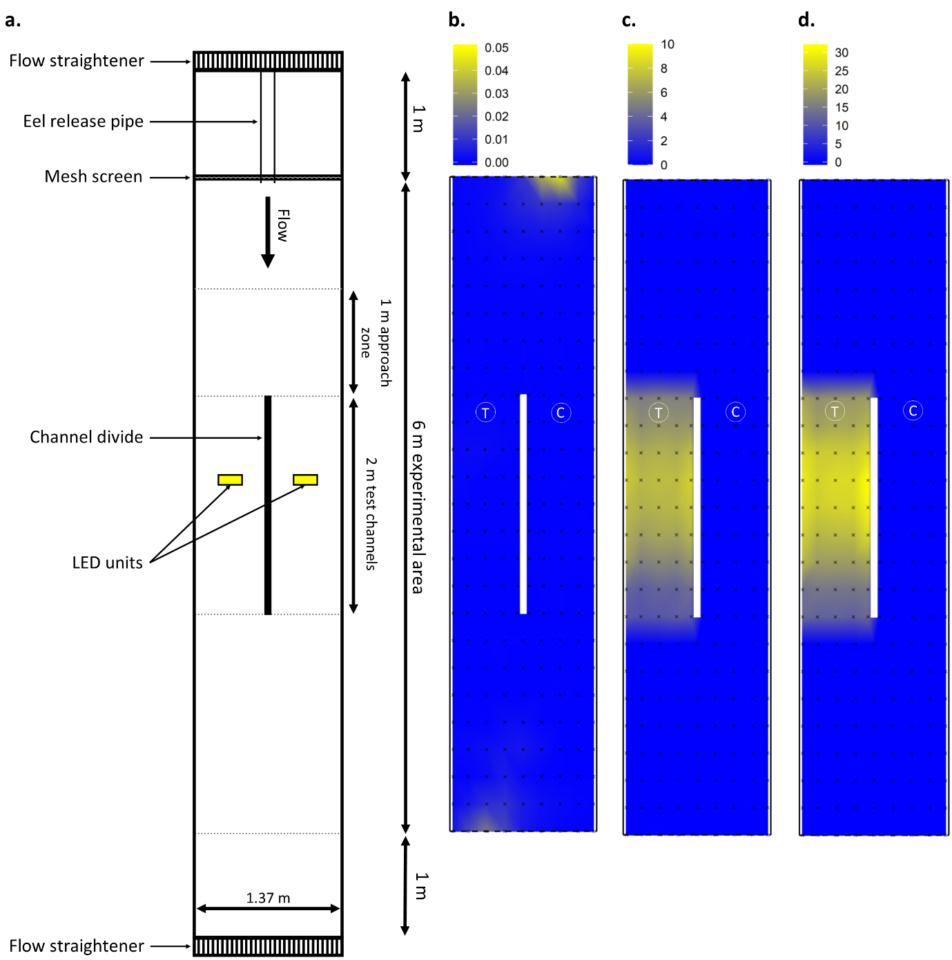
Fig 1a. Plan of the flume setup used to assess the response of downstream moving European eel (Anguilla anguilla) presented with a choice of two routes (test channels) under two light treatments and a control (dark). Linear interpolations show the field of illumination under simulations of (b.) dark night with the absence of an illuminated route (control), (c.) choice of dark (control) and low Artificial Light at Night (treatment) and (d.) choice of dark (control) and high Artificial Light at Night (treatment). Light units = lx, note the difference in scale between interpolations. Small black crosses in b. – d. denote locations of light measurement, and the location of the control (unlit) and treatment test channels (which were alternated throughout the experiment) are highlighted with a C and T, respectively.

2.3. Simulating ALAN
ALAN was simulated using two NEEWER® (model T120) white Light Emitting Diode (LED) units, with spectral composition (measured using an Ocean Insight HDX miniature spectrometer) mirroring the shift towards increased installation of broad-spectrum LED lighting (Fig 2). This transition is driven by high levels of energy efficiency and potential to reduce CO₂ emissions and costs (Davies and Smyth, 2017). The LED units were centrally located 0.78 m from the entrance of each test channel (Fig 1) and 1.85 m above the base of the flume (1.55 m above the water surface). The light units were switched off in both channels during the control, and in one channel only during ALAN treatments. Light intensity was adjusted and measured (at the water surface) at the entrance to the illuminated channel (treatment channel; Fig 1) immediately prior to the start of each trial using a Skye® High Output Lux sensor. Mean (± SD) light intensity at the entrance to the treatment channel was 0.0005 (± 0.0002) (Fig 1b), 5.11 (± 0.15) (Fig 1c) and 20.06 (± 0.30) (Fig 1d) lx during the control, low ALAN, and high ALAN treatments, respectively. The levels of illumination were set to simulate realistic dark night and direct ALAN conditions. For example, light intensity on a clear moonless night is approximately 0.001 lx, decreasing further when cloudy (Jechow and Hölker, 2019). Although absolute values of ALAN are site specific, varying with proximity to light sources, intensities of 5 lx are considered average for street level illumination (Gaston et al. 2013) and intensities up to 22.7 lx were recorded at known urban Atlantic salmon spawning sites in southern England (Riley et al. 2013). Intensities of 5 lx and 20 lx are also comparable to other laboratory studies that simulate the effects of direct ALAN on organisms (e.g. Riley et al. 2015; Willmott et al. 2018; Fobert et al. 2019).
To spatially characterise the field of illumination, measurements were taken at nine equidistant points (five within the test channels) along transects that spanned the width of the flume at 0.25 m longitudinal intervals throughout the experimental area. In total, 234 readings were recorded for each light treatment. For low and high ALAN treatments, light intensity increased in the downstream direction from the treatment channel entrance and reached a maximum of 8.3 lx (Fig 1c) and 34.5 lx (Fig 1d), respectively, at the water surface below the LED units.

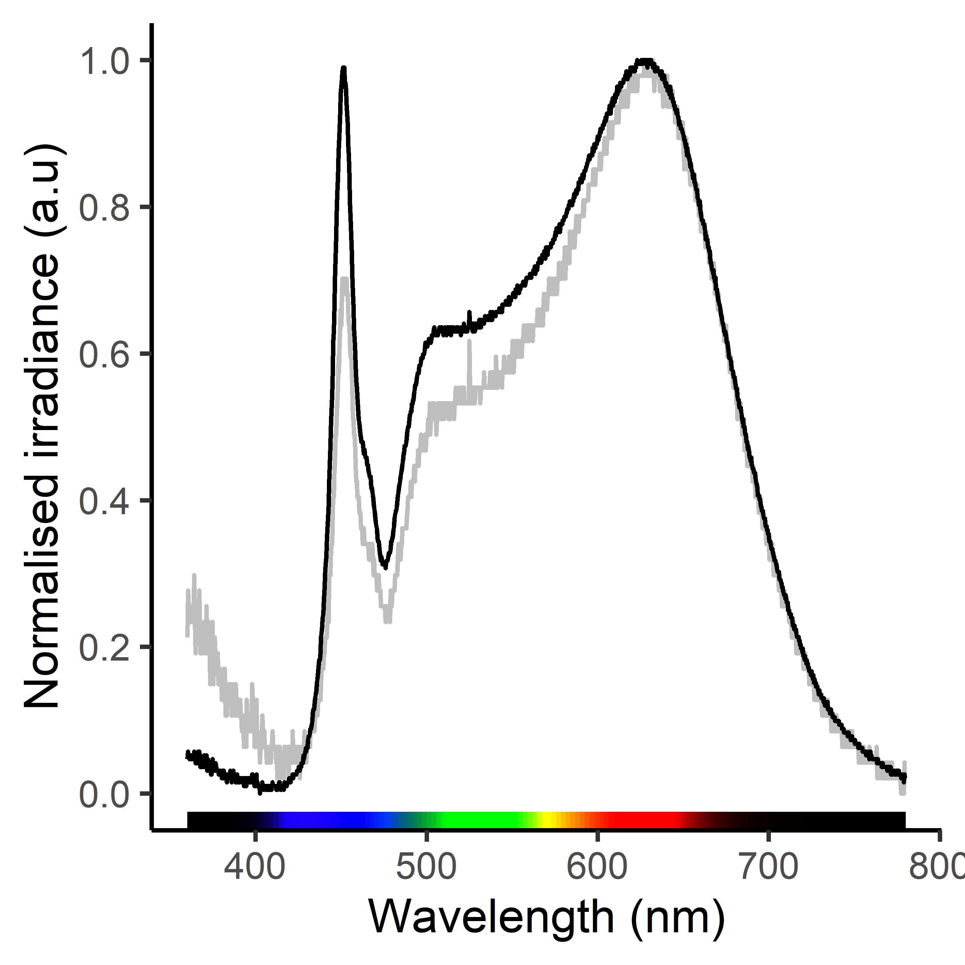
Fig 2. Spectral composition (normalised to the emission peak) of the LED unit used to assess the response of downstream moving European eel (Anguilla anguilla) to low (grey line) or high (solid line) Artificial Light at Night (ALAN) in an experimental flume. The brightness of the LED unit was adjusted with a dimmer switch. When dimmed under low ALAN, the ratio of the blue to broadband emission peak is reduced compared to high ALAN.

2.4. Experimental procedure
Forty 60 minute (max.) trials were conducted under the control and two treatment conditions (120 trials in total) during hours of darkness (1800 – 0400 h) using an individual eel once only. To ensure a balanced design that accommodated the experimental period (1800 – 0400 h) and date (11 – 24 November), the order of treatment was predetermined through random selection without replacement in blocks of three. Within each block, a control, low ALAN and high ALAN trial was conducted, in a randomised order, and the illuminated route (during ALAN treatments) was designated the “treatment channel”, and the alternative route the “control channel”. For statistical purposes, the route that was illuminated during ALAN treatments was also designated the “treatment channel” during the control even though both routes remained dark. The position of the treatment channel (left or right) was alternated between each block (i.e. every three trials). This design helped control for confounding effects, such as temperature, lateral bias in eel behaviour, or variability in flume hydrodynamics. There was no difference in light intensity when the left or right channel was illuminated (dim ALAN: z = -0.10, r = -0.01, p = 0.923; bright ALAN: z = -0.75, r = -0.01, p = 0.455).
Prior to the start of each trial, individual eel were allowed to acclimate to the flume in perforated sealed tubes (0.07 m diameter, 1.00 m long) placed immediately upstream of the first flow straightener. After a minimum of 1 h, the fish was transferred to the release pipe from which they were allowed to volitionally exit into the experimental area after a further 5 minutes. Each trial lasted for a maximum of one hour or until the eel had moved downstream through the 6 m long experimental area, after which it was collected, measured (total length, pectoral fin lengths and vertical and horizontal eye diameters, mm) and weighed (wet mass, g). Mean (± SD) flume water temperature, measured immediately prior to the start of each trial, was 10.1 (± 0.7) °C.
2.5. Data and statistical analysis
Four of the 120 eel did not exit the release pipe during the 1 h trial (three during the control and one during the high ALAN treatment) and were excluded from further analysis. Mean (± SD) trial time for those that did enter the experimental area was 5.3 minutes (± 9.2 minutes). On entering the experimental area, the Initial Response of the downstream moving fish as they approached within 1 m of the entrance to the test channels (approach zone in Fig 1a) was categorised with increasing magnitude in the hierarchy of response (1-4) following Vowles et al. (2014) as:
- No observable response: entrance to a test channel without altering swimming trajectory, speed of downstream movement, or other movement behaviour.
- Reaction: an observable but limited change in behaviour, such as a decrease or increase in speed or change in swimming kinematics, on selecting a test channel, and not returning upstream.
- Route switch: altered swimming trajectory by switching from one side of the flume to the other before selecting a test channel.
- Rejection: exhibition of a switch in orientation from positive to negative rheotaxis (head position 90 – 180° from bulk flow) followed by an upstream movement, or by swimming backwards, prior to entering a test channel.
Any fish simultaneously exhibiting two behaviours were assigned the one of the highest magnitude of response. This occurred on one occasion, when a fish switched from one side of the flume to the other before rejecting the treatment channel. Initial Response was categorised relative to the test channel approached (control or treatment; Fig 1b-d). Due to a low number of observations, reaction, route switch and rejection were combined into a single (response) category for statistical analysis. A generalized linear model with binomial error distribution and Wald’s χ² test statistic was used to determine whether light treatment (control, low ALAN, high ALAN) or degree of silvering influenced the Initial Response on approaching the test channels.
A goodness-of-fit (χ²) test determined whether Channel Selected (control or treatment) deviated from an expected (50:50) frequency during the light treatments. A generalized linear model with binomial error distribution and Wald’s χ² test statistic was used to determine whether degree of silvering influenced Channel Selected.
Time to Pass through the 2 m long test channels was calculated for each eel and defined as the time (s) between the whole body length of the eel entering and exiting. A two-way factorial ANOVA, with ocular “silvering” index included as a linear covariate, was used to determine whether Time to Pass was influenced by light treatment and channel selected. The model was tested using a Type II sum of squares method from the ‘car’ package (Fox and Weisberg, 2019) in RStudio (v3.6.0; R Core Team, 2019). After examining histograms of the model residuals and plots of the residuals against fitted values to assess assumptions of normality and homogeneity of variance, Time to Pass was transformed using the Tukey’s Ladder of Powers method and the analysis re-run (following Mangiafico, 2015). For light treatment, multiple pairwise comparisons were performed post hoc using a Tukey adjustment among group least square means using the ‘lsmeans’ package (Lenth, 2016) in RStudio (v3.6.0; R Core Team, 2019). Two eel (both during high ALAN) that entered a test channel before returning upstream were excluded from the analysis of Time to Pass.

3. Results
3.1. Initial response
Eel typically exhibited no observable response (90.0%) when approaching the control channel, independent of treatment (Wald’s χ² = 0.31, d.f. = 2, p = 0.855; Fig 3) and degree of silvering (Wald’s χ² = 1.73, d.f. = 1, p = 0.188). When approaching the treatment channel, initial response was influenced by light treatment (Wald’s χ² = 7.43, d.f. = 2, p < 0.05), with a greater probability to react, switch route or reject during low (61.5%; p < 0.05) and high (52.9%; p < 0.05) ALAN compared to the control (6.25%; Fig 3). For eel that responded when approaching the treatment channel, reaction (50.0%) and rejection (55.6%) were the most frequently observed behaviours during low and high ALAN, respectively. During the control light treatment, one reaction was observed (Fig 3). Degree of silvering did not influence the initial response when approaching the treatment channel (Wald’s χ² = 0.21, d.f. = 1, p = 0.645).

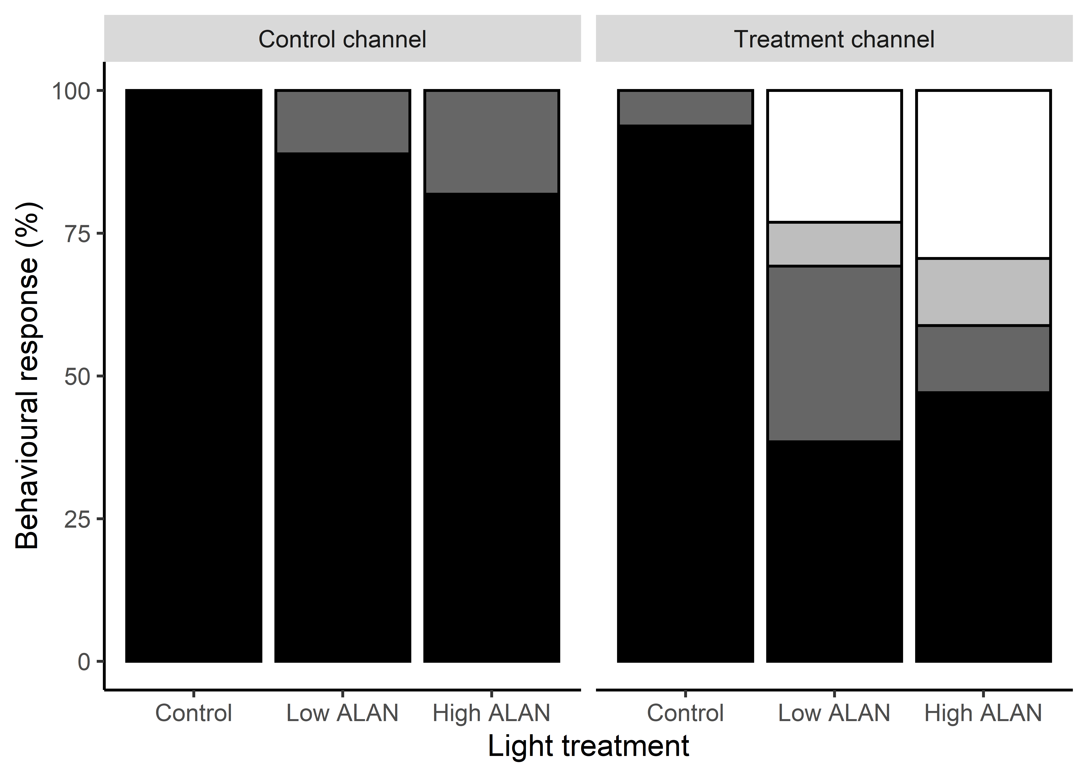
Fig 3. Initial response of downstream moving European eel (Anguilla anguilla) as they encountered a choice of route through either a treatment or control channel under three light treatments (control, low ALAN or high ALAN) in an experimental flume. Under the control light treatment, both channels were unlit. Under low and high ALAN treatments, one channel remained dark (control) and one was illuminated (treatment) to ca. 5 lx and 20 lx, respectively. Solid, dark grey, light grey and clear bars represent no observable response, reaction, route switch and rejection behaviours, respectively.

3.2. Channel selected
Eel that selected to pass through the control channel did not differ from 0.5 as expected under the control (both routes dark) treatment (χ² = 0.68, d.f. = 1, p = 0.411; Fig 4). However, when provided a choice of either control (dark) or treatment (low or high ALAN) channel, the route selected deviated from expectation (low: χ² = 12.10, d.f. = 1, p < 0.001; high: χ² = 5.77, d.f. = 1, p < 0.05), with more eel passing the control route (77.5% and 69.2% during low and high ALAN, respectively; Fig 4). Channel selected was not influenced by degree of silvering (Wald’s χ² = 2.35, d.f. = 1, p = 0.125).

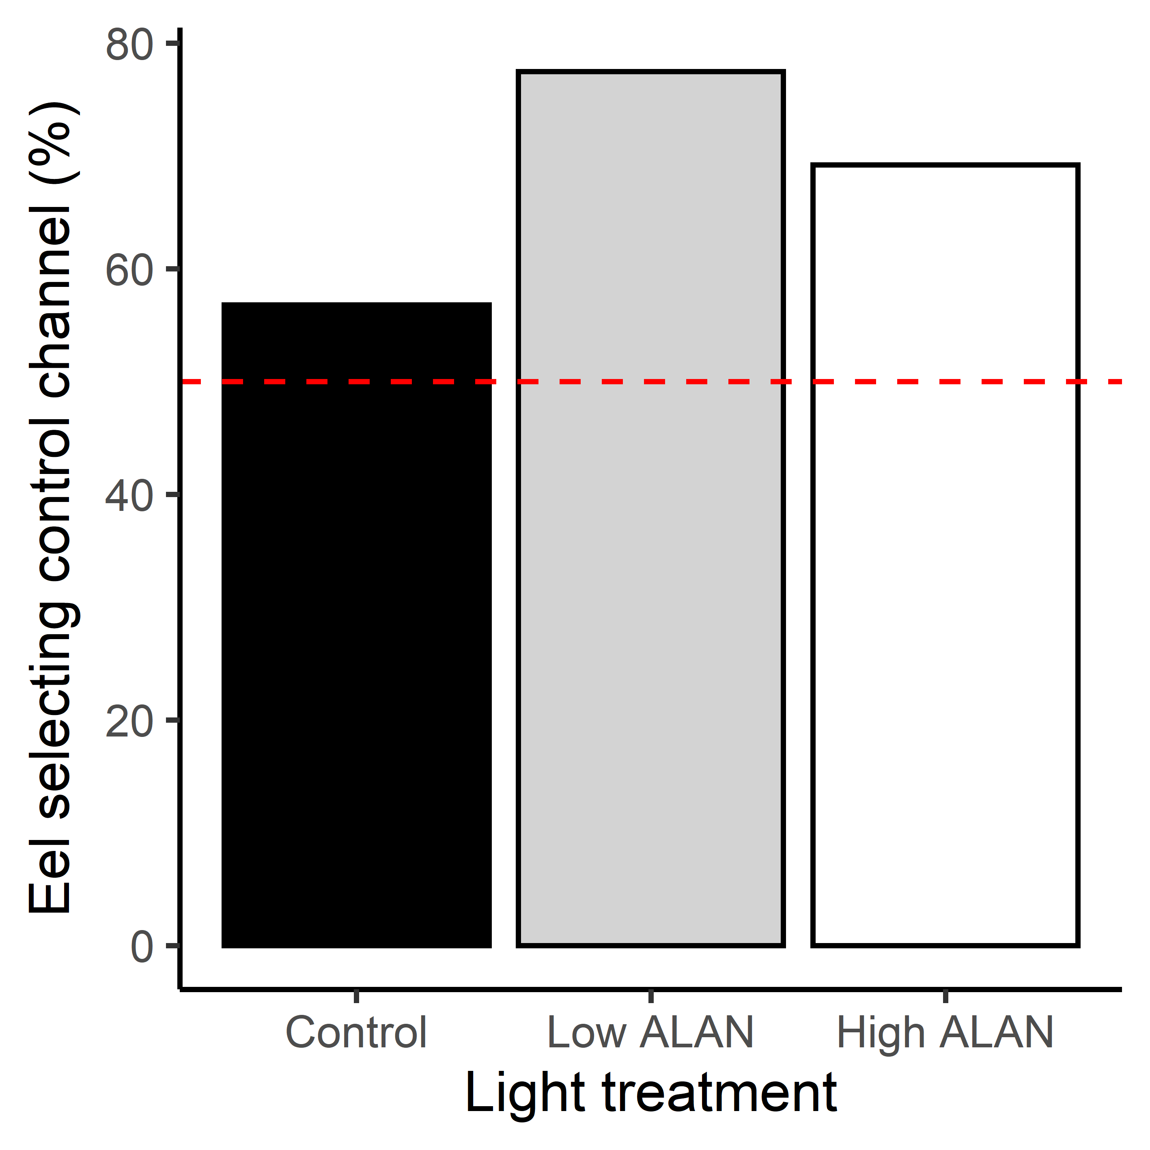
Fig 4. Percent of European eel (Anguilla anguilla) that selected the (dark) control over treatment test channel to descend an experimental flume under three light treatments. The entrance to the treatment channel remained dark or was lit to ca. 5 lx or 20 lx during the control, low ALAN and high ALAN treatment, respectively. Dashed line shows the expected (50%) frequency based on the null hypothesis that artificial light has no influence on channel selection.

3.3. Time to pass
Time to pass was influenced by light treatment (F_{2, 105} = 4.45, p < 0.05) and channel selected (F_{1, 105} = 8.61, p < 0.01), with eel passing more rapidly during the low ALAN treatment than under the control (p < 0.01; Fig 5), and through the illuminated channel faster than the unlit route (Fig 6). Compared to the control, passage was also slightly quicker under the high ALAN treatment (Fig 5), although this difference was not significant (p = 0.110). There was no interaction between light treatment and channel selected (F_{2, 105} = 0.45, p = 0.636). Time to pass was not influenced by degree of silvering (F_{1, 105} = 0.71, p = 0.400).

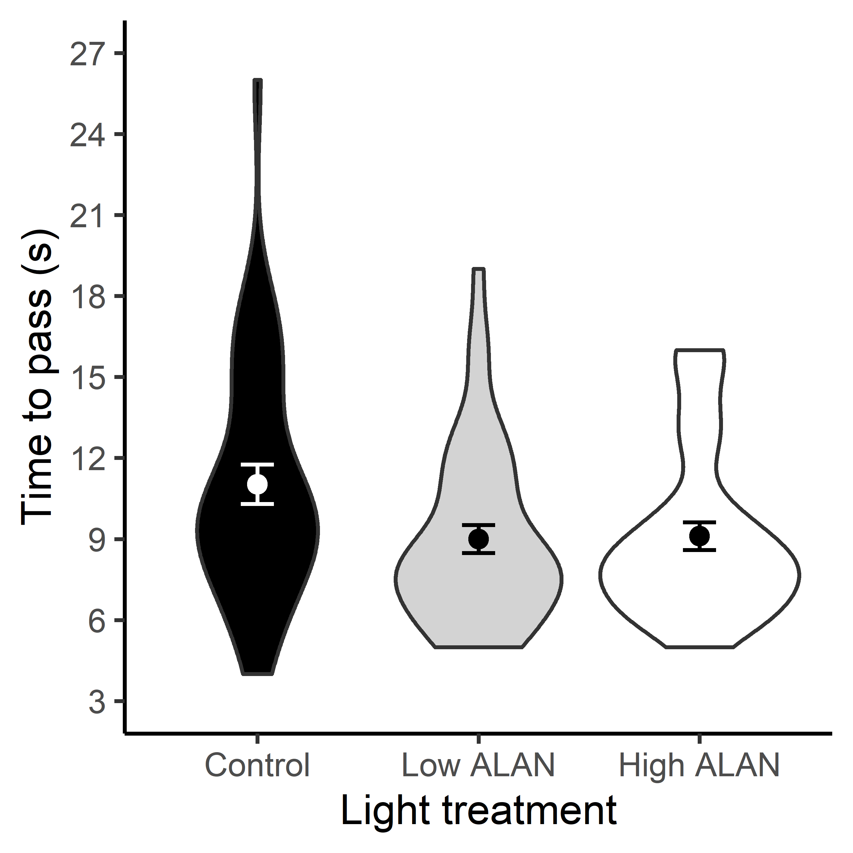
Fig 5. Main effect of three light treatments on the time for eel to pass downstream through a 2 m test channel in an experimental flume. Violin plots show the extent and probability distribution of the data. The points within violin plots display the mean (± SE).

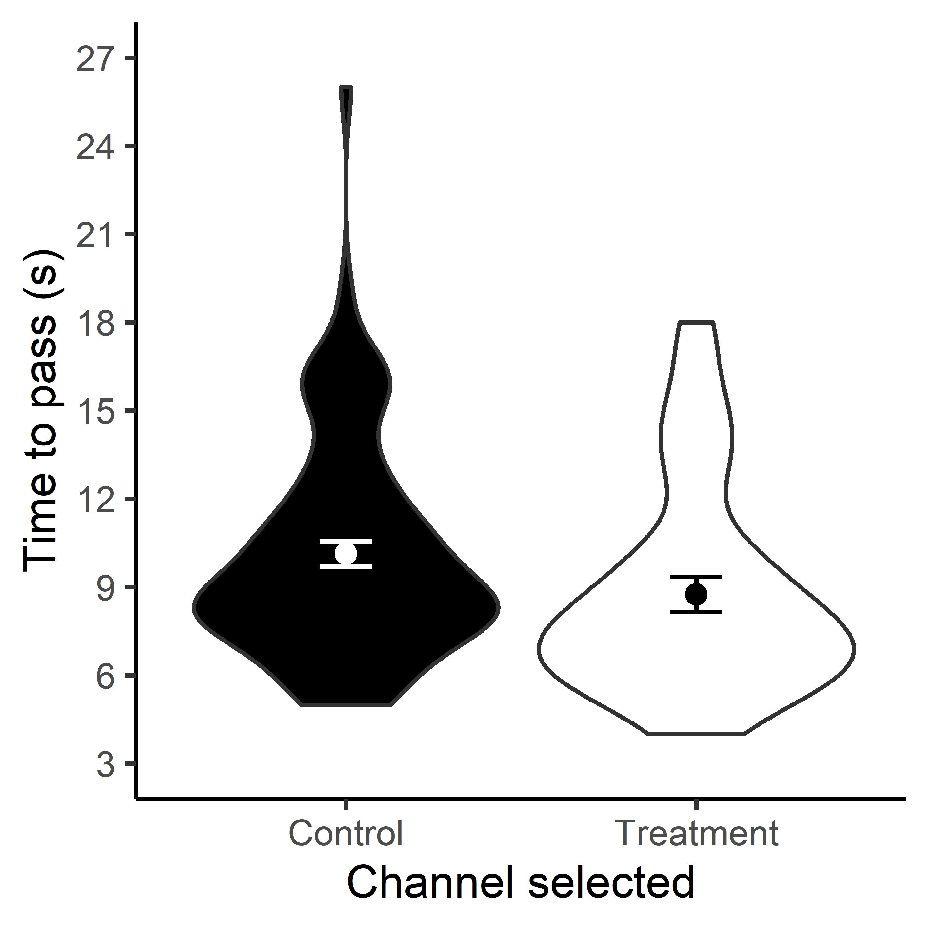
Fig 6. Main effect of test channel selected on time taken for eel to pass through a 2 section of an experimental flume. Violin plots show the extent and probability distribution of the data. The points within plots display the mean (± SE).

4. Discussion
When exposed to realistic levels of direct artificial light at night (ALAN) simulated by a broad-spectrum LED unit under an experimental setting, downstream moving European eel (Anguilla anguilla) tended to exhibit clear behavioural responses when approaching an illuminated route. Although the overall proportion of fish responding was greater under low ALAN, route switch and rejection (higher magnitude behaviours) were more prevalent under higher intensity conditions. Eel were more likely to select a dark channel when presented with a choice, and for those that did pass through the illuminated channel, progress was more rapid. Overall, eel behaviour (e.g. total number exhibiting an observable response, channel selected and time to pass) was impacted at least as much under the low compared with high intensity light condition tested. This information is useful because it indicates ALAN associated with urbanisation has potential to influence the migratory behaviour of an endangered freshwater fish species of high conservation concern. As eel are likely to frequently encounter ALAN emitted from infrastructure common along many European river systems during their seaward migration, there is a need to better understand the potential magnitude of impacts so efforts can be directed at mitigation. Therefore, the implications of these results, including the potential impact of even lower light intensities, such as those representative of indirect skyglow (which can range from as little as 0.007 lx to 0.55 lx; Hänel et al. 2018), under field conditions require further consideration.
Abrupt gradients of a range of stimuli (e.g. hydrodynamics, acoustics, electric fields) are known to influence the behaviour of downstream migrating eel. For example, they may reject hydrodynamic transitions created by physical structures, by swimming back upstream to search for an alternative route before continuing downstream (Behrmann-Godel and Eckmann, 2003; Piper et al. 2015; Winter et al. 2006), resulting in undesirable delay to their migration (Acou et al. 2008). In other cases, however, stimuli are intentionally used to induce such avoidance behaviour to deter eel from hazardous areas, such as water intakes. For example, infra-sound (Piper et al. 2019), electricity (M. Miller pers. comm.; Turnpenny and O’Keeffe, 2005) and high intensity continuous and strobe lighting (Brown, 2000; Elvidge et al. 2018; Hadderingh et al. 1992) have been used to induce avoidance behaviour (e.g. rejection and milling), which may be temporary if the fish becomes increasingly tolerant or habituated (but see Patrick et al. 1982 who note no tolerance to strobe light after 48 h). In this study, eel behaviour in response to ALAN was like those described for other stimuli, with fish being more likely to reject the area of transition and return upstream on encountering illuminated channels (23.1% and 29.4% during low and high ALAN respectively, compared with 0% during the dark control). However, a quarter of eel that initially rejected, re-approached and passed via the illuminated route. While avoidance was relatively short-lived for some individuals, there is evidence of simulated ALAN impacting fish activity (Pulgar et al. 2019) and risk-taking behaviour (Kurvers et al. 2018) after 10 days of exposure, suggesting limited habituation. The variation in initial response between treatments also indicates that the probability of avoidance behaviour (such as route switch and rejection) may be positively related to intensity of artificial illumination, a factor that is likely to influence the magnitude of impact under field settings, and will be confounded by numerous variables, including type of light source, intensity of the light field, and water depth and turbidity. Greater understanding of the spatial extent and brightness of artificial illumination of rivers (see Jechow and Hölker, 2019) will help identify ALAN “hotspots” where impact on the behaviour of aquatic organisms, and other biological processes, might be expected. However, our findings indicate that eel behaviour within river systems is likely to be modified, at least in the short-term, by this widespread environmental pollutant (Falchi et al. 2016), although the consequences for long-term fitness remain unknown.
Downstream migrating eel are not passively transported with bulk flow. Instead they can switch between active downstream movement with routes selected near the centre of the river and stationary phases of rest towards the riverbank (Behrmann-Godel and Eckmann, 2003). When in heavily modified river sections, eel have been observed moving nearer to river boundaries, including in proximity to infrastructure that spans the channel (Piper et al. 2017). Under the control (dark night) condition presented in this study, when eel were offered a choice of two unlit routes downstream, the probability of selecting either channel did not deviate from the 50:50 frequency expected. In contrast, when one of the routes was lit to 5 or 20 lx, eel were more likely to select the dark, unlit route. Within heavily modified rivers, the numerous direct sources of illumination emanating from banks (e.g. from street lighting, domestic and commercial buildings, docks, pontoons etc.) and channel-spanning structures (e.g. dams and bridges) may result in the preferred routes of downstream migrating eel being particularly exposed to light pollution, influencing their chosen route. In areas where alternative (unlit) routes are unavailable, eel migration may be delayed. Considering eel migrations are thought to be broadly synchronised across their range to ensure mature individuals arrive at oceanic spawning areas at a similar time (Sandlund et al. 2017), the extent of any delays as a result of artificially generated illumination should be quantified.
The broad-spectrum nature of LED derived light pollution is one of the primary reasons it can have a wide range of unintended ecological consequences across taxa (Davies et al. 2013). In this study, light generated from a broad-spectrum LED unit caused eel to pass through illuminated channels of the flume more rapidly than those that remained unlit. As eel migration at night is considered to be a strategy, at least in part, to reduce predation risk (Sandlund et al. 2017; Vøllestad et al. 1986), increasing the speed of downstream movement in areas that are artificially lit may be logical. Although it was hypothesised that the shift in visual spectral sensitivity towards shorter wavelengths that are characteristic of white LED lighting, and which occurs during maturation, would result in a greater magnitude of response, there was no evidence in support of this. However, a large proportion of eel used in this study were not in their “migratory phase” according to the ocular index calculated, and those that were, were likely at an early stage of maturation. More focused investigations across a wider ontogenetic range (but particularly on eel in a more advanced stage of maturation) and using more detailed morphological and physiological indices less prone to measurement error (Acou et al. 2006), may help reveal any affects related to changes in spectral sensitivity, life-stage and impact of ALAN. The observed increased swimming speed in relation to illumination in this study may relate to the broad-spectrum light affecting a generally negatively phototactic species independent of ontogenetic shifts in maximum spectral sensitivity. Evidence that American eel are unresponsive to red (> 600 nm) strobe light (Patrick et al. 1982) does however suggest that shifting the spectral composition of ALAN towards longer wavelengths may help mitigate observed impacts on the swimming speed of downstream moving eel. Despite a short distance travelled through the test channels, the difference in time taken to pass was significant in some instances. If this were to be scaled-up under a field setting, then the impacts to the speed and energetic cost of migration could be substantial. However, whether this is the case needs to be evaluated in situ, e.g. using high-resolution telemetry techniques.
5. Conclusions
Our results demonstrate that realistic levels of direct ALAN, simulated using a LED unit under experimental settings, can influence the downstream movement behaviour of the critically endangered European eel. Given the consistent and pervasive nature of light pollution compared to natural variations in illumination, which are influenced by periodic lunar phases and stochastic weather (such as cloud cover), the unintended impacts on eel movement and migration may be large. We therefore recommend field studies to understand the implications of these findings. In Europe, legislative targets to reverse the decline of European eel populations are focused on ensuring, with a high probability, the escapement of at least 40% of silver eel biomass to the sea relative to estimates where there are no anthropogenic pressures on the population (Council Regulation 1100/2007/EC). These targets do not include the need to mitigate for anthropogenic pressures that influence the timing of migration. However, if eel must pass multiple areas of artificial illumination, potentially spanning large spatial scales, then the natural timing of their migrations might be disrupted. The population levels effects of which would need to be understood. This study provides a platform to further quantify and mitigate the negative consequences of this major source of environmental pollution and driver of global change. Such research will help inform future urban light management strategies that are aimed at reducing ecological impact.

Acknowledgements:
This work was funded by a Fisheries Society of the British Isles Research Grant awarded to ASV and sanctioned by the University of Southampton Ethical Review Board. Thanks go to the ICER Team for assistance during the experimental period, and to Terry Smith for capture of the eels.
Author contributions:
ASV conceived the study and designed and performed the experiment. ASV conducted formal analysis of the data and drafted the original paper. PSK contributed to the writing, editing and critical review of the paper. Both authors agreed on the final version to be submitted.
Declaration of competing interests:
The authors declare that they have no known competing financial interests or personal relationships that could have appeared to influence the work reported in this paper.

References:
Acou, A., Laffaille, P., Legault, A., Feunteun, E., 2008. Migration pattern of silver eel (Anguilla anguilla, L.) in an obstructed river system. Ecol. Freshw. Fish. 17, 432-442.

Acou, A., Poizat, G., Crivelli, A-J., 2006. Errors in ocular index measurements in European eel Anguilla anguilla (L.). Ecol. Freshw. Fish. 15, 578-582.

Becker, A., Whitfield, A.K., Cowley, P.D., Järnegren, J., Næsje, T.F., 2013. Potential effects of artificial light associated with anthropogenic infrastructure on the abundance and foraging behaviour of estuary-associated fishes. J. Appl. Ecol. 50, 43-50.

Behrmann-Godel, J., Eckmann, R., 2003. A preliminary telemetry study of the migration of silver European eel (Anguilla anguilla L.) in the River Mosel, Germany. Ecol. Freshw. Fish. 12, 196-202.

Botha, L, M. Jones, T.M., Hopkins, G.R., 2017. Effects of lifetime exposure to artificial light at night on cricket (Teleogryllus commodus) courtship and mating behaviour. Anim. Behav. 129, 181-188.

Bowmaker, J.K., Semo, M., Hunt, D.M., Jeffery, G., 2008. Eel visual pigments revisited: The fate of retinal cones during metamorphosis. Visual. Neurosci. 25, 249-255.

Brown, R., 2000. The potential of strobe lighting as a cost-effective means of reducing impingement and entrainment. Environ. Sci. Policy. 3, 405-416.

Ceola, S., Laio, F., Montanari, A., 2015. Human-impacted waters: New perspectives from global high-resolution monitoring. Water. Resour. Res. 51, 7064-7079.

Davies, T.W., Bennie, J., Inger, R., Hempel de Ibarra, N., Gaston, K.J., 2013. Artificial light pollution: are shifting spectral signatures changing the balance of species interactions? Glob. Change. Biol. 19, 1417-1423.

Davies, T.W., Smyth, T., 2017. Why artificial light at night should be a focus for global change research in the 21st century. Glob. Change. Biol. 24, 872-882.

Dominoni, D.M., de Jong, M., Bellingham, M., O’Shaughnessy, P., van Oers, K., Robinson, J., Smith, B., Visser, M.E., Helm, B., 2018. Dose-response effects of light at night on the reproductive physiology of great tits (Parus major): Integrating morphological analysis with candidate gene expression. J. Exp. Zool. Part. A. 329, 473-487.

Elvidge, C.K., Ford, M.I., Pratt, T.C., Smokorowski, K.E., Sills, M., Patrick, P.H, Cooke, S.J., 2018. Behavioural guidance of yellow-stage American eel Anguilla rostrate with a light-emitting diode device. Endanger. Species. Res. 35, 159-168.

Falchi, F., Cinzano, P., Duriscoe, D., Kyba, C.C.M., Elvidge, C.D., Baugh, K., Portnov, B.A., Rybnokova, N.A., Furgoni, R., 2016. The new world atlas of artificial night sky brightness. Sci. Adv. 2(6), e1600377.

Fobert, E.K., Burke da Silva, K., Swearer, S.E., 2019. Artificial light at night causes reproductive failure in clownfish. Biol. Lett. 15, 20190272.

Foster, J.G., Algera, D.A., Brownscombe, J.W., Zolderdo, A.J., Cooke, S.J., 2016. Consequences of different types of littoral zone light pollution on the parental care behaviour of a freshwater teleost fish. Water. Air. Soil. Poll.. 227, 404.

Fox, J., Weisberg, S., 2019. An R Companion to Applied Regression, Third edition. Sage Thousand Oaks CA (USA). Available online at: http://socialsciences.mcmaster.ca/jfox/Books/Companion

Garratt, M.J., Jenkins, S.R., Davies, T.W., 2019. Mapping the consequences of artificial light at night for intertidal ecosystems. Sci. Total. Environ. 692, 760-768.

Gaston, K.J., Bennie, J., Davies, T.W., Hopkins, J., 2013. The ecological impacts of nighttime light pollution: a mechanistic appraisal. Biol. Rev. 88, 912-927.

Gaston, K.J., Visser, M.E., Hölker, F., 2015. The biological impacts of artificial light at night: the research challenge. Philos. T. R. Soc. B. 370, 20140133.

Hadderingh, R.H., van der Stoep, J.W., Habraken, J.M.P.M., 1992. Deflecting eels from water inlets of power stations with light. Ir. Fish. Invest. A. 36, 78-87.

Hänel, A., Posch, T., Ribas, S.J., Aubé, M., Duriscoe, D., Jechow, A., Kollath, Z., Lolkema, D.E., Moore, C., Schmidt, N., Spoelstra, H., Wuchterl, G., Kyba, C.C.M., 2018. Measuring night sky brightness: methods and challenges. J. Quant. Spectrosc. Ra. 205, 278-290.

Hopkins, G.R., Gaston, K.J., Visser, M.E. Elgar, M.A., Jones, T.M., 2018. Artificial light at night as a driver of evolution across urban-rural landscapes. Front. Ecol. Evol. 16, 1-8.

ICES., 2019. European eel (Anguilla anguilla) throughout its natural range. In Report of the ICES Advisory Committee, 2019. ICES Advice 2019, ele.2737.nea. https://doi.org/10.17895/ices.advice.4825.

Jechow, A., Hölker, F., 2019. How dark is a river? Artificial light at night in aquatic systems and the need for comprehensive night-time light measurements. WIREs. Water. e1388.

Kummu, M., De Moel, H., Ward, P.J., Varis, O., 2011. How close to water do we live? A global analysis of population distance to freshwater bodies. PLos. One. 6, e20578.

Kupprat, F., Hölker, F., Kloas, W., 2020. Can skyglow reduce nocturnal melatonin concentrations in Eurasian perch? Environ. Pollut. 262, 114324.

Kurvers, R.H.J.M., Drägestein, J., Hölker, F., Jechow, A., Krause, J., Bierbach, D., 2018. Artificial Light at Night affects emergence from a refuge and space use in guppies. Sci. Rep. 8, 14131.

Kyba, C.C.M., Kuester, T., Sánchez de Miguel, A., Baugh, K., Jechow, A., Hölker, F., Bennie, J.,
Elvidge, C.D., Gaston, K.J., Guanter, L., 2017. Artificially lit surface of Earth at night increasing in radiance and extent. Sci. Adv. 3(11), e1701528.

Lenth, R.V., 2016. Least-Squares Means: The R Package lsmeans. J. Stat. Softw. 69, 1-33.

Lowe, R.H., 1952. The influence of light and other factors on the seaward migration of the silver eel (Anguilla anguilla). J. Anim. Ecol. 21, 275-309.

Mangiafico, S.S., 2015. An R Companion for the Handbook of Biological Statistics version 1.3.3. Rutgers Cooperative Extension, New Brunswick, NJ (USA). Available online at http://www.rcompanion.org/rcompanion

Owens, A.C.S., Lewis, S.M., 2018. The impact of artificial light at night on nocturnal insects: A review and synthesis. Ecol. Evol. 18, 11337-11358.

Pankhurst, N.W., 1982. Relation of visual changes to the onset of sexual maturation in the European eel Anguilla anguilla L. J. Fish. Biol. 21, 127-140.

Patrick, P.H., Sheehan, R.W., Sim, B., 1982. Effectiveness of a strobe light eel exclusion scheme. Hydrobiologia. 94, 269-277.

Perkin, E.K., Hölker, F., Richardson, J.S., Sadler, J.P., Wolter, C., Tockner, K., 2011. The influence of artificial light on stream and riparian ecosystems: questions, challenges, and perspectives. Ecosphere. 2, 1-16.

Piper, A.T., Manes, C., Siniscalchi, F., Marion, A., Wright, R.M., Kemp, P.S., 2015. Response of seaward-migrating European eel (Anguilla anguilla) to manipulated flow fields. P. R. Soc. B. 282, 20151098.

Piper, A.T., Svendsen, J,C., Wright, R.M., Kemp, P.S., 2017. Movement patterns of seaward migrating European eel (Anguilla anguilla) at a complex of riverine barriers: implications for conservation. Ecol. Freshw. Fish. 26, 87-98.

Piper, A.T., White, P.R., Wright, R.M., Leighton, T.G., Kemp, P.S., 2019. Response of seaward-migrating European eel (Anguilla anguilla) to an infrasound deterrent. Ecol. Eng. 127, 480-486.

Pulgar, J., Zeballos, D., Vargas, J., Aldana, M., Manriquez, P.H., Manriquez, K., Quijón, P.A., Widdicombe, S., Anguita, C., Quintanilla, D., Duarte, C., 2019. Endogenous cycles, activity patterns and energy expenditure of an intertidal fish is modified by artificial light pollution at night (ALAN). Environ. Pollut. 244, 361-366.

R Core Team., 2019. R: A Language and Environment for Statistical Computing. R Foundation for Statistical Computing, Vienna. Available online at http://www.R-project.org

Reid, A.J., Carlson, A.K., Creed, I.F., Eliason, E.J., Gell, P.A., Johnson, P.T.J., Kidd, K.A., MacCormack, T.J., Olden, J.D., Ormerod, S.J., Smol, J.P., Taylor, W.W., Tockner, K., Vermaire, J.C., Dudgeon, D., Cooke, S.J., 2019. Emerging threats and persistent conservation challenges for freshwater biodiversity. Biol. Rev. 94, 849-873.

Riley, W.D., Bendall, B., Ives, M.J., Edmonds, N.J., Maxwell, D.L., 2012. Street lighting disrupts the diel migratory pattern of wild Atlantic salmon, Salmo salar L., smolts leaving their natal stream. Aquaculture. 330-333, 74-81.

Riley, W.D., Davison, P.I., Maxwell, D.L., Bendall, B., 2013. Street lighting delays and disrupts the dispersal of Atlantic salmon (Salmo salar) fry. Biol. Conserv. 158, 140-146.

Riley, W.D., Davison, P.I., Maxwell, D.L., Newman, R.C., Ives, M.J., 2015. A laboratory experiment to determine the dispersal response of Atlantic salmon (Salmo trutta) fry to street light intensity. Freshwater. Biol. 60, 1016-1028.

Russ, A., Rüger, A., Klenke, R., 2015. Seize the night: European blackbirds (Turdus merula) extend their foraging activity under artificial illumination. J. Ornithol. 156, 123-131.

Sandlund, O.T., Diserud, O.H., Poole, R., Bergesen, K., Dillane, M., Rogan, G., Durif, C., Thorstad, E.B., Vøllestad, L.A., 2017. Timing and pattern of annual silver eel migration in two European watersheds are determined by similar cues. Ecol. Evol. 7, 5956-5966.

Turnpenny, A.W.H., O’Keeffe, N., 2005. Screening for Intakes and Outfalls: a best practice guide. Bristol: Environment Agency. Science Report SC030231.

United Nations., 2018. World urbanization prospects: The 2018 revision [key facts]. Available online: https://population.un.org/wup/Publications/Files/WUP2018-KeyFacts.pdf [accessed 17/07/2019].

Vøllestad, L.A., Jonsson, B., Hvidsten, N.A., Næsje, T.F., Haraldstad, Ø., Ruud-Hansen, J., 1986. Environmental factors regulating the seaward migration of European silver eels (Anguilla anguilla). Can. J. fish. Aquat. Sci. 43, 1909-1916.

Vowles, A.S., Anderson, J.J., Gessel, M.H, Williams, J.G., Kemp, P.S., 2014. Effects of avoidance behaviour on downstream fish passage through areas of accelerating flow when light and dark. Anim. Behav. 92, 101-109.

Wakefield, A., Stone, E.L., Jones, G., Harris, S., 2015. Light-emitting diode street lights reduce last-ditch evasive manoeuvres by moths to bat echolocation calls. Roy. Soc. Open. Sci. 2, 150291.

Willmott, N.J., Henneken, J., Selleck, C.J., Jones, T.M., 2018. Artificial light at night alters life history in a nocturnal orb-web spider. PeerJ. 6, e5599.

Winter, H.V., Jansen, H.M., Bruijs, M.C.M., 2006. Assessing the impact of hydropower and fisheries on downstream migrating silver eel, Anguilla anguilla, by telemetry in the River Meuse. Ecol. Freshw. Fish. 15, 221-228.

Yurk, H., Trites, A.W., 2000. Experimental attempts to reduce predation by harbor seals on out-migrating juvenile salmonids. T. Am. Fish. Soc. 129, 1360-1366.

