Circulating tumour DNA as a biomarker in resectable and irresectable stage IV colorectal cancer; a systematic review and meta-analysis

Robert P. Jones^{1,2}, Sian Pugh³, Janet Graham^{4,5}, John N. Primrose⁶, Jorge Barriuso^{7,8},

- School of Cancer Studies, Institute of Translational Medicine, University of Liverpool, Liverpool, UK
- Department of Hepatobiliary Surgery, Liverpool University Teaching Hospitals NHS Foundation Trust, Liverpool, UK
- University of Cambridge, Cambridge, UK
- Beatson West of Scotland Cancer Centre, Glasgow, UK
- University of Glasgow, UK
- University of Southampton, Southampton, UK
- Division of Cancer Sciences, Faculty of Biology, Medicine and Health, University of Manchester, UK
- Department of Medical Oncology, The Christie NHS Foundation Trust, Manchester, UK

Corresponding author

Robert P. Jones
School of Cancer Studies
Institute of Translational Medicine
University of Liverpool
Brownlow Hill
Liverpool
L69 7ZX
United Kingdom

robjones@liv.ac.uk

Keywords; colorectal, cancer, biomarker, ctDNA

Abstract

Background
For patients with metastatic colorectal cancer, stratification for treatment (surgery or chemotherapy) is often based on crude clinicopathological characteristics like tumour size and number of lesions. Circulating tumour DNA (ctDNA) offers a potential biomarker of disease trajectory and biology, allowing better stratification.
This study aimed to systematically review ctDNA in stage IV colorectal cancer to assess its potential role as a prospective biomarker to guide management decisions.

Methods
A literature search was performed to identify studies where the measurement of ctDNA in stage IV colorectal cancer was correlated with a clinical outcome (radiological response, secondary resection rate, PFS, DFS or OS).

Results
Twenty-eight studies were included, reporting on 2823 patients. Circulating tumour DNA was detectable in between 80-90% of patients prior to treatment. Meta-analysis identified a strong correlation between detectable ctDNA after treatment (surgery or chemotherapy) and overall survival (HR 2.2, 95% CI 1.79-2.69, p <0.00001), as well as progression free survival (HR 3.15, 95% CI 2.10-4.73, p<0.00001). ctDNA consistently offered an early marker of long-term prognosis in irresectable disease, with changes after one cycle of systemic therapy demonstrating prognostic value. In resectable disease treated with curative intent, detection of ctDNA offered a lead time over radiological recurrence of 10 months.

Conclusion
Circulating tumour DNA is detectable in the majority of resectable and irresectable patients. The presence of ctDNA is clearly associated with shorter overall survival, with changes in ctDNA an early biomarker of adverse disease behaviour. Prospective trials are essential to test its clinical efficacy.

Introduction

Since the early 1980s, selected patients with liver dominant metastatic colorectal cancer (CRC) have been offered hepatic resection with the aim of improving survival. However, it is clear that not all patients with resectable disease enjoy long-term benefit with around 30% developing recurrence and 15% succumbing to their disease within a year.¹
Neoadjuvant therapy aims to improve these outcomes by destroying occult disease and selecting patients with favourable disease biology for surgery. The EORTC 40983 trial randomized patients to perioperative treatment with FOLFOX or surgery alone. The trial met its primary endpoint of improved 3-year PFS (33.2% vs. 42.4%, p=0.03)², but updated results after a median follow-up of 8.5 years demonstrated no improvement in PFS (HR 0.81, 95% CI 0.64–1.02, p=0.068) or OS (HR 0.87, 95% CI 0.66–1.14; p=0.3)³ ⁴ ⁵ ⁶. The 2014 New EPOC study aimed to evaluate the possible benefit of the addition of monoclonal antibody therapy to epidermal growth factor receptor (EGFR) in KRAS wild-type disease by adding Cetuximab to FOLFOX in the neoadjuvant setting. However, the authors reported a significantly shorter PFS for combination therapy (14.1 vs. 20.5 months)⁷, with a marked disadvantage in terms of OS.⁸ The role of adjuvant therapy is also unclear. The evidence supporting this approach is marginal, with three trials failing to show overall benefit^{9,10,11}. There is therefore a real lack of clarity around which patients will benefit from perioperative chemotherapy.
Tumour DNA is released into the blood after tumour cell apoptosis or necrosis, and genetic and epigenetic changes from these tumours can be detected in the bloodstream. Gene mutations that have been identified within the primary tumour (following biopsy or resection) can be used to make a personalised assay for each patient which can be used for ongoing ctDNA measurement. Alternatively, a panel of candidate genes can be used without knowledge of the mutational status of the primary tumour. The presence of a particular gene alteration can then be used to identify those who are “positive” or “negative”. The mutant allele frequency (MAF) can be used as a quantitative measure of disease response and could potentially give indirect information about tumour burden and pace of progression or response. Circulating tumour DNA therefore offers a potential biomarker of disease aggressiveness, presence of minimal residual disease or efficacy of treatment.
This study aimed to systematically review ctDNA in stage IV colorectal cancer to assess its potential role as a prospective biomarker to guide management decisions.
Methods

The aim of this review was to identify studies where the measurement of ctDNA in stage IV colorectal cancer was correlated with a clinical outcome (radiological response, secondary resection rate, PFS, DFS or OS). Because of the small number of studies considering only resectable disease, both resectable and irresectable groups were included for review.
A meta-analysis of proportion of cases with detectable ctDNA and survival depending on the presence of ctDNA was performed (For full details, see supplementary methods).

Results

The initial search identified 768 potentially relevant studies, all of which were retrieved for further analysis. Six hundred and seventy-nine reports were excluded based on their title or abstract (See figure 1). Of the 89 retrieved for full review, 15 were excluded for not reporting on metastatic colorectal cancer, 26 for not reporting on an appropriate clinical endpoint, 17 for not reporting on ctDNA, 2 as duplicate datasets, and 1 as being of insufficient quality for inclusion. 28 studies (26 full manuscripts, 2 conference abstracts) were therefore included in the review, reporting on 2700 patients with irresectable disease and 123 with resectable disease.

Figure 1; PRISMA figure showing study selection

Resectable disease

A total of 4 studies were included, all of which had been published since 2016, and included 123 patients (See table 1). Two were prospective cohort studies^{12,13}, with two analysing selected patient subgroups from a cohort based on subsequent patterns of recurrence^{14,15}. Different approaches to ctDNA analysis were adopted. Three studies adopted a novel discovery approach, with sequencing of primary tumour tissue and subsequent identification of patient-specific mutations within the cell free DNA.^{13–15} Bhangu et al¹² used a commercial assay measuring mutations in 43 cancer genes frequently involved in colorectal cancer, as well as epigenetic modifications.
On meta-analysis, patients with resectable disease had pre-operative ctDNA detectable in 83% (95% CI 55-100%) of cases (Figure 2). Bhangu et al¹² suggested levels of ctDNA correlated with radiological tumour volume, and found a change in ctDNA levels after one cycle of chemotherapy was associated with likelihood of proceeding to surgical resection and pathological response to chemotherapy in resected metastases. Changes in levels of methylated SEPT9 after one cycle were able to discriminate between those who responded to chemotherapy and underwent surgery, and those who did not (82% sensitivity, 100% specificity). SEPT9 dropping below the lower limit of detection after 2 cycles strongly correlated with histopathological response.
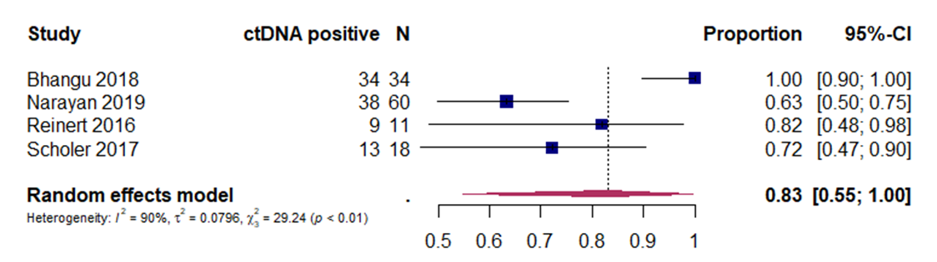

Figure 2; Forest plot showing proportion of resectable patients with detectable ctDNA

Narayan et al¹³ compared ctDNA expression in peripheral blood, hepatic veins and portal veins, all taken at the time of surgery, and found no difference. Schøler and Reinert^{14,15} both identified a lead time to detection of recurrence after surgery of 10 months for ctDNA over imaging, although both studies were subgroups from the same large cohort. Importantly, Schøler et al identified a single measurement of ctDNA clearance at 3 months after resection was strongly predictive of likelihood of disease recurrence (HR 4.9, 1.5-15.7, P=0.007), with 100% of patients who were ctDNA +ve at this point developing recurrence at a median follow-up of 36 months.
Only 2 series reported were able to be included for meta-analysis, with the presence of ctDNA showing no impact on overall survival (HR 5.28, 0.16-173.34, p=0.35), although high heterogeneity significantly limits interpretation of this result (Supplementary figure S1).

Irresectable disease
A total of 24 studies were included (22 full manuscripts, and 2 abstracts) (See table 2). Twenty (83%) had been published since 2016. Study methodology was reported in all 22 manuscripts and included 6 translational analyses of prospective randomized controlled trials and 17 prospective cohort studies (of which 3 were multi-centre, see table 2). Seven studies performed assays measuring ctDNA methylation^{16–22}, whilst seven used a commercial assay relying on a panel of frequently mutated colorectal cancer genes^{23–29}. The remaining eight used a combination of in-house bespoke assays and next generation sequencing (NGS) to identify mutational signatures within primary tumour which were then detected in ctDNA.
ctDNA detection at baseline varied. Of the 20 studies that performed a baseline measurement before treatment, meta-analysis demonstrated ctDNA positivity before treatment in 81% (95% CI 71-90) (Figure 3). A subgroup analysis of randomised studies demonstrated a similar positivity of 90% (95% CI 87-92%) (Supplementary figure S2). The assessment of funnel plots showed a high risk of bias for both resectable and irresectable series (supplementary figure S3).

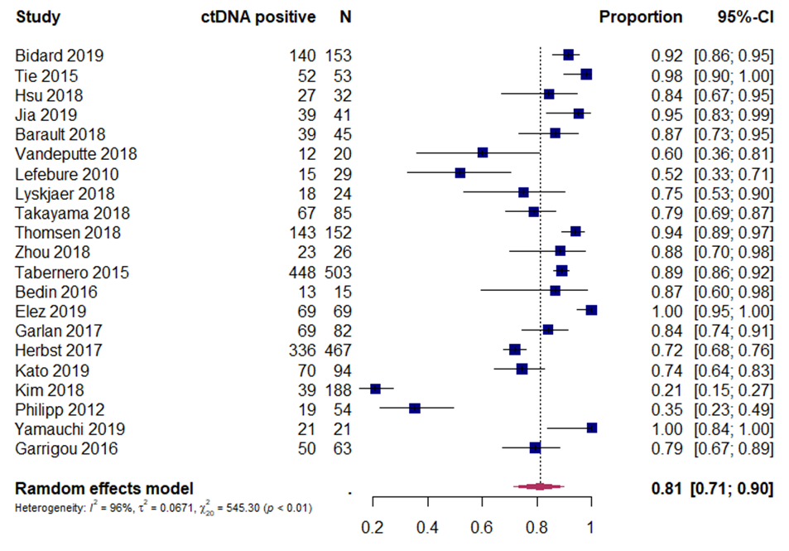
Figure 3; Forest plot showing proportion of irresectable patients with detectable ctDNA. Positive = present.

Three series assessed levels of ctDNA and relationship with radiological response, and all found a positive correlation ^{23,30,31}. Variations in sampling timepoints make direct comparison between series difficult, but Tie et al³¹ found that a marked reduction (≥10-fold) in ctDNA after one cycle of systemic therapy was associated with radiological response at 8-10 weeks (OR 5.25, p=0.016). The remaining 21 studies assessed the interaction between longitudinal changes in ctDNA and disease free, progression free or overall survival. Meta-analysis identified a strong correlation between ctDNA positivity and overall survival (HR 2.2, 95% CI 1.79-2.69, p <0.00001) (Figure 4), as well as progression free survival (HR 3.15, 95% CI 2.10-4.73, p<0.00001) (Figure 5).

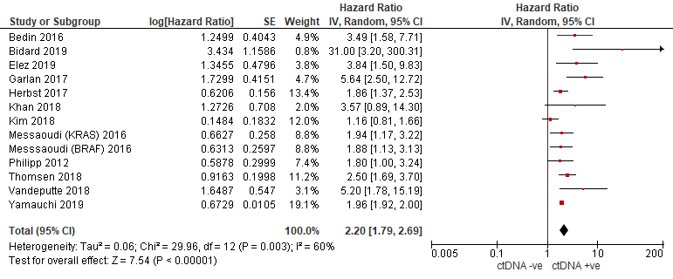
Figure 4; Forest plot showing overall survival in irresectable patients with detectable ctDNA. CtDNA negative (or absent) = ctDNA -ve; ctDNA positive (or present) = ctDNA +ve.

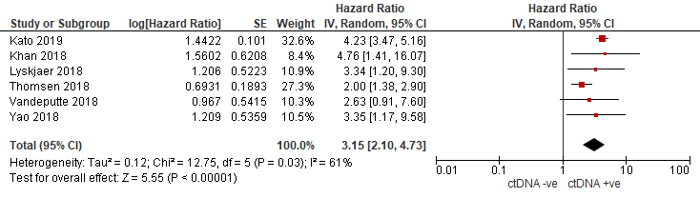
Figure 5; Forest plot showing progression free survival in irresectable patients with detectable ctDNA. CtDNA negative (or absent) = ctDNA -ve; ctDNA positive (or present) = ctDNA +ve

Baseline ctDNA level was identified as prognostically important by Garlan et al, who found patients with higher pre-treatment levels had a shorter overall survival (OS; 6.8 vs. 33.4 months: adjusted HR, 5.64; 95% CI, 2.5–12.6; P < 0.0001).²² A similar finding was reported by three other groups.^{17,19,27} Peeters et al²⁸ also identified a higher mutant allele frequency at baseline as a negative predictor of overall survival.
One striking similarity was the number of series reporting the prognostic value of early reduction in ctDNA (typically after one cycle of chemotherapy), with early reduction associated with much improved survival.^{19,22,24,25,27,32}
Bidard et al³³ assessed patients from the PRODIGE-14 trial of liver limited irresectable mCRC, and found a significantly lower rate of secondary liver resection in patients with detectable ctDNA after 4 weeks of chemotherapy (36% vs 85%, p=0.01). Garlan et al²² performed a prospective non-randomised cohort study, and classified patients as "good" or "bad” ctDNA responders based on the change in ctDNA between baseline and end of first or second cycle of chemotherapy. In multivariate analysis, good responders showed a better objective response rate (P < 0.001), and a longer median progression-free survival (8.5 vs. 2.4 months: HR, 0.19; 95% CI, 0.09–0.40; P < 0.0001) and OS (27.1 vs. 11.2 months: HR, 0.25; 95% CI, 0.11–0.57; P < 0.001).
A number of studies assessed mutant allele frequency and clonal changes as opposed to total ctDNA, and found a higher mutation frequency was negatively associated with survival.^{28,29,34–36} Khan et al³⁵ reported on a translational subgroup of the PROSPECT-R study, which enrolled RAS mutant mCRC, and found that RAS mutant clone decay in ctDNA after 8 weeks of treatment was associated with better PFS (HR 0.21 (95% CI 0.06 to 0.71), p=0.01) and OS (HR 0.28 (95% CI 0.07–1.04), p=0.06). Kim et al²⁹ performed a translational analysis of the ASPECCT study, which enrolled patients with RAS mutant mCRC. Loss of RAS mutant ctDNA within 4 weeks of treatment occurred in 47.6% and was associated with better PFS (HR 0.21 (95% CI 0.06 to 0.71), p=0.01) and OS (HR 0.28 (95% CI O.07 to 1.04), p=0.06). The assessment of funnel plots for the survival meta-analyses showed an elevated risk of bias (Supplementary figure S4). It was also hypothesised that the heterogeneity between studies could be decreased by analysing non-randomised controlled trials (RCT) separately from randomised series. The analysis proved that the less heterogenous group for the OS meta-analysis was the non-RCT as expected (see supplementary Figure S5)

Discussion

Circulating tumour DNA was detectable in between 80-90% of patients prior to treatment.
Although this review covered 2009-2019, 71% of included studies were published since 2018 reflecting the recent rapid growth in this field. The findings of this review highlight two different approaches to using ctDNA to personalise treatment; one involves the use of ctDNA to identify directly actionable mutations, as well as the emergence or decay of subclones that may alter treatment strategy (for example the removal or reintroduction of anti-EGFR agents). The second involves the quantitative use of ctDNA as a biomarker of response to treatment (for example cytotoxic chemotherapies or surgery), as well as identifying disease recurrence detectable before it becomes visible. This approach can be further extended to identify minimal residual disease (MRD) which remains after curative-intent surgery. As detailed in this review, both approaches can adopt a variety of analytical techniques. One strategy is to perform next generation sequencing of tumour tissue following resection or biopsy. Identified mutations can then be tracked longitudinally using bespoke assays. A second approach is tumour agnostic and uses panels of recognised mutations or gene methylations frequently seen in colorectal cancer and does not necessarily require direct sequencing of tumour tissue.
The timing of any biomarker analysis is clearly critical. In the resected population subgroup, detection of ctDNA at 3 months after curative intent surgery was highly prognostic, with 100% of ctDNA +ve patients developing recurrence, suggesting early ctDNA analysis may detect minimal residual disease. This timepoint offers logistical challenges, with the traditional window for starting adjuvant therapy being within 8 weeks of surgery. In the irresectable group, the prognostic value of very early changes (typically after 1 cycle of therapy) in ctDNA was also clear and associated with long-term survival. These findings imply ctDNA offers a very early and sensitive measure of disease response. For resectable disease, this raises 2 fundamental questions; is earlier detection of ctDNA after surgery possible (a function of assay sensitivity, as MRD will be present from resection), and would early detection offer any survival benefit? The detection of MRD by ctDNA seems to offer a lead time over the detection of radiological disease of around 10 months. Whether earlier treatment with systemic therapy would offer a survival benefit in this population is unclear and requires prospective testing. It is widely recognised that repeat surgical or ablation interventions for liver-limited recurrence are associated with improved overall survival, and so it may be that early detection of ctDNA recurrence could also lead to more intense radiological surveillance to allow such interventions.
Although this review included 6 randomised studies, all were retrospective analyses of translational study arms rather than studies where ctDNA guided management with the remainder being cohort studies. These present some limitations when considering how these findings could be used to help define a prospective study. The timing of any blood sampling in these series are likely to be combination of convenience (chosen to coincide with existing clinical visits) and feasibility. The optimum timepoint for any assay is therefore unclear, as is whether a single timepoint or multiple timepoints are required to fully assess disease trajectory. Furthermore, retrospective analyses do not require rapid turnaround from biosampling to results. By contrast, if a cycle of systemic therapy takes 14 days, prospective studies would require a turnaround of between 10-12 days to allow decision making around response to therapy. Both of these issues would need considering for a clinical trial of ctDNA-guided decision making.
This study assessed the presence of detectable ctDNA as a prognostic marker. The wide heterogeneity of analytical techniques, assay types, time points and data cut-offs make meta-analysis of the prognostic value of specific mutations impossible. In contrast to earlier stage disease, metastatic CRC also demonstrates broader heterogeneity and clonal selection in response to therapy, meaning the prognostic value of longitudinally tracking of a single detectable mutation may be limited. Most series in this study relied on measurements of variant allele frequency (VAF) as a quantification approach, which is a mutation dependent method. Assays for metastatic disease should therefore likely rely on a multigene approach to account for tumour heterogeneity and clonal evolution and overcome the limitations of tracking a single VAF. These obstacles were highlighted by a recent NCI Colon and Rectal Task Force ctDNA Consensus Statement³⁷, which recommended standardization of pre-analytical variables, plasma handling and minimisation of variation in ctDNA assays being used (including platform methodology, breadth and depth of coverage, validity and turnaround time) in future studies. Importantly, they also suggested the development of collaborative databases to enable high-quality future meta-analyses and pooled data analyses to identify the prognostic value of specific mutations in all stages of disease.
No reported studies directly compared validated prognostic markers in stage 4 CRC with ctDNA. In stage 2 and 3 disease, ctDNA appears to offer a prognostic advantage and predict benefit from adjuvant therapy better than assessment based on routine clinicopatholgical features³⁸. In resectable metastatic disease RAS status, node positivity of primary tumour and size of largest lesion are all recognised as prognostically valuable³⁹, but direct comparison against ctDNA has not been performed. RAS, BRAF^{v600E} and MSI status are recognised prognosticators in irresectable disease, but again a direct prospective comparison between their value vs. ctDNA has yet to be performed⁴⁰. Importantly, several studies have demonstrated high (>90%) levels of concordance between ctDNA and tissue-based RAS testing, suggesting ctDNA may have a role for tracking predictive biomarker evolution over time⁴¹.
The potential applications of ctDNA technology in stage IV CRC are promising. For patients with resectable and potentially curable disease, ctDNA detection after resection may indicate a role for adjuvant systemic therapy. CtDNA changes in response to therapy may allow de-escalation of treatment, whilst positivity after treatment could lead to personalisation of follow-up strategies, with remote blood-only surveillance or altered radiological surveillance intensity during the follow-up period. For patients with irresectable disease, ctDNA may allow the escalation or de-escalation of therapy, as well as switching ineffective therapies earlier before radiological evidence of lack of disease control. However, prospective trials are clearly essential to define the actual impact of these applications on clinical outcome.

In conclusion, this review summarises the evidence around ctDNA in stage IV colorectal cancer. Circulating tumour DNA is detectable in the majority of resectable and irresectable patients. The presence of ctDNA is clearly associated with shorter overall survival, with changes in ctDNA an early biomarker of adverse disease behaviour. Prospective trials are essential to test its clinical efficacy.

Conflict of interest
The authors declare no conflicts of interest.

Supplementary methods

For inclusion, studies had to be comparative (retrospective or prospective) reporting the relationship between circulating tumour DNA and a clinical outcome (radiological response, secondary resection rate, PFS, DFS or OS) following treatment for metastatic colorectal cancer. Potential studies were identified by title and abstract. The full article was then retrieved and reviewed to confirm eligibility. Bibliographies of cited references were reviewed to find further relevant publications.
Studies that originated from the same centre were checked to ensure that the same data set was not replicated. If papers referred to previously reported series, the most up‐to‐date and largest study was chosen. No attempt was made to quantify the quality of the studies
(such as the Jadad method⁴²) as this lacks statistical and empirical justification. Instead, data and methodological quality, as well as potential bias, were assessed qualitatively. Any discrepancies regarding inclusion or exclusion of a study were resolved by discussion.
Data was extracted on the study design, the number of patients and patient population, methods of measuring ctDNA, time-points at which ctDNA was measured, ctDNA detection at baseline (pre-treatment), length of follow-up, clinical endpoints measured, and outcome data.
Selected studies were divided into two groups, based on whether they considered resectable or irresectable stage 4 colorectal cancer. A general description of each study including methodology, patient population, size, assay type and analytical detail, length of follow-up and sampling time points was performed. These details are included in tables 1 and 2.

Meta-analysis of proportion of cases with ctDNA detected.

The proportion of cases with ctDNA detected with exact 95% confidence intervals (CIs) was calculated for each study. To handle extreme proportions, the Freeman–Tukey double arcsine transformation was the chosen approach for the calculation of pooled estimates and corresponding 95% CIs. If a study had a sample size below 10, the arcsine transformation was preferred. Random effects pooled estimates were calculated in order to take into account heterogeneity between estimates. Statistical heterogeneity among studies was evaluated using the chi-square test statistic and was measured using the I2 statistic, which is the proportion of total variation contributed by between-study variance tau-squared (τ2). Publication bias was evaluated using funnel plots and the asymmetry test developed by Egger et al. All analyses were carried out with R software (http://cran.r-project. org/) with packages ‘meta’ and ‘metafor’. All the reported P values were two sided.

Meta-analysis of the prognostic role of ctDNA
Data from individual studies were pooled in a meta-analysis using RevMan 5.3 (the Cochrane Collaboration, Copenhagen, Denmark). Pooled estimates of HRs were computed using the inverse variance approach. When HR was not reported, hazard rates (h) for ctDNA present and absent were derived from median survival time (MST) using h = ln(2) / MST. Statistical heterogeneity was reported using Cochran Q and I2 statistics. For analyses where there was evidence of statistical heterogeneity (Cochrane Q p < 0.10 or I2 >50%), the random effects method was used. Otherwise, the fixed effects model was used. Funnel plots were used to assess for potential publication bias.
Bibliography
1. Jones, R. P. et al. Systematic review and meta-analysis of follow-up after hepatectomy for colorectal liver metastases. Br J Surg 99, 477–86 (2012).
2. Nordlinger, B. et al. Perioperative chemotherapy with FOLFOX4 and surgery versus surgery alone for resectable liver metastases from colorectal cancer (EORTC Intergroup trial 40983): a randomised controlled trial. Lancet 371, 1007–16 (2008).
3. Nordlinger, B. et al. Perioperative FOLFOX4 chemotherapy and surgery versus surgery alone for resectable liver metastases from colorectal cancer (EORTC 40983): long-term results of a randomised, controlled, phase 3 trial. Lancet Oncol 14, 1208–15 (2013).
4. Sorbye, H. et al. Predictive factors for the benefit of perioperative FOLFOX for resectable liver metastasis in colorectal cancer patients (EORTC Intergroup Trial 40983). Ann Surg 255, 534–9 (2012).
5. Fong, Y., Fortner, J., Sun, R. L., Brennan, M. F. & Blumgart, L. H. Clinical score for predicting recurrence after hepatic resection for metastatic colorectal cancer: analysis of 1001 consecutive cases. Ann Surg 230, 309–18; discussion 318-21 (1999).
6. Ayez, N. et al. The use of neo-adjuvant chemotherapy in patients with resectable colorectal liver metastases: Clinical risk score as possible discriminator. Eur J Surg Oncol 41, 859–67 (2015).
7. Primrose, J. et al. Systemic chemotherapy with or without cetuximab in patients with resectable colorectal liver metastasis: the New EPOC randomised controlled trial. Lancet Oncol 15, 601–11 (2014).
8. Bridgewater, J. A. et al. Systemic chemotherapy with or without cetuximab in patients with resectable colorectal liver metastasis (New EPOC): long-term results of a multicentre, randomised, controlled, phase 3 trial. The Lancet Oncology (2020) doi:10.1016/S1470-2045(19)30798-3.
9. Mitry, E. et al. Adjuvant chemotherapy after potentially curative resection of metastases from colorectal cancer: a pooled analysis of two randomized trials. J Clin Oncol 26, 4906–11 (2008).
10. Ychou, M. et al. A randomized phase III study comparing adjuvant 5-fluorouracil/folinic acid with FOLFIRI in patients following complete resection of liver metastases from colorectal cancer. Ann Oncol 20, 1964–70 (2009).
11. Kanemitsu, Y. et al. A randomized phase II/III trial comparing hepatectomy followed by mFOLFOX6 with hepatectomy alone for liver metastasis from colorectal cancer: JCOG0603 study. Journal of Clinical Oncology 38, 4005–4005 (2020).
12. Bhangu, J. et al. Circulating Free Methylated Tumor DNA Markers for Sensitive Assessment of Tumor Burden and Early Response Monitoring in Patients Receiving Systemic Chemotherapy for Colorectal Cancer Liver Metastasis. Annals of Surgery 268, 894–902 (2018).
13. Narayan, R. R. et al. Peripheral Circulating Tumor DNA Detection Predicts Poor Outcomes After Liver Resection for Metastatic Colorectal Cancer. Ann Surg Oncol 26, 1824–1832 (2019).
14. Schøler, L. V. et al. Clinical Implications of Monitoring Circulating Tumor DNA in Patients with Colorectal Cancer. Clin Cancer Res 23, 5437–5445 (2017).
15. Reinert, T. et al. Analysis of circulating tumour DNA to monitor disease burden following colorectal cancer surgery. Gut 65, 625–634 (2016).
16. Bedin, C. et al. Diagnostic and prognostic role of cell-free DNA testing for colorectal cancer patients. International Journal of Cancer 140, 1888–1898 (2017).
17. Lefebure, B. et al. Prognostic Value of Circulating Mutant DNA in Unresectable Metastatic Colorectal Cancer. Annals of Surgery 251, 275–280 (2010).
18. Barault, L. et al. Discovery of methylated circulating DNA biomarkers for comprehensive non-invasive monitoring of treatment response in metastatic colorectal cancer. Gut 67, 1995–2005 (2018).
19. Herbst, A. et al. Methylated free-circulating HPP1 DNA is an early response marker in patients with metastatic colorectal cancer. International Journal of Cancer 140, 2134–2144 (2017).
20. Philipp, A. B. et al. Prognostic role of methylated free circulating DNA in colorectal cancer. International Journal of Cancer 131, 2308–2319 (2012).
21. Garrigou, S. et al. A Study of Hypermethylated Circulating Tumor DNA as a Universal Colorectal Cancer Biomarker. Clinical Chemistry 62, 1129–1139 (2016).
22. Garlan, F. et al. Early Evaluation of Circulating Tumor DNA as Marker of Therapeutic Efficacy in Metastatic Colorectal Cancer Patients (PLACOL Study). Clin Cancer Res 23, 5416–5425 (2017).
23. Jia, N. et al. Serial Monitoring of Circulating Tumor DNA in Patients With Metastatic Colorectal Cancer to Predict the Therapeutic Response. Front Genet 10, (2019).
24. Kato, S. et al. Genomic Assessment of Blood-Derived Circulating Tumor DNA in Patients With Colorectal Cancers: Correlation With Tissue Sequencing, Therapeutic Response, and Survival. JCO Precis Oncol 3, (2019).
25. Lyskjær, I. et al. Correlation between early dynamics in circulating tumour DNA and outcome from FOLFIRI treatment in metastatic colorectal cancer. Sci Rep 9, 1–10 (2019).
26. Messaoudi, S. E. et al. Circulating DNA as a Strong Multimarker Prognostic Tool for Metastatic Colorectal Cancer Patient Management Care. Clin Cancer Res 22, 3067–3077 (2016).
27. Vandeputte, C. et al. Circulating tumor DNA in early response assessment and monitoring of advanced colorectal cancer treated with a multi-kinase inhibitor. Oncotarget 9, 17756–17769 (2018).
28. Peeters, M. et al. Evaluation of Emergent Mutations in Circulating Cell-Free DNA and Clinical Outcomes in Patients with Metastatic Colorectal Cancer Treated with Panitumumab in the ASPECCT Study. Clin Cancer Res 25, 1216–1225 (2019).
29. Kim, T. W. et al. Impact of Emergent Circulating Tumor DNA RAS Mutation in Panitumumab-Treated Chemoresistant Metastatic Colorectal Cancer. Clin Cancer Res 24, 5602–5609 (2018).
30. Hsu, H.-C. et al. Targeted Sequencing of Circulating Tumor DNA to Monitor Genetic Variants and Therapeutic Response in Metastatic Colorectal Cancer. Mol Cancer Ther 17, 2238–2247 (2018).
31. Tie, J. et al. Serial circulating tumour DNA analysis during multimodality treatment of locally advanced rectal cancer: a prospective biomarker study. Gut (2018) doi:10.1136/gutjnl-2017-315852.
32. Thomsen, C. B. et al. Monitoring the effect of first line treatment in RAS/RAF mutated metastatic colorectal cancer by serial analysis of tumor specific DNA in plasma. J Exp Clin Cancer Res 37, (2018).
33. Bidard, F.-C. et al. Circulating Tumor Cells and Circulating Tumor DNA Detection in Potentially Resectable Metastatic Colorectal Cancer: A Prospective Ancillary Study to the Unicancer Prodige-14 Trial. Cells 8, (2019).
34. Elez, E. et al. Impact of circulating tumor DNA mutant allele fraction on prognosis in RAS-mutant metastatic colorectal cancer. Molecular Oncology 13, 1827–1835 (2019).
35. Khan, K. et al. Functional imaging and circulating biomarkers of response to regorafenib in treatment-refractory metastatic colorectal cancer patients in a prospective phase II study. Gut 67, 1484–1492 (2018).
36. Yamauchi, M. et al. Serial profiling of circulating tumor DNA for optimization of anti-VEGF chemotherapy in metastatic colorectal cancer patients. International Journal of Cancer 142, 1418–1426 (2018).
37. Dasari, A. et al. ctDNA applications and integration in colorectal cancer: an NCI Colon and Rectal–Anal Task Forces whitepaper. Nature Reviews Clinical Oncology (2020) doi:10.1038/s41571-020-0392-0.
38. Tie, J. et al. Circulating Tumor DNA Analyses as Markers of Recurrence Risk and Benefit of Adjuvant Therapy for Stage III Colon Cancer. JAMA Oncology 5, 1710 (2019).
39. Brudvik, K. W. et al. RAS Mutation Clinical Risk Score to Predict Survival After Resection of Colorectal Liver Metastases. Ann Surg (2017) doi:10.1097/SLA.0000000000002319.
40. Koncina, Haan, Rauh & Letellier. Prognostic and Predictive Molecular Biomarkers for Colorectal Cancer: Updates and Challenges. Cancers 12, 319 (2020).
41. Vidal, J. et al. Plasma ctDNA RAS mutation analysis for the diagnosis and treatment monitoring of metastatic colorectal cancer patients. Ann Oncol 28, 1325–1332 (2017).
42. Jadad, A. R. et al. Assessing the quality of reports of randomized clinical trials: is blinding necessary? Control Clin Trials 17, 1–12 (1996).

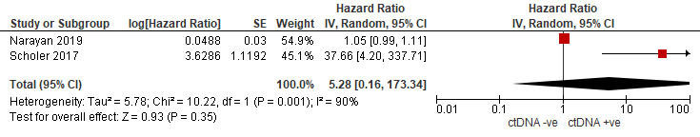

Supplementary figure S1; Disease free survival for resectable patients.

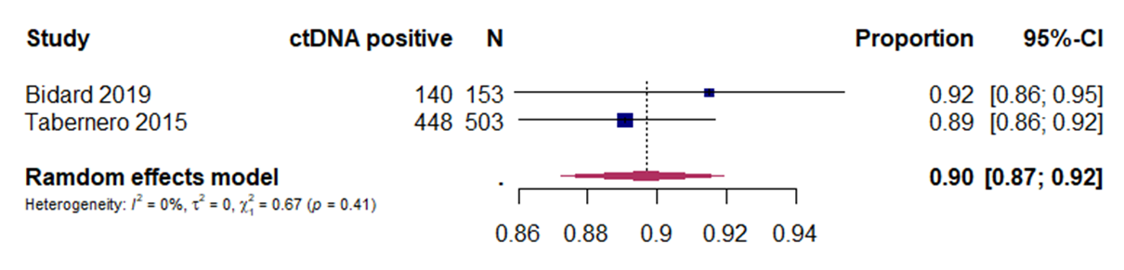

Supplementary figure S2; Forest plot showing proportion of irresectable patients from RCTs with detectable ctDNA
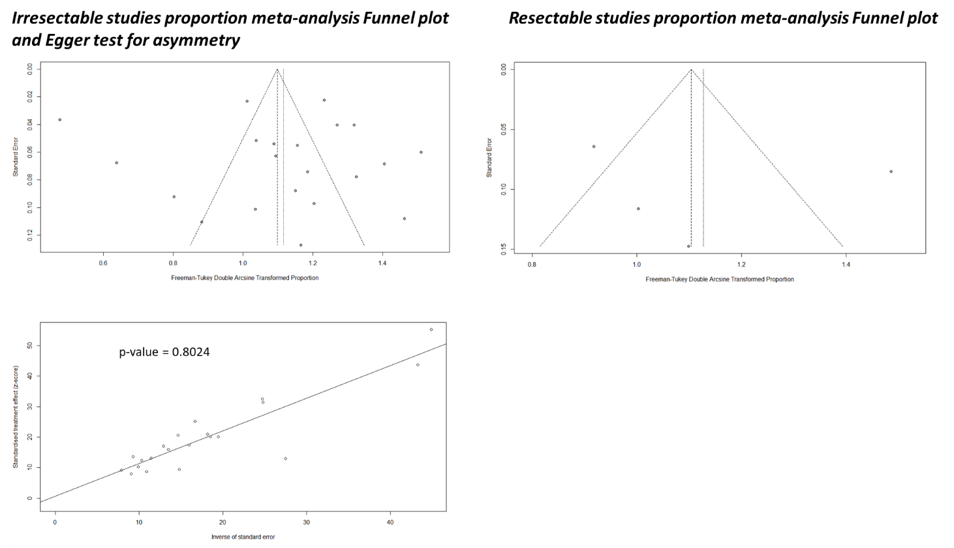
Supplementary figure S3. Funnel plots for proportion meta-analyses and asymmetry Egger test.

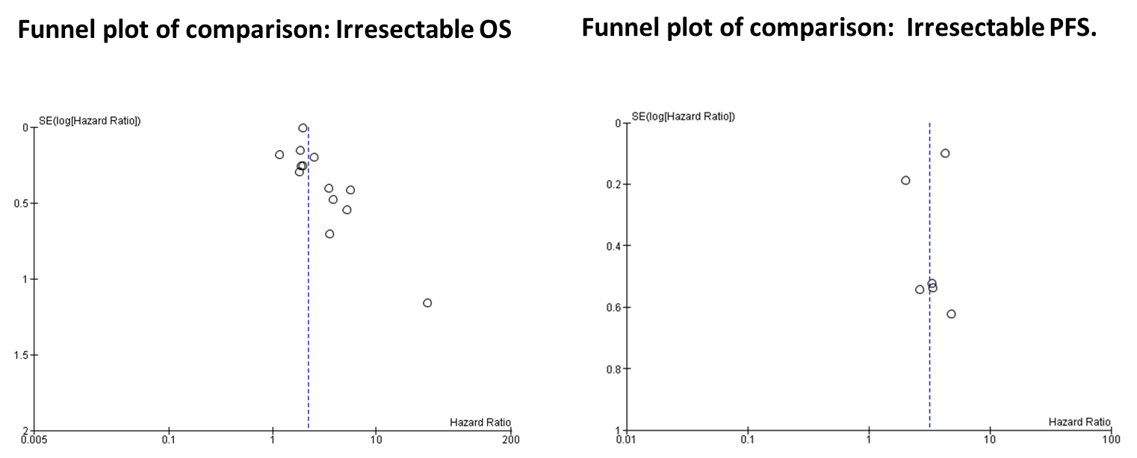

Supplementary figure S4. Funnel plots for OS and PFS meta-analyses of irresectable studies

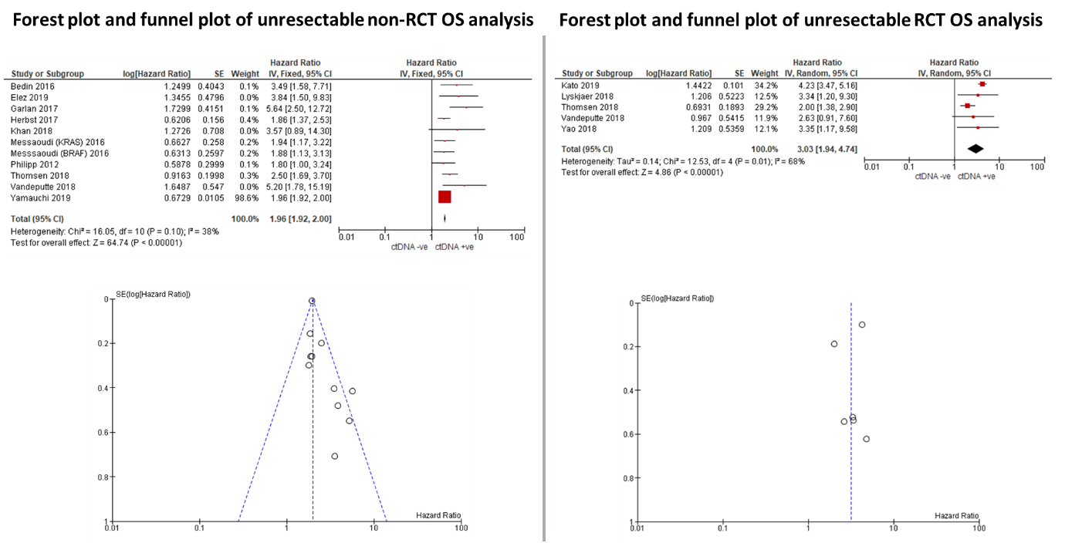

Supplementary figure S5. Forest plots and funnel plots for non-RCT and RCT OS.

