Modelling the dynamics of organisational change in a Spanish industrial cooperative

Amaia Sopelanaª*, Martin Kunc^{b}, Olga Rivera^{c}, Javier Aranceta^{d} and Arturo Rodriguez^{e}

ª TECNALIA, Parque Científico y Tecnológico de Bizkaia, Astondo Bidea, Edificio 700, E-48160 Derio, Spain.
^{b} Head of Decision Analytics and Risk, Office 2/3025, Southampton Business School, University of Southampton, University Road, Southampton, SO17 1BJ, UK
^{c} Deusto Business School, Universidad de Deusto, Mundaiz Kalea, 50, 20012 Donostia, Gipuzkoa, Spain.
^{d} MONDRAGON COMPONENTES, Avda. de Alava, 3, 20550 Aretxabaleta, Gipuzkoa, Spain.
e Faculty of Economics and Business, University of the Basque Country UPV/EHU, Lehendakari Agirre 83, 48015 Bilbao, Spain.

*Corresponding author: Amaia Sopelana, Tel.: +34 946 400 450 / Mobile: +34 667 17 89 33. Email address: amaia.sopelana@tecnalia.com (A. Sopelana)

Abstract.
There is increasing attention on the need for dynamic approaches to manage organisational change in order to sustain competitive advantage in changing business environments. Current frameworks and methods are misleading in terms of the fact that flexibility is a temporal and dynamic condition for survival in environments with a high degree of variability in most real-world organisations. This study aims to examine determinants underpinning organisational change strategies throughout the enterprise lifecycle in order to develop a predictive method that will help managers in the design of effective change options dealing with the complexity of organisational flexibility. A system dynamics model was constructed based on theoretical and empirical data from a case study of a Spanish cooperative company. Then, the predictive method shows the impact of managers’ decisions on organisational flexibility through simulations. The effectiveness of change strategies is investigated through the dynamic behaviour of key variables. These factors cause relevant delays on the desired results and could force firms to choose an inappropriate path for change. This study offers significant implications for theory and practice.
Keywords: organisational change, system dynamics, simulation, behavioural decision-making, Spain

Introduction
Within the theory of organisational adaptation, organisational flexibility – as the ability to quickly adapt to new or changing environments – has become a necessary condition for accomplishing the balance between exploration and exploitation (Dreyer & Grønhaug, 2004; Muthu Krishna, Prakash, & Manikandan, 2015; Sherehiy, Karwowski, & Layer, 2007; Verdú-Jover, 2009) and is recognised as a key driver for companies to survive and prosper in turbulent and unpredictable environments (Brozovic, 2018; Dreyer & Grønhaug, 2004).
Although it has appeared in a large number of conceptual works in recent decades, the number of empirical studies, explaining how organisations strive to achieve organisational flexibility is scarce. Some reasons are the complex nature and multidimensional structure of the processes that lead towards the desired level of organisational flexibility (e.g. De Toni & Tonchia, 2005; Teece, Pisano, & Shuen, 1997; Volberda, 1996). Moreover, managers face important difficulties to accomplish organisational flexibility through balancing change and stability (Hatum & Pettigrew, 2006). Within the context of organisational adaptation, the dynamic and temporal conditions are becoming more and more noteworthy for organisational change where the evolution of interlinked factors over time is critical. Consequently, useful insights are necessary from the analysis of these dynamic processes but there are relatively few studies that have developed quantitative models explaining the temporal relationships between those influencing factors (e.g. between the required flexible capabilities and the environmental turbulence (Suarez, Cusumano, & Fine, 1991) or their interaction with firm size (Kraatz & Zajac, 2001) in order to support managers. We developed a system dynamic model (Davis, Eisenhardt, & Bingham, 2007; Gary, Kunc, Morecroft, & Rockart, 2008; Repenning, 2002; Sterman, 2000) by systematically identifying the influencing factors responsible for organisational flexibility, their interrelations and temporal patterns. Then, the model is used to conduct what-if analysis scenarios with regard to alternative change strategies to support decision-making. The work involved a longitudinal case study of a large industrial cooperative group in Spain.

Literature Review

Organisational Flexibility
Research into organisational flexibility has focused on how the unpredictable, dynamic, and constantly changing environments force companies to improve their ability to continuously adapt to new competitive scenarios or cope with an uncertain and unpredictable environment (Dreyer & Grønhaug, 2004; Sherehiy et al., 2007). Nevertheless, studies exploring the temporal and dynamic conditions of the interlinked processes determining organisational flexibility levels along the enterprise lifecycle, have not used a modelling approach.
Over several decades, management literature has largely studied and analysed the organisational flexibility concept (Englehardt & Simmons, 2002; Jones, 2005; Volberda, 1999; Weiss, 2001) focusing mainly on those areas related to the firms’ capabilities to control and influence their environment, ensuring that a competitive advantage is gained and sustained. The context specificity of flexible capabilities and organisational design (Martínez-Sánchez, et al. 2009; Verdú-Jover, 2009; Volberda, 1999) and the strategic fit between environmental characteristics and the organisational flexibility level (Anand & Ward, 2004; van der Weerdt, et al., 2012) have been largely explored. Notwithstanding the substantial body of literature exploring the variety of components or dimensions of organisational flexibility, empirical evidence investigating such multidimensionality remains limited (Dreyer & Grønhaug, 2004). Addressing the multidimensionality of organisational flexibility requires researchers to discover, not only the key variables that define the level of organisational flexibility but also, the interrelationships between its components (e.g. van der Weerdt, et al., 2012).
While research studies claiming that organisational flexibility is dependent on the temporal dimension (Golden & Powell, 2000; Tan & Zeng, 2009) there are no methods to support decision-making that consider the temporal dimension. Some authors have stressed the importance of the dynamic perspective for describing organisational flexibility or flexibility strategies and therefore, the inclusion of the time factor in order: to create knowledge regarding the relationship between change and time (Dreyer & Grønhaug, 2004); to highlight the importance of environmental fit when considering flexibility (Anand & Ward, 2004); to take a time-based view of organisational transformation, considering the variation of firm strategies depending on the stage of economic transition (Tan & Zeng, 2009); to explore different levels of flexibility and fit between real flexibility and that required by the environment as well as to include the time factor (Verdú-Jover, 2009). In line with previous arguments, Tan and Zeng (2009), as well as Kunc (2018), also remark that the way in which different resources and their use levels affect firm performance depends on the stage of organisational transformation. Finally, authors assert that the formula to accomplish organisational flexibility along the enterprise lifecycle (with a temporal basis) remains limited (Dreyer & Grønhaug, 2004; Verdú-Jover, 2009; Volberda, 1999).
The complexity claimed by several authors regarding organisational flexibility implementation often forces managers to make a change decision whose effects are different than expected; the effects on a certain dimension are often difficult to correlate with effects on other dimensions.

Quantitative approaches considering interdependencies and time effects
Managers want to understand the consequences of change strategies on the organisation over time (Kazakov and Kunc, 2016). System dynamics appears to be the appropriate methodology for modelling the organisational dynamics and making the causal relationships between the variables that intervene in organisational flexibility explicit (Akkermans & van Oorschot, 2005; Lane & Husemann, 2008; Morecroft, 1999; Olaya & Dyner, 2005; Scott, Cavana, & Cameron, 2015; Xing & Dangerfield, 2011; Yang & Emma Liu, 2015). System dynamics can support the process of strategic development and it represents the art and science of interpreting interdependencies and behaviour over time (Kunc et al, 2018; Kunc & Morecroft, 2007). Additionally several SD models provide robust dynamic explanations to organisational theories (Saleh, et al., 2010; Galanakis, 2006; Erik R. Larsen & Lomi, 2002; Rahmandad, 2012; Repenning, 2002; Romme, Zollo, & Berendsy, 2010; Sastry, 1997).

SD Model Development
This section describes the steps followed (based on SD modelling process (Sterman, 2000) to develop the SD model.
The model was developed with a large cooperative industrial group, Mondragón Components (hereinafter “MC”) which has been shown as a proactive company to change as part of its strategic decisions to survive in competitive, turbulent and dynamic environments. The work combined qualitative and quantitative SD approach to model the Organisational Flexibility levels of a company in a certain timeframe. The approach taken is shown in Figure 1. Initially, the company employed a predefined qualitative template. In terms of participants over time, MC was formed by 9 cooperatives (operative units) and the R&D department at the beginning of the case study but when the stage 3 was deployed, two cooperatives have been closed due to the global economic crisis (see organisational structure in Figure 2).
In the case organisation, the total participants varied along the three stages as the Figure 1 shows due to availability limitations of the cooperatives’ managers (whose roles and responsibilities changed through the observed period). Thus, all responses were individually processed but the analysis of the results was developed and thereafter explained as a whole from the cooperative group perspective (as shown the results in Supplementary Online Material 2).
The data collection techniques used in stages 1&2 was based on the distribution of an online questionnaire (QSF method) by using mail survey to 9 managers of the MC’s cooperatives (operative units) and the R&D manager of the group. Six responses were received in both first stages. In both stages, the data analysis process was built upon the concepts and variables from the theoretical framework (validated by several authors (van der Weerdt et al., 2012; Volberda, 1999)) and a discussion of the strategic changes that MC implemented with the participants. Hence the first expected outcome was to gain understanding as to what extent the company change strategies affected its dynamic capabilities, organisational responsiveness and absorptive capacity leading to the changes in the organisational flexibility level.
Thus, authors proposed to develop a quantitative system dynamics model (SD) through face-to-face interviews with managers to describe and interpret the case as well as to predict the dynamics of the organisation during turbulent times in the stage 3 (Gary et al., 2008; Kunc & Morecroft, 2010; Torres, Kunc, & O’Brien, 2017). The R&D manager was appointed by the cooperatives’ managers of MCs to be interviewed and to provide insights and reasonings about the analysed changes. His answers (three rounds of face to face interviews) were reviewed and confirmed by the six cooperatives’ managers after the development of the SD model.

Model Conceptualisation
The main influence factors of organisational flexibility theoretically and empirically explored, were included in a schematic map to portray the decision-making processes. The schematic representation in Figure 3 provides the global structure of the variables intervening in the strategic change decision-making processes as well as the cause-effect relationships between influence factors. In this graphical representation, the comparison between the variables originally proposed by the theory and the new variables empirically supported by the case study is displayed. Moreover, the blue arrows relate to the interactions originally discovered and tested by the theoretical framework used in this study while the red arrows highlight the key interactions discovered as long as the case study came along, such as for instance, the influence that ‘Perceived ET’ will receive from ‘Metaflexibility’ or the influence of ‘Perceived ET’ over the Organisational Flexibility (level).
The theoretical framework of organisational flexibility taken as the basis for the SD model assumed Organisational Flexibility as the combination of two managerial tasks; the managerial task of controlling the dynamic capabilities (Extensiveness of flexibility mix) and the managerial task of organisational design (Responsiveness), respectively (see a full description of this theoretical framework in Supplementary Online Material 1).

Causal Loop Diagram description
Derived from interviews and reports, Figure 4 shows the SD model describing the components of the organisational flexibility system (see complete model and equations listed in Supplementary Online Material 3). Part of causal loop diagram was originally published in Sopelana, Kunc and Hernaez, 2014). However, face-to-face interviews with R&D manager of the MC group provided information to assess how empirical decisions were made when change strategies (routinisation or revitalisation) are implemented as well as the barriers perceived by managers to make best change decisions over dynamic capabilities, organisational design characteristics, absorptive capacity and control measures over resistance to change. The model is available in Vensim format. Authors used Vensim® software (Ventana Systems, Inc., 1998) to construct the stock and flow diagrams.
In the SD model, ‘Organisational Flexibility’ represents how well the organisation matches the current ‘Flexible Form’ with the flexibility levels that the environment is requiring (‘Environmental Turbulence’) since organisations follow goal seeking behaviour (Kunc and Morecroft, 2010). Only when both variables coincide, it displays the optimal level referenced by ‘zero’. When it takes positive values [0,1], represents a flexibility surplus while negative values [-1,0] show a flexibility deficit. Every time this variable differs from zero, representing an unbalanced state, the ‘Pressure to Change’ is activated and stimulates metaflexibity, managerial and organisational design tasks (i.e. the B1, R2 & R3). In order to show valuable information from the case study provided by MC company, Table 1 gathers the SFD’s variables as well as the corresponding quotations that supported the new variables.
Following SD methodology, the next step corresponds to the transformation of the qualitative model into a quantitative model (Sterman, 2000; Kunc, 2017). The stock and flow diagram (SFD) of the simplified linear model is portrayed in Supplementary Online Material 3, which integrates the different variables that intervene in the system as well as the mathematical equations that make up their interrelations. The initial conditions of the stocks and the model parameters appear in Tables S1, S2 and S3 in Supplementary Online Material 4. The variables in the SFD were quantitatively formulated thanks to the data from the QSF questionnaire to parametrise the variables that determine the level of organisational flexibility deployed by MC throughout the period 2007-2011; and additionally, we introduced some of the model parameters derived from assumptions.

Model validation
Following the SD guidelines, the validation tests were addressed prior to the simulation experiments. The SD model structure and parameters passed the extreme condition test performed confirming that radical change trajectory causes a collapse which, theoretically was envisaged “a radical trajectory can originate non-expected results and chaos” (Volberda, 1999). However, the assumptions related to the managers’ perception coinciding with the level of turbulence in the environment, failed. According to the theory, it would not be necessary to implement any strategic change. However, the system showed that the need for change could also come from required changes in responsiveness and extensiveness of the flexibility mix.
We then performed a behaviour sensitivity test to determine which variable has the strongest impact on system behaviour. The simulation runs showed that the model is highly sensitive to changes in the ‘Implementation Time’, mainly at the beginning of the simulation period. As soon as the model regains the equilibrium due to the change strategy, the confidence limits are narrower; the confidence limits of 95% are closer to the estimated values. ‘Organisational Flexibility’ and ‘Pressure to Change’ show a significant sensitivity to changes in the ‘Environment Turbulence’ as was expected. As for the managers’ perception, the sensitivity of the aforementioned variables as the initial manager’s perception oscillates is higher. To conclude, the results show the significance of these variables on the success of any change strategy searching for an optimal level of organisational flexibility.

Organisational Flexibility quantitative analysis
In this section, the simulation exercises and their results are presented. Using several what-if scenarios (Table 2; Table 3), the organisational changes after implementing the change strategies were quantitatively predicted by the SD model.

The significance of management perception
Disruptions to the management perception were simulated to examine the long-term dynamic effects of disruptions on organisational capability to achieve the desired change trajectory which comes from the suggestions embedded in the QSF method to address the environment turbulence. In the scenarios presented in this section, the simulations illustrate different change strategies addressing changes in the environment when the management perception differs from the real state. A new period of changes is introduced in which managers should choose the appropriate change strategy that helps the system achieve equilibrium. The simulation results of both scenarios are shown in Figure 6.
Scenario 1a) represents an example of a revitalisation strategy implemented by the company to initiate a transition towards a Flexible type. This type of transition is commonly applied when companies are dealing with new market tendencies or are striving to enter new markets with new business models or new competitive advantages under a hyper-competition situation. While Scenario 1b) represents the implementation of a routinisation strategy to initiate a transition towards a Planned type. Strategy related to periods in which the firm’s leadership in its market is strong and the market is mature. The system forces the “Perceived ET” towards the required level in the environment in both scenarios. However, during that first 12-month period, the simulations results illustrate that the management perception forces the managers towards a change strategy that is not aligned to what the environment was demanding.
In both scenarios, the “Organisational Flexibility” level (positive or negative), forces the system to adjust the management perception throughout the first 12 months. From that moment on, the reinforcing processes of the managerial task and organisational design task, dominate the system and force the “Flexible Form” variable to achieve the level that the environment is demanding. The graphical representation of the “Perceived ET” variable in the previous figures (Figure 6) fits the evolution of the “Organisational Flexibility” variable that is portrayed in Figure 7. The left side of the figure shows a surplus of flexibility and the right side represents a deficit of flexibility that tends to be covered modifying the Flexible Form accordingly.
As derived from the analysis of the results (stage 1 & 2), several organisational change initiatives were led by some cooperatives which were not aligned with what the “competitive forces” required at that time (management misperceptions). When authors were able to explore the results from qualitative exploration in the face to face interviews (stage 3 on Figure 1), the R&D manager assured that the assessment of the evolution of competitive forces in its environment (customers, suppliers, competitors, partners, etc.) does not represent an activity commonly applied by managers of cooperatives in decision-making processes although the R&D department do effectively share the information coming from different dissemination events (conferences, fairs, etc). The interviewed R&D manager also asserted that the change policy choices made by the company in the observed period (time of economic crisis) were not appropriately planned, being implemented in a reactive way, when the environment changed drastically or unexpectedly.
The simulation results illustrate that a longer period is needed to recover the equilibrium state (organisational flexibility level equal to zero) “Perceived ET” differs from actual conditions. In Scenario 1a), increasing towards the required level (Flexible type) but the process is not completed until Month 30; and in Scenario 1b), decreasing towards Planned type by Month 42.
The simulations’ results also highlighted the fact that management perception functions as a motivation for inappropriate change strategies that cause overestimated efforts as well as affecting organisational performance. This fact is also verified by the R&D manager: the expected time for the complete implementation of the strategy selected. They assured that “for this type of cooperatives revitalization strategies are more related to changes at an operational level and they have had a character of continuity (they have suffered some interruptions but not too many) while, revitalization strategies more focused on differentiation or at strategic level have suffered a long break due to the crisis’ effects”.
Thanks to the feedback received in the stage 3, we were able to compare the simulations results with the empirical evidence. In the case of MC, since the company decided to reduce and concentrate efforts towards greater specialisation, the R&D effort in absorptive capacity was not sufficient to align the management perception of the environmental turbulence (“Perceived ET”) to appropriate change initiatives. Moreover, the vast majority of the coops in MC company (as the participants assured) implemented a revitalization strategy from 2007 when the environmental turbulence changes revealed the contrary. The R&D manager assured that “It was a period of volatility, of changes and uncertainty in which the new business opportunities identified needed the deregulation of processes, changes in basic organisational forms, new values, openness and a more innovative culture (processes of internationalization, merger or acquisition, etc.). However, such a strategy was not encouraged by the R&D department of the group”.

Controlling the “Resistance to Change” level
As derived from the case study (face-to-face interviews), company efforts to achieve the optimal level of “Organisational Flexibility” generated some resistance to change that reduced the adaptation process. MC’s R&D manager asserted that “some change strategies usually cannot be implemented due to some circumstances coming from change resistance”. Moreover, too much resistance appeared not only among the employees, but the top managers also showed a lot of resistance and organisational inertia appeared. We could check through those face to face interviews that the effect of revitalisation strategies implemented by the MC on the “Extensiveness of Flexibility Mix” was not immediate since all the forces of change arose from external forces instead of being internally driven. Thus, they were difficult to control or balance with the recommendations that came from the R&D department, for instance. The R&D manager explained that such external forces, coming from to the coop’s CEO (who is also owner of the co-op), means that a radical change in the current strategic direction could suddenly be implemented when the CEO is replaced. Any attempt to control such circumstances that characterise the cooperative framework (resistance) was implemented over the four-year period. One of the most significant factors that MC failed to account for was “the organisational structure required to support the change triggered by the new strategic direction of coping with environmental evolution” (R&D manager)).
The following simulation experiment checks how the organisation establishes any type of control over the “Resistance to Change” when change strategies are implemented and shows the results in terms of flexibility at an organisational level. The parameters used in this scenario are shown in the following table.
Figure 8 shows the results of Scenario b) and as expected, the graphical representation shows that the optimal level of “Organisational Flexibility” is not achieved in the simulation period. The level of “Resistance to Change” quickly rises up to a value of 0.8 by Month 20 and remains accumulated at values in excess of 0.75 until the end of the simulation period.
Figure 9 shows the results of the second simulation. The optimal level of “Organisational Flexibility” is well addressed within the simulation period, by Month 26. The level of “Resistance to Change” starts rising from Month 12 until Month 18, when it accumulates a value of 0.4, less than with the basic control. From Month 18, the values of “Resistance to Change” begin to fall until Month 26, when the system recovers equilibrium.

Discussion
This paper uses a case study to develop a quantitative system dynamics model that allows authors to examine how organisational flexibility levels fluctuate over time and the drivers that can affect the appropriate fit with the environment forces. The simulations of the Dynamic Model of Organisational Flexibility display the expected changes on the Organisational Flexibility level due to change strategies. The results demonstrate that any change strategy takes longer than expected to achieve the optimal level of organisational flexibility. Such a delay is mainly due to the fact that the need for change is an accumulation process, leading to delays, rather than an instantaneous process so it has to permeate the organisation’s members.
Simulations also indicate the significance of management perception of the environmental turbulences in which the company operates. When perceptions differ from the real turbulence, managers fail in the selection of the organisational change trajectory. In such a situation, the company deals with new changes from a weak position and, consequently, a significant delay is originated in achieving the expected results.
Finally, the simulation shows the effects of implementing control mechanisms over resistance to change when change strategies are implemented. The resistance to change may delay or stop the adaptation process. Better performance will be achieved if managers complement these change processes with specific resistance to change control mechanisms.
Our paper also makes contributions to the literature in organisational flexibility in two areas. Firstly, we present a decision support system that complements the existing static method discussed in the literature review by incorporating a temporal dimension to organisational changes and capturing the dynamic complexity originated from interrelated processes. Secondly, we identified new variables that complement the existing theory in organisational flexibility such as resistance to change, which is critical to understand the failure of change strategies and their delays on being implemented, and managerial perception of the need for change, which reflects some of the issues raised in the field of behavioural operational research (Kunc et al, 2016; White et al, 2020). In other words, this paper has enriched the literature by bringing concepts existing in the OR field, dynamic complexity and behavioural issues, to demonstrate the relevance of interdisciplinary research.

Conclusions
Managerial implications from the quantitative model are proposed, enabling the consequences of how companies solve the fundamental “structural” and “temporal” tensions affecting organisational flexibility to be examined in order to discover the outcomes of the interactions among multiple underlying organisational and strategic processes, especially as they unfold over time.
SD is used as a predictive method for organisational change decision-making processes that supports qualitative methods (in this case, Volberda’s theoretical framework and its associate methods to examine flexibility variables) allowing the authors to illustrate the consequences of the processes over time and determine the critical parameters to intervene in the organisations during strategic change. From our analysis, the following managerial implications were derived:
- Management perception of the turbulence in the environment in which the firm operates may force them to choose an inappropriate change trajectory. The firm will be dealing with new changes from a weak position and consequently, a significant delay is originated in achieving the expected results. Therefore, in order to reinforce the change strategies, managers should start the process by focusing efforts on the absorptive capacity (“Metaflexibility”), ensuring that the most effective change strategy is chosen in accordance with the real environmental turbulence.
- Company’s efforts in achieving the optimal level of organisational flexibility generate resistance to change, which may stop the adaptation process. An organisation that establishes any type of control over the resistance to change when change strategies are implemented will achieve better performance.
SD allows the influence of interactions between dynamic capabilities, organisational design and absorptive capacity to be explored when companies aim to identify better implementations of the strategic transitions. However, there are some limitations opening the path for future research in this area. For instance, new variables and their corresponding interactions related to the dimensions explored in this research should be assessed and thus the model could be extended. A fruitful opportunity for empirical research would be to discover some new constraints or new drivers of the aforementioned dimensions and evaluate their effects on organisational flexibility.
Finally, relevant outcomes could be obtained if different organisational contexts were evaluated and if alternative environmental changes were proposed.

Funding:
This research did not receive any specific grant from funding agencies in the public, commercial, or not-for-profit sectors.

Acknowledgements
Thanks to the reviewers for their insightful comments, to the managers of MC that collaborate in the questionnaires, to MC’s R&D manager who participate in the questionnaire and assist the authors during the interviews, to Niels van der Weerdt (PhD) from Erasmus University for his support in analysing the data from MCs, and to Hedapen global services, a company that assisted in drafting the paper, and a language service provider who helped in proofreading the final version of the paper.

REFERENCES
Akkermans, H. A., & van Oorschot, K. E. (2005). Relevance assumed: a case study of balanced scorecard development using system dynamics. Journal of the Operational Research Society, 56(8), 931–941. https://doi.org/10.1057/palgrave.jors.2601923
Anand, G., & Ward, P. T. (2004). Fit, Flexibility and Performance in Manufacturing: Coping with Dynamic Environments. Production and Operations Management, 13(4), 369–385. https://doi.org/10.1111/j.1937-5956.2004.tb00224.x
Brozovic, D. (2018). Strategic Flexibility: A Review of the Literature. International Journal of Management Reviews. https://doi.org/10.1111/ijmr.12111
Davis, J. P., Eisenhardt, K. M., & Bingham, C. B. (2007). DEVELOPING THEORY THROUGH SIMULATION METHODS. 32(2), 480–499.
De Toni, A., & Tonchia, S. (2005). Definitions and linkages between operational and strategic flexibilities. Omega, 33(6), 525–540. https://doi.org/10.1016/j.omega.2004.07.014
Dreyer, B., & Grønhaug, K. (2004). Uncertainty, flexibility, and sustained competitive advantage. Journal of Business Research, 57(5), 484–494. https://doi.org/10.1016/S0148-2963(02)00315-6
Englehardt, C. S., & Simmons, P. R. (2002). Organizational flexibility for a changing world. Leadership & Organization Development Journal, 23(3), 113–121. https://doi.org/10.1108/01437730210424057
Galanakis, K. (2006). Innovation process. Make sense using systems thinking. Technovation, 26(11), 1222–1232. https://doi.org/10.1016/j.technovation.2005.07.002
Gary, M. S., Kunc, M., Morecroft, J. D. W., & Rockart, S. F. (2008). System dynamics and strategy. System Dynamics Review, 24(4), 407–429. https://doi.org/10.1002/sdr.402
Golden, W., & Powell, P. (2000). Towards a definition of flexibility: in search of the Holy Grail? Omega, 28(4), 373–384. https://doi.org/10.1016/S0305-0483(99)00057-2
Hatum, A., & Pettigrew, A. M. (2006). Determinants of organizational flexibility: A study in an emerging economy. British Journal of Management, 17(2), 115–137. https://doi.org/10.1111/j.1467-8551.2006.00469.x
Jones, R. A. (2005). So what is flexibility? : toward a multi-level theory of organisational, group, and individual flexibility (Doctoral dissertation). (Retrieved from http://eprints.qut.edu.au/16129/). https://doi.org/16129
Kraatz, M. S., & Zajac, E. J. (2001). How Organizational Resources Affect Strategic Change and Performance in Turbulent Environments: Theory and Evidence. Organization Science, 12(5), 632–657. https://doi.org/10.1287/orsc.12.5.632.10088
Kunc, M. (2017). System dynamics: A multi approach to simulation. Proceedings of the Operational Research Society Simulation Workshop 2018, SW 2018.
Kunc, M. H., & Morecroft, J. D. W. (2007). System Dynamics Modelling for Strategic Development. In Dyson, R and O’Brien, F. (eds.) Supporting Strategy: Frameworks, Methods and Models, New York: Wiley & Sons, (157-189).
Kunc, M., Malpass, J., & White, L. (Eds.). (2016). Behavioral operational research: theory, methodology and practice. Springer.
Lane, D. C., & Husemann, E. (2008). System dynamics mapping of acute patient flows. Journal of the Operational Research Society. https://doi.org/10.1057/palgrave.jors.2602498
Larsen, E. R., & Lomi, A. (2002). Representing change: A system model of organizational inertia and capabilities as dynamic accumulation processes. Simulation Modelling Practice and Theory, 10(5–7), 271–296. https://doi.org/10.1016/S1569-190X(02)00085-0
Martínez-Sánchez, A., Vela-Jiménez, M. J., Pérez-Pérez, M., & De-Luis-Carnicer, P. (2009). Inter-organizational cooperation and environmental change: Moderating effects between flexibility and innovation performance. British Journal of Management, 20(4), 537–561. https://doi.org/10.1111/j.1467-8551.2008.00605.x
Morecroft, J. D. W. (1999). Management attitudes, learning and scale in successful diversification: A dynamic and behavioural resource system view. Journal of the Operational Research Society. https://doi.org/10.1057/palgrave.jors.2600696
Muthu Krishna, V., Prakash, G., & Manikandan, M. (2015). Congregating or Swerving ? - Developmental trends and changing role of Indian Organizational flexibility along Globalization process. Procedia - Social and Behavioral Sciences, 189, 64–80. https://doi.org/10.1016/j.sbspro.2015.03.193
Olaya, Y., & Dyner, I. (2005). Modelling for policy assessment in the natural gas industry. Journal of the Operational Research Society. https://doi.org/10.1057/palgrave.jors.2601895
Rahmandad, H. (2012). Impact of Growth Opportunities and Competition on Firm-Level Capability Development Trade-offs. Organization Science, 23(1), 138–154. https://doi.org/10.1287/orsc.1100.0628
Repenning, N. (2002). A simulation-based approach to understanding the dynamics of innovation implementation. Organization Science, 13(2), 109–127. https://doi.org/10.1287/orsc.13.2.109.535
Romme, A. G. L., Zollo, M., & Berendsy, P. (2010). Dynamic capabilities, deliberate learning and environmental dynamism: A simulation model. Industrial and Corporate Change, 19(4), 1271–1299. https://doi.org/10.1093/icc/dtq031
Sastry, M. A. (1997). Problems and Paradoxes in a Model of Punctuated Organizational Change. Administrative Science Quarterly, 42(2), 237–275. https://doi.org/10.2307/2393920
Scott, R. J., Cavana, R. Y., & Cameron, D. (2015). Interpersonal success factors for strategy implementation: A case study using group model building. Journal of the Operational Research Society. https://doi.org/10.1057/jors.2014.70
Sherehiy, B., Karwowski, W., & Layer, J. K. (2007). A review of enterprise agility: Concepts, frameworks, and attributes. International Journal of Industrial Ergonomics, 37(5), 445–460. https://doi.org/10.1016/j.ergon.2007.01.007
Sterman, J. D. (2000). Business dynamics: Systems thinking and modeling for a complex world. In Management (Irwin/McGr). https://doi.org/10.1057/palgrave.jors.2601336
Suarez, F. F., Cusumano, M. A., & Fine, C. H. (1991). Flexibility and Performance : A Literature Critique and Strategic Framework. Sloan School, MIT.
Tan, J., & Zeng, Y. (2009). A stage-dependent model of resource utilization, strategic flexibility, and implications for performance over time: Empirical evidence from a transitional environment. Asia Pacific Journal of Management, 26(3), 563–588. https://doi.org/10.1007/s10490-009-9140-9
Teece, D. J., Pisano, G., & Shuen, A. (1997). Dynamic capabilities and strategic management. Strategic Management Journal, 18(7), 509–533. https://doi.org/10.1002/(SICI)1097-0266(199708)18:7<509::AID-SMJ882>3.0.CO;2-Z
van der Weerdt, N., Volberda, H. W., Verwaal, E., & Stienstra, M. (2012). Organizing for Flexibility: Addressing Dynamic Capabilities and Organization Design. In A. Bøllingtoft, L. Donaldson, G. P. Huber, D. D. Håkonsson, & C. C. Snow (Eds.), Collaborative Communities of Firms: Purpose, Process, and Design (pp. 105–125). https://doi.org/10.1007/978-1-4614-1284-7_7
Verdú-Jover, A. J. (2009). Measuring the organizational responsiveness through managerial flexibility. Journal of Organizational Change Management, 22(6), 668–690. https://doi.org/10.1108/09534810910997069
Volberda, H.W. (1996). Toward the Flexible Form: How to Remain Vital in Hypercompetitive Environments. Organization Science, 7(4), 359–374. https://doi.org/10.1287/orsc.7.4.359
Volberda, Henk W. (1999). Building the Flexible Firm: How to Remain Competitive (ERIM (Elec).
Weiss, C. R. (2001). On flexibility. Journal of Economic Behavior & Organization, 46(3), 347–356. https://doi.org/10.1016/S0167-2681(01)00183-4
White, L., Kunc, M., Burger, K., & Malpass, J. (2020). Behavioral Operational Research. Springer.
Xing, Y., & Dangerfield, B. (2011). Modelling the sustainability of mass tourism in island tourist economies. Journal of the Operational Research Society. https://doi.org/10.1057/jors.2010.77
Yang, S. J. S., & Emma Liu, Y. (2015). Anticipated responses: The positive side of elicited reactions to competitive action. Journal of the Operational Research Society, 66(2), 316–330. https://doi.org/10.1057/jors.2014.3

Table 1: Case Study insights for creating the SD MODEL
SD model development |  | case study
Feedback loops | Variables
B1 balancing loop - “absorptive-capacity management” | ‘Perceived ET’ - managers’ interpretation of changes in competitive forces | It influences management decisions on change strategies. The managers’ perceptions of their environment resulted less turbulent than it was.  The R&D Manager mentioned: “[…] our error margin could be higher than in other companies with a different organisational structure than a cooperative group”; On the one hand, “R&D department can access future exploration insights with the appropriate resources to process the data gathered.” Oppositely, “the operational part of cooperatives has more information about those circumstances that affect exploitation activities, but they have no overall resources to process this information and make it useful in decision making”.
 | ‘Metaflexibility’ - when perceptions differ from real ‘ET’, the change could be firstly triggered over ‘metaflexibility’ | R&D manager assured: “the monitoring capabilities have been focused on the operative level (exploitation activities) resulting in lower interest in the exploration activities (led by R&D management) and moreover, in the assignation of resources to process this information and make it useful in decision-making”.
 | ‘Perception Time’ (affects ‘Perceived ET’) - incorporates the consideration of delays in the managers’ perception of the changes. | The effect of the absorptive capacity on the management perception for activating change suffered a delay or even didn’t occur.  The R&D manager assured that MC’s coops show a higher interest in "the analysis of their most competitive capabilities […] instead of hearing the advising proposals for appropriate changes into new markets and/or new business models coming from R&D department.” Moreover, “measuring or assessing the evolution of competitive forces in their environment (customers, suppliers, competitors, partners, etc.) is not currently used as a best practice or even used for decision-making. […], change decisions are not taken on the basis of a thorough study of the environment and the forces operating in it. It is assumed (and commonly accepted) that the environment is fairly predictable”.
R2 reinforcing loop: “Sufficiency of Flexibility Mix” | ‘Extensiveness of Flexibility Mix’ - change process could continue with the managerial task, organisation’s ability to evolve the volume and variety of dynamic capabilities according to the competitive forces’ demands. | The scores of ‘Extensiveness of Flexibility Mix’ scarcely changed in the four-year period due to reduced values in operational and structural flexibility (reduced flexibility of changing workforce, activities and suppliers in manufacturing processes) while the strategic flexibility increases (growth in international sales, higher participation in international markets, development of new products and services).  “In times of crisis, it is unavoidable that the absorption of other co-ops’ staff and debts affected the operational and structural dimensions”; “The efforts of R&D to adapt its products to these new markets have been crucial both to improve its position in flexibility and prevent the entry of competitors” (R&D Manager).
R3 reinforcing loop: “Adequacy of Organisational Design” | ‘Responsiveness’ - if change process continues with the organisational design task: the redesign or selection of adequate organisational design conditions according to the competitive forces’ demands (technology, structure and/or organisational cultures) | This variable evolved towards a more organic structure and innovative culture due to the adaption of structural conditions to the internationalisation process: planning and control systems, tasks descriptions and roles, and established rules and management levels, were relieved in the four-year period.  The R&D manager explained “Concerning the operative level of co-ops, the technological characteristics (production layouts, employee’s rotation, etc.) can offer high levels of flexibility but to some extent, they have been affected by the restrictions or constraints that some structural conditions may occasion.” The cooperatives’ managers are elected by the Governing Council, whose 50% of members are replaced every 2 years: “The particularity (or disadvantage) here [of coops] is that the CEO’s process of change ,primarily affects businesses continuity in early stages whose success or failure need more time to be proven.” (R&D manager).
R2 & R3 | ‘Implementation time’ | The expected time for the strategy to be active or whether the desired effects are achieved in the expected period was thoroughly explored in the longitudinal study’s results.  “Most of the managers want or are interested in significant decisions for change but they can be replaced before their implementation”; "The control over the time spent on implementing the strategy should be stronger” (R&D manager).
R4 – “Organisational reaction to changes” feedback loop | ‘Resistance to Change’ – company’s reactions to the need for the proposed changes.  The equilibrium resulted from the balancing process (B1) and the two reinforcing processes (R2 & R3) could be constrained by R4 (Figure 5), which acts as a vicious cycle to undercut the effect of the dominant feedback processes. | Change strategies boost resistance to change from the vast majority of the staff, from employees and from managers.  “The resistance of top managers appeared when new managers were appointed who disagreed on strategies implemented by previous managers”; “The corporate structure affected the social influence of members of the Governing Council in MC, which took precedence over strategic decisions” (R&D manager).

Table 2: Simulation scenarios proposed
PROPOSED WHAT-IF SCENARIOS
Differences between managers’ perception and real Environmental Turbulence | Scenario 1a) initially, “Perceived ET” is lower than the real level of the “Environmental Turbulence” which increases in Month 12. Consequently, a revitalisation strategy was needed.
 | Scenario 1b) initially, “Perceived ET” is higher than the real level of the “Environmental Turbulence”, which decreases in Month 12. Consequently, a routinisation strategy was needed.
Resistance to Change control measures (initially “Flexible From” matched to the “Environmental Turbulence” which is modified in Month 12) | Scenario 2a) implementing a routinisation strategy where management control over “Resistance to Change” is relatively low.
 | Scenario 2b) implementing a revitalisation strategy and high control over “Resistance to Change”

Table 3: Parameters values in Scenario 2
Scenario 2 | Level of Control over Resistance to Change | Implementation Time
a) Routinisation strategy | 0.2 | 20 months
b) Revitalisation strategy | 0.8 | 6 months

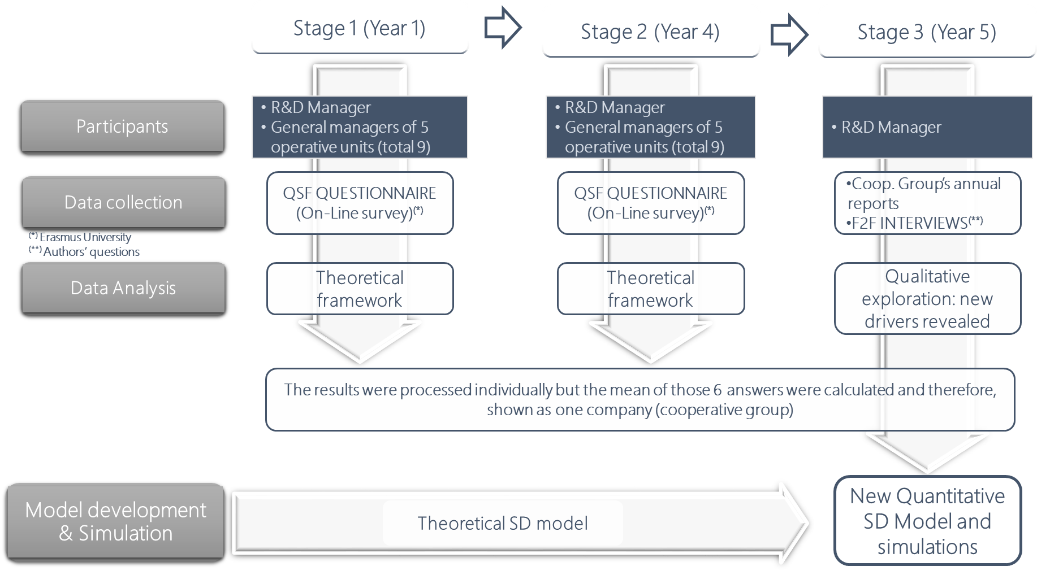
Figure 1: Graphical outline of the case study stages and its main components
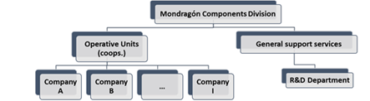
Figure 2: MC Organisational structure
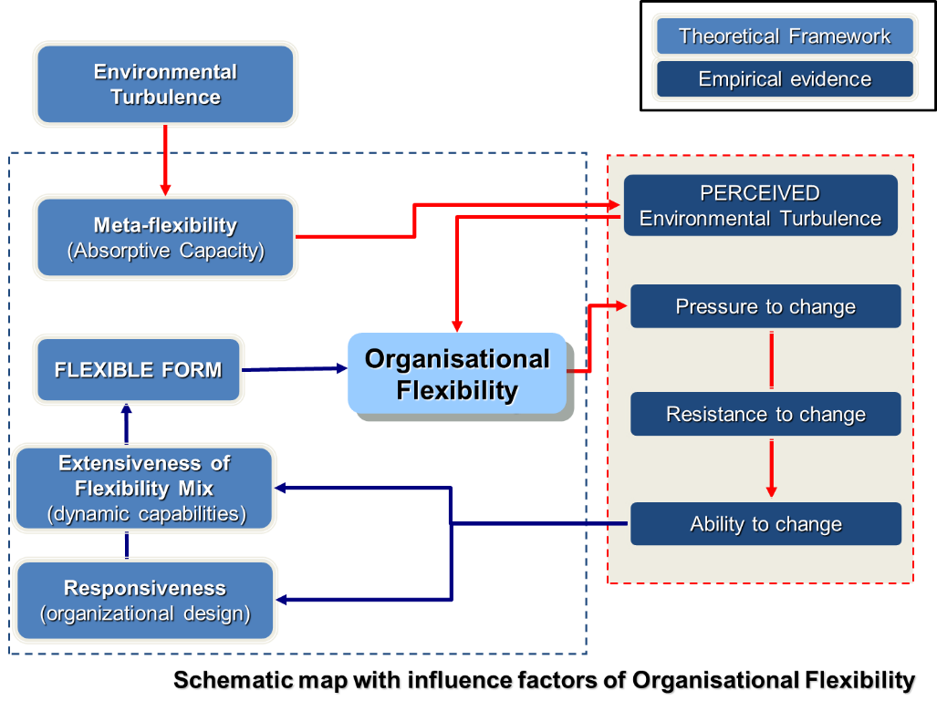

Figure 3: Schematic map with influence factors of Organisational Flexibility

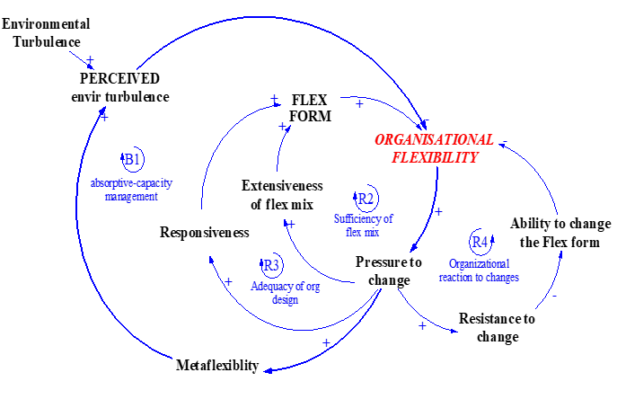
Figure 4: Overview of the perspective on Organisational Flexibility SD model
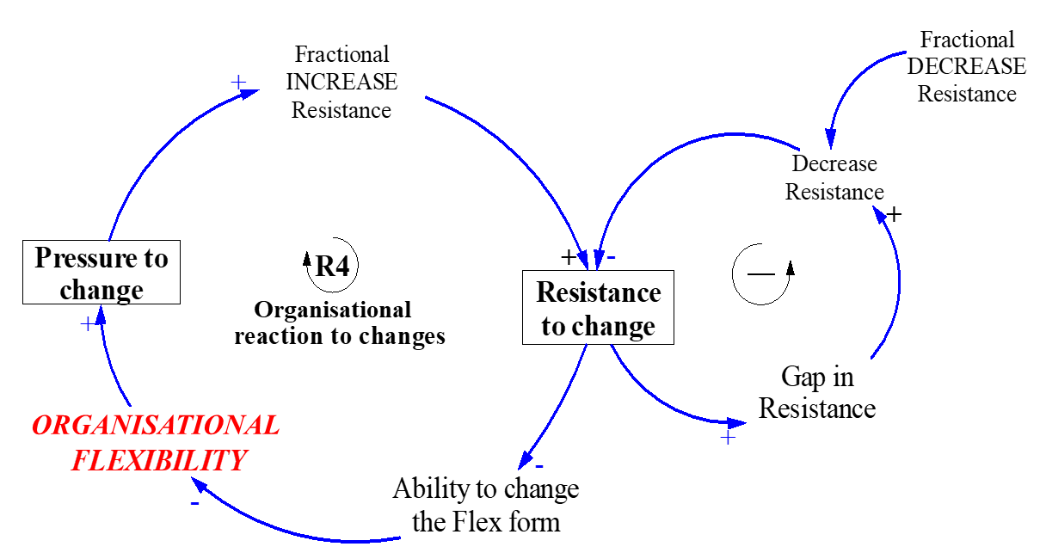
Figure 5: Organisational reaction to changes originated by “Resistance to Change”

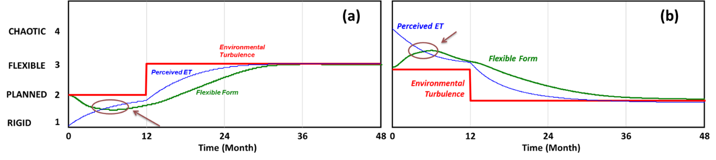
Figure 6: REVITALISATION & ROUTINISATION strategies with different management perceptions

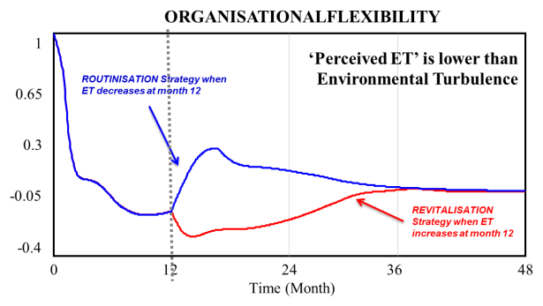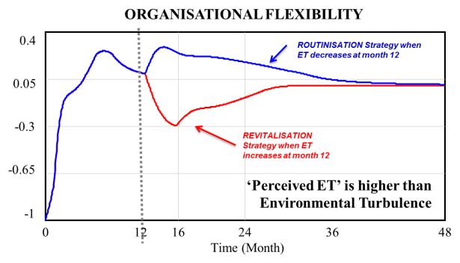
Figure 7: ORGANISATIONAL FLEXIBILITY (STEP in Month 12)

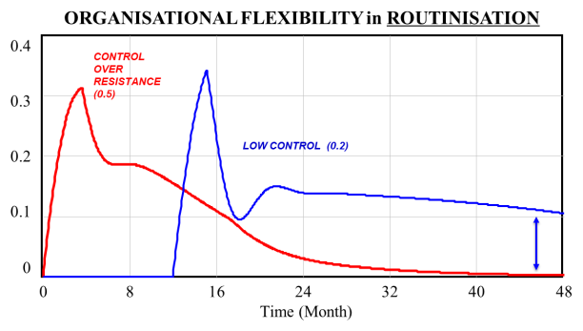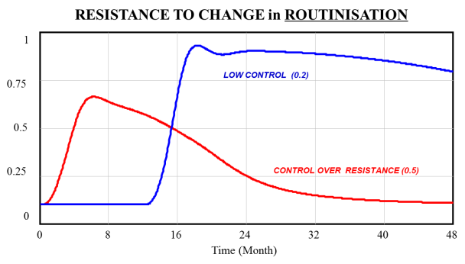
Figure 8: Simulation results in routinisation with low control (Scenario 2a)

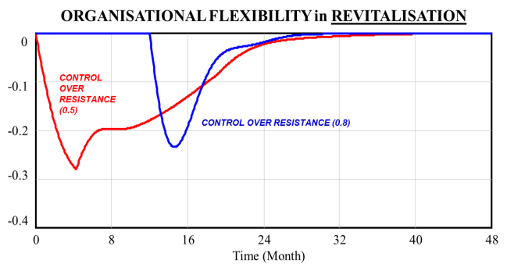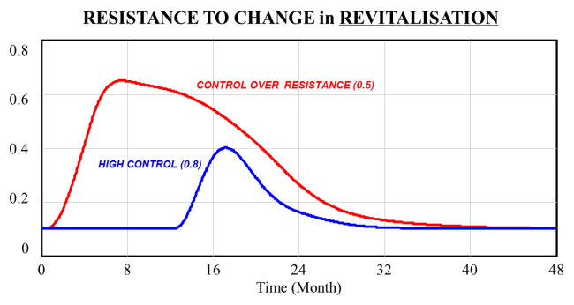
Figure 9: Simulation results in revitalisation with high control (Scenario 2b)

The QSF method, derived from the theoretical framework of Volberda (1998) was a web-based questionnaire (http://www.evaluation-erasmus.nl/cgi-bin/react_tool.pl?md5obj=4766f48d3dfb5de5ba85d18b614e209d) developed by the Department for Strategy & Business Environment at the Erasmus University. The digital form of the questionnaire titled “Quick Scan Flexibility”(version 1.61 EO – English) was active during the period October 24th, 2006 – October, 24th, 2008.
Additional information in Supplementary Online Material 2, Figure S2.
For additional information see Supplementary Online Material 3.

