Engineering mechanical properties by controlling the microstructure
of an Fe-Ni-Mn martensitic steel through pre-cold rolling
and subsequent heat treatment

Hamidreza Koohdar^{a,*}, Pouya Hakimipour^{b}, Hamid Reza Jafarianª, Terence G. Langdon^{c},
Mahmoud Nili-Ahmadabadi^{b,d}
ª School of Metallurgy and Materials Engineering, Iran University of Science and Technology (IUST), Narmak, Tehran, Iran
^{b} School of Metallurgy and Materials Engineering, College of Engineering, University of Tehran, Tehran, Iran
^{c} Materials Research Group, Department of Mechanical Engineering, University of Southampton, Southampton SO17 1BJ, UK
^{d} Center of Excellence for High Performance Materials, School of Metallurgy and Materials Engineering,College of Engineering, University of Tehran, Tehran, Iran
∗ Corresponding author: Tel. / Fax: +98 21 73228865. Email address: hkoohdar@iust.ac.ir

Abstract
Experiments were conducted to examine the effects of prior cold rolling and subsequent heat treatment on the microstructure, phase evolution and mechanical properties of an Fe-10Ni-7Mn martensitic steel. The results show that 70% cold rolling leads to deformation-induced austenite formation in the microstructure and reduces the size of the martensite blocks. Prior cold rolling increases the reversed austenite volume fraction under post-deformation intercritical annealing (PDIA) at 600 °C compared with the solution annealed condition. Electron back scattering diffraction and dilatometric studies showed that under PDIA there is a reverse transformation of martensite to austenite through a sequential combination of martensitic and diffusional mechanisms. There is also a precipitation of θ-NiMn particles in the PDIA specimen after subsequent ageing leading to an increase in the ultimate tensile strength in tensile testing. Cyclic tensile testing revealed pseudoelastic behavior in the cold-rolled specimen but this disappeared after PDIA and appeared again after subsequent ageing.
Keywords: Deformation-induced austenite; Fe-Ni-Mn martensitic steel; Microstructure control; Post-deformation intercritical annealing; Reverse transformation.
1. Introduction
Fe-Ni-Mn alloys are categorized as high strength martensitic steels having a lath martensite microstructure accompanied by a high density of dislocation which is important for achieving a combination of high strength and good toughness. These alloys have reasonably good ductility in a solution-annealed (SA) condition and exhibit superior age hardenability through the formation of intermetallic θ-NiMn precipitates but nevertheless they suffer from extreme intergranular embrittlement after ageing [1-5]. A reversion of bcc martensite (α′) to fcc austenite (γ) has been reported to enhance the ductility of Fe-Ni-Mn alloys in the later stages of ageing [6] and the (α+γ) structure shows low temperature ductility due to the existence of retained austenite [7,8]. Austenite may be formed also in low carbon martensitic steel by intercritical annealing in the dual phase (α+γ) region due to a reverse transformation of martensite to austenite [7,9]. In practice, there are two main mechanisms for the reverse transformation which may be diffusional or diffusionless occurring at low and high heating rates, respectively [10-12].
Ultrafine-grained (UFG) materials with grains sizes of <1 µm may be produced by subjecting specimens to different techniques of severe plastic deformation (SPD) including high-pressure torsion (HPT) [13-15], accumulative roll-bonding (ARB) [16], equal-channel angular pressing (ECAP) [17] and repetitive corrugation and straightening by rolling (RCSR) [18]. The UFG materials produced by SPD processing generally exhibit excellent properties such as high strength, good ductility and low temperature superplasticity, due to their thermo-dynamically metastable structures which contain high densities of lattice defects and high strain distortions [19]. Similarly, the heavy cold rolling and subsequent annealing of lath martensite in low carbon steel also shows an ability to produce UFG materials and the lath martensitic structure accompanied by a high density of dislocation can assist in the evolution of UFG during heavy cold rolling [20-22].
External forces can change the phase equilibrium and produce changes in the typical transformation behavior of materials [23]. There has been extensive research on the microstructural evolution and thermal stability of severely deformed steels during annealing [24-26]. For example, it was shown that cold rolling of Fe-9Mn-0.05C (wt. %) steel accelerated the martensite to austenite transformation in subsequent annealing [27] and heavy cold rolling by 60% reduction in thickness of a UFG Fe-10Ni-7Mn (wt. %) alloy increased the ductility after ageing [28]. Also, the heavy cold rolling of an Fe-10Ni-7Mn alloy led to austenite formation due to a deformation-induced reverse transformation [29-31]. These investigations confirmed that 60% cold rolling provided the required driving force for the reverse transformation [32].
The presence of retained austenite in the microstructure of Fe-Ni-Mn alloys can introduce a shape memory effect (SME) and pseudoelastic behavior [9,30,33,34] where SME in these alloys is associated with the stress-induced austenite (fcc) to epsilon martensite (hcp) transformation and its subsequent reversion when heating to a sufficient temperature [30]. In pseudoelastic behavior, the shape of the specimen goes back to its original form during the loading-unloading tensile cycle with the advent of a hysteresis loop to the point of zero strain. The main source of pseudoelasticity in these Fe-Ni-Mn alloys is the austenite to epsilon martensite transformation under loading and its reversion after unloading [9,30,33,34]. Initially, it was believed that this behavior took place only at temperatures above the reverse transformation temperature (A_{s}) but more recently it was discovered that the behavior was also observed at temperatures below A_{s} which was associated with the reversible motion of fcc/hcp interfaces [35].
Based on the results available from investigations conducted to date, the objective of this research was to evaluate and characterize the effect of prior cold rolling on the reverse transformation in an Fe-10Ni-7Mn (wt. %) high strength martensitic steel during post-deformation intercritical annealing (PDIA) in the ferritic-austenitic (α+γ) dual phase region. In addition, special emphasis was placed on examining the effect of pre-deformation and subsequent heat treatment on the microstructure, phase evaluation and mechanical properties of the Fe-Ni-Mn alloy.
2. Experimental material and procedures
An ingot of an Fe-10Ni-7Mn (wt. %) alloy was prepared using a vacuum arc re-melting (VAR) furnace. This ingot was hot-forged by 50% reduction at 1150 °C and then homogenized in a vacuum furnace at 1150 °C for 86.4 ks. Thereafter, the homogenized ingot was solution-annealed at 950 °C for 3.6 ks and quenched in cold water to obtain a fully-martensitic microstructure. Deformation processing was conducted by conventional cold rolling of the SA specimen at room temperature to a 70% reduction in thickness.
Dilatometric specimens with lengths of 10 mm and diameters of 2.4 mm were taken from the SA material and from the 70% cold-rolled (CR) specimens. In order to investigate the effect of rolling on the reverse transformation temperatures, the SA and the CR dilatometric specimens were continuously heated to the single phase austenitic region at a heating rate of 5 °C/min. Also, in order to study the reverse transformation mechanism, some of the dilatometric specimens were heated at a rate of 20 °C/s up to 600 °C at which the (α+γ) dual phase region is stable and then maintained isothermally at this temperature.
Post-deformation intercritical annealing (PDIA) was performed on CR specimens of 2 mm thickness in a salt bath at 600 °C for different holding times. Thereafter, a subsequent isothermal ageing treatment was conducted at 480 °C for 3.6 ks in a salt bath followed by water quenching. Sheet-type tensile test pieces of 2 mm thickness, 6.25 mm width and 25 mm gage length were cut from the SA sample, the CR specimen and the PDIA-processed specimens for 3.6 ks before and after an ageing treatment according to ASTM A370.
In order to study the retained austenite at room temperature and its volume fraction, X-ray diffraction (XRD) analysis was conducted in the angular range of 2θ = 40-100° using Cu-K_{α} radiation with a step scanning rate of 0.02° per 3.6 s. The amount of the reversed austenite at the intercritical annealing temperature was also calculated using the dilatometric results. Scanning electron microscopy (SEM) equipped with electron backscatter diffraction (EBSD) was used for microstructural observations. The specimens for the EBSD measurements were mechanically polished and then electrolytically etched using a 900 ml CH₃COOH + 100 ml HClO₄ solution at a temperature of 11°C with a voltage of 20 V. The step size of the test was 0.2 μm and the system operating voltage was 15 kV. The EBSD data were analyzed by TSL-OIM analytical software. Hardness values were determined using a Vickers microhardness tester with a 100 gf load and dwell times of 0.01 ks. Tensile tests were carried out at room temperature with initial strain rates of 7 × 10⁻⁴ s⁻¹ using a SANTAM tensile testing machine. The pseudoelastic behavior and strain hysteresis were also examined by applying cyclic tensile testing using an extensometer at room temperature.
3. Experimental results
3.1. Microstructure and phase evolution
3.1.1. Reverse transformation under cold rolling
Figs. 1a and b show grain boundary maps and phase maps of the SA and the CR specimens, respectively. In the grain boundary maps, high-angle grain boundaries (HAGBS) having misorientation above 15° are indicated by black lines and low-angle grain boundaries (LAGBs) having misorientations between 2° and 15° are shown by red lines. In addition, the martensite and austenite phases are shown in pink and green colors, respectively. According to Fig. 1a, the microstructure of the SA specimen consists of a fully-lath martensite whereas the microstructure of the CR specimen in Fig. 1b shows martensitic blocks elongated in the rolling direction together with small amounts of fine-grained austenite. Since the initial microstructure of the SA specimen is fully martensitic, it follows that the observed austenite in the microstructure of the CR specimen is deformation-induced. Comparing Figs 1a and b shows that the fraction of LAGBs increases after rolling since deformation can introduce large numbers of dislocations in the lath martensite microstructure.
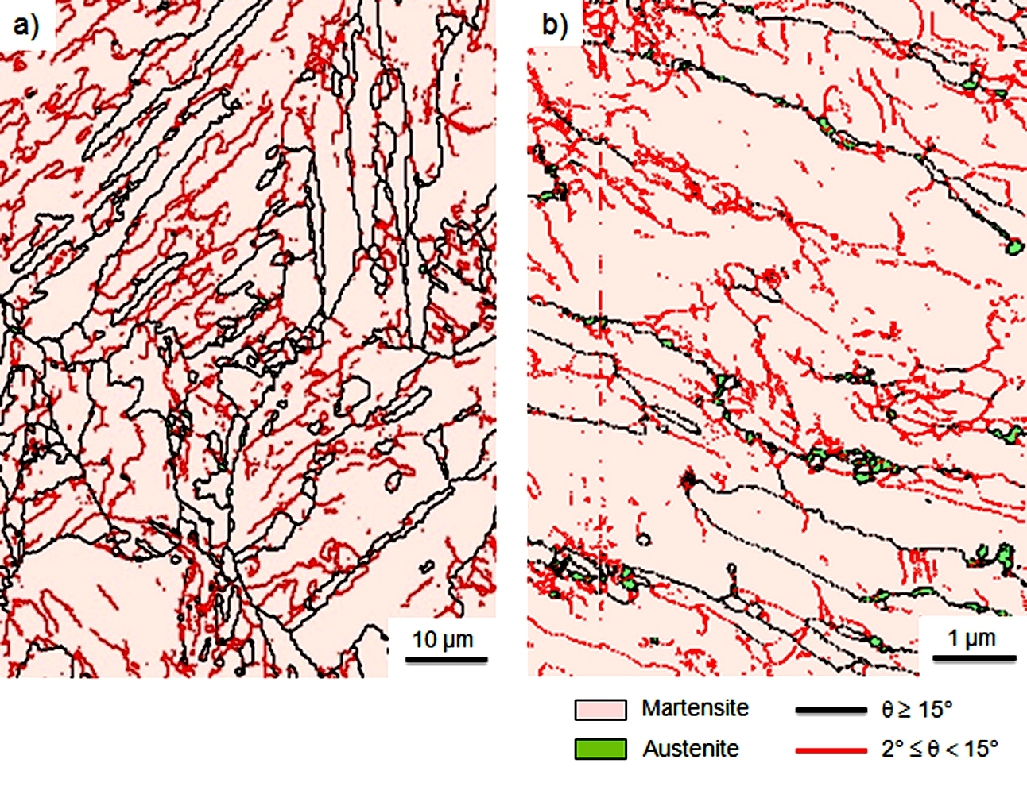
Fig. 1. Grain boundaries and phase maps of (a) SA, and (b) CR specimens.
Fig. 2 shows dilatation curves for the SA and CR specimens where the austenite start (A_{s}) and finish (A_{f}) temperatures are marked. It is clear from detailed examination that the reverse transformation of martensite to austenite is accompanied by a contraction. Thus, comparing the two curves in Fig. 2 shows that cold rolling leads to a small reduction in the A_{s} and A_{f} temperatures such that A_{s} decreases from 520 to 511 °C and A_{f} decreases from 608 to 601 °C. This trend is not consistent with an earlier report that in a lath martensitic microstructure the value of A_{s} is maintained approximately constant irrespective of the degree of deformation [36]. This apparent discrepancy probably arises because the present results denote deformation-induced austenite when using cold rolling. In addition, there is a smooth deviation from the linear curve preceding the A_{s} temperature as shown in Fig. 2 and this deviation is related to the θ-NiMn precipitate formation which was reported in earlier investigations performed on Fe-Ni-Mn alloys [3,37]. The precipitation start (P_{s}) and finish (P_{f}) temperatures are also represented in Fig. 2 and it is observed that cold rolling leads to a reduction in the P_{s} and P_{f} temperatures by increasing the nucleation sites of precipitates caused by the dislocation concentrations.
Fig. 2. Dilatation curves versus temperature at the heating rate of 5 °C/min for the SA and the CR specimens.
3.1.2. Reverse transformation under intercritical annealing
The dilatation curves for the SA and the CR specimens are illustrated in Fig. 3 together with a curve for pure iron which was used as a standard sample. The samples were continuously heated to 600 °C in the dual phase (α+γ) region at a heating rate of 20 °C/s and then isothermally maintained for 10.8 ks. In Fig. 3 the primary line with a positive slope for each curve, as marked by AB for the SA sample, corresponds to thermal expansion of the sample (designated section І). According to the plot, during heating the maximum dilatation of the CR specimen at point E is relatively low compared to the other samples. This suggests that a reverse transformation may be initiated in the CR specimen during continuous heating although, from a practical consideration, the higher free volume in this specimen should also be considered [18]. In fact, an increase of free volume in the CR specimen would provide fast diffusion tracks which eventually promote the reverse transformation. Section II of the dilatation curve for the pure iron, corresponding to isothermal holding at 600 °C, is approximately constant indicating that there is no reverse transformation. By contrast, the dilatation curves of the other two specimens decrease significantly corresponding to a reverse transformation. This reduction can be categorized into two parts where the first part, marked BC for the SA sample, shows a sharp decrease that is less for the CR specimen and the second part, marked CD for the SA sample, shows a gradual decrease but with a greater decrease in the CR specimen. Therefore, it can be proposed that the reversed austenite formation occurs by a sequential combination of two different mechanisms.
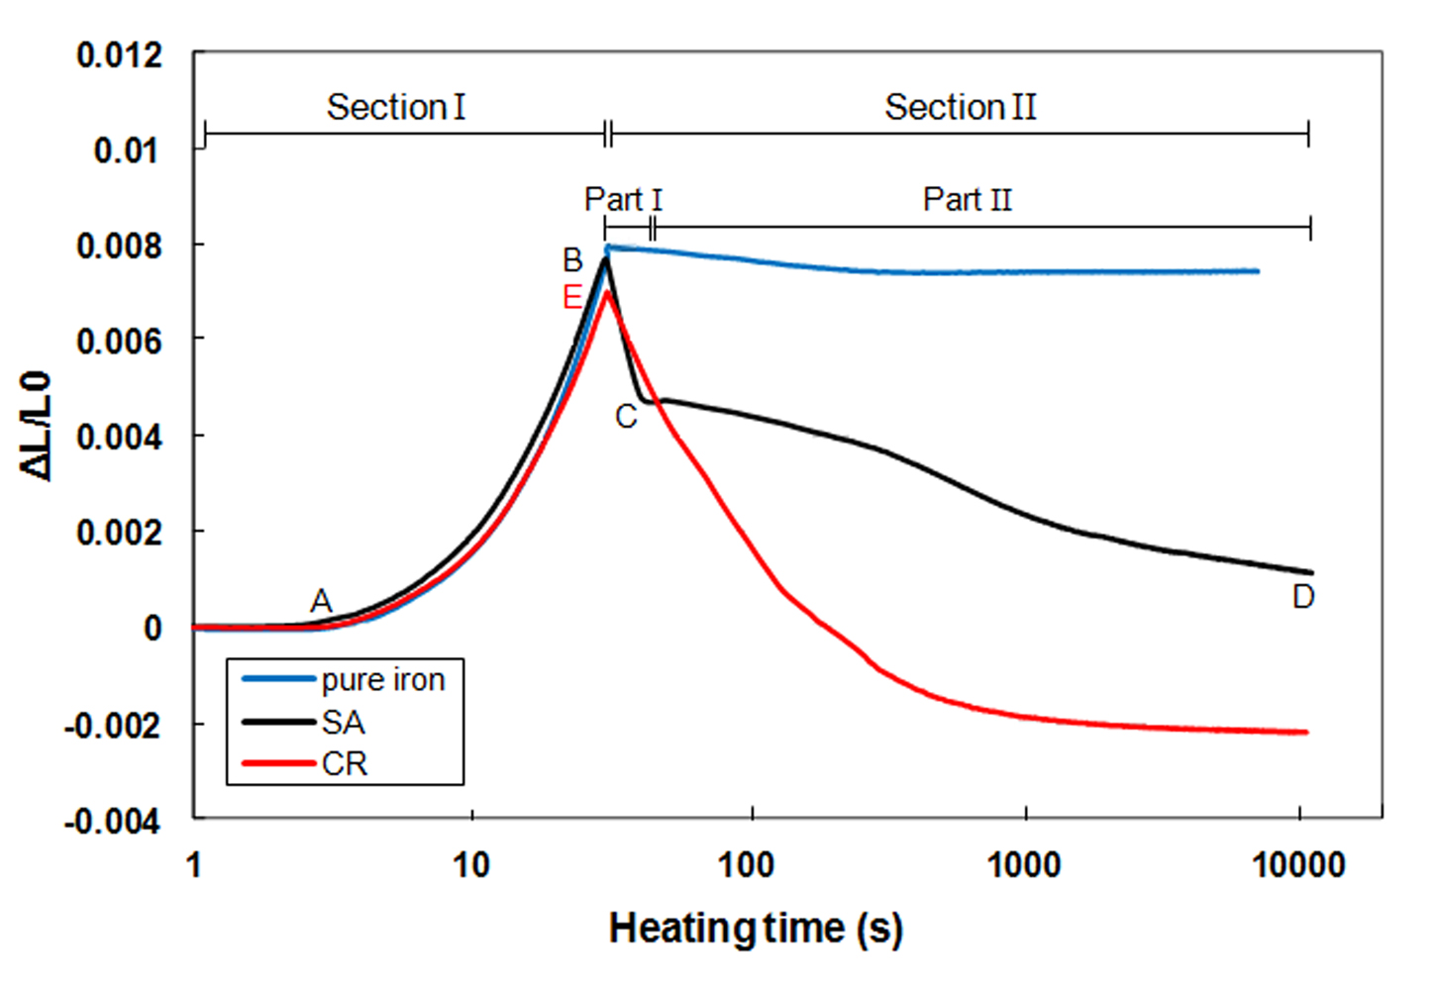
Fig. 3. Dilatation curves of the SA, CR, and pure iron specimens continuously heated to 600 °C at a heating rate of 20 °C/s and isothermally maintained for 10.8 ks.

In order to determine the amount of reversed austenite, it is assumed there is isotropic dilatation and therefore the experimental relative changes in volume $({\left({∆V}/{V_{0}}\right)}_{exp})$ can be calculated as a function of the relative change in length $\left({∆L}/{L_{0}}\right)$ by the relationship [38]:
${\left({∆V}/{V_{0}}\right)}_{exp}={(1+{∆L}/{L_{0}})}^{3}-1≈3{∆L}/{L_{0}}$ (1) In practice, the value of $\left({∆L}/{L_{0}}\right)$ is very small so that the square and cubic terms of $\left({∆L}/{L_{0}}\right)$ may be neglected. The theoretical relative change in volume $({\left({∆V}/{V_{0}}\right)}_{theo})$ is then calculated as a function of the lattice parameter of the austenite and martensite by the relationship:
${({∆V}/{V_{0}})}_{theo}={(V_{0γ}-V_{0α})}/{V_{0α}}={({{(a}_{γ}^{3}}/{4)}-{(a_{α}^{3}}/2))}/{{(a}_{α}^{3}}/2)$ (2) where $a$ is the lattice parameter which is calculated as a function of the d-spacing by the relationship:
$d=a/{\sqrt{(h^{2}+k^{2}+l^{2})}}$ (3)
where h, k and l are the Miller indices of the crystal compact plane.
The values of $d_{γ(111)}$ and $d_{α(110)}$ calculated from the XRD spectra of the CR specimen after subsequent intercritical annealing at 600 °C for 0.04 ks are 2.070 and 2.035 Å, respectively. Thus, the value of $a_{γ}$ and $a_{α}$ were calculated from Eq. (3) as 3.5854 and 2.8785 Å, respectively, and the value of ${\left({∆V}/{V_{0}}\right)}_{theo}$ was calculated as -0.0338 using Eq. (2).
Fig. 4 shows the calculated volume fractions of the reversed austenite for the intercritically-annealed specimens as a function of the isothermal heating time which was extracted from Fig. 3. In the CR specimen the volume fraction of the reversed austenite initially is about 6% which corresponds to the austenite formation during continuous heating. This value was calculated from the difference in Fig. 3 between point B (the maximum point of section І for the SA sample) and point E (the maximum point of section І for the CR specimen) and using Eq. (2). The volume fractions of the reversed austenite in part I in Fig. 3 were calculated for the SA and the CR specimens as 25% and 14%, respectively, and the values for part II were 33% and 67%, respectively.
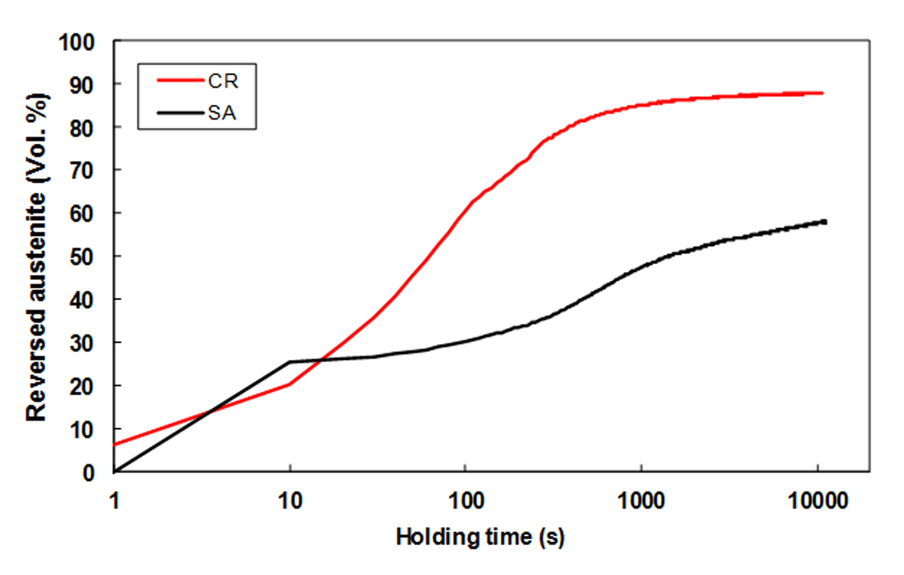
Fig. 4. The calculated volume fraction of the reversed austenite for the SA and CR specimens using data of Figure 3 and equation 2.

The XRD analyses of (a) the CR specimen and (b) the PDIA samples are shown in Fig. 5 for various times as indicated on the right. For the CR specimen, the diffraction lines show only the martensite phase while detailed analysis from the phase map of this specimen in Fig. 1b shows the microstructure also contains a small amount of the austenite phase. This apparent discrepancy is probably due to the very small size and low volume fraction of the austenite phase which means that it is not easily recognized by the XRD analysis. For the PDIA processed samples in Fig. 5b, there are four additional peaks that are attributed to the (111), (200), (220), and (311) planes of the austenite phase, respectively. It should be noted that preferred orientations may develop by rolling leading to a change in the main peak of some XRD spectra.
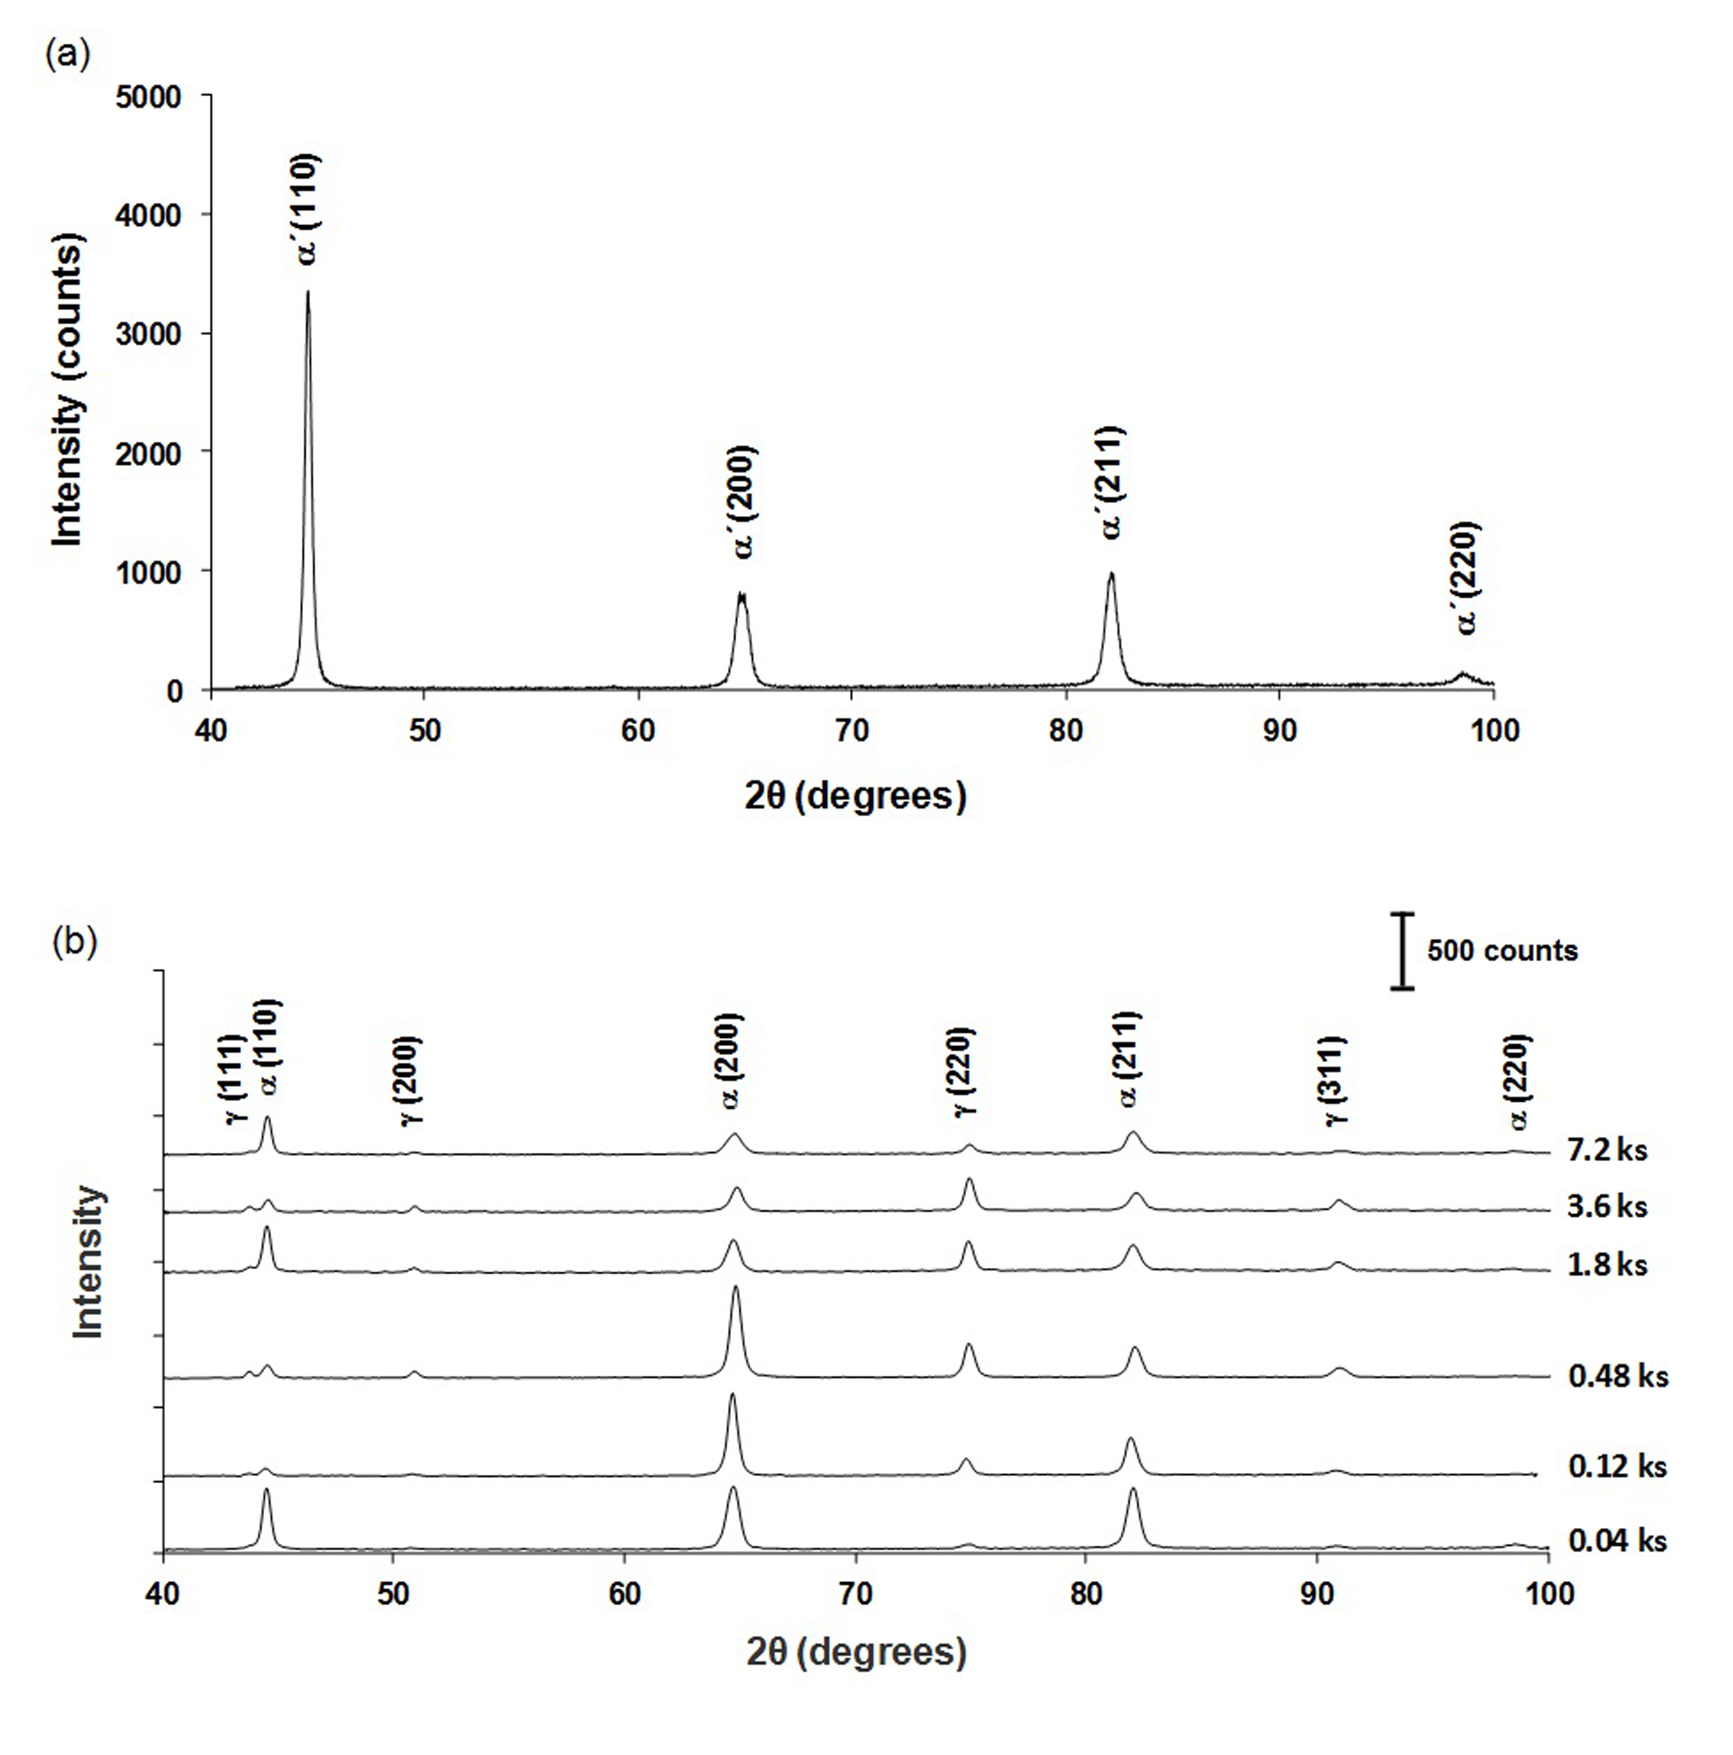
Fig. 5. X-ray diffraction patterns of the specimens (a) CR, and (b) PDIA processed at 600 °C for indicated times.
The amounts of the retained austenite at room temperature for the PDIA processed specimens were measured by XRD for various holding times and the results are shown in Fig. 6. It is clear that an increase in the holding time up to 3.6 ks leads to an increase in the percentage of the retained austenite up to a maximum of about 50% and a further increase in the holding time above 3.6 ks gives a reduction in the volume fraction of the retained austenite at room temperature.
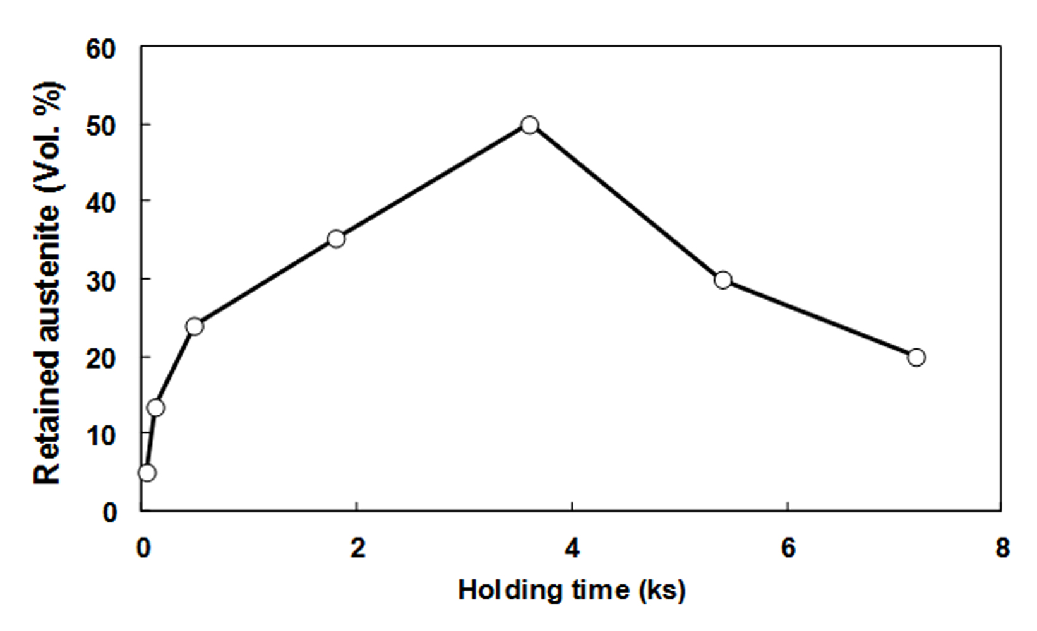
Fig. 6. The calculated volume fraction of the retained austenite at room temperature for the PDIA processed specimens at 600 °C for different holding times using data of Figure 5.

The grain boundary and phase maps of the PDIA processed specimens for holding times of (a) 0.04 and (b) 0.48 ks are shown in Fig. 7 where the austenite and martensite phases are clearly visible. It was reported earlier that the austenite phase nucleates at grain, packet and block boundaries [37,39] and in the present study the nucleation of the austenite occurred preferentially at block boundaries as indicated in Fig. 7a. In addition, it should be noted that pre-deformation can create some preferred sites for nucleation of the austenite. For example, in some areas of the CR specimen the strain concentration leads to the formation of smaller martensitic blocks which in turn lead to the formation of smaller austenite grains. From Figs. 7a and b, it is concluded that, by increasing the holding time from 0.04 to 0.48 ks, the volume fraction of the retained austenite drastically increases and this is in good agreement with the XRD results.

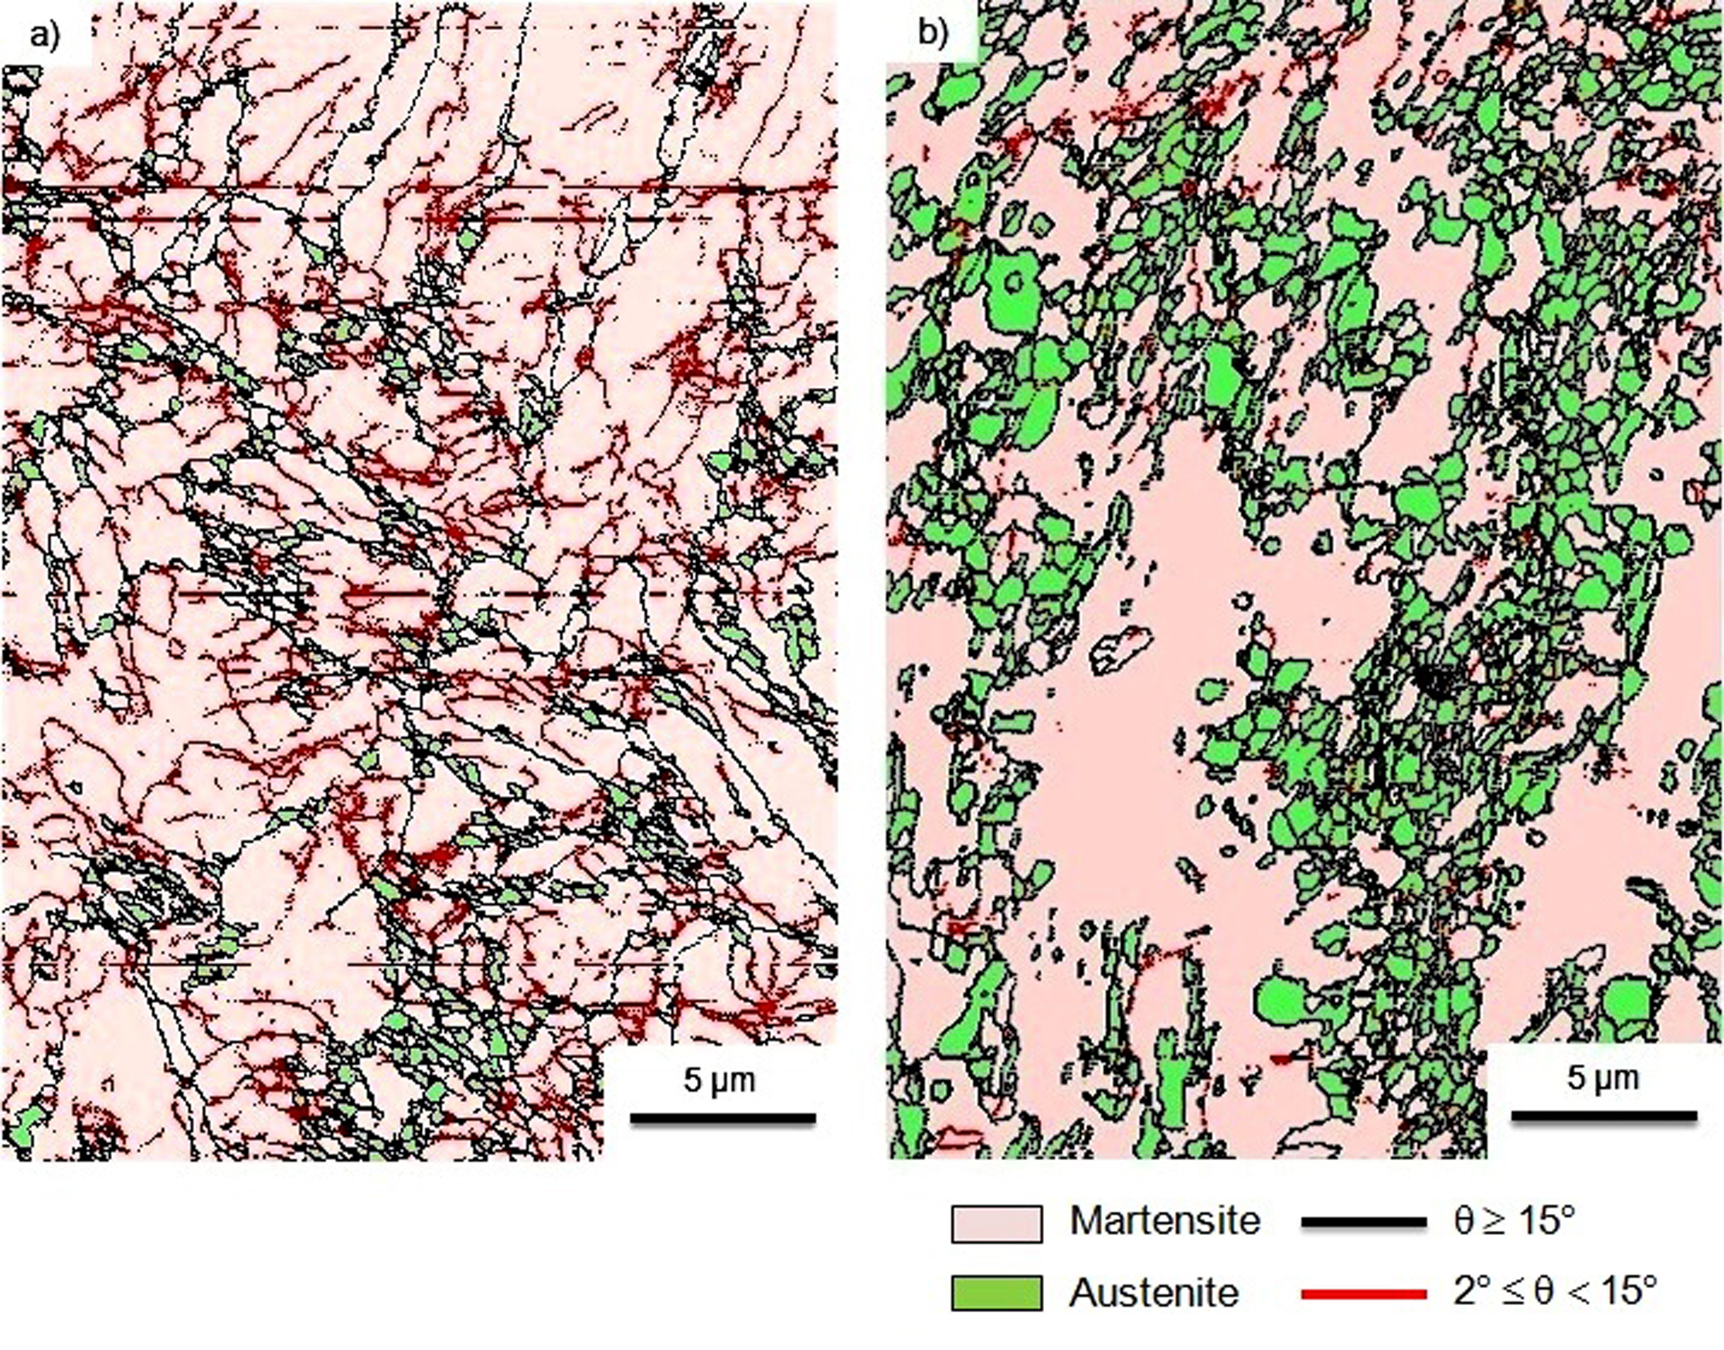
Fig. 7. Grain boundaries and phase maps of the PDIA processed specimens at 600°C for (a) 0.04, and (b) 0.48 ks.

Figs. 8 shows the phase maps together with the orientation relationship between the retained austenite and the parent martensite in the PDIA processed specimens for times of (a) 0.04 and (b) 0.48 ks, respectively. It is clear that most of the boundaries between the austenite and martensite coincide with the Kurdjumov-Sachs (K-S) orientation relationship of ({111}_{A} // {011}_{M}, <101>_{A} // <111>_{M} ), where the subscripts of A and M represent austenite and martensite, respectively.
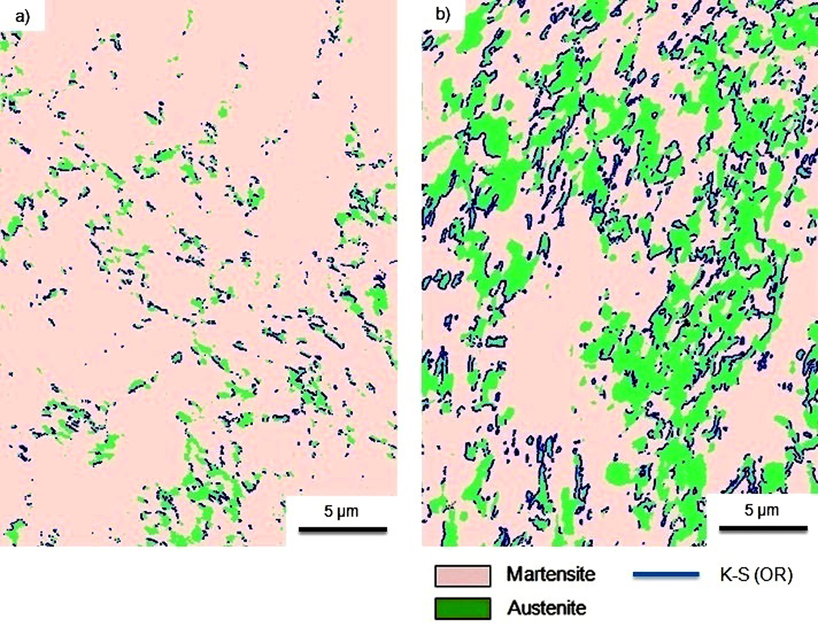
Fig. 8. Distribution of the K-S orientation relationship between the retained austenite and martensite in the PDIA processed specimens at 600°C for (a) 0.04 ks, and (b) 0.48 ks.

3.2. Mechanical properties
3.2.1. Microhardness measurements
An evaluation of the Vickers microhardness, Hv, for the CR specimen and the PDIA processed samples for various holding times is shown in Fig. 9 where each experimental point corresponds to the mean of five separate measurements. The microhardness of the CR specimen is about 250 Hv but this rises to about 295 Hv after PDIA for only 0.04 ks and subsequent increases in the holding time produce a reduction in the microhardness to a final value slightly lower than 250 Hv.

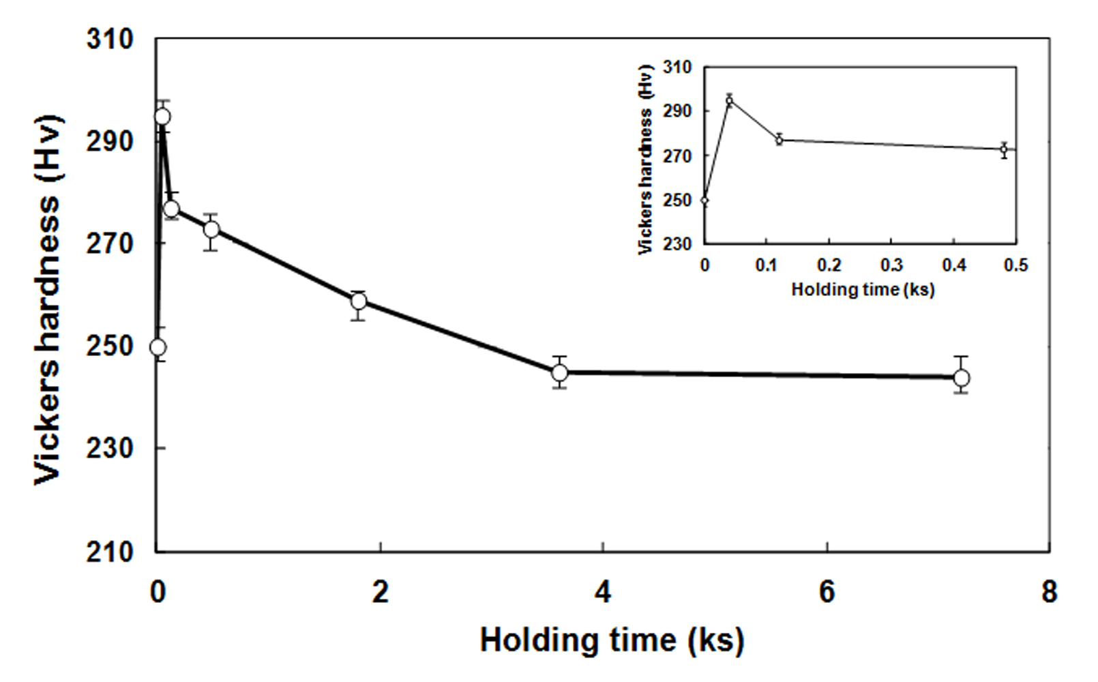
Fig. 9. Values of the Vickers microhardness for the CR specimen and the PDIA processed samples at 600 °C for different holding times. The inset shows the microhardness in the early stages of PDIA.

3.2.2. Strength-ductility measurements
The engineering stress-strain curves obtained at room temperature are plotted in Fig. 10 for the SA sample, the CR specimen and the PDIA processed samples for 3.6 ks before and after the ageing treatment. In addition, the values of the yield strength (YS), ultimate tensile strength (UTS) and fracture strain for the different testing conditions are summarized in Table 1. For the SA sample, the UTS and fracture strain were recorded as ~695 MPa and ~6.3%, respectively, whereas after 70% cold rolling the UTS increased to ~877 MPa with a corresponding decline in the fracture strain to ~3.8%. After PDIA, the UTS and fracture strain increased to ~955 MPa and ~9.1%, respectively, due to the reversed austenite formation with a fine-grained structure. Finally, subsequent ageing treatment on the PDIA processed specimen increased the UTS and fracture strains to ~1215 MPa and ~13.1%, respectively. These latter results are related specifically to the formation of θ-NiMn precipitates in the microstructure as reported previously [4,9].
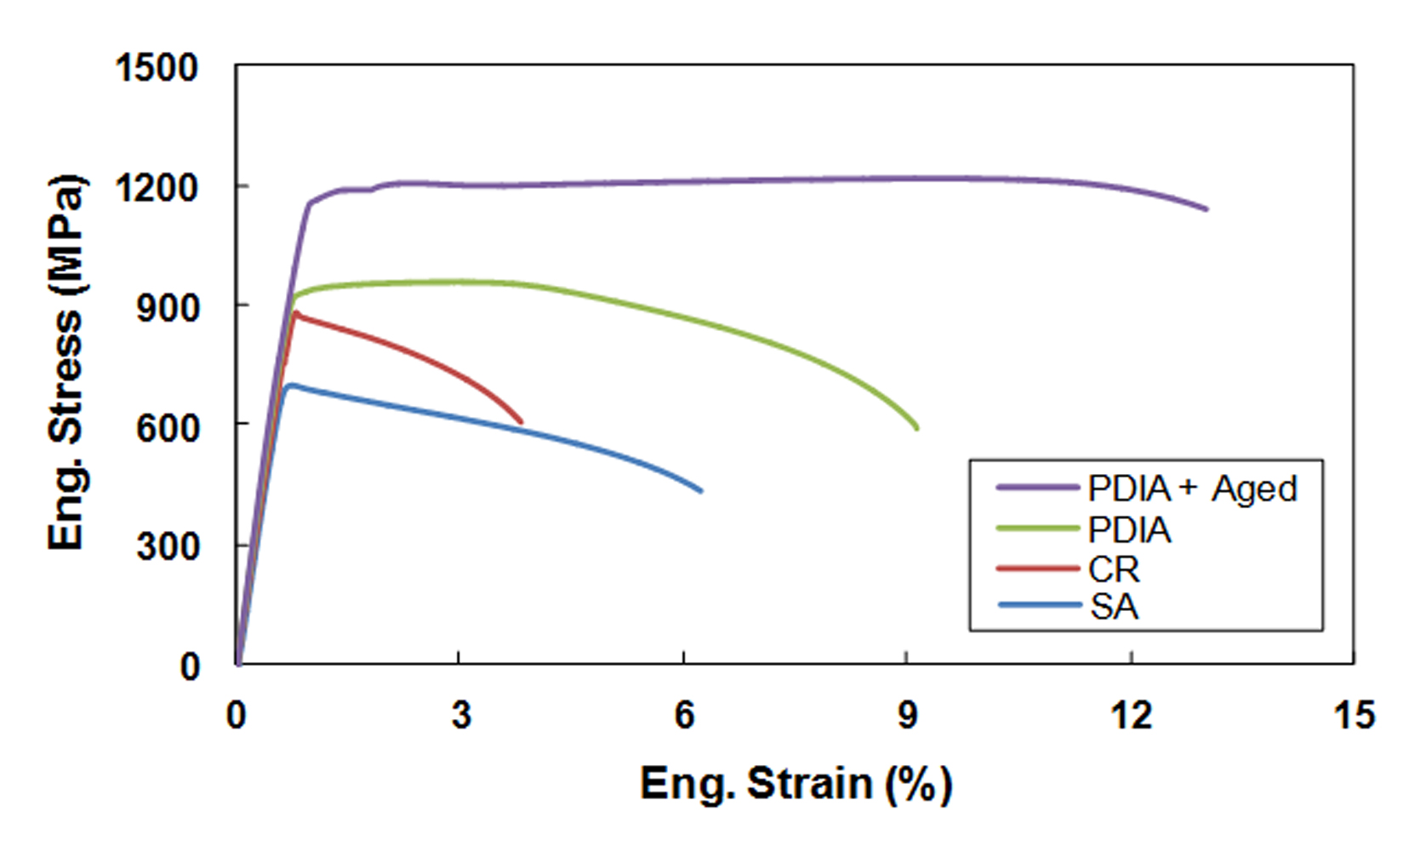
Fig. 10. Engineering stress-strain curves at room temperature for the SA sample, the CR specimen, and the PDIA processed samples at 600°C for 3.6 ks before and after ageing treatment at 480°C for 3.6 ks.

Table 1. Values of yield strength (YS), ultimate tensile strength (UTS) and fracture strain for the SA sample, the CR specimen, and the PDIA processed samples before and after ageing.
Condition | YS (MPa) | UTS (MPa) | Fracture Strain (%)
SA | 660 | 695 | 6.3
CR | 780 | 877 | 3.8
PDIA | 903 | 955 | 9.1
PDIA followed by ageing | 1150 | 1215 | 13.1

3.2.3. Pseudoelastic behavior
The stress-strain curves of cyclic loading-unloading at room temperature for the different specimens in various experimental conditions are represented in Fig. 11. In Fig. 11a the cyclic stress-strain curve of the SA sample is normal linear elasticity without strain hysteresis since the microstructure of the sample is fully martensitic whereas the stress-strain curve for the CR specimen in Fig. 11b shows a nonlinear spring back strain at the lower stresses and a strain hysteresis between the unloading and reloading curves. It is concluded that this pseudoelasticity is related to the presence of deformation-induced austenite accompanied by a high dislocation density. Fig. 11c represents the cyclic stress-strain curve of the PDIA processed specimen after holding for 3.6 ks where, as a consequence of PDIA, the pseudoelastic behavior in the CR specimen disappears due to dislocation annihilation in the deformation-induced austenite. Finally, Fig. 11d shows the stress-strain curve of the PDIA processed specimen followed by subsequent ageing where the pseudoelasticity re-appears due to the strengthening of the microstructure by the θ-NiMn precipitates as they effectively prevent slip deformation.
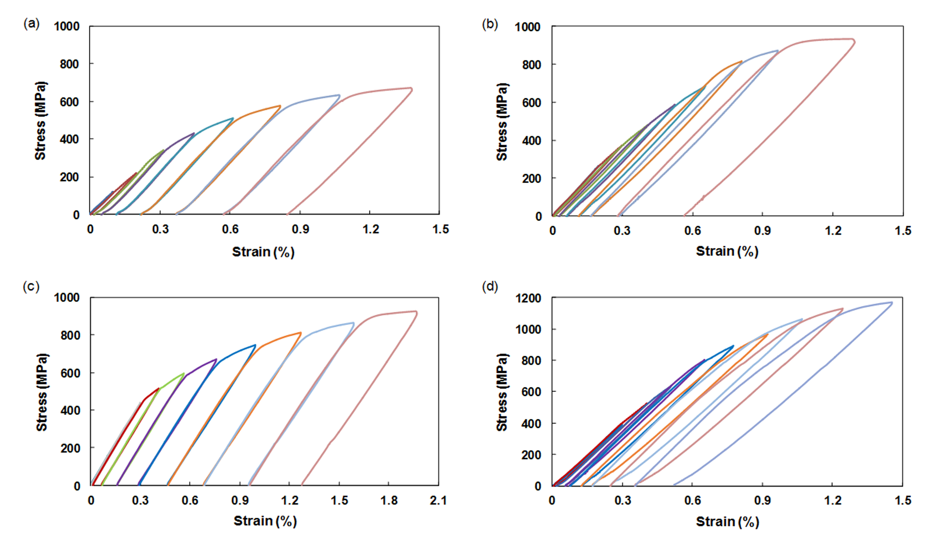
Fig. 11. Stress-strain curves of cyclic loading-unloading for the specimens (a) SA, (b) CR, (c) and (d) PDIA processed at 600°C for 3.6 ks before and after ageing treatment at 480°C for 3.6 ks, respectively.

4. Discussion
It was shown in Fig. 1 that the fraction of LAGBs increased after cold rolling and there was also a refining of the martensite blocks. Very fine and limited austenite particles were nucleated at HAGBs and these are visible in Fig. 1b. The nucleation of austenite is attributed to the strain concentration and the consequent rise in temperature during heavy cold rolling. Austenite formation as a result of a deformation-induced reverse transformation in Fe-10Ni-7Mn was reported earlier [29-31]. In addition, the required driving force for the reverse transformation in Fe-10Ni-7Mn was calculated [32] and the possibility of austenite formation during heavy cold rolling was further clarified. In practice, the A_{s} temperature decreased in the CR specimen compared to the SA sample as shown in Fig. 2 and this decrease in A_{s} is due to the formation of ultrafine austenite by cold rolling as indicated in Fig. 1b where this provides nucleation sites for austenite formation during PDIA.
The dilatation curves of the specimens are shown in Fig. 3 and they indicate that the reverse transformation consists of two parts. Thus, the first part shows a sharp decrease whereas the second part exhibits a gradual decrease as the holding time increases. This sharp decrease in part І may be a displacive (martensitic) transformation since it is time independent and it was shown that a displacive transformation is characterized by a rapid change that is not thermally-activated [40]. The gradual decrease in part ІІ indicates that a complete reverse transformation is achieved by a diffusional transformation where this isothermal transformation is in general a characteristic feature of time-dependent diffusional transformations. As a result, it is concluded that the reverse transformation of martensite to austenite is initiated by a martensitic mechanism and then deviates to a conventional diffusional type. Also, the presence of the K-S orientation relationship between the retained austenite and martensite in the PDIA processed specimens for 0.04 and 0.48 ks clearly supports a reversed austenite having a diffusional or/and martensitic nature (Fig. 8). It was reported in several studies that, when the reverse transformation takes place by diffusional or a martensitic mechanism, the reversed austenite usually satisfies an orientation relationship with respect to martensite [39,41,42]. A recent study of the reverse transformation of a similar alloy in the SA condition during post-intercritical annealing at 600 °C showed that the reverse transformation takes place by a sequential combination of two mechanisms including both martensitic and diffusional types [43].
According to Fig. 4, the calculated volume fraction of reversed austenite using data of Fig. 3 indicates that cold rolling greatly accelerated part ІІ of the revere transformation but suppressed part І of this transformation. Accelerating the reverse transformation by cold rolling was also reported [27]. In practice, part І of the reverse transformation (Fig. 3) becomes smaller in the CR specimen and this is attributed to the decline in A_{s} temperature. In this way, the martensitic transformation that is independent of temperature is not influenced but the driving force of the diffusional transformation can increase. Therefore, part І of the reverse transformation is effectively suppressed by part ІІ.
Microstructural evolution in Fig. 7a indicates that initially the austenite nucleates in the finer martensite block region. The reversed austenite is more easily and preferentially nucleated at these block boundaries or at prior austenite nuclei that are formed by rolling. Therefore, the reverse transformation is accelerated in the CR specimen comparing to the SA specimen. Also, the decline in the A_{s} temperature in the CR specimen increases the driving force of the diffusional transformation and consequently accelerates the reverse transformation. As a result, it is apparent from Fig. 4 that the maximum volume fraction of the reversed austenite increased from 58% in the SA specimen to 87% in the CR specimen during post-intercritical annealing for 10.8 ks.
According to Fig. 6, the volume fraction of the retained austenite at room temperature for the PDIA specimens processed for various times increases with an increase in holding time up to a maximum of 50% at 3.6 ks and then decreases at a later stage of reversion. However, the volume fraction of the reversed austenite at the intercritical annealing temperature increases continuously against the holding time as shown in Fig. 4. The volume fraction of the retained austenite at room temperature is essentially determined by two parameters based on the volume fraction and the stability of the reversed austenite [44]. It was reported also that the stability of the austenite depends on various factors such as the grain size, orientation gradient and the re-crystallization of austenite [45] and the increasing holding time leads to an increase in the reversed austenite grain size which consequently increases the martensite start (M_{s}) temperature [46]. Hence, the stability of austenite at room temperature can be decreased by increasing the holding time. Therefore, in practice there is essentially a trade-off between these two variables such that the volume fraction of the retained austenite at room temperature is a maximum near a holding time of 3.6 ks.
According to Fig. 9, the microhardness data demonstrate that in the beginning of the reverse transformation, corresponding to part I in Fig. 3, the hardness value increases significantly due to the austenite formation accompanied by a high dislocation density. Thereafter, further annealing leads to a recovery of the specimen as well as changing the reverse transformation mechanism from a martensitic to a diffusional type causing a decrease in the hardness value.
As illustrated in Fig. 10 and documented in Table 1, the SA sample has values for the YS and UTS which are similar with only minor strain hardening due to the high dislocation density of martensite, while the alloy displays an elongation of about 6.3% due to the relatively ductile nature of the starting material. A 70% cold rolling increases the UTS of the SA sample to ∼877 MPa while the elongation decreases to ∼3.8% and this higher strength and lower ductility is attributed to the effect of the heavy cold deformation which causes a high density of dislocations and leads to a high density of shear bands and fine grains [18]. After the PDIA for 3.6 ks, the UTS and fracture strain increase to ~955 MPa and ~9.1%, respectively, and this is related to the nature of the reversed austenite with a fine-grained structure. As noted earlier, the austenite grains formed by PDIA for 3.6 ks have two main characteristics including martensitic and diffusional. The displacively-formed austenite inherits the dislocation structure from the parent martensite and this increases the strength of the microstructure [47,48] whereas the reversed austenite formed by a diffusional mechanism produces an increase in ductility. Finally, the subsequent isothermal ageing treatment for the PDIA specimen leads to increases in the UTS and fracture strain to ~1215 MPa and ~13.1%, respectively, by strengthening the microstructure through the formation of θ-NiMn precipitates.
From the cyclic tensile test results in Fig. 11b, it is apparent that there is a pseudoelastic behavior in the CR specimen which is attributed to the presence of deformation-induced austenite having a high dislocation density. Dislocation generation in the formed austenite under cold rolling leads to an increase in the yield strength and promotes an austenite to epsilon martensite transformation rather than slip deformation during cyclic tension. In addition, the accumulation of dislocations produces a large stress field around the tip of the epsilon-martensite and acts as a back-stress on the growing martensite so that the reversible motion of the austenite and epsilon-martensite (fcc/hcp) interface is feasible. An effect of the back-stress on the reversibility of the austenite to epsilon-martensite transformation was also proposed earlier [49]. As shown in Fig. 11c, after PDIA for 3.6 ks, although the yield strength of the specimen is higher than the CR sample and the occurrence of slip deformation is more difficult but nevertheless there is no evidence for any pseudoelasticity. This latter situation is due to the dislocations annihilation in the microstructure during PDIA and a lack of back-stress produced by dislocations on the growing martensite which can lead to the reversible movement of the fcc/hcp interface. According to Fig. 11d, the pseudoelastic behavior appeared again in the stress-strain curve of the PDIA processed specimen followed by isothermal ageing and this pseudoelasticity after ageing is associated with the θ-NiMn precipitate formation. Thus, the presence of precipitates in the microstructure improves the pseudoelastic behavior by strengthening the austenite and assisting the reversible movement of the fcc/hcp interface through a back stress produced on the growing martensite [35,50,51].
5. Summary and conclusions
This research examined the effects of prior cold rolling and subsequent heat treatment on the microstructure, phase evaluation and mechanical properties of an Fe-10Ni-7Mn (wt. %) fully martensitic steel. The results lead to the following conclusions:
- Cold rolling by 70% produces deformation-induced austenite formation and also refines the martensite blocks and reduces the A_{s} temperature.
- The prior austenite and the smaller martensite blocks are the primary potential sites for austenite nucleation during PDIA.
- Both martensitic and diffusional reverse transformations were present during PDIA at 600 °C but the diffusional mechanism was dominant.
- The volume fraction of the retained austenite at room temperature for the CR specimen showed a maximum value of 50% after PDIA at 600°C for 3.6 ks. This was attributed to the interaction between stability and the volume fraction of the reversed austenite.
- The ultimate tensile strength was increased from ~695 MPa for the solution-annealed sample to ~1215 MPa for the PDIA-processed specimen followed by subsequent ageing due to θ-NiMn precipitate formation in the microstructure.
- Cyclic tensile testing revealed pseudoelastic behavior in the CR specimen that disappeared after PDIA due to dislocation annihilation in the microstructure of the deformation-induced austenite. This pseudoelasticity appeared again after subsequent ageing due to the strengthening of the microstructure by θ-NiMn precipitates which effectively inhibited slip deformation.
Data availability
The raw/processed data required to reproduce these findings cannot be shared at this time as the data form part of an ongoing study.

References
[1] K. Rohrbach, M. Schmidt, ASM Metals Hand Book, vol. 4, 10th ed., ASM International, OH, 1991.
[2] S.Morito, H.Tanaka, R.Konishi, T.Furuhara, T.Makia, The morphology and crystallography of lath martensite in Fe-C alloys, Acta Mater. 51 (2003) 1789-1799. https://doi.org/10.1016/S1359-6454(02)00577-3.
[3] M. Yodogawa, Precipitation behaviour in Fe-Ni-Mn martensitic alloys, Trans. JIM. 17 (1976) 799-808. https://doi.org/10.2320/matertrans1960.17.799.
[4] S. Hossein Nedjad, M. Nili Ahmadabadi, R. Mahmudi, H. Farhangi, Effect of conventional and subzero treating on the mechanical properties of aged martensitic Fe-12wt.% Ni-Xwt.% Mn alloys, Mater. Sci. Eng. A 738 (2004) 314-318. https://doi.org/10.1016/j.msea.2003.10.356.
[5] S. Hossein Nedjad, M.R. Movaghar Garabagh, M. Nili Ahmadabadi, H. Shirazi, Effect of further alloying on the microstructure and mechanical properties of an Fe-10Ni-5Mn maraging steel, Mater. Sci. Eng. A 473 (2008) 249-253. https://doi.org/10.1016/j.msea.2007.05.093.
[6] H.C. Lee, S.H. Mun, D. McKenzie, Electron microscopy study on the grain-boundary precipitation during aging of Fe-10Ni-5Mn steel, Metall. Mater. Trans. A 34 (2003) 2421-2428. https://doi.org/10.1007/s11661-003-0002-7.
[7] Y. Iwabuchi, Toughness deterioration of 13Cr-3.8 Ni cast steel in the process of tempering, ISIJ Int. 70 (1984) 701-708. https://doi.org/10.2355/tetsutohagane1955.70.7_701.
[8] T. Kobayashi, H. Tachibana, Y. Ueda, Effect of nickel on strengthening and toughening of 13% Cr cast stainless steel by quenching from (α+γ) temperature range, ISIJ Int. 68 (1982) 1054-1062. https://doi.org/10.2355/tetsutohagane1955.68.8_1054.
[9] H.R. Koohdar, M. Nili-Ahmadabadi, M. Habibi-Parsa, H.R. Jafarian, Development of pseudoelasticity in Fe-10Ni-7Mn (wt. %) high strength martensitic steel by intercritical heat treatment and subsequent ageing, Mater. Sci. Eng. A 621 (2015) 52-60. https://doi.org/10.1016/j.msea.2014.10.049.
[10] C.A. Apple, G. Krauss, The effect of heating rate on the martensite to austenite transformation in Fe-Ni-C alloys, Acta Metal. 20 (1972) 849-856. https://doi.org/10.1016/0001-6160(72)90077-6.
[11] J. Jelenkowski, Studies of the α′→ γ transformation in Fe-(23–26)Ni-2Ti alloys containing an addition of aluminium or molybdenum, J. Mater. Process. Technol. 64 (1997) 207-214. https://doi.org/10.1016/S0924-0136(96)02569-1.
[12] S.J. Lee, Y. Park, Y.K. Lee, Reverse transformation mechanism of martensite to austenite in a metastable austenitic alloy, Mater. Sci. Eng. A 515 (2009) 32-37. https://doi.org/10.1016/j.msea.2009.02.010.
[13] A.P. Zhilyaev, T.G. Langdon, Using high-pressure torsion for metal processing: Fundamentals and applications, Prog. Mater. Sci. 53 (2008) 893-979. https://doi.org/10.1016/j.pmatsci.2008.03.002.
[14] F.J. Kalahroudi, H.R. Koohdar, H.R. Jafarian, Y. Haung, T.G. Langdon, M. Nili-Ahmadabadi, On the microstructure and mechanical properties of an Fe-10Ni-7Mn martensitic steel processed by high-pressure torsion, Mater. Sci. Eng. A 749 (2019) 27-34. https://doi.org/10.1016/j.msea.2019.02.002.
[15] F.J. Kalahroudi, H.R. Koohdar, T.G. Langdon, M. Nili-Ahmadabadi, Phase evolution and mechanical properties of an intercritically-annealed Fe-10Ni-7Mn (wt. %) martensitic steel severely deformed by high-pressure torsion, Mater. Sci. Eng. A, In Press (2020) 140519. https://doi.org/10.1016/j.msea.2020.140519.
[16] N. Tsuji, Y. Saito, S.H. Lee, Y. Minamino, ARB (accumulative roll-bonding) and other new techniques to produce bulk ultrafine grained materials, Adv. Eng. Mater. 5 (2003) 338-344. https://doi.org/10.1002/adem.200310077.
[17] R.Z. Valiev, T.G. Langdon, Principles of equal-channel angular pressing as a processing tool for grain refinement, Prog. Mater. Sci. 51 (2006) 881-981. https://doi.org/10.1016/j.pmatsci.2006.02.003.
[18] A. Mirsepasi, M. Nili-Ahmadabadi, M. Habibi-Parsa, H. Ghasemi-Nanesa, A.F. Dizaji, Microstructure and mechanical behavior of martensitic steel severely deformed by the novel technique of repetitive corrugation and straightening by rolling, Mater. Sci. Eng. A 551(2012) 32-39. https://doi.org/10.1016/j.msea.2012.04.073.
[19] T.G. Langdon, Twenty-five years of ultrafine-grained materials: Achieving exceptional properties through grain refinement, Acta Mater. 61 (2013) 7035-7059. https://doi.org/10.1016/j.actamat.2013.08.018.
[20] N. Tsuji, R. Ueji, Y. Minamino, Y. Saito, A new and simple process to obtain nano-structured bulk low-carbon steel with superior mechanical property, Scripta Mater. 46 (2002) 305-310. https://doi.org/10.1016/S1359-6462(01)01243-X.
[21] J. Tianfu, G. Yuwei, Q. Guiying, L. Quan, W. Tiansheng, W. Wei, X. Furen, C. Dayong, S. Xinyu, Z. Xin, Nanocrystalline steel processed by severe rolling of lath martensite, Mater. Sci. Eng. A 432 (2006) 216-220. https://doi.org/10.1016/j.msea.2006.06.047.
[22] S. Morito, J. Nishikawa, T. Maki, Dislocation density within lath martensite in Fe-C and Fe-Ni alloys, ISIJ Int. 43 (2003) 1475-1477. https://doi.org/10.2355/isijinternational.43.1475.
[23] G. Martin, P. Bellon, Driven alloys, Solid State Phys. 50 (1996) 189-331. https://doi.org/10.1016/S0081-1947(08)60605-0.
[24] D.H. Shin, Y.S. Kim, E.J. Lavernia, Formation of fine cementite precipitates by static annealing of equal-channel angular pressed low-carbon steels, Acta Mater. 49 (2001) 2387-2393. https://doi.org/10.1016/S1359-6454(01)00165-3.
[25] Y. Ivanisenko, R.K. Wunderlich, R.Z. Valiev, H.J. Fecht, Annealing behaviour of nanostructured carbon steel produced by severe plastic deformation, Scripta Mater. 49 (2003) 947-952. https://doi.org/10.1016/S1359-6462(03)00478-0.
[26] K.T. Park, D.H. Shin, Annealing behavior of submicrometer grained ferrite in a low carbon steel fabricated by severe plastic deformation, Mater. Sci. Eng. A 334 (2002) 79-86. https://doi.org/10.1016/S0921-5093(01)01796-8
[27] J. Han, S.J. Lee, J.G. Jung, Y.K. Lee, The effects of the initial martensite microstructure on the microstructure and tensile properties of intercritically annealed Fe-9Mn-0.05 C steel, Acta Mater. 78 (2014) 369-377. https://doi.org/10.1016/j.actamat.2014.07.005.
[28] H. Shirazi, M. Nili-Ahmadabadi, A. Fatehi, S. Hossein Nedjad, Effect of severe plastic deformation on mechanical properties of Fe-Ni-Mn high strength steel, Adv. Mater. Res. 83 (2010) 16-23. https://doi.org/10.4028/www.scientific.net/AMR.83-86.16.
[29] H. Ghasemi-Nanesa, M. Nili-Ahmadabadi, H. Shirazi, S. Hossein Nedjad, S. H. Pishbin, Ductility enhancement in ultrafine-grained Fe-Ni-Mn martensitic steel by stress-induced reverse transformation, Mater. Sci. Eng. A 527 (2010) 7552-7556. https://doi.org/10.1016/j.msea.2010.08.028.
[30] H.R. Koohdar, M. Nili Ahmadabadi, M. Habibi-Parsa, H.R. Jafarian, H. Ghasemi-Nanesa, H. Shirazi, Observation of pseudoelasticity in a cold rolled Fe-Ni-Mn martensitic steel, Mater. Sci. Eng. A 658 (2016) 86-90. https://doi.org/10.1016/j.msea.2016.01.113.
[31] H.R. Koohdar, M. Nili Ahmadabadi, M. Habibi-Parsa, H. Ghasemi-Nanesa, Investigating on the reverse transformation of martensite to austenite and pseudoelastic behavior in ultrafine-grained Fe-10Ni-7Mn (wt %) steel processed by heavy cold rolling, Adv. Mater. Res., 829 (2014) 25-29. https://doi.org/10.4028/www.scientific.net/AMR.829.25.
[32] H. Ghasemi-Nanesa, M. Nili-Ahmadabadi, H.R. Koohdar, M. Habibi-Parsa, S. Hossein Nedjad, S.A. Alidokht, T.G. Langdon, Strain-induced martensite to austenite reverse transformation in an ultrafine-grained Fe-Ni-Mn martensitic steel, Phill. Mag. 94 (2014) 1493-1507. https://doi.org/10.1080/14786435.2014.886785.
[33] S. Watanabe, S. Sato, K. Miura, An unique feature of mechanical property of iron-nickel manganese alloy, J. Mater. Process. Technol. 53 (1995) 467-476. https://doi.org/10.1016/0924-0136(95)02003-5.
[34] H.R. Koohdar, M. Nili-Ahmadabadi, F.J. Kalahroudi, H.R. Jafarian, T.G. Langdon, The effect of high-pressure torsion on the microstructure and outstanding pseudoelasticity of a ternary Fe-Ni-Mn shape memory alloy, Mater. Sci. Eng. A 802 (2021) 140647. https://doi.org/10.1016/j.msea.2020.140647.
[35] T. Sawaguchi, T. Kikuchi, S. Kajiwara, The pseudoelastic behavior of Fe-Mn-Si-based shape memory alloys containing Nb and C, Smart Mater. Struct. 14 (2005) S317-S322. https://doi.org/10.1088/0964-1726/14/5/022.
[36] S.B. Seo, J.H. Jun, C.S. Choi, Effect of prior deformation on A_{s} temperature of martensite in Fe-Ni alloys, Scripta Mater. 42 (1999) 123-127.
[37] H. Shirazi, G. Miyamoto, S. Hossein Nedjad, H.Ghasemi-Nanesa, M. Nili-Ahmadabadi, T.
Furuhara, Microstructural evaluation of austenite reversion during intercritical annealing of Fe-Ni-Mn martensitic steel, J. Alloys Compd. 577S (2013) S572-S577. https://doi.org/10.1016/j.jallcom.2012.02.015.
[38] C. Garcia-Mateo, F.G. Caballero, C. Capdevila, C. Garcia de Andres, Estimation of dislocation density in bainitic microstructures using high-resolution dilatometry, Scripta Mater. 61 (2009) 855-858. https://doi.org/10.1016/j.scriptamat.2009.07.013.
[39] N. Nakada, T. Tsuchiyama, S. Takaki, S. Hashizume, Variant selection of reversed austenite in lath martensite, ISIJ Int. 47 (2007) 1527-1532. https://doi.org/10.2355/isijinternational.47.1527.
[40] Z. Nishiyama, Martensitic Transformation, Academic Press, New York, 1978.
[41] V.I. Zel’dovich, Three mechanisms of formation of austenite and inheritance of structure in iron alloys, Met. Sci. Heat Treat. 50 (2008) 442-448. https://doi.org/10.1007/s11041-009-9082-3.
[42] S.S. D’Yachenko and G.V. Fedorov, A study of recrystallization in steel heated by the method of high-temperature x-ray diffractometry, Fiz. Met. Metalloved. 18 (1964) 73-77.
[43] H.R. Koohdar, M. Nili Ahmadabadi, M. Habibi-Parsa, H.R. Jafarian, T. Bhattacharjee, N. Tsuji, On the stability of reversely formed austenite and related mechanism of transformation in an Fe-Ni-Mn martensitic steel aided by electron backscattering diffraction and atom probe tomography, Metall. Mater. Trans. A 48 (2017) 5244-5257. https://doi.org/10.1007/s11661-017-4288-2.
[44] D.S. Leem, Y.D. Lee, J.H. Jun, C.S. Choi, Amount of retained austenite at room temperature after reverse transformation of martensite to austenite in an Fe-13%Cr-7%Ni-3%Si martensitic stainless steel, Scripta Mater. 45 (2001) 767-772. https://doi.org/10.1016/S1359-6462(01)01093-4.
[45] H.Z. Wang, P. Yang, W.M. Mao, F.Y. Lu, Effect of hot deformation of austenite on martensitic transformation in high manganese steel, J. Alloys Compd. 558 (2013) 26-33. https://doi.org/10.1016/j.jallcom.2012.12.032.
[46] H.S. Yang, H.K.D.H. Bhadeshia, Austenite grain size and the martensite start temperature, Scripta Mater. 60 (2009) 493-495. https://doi.org/10.1016/j.scriptamat.2008.11.043.
[47] G. Krauss, Fine structure of austenite produced by the reverse martensitic transformation, Acta Metall. 11 (1963) 499-509. https://doi.org/10.1016/0001-6160(63)90085-3.
[48] H. Kessler, W. Pitsch, On the nature of the martensite to austenite reverse transformation, Acta Metall. 15 (1967) 401-405. https://doi.org/10.1016/0001-6160(67)90224-6.
[49] N. Bergeon, G. Guenin, C. Esnouf, Microstructural analysis of the stress-induced ε martensite in a Fe-Mn-Si-Cr-Ni shape memory alloy: Part II: Transformation reversibility, Mater. Sci. Eng. A 242 (1998) 87-95. https://doi.org/10.1016/S0921-5093(97)00512-1.
[50] A. Baruj, T. Kikuchi, S. Kajiwara, N. Shinya, Improvement of shape memory properties of NbC containing Fe-Mn-Si based shape memory alloys by simple thermo-mechanical treatments, Mater. Sci. Eng. A 378 (2004) 333-336. https://doi.org/10.1016/j.msea.2003.10.357.
[51] A. Baruj, T. Kikuchi,S. Kajiwara, TEM observation of the internal structures in NbC containing Fe-Mn-Si-based shape memory alloys subjected to pre-deformation above room temperature,Mater. Sci. Eng. A 378 (2004) 337-342. https://doi.org/10.1016/j.msea.2003.10.358.

Table captions
Table 1. Values of yield strength (YS), ultimate tensile strength (UTS) and fracture strain for the SA sample, the CR specimen, and the PDIA processed samples before and after ageing.

Figure captions
Fig. 1. Grain boundaries and phase maps of (a) SA, and (b) CR specimens.
Fig. 2. Dilatation curves versus temperature at the heating rate of 5 °C/min for the SA and the CR specimens.
Fig. 3. Dilatation curves of the SA, CR, and pure iron specimens continuously heated to 600 °C at a heating rate of 20 °C/s and isothermally maintained for 10.8 ks.
Fig. 4. The calculated volume fraction of the reversed austenite for the SA and CR specimens using data of Figure 3 and equation 2.
Fig. 5. X-ray diffraction patterns of the specimens (a) CR, and (b) PDIA processed at 600 °C for indicated times.
Fig. 6. The calculated volume fraction of the retained austenite at room temperature for the PDIA processed specimens at 600 °C for different holding times using data of Figure 5.
Fig. 7. Grain boundaries and phase maps of the PDIA processed specimens at 600°C for (a) 0.04, and (b) 0.48 ks.
Fig 8. Distribution of the K-S orientation relationship between the retained austenite and martensite in the PDIA processed specimens at 600°C for (a) 0.04 ks, and (b) 0.48 ks.
Fig. 9. Values of the Vickers microhardness for the CR specimen and the PDIA processed samples at 600 °C for different holding times. The inset shows the microhardness in the early stages of PDIA.
Fig. 10. Engineering stress-strain curves at room temperature for the SA sample, the CR specimen, and the PDIA processed samples at 600°C for 3.6 ks before and after ageing treatment at 480°C for 3.6 ks.
Fig. 11. Stress-strain curves of cyclic loading-unloading for the specimens (a) SA, (b) CR, (c) and (d) PDIA processed at 600°C for 3.6 ks before and after ageing treatment at 480°C for 3.6 ks, respectively.

