Lasers that Learn: The Interface of Laser Machining and Machine Learning

Ben Mills 1\*, James. A. Grant-Jacob 1

1 Optoelectronics Research Centre, University of Southampton, SO17 1BJ, UK

\*[b.mills@soton.ac.uk](mailto:b.mills@soton.ac.uk)

Abstract: Laser machining is a highly flexible non-contact fabrication method used extensively across academia and industry. Whilst simulations based on fundamental understanding offer some insight into the processes, the highly nonlinear interactions between laser light and matter, and the variety of materials involved, mean that theoretical modelling is not particularly applicable to practical experimentation. However, recent breakthroughs in the field of machine learning now mean that neural networks are capable of accurate and rapid modelling of laser machining at a scale, speed, and precision well-beyond existing theoretical approaches, with applications including 3D surface visualisation and real-time error correction. In this review, a perspective at the intersection of laser machining and machine learning is presented, followed by a discussion of the future milestones and challenges for this field.

Introduction

Lasers are used for an ever-increasing number of applications, including marking [1-5], cutting [6-10], cleaning [11-15], drilling [16-20], engraving [21-25], ablation [26-30], additive manufacturing [31-37] and welding [38-42]. Similarly, lasers are applied to the processing of an extensive range of materials, from metals, ceramics, plastics, composites, glasses, thin films, and anodised surfaces, through to perhaps more unexpected materials such as wood [43], leather [44], cotton [45], dough [46] and even egg shells [47]. Laser materials processing is applied to almost all manufacturing industries, including aerospace, automotive, electronics, batteries, medical, 3D printing, semi-conductors, sensors and solar [48-50]. Similarly, size scales vary from the welding of ship steel [51, 52] down to materials processing around the diffraction limit [53-57]. Quite simply, lasers have completely transformed manufacturing in the decades since their invention.

This impressive number of industrial and academic applications is due, in part, to the significant flexibility with respect to parameters such as pulse length, pulse energy, wavelength, and beam size. However, this flexibility comes at a price, namely the significant amount of time and effort that must be dedicated to finding the optimal set of parameters for each manufacturing process. For example, if you need to vary 5 parameters with 10 steps each, that corresponds to a total of 10^5 experimental trials. Due to the often highly nonlinear relationship between parameters, the standard practice is generally the systematic collection of laser machining data for all parameter combinations, to identify the optimal combination. However, this process is both time-consuming and unfocussed, and it can take days or weeks, hence costing unnecessary effort, time, and money. Even when the optimal parameters have been determined, small changes, for example in laser power or beam shape, during manufacturing can result in a final product quality that is below the required standard, again with associated time and money costs. What is needed therefore, is a set of modelling methodologies for identifying optimal parameters and providing real-time monitoring and error correction during manufacturing.

However, the processes that describe laser machining, such as the light-matter interaction, heat conduction, phase-change of material, and the removal of material, are particularly complex and hence challenging to model precisely directly from a theoretical basis. The exact details of these processes depend on many factors, including the laser parameters (e.g. wavelength, fluence, and pulse length) and associated diffraction effects, as well as the sample properties (e.g. absorption, reflectivity, melting temperature, and ablation threshold). In addition, different interaction effects become dominant as the temporal interaction length varies from continuous wave to ultrafast (i.e. femtosecond pulses), where the additional nonlinear effects that can occur for short pulses, such as multiphoton absorption and ionisation, further increases this complexity.

In general, theoretical modelling of laser machining can be divided into analytical and numerical treatment [58]. Analytical modelling is usually based on a specific property of interest along with an associated set of assumptions, with examples including heat conduction and material phase change [59], residual stress [60], striation and surface roughness [61], analysis of assisting gas jet modelling [62, 63], reaction of oxygen with molten surface [64], energy balance [65] and melt geometry [66]. Numerical modelling approaches such as the finite element method (FEM) [67-70] can in general offer a broader solution, albeit approximated due to the requirement for calculation nodes whilst also heavily reliant on significant computing resources.

The FEM is a widely used numerical method for solving partial differential equations in two or three space variables, whilst considering specific boundary conditions. The approach is used widely in domains including structural analysis, fluid flow, electromagnetic field, and heat transfer, and hence has an obvious application in the modelling of laser machining. Typically, a larger system is divided into basic parts, known as finite elements, through a discretisation algorithm that effectively transforms the system into a mesh-like structure. A set of algebraic equations can then be devised for each element, which can then be assembled to describe the entire system. Through the introduction of boundary conditions, the equations can then be solved to provide a solution for a specific simulation.

The FEM has been applied to a wide range of laser, and laser assisted, machining, with particular emphasis on the heat affected zone. As a general overview, Shetty et al. [71] have shown the application of FEMs for a range of conventional manufacturing process machining, including turning, milling, trimming, and drilling. Van Elson et al. [72] demonstrated analytical and numerical solutions for heat conduction and diffusion for a localised laser-produced heat source, with applications in laser machining, welding, layered manufacturing, and laser alloying. Dai et al. [73] showed how FEM can be used to solve heat transport at the microscale.

Specifically, for laser machining, Negarestani et al. [74] presented an improvement to the quality of laser machining for cutting and drilling of carbon-fibre-reinforced polymer composites through understanding the mechanisms of the transient thermal behaviour and its effect on material removal. Using FEMs, a three-dimensional modelling for simulating the temperature field and subsequent material removal was developed, which was able to predict the dimensions of the heat affected zone during machining. Similarly, Dixit et al. [75] showed the application for investigating thermal stress and temperature distribution of laser power for laser materials processing of aluminium oxide ceramic, and Shalahim et al. [76] for acrylic sheet for a range of material models and process parameters. Martinez-Calderon et al. [77] showed the application of finite difference time domain modelling for optimisation of laser materials processing to produce tailored optical properties of diamond through the fabrication of surface nanostructures. Similarly, work by Romer et al. [78] showed finite difference time domain for modelling laser produced nanostructures on a range of materials. Afrasiabi et al. [79] showed the application of a particle strength exchange model, which offers some advantages over more conventional FEM for modelling metal removal in laser drilling, and later showed a mesh free method for accurate three-dimensional thermal simulation during laser drilling [80].

Laser machining is a key enabling technique for a range of industrial manufacturing techniques [81-83], including laser-assisted machining, which uses laser energy to locally preheat and soften materials before application of a conventional cutting tool, and which has seen many applications of finite element modelling. Tagliaferri et al. [84] used the FEM for modelling the laser heating process, for laser power, scanning speed, focus distance, and surface roughness, to enable reduced cutting tool wear and cutting forces. Yang et al. [85] used the FEM to model the depth and width of the heat affected zone when laser heating a titanium alloy. Tian et al. [86] showed the application of the FEM for modelling the progression of defects, such as cracks, in the shear zone, during laser-assisted machining of silicon nitride ceramics. Singh et al. [87] presented the FEM for optimisation of laser-assisted machining of steel, via modelling the temperature distribution, flow stress reduction due to laser heating, and cutting forces. Kim et al. [88] used the FEM for laser-assisted machining of three-dimensional shapes, for optimisation of the pre-heating temperature. Finally, Shi et al. [89] used the FEM for optimisation of the laser-assisted machining of nickel chromium alloy.

Whilst effects that are deterministic and can be described by equations, such as absorption and heat transfer, can be accurately modelled via theoretical approaches, as the domain grows in size (i.e. a larger target sample), the computational requirements will similarly increase. In the case of finite element methods, techniques to reduce this computational complexity include using a variable mesh or using symmetry arguments to reduce dimensions [90], or in the case of laser machining, using the edge of the mesh as the laser cut position [74]. However, even with such techniques, there will always be a practical limit to the size of the domain that can be accurately modelled. Effects that are non-deterministic, such as experimental variations in laser power and beam shape, sample defects, and the production of debris [91, 92], are even more challenging to model theoretically, as they require intimate knowledge of the statistical variations of the experiment. Rather than starting from a theoretical understanding of the system, the machine learning modelling approach (as discussed in this review) starts directly from the experimental data, and hence, alleviates the challenges associated with acquiring a complete understanding of the experimental environment. Of course, such a data-driven approach also ensures that all physical effects can be included in the model, including those that are not fully understood.

Laser micromachining, which generally refers to the machining of features on the microscale and nanoscale, has its own set of modelling challenges [29, 93]. Typically, femtosecond pulses are used, which results in a reduced heat affected zone as compared to longer pulses [94], but also introduces many associated nonlinear effects. Whilst these effects unlock capabilities such as surface nanoscale structuring [95] and machining inside transparent volumes [96, 97], the increased complexity means a data-driven machine learning approach for modelling becomes even more advantageous. The most critical factor in enabling effective modelling via machine learning is the collection of sufficient appropriate training data. In the case of micromachining, this appears to be even more critical, due to the highly nonlinear response of the target material during machining. The training data must also provide information regarding the diffraction limit (see for example [98], where the neural network was shown to learn an equivalent effect to the diffraction limit). Finally, if the objective of the machine learning approach is to provide a 3D surface profile, then an appropriate and high-resolution imaging device, such as a white light interferometer, may be needed for collecting the training data.

Rather than using a theoretically driven solution for modelling laser machining, this review describes the application of machine learning for enabling a data-driven solution (i.e. directly from experimental data), as highlighted in Fig. 1. This approach is based on the premise that machine learning can be used to empirically identify the relationship between experimental parameters directly from experimental data, and hence can offer a capability for modelling laser machining processes. Critically, as discussed in this review, the speed of calculations offered by the machine learning approach leads to the potential for real-time modelling of parameters and process optimisation. In this review, section 2 introduces often used machine learning approaches, with a focus on neural networks. Section 3 reviews the literature at the interface of laser machining and machine learning. Section 4 draws together the trends in the literature and discusses the potential milestones and challenges for the field. Section 5 presents the conclusions.

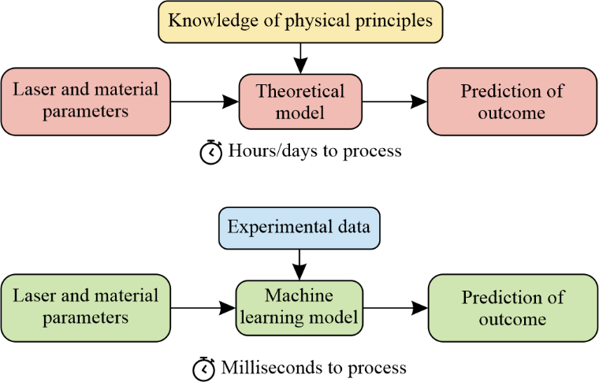

Fig. . Contrasting the practical application of (top) theoretically driven and (bottom) data-driven approaches for modelling laser machining.

Introduction to Machine learning

Machine learning is a broad field that encompasses a wide variety of algorithms that improve automatically through experience. Critically, such approaches do not require an explicit programmatical description of the relationship and rules that govern the data, and instead, the algorithms learn the properties of the data directly from the data. The field of machine learning can be broadly divided into supervised, unsupervised and reinforcement learning. Supervised learning [99-101] involves the generation of a mathematical model that maps input data onto the associated output data, and hence can be used to make predictions. Unsupervised learning [102-104] is used to discover structure within data, to find clustering or grouping of data points. Reinforcement learning [105-108] governs how a software agent makes decisions inside an environment to maximise a reward. Whilst all three are important areas of research, supervised learning has been predominantly the focus of investigation for laser machining to date and hence is the focus of this review. As shown in Fig. 2, within the field of machine learning (which can be described as a type of artificial intelligence) exists the field of deep learning. Within the field of deep learning exists the critically important convolutional neural network (CNN). A further subtype, known as the conditional generative adversarial network (cGAN) is a neural network architecture that involves two CNNs that assist each other during the training process.

Machine Learning Models

Within the field of machine learning, there are a wide range of models [109-111], with the most prominent briefly discussed here. An artificial neural network (ANN) is a network of connected units called artificial neurons, which are loosely inspired by the neurons in biological intelligence. As shown in Fig. 3, in general an ANN will have an input layer, a hidden layer, and an output layer. Internally, each artificial neuron will receive information from adjacent neurons and, after processing the sum of information using a nonlinear function, will transmit the processed information forwards through the network. The learning process typically involves the automatic optimisation of the nonlinear functions at each neuron, via an algorithm known as backpropagation [112-114]. The network therefore operates as a transfer function and can be used to transform input data into output data.

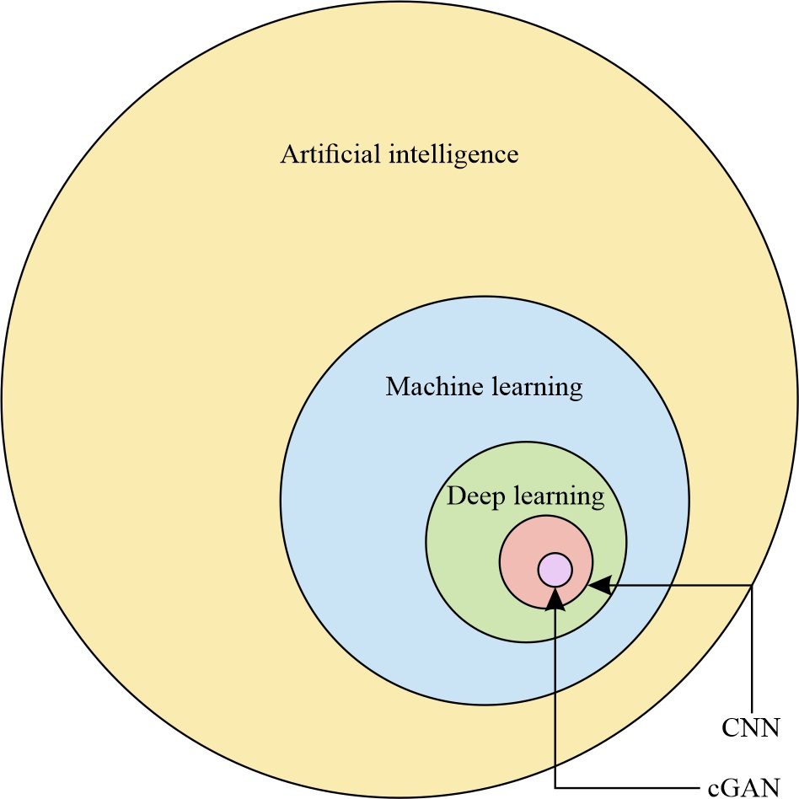

Fig. 2. Relationship between different types of machine learning discussed in this review.

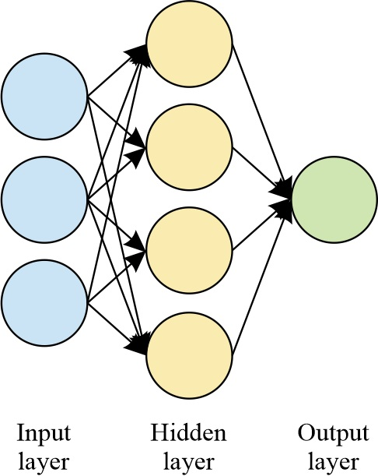

Fig. 3. Schematic of an ANN, showing the input layer, hidden layer, and the output layer.

Decision trees [115, 116] utilise a network of evaluations in order to make predictions about the value of an item directly from observations of the item. Support vector machines [117-119] allow the representation of the sample data as points in space, mapped such that there is a clear divider between two or more subsets of the sample data. New data items can then be mapped to the same space, and hence a category prediction made based on their location with respect to the divider. Regression analysis [120] includes a wide range of statistical methods that are used to assess the relationship between data inputs and associated outputs, and include both linear regression (e.g. using least-squares error metric to calculate a best-fit line through a data set) and nonlinear regression (e.g. using a quadratic of higher order polynomial fit). Bayesian networks [121, 122] are a method for creating a probabilistic connecting graphical model that allows the relationship between variables to be identified, and hence a probabilistic distribution of outcomes predicted for any given input. Genetic algorithms [123-125] are a type of search algorithm that is inspired by the process of natural selection, whereby algorithmic equivalents to biological processes such as mutation and recombination effects are used to create new genotypes in order to encourage the likelihood of identifying effective solutions to a given problem.

Deep Learning

A fundamentally important type of ANN is the deep neural network [126], which is generally defined as an ANN with multiple hidden layers. Critically, due to the nature of the nonlinear functions, as the number of hidden layers in an ANN is increased, the network will mathematically tend towards a universal function approximator [127, 128] and as such able to approximate any function, hence enabling practical application to considerably more complex tasks.

A convolutional neural network (CNN) is a type of deep neural network that is generally applied to image data, due to the capability for processing spatially represented data. CNNs are loosely inspired by the neuronal architecture in the biological visual cortex, where cortical neurons respond to a visual stimulus in a restricted area of the vision but where these areas overlap. Similarly, the computational neurons in a CNN process a single region of data (although overlapping with adjacent regions) through a series of convolutional processes. A convolution is a mathematical operator that is used to calculate the integral of the product of two functions as one is shifted, for all possible shift values. In a CNN, the input data for each layer is convolved with a generally much smaller array, known as a filter, to produce data for the next layer. The consequence of this process is that the output data contains a definitive description regarding the similarity of the filter and the input data. The convolutional process therefore acts as a pattern matching algorithm, identifying where (and how strongly) the filter data matches the input data. In practice, if a filter contained a circular shape, this process would identify all locations in the input image where a circular shape with the same properties existed. Consecutive convolutional layers therefore introduce the capability for higher and higher abstraction of pattern recognition, whilst increasing the number of filters at each layer improves the capability to recognise a greater number of patterns in the input data. Critically, these filters are randomly initialised and optimised automatically during the training process. CNNs have been used widely for both classification of images (i.e. describing the content in images) and image-to-image processing (i.e. transforming an image into another image). The concept for a classification CNN is shown in Fig. 4, which shows the transformation from 2D data input (e.g. a photograph of a scene) to an output that describes the content of the input data (e.g. what objects are in the photo) [129-131]. The concept for an image-to-image CNN is shown in Fig. 5, which shows the transformation of input 2D data to output 2D data with a different appearance through encoding and decoding processes (e.g. for image enhancement or the provision of spatial labelling [132]). The principle of both approaches are similar and involve the aforementioned convolutional processes in addition to a range of many other algorithmic processes including pooling, batch normalisation and dropout [133].

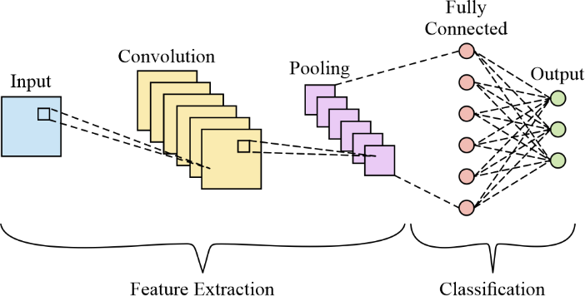

Fig. 4. Concept of classification CNN, showing the transformation from input image to output labels through a feature extraction and classification process.

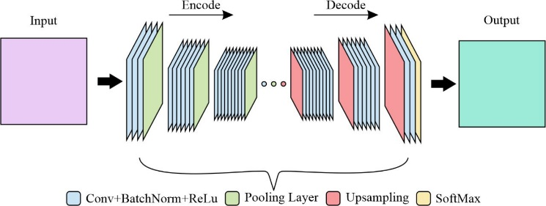

Fig. 5. Concept of image-to-image CNN, showing the transformation from input image to output image through an encoding and decoding process.

A conditional generative adversarial network (cGAN) [134, 135] can be envisaged as two CNNs that are trained simultaneously. Specifically, the network consists of a generator, which transforms an experimental input image into a generated output image, and a discriminator, which receives an experimental input image along with either the associated experimental output image or the associated generated output image, as shown in Fig. 6. The discriminator then judges whether the output image that it is provided with is experimental or generated. During training, the discriminator becomes more effective at judging whether the generator output is realistic, which enables the generator to become more effective at producing realistic images. The nature of this adversarial training approach is that both the generator and the discriminator improve in effectiveness during the training process [136, 137] until a Nash equilibria is reached [138]. Once training is complete, the generator can be used as an image-to-image processing function, for the transformation of images that were not in the training data set.

Machine Learning and Laser Machining

As highlighted in section 1, laser machining is extremely challenging to model accurately when starting from the fundamental physical rules of light-matter interaction, particularly for ultrashort pulses. Whilst there is a wealth of modelling approaches, the challenges associated with scaling up such models to practical size scales and the inclusion of all experimental characteristics has driven the search for alternative modelling solutions. Machine learning has recently shown itself to be an important alternative, as it offers the capability to produce a model of an experiment directly from experimental data. In other words, machine learning enables a data-driven modelling approach for laser machining.

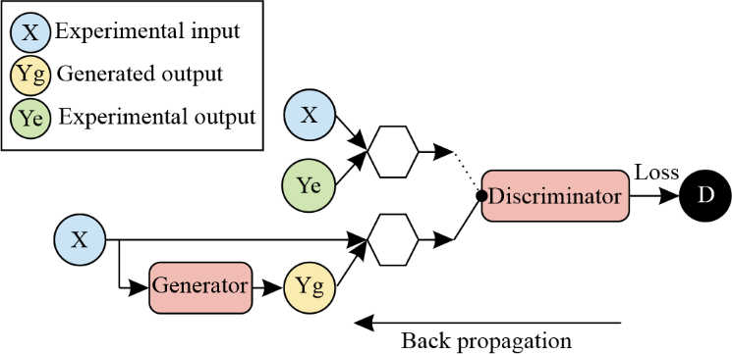

Fig. 6. Concept of the cGAN architecture. The generator network transforms experimental input into generated output (i.e. a prediction). The discriminator network is trained to identify whether the input pair is i) experimental input and experimental output or ii) experimental input and generated output.

As shown in this section, machine learning can be applied to laser machining to provide a modelling environment that enables a range of capabilities, such as the optimisation of processing parameters, the identification of the relationship between parameters, and the predictive visualisation of the outcome of laser machining under different experimental conditions. A critically important advantage of using a data-driven modelling approach is that all experimental characteristics, including those that may be challenging to model programmatically such as beam shape inhomogeneity or experimental noise, are automatically included in the modelling system. In general, the results in the literature have focussed on neural networks, and hence the discussion here is focussed on this machine learning technique.

In general, the practical application for using neural networks for modelling laser machining includes three stages, as shown in Fig. 7. The first stage is the collection of experimental data in the form of data inputs and their associated data outputs. As an example, this could be laser fluence and repetition rate as the inputs, and then a measure of the depth of the laser machined features as the output. The second stage is the training of the neural network, where the internal weights of the network are automatically adjusted via backpropagation. The neural network accuracy is typically measured during the training process to optimise the training progress. The third stage involves providing the trained neural network with a different set of input values, where the neural network then provides a prediction for the associated output values. Once trained, the neural network therefore can be used as a “black box” modelling unit that transforms input data into the associated output data. Notably, the nature of the transformation from input data to output data is specifically determined by the format of the input and output data used for training. For this example, the neural network would be able to predict the feature depth for any laser fluence and repetition rate, including of course those that were not including in the collected experimental data.

As shown in Fig. 7, once the neural network is trained, it can then be applied to the modelling of input data that was not included in the training data. Here, a key strategy in testing the accuracy of the predictions from a neural network is through the separation of the collected experimental data into training and validation pairs. In practice, this ensures that the data used for validation is not processed by the neural network during training, and hence operates as “unseen data”. It is important to note that as the training occurs on experimental data, bias (or inaccuracies) in the data will be replicated with the neural network. It is also true that a machine learning system trained on a set of data from one environment may not be able to accurately predict the case for another set of data, if the properties of the latter is not represented in the original training data.

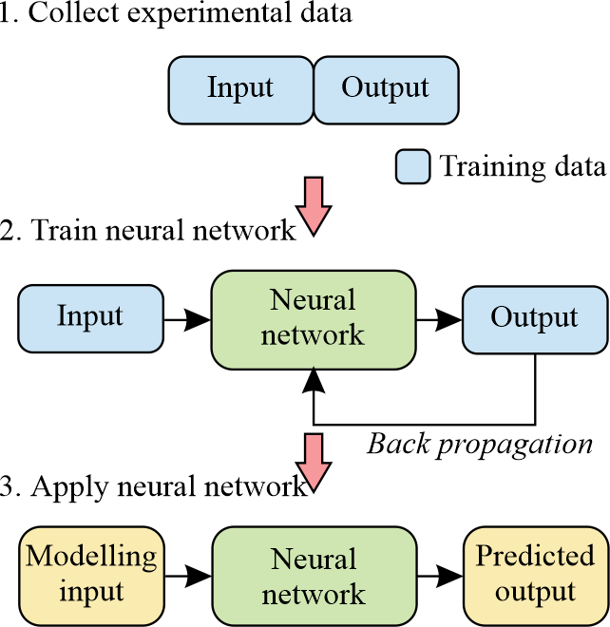

Fig. 7. Concept of practical application of machine learning for laser machining.

To highlight the relevance of the interface of laser machining and machine learning, Fig. 8 shows the yearly frequency of publications when using a range of search keywords (laser machining, machine learning, artificial neural network, convolutional neural network and generative adversarial network) in Google Scholar, with data for 2020 estimated based on the number of days remaining in the year at the point of data collection. This figure therefore provides a snapshot of publication activity for laser machining and all machine learning research fields over the last 40 years. “Laser machining” has seen an exponential rise, representing a steady improvement in manufacturing processes and techniques over this period. “Machine learning” has seen exponential growth from 1990 until 2018, followed by a rapid drop, which could be argued to be a result of the preference to use a more descriptive terminology, as this coincides with the advent of rapid growth in the use of “convolutional neural network” as a search term. “Artificial neural network” (i.e. ANN) saw a rapid increase between 1985 and 1995 with a constant exponential increase in frequency from 1995 onwards. “Convolutional neural network” (i.e. CNN) has experienced exponential growth between 1985 and 2014, before an extremely rapid acceleration of publications onwards. Similarly, “generative adversarial network”, which also includes the search results for conditional generative adversarial network, i.e. a cGAN, has seen exponential growth since 2014.

This remaining part of this section provides a chronological perspective of the literature at the interface of machine learning and laser machining, firstly focussed on ANNs and then followed by deep learning. Of interest is the extremely broad nature of the applications, which appear across almost all types of laser sources, materials, and size scales. Much of the literature is closely related to the needs of industry, where the drive for cost reduction requires absolute efficiency in the usage of laser photons. The literature presented in this section presents a clear association with the publication frequency data shown in Fig. 8, where literature results between the years 2000 and 2015 are almost exclusively based on ANNs (sections 3.1, 3.2 and 3.3), whilst the literature from 2015 onwards is increasingly based on deep learning (section 3.4).

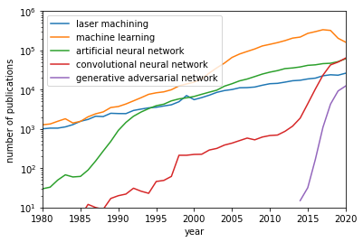

Fig. 8. Yearly frequency of publications with content corresponding to displayed search terms.

Steel

The most common material to be investigated has been steel, as this has many important industrial applications. The literature presents a series of approaches for identifying the optimal laser parameters for specific tasks. In general, this involved using an ANN with a single hidden layer, with a set of laser and sample parameters as the input, and with a measure of materials processing quality as the output. Ciarana et al. [139] used an ANN with a single hidden layer (network shape of 4-5-1) to optimise the machining parameters when machining straight and tapered walls in hardened steel (AISI H13) with an Nd:YAG with 20µm spot size. The input parameters for the ANN were pulse intensity, scanning speed, pulse frequency and cutting time, and output of dimensional prediction and surface roughness. Sivarao et al. [140] used an ANN (shape of 3-8-1) to predict the end product quality and surface roughness when cutting 3mm thick Manganese Molybdenum with a 4kW CO2 laser (Helius Hybrid CO2 Laser Cutting machine). The three input parameters were cutting speed, gas pressure and power, and the ANN was able to achieve a ~90% prediction accuracy. Dhara et al. [141] used an ANN (shape 4-25-2) for identifying the parameters needed to increase the depth of machined groove and reduce the recast layer, when using an Nd:YAG with spot size 100µm for micromachining of tungsten-molybdenum general purpose high speed steel. The input parameters were lamp current, laser repetition rate, pulse width and air pressure, with the outputs being depth of groove and height of recast layer.

Rajamam et al. [142] used regression (a type of machine learning) in order to model the effects of power and feed speed on the quality of machining, in terms of kerf width, surface roughness, striation frequency and the size of the heat affected zone, when machining steel with a CO2 laser. Teixidor et al. [143] explored a range of machine learning approaches for the modelling of the machining of microscale geometries in hardened steel with using an Nd:YAG. The parameters of scanning speed, pulse intensity and repetition rate were optimised to control the depth and width of channels, the surface roughness and the material removal rate. The ANN and decision tree approach was found to be superior to the k-nearest neighbor and linear regression approaches. Zhang et al. [144] used an ANN to predict the quality of cut for a 3KW CO2 laser cutting 1mm thick steel, with inputs of laser power and cutting speed, and outputs of dross, roughness and width. Radovanovic et al. [145] demonstrated the application of regression and an ANN for the modelling of surface roughness when cutting mild steel with a CO2 laser, where results showed that the ANN approach provided considerably higher accuracy and was effective in modelling the nonlinear and complex relationships between machining parameters.

Nakhjavani et al. [146] investigated the application of an ANN for the optimisation of process parameters when using a Nd:YAG laser for percussive drilling into 2.5mm mild steel EN3 sheets. As shown in Fig. 9, the input parameters of peak power, pulse width, pulse frequency, number of pulses, assist gas pressure and focal plane position were optimised to predict the hole entrance diameter, circularity of hole entrance and hole exit, and hole taper. Sohrabpoor et al. [147] applied an ANN and an adaptive inference model to predict the surface quality of laser processed 316L stainless steel cylindrical pins when machined with a CO2 laser. Velli et al. [148] showed that the laser induced periodic surface structures (LIPSS) [149-151] produced via a Yb:KBW femtosecond source on stainless steel (and titanium alloy and crystalline silicon) could be predicted via a range of machine learning models.

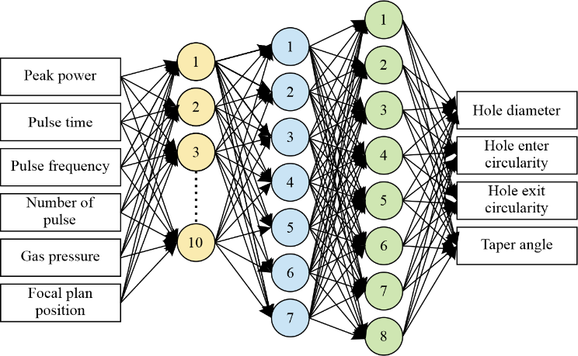

Fig. 9. Adapted from [146]. Architecture of ANN used for identification of optimal machining of steel.

Laser-based material modification without material removal is a technique often applied to steel for manufacturing applications. One such example, laser hardening, which involves the heating and cooling of the target metal to introduce metallurgical modification, is inherently complex and hence the attraction for an ANN prediction tool. Lambiase et al. [152] used an ANN with three hidden layers, for predicting the optimal laser parameters for the laser hardening of steel. Maji et al. [153] used an ANN (shape 3-11-1) to predict the optimal parameters for manufacturing dome profiles through surface melting of AISI 304 stainless steel sheets when using a Yb fibre laser, with inputs of laser power, scan speed and spot diameter, and associated output of dome height. A second example of material modification is the laser-based bending of steel. Cheng et al. [154] used an ANN in order to predict the bending angle of steel sheets when irradiated by a CO2 laser, for different values of scan speeds, laser powers, laser spots size, along with the thickness and length of the metal workpiece. The authors found an ANN with a single hidden layer of five neurons produced the optimal answer and was favourable to a regression model.

Aluminium and Other Metals

Aluminium features less frequently than steel, but in general has a similar approach to parameter optimisation through the use of an ANN. Campanelli et al. [155] used an ANN to determine the optimal scanning velocity and pulse frequency for the desired ablation depth in an aluminium alloy when using a Nd:YVO4 laser source with focus diameter of 40μm. Rahimi et al. [156] investigated the optimisation of laser engraving of Al-SiC composite via a Q-switched Nd:YAG laser via an ANN with shape of 4-9-1. The ANN inputs were gas flow, distance between workpiece and beam focus, laser repetition rate, and laser pump value, and associated ANN outputs were depth, width, and contrast of engraved zone. Feng et al. [157] used an ANN to model the key processing parameters for underwater laser milling of RSA-905 aluminium.

Results for machining in other metals include the following. Yousef et al. [158] used a set of two ANNs to model the mean depth and diameter of the crater in the materials of brass, copper and stainless steel when machined with an Nd:YAG with varying pulse energy. As shown by the architecture in Fig. 10, Klancnik et al. [159] used an ANN for predicting roughness and kerf width when using a CO2 laser for cutting tungsten. Barletta et al. [160] demonstrated that an ANN can be applied for the optimisation of paint stripping of epoxy-polyester coatings on aluminium substrates when using a 1.5kW diode laser source. As shown by the network architecture in Fig. 11, Biswas et al. [161] used an ANN to model laser microdrilling of titanium nitride-aluminium composite using an Nd:YAG, with ANN inputs of lamp current, pulse frequency, pulse width, air pressure and focal length.

Plastic, Ceramic, Glass and Other Non-Metals

The manufacturing approach for machining plastics is generally the use of a CO2 laser to produce melting. However, melting is still a complex process that can be challenging to optimise. Desai et al. [162] used an ANN for predicting the cutting depth when machining a variety of thermoplastics with a CO2 laser, for varying laser power, cutting speed, absorptivity, and latent heat of vapourisation. Noor et al. [163] used an ANN (shape 3-7-1) to optimise the surface roughness when cutting 3mm thick acrylic sheets with a CO2 laser, for ANN inputs of laser power, cutting speed and tip distance. Yang et al. [164] demonstrated the application of the Taguchi method (a statistical model) for improving predictive accuracy when using a ANN to model CO2 laser cutting of PMMA. Tsai et al. [165] optimised the cutting of the epoxy on quad-flat no-leads packages (used for attaching integrated circuits) using a 1μm wavelength solid state laser. Dhupal et al. [166] used an ANN to optimise the machining of microgrooves in aluminium titanate ceramic when using an Nd:YAG laser machining microgrooves in aluminium titanate ceramic. The ANN (shape of 5-9-9-3) had inputs of lamp current, repetition rate, pulse width, assist air pressure, and cutting speed, and outputs of upper width, lower width and depth of the trapezoidal microgroove. Karazi et al. [167] used an ANN to predict the width and depth of microchannels in glass when using a CO2 laser. Song et al. [168] showed that an ANN can be used to optimise the process of laser-assisted machining, in order to pre-heat and hence, soften the target material to reduce machining time and wear of the mechanical cutting tools. Liao et al. [169] used decision tree methods to predict the damage growth on fused silica optics in the case of an Nd:YAG laser.

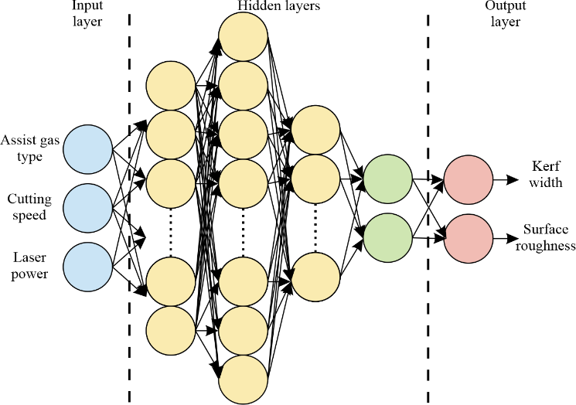

Fig. 10. Adapted from [159]. Network architecture used for the optimisation of CO2 laser parameters for cutting tungsten.

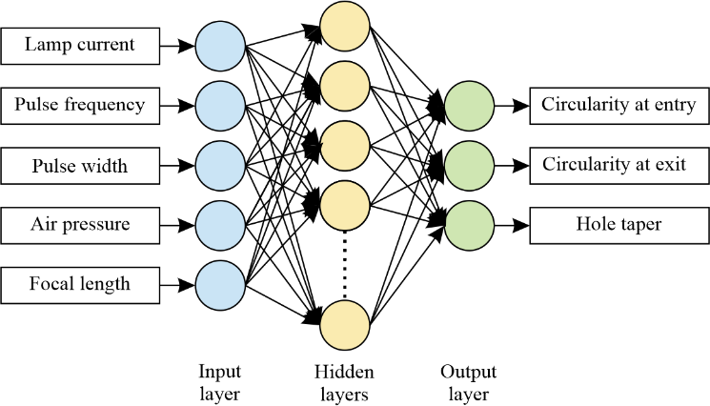

Fig. 11. From [161]. Architecture used for optimisation of parameters for the microdrilling of titanium nitride-aluminium.

Jacob et al. [170] used an ANN to predict etch depth for photoresist removal via a 248nm Excimer laser. Yildiz et al. [171] modelled the thermal damage using an ANN for a range of lasers for biological applications. Laser materials processing also has application in the clothing industry, including for the application of producing faded and torn products such as jeans [172]. Hung et al. [173] showed that an ANN can be used to predict the colour properties of cotton fabrics under different material parameters. The ANN (shape 8-25-4) had inputs including fibre composition, fabric density, mass of fabric, fabric thickness and density of yarn, and had outputs including a range of parameters used to define colour yield. The same author [174] also showed that two hidden layers assisted in the colour prediction when varying laser processing parameters related to intensity, resolution and speed.

Deep Learning

In general, the literature associated with the application of deep learning for laser machining presents capabilities well beyond those associated with ANNs. Of particular importance here is the capability for applying image-based data (i.e. 2D data) as an input for processing by the neural network. Oh et al. [175] used a cGAN and CNN to provide a thermal simulation in order to predict the hardness distribution when using a 2kW fibre laser for heat-treatment of steel, clearly showing improvement over previous modelling approaches. Sun et al. [176] used a CNN to identify and predict the effectiveness of laser cleaning of rusty iron through analysis of images of the samples. In the field of food science, Chen et al. [177] used a CNN to predict the visual appearance of dough when irradiated by a CO2 laser, for different laser and dough parameters.

A critical result in the field of ultrafast laser machining with deep learning has been the integration of camera images during manufacturing to assist in real-time feedback, particularly given the additional complexities arising from the use of femtosecond pulses. As shown in Fig. 12, Mills et al. [178] used images of the sample during laser machining in order to identify the material type (silica and nickel), the number of laser pulses used for machining, and the laser fluence. The motivation here was that the effects of experimental noise, such as laser fluence fluctuations, could be identified in real-time during laser machining. Similarly, Tani et al. [179] used the interferometric speckle pattern from the surface of the laser machined region as an input to a CNN in order to identify sample parameters including the depth of machining and the type of material (aluminium, copper and nickel). Here, the anticipation is that real-time feedback, in combination with the capability for a neural network to identify the material type, has significant potential for the enhanced laser-based processing of structures consisting of layers of different materials.

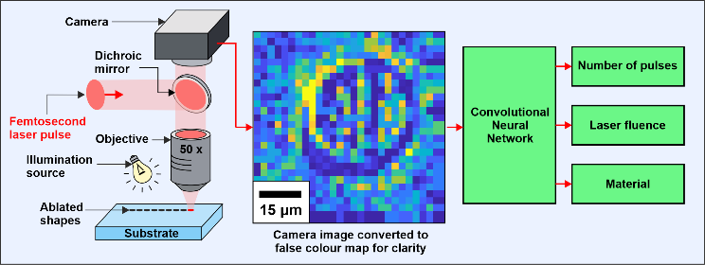

Fig. 12. Adapted from [178]. The potential for using a neural network for real-time feedback.

An important direction in this field has been the demonstration of deep learning for predictive visualisation of the 3D surface profile of a target material, when using a variety of spatial intensity profiles for ultrafast laser machining, as shown by the concept in Fig. 13. This has been achieved through the application of neural networks that can process arrays of data as both the input (e.g. spatial intensity profile) and the output (e.g. 3D depth profile). The complexity of modelling such a dynamic from a theoretical understanding of light-matter interaction is significant due to the plethora of effects, which includes both the nonlinear interactions typical of ultrafast laser machining and the effects of diffraction associated with non-Gaussian spatial intensity profiles. Whilst liquid crystal spatial light modulators have seen many applications in ultrafast laser machining [180-182], the focus of the application to machine learning has seen the use of digital micromirror devices (DMDs) [183-185] for beam shaping. DMDs have extensive use as spatial light modulators for both additive [186-190] and subtractive [191-195] laser-based manufacturing.

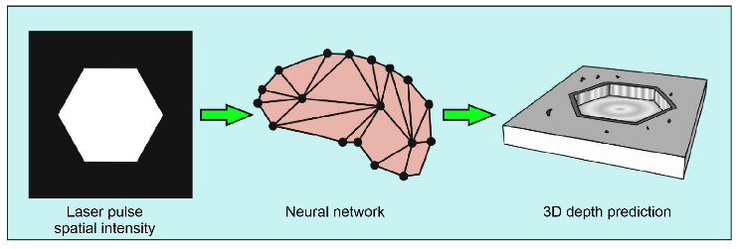

Fig. 13. Adapted from [196]. Concept of using a neural network for predictive visualisation of laser machining with varying spatial intensity profiles.

Mills et al. [98] showed that a cGAN can be used to transform the spatial intensity profile used for ultrafast laser machining into a generated scanning electron microscope (SEM) image of the machined sample, hence providing a predictive visualisation of what the sample would look like if imaged via an SEM. Analysis of the generated SEM images showed that the cGAN had learned properties of diffraction. Heath et al. [196] used a cGAN to predict the 3D depth profile of the sample for a single laser pulse with a range of spatial intensity profiles. The capability of this neural network is shown in Fig. 14, where the a,c) 3D surface profile predicted via the neural network can be compared to the b,d) experimentally measured 3D surface profile, when femtosecond laser machining with a single pulse with one of two different spatial intensity profiles. Analysis of the outputs from the neural network model was used to predict a range of properties, such as the degree of debris deposition for different beam sizes. This work was enhanced by McDonnell et al. [197] who extended this work to include three laser pulses, and showed that the cGAN was able to predict that multiple pulses could enable a higher machining resolution than a single laser pulse, when each pulse had a specific spatial intensity profile. In combining the concepts of real-time correction and DMD-based beam shaping, Xie et al. [198] showed that a DMD can be used in a real-time feedback loop in order to provide corrections to the beam shape and position during laser machining, along with the demonstration of the real-time ceasing of laser machining at task completion, despite not knowing the task length beforehand. As presented here, recent results have demonstrated the potential for using ANNs for modelling thermal and structural effects during laser machining [199, 200], and for using GANs for 3D visualisation of surfaces, such as those produced for single laser pulses [98] and multiple laser pulses [197]. The authors anticipate that further breakthroughs in the field of data-driven machine learning for laser machining will assist in the development of new understanding of the transient processes that occur during laser machining.

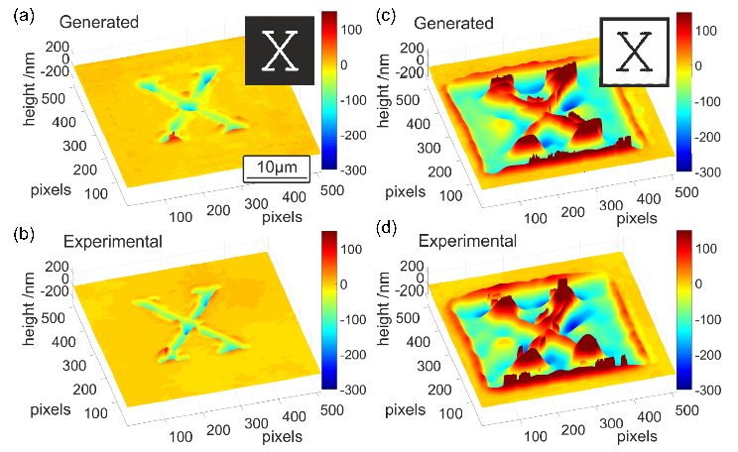

Fig. 14. From [196]. Demonstration of using a cGAN for the predictive visualisation of the 3D surface profile when laser machining with different spatial intensity profiles.

Future Prospects

Whilst this review has provided an insight into the application of machine learning for laser machining, machine learning has similarly already transformed many aspects of manufacturing in general (see for example reviews for optimisation tools [201], smart machining [202] and additive manufacturing [203, 204]). Machine learning has also been applied to other laser based manufacturing approaches [205-208] and for the control and optimisation of the laser sources themselves [209, 210]. The techniques for imaging the sample have also developed rapidly, from using a camera and CNN for real-time monitoring of the laser beam [211], to using a CNN for positional correction during manufacturing [212]. The application of machine learning for supporting the use of a laser for sample observation includes feature detection in wood [213], surface roughness measurements [214], laser-based odometry [215] and laser induced breakdown spectroscopy [216]. Machine learning has also repeatedly shown the capability for enhancing computational imaging and microscopy [217-223]. Hence, in summary, machine learning is being applied to the entire spectrum of laser machining, from the lasers to the material interaction, to the imaging and sample analysis. Whilst this review up to this point has been focussed on the progress of this field to date, this section offers the authors’ view on the future milestones for this field, along with some of the anticipated critical challenges.

The All-Encompassing Neural Network

To date, and as discussed in section 3, the application demonstrations at the interface of laser machining and machine learning have been extremely broad. For example, neural networks have been applied to a very wide range of individual materials, such as steel, aluminium, and plastics. However, whilst a neural network trained on experimental data from steel may be extremely effective at predicting the effect of machining steel with different laser parameters, in general, the network will be less effective at modelling other materials. A similar argument can be applied in the case for laser parameters, such as laser wavelength. This is simply a consequence of the property that neural networks are generally much more effective at interpolation (i.e. within the training dataset) than extrapolation (i.e. beyond the remit of the training dataset). This leads to the important realisation that neural networks need to be trained on data appropriate to the problem that is desired to be solved.

Ultimately, it could be argued that the capability of neural networks is based on the three factors of i) availability of computing power, ii) quality and amount of training data, and iii) developments in neural network architecture and algorithmic processes. As the likelihood is that all three factors will continue to increase (in fact, computing power has historically increased exponentially [224]), the anticipation is that neural network capability for laser machining will continue to increase over time. As historical evidence for this hypothesis, the literature around the year 2010 generally shows the optimisation of individual laser parameters, whilst the literature around 2020 describes applications of neural networks for producing predictive surface visualisations [98] and taking into account diffractive effects [197]. This period of time has clearly resulted in a significant development of neural network capability for modelling laser machining, and hence it an interesting thought experiment to extrapolate this progress in order to identify potential future capability. Here, it is the authors’ view that a consummate milestone in this field will be a neural network that can be applied to all laser machining applications. In practice, this could be a neural network that has been trained on experimental data for all possible materials, and under all possible lasers and associated laser parameters, as shown by the concept in Fig. 15. Such a neural network could therefore have encoded all light-matter interaction effects (e.g. heating, ablation, ionisation), in addition to light propagation effects (i.e. diffraction and interference), and hence, be an all-encompassing model for laser machining. Critically, due to the nature of the neural network architecture, modelling calculations on such a neural network may only take a few milliseconds, which would be fundamentally ground-breaking capability compared to calculations based on theoretical understanding that can take days or even weeks.

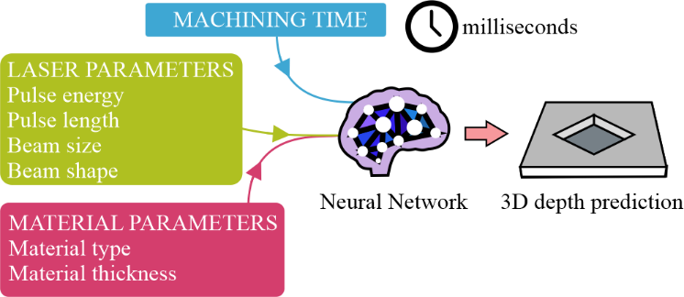

Fig. 15. Anticipated milestone: A neural network that can model all aspects of laser machining, for all laser and material parameters, within a time scale of milliseconds.

Real-Time Error Compensation

Neural networks have shown the capability for real-time observation and identification of laser and material parameters during laser machining [178, 179]. In addition, neural networks been shown to achieve the modelling of laser machining under a range of laser parameters within milliseconds [98, 196], hence demonstrating a real-time modelling capability. It is of the authors’ view that the synergy of real-time observation and real-time modelling will lead to the provision of the fundamentally important milestone of real-time error compensation, as highlighted by the diagram in Fig. 16.

As an example, consider the case that the laser fluence erroneously and unintentionally increases by 10% during laser machining, and consequently the target material begins to be machined incorrectly. The real-time observational component (e.g. a camera and neural network) recognises that the appearance of the target material is now different to the anticipated appearance of the material at this point in the machining and, through processing of the observational data, provides the information that the laser fluence has increased by 10%. However, due to the highly nonlinear nature of laser machining, reducing the laser fluence to 90% of the original value for a period would almost certainly not produce the desired correction. Instead, what is needed is a modelling approach that can identify the laser parameters that should be changed (and to what magnitude) to compensate for the previous manufacturing mistake. Critically, this modelling calculation should be completed in real-time, to compensate for the laser machining mistake immediately. It is of the authors’ view that the implementation of such a technique would enable significant improvements to quality control in laser machining, including for the automation and control of tasks where the process conditions are not known before machining commences [198], for example, the laser cleaning of rust. Such process control may be of particular importance for the future of high-precision ultrafast laser machining, where the extremely high nonlinearities provide the opportunity for techniques such as sub-diffraction-limit fabrication [53, 192, 225, 226] but with the associated extreme sensitivity to fluctuations in the laser parameters (which could therefore be compensated in real-time via machine learning).

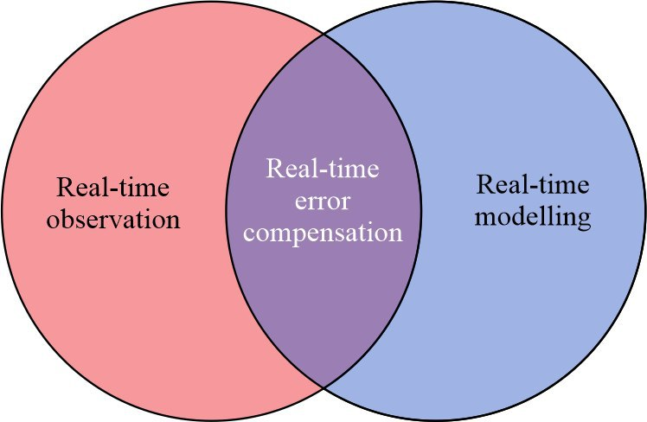

Fig. 16. Anticipated milestone: Enabling real-time error compensation, through the application of neural networks for simultaneous real-time error identification and real-time modelling.

Assisting in Developing Physical Understanding

As shown in this review, neural networks have been shown to be capable of solving extremely complex problems directly from experimental data, and hence without the need for physical understanding of the system. Therefore, it is critical that neural networks are able to provide insight and understanding of the problems that they are used to solve. In practice, this has already happened to a limited extent, where relationships between parameters have been identified, for example, between laser parameters and the associated sample surface quality. As a more specific example, Heath et al. [196] identified that the neural network outputs were inconsistent with known theoretical calculations, until the theory was adapted in order to include a misaligned mirror model (the misaligned mirror was later realised on the experimental setup). Whilst in specific cases the neural network parameters learnt during training can be analysed [227], the number of parameters (around 10^8 for the cGAN in [98]) makes this process extremely challenging due to obfuscation.

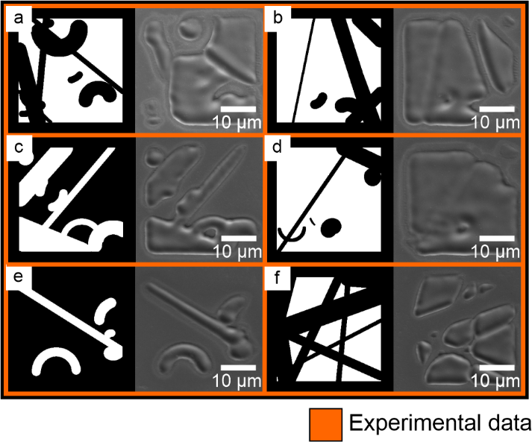

Fig. 17. Adapted from [98]. Examples of training data collected for the predictive visualisation of laser machining for varying spatial intensity profile, showing (left) programmed spatial intensity profile and (right) SEM image of the corresponding experimental laser machined surfaces. Note that the training data is therefore formed of randomly generated spatial intensity profiles.

Whilst experimental data collection generally requires the changing of only a single parameter at a time while keeping all other constant (for example measuring the sample quality for all laser fluences whilst keeping all other parameters constant), the approach for data collection when using a neural network is fundamentally different. Here, there is no need for systematic data collection and instead a sparse and unsystematic data collection across all parameters is sufficient. As an example, to create training data for the neural network capable of predictive visualisation of laser machining for any spatial intensity profile (as shown in the concept in Fig. 13, with associated results shown in Fig. 14) the training data was formed of randomly generated spatial intensity profiles, as shown in Fig. 17. This may be considered in stark contrast to the generally accepted systematic approach for experimental data collection. Importantly, even though neural network training data may be associated with randomly chosen parameter values, the trained neural network can still provide an output prediction for any suitable input, and hence can be used to produce a partial differential of data across any dimension of parameter space. The anticipation is that this predictive capability could therefore be used to enable the construction of a more general set of rules and understanding for laser machining.

Challenges

A fundamental challenge for deep learning is the significant amount of data that is generally considered as necessary for accurate training. In the case of laser machining, this poses a critical challenge, as the accrual of each single data item physically involves parameter changes of experimental hardware along with subsequent laser materials processing, in addition to an associated measurement to provide a quantification of the success or quality of the processing under the chosen parameters. Therefore, physically collecting tens or hundreds of thousands of data points could take weeks or longer. Clearly this is not practically feasible and hence, an approach known as data augmentation can be applied to increase the effective amount of training data. In the case of image-based data, this often includes approaches such as random cropping [130], flipping [228], dropout [229], batch normalization [230] and selective data erasing [231]. Such methods have already been demonstrated in the field of laser materials processing [198], and will likely be an important future direction.

To observe the sample faster and more accurately during machining, a key strategy may be reducing hardware processing times through advances in photonics. Several developments are in progress here, ranging from using lithography to create neural networks onto the camera sensor [232] to a plethora of techniques for integrating photonics with computing [233-239]. Finally, whilst neural networks are generally designed as deterministic (i.e. constant output for constant input), in specific cases small changes in the input can have dramatic effects on the output. This effect is explored in the field of adversarial attacking [240, 241], where it is shown that in extremely specific cases, changes to the intensity value of even just a single image pixel [242] can result in a fundamentally incorrect prediction by the neural network. Whilst research into adversarial attacking is assisting the development of techniques for making neural network predictions more robust [243], the application of neural networks for laser machining may therefore need to include additional levels of failsafe such as setting hard limits of parameters or additional sanity checking algorithms in order to ensure safety for human operators and equipment.

Conclusions

This review article has discussed the rich and rapidly developing interface of laser machining and machine learning, along with prospects for the future of this field. Laser machining is a well-established manufacturing process that has many applications across academia and industry. However, the flexibility inherent in the process, such as the plethora of different wavelengths, pulse energies and pulse lengths, means that optimisation of parameters for specific tasks can be challenging. Due to the highly nonlinear light-matter interactions that occur during laser machining, modelling based on fundamental understanding can be limited in accuracy when applied to practical experiments. Machine learning offers a solution to this problem, namely a data-driven modelling approach that can be used to optimise laser parameters and be used as a predictive visualisation tool for laser machining. Critically, machine learning can provide simulation capability on the time scale of milliseconds, hence enabling the capability for real-time modelling. In addition, machine learning has been shown to be capable of real-time observation of the sample being machined, to identify laser and material parameters. The authors’ postulation is therefore that neural networks will enable real-time error compensation for laser machining, with associated future manufacturing breakthroughs in resolution, reliability, and speed.

Acknowledgements

B.M. was supported by an EPSRC Early Career Fellowship (EP/N03368X/1) and EPSRC Investigator-Led Grant (EP/T026197/1). The authors would like to thank Prof. Robert Eason for constructive help in reviewing this manuscript. Data supporting this study are openly available from the University of Southampton repository at be https://doi.org/10.5258/SOTON/D1710.

References

1. Diaci, J., et al., Rapid and flexible laser marking and engraving of tilted and curved surfaces. Optics and lasers in engineering, 2011. 49(2): p. 195-199.

2. Qi, J., K. Wang, and Y. Zhu, A study on the laser marking process of stainless steel. Journal of Materials Processing Technology, 2003. 139(1-3): p. 273-276.

3. Valette, S., et al., Influence of femtosecond laser marking on the corrosion resistance of stainless steels. Applied Surface Science, 2006. 252(13): p. 4696-4701.

4. Velotti, C., et al., Laser marking of titanium coating for aerospace applications. Procedia Cirp, 2016. 41: p. 975-980.

5. Wrobel, J., A. Marchant, and D. Howe, Laser marking of thin organic films. Applied Physics Letters, 1982. 40(11): p. 928-930.

6. Moradi, M., et al., Enhancement of low power CO2 laser cutting process for injection molded polycarbonate. Optics & Laser Technology, 2017. 96: p. 208-218.

7. Schulz, W., et al., Heat conduction losses in laser cutting of metals. Journal of Physics D: Applied Physics, 1993. 26(9): p. 1357.

8. Choudhury, I.A. and S. Shirley, Laser cutting of polymeric materials: an experimental investigation. Optics & Laser Technology, 2010. 42(3): p. 503-508.

9. Niziev, V. and A. Nesterov, Influence of beam polarization on laser cutting efficiency. Journal of Physics D: Applied Physics, 1999. 32(13): p. 1455.

10. Powell, J., CO2 laser cutting. Vol. 214. 1993: Springer.

11. Rauh, B., et al., UV-laser cleaning and surface characterization of an aerospace carbon fibre reinforced polymer. International Journal of Adhesion and Adhesives, 2018. 82: p. 50-59.

12. Shi, T., et al., A study of microstructure and mechanical properties of aluminum alloy using laser cleaning. Journal of Manufacturing Processes, 2019. 42: p. 60-66.

13. Park, H.K., et al., A practical excimer laser-based cleaning tool for removal of surface contaminants. IEEE Transactions on Components, Packaging, and Manufacturing Technology: Part A, 1994. 17(4): p. 631-643.

14. Tam, A.C., H.K. Park, and C.P. Grigoropoulos, Laser cleaning of surface contaminants. Applied surface science, 1998. 127: p. 721-725.

15. Tam, A.C., et al., Laser‐cleaning techniques for removal of surface particulates. Journal of Applied Physics, 1992. 71(7): p. 3515-3523.

16. Salonitis, K., et al., A theoretical and experimental investigation on limitations of pulsed laser drilling. Journal of Materials Processing Technology, 2007. 183(1): p. 96-103.

17. Gautam, G.D. and A.K. Pandey, Pulsed Nd: YAG laser beam drilling: A review. Optics & Laser Technology, 2018. 100: p. 183-215.

18. Hwang, D., T. Choi, and C. Grigoropoulos, Liquid-assisted femtosecond laser drilling of straight and three-dimensional microchannels in glass. Applied Physics A, 2004. 79(3): p. 605-612.

19. Yilbaş, B.S., A.Z. Şahin, and R. Davies, Laser heating mechanism including evaporation process initiating laser drilling. International Journal of Machine Tools and Manufacture, 1995. 35(7): p. 1047-1062.

20. Von Allmen, M., Laser drilling velocity in metals. Journal of Applied Physics, 1976. 47(12): p. 5460-5463.

21. Yue, Y. and T. Kurokawa, Designing responsive photonic crystal patterns by using laser engraving. ACS applied materials & interfaces, 2019. 11(11): p. 10841-10847.

22. Uh, J., et al., Laser engraving of micro-patterns on roll surfaces. ISIJ international, 2002. 42(11): p. 1266-1272.

23. Lahoz, R., et al., Laser engraving of ceramic tiles. International Journal of Applied Ceramic Technology, 2011. 8(5): p. 1208-1217.

24. Kan, C., C. Yuen, and C. Cheng, Technical study of the effect of CO2 laser surface engraving on the colour properties of denim fabric. Coloration Technology, 2010. 126(6): p. 365-371.

25. Moriya, T., et al., Development of PET detectors using monolithic scintillation crystals processed with sub-surface laser engraving technique. IEEE Transactions on Nuclear Science, 2010. 57(5): p. 2455-2459.

26. Ravi‐Kumar, S., et al., Laser ablation of polymers: a review. Polymer International, 2019. 68(8): p. 1391-1401.

27. Preuss, S., A. Demchuk, and M. Stuke, Sub-picosecond UV laser ablation of metals. Applied Physics A, 1995. 61(1): p. 33-37.

28. Vogel, A. and V. Venugopalan, Mechanisms of pulsed laser ablation of biological tissues. Chemical reviews, 2003. 103(2): p. 577-644.

29. Liu, X., D. Du, and G. Mourou, Laser ablation and micromachining with ultrashort laser pulses. IEEE journal of quantum electronics, 1997. 33(10): p. 1706-1716.

30. Chichkov, B.N., et al., Femtosecond, picosecond and nanosecond laser ablation of solids. Applied physics A, 1996. 63(2): p. 109-115.

31. Scotti, G., et al., Laser additive manufacturing of stainless steel micro fuel cells. Journal of Power Sources, 2014. 272: p. 356-361.

32. Zhu, Y., et al., Microstructure and mechanical properties of hybrid fabricated Ti–6.5 Al–3.5 Mo–1.5 Zr–0.3 Si titanium alloy by laser additive manufacturing. Materials Science and Engineering: A, 2014. 607: p. 427-434.

33. Leung, C.L.A., et al., The effect of powder oxidation on defect formation in laser additive manufacturing. Acta Materialia, 2019. 166: p. 294-305.

34. Gu, D.D., et al., Laser additive manufacturing of metallic components: materials, processes and mechanisms. International materials reviews, 2012. 57(3): p. 133-164.

35. Lin, T.-C., et al., Aluminum with dispersed nanoparticles by laser additive manufacturing. Nature communications, 2019. 10(1): p. 1-9.

36. Grant-Jacob, J.A., et al., Micron-scale copper wires printed using femtosecond laser-induced forward transfer with automated donor replenishment. Optical Materials Express, 2013. 3(6): p. 747-754.

37. Mills, B., et al., Single-pulse multiphoton fabrication of high aspect ratio structures with sub-micron features using vortex beams. Applied Physics A, 2012. 108(3): p. 651-655.

38. Akman, E., et al., Laser welding of Ti6Al4V titanium alloys. Journal of materials processing technology, 2009. 209(8): p. 3705-3713.

39. Cao, X.-j., et al., A review of laser welding techniques for magnesium alloys. Journal of Materials Processing Technology, 2006. 171(2): p. 188-204.

40. Hong, K.-M. and Y.C. Shin, Prospects of laser welding technology in the automotive industry: A review. Journal of Materials Processing Technology, 2017. 245: p. 46-69.

41. Wang, P., et al., Laser welding dissimilar materials of aluminum to steel: an overview. The International Journal of Advanced Manufacturing Technology, 2016. 87(9-12): p. 3081-3090.

42. Stavridis, J., A. Papacharalampopoulos, and P. Stavropoulos, Quality assessment in laser welding: a critical review. The International Journal of Advanced Manufacturing Technology, 2018. 94(5-8): p. 1825-1847.

43. Lee, C.K., R.F. Chaiken, and J.M. Singer. Charring pyrolysis of wood in fires by laser simulation. in Symposium (International) on Combustion. 1977. Elsevier.

44. Stepanov, A., et al., Laser cutting of leather: tool for industry or designers? Physics Procedia, 2015. 78: p. 157-162.

45. Hung, O.-n. and C.-w. Kan, Effect of CO2 laser treatment on the fabric hand of cotton and cotton/polyester blended fabric. Polymers, 2017. 9(11): p. 609.

46. Blutinger, J.D., et al., Characterization of dough baked via blue laser. Journal of Food Engineering, 2018. 232: p. 56-64.

47. Chen, M.-F., et al., Laser coding on the eggshell using pulsed-laser marking system. Journal of Materials Processing Technology, 2009. 209(2): p. 737-744.

48. Majumdar, J.D. and I. Manna, Laser processing of materials. Sadhana, 2003. 28(3-4): p. 495-562.

49. Padmanabham, G. and R. Bathe, Laser materials processing for industrial applications. Proceedings of the National Academy of Sciences, India Section A: Physical Sciences, 2018. 88(3): p. 359-374.

50. Jansen, T., et al., Processing of Advanced Battery Materials—Laser Cutting of Pure Lithium Metal Foils. Batteries, 2018. 4(3): p. 37.

51. Kelly, S., et al., Using hybrid laser-arc welding to reduce distortion in ship panels. Welding Journal (Miami, Fla), 2009. 88(3): p. 32-36.

52. Jokinen, T., et al., Welding of ship structural steel A36 using a Nd: YAG laser and gas–metal arc welding. Journal of Laser Applications, 2000. 12(5): p. 185-188.

53. Ali, M., et al., Review of laser nanomachining. Journal of laser applications, 2008. 20(3): p. 169-184.

54. Korte, F., et al., Far-field and near-field material processing with. femtosecond laser pulses. Applied Physics A, 1999. 69(1): p. S7-S11.

55. Tanaka, T., H.-B. Sun, and S. Kawata, Rapid sub-diffraction-limit laser micro/nanoprocessing in a threshold material system. Applied Physics Letters, 2002. 80(2): p. 312-314.

56. Gan, Z., et al., Three-dimensional deep sub-diffraction optical beam lithography with 9 nm feature size. Nature communications, 2013. 4(1): p. 1-7.

57. Stoian, R., Volume photoinscription of glasses: three‑dimensional micro‑and nanostructuring with ultrashort laser pulses. Applied physics. A, Materials science & processing, 2020. 126(6).

58. Parandoush, P. and A. Hossain, A review of modeling and simulation of laser beam machining. International journal of machine tools and manufacture, 2014. 85: p. 135-145.

59. Modest, M. and H. Abakians, Evaporative cutting of a semi-infinite body with a moving CW laser. 1986.

60. Aloke, R., et al., A model for prediction of dimensional tolerances of laser cut holes in mild steel thin plates. International Journal of Machine Tools and Manufacture, 1997. 37(8): p. 1069-1078.

61. Di Pietro, P. and Y. Yao, A new technique to characterize and predict laser cut striations. International Journal of Machine Tools and Manufacture, 1995. 35(7): p. 993-1002.

62. Yilbas, B. and A. Kar, Thermal and efficiency analysis of the CO2 laser cutting process. Optics and lasers in engineering, 1998. 30(1): p. 93-106.

63. Man, H., J. Duan, and T. Yue, Dynamic characteristics of gas jets from subsonic and supersonic nozzles for high pressure gas laser cutting. Optics & laser technology, 1998. 30(8): p. 497-509.

64. Kaebernick, H., D. Bicleanu, and M. Brandt, Theoretical and experimental investigation of pulsed laser cutting. CIRP Annals, 1999. 48(1): p. 163-166.

65. Cenna, A. and P. Mathew, Analysis and prediction of laser cutting parameters of fibre reinforced plastics (FRP) composite materials. International Journal of Machine Tools and Manufacture, 2002. 42(1): p. 105-113.

66. Tani, G., L. Tomesani, and G. Campana, Prediction of melt geometry in laser cutting. Applied surface science, 2003. 208: p. 142-147.

67. Modest, M.F., Three-dimensional, transient model for laser machining of ablating/decomposing materials. International Journal of Heat and Mass Transfer, 1996. 39(2): p. 221-234.

68. Modest, M.F., Laser through‐cutting and drilling models for ablating/decomposing materials. Journal of Laser Applications, 1997. 9(3): p. 137-145.

69. Sheng, P.S. and V.S. Joshi, Analysis of heat-affected zone formation for laser cutting of stainless steel. Journal of materials processing technology, 1995. 53(3-4): p. 879-892.

70. Yu, L., Three-dimensional finite element modelling of laser cutting. Journal of materials processing technology, 1997. 63(1-3): p. 637-639.

71. Shetty, N., et al., A review on finite element method for machining of composite materials. Composite Structures, 2017. 176: p. 790-802.

72. Van Elsen, M., et al., Solutions for modelling moving heat sources in a semi-infinite medium and applications to laser material processing. International Journal of heat and mass transfer, 2007. 50(23-24): p. 4872-4882.

73. Dai, W. and R. Nassar, A finite difference scheme for solving the heat transport equation at the microscale. Numerical Methods for Partial Differential Equations: An International Journal, 1999. 15(6): p. 697-708.

74. Negarestani, R., et al., Numerical simulation of laser machining of carbon-fibre-reinforced composites. Proceedings of the Institution of Mechanical Engineers, Part B: Journal of Engineering Manufacture, 2010. 224(7): p. 1017-1027.

75. Dixit, S.R. and D. Dhupal, Analysis of Thermal Stress and Temperature Distribution of Laser Power 10.0 w and 20.0 w on Material Removal in Aluminium Oxide Ceramic. Materials Today: Proceedings, 2018. 5(5): p. 12821-12831.

76. Shalahim, N., et al. Finite element simulation of laser-micromachining. in World Congress on Engineering 2012. July 4-6, 2012. London, UK. 2010. International Association of Engineers.

77. Martínez-Calderon, M., et al., Tailoring diamond’s optical properties via direct femtosecond laser nanostructuring. Scientific reports, 2018. 8(1): p. 1-9.

78. Römer, G., et al., Finite-difference time-domain modeling of laser-induced periodic surface structures. Physics procedia, 2014. 56: p. 1325-1333.

79. Afrasiabi, M., E. Chatzi, and K. Wegener, A particle strength exchange method for metal removal in laser drilling. Procedia CIRP, 2018. 72: p. 1548-1553.

80. Afrasiabi, M. and K. Wegener, 3D Thermal Simulation of a Laser Drilling Process with Meshfree Methods. Journal of Manufacturing and Materials Processing, 2020. 4(2): p. 58.

81. Lee, H., et al., Lasers in additive manufacturing: A review. International Journal of Precision Engineering and Manufacturing-Green Technology, 2017. 4(3): p. 307-322.

82. Sparkes, M. and W. Steen, “Light” industry: an overview of the impact of lasers on manufacturing. Advances in Laser Materials Processing, 2018: p. 1-22.

83. Bogue, R., Lasers in manufacturing: a review of technologies and applications. Assembly Automation, 2015.

84. Tagliaferri, F., et al., Study of the influences of laser parameters on laser assisted machining processes. Procedia Cirp, 2013. 8: p. 170-175.

85. Yang, J., et al., Experimental investigation and 3D finite element prediction of the heat affected zone during laser assisted machining of Ti6Al4V alloy. Journal of Materials Processing Technology, 2010. 210(15): p. 2215-2222.

86. Tian, Y. and Y.C. Shin, Multiscale finite element modeling of silicon nitride ceramics undergoing laser-assisted machining. 2007.

87. Singh, G., et al., Finite element modeling of laser-assisted machining of AISI D2 tool steel. Materials and manufacturing processes, 2013. 28(4): p. 443-448.

88. Kim, I.-W. and C.-M. Lee, A study on the machining characteristics of specimens with spherical shape using laser-assisted machining. Applied Thermal Engineering, 2016. 100: p. 636-645.

89. Shi, B., et al., Numerical and experimental investigation of laser-assisted machining of Inconel 718. Machining Science and Technology, 2008. 12(4): p. 498-513.

90. Chau, K.N., et al., A polytree-based adaptive polygonal finite element method for multi-material topology optimization. Computer Methods in Applied Mechanics and Engineering, 2018. 332: p. 712-739.

91. Matsumura, T., A. Kazama, and T. Yagi, Generation of debris in the femtosecond laser machining of a silicon substrate. Applied Physics A, 2005. 81(7): p. 1393-1398.

92. Grant-Jacob, J.A., B. Mills, and R.W. Eason, Parametric study of the rapid fabrication of glass nanofoam via femtosecond laser irradiation. Journal of Physics D: Applied Physics, 2014. 47(5): p. 055105.

93. Cheng, J., et al., A review of ultrafast laser materials micromachining. Optics & Laser Technology, 2013. 46: p. 88-102.

94. Amer, M.S., et al., Femtosecond versus nanosecond laser machining: comparison of induced stresses and structural changes in silicon wafers. Applied Surface Science, 2005. 242(1-2): p. 162-167.

95. Ahmmed, K., C. Grambow, and A.-M. Kietzig, Fabrication of micro/nano structures on metals by femtosecond laser micromachining. Micromachines, 2014. 5(4): p. 1219-1253.

96. Gattass, R.R. and E. Mazur, Femtosecond laser micromachining in transparent materials. Nature photonics, 2008. 2(4): p. 219-225.

97. Bricchi, E., et al., Birefringent Fresnel zone plates in silica fabricated by femtosecond laser machining. Optics letters, 2002. 27(24): p. 2200-2202.

98. Mills, B., et al., Predictive capabilities for laser machining via a neural network. Optics express, 2018. 26(13): p. 17245-17253.

99. Caruana, R. and A. Niculescu-Mizil. An empirical comparison of supervised learning algorithms. in Proceedings of the 23rd international conference on Machine learning. 2006.

100. Reed, R. and R.J. MarksII, Neural smithing: supervised learning in feedforward artificial neural networks. 1999: Mit Press.

101. Lewis, D.D. and J. Catlett, Heterogeneous uncertainty sampling for supervised learning, in Machine learning proceedings 1994. 1994, Elsevier. p. 148-156.

102. Hastie, T., R. Tibshirani, and J. Friedman, Unsupervised learning, in The elements of statistical learning. 2009, Springer. p. 485-585.

103. Barlow, H.B., Unsupervised learning. Neural computation, 1989. 1(3): p. 295-311.

104. Caron, M., et al. Deep clustering for unsupervised learning of visual features. in Proceedings of the European Conference on Computer Vision (ECCV). 2018.

105. Sutton, R.S. and A.G. Barto, Reinforcement learning: An introduction. 2018: MIT press.

106. Li, Y., Deep reinforcement learning: An overview. arXiv preprint arXiv:1701.07274, 2017.

107. Henderson, P., et al., Deep reinforcement learning that matters. arXiv preprint arXiv:1709.06560, 2017.

108. Arulkumaran, K., et al., Deep reinforcement learning: A brief survey. IEEE Signal Processing Magazine, 2017. 34(6): p. 26-38.

109. Khan, A., et al., A review of machine learning algorithms for text-documents classification. Journal of advances in information technology, 2010. 1(1): p. 4-20.

110. Kotsiantis, S.B., I. Zaharakis, and P. Pintelas, Supervised machine learning: A review of classification techniques. Emerging artificial intelligence applications in computer engineering, 2007. 160(1): p. 3-24.

111. Dey, A., Machine learning algorithms: a review. International Journal of Computer Science and Information Technologies, 2016. 7(3): p. 1174-1179.

112. Hecht-Nielsen, R., Theory of the backpropagation neural network, in Neural networks for perception. 1992, Elsevier. p. 65-93.

113. Chauvin, Y. and D.E. Rumelhart, Backpropagation: theory, architectures, and applications. 1995: Psychology press.

114. Rumelhart, D.E., et al., Backpropagation: The basic theory. Backpropagation: Theory, architectures and applications, 1995: p. 1-34.

115. Quinlan, J.R., Induction of decision trees. Machine learning, 1986. 1(1): p. 81-106.

116. Quinlan, J.R. Decision trees as probabilistic classifiers. in Proceedings of the Fourth International Workshop on Machine Learning. 1987. Elsevier.

117. Cortes, C. and V. Vapnik, Support-vector networks. Machine learning, 1995. 20(3): p. 273-297.

118. Drucker, H., et al. Support vector regression machines. in Advances in neural information processing systems. 1997.

119. Suykens, J.A. and J. Vandewalle, Least squares support vector machine classifiers. Neural processing letters, 1999. 9(3): p. 293-300.

120. Herbrich, R., T. Graepel, and K. Obermayer, Support vector learning for ordinal regression. 1999.

121. Neapolitan, R.E., Learning bayesian networks. Vol. 38. 2004: Pearson Prentice Hall Upper Saddle River, NJ.

122. Nielsen, T.D. and F.V. Jensen, Bayesian networks and decision graphs. 2009: Springer Science & Business Media.

123. Sivanandam, S. and S. Deepa, Genetic algorithms, in Introduction to genetic algorithms. 2008, Springer. p. 15-37.

124. Holland, J.H., Genetic algorithms. Scientific american, 1992. 267(1): p. 66-73.

125. Gen, M. and L. Lin, Genetic algorithms. Wiley Encyclopedia of Computer Science and Engineering, 2007: p. 1-15.

126. LeCun, Y., Y. Bengio, and G. Hinton, Deep learning. nature, 2015. 521(7553): p. 436-444.

127. Hornik, K., M. Stinchcombe, and H. White, Multilayer feedforward networks are universal approximators. Neural networks, 1989. 2(5): p. 359-366.

128. Hartman, E.J., J.D. Keeler, and J.M. Kowalski, Layered neural networks with Gaussian hidden units as universal approximations. Neural computation, 1990. 2(2): p. 210-215.

129. He, K., et al. Deep residual learning for image recognition. in Proceedings of the IEEE conference on computer vision and pattern recognition. 2016.

130. Krizhevsky, A., I. Sutskever, and G.E. Hinton. Imagenet classification with deep convolutional neural networks. in Advances in neural information processing systems. 2012.

131. Szegedy, C., et al., Inception-v4, inception-resnet and the impact of residual connections on learning. arXiv preprint arXiv:1602.07261, 2016.

132. Long, J., E. Shelhamer, and T. Darrell. Fully convolutional networks for semantic segmentation. in Proceedings of the IEEE conference on computer vision and pattern recognition. 2015.

133. Goodfellow, I., et al., Deep learning. Vol. 1. 2016: MIT press Cambridge.

134. Isola, P., et al. Image-to-image translation with conditional adversarial networks. in Proceedings of the IEEE conference on computer vision and pattern recognition. 2017.

135. Mirza, M. and S. Osindero, Conditional generative adversarial nets. arXiv preprint arXiv:1411.1784, 2014.

136. Goodfellow, I., et al. Generative adversarial nets. in Advances in neural information processing systems. 2014.

137. Radford, A., L. Metz, and S. Chintala, Unsupervised representation learning with deep convolutional generative adversarial networks. arXiv preprint arXiv:1511.06434, 2015.

138. Hsieh, Y.-P., C. Liu, and V. Cevher. Finding mixed nash equilibria of generative adversarial networks. in International Conference on Machine Learning. 2019.

139. Ciurana, J., G. Arias, and T. Ozel, Neural network modeling and particle swarm optimization (PSO) of process parameters in pulsed laser micromachining of hardened AISI H13 steel. Materials and Manufacturing Processes, 2009. 24(3): p. 358-368.

140. Sivarao, B.P., N. Tayeb, and V. Vengkatesh, Modeling, testing and experimental validation of laser machining micro quality response by artificial neural network. Int J Appl Sci Eng Tech, 2009. 9: p. 161-166.

141. Dhara, S.K., A. Kuar, and S. Mitra, An artificial neural network approach on parametric optimization of laser micro-machining of die-steel. The International Journal of Advanced Manufacturing Technology, 2008. 39(1-2): p. 39-46.

142. Rajaram, N., J. Sheikh-Ahmad, and S. Cheraghi, CO2 laser cut quality of 4130 steel. International Journal of Machine Tools and Manufacture, 2003. 43(4): p. 351-358.

143. Teixidor, D., et al., Modeling pulsed laser micromachining of micro geometries using machine-learning techniques. Journal of Intelligent Manufacturing, 2015. 26(4): p. 801-814.

144. Zhang, Y., et al. Synthetic evaluation and neural-network prediction of laser cutting quality. in Lasers in Material Processing and Manufacturing II. 2005. International Society for Optics and Photonics.

145. Radovanović, M., Comparative modeling of CO2 laser cutting using multiple regression analysis and artificial neural network. International Journal of Physical Sciences, 2012. 7(16): p. 2422-2430.

146. Nakhjavani, O. and M. Ghoreishi, Multi criteria optimization of laser percussion drilling process using artificial neural network model combined with genetic algorithm. Materials and Manufacturing Processes, 2006. 21(1): p. 11-18.

147. Sohrabpoor, H., et al., Improving precision in the prediction of laser texturing and surface interference of 316L assessed by neural network and adaptive neuro-fuzzy inference models. The International Journal of Advanced Manufacturing Technology, 2019. 104(9-12): p. 4571-4580.

148. Velli, M.C., et al., Predictive modeling approaches in laser-based material processing. arXiv preprint arXiv:2006.07686, 2020.

149. Dufft, D., et al., Femtosecond laser-induced periodic surface structures revisited: A comparative study on ZnO. Journal of Applied Physics, 2009. 105(3): p. 034908.

150. Prentice, J.J., et al., Particulate reduction in PLD-grown crystalline films via bi-directional target irradiation. Applied Physics A, 2019. 125(2): p. 152.

151. Bonse, J., et al., Femtosecond laser-induced periodic surface structures. Journal of Laser Applications, 2012. 24(4): p. 042006.

152. Lambiase, F., A. Di Ilio, and A. Paoletti, Prediction of laser hardening by means of neural network. Procedia CIRP, 2013. 12: p. 181-186.

153. Maji, K., D. Pratihar, and A. Nath, Laser forming of a dome shaped surface: Experimental investigations, statistical analysis and neural network modeling. Optics and Lasers in Engineering, 2014. 53: p. 31-42.

154. Cheng, P. and S. Lin, Using neural networks to predict bending angle of sheet metal formed by laser. International Journal of Machine Tools and Manufacture, 2000. 40(8): p. 1185-1197.

155. Campanelli, S., et al., An artificial neural network approach for the control of the laser milling process. The International Journal of Advanced Manufacturing Technology, 2013. 66(9-12): p. 1777-1784.

156. Rahimi, M.H., et al., Modelling and optimization of laser engraving qualitative characteristics of Al-SiC composite using response surface methodology and artificial neural networks. Optics & Laser Technology, 2019. 112: p. 65-76.

157. Feng, W., et al., Underwater laser micro-milling of fine-grained aluminium and the process modelling by machine learning. Journal of Micromechanics and Microengineering, 2020. 30(4): p. 045011.

158. Yousef, B.F., et al., Neural network modeling and analysis of the material removal process during laser machining. The International Journal of Advanced Manufacturing Technology, 2003. 22(1-2): p. 41-53.

159. Klancnik, S., et al., Prediction of laser cut quality for Tungsten alloy using the neural network method. Strojniški vestnik-Journal of Mechanical Engineering, 2015. 61(12): p. 714-720.

160. Barletta, M. and A. Gisario, An application of neural network solutions to laser assisted paint stripping process of hybrid epoxy-polyester coatings on aluminum substrates. Surface and Coatings Technology, 2006. 200(24): p. 6678-6689.

161. Biswas, R., et al., Artificial neural network modelling of Nd: YAG laser microdrilling on titanium nitride—alumina composite. Proceedings of the Institution of Mechanical Engineers, Part B: Journal of Engineering Manufacture, 2010. 224(3): p. 473-482.

162. Desai, C.K. and A. Shaikh, Prediction of depth of cut for single-pass laser micro-milling process using semi-analytical, ANN and GP approaches. The International Journal of Advanced Manufacturing Technology, 2012. 60(9-12): p. 865-882.

163. Noor, M., et al. Response Surface Method and Neural Network to Determine Surface Roughness for Laser Cutting on Acrylic Sheets. in 12th CIRP Conference on Modelling of Machining Operations. 2009.

164. Yang, C.-B., C.-S. Deng, and H.-L. Chiang, Combining the Taguchi method with artificial neural network to construct a prediction model of a CO 2 laser cutting experiment. The International Journal of Advanced Manufacturing Technology, 2012. 59(9-12): p. 1103-1111.

165. Tsai, M.-J., C.-H. Li, and C.-C. Chen, Optimal laser-cutting parameters for QFN packages by utilizing artificial neural networks and genetic algorithm. Journal of Materials Processing Technology, 2008. 208(1-3): p. 270-283.

166. Dhupal, D., B. Doloi, and B. Bhattacharyya, Optimization of process parameters of Nd: YAG laser microgrooving of Al2TiO5 ceramic material by response surface methodology and artificial neural network algorithm. Proceedings of the Institution of Mechanical Engineers, Part B: Journal of Engineering Manufacture, 2007. 221(8): p. 1341-1350.

167. Karazi, S., A. Issa, and D. Brabazon, Comparison of ANN and DoE for the prediction of laser-machined micro-channel dimensions. Optics and Lasers in Engineering, 2009. 47(9): p. 956-964.

168. Song, H., et al., Experimental study of the cutting force during laser-assisted machining of fused silica based on artificial neural network and response surface methodology. Silicon, 2019. 11(4): p. 1903-1916.

169. Liao, Z.M., et al., Predictive modeling techniques for nanosecond-laser damage growth in fused silica optics. Optics express, 2012. 20(14): p. 15569-15579.

170. Jacob, J., P. Shanmugavelu, and R. Balasubramaniam, Investigation of the performance of 248 nm excimer laser assisted photoresist removal process in gaseous media by response surface methodology and artificial neural network. Journal of Manufacturing Processes, 2019. 38: p. 516-529.

171. Yildiz, F. and A.T. Özdemir, Prediction of laser-induced thermal damage with artificial neural networks. Laser Physics, 2019. 29(7): p. 075205.

172. Ondogan, Z., et al., Improving the appearance of all textile products from clothing to home textile using laser technology. Optics & Laser Technology, 2005. 37(8): p. 631-637.

173. Hung, O., et al., Using artificial neural network to predict colour properties of laser-treated 100% cotton fabric. Fibers and polymers, 2011. 12(8): p. 1069-1076.

174. Hung, O., et al., Artificial neural network approach for predicting colour properties of laser-treated denim fabrics. Fibers and Polymers, 2014. 15(6): p. 1330-1336.

175. Oh, S. and H. Ki, Deep learning model for predicting hardness distribution in laser heat treatment of AISI H13 tool steel. Applied Thermal Engineering, 2019. 153: p. 583-595.

176. Sun, B., et al., Cleanliness prediction of rusty iron in laser cleaning using convolutional neural networks. Applied Physics A, 2020. 126(3): p. 1-9.

177. Chen, P.Y., et al., Visual modeling of laser-induced dough browning. Journal of Food Engineering, 2019. 243: p. 9-21.

178. Mills, B., et al., Image-based monitoring of femtosecond laser machining via a neural network. Journal of Physics: Photonics, 2018. 1(1): p. 015008.

179. Tani, S., Y. Aoyagi, and Y. Kobayashi, Neural-network-assisted in situ processing monitoring by speckle pattern observation. arXiv preprint arXiv:2006.11351, 2020.

180. Sanner, N., et al., Programmable focal spot shaping of amplified femtosecond laser pulses. Optics letters, 2005. 30(12): p. 1479-1481.

181. Parry, J.P., et al., Application of a liquid crystal spatial light modulator to laser marking. Applied optics, 2011. 50(12): p. 1779-1785.

182. Beck, R.J., et al., Application of cooled spatial light modulator for high power nanosecond laser micromachining. Optics express, 2010. 18(16): p. 17059-17065.

183. Dudley, D., W.M. Duncan, and J. Slaughter. Emerging digital micromirror device (DMD) applications. in MOEMS display and imaging systems. 2003. International Society for Optics and Photonics.

184. Douglass, M. DMD reliability: a MEMS success story. in Reliability, Testing, and Characterization of Mems/Moems II. 2003. International Society for Optics and Photonics.

185. Sontheimer, A.B. Digital micromirror device (DMD) hinge memory lifetime reliability modeling. in 2002 IEEE International Reliability Physics Symposium. Proceedings. 40th Annual (Cat. No. 02CH37320). 2002. IEEE.

186. Mills, B., et al., Single-pulse multiphoton polymerization of complex structures using a digital multimirror device. Optics express, 2013. 21(12): p. 14853-14858.

187. Heath, D.J., et al., Dynamic spatial pulse shaping via a digital micromirror device for patterned laser-induced forward transfer of solid polymer films. Optical Materials Express, 2015. 5(5): p. 1129-1136.

188. An, K., et al., Selective sintering of metal nanoparticle ink for maskless fabrication of an electrode micropattern using a spatially modulated laser beam by a digital micromirror device. ACS Applied Materials & Interfaces, 2014. 6(4): p. 2786-2790.

189. Praeger, M., et al., Laser-Induced Backward Transfer of Monolayer Graphene. Applied Surface Science, 2020: p. 147488.

190. Feinaeugle, M., et al., Laser-induced backward transfer of nanoimprinted polymer elements. Applied Physics A, 2016. 122(4): p. 398.

191. Mills, B., et al., Sub-micron-scale femtosecond laser ablation using a digital micromirror device. Journal of micromechanics and microengineering, 2013. 23(3): p. 035005.

192. Heath, D.J., et al., Sub-diffraction limit laser ablation via multiple exposures using a digital micromirror device. Applied optics, 2017. 56(22): p. 6398-6404.

193. Heath, D.J., et al., Rapid bespoke laser ablation of variable period grating structures using a digital micromirror device for multi-colored surface images. Applied Optics, 2015. 54(16): p. 4984-4988.

194. Cheng, J., et al., High-speed femtosecond laser beam shaping based on binary holography using a digital micromirror device. Optics letters, 2015. 40(21): p. 4875-4878.

195. Woods, J., et al., Semiconductor disk laser in bi-frequency operation by laser ablation micromachining of a laser mirror. Optics express, 2019. 27(16): p. 22316-22326.

196. Heath, D.J., et al., Machine learning for 3D simulated visualization of laser machining. Optics Express, 2018. 26(17): p. 21574-21584.

197. McDonnell, M., et al., Modelling laser machining of nickel with spatially shaped three pulse sequences using deep learning. Optics Express, 2020. 28(10): p. 14627-14637.

198. Xie, Y., et al., Deep learning for the monitoring and process control of femtosecond laser machining. Journal of Physics: Photonics, 2019. 1(3): p. 035002.

199. Anicic, O., et al., Prediction of laser cutting heat affected zone by extreme learning machine. Optics and Lasers in Engineering, 2017. 88: p. 1-4.

200. Nguyen, T.H., et al., An extreme learning machine for predicting kerf waviness and heat affected zone in pulsed laser cutting of thin non-oriented silicon steel. Optics and Lasers in Engineering, 2020. 134: p. 106244.

201. Chandrasekaran, M., et al., Application of soft computing techniques in machining performance prediction and optimization: a literature review. The International Journal of Advanced Manufacturing Technology, 2010. 46(5-8): p. 445-464.

202. Kim, D.-H., et al., Smart machining process using machine learning: A review and perspective on machining industry. International Journal of Precision Engineering and Manufacturing-Green Technology, 2018. 5(4): p. 555-568.

203. Qi, X., et al., Applying neural-network-based machine learning to additive manufacturing: current applications, challenges, and future perspectives. Engineering, 2019. 5(4): p. 721-729.

204. Freeman, F.S., L. Chechik, and I. Todd, Beat the machine (learning): metal additive manufacturing and closed loop control. Physics Education, 2020. 55(5): p. 055012.

205. Oh, S. and H. Ki, Cross-Section Bead Image Prediction in Laser Keyhole Welding of AISI 1020 Steel Using Deep Learning Architectures. IEEE Access, 2020. 8: p. 73359-73372.

206. Günther, J., et al., First steps towards an intelligent laser welding architecture using deep neural networks and reinforcement learning. Procedia Technology, 2014. 15: p. 474-483.

207. Francis, J. and L. Bian, Deep learning for distortion prediction in laser-based additive manufacturing using big data. Manufacturing Letters, 2019. 20: p. 10-14.

208. Gonzalez-Val, C., et al., A convolutional approach to quality monitoring for laser manufacturing. Journal of Intelligent Manufacturing, 2020. 31(3): p. 789-795.

209. Sharifi, S., et al., Towards classification of experimental Laguerre–Gaussian modes using convolutional neural networks. Optical Engineering, 2020. 59(7): p. 076113.

210. Amil, P., M.C. Soriano, and C. Masoller, Machine learning algorithms for predicting the amplitude of chaotic laser pulses. Chaos: An Interdisciplinary Journal of Nonlinear Science, 2019. 29(11): p. 113111.

211. Lin, C.-S., et al., The application of deep learning and image processing technology in laser positioning. Applied Sciences, 2018. 8(9): p. 1542.

212. Zhao, C., et al., Random residual neural network–based nanoscale positioning measurement. Optics Express, 2020. 28(9): p. 13125-13130.

213. He, T., et al., Application of deep convolutional neural network on feature extraction and detection of wood defects. Measurement, 2020. 152: p. 107357.

214. Xu, X. Non-contact surface roughness measurement based on laser technology and neural network. in 2009 International Conference on Mechatronics and Automation. 2009. IEEE.

215. Valente, M., C. Joly, and A. de La Fortelle. An LSTM Network for Real-Time Odometry Estimation. in 2019 IEEE Intelligent Vehicles Symposium (IV). 2019. IEEE.

216. Wang, J., et al., Classification of Chinese herbal medicine by laser-induced breakdown spectroscopy with principal component analysis and artificial neural network. Analytical letters, 2018. 51(4): p. 575-586.

217. Barbastathis, G., A. Ozcan, and G. Situ, On the use of deep learning for computational imaging. Optica, 2019. 6(8): p. 921-943.

218. Nehme, E., et al., Deep-STORM: super-resolution single-molecule microscopy by deep learning. Optica, 2018. 5(4): p. 458-464.

219. Nehme, E., et al., DeepSTORM3D: dense 3D localization microscopy and PSF design by deep learning. Nature Methods, 2020. 17(7): p. 734-740.

220. Grant-Jacob, J.A., et al., A neural lens for super-resolution biological imaging. Journal of Physics Communications, 2019. 3(6): p. 065004.

221. Rivenson, Y., et al., Deep learning microscopy. Optica, 2017. 4(11): p. 1437-1443.

222. Rivenson, Y., et al., Phase recovery and holographic image reconstruction using deep learning in neural networks. Light: Science & Applications, 2018. 7(2): p. 17141-17141.

223. Waller, L. and L. Tian, Computational imaging: Machine learning for 3D microscopy. Nature, 2015. 523(7561): p. 416-417.

224. Shalf, J., The future of computing beyond Moore’s law. Philosophical Transactions of the Royal Society A, 2020. 378(2166): p. 20190061.

225. Uenohara, T., Y. Takaya, and Y. Mizutani, Laser micro machining beyond the diffraction limit using a photonic nanojet. CIRP Annals, 2017. 66(1): p. 491-494.

226. Sun, H.-B. and S. Kawata, Two-photon laser precision microfabrication and its applications to micro-nano devices and systems. Journal of lightwave technology, 2003. 21(3): p. 624.

227. Lapuschkin, S., et al., Unmasking clever hans predictors and assessing what machines really learn. Nature communications, 2019. 10(1): p. 1-8.

228. Simonyan, K. and A. Zisserman, Very deep convolutional networks for large-scale image recognition. arXiv preprint arXiv:1409.1556, 2014.

229. Srivastava, N., et al., Dropout: a simple way to prevent neural networks from overfitting. The journal of machine learning research, 2014. 15(1): p. 1929-1958.

230. Ioffe, S. and C. Szegedy, Batch normalization: Accelerating deep network training by reducing internal covariate shift. arXiv preprint arXiv:1502.03167, 2015.

231. Zhong, Z., et al. Random Erasing Data Augmentation. in AAAI. 2020.

232. Mennel, L., et al., Ultrafast machine vision with 2D material neural network image sensors. Nature, 2020. 579(7797): p. 62-66.

233. Hughes, T.W., et al., Training of photonic neural networks through in situ backpropagation and gradient measurement. Optica, 2018. 5(7): p. 864-871.

234. Woods, D. and T.J. Naughton, Photonic neural networks. Nature Physics, 2012. 8(4): p. 257-259.

235. Lin, X., et al., All-optical machine learning using diffractive deep neural networks. Science, 2018. 361(6406): p. 1004-1008.

236. De Lima, T.F., et al., Machine learning with neuromorphic photonics. Journal of Lightwave Technology, 2019. 37(5): p. 1515-1534.

237. Vandoorne, K., et al., Experimental demonstration of reservoir computing on a silicon photonics chip. Nature communications, 2014. 5(1): p. 1-6.

238. Chakraborty, I., G. Saha, and K. Roy, Photonic in-memory computing primitive for spiking neural networks using phase-change materials. Physical Review Applied, 2019. 11(1): p. 014063.

239. Mao, J.Y., et al., Photonic memristor for future computing: a perspective. Advanced Optical Materials, 2019. 7(22): p. 1900766.

240. Huang, S., et al., Adversarial attacks on neural network policies. arXiv preprint arXiv:1702.02284, 2017.

241. Dong, Y., et al. Efficient decision-based black-box adversarial attacks on face recognition. in Proceedings of the IEEE Conference on Computer Vision and Pattern Recognition. 2019.

242. Su, J., D.V. Vargas, and K. Sakurai, One pixel attack for fooling deep neural networks. IEEE Transactions on Evolutionary Computation, 2019. 23(5): p. 828-841.

243. Madry, A., et al., Towards deep learning models resistant to adversarial attacks. arXiv preprint arXiv:1706.06083, 2017.