Directability, Eye-gaze, and the Usage of Visual Displays during an Automated Vehicle Handover Task
Jediah R Clark¹, Neville A Stanton² and Kirsten M A Revell³
¹²³Human Factors Engineering Team,
Transportation Research Group,
Boldrewood Innovation Campus,
University of Southampton,
Burgess Road,
Southampton, SO16 7QF, UK.

Phone: (023) 8059 1291
Fax: not available
E-mail: clarkjediah@gmail.com

Abstract
The proposed next step in semi-automated vehicle technology is to allow a driver to conduct secondary tasks whilst automation is in full control of the driving task. The driver may be required to take control and promptly re-enter ‘the control loop’ if an automated feature reaches a design, geographical or capability boundary. In these circumstances it is of importance to raise the ‘Situation Awareness’ (SA) of the system through transactions between driver and vehicle. Communication literature suggests that a useful method for facilitating interactions between driver and automation is ‘directability’, guidance towards future actions or relevant pieces of information (e.g. road hazards). It is proposed that this would lead to improved SA. This study evaluated the role of directability in semi-automated vehicles by testing two research questions, how well can vocal communication from an automated assistant guide driver visual gaze, and how do drivers utilise visual displays during handover and manual driving? Participants took part in a simulated driving handover task on a highway. It was found that vocal guidance was effective in directing visual gaze. Further, the majority of visual-gaze in both handover and manual tasks was directed towards the road environment, and displays close to the road-view. This study provides additional evidence that vocal communication could serve as a reliable SA raising method, as well as provide insights into how different visual displays can be utilised for raising SA in level 3 and 4 automated vehicles.

1. Introduction
1.1 Transitions in shared control automated vehicles
A number of challenges face the development and implementation of driverless cars onto our roadways (Stanton, 2019; Stanton & Marsden, 1997). With legislation, technological hurdles and public perception all holding this technological future in the balance, it is important to consider the safety implications of automated vehicles (AVs) so that these challenges can be addressed. As many automated functions are currently available in current-day vehicles, a proposed stage in rolling-out AVs onto our roadways is to limit AVs to specific design, geographical and capability boundaries (conditionally/highly automated vehicles; C/HAVs; Clark, Stanton, & Revell, 2018a; SAE, J3106, 2016; e.g., Audi’s A8, Audi, 2018). Should these boundaries (such as an approaching non-automated zone) be violated during a journey, a notification is presented (McCall et al., 2016) indicating that a transition of control and responsibility is to take place. This study is concerned with improving safety during these transfers of control by attempting to direct the visual gaze of drivers towards information-rich areas during a simulated handover task.
AVs that require the transition of control and responsibility may pose a range of novel safety risks that must be addressed. This is evident within areas involving such transitions in human teams as well as human-automation teams. Whilst not in control of a vehicle, and indeed, not paying attention towards the roadway environment, drivers experience out-of-the-loop performance degradation which may lead to vulnerabilities in the system when a control transition is required (De Winter et al., 2014; Stanton et al., 2006; Stanton et al., 2017). It therefore seems appropriate to raise a system’s SA (i.e. human + vehicle) prior to these transitions to ensure that errors and incidents are less likely to occur.

1.2 Communication during the transfer of control
Stanton et al.’s (2006) theory of Distributed Situation Awareness (DSA) moves the field towards one that encompasses a distributed cognition framework. DSA proposes that each agent in a system has a different interpretation of the situation based on previous experience and the information that is made available to them. Situation awareness, therefore, emerges through ‘transactions’ (Sorensen & Stanton, 2016) between individual agents as well as the environment and individually held schemata (Neisser, 1976; Stanton et al., 2006). Level 3 AV research typically focuses on emergency scenarios where time criticality is of great importance (Eriksson & Stanton, 2017a), however, planned vehicle-to-driver handover will occur at least once every journey and remains largely unexplored.
To learn how these transactions could be carried out during C/HAV handover, literature covering shift-handover in human teams suggests that vocal communication is beneficial for a number of reasons including instant transfer of information, the ability to feedback a level of understanding, and allow for information to be presented without the requirement of capturing driver visual attention (Clark, Stanton, & Revell, 2018a; Clark, Stanton, & Revell, 2019; Chui & Stone, 2012; Parke & Mishkin, 2005). This form of interaction allows for both parties to guide one other to relevant pieces of information, and allow for the system to raise its SA and allow each party to communicate when they have not received, or have trouble understanding, incoming information. Such confirmations are also thought to be important during communicative processes (Clark, 1996), as this allows for each party to better understand what the other party is aware of.
As a way of addressing DSA and the role that communication has in human-machine teams, the theory-base of ‘joint-activity’ (Clark, 1996; Klein et al., 2004; 2005) may help guide C/HAV designers and manufacturers towards creating a system that facilitates collaborative interactions, whilst addressing the distributed nature of SA. Klein et al. (2004; 2005) identify a concept that may provide for both the two-way approach found in handover literature, and the proposals outlined in the theory of DSA– the concept of directability. For C/HAV handover, this could include the vehicle directing the driver towards information such as hazards in the environment, the status of the vehicle, directing the driver towards upcoming events or actions. Handover assistants designed in this way may go some way to alleviate the vulnerabilities that arise during the transfer of control (Clark, Stanton, & Revell, 2018a; Walch et al., 2015). These assistants provide the driver with information and guidance as to what is going on in the environment, what is expected of them, and when/how transitions will take place. Previous research also indicates that vocal interaction style may have a desired effect on driver visual gaze behaviour (Clark, Stanton, & Revell, 2018b).
1.3 Visual gaze and automated driving
This study was concerned with the ability for vocal interfaces to raise the awareness of a driver during automated driving via vocal interaction with the vehicle. Intuitively, access to visual information during the driving task is crucial to optimal driving performance (Owsley, & McGwin, 2010). Eye movements have also been proposed as a way of measuring situation awareness and predicting task performance (de Winter et al., 2018). It follows that driver eye movements during automated driving should be considered when assessing various human-machine interface (HMI) implementation. The study was concerned with a number of additional factors that may influence visual gaze during AV interactions. Visual behaviour during the driving task appears to differ based on a handful of demographics: 1) Gender effects show that female drivers may conduct greater amounts of visual search during driving tasks than their male counterparts (Yan et al., 2016). 2) Older drivers may experience a deterioration in visual-motor coordination (Sun et al., 2016). Another variable that may affect takeover performance is the duration of time-out-of-the-loop. Time out-of-the-loop (TOOTL) can result in slower reactions, and changes in gaze behaviour (Feldhütter, Gold, Schneider, & Bengler, 2017). Finally, expecting a handover may allow for more efficient visual search during transitions, leading to greater attention towards the road environment (Merat et al., 2014). Therefore, for planned handover, such as the task implemented in this study, visual gaze durations towards areas of interest such as road-ahead may be higher than that of unexpected transitions. Not only is the handover task itself of importance, but the time following the takeover (where the system remains vulnerable) requires attention. This study has a secondary objective of analysing eye-gaze directly following handover to understand how visual interfaces are utilised during this period.
To understand how visual information streams should be utilized for the purpose of handover transactions, this study implemented a handover task in a highway environment to 1) analyse how well vocal cues can guide visual gaze during handover and 2) understand the factors that may affect how, and to what extent, drivers rely on different visual displays during the C/HAV handover process, and moments after control is regained, by recording visual gaze behaviour. This was achieved by asking drivers questions regarding the driving scenario in an attempt to direct their gaze towards areas of importance (e.g. where hazards are, the status of the vehicle). By asking questions, drivers were able to feedback their responses and allow for the system to make a judgement of whether they are aware of their surroundings, therefore acting as a confirmation that they’ve processed the information and are aware of it. Gaze behaviour was tested for group differences for five variables – age, gender, time out-of-the-loop, and car type owned.

2. Method

2.1 Participants
The quality of eye-tracking data is inherently dependent on individual differences, and can result in systematic and variable error. This has been well documented, and is a notable concern for eye-trackers that are not head-mounted (Aaltonen, Hyrskykari, & Räihä, 1998, p. 135; Hornof & Halverson, 2002). Participants that appeared to be poorly calibrated (more than or equal to 50% unaffiliated area of interest categorisation; i.e., not detected by eye-tracker or gaze was recorded for areas such as vehicle frame due to poor calibration) were excluded from the analysis. Of the original sixty-five participants, thirty were included in the analysis. During experimentation, there were no instances of simulator sickness, and one drop-out was incurred due to personal health concerns.
Participants (N=30) were recruited through a third party in collaboration with Jaguar Land Rover (Ethics Number: ERGO Number - 41761.A3). The breakdown of demographics that the participants represented are displayed in table 1.
Table 1.
Demographic Spread of Drivers
 | Mainstream  (e.g., Ford Fiesta) |  |  | Premium  (e.g., BMW F Series)
Age | 18-34 | 35-56 | 57-82 | 18-34 | 35-56 | 57-82 | Totals
Male | 5 | 3 | 1 | 2 | 6 | 2 | 19
Female | 2 | 4 | 3 | 0 | 1 | 1 | 11
Totals | 7 | 7 | 4 | 2 | 7 | 3 | 30
Note. N = 30; premium vehicle drivers made up 40% of the sample
Drivers mean years spent driving was 23.8 years (SD = 14.2), and approximate annual mileage was 12111 miles (SD = 5688). Recruitment exclusion criteria included: irregular drivers (less than once per week), less than two years driving experience, conflict of interest either with their own or a close family-member’s occupation/activities, susceptible to motion sickness, and pregnancy.

2.2 Design
This study has three research questions:
- How well does vocal interaction guide visual gaze during handover?
- How are visual interfaces utilised differently for handover and manual driving on an individual basis?
- How are visual interfaces utilised differently for handover and manual driving as a function of time-out-of-the-loop, gender, age and current car ownership?
To address these questions, participants took part in four repeated measures driving ‘trials’, each consisting of three handbacks (driver to vehicle), and three handovers (vehicle to driver). For each participant, half of trials were defined as being a ‘shorter’ time out-of-the-loop (TOOTL) consisting of one minute of automated control (three minutes in total for each short trial). The other half of trials were defined as being a ‘longer’ time out-of-the-loop consisting of 10 minutes of automated control (30 minutes in total for each long trial). The entire experiment took no longer than two hours 40 minutes to complete. To navigate when handovers took place, the experiment recorded time elapsed, availability of automation, current HMI state, and information regarding what stage the driver is at within the handover process. The independent variables collected included:
- Whether the condition was set to short TOOTL or long TOOTL – repeated measures – two driving trials per condition
- Demographic information from questionnaires: gender, age of driver and current vehicle model driven – between groups measure.
- The area in which visual gaze was categorised: road ahead, head-up display, instrument cluster, and central console.
- The proportion of vocal questions relating to each area (road ahead, head-up display, instrument cluster, and central console) during handover.
The dependent variables of interest were:
- Total gaze duration (how long participants spent looking at certain areas) towards four pre-allocated areas for categorising gaze coordinates: road ahead, head-up display, instrument cluster, and central console (see fig 1. For illustration). A recording of the coordinates of gaze at a 20Hz resolution categorised each 20th of a second into one of the four areas of interest, giving a total gaze time for each of the four areas for each participant. This was measured on two occasions, the time taken between notification and handover (varying between participants due to individual behaviour), and the 60 seconds of manual driving following the takeover. Gaze coordinates allowed the categorisation of gaze-time for each participant towards the four areas of interest.
As each participant took part in four trials (two short periods and two long periods of time-out-of-the-loop), participants were counterbalanced to experience time-out-of-the-loop in various orders (SSLL, LLSS, SLSL, LSLS where S = short and L = long). These were balanced across age and gender to ensure that each demographic experienced a similar number of orders throughout data collection.
Vocal interaction for the handover process was inspired by previous work into non-critical handover interactions (Clark et al., 2018a; Clark et al., 2018b). The automated assistant asked the driver to answer a range of questions to ensure that awareness had been raised. This study implemented this method by asking the driver a set of questions before control was handed over to them. Drivers reported back vocally to the vehicle answers the questions asked. Correct responses were logged, and the question was repeated if incorrect before moving on to the next question. Table 2 displays the questions asked, and the relevant visual HMI component in which answers resided. Questions were randomly selected and defaulted to five questions, however, following each trial, participants could raise or lower the amount of questions asked to between 1 and 10.
Table 2.
List of potential questions asked during handover protocol and their associated visual display
Question # | Question Vocally Presented | Associated Visual Display
1 | What colour is the vehicle in front? | Road View
2 | What type of vehicle is in front? | Road View
3 | Are you on a corner? | Road View
4 | Do you see a corner? | Road View
5 | What is the weather like? | Road View
6 | What lane are you in? | Road View
7 | What speed are you going at? | Head-up Display / Instrument Cluster
8 | What is your EV range? | Instrument Cluster
9 | What is your fuel range? | Instrument Cluster
10 | What time is it? | Instrument Cluster

To understand how well vocal interaction guides visual attention this study aimed to correlate the area where the question relates to real-time visual gaze.

2.3 Apparatus
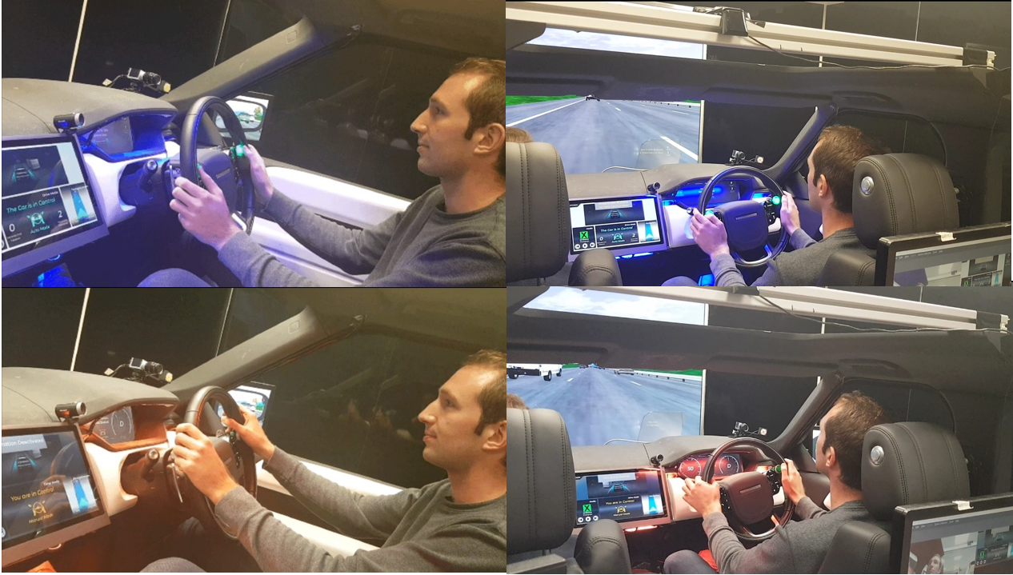
STISIM drive software was used to simulate a typical UK motorway environment. The simulator was built similar to that of the Range Rover Evoque, equipped with a single front-view screen, with separate wing mirrors and an augmented display for rear-view. In automated-vehicle tasks, multi-modal cues have been established as being beneficial for driver awareness and driver-automation interaction (Borojeni et al., 2016; Petermeijer et al, 2017; Politis, Brewster, & Pollick, 2015). To that end, the simulator was equipped with a variety of HMI elements. Visually, the driver was presented with a digitalized instrument cluster (size approximately in line with that of the Range Rover Evoque), centre console (18-inch, 16:9, installed in the direct centre of the vehicle) and a head-up display.
Figure 1. Example of vehicle in (top) and out (bottom) of automated mode

The vehicle was also equipped with vocal and audio information streams, ambient lighting to indicate driving mode (orange for manual, blue for automated; see figure 1), and a vibrating seat that was initiated when a handover was expected, and when control was safely transferred to the driver.
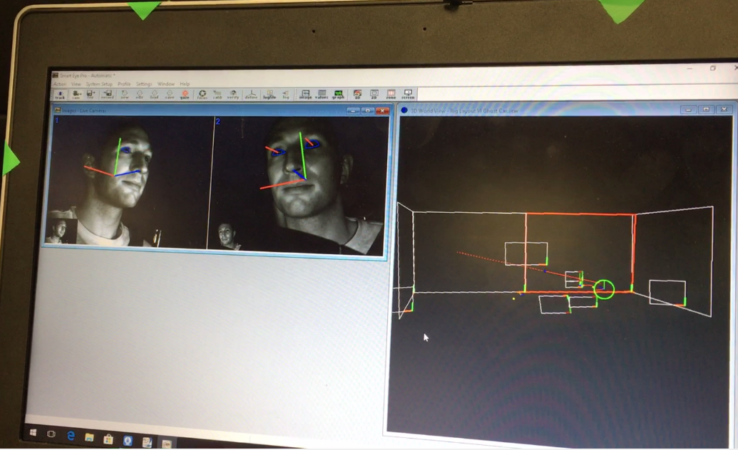
Eye tracking was conducted using two BASLER acA640 – 100gm cameras tasked with measuring head-position and eye- trajectory (plotted on three axes). Eye-gazes were computed using SMART Eye software (version 7.0) using a construction of a 3D mesh representing the simulator environment and the associated information displays (see figure 2 and 3).
Figure 2. Eye-tracking interface and areas of interests used for analysis

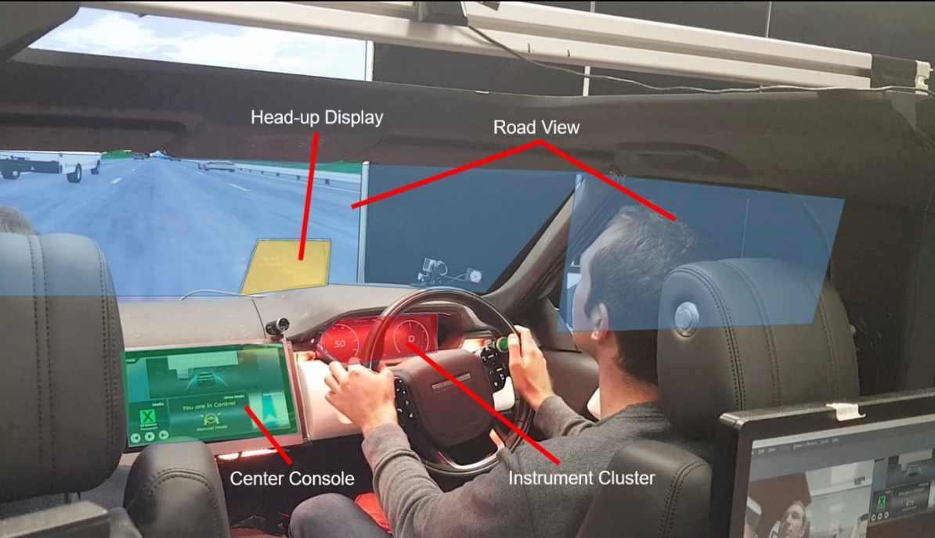
Figure 3. In-vehicle depiction of areas-of-interest used for analysis

2.4 Procedure
On arrival to the laboratory, participants were given a brief verbal introduction to the study and safety aspects. They then read the information sheet, and signed a consent and attendance form. Following this, participants completed a demographic questionnaire capturing age, gender, and driving experience both generally and with automated features. Participants were then guided into the driving simulator where they adjusted seat and steering wheel positioning. Drivers were then introduced to the controls and information displays including the: cluster information, the head-up display, the central console, audio and verbal interaction, vibrating seat, and ambient lighting. Drivers were then introduced to what will happen in the experiment outlining how and when transitions were expected.
Drivers took part in a shorter out-of-the-loop condition (~7 minutes in total) to become familiar with the vehicle’s controls and how to interact with the system. Drivers were then instructed that there were four trials in total, potentially taking up to 35 minutes to complete, and that breaks are encouraged prior to each trial. When the participant was satisfied that any remaining questions were addressed, the trials began.
For each trial, participants started in the hard shoulder of a motorway and were instructed to drive off into the middle lane, and keep to the local speed limit (70mph). After a minute, the system vocalized to the driver that automation was available, and presented the driver with a tone and visual wording/icon accordingly. Participants passed control to the vehicle by pressing two flashing green buttons with their thumbs on the steering wheel. Once activated, the black lighting of the displays and the orange ambient lighting transitioned to white displays/blue lighting. Vocal indications were given throughout such as: ‘the car has control’.
During automated control, to simulate a secondary task the driver played Tetris on a Window’s tablet, they were told that score was being recorded. The secondary task was implemented to ensure that driver’s attention was directed away from the driving task during automated control to measure how drivers raise awareness during the control transition process. A visual indicator counting down the time left in automation (from one minute or ten minutes depending on condition) was displayed on all three screens by default. At five, two, and one minute before manual control was expected, an audio tone and a vocalized alert was given to the driver notifying them of time remaining. When the countdown reached zero, the seat vibrated in co-occurrence with an audio and vocal alert. The handover icon animated the requirement to resume driving position. At this stage, the vehicle vocalized questions, and displayed them on each display. Questions asked the driver about vehicle status (e.g., fuel left, speed), or the driving environment (e.g., what colour is the vehicle in front). Each answer was delivered vocally, and was categorized as being either correct or incorrect by the researcher. Once the car was satisfied that more than half of questions were correctly answered, the vehicle indicated to the driver to take control of the vehicle by vocally and visually communicating with the driver. Should questions come below the 50% threshold, an additional warning was given to the driver, but the handover was still initiated. After pressing the two green buttons the driver was now in control, audio, vocal, visual alerts and ambient lighting (now orange) were given and the vibrating seat pulsed one last time to confirm the handover. This process represented one control cycle, and was performed three times for each condition (12 for entire experimental session) before being asked to pull over to the hard shoulder and bring the vehicle to a stop.
Once four trials had been complete, the driver left the vehicle and took part in a final debrief questionnaire where they were able to report their preferences and opinions about the handover procedures they had experienced. They were then thanked for their time, notified of payment, and advised not to drive for another 20 minutes.

2.5 Method of Analysis
The following analyses were conducted to assess the nature of both handover and post-handover visual gaze behaviour:
- Repeated measures ANOVA testing differences in total gaze durations during the vehicle-to-driver handover process between four primary visual streams (road, cluster, head-up display and center console).
- A Pearson’s correlation between the visual streams that were vocally prompted to, and actual visual gaze duration, testing for how well vocal interaction guides visual search.
- How demographic and situational factors affected gaze durations – Gender, age, type of vehicle the driver owns and time out-of-the-loop.
- Analysis of the above for post-handover (manual driving) visual gaze durations (with no vocal guidance provided).

3. Results
Gaze data were analysed using R-Studio v.0.99.902. Bar plots were generated using the ggplot2 package. Post-experiment data processing involved trimming the data to isolate the time between the handover alert, and the resumption of control from the driver. The four primary visual information streams were used for analysis (road, instrument cluster, head-up display, center console). Frequencies of counts (one fiftieth of a second) were transformed into a mean time for a single handover in seconds for each participant, and mapped to the associated area of interest. The data were analysed by testing for overall differences in area of interest gaze-times, and then with the addition of explanatory variables such as gender, age, class of car owned and time out-of-the-loop.

3.1 Handover Process Visual Gaze Durations

3.1.1 Overall visual gaze duration
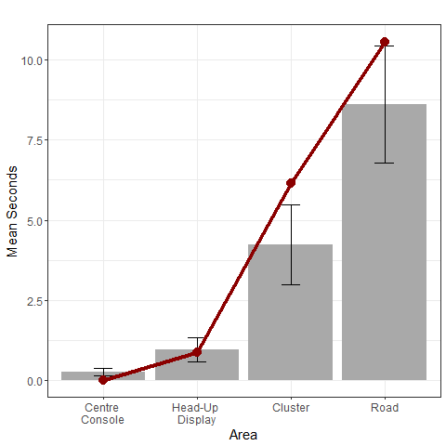
Figure 4 displays overall differences in total gaze duration between each area of interest, displaying mean seconds for each area. Overall handover time varied based on a number of factors: how many questions participants selected to answer during the handover period after the first trial (default 5, could be changed to 1 - 10), and how long drivers took to respond with correct answers to vocal prompts. Finally, gaze-times that were unaffiliated to an area of interest were excluded from the plots and analysis. A repeated measures ANOVA found that there was a main effect of area on gaze duration, F(3, 124) = 72.64, p < .001, ηp² = .69. Pairwise t-tests corrected with the Holm-Bonferroni method showed that there was a significant difference in mean-gaze duration for all comparisons of areas of interest (p < .001).
Figure 4. Overall mean total gaze duration from the notification to the takeover of control displayed. Error bars represent confidence (95%) intervals. Line-plot indicates the expected gaze-time in relation to vocal prompts to which the means are correlated with. *** indicates p < .001.
Based on the distribution of where answers resided within the visual streams, total gaze duration was tested for a correlation with the percentage of questions that were implemented during handover protocol across the entire study. These distributions were as follows: Road view – 60%, Instrument Cluster – 35%, Head-up Display – 5%, Center Console – 0%. There was a significant Pearson’s correlation between vocal guidance and associated gaze durations towards the assigned visual stream (r = 0.71, p < .001).
Figure 5 displays visual gaze times as a stacked bar-plot representing each individual who took part in the trials. The stacked bar plot reveals four distinct features of individual gaze behaviour. 1) Overall, drivers appeared to gaze at the road as their main form of visual information source, varying little amongst drivers. 2) There was a consistent trend for greater gaze towards the instrument cluster for supplementary information. This seemed to vary little across participants. 3) The HUD was utilized by most participants, but gaze-times varied greatly across the sample. 4) The central console played a minor role in handover gaze behaviour, varying little across the sample. Figure 6 illustrates these differences as an expression of percentage for each individual participant rather than the absolute value.
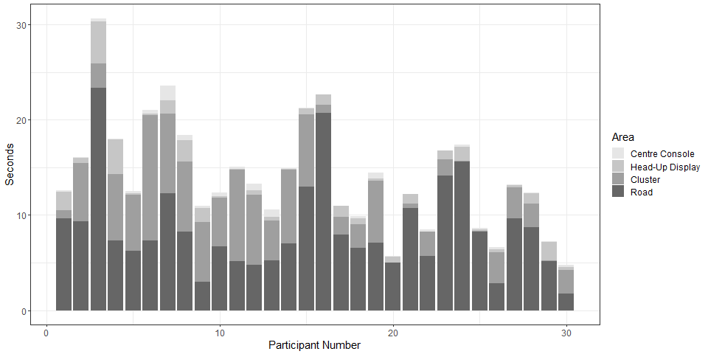
Figure 5. Handover total gaze duration in seconds towards areas of interest displayed across participant number
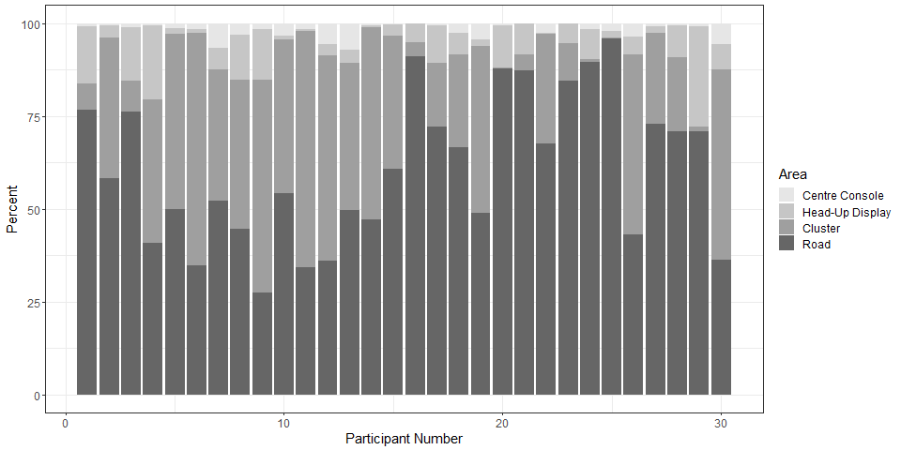
Figure 6. Handover gaze duration displayed as percentage towards areas of interest displayed across participant number

3.1.3 Demographics and Behavioural Factors
It was hypothesized that demographical factors such as gender, age and class of vehicle owned would have an effect on gaze-behaviour during handover. Mixed-effects ANOVAs found no significant main effect for each variable (gender, age, vehicle-type owned and time-out-of-the-loop; F(1, 115) = 0.44, p > .05, ηp² = .01; F(2, 114) = 1.33, p > .05, ηp² = 0.026; F(1, 115) = 1.02, p > .05, ηp² = 0.0003; F(1, 235) = 2.18, p > .05,, ηp² = 0.003 respectively. Figure 7 shows the effect of these factors on handover gaze behaviour. The spread of gaze time in these figures show the variability in gaze behaviour within groups - no clear differences arise for every category during analysis.
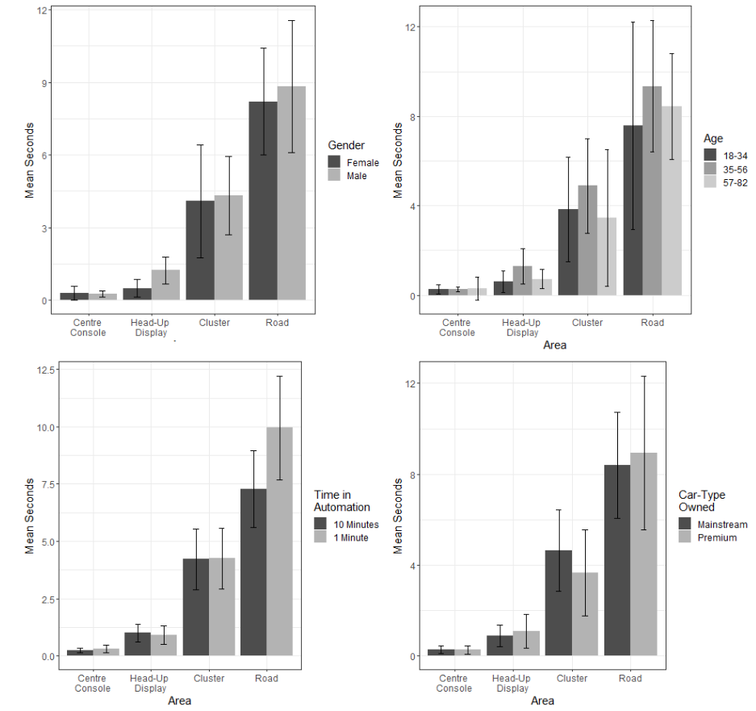
Figure 7. Handover gaze times displayed for each demographic recorded (age, gender, out-of-the-loop condition and car-type owned
As demographic differences such as gender are typically low. A post-hoc G-power analysis suggests that with effect sizes as low as 0.44, a minimum sample size recommended is within the region of 70 drivers.

3.2 Post-Handover (Manual Driving) Visual Gaze Durations
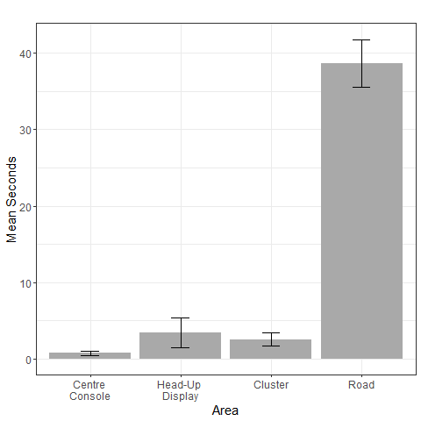
Figure 8 displays data from 60 seconds of manual driving following the handover process. It appeared that drivers were primarily gazing at the road with supplementary interface information coming from the head-up display and instrument cluster. A repeated measures ANOVA showed that there was a significant main effect of area on gaze-duration, F(3, 116) = 207, p < .001, ηp² = .84. Post-hoc pairwise t-tests corrected using the Bonferroni Holm method showed that there was a significant difference between every comparison of area (p < .001) except for the head-up display paired with the center console (p > .05).
Figure 8. Overall post- handover mean gaze-times displayed with confidence (95%) intervals. *** indicates p < .001.
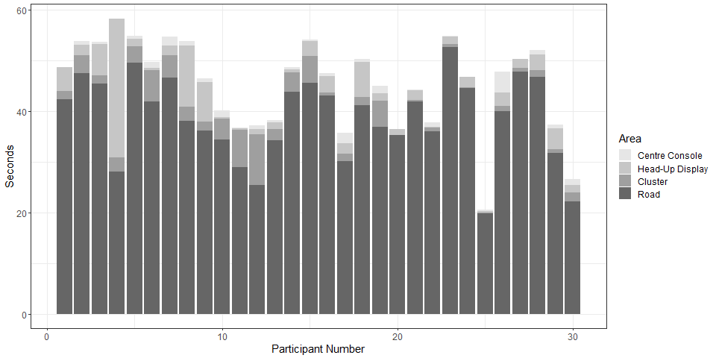
Analogous to that of figures 9 and 10, the stacked barplots in figures 5 and 6 show overall visual gaze towards the four main areas of interest during manual driving for each participant. The data reveal noticeable trends 1) Overall, drivers are heads-up, focusing on the road environments 2) There was a greater reliance on head-up displays for information when compared to visual gaze behaviour during handover interactions 3) similar to the handover, the instrument cluster remained one of the most relied on visual information displays. 4) Much like the handover data, the central console played a minor role in handover gaze behaviour, varying little across the sample. Figure 10 illustrates these differences as an expression or percentage rather than absolute value. These percentages illustrate how these proportions vary between drivers.
Figure 9. Post-handover (manual) gaze-time in seconds towards areas of interest displayed across participant number

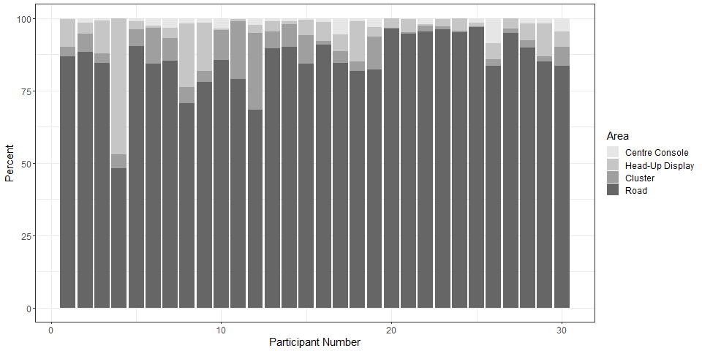
Figure 10. Post-handover (manual) gaze-time in percentage towards areas of interest displayed across participant number
For demographic differences, mixed-effects ANOVAs found no significant main effect for most variables (age, vehicle-type owned and time-out-of-the-loop, F(2, 114) = 0.52, p > .05, ηp² = .009; F(1, 115) = 0.21, p > .05, ηp² = .002; F(1, 235) = 0.32, p > .05, ηp² = .001, respectively). A Mixed-effects ANOVA for gender differences was significant, F(1, 115) = 7.05, p < .01, ηp² = .06, showing that males and females differed significantly. Figure 11 shows the effect of these factors on handover gaze behaviour, indicating once again, that there is a great amount of variability within groups, resulting in less prevalent group differences.

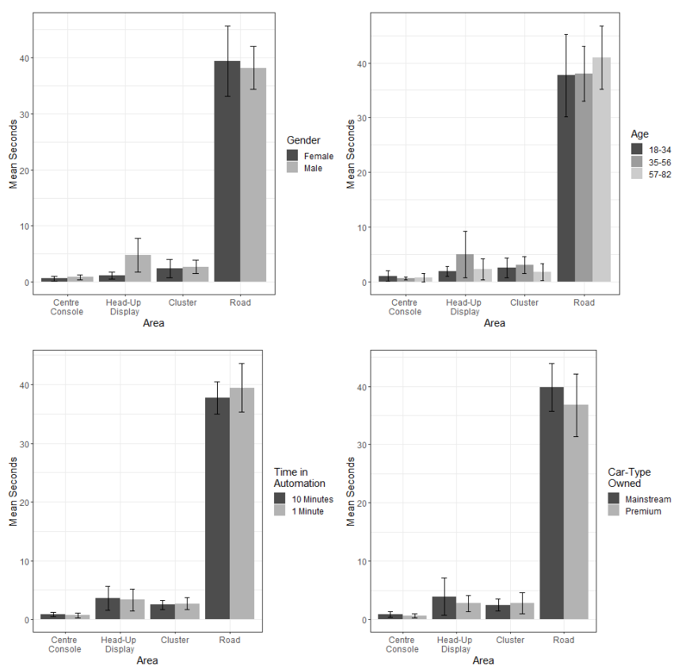
Figure 11. Post-handover (manual) gaze times displayed for each demographic recorded (age, gender, out-of-the-loop condition, car-type owned and whether drivers selected high or low amounts of visual information to be displayed on interfaces

4. Discussion
The present study explored the nature of visual gaze durations towards differing visual information streams during handovers from a conditionally/highly automated vehicle (C/HAV) to the driver, and manual driving following these handovers.
Overall, during the experiment drivers relied significantly on the road environment as their primary source of visual information, indicating that although HMIs are important for the handover process (Eriksson & Stanton, 2018; Walch et al., 2015), it must not be forgotten that the real-time road environment is where drivers will look to gain accurate and detailed information. It follows that if the driver is to focus on the road environment, handover assistants could be implemented in a way to guide or supplement visual gaze towards important cues, rather than rely on head-down displays alone (e.g., Tesla, 2018). This could be implemented in tandem with vocal interaction (Clark, Stanton, & Revell, 2018; Eriksson & Stanton, 2017b; Large et al., 2017), or via more explicit head-up displays indicating road hazards through augmented reality (Eriksson et al., 2019).
Perhaps the most salient finding from this experiment was the high correlation between audio guidance towards areas of interest and visual gaze behaviour. This indicates that vocal guidance could serve as a robust tool in guiding drivers’ attention to relevant pieces of information for the purpose of transactions in situation awareness (Sorensen & Stanton, 2016), advancing on previous findings in eye-gaze behaviour during handover interactions (Clark, Stanton, & Revell, 2018b) indicating that designing vocal interactions to promote visual guidance should be considered by automotive designers and manufacturers alike.
During handover interactions the instrument cluster, a short distance below the road view, was the visual HMI component that had the statistically significant longest gaze duration out of all visual streams, for the purpose of handover interaction. Instrument clusters are more populous amongst road-vehicle models than both head-up displays and central consoles, which are more likely to be found in prestige vehicles. As outlined by the Technology Acceptance Model (TAM3; Venkatesh & Bala, 2008) it follows that drivers may have interacted with the instrument cluster as this is a component that they are more familiar with compared to the other visual displays. This may lead to an increased perceived usefulness, and in turn, intention to use. The cluster display also requires less physical effort to glance at if the driver is in a standard driving position, therefore may be preferred over the center console.
The TAM3 may also explain why there was a great amount of individual difference in the gaze duration towards the head-up display during handover and manual interactions. It may be that those with current HUD technology in their vehicles are more likely to use this visual information stream as their experience may interact with their perceived usefulness and intention to use. In this experiment, the head-up display was limited to a small subsection, just above the view of the steering wheel. It was not addressed whether an entire screen augmentation would better guide a driver’s search for visual information.
One recurrent finding during this experiment was the low reliance on the central console compared to the other visual streams made available. The role of the central console in HMI design is contentious, as it is possible to display a lot of information on these screens, such as those found within infotainment systems in current level 3/4 models and concept designs (e.g., Tesla S Class, Audi A8; Tesla, 2018; Audi, 2018), but little is known about their practical affordances. The nature of the central console during handover interactions has not yet been established, although our findings show that the role for handover information on this particular display may not be as important as those that are found within the road environment or screens closer to this area.
For post-handover manual driving, drivers’ attention for the most part was heads-up. Minor glances towards each displays were made, with some drivers opting to rely on the head-up display for supplementary information.
It was hypothesized that certain demographics of drivers may have differing gaze duration behaviour when it comes to the handover task (Feldhütter, Gold, Schneider, & Bengler, 2017; Sun et al., 2016; Yan et al., 2016). Our findings show that, visual gaze towards visual displays did not differ with respect to demographics such as gender, age, and whether the driver drove a premium or mainstream vehicle. These findings extend to other such variables such as time out-of-the-loop and how much information was kept on visual displays. However, there was a significant effect for gender on the reliance on head-up-displays, indicating that males may favour this visual stream for manual driving more so than females. Previous findings show that visual behaviour regarding scan paths and vigilance are variables that differ (Feldhütter, Gold, Schneider, & Bengler, 2017; Sun et al., 2016; Yan et al., 2016), however, our findings indicate that this may not extend to which visual streams drivers utilize during handover interactions. It follows that perhaps providing a default option for drivers that covers road-based guidance, and cluster information, as well as high amounts of HUD customizability (due to the high within subjects variance in gaze duration), might be the best approach to cater for a broad range of driver characteristics.
This experiment makes a contribution towards how the role of directability (Clark, 1996; Klein et al., 2004; 2005) can be implemented as a method of vehicle-to-driver communication. Based on these findings, directing attention towards relevant visual information, as well as focusing on head-up appear to be valid as a way of implementing this approach. It follows that, based on our road gaze time duration findings, guiding the driver to important areas within the environment may allow for drivers to raise their own SA during transactions (Sorensen, & Stanton, 2016; Stanton et al., 2006; Stanton et al., 2017). This brings into question the direction of current handover assistants are taking, as many implement a center-console approach targeting interactions during time-out-of-the-loop (e.g., Tesla S- Class; Tesla, 2018). Our findings suggest that relying on such interfaces may be appropriate during automated periods, although a shift of focus towards head-up methods may be more suitable during SA transactions during handover.
Additionally, the variation in eye-gaze behaviour between drivers (see figures 5, 6, 9 and 10) shows the requirement for these transactions to be customizable. Manufacturers should remain focused on raising SA for safety, but appropriately implement concepts such as directability as a means to do so. In other words, as seen by these findings, designs should ensure that handover assistants are utilized by the driver in a way that they feel is accessible and suits their schema requirements (Neisser, 1976; Stanton et al., 2006).

4.1 Conclusions
This experiment measured driver eye-gazes during handover and manual interactions in a level three automated vehicle motorway simulation. Eye gaze durations showed that vocal guidance may serve as an effective tool in guiding visual attention. Further, great variability in the utilisation of visual information streams suggests the requirement for customization. Finally, particularly during manual driving following handover, drivers gazed minimally at the center console - suggesting that current AV designs are not addressing the unique requirements of handover interaction and how these visual streams are utilized when coming back into the loop. These findings show how the concept of directability can be implemented into AVs as a means of facilitating situation awareness transactions. Further work should address the ways in which head-up augmentations can be used to guide visual awareness, and explore which vocal cues may be most suitable in raising SA during control transitions.

5.0 Acknowledgements
This work was supported by Jaguar Land Rover and the UK-EPSRC grant EP/N011899/1 as part of the jointly funded Towards Autonomy: Smart and Connected Control (TASCC) Programme.

6.0 References

Aaltonen, A., Hyrskykari, A., & Räihä, K.-J. (1998). 101 spots, or how do users read menus? In Proceedings of CHI 98 (pp. 132-139). New York: ACM Press

Audi. (2018). Audi A8 - Audi AI traffic jam pilot. Retrieved from: https://www.audi-technology-portal.de/en/electrics-electronics/driver-assistant-systems/audi-a8-audi-ai-traffic-jam-pilot
Borojeni S S, Chuang L, Heuten W, Boll S. (2016, October). Assisting drivers with ambient take-over requests in highly automated driving. In: Proceedings of the 8th International Conference on Automotive User Interfaces and Interactive Vehicular Applications (pp. 237-244). New York, NY: ACM. http://dx.doi.org/10.1145/3003715.3005409

Clark, H. H. (1996). Using language (pp. 274-296). Cambridge University Press: Cambridge.

Clark, J.R., Stanton, N.A., & Revell, K.M.A. (2018a; in press). Conditionally and highly automated vehicle handover: A study exploring vocal communication between two drivers. Transportation Research Part F: Psychology and Behaviour. https://doi.org/10.1016/j.trf.2018.06.008

Clark, J., Stanton, N., & Revell, K. (2018b, July). Handover Assist in Highly Automated Vehicles: How Vocal Communication Guides Visual Attention. In. International Conference on Applied Human Factors and Ergonomics (p. 295-306). Springer, Cham.
Clark, J. R., Stanton, N. A., & Revell, K. M. (2019). Identified handover tools and techniques in high-risk domains: using distributed situation awareness theory to inform current practices. Safety science, 118, 915-924.
Chui, M.A., & Stone, J.A. (2012). The prescription handoff in community pharmacy: A study of its form and function. Journal of the American Pharmacists Association, 52(6), e161-e167. doi:10.1331/JAPhA.2012.11233
De Winter, J. C. F., Eisma, Y. B., Cabrall, C. D. D., Hancock, P. A., & Stanton, N. A. (2018). Situation awareness based on eye movements in relation to the task environment. Cognition, Technology & Work, 1-13.
De Winter, J. C., Happee, R., Martens, M. H., & Stanton, N. A. (2014). Effects of adaptive cruise control and highly automated driving on workload and situation awareness: A review of the empirical evidence. Transportation Research Part F: Traffic Psychology and Behaviour, 27, 196-217.
Eriksson, A., Petermeijer, S. M., Zimmermann, M., De Winter, J. C. F., Bengler, K. J., & Stanton, N. A. (2019). Rolling out the red (and green) carpet: supporting driver decision making in automation-to-manual transitions. IEEE Transactions on Human-Machine Systems, 49(1), 20-31. doi: 10.1109/THMS.2018.2883862
Eriksson, A., & Stanton, N. A. (2017a). Takeover time in highly automated vehicles: noncritical transitions to and from manual control. Human factors, 59(4), 689-705.
Eriksson, A., & Stanton, N. A. (2017b). The chatty co-driver: A linguistics approach applying lessons learnt from aviation incidents. Safety Science, 99(Part A), 94–101. https://doi.org/10.1016/j.ssci.2017.05.005
Eriksson, A. & Stanton, N.A. (2018). Driver Reactions to Automated Vehicles: A Practical Guide for Design and Evaluation (pp. 1-158). CRC Press: FL, Boca Raton.

Feldhütter, A., Gold, C., Schneider, S., & Bengler, K. (2017). How the duration of automated driving influences take-over performance and gaze behavior. In Advances in Ergonomic Design of Systems, Products and Processes (pp. 309-318).. Springer, Berlin, Heidelberg.
Hornof, A. J., & Halverson, T. (2002). Cleaning up systematic error in eye-tracking data by using required fixation locations. Behavior Research Methods, Instruments, & Computers, 34(4), 592-604. https://doi.org/10.3758/BF03195487

Klein, G., Feltovich, P. J., Bradshaw, J. M., & Woods, D. D. (2005). Common ground and coordination in joint activity. Organizational Simulation, 53, 139-184. doi:10.1002/0471739448.ch6

Klein, G., Woods, D. D., Bradshaw, J. M., Hoffman, R. R., & Feltovich, P. J. (2004). Ten challenges for making automation a" team player" in joint human-agent activity. IEEE Intelligent Systems, 19(6), 91-95. doi: 10.1109/MIS.2004.74

Large, D.R., Clark, L., Quandt, A., Burnett, G. & Skrypchuk, L. (2017). Steering the conversation: A linguistic exploration of natural language interactions with a digital assistant during simulated driving. Applied Ergonomics, 63(Supplement C), 53-61.

McCall, R., McGee, F., Meschtscherjakov, A., Louveton, N., & Engel, T. (2016, October). Towards a taxonomy of autonomous vehicle handover situations. In Proceedings of the 8th International Conference on Automotive User Interfaces and Interactive Vehicular Applications (pp. 193-200). ACM.
Merat, N., Jamson, A. H., Lai, F. C., Daly, M., & Carsten, O. M. (2014). Transition to manual: Driver behaviour when resuming control from a highly automated vehicle. Transportation Research Part F: Traffic Psychology and Behaviour, 27, 274-282.

Neisser, U. (1976). Cognition and reality: Principles and implications of cognitive psychology. New York, NY, US: W H Freeman/Times Books/ Henry Holt & Co.

Owsley, C., & McGwin Jr, G. (2010). Vision and driving. Vision Research, 50(23), 2348-2361.
Parke, B., & Mishkin, A. (January, 2005). Best practices in shift handover communication: Mars exploration rover surface operations. International Association for the Advancement of Space Safety Conference. Nice: IAASS
Petermeijer S, Bazilinskyy P, Bengler K, de Winter J (2017) Take-over again: Investigating multimodal and directional TORs to get the driver back into the loop. Applied Ergonomics, 62. 204-215. doi: 10.1016/j.apergo.2017.02.023
Politis I, Brewster S, Pollick F. (2015, September). Language-based multimodal displays for the handover of control in autonomous cars. In: Proceedings of the 7th International Conference on Automotive User Interfaces and Interactive Vehicular Applications (pp. 3-10). New York, NY: ACM, doi: 10.1145/2799250.2799262

SAE On-road Automated Vehicles Standards Committee. (2016). Taxonomy and Definitions for Terms Related to On-Road Motor Vehicle Automated Driving Systems. Accessible: http://standards.sae.org/j3016_201401/

Sorensen, L. J., & Stanton, N. A. (2016). Keeping it together: The role of transactional situation awareness in team performance. International Journal of Industrial Ergonomics, 53, 267-273. doi: 10.1016/j.ergon.2016.02.007
Stanton, N. A. (2019). Thematic issue: driving automation and autonomy. Theoretical Issues in Ergonomics Science, 1-7.
Stanton, N., & Marsden, P. (1997). Drive-by-wire systems: some reflections on the trend to automate the driver role. Proceedings of the Institution of Mechanical Engineers, Part D: Journal of Automobile Engineering, 211(4), 267-276. doi: 10.1243/0954407971526425
Stanton, N. A., Stewart, R., Harris, D., Houghton, R. J., Baber, C., McMaster, R., & Linsell, M. (2006). Distributed situation awareness in dynamic systems: theoretical development and application of an ergonomics methodology. Ergonomics, 49(12-13), 1288-1311.
Stanton, N., Salmon, P., Walker, G., Salas, E., & Hancock, P. A. (2017). State-of-science: situation awareness in individuals, teams and systems. Ergonomics, 60(4), 1-18. doi: 10.1080/0
Sun, Q. C., Xia, J. C., Falkmer, T., & Lee, H. (2016). Investigating the spatial pattern of older drivers' eye fixation behaviour and associations with their visual capacity. Journal of Eye Movement Research, 9(6), 1-16.
Tesla (2018). Tesla Model S. Retrieved from: https://www.tesla.com/models.
Venkatesh, V., & Bala, H. (2008). Technology acceptance model 3 and a research agenda on interventions. Decision sciences, 39(2), 273-315.
Walch, M., Lange, K., Baumann, M., & Weber, M. (2015, September). Autonomous driving: investigating the feasibility of car-driver handover assistance. In Proceedings of the 7th International Conference on Automotive User Interfaces and Interactive Vehicular Applications (pp. 11-18). ACM.
Yan, X., Zhang, X., Zhang, Y., Li, X., & Yang, Z. (2016). Changes in drivers’ visual performance during the collision avoidance process as a function of different field of views at intersections. PLoS one, 11(10), e0164101.

