Clinical evaluation of type 2 disease status in a real-world population of difficult to manage asthma using historic Electronic Health Care Records of Blood Eosinophil counts

Short Title
Historical Blood Eosinophil Counts in Difficult to Manage Asthma
Counts
Word = 3121, Table = 4, Figure = 4

Authors
Adnan Azim MRCP ^{a,b,c}, Colin Newell MSc^{b}, Clair Barber BSc ^{a,b}, Matthew Harvey MSc ^{b}, Deborah Knight^{b}, Anna Freeman MRCP ^{a,b,c}, Wei Chern Gavin Fong MSc^{c}, Paddy Dennison PhD^{b,c}, Hans Michael Haitchi PhD ^{a,b,c,d}, Ratko Djukanovic DM^{a,b,c,d}, Ramesh Kurukulaaratchy DM^{a,b,c,e} *, Peter Howarth DM^{a,b,c,d} *.
*contributed equally

Affiliations
- Clinical and Experimental Sciences, Faculty of Medicine, University of Southampton, UK.
- National Institute for Health Research (NIHR) Southampton Biomedical Research Centre at University Hospital Southampton NHS Foundation Trust, UK.
- Asthma, Allergy and Clinical Immunology Department, University Hospital Southampton NHS Foundation Trust, UK.
- Institute for Life Sciences, University of Southampton, Southampton, UK.
- The David Hide Asthma & Allergy Research Centre, St Mary’s Hospital, Newport, Isle of Wight, UK.

Corresponding Author:
Dr Ramesh J Kurukulaaratchy DM FRCP
Consultant in Respiratory Medicine & Allergy
Asthma, Allergy & Clinical Immunology, Mailpoint 52, Floor 2 Minerva House, Southampton General Hospital, Tremona Road, Southampton, Hampshire. SO16 6YD. United Kingdom
Email: Rjk1s07@soton.ac.uk
Tel: +442381 208790

Conflict of Interest disclosure statement:
PHH declares that he has employment though GSK. AA, CN, CB, ZL, MH, DK, AF, WCGF, PD, HMH, RD, RK, declare that they have no known competing financial interests or personal relationships that could have appeared to influence the work reported in this paper.

Funding Source:
The WATCH study uses the NIHR BRC and Clinical Research Facility at UHSFT that is funded by the NIHR Southampton. The WATCH study itself is not externally funded. Funding assistance for database support for the WATCH study was initially obtained from a non-promotional grant from Novartis (£35,000). Funding assistance for patient costs (e.g. parking) were initially provided by a charitable grant (£3,500) from the Asthma, Allergy & Inflammation Research (AAIR) Charity.

Data Availability Statement:
The data that support the findings of this study are available from the corresponding author upon reasonable request

Abbreviations
ABPA Allergic Bronchopulmonary Aspergillosis
ACQ Asthma Control Questionnaire
BD Bronchodilator
BDP Beclomethasone
BMI Body Mass Index
BTS British Thoracic Society
CI Confidence Interval
CT Computed Tomography
EGPA Eosinophilic Granulomatosis with Polyangiitis
EHR Electronic health record
FEF 25-75% Forced expiratory flow between 25-75% exhalation
FeNO Fractional Exhaled Nitric Oxide
FEV1 Forced Expiratory Volume in 1 second
FVC Forced Vital Capacity
GORD Gastroesophageal Reflux Disorder
IgE Immunoglobulin E
IL Interleukin
IQR Interquartile Range
MAPK Mitogen-Activated Protein Kinase
NICE National Institute for Health and Clinical Excellence
NPV Negative Predictive Value
OCS Oral corticosteroids
PPV Positive Predictive Value
REC Research Ethics Committee
SAFS Severe Asthma with Fungal Sensitisation
SD Standard Deviation
SNOT 22 Sinonasal Outcome Test
SPT Skin prick test
TAK1 Transforming growth factor-β–associated kinase-1
UHSFT University Hospital Southampton Foundation Trust
UKAS United Kingdom Accreditation Service
WATCH Wessex AsThma CoHort of Difficult Asthma

ABSTRACT
Background: Blood eosinophil measurement is essential for the phenotypic characterisation of patients with difficult asthma and in determining eligibility for anti-IL-5/IL-5Rα biological therapies. However, assessing such measures over limited timespans may not reveal the true underlying eosinophilic phenotype, as treatment, including daily oral corticosteroid therapy, suppresses eosinophilic inflammation and asthma is intrinsically variable.
Methods: We interrogated the electronic health care records of patients in the Wessex AsThma CoHort of difficult asthma (WATCH)study (UK). In 501 patients being evaluated in this tertiary care centre for difficult to control asthma, all requested full blood count test results in a 10-year retrospective period from the index WATCH assessment were investigated (n=11,176).
Results: In 235 biological therapy-naïve participants who had 10 or more measures in this time period, 40.3% were eosinophilic (blood eosinophils >300 cells/µL) at WATCH enrolment while an additional 43.1%, though not eosinophilic at enrolment, demonstrated eosinophilia at least once in the preceding decade. Persistent eosinophilia was associated with worse post bronchodilator airway obstruction and higher Fractional exhaled Nitric Oxide (FeNO). In contrast, the 16.6% of patients who never demonstrated eosinophilia at this blood eosinophil threshold, showed preserved lung function and lower markers of Type 2 inflammation.
Conclusions: This highlights the central role that Type 2 inflammation, as indicated by blood eosinophilia, has in difficult asthma and suggests that longitudinal electronic health care record analysis can be an important tool in clinical asthma phenotyping, providing insight that may help understand disease progression and better guide more specific treatment approaches.

INTRODUCTION
Asthma is classically recognised to be a Type 2 (T2) inflammatory airway disorder, in which systemic interleukin-5 (IL-5) signalling to the bone marrow increases circulating eosinophils and recruitment to airway tissue ¹. However, it is also recognised that non-eosinophilic forms of asthma constitute a proportion of the asthma population. The measurement of airway eosinophilia in induced sputum is well established as a predictive marker for asthma exacerbations and steroid therapy response ² but is unsuitable for routine clinical practice or large epidemiological studies due to the practical limitations of undertaking sputum induction in a clinical setting ³.
Though not perfectly correlated, blood eosinophils are recognised to be a good biomarker for airway eosinophils ^{4,5} and, in view of their ready accessibility, have been widely adopted into the clinical characterisation of asthma patients. The utility of blood eosinophil counts has been demonstrated by large population studies, in which raised baseline blood eosinophil counts are associated with poor asthma control ⁶, lung function decline ⁷ and exacerbations ^{8,9}. Moreover, they offer theragnostic value by defining a phenotype of severe asthma patients that can be stratified toward newly emerged anti-IL5/ IL-5 receptor alpha (IL-5 Rα) therapies ¹⁰⁻¹³.
Eosinophilic inflammation is recognised to fluctuate in both blood and sputum over time ¹⁴⁻¹⁷: few patients are “eosinophilic” at every measurement ^{18,19}. This therefore challenges the robustness of translating associations determined by single-measurement cross-sectional study designs ²⁰, into clinical practice, particularly when full blood counts are among the most commonly requested blood test panels in clinical care ^{21,22}.
We sought to explore whether interrogation of repeat blood eosinophil count measures provided additional phenotypic information beyond that provided by binary categorisation of patients based on a single time point. We have focussed our analysis to the routinely measured full blood count test results extracted by electronic health-records (EHR) ²³ from patients in the Wessex AsThma CoHort of difficult asthma (WATCH) study, which is drawn from a large catchment area across the South Central England region of the UK ²⁴,

METHODS

Population
WATCH is a prospective observational study of patients managed in a tertiary difficult asthma clinic at University Hospital Southampton with “high dose therapies” and/or “continuous or frequent use of oral steroids” according to the BTS (British Thoracic Society) Adult Asthma Management Guidelines 2016. Detailed study methodology has been published elsewhere ²⁵. The study had ethical approval (REC reference: 14/WM/1226) and all patients provided written informed consent.
Patients were excluded from analysis if they had evidence of other systemic causes for their eosinophilia (e.g. eosinophilic granulomatosis with polyangiitis). For patients treated with biological asthma therapies, blood tests after therapy start dates were excluded.
Clinically requested blood tests were processed by the fully accredited hospital pathology laboratory, compliant to ISO142819 standards. Clinical data including detailed clinical, health and disease-related questionnaires, anthropometry, allergy skin prick testing, blood tests and lung function testing were captured at enrolment to the WATCH study; differential cell counts on induced sputum were available in a subset of patients (details in supplementary data) from which sputum inflammatory phenotypes were determined using a >2% cut off for sputum eosinophils ²⁶ and >61% cut off for sputum neutrophils ²⁷. Electronic clinical records were extracted where available to augment comprehensive data capture in a pragmatic fashion ²⁵.
Patients with multiple blood test results (defined by 10 or more blood test results) over the preceding 10-years leading up to WATCH enrolment were identified. This cut off was selected since the median number of eosinophil counts in the preceding decade for WATCH cohort enrolled subjects was 10. Patients were categorised as “never eosinophilic” if they have never demonstrated an eosinophil count >300 cells/µL in any of the ten or more blood tests extracted. Those demonstrating at least one eosinophil count of >300 cells/µL in the minimum of 10 or more blood tests were categorised as “eosinophilic”. To further assess how different patterns of eosinophilia might differentially associate with clinical features we subdivided eosinophilic subjects into tertiles determined by the frequency with which their eosinophil counts were >300 cells/µL: rare, intermittent, persistent. Blood test metadata were also extracted: date of test, time of test, requester, clinical indication.

Statistical analysis
Statistical analysis was performed using SPSS 25 (NY, USA), GraphPad Prism 7 (La Jolla, California, USA) and R (Vienna, Austria). Continuous clinical variables are presented as median (IQR) and categorical variables as frequencies (percentages). Between group differences were assessed by Mann Whitney, Kruskal Wallis, Chi Squared or Fisher’s Exact test where appropriate. Pairwise deletion was applied in the case of missing data and correction for multiple testing used where appropriate. Biomarkers were assessed using Receiver Operating Characteristic Curves and Positive Predictive Values calculated from natural frequencies in our cohort. Spearman’s rank order correlation was employed to assess associations.

RESULTS

Identified Patients
A total of 11,176 discrete blood eosinophil count results from the WATCH cohort of 501 patients were identified over the 10-years prior to study enrolment. On exclusion of 5 patients with a diagnosis of Eosinophilic Granulomatosis with Polyangiitis (EGPA) and blood tests taken after initiation of first biological therapy, 9,604 blood eosinophil count results were available from 471 patients (Figure 1).
The earliest extracted blood test was from 05/01/2006 and the latest from 31/07/2019. The median time span for blood test collection was 3,036 (IQR 3,131) days (8.32 years). The majority of blood tests, however, were performed in the last few years, with 49.9% of blood test results derived from the five-year period from 2014 to 2018 (inclusive) ( Supplementary Table E1 and Figure E1). During this period, Omalizumab had already been available in our clinic for a decade (introduced in 2008) and Mepolizumab had only just been introduced (in 2017 and briefly in 2013 through a clinical trial).
Patients excluded from the analysis (n=25) had a higher FeNO than those with at least one blood test (Supplementary Table E2) but had no other statistically significant differences in terms of basic demographics, lung function tests, healthcare utilisation or asthma control (as measured by ACQ6) between the two broad categories at initial assessment.
The median number of blood tests per patient was 10 (IQR 18.5). Of the 471 patients, 235 had 10 or more available eosinophil counts. Though broadly comparable in terms of basic demographics, lung function tests, healthcare utilisation or asthma control (as measured by ACQ6), patients with ten or more blood tests were slightly older, had a higher BMI and lower total IgE than those with fewer than 10 blood tests (Supplementary Table E3).

Eosinophilic sub-grouping of Patients
Of the 235 patients with 10 or more clinical blood test results, 79 (40.3%) were eosinophilic (using a threshold of >300 cells/µL) at enrolment to the study. Of the remaining 156 patients who were non-eosinophilic, 117 (75.0%) had historically demonstrated an eosinophilia on at least one occasion whilst just 39 (25.0%) never demonstrated an eosinophilia (Figure 1). Thus, only 16.6% of patients were never eosinophilic, which reduced to 3.4% (n=8) if the threshold was reduced to >200 cells/µL.

Never Eosinophilic Patients
Patients with difficult to treat asthma who never demonstrated eosinophilia were more likely to have less severe post-bronchodilator airflow obstruction, lower fractional exhaled nitric oxide (FeNO) and lower total serum immunoglobulin E (IgE) levels than the ever-eosinophilic (historical) group (Table 1). Nine (23.1%) of these patients subsequently received anti-IgE monoclonal antibody therapy. By comparison 43.4% of ever eosinophilic patients subsequently commenced biologic therapy. Other than ABPA/SAFS (Allergic Bronchopulmonary Aspergillosis/ Severe Asthma with Fungal Sensitisation), which was not seen in the never eosinophilic patients, there were no differences in the prevalence of common co-morbidities between these groups (Table 2). Presence of nasal polyposis on CT and sputum differential cell counts were available in only a small subset of patients, in whom investigation was clinically relevant.
In those patients not currently demonstrating a blood eosinophilia, concurrently measured FeNO was no different between never eosinophilic and historically eosinophilic patients. However, in such patients, serum total IgE was significantly higher in historically eosinophilic patients (median 64.85, IQR 190.8) compared to never eosinophilic patients (median 11.60, IQR 79.8), U =861.5, p<0.001 (Figure 2). The AUC for serum total IgE in discriminating between these groups was 0.698, p<0.001; the AUC for FeNO was not statistically significant (Figure 2).

Frequency of Eosinophilia
“Eosinophilic” patients were divided into equal tertiles based upon percentage of eosinophil counts >300 cells/µL, thereby dividing patients into four groups based on frequency of that degree of eosinophilia: Never, Rare, Intermittent and Persistent. Broadly, patients demonstrated a blood eosinophilia in 1 in 10 blood results in the Rare group; 1 in 3 results in the Intermittent group and 3 in 4 results in the Persistent group. Table 3). Only 1 patient, with at least 10 blood eosinophil results, registered an eosinophil count of > 300 cells/µL in all of their test results.
The clinical features of these four groups are shown in Supplementary Table E4. In general, as the frequency of eosinophilia increased so too did the surrogate biomarkers FeNO and total IgE and co-morbidity with ABPA and bronchiectasis. Increasing eosinophilia was also associated with worsening lung function, particularly FEV₁/FVC ratio and FEF_{25-75%} (Figure 3, data in Table E5).

Sputum Eosinophilia
Sputum differential counts were performed in a subset (n=87) of patients at a single time point following non-biologics asthma treatment optimisation, as part of their workup in the regional difficult asthma clinic at University Hospital Southampton.
Sputum eosinophil counts were higher in those patients with persistent blood eosinophilia (median 4.4%, IQR 10.6) than patients never eosinophilic (median 0.4%, IQR 1.1), p<0.001 by Kruskall Wallis corrected for multiple comparisons) (Figure 4A). Accordingly, patients less frequently eosinophilic on blood tests showed a tendency to paucicellular or neutrophilic sputum profiles while those that showed more frequent blood eosinophilia had a tendency to demonstrate eosinophilic sputum profiles (Supplementary Tables E6 and E7). However, increasing persistence of blood eosinophil counts was also associated with an increase in sputum neutrophilia (Supplementary Table E6).
We compared the predictive value for current and historical evidence for blood eosinophilia in determining the sputum eosinophilia (sputum eosinophils >2%). The positive predictive value (PPV) for a single contemporaneous blood eosinophil count to predict sputum eosinophilia was 60.71% (95%CI 45.94 to 73.76); superior to evidence of any retrospectively noted historical eosinophilia 42.25% (95%CI 38.64 to 45.95). Whilst the negative predictive value (NPV) of a contemporaneous blood eosinophil count was 71.11% (95% CI 61.20 to 79.35), never demonstrating a blood eosinophilia across multiple historical counts improved the NPV to 90.91% (95% CI 57.35% to 98.67%) (Figure 4B, contingency tables described in Supplementary Table E8).

DISCUSSION
The measurement of clinical and biological features in large cohorts has clearly demonstrated the heterogenous nature of severe asthma. However, the chronic and dynamic nature of severe asthma is poorly represented in clusters derived from cross-sectional study designs, which are weighted towards measurements that are static (age of onset, atopic status) or the measurement of variables known to fluctuate (eosinophil counts ^{18,19} and FeNO ²⁸) at a single time-point. Variability in eosinophils has been associated with poor asthma control ¹⁷ and lung function decline ¹⁶. Therefore characterising patients based on fluctuations in repeated measures offers a novel approach to asthma phenotyping ²⁹.
Here, we have used electronic health records to stratify patients with difficult to control asthma based upon repeated blood eosinophil counts into clinically intuitive and therefore clinically translatable descriptions. Using a 300 cells/µL cut off (as per NICE asthma biologic guidelines), consistent with other studies, we found very few patients (0.8%) to be eosinophilic on every measurement ^{14,17-19}. However, though our cross-sectional data corroborates the statement that T2 inflammation is found in around 50% of patients with severe asthma³⁰, our findings demonstrate that in fact, the vast majority (83%) of difficult to treat asthma patients have evidence of eosinophilia on at least one occasion in the past decade. Whilst blood eosinophil counts of 150 cells/uL or greater have been used in severe asthma as a predictor of response to anti-eosinophil biologics^{10,11}, and this used to define an eosinophilic phenotype, we have taken the more conservative level of 300 cells/uL. However, we have also evaluated the impact of taking a lower threshold of 200 cells/uL, used as the laboratory in Southampton only reports results in centiles and so cannot define a 150 cells/uL threshold. At the blood eosinophil threshold of 200 cells/uL, only 3% of severe asthmatics were never eosinophilic. This may have significant relevance to clinical practice of prescribing a rapidly expanding portfolio of biologic drugs whose use is partly governed by meeting a qualifying blood eosinophilia as demonstration of having eosinophilic/ T2 asthma.
Transient or intermittent blood eosinophilia is likely to reflect varying levels of T2 suppressing treatment such as corticosteroids and the inherent variability in disease severity within this exacerbation prone population. As such, contemporaneously taken measures have greater relevance to understanding the airway biology ⁴ of patients as part of their workup in a severe asthma clinic. Nevertheless, subjects with persistently uncontrolled eosinophilic expression (never and rare vs intermittent and persistent) over the 10-year observational period had by the end of the observation period more sputum eosinophilia, more severe airflow obstruction and worse small airways disease pattern, as assessed by FEF₂₅₋₇₅. Eosinophilic inflammation has been implicated in airway remodelling in asthma ³¹, a process that alters airway wall thickness and has been linked to reduced lung function and loss of reversibility. The reported rates of lung decline in a severe asthma population have varied at around 30ml/year ^{16,32,33} however, the nature of our EHR data, means that there are few spirometry data pre-dating the blood test data to allow for assessment of change over time. Similarly, in the absence of detailed contemporaneous medication data, it is difficult to describe the proportion of blood eosinophil count fluctuations that occur independently of changes in acute or maintenance treatments. As the WATCH longitudinal cohort study continues, these data can be collected prospectively, potentially allowing further stratification of the variable blood eosinophil sub-group. Nevertheless, the present findings are consistent with the established association of eosinophilic inflammation and lung function decline ^{14,16,34,35} and support the rationale of a treatment strategy to control eosinophilic inflammation in asthma ², a rationale further evidenced by the lack of lung function decline in those who are rendered exacerbation free with mepolizumab therapy ³⁶.
At the other end of the spectrum, retrospective interrogation of blood eosinophil counts better identifies a group of “never eosinophilic” patients than considering contemporaneous blood tests alone. Strictly, these patients should be more accurately termed “patients with no evidence of prior eosinophilia”. It is possible, for example, that many such patients do in fact have an “eosinophilic phenotype” but that it has never been captured by intermittent snapshot testing or was masked by oral corticosteroid treatment. Comparison of never and historically eosinophilic patients suggests that this might be especially true of patients with a raised serum IgE. Patients with no evidence of prior eosinophilia underwent fewer blood tests results than patients with evidence of eosinophilia and so it is possible that if they had had additional blood tests that they might reveal eosinophilia. However, as they showed a tendency to have paucicellular or neutrophilic, rather than eosinophilic, sputum phenotypes this would argue against this and favour them being truly non-eosinophilic. Furthermore, the clinical features of these patients with no evidence of eosinophilia are also distinct: they have preserved lung function and have lower levels of FeNO, total IgE and sputum eosinophilia but otherwise similar levels of poor asthma control and healthcare utilisation (in the past 12 months). This is consistent with other cluster analyses of secondary care asthma population ³⁷ and severe asthma populations ³⁸. It is possible that these difficult-to-treat asthma patients represent a distinctive phenotype of patients with heightened symptom perception that is discordant to their airway pathophysiology or a group with other distinct biology. Future research should focus on further assessing their mechanistic nature.
Though patients with no evidence of historical blood eosinophilia are unlikely to demonstrate airway eosinophilia, the direct opposite is not necessarily true. Patients with persistent blood eosinophilia remain heterogenous in terms of airway inflammation and also demonstrate an increase in sputum neutrophilia. Accepting the temporal dissociation between blood and sputum sampling, a number of mechanisms may be responsible for this finding. Firstly, blood eosinophil counts are a biomarker of the entire respiratory tract rather than just central airways that are described by induced sputum ³⁹. Confirmation of nasal polyposis by CT, was only available in a small proportion of patients (Table E4), however, it is likely that the upper airways also contribute to the recorded blood eosinophilia ⁴⁰. Alternatively, airway neutrophilia is associated with an altered airway microbiome ⁴¹, which may induce corticosteroid resistance through TAK1 (Transforming growth factor-β–associated kinase-1)/MAPK (mitogen-activated protein kinase) activation, for example ⁴². This would favour persistent type 2 disease expression despite high dose steroid therapy and contribute to persistent blood eosinophilia. Both of these proposed mechanisms reinforce the importance of interpreting eosinophil blood test results in the context of disease state, co-morbidities and treatment being taken ⁴³ and explain why a single cross sectional measure may be an imperfect biomarker for T2 high asthma ⁴⁴ or anti-IL5 therapy response ⁴⁵.
Inherent to the EHR system analysis described here are a number of biases, such as patient behaviour, clinician behaviour and healthcare processes. We have included all full blood counts from the past ten years indiscriminately. Blood tests were requested for asthma purposes, such as during an acute exacerbation or as part of a characterisation process, but some were requested for any other purpose, ranging from routine (e.g. annual diabetes check, pre-operative assessment) to emergent (e.g. chest pain). Perhaps the most salient reason for a spike in eosinophilia is an asthma exacerbation but it is worth considering different patients will have different thresholds for seeking medical attention: for the same severity of exacerbation, some patients may self-manage their asthma, while others may present to a primary care service and others to the Emergency Department. Each presentation harbours varying likelihoods of performing blood tests in relation to commencing steroid treatment (ranging from no blood test to blood test on rescue steroids). Similarly, whilst all the patients included in the study were treated with high dose asthma therapies, a proportion of blood tests pre-date asthma treatment optimisation, diagnosis or even symptom onset.
The impact of patient behaviour, clinician behaviour and healthcare processes on EHR data mean that any inferences to underlying mechanisms are purely hypothesis generating, but this form of sampling bias is not exclusively undesirable. The purposive sampling towards clinical events mean that the occurrence of a blood test, independent of its result, might itself be significant ⁴⁶. Moreover, this data is truly representative of clinical practice and the findings described herein are therefore highly translational and relevant to the clinical setting.

CONCLUSIONS
Here we demonstrate that the longitudinal perspective facilitated by the interrogation of electronic healthcare records provides an opportunity to stratify patients beyond the binary classification of eosinophilia. This additional phenotypic perspective allows appreciation of the multifactorial contributions to severe eosinophilic asthma as well as the identification of a small but distinct non-eosinophilic phenotype. Future studies should prioritise longitudinal perspectives on asthma characterisation, as these are likely to better guide stratified patient management.

ACKNOWLEDGEMENTS
The authors wish to thank the patients who are participating in this study. They also wish to acknowledge the support of the National Institute for Health Research Southampton Biomedical Research Centre (NIHR SBRC) and NIHR Clinical Research Facility, which are funded by NIHR and are a partnership between the University of Southampton and University Hospital Southampton NHS Foundation Trust (UHS-NHS-FT). The authors also acknowledge funding support from Novartis and the AAIR Charity.

FUNDING
The WATCH study makes use of the NIHR SBRC and Clinical Research Facility at UHS-NHS-FT that are funded by the NIHR. The WATCH study itself is not externally funded. Funding assistance for database support for the WATCH study was initially obtained from a non-promotional grant from Novartis (£35,000). Funding assistance for relevant patient costs (e.g. parking) were initially provided by a charitable grant (£3,500) from the Asthma, Allergy & Inflammation Research (AAIR) Charity.

TABLES
 | Never  Eosinophilic |  | Ever  Eosinophilic
 | 39 | Missing | 196 | Missing | P value
Age (at enrolment; years) | 56.0 [37.0,63.0] | 0 | 55.5 [41.8,64.0] | 0 | Ns
BMI | 31.5 [28.8,36.0] | 0 | 30.3 [26.4,36.6] | 0 | Ns
Sex (female) | 31 (79.5%) | 0 | 129 (65.8%) | 0 | Ns
Smoker (ever) | 16 (41.0%) | 0 | 101 (51.5%) | 0 | Ns
Age of Asthma Diagnosis (years) | 20.0 [7.8,44.5] | 3 (7.7%) | 22.0 [5.8,43.0] | 12 (6.1%) | Ns
Current Inhaled Corticosteroid Dose (BDP equivalent, μg) | 2050.0 [1625.0,3000.0] | 9 | 3000.0 [2000.0,3000.0] | 31 | Ns
Subsequently started on Asthma Biologics* | 9 (23.1%)† | 0 | 85 (43.4%) | 0 | P<0.05
4 or more OCS courses in past year | 11 (30.6%) | 3 (7.69%) | 67 (38.3%) | 21 (10.71%) | Ns
Maintenance OCS | 10 (25.6%) | 1 (2.6%) | 56 (28.3%) | 5 (2.5%) | Ns
Hospitalised for asthma in past year | 14 (35.9%) | 0 | 67 (34.2%) | 0 | Ns
Ever Intubated for asthma | 5 (12.8%) | 0 | 25 (12.6%) | 0 | Ns
Atopic (positive SPT to any aeroallergen) | 19 (59.4%) | 7 (17.95%) | 91 (65.0%) | 56 (28.57%) | Ns
FeNO | 13.0 [5.7,19.0] | 14 (35.9%) | 18.4 [9.3,34.2] | 46 (23.2%) | P<0.05
Post BD FEV₁% predicted | 83.8 [67.9,92.3] | 13 (33.3%) | 74.4 [59.4,92.7] | 68 (34.3%) | Ns
Post BD FEV₁/FVC ratio | 76.5 [64.5,82.0] | 13 (33.3%) | 66.0 [55.0,77.0] | 68 (34.3%) | P<0.05
Post BD FEF₂₅₋₇₅% predicted | 69.2 [34.5,96.7] | 13 (33.3%) | 41.6 [27.1,72.1] | 68 (34.3%) | Ns
Total IgE | 11.6 [0.0,64.3] | 7 (17.9%) | 71.4 [19.6,331.0] | 53 (26.8%) | P<0.001
ACQ6 | 2.7 [1.7,3.7] | 6 (15.4%) | 2.5 [1.5,3.5] | 15 (7.6%) | Ns
Number of Full Blood Counts in Past 10-years | 17.0 [13.5,26.0] | 0 | 24.0 [15.0,46.2] | 0 | P<0.05
Continuous variables expressed as median [Q1, Q3] with differences measured by Mann Whitney U test. Categorical variables expressed as n (%) with differences measured by Chi Square test. BMI = Body mass index, BDP = beclomethasone dose equivalent, OCS = oral corticosteroids, SPT = skin prick test, FeNO = fraction of nitric oxide in exhaled breath, BD = bronchodilator, FEV₁ = forced expiratory volume in 1 second, pred = predicted, FVC = Forced vital capacity, FEF₂₅₋₇₅ = Forced expiratory flow at 25% to 75% of FVC, IgE = immunoglobulin E, ACQ = asthma control questionnaire. *Blood test results are all pre-biologic. †(all of these patients received anti-IgE therapy)
Table 2 Comparison of co-morbidities between patients with no evidence of blood eosinophilia and those with eosinophilia on at least one occasion.
 | Never  Eosinophilic |  | Ever  Eosinophilic |  | P value
 | 39 | Missing | 196 | Missing
Rhinitis | 24 (70.6%) | 5 | 114 (65.9%) | 23 | Ns
Nasal Polyposis (on CT) | 0 | 35 | 7 (25.9%) | 169 | Ns
Eczema | 9 (23.1%) | 0 | 48 (25.0%) | 4 | Ns
ABPA or SAFS* | 0 | 0 | 20 (10.4%) | 3 | P<0.05
Bronchiectasis | 3 (7.7%) | 0 | 34 (17.5%) | 2 | Ns
GORD | 29 (76.3%) | 1 | 132 (69.8%) | 7 | ns
Depression | 13 (37.1%) | 4 | 69 (38.1%) | 15 | Ns
Anxiety | 9 (26.5%) | 5 | 64 (35.6%) | 16 | Ns
Dysfunctional Breathing | 21 (55.3%) | 1 | 95 (50.3%) | 7 | Ns
Vocal Cord Dysfunction | 4 (11.4%) | 4 | 31 (17.6%) | 20 | Ns
Clinical Sulphite Sensitivity† | 2 (5.1%) | 0 | 12 (6.2%) | 2 | Ns
Clinical Salicylate Sensitivity† | 8 (20.5%) | 0 | 43 (22.3%) | 3 | Ns
Sleep Apnoea | 1 (2.6%) | 0 | 14 (7.3%) | 4 | Ns
Categorical variables expressed as n (%) with differences measured by Chi Square test. CT = Computed Tomography, ABPA = Allergic Bronchopulmonary Aspergillosis, SAFS = Severe Asthma with Fungal Sensitisation, GORD = Gastro-oesophageal Reflux Disease.* Determined clinically using evidence of relevant serological and radiological information guided by conventional clinical diagnostic criteria. †Determined clinically based on compatible history of reaction on exposure and consistent clinical phenotypes.
Table 3 Summary Eosinophil count statistics in groups defined by frequency of blood eosinophilia
 | Never  (39) | Rare  (65) | Intermittent  (65) | Persistent  (66)
% Eos counts >0.3 | 0 | 11.27 (10.69) | 39.61 (16.96) | 76.26 (14.71)
Number of tests | 17 (14) | 27.50 (43) | 24.50 (39) | 20.50 (23)
Minimum Eos | 0 (0) | 0 (0) | 0 (0) | 0 (0.1)
Median Eos | 0.1 (0.1) | 0.1 (0.0) | 0.2 (0.0) | 0.4 (0.11)
Maximum Eos | 0.2 (0.0) | 0.4 (0.2) | 0.7 (0.6) | 1.1 (0.9)

FIGURE LEGENDS

Figure 1: Consort diagram of participants recruited to the study and included in this analysis.
Figure 2: A: Boxplots comparing Total IgE and FeNO between “never eosinophilic” and “historically eosinophilic” (at least one blood eosinophil count >300 cells/µL but not currently)”. B: Receiver Operating Characteristic Curve for Total IgE and FeNO in predicting “historically eosinophilic (but not currently)” from “never eosinophilic.
Figure 3: Post bronchodilator Spirometry differences between groups of patients defined by frequency of blood eosinophilia. * p<0.05, ** p<0.01
Figure 4: A Differences in Percentage of Sputum Eosinophils in Cell Differential Count of Induced Sputum in Patients between groups of patients defined by frequency of blood eosinophilia. Between group differences assessed by Kruskall Wallis with pairwise comparisons against never eosinophilic groups by Dunn’s correction for multiple comparisons * p<0.05. B Proportion of patients with a sputum eosinophilia (>2%) according to demonstration of blood eosinophila at cross section or retrospectively.

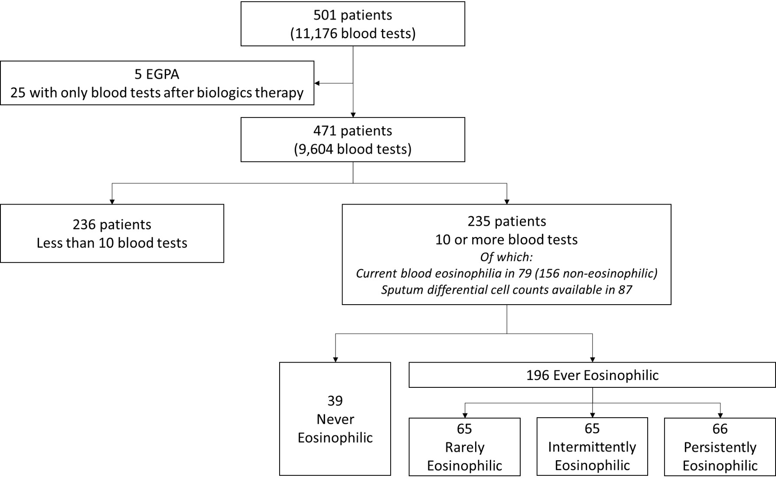

Figure 1

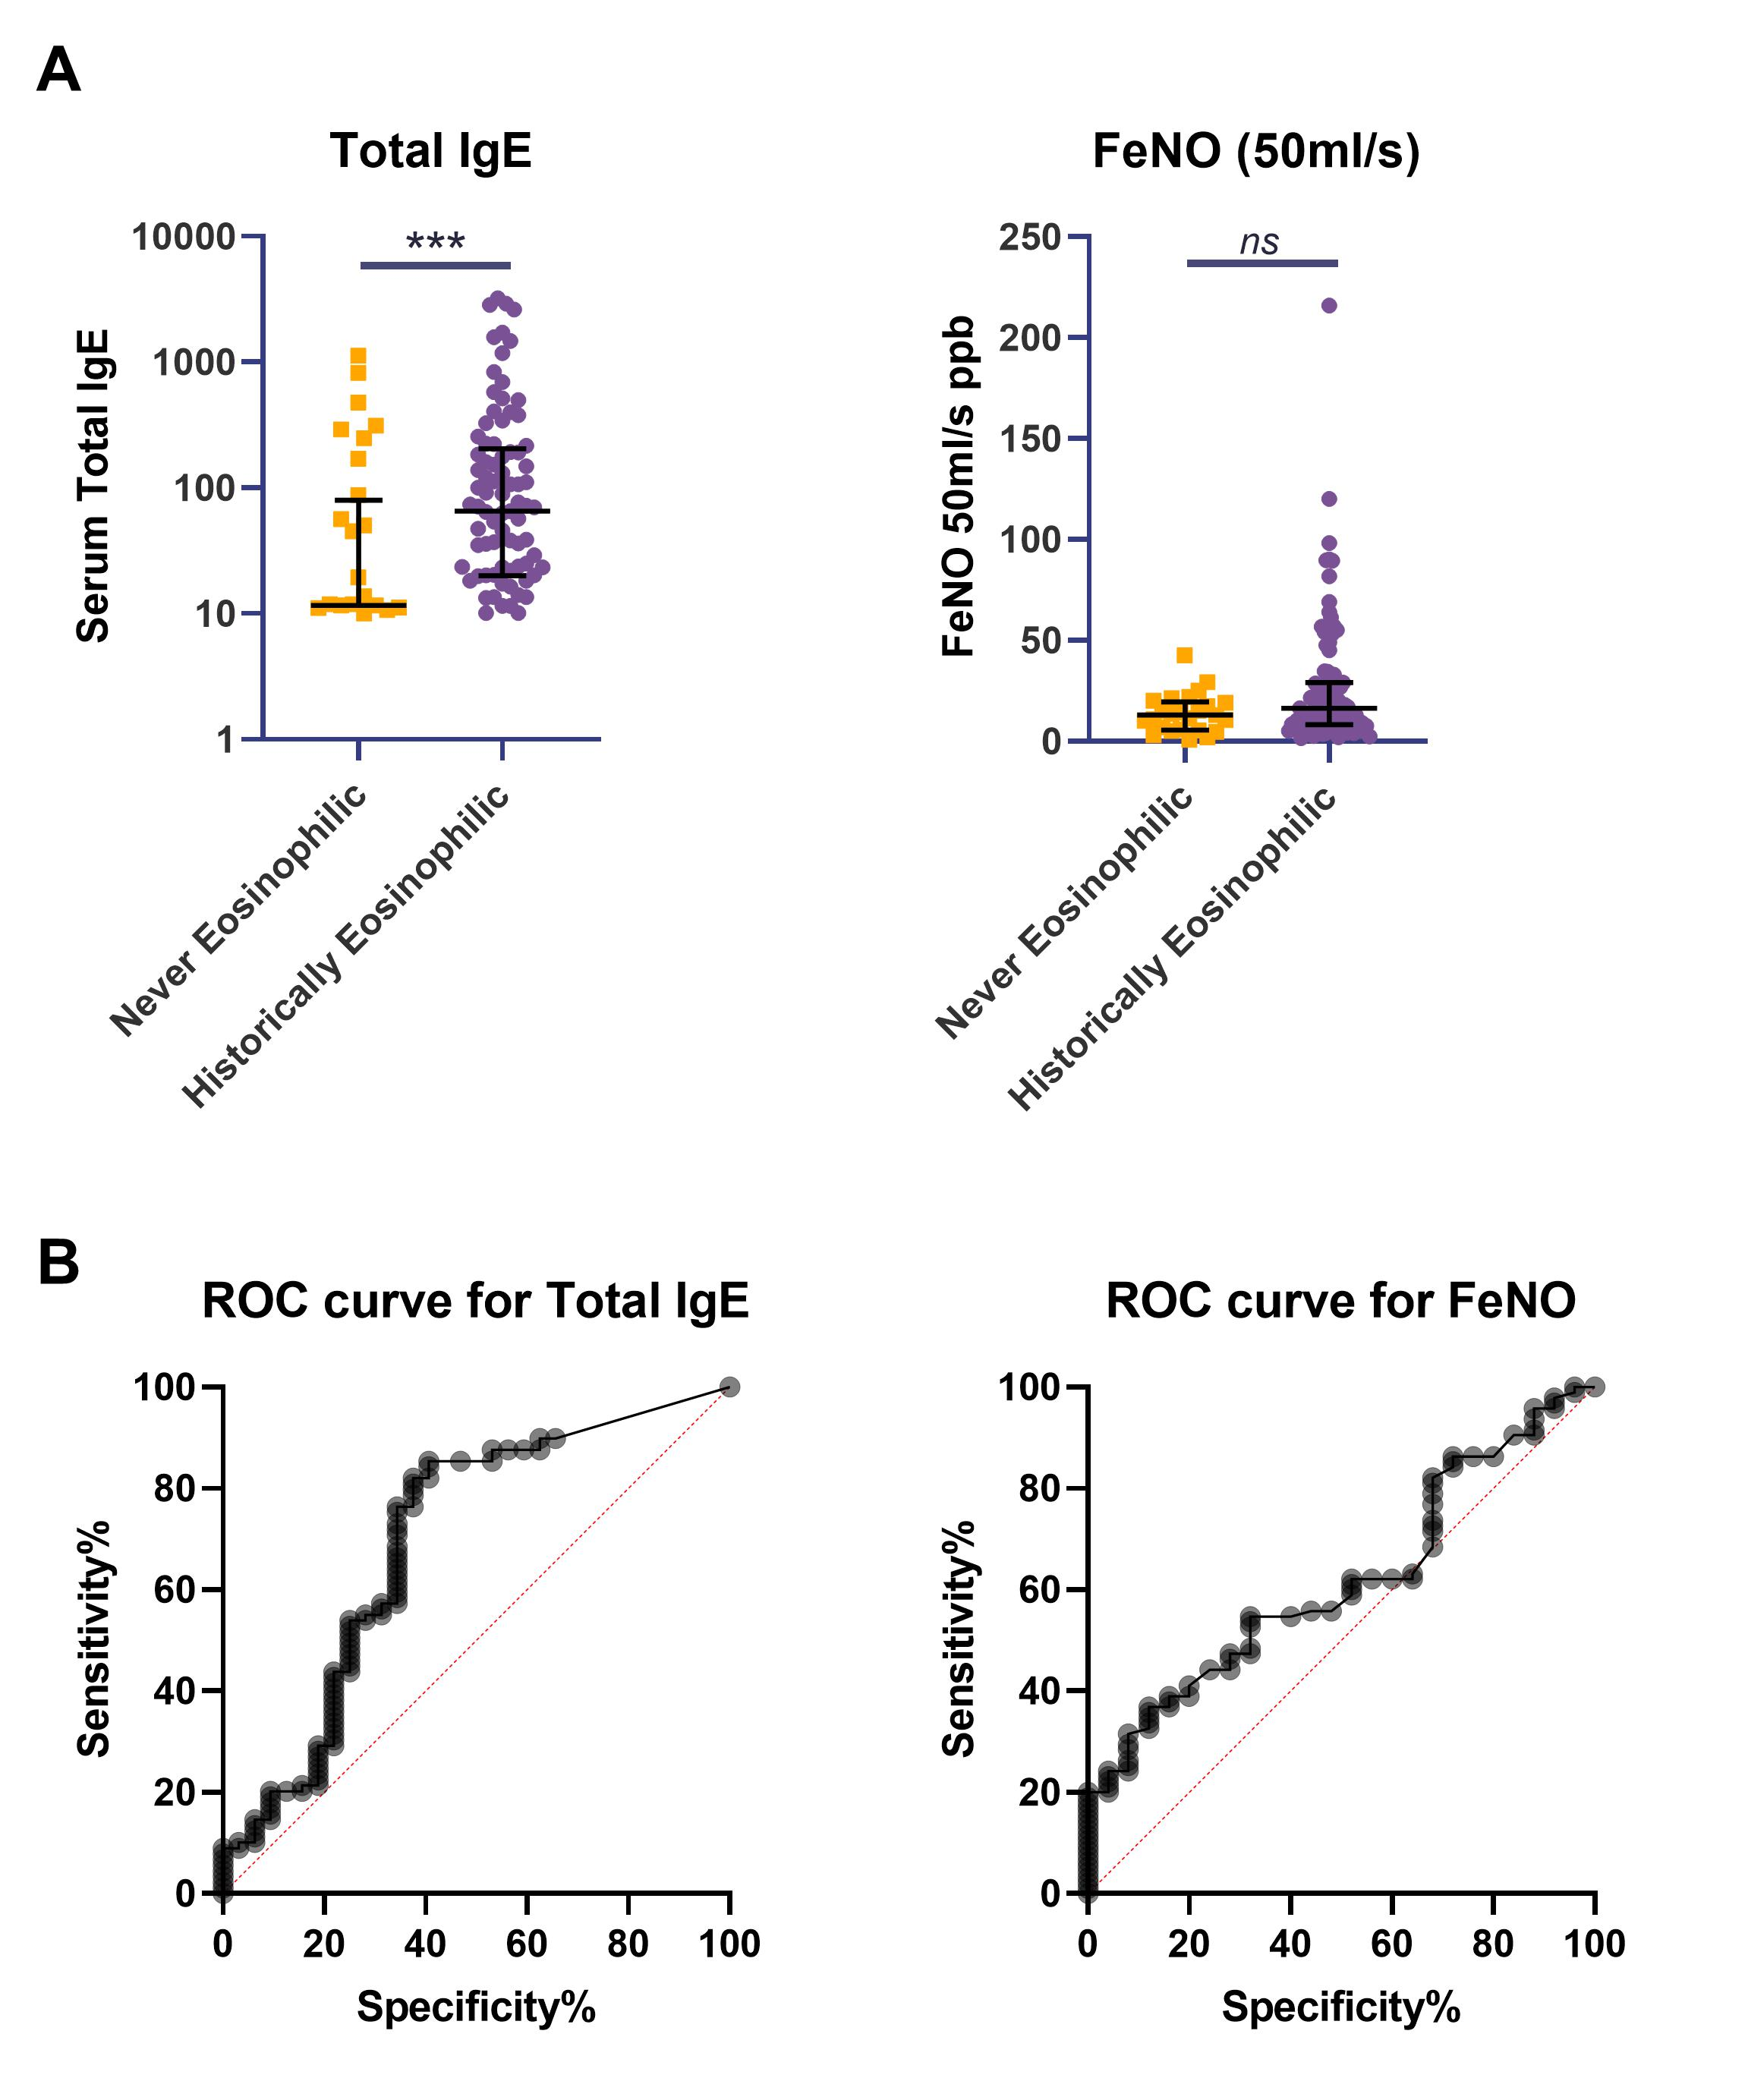

Figure 2

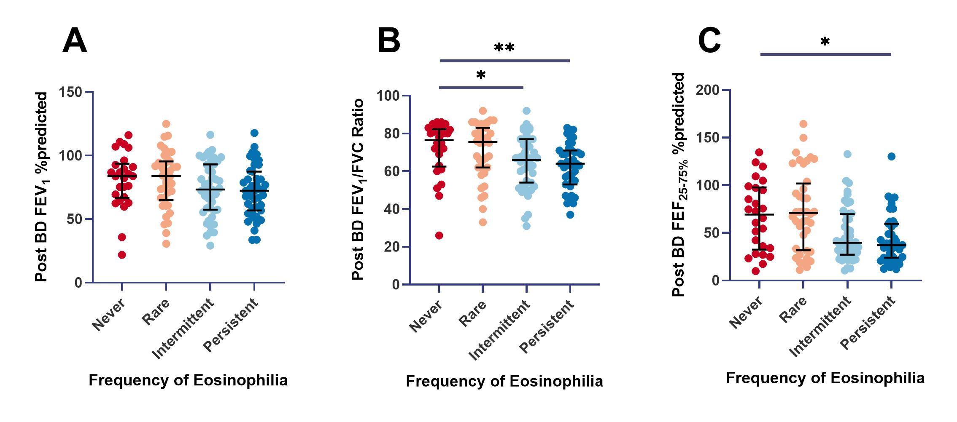

Figure 3

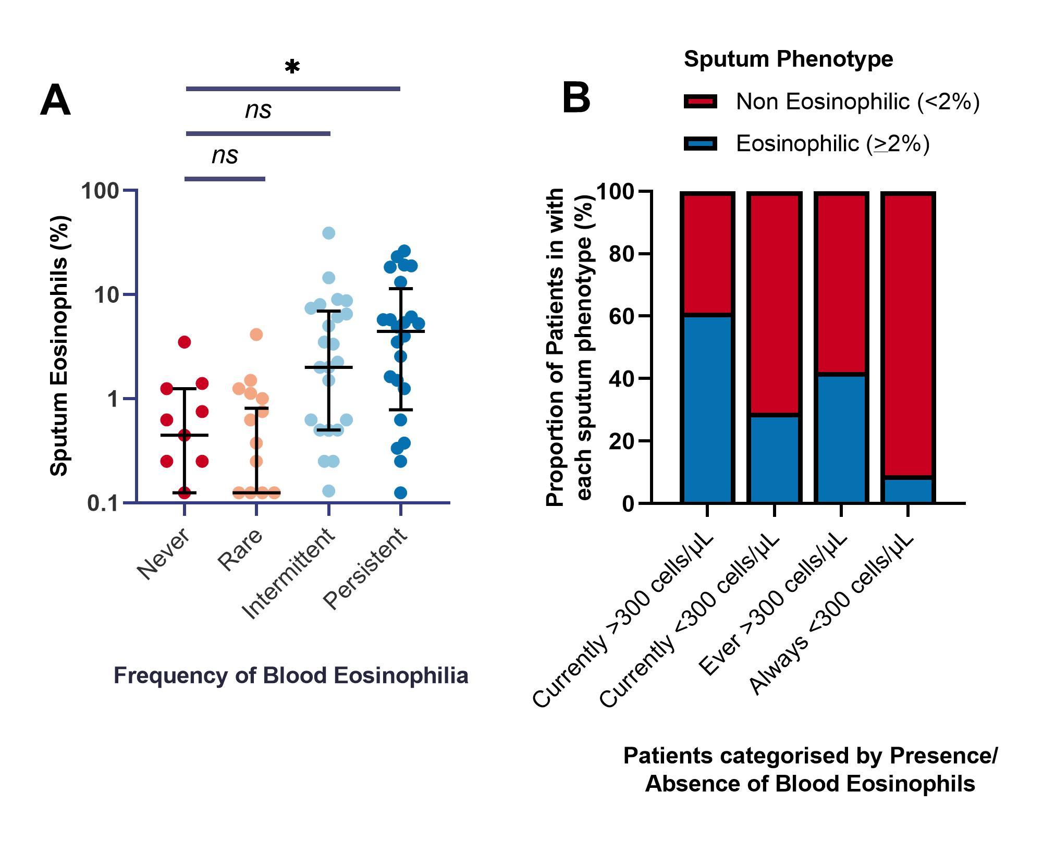

Figure 4

REFERENCES

1. George L, Brightling CE. Eosinophilic airway inflammation: role in asthma and chronic obstructive pulmonary disease. Ther Adv Chronic Dis. 2016;7(1):34-51.
2. Green RH, Brightling CE, McKenna S, et al. Asthma exacerbations and sputum eosinophil counts: a randomised controlled trial. Lancet. 2002;360(9347):1715-1721.
3. Davies AR, Hancox RJ. Induced sputum in asthma: diagnostic and therapeutic implications. Curr Opin Pulm Med. 2013;19(1):60-65.
4. Wagener AH, de Nijs SB, Lutter R, et al. External validation of blood eosinophils, FE(NO) and serum periostin as surrogates for sputum eosinophils in asthma. Thorax. 2015;70(2):115-120.
5. Zhang XY, Simpson JL, Powell H, et al. Full blood count parameters for the detection of asthma inflammatory phenotypes. Clinical and experimental allergy : journal of the British Society for Allergy and Clinical Immunology. 2014;44(9):1137-1145.
6. Price DB, Rigazio A, Campbell JD, et al. Blood eosinophil count and prospective annual asthma disease burden: a UK cohort study. Lancet Respir Med. 2015;3(11):849-858.
7. Hancox RJ, Pavord ID, Sears MR. Associations between blood eosinophils and decline in lung function among adults with and without asthma. The European respiratory journal. 2018;51(4).
8. Tran TN, Khatry DB, Ke X, Ward CK, Gossage D. High blood eosinophil count is associated with more frequent asthma attacks in asthma patients. Annals of allergy, asthma & immunology : official publication of the American College of Allergy, Asthma, & Immunology. 2014;113(1):19-24.
9. Vedel-Krogh S, Fallgaard Nielsen S, Lange P, Vestbo J, Nordestgaard BG. Association of Blood Eosinophil and Blood Neutrophil Counts with Asthma Exacerbations in the Copenhagen General Population Study. Clin Chem. 2017;63(4):823-832.
10. Ortega HG, Liu MC, Pavord ID, et al. Mepolizumab treatment in patients with severe eosinophilic asthma. The New England journal of medicine. 2014;371(13):1198-1207.
11. Chupp GL, Bradford ES, Albers FC, et al. Efficacy of mepolizumab add-on therapy on health-related quality of life and markers of asthma control in severe eosinophilic asthma (MUSCA): a randomised, double-blind, placebo-controlled, parallel-group, multicentre, phase 3b trial. Lancet Respir Med. 2017;5(5):390-400.
12. FitzGerald JM, Bleecker ER, Nair P, et al. Benralizumab, an anti-interleukin-5 receptor alpha monoclonal antibody, as add-on treatment for patients with severe, uncontrolled, eosinophilic asthma (CALIMA): a randomised, double-blind, placebo-controlled phase 3 trial. Lancet. 2016;388(10056):2128-2141.
13. Bleecker ER, FitzGerald JM, Chanez P, et al. Efficacy and safety of benralizumab for patients with severe asthma uncontrolled with high-dosage inhaled corticosteroids and long-acting beta2-agonists (SIROCCO): a randomised, multicentre, placebo-controlled phase 3 trial. Lancet. 2016;388(10056):2115-2127.
14. Graff S, Demarche S, Henket M, Paulus V, Louis R, Schleich F. Increase in blood eosinophils during follow-up is associated with lung function decline in adult asthma. Respir Med. 2019;152:60-66.
15. McGrath KW, Icitovic N, Boushey HA, et al. A large subgroup of mild-to-moderate asthma is persistently noneosinophilic. Am J Respir Crit Care Med. 2012;185(6):612-619.
16. Newby C, Agbetile J, Hargadon B, et al. Lung function decline and variable airway inflammatory pattern: longitudinal analysis of severe asthma. The Journal of allergy and clinical immunology. 2014;134(2):287-294.
17. Rakowski E, Zhao S, Liu M, et al. Variability of blood eosinophils in patients in a clinic for severe asthma. Clinical and experimental allergy : journal of the British Society for Allergy and Clinical Immunology. 2019;49(2):163-170.
18. Coumou H, Westerhof GA, de Nijs SB, Amelink M, Bel EH. Diagnosing persistent blood eosinophilia in asthma with single blood eosinophil or exhaled nitric oxide level. Respir Med. 2018;141:81-86.
19. Mathur SK, Fichtinger PS, Evans MD, Schwantes EA, Jarjour NN. Variability of blood eosinophil count as an asthma biomarker. Annals of allergy, asthma & immunology : official publication of the American College of Allergy, Asthma, & Immunology. 2016;117(5):551-553.
20. Kostikas K, Brindicci C, Patalano F. Blood Eosinophils as Biomarkers to Drive Treatment Choices in Asthma and COPD. Curr Drug Targets. 2018;19(16):1882-1896.
21. Miyakis S, Karamanof G, Liontos M, Mountokalakis TD. Factors contributing to inappropriate ordering of tests in an academic medical department and the effect of an educational feedback strategy. Postgrad Med J. 2006;82(974):823-829.
22. Osei-Bimpong A, McLean R, Bhonda E, Lewis SM. The use of the white cell count and haemoglobin in combination as an effective screen to predict the normality of the full blood count. Int J Lab Hematol. 2012;34(1):91-97.
23. Friedman CP, Wong AK, Blumenthal D. Achieving a nationwide learning health system. Sci Transl Med. 2010;2(57):57cm29.
24. Azim A, Freeman A, Lavenu A, et al. New Perspectives on Difficult Asthma; Sex and Age of Asthma-Onset Based Phenotypes. J Allergy Clin Immunol Pract. 2020.
25. Azim A, Mistry H, Freeman A, et al. Protocol for the Wessex AsThma CoHort of difficult asthma (WATCH): a pragmatic real-life longitudinal study of difficult asthma in the clinic. BMC Pulm Med. 2019;19(1):99.
26. Hastie AT, Moore WC, Meyers DA, et al. Analyses of asthma severity phenotypes and inflammatory proteins in subjects stratified by sputum granulocytes. J Allergy Clin Immunol. 2010;125(5):1028-1036 e1013.
27. Simpson JL, Scott R, Boyle MJ, Gibson PG. Inflammatory subtypes in asthma: assessment and identification using induced sputum. Respirology. 2006;11(1):54-61.
28. Stern G, de Jongste J, van der Valk R, et al. Fluctuation phenotyping based on daily fraction of exhaled nitric oxide values in asthmatic children. J Allergy Clin Immunol. 2011;128(2):293-300.
29. Delgado-Eckert E, Fuchs O, Kumar N, et al. Functional phenotypes determined by fluctuation-based clustering of lung function measurements in healthy and asthmatic cohort participants. Thorax. 2018;73(2):107-115.
30. Asthma GIf. Global Strategy for Asthma Management and Prevention https://ginasthma.org/wp-content/uploads/2020/06/GINA-2020-report_20_06_04-1-wms.pdf. Published 2020. Accessed 10/10/20.
31. Kay AB, Phipps S, Robinson DS. A role for eosinophils in airway remodelling in asthma. Trends Immunol. 2004;25(9):477-482.
32. Bai TR, Vonk JM, Postma DS, Boezen HM. Severe exacerbations predict excess lung function decline in asthma. The European respiratory journal. 2007;30(3):452-456.
33. James AL, Palmer LJ, Kicic E, et al. Decline in lung function in the Busselton Health Study: the effects of asthma and cigarette smoking. Am J Respir Crit Care Med. 2005;171(2):109-114.
34. Contoli M, Baraldo S, Marku B, et al. Fixed airflow obstruction due to asthma or chronic obstructive pulmonary disease: 5-year follow-up. The Journal of allergy and clinical immunology. 2010;125(4):830-837.
35. Broekema M, Volbeda F, Timens W, et al. Airway eosinophilia in remission and progression of asthma: accumulation with a fast decline of FEV(1). Respir Med. 2010;104(9):1254-1262.
36. Ortega H, Yancey SW, Keene ON, Gunsoy NB, Albers FC, Howarth PH. Asthma Exacerbations Associated with Lung Function Decline in Patients with Severe Eosinophilic Asthma. J Allergy Clin Immunol Pract. 2018;6(3):980-986 e981.
37. Haldar P, Pavord ID, Shaw DE, et al. Cluster analysis and clinical asthma phenotypes. Am J Respir Crit Care Med. 2008;178(3):218-224.
38. Hinks TS, Brown T, Lau LC, et al. Multidimensional endotyping in patients with severe asthma reveals inflammatory heterogeneity in matrix metalloproteinases and chitinase 3-like protein 1. The Journal of allergy and clinical immunology. 2016;138(1):61-75.
39. Drake VE, Rafaels N, Kim J. Peripheral blood eosinophilia correlates with hyperplastic nasal polyp growth. Int Forum Allergy Rhinol. 2016;6(9):926-934.
40. Sreeparvathi A, Kalyanikuttyamma LK, Kumar M, Sreekumar N, Veerasigamani N. Significance of Blood Eosinophil Count in Patients with Chronic Rhinosinusitis with Nasal Polyposis. J Clin Diagn Res. 2017;11(2):MC08-MC11.
41. Green BJ, Wiriyachaiporn S, Grainge C, et al. Potentially pathogenic airway bacteria and neutrophilic inflammation in treatment resistant severe asthma. PLoS One. 2014;9(6):e100645.
42. Goleva E, Jackson LP, Harris JK, et al. The effects of airway microbiome on corticosteroid responsiveness in asthma. Am J Respir Crit Care Med. 2013;188(10):1193-1201.
43. Ortega H, Llanos JP, Lafeuille MH, et al. Effects of systemic corticosteroids on blood eosinophil counts in asthma: real-world data. The Journal of asthma : official journal of the Association for the Care of Asthma. 2019;56(8):808-815.
44. Pavlidis S, Takahashi K, Ng Kee Kwong F, et al. "T2-high" in severe asthma related to blood eosinophil, exhaled nitric oxide and serum periostin. Eur Respir J. 2019;53(1).
45. Drick N, Seeliger B, Welte T, Fuge J, Suhling H. Anti-IL-5 therapy in patients with severe eosinophilic asthma - clinical efficacy and possible criteria for treatment response. BMC pulmonary medicine. 2018;18(1):119.
46. Agniel D, Kohane IS, Weber GM. Biases in electronic health record data due to processes within the healthcare system: retrospective observational study. BMJ. 2018;361:k1479.

