Optimization in Redox Flow Batteries
Puiki Leung¹, Joseph Johannes Henricus Pijpers², Carlos Ponce de León¹

¹Faculty of Engineering and Physical Sciences, University of Southampton, Highfield, Southampton, SO17 1BJ, United Kingdom
²Instituto Nacional de Electricidad y Energías Limpias. Reforma 113, Colonia Palmira, Cuernavaca, Morelos, C.P. 62490 Mexico

Puiki Leung, e-mail: P.K.Leung@soton.ac.uk
Joseph Johannes Henricus Pijpers, e-mail: jpijpers@ineel.mx
Carlos Ponce de León, e-mail: capla@soton.ac.uk

Abstract
This paper presents some optimization approaches for redox flow batteries, which are promising energy storage devices due to their potential of providing long-duration storage at low cost. In order to compete with alternative energy storage technologies (e.g. lithium-ion batteries), flow battery optimization will need to focus on increased round-trip efficiency and ensuring outstanding flow battery durability, while utilizing low-cost material for critical electrolyte and stack components.

Keywords: current density; electrode materials and treatment; energy density; energy storage; figures of merit; flow rate management; porous electrodes; power density; pressure drop; redox flow batteries.

1. Introduction
This paper analyses some operational parameters that are fundamental to improve the performance of Redox Flow Batteries (RFBs). These batteries are designed to support electricity generation plants by providing a reversible energy storage capability and manage and facilitate the electricity load in the grid. A typical RFB module consists on an arrangement of a large number, of up to 200 bipolar cells. Each single cell contains two compartments divided by a separator that keeps apart two redox couples dissolved in an electrolyte. The electrolyte is distributed through the cells from two reservoirs using centrifugal magnetic driven or peristaltic pumps. A schematic diagram of a single cell is presented in Figure 1 showing the electrodes, separator, pumps, reservoirs and simplified electrical components.

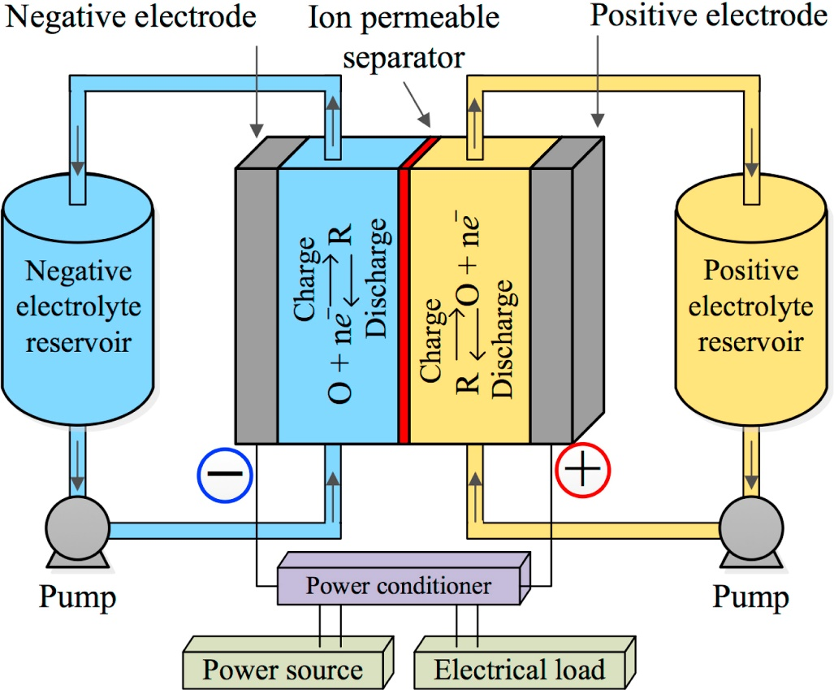

Figure 1. Schematic diagram of a unitary redox flow battery with all the components of a divided single cell electrolyte reservoirs and pumps. With permission from Elsevier.

As the number of single cells increases, the electrolyte is distributed to all the cells that are arranged parallel to each other and connected in bipolar mode configuration. By optimizing the performance parameters such as current density, flow rate and distribution, pressure drop and mass transport among other properties, the energy storage and delivery rate can be more effective leading to a more competitive energy storage device.
The continuous increase of wind and solar electricity sources integrated into the utility grid in many countries presents an ideal opportunity to establish the redox flow batteries as one of the main competitive technologies for energy storage. The need for energy storage devices responds to the rising demand of clean energy which has exponentially increased the installed worldwide capacity of solar and wind electricity over the past decade, for example in 2017 and 2018 the installed capacity of solar was around 98 GW and 107 GW, respectively and provided approximately 1.8% of the worldwide electricity, this was an increase of over 29% more compared to the installed capacity in 2016 making photovoltaic one of the fastest growing industries in the world (Kozak-Jagiea et al. 2020). Similarly, the global cumulative installed capacity for wind energy has increased approximately 22% per year since 2006 reaching over 651 GW in 2019 (Karnauskas et al. 2018, Lee et al. 2019).

2. Main characteristics of redox flow batteries
RFBs can provide electricity and independence from the grid when combined with solar photovoltaic arrays or wind turbines storing energy during peak energy generation and delivering it when the generation is low. For fossil fuel power generation plants, RFBs can provide load levelling capacity, increasing the life span of the power plant which can operate at constant power.
The main characteristics of RFBs include simple operation and flexibility to scale up, long life and reliability at moderate operational and maintenance costs. The two redox electroactive species that store the energy need to be abundant and low cost in order to offer a competitive advantage over other energy storage systems. In practice, high concentration of the electroactive species and large volume of the electrolyte results in high energy storage capacity whereas by increasing the number of bipolar cells and/or the size of the electrodes (electrode area) will increase the power capability. Ideally, the oxidant and the reduced electroactive species should be highly soluble in the electrolyte, i.e. with no phase changes of the electroactive species during charge/discharge cycles, this is the case of the all vanadium RFBs. Other types RFBs operate in hybrid mode, i.e. when one or both of the reduced or oxidized species are solid and deposit on the electrode surface like the zinc – cerium or the soluble lead acid redox flow batteries, respectively. The formation of a solid phase imposes some restrictions on the reactor design because there is a need to account for the thickness of the deposited layer and the possibility of the formation of dendrites that could cause a short circuit if they grow sufficiently long to perforate the membrane. The membrane should be able to restrict the diffusion of the electroactive species to and from the cathode and anode compartments and should be able to allow the transport of non-electroactive species with their associated water molecules in order to keep the electro neutrality in both sides. The membrane either anionic or cationic should be appropriately selected to maintain the pH constant in both sides. In spite of being rather expensive, the most commonly-used membrane is Nafion® as it offers low electric resistivity and exhibits a long life span due to its excellent chemical stability. Lower-cost alternatives in the form of non-fluorinated membranes have been reported recently (Wu et al. 2020) for instance, sulfonated PEEK membranes, though it will be important to validate that these hydrocarbon membranes are stable strongly oxidizing or reducing chemical environments during prolonged battery cycling. Alternatively, redox-active compounds have been attached to soluble polymer chains, enabling the use of low-cost porous cellulose membranes (Janoschka et al. 2015).
In this article, we will review some optimization strategies that are commonly pursued to improve the functioning of some critical stack and electrolyte components. Typically, flow battery optimization should result in more efficient, more durable, and lower-cost flow battery systems. More efficient flow battery can be achieved by optimizing the flow field design (optimizing mass transfer and minimizing pressure drop) and minimizing all the Ohmic resistance within the electrochemical cells (in particular, minimization of the ion-exchange membrane resistance). Flow battery durability can be optimized by improving the electrolyte chemistry (and understanding how operating conditions affect the electrolyte durability) and by ensuring long lifetimes of critical stack components (e.g. seals, and membrane separators). Reductions in flow battery cost can be achieved by improving battery efficiency and durability, as well as by developing low-cost materials for redox-active compounds and critical stacks components, in particular, bipolar plates and membranes (Noack, et al. 2016).

3. Electrode and stack
Figure 2a shows an example of a RFB reactor of 5 bipolar cells used for the polysulfide/bromide energy storage system. The schematic image shows the manifolds for the electrolyte inlet and outlet as well as the current collectors. In this system the cells are over 1.5 m height and the length depend on the number of bipolar cells assembled in the module, which could be up to 200 bipolar cells. In the example of Figure 2a, the bipolar electrodes measure approximately 66.8 cm × 108.0 cm which resulted in a projected area of 0.72 m². One of the most distinctive characteristic of this system is the 0.2 cm inter-electrode gap that allowed to accommodate a Nafion® 115 cation exchange membrane and two high-density polyolefin (HDPE, Netlon™) turbulence promoter, one in each side of the membrane as shown in Figure 2b. An individual electrode frame in Figure 2c shows electrolyte inlets and outlets of 6.3 cm internal diameter that the manifolds to transport the electrolyte to each compartment when several frames stack together to form the module. The spiral in the manifold were designed to reduce the bypass current and make the system more efficient by avoiding loss of current between the electrolyte circuit and the electrode compartments.
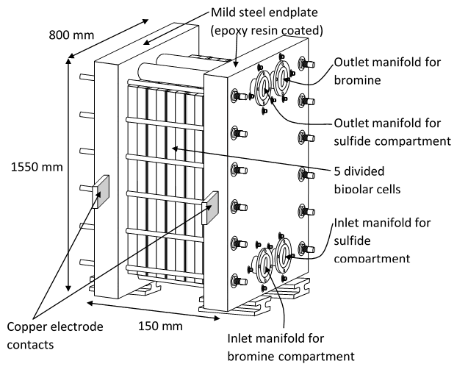
a)

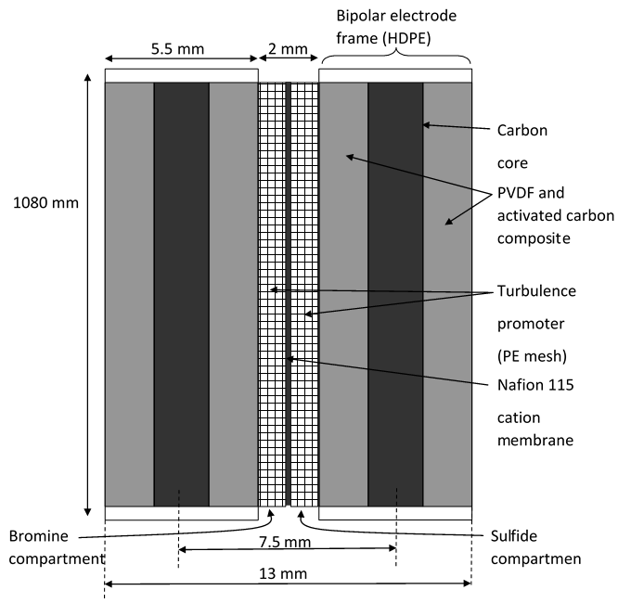
b)

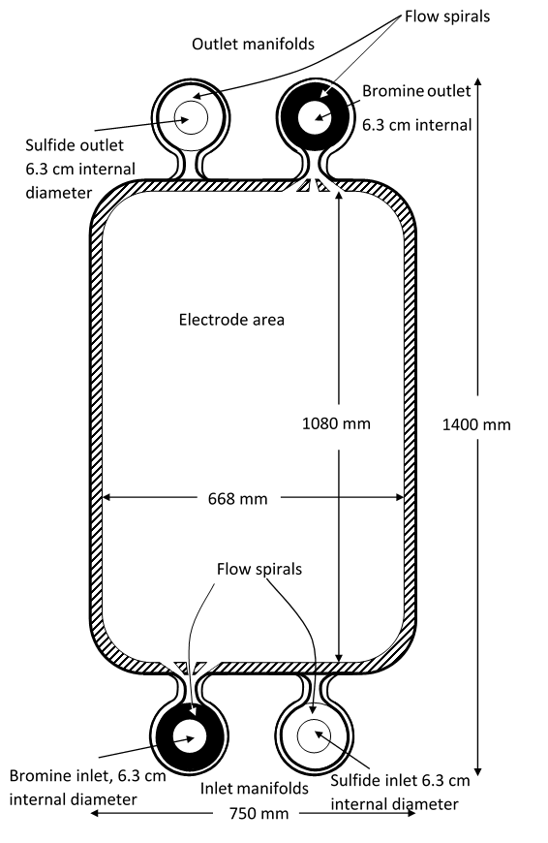
Figure 2. a) Lateral view of the reactor showing the inlet and outlet manifolds and the location of the current collectors. Not to scale. b) Details of a bipolar cell showing the main components. Not to scale. The dimensions are nominal. c) Electrode configuration showing the location of the spirals and the projected electrode area. With permission from Elsevier.

4. Figures of merit
The performance of the RFB is strongly influenced by several parameters that need to be minimized: shunt (bypass or leakage) currents, uneven flow distribution, reactant back mixing and loss or decreased ionic conductivity due to water transfer through the membrane. The main parameters used to evaluate the performance are the figures of merit that refer to the electrolyte volume, reactant conversion and state of charge, some of the most common are:
$η_{V}=\frac{V_{cc}\left(discharge\right)}{V_{cc}\left(charge\right)}$ (1)
$η_{C}=\frac{Q_{}\left(discharge\right)}{Q_{}\left(charge\right)}$ (2)
$η_{e}=\frac{E\left(discharge\right)}{E\left(charge\right)}$ (3)
$η_{P}=\frac{{IV}_{cc}\left(discharge\right)}{{IV}_{cc}\left(charge\right)}$ (4)
Where V_{CC}(discharge) and V_{CC}(charge are the cell voltages during discharge and charge respectively and η_{V}, η_{C}, η_{e} and η_{P}, are the voltage, coulombic, energy and power efficiencies while E, I and P are the energy, current and power. The energy efficiency η_{e}, also known as the round-trip efficiency (RTE), is the product of the coulombic and voltage efficiencies η_{C} η_{V} and it represent the ratio of the energy out and the energy input in the system:
RTE = $\frac{energy out}{energy in}×100\%$ (5)
More specific figures of merit for energy storage systems have proposed by (Rodrigues, et al., 2017) and can be defined as the storage efficiency index (SEI), that measures the ability to store energy when a renewable energy source is available, and the demand response index (DRI), that evaluates the response capacity of the battery on energy demand:
$SEI=\frac{\sum{E_{{Bat}_{IN}}^{k}}}{\sum{E_{{WP}_{Gen}}^{k}-\sum{E_{{WP}_{Grid}}^{k}}}}$ (6)
$DRI=\frac{\sum{E_{out}^{k}}}{\sum{E_{Dem}^{k}-\sum{E_{{WP}_{Grid}}^{k}}}}$ (7)
Where $\sum{E_{{Bat}_{IN}}^{k}}$ is the energy input in the battery, $\sum{E_{out}^{k}}$ is the energy output from the battery, $\sum{E_{{WP}_{Gen}}^{k}}$ is the wind or solar power generation, $\sum{E_{Dem}^{k}}$ is the energy consumption referring to the final consumers and $\sum{E_{{WP}_{Grid}}^{k}}$ the wind or solar power consumed.

5. Flow velocity
The flow velocity is associated with the concentration overpotential per unit area. Increased flow velocity enhances the mass transport of active species, resulting in higher limiting current densities. The electrolyte flow velocity and the corresponding power densities varies with the electrode/cell architectures. For instance, carbon paper tends to yield higher power densities (often > 0.5 W cm⁻²) than with carbon felt (mostly < 0.55 W cm⁻²) but at higher electrolyte flow velocities (i.e. > 4 cm s⁻¹).
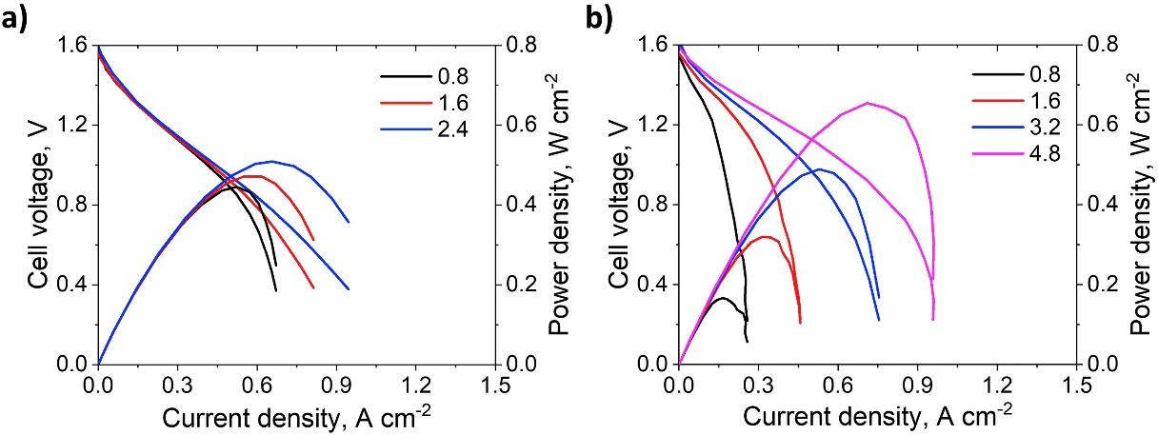
Figure 3. Polarization curves at different flow velocities; a) three-channel serpentine (SFF)-Graphite felt, and b) SFF-Carbon paper (3- layers of SGL 10 AA 360 μm thick, used at cathode and anode). With permission from Elsevier.

The comparison (polarization curves) of electrochemical performances of graphite felt and carbon felts with serpentine flow fields is shown in Figure 3. At slower electrolyte velocity (< 3 cm s⁻¹), the output power density of carbon paper was observed to be similar to that with felt electrodes. Thinner and denser carbon paper tends to reduce the internal resistance, also allows higher electrolyte flow velocities while avoiding excessive pressure build up. In most cases, carbon papers had less activation and ohmic losses. However, rapid drop in discharge voltages at increased current densities indicated that improved mass transport of active species/ higher electrolyte flow velocities (> 3 cm s⁻¹) are required. Taking account of internal resistance issues, the power output (i.e. 0.65 W cm⁻²) is still superior with carbon papers at higher electrolyte flow velocities (i.e. > 4 cm s⁻¹).
For porous electrodes with flow field architectures, larger pump powers are required to overcome the pressure drop across the flow, together at the point of porosity at increased tortuosity. Electrolyte flows at the inlets/outlets or across the porous electrodes with non-uniform porosity tend to give disorder flow and enable a higher reactant flux than with diffusion process only. This may hinder the flow velocity or enhance the mass transport of the active species or improve the electrolyte contact with the electrode surface.
Within these porous structures, convective flows tend to extend over a wider area at increased flow rate, which reduce the concentration overpotential and enhances the electrochemical performance, while pump power and pressure drop were increased within the cells. In a scaled up system, higher flow velocity also implies the requirements of more powerful and hence more expensive pumps. Meanwhile, when larger pumps are used, the efficiencies were usually lower for obtaining lower flow velocity during low current operations.
Since the electrochemical performances are highly associated with the mass transport of active species towards the electrode surfaces, flow velocity has impact on the battery capacities and charge/discharge cell voltages, especially at high currents. Taking account that cycling of most batteries are controlled by voltage limits, insufficient flow velocity often resulted in premature voltage cut-off at the end of each charge/discharge cycle, hence the maximum capacity cannot be exploited effectively. In this regard, control/step-up strategies for the electrolyte flow velocities have been proposed to improve the system efficiencies and maintain high capacities at the same time. For instance, lower flow velocity was mainly used in the charge-discharge processes but ‘stepped up’ towards the end of the charge/discharge processes. With this strategy, the system efficiency can be improved by as much as 8 %.

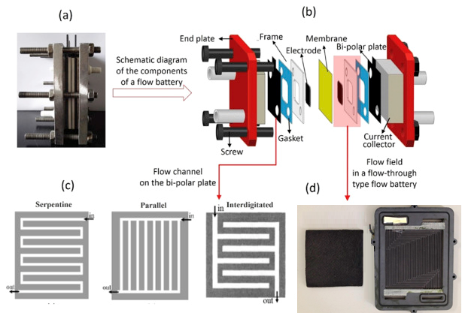
Figure 4. (a) Digital picture of a single flow battery (b) Schematic diagram of the components of a flow battery (c) Flow channels on the bi-polar plate (d) Digital picture of the flow field in a flow-through type flow battery. With permission from Elsevier.

Uniform distributions of electrolytes can be optimized by introducing suitable ‘flow-fields’ (i.e. parallel, serpentine, and interdigitated, see Figure 4) in end-/bipolar plates, that can be facilitated by computational fluid dynamics (CFD) and other multi-physics software. These flow fields could improve the cell performances, particularly power outputs, by reducing their inter-electrode gaps (zero-gap architecture) and the overall cell resistances. These flow channels may lead to a poor mechanical performance of the cell stacks at scaled-up sizes. Conventional architecture enables electrolyte to be forced to flow through the porous electrodes. At higher flow velocity, the hydraulic resistance could cause a high pressure drop, although (Reed et al. 2016), reported that lower flow rates still enable reasonable performances. Parallel flow field involves multiple parallel channels that connect to the inlet and outlet through header channels. Serpentine flow field consists of a single channel that passes along the length of the cell and split into multiple adjacent serpentine channels. Interdigitated flow fields have parallel channels that are blocked and do not lead to both inlet and outlet of the electrode compartments. This design forces hydraulic convection across the porous electrodes, and the barrier separating adjacent channels. At low electrolyte velocity, interdigitated flow fields with a thin carbon paper electrode were reported to have the best performance, outperforming that with serpentine flow field with a thicker electrode (Houser, et al. 2016).

6. Porous electrodes (carbon felt vs. carbon paper)
Porous electrodes are three-dimensional materials, providing high surface areas to facilitate more efficient chemical conversion per electrolyte pass and reduce the polarizations in the reaction processes. Carbon/graphite felts and papers are common electrode materials for different RFB chemistries due to its chemical inertness with various electrolytes (i.e. concentrated acid/alkaline), although the untreated samples often have poor wettability and undergo degradation in oxidizing reactions under medium- and long term operations. It has been demonstrated that current densities can be much higher when using porous electrodes (> 50 mA cm⁻²) respect to planar electrodes (< 50 mA cm⁻²), leading to higher power densities and therefore reduced stack dimension for the same power output, which in turn results in lower stack cost (Gautam et al. 2020).

For all-vanadium RFBs, the conventional stack design with an “open flow field” configuration (i.e. a thick carbon felt in contact with planar bipolar plates with no flow fields) typically results in power densities < 0.2 W cm⁻² (Kumar et al. 2016). When using flow fields in combination with thin carbon paper or cloth electrodes, the power density could be increased up to 0.55 W cm⁻² by minimizing internal resistance, better electrolyte distribution and less parasitic pump losses. Compared to carbon paper, the improvement in energy density was less pronounced with carbon felt electrodes, even in conjunction with flow fields. For VRFBs, improved performance was obtained by minimizing the internal ohmic resistance when the thicknesses of carbon felt electrodes were compressed by 20 –80 % (Zheng et al. 2014, Chang et al. 2014, Brown et al. 2016, Park et al. 2014 and Oh et al. 2015a). For carbon felt electrodes, one of the highest peak power densities were obtained (ca. 0.3 mW cm⁻²) with a felt compression of ca. 30 % (Chen et al. 2013). Other vanadium systems have reported higher power densities of 360 mW cm⁻² in a 40-cell stack, however no details of compression or type of flow fields was provided (Guarnieri et al. 2019).
In comparison, the obtained power density can be several times higher for porous carbon electrodes with zero-gap flow field architectures than carbon felt electrodes that have not been compressed heavily in similar conditions. Even in the early work of (Aaron et al. 2012), 3 layers of pre-treated carbon papers were used in a serpentine flow field architecture, the power density was up to 0.56 – 0.77 W cm⁻² at electrolyte flow velocity of 4 cm s⁻¹. The same research group further achieved a peak power density of up to ca. 1.3 W cm⁻² at 1,000 mA cm⁻². The highest peak power density of 1.350 W cm⁻² was obtained at 1,600 mA cm⁻² without exact cell details disclosed. Following these, several research groups evaluated the kinetics or/and mass transport properties of carbon paper electrodes in different electrode architectures (Houser, et al. 2017).
It is worth noting that the active areas used in these academic publications were relatively small (<25 cm²) compared to commercial flow battery stack (i.e. MW scale: active area in the range of 0.1 – 2.0 m²). It is known that smaller-sized cells tends to have improved mass transport of active species. Less uniform distributions of electrolyte were often observed in larger cells or/and at lower flow velocity. In such cases, electrolytes were likely to take a diagonal path from the inlet to the outlet, leaving significant parts of the electrode areas poorly irrigated.
The polarization curves (E vs. j) reported in these works were obtained under different operating conditions, i.e. cell sizes and electrolyte conditions. Many of these curves were obtained with quick scans of potential or current, which minimized the depletion of charged/discharged species locally within the electrode compartments. Although these polarization curves may provide an insight into the potential losses, information regarding system efficiencies and capacity stability were still not accessible. Hence, the polarization curves were incapable of evaluating the charge-discharge performances, which were mainly suitable for rough performance evaluations, especially for small-sized /laboratory scaled batteries.

7. Compression of porous electrodes
The correlation between battery resistance and performances at different compression ratios has also been identified, even with non-uniformly compressed electrodes. In general, increased clamping/compressive pressure on the electrode layers improves the electrical conductivity of the battery, and hence reduce the overall polarization. Figure 5 shows the X-ray computed tomography of carbon felt electrodes at increased compression. These compressive pressures were also effective in diminishing the contact resistances, resulting in higher voltage and energy efficiencies. Excessive compressions may result in non-uniform flow distributions and occurrences of regions with the retarded flow of electrolyte. A segmented cell can be used to visualize the real-time flow distributions across the electrode at different compression ratio through spatially resolved measurements.
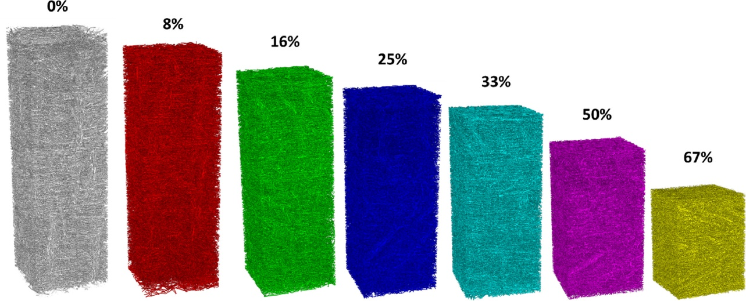
Figure 5. Reconstructed tomograms of the compressed felt showing the change in thickness as the sample is compressed. The sample shown in the images has a side length of 2 mm, shown at compressions of (from left to right) 0%, 8%, 16%, 25%, 33%, 50%, and 67%. With permission from Elsevier.

Limited by the experimental approaches, the influences of compressive forces on the activation, ohmic and mass transport polarizations are often difficult to be validated experimentally, especially the stability and performances of key functional materials are still unclear in medium- and long-term. Most existing studies evaluated electrode porosity, strain-stress evolution, area specific resistance, hydrodynamic and electrochemical performance at different compression ratios. The transport processes at different compression ratios can be mainly evaluated in detail by numerical modelling. Early models of (Shah et al. 2008) and (You et al. 2019) demonstrated that high porosity could lead to more significant side reactions (i.e. gases evolutions), while smaller porosity tends to result in more uniform distributions of polarizations. The influence of electrode compression on the voltage losses and hydraulics have also been conducted in a 2D model by (Bromberger et al. 2014), showing that higher electrode compressions tended to reduce the ohmic losses but increase the pressure drop, therefore an optimal compression ratio is required by balancing its electrical, electrochemical and hydraulic performances. The compression ratios evaluated by (Oh et al. 2015a and 205b) using a three-dimensional, transient model, showed that the electrode compression can reduce the ohmic resistance effectively, but has little influences on the mass transport and the kinetics of the electrode reactions.

8. Pressure drop
RFBs with electrolyte flowing in an “open flow field configuration” may experience large pressure drop across the cells/stacks. In practice, increased flow velocities are required for higher current density operations or physically larger cell dimensions, which increase the flow resistance and associated pumping losses. When using thin porous electrodes in combination with flow fields in the bipolar plates, the pressure drop is often smaller and more linear with uniform porosity, than those with lower porosity at the inlets or the outlets Figure 6. High pressure drop is usually associated with the permeability of the porous electrodes. The permeability varies with different electrode materials. For the case of carbon felts, the permeability of those from SGL and Alfa Aesar was in the range of 2–4 and 4–7.5 × 10⁻¹¹ m², respectively. The permeability of porous electrodes depends strongly on the compression ratios, which is by compressing different number of electrodes into certain thicknesses. By increasing the compression ratios, the permeability tended to decrease with the aggravation of flow resistances. Yue (Yue et al. 2019) have suggested that the porosity has a linear correlation with the compression ratio which in turns affects the momentum, mass and charge transport and the electrochemical reaction and can be described by the Carman-Kozeny equation which correlates the carbon electrode fiber d_{f}, the dimensionless Kozeny-Carman constant, k_{CK}, the velocity of the electrolyte $\vec{v}$, the temperature T, the dimensionless porosity of the carbon electrode, the dynamic viscosity $μ$ and the liquid pressure, P:
$\frac{16μk_{CK{\left(1-ε\right)}^{2}}}{d_{f}^{2}ε^{3}}\vec{v}=-P+μ^{*}\left[∇\vec{v}+{\left(∇\vec{v}\right)}^{T}\right]$ (8)
The pressure drop tends to increase with the electrolyte flow rate, which may increase the risk of electrolyte leakages. In various cell designs, headers at the inlet and outlet were used to improve the distributions of the electrolytes. However, some longer and narrower channels/ electrolyte paths, particularly those for shunt current minimization, may also increase the pressure drop. In general, the higher pressure drop in a conventional cell architecture could be due to the scenario that the entire fluid needs to traverse the entire length of the cell through the porous electrodes.
Incorporation of flow field can minimize these pressure drops and improve the distribution of the active species. Under-the-rib cross-flow tends to take place caused by the pressure difference between the parallel channels. When serpentine flow field is used, the electrolyte flow velocity is reduced, together with the pressure drop facilitated by the serpentine channels. Compared to interdigitated flow field, the pressure drop increased significantly with electrolyte flow velocity. To minimize the pressure drop, the flow resistance of electrolyte can be reduced with advanced designs of porous electrodes, i.e. introducing flow channels in the porous electrodes, and the power densities can be enhanced with optimized local porosities (higher/lower porosities at the inlets/outlets). It is essential to maximize the mass transport with reasonable energy consumption of the pumps, therefore optimizing these relationships is advisable for variable operating conditions in practical applications.
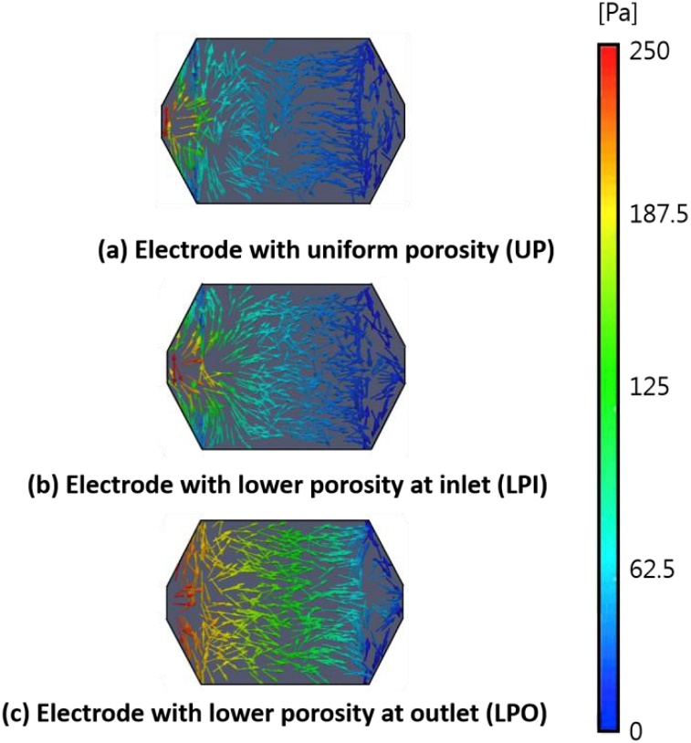
Figure 6. Pressure and velocity vectors of electrolyte in the different electrode designs. With permission from Elsevier.

9. Electrode materials
Electrode materials should provide a high electrical conductivity, good mechanical properties and strong chemical resistances at low-cost for scaled up applications. Carbon-based electrodes are more common than noble metal (or conductive metal oxide) coated electrodes, as they do not dissolve, or form insulated oxide in typical oxidation processes (up to +1.0 V vs. SHE). For highly oxidizing reactions (i.e. Ce(III)/Ce(IV), > 1.0 V vs. SHE), noble metal or conductive metal oxide coatings have good electrochemical stability or catalytic property and appear to be one of the few practical options for practical applications.
When carbon-based materials are used as end-/bipolar plates, they are typically carbon polymer composites consisted of polymer binders and carbon particles. This offers advantages in mechanical properties over pure carbon materials for scale-up applications, in which large compressive forces are often applied over large areas. The polymer and carbon content can be structurally modified/optimized to obtain reasonable electrical conductivity and mechanical properties, which have high design flexibility and allow various complicated shapes. In some studies, carbon polymer electrodes with sinusoidal corrugations were reported to decrease the pumping and ohmic losses by 21 % and 5 %, respectively. Since some porous materials are soft and flexible, their shapes and thicknesses can be controlled and optimized by the shape of the end-/bipolar plate, the thickness of the flow frame and the applied compressive forces. For instances, the porosity of carbon felts is highly influenced by the force at which it is compressed in the electrode compartment and this will have an effect in the electrical, electrochemical, and hydraulic properties of the electrode. Carbon felt electrodes can be potentially deformed by the end-/bipolar plates, leading to non-uniform porosity that may hinder flow velocity or enable higher reactant flux. The permeability and electrical resistance of the carbon felt could be modified and tailored easily with the fiber volume fraction. The high carbon content tends to enhance the electrical conductivity but may result in poor mechanical properties. Some studies reported that carbon content may lead to undesirable reactions/situations, such as gas evolutions and carbon disintegration, especially in the overcharged processes. The oxidation of these carbon and polymer also increased the electrical resistances after prolonged cycling.

10. Electrode treatments
Carbon-based materials are typical electrodes for flow batteries. Electrode treatments can further optimize their specific surface area, surface activity and sometimes wettability for electrolyte transport and electrochemical reactions. These can be achieved by various existing electrode modification/ pre-treatment methods, i.e. thermal, acid and plasma treatments and electrochemical oxidations. These approaches incorporate oxygen functional groups and increase the corresponding active areas to improve the electrode performances. Other researches improved the catalytic properties by depositing catalytic metals on the electrode surfaces. In early studies, porous carbon felt electrodes were modified through impregnation or by ion-exchange with solutions of Pt(IV), Pd(II), Te(IV), Mn(II), In(III), Au(IV) and Ir(III) ions (Leung et al. 2012). Ir impregnated electrodes have the best performances of catalytic activity and stability. On the other hand, most noble metal modified/decorated electrodes (i.e. Pt, Pd and Au) tend to evolve excessive hydrogen when used as negative electrode reactions. Non-precious metal oxides (bismuth, manganese and titanium oxides) were also introduced to improve the catalytic activity, while optimizing with their semi-conductive properties. Nanoparticles, such as Mn₃O₄, Nb₂O₅ and TiC, have been used to decorate carbon felt electrodes by providing a synergistic effect of nanostructure and active surfaces. TiN, TiC catalysts were also reported to have high activity towards vanadium reactions in the negative half-cells. Despite the relatively high efficiencies (i.e. energy efficiencies> 90 %), most catalysts cannot provide catalytic properties on both sides of vanadium reactions, i.e. durability in the positive electrode reactions. To address this issue, a number of bifunctional electrodes (i.e.WO₃) have been proposed.
Introducing oxygen functional groups, especially hydroxyl groups are the commonest approach through acid, microwave, and other treatments to create active sites and improve the electrode activity. Carboxyl group was also reported to have similar function of its hydroxyl counterpart to catalyze the vanadium reactions. Nitrogen-doped carbon has also been used in various work to improve the activity by changing the charge distribution between the nitrogen and carbon atom. That may increase the vacancy and defect on the carbon matrix that enhance the electron transport. For instance, the vanadium ions (VO²⁺/V³⁺) are absorbed by the nitrogen atoms in the charging process to form the N-V bond for further electron-transfer on the nitrogen active site in the redox reactions. In addition to nitrogen, boron, phosphorus, sulfur and halogen, have also been doped on carbon. Similar to their oxygen and nitrogen doped counterparts, these electrodes tend to enhance the ion exchange by either providing hydroxyl groups on the carbon surface or changing the charge distribution between heteroatom and carbon in the network.
Other approaches include pore etching method to create rich pores on the surface of carbon fibers. Various etching methods have been reported for the use of redox flow batteries, including water, CO₂, FeOOH, KOH, FeCl₃, ZnO, CuO, CH₃COOCo. Among these, KOH etching is the most common approach, and has been effective in generating active sites (i.e. nanopores) for high current operation (up to 250 mA cm⁻². Gradient-pore-oriented carbon felt electrode was developed by exhibiting three types of porous structures, from micro- to nano- scale, on the carbon fiber surface (Wang et al. 2019). Figure 7 shows that the micropores (~20 μm) provides larger surface area for electrolyte contacts, while the nanopores (~20 nm) enable the active sites for redox reactions. The mesoscale pores (~0.5 μm) had a tendency to connect these micropores and nanopores together with optimized distribution. With this configuration, 63% energy efficiency was achieved for VRFB at current density of up to 500 mA cm⁻².

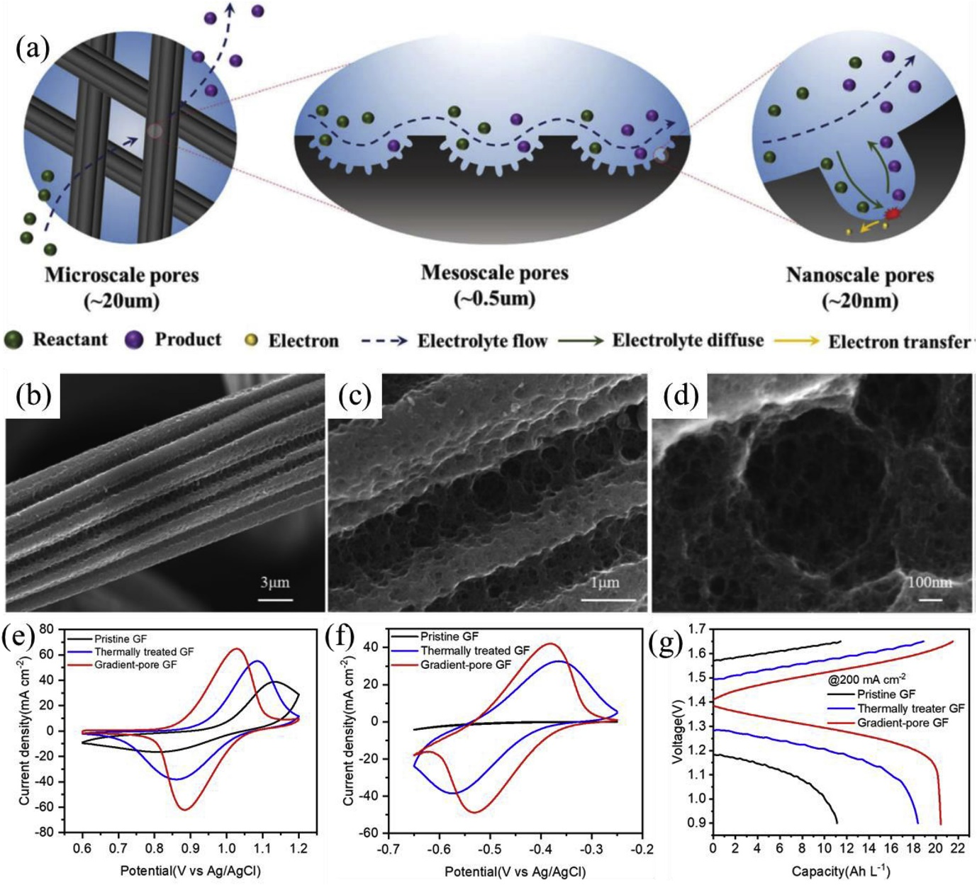
Figure 7. Schematic of the gradient-pore graphite felt electrode (a). SEM images of thermally treated gradient-pore graphite felt (b)-(d) and CV curves of pristine, thermally treated and gradient-pore graphite felts in the potential windows of (e) 0.6 to 1.2 V and (f) −0.7 to −0.2 V at the scan rate of 5 mV s⁻¹. CV curves of gradient-pore graphite felt for (g) VO²⁺/VO₂⁺. With permission from The Royal Society of Chemistry.

11. Electrolyte compositions/conditions
Electrolyte compositions are crucial for battery performances, in regards of specific energy, chemical stability and electrochemical performances. The higher vanadium concentration is beneficial in reducing the rate of oxidation of V(II) by the atmospheric air in the negative half-cell, while increased acid concentration tends to reduce the rate of capacity degradation. The free ions from sulfuric acid (HSO₄⁻, SO₄²⁻ and H⁺) could act as hindrance ions at the interface and may bond with V(II) ions and form VSO₄ or V(HSO₄)₂.
For practical VRFBs, the vanadium concentrations are often limited by their solubility (i.e. 2 M). The vanadium concentration was often in the range of 1–2 M at acid concentrations between 3 and 5 M. V(V) has a tendency to precipitate from H₂SO₄ (i.e. forming V₂O₅ at 40 ºC) when stored for prolonged periods at high temperatures and state-of-charge (SOCs), while V(II), V(III) and V(IV) have reduced solubility (i.e. forming sulfates) in sulfuric acid at temperatures lower than 5 ºC. It is therefore essential to maintain the electrolyte temperatures relatively moderate (15 – 40 ºC), higher vanadium concentration was reported to be possible (i.e. 3 M) for obtaining higher specific energy (i.e. 35 W h kg⁻¹) (Lourenssen et al. 2019, and Cao et al. 2018). Re-dissolving precipitation has also been demonstrated by mixing the two electrolytes or by discharging the electrolytes within the cell. Another strategy to maintain the electrolyte temperature is the use of thermal management. Advanced strategies to control the temperature of the electrolyte in a 9 kW/27 kWh vanadium redox flow battery stack were suggested by (Trovò et al., 2020). The advantage that the authors pointed out was that this strategy avoids V(V) precipitation during standby, limiting self-discharge losses.
Existing works reported different trends on solubility and ionic conductivities depend on the electrolyte compositions. The increased acid and salt contents may enhance the ionic conductivity, but may also increase the viscosity and reduce the solubility of the active species. The acid concentration needs to be optimized, as high acid content may reduce the solubility and ionic conductivity (increased viscosity). Mixed acids/anions are also common approach to enhance the solubility and sometimes improve the reaction kinetics due to weaker ligands. Some scaled-up system has demonstrated solubility of vanadium of up to 2.5 M in the mixed chloride-sulfate electrolytes and stable cycling performances over a temperature range of –5 to 50 ºC, although the chloride ions in the positive half-cell may reduce V(V) at high SOCs (i.e. > 98 %). Other researchers also showed that the mixed acids of methanesulfonate and sulfate have improvements in electrochemical activity and solubility over sulfuric acid, however, may result in slight increase in solution resistance.
A relatively recent development is the investigation of RFB concepts in which the (expensive) vanadium in the electrolytes is substituted by lower-cost organic redox-active molecules (Huskinson et al. 2014, Wei et al. 2017 and Leung et al. 2017). Advantages of organic molecules include the tunable redox potential and solubility when decorating a redox-active molecular center (e.g. anthraquinone, viologen, TEMPO, etc.) with suitable electron-donating or electron-withdrawing functional groups. Also, these organic redox-active compounds can be produced from abundantly available oil-based raw materials, which will result in lower-cost electrolytes that exhibit less price volatility compared to inorganic minerals (such as vanadium). The main challenge of the organics RFB’s is related to flow battery durability, since organic molecules can undergo chemical or electrochemical degradation when subjected to prolonged battery cycling.

12. Conclusions and recommendations
Although vanadium-based RFB’s already constitute a mature technology for long-duration energy storage, their relatively high investment cost may impede large-scale deployment, especially in the context of the rapidly decreasing cost of lithium-ion batteries. Therefore, it is important to optimize RFB’s (vanadium-based, as well as technologies using alternative electrolyte chemistries) to maximize round-trip efficiency and battery durability, while using low-cost materials in stack and electrolyte. This paper highlights several recent trends in stack and electrolyte material development, flow field design optimization, and fine-tuning of the operating conditions (in particular, electrolyte velocity) that are all essential for the realization of efficient, durable, and cost-competitive flow battery technologies.

12.References
Aaron, D.S., Liu, Q., Tang, Z., Grim, G.M., Papandrew, A.B., Turhan, A., Zawodzinski, T.A., Mench, M.M., 2012. Dramatic performance gains in vanadium redox flow batteries through modified cell architecture. J. Power Sources, 206, 450-453.
Arenas, L.F., Ponce de León, C., Walsh, F.C., 2017. Engineering aspects of the design, construction and performance of modular redox flow batteries for energy storage. J. of Energy Storage 11, 119–153.
Banerjee, R., Bevilacqua, N., Mohseninia, A., Wiedemann, B., Wilhelm, F., Scholta, J., Zeis, R., 2019. Carbon felt electrodes for redox flow battery: Impact of compression on transport properties. J. Energy Storage, 26, 100997.
Bhattarai, A., Wai, N., Schweiss, R., Whitehead, A., Lim, T.M., Hng, H.H., 2017. Advanced porous electrodes with flow channels for vanadium redox flow battery. J Power Sources, 341, 83-90.
Bromberger, K., Kaunert, J., Smolinka, T., 2014. A Model for All‐Vanadium Redox Flow Batteries: Introducing Electrode‐Compression Effects on Voltage Losses and Hydraulics. Special Issue: Energy Research at Fraunhofer Institute for Solar Energy Systems ISE, 2, 64-76.
Brown, L.D., Neville, T.P., Jervis, R., Mason, T.J., Shearing, P.R., Brett, D.J.L., 2016. The Effect of Felt Compression on the Performance and Pressure Drop of All-Vanadium Redox Flow Batteries. J. Energy Storage, 8, 91–98.
Cao, L., Skyllas-Kazacos, M., Menictas, C., Noack, J., 2018. A review of electrolyte additives and impurities in vanadium redox flow batteries, J. Energy Chem., 27, 1269–1291.
Chang, T.C., Zhang, J.P., Fuh, Y.K., 2014. Electrical, Mechanical and Morphological Properties of Compressed Carbon Felt Electrodes in Vanadium Redox Flow Battery. J. Power Sources, 245, 66–75.
Chen, D., Hickner, M.A., Agar, E., Kumbur, E.C., 2013. Optimizing Membrane Thickness for Vanadium Redox Flow Batteries. J. Membr. Sci., 437, 108–113.
Choe, J., Kim, J., Lee, D.G., 2016. Shape optimization of the corrugated composite bipolar plate (CCBP) for vanadium redox flow batteries (VRFBs). Composite Structures, 158, 333-339.
Darling, R.M., Perry, M.L., 2014. The Influence of Electrode and Channel Configurations on Flow Battery Performance. J. Electrochem. Soc., 161, A1381–A1387.
Dennison, C.R., Agar, E., Akuzum, B., Kumbur, E.C., 2016. Enhancing Mass Transport in Redox Flow Batteries by Tailoring Flow Field and Electrode Design. J. Electrochem. Soc., 163, A5163–A5169.
Gautam, R.K., Kapoor, M., Verma, A., 2020. Tactical Surface Modification of a 3D Graphite Felt as an Electrode of Vanadium Redox Flow Batteries with Enhanced Electrolyte Utilization and Fast Reaction Kinetics. Energy & Fuels 34, 5060-5071.
Ghimire, P.C., Bhattarai, A., Schweiss, R., Scherer, G.G., Wai, N., Yan, Q., 2018. A comprehensive study of electrode compression effects in all vanadium redox flow batteries including locally resolved measurements. Appl. Energy, 230, 974–982.
Guarnieri, M., Trovò, A., Marini, G., Sutto, A., Alotto P., 2019. High current polarization tests on a 9 kW vanadium redox flow battery. J. Power Sources, 431, 239-249.
Houser, J., Clement, J., Pezeshki, A., Mench, M.M., 2016. Influence of architecture and material properties on vanadium redox flow battery performance. J. Power Sources, 302, 369–377.
Houser, J., Pezeshki, A., Clement, J.T., Aaron, D., Mench, M.M., 2017. Architecture for Improved Mass Transport and System Performance in Redox Flow Batteries. J. Power Sources, 351 96–105.
Huskinson, B., Marshak, M.P., Suh, C., Er, S., Gerhardt, M.R., Galvin, C.J., Chen, X., Aspuru-Guzik, A., Gordon, R.G., Aziz, M.J., 2014. A metal-free organic–inorganic aqueous flow battery. Nature, 505,195–198.
Janoschka, T., Martin, M., Martin, U., Friebe, C., Morgenstern, S., Hiller H., Hager, M.D., Schubert, U.S., 2015. An aqueous, polymer-based redox-flow battery using non-corrosive, safe, and low-cost materials. Nature, 527, 78–81.
Jyothilatha, T., Jayanti, S., 2014. Hydrodynamic analysis of flow fields for redox flow battery applications. J. Appl. Electrochem., 44, 995-1006.
Karnauskas, K.B., Lundquist, J.K., Zhang, L., 2018. Southward shift of the global wind energy resource under high carbon dioxide emissions. Nature Geoscience, 11, 38–43.
Ke, X., Alexander, J.I.D., Prahl, J.M., Savinell, R.F., 2014. Flow distribution and maximum current density studies in redox flow batteries with a single passage of the serpentine flow channel. J. Power Sources, 270, 646–657.
Kim, K.J., Lee, H.S., Kim, J., Park, M.S., Kim, J.H., Kim, Y.J., Skyllas-Kazacos, M., 2016. Superior Electrocatalytic Activity of a Robust Carbon-Felt Electrode with Oxygen-Rich Phosphate Groups for All-Vanadium Redox Flow Batteries. ChemSusChem, 9, 1329-1338.
König, S., Suriyah, M.R., Leibfried, T., 2016. Innovative model-based flow rate optimization for vanadium redox flow batteries. J. Power Sources, 333, 134-144.
Kozak-Jagiea, E., Klich, A., Mojkowska-Gawełczyk M., 2020. The Use of Photovoltaic Conversion in Innovative Solutions. IOP Conf. Ser.: Mater. Sci. Eng. 960, 032096.
Kumar, S., Jayanti, S., 2016. Effect of flow field on the performance of an all-vanadium redox flow battery. J. Power Sources, 307, 782–787.
Le Donne, A., Trifiletti, V., Binetti, S., 2019. New earth-abundant thin film solar cells based on chalcogenides. Frontiers in Chemistry 7, 297.
Lee, J., Zhao, F. Global Wind Energy Council. Global wind Report 2019. Date: 25 March 2020. https://gwec.net/global-wind-report-2019/
Leung, P., Li, X., Ponce de Leon, C., Berlouis, L., Low, C.T.J., Walsh, F.C., 2012. Progress in redox flow batteries, remaining challenges and their applications in energy storage. RSC Adv, 2, 10125-10156.
Leung, P., Shah, A.A., Sanz, L., Flox, C., Morante, J.R., Xu, Q., Mohamed, M.R., Ponce de León, C., Walsh, F.C., 2017. J. Power Sources. Recent developments in organic redox flow batteries: A critical review. 360,243-283.
Liu, Q.H., Grim, G.M., Papandrew, A.B., Turhan, A., Zawodzinski, T.A., Mench, M.M., 2012. High performance vanadium redox flow batteries with optimized electrode configuration and membrane selection. J. Electrochem. Soc., 159, A1246-A1252.
Liu, T., Li, X., Xu, C., Zhang, H., 2017. Activated Carbon Fiber Paper Based Electrodes with High Electrocatalytic Activity for Vanadium Flow Batteries with Improved Power Density. ACS Appl. Mater. Interfaces, 9, 4626–4633.
Lourenssen, K., Williams, J., Ahmadpour, F., Clemmer, R., Tasnim, S., 2019. Vanadium redox flow batteries: A comprehensive review, J. Energy Storage, 25, 100844.
Ma, X., Zhang, H., Sun, C., Zou, Y., Zhang, T., 2012. Pulsating electrolyte flow in a full vanadium redox battery. J. Power Sources, 203, 153-158.
Maurya, S., Nguyen, P.T., Kim, Y.S., Kang, Q., Mukundan, R., 2018. Effect of flow field geometry on operating current density, capacity and performance of vanadium redox flow battery. J. Power Sources, 404, 20-27.
Mayrhuber, I., Dennison, C.R., Kalra, V., Kumbur, E.C., 2014. Laser-Perforated Carbon Paper Electrodes for Improved Mass-Transport in High Power Density Vanadium Redox Flow Batteries. J. Power Sources, 260, 251–258.
Noack, J., Wietschel, L., Roznyatovskaya, N., Pinkwart, K., Tübke, J., 2016. Techno-Economic Modeling and Analysis of Redox Flow Battery Systems. Energies, 9,627-635.
Oh, K., Won, S., Ju, H., 2015a. Numerical Study of the Effects of Carbon Felt Electrode Compression in All-Vanadium Redox Flow Batteries. Electrochim. Acta, 181, 13–23.
Oh, K., Yoo, H., Ko, J., Won, S., Ju, H., 2015b. Three-dimensional, transient, nonisothermal model of all-vanadium redox flow batteries. Energy, 81, 3-14.
Park, S.K., Shim, J., Yang, J.H., Jin, C.S., Lee, B.S., Lee, Y.S., Shin, K.H., Jeon, J.D., 2014. The Influence of Compressed Carbon Felt Electrodes on the Performance of a Vanadium Redox Flow Battery. Electrochim. Acta, 116, 447–452.
Perry, M.L., Darling, R.M., Zaffou, R., 2013. High Power Density Redox Flow Battery Cells. ECS Trans., 53, 7–16.
Ponce-de-Leon, C., Reade, G.W., Whyte, I., Male, S.E., Walsh, F.C., 2007. Characterization of the reaction environment in a filter-press redox flow reactor. Electrochim. Acta 52, 5815–5823.
Prasad, K.B.S., Jayanti, S., 2008. Effect of channel-to-channel cross flow on local flooding in serpentine flow fields. J. Power Sources, 180, 227-231.
Rodrigues, E.M.G., Godina, R., Catalão J.P.S., 2017. Modelling electrochemical energy storage devices in insular power network applications supported on real data. Appl. Energy 188, 315–329.
Reed, D., Thomsen, E., Li, B., Wang, W., Nie, Z., Koeppel, B., Kizewski, J., Sprenkle, V., 2016. Stack developments in a kW class all vanadium mixed acid redox flow battery at the Pacific Northwest National Laboratory. J. Electrochem. Soc., 163, A5211–A5219.
Shah, A.A., Watt-Smith, M.J., Walsh, F.C., 2008. A dynamic performance model for redox-flow batteries involving soluble species. Electrochim Acta, 53, 8087–8100.
Tang, A., Bao, J., Skyllas-kazacos, M., 2014. Studies on pressure losses and flow rate optimization in vanadium redox flow battery. J. Power Sources, 248, 154-162.
Trovò, A., Guarnieri, M., 2020. Standby thermal management system for a kW-class vanadium redox flow battery. Energy Conversion and Management, 226, 113510.
Wang, Q., Qu, Z.G., Jiang, Z.Y., Yang, W.W., 2018. Experimental study on the performance of a vanadium redox flow battery with non-uniformly compressed carbon felt electrode. Appl Energy, 213, 293–305.
Wang, R., Li, Y.S., He, Y.L., 2019. Achieving gradient-pore-oriented graphite felt for vanadium redox flow batteries: meeting improved electrochemical activity and enhanced mass transport from nano- to micro-scale. J. Mater. Chem. A, 7, 10962-10970.
Wang, R., Li, Y.S., 2020. Carbon electrodes improving electrochemical activity and enhancing mass and charge transports in aqueous flow battery: Status and perspective. Energy Storage Materials, 31, 230-251.
Wei, X., Pan, W., Duan, W., Hollas, A., Yang, Z., Li, B., Nie, Z, Liu, J., Reed, D., Wang, W., Sprenkle, V., 2017. Materials and Systems for Organic Redox Flow Batteries: Status and Challenges. ACS Energy Lett., 2,2187–2204.
Won, S., Oh, K., Ju, H., 2016. Numerical Studies of Carbon Paper-Based Vanadium Redox Flow Batteries. Electrochim. Acta, 201, 286–299.
Wu, L., Shen, Y., Yu, L., Xi, J., Qiu, X., 2016. Boosting vanadium flow battery performance by Nitrogen-doped carbon nanospheres electrocatalyst. Nano Energy, 28, 19-28.
Wu, M., Jing, Y., Wong, A.A., Fell, E.M., Jin, S., Tang, Z., Gordon, R.G., Aziz, M.J., 2020. Extremely Stable Anthraquinone Negolytes Synthesized from Common Precursors. Chem. 6, 1432-1442.
Xu, Q., Zhao, T.S., Zhang, C., 2014. Performance of a vanadium redox flow battery with and without flow fields. Electrochim. Acta, 142, 61–67.
Xu, C., Yang, X., Li, X., Liu, T., Zhang, H., 2017. Ultrathin free-standing electrospun carbon nanofibers web as the electrode of the vanadium flow batteries. J Energy Chem., 26, 730–737.
Yin, C., Gao, Y., Guo, S., Tang, H.A., 2014. Coupled three dimensional model of vanadium redox flow battery for flow field designs. Energy, 74, 886-895.
Yoon, S.J., Kim, S., Kim, D.K., 2019. Optimization of local porosity in the electrode as an advanced channel for all-vanadium redox flow battery. Energy, 172, 26-35.
You, D., Zhang, H., Chen, J., 2009. A simple model for the vanadium redox battery. Electrochim Acta, 54, 6827–6836.
You, X., Ye, Q., Cheng, P., 2016. Scale-Up of High Power Density Redox Flow Batteries by Introducing Interdigitated Flow Fields. Int. Commun. Heat Mass Transf., 75, 7–12.
Yue, M., Lv, Z.Q., Zheng, Q., Li, X.F., Zhang, H.M., 2019. Battery assembly optimization: Tailoring the electrode compression ratio based on the polarization analysis in vanadium flow batteries. Appl. Energy, 235, 495-508.
Zhang, W., Xi, J., Li, Z., Zhou, H., Liu, L., Wu, Z., Qiu, X., 2013. Electrochemical activation of graphite felt electrode for VO²⁺/VO₂⁺ redox couple application. Electrochim. Acta, 89, 429-435.
Zhang, Z., Xi, J., Zhou, H., Qiu, X., 2016. KOH etched graphite felt with improved wettability and activity for vanadium flow batteries. Electrochim. Acta 218, 15-23.
Zheng, Q., Xing, F., Li, X.F., Ning, G.L., Zhang, H.M., 2016. Flow field design and optimization based on the mass transport polarization regulation in a flow-through type vanadium flow battery. J. Power Sources, 324, 402-411.
Zheng, Q., Xing, F., Li, X., Liu, T., Lai, Q., Ning, G., Zhang, H., 2014. Investigation on the performance evaluation method of flow batteries. J. Power Sources, 266, 145-149.
Zhou, X.L., Zeng, Y.K., Zhu, X.B., Wei, L., Zhao, T.S., 2016. A High-Performance Dual-Scale Porous Electrode for Vanadium Redox Flow Batteries. J. Power Sources, 325,329–336.
Zhou, X.L., Zhao, T.S., An, L., Zeng, Y.K., Wei, L., 2017. Critical Transport Issues for Improving the Performance of Aqueous Redox Flow Batteries. J. Power Sources, 339, 1–12.

